Changes in Electricity Load Profiles Under COVID-19: Implications of “The New Normal” for Electricity Demand

Casey D. Burleyson, Aowabin Rahman, Jennie S. Rice, Amanda D. Smith, and Nathalie Voisin
Pacific Northwest National Laboratory

Abstract
Shelter-in-place orders and school and business closures related to COVID-19 have changed the hourly profile of electricity loads in the U.S. Such shifts have significant implications for utilities and grid operators, affecting operational efficiency as well as investment decisions. It is critical to understand if and how these changes may persist as economies gradually reopen. Using 2 years of observed electricity consumption data from more than 3.8 million residential and non-residential customers from the Commonwealth Edison utility in Illinois, we show that the onset of COVID-19 shifted weekday residential load profiles to closely resemble weekend profiles from previous years. We use this finding to estimate the potential impact of continued COVID-19-type profiles of electricity use on total load profiles. We find that long-term structural changes to the workplace like widespread teleworking could lead to 5-7% higher spring and summertime peak hourly loads occurring up to 2.5 hours earlier.

Introduction
Understanding and predicting the diurnal profile of electricity demands (also called load) is critical for planning economically efficient electricity grid operations, designing rates, and evaluating policies¹⁻⁴. Grid operators rely on load forecasts that are highly dependent on the day of week and time of year, holidays, and medium-range weather forecasts³. While most of the load forecast uncertainty at these time scales is typically driven by uncertainty in weather forecasting⁵⁻⁶, behavioral and economic shifts during the COVID-19 pandemic and their potential to persist beyond the current crisis are introducing new uncertainties⁷. Shelter-in-place measures to limit the viral spread of COVID-19 during the spring of 2020 have disrupted the ways in which people work, teach, worship, and socialize. These disruptions have modified and will continue to modify when, where, and how we use electricity. Even when COVID-19 cases subside, some COVID-19-induced changes may continue. For example, several large companies in the United States (U.S.) and United Kingdom (U.K.) have announced plans to allow for widespread permanent teleworking even as they begin to allow employees back into the office⁸⁻¹⁰.

Teleworking and stay-at-home orders resulting from COVID-19 have caused increases in residential demands and decreases in commercial and industrial demands¹¹⁻¹³. In the U.S., the Energy Information Administration (EIA) reports that residential electricity sales were 6% higher in April 2020 than in any April of the five previous years while commercial and industrial sales decreased by 9% and 10%, respectively¹³. A blog post from the New York Independent System Operator (NYISO) reported later-than-normal morning peaks, higher midday residential energy use, and temporal patterns similar to “a widespread snow day”⁷. A comparison of electricity demand profiles across Europe during the second week of April 2020 showed that total weekday electricity consumption was considerably reduced in countries that instituted COVID-19 containment measures and that the weekday hourly profiles resembled pre-pandemic weekend profiles¹⁴. However, these studies include only qualitative discussions of “probable” impacts by customer class (residential vs. commercial) and do not project the potential implications if such changes were to persist.

The potential for a “new normal” due to COVID-19 will create challenges in predicting hourly load profiles. Future profiles will need to reflect societal changes not present in pre-COVID-19 studies. Prior research on the energy and climate impacts of teleworking has focused primarily on changes in vehicle distance traveled, with overall energy use being a secondary focus¹⁵. While some pre-COVID-19 studies have addressed the impacts of teleworking on total energy use in the residential and commercial sectors¹⁶⁻¹⁷, their results were provided at annual time scales. There is a need for new research investigating the impacts of these changes on hourly electricity load profiles by customer class. Weekday changes in residential loads have the potential to significantly change the total load profile.

In this analysis, we explore a range of potential scenarios for the possible “new normal” of persistent shifts in sectoral electricity demands due to COVID-19 containment measures. Our analysis takes advantage of one of the few publicly available datasets of hourly demands that resolves residential loads separately from non-residential loads. The ability to isolate residential from non-residential differences in electricity profiles during COVID-19 is necessary to improve hourly load forecasts at scales relevant for electricity system planning and operations. This work can aid preparation for a “new normal” by illustrating the potential impacts of different reopening and long-term teleworking scenarios on residential and non-residential load profiles in future months and years.

Results

Changes in Load Profiles During COVID-19 Shelter-in-Place Orders
We evaluated the past 24 months (April 2018 through April 2020) of 30-minute interval electricity use data for residential and non-residential customers of the Commonwealth Edison (ComEd) utility service territory in the U.S. state of Illinois. Data was obtained through ComEd’s Anonymous Data Service¹⁸. ComEd has installed millions of smart meters to monitor the electricity use of its customers in 24 Illinois counties¹⁹. We use this metered data to explore how shelter-in-place rules during March and April 2020 affected the mean residential and non-residential load profiles.

A mandatory shelter-in-place order for the state of Illinois was issued on 20-March 2020²⁰. The impact of this order on electricity demand is evident in the daily load profiles produced from the ComEd data starting the week of 16-March 2020 (Fig. 1). While the weekday load profile of non-residential customers maintained a consistent shape after the shelter-in-place order, non-residential electricity consumption was noticeably lower (Fig. 1c,f). In contrast, the residential weekday load profile showed a dramatic change in shape, with a more gradual morning ramp, higher midday loads, and a smaller and less steep ramp to the evening peak (Fig. 1b,e). Weekday residential evening ramps were commonly greater than +1000 MW in a 3-hour period in February 2020 before COVID-19 conditions set in. Weekday residential load profiles after 16-March had ramps that were half as steep. Total April 2020 weekday electricity consumption for non-residential customers was 16% lower than in April 2019 while consumption for residential customers was 12% higher. This is due in part to year-to-year changes in the weather, but also to the wide-ranging impacts of the shelter-in-place order. Changes to the mean residential load profiles in April 2020 are consistent with people not waking up as early, not departing for work en masse between 7 am – 8 am, and using electricity at home more consistently throughout the day.

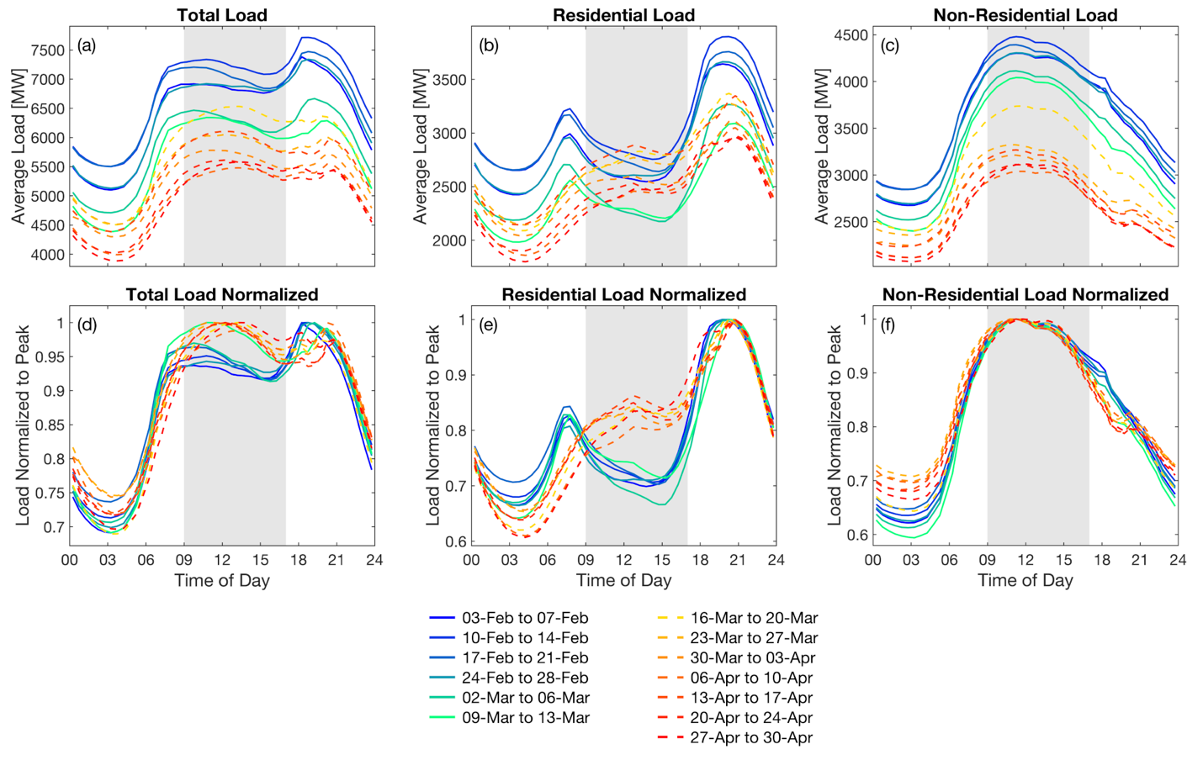

Fig. 1. Weekday mean load profiles for all (left), residential (center), and non-residential (right) customers by week from 3-Feb to 30-Apr 2020. The top row shows the absolute values (in MW) while the bottom row normalizes the values to the 30-minute mean daily peak in order to show changes in the shape. Shading in this and subsequent figures reflects nominal business hours (9 am – 5 pm).

Importantly for our subsequent analysis projecting future load profiles, the COVID-19 April 2020 residential weekday profile closely resembles the residential weekend load profiles for April in 2018 and 2019 (Fig. 2a). Figure 3 shows the correlation by day between the residential load profile for a given weekday in 2020 and the mean weekday or weekend residential load profile from the same month in 2019. The correlations shifted sharply the third week in March such that the weekday load profiles for residential customers closely resemble typical weekend profiles from the previous year. This transition to ‘perpetual weekend’ load profiles is consistent with NYISO’s observation of load profiles similar to “a widespread snow day”⁷.

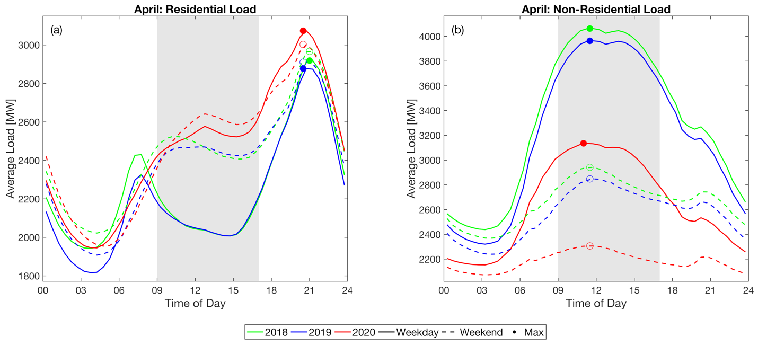

Fig. 2. The diurnal profile of observed mean weekday (solid lines) and weekend (dashed lines) loads in April for residential (top row) and non-residential (bottom row) customers. Diurnal maximum values are indicated by circles.

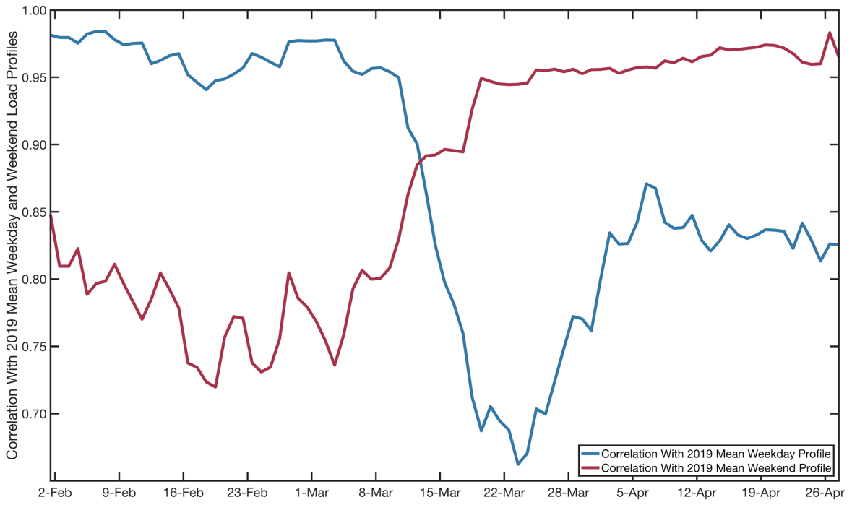

Fig. 3. Correlation between the residential load profile for a given day in 2020 and the mean weekday (blue) or weekend (red) load profile from the same month in 2019. Lines show the average correlation after a 10-day running mean was applied. Weekends were excluded from the running mean calculation.

Future Weekday Load Profiles Under “The New Normal”
Next, we explore the potential implications for weekday loads during an entire year if the COVID-19-induced changes observed in April 2020 were to persist to varying degrees. For example, some of the policies and behaviors that drove the changes in load shape may continue into the summer and fall or permanently as a result of long-term structural changes (e.g., widespread teleworking or higher unemployment). To better understand the potential implications of some of these changes, we conducted an analysis where we applied the observed changes in March and April 2020 to ‘normal’ historical load profiles in our dataset (i.e., April 2018 through April 2020). This approach is a proxy for predicting what might happen in the coming months if COVID-19-induced changes to the way we work and live persist into the future. We perform two sets of sensitivity studies. The first addresses the potential persistence of March and April conditions by evaluating scenarios of increasing residential loads and compensatory, decreasing non-residential loads. The second assumes that non-residential loads will return to pre-COVID-19 levels as businesses re-open and focuses on the incremental impact on residential and total load profiles of increasing fractions of residential customers teleworking/staying home on weekdays in the future. For context, historical average weekday and weekend load profiles for ComEd’s residential and non-residential customers are shown for 2019 in Fig. 4 and for years 2018 and 2020 in Figs. S2 and S5 in the Supplemental Information (SI).

Based on the observed transition of residential weekday load profiles to ‘perpetual weekends’ in March and April 2020 (Fig. 2a and Fig. 3), we modified the weekday load profiles for residential customers in historical months by replacing incrementally larger fractions of their historical mean weekday load profiles with their corresponding weekend load profiles from the same month. To create a composite historical residential load profile with, for example, 10% of residential customers continuing to stay home, we combine 90% of the observed weekday load profile with 10% of the observed weekend profile of the same month. This method is validated by applying it to observed data from April 2020 when widespread ‘perpetual weekends’ were already in place. As expected, swapping out weekend and weekday residential load profiles in April 2020 had a negligible impact on the total load profile because weekday and weekend residential profiles were no longer differentiated (Fig. S7d in the SI).

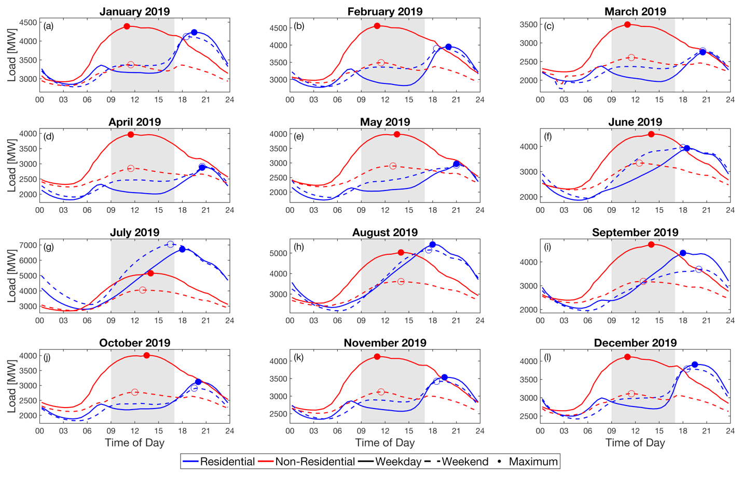

Fig. 4. The diurnal profile of observed mean weekday (solid lines) and weekend (dashed lines) loads by month in 2019 for residential (blue lines) and non-residential (red lines) customers. Diurnal maximum values are indicated by circles.

To simulate a range of possible changes in non-residential loads, we decreased the magnitude of non-residential loads to represent proportional decreases in the number of people continuing to stay home. Taking the observed year-over-year roughly 15% decrease in non-residential loads observed when virtually everyone in ComEd’s service territory sheltered-in-place in April 2020, we linearly scaled the non-residential load profiles from -15% total shelter-in-place conditions (100% of residential customers sheltering-in-place) to no change in a “business as usual” scenario without COVID-19 (or 0% of residential customers sheltering-in-place). The timing of businesses reopening as well as the percentage of people who will return to their normal lives outside of the home during the day and the operating conditions of non-residential buildings are highly uncertain over the coming months. As such, the 15% reduction in non-residential loads and its subsequent impact on total load profiles should likely be taken as an upper-bound. The scaling approach was applied evenly across all hours of the day to reflect our finding that non-residential loads decreased in magnitude but generally maintained a consistent shape in late March and April 2020 (Fig. 1c,f). More details on this approach are given in the Methods section.

Figure 5 shows the results from this first sensitivity study for all twelve months of 2019. Because non-residential loads make up half or more of the total load in the ComEd service area (Fig. S1 in the SI), a 15% reduction in non-residential loads generally lowered the magnitude of the total loads, but the overall shape of the demand profiles for each month was generally preserved. This is consistent with EIA projections that the U.S. demand for electricity during the summer of 2020 may be as low as it was in 2009²¹. The timing of the diurnal peak, while reduced in magnitude, does shift earlier by up to 2.5 hours. Our next experiment will show that this shift is associated with changes in the residential load profiles.

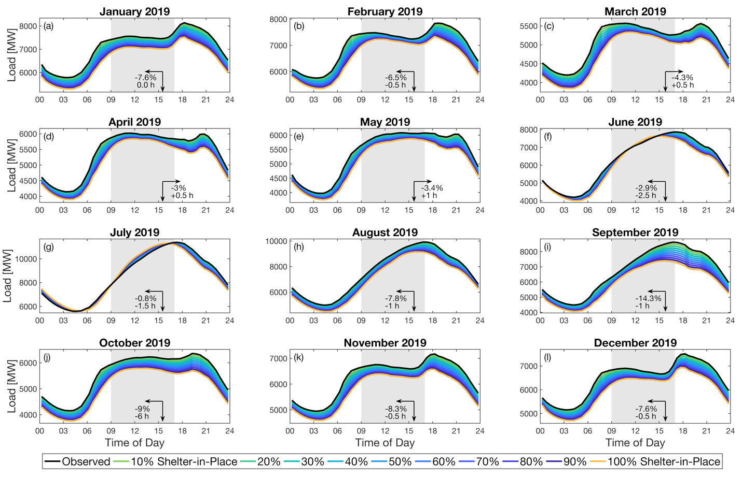

Fig. 5. Potential changes in the total weekday load profile by month in 2019 under scenarios in which residential loads were modified to simulate different fractions (line colors) of the population sheltering-in-place and non-residential loads were scaled in proportion to the fraction of the population sheltering-in-place. Annotations in each panel show how the timing and magnitude of the 30-minute peak load shifted under 100% shelter-in-place.

Our final sensitivity experiment explores the potential impact of widespread teleworking continuing to some degree while non-residential electricity consumption returns to pre-COVID-19 conditions. In other words, we are exploring a scenario where the electricity consumption from businesses and other non-residential buildings will return roughly to their pre-COVID-19 state while some fraction of the workforce permanently transitions to teleworking and/or distance learning. Different fractions of teleworking were represented using the same methodology as above: by swapping out fractions of residential customers’ mean weekday profiles with their corresponding weekend profile from the same month. Figure 6 shows our results for 2019. Changes in the timing and magnitude of daily weekday peak electricity loads under 100% teleworking scenarios are annotated in each panel. Most notable are the increases in daily peak loads in the spring and summer, which ranged from +5.1% in March to +6.8% in April. Critically, for electricity operations planning, the summer months of June and July are projected to have daily peak loads that are more than 5% higher and occur 1.5-2.5 hours earlier in the day. Changes in the daily peak hour in winter, fall, and spring months were less than 1 hour in either direction.

These projected changes in the timing of the diurnal peak load under “business as usual but with perpetual teleworking” scenarios are consistent with the first sensitivity experiment. The increase in the magnitude of peak loads is due to increased residential electricity usage during the day combined with the return to pre-COVID non-residential demands. While the pattern varies by season, residential loads are generally higher on the weekends during daytime (9 am – 5 pm). With the shift towards canonical weekend profiles, residential loads are increased during the day and align more closely with both the typical peak for non-residential demand and the availability of solar energy. Similar patterns were observed in 2018 and in January and February 2020 before widespread shelter-in-place conditions set in (Figs. S4 and S7 in the SI).

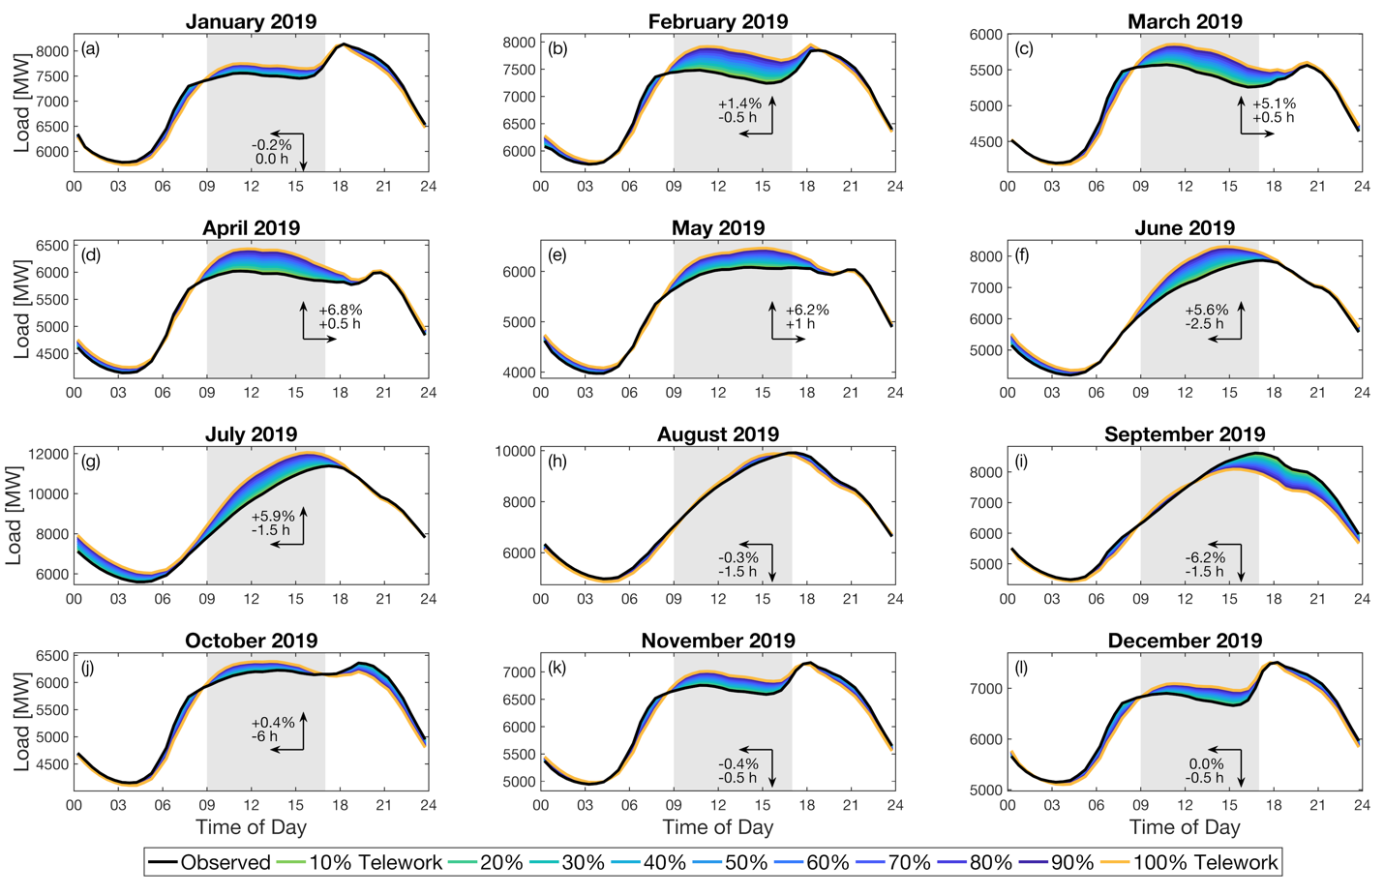

Fig. 6. Potential changes in the weekday total load profile by month in 2019 under scenarios in which different fractions of residential customers telework permanently. Annotations in each panel show how the timing and magnitude of the 30-minute peak load shifted under 100% telework.

Discussion
While some COVID-19-induced changes to the way we work and live are likely to revert to pre-COVID-19 conditions, others like widespread teleworking may be permanent fixtures of “the new normal.” In addition to showing the potential impact of the gradual relaxation of shelter-in-place restrictions in different months of the year, this research demonstrates the potential for long-term changes like permanent teleworking to increase total weekday electricity loads during workday hours, to shift the timing of daily peak demand by up to 2.5 hours earlier, and to reduce the slope and magnitude of the morning and evening ramps. Such changes could have major implications for electricity operations planning. As one example, the shape of the pre-COVID residential weekday load profile in the ComEd service area closely follows that of California ISO’s “duck curve”²². Our analysis shows that the increased daytime loads under extended teleworking/stay-at-home scenarios could be expected to “flatten” the duck curve similar to the shift seen in the ComEd profile during shelter-in-place conditions in March-April 2020. This flattened daily net load profile could lower ramping needs, reduce oversupply risks²³⁻²⁴, and change market prices²⁵. Such an impact on a duck curve load shape was observed during March and April 2020 in a small community in Austin, Texas with extensive solar penetration²⁶.

Given the COVID-19 impact on hourly load profiles and the fact that COVID-19 measures have been implemented worldwide, this research demonstrates the need to isolate residential and non-residential electricity demands from the total load in order to inform system operators and utilities for resource planning. While a handful of region-specific, system-scale hourly load forecasting models are emerging that focus on isolating residential and non-residential hourly loads²⁷⁻²⁸, more widespread analyses of the type presented here are needed. The observed and potential shifts in electricity load profiles documented in this paper also motivate new approaches to predicting long-term changes in total hourly loads that explicitly represent potential shifts in behaviors and economics²⁹. Better understanding these shifts is critical to inform and update load forecasting approaches that typically draw upon historical hourly load profiles for future electricity system planning and operations³⁰⁻³². The findings also expose new research directions in isolating customer classes to evaluate heterogeneity in customer adaptations to extreme weather events, adoption of new technologies such as residential battery systems, and the effectiveness of time-of-use pricing programs.

Methods
The core dataset underpinning this study is end-use electricity consumption from the Commonwealth Edison (ComEd) utility. The ComEd service territory spans all or part of 24 counties in northern Illinois, including Cook County and the greater Chicago metropolitan area. Since 2017, ComEd has made 30-minute anonymized energy usage data available for purchase. This Anonymous Data Service (ADS¹⁸) covers ComEd customers where Advanced Metering Infrastructure devices have been deployed. Anonymized end-use electricity data are classified by customer class (4 residential and 11 non-residential customer classes) and zip code. While the number of customers in the ADS varies from month-to-month, an average month has more than 3.5 million residential customer records and 330,000 non-residential customer records. This constitutes nearly all of the 3.65 million residential and 386,000 non-residential customer ComEd reported in 2018³³. This study uses ADS data from April 2018 through April 2020. The raw ADS metered electricity consumption data (kWh) is in 30-minute intervals for each customer. We aggregate these into residential and non-residential customer classes. We then convert the units from kWh per 0.5 h to MWh per h (a multiplier of 2/1000 kW/MW). This facilitates presenting the hourly load profiles as MW on the y-axis and hours on the x-axis.

Our analysis has two core components. First, we demonstrate how daily electricity load profiles for ComEd’s residential and commercial customers shifted as the U.S. transitioned to widespread shelter-in-place conditions in March-April 2020. This analysis is based on 30-minute aggregate loads for residential and non-residential customers. Second, we performed a sensitivity study to explore how historical weekday total load profiles may have shifted if shelter-in-place conditions or widespread teleworking had occurred in prior months and years. To do this we modified historical monthly mean residential and non-residential daily load profiles to reflect the changes observed under near-universal shelter-in-place conditions in March and April of 2020.

Our approach to changing residential customer load profiles is based on the observed shift of weekday load profiles in April 2020 to closely resemble canonical weekend load profiles from previous years. To simulate a certain fraction of residential customers continuing to shelter-in-place or teleworking permanently, for example 20%, we summed 20% of the mean weekend load profile for residential customers with 80% of the mean weekday load for the same month. This method was repeated for different fractions of residential customers ranging from 0-100%. To ensure that natural meteorological variability between historical weekdays and weekends is not aliased on to this analysis, we evaluated the statistical differences between mean weekday and weekend temperatures by month for previous years using a two-sample t-test and a 5% significance threshold (Figs. S8-S10 in the SI). With the exception of August 2018 and February 2020, which were not quantitatively analyzed in the main text, the average weekday and weekend temperatures for all previous months were statistically indistinguishable. This suggests that the changes in the magnitude and timing of peak loads that we report in the main text are largely due to the shift in load profiles for residential customers and not to natural meteorological variability.

To capture changes in non-residential load under different levels of phased reopening we conducted an analysis in which the non-residential customer loads were scaled proportionally to the number of residential customers hypothetically sheltering-in-place in previous years. While this relationship is likely to be nonlinear in actuality, we use linear proportionality here as an approximation in lieu of observed data that support a more complex relationship. The maximum delta applied to non-residential loads was subjectively chosen as the -15% year-over-year change in non-residential loads observed in April 2020. Using this observed value, non-residential customer loads were uniformly scaled by [1 - (0.15 * Shelter-in-Place Penetration)], as summarized in Table 1.

Shelter-in-Place Penetration | Non-Residential Customers Scaling Factor
0% | Observed
10% | 0.985 * Observed
20% | 0.970 * Observed
30% | 0.955 * Observed
40% | 0.940 * Observed
50% | 0.925 * Observed
60% | 0.910 * Observed
70% | 0.895 * Observed
80% | 0.880 * Observed
90% | 0.865 * Observed
100% | 0.850 * Observed

Table 1. Scaling factors uniformly applied to the diurnal load profile for non-residential customers for different ranges of residential customers continuing to shelter-in-place.

Acknowledgements
This research was supported by the U.S. Department of Energy, Office of Science, as part of research in the MultiSector Dynamics, Earth and Environmental System Modeling Program. Pacific Northwest National Laboratory is a multi-program national laboratory operated by Battelle for the U.S. Department of Energy under Contract DE-AC05-76RL01830.

References
1. Alfares, H.K., and Nazeeruddin, M., 2002. Electric load forecasting: literature survey and classification of methods. International Journal of Systems Science, 33(1), 23-34.

2. Yamin, H.Y., 2004. Review on methods of generation scheduling in electric power systems. Electric Power Systems Research, 69(2), 227-248.

3. Singh, A.K., Khatoon, S., Muazzam, M., and Chaturvedi, D., 2012. Load forecasting techniques and methodologies: A review. 2012 2nd International Conference on Power, Control and Embedded Systems, Allahabad, 2012, pp. 1-10, doi: 10.1109/ICPCES.2012.6508132.

4. Frick, N. M., Wilson, E., Reyna, J., Parker, A., Present, E., Kim, J., Hong, T., Li, H., & Eckman, T. (2019). End-Use Load Profiles for the U.S. Building Stock: Market Needs, Use Cases, and Data Gaps. Lawrence Berkeley National Laboratory.

5. McSharry, P.E., Bouwman, S. and Bloemhof, G., 2005. Probabilistic forecasts of the magnitude and timing of peak electricity demand. IEEE Transactions on Power Systems, 20(2), 1166-1172.

6. Shao, Z., Chao, F., Yang, S.-L. and Zhou, K.-L., 2017. A review of the decomposition methodology for extracting and identifying the fluctuation characteristics in electricity demand forecasting. Renewable and Sustainable Energy Reviews, 75, 123-136.

7. New York Independent System Operator. COVID-19 and the electric grid: Load shifts as New Yorkers respond to crisis. https://www.nyiso.com/-/covid-19-and-the-electric-grid-load-shifts-as-new-yorkers-respond-to-crisis#:~:text=Blog-,COVID%2D19%20and%20the%20Electric%20Grid%3A%20Load%20Shifts%20as,New%20Yorkers%20Respond%20to%20Crisis&text=That%20means%20energy%20load%20is,City%20and%20on%20Long%20Island. (2020) [accessed 2020.06.27].

8. D’Urbino, L. What will be the new normal for offices? The Economist
https://www.economist.com/britain/2020/05/09/what-will-be-the-new-normal-for-offices
(2020) [accessed 2020.06.27].

9. Sandler, R. Twitter to allow employees to work from home after coronavirus. Forbes https://www.forbes.com/sites/rachelsandler/2020/05/12/twitter-to-allow-employees-to-work-from-home-after-coronavirus/#d2751123e9fd (2020) [accessed 2020.06.27].

10. Lerman, R., and Dwoskin, E. Facebook will now let some employees work from anywhere, but their paychecks could get cut. The Washington Post https://www.washingtonpost.com/technology/2020/05/21/facebook-permanent-remote-work/ (2020) [accessed 2020.06.27].

11. Bandyk, M. A COVID-19 hit to public power? For some, it's not all bad. Utility Dive https://www.utilitydive.com/news/a-covid-19-hit-to-public-power-for-some-its-not-all-bad/580208/ (2020) [accessed 2020.06.27].

12. Lee, A., and DeVilbiss, J. Daily electricity demand impacts from COVID-19 mitigation efforts differ by region. U.S. Energy Information Administration (EIA) Today in Energy https://www.eia.gov/todayinenergy/detail.php?id=43636 (2020) [accessed 2020.06.27].

13. Gorski, A., and Lawson, G. Stay-at-home orders led to less commercial and industrial electricity use in April. U.S. Energy Information Administration (EIA) Today in Energy https://www.eia.gov/todayinenergy/detail.php?id=44276 (2020) [accessed 2020.06.30].

14. Bahmanyar, A., Estebsari, A., and Damien, E., 2020. The impact of different COVID-19 containment measures on electricity consumption in Europe. Energy Research & Social Science,
68, 101683, https://doi.org/10.1016/j.erss.2020.101683.

15. Hook, A., Court, V., Sovacool, B., and Sorrell, S., 2020. A systematic review of the energy and climate impacts of teleworking. Environmental Research Letters, https://doi.org/10.1088/1748-9326/ab8a84.

16. Matthews, H.S., and Williams, E., 2005. Telework adoption and energy use in building and transport sectors in the United States and Japan. Journal of Infrastructure Systems, 11(1), 21–30.

17. Sekar, A., Williams, E., and Chen, R., 2018. Changes in time use and their effect on energy consumption in the United States. Joule, 2(3), 521-536, https://doi.org/10.1016/j.joule.2018.01.003.

18. ComEd ADS Handbook. Data services handbook for third parties. https://www.comed.com/SiteCollectionDocuments/SmartEnergy/ADSHandbook.pdf
(2020) [accessed 2020.04.01].

19. ComEd Smart Meters FAQ. https://www.comed.com/SiteCollectionDocuments/SmartEnergy/SmartMeterFAQ.pdf
(2017) [accessed 2020.06.27].

20. Petrella, D., St. Clair, S., Johnson, S., and Pratt, G. Gov. J.B. Pritzker issues order requiring residents to ‘stay at home’ starting Saturday. Chicago Tribune https://www.chicagotribune.com/coronavirus/ct-coronavirus-illinois-shelter-in-place-lockdown-order-20200320-teedakbfw5gvdgmnaxlel54hau-story.html (2020) [accessed 2020.06.27].

21. Hodge, T. EIA expects 2020 summer U.S. electricity demand to be lowest since 2009. U.S. Energy Information Administration (EIA) Today in Energy https://www.eia.gov/todayinenergy/detail.php?id=44055#:~:text=The%20U.S.%20Energy%20Information%20Administration,5%25%20less%20than%20last%20summer (2020) [assessed 2020.06.27].

22. California Independent System Operator. What the duck curve tells us about managing a green grid. https://www.caiso.com/Documents/FlexibleResourcesHelpRenewables_FastFacts.pdf (2016) [accessed 2020.06.27].

23. Cochran, J., Denholm, P., Speer, B., and Miller, M., 2015. Grid integration and the carrying capacity of the U.S. grid to incorporate variable renewable energy. National Renewable Energy Lab.

24. Wang, C., and Shahidehpour, S.M., 1993. Effects of ramp-rate limits on unit commitment and economic dispatch. IEEE Transactions on Power Systems, 8(3), 1341-1350.

25. Rober, W. Electricity prices fall along with demand. Statista https://www.statista.com/chart/21675/electricity-prices-covid/ (2020) [accessed 2020.06.27].

26. St. John, J. The Solar ‘Duck Curve’ Might Look Different Under Coronavirus. Green Tech Media https://www.greentechmedia.com/articles/read/tracking-the-duck-curve-under-coronavirus-lockdown-and-other-findings-from-pecan-street (2020) [accessed 2020.07.02].

27. Gerwig, C., 2015. Short Term Load Forecasting for Residential Buildings—An Extensive Literature Review. In: Neves-Silva R., Jain L., Howlett R. (eds) Intelligent Decision Technologies. IDT 2017. Smart Innovation, Systems and Technologies, vol 39. Springer, Cham.

28. Lusis, P., Khalilpour, K.R., Andrew, L., and Liebman, A., 2017. Short-term residential load forecasting: Impact of calendar effects and forecast granularity. Applied Energy, 205, 654-669.

29. Lindberg, K.B., Seljom, P., Madsen, H., Fischer, D., and Korpås, M., 2019. Long-term electricity load forecasting: Current and future trends. Utilities Policy, 58, 102-119.

30. Bailey, M., Brownlee, B., Moyer, K., and Zhang, H., 2014. Planning for energy futures: The WECC Interconnection-wide Transmission expansion experience, pp. 1-5, IEEE.

31. Cohen, S.M., and Coauthors, 2019. Regional Energy Deployment System (ReEDS) Model Documentation: Version 2018. National Renewable Energy Laboratory.

32. Wise, M., Patel, P., Khan, Z., Kim, S.H., Hejazi, M., and Iyer, G., 2019. Representing power sector detail and flexibility in a multi-sector model. Energy Strategy Reviews, 26, 100411.

33. EIA-861M Dataset: https://www.eia.gov/electricity/data/eia861m/

