Title:
Potential Risks of a Widespread Use of 3D Printing for the Manufacturing of Face Masks during the SARS-CoV-2 Pandemic

Running Head:
Potential Risks of 3D Printed Face Masks

Duda S^{1*}, Hartig S^{2*}, Hagner K³, Meyer L¹, Wessling Intriago P¹, Meyer T², Wessling H¹
*Authors contributed equally to this work
¹Department of Neurosurgery, Hospital of the German Armed Forces, Lange Strasse 38, 26655 Westerstede, Germany
²Laboratory for Manufacturing Technology, Helmut Schmidt University / University of the German Armed Forces, Holstenhofweg 85, 22043 Hamburg, Germany
³Bundeswehr Research Institute for Protective Technologies and NBC Protection (WIS), Humboldtstraße 100, 29633 Munster, Germany

Corresponding author:
Sven Duda, MD
svenduda@bundeswehr.org
Conflict of interest:
The authors declare that there is no conflict of interest.
Funding:
The German Ministry of Defence financially supported this research.
Ethical conduct of research disclosure:
Informed consent was obtained from the research associates of the Institute for Protection Technologies, who functioned as test persons.
Acknowledgements:
We would like to thank the Freudenberg SE company for providing FFP2 and FFP3 filter fleece for research purposes. Furthermore we thank Karola Hagner and her research associates, Thomas Dawert, Matthias Jansen, Rolf Gloge and Dennis Lange at the Institute for Protection Technologies at the Military Science Institute of the German Armed Forces for their technical investigation of the manufactured masks. Moreover we would like to thank the Commanding Officer of the German Armed Forces Hospital Westerstede, Col. (MC) Grüne, MD, for entrusting us with the task to scientifically evaluate the use of 3D printed face masks and for his relentless support.

Keywords: Additive Manufacturing, 3D Printing, Face Masks, SARS-CoV-2, COVID-19
Abstract

Background
In 2020 the SARS-CoV-2 pandemic caused serious concerns about the availability of face masks. This paper studies the technical feasibility of user specific face mask production by 3D printing and the effectiveness of these masks.
Material and Methods
Six different face mask designs were produced by 3D printing and tested by subjective experimenter evaluation and using a respirator fit testing kit. Results were compared to the requirements as given for standard protective face masks.
Results
None of the printed masks came anywhere near the required standards for personal protective gear.
Conclusion
In spite of their euphoric presentation in the press, none of the currently advertised 3D printed mask designs are suitable as reliable personal protective equipment.

Introduction
In 2020 the pandemic spread of the SARS-associated coronavirus, SARS-CoV-2, serious concerns about the availability of suitable face masks have risen even in advanced countries with highly specialized health care systems [1]. Due to a lack of availability of protective face masks, improvised masks were considered even in the health care sector [2]. The demand for protective face masks increased even further when the call for a widespread use of face masks among the public grew louder [3]. As opposed to this, the WHO did not recommend the public use of face masks due to a lack of evidence [4]. However, the strict adherence to evidence based medicine in cases of pandemics of previously not known and potentially lethal agents has been a subject of scientific dispute, given that measures of containment have to be applied rapidly, while the completion of valid randomized controlled studies is usually very time consuming [5]. Earlier studies showed evidence that homemade face masks can aid to reduce particle inhalation and expectoration but their protective capability remains questionable [6,7]. Next to freely available sewing instructions for face masks from fabric, the widespread use of 3D printing led to a large number of different open-source, non-certified face masks available for download and 3D printing on a desktop 3D printer. Swennen et al. already published a proof of concept [8].
In this study we investigated the safety and effectiveness of a number of foldable and rigid 3D printed face masks using a respirator fit test. Included in the study were firstly mask designs, which were based on freely available designs downloaded from highly advertised sites in the www, but were modified and further developed by the Working Group for 3D Printing in Neurosurgery of the Armed Forces Hospital in Westerstede (BwKWST) in cooperation with the Laboratory for Manufacturing Technology of the University of the German Armed Forces in Hamburg (HSU). Given their high level of publicity in the online press as well as in social media, we additionally included mask designs without modification by this cooperation. After thus producing a number of protective mask prototypes, an independent evaluation of these prototypes regarding their efficiency and safety was warranted.
The Bundeswehr Research Institute for Protective Technologies and NBC Protection
(WIS) in Munster was contacted for the purpose of performing independent testing of the mask prototypes. They agreed to test 6 different prototypes of masks, of which 2 had been developed and/or modified by our working group and 4 were directly downloaded from websites advertising the use of specific designs. As a means of reference, two masks known to correspond two different levels of requirements for protective efficiency defined by german normative authorities (DIN EN 149) as well as a mask sawn from fabric according to a design freely published on the internet were also subject to an identical array of tests.

Material and Methods
Design Process HSU/BwKWST Face Masks
In order to simulate a typical chain of development, production and supply, the medical members of the research group, i.e. the working group “3D Printing in Neurosurgery” were assigned the role of “users”. Since it is an adaptive design, product development according to VDI 2221 begins as early as the design phase. To ensure that this phase can be completed as effectively and quickly as possible, the evaluation of the designs is carried out directly at the user's premises by the user. The direct user feedback enables a target-oriented development according to the needs of the user. For this purpose, desktop 3D printers, such as Ultimaker 3 (Ultimaker, Geldermalßen, Netherlands), were installed at the user's premises at the Neurosurgical Department of the German Armed Forces Hospital in Westerstede. Mask designs were developed and constructed at the Laboratory for Manufacturing Technologies of the University of the German Armed Forces in Hamburg by using the design software Fusion 360 (Autodesk, Washington D.C., USA). The designs were then digitally transferred to the user environment for prototype production and evaluation (Fig. 1). By directly involving the user in the product development process, the time to the finished product can be minimized. Even if designer, constructor and user are not at the same place, a fast iteration to the final product can be carried out by the digital transmission of the model data and the production at the users site. The feedback about possible design changes is then again carried out via a digital medium and can be immediately implemented in a new version/draft. This process enables the development department to respond directly to new user requirements and test them. Product errors can be detected and corrected at an early stage through the extensive use of prototypes in final product quality.

3D Printing and Assembly of Open-Source Face Masks
The open-source .STL-data of four different face masks (Copper 3D NanoHack, www.copper3d.com; Lafactoria3D COVID-19 Mask V2, www.lafactoria3d.es; Maker Mask Respirator, www.makermask.com; Montana Mask, www.longliveyoursmile.com) were downloaded from the internet. The foldable Copper 3D NanoHack mask was further developed and adapted to the requirements of the physicians represented in the working group using the previously described design process. This led to the production of two modified versions, the HSU/BwKWST FM V3 (V3) and HSU/BwKWST FM V4 (V4). The COVID-19 Mask V2 was available in different sizes. For comparison, printing of the large mask with thick wall diameter, which was provided in the downloadable file, was chosen.
3D printing of all masks was prepared using the software Cura (Ultimaker, Geldermalßen, Netherlands) and performed using Ultimaker 3 printers (Ultimaker, Geldermalßen, Netherlands) and white polylactic acid (PLA, Ultimaker, Geldermalßen, Netherlands) or black thermoplastic polyurethane (TPU95A, Ultimaker, Geldermalßen, Netherlands) filament. Printjob parameters, like printing temperature (200 C°), layer thickness (0,2 mm), infill (10%) and printing speeds (45 - 70 mm/s) were set. Afterwards a machine code (G Code) was generated. Small parts (i.e. filters, fastening clips, caps) were printed using the 0.4 mm nozzle at a printing speed of 70 mm/s and additional build plate adhesion was applied. Masks were printed using the 0.8 mm nozzle at a printing speed of 45 mm/s. Afterwards the masks were assembled according to the provider's instructions. Combined FFP3 fleece (Freudenberg SE, Weinheim, Germany) was trimmed to fit the filters and used as filter material.

Mask Design Evaluation and Respirator Fit Testing
The simplified testing array consisted firstly in a thorough descriptive evaluation of application and wearing comfort as well as subjective estimation of permeability by between two and four participants for each mask and secondly in a determination of the Protective Factor (PF) of each mask for each participant in three different measurements. These measurements were put into practice using the respirator leakage tester PortaCount® 8020M (TSI Inc., Minnesota, USA), which is the standard equipment of the German Armed Forces for the testing of CBRN (chemical, biological, radiological and nuclear) protective gear. Using the measured Protective Factor, the Total Inward Leakage (TIL) was calculated and compared to the requirements as given in the DIN149 regulation.
The Protective Factor is defined as the quotient between particle concentration outside the mask (pco) and particle concentration inside the mask (pci):

PF = pco/pci

The TIL is a percentage which can be calculated as the quotient between 100 and the PF (mean) of each mask type:

TIL (%) = 100/PF

Statistical Analysis
Data is presented as mean ± standard deviation of the mean. Microsoft Excel (Microsoft Corporation, Washington, USA) was used for data analysis and graphical illustration. Results were analyzed for significant differences using the Welch-Test for normally distributed and Mann-Whitney-U-Test for not normally distributed data. A p-value of <0,05 was considered to indicate statistically significant differences between groups.

Results
Design Process HSU/BwKWST Masks
By outsourcing prototype production to the user, a significant increase in iteration speed was achieved in the design process for the face mask. At the beginning of the design phase, there was no 3D printer available on the user side, so additive manufacturing capabilities were used in the designer's environment to produce the first prototypes. These were then sent to the user by mail to get direct feedback. Due to the postal dispatch there was a delay of 2-3 days. With the use of 3D printers at the users environment and on site prototype production the postal dispatch could be eliminated. The time between the completion of the design process of a new iteration and the direct user feedback took only 3-4 hours (manufacturing time). Using this process, 3 iteration loops could be drawn within one working day. This represents a time saving of 9 days compared to the previous procedure.
The basic design of the mask from www.copper3d.com has been adopted for HSU/BwKWST FM V1 (V1) shown in Figure 2A. Due to the symmetrical design, the filter area has been doubled. Furthermore, a thread has been added so that a freely available FFP3 filter could be used. However, the use of commercially available filter inserts was not considered further in the following versions due to their potentially limited availability. For this reason, an integrated replaceable filter material was added in the HSU/BwKWST FM V2 (V2) (Fig. 2B). Moreover, the slotted holes for the rubber bands have been divided to increase the wearing comfort. In order to protect the wearer's eye area, pins, which act as holding points for a face shield, were integrated. The material surfaces at the lower mask margin were expanded to provide a better seal at the chin area. During thermoforming, a fold is created here instead of a slit, which had to be sealed afterwards. This feature was retained for all subsequent versions, as it is more suitable for sealing the mask against the face. The HSU/BwKWST FM V3 (V3) uses a sealing lip made of TPU (thermoplastic urethane) which is placed around the outer contour due to the sealing problems in the edge area (Fig. 2C). By using the flexible material, an attempt was made to seal the mask tightly to the face. As there is a strong curvature in the area of the nose and the nostrils during the thermal adaptation of the mask to the face, the possibility of leakage is very high here. Several design approaches have been followed, as shown in HSU/BwKWST FM V1, V2 and V3 with different cut-outs, with V3 providing the best seal. Four strap fastening clips, which allow an adjustment of the rubber band, were added to the openings for the rubber bands to improve the mask fitment and wearing comfort in the HSU/BwKWST FM V4 (V4) (Fig. D). The rubber bands were fixed with knots to the previous masks. A later adjustment of the rubber bands was therefore only possible by removing the mask or by a second person. Two different versions of the removable filter inserts were developed for V3 and V4. The main objective was a simple change of the filters instead of changing the filter material within the mask. When changing the filter material, a significant additional effort is required due to the possible contamination. When changing the filter insert, the risk of contamination is lower because the test person does not come into contact with the contaminated filter material. The variants differ with respect to the shape of the filter surface (Fig. 2E and F, square filter design; Fig. 2G and H, round filter design). The advantage of the square variant is that the shape of the filter material makes it easier to cut to size. On the other hand the installation of the round insert is advantageous. With both filter inserts, the filter material is inserted between the lower part and the cover. The HSU/BwKWST FM V1 and V2 were designed, shipped, printed and evaluated according to the described design process between the Laboratory for Manufacturing Technologies at the University of the German Armed Forces and the Department of Neurosurgery at the German Armed Forces Hospital in Westerstede. Only the HSU/BwKWST FM V3 and V4 were released for further tests.

3D Printing and Assembly of Open-Source Face Masks
3D Printing of Open-Source Face Masks
3D printing of the different open-source face masks was successfully carried out using Ultimaker 3 printers (Ultimaker, Geldermalßen, Netherlands). The HSU/BwKWST FM V3 was printed in 5h 10min, the HSU/BwKWST FM V4 in 3h 8min, the COVID-19 Mask V2 (PLA and TPU95A, respectively) in 2h 24min, the Montana Mask in 4h 38min and the Maker Mask in 10h 54min. Material requirements were 6g TPU and 72 g PLA for the HSUBwKWST FM V3, 97 g PLA for the HSU/BwKWST FM V4, 37,3 g PLA or TPU95A for the COVID-19 Mask V2 and 126 g Maker Mask, respectively.

Assembly of 3D Printed Face Masks
The foldable HSU/BwKWST FM V3 and V4 were fitted to the face by heating of the thermoplastic material with a hair dryer and adapting the form to the experimenter's face. The filter boxes were screwed on the masks after the filter material was trimmed and elastic bands were attached. The HSU/BwKWST FM V3 had an additional TPU95A inlay to seal the mask / face junction. A further assembly was not necessary. The HSU/BwKWST FM V4 is shown in Figure 3.
Assembling the COVID-19 Mask V2 (PLA and TPU95A versions) as well as the very similar Montana Mask was easier. For the Covid 19 Mask V2, the filter material was loosely laid into a filterbox, which then had to be clipped to the mask, giving rise to leakage concerns. The filter material was directly clipped to the frame of the Montana Mask. Additionally the mask had a sealing line around the mask body. Due to the rather small filter area, both types of filter connections caused subjective difficulties with respect to the respiratory resistance. However, due to the even smaller filter area, this problem appeared to be more important in the case of the Covid 19 Mask V2 than in the case of the Montana Mask.
Building the Maker Mask was a much more complicated procedure, given that it consists of 24 different parts, which have to be assembled by the user. First the in- and outlet valves were assembled using super glue. Hot-melt adhesive was used to mount the filter boxes. Afterwards an elastic band was fixed to the printed straps and was attached to the mask with hooks. Following the recommendation of the designers, an effort was made to seal the rim with a standard window sealing (P-profile, tesamoll, tesa SE, Norderstedt, Germany).

Mask Design Evaluation and Respirator Fit Testing
Mask Design Evaluation
Both the HSU/BwKWST FM V3 and HSU/BwKWST FM V4 were based on the principle of thermoplastic fitting by heating up the printed items. Even though this method leads to individually tailored masks, with a subjectively almost perfect fit, the procedure is not without difficulty and requires skill, patience and experience. For both types a second weakness was identified in relation with the screw mechanism to connect filters to the mask. This is another probable major source of leakages, given that the mechanism may be subject to alterations by the process of thermoplastic fitting.
The subjective impression regarding the fitting of the masks to the experimenter's faces was rather disappointing in the case of the PLA Version of the Covid-19 Mask V2 as well as of the Montana mask, which was also printed using PLA. The basic form of the mask is taken from a respirator and thus fits well to the standard contour of a human face. However, due to the rigidity of this material there are necessarily leakages whenever the experimenter is talking or performing any other face-movements. In this regard, the much more flexible TPU95A COVID-19 Mask V2 was estimated by the experimenters as being clearly superior, given that its flexibility allowed all facial movements without producing the same kind of obvious leakages.
Inspection of the Maker Mask identified the junction between the outlet valve and the mask itself as a problematic weakness, given that it can easily be inadvertently loosened and thus produce a major leakage. It turned out to be almost impossible to produce a complete sealing, given that the groove for the placement of the p-profile was too small and led to displacements. Also the fact that the sealing material was not a closed ring produced necessarily a locus minoris resistentiae at the point where both ends had to be connected. All participants found the mask to be extremely uncomfortable during the testing. Inbreathing was difficult and expiration revealed that the outlet valve is of limited benefit, given the leakages. The mask left a deep and rather painful pressure mark in the facial skin even after only a short test period of only a few minutes.

Respirator Fit Testing
Mean values and standard deviations of the protective factor (PF) for all tested masks as determined by our examination by the respirator fit testing are represented in Figure 4. The PF of the HSU/BwKWST FM V3 and V4 were 2,19 ± 0,45 (n=9, best single result 2,5) and 2,43 ± 0,35 (n=12, best single result 3,0), respectively. The Montana Mask had a PF of 1,72 ± 0,13 (n=6, best single result 1,8) and the Maker Mask of 1,88 ± 0,37 (n=9, best single result 2,7). Made from TPU95A the PF of the COVID-19 Mask V2 was 2,33 ± 0,75 (n=12, best single result 3,6). When printed from PLA the PF of the COVID-19 Mask V2 was 2,80 ± 1,33 (n=6, best single result 4,8). For the masks made from fabric a PF of 2,23 ± 0,18 (n=6, best single result 2,5) was measured. For each mask, the single best result of all the tests has been identified and marked with an x. The overall best single result was present in the COVID-19 V2 Mask PLA group with a PF of 4,80. With a PF of 1,80 the best single result of the Montana Mask was the worst in our analysis. The PF of the FFP2 mask (n=3, 8825+, 3M Deutschland GmbH, Neuss, Germany) was 43,67 ± 6,03 and the PF of the FFP3 mask (n=3, 8835+, 3M Deutschland GmbH, Neuss, Germany) was 231,33 ± 32,13 (data not shown). The PF of HSU/BwKWST FM V4 (p<0,01) and Fabric Mask (p<0,05) was significantly greater than the PF of the Maker Mask. Other significant inter-group differences were not found as the FFP2 and FFP3 masks were not part of the statistical analysis due to obvious differences and a small sample size.
The values for the total inward leakage as calculated based on the respirator fit testing findings are represented in Figure 4. Additionally the reference values of FFP2 (red, TIL 8%) and FFP3 (black, TIL 2%) masks according to DIN149 have been printed as target levels for high quality masks. The TIL of the HSU/BwKWST FM V3 (n=9) and V4 (n=12) were 45,69% and 41,24%, respectively. The Montana Mask had a TIL of 58,25% (n=6) and the TIL of the Maker Mask was 53,35% (n=9). Made from TPU95A the COVID-19 Mask V2 had a TIL of 43,01% (n=12) and the COVID-19 Mask V2 made from PLA had a TIL of 35,71% (n=6). The TIL of the masks made from fabric was 44,78%.

Discussion
In this study different open-source masks available for 3D printing on desktop 3D printers were manufactured and analyzed using a descriptive evaluation and a respirator fit testing.
The different mask types were successfully printed using widely available desktop 3D printers. The material requirements and printing time of the HSU/BwKWST FM V3 and V4 masks were in the same range as the Montana Mask and two times as high as for the COVID-19 Mask V2 with the set printing parameters. Printing of the Maker Mask needed the most material and time. Additionally the assembly of the Maker Mask was complex and included permanent hot-melt and super glue fixation of the filter boxes and valves, respectively. The absence of the possibility to fully disassemble the Maker Mask disqualifies this mask for chemical disinfection, which we considered to be one of the major benefits of reusable 3D printed face masks. Similar concerns had risen with respect to disinfection of the foldable HSU/BwKWST FM V3 and V4 where small folds, that could impair the disinfection process, resulted from the thermoforming of the masks. The forming of the 3D masks from a 2D printed element proved to be unsuitable as the folding principle of this mask type cannot lead to a leakage free facial sealing line. Next to that an investigation of whether the folding of the previously flat masks affects the filament and fiber structure of the PLA within the HSU/BwKWST FM V3 and V4 is necessary, as it could have led to micro leakages.
Additionally, the folding is a possible source of danger, since even minor imperfections lead to leakages at the mask body itself or at the filter threads, i.e. due to the individualized handling, there can be no guarantee for stable safety levels in the use of this type of mask. Moreover, the subjective impression of a “perfect fit” can lead to a false sense of safety.
The filter areas of the tested masks vary between 1600 mm² (COVID-19 Mask V2) 3600 mm² (Montana Mask), 4000/5000mm² (round/square HSU/BwKWST FM V3 and V4, respectively), which is significantly smaller than the filter area of medical N95 masks (approx. 15000 mm²). Except for the filters of the Maker Mask and the HSU/BwKWST FM V3 and V4, the filter areas of the 3D printed masks were considered to be too small by the experts of the WIS. Small filter areas lead to a high breathing resistance. Due to the high flow through the filter material, the filter load is significantly higher than for certified FFP masks. Thus, the exhalation resistance is higher than in the HSU/BwKWST FM V3 and V4 and Maker Mask resulting in a potentially higher leakage [9]. Filter fixation was rated to be best in Montana and Maker Masks, whereas the filter boxes of the other masks were found to be associated with air leakage. Due to the Fused Filament Fabrication (FFF) process, the threads of the filter inserts cannot be manufactured with the needed tolerances for remaining airtight. They thus cause the user to breathe unfiltered air alongside the filter. With respect to comfort and utility in the medical sector, the COVID-19 Mask V2 made from TPU95A and HSU/BwKWST FM V3 and V4 were rated best by the participants’ subjective impressions, as these masks facilitated a good fit and did not lead to obvious leakages while talking.
Given the fact that the WIS has faced an unusual number of requests for testing of protective equipment due to the pandemic, a simplified test array has been developed in order to reach preliminary conclusions for the conceptual aptness of 3D printing in the production of reliable protective masks in medical environments. Strictly speaking, the experimental setup is not suitable to measure the TIL as a particle counter was used instead of measuring a NaCl aerosol with a flame photometer. Due to local availability, the TIL was in our case calculated from the Protective Factor, which is a limitation of our experimental setup. In case of the identification of prototypes, which qualify in principle, further, more detailed testing arrays would have been warranted. Due to the protective factor of the masks being not satisfactory, a filter efficiency testing, which was initially planned, was not performed for all masks (data not shown).
The mean PF values ranged from 1,72 ± 0,13 (Montana Mask) to 2,80 ± 1,33 (COVID-19 Mask V2 PLA), the latter representing the best single result (PF 4,8). Remarkably the COVID-19 Mask V2 TPU95A group had a best single result of 3,6 corresponding to the good subjective fitment to the face. The use of flexible thermoplastics such as TPU can lead to a higher seal, but skin compatibility is questionable because TPU contains plasticizers. Significant inter-group differences were only found for the HSU/BwKWST FM V4 (2,43 ± 0,35) and Fabric Mask (2,23 ± 0,18) showing a significantly higher PF for the V4 (p<0,01) and Fabric Mask (p<0,05), when compared to the Maker Mask (1,88 ± 0,37). The statistical analysis is limited in general, as the data of the Montana Mask and COVID-19 Mask V2 TPU95A were not normally distributed. Thus, the tests involving these groups were non-parametric tests despite the data of the reference groups being sometimes normally distributed. This could have led to false non-significant test results for inter-group comparisons. Additionally, sample sizes were generally small and not equal in the different groups.
None of the tested 3D printed masks came anywhere near the FFP2 (8%) and FFP3 (2%) reference levels for TIL. The Maker Mask (53,25%) and the Montana Mask (58,25%) had markedly worse results than the masks made from fabric (44,78%). The HSU/BwKWST FM V3 had a slightly worse result (45,69%). The HSU/BwKWST FM V4 (41,24%) and the two versions of Covid-19 Mask V2 (TPU95A, 43,01%; PLA 35,71%) had better results. The PLA version of the COVID-19 mask reached the best result overall, markedly better than all competitors, but still by far missing the standard required by the DIN EN 149 regulation.

Conclusion
Regarding the question of technical feasibility, our study has shown that the widespread availability of relatively low-cost 3D printing technology allows to quickly develop user-specific design solutions and improvements. The key to a more efficient and less time consuming design process was the transfer of printing infrastructure to the user environment and the permanent online exchange of information between the user and the designer environment.

Regarding the problem of safety of a widespread use of 3D printed face masks in a pandemic, we conclude that in spite of their sometimes overly euphoric presentation in the press and the online media, none of the currently advertised 3D printed face mask designs looked at in our study are suitable as a reliable personal protective equipment. Main reasons for this are the low flexibility of the material and the thin sealing line preventing the necessary sealing performance on the face and leakages related to the connection of the masks with the filter material caused by the simplified filter and filter box construction

Thus, in summary we cannot recommend the use of a face mask produced in the Fused Filament Fabrication process as a protective gear in medical environments. The risk resulting from usage may be significant as the protective effect of the designs we looked at is poor. We also strongly recommend to desist from advertising 3D printed solutions for face mask production in cases of supply shortages, especially on websites related to well reputed medical or scientific institutions to avoid a false sense of security in users of possibly defective products unless the design have been qualified to a regulation such as DIN EN 149. Changes of certified designs would require a new qualification process. Subjective impressions might suggest a protective effect that does not exist.

Further investigations may be beneficial; one possible field would to investigate the feasibility and safety of the production of molds using Fused Filament Fabrication to produce masks from silicone.

References
1 Wang M-W, Zhou M-Y, Ji G-H et al. Mask crisis during the COVID-19 outbreak. European Review for Medical and Pharmacological Sciences 24(6), 3397–3399 (2020).

2 Abd-Elsayed A, Karri J. Utility of Substandard Face Mask Options for Health Care Workers During the COVID-19 Pandemic. Anesthesia & Analgesia 131(1), 4–6 (2020).

3 Javid B, Weekes MP, Matheson NJ. Covid-19: should the public wear face masks? BMJ m1442 (2020).

4 World Health Organization. Advice on the use of masks in the context of COVID-19: interim guidance, 6 April 2020.

5 Greenhalgh T, Schmid MB, Czypionka T, Bassler D, Gruer L. Face masks for the public during the covid-19 crisis. BMJ m1435 (2020).

6 Davies A, Thompson K-A, Giri K, Kafatos G, Walker J, Bennett A. Testing the Efficacy of Homemade Masks: Would They Protect in an Influenza Pandemic? Disaster med. public health prep. 7(4), 413–418 (2013).

7 Bowen LE. Does That Face Mask Really Protect You? Appl Biosaf. 15(2), 67–71 (2010).

8 Swennen GRJ, Pottel L, Haers PE. Custom-made 3D-printed face masks in case of pandemic crisis situations with a lack of commercially available FFP2/3 masks. International Journal of Oral and Maxillofacial Surgery 49(5), 673–677 (2020).

9 Nelson TJ, Colton CE. The Effect of Inhalation Resistance on Facepiece Leakage. AIHAJ - American Industrial Hygiene Association 61(1), 102–105 (2000).

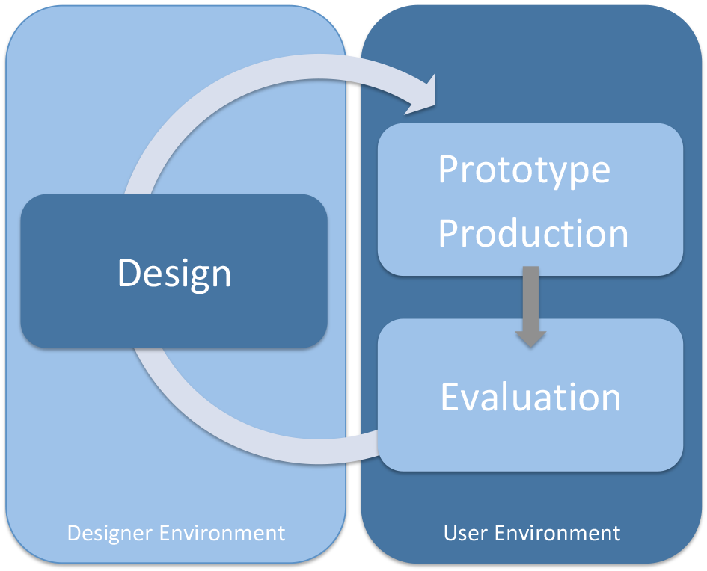

Figure 1: Design Process
Mask design development was performed at the designer environment at the Laboratory for Manufacturing Technology at the University of the German Armed Forces in Hamburg. The design variants were then digitally transferred to the user environment at the Department of Neurosurgery at the Hospital of the German Armed Forces in Westerstede. After prototype production the masks designs were evaluated. The requirements for the next design variant were then sent to the designer for further modification and development.

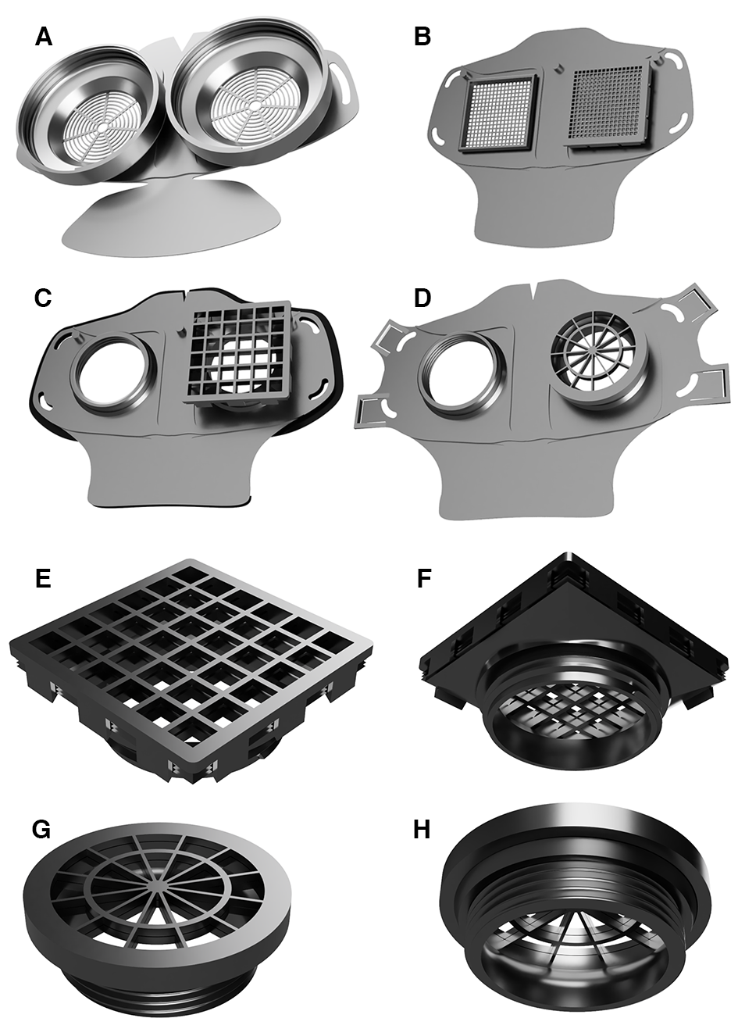

Figure 2: Mask Design Variants of the HSU/BwKWST Face Masks
Four different variants of the HSU/BwKWST Face Masks were produced. The HSU/BwKWST FM V1 is shown in A. B depicts the HSU/BwKWST FM V2 with a new mask design at the chin area, fixation pins for an additional face shield and altered fixation holes for elastic bands. C HSU/BwKWST FM V3 with an additional inlay made from black TPU95A (black rim) and a novel design of the nasal cut. D shows the further developed HSU/BwKWST FM V4 with four fastening strips and without the TPU inlay that was previously incorporated to V3. E and F show the square filter design with a clip fastening mechanism and G and H the round filter design with a fastening thread.

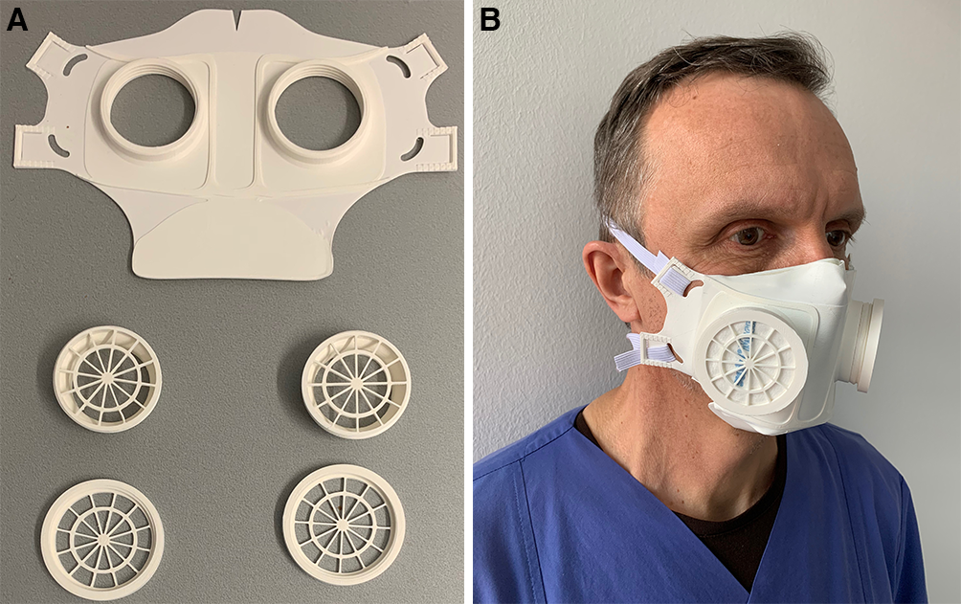
Figure 3: HSU/BwKWST FM V4 Assembly
A Depiction of the individual parts of the foldable HSU/BwKWST FM V4 made from thermoplastic PLA. B HSU/BwKWST FM V4 test fitted to the experimenters face.

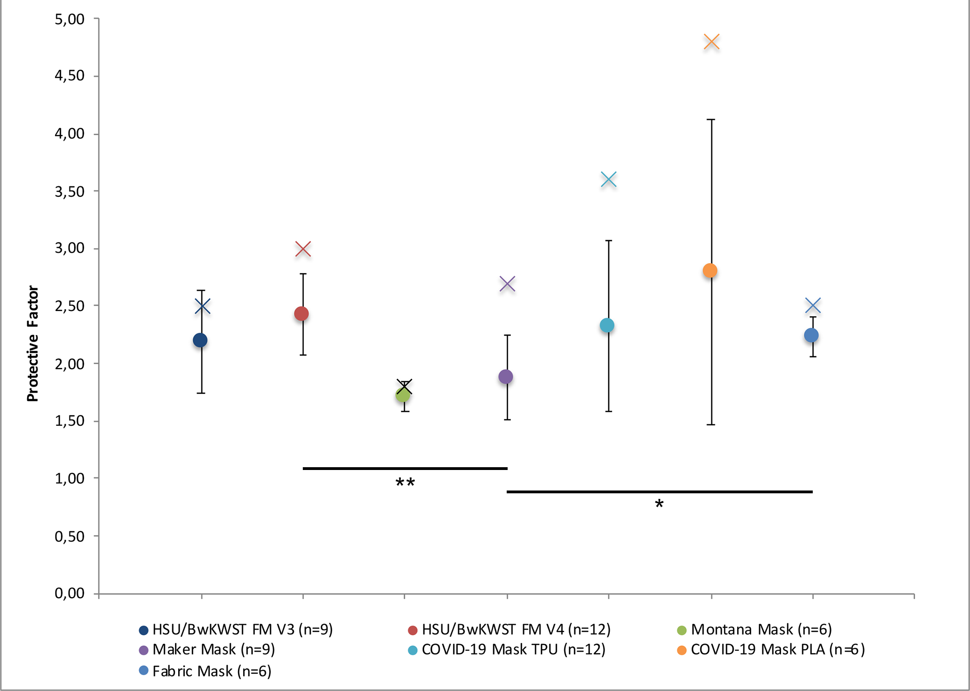

Figure 4: Protective Factor of 3D Printed Face Masks
The Protective Factor (PF) was calculated from the particle concentration outside the mask divided by the particle concentration inside the mask. Data is presented as mean ± standard deviation of the mean. The best single value calculated for each mask is represented as x in the corresponding, group specific, color.

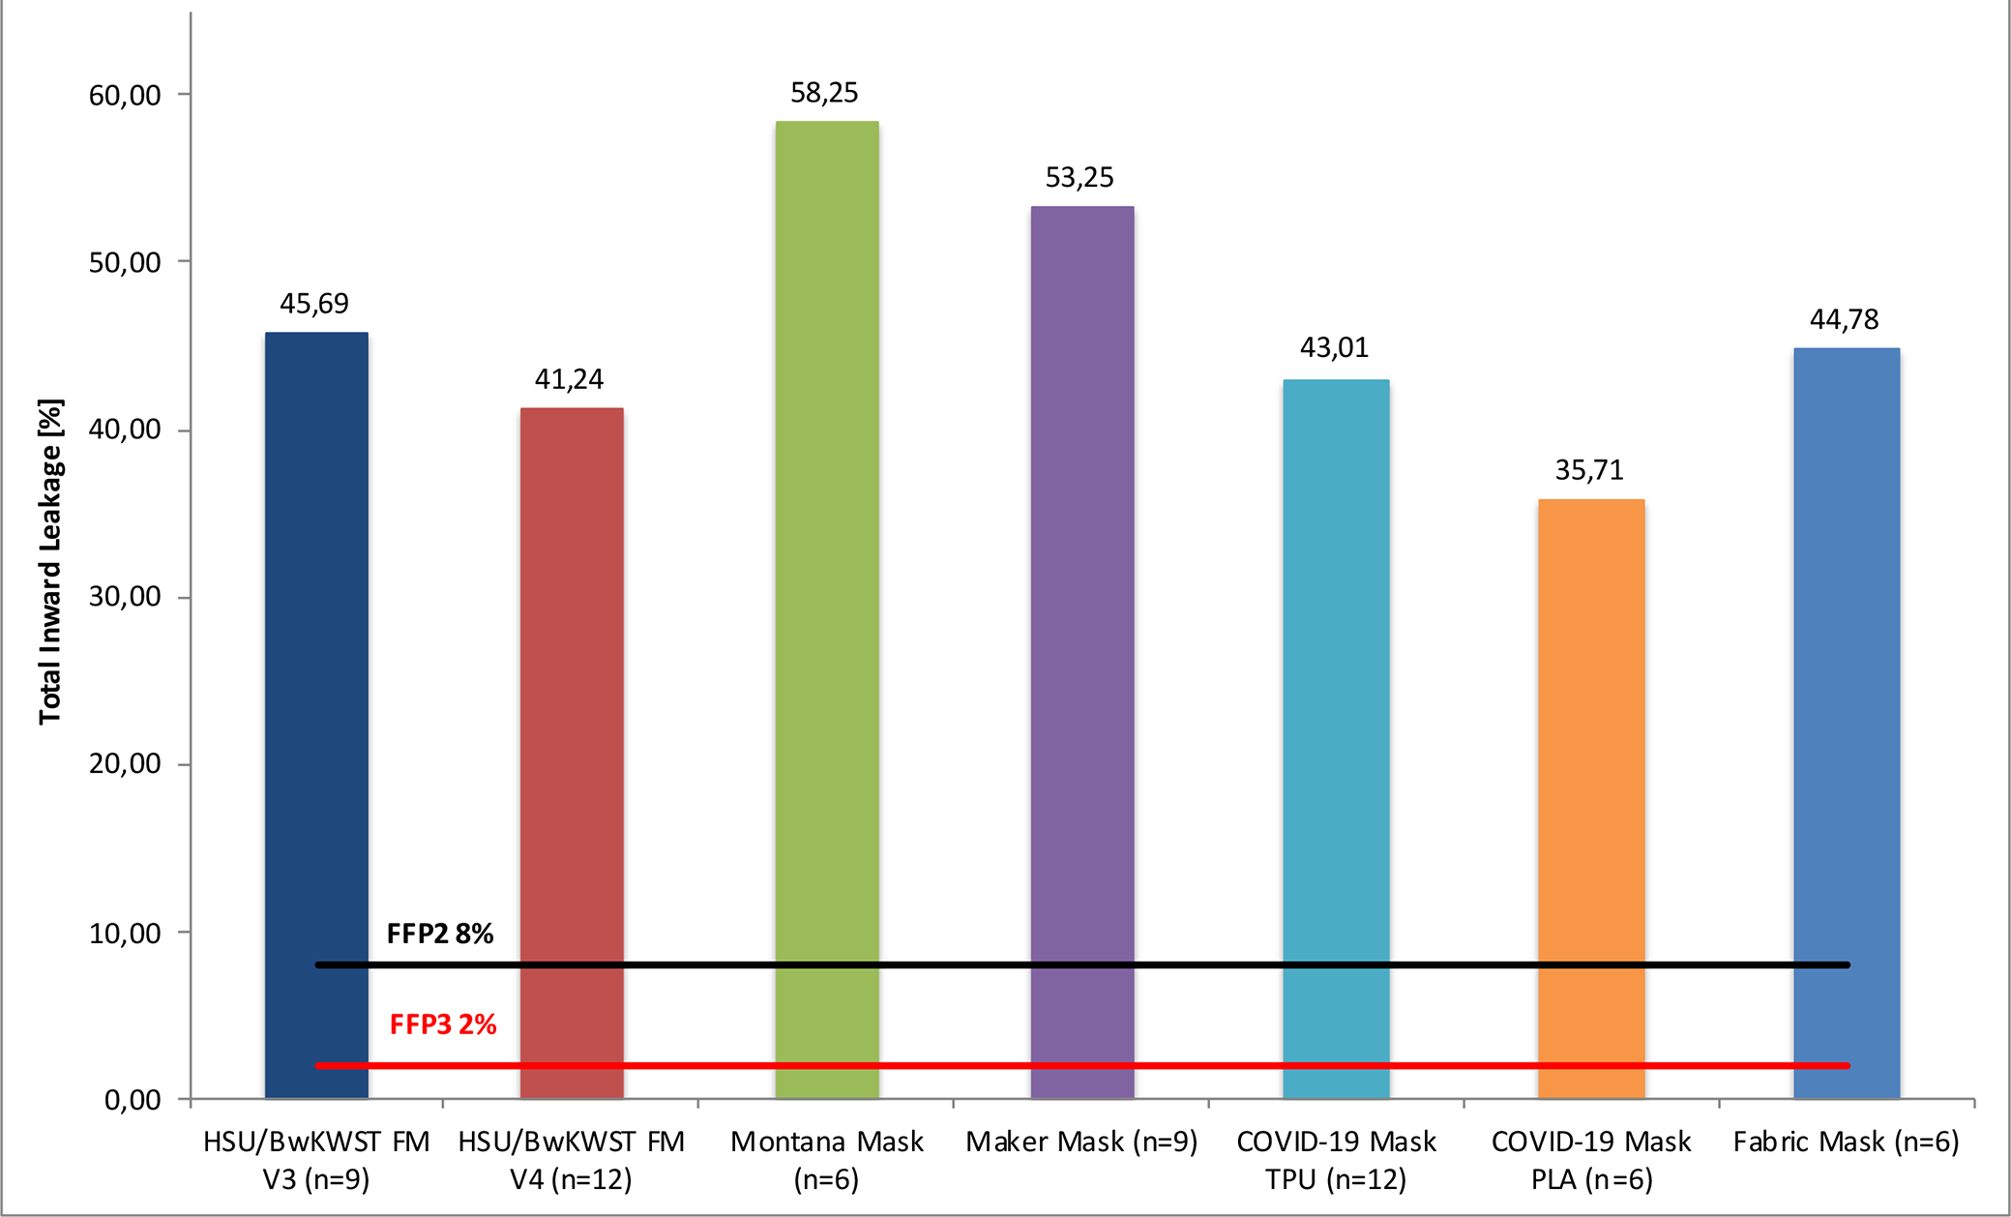

Figure 5: Total Inward Leakage of the tested Mask Designs
The Total Inward Leakage (TIL, %) was calculated from 100 divided by the PF and is presented in %. Reference parameters are Filtering Face Piece 2 (FFP2, red line, 8%) and Filtering Face Piece 3 standards (FFP3, black line, 2%) according to the DIN EN 149 regulation.

