Design and utilization of homemade wastewater samplers during the COVID-19 pandemic
Pruthvi Kilaru¹, Dave Monk², and David A. Larsen¹
1. Syracuse University Department of Public Health, Syracuse, NY, USA
2. Arcadis

Abstract
With recent interest in wastewater surveillance for SARS-CoV-2, commercial composite samplers are on backorder. Further, their high cost can be prohibitive. Herein we present plans for a homemade wastewater sampler constructed from parts found routinely at hardware stores.

Introduction
Monitoring community-level transmission of SARS-CoV-2 through the use of wastewater surveillance is a potential turning point for the pandemic.^{1–4} Initially used in the 1990s lower income countries for polio surveillance,⁵ wastewater surveillance involves the collection and analysis of untreated sewage to detect SARS-CoV-2 RNA, leading to a measure of transmission amongst a population. Multiple groups have already confirmed the efficacy of use of wastewater surveillance for COVID-19 and decision makers from the state, municipal, and local level have begun to use the method to monitor the health of their constituents within the United States.^{6–8} In addition to governmental entities, colleges and universities across the US have also announced the use of wastewater surveillance at the dormitory or residence halls level in order to quickly detect and respond to cases within their student populations.^{9,10} With increased interest in the use of wastewater surveillance to monitor SARS-CoV-2 transmission, the resources and equipment needed in order to conduct this form of population health monitoring have become scarce.
One of these essential pieces of equipment that has become hard to procure in the United States has been the portable composite sampler. This type of sampler allows multiple discrete samples to be collected at programmed intervals over a selected timeframe, often 24 hours. Numerous studies have shown that composite sampling is superior to grab sampling for a temporally variable sampling source such as wastewater and for parameters not affected by this sampling collection method and holding time.^{11–13} A composite 24-hour sample is the preferred sample method for SARS-CoV-2 monitoring,¹⁴ and recent research suggests that composite sampling is superior to grab sampling for quantification of SARS-CoV-2 concentrations.¹⁵
As the popularity of wastewater surveillance to monitor SARS-CoV-2 transmission increases, the national backorder of commercial portable composite samplers from the country’s top producers has increased to over 3 weeks. In addition to the wait time, the cost of portable composite samplers, which can exceed $7,000, has been prohibitive for some looking to implement the practice. These barriers make it difficult for wastewater surveillance to be adopted in a larger scale.
In response to the scarcity of and financial barrier imposed by commercial portable composite samplers, we have designed and created a low-cost DIY portable composite sampler constructed from items whose supply chains have not yet been disrupted by the COVID-19 pandemic. Though DIY water samplers have been constructed before, these samplers have not had the capability to collect 24-hour composite samplers and have not been used for the application of collecting wastewater.¹⁶ Our DIY alternative to commercial portable composite samplers can be created for less than $1,200, as shown in table 1, and can obtain a 24-hour composite sample, thus showing to be a useful tool in implementing wastewater surveillance.

Table 1. Cost (in USD) of necessary materials to build low-cost DIY composite sampler
Item | Quantity | Price (USD)
Peristaltic Pump | 1 | $515
12 Volt 650 CCA Car Battery | 1 | $180
Manual Battery Charger | 1 | $30
Marine Battery Terminals | 1 | $10
12v DC to 120 V AC Inverter | 1 | $110
Interval Timing Outlet/Plug | 1 | $25
Collection Jar/Jug with Rubber Plug | 1 | $20
Heavily Insulated Cooler | 1 | $75
Supply Storage Shed or Deck Box | 1 | $165
Small Roll of Insulation to Line Shed or Deck Box | 1 | $20
Pad Lock | 1 | $10
Total Cost |  | $1,160

Materials

Constructing the Pump
The main component of any composite sampler is the pump that is used to draw the sample from the source to the collection container. Our design uses a peristaltic pump, as these are the types of pumps found in commercial composite samplers and are typically used in applications related to sampling sewage or other slurries. The peristaltic pump is so popular due its design, which relies on applied pressure differentials to drive samples up a tube and thus prevents the sample from coming into direct contact with the pump. For our construction we used a variable speed Stenner Metering Pump (Model #: 85MJH1A1STG1), Figure 1.

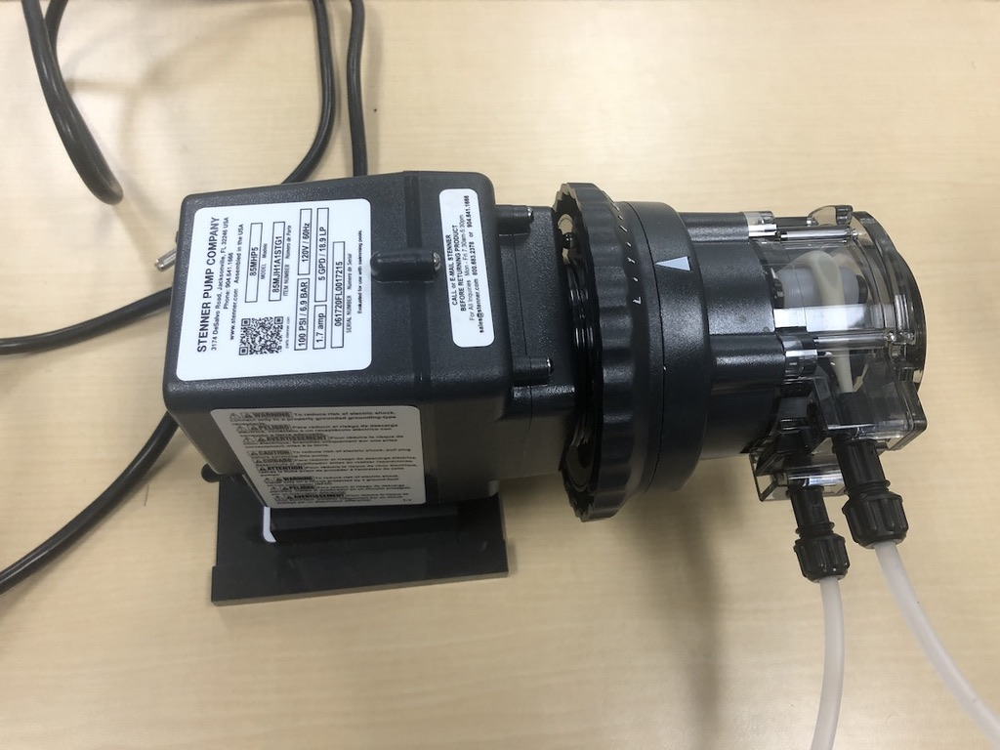
Figure 1. The variable speed Stenner Metering Pump used to pull wastewater. The dial at the neck of the pump sets the speed at which the sample is pulled with 5 gallons per day (GPD) being the max speed.

When deploying the sampler to locations where a power outlet is not available and running an extension cord is not viable, a power supply is needed. We used a 12 Volt 650 Cold Cranking Amps (CCA) Car Battery connected to a 12 Volt Direct Current (DC) to 120 Volt Alternating Current (AC) Inverter using marine battery terminals to connect the eyelet terminals of the converter to the car battery ends, Figure 2. This power supply could then be used to power the peristaltic pump by plugging the peristaltic pump into the grounded outlets found on the inverter.

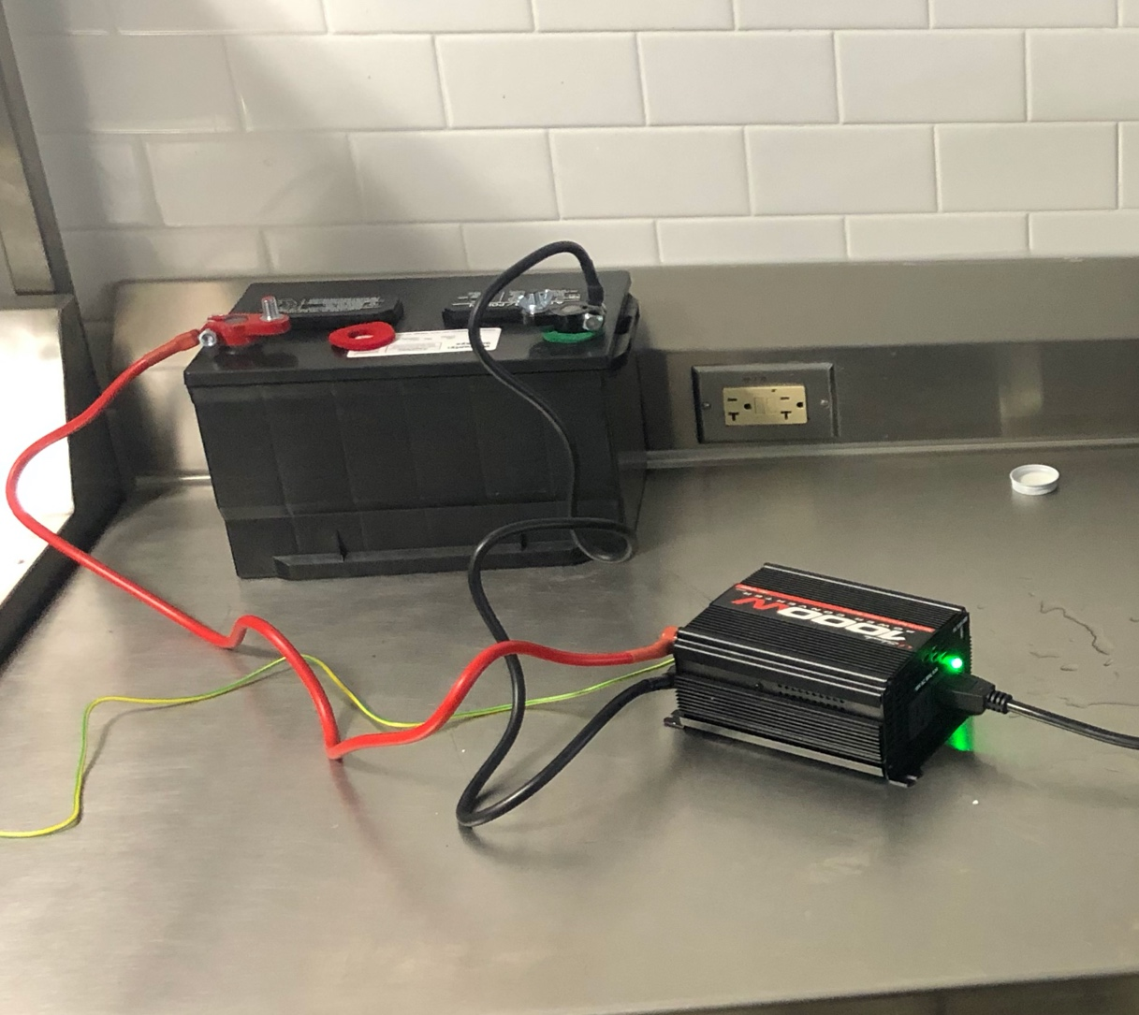
Figure 2. 12 Volt 650 CCA Car Battery connected to a 12v DC to 120v AC inverter using eyelet to navy clip converters.

Unfortunately, the 12 Volt 650 CCA Car Battery could not support the continuous sampling functionality of the peristaltic pump for 24-hours. Before devising a solution to the power consumption issue, we calculated the theoretical continuous run time of the device to be around 4.75 hours, using equations 1 though 3. (Indeed, during our first overnight trial run the battery was drained, the alarm on the inverter was activated, and a bomb threat was called in. Be sure to coordinate with public safety on the locations and specifications of DIY wastewater samplers.)

Equation 1. Calculating theoretical run time of DIY portable composite sampler
$$Run Time= \frac{Battery Amp Hours }{DC Amperage}$$

Equation 2. Calculating Amp Hours of 12 V 850 CCA Car Battery
$$Battery Amp Hours=\frac{Battery Cold Cranking Amps}{7.25}$$

Equation 3. Converting AC Amperage of peristaltic pump to DC Amperage
$DC Amperage= \frac{AC Voltage × AC Amperage}{DC Voltage} × \left(\frac{Power Factor}{Efficiency}\right)$*

*Power Factor / Efficiency was given the constant of 1.1

Once the theoretical run time of the DIY portable composite sampler was calculated, two solutions were devised to extend the life of the power supply to conduct 24-hour composite sampling. The first solution was to create a power bank by connecting four 12 Volt 650 CCA Car Batteries in parallel and allowing the pump to run continuously for the 24-hour sampling period. This solution was ultimately dropped as utilizing a power bank made of 4 batteries no longer allowed for the composite sampler to be portable. Other drawbacks included long recharge time for the power bank, the cost of the power bank, as well as deviation from commercial portable composite samplers which sample in timed intervals rather than continuously. The second solution was to add a continuous interval timing outlet in between the inverter and peristaltic pump, Figure 3. The outlet was set to supply power to the pump for 5 minutes every half hour cutting down the run time of the peristaltic pump to 4 hours while collecting samples over a 24-hour period. This solution was ultimately chosen as part of the final design as it allowed the design to remain portable and costed less, while functioning in a similar manner to commercial peristaltic pumps. After a 24-hour collection, the battery would have 2 hours of battery life left and could then be recharged to full capacity using a manual battery charger.

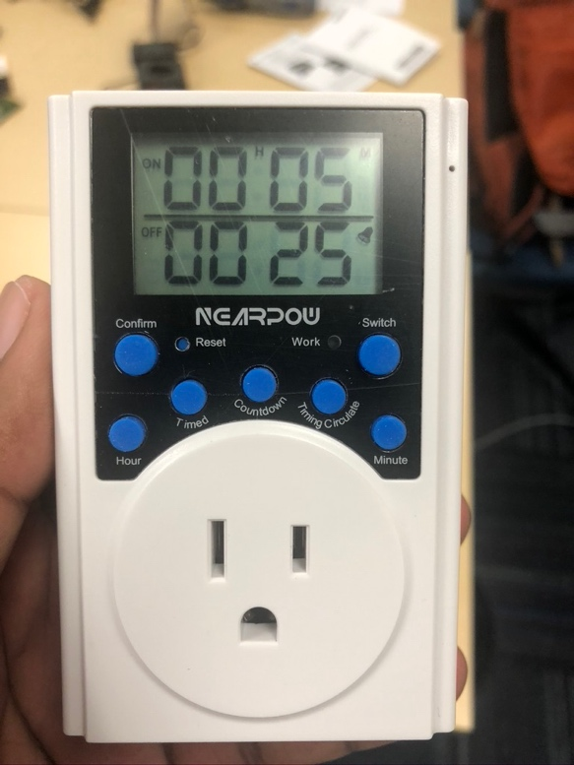
Figure 3. Continuous interval timing outlet, found on Amazon, set to supply power to the pump for 5 minutes then stop for 25 minutes, totaling to a 30-minute period.

Alternatively, if a continuous interval timing outlet cannot be found, a relay outlet connected to an Arduino Uno with the positive end connected to pin 12 and the negative end connected to ground can be used, utilizing the code found in script 1.

void setup() {
// initialize digital pin 12 as an output
pinMode(12, OUTPUT);
}
Void loop() {
digitalWrite(LED_BUILTIN, HIGH); // Turn on pin 12 to high current output
delay(300000); // Remain on for 300000 milliseconds (5 min)
digitalWrite(LED_BUILTIN, HIGH); // Turn off pin 12 to no current output
delay(1500000); // Remain off for 1500000 milliseconds (25 min)
}
Script 1. Arduino code to program the Arduino Uno to turn the relay on for 5-minute intervals every half hour
After addressing the electrical components of the portable composite sampler’s design, we focused on the sample collection portion. Using the 25-foot long 1/4th inch tubing provided with the peristaltic pump, we cut the tubing to into a 3-foot tube and a 22-foot tube. The 3-foot tube was connected to the peristaltic pump’s outlet and attached to a glass jug using a rubber stopper for the composite sample to be collected in. The 22-foot tube was connected to the pump’s inlet with a weight and filter attached to the end so it could be dropped into a manhole or sewage trap for wastewater sampling. A complete design of the pump construction can be seen in Figure 4.

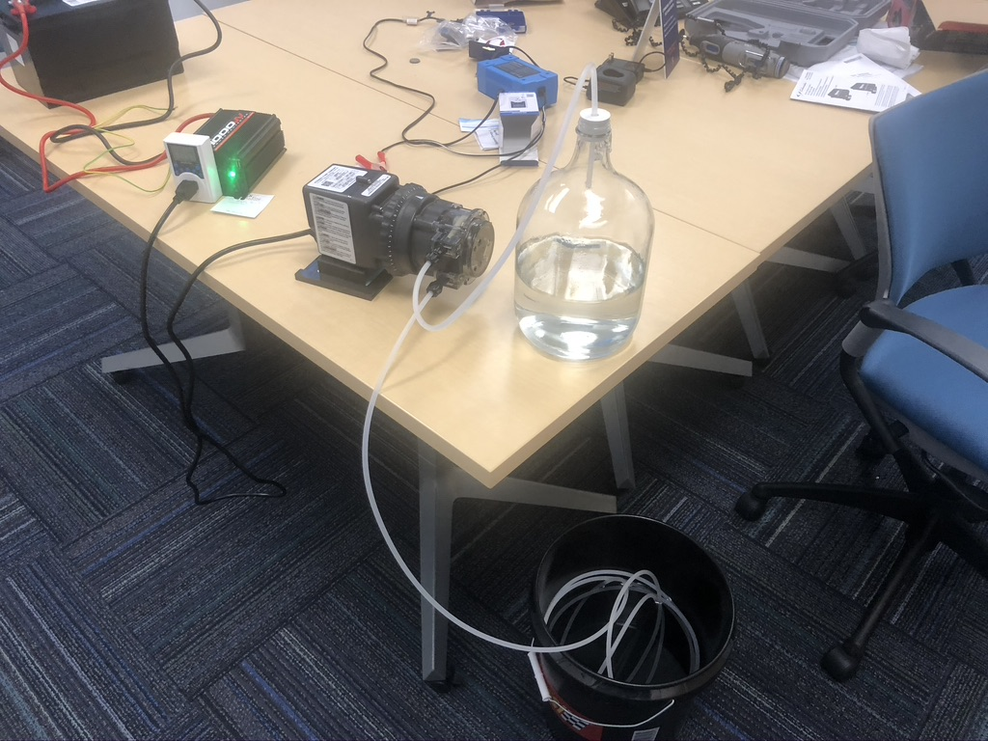
Figure 4. The full build of the pump and the power supply containing the continuous interval timing outlet in between.

Housing and Temperature Control
In addition to the pump, other important elements of composite samplers are a secure pump housing and a temperature-controlled climate to hold the pump and the sample around 4 degrees Celsius to prevent the pump freezing in cold weather and to prevent sample degradation in warm weather. To house our DIY portable composite sampler, our design used a deck box often found by the side of a pool or next to a patio space to store outdoor equipment. This was used to provide enough space to insulate the housing with fiberglass insulation to prevent freezing during subzero temperatures and to house a cooler on the inside in which the collection jar sits in order to keep the collected sample cool throughout the sampling process, Figure 5.
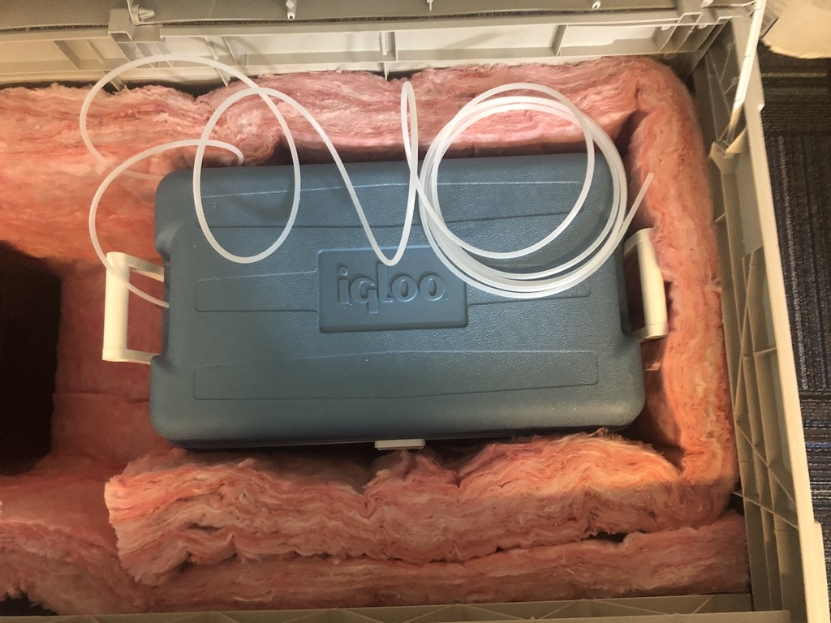
Figure 5. The deck box containing fiberglass insulation to keep the deck box climate controlled and a cooler to hold the sample in to keep it cool.
Before sampling begins, the collection jug is inserted into the cooler, the pump’s outlet tube is inserted into the jug through a hole drilled into the cooler, and the cooler is filled with ice, similar to commercial samplers, Figure 6. Due to the heavily insulated nature of the cooler, the sample is kept at the requisite temperature throughout the 24-hour collection period and sample degradation is kept to a minimum. The cooler is then placed within the insulated deck box to contain the entire build within a single housing.

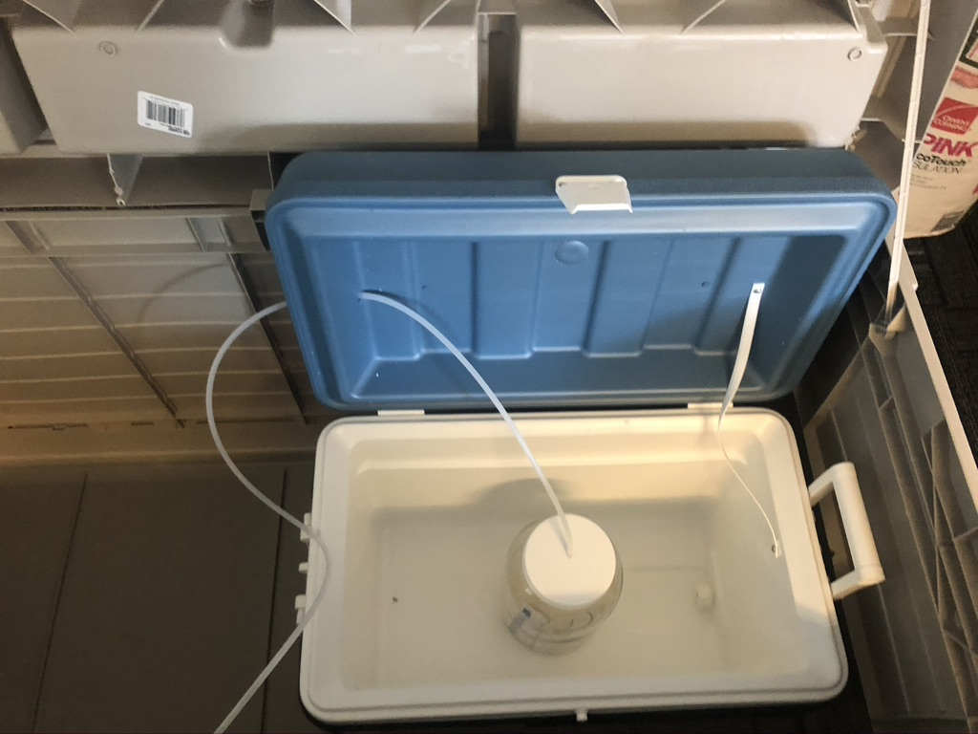
Figure 6. Tubing going through a hole drilled into the cooler and then into the collection jar.

We then drilled a ¼ inch hole into the deck and cut a slit into the fiberglass insulation to allow the outlet tube, with a weight and filter attached to it, to come out of the housing so it can be dropped into a manhole or sewage trap to collect a 24-hour composite sample of wastewater. The deck box is then secured using a padlock.

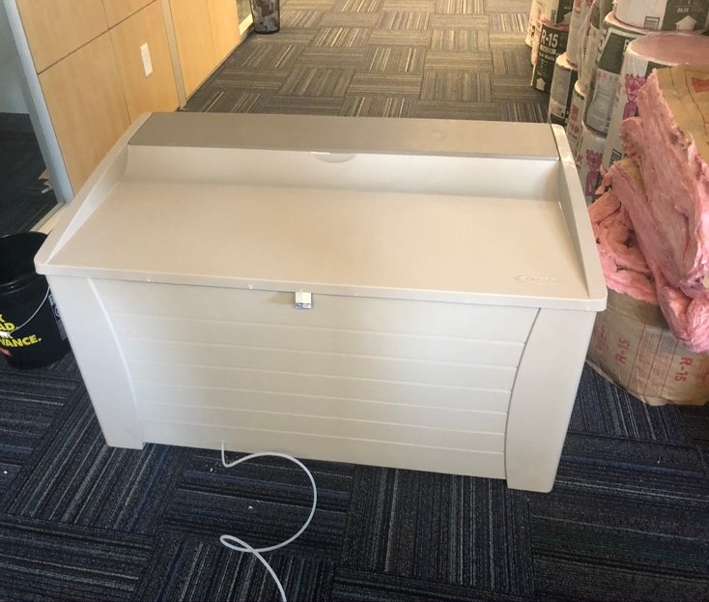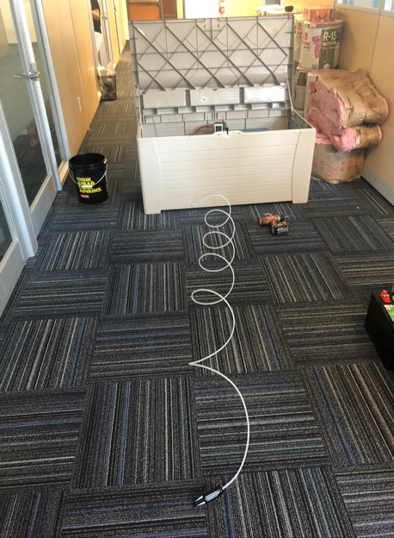
Figure 7. (Left) Locked deck box with tubing coming out of the bottom of the deck box. (Right) Full length of the tubing coming out of the bottom of the deckbox through a 1/4 inch hole.
If sampling is being done in an interior location within a building that is temperature controlled, the housing is unnecessary, and the pump assembly and cooler can be stored in a 2’ x 4’ box or wooden crate.

Standard Operating Procedure
After the sampler is placed at the sampling location, day to day operations begin by attaching a fully charged battery to the inverter and adding ice to the cooler containing the collection jar. The variable speed Stenner Metering Pump is set at 75% sampling capacity to prevent overflow of the sample in the collection bottle. This should yield a sample of approximately 0.625 gallons, or 2.37 liters. The continuous interval timing outlet is set to turn on for 5 minutes and to turn off for 25 minutes continuously until the sampler was turned off at the end of the collection period. Once these measures are taken, the inverter is turned on and the system is left to sample for 24-hours.
At the completion of the 24-hour sampling cycle, the battery is removed from the sampler to recharge using a manual battery charger plugged into an outlet, the collection container is removed from the cooler, and the cooler is drained and emptied. The collection container is then taken to the lab to be tested for the presence of SARS-CoV-2 viral RNA.

Testing the Sampler
Two tests were conducted to test the feasibility of the DIY sampler. The first test was conducted to test the peristaltic pumps ability to sample from the sampling locations we identified. As our primary objective was to test wastewater at the dormitory level of a mid-sized university (approximately 17,000 students), we ran the pump to sample from the effluent of a dormitory through an interior location containing a fluid ejector. The location was selected as it did not require the pump to be in a housing and because it could allow the pump to be connected to a standard 120v AC outlet. The decision to plug the pump into an outlet rather than using the power supply was made as the purpose of the test was to look at the efficacy of the pump and see if it could sample at our chosen locations without running into issues such as pump clogging or pump failure. The pump was set to 10% flow, to prevent overflow of the collection container, and left on to continuously sample from 11:30 am to 11:30 am the next day, for a 24-hour sample, Figure 8.

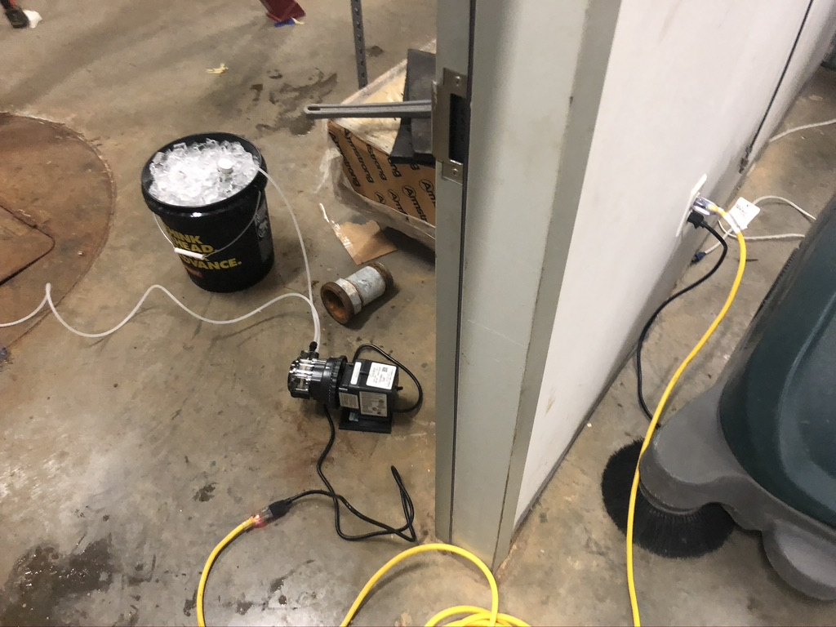
Figure 8. Set up for the first test of the sampler.

The second test was conducted to test the run time and sample volume collection of the sampler. For this test, the sampler was run using the constructed power supply. The variable speed Stenner Metering Pump is set at 75% sampling capacity and the continuous interval timing outlet is set to turn on for 5 minutes and to turn off for 25 minutes as specified in the operating procedure. The inlet tubing was dropped into a bucket containing freshwater, the outlet tubing was connected to the collection container, and the device was allowed to run from 9:30 am until 9:30 am the next day or until the sampler stopped sampling. This was done to test the power supply’s ability to run throughout the 24-hour collection period as well as to see how much of a sample was yielded during the collection period, Figure 9.

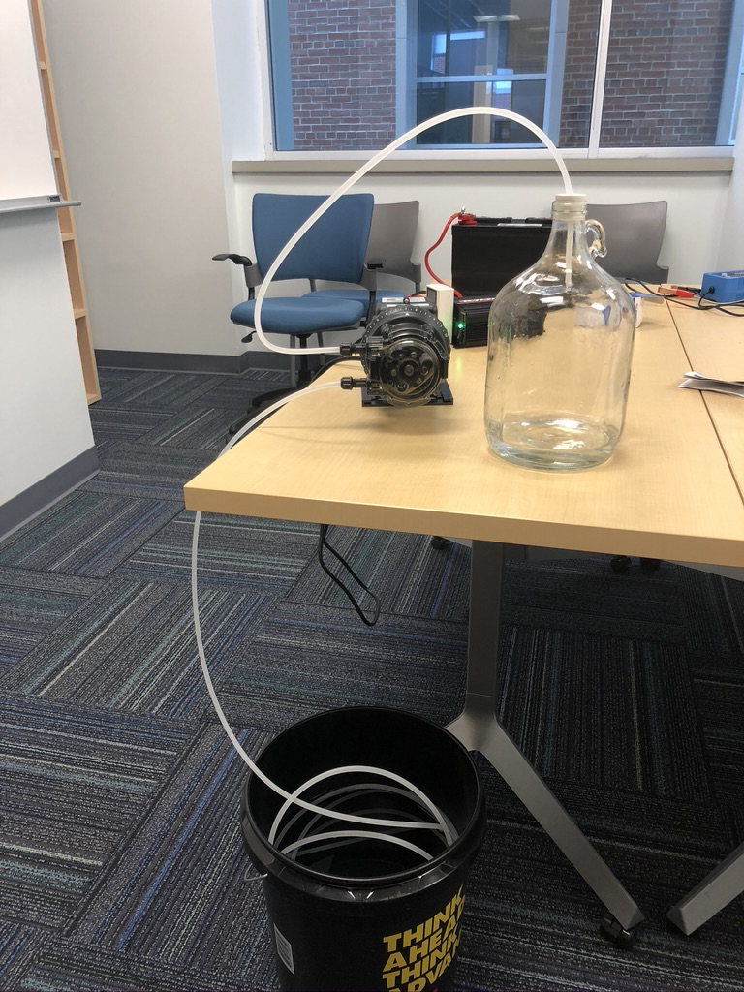
Figure 9. Set up for the second test of the sampler.

The first test conducted using a fluid ejector in a dormitory was successful in that the pump was able to sample continuously for 24 hours without succumbing to any issues regarding clogging or pump failure. The theoretical yield of the 24-hour sample was 0.5 gallons, or about 1.9 liters, as the pump was set at 10% sampling capacity. The actual yield was 0.38 gallons, or 1.44 liters, giving a percent yield of 75.8%.
The second test looking at the runtime of and volume collection of the sampler showed that the sampler could run for a 24-hour period and collect the required 24-hour composite sample. The sampler had run from 9:30 am the day it was set up to 9:30 am the following day when we returned to the setup location. We removed the outlet from the collection jar and allowed the sampler to run until it stopped 2 hours later, giving it a total run time of ~4.5 hours. The theoretical yield for the 24-hour composite sample was 0.625 gallons, or 2.37 liters, as the pump was set at 75% sampling capacity and ran for a total period of 4 hours (48 cycles of 5 minutes). The actual yield was 0.46 gallons, or 1.75 liters, giving a percent yield of 73.8%.

Discussion
From initial testing the proposed DIY composite sampler could be a potential alternative to commercial composite samplers for use in 24-hour wastewater composite sampling to test for SARS-CoV-2 viral RNA. Unfortunately, the yields of each test were lower than expected at ~75% of the theoretical yield. This could be due to human error stemming from the design of the pump which relies on someone to manually adjust the settings by turning a large dial on the pump. Additionally, as the second test relied on the pump to stop and start multiple times, there may have been a loss in sampling as the pump started up each time. Though theoretical yields were not achieved, early testing has shown that the DIY sampler is able to sample from wastewater sources. Further testing in the full housing and in external environments is needed to verify the sampler’s ability to operate in the local climate and the feasibility of using it as a long-term solution.
One of the drawbacks of our first design was the use of a car battery for the power supply. Though the 12 Volt 650 CCA Car Battery is able to supply the sampler with enough power to sample for the 24-hour period, there is not much reserve power left in the battery at the end of sampling. This can be detrimental when using car batteries as constantly discharging the battery will reduce the battery’s ability to hold a charge and can potentially eliminate the battery’s ability to sample for the 24-hour period in the future. There are two potential solutions to this issue. The first is to use a higher rated car battery such as a 12 Volt 850 CCA Car Battery which should have a theoretical run time of 6.5 hours, allowing for a higher amount of reserve power once sampling is complete. This solution, however, runs into the same issue as car batteries are not meant to be discharged and recharged significantly and this battery will still run into issues regarding its ability to hold a charge in the future. The second solution is to use a 12v 210 RC deep cycle battery, often found in solar panel setups and mobile/off-grid homes. These batteries are better suited to be discharged completely and recharged to full capacity. In addition, their main application is to run DC to AC setups, which make them a better choice for future designs of the DIY sampler. Another benefit of using this type of battery includes the ability to add solar power to the system in the future. If the sampler is meant to stay in one sampling location, a solar panel can be added to it, so batteries do not have to be swapped out and recharged every time a sample is taken. Theoretically, as deep cycle batteries allow for a 25 Amps pull for 210 minutes, the sampler, pulling 18.77 amps, could run for 280 minutes, or ~4.67 hours. A drawback of using a 12v 210 RC deep cycle battery is the weight. On average 12v 210 RC deep cycle batteries are 10 to 20 pounds heavier than car batteries which could reduce portability of the sampler. This solution is currently being tested and has been promising in the field as it has pulled the expected yield, lasted the full sampling period with a greater sampling frequency, and has been able to recharge to full capacity, Figure 10.

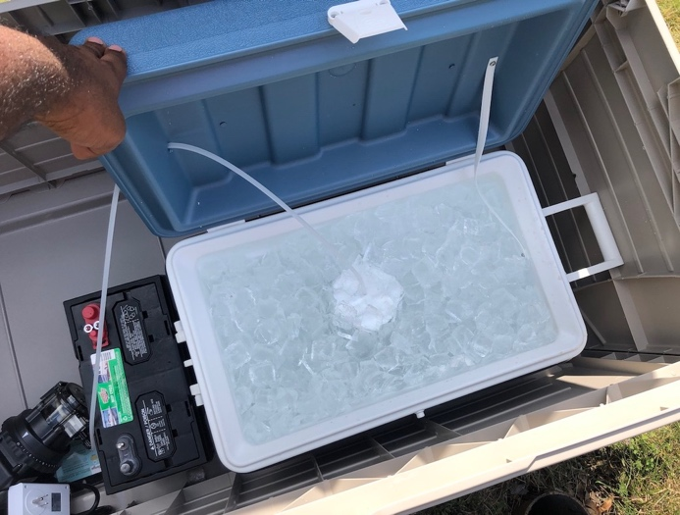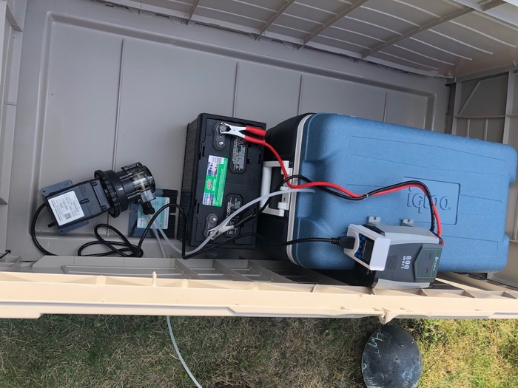
Figure 10. Set up of sampler in the field using a 12v 210 RC deep cycle battery purchased form Interstate Batteries.
As an alternative to the power supply, if outlets are both accessible and available from the sampling location, a setup similar to the one used in the first test can be used to obtain a 24-hour composite sample, Figure 8.

Conclusions
Early testing and use cases of a DIY composite sampler show it to be a potentially promising alternative to commercial composite samplers when sampling wastewater to test for the presence of SARS-CoV-2 Viral RNA. Further testing is needed to verify its feasibility in applying it in the field and its ability to obtain fecal matter. Additionally, alternatives to the current power supply design should be explored to ensure the longevity of the DIY sampler.

References

1. Green, H. et al. Quantification of SARS-CoV-2 and cross-assembly phage (crAssphage) from wastewater to monitor coronavirus transmission within communities. medRxiv 2, 2020.05.21.20109181 (2020).
2. Randazzo, W. et al. SARS-CoV-2 RNA titers in wastewater anticipated COVID-19 occurrence in a low prevalence area. Water Res. 181, 115942 (2020).
3. Ahmed, W. et al. First confirmed detection of SARS-CoV-2 in untreated wastewater in Australia: A proof of concept for the wastewater surveillance of COVID-19 in the community. Sci. Total Environ. 728, 138764 (2020).
4. Medema, G., Heijnen, L., Elsinga, G., Italiaander, R. & Medema, G. Presence of SARS-Coronavirus-2 in sewage. medRxiv (2020).
5. Vaccines and Biologicals & World Health Organization. Guidelines for environmental surveillance of poliovirus circulation. (2003).
6. Governor’s Press Office. Governor Cuomo Announces New Testing Initiatives to Improve COVID-19 Detection & Control Across New York State Contact the Governor ’ s Press O ffi ce. (2020).
7. Madison County tracking COVID-19 through wastewater surveillance. Localsyr.com 2020 (2020).
8. Spectrum News Staff. Waste ​ water in Monroe County Being Tested for COVID-19. Spectrum News 2020 (2020).
9. Auburn, L. Rochester Institute of Technology RIT to monitor wastewater for signs of surges in coronavirus cases before symptoms set in. RIT News (2020).
10. Coin, G. Syracuse University , ESF will test sewage dorm- by-dorm to track coronavirus spread. Syracuse.com (2020).
11. Cornman, R. S., McKenna, J. E., Fike, J., Oyler-McCance, S. J. & Johnson, R. An experimental comparison of composite and grab sampling of stream water for metagenetic analysis of environmental DNA. PeerJ 2018, 1–28 (2018).
12. Schaeffer, D. J., Kerster, H. W. & Janardan, K. G. Grab versus composite sampling: A primer for the manager and engineer. Environ. Manage. 4, 157–163 (1980).
13. Brumelle, S., Nemetz, P. & Casey, D. Estimating means and variances: the comparative efficiency of composite and grab samples. Environ. Monit. Assess. 4, 81–84 (1984).
14. The Water Research Foundation. Wastewater Surveillance of the COVID-19 Genetic Signal in Sewersheds: Recommendations from Global Experts. International Water Research Summit on Environmental Surveillance of COVID-19 Indicators in Sewersheds (2020).
15. Curtis, K., Keeling, D., Yetka, K., Larson, A. & Gonzalez, R. Wastewater SARS-CoV-2 Concentration and Loading Variability from Grab and 24-Hour Composite Samples. medRxiv 2020.07.10.20150607 (2020). doi:10.1101/2020.07.10.20150607
16. Sattley, W. M., Burchell, B. M., Conrad, S. D. & Madigan, M. T. Design, construction, and application of an inexpensive, high-resolution water sampler. Water 9, (2017).

