Barriers to sustainable urban stormwater management in developing countries: the case of Brazil

Anaí Floriano Vasconcelos^{1a*}, Ademir Paceli Barbassa^{1b}, Maria Fernanda Nóbrega dos Santos^{1c}, Maryam Imani^{2d}
¹ Department of Civil Engineering, Federal University of São Carlos (UFSCar), Washington Luis Highway, km 235, 13565-905, São Carlos, SP, Brazil
² School of Engineering & the Built Environment, Anglia Ruskin University, Bishop Hall Lane, Chelmsford, CM1 1SQ, Essex, UK
ª anai_vas@yahoo.com.br
^{b} barbassa@ufscar.br
^{c} mfnsantos@yahoo.com.br
^{d} maryam.imani@aru.ac.uk
* Corresponding author

Abstract
Urban stormwater management is one of the key challenges concerning the sustainability in urban areas. Through several approaches, sustainable urban stormwater management (SUSM) is becoming widely adopted around the world and is proving its effectiveness in enhancing sustainability and quality of life in the cities. Nevertheless, these strategies are still not widespread in developing countries, such as Brazil, where more than 40% of municipalities reported pluvial flooding in the last five years. Inspired by international experiences, this paper presents the barriers to the widespread adoption of SUSM in Brazil, as a developing country case study with severe urban stormwater management problems. A thorough literature review has been conducted. Surveys relating to urban stormwater management have been completed by different stakeholder groups to investigate the factors involved in the problem, such as institutional issues, professional capacity, and resource availability. “Lack of design and maintenance standards”, “Lack of long-term planning”, “Lack of dissemination and knowledge”, “Lack of incentives”, and “Reluctance to change” have been recognized as the most challenging barriers by 80% of the respondents. Overcoming the common barriers is the prelude to effective SUSM solutions to increase urban stormwater sustainability in Brazil and in other developing countries with similar challenges.

Keywords
Barriers, Brazil, runoff source control measures, stormwater, sustainable urban stormwater management, urban sustainability

1. Introduction
Anthropic activities affect soil use, resulting in interference in the physical phenomena of the hydrological cycle (Salvadore et al., 2015). Urban development is directly associated with the increase in impervious areas. Given the population growth, particularly in developing countries and its concentration in urban areas (UN, 2010), it is essential to plan and control the expansions to minimize its impact on the hydrological cycle.
To increase hydrological sustainability in urban areas, some approaches have been proposed around the world. According to Fletcher et al. (2015), the concept of alternative or compensatory drainage technologies has emerged in North America and Europe in the 1970s with the aim of minimizing the negative effects of urbanization on hydrological processes. Initially, these technologies were intended to control runoff volume to prevent flooding. With their evolution, the approaches have started to consider other aspects, such as problems related to water quality deterioration due to urbanization. Drawing on these, sustainable urban stormwater management (SUSM) has been globally recognized as effective strategies to tackle development-induced environmental challenges which need to be applied and assessed.
Currently, several terminologies are used around the globe for SUSM. Although they have small conceptual differences, they are similar in terms of objectives (Fletcher et al., 2015). For our purposes here, SUSM comprises green infrastructure (GI), low-impact development (LID), sustainable urban drainage systems (SUDS), alternative techniques, compensatory techniques, best management practices (BMPs), stormwater control measures, source control, water-sensitive urban design (WSUD), integrated urban water management (IUWM), sustainable urban water management (SUWM), and low impact urban design and development (LIUDD).
Although the effectiveness of SUSM has been extensively studied (e.g. Zimmer et al., 2007; Loperfido et al., 2014; Li et al., 2017), but their wider adoption and implementation is still growing even in countries with a more developed urban drainage system, such as Australia and US (Brown and Farrelly, 2009; Dhakal and Chevalier, 2017). Brazil has high rainfall indexes (FAO, 2010), and more than 40% of its cities suffer from stormwater management problems (Brasil, 2018). Despite this, Brazilian legislation only initially addresses issues related to SUSM and the implementation of effective measures to improve these problems.
To understand why SUSM measures have not been widely adopted, some global researches have focused on assessing the barriers to their implementation (e.g. Roy et al., 2008; Dhakal and Chevalier, 2017; Qiao et al., 2018). It is important to highlight that all these studies have been carried out in countries where the concept of SUSM is more widespread. This means that their problems and potential solutions are biased towards country-specific conditions. This is not the case in Brazil and other developing countries. In this context, it is important to study a local reality that has not yet been explored and that seems to be more likely in other countries that have not been studied, such as the other countries in Latin America and countries in Africa and Asia. According to Barbosa et al. (2012), this is the way to support decision making on stormwater management when there is insufficient time or financial resources to conduct studies and provide the necessary data. Studies such as those by Parkinson et al. (2003), Souza (2013), and Almeida (2014) have indirectly addressed some of the obstacles to SUSM in Brazil. However, as identifying the barriers to SUSM is not the main objective of the studies mentioned, a broad and specific study on the subject has not been carried out. Brazilian urban stormwater management (USM) problems are representative of those in several other countries around the world. The mass migration of people from rural to urban areas in recent decades in Brazil and other developing countries has led to necessary urban expansion. As a result, stormwater drainage systems, where they exist, have become inadequate in terms of water capacity and water quality preservation.
Considering the importance of knowing the existing barriers in order to increase SUSM, this work aims to conduct a systematic evaluation and discuss the barriers to SUSM in Brazil, a typical developing country with an important role to play in the global water resources management, since it has worldwide important water reserves. This is accomplished by a thorough literature review and surveying USM stakeholder groups.

2. Materials and Methods
This study is formed of three stages, namely the identification and classification of the barriers, the survey process and comparative assessment of the survey results on the barriers’ components, as illustrated in Figure 1.

Figure 1. Research methodology for the assessment of barriers

2.1. Stage 1: Identification and classification of the barriers
A literature review is conducted to identify the existing SUSM-related barriers around the world. The studies have shown lack of thorough revisions on SUSM barriers, particularly in relation to Brazilian regulation and policies. A further in-depth investigation by the authors has revealed a few studies in relation to urban drainage regulations in Brazil by which barriers on SUSM adoption could be identified. To enrich the investigations, the research domain has been expanded to international reviews, aiming to identify the barriers that can potentially correspond to Brazilian context, given local specificities. Table 1 provides a summary of the reviews in numbers and the detailed list of the barriers is presented as supplementary material. It should be noted that the numbers in Table 1 include the barriers identified internationally but may have not been necessarily identified, reviewed or cited in Brazilian documents. It does not mean that they do not exist in this country, since they were not systematically investigated until now.

Country/Region | Reference | Barrier Type(s) | Number of Barrier(s) | Number of These Barriers Cited on Brazilian Context Studies
Asia, Europe, Oceania, and US | Chang et al. (2018) | Political | 2 | 1
Australia | McManus (2009) | Regulatory, Technical | 7 | 2
Australia | Farrelly and Brown (2011) | Governance | 3 | 0
Australia, Canada, China, Germany, South Korea, UK, and US | Li et al. (2019) | Technical, Institutional, Community, Regulatory, and Financial | 22 | 11
Australia, UK, and US | Dhakal and Chevalier (2017) | Political | 6 | 4
Australia and US | Roy et al. (2008) | Financial, Technical, Institutional, Strategic vision, and Regulatory | 7 | 4
Australia and other no specific countries | Brown and Farrelly (2009) | Institutional | 12 | 8
Australia and other no specific countries | Marlow et al. (2013) | Strategic vision, Technical, Financial, and Institutional | 6 | 4
China | Jiang et al. (2017) | Institutional | 5 | 5
Germany | Dierkes et al. (2015) | Technical and Regulatory | 3 | 2
Israel | Goulden et al. (2018) | Social and Institutional | 4 | 3
New Zealand | Van Roon et al. (2005) | Technical, Regulatory, Financial, And Strategic vision | 8 | 4
UK | Heal et al. (2009) | Technical | 1 | 1
US | National Research Council (2008) | Financial, Technical, and Regulatory | 11 | 5
US | Chaffin et al. (2016) | Social and political | 5 | 2
US | Subramanian (2016) | Regulatory | 3 | 3
US | Cousins (2017) | Institutional | 12 | 3
US | Maeda et al.,(2018) | Social | 1 | 1
No specific country | Barbosa et al. (2012) | Regulatory, Technical, and Financial | 3 | 0
No specific country | Sage et al. (2015) | Technical | 2 | 2
No specific country | Qiao et al. (2018) | Governance | 22 | 10
Table 1. Number of SUSM barriers: international scale vs Brazilian scale

Floods are a chronic problem in Brazilian urban areas (Brasil, 2011) and USM is still based on the traditional concept of collecting runoff and carrying it as quickly as possible to a final destination (Souza, 2013), what worsen the problem. In this context, there are incipient initiatives being taken to implement SUSM in the Brazilian cities, which are presented in Table 2. In this table, the state and municipal initiatives presented focus on the state of São Paulo, particularly the city of São Carlos where the Gregório stream model catchment is located. This catchment is used as a reference in this study to survey the population (better explained on the section 2.2). These initiatives are important as a starting point to the paradigm shift, but as their implementation is not monitored, it is not possible to know their real impacts on urban drainage system. However, analyzing the technical aspects of these regulations can give directions of their potential impacts. São Paulo's Law 12.526 of 2007 contemplates quantitative technical aspects for retention systems, but its calculation methodology does not use the reduction of peak flow as a parameter, which does not contribute effectively and directly to flood control. In addition, this law covers only large buildings in regions directly controlled by the state or metropolitan regions. Outside these limits, municipalities need to establish their own laws. Some municipalities have already done it (e.g. São Paulo, 2002; São Carlos, 2003; Rio de Janeiro, 2004), but with the same practical problems. The Municipal Law No. 16.402 (São Paulo, 2016) is also applicable only to lots larger than 500 m². Yet in the lot scale measures there are the São Carlos’ municipal laws that propose infiltration wells only for new buildings or renovations and a reduction of just 4% as an incentive to sustainable initiatives.
There are drainage manuals with pre-design procedures for source control measures in Brazil (e.g. Paraná, 2002; Porto Alegre, 2005; São Paulo, 2012). These manuals are part of the municipal Drainage Master Plan. Only 20.2% of the Brazilian municipalities have these plans (Brasil, 2018) and they do not necessarily include drainage manuals neither sustainable stormwater management. Most part of these plans also does not have laws and regulations to implement them. These are examples of regulatory barriers existing in Brazil and they are in accordance with many cited references.
The observations in Table 1 and Table 2 show that, although there are common barriers to the implementation of SUSM globally, there are other concurrent country-specific factors that can be considered as barriers. The supplementary material provided presents some specific barriers, identified only in Brazilian studies. It is the case of “Not enough work in small cities to justify the quantity of technical professionals needed to form a properly trained team”, “Lack of knowledge about the existing urban drainage system”, and “Lack of knowledge about the physical processes related to the urban drainage“ (Parkinson et al., 2003); and “Structures need to be constructed” to adopt source control measures, and the “Lack of institutional actions to implement politics related to monitoring the adoption of the laws” created to implement SUSM (Almeida, 2014). Some of the barriers identified per international studies and not per Brazilian literature refer to specific aspects related to the SUSM implementation, which Brazil is just starting to have contact, with its new stormwater politics (Table 2).

Scale | Initiative | Description | References
Federal | Principles of Sustainable Urban Stormwater Management | It is a part of the "Sustainable Urban Drainage Systems and Stormwater Management Proposal Submission Manual", a reference for urban drainage projects supported by the federal government. | Brasil (2012)
Federal | Statute of the City | It presents urban policy instruments that can be used for more sustainable management of the water resources in urban areas, such as land use plans. | Brasil (2001)
Federal | Federal Law No. 11.445 | It establishes the basic national sanitation guidelines and opens new institutional perspectives for the design and management of stormwater systems. | Brasil (2007)
State (São Paulo) | State Law No. 12.526 | It requires that new settlements with more than 500 m² of impervious surface area implement a stormwater retention system. | São Paulo (2007)
State (Paraná) | Urban Drainage Manual – Metropolitan Region of Curitiba – PR | The manual is part of the Iguaçu River Basin Drainage Master Plan and presents some source control measures, their conditionings and applicability, and pre-design procedures. | Paraná (2002)
Municipal (São Paulo) | Drainage and stormwater management manual: Technical aspects; Design guidelines | The manual presents some source control measures, their restrictions, applicability, and pre-design procedures. | São Paulo (2012)
Municipal (Porto Alegre) | Urban Drainage Manual | The document is a volume of the Urban Drainage Master Plan and presents infiltration and storage source control measures and their design procedures, based on international references. | Porto Alegre (2005)
Municipal | Many municipal laws | These laws require the construction of detention or retention systems in lots with a significant impervious area. | e.g. São Paulo (2002); São Carlos (2003); and Rio de Janeiro (2004)*
Municipal (São Paulo) | Municipal Law No. 16.402 | It establishes a minimum value for the "environmental quota" for new buildings or renovations with an increase of more than 20% of constructed area. | São Paulo (2016)
Municipal (São Carlos) | Municipal Law No. 13.692 | It gives a reduction of up to 4% on the urban land tax for buildings with trees on their property and a permeable area on the lot. | São Carlos (2005)
Municipal (São Carlos) | Municipal Law No. 15.958 | It requires infiltration wells in all new buildings or renovations | São Carlos (2011)
* There are more which can be provided upon a request.
Table 2. Brazilian regulations to drive SUSM implementation

The most common barriers identified in Table 1, have been selected and categorized in six types, according to their source as shown in Table 3. The “Municipality issues” focuses on the institutional problems on the city scale, since the urban stormwater management occurs within the city. The state and federal governments propose wider politics to drive the local ones. These wider politics barriers have been included in the “Laws and regulations” type.

Barrier types | Barrier | Description
Municipality issues | Lack of coordination and collaboration | Lack of coordination and collaboration among the institutions involved in urban drainage
Municipality issues | Lack of autonomy | Lack of autonomy of the urban drainage division
Municipality issues | Lack of administrative continuity | Lack of administrative continuity because when a new mayor comes into power the projects are not continued
Municipality issues | Urban drainage is not a priority | Municipality does not consider urban drainage a priority
Municipality issues | Lack of capacity or experience | Lack of capacity or experience of the municipalities in managing problems (uncertainties and risks) related to innovative solutions, such as sustainable urban drainage structures
Municipality issues | Dearth of technical professionals | Lack of technical professionals (quantity) in public institutions to carry out the activities related to sustainable urban drainage management, such as design review and inspection
Municipality issues | Small cities without properly trained teams | Not enough work in small cities to justify the quantity of technical professionals needed to form a properly trained team
Strategic vision | Lack of long-term planning | Lack of strategic vision and long-term planning to justify the sustainable urban drainage strategies
Strategic vision | Poorly defined economic benefits | Poorly defined economic benefits of sustainable urban drainage, which makes it hard to justify money and urban space for the implementation
Strategic vision | Reluctance to change | Reluctance to change from the well-known conventional drainage strategies to other more sustainable ones
Strategic vision | There is no space | No space in the city for the implementation of sustainable urban drainage structures
Laws and regulations | Lack of proper laws | Lack of proper laws for sustainable urban stormwater management
Laws and regulations | Assignment conflict | Assignment conflict among the institutions involved in urban drainage
Laws and regulations | Laws applicable only to new development | Sustainable urban stormwater laws applicable only to new development
Laws and regulations | Lack of incentives | Lack of incentives for the shift from conventional to sustainable urban drainage
Financial resources | Lack of financial resources | Lack of investment in sustainable urban drainage
Financial resources | Construction costs fall on the owners | Construction costs in private areas fall on the owners and may not be accepted
Community engagement | Lack of dissemination and knowledge | Lack of dissemination and knowledge about conventional urban drainage issues, sustainable urban drainage benefits, and how to implement sustainable urban drainage
Community engagement | Lack of community engagement | Lack of community engagement in finding solutions
Community engagement | Population would play a role in the maintenance | Population would have to help with maintaining the distributed structures, which raises some concerns
Community engagement | Access issue regarding inspection | An issue regarding access to stormwater management structures for inspection in private areas
Urban drainage knowledge | SUSM is not learned in higher education | Sustainable urban drainage is not part of the professionals’ higher education
Urban drainage knowledge | Untrained professionals | Public and private professionals are not properly trained to work in the area of sustainable urban stormwater management
Urban drainage knowledge | Lack of design and maintenance standards | Lack of design and maintenance standards for sustainable structures
Urban drainage knowledge | Unknown costs | Costs of sustainable stormwater management structures are unknown
Urban drainage knowledge | Limited knowledge about the maintenance | Limited knowledge about the maintenance that will be needed for the structures
Urban drainage knowledge | Uncertain long-term performance | Uncertain long-term performance of sustainable stormwater management structures
Urban drainage knowledge | Limited knowledge about the catchment-scale results | Limited knowledge about the catchment-scale hydrologic results of stormwater distributed by structures
Urban drainage knowledge | Gap between theoretical and practical | The big gap between the theoretical knowledge and the practical implementation of sustainable urban stormwater management
Urban drainage knowledge | Existing drainage system unknown | Lack of knowledge about the existing urban drainage system and its performance, which would be useful for a data-driven paradigm shift
Urban drainage knowledge | Safety concerns | Safety, aesthetic, and integration concerns about the structures in the urban context
* Brazil flags indicate barriers identified by at least one Brazilian study.
Table 3. Literature common barriers those are coherent with the Brazilian context

2.2. Stage 2: Survey process
- Survey Design
This study has adopted a joint qualitative-quantitative surveying method for data collection aiming to investigate the perceptions of different stakeholder groups involved in USM regarding the barriers to implementing SUSM in Brazil.
Due to the sheer size of the Brazil, web-based, online and personally-administered surveys have shown as effective methods to reach a broader range of stakeholders (Lindhjem and Navrud, 2011). Drawing on this, this study has adopted the above methods to design and conduct the survey for data and information collection at Stage 2 in Figure 1. The online survey methods are challenged in terms of their inclusivity (e.g. no or very limited access to internet) leading to no or low response rate. However, according to Scheuren (2004), the response rate can be improved by accurately assessing potential respondents. Furthermore, according to Leedy and Ormrod (2009), the answers are more reliable if participants' anonymity is guaranteed. Therefore, this study uses both strategies to promote the response rate.
Figure 2 demonstrates the designed survey structure, formed of four parts. The first part is the survey introduction, focusing on the presentation of the research challenge, the survey, and the SUSM concept. The second part focuses on the initial questions, specific to each group aiming to verify the respondents' connection with USM and to identify specific barriers. Building on results of the Part 2, a list of potential barriers, either confirmed or refuted by the respondents, are drawn in Part 3. The last part is an open question about the other barriers with space for general comments on the subject thought to comprise barriers or experiences of the stakeholders that have not been identified in previous studies.

Figure 2. Survey structure

- Stakeholder Selection
In this study, all potential stakeholders (i.e. survey recipients) have been divided into the following four groups and each group has received a survey with the same structure but with a content adjusted to suit the expertise and level of knowledge on the subject in that group:
- Public professionals group (Publ): Professionals whose work relates to municipal urban drainage of the Brazilian cities with more than 200,000 inhabitants;
- Private professionals group (Priv): Private companies or self-employed professionals that work in the design, construction, or maintenance of urban drainage systems;
- Teachers group (Teac): Teachers at higher education and research institutions who work in urban drainage and who are therefore directly connected to the professionals qualification;
- Population group (Popu): Residents who live in Gregório stream catchment in São Carlos, São Paulo, which historically deals with flooding and other drainage problems (Mendes and Mendiondo, 2007).

- Survey Dissemination
Prior to the broad dissemination of the surveys, pilot questionnaires have been sent to two members of each of the stakeholder groups. This approach could further clarify the survey objectives and the corresponding questions aiming to minimize the chance of any bias response.
The invitation letters, containing the survey's access link and instructions, have been distributed per electronic mail or in person, in the case of Popu. They also have informed recipients of the research purpose and ensured respondents' anonymity (no personal data has been collected). In this study, the well-known snowball method (Noy, 2008) has been utilized to reach wider range of participants by an active circulation of the survey in the same stakeholder group and through the first recipient stakeholders.
The Internet-based surveys have been made available for a duration of two months (Oct-Nov 2018). The spatial distribution of the invitation letters has covered the whole Brazilian territory (Figure 3), thus gathering the opinions of stakeholders in the most varied contexts.

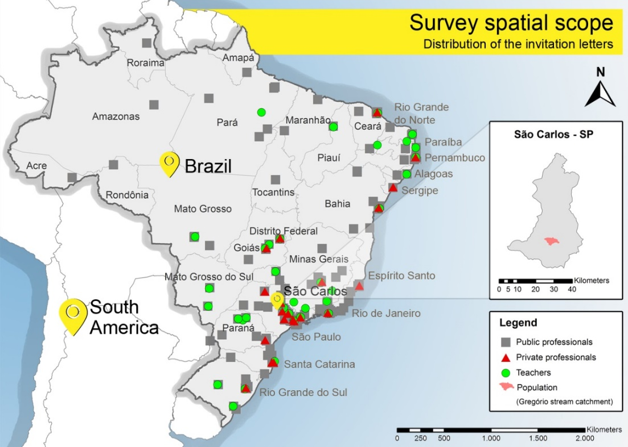
Figure 3. Spatial distribution of the survey invitation letters sent

2.3. Stage 3: Assessment of Barriers
- Assessment Process
The flowchart in Figure 4 illustrates the survey assessment process used to analyze the survey results when completed. Description of each step as follows:

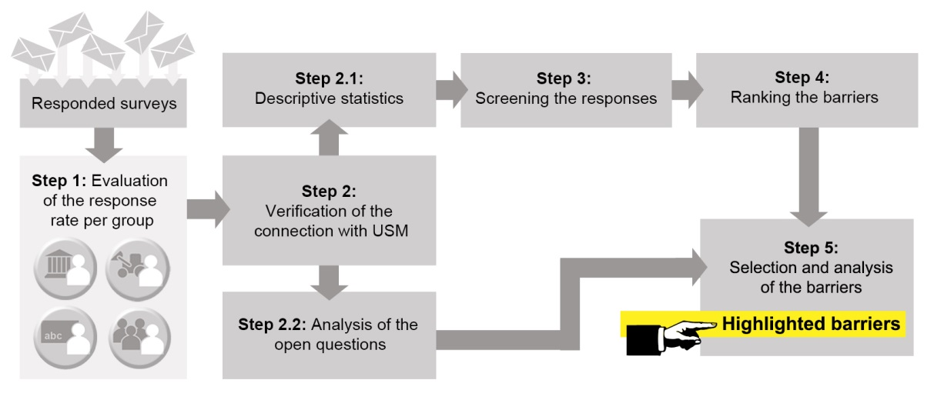
Figure 4. Flowchart of the process for analyzing the survey answers

Step 1: Evaluation of the response rate per group
The response rate indicates the representativeness of the responses for each stakeholder group. It is determined as the number of surveys responded (i.e. received) to the number of invitations sent, in percentage.
Step 2: Verification of the connection with USM
The connection between the respondents, their stakeholder group and the research topic has been verified through the initial questions. If any of the respondents does not correspond to the expected group, their responses are discarded. These questions have been also responsible to raise some specific potential barriers per group. Their response rates have been computed separately.
Step 2.1: Descriptive statistics
The responses regarding potential barriers, outlined in Table 3, have been computed using descriptive statistics to organize, summarize, and facilitate the interpretation of the results. The word "obstacle" has been used synonymously with "barrier".
Step 2.2: Analysis of the open questions
Responses to the open questions have been individually analyzed aiming to identify any new barriers or other relevant concerns related to SUSM in Brazil. The new barriers have been also categorized as Table 3.
Step 3: Screening the responses
The ratio of the number of affirmative responses to the number of negative responses ("Yes"/"No" rate) for each barrier, is used to measure the relevance of the barrier disregarding the answers from the respondents that do not feel confident to their opinion. This implies that the neutral response of "I do not have opinion" should be ignored. Hence, if this rate is less than or equal to 1.5, the barrier is not considered important. However, if there is at least 80% affirmative responses, it is considered a very important barrier.
Step 4: Ranking the barriers
To evaluate the relevance of each barrier to their types, they have been ordered from highest to lowest average of affirmative responses. The barrier types have been also ordered using the same criteria. This results in a general barriers and barrier types ranking. Next, the mean (M) and standard deviation (SD) of the percentages of affirmative responses for each barrier type have been calculated to identify the features of the most important barriers.
Step 5: Selection and analysis of the barriers
The study has identified three groups of relevant barriers:
- The barriers with at least 80% affirmative responses (total or in one specific stakeholder group);
- The barriers with a much higher percentage of affirmative responses per group than the total M;
- The barriers obtained from the open questions.
These barriers have been highlighted, related to previous studies, and discussed in the Brazilian context.

3. Results and Analysis
3.1. Survey response results
Table 4 outlines the population size of the stakeholder groups and the survey's response rates.

Stakeholder group | Population size | Subgroup size | Number of invitations sent | Number of responses received | Response rate (%)
Publ | 5570 municipalities* | 149 | 119 | 26 | 22
Priv | unknown | 50 | 50 | 10 | 20
Teac | unknown | 81 | 81 | 19 | 23
Popu | 21009 residences** | 774 | 774 | 32 | 4
General | unknown | 1054 | 1024 | 86 | 8
* IBGE (2017); ** IBGE (2011)
Table 4. Summary of survey responses in each stakeholder group

The response rate presented in Table 4, is calculated based on the invitations sent. However, due to the snowball strategy, it is possible that this value is lower. The response rates obtained for the Publ, Priv, and Teac groups are consistent with the surveying methodology used (Kwak and Radler, 2002; Sills and Song, 2002). This good response rate reinforces the representativeness of the collected data and the importance of the topic for the surveyed stakeholders. However, the Popu group’s response rate is lower (4%), possibly because of the smaller salience of the issue for this group compared to the others. The Popu group has the highest number of responses, which guarantees diversity of the opinions.
- Initial questions
A summary of the response rates to the initial questions (see Part 2) is presented for each group in Figure 5. The overall observations of the results show the compatibility of the targeted audiences to their associated groups. These results are discussed together with the results presented in section 3.2.

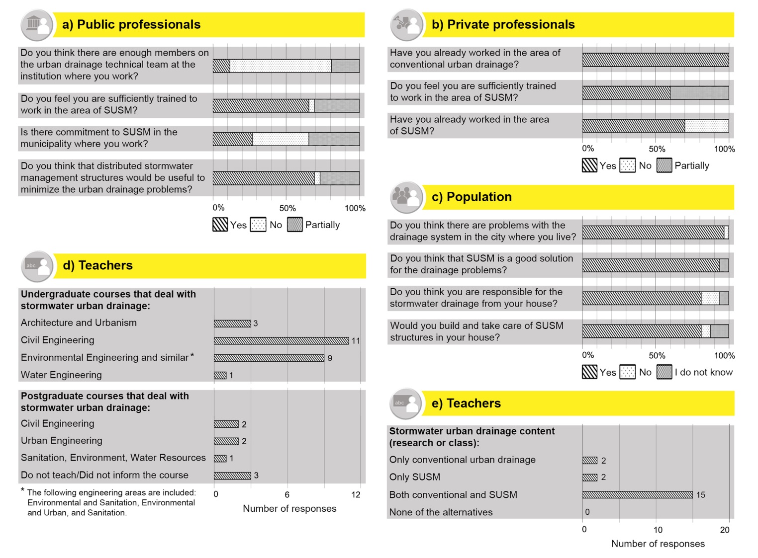
Figure 5. Summary of responses to the initial questions

3.2 Barriers Ranking
The potential barriers, identified by the surveys and their descriptions, are presented in Table 3. Figure 6 shows a ranked summary of the respondents' perceptions about the potential barriers.

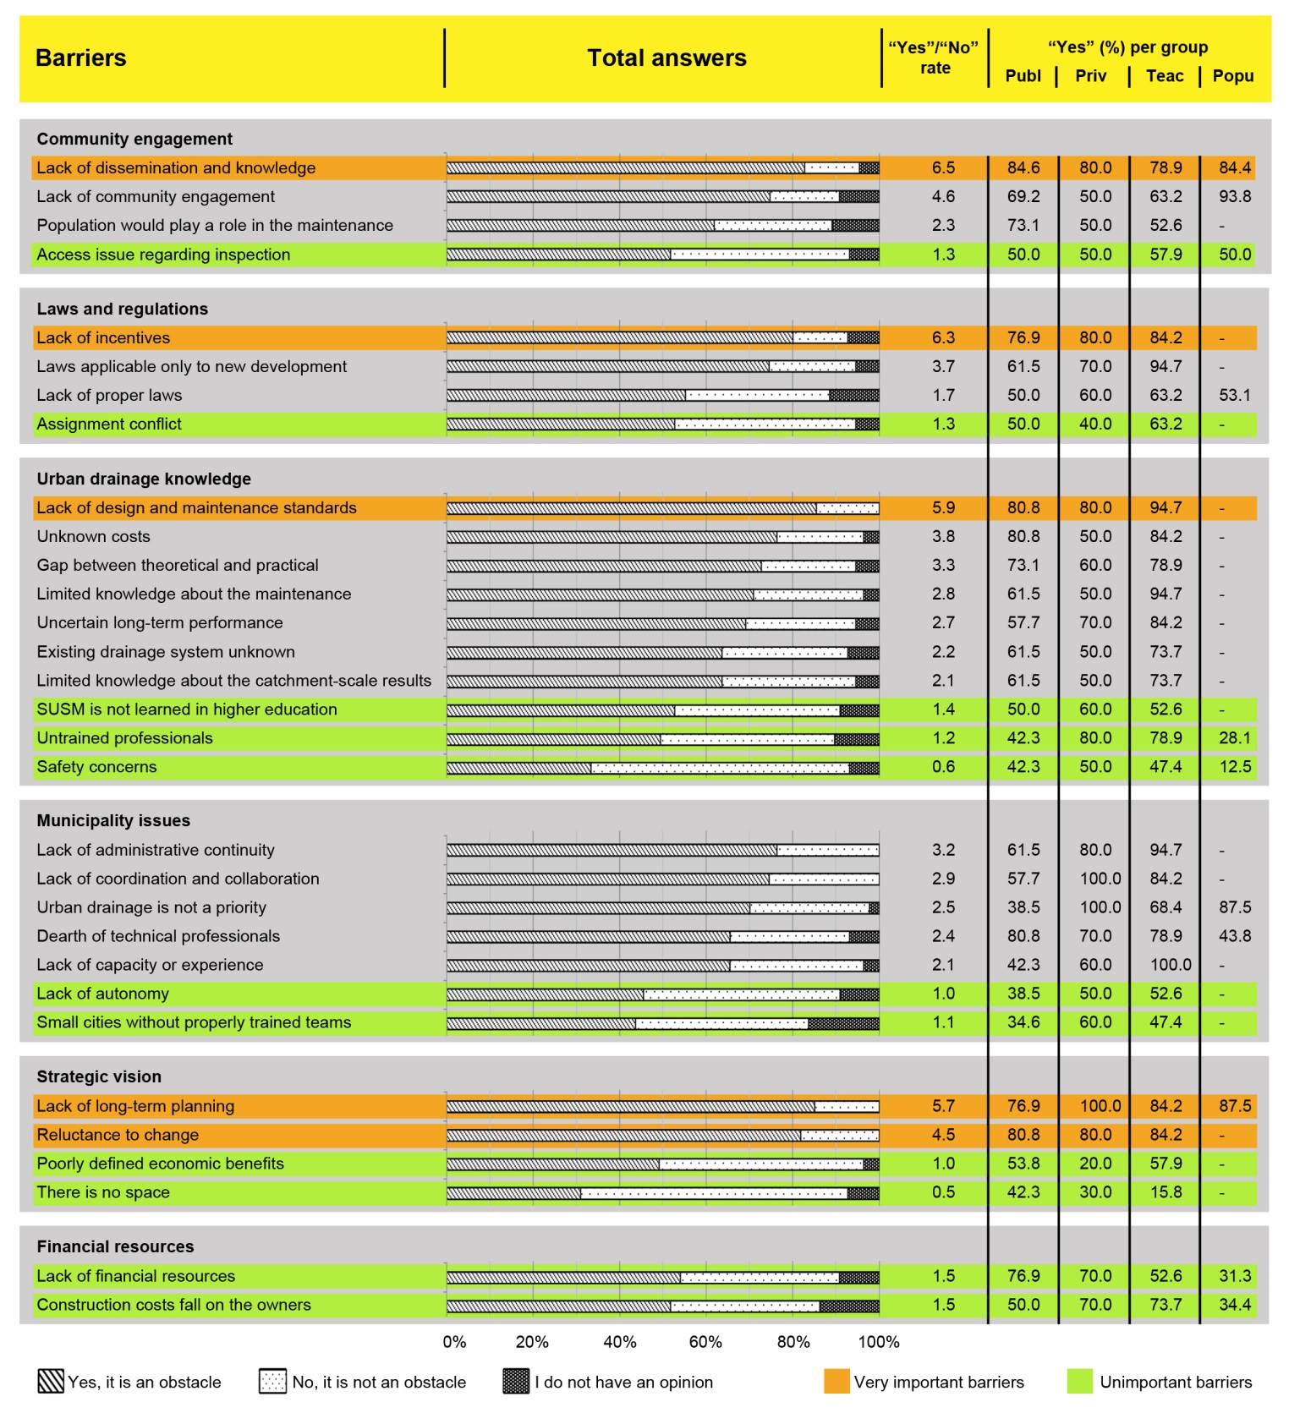
Figure 6. Summary of survey responses in relation to the potential barriers

In addition to the general ranking, the barriers have been analyzed per type and evaluated per stakeholder group. This can help with better understanding of the problem and its source leading to producing appropriate solutions. For this purpose, the M and SD per barrier type and stakeholder group are presented in Figure 7.

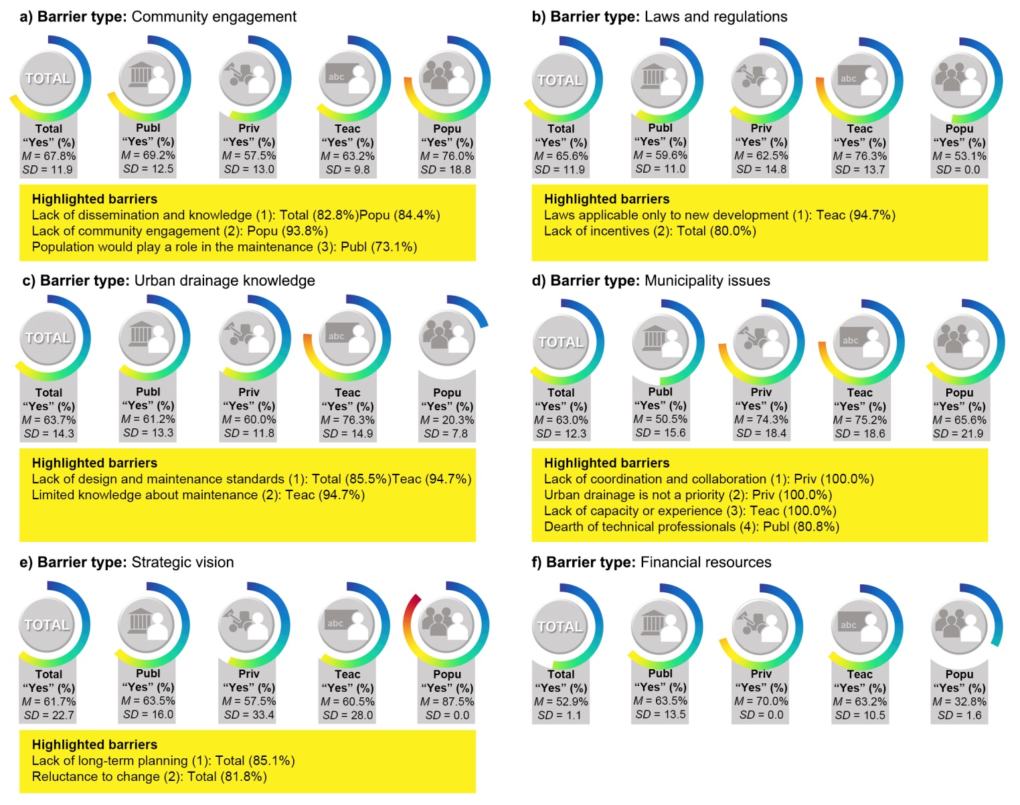
Figure 7. Summarized survey analysis results for each barrier type a) Community engagement; b) Laws and regulations; c) Urban drainage knowledge; d) Municipality issues; e) Strategic vision; f) Financial resources

- Community engagement
Although the Popu group is expected to be engaged with the urban drainage problems (Figure 5c), it can be observed in Figure 7a that the barrier type "Community engagement" has the highest total M, what means that it is a relevant obstacle to be tackled. The Popu group's M is almost 10% percentage points higher than the total M. The higher values are observed for barriers that do not rely on the population actions to be solved ("Lack of dissemination and knowledge" and "Lack of community engagement") and that have not been investigated via the initial questions. This indicates the Popu group's discontent with the current participation.
In relation to the highlighted barriers, although 84.4% of the Popu group have reported the ”Lack of dissemination and knowledge” of the subject, 93.8% of this group’s respondents have acknowledged SUSM as a good solution (Figure 5c). This is reinforced by some comments made by the Popu group in the open question at the end of the survey.
Regarding the Popu group's answers to the initial questions (Figure 5c), 81.3% of respondents have stated they would build and take care of SUSM structures on their lots and only 6.2% have said they would not. This conflicts with the perceptions of the other stakeholder groups, as 61.8% have recognized "Population would play a role in the maintenance” of the structures as a barrier. Still, based on the answers to the initial questions, it is verified that the same 81.3% of the population feel responsible for their houses' stormwater drainage and 12.5% ​​do not. The response rate difference between those who do not feel responsible and those who would not adopt and take care of the structures also shows that, although some people do not feel it is their responsibility, they might cooperate. Therefore, from its own point of view the population does not represent a barrier to the use of SUSM. These results corroborate those of Mendes and Mendiondo (2007) and de Almeida (2014).
- Laws and regulations
The results in Figure 7b show the "Laws and regulations" as the second most recognized barrier type. In this case, the Teac group has the highest M, although they suffer less interference from laws and regulations in their daily work compared to the Publ and Priv groups. However, it is believed that the Teac group may have knowledge about the situation in other places where SUSM is already more developed and therefore can see strategies to overcome this barrier type.
- Urban drainage knowledge
The barrier type "Urban drainage knowledge" has a high SD due to a big discrepancy in the perceptions about its barriers (Figure 7c). For the Teac group, this is an important barrier type because they have the highest M, and two barriers (“Lack of design and maintenance standards” and “Limited knowledge about maintenance”) have gotten more than 94% affirmative answers. When correlating the responses to the barriers with the initial questions, some aspects deserve particular attention. In the initial answers (Figure 5e), 89.5% of the teachers have stated they teach or research SUSM. However, 52.6% have considered "SUSM is not learned in higher education" a barrier. This indicates that although the courses address the issue, it may not be enough. It is also possible that SUSM is only a research topic for these teachers and does not reach the classrooms. The barrier "Untrained professionals" is not considered an important barrier, with a "Yes"/"No" rate of 1.2. It is confirmed through the answers to the initial questions, where the professionals have felt at least partially able to work in the area of SUSM (65.4% of the Publ group have answered "Yes" and 30.8% have answered "Partially", and 60.0% of the Priv group have answered "Yes" and 40.0% have answered "Partially"). This indicates that these stakeholder groups do not recognize ‘lack of professional qualification’ as a problem. This apparent capacitation does not reflect itself in SUSM implementation and is also not coherent with the poor guidelines existing for the country, which implies that these professionals do not even know the magnitude of the theme.
- Municipality issues
Figure 7d shows that the Publ respondents see the functioning of their institutions as the least important/relevant barrier to SUSM adoption. For this group, the "Dearth of technical professionals" stands out as a barrier, which has also been cited by previous international studies. This indicates that this it is not an exclusively Brazilian problem. This barrier has also been identified via the initial questions for the Publ group. The "Lack of coordination and collaboration" has been highlighted as an important barrier in the “Municipality issues” which needs more attention and no effort in this regard is identified in the public policies in force in Brazil.
The highest M values, for this barrier type, are related to the Priv and Teac groups. This indicates that these two groups perceive the barriers to SUSM implementation a municipality-related/ level problem. This emphasizes that each stakeholder group has greater sensitivity to the barriers that directly affect their daily businesses and lives. Also, Figure 7d shows that the "Urban drainage is not a priority" is an unanimous barrier for the Priv group but has received low recognition by the Publ group (38.5%). However, correlating with the initial questions (Figure 5a), it can be seen that the Publ group does not see a SUSM efforts in the institutions where they work (only 26.9% answered "Yes"). Hence, it can be concluded that, regardless of urban drainage being a priority for municipalities, SUSM is not incorporated into the institutional culture of USM in Brazil.
- Strategic vision
Figure 7e shows that the "Lack of long-term planning" and "Reluctance to change" have received a very high percentage of affirmative responses. It should be noted that they have been widely recognized by previous studies as well. However, the answers to the initial questions from Publ group (Figure 5a) show that most municipalities' professionals believe that USM, using distributed structures, would minimize city’s stormwater drainage problems. This can be positively interpreted that in general professionals are not reluctant to a paradigm shift in SUSM adoption.
- Financial resources
The "Financial resources" barrier type has received the lowest percentage of affirmative answers (Figure 7f), and its two barriers are not considered important. The Popu group is the group that least see this aspect as a barrier, even when it is to assume the costs of any interventions. This underlines the population's willingness to help improve urban drainage conditions. However, the Priv group has responded positively with the highest percentage, perhaps because they deal daily with the budget constraints imposed by clients when proposing projects involving SUSM strategies and consequently directly suffer the impacts.
- Open questions barriers
The barriers pointed out through the open questions are presented in Table 5.

Answers to the open question on barriers | Barrier types
- There is no specific urban drainage management agency | Municipality issues
- The most inexpensive solution is adopted rather than the most cost-effective one | Strategic vision
- Common grant for paving and drainage, and the government prioritizes the paving | Municipality issues
- The SUSM structures are not included in the municipalities' budget spreadsheets for public works, which makes them impossible to be adopted by the designers | Municipality issues
- When necessary, the environmental licensing of the structures can be a barrier | Laws and regulations
- The federal government retains a large part of the money targeted to the states and municipalities, what precludes the Stormwater Management Plan implementation | Financial resources
Table 5. Summary of responses to the open question about barriers and their types

The absence of a specific urban drainage management agency (barrier "a") has been already identified as a barrier by Chaffin et al. (2016). Barrier "b" is related to the lack of strategic vision and long-term planning, one of the barriers identified in the survey. Barriers "c", "d", "e", and "f" are consequences of the nature of Brazilian public works. It is suggested that these barriers should be validated in future investigations.

3.3. Implications of the barriers for urban policies and cities
Analyzing the complete responses of the survey it is possible to note that the percentage of "I do not have opinion" answers is low, which confirms that the respondents have felt able to opine on each of the potential barriers investigated. In general, at least 30% of the respondents have considered that all the potential barriers are indeed obstacles for SUSM. But it does not mean that they are all important and the “Yes” / “No” rate should be evaluated. Table 6 overviews the existing policy in Brazil and other countries in order to better understand the international experiences in relation to the common barriers seeking for shared solutions and interventions particularly from the regulatory aspect.

Barrier | Brazilian situation | International experience
Lack of dissemination and knowledge | There are no information materials focused on the community engagement.  NEED TO BE CREATED | Politics:  - Green Infrastructure Municipal Handbook – US (US-EPA, 2008)  - A Citizen’s Guide to Stormwater Management in Maryland – US (Chesapeake Bay Foundation, 2004)  Experiments:  - Adaptative management – US (Chaffin et al., 2016)
Lack of incentives | There are small local initiatives, such as São Carlos (2005).  NEED TO BE CREATED | Politics:  - Urban Stormwater Management in the United States – US (National Research Council, 2008)  - Overlapping and reinforcing incentives and requirements – Germany (Buehler et al., 2011)
Lack of design and maintenance standards | There are some technical manuals to the professionals (e.g. Paraná, 2002; Porto Alegre, 2005; São Paulo, 2012) based on the international literature and that do not include all the necessary information.  NEED TO BE UPGRADED | Politics:  - States WSUD guidelines – Australia (Chang et al., 2018)  - Urban Stormwater Management in the United States – US (National Research Council, 2008)  - The SuDs Manual – UK (Ballard et al., 2015)  - Beijing’s guidelines, laws, politics and regulations – China (Vojunovic and Huang, 2014)  Experiments:  - Adaptative management – US (Chaffin et al., 2016)
Lack of long-term planning | The Urban Drainage Master Plans are a trial to plan in long-term and integrated to the urban planning, but the most part of the cities do not have one and, that which have, do not implement them.  NEED TO BE UPGRADED | Politics:  - European Union’s Water Framework – EU (Council of European Communities, 2000)  - Sponge Cities – China (China State Council, 2015 apud Chang et al., 2018)
Reluctance to change | There are no initiatives in this sense.  NEED TO BE CREATED | Experiments:  - Adaptative management – US (Chaffin et al., 2016)
Table 6. Policies to overcome the most important barriers

Accordingly to Brown and Farrelly (2009) the barriers are inter-dependent, what means that they are likely less responsive to mutually exclusive programmes of change. Chang et al. (2018) has comprehensively reviewed some politics that address the role SUSM paradigm and can serve as reference, since they have good practical results. All of them have correlate laws and regulations, essential to implement the politics. It is also interesting to note that the main related barriers in countries where SUSM is more widespread (supplementary material) are not the same as the highlighted in Table 6, since they already have their politics for some years and therefore face other kind of challenges. So, when purposing politics and strategies to overcome the developing countries barriers, it is important to take into account the barriers related to the politics used as reference and so learn with their experience. As overviewed here, the barriers overcoming is a complex subject that need to be better discussed in a dedicated study.

5. Conclusions
This study has conducted a survey research to investigate the barriers to the widespread adoption of SUSM internationally with a particular focus on Brazil as a case study. The outcomes of this research could be used to develop effective shared solutions to SUSM adoption, particularly in other developing countries with similar challenges.
Many aspects are related to the difficulty of implementing SUSM in Brazil. Of the 31 potential barriers evaluated by the survey, 20 are classified as barriers. The very important barriers, validated by more than 80% of the consulted stakeholders, are the "Lack of design and maintenance standards", "Lack of long-term planning", "Lack of dissemination and knowledge", "Reluctance to change", and "Lack of incentives". They are distributed into four of the six barrier types, namely: strategic vision (2), laws and regulations (1), community engagement (1), and urban drainage knowledge (1). Any of the “municipality issues” and “financial resources” barriers has reached 80% of affirmative responses, hence they are not considered very important by the participant stakeholders. As the very important barriers do not belong all to the same barrier type, it might hinder resolution efforts and request an integrated solution analysis and purposing.
The Brazilian federal government is aware of the need for SUSM, and efforts have been made in this regard. At the state and municipal levels, this trend has not been universally adopted but is growing, with new public policies being proposed. This paper contributes to this progress because it investigates and compiles the Brazilian barriers, which have not yet been systematically studied to date. Eight of the 20 barriers, raised per this study, have not even been cited per Brazilian urban drainage studies before.
The information available in this paper about the Brazilian barriers, the overall barriers, and the politics adopted in countries where SUSM is more widespread are the basis to the search and proposition of efficient and integrated solutions, important object of future studies.

Acknowledgements
This study was financed in part by the Coordenação de Aperfeiçoamento de Pessoal de Nível Superior – Brasil (CAPES) – Finance Code 001 and by PROAP-CAPES. We thank Professor Cecília Candolo for her valuable help in elaborating the surveys and planning their execution and all the people who completed the surveys.

References
Almeida, M.F. (2014). Aplicação de técnicas compensatórias na drenagem urbana, sob a ótica dos usuários do espaço: estudo de caso em São Carlos–SP. Dissertação (Mestrado) – Universidade Federal de São Carlos. 132 p.
Ballard, B.W., Wilson, S., Udale-Clarke, H., Illman, S., Scott, T., Ashley, R., Kellagher, R. (2015). The SuDS Manual. CIRIA.
Barbosa, A.E., Fernandes, J.N., David, L.M. (2012). Key issues for sustainable urban stormwater management. Water Res., 46, 6787-6798. https://doi.org/10.1016/j.watres.2012.05.029
Brasil. (2001). Lei Federal n° 10.257, de 10 de julho de 2001. Regulamenta os arts. 182 e 183 da Constituição Federal, estabelece diretrizes gerais da política urbana e dá outras providências.
Brasil. (2007). Lei Federal n° 11.445, de 5 de janeiro de 2007. Estabelece diretrizes nacionais para o saneamento básico; altera as Leis nos 6.766, de 19 de dezembro de 1979, 8.036, de 11 de maio de 1990, 8.666, de 21 de junho de 1993, 8.987, de 13 de fevereiro de 1995; revoga a Lei no 6.528, de 11 de maio de 1978; e dá outras providências.
Brasil. (2011). Atlas de saneamento 2011.
Brasil. (2012). Manual para apresentação de propostas para sistemas de drenagem urbana sustentável e de manejo de águas pluviais. Programa–2040: Gestão de riscos e resposta a desastres.
Brasil. (2018). Sistema Nacional de Informações sobre Saneamento: Diagnóstico do Manejo de Águas Pluviais Urbanas – 2015.
Brown, R.R., Farrelly, M.A. (2009). Delivering sustainable urban water management: a review of the hurdles we face. Water Sci. Technol., 59(5), 839-846. https://doi.org/10.2166/wst.2009.028
Buehler, R., Jungjohann, A., Keeley, M., Mehling, M. (2011). How Germany became Europe’s green leader: A look at four decades of sustainable policymaking. Solutions J., 2(5), 51-63.
Carneiro, P.R.F. (2008). Controle de inundações em bacias metropolitanas, considerando a integração do planejamento do uso do solo à gestão dos recursos hídricos. Estudo de caso: bacia dos Rios Iguaçu/Sarapuí na região metropolitana do Rio de Janeiro. Tese (Doutorado) – Universidade Federal do Rio de Janeiro. 296 p.
Chaffin, B.C., Shuster, W.D., Garmestani, A.S., Furio, B., Albro, S.L., Gardiner, M., Spring, M.; Green, O.O. (2016). A tale of two rain gardens: Barriers and bridges to adaptative management of urban stormwater in Cleveland, Ohio. J. Environ. Manage., 183, 431-441. https://doi.org/10.1016/j.jenvman.2016.06.025
Chang, N., Lu, J., Chui, T.F.M., Hartshorn, N. (2018). Global policy analysis of low impact development for stormwater management in urban regions. Land Use Policy, 70, 368-383. https://doi.org/10.1016/j.landusepol.2017.11.024
Chesapeake Bay Foundation. (2004). A citizen’s guide to stormwater management in Maryland.
Cousins, J.J. (2017). Of floods and droughts: The uneven politics of stormwater in Los Angeles. Political Geogr., 60, 34-46. https://doi.org/10.1016/j.polgeo.2017.04.002
Cruz, M.A.S., Souza, C.F., Tucci, C.E.M. (2007). Controle da drenagem urbana no Brasil: avanços e mecanismos para sua sustentabilidade. In: XVII Simpósio Brasileiro de Recursos Hídricos. São Paulo: ABRH.
Dierkes, C., Lucke, T., Helmreich, B. (2015). General technical approvals for decentralised sustainable urban drainage systems (SUDS)—The current situation in Germany. Sustainability, 7, 3031–3051. https://doi.org/10.3390/su7033031
Dhakal, K.P., Chevalier, L.R. (2017). Managing urban stormwater for urban sustainability: Barriers and policy solutions for green infrastructure application. J. Environ. Manage., 203, 171-181. https://doi.org/10.1016/j.jenvman.2017.07.065
FAO. (2010). National Rainfall Index in the 1961-2002 period. Rome.
Farrelly, M., Brown, R. (2011). Rethinking urban water management: Experimentation as a way forward? Global Environ. Change, Special Issue on The Politics and Policy of Carbon Capture and Storage, 21(2), 721–732. https://doi.org/10.1016/j.gloenvcha.2011.01.007
Fletcher, T.D., Shuster, W., Hunt, W.F., Ashley, R., Butler, D., Arthur, S., Trowsdale, S., Barraud, S., Semadeni-Davies, A., Bertrand-Krajewski, J., Mikkelsen, P.S., Rivard, G., Uhl, M., Dagenais, D., Viklander, M. (2015). SUDS, LID, BMPs, WSUD and more–The evolution and application of terminology surrounding urban drainage. Urban Water J., 12(7), 525-542. https://doi.org/10.1080/1573062X.2014.916314
Forgiarini, F.R. (2010). Incentivos econômicos à sustentabilidade da drenagem urbana: o caso de Porto Alegre – RS. Tese (Doutorado) – Universidade Federal do Rio Grande do Sul. 244 p.
Goulden, S., Portman, M.E., Carmon, N., Alon-Mozes, T. (2018). From conventional drainage to sustainable stormwater management: Beyond the technical challenges. J. Environ. Manage., 219, 37–45. https://doi.org/10.1016/j.jenvman.2018.04.066
Heal, K.V., Bray, R., Willingale, S.A.J., Briers, M., Napier, F., Jefferies, C., Fogg, P. (2009). Medium-term performance and maintenance of SUDS: A case-study of Hopwood Park Motorway Service Area, UK. Water Sci. Technol., 59(12), 2485-2494. https://doi.org/10.2166/wst.2009.288
IBGE. (2011). Censo Demográfico 2010: Características da população e dos domicílios: resultados do universo. Rio de Janeiro. https://censo2010.ibge.gov.br/resultados.html Accessed 23 June 2018.
IBGE. (2017). Estimativas da população residente para os municípios e para as unidades da Federação brasileiros com data de referência em 1º de julho de 2017. Rio de Janeiro. https://ww2.ibge.gov.br/home/estatistica/populacao/estimativa2017/default.shtm Accessed 23 June 2018.
Jiang, Y., Zevenbergen, C., Fu, D. (2017). Understanding the challenges for the governance of China’s “sponge cities” initiative to sustainably manage urban stormwater and flooding. Nat. Hazards, 89, 521-529. https://doi.org/10.1007/s11069-017-2977-1
Kwak, N., Radler, B. (2002). A Comparison Between Mail and Web Surveys: Response Pattern, Respondent Profile, and Data Quality. J. Off. Sta., 18(2), 257-273.
Leedy, P.D., Ormrod, J.E. (2009). Practical research: planning and design. 9th ed., Pearson Education, New Jersey.
Lengler, C. (2012). Instrumentos tributários imobiliários municipais aplicados à drenagem urbana: estudo de caso de taxa, contribuição de melhoria e benefício fiscal em Porto Alegre, RS. Dissertação (Mestrado) – Universidade Federal do Rio Grande do Sul. 160 p.
Li, C., Peng, C., Chiang, P.-C., Cai, Y., Wang, X., Yang, Z. (2019). Mechanisms and applications of green infrastructure practices for stormwater control: A review. J. Hydrol., 568, 626-637. https://doi.org/10.1016/j.jhydrol.2018.10.074
Li, C., Fletcher, T.D., Duncan, H.P., Burns, M.J. (2017). Can stormwater control measures restore altered urban flow regimes at the catchment scale? J. Hydrol., 549, 631-653. https://doi.org/10.1016/j.jhydrol.2017.03.037
Lindhjem, H., Navrud, S. (2011). Are Internet surveys an alternative to face-to-face interviews in contingent valuation? Ecol. Econ., 70(9), 1628-1637. https://doi.org/10.1016/j.ecolecon.2011.04.002
Lisbôa, É. G.; Barp, A. R. B.; Duarte, A. A. M. (2012). A Cobrança de Taxa como Alternativa de Financiamento para um Plano de Drenagem Urbana no município de Belém/PA. Rev. Bras. Rec. Hídr., 17(2), 53–67. https://doi.org/10.21168/rbrh.v17n2.o53-67
Loperfido, J.V., Noe, G.B., Jarnagin, S.T., Hogan, D.M. (2014). Effects of distributed and centralized stormwater best management practices and land cover on urban stream hydrology at the catchment scale. J. Hydrol., 519, 2584-2595. https://doi.org/10.1016/j.jhydrol.2014.07.007
Maeda, P.K., Chanse, V., Rockler, A., Montas, H., Shirmohammadi, A., Wilson, S., Leisnham, P.T. (2018). Linking stormwater Best Management Practices to social factors in two suburban watersheds. PLoS ONE, 13(8):e0202638. https://doi.org/10.1371/journal.pone.0202638
Marlow, D.R., Moglia, M., Cook, S., Beale, D.J. (2013). Towards sustainable urban water management: A critical reassessment. Water Res., 47, 7150-7161. https://doi.org/10.1016/j.watres.2013.07.046
Martins, L.G.B. (2017). Avaliação do potencial de aplicação de técnicas compensatórias em áreas urbanas consolidadas. Tese (Doutorado) – Universidade de São Paulo. 197 p.
McManus, R. (2009). Water Sensitive Urban Design barriers and opportunities in Darwin - Discussion paper. http://www.equatica.com.au/Darwin/reports-pdfs/Final%20Docs/8005_Darwin%20WSUD%20Barriers%20Opportunities%20Discussion%20Paper%20FINAL%20_May09_.pdf Accessed 3 April 2019.
Mendes, H.C., Mendiondo, E.M. (2007). Histórico da Expansão Urbana e Incidência de Inundações: o Caso da Bacia do Gregório, São Carlos–SP. Rev. Bras. Rec. Hídr., 12(1), 17-27. https://doi.org/10.21168/rbrh.v12n1.p17-27.
Miguez, M.G., Rezende, O.M., Veról, A.P. (2015). City growth and urban drainage alternatives: Sustainability challenge. J. Urban Plann. Dev., 141(3):04014026. https://doi.org/10.1061/(ASCE)UP.1943-5444.0000219
National Research Council. (2008). Urban Stormwater Management in the United States, The National Academies Press, Washington. https://www3.epa.gov/npdes/pubs/nrc_stormwaterreport.pdf Accessed 20 April 2018.
Noy, C. (2008). Sampling Knowledge: The Hermeneutics of Snowball Sampling in Qualitative Research. International J. Social Res. Method., 11(4), 327-44. https://doi.org/10.1080/13645570701401305
Paraná. (2002). Plano Diretor de Drenagem para a Bacia do Rio Iguaçu na Região Metropolitana de Curitiba: Manual de Drenagem Urbana da Região Metropolitana de Curitiba – PR.
Parkinson, J., Milograna, J., Campos, L.C., Campos, R. (2003). Drenagem Urbana Sustentável–Relatório do Workshop em Goiânia–GO. http://semarh.se.gov.br/wp-content/uploads/2017/02/drenagem_urbana_no_brasil-workshop_relatorio081003.pdf Accessed 8 January 2019.
Porto Alegre. (2005). Plano Diretor de Drenagem Urbana: Manual de Drenagem Urbana – Volume VI.
Qiao, X., Kristoffersson, A., Randrup, T.B. (2018). Challenges to implementing urban sustainable stormwater management from a governance perspective: A literature review. J. Cleaner Prod., 196, 943-952. https://doi.org/10.1016/j.jclepro.2018.06.049
Rio de Janeiro. (2004). Lei nº 23.940, de 30 de janeiro de 2004. Torna obrigatório, nos casos previstos, a adoção de reservatórios que permitam o retardo do escoamento das águas pluviais para a rede de drenagem.
Roy, A.H., Wenger, S.J., Fletcher, T.D., Walsh, C.J., Ladson, A.R., Shuster, W.D., Thurston, H.W., Brown, R.R. (2008). Impediments and solutions to sustainable, watershed-scale urban stormwater management: Lessons from Australia and the United States. Environ. Manage., 42, 344-359. https://doi.org/10.1007/s00267-008-9119-1
Sage, J.; Berthier, E.; Gromaire, M.C. (2015). Stormwater management criteria for on-site pollution control: A comparative assessment of international practices. Environ. Manage., 56(1), 66–80. https://doi.org/10.1007/s00267-015-0485-1
Salvadore, E., Bronders, J., Batelaan, O. (2015). Hydrological modelling of urbanized catchments: a review and future directions. J. Hydrol., 529, 62-81. https://doi.org/10.1016/j.jhydrol.2015.06.028
Santos, M.F.N., Reis, M.R.M., Paiva, S.B., Gonçalves, L.M., Barbassa, A.P. (2016). Descentralizando o manejo das águas pluviais: como promover a participação da comunidade? In: 7o Congresso Luso Brasileiro para o Planejamento Urbano, Regional, Integrado e Sustentável. Maceió, Brasil.
São Carlos. (2005). Lei nº 13.692, de 25 de novembro de 2005. Institui a Planta Genérica de Valores do Município, define critérios para lançamento do Imposto Predial e Territorial Urbano, e dá outras providências.
São Carlos. (2011). Lei nº 15.958, de 29 de dezembro de 2011. Dispõe sobre o código de obras e edificações do Município de São Carlos, e dá outras providências.
São Carlos. (2003). Lei nº 13.246, de 27 de novembro de 2003. Dispõe sobre a construção de reservatório de detenção ou retenção de águas em conjuntos habitacionais, áreas comerciais e industriais, loteamentos ou parcelamentos em áreas urbanas.
São Paulo. (2002). Lei nº 13.276, de 04 de janeiro de 2002. Torna obrigatória a execução de reservatório para as águas coletadas por coberturas e pavimentos nos lotes, edificados ou não, que tenham área impermeabilizada superior a 500m².
São Paulo. (2007). Lei nº 12.526, de 2 de janeiro de 2007. Estabelece normas para a contenção de enchentes e destinação de águas pluviais.
São Paulo. (2012). Manual de drenagem e manejo de águas pluviais: aspectos tecnológicos; diretrizes para projetos. 128p. il. v.3.
São Paulo. (2016). Lei nº 16.402, de 22 de março de 2016. Disciplina o parcelamento, o uso e a ocupação do solo no Município de São Paulo, de acordo com a Lei nº 16.050, de 31 de julho de 2014–Plano Diretor Estratégico.
Scheuren, F. (2004). What is a Survey? http://www.amstat.org/sections/srms/pamphlet Accessed 15 January 2019.
Sills, S.J., Song, C. (2002). Innovations in Survey Research: An Application of Web-Based Surveys. Social Sci. Comput. Rev., 20(1), 22-30. https://doi.org/10.1177/089443930202000103
Souza, V.C.B. (2013). Gestão da drenagem urbana no Brasil: desafios para a sustentabilidade. Revista Eletrônica de Gestão e Tecnologias Ambientais, 1(1), 57-72. https://doi.org/10.17565/gesta.v1i1.7105
Subramanian, R. (2016). Rained out: Problems and solutions for managing urban stormwater runoff. Ecol. Law Q., 43, 421–448. https://doi.org/10.15779/Z389C6S134
Tucci, C.E. (2004). Gerenciamento integrado das inundações urbanas no Brasil. Rev. Gest. Agua Am. Lat., 1(1), 59–73. https://doi.org/10.21168/rega.v1.n1.p59-73
Tucci, C.E. (2007). Regulação das águas pluviais urbanas. Rev. Gest. Agua Am. Lat., 4(1), 75–89.
United Nations–UN.(2010). World Population Prospects: The 2009 Revision. New York.
US-EPA. (2008). Green Infrastructure Municipal Handbook.
Van Roon, M., Dixon, J., Van Roon, H. (2005). Reformulating planning tools to promote low impact urban design and development. In: New Zealand Water and Waste Association 4th South Pacific Conference on Stormwater and Aquatic Resource Protection. Auckland, New Zealand.
Vojinovic, Z., Huang, J. (2014). Unflooding Asia: The Green Cities Way. Asian Developing Bank. https://www.adb.org/sites/default/files/publication/149304/unflooding-asia.pdf Accessed 3 April 2019.
Zimmer, C.A., Heathcote, I.W., Whiteley, H.R., Schroeter, H. (2007). Low-Impact-Development Practices for Stormwater: Implications for Urban Hydrology. Can. Water Resour. J., 32(3), 193-212. https://doi.org/10.4296/cwrj3203193

