California’s Food-Energy-Water System: An Open Source Simulation Model of Adaptive Surface and Groundwater Management in the Central Valley
Authors: Harrison B. Zeff ^{a*}, Andrew L. Hamilton^{b}, Keyvan Malek^{c}, Jonathan D. Herman^{d}, Jonathan S. Cohen^{e}, Josue Medellin-Azuara^{f}, Patrick M. Reed^{g}, and Gregory W. Characklis^{h}
ª Postdoctoral Researcher, University of North Carolina at Chapel Hill, Department of Environmental Sciences and Engineering, Chapel Hill, NC, USA 27599 (corresponding author), ORCID: https://orcid.org/0000-0003-0006-789X Email: zeff@live.unc.edu Phone: (01-717-856-2464)
^{b} Ph.D. Candidate, University of North Carolina at Chapel Hill, Department of Environmental Sciences and Engineering, Chapel Hill, NC, USA 27599 Email: andrew.hamilton@unc.edu
^{c} Postdoctoral Researcher, Cornell University, Department of Civil and Environmental Engineering, Ithaca, NY, USA 14853 Email: km663@cornell.edu
^{d} Assistant Professor, University of California, Davis, Department of Civil and Environmental Engineering, Davis, CA, USA 95616 Email: jdherman@ucdavis.edu
^{e} Postdoctoral Researcher, University of California, Davis, Department of Civil and Environmental Engineering, Davis, CA, USA 95616 Email: joncohen@ucdavis.edu
^{f} Associate Professor, University of California, Merced, Department of Civil and Environmental Engineering, Associate Director, UC Agricultural Issues Center, Merced, CA, USA 95344 Email: jmedellin-azuara@ucmerced.edu
^{g} Professor, Cornell University, Department of Civil and Environmental Engineering, Ithaca, NY, USA 14853 Email: patrick.reed@cornell.edu
^{h} Professor, University of North Carolina at Chapel Hill, Department of Environmental Sciences and Engineering, Director, Center on Financial Risk in Environmental Systems, Chapel Hill, NC, USA 27599 Email: charack@email.unc.edu

Abstract:
This study introduces the California Food-Energy-Water System (CALFEWS) simulation model to describe the integrated, multi-sector dynamics that emerge from the coordinated management of surface and groundwater supplies throughout California’s Central Valley. The CALFEWS simulation framework links the operation of state-wide, interbasin transfer projects (i.e., State Water Project, Central Valley Project) with coordinated water management strategies abstracted to the scale of irrigation/water districts. This study contributes a historic baseline (October 1996 – September 2016) evaluation of the model’s performance against observations, including reservoir storage, inter-basin transfers, environmental endpoints, and groundwater banking accounts. State-aware, rules-based representations of critical component systems enable CALFEWS to simulate adaptive management responses to alternative climate, infrastructure, and regulatory scenarios. Moreover, CALFEWS has been designed to maintain interoperability with electric power dispatch and agricultural production models. As such, CALFEWS provides a platform to evaluate internally consistent scenarios for the integrated management of water supply, energy generation, and food production.
Keywords: Adaptive management, water resources, groundwater recharge, interbasin transfers, dynamic simulation
Name of Software: CALFEWS
Developers: H.B. Zeff (zeff@live.unc.edu), A.L. Hamilton, K. Malek, J.D. Herman, J.S. Cohen, with contributions from G.W. Characklis, P.M. Reed, and J. Medellin-Azuara.
Software/Date Availability: All code and data for this project, including figure generation, are available in a live repository (http://github.com/hbz5000/CALFEWS) and a permanent archive (https://doi.org/10.5281/zenodo.4091708)
Source Language: Python, Cython
License: MIT

Introduction:
Throughout the 20th century, large-scale water storage and conveyance projects were developed to support urban growth and agricultural production in California. These projects have generated significant economic benefits for the state, particularly within the Central Valley where water storage and conveyance infrastructure support irrigation in four of the five most productive agricultural counties in the United States (USDA, 2012). However, surface water deliveries from these projects are highly uncertain due to complex interactions between hydrologic variability, environmental regulations, and infrastructure capacity constraints (CADWR, 2018). Water users are often able to partially mitigate surface water shortfalls by pumping groundwater but doing this repeatedly has resulted in substantial drawdowns of Central Valley aquifers, particularly during recent droughts in 2007-09 and 2012-2016 (Xiao et al., 2017). In the Tulare Basin, aquifers are managed through a network of groundwater recharge basins, recovery wells, and surface conveyance. Much of the capacity in this system has been developed through groundwater banking institutions, in which excess surface water is recharged (‘banked’) via spreading basins so that it can be subsequently recovered (‘withdrawn’) during wetter periods (Christian-Smith, 2013). Recharge and recovery capacity have been developed jointly by local irrigators and municipal/urban users from around the state (Wells Fargo, 2017; USBR, 2013), operated through cooperative agreements and exchanges between municipal and agricultural sectors.
The importance of the groundwater banking system to both agricultural and municipal contractors underscores the need for simulation models that can capture multi-scale institutional responses to floods and droughts, ranging from state and federal management of reservoirs and inter-basin transfer projects to local irrigation and groundwater banking decisions. Existing surface water models for California, like CalSIM (Draper et al., 2004), CalLite (Islam et al., 2011), and CALVIN (Draper et al., 2003) are deterministic mathematical programming (MP) models that represent reservoir systems using prescriptive optimization models to determine optimal water allocations at the statewide scale. Individual water suppliers like Metropolitan Water District (Groves et al., 2015) and the Inland Empire Utilities Agency (Lempert and Groves, 2010) perform vulnerability assessments with customized, regional WEAP models (Yates et al., 2009) that use linear programming to solve constrained water allocation problems. Other MP models are widely used for drought planning (Labadie and Larson, 2007; Zagona et al., 2001), and recent work has shown how they can be coupled with non-linear groundwater models to better reconcile the impact of surface/groundwater substitution on stream-aquifer interactions (Dogrul et al., 2016). Broadly, this class of MP models are designed to determine optimal allocations of water given a set of welfare or benefit functions distributed through time. They do not typically capture critical interactions between the institutional agreements that govern surface water rights, groundwater management, and regulatory constraints on conveyance. These interactions are important for representing the water balance dynamics as well as the institutional rules that govern the interdependent management of extreme flood and drought events in California. Infrastructure and regulatory constraints impact operations at a daily time scale in ways that are missed when aggregating operations to a monthly level, particularly with respect to high flow periods during which water is most readily available for groundwater recharge. The simulation framework used by CALFEWS links the operations of local irrigation and water storage districts with statewide water import projects at a daily step to better capture the institutional relationships that drive water distribution in the Central Valley.
The CALFEWS simulation-based approach is capable of representing California’s coordinated water resources operations across institutionally complex systems by conditioning actions on shared state variables that represent hydrologic and regulatory conditions (as recommended by Haimes, 2018). Within CALFEWS, a set of common, dynamic state variables related to snowpack and streamflow are used to toggle between operating rules when they have been explicitly defined by the relevant stakeholders (e.g., SWRCB, 1990; USACE, 1970) and to evaluate adaptive decision rules when operations are empirically derived from historical relationships. As a daily simulation, model state variables and operations can be evaluated relative to historical observations (CDEC, 2020a) at a number of critical locations throughout the Central Valley system, including storage at 12 major surface water reservoirs, pumping rates through SWP and CVP facilities in the Sacramento-San Joaquin Delta (delta) that bring water into Central and Southern California, estimates of delta salinity (which can limit pumping), and storage accounts in major groundwater banks (see Figure 1). Simulation results can be directly compared to these observations as a means of quantifying how well decision rules simulate observed responses to the broad range of changing hydrologic (CDEC, 2020b), regulatory (NMFS, 2009; Meade, 2013) and infrastructure (AECOM, 2016; USACE, 2017) conditions that have shaped system dynamics surrounding California’s North-South interbasin water transfers from the delta to contractors throughout Central and Southern California. This simulation framework specifically supports Monte Carlo exploratory modelling results, particularly with respect to irrigation deliveries and pumping requirements that can be linked to state-of-the-art agricultural production (Howitt et al., 2012) and electric power dispatch (Kern et al., 2020) models. Decision rules are spatially resolved at the scale of individual irrigation and water districts, which have historically been the primary unit of organization for consolidating water rights and financing water infrastructure in California, particularly in the Southern San Joaquin and Tulare Basins (Hanak et al., 2011). By allocating water through individual district turnouts on canals and natural channels, the decisions are able to better reflect the relationship between water rights institutions and the ownership and operation of storage and conveyance infrastructure, which is not possible using models that rely on broader regional aggregation of water supplies and demands. CALFEWS therefore operates at the spatial and temporal resolution required to link food, energy, and water systems through consistent hydrologic scenarios, enabling it to serve as a useful platform for evaluating complex risks that can be transmitted between these systems (Bazilian et al., 2011; Liu, 2016; Cai et al., 2018; Haimes, 2018).
Methods
The CALFEWS model simulates coupled water storage and conveyance networks in California’s Central Valley (Figure 1). Two large water transfer projects link the Sacramento, San Joaquin, and Tulare Basins, first via SWP and CVP delta pumping facilities that convey water to San Luis Reservoir and second through the Friant-Kern Canal. Complex environmental regulations constrain pumping based on hydrologic conditions in the delta. State (SWP) and federal (CVP) agencies manage delta hydrologic conditions and export pumping through coordinated releases from seven reservoirs in the Sacramento and San Joaquin headwaters. Individual irrigation and water districts control imports from San Luis and Millerton Reservoirs through a shared network of canals connecting districts to the California Aqueduct and the Friant-Kern Canal. In wet years, districts recharge aquifers with excess surface water when surface storage becomes insufficient. State and federal actions to manage flow, storage, and water exports interact with local decisions made by institutional users, including irrigation and water storage districts. CALFEWS simulates this dynamic by linking infrastructure operations to institutional decisions tied to hydrologic and other water management states, such as snowpack observations and reservoir storage.
The flow of information between observed states (e.g., snowpack, full-natural-flow), distributed decision-making (e.g. reservoir releases, groundwater recharge diversions), and modelled state responses (e.g. reservoir storage, groundwater bank accounts) during a single CALFEWS simulation step are illustrated in Figure 2. At the beginning of each time step, new hydrologic input data are used to update observed states at storage, regulatory, and demand nodes throughout the Sacramento, San Joaquin, and Tulare Basins. New observations, along with seasonal trends extracted from a historical record, are used to inform a battery of distributed, heterogeneous decisions made by urban and agricultural water users, reservoir operators, and local/imported water project managers. Modelled state variables, including reservoir storage and groundwater account balances, are updated by aggregating the distributed decisions through priority-based operational rules that determine infrastructure capacity utilization (Figure 1).
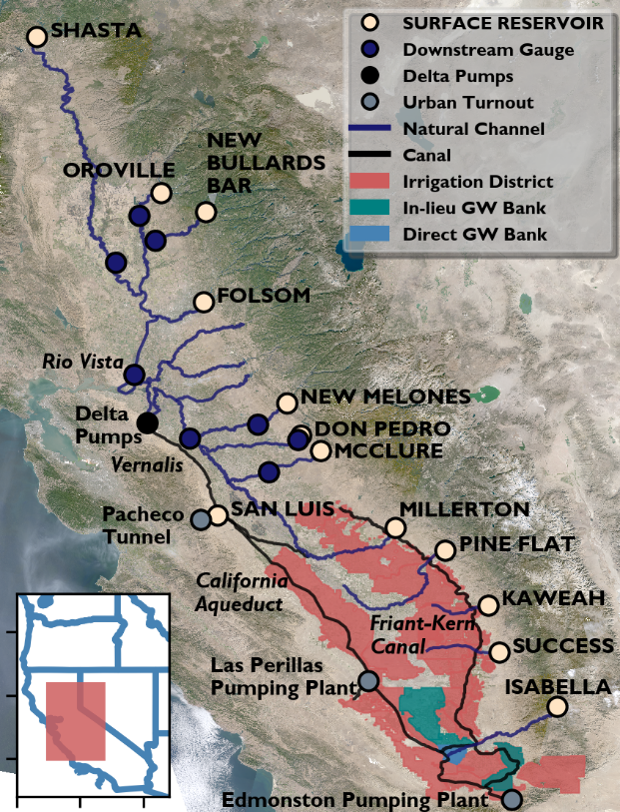
Figure 1: CALFEWS flow network (natural channels and canals) with storage, regulatory, urban turnout, irrigation district, and groundwater banking nodes.

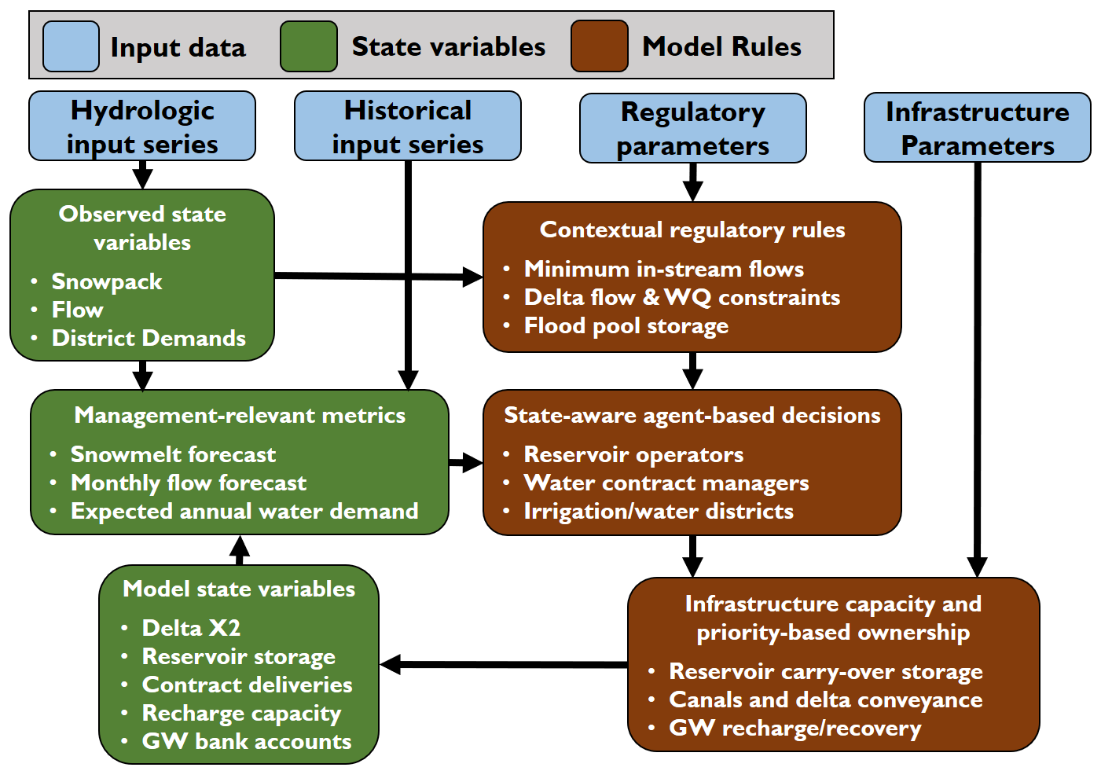
Figure 2: CALFEWS model schematic for the development of state-aware decision rules and infrastructure operations
Hydrologic preprocessing and reservoir decisions extend an initial study in the Sacramento Valley by Cohen et al. (2020). The Methods section is organized into four parts, describing: (i) how observed state variables are defined based on hydrologic data; (ii) how metrics used to drive management decisions are calculated from observed and modelled state variables; (iii) how management decisions are triggered through applying seasonal adaptive thresholds to the calculated metrics; and (iv) how distributed management decisions are aggregated to update modelled state variables.
Hydrologic Data and Observed State Variables
Daily hydrologic time series data obtained through the California Data Exchange Center (CDEC) are used to update hydrologic states at storage nodes (reservoirs), regulatory nodes (flow gauge), and demand nodes (irrigation/water districts, groundwater banks, and urban withdrawal points) at a daily time step. Storage nodes are associated with CDEC full-natural-flow, reservoir inflow, and snowpack CDEC stations as listed in Table 1. Full-natural-flow and snowpack observations are state variables used for distributed decisions and do not directly interact with CALFEWS infrastructure. Flow observations from reservoir inflow nodes are used to make daily storage updates. Regulatory nodes use downstream flow observations to generate incremental flows within a given reach based on the difference between CDEC flow gauge data and upstream releases, such that:
${inc}_{r,t}={down}_{r,t}- \sum_{w_{u}}{R_{w_{u},t}}-\sum_{r_{u}}{{inc}_{r_{u},t}}$ (1)
where inc= incremental flows (m³/s); down = flow at downstream gauge location (m³/s); R = upstream release (m³/s); r = regulatory node; w_{u} = reservoirs upstream of regulatory node r; r_{u} = regulatory nodes upstream of regulatory node r; t = time step index.
Incremental flows aggregate the unobserved contribution of ‘uncontrolled’ tributaries, stream-aquifer interactions, consumptive uses, and return flows that take place within reaches defined by the location of reservoir outlets and control gauges, as shown in Figure 1. Table 1 also lists the CDEC flow stations and upstream reference gauges used to develop incremental flows at each downstream location. Data for within-delta consumptive uses and the contribution of the ‘Eastside Streams’ are taken from the California DWR’s DAYFLOW data set (CDEC, 2020c). Negative incremental flow values signify a losing reach within the Sacramento-San Joaquin flow network. Delta inflows are equal to the sum of incremental flows at all regulatory nodes and releases at all reservoir nodes. Delta outflows are subject to a water balance within the delta to account for consumptive and exported losses, such that:
${dout}_{t}={din}_{t}-E_{t}- {depletions}_{t}$ (2)
where E = delta exports (transfers) to San Luis Reservoir (m³/s); dout = total delta outflow (m³/s);din = total delta inflow (m³/s) depletions = consumptive use between delta inflow and delta outflow gages (m³/s); and w_{d} = reservoirs that drain to the delta
Pumping in the delta is highly regulated and recent changes aimed at improving ecological functions have reduced SWP and CVP project yields, presenting challenges to large water providers who are reliant on imports (MWD, 2016). Regulatory constraints reflect rules outlined in State Water Control Board Decision 1641 (SWRCB, 1990) and National Marine and Fisheries Services Biological Opinions (NMFS, 2009), governing minimum outflow requirements, inflow/export ratios, seasonal limits on pumping rates, and salinity targets. CALFEWS uses the relationship between delta outflows and the ‘X2’ salinity line (Jassby et al., 1995) to apply salinity constraints to model operations. Delta outflows impact the salinity within the transitional area between the Sacramento-San Joaquin Delta and the San Francisco Bay. The delta X2 line measures the point, relative to the Golden Gate Bridge, where salinity one meter from the bottom of the delta bed is equal to 2 parts per thousand. The X2 relationship is calculated according to Mueller-Solger (2012), updating the value of X2 in each time step based on the previous time step delta outflow, such that:
${X2}_{t}=10.16+0.945{X2}_{t-1}-1.487\log_{10}{{dout}_{t-1}}$ (3)
where X2 = delta ‘X2’ salinity line (km)
Table 1: Watershed name and outflow/downstream flow gauge for each of the 12 major reservoirs modelled in CALFEWS. Stations correspond to IDs on California Data Exchange Center.
Reservoir Name | Watershed Name | Outflow CDEC gauge | Downstream CDEC gauge | Delta inflow gauge | Snowpack stations
Shasta | Upper Sacramento | SHA | WLK | RIO | SLT; STM; CDP
Oroville | Feather\ | ORO | GRL | RIO | KTL; GRZ; PLP
New Bullards | Yuba | YRS | MRY | RIO | KTL; GRZ; PLP
Folsom | American | FOL | N/A | RIO | CAP; SIL; HYS
New Melones | Stanislaus | NML | OBB | VER | DDM; GNL; REL; SLM; BLD
Don Pedro | Tuolumne | DNP | LGN | VER | DAN; TUM; HRS; PDS
Exchequer | Merced | EXC | CRS | VER | STR; TNY
Millerton | San Joaquin | MIL | N/A | N/A | VLC; AGP; CHM; HNT
Pine Flat | Kings | PNF | N/A | N/A | BSH; BCB; UBC
Kaweah | Kaweah | TRM | N/A | N/A | FRW; GNF
Success | Tule | SCC | N/A | N/A | FRW; GNF
Isabella | Kern | ISB | N/A | N/A | CBT

The Tulare Basin component does not contain downstream regulatory nodes. Instead, reservoirs are connected to demand nodes by canals or river channels. Reservoir operations are determined based on state-aware decisions that simulate requests for water use at individual demand nodes. Irrigation and water districts use management metrics derived from hydrologic states to transition between non-linear rules used to request deliveries under normal, flood and drought conditions. Deliveries are requested as a function of water demand at each node, explicitly simulated based on land cover and historic withdrawals at municipal diversion points (CADWR, 2018; ID4, 2018). Land cover data is determined based on crop types described in historic pesticide permitting data (Mall and Herman, 2019) or listed in agricultural water management plans, aggregated by irrigation district. Daily consumptive demands are calculated by applying expected seasonal ET requirements (ITRC, 2003) to the total crop acreage, by district, such that:
${demand}_{d,t}={MDD}_{d,t}+ \sum_{crop}{k_{loss}*{ET}_{crop, dowy,e}*A_{d, crop,y}}$ (4)
where demand = maximum node demand (m³/s); MDD = daily municipal demand (m³/s); ET = daily crop evapotranspiration (m); A = acres of crop cover within irrigation district service area (m²); dowy = day of the water year (1, 2, 3…., 365); y = year; d = irrigation district; crop = crop type; e = environmental index based hydrologic conditions; and k_{loss} =loss factor for seepage and evaporation during conveyance
Relating Observed States to Management-Relevant Metrics
Daily hydrologic states provide CALFEWS with a snapshot of flow, snowpack, and water demand conditions at nodes throughout the Central Valley (Figure 1). However, management decisions that incorporate estimates of future hydrologic conditions can make more efficient use of limited infrastructure capacity (including reservoir storage, delta pumps, spreading basins, extraction wells, and canal conveyance). To this end, CALFEWS uses a training data series to relate snowpack and full-natural-flow to seasonal hydrologic conditions, including estimates of total ‘snowmelt season’ (April – July) flows and future flows at one-month intervals. The historical training series covers the period October 1996 – September 2016, for which CDEC contains daily data for all model hydrologic states. A series of daily linear regressions developed from the training series are used to relate the hydrologic state on a given day of the water year to future water availability aggregated over management-relevant periods. First, estimates from snowpack stations in each watershed are related to reservoir inflow stations as listed in Table 1. The total inflow to each reservoir during the snowmelt season (April 1 – July 31) can be expressed as a function of the total snowpack accumulation at the associated sites through a given day of the water year. New snowpack observations can be used to produce an estimate of the subsequent snowmelt season inflows to a reservoir using unique linear coefficients for each day, as in Cohen et al. (2020), such that:
${{SMI}^{*}}_{w,t}={msnow}_{w,dowy}*{SP}_{w,t}+ {bsnow}_{w,dowy}$ (5)
where SMI* = estimated reservoir inflow during the snowmelt season (April – July) (m³); dowy = day of the water year, SP = aggregated index of snow water equivalent (SWE) depth (m); msnow = linear regression coefficient (m²); bsnow = linear regression constant (m³), w = watershed
Using the 20-year historical training period, regression coefficients can be estimated for each day of the water year such that the sum of squared errors between the estimates produced in equation (5) and the eventual snowmelt season inflow observations are minimized, such that:
$\hat{{msnow}_{w,dowy}},\hat{{bsnow}_{w,dowy}}=\operatorname{argmin}{\sum_{y=1997}^{2016}{{\left({{SMI}^{*}}_{w,dowy, y}-\sum_{da=181}^{304}{Q_{w,da,y}}\right)}^{2}}}$ (6)
Where Q = reservoir inflow (m³/s)
The 20-year historical training period provides 20 unique snowpack accumulation observations to inform each daily regression. The daily linear relationships between snowpack observations and the subsequent total snowmelt-season inflow at selected reservoirs are shown in Figure 3, column 1, with colored lines corresponding to the line of best fit for snowpack observations occurring every day from Oct 1st – April 1st. Individual observations from every year of the historical record are shown for three specific days, October 1st (blue points), January 1st (green points), and April 1st (beige points) to illustrate seasonal changes in the fit of this data to this linear relationship. Although the relationship is noisy, the linear fit for all reservoirs/watersheds improves over the course of the water year as more information about the total snowpack accumulation becomes available. A statistical summary of goodness-of-fit metrics can be found in Supplement A.
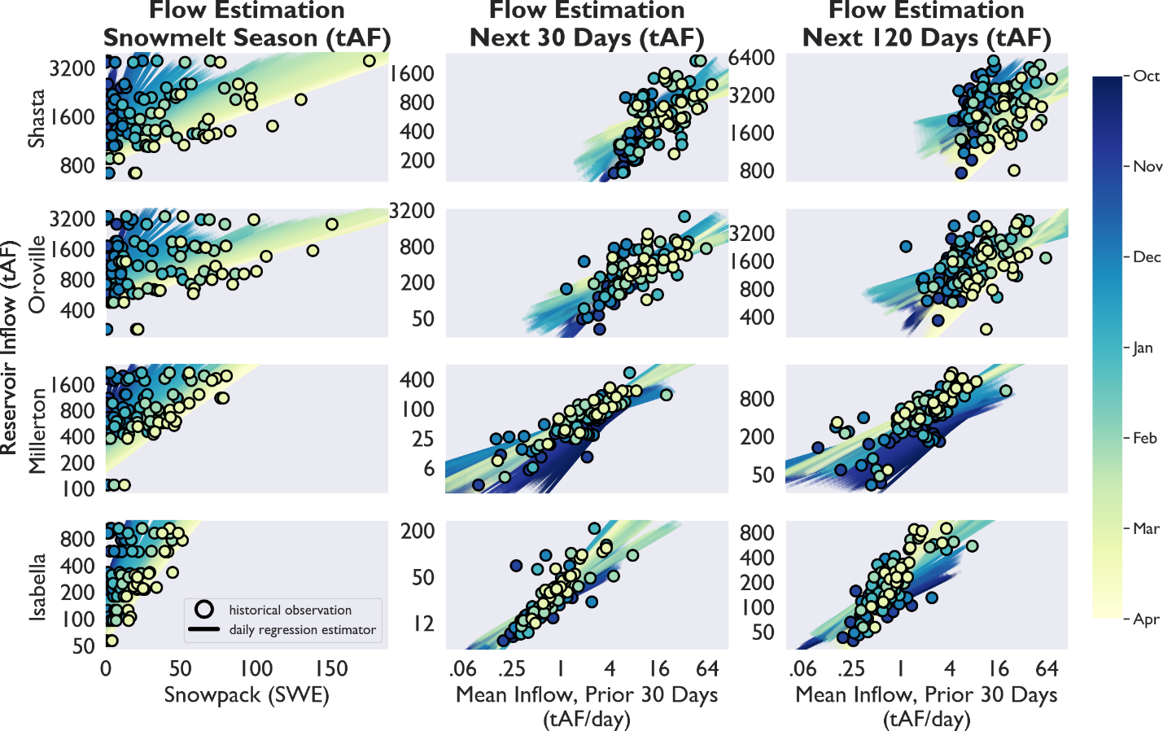
Figure 3: Historical period observations and time-dynamic log-scale relationships between CALFEWS observed states and select decision-relevant metrics in four key watersheds
Snowpack observations send strong signals about water availability during the snowmelt season, when most irrigation demand takes place. However, shorter-term (monthly) estimates of future water availability can also inform infrastructure operations with respect to managing reservoir flood control pools or maintaining adequate supplies for seasonal environmental releases. At each time step in the training period, the previous 30 days of full-natural-flow observations can be linearly related to future reservoir inflow observations, aggregated into 12 unique, consecutive periods of 30 days. Using 12 sets of linear coefficients for each day of the water year, the next 360 days of flow, in 30 day increments, can be estimated at each timestep based on the trailing, 30-day moving average full-natural-flow, such that:
${Q^{*}}_{w,int,t}={{bflow}_{w,dowy,int}+ mflow}_{ w,dowy,int}*\sum_{da=t-30}^{t}{\frac{{FNF}_{da, w}}{30}}$ (7)
where Q* = estimated reservoir inflow in time interval int (m³); int = future flow interval (0, 1, 2, …., 11); bflow = linear regression coefficient (m³); mflow = linear regression constant; FNF = full-natural-flow (m³/s)
As in equation (6), the 20-year historical training period is used to estimate regression coefficients for each day of the water year such that the sum of squared errors between the estimates produced in equation (7) and the observed reservoir inflow observations are minimized for every future interval, such that:
$\hat{{mflow}_{w,dowy, int}},\hat{{bflow}_{w,dowy, int}}=\operatorname{argmin}{\sum_{y=1997}^{2016}{{\left({Q^{*}}_{w,int,dowy,y}-\sum_{da=dowy}^{dowy+30*int}{Q_{w,da,y}}\right)}^{2}}}$ (8)
where Q = total reservoir inflow (m³/s); bflow = linear regression coefficient; mflow = linear regression constant; FNF = full-natural-flow (m³/s); int = interval index (0, 1, 2, … 11);
The last two columns of Figure 3 show daily linear relationships between the trailing, 30-day moving average full-natural-flow and the expected reservoir inflow aggregated over future periods of 30 and 120 days. As in the snowpack accumulation column, observations from every October 1st, January 1st, and April 1st in the historical training period are shown to illustrate data fit to the daily linear relationships. The relationships are unique to each watershed and change over the course of the water year to reflect seasonal flow patterns. As the aggregation period gets longer and includes observations further into the future, the linear relationship becomes noisier, as shown in the difference between the 30- and 120-day aggregation periods.
In addition to estimating flow into reservoirs, management-related metrics also take advantage of estimates of future incremental flows, inc* at each gauge location r. Substituting incremental flows, as calculated in equation (1), for reservoir inflow, Q in equation (8), linear coefficients can be generated to estimate inc* using the trailing, 30-day moving average full-natural-flow in equation (7). Full-natural-flow estimators can be aggregated to reflect the drainage area of each incremental flow station, as in Table 1.
In addition to the hydrologic indicators outlined in equations (5-8), Tulare Basin management metrics also incorporate estimates of the future demand at each demand node through the end of a given water year. Future demands are estimated as a combination of municipal and irrigation demands. As in equation (4), irrigation demands are calculated based on land cover and municipal demands are calculated using observations from historical records. Municipal demands are estimated through the end of a given water year based on the current allocation of municipal supplies, such that:
${{MDD}^{*}}_{d,t}={burb}_{d,dowy}+{murb}_{d,dowy}*\sum_{contract}{{alloc}_{d, contract,y}}$ (9)
where MDD* = expected municipal demand (m³/s); burb = linear regression constant for municipal demand; murb = linear regression coefficient for municipal demand; alloc = total water contract allocation (m³); contract =contract type; y = year; d = water district
Irrigation demands are estimated through the end of a given water year based on crop acreages within the service area of an irrigation district and expected crop evapotranspiration (ITRC, 2003), such that:
${{IRD}^{*}}_{d,t}= \sum_{da=dowy}^{365}{\sum_{crop}{k_{loss}*{ET}_{crop,da,e}*A_{d, crop,y}}}$ (10)
where IRD* = irrigation demand (m³/s); ET = daily crop evapotranspiration (m); A = acres of crop cover within irrigation district service area (m²); y = year; d = irrigation district; crop = crop type; and k_{loss} =loss factor for seepage and evaporation during conveyance
The management-relevant metrics calculated in equations (5-10) are updated at each node illustrated in Figure 1 with daily hydrologic observations. Together, these metrics serve as the building blocks for adaptive rules used to inform institutional decisions and operate shared infrastructure.
Multi-scale Adaptive Decision-Making Rules
CALFEWS abstracts various decision-making institutions as sets of decision rules that can be triggered using the management – relevant metrics calculated in equations (5-10). In this section, we explain the rules that describe the actions of reservoir operators, water contract managers, and irrigation/water districts, the three institutional groups that jointly determine CALFEWS infrastructure operations. Transitions between rule formulations, driven by changes to metrics updated with new hydrologic observations, enable the adaptive operation of infrastructure illustrated in Figure 1.

Reservoir Operators
Reservoir operations are implemented using independent rules governing minimum environmental releases and flood control pools at each reservoir. Rules change seasonally as a function of environmental indices that are calculated from hydrologic observations and management metrics from equations (5-10). Environmental release rules at each reservoir constrain releases to meet seasonal minimum flows at three locations: immediately below the dam outlet, at the reservoir-specific downstream gages described in equation (1), and at the delta inflow gauges described in equation (2), such that:
${minstr}_{w,t}={max⁡(e_rl}_{w,m, e }, {e_dn}_{w,m,e}-{inc}_{r_{w},t} {kdi}_{w}*\left[ {e_in}_{b,m,e}-\sum_{r_{b}}{{inc}_{r_{b},t}}\right])$ (11)
where minstr = minimum release at reservoir to meet instream flow requirement (m³/s); e_rl = environmental minimum flow at dam outlet (m³/s); e_dn = environmental minimum flow at downstream gauge (m³/s);e_in = environmental minimum flow at delta inflow gauge; m = month; e = environmental index; kdi = delta inflow requirement sharing coefficient; b = delta inflow drainage basin; r_{w}= incremental reach downstream of reservoir w; r_{b}= incremental reaches associated with delta inflow gage b (Rio Vista, Vernalis)
In addition to instream flow requirements, managers in Sacramento River Basin reservoirs maintain responsibility for meeting inflow and outflow regulations in the Sacramento-San Joaquin delta, including the location of the ‘X2’ line used to measure salinity, described in equation (3). As with instream flow requirements, the delta rules change seasonally as a function of environmental indices calculated from equations (5-8). If downstream incremental flows are insufficient to maintain minimum delta outflows after meeting consumptive uses within the delta, additional delta outflow releases must be made from the Sacramento River Basin reservoirs, such that:
${minout}_{w,t}={crl}_{w}*max\left(\left[{dmin}_{m,e}, {dx2}_{t}\right]{+{depletions}_{t}}-\sum_{r}{{inc}_{r,t}},0\right)$ (12)
where minout = minimum release for delta outflow (m³/s); crl = Article 6 SWP/CVP sharing fraction for in-basin releases; dmin = minimum delta outflow (m³/s); dx2 = minimum outflow to meet X2 (salinity) requirements (m³/s); depletions = within-delta consumptive use (m³/s); inc = incremental flows (m³/s); minstream = minimum release for instream flow requirements (m³/s); minflood = minimum release for flood control (m³/s); r = incremental flow nodes and w_{d} = reservoirs nodes that drain to the delta
The minimum delta outflow that is required to meet X2 location requirements is calculated each day by rearranging equation (3) used to calculate the X2 location (Mueller-Solger, 2012), such that:
${dx2}_{t}={10}^{{{10.16+0.945{X2}_{t-1}- X2max}_{dowy,e}}/{1.487}}$ (13)
where dx2 = minimum delta outflow required to maintain X2 location salinity requirements (m³/s); X2_{max} = X2 regulatory line (km); X2 = simulated X2 value (km)
When minout is positive, CALFEWS distributes responsibility for making releases to individual reservoirs based on the SWP/CVP Coordinated Operations Agreement (USBR, 2018), that states, ‘when water must be withdrawn from reservoir storage to meet in-basin uses, 75% of the responsibility is borne by the CVP and 25% is borne by the SWP’. In CALFEWS, the SWP portion of this responsibility is applied to calculations of available water stored at Oroville Reservoir, and the CVP portion of this responsibility is released from Shasta Reservoir, such that crl in equation (11) is equal to 0.75 at Shasta, 0.25 at Oroville, and 0.0 everywhere else.
A complete schedule of instream flow requirements, delta outflow requirements, and index thresholds, reflecting State Water Resources Control Board decisions, National Marine and Fisheries Services Biological Opinions, and other streamflow agreements (CADWR, 1967; FERC, 2015; FERC, 2016; FERC, 2019; NMFS, 2009; Sacramento Water Forum, 2015; SWRCB, 1990; SWRCB, 2000; YCWA, 2007) can be found Supplemental Section A.
CALFEWS also simulates the flood control decisions made by reservoir operators. Flood control rules are formulated as seasonal flood pool requirements used by the Army Corps of Engineers to provide a cushion of unused storage for flood control. Effective capacity in each reservoir is determined using indices from the reservoir-specific Army Corps Flood Control Manuals (USACE, 1970; USACE, 1977; USACE, 1980; USACE, 1981; USACE, 1987; USACE, 2004; MID and TID, 2011). The flood control pool is designed to prevent storage from reaching the maximum design capacity, beyond which uncontrolled flows spill from the reservoir risking downstream flooding and potentially threatening the integrity of the dam itself. If storage encroaches into the flood control pool, reservoir operators must release water to clear this space. As a modelling convention, 20% of the total volume of flood pool encroachment is released every day until storage has either been cleared from the pool or reaches the maximum design capacity, such that:
${minflood}_{w,t}=max\left[0.2*\left(S_{w,t}-{toc}_{w,fci, t}\right), \left(S_{w,t}-{SMAX}_{w}\right),0\right]$ (14)
where minflood = minimum release for flood control (m³/s); toc = top of conservation pool, SMAX = maximum storage capacity, fci = flood control index value
A complete schedule of flood pool volumes and flood control index thresholds for all reservoirs can be found in Supplemental Section A.
Water Contract Managers
Water contracts entitle owners to some amount of surface water, either as flow in a river or a portion of the yield in an imported water project (e.g., SWP/CVP). Water deliveries from these contracts are simulated in CALFEWS through requests for reservoir releases and subsequent withdrawals from rivers and canals. Each contract is associated with one or more reservoirs (Table 2) where contractors can store their water. Some reservoirs store multiple contracts under a priority-based system to allocate supplies between the contracts. Before deliveries can be made, water contract managers must use hydrologic variables to estimate the total contract allocation in a given year and/or when to make additional flood flows available to contractors. Decisions about contract allocations and flood flow availability help contractors to make their own coordinated surface and groundwater use decisions based on individual supplies and demands. CALFEWS includes ten unique water contracts including water rights along the Kings River, Kaweah River, Tule River, and Kern River; delta imports delivered through the State Water Project, Central Valley Project – San Luis Division, Central Valley Project – Exchange Division, and Central Valley Project - Cross Valley Division, as well as two classes of Central Valley Project water delivered through the Friant-Kern Canal (Friant – Class 1 and Friant – Class 2). Contract allocations rely upon estimates of total flow through the end of a given water year (Sept 30th), calculated by updating equations (5-8) with new snowpack and full-natural-flow observations in each time step. The expected available water at each reservoir is estimated to be the existing storage, plus the total expected inflows, less the total volume needed to meet instream flow requirements and maintain end-of-water-year (Sept 30th) storage targets, such that:
${AW}_{w,t}=S_{w,t}-{EOS}_{w}+\sum_{m=t_{m}}^{SEPT}{{RI}_{w,m}}- \sum_{da=t}^{t+365-dowy}{max⁡({{minstr}^{*}}_{w,da},{{minout}^{*}}_{w,da})}$(15)
where AW = available water (m³); S = current storage (m³); EOS = end of September storage target (m³); e = environmental index; RI = remaining inflow (m³), as calculated from equations (5) and (7); and t_{m} = month of current time step

Table 2: Tulare Basin Reservoirs and their surface water contracts.
Reservoir Name | Water Contracts
San Luis (state) | State Water Project
San Luis (federal) | Central Valley Project/ Exchange Contractors (senior)  Central Valley Project/Delta Division  Central Valley Project/Cross Valley Contractors
Millerton | Central Valley Project/Friant Division Class 1 (senior)  Central Valley Project/Friant Division Class 2
Pine Flat | Kings River Water Rights-holders
Kaweah | Kaweah River Water Rights-holders
Success | Tule River Water Rights-holders
Isabella | Kern River Water Rights-holders

Water that is available through SWP and CVP contracts is stored in reservoirs north of the delta (as described in Table 2) and must be pumped through the delta and into San Luis Reservoir before it can be delivered to contractors. Water allocations sourced north of the delta are subject to variability caused by (a) the need to release stored water to meet delta outflow requirements; (b) the ability to export unstored incremental flows that are available in excess of delta regulations; and (c) conveyance limitations within the delta caused by infrastructure capacity and regulatory constraints. Equation (15) reflects the additional responsibility of reservoir operators to make releases to support delta outflows (minout), reducing the amount of water stored in these reservoirs that can be assumed ‘available’ for delivery to contractors. However, if incremental flows are high enough throughout the Sacramento-San Joaquin watershed, unstored flows that reach the delta in excess of the required outflows can be exported through SWP/CVP pumps. As with their shared responsibility to meet delta outflow requirements, unstored exports are divided between the projects based on the SWP/CVP Coordinated Operations Agreement, which states that ‘unstored water available for export is allocated 55%/45% to the CVP and SWP, respectively’ (USBR, 2018), such that:
${UW}_{c,t}={cex}_{c}*\sum_{da=t_{dowy} }^{365}{ max\left(\sum_{r}{{{inc}_{r,t}}^{*}}{- dmin}_{m,e}-{{depletions}_{t}}^{*},0\right)}$ (16)
where UW = unstored water available (m³); cex = Article 6 SWP/CVP sharing fraction for excess unstored flows; inc* = estimated incremental flows from training period (m³/s); and depletions* = estimated in-delta consumptive use from training period (m³/s)
Individual contracts allocate estimated available and unstored water as a percentage of a full annual delivery. In reservoirs that hold more than one type of water contract, allocations are determined based on seniority, such that:
${alloc}_{c,t}=max\left(\frac{ {UW}_{c,t}+\sum_{ w_{c}}{{AW}_{w_{c},t}}+\sum_{jnc}{{DEL}_{jnc}}+\sum_{snc}{{DEL}_{snc}}- \sum_{ snc}{{DELMAX}_{snc}}}{\sum_{jnc}{{DELMAX}_{jnc}}}, 0\right)$ (17)
where alloc = contract allocations; DEL = year-to-date contract deliveries (m³); DELMAX = maximum annual contract delivery (m³); w_{c} = reservoirs used to store contract c; snc = all contracts at reservoir w that have a higher seniority than contract c; jnc = all contracts at reservoir w with the same seniority as contract c
Senior water contracts that share storage with more junior contracts (i.e., CVP – Exchange and Friant – Class 1) have defined maximum annual deliveries, as listed in Table 2, and contract allocations in equation (17) are capped at 1.0. The junior contracts at each storage reservoir receive an allocation only after full allocations are granted to their more senior counterparts. The maximum annual contract delivery values for junior contracts are limited by pumping and conveyance constraints, enumerated in Supplement A. Local water rights on the Kern, Tule, Kaweah, and Kings River are the senior rights stored in their respective reservoirs, but those reservoirs contain no junior water rights. The maximum annual contract delivery for these contracts is unlimited, and allocations, as formulated in equation (17), are calculated using the average annual flow of each river as the value for DELMAX, with allocations allowed to be > 1.0.
Annual contract allocation decisions allow irrigation/water districts to schedule contract deliveries based on their individual allocations and estimated demands over the course of a water year. Water contract managers can also make unscheduled deliveries available to irrigation/water districts during brief, intermittent periods when reservoir storage is expected to encroach on the flood pool. These deliveries are made in addition to scheduled deliveries and can be used to meet consumptive demands or for targeted aquifer recharge. When water is being cleared from the flood control pool, release rates, as calculated in equation (14), often exceed the capacity to recharge aquifers and/or the immediate demands for any other productive uses of the water. To allow irrigation/water districts to use as much of this unscheduled water as possible, water contract managers make unscheduled water deliveries available before storage levels reach the flood control pool. The unscheduled water available in each time step is equal to the minimum rate that storage would need to be released to avoid flood pool encroachment over any look-ahead period n, such that:
${unsch}_{w,t}=\max_{n=0,…,365}{\frac{S_{w,t}+\sum_{da=t}^{t+n}{\left[\frac{{Q_{w,m_{n},t}}^{*}}{{numdays}_{m}}-\sum_{d_{w}}{{demand}_{d_{w},n}}\right]-{toc}_{w,e,n} }}{n}}$ (18)
where unsch = maximum flow rate for unscheduled deliveries (m³/s); n = lookahead period (d); Q* = estimated reservoir inflow in time interval m (m³/s); numdays = number of days in time interval m; demand = maximum node demand (m³/s); d_{w} = irrigation districts that store water in reservoir w; toc = top of conservation pool (m³); S = reservoir storage (m³)
If the unscheduled delivery rate rises above a given threshold, defined here equal to the total recharge capacity of contractor districts, unscheduled deliveries become available to any district that makes a request. Contract manager decisions about the size of an annual allocation and the rate and timing of unscheduled flows, as calculated in equations (17-18), form the basis for thresholds used by districts to make adaptive, state-based decisions.
Districts
Import projects and local water rights in the Tulare Basin are delivered to individual contractors from one of six surface water reservoirs, conveyed through a system of natural channels and canals (Figure 1). Contractors are typically organized into ‘districts’ that provide water within a service area that contains individual consumptive demands and/or capacity for aquifer recharge. Here, we refer to an Irrigation District (ID) as a contractor that delivers water to irrigators but does not engage in groundwater recharge within the boundaries of their service area. A Water District (WD) refers to a contractor that makes deliveries primarily to municipal users or suppliers. Water Storage Districts (WSD) refer to contractors that have both irrigation demands and groundwater recharge facilities within their service areas. Finally, a Groundwater Bank (GWB) is a standalone entity with no irrigation demands that includes groundwater recharge and recovery capacity that are owned and operated by one or more ID, WD, or WSDs. A list of canals and the orientation of their nodes can be found in Tables 3 and 4. Consumptive demands are described in equation (4) and represent either irrigation demand, diversion to a municipal water treatment plant, or pumping into a canal branch that leaves the Tulare Basin (shown in Figure 1 as the Pacheco Tunnel, Las Perillas, and Edmonston Pumping Plants). Aquifer recharge capacity in a WSD or GWB represents the rate at which water can be diverted into dedicated spreading basins and percolate into the groundwater aquifer. Spreading basins within a WSD service area are operated with the intention of increasing groundwater levels, reducing pumping costs for district landowners when WSD surface water supplies are insufficient to meet irrigation demands. Deliveries to districts for irrigation and recharge are dependent on shared infrastructure, including surface water storage, canal conveyance, and groundwater recharge and recovery capacity. District decisions represent ‘requests’ on this shared infrastructure, subject to priority-based capacity sharing rules.

Table 3: Nodes, main canals/channels (those that begin at a reservoir).
Node | California Aqueduct/Delta Mendota Canal | Friant-Kern Canal | Madera Canal | Kern River | Kings River | Kaweah River | Tule River
1 | San Luis Reservoir | Millerton Reservoir | Millerton Reservoir | Isabella Reservoir | Pine Flat Reservoir | Kaweah Reservoir | Success Reservoir
2 | South Bay Pumping Plant | City of Fresno | Madera WSD | Cawelo WSD | Consolidated ID | Tulare WSD | Lower Tule WSD
3 | San Luis ID | Fresno WSD | Chowchilla WSD | North Kern WSD | Alta ID | Friant-Kern Canal | Porterville ID
4 | Panoche ID | Kings River |  | Kern-Delta WSD | Kings River Water Authority | Kaweah-Delta WSD | Friant-Kern Canal
5 | Del Puerto ID | Tulare WSD |  | Cross Valley Canal | Fresno WSD | Tulare Lake WSD | Tulare Lake WSD
6 | Westlands ID | Kaweah-Delta WSD |  | Arvin-Edison Canal | Friant-Kern Canal
7 | Las Perillas Pumping Plant | Kaweah River |  | Friant-Kern Canal | Kaweah-Delta ID
8 | Tulare Lake ID | Exeter ID |  | Kern Canal | Tulare Lake ID
9 | Dudley Ridge ID | Lindsay ID |  | Rosedale-Rio Bravo ID
10 | Lost Hills ID | Lindmore ID |  | City of Bakersfield
11 | Berrenda-Mesa ID | Porterville ID |  | Berrenda Mesa WB
12 | Belridge ID | Lower Tule WSD |  | Bakersfield ‘2800’ WB
13 | Semitropic WSD | Tule River |  | Pioneer WB
14 | Buena Vista WSD | Teapot Dome ID |  | Kern WB
15 | West Kern WSD | Saucelito ID |  | Buena Vista ID
16 | Cross Valley Canal | Terra Bella ID |  | California Aqueduct
17 | Kern Bank Canal | Pixley WSD
18 | Kern River | Delano-Earlimart WSD
19 | Henry Miller ID | Kern-Tulare WSD
20 | Wheeler Ridge-Maricopa ID | South San Joaquin ID
21 | Arvin Edison Canal | Shafter-Wasco ID
22 | Tejon-Castaic ID | North Kern WSD
23 | Tehachapi ID | Cross Valley Canal
24 | Edmonston Pumping Plant | Kern River
25 |  | Arvin-Edison Canal

Table 4: Nodes, intermediate canals (begin/end with other canals).
Node | Cross Valley Canal | Kern Bank Canal | Arvin-Edison Canal | Cross Valley Canal | Kern Canal
1 | California Aqueduct | California Aqueduct | Friant-Kern Canal | California Aqueduct | Kern River
2 | Buena Vista WSD | Kern Water Bank | Cross Valley Canal | Buena Vista WSD | Kern-Delta WSD
3 | Kern GWB | Kern Canal | Kern River | Kern GWB | Improvement District No 4
4 | Pioneer GWB |  | Arvin-Edison WSD | Pioneer GWB | Pioneer WB
5 | Bakersfield ‘2800’ GWB |  | California Aqueduct | Bakersfield ‘2800’ GWB | Buena Vista WSD
6 | Berrenda-Mesa GWB |  |  | Berrenda-Mesa GWB | Kern Bank Canal
7 | Rosedale-Rio Bravo WSD |  |  | Rosedale-Rio Bravo WSD
8 | Improvement District No 4 |  |  | Improvement District No 4
9 | Kern River |  |  | Kern River
10 | Friant-Kern Canal |  |  | Friant-Kern Canal
11 | Arvin-Edison Canal |  |  | Arvin-Edison Canal
12 | Cawelo WSD |  |  | Beardsley Canal
13 | North Kern WSD

When contract managers decide to make unscheduled water available to districts, the unscheduled request at each canal node is equal to the maximum amount of water that can be diverted at each node, the sum of consumptive demand and recharge capacity, such that:
${requn}_{cni,d,t}={demand}_{d_{cni},t}+{ko}_{cni,d,t}*{bcap}_{cni}$ (19)
where requn = unscheduled water request (m³/s), cni = canal node index; demand = consumptive demand (m³/s); d_{cni} = irrigation/water district at canal node cni; ko = district ownership share of groundwater recharge capacity at canal node cni; bcap = initial aquifer recharge capacity (m³/s)
Districts also receive scheduled deliveries from their individual water contract accounts. Scheduled deliveries are equal to some fraction of the maximum unscheduled request, based on the estimated district supplies. District supplies from local water rights and/or imported SWP and CVP contracts are calculated as fixed percentage of the total contract allocation calculate in equation (17), such that:
${supply}_{d,c,t}={{kalloc}_{d,c}*alloc}_{c,t}+{carry}_{d,c,y}$ (20)
where supply = annual estimated district water supplies (m³); d = district; c = contract, alloc = contract allocation (m³); carry = previous year’s unused contract allocation credited towards this year’s supplies (m³); y = year
Under normal conditions, districts are able to ‘carry-over’ their water accounts from one water year to the next using excess reservoir storage capacity. At the beginning of each new water year (October 1st), contract allocations are reset and districts are granted a carry-over credit for any of the previous year’s allocation that was not delivered to the district (via scheduled delivery), such that:
${carry}_{d,c,y}={supply}_{d,c,t-1}-\sum_{da=t-365}^{t-1}{{del}_{d,c,da}}$ (21)
where del = scheduled contract deliveries (m³/s)
When reservoirs fill this unused storage capacity with new inflow, districts forfeit any carry-over water that is stored in the reservoir. Their individual carry-over water is redistributed as part of the current year’s contract allocation to replace any unscheduled deliveries or flood spills caused by storing the previous year’s water. To avoid losing their carry-over supplies in this fashion, districts request increased deliveries for recharge before the reservoir fills. At each time-step, the time-to-fill can be calculated such that:
$\hat{{nfill}_{w,dowy}}=\operatorname{argmin}{{\left({toc}_{w, e,nfill}-S_{w,t}-\sum_{da=t}^{t+nfill}{\left[\frac{{Q_{w,m_{da},t}}^{*}}{{numdays}_{m}}-\sum_{d_{w}}{{demand}_{d_{w},da}}\right]}\right)}^{2}}$(22)
where nfill = time until the reservoir reaches capacity (days); Q* = estimated reservoir inflow in time interval m (m³/s); numdays = number of days in time interval m; demand = maximum node demand (m³/s); d_{w} = irrigation districts that store water in reservoir w; toc = top of conservation pool (m³); and S = reservoir storage (m³)
Equation (22) is calculated through simulation in each time step. If S starts out greater than toc, the reservoir is already full and nfill is equal to zero. If the value of nfill results in storage less than the top of the conservation pool, such that:
${toc}_{w, e,nfill}>S_{w,t}+\sum_{da=t}^{t+\hat{{nfill}_{w,dowy}}}{\left[\frac{{Q_{w,m_{da},t}}^{*}}{{numdays}_{m}}-\sum_{d_{w}}{{demand}_{d_{w},da}}\right]}$ (23)
the reservoir is not expected to fill and nfill is set to a maximum value of 365. Given a reservoir fill-time of nfill, districts can calculate a dynamic recharge capacity based on the rate at which surface water can be recharged into the aquifer, such that:
${drchg}_{d,w,t}=\left[\sum_{cni}{{kb}_{gwb,d,t}*{bc}_{gwb}}\right]*{nfill}_{w,dowy}$ (24)
where drchg = dynamic recharge capacity during reservoir fill period (m³); kb = district ownership share of spreading basin capacity; bc = groundwater recharge capacity (m³/s); gwb = groundwater bank index; d = district index
When a district has carry-over water stored in a reservoir, it is in danger of losing it if it cannot be delivered before that reservoir fills. If the total carry-over water that has not yet been delivered to the district is greater than the dynamic recharge capacity, calculated in equation (24), the district requests an expedited scheduled delivery, such that:
${reqsch}_{d,c,t}=min\left({carry}_{d,c,y}-\left[{drchg}_{d,w_{c},t}+\sum_{da=wys}^{t}{{del}_{d,c,da}}\right], \sum_{cni}{{requn}_{cni,d,t}}\right)$ (25)
where reqsch = scheduled contract delivery request (m³/s); carry = previous year’s unused contract allocation (m³); del = scheduled contract deliveries (m³); drchg = dynamic recharge capacity (m³), requn = maximum unscheduled water request (m³/s); wys = first day of the water year (October 1)
If a district has adequate dynamic recharge capacity for their carry-over supplies, they will request a normal scheduled delivery as a function of their remaining supplies that have not been delivered during the current water year, such that:
${reqsch}_{d,c,t}=min\left(\frac{{supply}_{d,c,t}-\sum_{da=t-dowy}^{t}{{del}_{d,c,da}}}{{{MDD}^{*}}_{d,t}+{{IRD}^{*}}_{d,t}},1.0\right)* {demand}_{d,t},$ (26)
where MDD* = expected municipal demands through the end of the year (m³); IRD* = expected irrigation demands through the end of the year (m³); supply = annual estimated contract supplies (m³); del = scheduled contract deliveries (m³/s)
Equation (26) represents the request that a district would make to a surface water reservoir used for the storage of that district’s water contract. Likewise, a district can also make a request to a groundwater bank for recovery of that district’s banked groundwater. Nodes that represent out-of-district groundwater banks also have the capacity to recover groundwater, making it available either as a direct delivery via canal or as an exchange for the stored surface water of another district. Districts with positive banking accounts can request recovery of those accounts when their surface water supplies are low. Groundwater recovery is limited by the pumping capacity at the bank, so districts initiate groundwater recovery before they have completely exhausted their surface supplies. Like deliveries for recharge, groundwater recovery is a state-aware decision made by individual districts comparing their total recovery capacity to the expected surface water shortfall. Recovery capacity is evaluated through the end of the water-year, such that:
${drcvy}_{d,t}=\left(365-{dowy}_{t}\right)*\sum_{gwb}{{kw}_{gwb,d,t}*{wc}_{gwb}}$ (27)
where drcvy = remaining recovery capacity (m³); dowy = day-of-water-year index, beginning October 1 (1.. 365); kw = district ownership share of recovery well capacity; and wc = total recovery well capacity (m³/s)
When this threshold is greater than the difference between a district’s consumptive demand and surface water supplies through the end of the water year, recovery well requests are triggered, such that:
${rwb}_{gwb, d,t}={{MDD}^{*}}_{d,t}+{{IRD}^{*}}_{d,t}-\sum_{c}{\left({supply}_{d,c,t}-\sum_{da=wys}^{t}{{del}_{d,c,da}}\right)}- {drcvy}_{d,t}$ (28)
where rwb = groundwater bank recovery well request (m³/s); MDD* = expected municipal demands through the end of the year (m³); IRD* = expected irrigation demands through the end of the year (m³); supply = annual estimated contract supplies (m³); del = scheduled contract deliveries (m³/s); wys = first day of the water year;
Equations (19-28) represent the thresholds and decision rules used to estimate the requests made by individual districts. These requests are then subject to priority-based infrastructure capacity sharing rules that translate individual request into water deliveries and changes in model state variables.
Operational Rules for Shared Infrastructure
Water distribution in each time step and the resulting changes to model state variables (surface and groundwater accounts, delta X2, reservoir storage) are governed by infrastructure operations, including shared capacity in surface reservoirs, pumping plants, canal conveyance, spreading basins, and recovery wells. Decisions made by reservoir operators, contract managers, and irrigation/water districts, described in equations (11-28) are aggregated to joint infrastructure operations via priority-based sharing rules.
To resolve SWP and CVP operations in the delta, reservoir operations integrate the reservoir operator decisions described in equations (11-14) with releases based on CVP and SWP contract manager allocation decisions described in equations (15-18). SWP and CVP contract managers face the additional decision of scheduling releases from north of the delta storage to support pumping while meeting regulatory constraints. Several seasonal and contextual limits are placed on maximum pumping levels at SWP and CVP facilities (SWRCB, 2000; NMFS, 2009), including a rule specifying the minimum allowed ratio between delta exports (through SWP and CVP pumps) and delta inflows. When this rule, called the E/I ratio, is binding, any increase in the combined pumping rate in the delta must also be met with a larger increase in total delta inflow, some of which escapes the delta as outflow (SWRCB, 2000). Rearranging equation (2) and using a general ‘delta inflow’ term to replace the summations of reservoir releases and incremental flows, the maximum export rate can be expressed as a function of E/I ratio, delta outflow, and delta depletions (consumptive uses within the delta), such that:
$E_{t}≤\frac{{EIR}_{m}*\left({dout}_{t}+{depletions}_{t}\right)}{1-{EIR}_{m}}$ (29)
where E = delta exports (m³/s); dout = delta outflow (m³/s); depletions = delta consumptive use (m³/s); and EIR_{m} = E/I ratio in month m (i.e., 0.35 or 0.65).
Substituting minimum delta outflow regulations for dout in equation (17) results in the maximum allowable export rate when delta outflow is at the minimum target levels. Even though the permitted capacity at any given moment may be higher than this rate, pumping above this level will result in additional required delta outflows, reducing the yield of the SWP and CVP delta export projects. CALFEWS decision rules use this rate as a maximum target to schedule reservoir releases for export, such that:
${E_{c,t}}^{''}=\frac{\sum_{ w_{c}}{{AW}_{w_{c},t}}}{max\left(\sum_{da= t}^{365-dowy+t}{{E_{t}}^{'}} , \sum_{ w_{SWP}}{{AW}_{w_{c},t}}+\sum_{ w_{CVP}}{{AW}_{w_{c},t}} \right)}*{min⁡(E_{t}}^{'},{pmax}_{m,e})$ (30)
Where E’’ = target export rate for individual contract (SWP & CVP), (m³/s); E’ = maximum total export at minimum delta outflow (m³/s); AW = available water at each reservoir (m³); pmax = maximum combined pumping capacity at SWP and CVP delta pumps (m³/s).
SWP and CVP contract managers augment downstream incremental flows and regulatory releases described in equations (11-14) with additional releases meant to support exports at the level calculated in equation (30), such that:
${rexp}_{c,t}={E_{c,t}}^{''}-{cex}_{c}*\left[\sum_{r}{{inc}_{r,t}}+\sum_{wc}{{envrel}_{w,t}}-{dmin}_{m, e}-{depletions}_{t}\right]$ (31)
where rexp = total contract releases for delta export (m³/s); cex = SWP/CVP sharing agreement for excess unstored flows; inc = incremental flows (m³/s); envrel = minimum reservoir release to meet in-stream requirements, delta outflow requirements, and flood control releases (m³/s)
Releases for each contract (SWP and CVP) are distributed between the north of delta reservoirs based on the fraction of the total expected available water (AW) stored in each reservoir. The export rate E** is a target used to manage reservoir releases, but delta pumps can also capture downstream incremental flows that are larger than the required delta outflow and depletions, subject to the SWP/CVP sharing agreement in SWRCB (2000), such that:
$E_{c,t}=max\left({E_{c,t}}^{''},min\left({cex}_{c}*\left[\sum_{r}{{inc}_{r,t}}+\sum_{wc}{{envrel}_{w,t}}-{dmin}_{m, e}-{depletions}_{t}\right], {pmax}_{c,m,e}\right)\right)$(32)
where totexp = total delta exports (m³/s); e = environmental index; and t_{m} = month of current time step, E** = target export rate for individual contract (m³/s)
Operations in the Tulare Basin integrate the reservoir operator decisions described in equations (11-14) with the request decisions made by irrigation/water districts in equations (19-28). Deliveries for irrigation and groundwater recharge travel through a shared network of canals and natural channels before they can fulfill district requests. Each reach of canal has a conveyance capacity, which is shared between nodes using a priority-based system, such that:
${del}_{cni,c,t}={kc}_{cni,w,p}*\sum_{d_{cni}}{{reqp}_{cni,d_{cni},c,t}}+{kc}_{cni,np}*\sum_{d_{cni}}{{reqnp}_{cni,d_{cni},c,t}}$ (33)
where delivery_{cni,c} = total deliveries to a canal node cni from surface water contract c (m³/s); cni = canal node index; k_{p} = canal sharing coefficient for priority requests; kc_{np} = canal sharing coefficient for non-priority requests; reqp = priority district requests, scheduled or unscheduled (m³/s), reqnp = non-priority district requests, scheduled or unscheduled (m³/s), d_{cni} = districts with ownership rights at the canal node
The canal sharing coefficient, kc_{cni,p} is calculated to share the conveyance of any given reach equally with all requests made ‘down-canal’ of that reach, giving priority to ‘priority requests’, such that:
${kc}_{cni, p}=min\left(\frac{{ccap}_{cni}}{ \sum_{nd=cni}^{{cni}_{end}}{\sum_{d_{nd}}{{req}_{nd,d_{nd},p,t}}}}, 1.0\right)$ (34)
and
${kc}_{cni,np}=min\left(\frac{max\left({ccap}_{cni}-\sum_{nd=cni}^{{cni}_{end}}{\sum_{d_{nd}}{{req}_{nd,d_{nd},p,t}}}, 0.0\right)}{ \sum_{nd=cni}^{{cni}_{end}}{\sum_{d_{nd}}{{req}_{nd,d_{nd},np,t}}}}, 1.0\right)$ (35)
where req = district request, scheduled or unscheduled (m³/s); ccap = canal conveyance capacity in reach cni (m³/s)
Releases for canal deliveries are made from each reservoir in addition to the regulatory releases described in equations (11-14), such that:
${rdel}_{c,t}= \sum_{{nd= cni}_{start}}^{{cni}_{end}}{{del}_{nd, c, t}}$ (36)
Groundwater recovery requests originate from within the canal network, rather than at the head of the canal network as do surface water delivery requests. It is not always possible to deliver this recovered groundwater directly to the district that is making pumped withdrawals from their groundwater banking account. Instead, recovered groundwater can be delivered to any other district for exchange, provided that district has surface water stored in an accessible reservoir. In CALFEWS, recovery exchange is simulated by delivering recovered water to districts with turnouts along the downstream canal nodes, such that:
${del}_{cni,gwb,t}=max\left[min\left(\sum_{d_{cni}}{{reqsch}_{d_{cni},c,t}}, {reqrvy}_{cni, d,t}-\sum_{nd={cni}_{gwb}}^{cni}{{del}_{nd,gwb,t}}\right), 0.0\right]$ (37)
where delivery_{cni,gwb} = delivery of recovered groundwater from groundwater bank gwb to canal node cni (m³/s); reqsch = scheduled request at delivery node (m³/s); reqrvy = banked recovery request at bank node (m³/s)
Deliveries to each node within the canal network, as detailed in Tables 3 and 4, are calculated through iteration. Figure 4 illustrates the flow of water through different system states over the course of a single water year. The flow begins in Northern California, where water is either routed to the delta outflow sink (along the top of the chart), pumped through the delta to San Luis Reservoir, or carried over into the next year in surface water storage. The flow can come from one of four reservoirs used as north-of-the delta storage by the SWP and CVP, or from ‘uncontrolled’ sources closer to the delta. From there water pumped to San Luis Reservoir joins that stored in the other surface water reservoirs that form Tulare Basin supplies, including Millerton Reservoir via the Friant-Kern Canal. Annual flows to those reservoirs are divided into various surface water contracts (Table 2), where along with the previous year’s contract carry-over water it forms this year’s contract allocation. Some of the surface water is delivered as unscheduled flood deliveries. Contract allocations and unscheduled deliveries are divided among individual contractors, grouped here by general geographic characteristics for visual simplicity (the complete list of contractors and groundwater banks included in CALFEWS is shown in Tables 3 and 4). Based on contractor requests, contract allocations and unscheduled deliveries are sent for irrigation, municipal use, and direct or in-lieu groundwater recharge. Contractors can also save undelivered carry-over water for the next water year. Whatever contractor demands cannot be met via individual surface water supplies trigger groundwater use, either via banked recovery or private, in-district wells.
After delta exports and district deliveries are resolved, CALFEWS updates state variables based on infrastructure operations. Reservoir releases, calculated in equations (11-14, and 36) are used to update storage at each simulated surface water reservoir and delta outflow, which is used to update the X2 salinity line, as in equations (3-4). Recharge and recovery operations at groundwater banks are used to update individual district banking accounts. Scheduled contract deliveries are used to update allocations and individual district accounts to surface water contracts. Updated state variable values are carried through to the next time step where they form the basis for the next iteration of adaptive decisions.
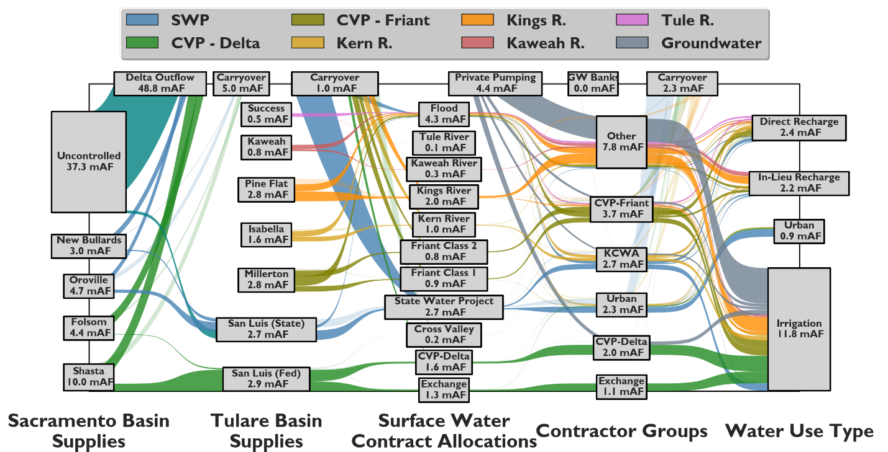
Figure 4: CALFEWS water flow between inter-basin transfer projects, surface water storage, water contract allocations, individual district supplies, and water use categories
Results
Model Evaluation and Capabilities
The adaptive operating rules employed in CALFEWS enable simulations based on any daily input time series of flow and snowpack data at the storage and regulatory nodes shown in Figure 1. Simulation results based on historical input data can be compared to observations at a number of critical locations throughout the Central Valley system as a means of quantifying how well decision rules capture historical system operations. In addition to encompassing a range of hydrologic conditions, the 20-year historical period of comparison, October 1996 – September 2016, includes substantial changes to statewide regulatory regimes that impacted the operation of the SWP and CVP as well as significant infrastructure expansion within Kern County groundwater banks. During simulations of this historical evaluation period, CALFEWS representations of these changes, including environmental flow requirements, pumping limits, and infrastructure capacities are integrated to reflect the timing of their implementation. Choosing an evaluation period that experienced these types of structural changes, in addition to a wide range of hydrologic conditions, increases confidence that the system of adaptive rules embedded within CALFEWS can provide insight into future uncertainties related to hydrologic change, infrastructure development, and environmental policies.
Figure 5 shows the performance between observed storage and simulated results during the 20-year historical period at all twelve surface reservoirs. In the Sacramento Basin, all four simulated reservoirs, Shasta, Oroville, Folsom, and New Bullards Bar Dam (Figures 5a-d) display R² values ranging between 0.86 and 0.94. These large reservoirs form the bulk of the releases to regulate delta outflows and support north-south exports. San Joaquin Reservoirs (Figures 5e-g), including New Melones, Don Pedro, and Exchequer have slightly higher levels of performance, with R² values ranging from 0.93 – 0.97. Many of the releases for these reservoirs are made to deliver water to downstream agricultural users. Agricultural demands supplied by these three reservoirs are not modelled based on implied ET demands from land cover as CALFEWS does for Tulare Basin irrigators. Instead, historical withdrawals for irrigation are calculated as negative incremental flows in the reaches between these reservoirs and their downstream regulatory node, as in equation (1). Negative incremental flows force the reservoirs to release water to meet downstream flow requirements, meeting the demands without the type of explicit agricultural modelling that occurs in the Tulare Basin, as described by equation (10). Although New Melones, Don Pedro, and Exchequer are not explicitly operated to support SWP and CVP delta export programs, the three reservoirs here perform important flood control and minimum flow regulation for delta inflows through the Vernalis gauge that can impact pumping rates.
Releases from Millerton Reservoir are not included when regulating flows at Vernalis, even though the dam controls the headwaters of the San Joaquin River. We assume here that most excess releases are consumed at the Mendota Pool (before interacting with any gages in the delta system), and any releases that do contribute to delta inflows are included in the observed ‘uncontrolled’ flows on the San Joaquin River. The reservoirs shown in Figure 5h-l (Millerton, Pine Flat, Kaweah, Success, and Isabella) deliver water directly to the Tulare Basin irrigation/water districts. The simulation results for Millerton Reservoir (Figure 5h) are the poorest of the CALFEWS represented reservoirs, but still generate an R² value of 0.57. Millerton is a smaller reservoir subject to flashy flows, especially during the winter ‘wet’ periods. Flood control releases can be large and potentially occur well in advance of the reservoir reaching full capacity, as operators attempt to deliver as much flood water as possible to contractors along the conveyance-constrained Friant-Kern Canal. The flow estimates used in equation (18) to schedule flood control decisions in CALFEWS do not capture all of the information used by Millerton Reservoir operators and Friant contract managers when they make their flood control decisions, leading to errors in storage when the timing of flood releases are mismatched. Model operations would likely be improved by more resolved estimation of wet period flow in the San Joaquin headwaters. It should be noted, however, that operational rules used in CALFEWS do broadly capture major storage dynamics in Millerton and perform quite well in simulating the recent 2012 – 2016 drought, suggesting that they can adequately represent the influence of the San Joaquin River Restoration Project, which began in 2009, on dry-year storage levels in Millerton Reservoir.
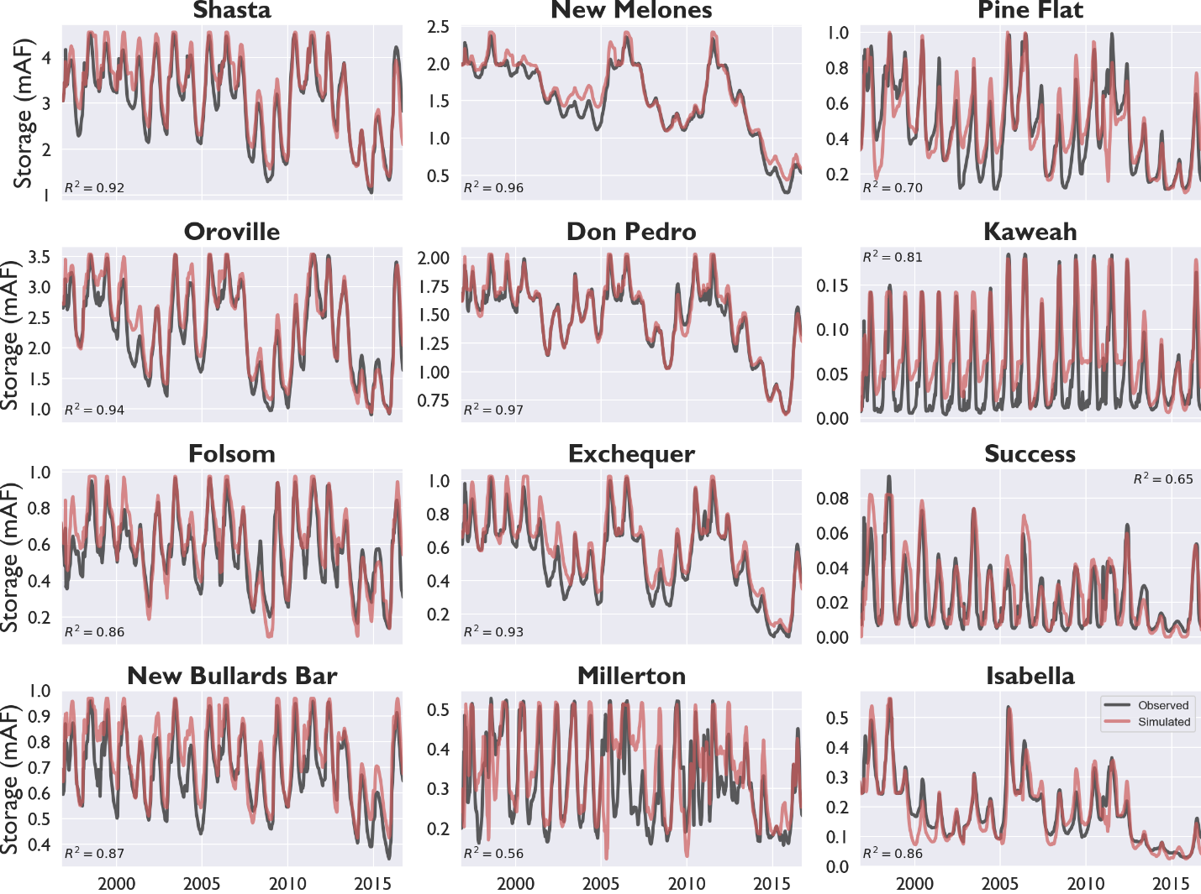
Figure 5: Daily correspondence between observed and simulated storage at the 12 major surface water reservoirs modelled in CALFEWS (excluding San Luis Reservoir), October 1996 – September 2016.
Flow that makes it to the delta is either exported through SWP (Figure 6a) and CVP (Figure 6b) pumping works or allowed to flow out to the San Francisco Bay, where the impact on the ‘X2’ salinity line (Figure 6c) can be measured. The delta X2 salinity line measures the point where salinity in the delta is equal to 2 parts per thousand, one meter from the bottom of the bay floor, relative to the Golden Gate Bridge. X2 values peak in the late summer/early fall, after low summer flows have allowed delta salinity to move eastward (inland, farther from the Golden Gate Bridge), and reach their low point in the spring after high winter flows push the salinity back towards the sea. Simulated X2 corresponds well with historical values, as calculated in the California DWR’s DAYFLOW time series, displaying an R² of 0.95 for weekly average values and 0.96 for monthly averages. Simulations of exports at the SWP and CVP delta pumps also correspond well with historical observations at the annual scale (R² of 0.89 and 0.91 for the SWP and CVP, respectively), with the relationship holding up well even when compared on a weekly time step (R² of 0.64 and 0.59, respectively). The sub-annual results are particularly important because the pumping time series serve as inflows into San Luis Reservoir and the timing of inflows impacts the size and type of deliveries that can be made to Tulare Basin contractors.
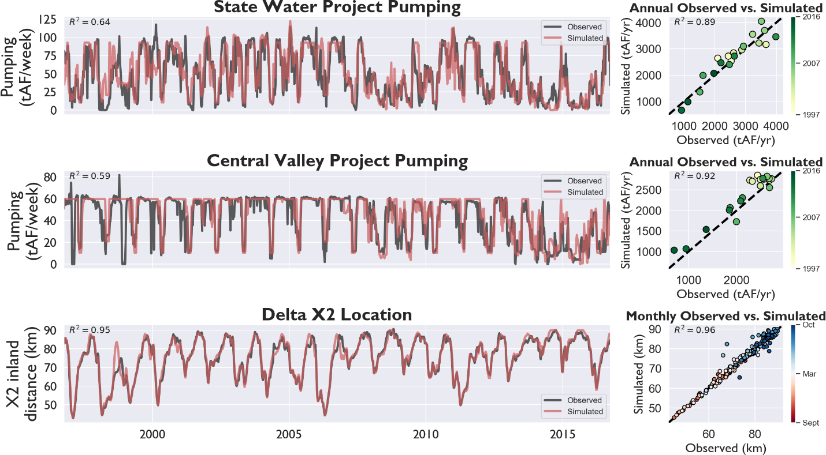
Figure 6: Correspondence between total weekly and annual observed and simulated pumping through SWP and CVP delta pumps, and weekly/monthly estimations of the delta X2 salinity, measuring distance inland from the Golden Gate Bridge to a point of 2 ppt salinity, October 1996 – September 2016
The model’s ability to capture the storage dynamics for the San Luis Reservoir, both the state and federal portions, are shown in Figure 7. Despite being subject to some degree of modelling error in inflow (delta pumping estimations) and reservoir releases (district demand estimations), they broadly capture the monthly observed storage (monthly is the only time step at which individual SWP and CVP storage accounts are recorded in San Luis Reservoir). Simulated storage in San Luis Reservoir has an R² value of 0.73 in the SWP portion and 0.66 in the CVP portion. Given the sheer complexity of the San Luis Reservoir’s operations, the CALFEWS simulation manages to capture the general timing, variability, and bounds of the system’s storage.
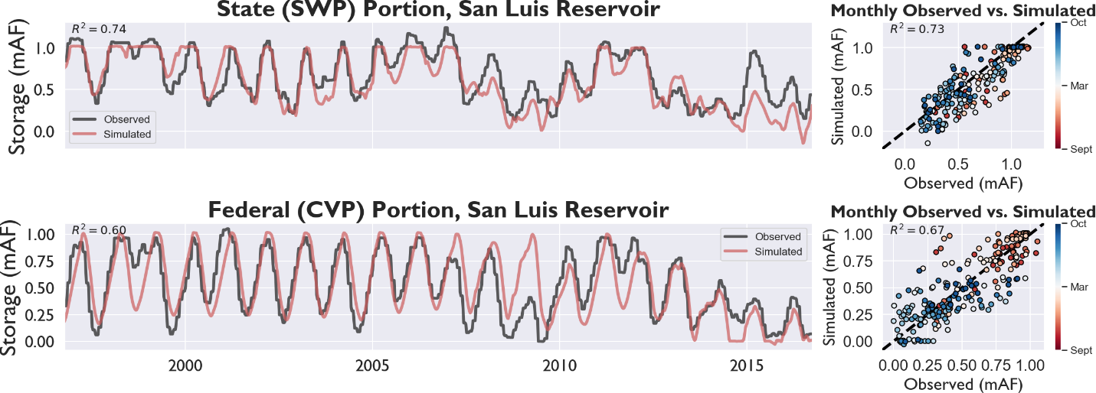Figure 7: Correspondence between observed and simulated monthly storage in the state (SWP) and federal (CVP) portions of San Luis Reservoir, October 1996 – September 2016.
Water delivered for groundwater recharge is delivered either within the service area of an WSD or to a GWB outside of the district service area. Water recharged in GWBs can be recovered and delivered to an ID/WD/WSD, but only if the district has a positive balance in the bank. Figure 8 illustrates the correspondence between simulated and observed (CDEC, 2018; Hanak et al., 2012) groundwater storage accounts in the Kern GWB (KWB) and Semitropic WSD (SWSD), where most of the banking users are SWP contractors. The KWB is operated for primarily agricultural users, while banking members in the SWSD are mostly municipal water districts. CALFEWS is able to capture the historical groundwater banking dynamics with relatively high R² of 0.70 and 0.67 for the annual change in storage accounts at KWB and SWSD, respectively. High levels of R² at KWB (0.77) and SWSD (0.64) are also attained for the total cumulative balance in each bank. At both banks, errors are largest in very wet years in which simulated results do not recharge as much water as is reflected in observed accounts. Simulation results have better correspondence with observations during dry years. As the most ‘downstream’ part of the CALFEWS model, groundwater banking results are subject to modelling errors in reservoir releases, delta pumping, and contractor water demands. However, the errors observed in banking accounts, in both the KWB and SWSD, are not systematically biased in any direction, and storage accounts in both banks are very close to the observed accounts at the end of the 20-year simulation. To the authors’ knowledge, no simulation system outside of CALFEWS has ever been able to capture the complexity of human systems operations and water balance dynamics with the level of fidelity shown here. Errors between simulated groundwater banking storage accounts and observed storage accounts overall appear not to be amplified across years, that is, our simulation results do not show sustained inter-annual over or under-prediction.
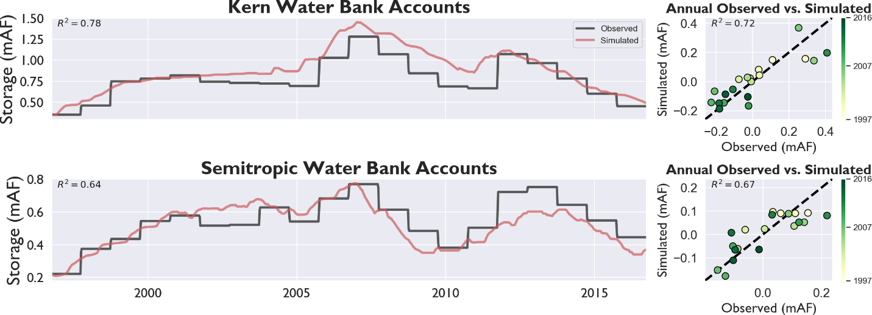
Figure 8: Correspondence between simulated and observed groundwater banking balances, and net annual change in groundwater banking balances, held in the Kern and Semitropic Water Banks, October 1996 – September 2016 note: observed balances available at an annual time step
State-Aware Decisions
The general agreement between observed and simulated results at key Central Valley locations set the stage for a deeper look into the dynamic and adaptive ways CALFEWS simulations represent stakeholder decisions. Simulated infrastructure operations are the product of individual, heterogeneous agents making decisions in response to changing hydrologic and management states. These states are based on the translation of environmental variables into simulated, management-relevant states like those relating to State Water Project allocations shown in Figure 9. Simulated allocations are updated in every timestep based on the component parts of the SWP contract allocation described in equations (15-17). During the CALFEWS simulation of the historical evaluation period (Oct 1996 – Sept 2016), the expected SWP allocation (white line) responds to changes in the expected available water at Oroville and New Bullards, the SWP portion of any expected unstored flows, and the year-to-date exports that have already been delivered to San Luis Reservoir. In addition, annual simulated allocations are also constrained by the expected pumping capacity through the end of the water year. During the historical evaluation, pumping constraints cause the expected SWP allocation to occasionally fall below the sum of its component parts, particularly during wet periods. When this occurs, SWP contract managers ‘carry-over’ this excess water in Oroville and/or New Bullards, resulting in end-of-year storage above target levels. In the following years, this extra carry-over storage is included in the calculations of expected available storage in the respective reservoirs, increasing initial estimates of that year’s SWP allocation.
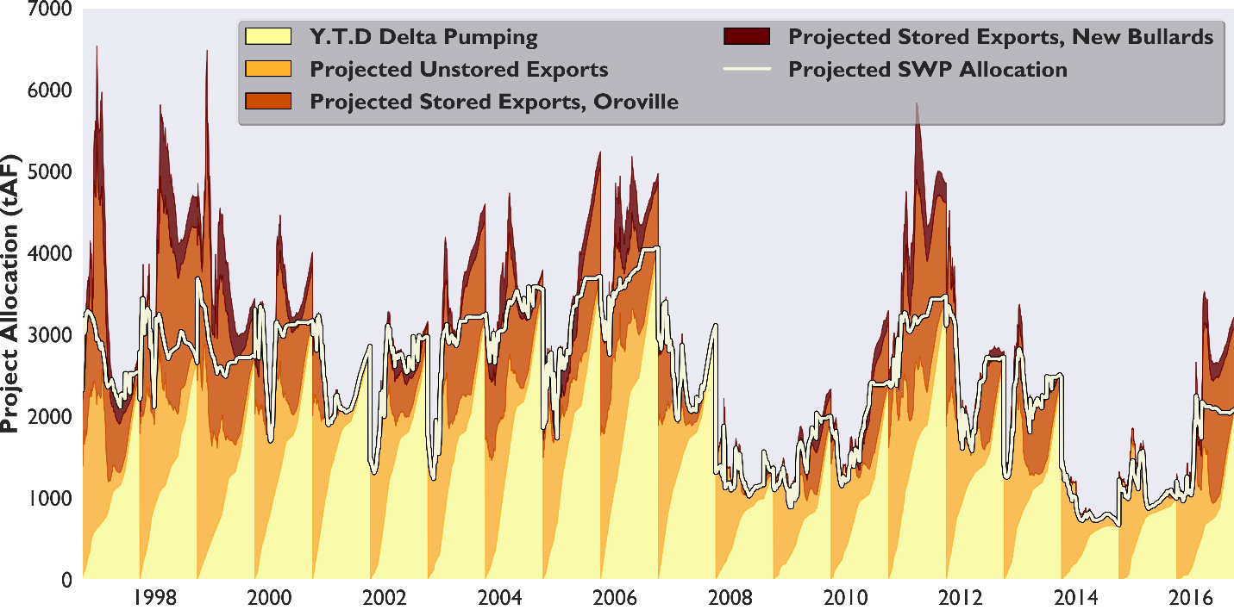
Figure 9: Projected annual State Water Project contract allocations, as a function of expected available water in Oroville and New Bullards Bar Reservoirs, expected unstored flows available for export in the delta, and year-to-date pumping at SWP delta facilities during the historical evaluation period, October 1996 – September 2016
Calculations of SWP allocations (Figure 9) are translated into individual contractor allocations that can be used to make district-level water supply decisions, as demonstrated for a specific irrigation district, Wheeler Ridge – Maricopa (Figure 10). The historical evaluation period includes a significant, recent drought from 2013-2016, during which CALFEWS simulated the district’s groundwater recovery operations. In 2013, the first year of the drought, the district’s portion of the SWP allocation was equal to approximately half of its expected irrigation demand. The district made requests for surface water deliveries based on this allocation according to equation (27), with the balance of the irrigation demand met through recovery of the district’s banked groundwater (originating in groundwater banks outside the district’s service area) and private groundwater pumping by the district’s irrigators. Although the district had sufficient supplies in their groundwater bank account in 2013, the district’s recovery pumping capacity at the bank limited the rate at which the banked water could be delivered to the district, requiring some amount of in-district, private groundwater pumping. The following winter, low snowpack levels caused expected SWP allocations to drop further (Figure 9), which in turn reduced Wheeler Ridge-Maricopa’s expected surface water supply (Figure 10). The district relied heavily on banked groundwater recovery in water year 2014 to make up for reduced surface water deliveries, and by the end of the irrigation season the district completely depleted their banked groundwater storage. CALFEWS simulation rules do not permit groundwater recovery when banked storage accounts are empty, so when the simulated historical drought continued in 2015, the district’s irrigation was almost entirely supplied by private groundwater pumping at wells within the district’s service area. The final year of the drought, 2016, started out dry, but increased precipitation led to larger expected water contract allocations, increasing district surface water supplies. Irrigators within the district began the year pumping private groundwater, expecting that the rest of the year would be dry as well, but were able to cease pumping by July when it was clear the remaining demands could be met through surface water deliveries from the SWP. Due to increases to the SWP allocation late in the year, the district was able to end the year with additional supplies and thus carry-over SWP supplies into the next year.
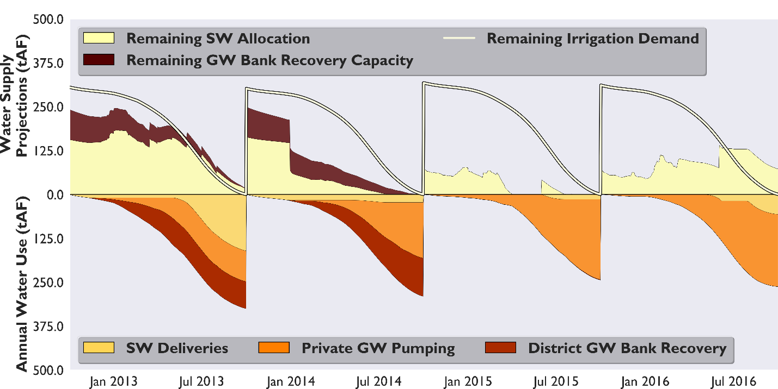
Figure 10: Expected water supplies for the Wheeler Ridge-Maricopa Water Storage District, with irrigation deliveries from the district’s surface water contract, groundwater banking recover, and in-district private groundwater wells during the drought period October 2012 – September 2016.
During wet periods, CALFEWS also simulates unscheduled flood deliveries to contractors. Decisions about the timing and magnitude of these releases are made by surface water contract managers when reservoirs are close to filling. As reservoir storage increases, reservoir fill-time falls in accordance with seasonal trends (e.g., the same storage volume will correspond to a shorter fill-time if it is observed in December, and a longer fill-time if it is observed in June, after a significant portion of snowmelt has already occurred), and as storage approaches capacity fill-time goes to zero (Figure 11). At San Luis Reservoir, natural inflow is negligible, and the reservoir is almost entirely fed by SWP/CVP pumps at the delta. Pumping capacity limits the rate of inflow into San Luis Reservoir during high flow periods, reducing the need for pre-emptive flood releases driven by expected future inflows, as in equation (19). In CALFEWS, SWP flood releases are not made from San Luis Reservoir until storage approaches capacity in the state-owned portion of San Luis Reservoir. However, reservoir fill-time in San Luis is an important metric for individual districts attempting to manage their carry-over water. If an SWP contractor does not deliver their entire SWP contract, they are able to carry it over in San Luis Reservoir. Any carry-over water remaining in San Luis when it reaches capacity is forfeited by the district carrying it over and instead delivered to any contractor with the capacity to take it. Districts therefore will attempt to use any carry-over water if they observe the reservoir filling up. This decision is triggered when a district’s cumulative recharge capacity during the expected reservoir fill-time, calculated in equation (24), is less than a district’s current and/or expected cumulative carryover.
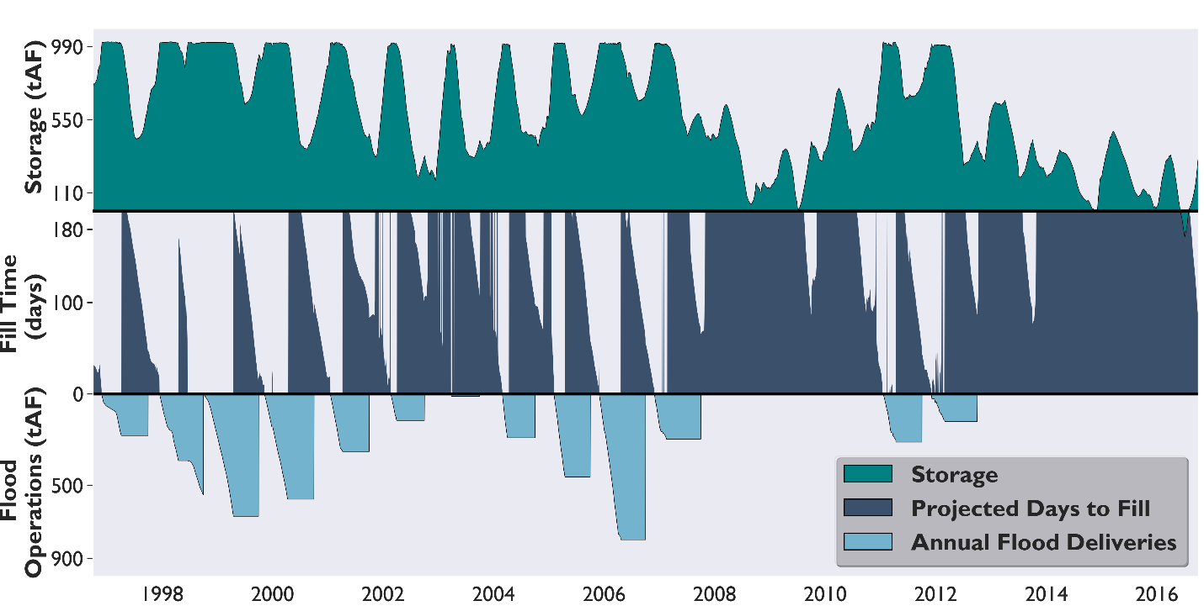
Figure 11: Storage, reservoir fill-time, and flood deliveries from San Luis Reservoir during the historical evaluation period, October 1996 – September 2016
Individual district carry-over operations, as shown in Figure 12, are designed to store excess surface water allocations (carry-over water) from one year for use in the next, either for groundwater recharge, or, when possible, to meet irrigation or municipal demands. In the historical simulation, Wheeler Ridge- Maricopa begins water year 2005 (October 2004) with about 25 tAF (31 x 10⁶ m³) of unused carry-over water in San Luis Reservoir, as shown by the white line. However, San Luis Reservoir also had a significant volume of unused storage capacity at this time, and the district’s metric to measure their dynamic recharge capacity (the total volume of water that could be diverted into district groundwater recharge facilities before San Luis reached its storage capacity) remained larger than the volume of carry-over water they stored in San Luis. As the winter progressed, the simulation delivered the district’s carry-over water to meet winter irrigation demands. The district was able to use all of their carry-over water for irrigation before San Luis Reservoir filled in February of 2005 (Figure 12). Expectations for that year’s SWP contract allocation continued to increase throughout 2005 (as previously shown in Figure 9), eventually causing Wheeler Ridge – Maricopa’s individual SWP supplies to exceed their remaining irrigation demand. The district carried over a similar volume in water year 2006, but San Luis Reservoir was much closer to capacity because other contractors were also storing carry-over water. Reservoir fill-time fell much more quickly at the beginning of water year 2006, reflected in the district’s falling dynamic recharge capacity (dark blue area of Figure 12). At the point during water year 2006 when this dynamic recharge capacity fell below the districts’ remaining carry-over storage, CALFEWS triggered the district’s decision to begin delivering their carry-over water to groundwater recharge facilities. The use of groundwater recharge capacity allowed Wheeler Ridge – Maricopa to deliver all their carry-over water earlier than in 2005, avoiding the need to forfeit unused supplies. Water year 2006 also saw very high expected SWP contract allocations, and by mid-summer of 2006, the district was expected to bring a very large volume (>60 x 10⁶ m³) of carry-over water into the next year. High simulated storage levels at San Luis Reservoir again resulted in low dynamic recharge capacity for the district, and the combination of high expected carry-over storage and low dynamic recharge capacity caused the district to begin delivering their potential carry-over water to groundwater banking facilities before the end of water year 2006. The district was able to recharge this water more quickly than expected, because few other districts were recharging surface water at this time and Wheeler Ridge – Maricopa was able to take advantage of unused capacity at their groundwater banking facilities. At the start of water year 2007, the district delivered their remaining carry-over water for irrigation and groundwater recharge before San Luis Reservoir could re-fill in early 2007. Carry-over storage operations in CALFEWS enable individual districts to make coordinated surface and groundwater use decisions, saving their surface water for irrigation or municipal demands when possible while still avoiding ‘losing’ their supplies through selective use of groundwater recharge capacity.
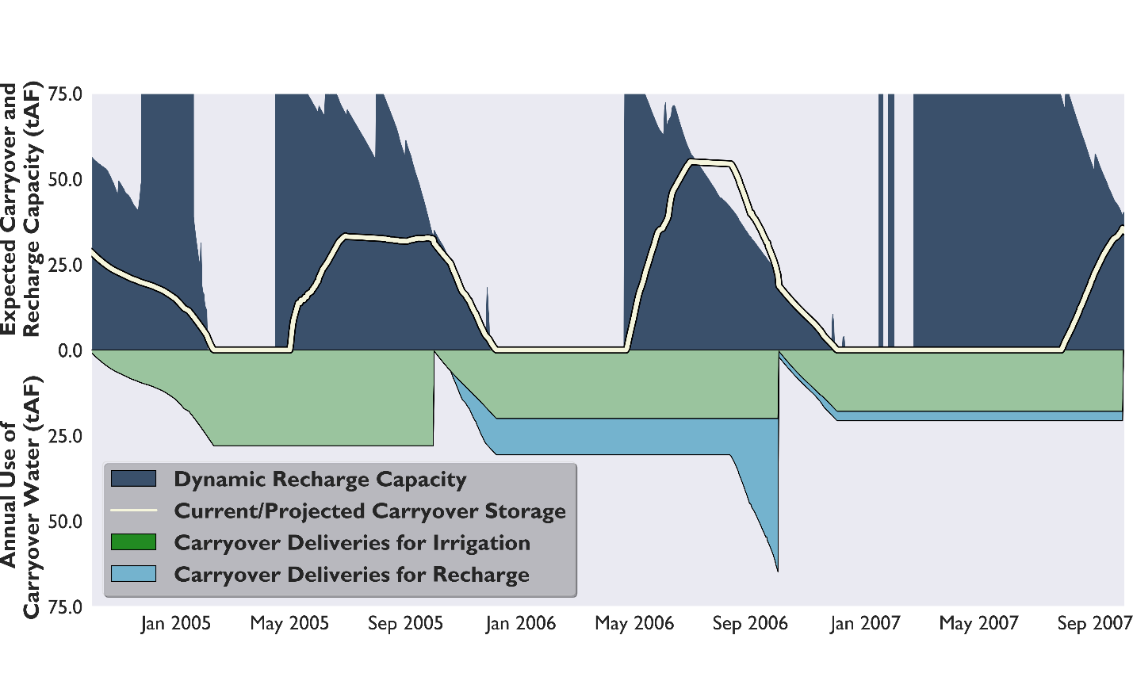
Figure 12: Carry-over storage and dynamic recharge capacity (cumulative groundwater recharge capacity during the expected reservoir fill-time) for the Wheeler Ridge – Maricopa Water Storage District during a wet period from October 2004 – September 2007, with deliveries of carry-over storage for irrigation and groundwater recharge.
Extended Historical Re-evaluation
The rules-based adaptations that drive simulations allow CALFEWS to evaluate reservoir releases, delta operations, irrigation deliveries, and groundwater recharge/recovery under a wide range of input conditions, infrastructure configurations, and regulatory regimes. Over the course of the 20 year historical evaluation period (October 1996 – September 2016), decisions rules adapt to increasing capacity in Tulare Basin groundwater banks (AECOM, 2016), the imposition of the National Fisheries and Wildlife Services Old & Middle River rule (NMFS 2009), limiting the capacity of delta pumps between January and June, and the San Joaquin River Restoration Project (Meade, 2013), which increases the required environmental releases from Millerton Reservoir. These changes are implemented into model simulations as they occur in real time (construction of the Kern Water Bank, 2001-2003; Old & Middle River delta rule, 2008; San Joaquin River Restoration, 2009) over the historical evaluation period, but we can also conduct an extended historical re-evaluation, applying regulatory changes to the entirety of an extended full-natural-flow record available through the California Data Exchange Center (CDEC). Full-natural-flow records in the Sacramento, San Joaquin, and Tulare Basins reach back as far as 1905, enabling a 111-year extended historic re-evaluation, under scenarios reflective of current infrastructure and regulatory conditions. In watersheds where flow and snowpack data were not available over the entire period, they are synthetically extended using historical relationships with existing data. In addition, incremental flow and reservoir inflow datasets are not available for the same historical duration, so inputs are synthetically generated based on more recent (10/1996 – 09/2016) observed relationships with the full-natural-flow data, as described in Supplemental Section B.
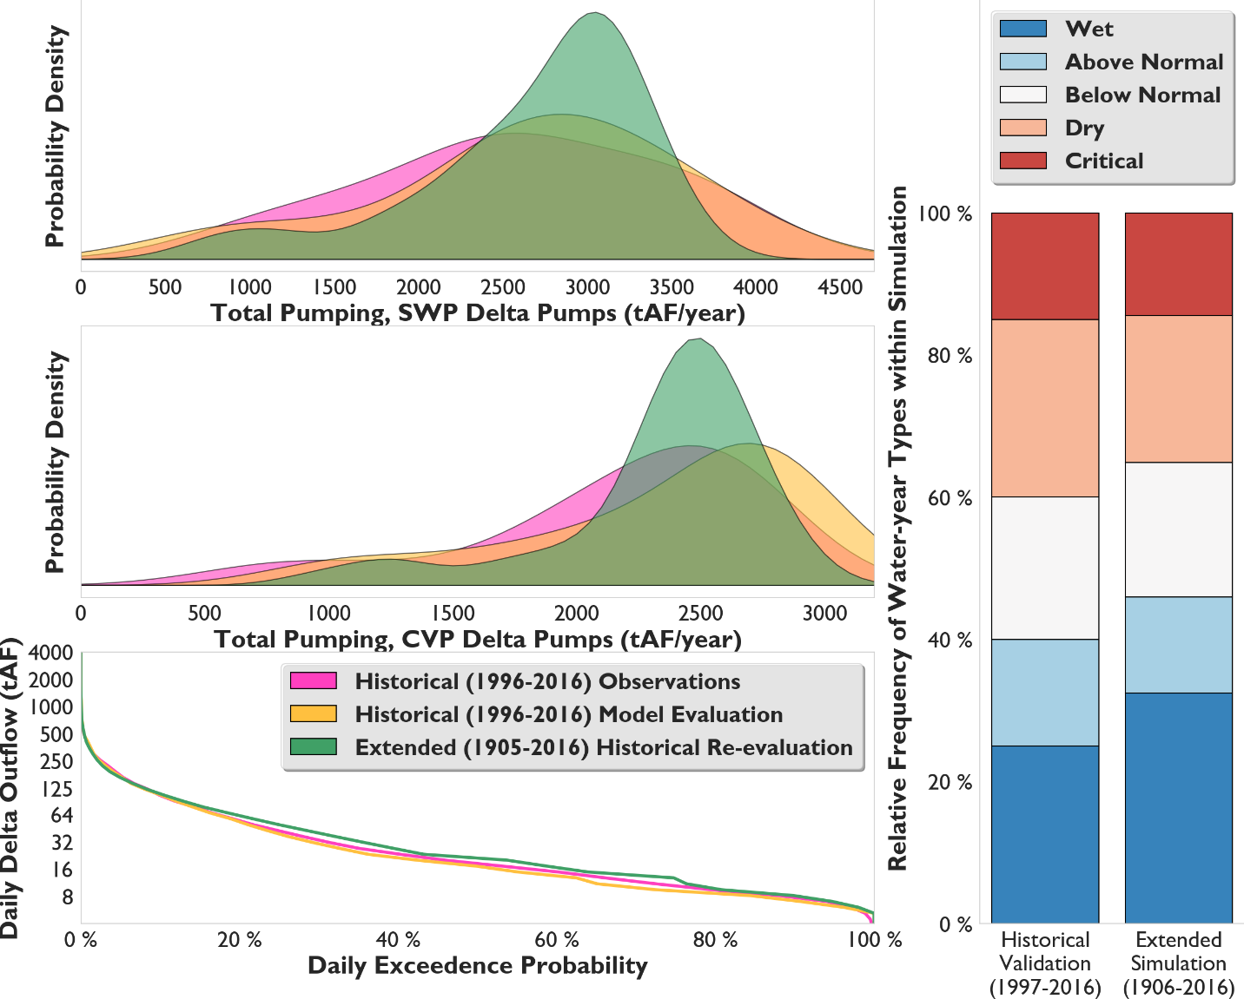
Figure 13: Scenario comparison between the historical evaluation (October 1996 – September 2016) and the extended historical re-evaluation (October 1905 – September 2016) with respect to SWP and CVP delta pumping, total delta outflows, and the distribution of Sacramento River Index (SRI) water year types
Simulation results illustrate the water availability that would have been observed in the system under historical hydrologic variability and a static set of institutional conditions, including current land use, population, infrastructure, and regulatory regime. Figure 13 compares the distribution of SWP and CVP delta pumping and delta outflows under the extended historical re-evaluation scenario (111 years, water years 1906-2016), the historical evaluation scenario (20 years, water years 1997 - 2016), and historical observations (20 years, water years 1997-2016). Although the extended historical period (1905-2016) contains a slightly higher portion of ‘Wet’ and ‘Above Normal’ water years than the historical evaluation period (1996-2016), it produces a much lower frequency of years with very high annual exports through both the SWP pumps (>4300 x 10⁶ m³/year) and CVP pumps (>3400 x 10⁶ m³/year). This illustrates the impact of applying the recent regulatory changes across the entire extended historical period, rather than only during the 2008-16 period under which they are applied in the historical evaluation scenario. New regulations applied to the delta primarily limit pumping rates from January to June, preventing the pumps from running at capacity for a substantial portion of the year and limiting the water that can be exported during the typical high-flow season. The regulatory impact can also be observed in very dry years, which form a second, smaller peak in the bi-modal pumping distribution that is most pronounced in the extended historical scenario. During these years, there is often very little snowpack above SWP and CVP storage reservoirs, and most of the water that could be exported is available as uncontrolled inflows to the delta during brief periods in the wetter winter months. However, regulations become more restrictive to wintertime pumping operations when conditions are the driest. In addition to having fewer supplies to export, SWP and CVP managers are also effectively operating with reduced infrastructure capacity during dry years, leading to the bimodal distribution shown in Figure 13.
Discussion
This study presents results from a 20-year historical simulation and a 111-year, synthetically extended historical re-evaluation. In both scenarios, infrastructure and land cover are set deterministically, the former tracking the observed changes over the 20-year period October 1996 – September 2016, and the latter applying current conditions to the entire hydrologic record that occurred from October 1905 – September 2016. The historical simulation provides a benchmark for quantifying how well the decision rules described in CALFEWS capture stakeholder adaptations to continually changing surface and groundwater conditions throughout the State of California. In contrast with statewide MP-based models such as CALVIN (Draper et al., 2003), CalSIM (Draper et al., 2004), or CalLite (Islam et al., 2011) that seek to identify optimal allocations of surface water under a specific set of hydrologic and demand conditions, the state-aware decision rules framework adopted here seeks to describe the system as it currently exists. Perhaps more importantly, the framework describes how decisions within the current system is driven by different environmental indicators (e.g., snowpack, flow, land cover). The ability to quantify and evaluate how individual water users respond to changing conditions is particularly helpful in identifying how they are impacted by marginal changes from current operations like those that could arise from the State’s Flood-MAR Research and Data Development plan (CADWR, 2019). By linking decision rules to a heterogeneous set of users and stakeholders like irrigation districts or reservoir operators, the analysis can also capture the distributional effects of changes to operating policies and/or infrastructure. These distributional effects are particularly important with respect to the continuing development of groundwater recharge and recovery efforts in the state. The location, magnitude, and timing of groundwater recharge determines how much groundwater can be recovered in the future, and by whom. The groundwater banking rules used in CALFEWS, limiting groundwater recovery to only water that has been previously recharged at the site, aids in understanding these multi-year regulatory links between flood and drought periods.
The spatial and temporal scale used within the CALFEWS simulation framework also allow it to be interoperable with land use and power dispatch models. Land cover selection used to estimate irrigation demand in this study is deterministic, ignoring the relationship between surface water variability and irrigated acreage. Irrigation demands that are not met by surface water or banked recovery deliveries are assumed to be met through private groundwater pumping. However, literature suggests that the relationship between surface water availability, groundwater pumping, and irrigated acreage is a more complex economic decision for irrigators (Medellin-Azuara et al., 2015). In future work, irrigation deliveries generated by CALFEWS can be linked with economic models of agricultural production such as California’s SWAP (Howitt et al., 2012) to represent adaptive land use decisions. In order to get an accurate picture of the pumping costs faced by irrigators, future versions of CALFEWS can also include an explicit representation of the changes to groundwater levels that result from direct aquifer recharge and groundwater pumping in a given spatial area, an important factor in meeting sustainability targets described in the Sustainable Groundwater Management Act. Extending the state-aware decision framework to groundwater levels (as an environmental indicator) and district-level land cover (using a decision rule) could enable the exploration of more complex groundwater management strategies.
Likewise, state-of-the-art power dispatch modelling has demonstrated the connection between drought and wholesale energy prices in California (Kern et al., 2020), with a particular attention to changes in hydropower generation and temperature-based variability in energy use for the cooling of buildings. However, these models can also consider changes to other energy consumption related to surface water drought in California, such as changes to the volume of groundwater pumping or conveyance of the State Water Project, the single largest energy user in the State. Coordinated modelling of surface and groundwater use, paired with estimates of wholesale and retail electric power prices, can provide insight into the financial risks faced by irrigation districts, groundwater banks, and individual irrigators. These risks impact the ability of institutions to repay loans and meet other fixed cost obligations, playing a role in determining investment decisions. Future versions of CALFEWS can incorporate feedbacks between environmentally-driven changes in energy consumption, energy prices, and financial risk to irrigators and groundwater bankers. As water supplies become more diversified as outlined in the State of California’s Resilient Water Portfolio Initiative (CANRA, 2020), institutions that are capable of managing the year-to-year financial variability will be capable of greater adaptation in response to hydrologic and regulatory uncertainty.
Conclusions
This study introduces the California Food-Energy-Water System (CALFEWS) simulation model to illustrate the integrated, multi-sector dynamics that emerge from the coordinated management of surface and groundwater in the State of California. The CALFEWS simulation framework captures the relationships between actors at multiple scales, linking the operation of inter-basin transfer projects in California’s Central Valley with coordinated water management strategies abstracted to the more highly resolved scale of irrigation and water storage districts. A set of interdependent rules, conditioned on dynamic environmental variables, enable the model to abstract the coordinated management of surface and groundwater resources in the Central Valley. These abstractions are evaluated against observations from a recent, 20-year period (Oct 1996 – Sept 2016), and are shown to accurately represent SWP/CVP deliveries, surface water storage, and groundwater banking operations in California’s Tulare Basin. Distributed, state-aware decisions provide insight into how a range of institutions adapt to changing hydrologic and regulatory conditions in a way that is consistent with recent historical observations of surface water storage, delta exports and water quality metrics, and groundwater banking accounts in the Tulare Basin.
Flexible decision rules enable CALFEWS to evaluate alternative streamflow scenarios under particular infrastructure and regulatory assumptions. The simulation framework can specifically support Monte Carlo exploratory modelling results, particularly with respect to irrigation deliveries and pumping requirements. Simulations can be linked with agricultural production and electric power dispatch models to create hydrologically consistent scenarios upon which to evaluate risks to food and power systems. Economic models of agricultural production like the Statewide Agricultural Production (SWAP) model used in California (Howitt et al., 2012) use surface water deliveries and groundwater access to estimate crop choice decisions, groundwater pumping, and annual agricultural yields. Abstractions of groundwater banking operations made within CALFEWS can better resolve water deliveries to individual districts, allowing for more detailed projections of land use and groundwater pumping (Medellin-Azuara et al., 2015). Hydropower is responsible for between 7 and 21% of California’s total energy generation (USEIA, 2020), but energy used for conveyance and distribution can offset a significant portion of this production. During the period 1998-2004, the energy used to convey State Water Project supplies alone ranged between 8% (wet year) and 24% (dry year) of the total annual hydropower production (CEC, 2010; Nyberg, 2020). State-of-the-art electric power dispatch modelling has demonstrated the connection between drought and wholesale energy prices in California (Kern et al., 2020) based on changes to hydropower generation and energy use for cooling structures. However, the literature has not considered any potential drought-induced covariation between hydropower production and the energy demands for surface water conveyance and groundwater pumping.
Instead of a prescribed sequence of optimal water deliveries assigned to specific time periods, CALFEWS formulates daily data input series into a number of state variables that are used to coordinate infrastructure operations. Model rules adapt to dynamic regulatory constraints on infrastructure, enabling Monte Carlo simulations that combine different hydrologic, regulatory, and infrastructure scenarios. Institutional abstraction at multiple scales (e.g., inter-basin transfer projects, irrigation districts, joint groundwater banks) enables rule-based coordination between regional and statewide actors, linked through conditions throughout the state. Regulations and hydrologic conditions that affect exports through SWP and CVP delta pumps, for example, also affect imported water contract allocations and floodwater availability, which in turn influences how individual districts operate their groundwater recharge and recovery infrastructure. Groundwater banking and other coordinated use operations create a relationship between flood and drought periods, limiting recovery operations as a function of previous recharge. This relationship may become more important to irrigators and municipal users as the issue of groundwater sustainability increases in salience due to the recently enacted Sustainable Groundwater Management Act (CADWR, 2019). CALFEWS provides a foundational framework that can support future Monte Carlo exploratory modeling efforts to understand the path-dependent impacts of hydrologic and regulatory uncertainty on coordinated surface and groundwater management, revealing potential risks and opportunities as they play a larger role in statewide ‘Resilient Water Portfolios’ (CANRA et al., 2020). CALFEWS is able to resolve these actions at the level of individual irrigation and urban water districts, providing insight into financial risks and water use at a management-relevant scale. Tools that allow institutions evaluate and manage co-evolving physical and financial risks are crucial to the process of developing sustainable and resilient water solutions for institutionally complex contexts like the American West.

Acknowledgements
This work was supported by the National Science Foundation through the Innovations in Food, Energy, and Water Program (CNS-1639268)

References
AECOM (2016). Kern Water Bank Study Area Physical Data Collection Technical Report. State of
California Department of Water Resources. Available online: https://water.ca.gov/LegacyFiles/environmentalservices/docs/mntry_plus/revisedeir_volume%20II/7-1%20Data%20Report.pdf
Bazilian, M., Rogner, H., Howells, M., Hermann, S., Arent, D., Gielen, D., Steduto, P., Mueller, A.,
Komor, P., Tol, R.S.J, and K.K. Yumkella. (2011). Considering the energy, water, and food nexus: Towards and integrated modelling approach. Energy Policy 39, 7896-7906.
CADWR, 1967. Contract Between State of California Department of Water Resources and
Merced Irrigation District for Recreation and Fish Enhancement Grants Under the Davis-Grunsky Act. California Department of Water Resources. Available online: https://www.waterboards.ca.gov/waterrights/water_issues/programs/water_quality_cert/docs/mrcdrvr2179/mr_davis_grunsky_contract.pdf Accessed 2/19/2019.
CADWR (2018). The Final State Water Project Delivery Capability Report 2017. California Natural
Resources Agency, Sacramento, CA. Available online: https://data.cnra.ca.gov/dataset/dcr2017
CADWR (2020). FloodMAR Research and Data Development Plan: Priority Actions to Expand
Implementation of Effective and Efficient Flood-MAR Projects in California. California Department of Water Resources, Sacramento, CA. Available online: https://water.ca.gov/-/media/DWR-Website/Web-Pages/Programs/Flood-Management/Flood-MAR/Flood-MAR-RDD-Plan_a_y_19.pdf?la=en&hash=F87030022485CF01BC6E9D6AE4C134818A4FCB0E
Cai, X., Wallington, K., Shafiee-Jood, M., and Marston, L. (2018). Understanding and managing the
food-energy-water nexus – opportunities for water resources research. Advances in Water Resources 111, 259-273.
CANRA (2020). California Water Resilience Portfolio 2020. California Natural Resources Agency,
Sacramento, CA. Available online: https://waterresilience.ca.gov/wp-content/uploads/2020/01/California-Water-Resilience-Portfolio-2019-Final2.pdf
CDEC (2020a). California Data Exchange Center Current and Historical Data. Available online:
https://cdec.water.ca.gov/queryTools.html
CDEC (2020b). Chronological Reconstructed Sacramento and San Joaquin Valley Water Year
Hydrologic Classification Indices. Available online: http://cdec.water.ca.gov/reportapp/javareports?name=WSIHIST
CDEC, 2020c. California Data Exchange Center DAYFLOW. Available online:
https://data.ca.gov/dataset/dayflow
CEC (2010). Embedded Energy in Water Studies: Study 1: Statewide and Regional Water-Energy
Relationship. California Energy Commission, Sacramento, CA. Available online:
https://www.cpuc.ca.gov/general.aspx?id=4388
Christian-Smith, J.C. (2013). Improving Water Management through Groundwater Banking: Kern County
and the Rosedale-Rio Bravo Water Storage District. Pacific Institute. Available online: https://pacinst.org/wp-content/uploads/2013/02/groundwater_banking3.pdf
Cohen, J., Zeff, H.B., and J.D. Herman (2020). Adaptation of Multiobjective Reservoir Operations to
Snowpack Decline in the Western United States. Journal of Water Resources Planning and Management 146(12): 04020091.
Dogrul, E., Kadir, T.N., Brush, C.F., and F.I. Chung (2016). Linking groundwater simulation and
reservoir system analysis models: The case for California’s Central Valley. Environmental Modelling and Software 77, 168-182.
Draper, A.J., Jenkins, M.W., Kirby, K.W., Lund, J.R., and R.E. Howitt (2003). Economic-engineering
optimization for California water management. Journal of Water Resources Planning and Management 129(3), 155-164.
Draper, A.J., Munevar, A., Arora, S.K., Reyes, E., Parker, N.L., Chung, F.I., and L.E. Peterson (2004).
CalSim: Generalized model for reservoir system analysis. Journal of Water Resources Planning and Management 130(6). 480-489.
FERC, 2015. Draft Environmental Impact Statement for Hydropower Licenses: Merced River
Hydroelectric Project – FERC Project No 2179-043 and Merced Falls Hydroelectric Project – FERC Project No 2467-202. Federal Energy Regulatory Commission. Available online: https://ferc.gov/industries/hydropower/enviro/eis/2015.asp Accessed 2/19/2019.
FERC, 2016. Endangered Species Act Section 7(a)(2) Biological Opinion, and Magnuson-
Stevens Fishery Conservation and Management Act Essential Fish Habitat Response and Fish and Wildlife Coordination Act Recommendations for Relicensing the Oroville Facilities Hydroelectric Project, Butte County California (FERC Project No. 2100-134). United States Federal Energy Regulatory Commission. Available online: https://www.westcoast.fisheries.noaa.gov/publications/Central_Valley/Sacramento%20River/2016_12_05_oroville_ferc_bo_final_signed.pdf Accessed 2/18/2019.
FERC, 2019. Draft Environmental Impact Statement for Hydropower Licenses: Don Pedro
Hydroelectric Project – FERC Project No 2299-082 and La Grange Hydroelectric Project – FERC Project No 14581-002. Federal Energy Regulatory Commission. Available online: https://www.ferc.gov/industries/hydropower/enviro/eis/2019/02-11-19-DEIS/P-2299-082-DEIS.pdf?csrt=15274894557756840560. Accessed 2/19/2019.
Groves, D.G., Bloom, E., Lempert, R.J., and J.R. Fischbach (2015). Developing Key Indicators for
Adaptive Water Planning. Journal of Water Resources Planning and Management 141(7).
Haimes, Y.Y. (2018). Modelling and managing interdependent complex systems of systems. John Wiley
and Sons.
Hanak, E., Lund, J., Dinar, A., Gray, B., Howitt, R., Mount, J. Moyle, P., and B. Thompson (2011).
Managing California’s Water From Conflict to Reconciliation. San Francisco, CA: Public Policy Institute of California.
Hanak, E. and E. Stryjewski (2012). California’s water market, by the numbers: Update 2012. San
Francisco: Public Policy Institute of California.
Howitt, R.E., Medellin-Azuara, MacEwan, D., and J.R. Lund (2012). Calibrating disaggregate economic
models of agricultural production and water management. Environmental Modelling and Software 38, 244-258.
Improvement District No. 4 (2018). Improvement District No. 4: Report on Water Conditions 2017.
Kern County Water Agency. Available online: http://www.kcwa.com/wp-content/uploads/2018/07/ROWC2016.pdf
Islam, N., Arora, S., Chung, F., and E. Reyes (2011). CalLite: California Central Valley Water
Management Screening Model. Journal of Water Resources Planning and Management 137(1), 123-133.
ITRC (2003). California Crop and Soil Evaporation for Water Balances and Irrigation
Scheduling/Design. California Department of Water Resources, Sacramento, CA.
Jassby, A.D., Kimmerer, W.J., Monismith, S.G., Armor, C., Cloern, J.E., Powell, T.M., Schubel, J.R., and
T.J. Vendlinski (1995). Isohaline position as a habitat indicator for estuarine populations. Ecological Applications 5(1), 272-289.
Kern, J.D., Su, Y., and J. Hill (2020). A retrospective study of the 2012 – 2016 California drought and its
impacts on the power sector. Environmental Research Letters, in press: doi.org/10.1088/1748-9326/ab9db1
Labadie, J.W. (2004). Optimal operation of multireservoir systems: state-of-the-art review. Journal of
Water Resources Planning and Management 130(2), 93-111.
Labadie, J.W. and R. Larson (2007). MODSIM 8.1: River basin management decision support system,
user manual and documentation. Colorado State University, Fort Collins CO.
Lempert, R.J., and D.G. Groves (2010). Identifying and evaluating robust adaptive policy responses to
climate change for water management agencies in the American West. Technological Forecasting and Social Change 77(6), 960-974.
Liu, Q (2016). Interlinking climate change with water-energy-food nexus and related ecosystem processes
in California case studies. Ecological Processes 5(14).
Mall, N.K. and J.D. Herman (2019). Water shortage risks from perennial crop expansion in California’s
Central Valley. Environmental Research Letters, 14(10), 104014.
Maier, H.R., Kapelan, Z., Kasprzyk, J., Kollat, J., Matott, L.S., Cunha, M.C., Dandy, G.C., Gibbs, M.S.,
Keedwell, E., Marchi, A., Ostfeld, A., Savic, D., Solomatine, D.P., Vrugt, J.A., Zecchin, A.C., Minsker, B.S., Barbour, E.J., Kuczera, G., Pasha, F., Castelletti., A., Giuliani, M., and P.M. Reed (2014). Evolutionary algorithms and other metaheuristics in water resources: current status, research challenges and future directions. Environmental Modelling and Software 62, 271-299.
Meade, R.J. and SJRRP Settling Parties (2013). San Joaquin River Restoration Program Restoration
Administrator 2012 Annual Report. Available online: http://www.restoresjr.net/wp-content/uploads/2019/03/2012-RA-Annual-Report-Final.pdf
Medellin-Azuara, J., MacEwan, D., Howitt, R.E., Koruakos, G., Dogrul, E.C., Brush, C.F., Kadir, T.N.,
Harter, T., Melton, F., and J.R. Lund (2015). Hydro-economic analysis of groundwater pumping for irrigated agriculture in California’s Central Valley, USA. Hydrogeology 23(6) 1205-1216.
Mueller-Solger, A. (2012). Notes on Estimating X2, the distance from the Golden Gate to 2ppt Salinity
(km). California Department of Water Resources, Sacramento, CA. Available online: https://19january2017snapshot.epa.gov/sites/production/files/documents/notes-on-estimating-x2-with-dayflow.pdf
MWD (2016). Integrated Water Resources Plan: 2015 Update. The
Metropolitan Water District of Southern California, Los Angeles, CA. Available online:
http://www.mwdh2o.com/PDF_About_Your_Water/2015%20IRP%20Update%20Report%20(web).pdf
NMFS, 2009. Biological Opinion and Conference Opinion on the Long-Term Operations of the
Central Valley Project and the State Water Project. National Marine and Fisheries Service. Available online: https://www.westcoast.fisheries.noaa.gov/publications/Central_Valley/Water%20Operations/Operations,%20Criteria%20and%20Plan/nmfs_biological_and_conference_opinion_on_the_long-term_operations_of_the_cvp_and_swp.pdf Accessed 2/18/2019.
Nyberg, M., (2020). California Hydroelectric Statistics and Data. California Energy Commission,
Sacramento, CA. Available online: https://ww2.energy.ca.gov/almanac/renewables_data/hydro/index_cms.php
O’Geen, A., Sall, M., Dahlke, H., Doll, D., Elkins, R., Fulton, A. Fogg, G., Harter, T., Hopmans, J.,
Ingels, C., Niederholzer, F., Sandoval, S.S., Verdegaal, P., Wlkinshaw, M. (2015). Soil suitability index identifies potential areas for groundwater banking on agricultural lands. California Agriculture 69(2), 75-84.
Reed, P.M., Hadka, D., Herman, J.D., Kasprzyk, J.R., and J.B. Kollat (2013). Evolutionary
multiobjective optimization in water resources: the past, present, and future. Advances in Water Resources 51, 438 – 456.
Sacramento Water Forum, 2015. The Lower American River Modified Flow Management
Standard: A Drought Buffer for the Environment and Local Water Supplies. Available online: http://www.waterforum.org/wp-content/uploads/2017/04/WF-Modified-FMS-10_8_final_Single.pdf Accessed 2/18/2019.
SWRCB, 1990. Water Rights Order 90-05: Order Setting Terms and Conditions for Fishery
Protection and Setting a Schedule for Completion of Tasks. United States Bureau of Reclamation. Available online: https://www.waterboards.ca.gov/waterrights/board_decisions/adopted_orders/orders/1990/wro90-05.pdf. Accessed 2/18/2019.
SWRCB, 2000. Revised Water Right Decision 1641: Implementation of Water Quality
Objectives for the San Francisco Bay/Sacramento-San Joaquin Delta Estuary. California EPA. Available online: http://www.waterboards.ca.gov/waterrights/board_decisions/adopted_orders/de cisions/d1600_d1649/wrd1641_1999dec29.pdf. Accessed 2/18/2019.
USACE, 1970. Oroville Dam and Reservoir: Report on Reservoir Regulation for Flood Control.
Sacramento District, Army Corps of Engineers, Sacramento, California.
USACE, 1977. Shasta Dam and Lake: Report on Reservoir Regulation for Flood Control.
Sacramento District, Army Corps of Engineers, Sacramento, California.
USACE, 1980. New Melones Dam and Lake Stanislaus River, California: Report on Reservoir
Regulation for Flood Control. Sacramento District, US Army Corps of Engineers, Sacramento, California.
USACE, 1981. New Exchequer Dam and Reservoir (Lake McClure) Merced River, California:
Water Control Manual. Sacramento District, Army Corps of Engineers, Sacramento, California.
USACE, 1987. Folsom Dam and Lake American River, California: Water Control Manual.
Sacramento District, Army Corps of Engineers, Sacramento, California.
USACE, 2004. New Bullards Bar Dam and Reservoir, North Yuba River, Calfornia: Water
Control Manual. Sacramento District, Army Corps of Engineers, Sacramento, California.
USACE, 2017. Isabella Dam Safety Modification Project Temporary Water
Control Manual Deviation Draft Supplemental Environmental Assessment. Sacramento, CA. Available online: https://www.spk.usace.army.mil/Portals/12/documents/civil_works/Isabella/Project%20Documents/IDSMP_WCM_Dev_SEA7_Sep2017.pdf?ver=2017-09-19-174749-487
USBR, 2013. Arvin-Edison Water Storage District and Metropolitan Water District
10-year Water Transfer/Exchange Program. U.S. Department of the Interior, Fresno, CA. Available online: https://www.usbr.gov/mp/nepa/includes/documentShow.php?Doc_ID=15863
USBR, 2018. Addendum to the Coordinated Operation Agreement Central Valley Project / State
Water Project. U.S. Department of the Interior, Sacramento, CA. Available online: https://www.usbr.gov/mp/nepa/includes/documentShow.php?Doc_ID=36503. Accessed 6/27/2020.
USDA NASS (2012). 2012 Census of Agriculture, State and County Profiles. Available online:
https://www.nass.usda.gov/Publications/AgCensus/2012/Online_Resources/County_Profiles/California/index.php. Accessed 3/6/2019.
USDOE, 2015. State of California: Energy Risk Profile. United States Department of Energy, Office of
Electricity Delivery and Energy Reliability. Available online: https://www.energy.gov/sites/prod/files/2015/05/f22/CA-Energy%20Sector%20Risk%20Profile.pdf Accessed 9/1/2020
USEIA, 2020. California: State Profile and Energy Uses. United States Energy Information
Administration. Available online: https://www.eia.gov/state/analysis.php?sid=CA
Wells Fargo Securities (2017). Semitropic Improvement District of Semitropic Water Storage District
Revenue Refunding Bond 2017 Series A. Nossaman LLP, Irvine, California.
Xiao, M., Koppa, A., Mekonnen, Z., Pagan, B.R., Zhan, S., Cao, Q., Aierken, A., Lee, H., and D.P.
Lettenmaier (2017). How much groundwater did California’s Central Valley lose during the 2012-2016 drought? Geophysical Research Letters 44(10), 4872-4879.
Yates, D., Sieber, J., Purkey, D., and A. Huber-Lee (2009). WEAP21 – A Demand-, Priority-, and
Preference-Driven Water Planning Model. Water International 30(4), 487-500.
Yuba County Water Agency, 2007. Lower Yuba River Fisheries Agreement. Yuba County
Water Agency and California Department of Fish and Game. Available online: http://www.yubaaccordrmt.com/Yuba%20Accord%20Documents/Yuba%20Accord%20Documents/Final%20Fisheries%20Agreement%2011-08-07.pdf. Accessed 2/18/2019.
Zagona, E.A., Fulp, T.J., Shane, R., Magee, T., and H.M. Goranflo (2001). Riverware: A generalized tool
for complex reservoir system modeling. Journal of the American Water Resources Association 37(4), 913-929.

