Grain based modelling of rocks using the combined finite-discrete element method

INTRODUCTION
Macroscopic behaviour and bulk properties of crystalline rocks are closely related to their microstructures, which are characterized by the grain scale properties [1, 2]. These properties include grain morphology, grain size and spatial distribution, crystallographic anisotropy and orientation, elastic properties of grains, and the properties of the grain interfaces [2]. Thus, investigation of the rock microstructural failure considering grain scale behaviour is of fundamental importance to determine the macroscopic response of the rock (e.g. stress-strain response), the localized microscopic phenomena (e.g. nucleation and propagation of cracks), and their sensitivity to the presence of bedding planes, flaws, pores, and cavities [3].
The Griffith theory assumes that the propagation and coalescence of the existing flaws in the material fabric is the source of macroscopic failure [4]. Petrographic studies have demonstrated that different processes, natural or stress-induced, produce cracks with peculiar and recognizable characteristics [5, 6]. However, crack initiation, crack propagation, and specimen failure are progressive and separate processes [7]. In rocks, microcracks form when the local stress exceeds the local strength, and the coalescence of many microcracks forms macroscopic fractures with some crack configurations being more favourable for coalescence than others [5]. Kranz [5] categorizes microcracks in rock into four types: grain boundary cracks (coincident with a grain boundary), intragranular cracks (cracks lie totally within the grain and do not extend to a grain boundary); intergranular cracks (cracks which extend from a grain boundary to another grain boundary); and multigranular or transgranular cracks (cracks which cross several grains and grain boundaries). Eberhardt et al. [8] have shown that the grain size has a minor effect on the stress at which cracks initiate, but their effect is significant in controlling the behaviour and trajectory of the propagating crack, which in turn influences the macroscopic fracture propagation. In addition, the strength of the mineral constituent and their cementation have a significant effect on crack initiation [7, 8].
Laboratory experimental studies of grain deformation and crack mechanisms are exhaustive and very complicated procedures. In addition, experimental results are dictated by sample specific characteristics, such as naturally occurring grain morphologies and orientations, which makes experimental repeatability nearly impossible. One way to overcome these limitations is the use of a modelling technique that can account for specific morphologies and microstructure crystal shape and distribution. Voronoi tessellations (i.e. Voronoi diagrams), which are considered suitable representations of polycrystalline granular structures [9], have been proposed to address this point in numerical simulations. For example, in the Particle Flow Code grain based models (PFC2D-GBM) developed by Potyondy [10] Voronoi-like diagrams are generated using clumped circular particles to represent grains and smooth-joint contacts to represent the grain interfaces [11–15]. In UDEC, the GBM are initially created using the PFC-GBM packing scheme [10], and the resulting Voronoi-like diagram is used to generate blocks. These blocks represent grains and their contact surface represent the grain interface. The generated blocks can be unbreakable [16, 17] or sub-divided into several smaller blocks to account for breakable grains [18–20]. The UDEC-GBM, with the contact along the grain boundary, overcame some of the limitations of PFC2D-GBM approach in representing rock-like morphologies; however, both approaches used a single bond strength to represents the various grain interfaces.
Conventional simulations in the combined finite-discrete element method (FDEM) attempted to simulate heterogeneous models using unstructured 2D Delaunay triangulations models (i.e., each triangulation represented a mineral phase) to represent sample heterogeneity [21–23]. Those models were not intended to mimic the effect of grains but rather identify the effect of heterogeneity on rock failure behaviour; thus, were unable to investigate the role of intergranular and intragranular cracks.
In this paper, we introduce a novel Voronoi diagrams based approach to realize grain based modelling (GBM) in the combined finite-discrete element method (FDEM). This framework enables the explicit modelling of the intergranular and intragranular contacts between the various grains, while also taking into consideration the actual grain morphology. Furthermore, this explicit modelling approach allows each grain contact to be assigned different properties, whether the contact is between dissimilar grains (i.e. interphase boundary) or similar mineral phase (i.e. homophase boundary).
This paper is structured to first introduce the microstructure modelling and the new algorithm developed for grain based modelling (GBM), followed by a discussion that validates the simulation results against published experimental results [23] and numerical studies [21]. Then we present the advantages of GBM over conventional FDEM micro-modelling approaches [21, 23–25]. GBM provides an efficient way to model fracturable mineral grains, to provide insights into grain scale crack propagation and crack patterns, and to enhance the understanding of the relationship between the evolution of the stress-strain curve and the failure mechanisms of crystalline rocks.

CONCEPTS AND METHODS
  - The combined finite-discrete element method (FDEM)
FDEM was first introduced by Munjiza et al. [26] to simulate the behaviour of deformable bodies and their interactions. The method was further developed to simulate rock behaviour by explicitly modelling rock elastic deformation, crack initiation, and crack propagation [27]. A two-dimensional (2D) FDEM model is built based on a discretized triangular element mesh (Figure 1), where each adjacent pair of triangular elements is connected with a four-node cohesive crack element (CCE) (Figure 1) [28, 29].
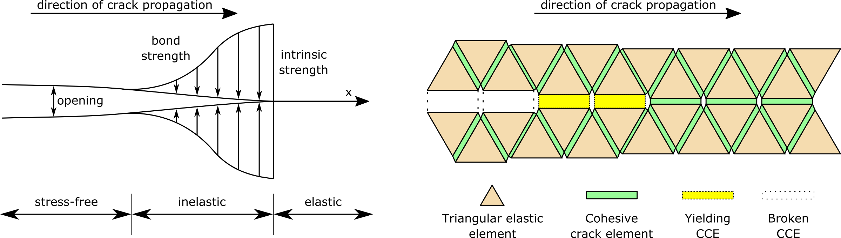

Figure 1 - Typical behaviour of cohesive crack elements in FDEM (adapted from Lisjak et al. [22]).
The CCE undergoes elastic deformation according to the stress conditions, and once the stress within the elements overcomes the intrinsic strength of the material, the displacement-based yielding and failure process initiates [27]. This process is simulated by explicitly modelling crack initiation and propagation using softening and breakage of the CCE, allowing the model to transition from a continuum to discontinuum (Figure 1) [22, 27]. As the simulation progresses, finite displacements and rotations of the discrete bodies are allowed and new contacts are recognized [27].
  - Voronoi diagrams
Voronoi diagrams are extensively used in computational geometry and have been already adopted for representing polycrystalline materials at the grain scale [1, 9, 30]. Voronoi diagrams have several distinct advantages: first, they can be defined analytically and numerically to possess unique geometrical properties; secondly, the polygons are a convex set that are confined in the domain in which they exist (i.e. collectively exhaustive as every point within the domain is assigned to a seed); and lastly, they are mutually exclusive except for their boundaries (i.e. two adjacent tessellations do not overlap but share a boundary). These unique geometrical properties translate into Voronoi diagrams being an adequate morphological generator for polycrystalline structures, as the grains fill up the entire domain; furthermore, the seeds are fixed at their spatial position during the growth process resulting in no overlapping between the grains [1, 31–33]. Adaptation of such modelling techniques can help evaluate the impact of the morphological changes and mineral grain properties on crack initiation and crack propagation.
In this work, Voronoi diagrams (Figure 2a) are created from points (Voronoi seeds) placed inside defined domains using a Poisson random point process [33]. An edge in Voronoi diagrams is created by constructing a perpendicular bisector to the line connecting two adjacent Voronoi seeds. The line connecting the intersections of these lines (i.e., Voronoi vertex) enclose the initial region. With the initial regions established, a regularization process removes all the small edges of the Voronoi regions smaller than a user defined value (e.g. smallest grain size). Removing these small edges can reduce the pathological behaviour of the subsequent mesh of the FDEM model and avoid the need of excessive mesh refinement. However, it also causes geometric distortion, which is resolved by a two-step process: new vertex positioning and new region interpolation [33]. Figure A 1 in the Appendix illustrates the two-dimensional (2D) regularization process. This process is iterative and terminates when all edges meet the defined threshold, or the maximum number of user defined regularization loops has been reached.
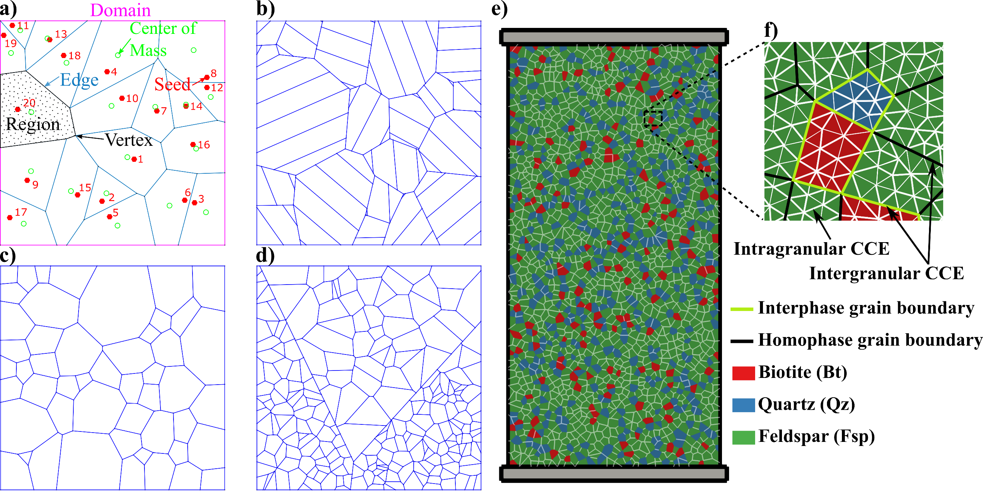
Figure 2. (a) Typical elements of a Voronoi diagram. The red dots indicate the seed location within the domain (magenta) and the green circles indicate the center of mass of the Voronoi region. (b-d) Voronoi diagrams with different grain level microstructures: (b) lamellar twining, (c) combination of grains with different sizes, and (d) pulverized grains. e) shows the simulated model, indicating the various types of mineral phases and grain boundaries used in the simulation. f) shows a zoomed in view of the grain boundaries and CCEs.

GBM IN FDEM
  - Grain and Grain boundary modelling
Minerals exist in various crystal forms that are determined by factors such as the crystal structure (internal factors), and the condition of the crystal growth process (external factors, e.g. temperature and pressure). Voronoi tessellations can be used to numerically reproduce those conditions, thus represent resulting crystal morphologies such as cleavage and lamellar twinning (Figure 2b-d), which are common emergent morphological properties from crystal structures [34].
Neper (version 2.0.5), an open-source software for polycrystal generation and meshing, capable of generating multiscale tessellations, was used to create the initial Voronoi regions [33], while the GBM structure for the FDEM model was built with a new graphical user interface (GUI) coded in Python 2.7.12. An instance of the GUI and the associated codes are provided as supplementary materials. Using the GUI, the simulated sample domain is first divided into Voronoi regions based on the predefined number of Voronoi seeds (i.e., number of grains). These regions represent mineral grains, and their associated mineral phases are randomly assigned according to the mineral composition of the actual sample. Then the GUI parses through the data to define and group the boundaries between grains. Lastly the GUI compiles the GBM model data as a coherent geometry file. The GBM geometry is then meshed into triangular elements, using Gmsh 2.12.0 [35], to create a model compatible with the FDEM simulation software IRAZU [36] (Geomechanica Inc., version 3.1.0).
In our GBM representation grain boundaries are either interphase boundaries or homophase boundaries. These two types of boundaries are simulated using CCEs characterized by lower strength properties (i.e. intergranular CCEs) compared to CCEs inside grains (i.e. intragranular CCEs). This approach, as elaborated in Figure 2f, enables both types of grain boundaries to be simulated, and it also allows for the capturing of the heterogeneity of the fracture system caused by the heterogeneity of the mineral phases and grain size.
  - Model generation
A series of compression test simulations on a Stanstead granite model were carried out to demonstrate the applicability of GBM in FDEM. The heterogeneous composition of the sample and the access to reliable experimental data [23] make it an adequate verification model for GBM. The 2D synthetic sample was simulated in uniaxial compression and under different biaxial conditions.
The synthetic sample (Figure 2f) has a rectangular cross-section of 54 mm in width and 108 mm in height. Considering that the average mineral grain size in the tested Stanstead Granite ranged from 0.25 to 4.5 mm [37], the heterogeneity and spatial distribution of the mineral phases in the synthetic samples was generated by Poisson random point process following a Gaussian distribution of a set of 2,000 seeds. Each seed was assigned a different weight, i.e. a minimum permissible distance between two seeds, having a mean of 0.5 mm and a standard deviation of 0.1. This division generated Voronoi diagrams with equivalent grain size ranging between 0.76 mm to 2.98 mm, having an average grain size of 1.90 mm. Moreover, two rectangles, slightly wider than the sample, were created at the top and bottom of the sample to represent loading platens. For clarity, the color scheme shown in Figure 2f will be adopted throughout this paper.
The model was meshed using an unstructured 2D Delaunay mesh into 74,823 triangular elements having an average element size of 0.5 mm. The mesh sensitivity analysis (Figure A 2) showed that this value represented an acceptable compromise between computational demand and numerically accuracy, while adhering to the smallest edge of the grain morphology. The mineral composition of the synthetic Stanstead granite sample was: 71 % feldspar (Fsp), 21 % quartz (Qz), and 8 % biotite (Bt). Table 1 presents the properties of each mineral phase and interphase boundaries which were adopted from Mavko et al. [38], Mahabadi [23], and Zhao et al. [21]. The numerical parameters assigned to the homophase boundaries of the model were obtained using an iterative calibration procedure [39] until the emergent macroscopic strength parameters from the uniaxial and biaxial simulations closely matched those obtained from laboratory testing [23]. The fracture parameters obtained during the calibration procedure produced plausible strength and elastic properties as well as fracture patterns; however, it remains important to emphasize that these calibrated parameters are not a unique set [39]. The simulation results used to attain the calibrated values are presented in Figure A 3. The two loading platens were assumed to be rigid and moving towards the sample at a constant velocity of 0.125 m/s each, corresponding to a strain rate of 2.31 s⁻¹. Although the simulated loading velocity is much greater than the laboratory experiment, it has been demonstrated that a quasi-static condition is ensured at the aforementioned loading velocity [23]. Confining pressures were applied to the vertical sides of the sample. In total, five simulations with confining pressures at 0 MPa (i.e. uniaxial compression), 2 MPa, 5 MPa, 10 MPa, and 30 MPa, were carried out. The simulations were run as plane strain models and a time step of 5 × 10⁻⁷ milliseconds was adopted to ensure the numerical stability of the model for the explicit time integration scheme of the code.
Table 1. Mineral phase and interphase grain boundary properties, adapted from Mavko et al. [38], Mahabadi [23], and Zhao et al. [21], and calibrated homophase boundaries.
Property (Unit) | Qz |  | Fsp |  | Bt
Composition (%) | 21 |  | 71 |  | 8
Density (kg/m³) | 2600 |  | 2600 |  | 2800
Young’s Modulus (GPa) | 83.1 |  | 56.4 |  | 17.2
Poisson Ratio (-) | 0.07 |  | 0.32 |  | 0.36
Friction Coefficient (-) | 1.27 |  | 1.27 |  | 1.27
Cohesion (MPa) | 24.2 |  | 24.2 |  | 24.2
Tensile Strength (MPa) | 11.4 |  | 5.5 |  | 42.0
Mode I Fracture Energy (J/m²) | 907 |  | 310 |  | 599
Mode II Fracture Energy (J/m²) | 1814 |  | 620 |  | 1198
Fracture Penalty (GPa) | 416 |  | 282 |  | 86
Normal Penalty (GPa/m) | 83.1 |  | 56.4 |  | 17.2
Tangential Penalty (GPa/m) | 831 |  | 564 |  | 172
 | Interphase |  |  | Homophase
Property (Unit) | Qz-Fsp | Qz-Bt | Fsp-Bt | Qz-Qz | Fsp-Fsp | Bt-Bt
Friction Coefficient (-) | 0.82 | 0.82 | 0.82 | 1.14 | 1.14 | 1.14
Cohesion (MPa) | 19.3 | 19.3 | 19.3 | 21.8 | 21.8 | 21.8
Tensile Strength (MPa) | 0.24 | 0.21 | 0.21 | 10.3 | 4.95 | 3.78
Mode I Fracture Energy (J/m²) | 0.006 | 0.0005 | 0.0005 | 680 | 232.5 | 449
Mode II Fracture Energy (J/m²) | 1451 | 382 | 382 | 1360 | 465 | 898.5
Fracture Penalty (GPa) | 282 | 86 | 86 | 208 | 141 | 43.0
Normal Penalty (GPa.m) | 56.4 | 17.2 | 17.2 | 41.6 | 28.2 | 8.6
Tangential Penalty (GPa/m) | 564 | 172 | 172 | 416 | 282 | 86
  - Post-Processing
Using GBM to simulate grains allows for the explicit tracking and tracing of the intragranular and intergranular cracks. To complement this refined geometry, a post-processing script was written in Python 2.7.12 and executed within the Paraview Python environment (pvpython) version 5.4.0-RC3. This feature is exploited in addressing mesh dependency, especially in unconfined compressive strength condition, and the quantitative analysis of the evaluation of the cracking mechanisms with change in confining pressure.
As proven by Lisjak et al. [22] FDEM models have the ability to calculate the seismic energy numerically released by any fracturing, which, at laboratory scale, correspond to acoustic emissions (AE). AE are generally used to experimentally monitor the damage accumulation in brittle materials and to map crack initiation and propagation as they occur [40], as well as to evaluate the frequency-magnitude relationship (b-value) and spatial fractal dimensions (D-value) [21, 28, 41, 42]. The use of GBM-FDEM models could allow to numerically investigate the relationship between failure micro-mechanisms, intergranular or intragranular failures, associated seismic signal, changes in confinement pressure, and to reproduce a better spatial distribution of the cracks.

RESULTS
Conventionally, the calibration procedure looks only at the strength values and the Young’s modulus, disregarding the failure mode and fracturing patterns. However, in our simulations, the emergent properties of the synthetic sample as well as the crack patterns of the GBM show great resemblance to the results of previous laboratory test results [23] and conventional FDEM simulation [21] (Figure 3a). The GBM simulation results exhibit a Class II failure in unconfined condition and under low confinement, which is typical of brittle failure in granite [43]. On the other hand, at higher confinement pressure the GBM simulation results show better prediction of post-peak behaviour than Zhao et al. [21] (Figure 3a). Macroscopically, the GBM simulations show strain weakening post-peak failure at confining pressures below 30MPa transitioning to strain hardening for higher confinements [44, 45].
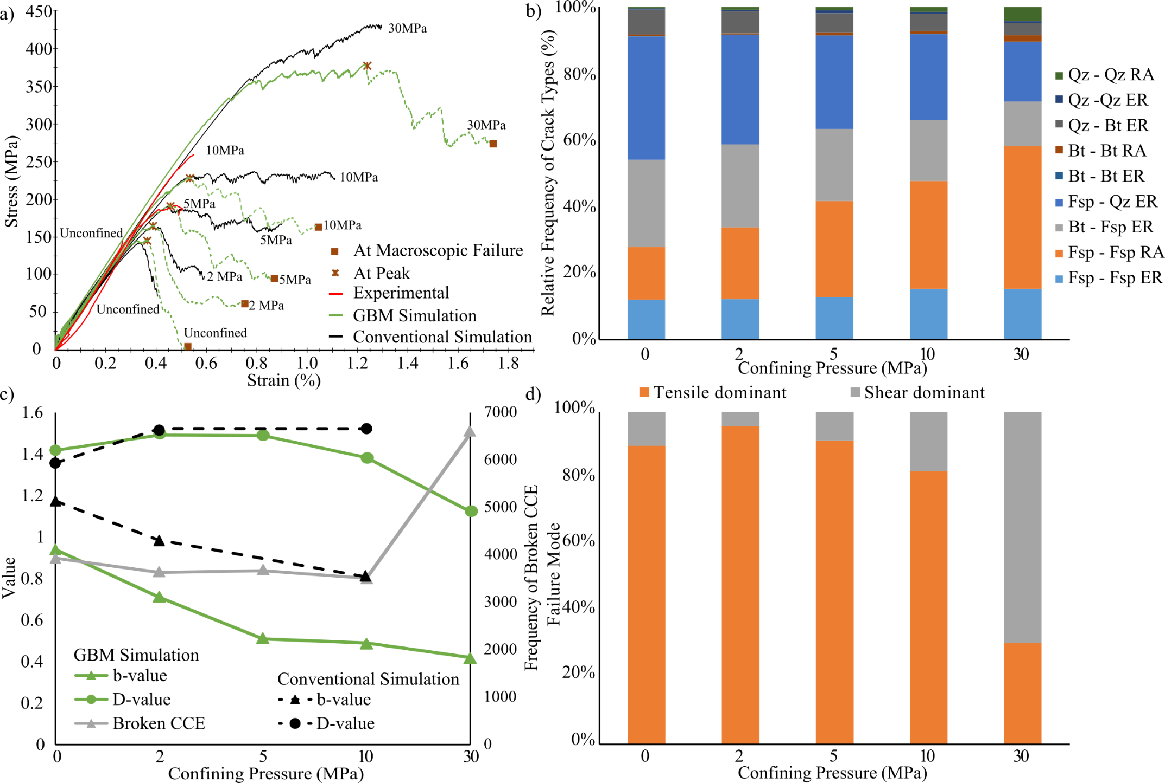
Figure 3. Results of the simulation represented as a) Comparison of stress-strain results between experimental results (red), GBM (green), and conventional simulation results (black). The dashed portion of the GBM simulations stress-strain curves indicate the post peak behaviour exclusively captured by the simulation. The brown asterisks indicate peak stress and the brown boxes indicate the macroscopic failure points. b) Influence of confining pressure, at macroscopic failure, on the crack modes. ER represents interphase cracks and RA represents intraphase cracks. c) Evolution of the b-value and D-value (green) and change in frequency of broken CCE (grey) as a function of the confining pressure for GBM simulations in comparison to the b-value and D-value (black) of conventional FDEM simulations [21]. d) Change in the dominant failure mode, at peak, with increase in confining pressure.
The results of the simulation indicate that under uniaxial conditions, cracks initiate along the grain boundaries, parallel to the direction of the loading at about 35% of the peak strength (Figure 4 - Panel A). As the sample approaches failure, there is a proliferation of microcracking, accumulating rapidly at 50–60% of the peak strength (Figure 4 - Panel A), caused by the coalescence of several intergranular cracks extending along grain boundaries. At peak stress, majority of the cracks are intergranular. The macroscopic failure occurs as several extensional fractures propagate parallel to the direction of loading. The fractures are dominated by tensile cracks along grain boundaries (Figure 3b and d) majority of which are along feldspar grain boundaries (Figure 3b, Figure 4 – Panel B and Figure 4 – Panel C). Comparison of GBM macroscopic failure fracture patterns, conventional simulations [21], and the micro-CT images of the tested laboratory samples [23] is presented in Figure 5.
Under low confinement, the process of coalescence of the cracks is similar to that of the uniaxial loading condition; however, the transition of the macroscopic failure mode from axial splitting to conjugated shear planes is due to the coalescence of several homophase, interphase, and intraphase cracks, and not to the propagation of a single crack along grain boundaries as inferred by classical GBM models. This macroscopic failure behaviour is exhibited up to a confining pressure of 10 MPa, beyond which the number of broken CCE increases substantially (Figure 3c) with the proliferation of intragranular cracks concentrated along the shear band. At higher confining pressures the microcrack coalescence is limited, leading to large scale deformation caused by the increasing amount of isolated and homogenously distributed microcracks. These cracks occur before the peak strength is reached and the shear-band localizes after the peak strength is reached (Figure 4 – Panel B).
The range of simulated AE magnitudes is comparable to laboratory scale activity recorded in the range between −7.5 and −6.8 [46]. The b-value shows a significant drop with the increase in confinement pressure between the unconfined condition and 5 MPa confinement (Figure 3c). Beyond 5 MPa the b-value decays at lower rate. The D-value increased slightly from 1.419 to 1.492, as the confining pressure increased from 0 to 2 MPa. This is then followed by a decay of similar trend to that of the b-value. These values exhibit a trend similar to those of the conventional FDEM simulations [21] (Figure 3c).
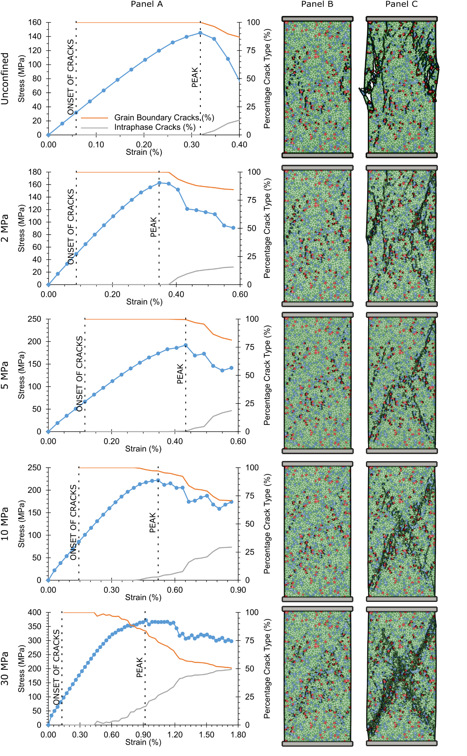
Figure 4. Simulation results, at peak and macroscopic failure, showing the transition from brittle failure at low confining pressure, to shear dominated failure along shear bands at higher confining pressure. Panel A shows the frequency of the cracks and their onset as the sample undergoes strain overlaid by the complete stress-strain curves. The orange line and the grey line represent the grain boundary and the intraphase cracks respectively. The graph clearly illustrates the increase in the frequency of the cracks as the confining pressure increases with the proportion of intragranular cracks increasing drastically above the 10MPa confinement. Panel B and Panel C illustrate the cracks at peak and at macroscopic failure respectively.
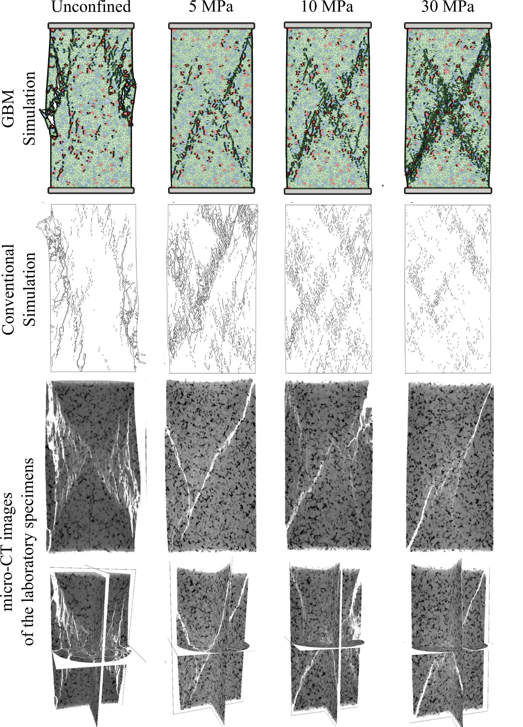
Figure 5. Comparison between the fracture patterns of GBM simulations, conventional simulations [21], and micro-CT images of the tested laboratory specimens [23].

DISCUSSION
Increasing the confining pressure causes a shift in the failure mechanism of the numerical models from tensile dominant to shear dominant microcracks (Figure 3d), a substantial increase in the frequency of the CCE breakage (Figure 3c), and a change in the proportion of the intergranular to the intragranular cracks (Figure 3b). This change in failure mechanism is also reflected by temporal variation of the failure mode, and the variation in strain at which the onset of cracking occurs (Figure 4 - Panel A).
As confining pressures increases, a macroscopic shear band develops with localized increase of the intraphase microcracks (Figure 4 – Panel C). This emergent behaviour of the model is the result of confining pressure suppressing crack propagation, meaning that cracks require more energy to grow; at very high confining pressure the coalesce of isolated clusters of microcracks along the shear band leads to a pseudo-ductile deformation [47, 48].

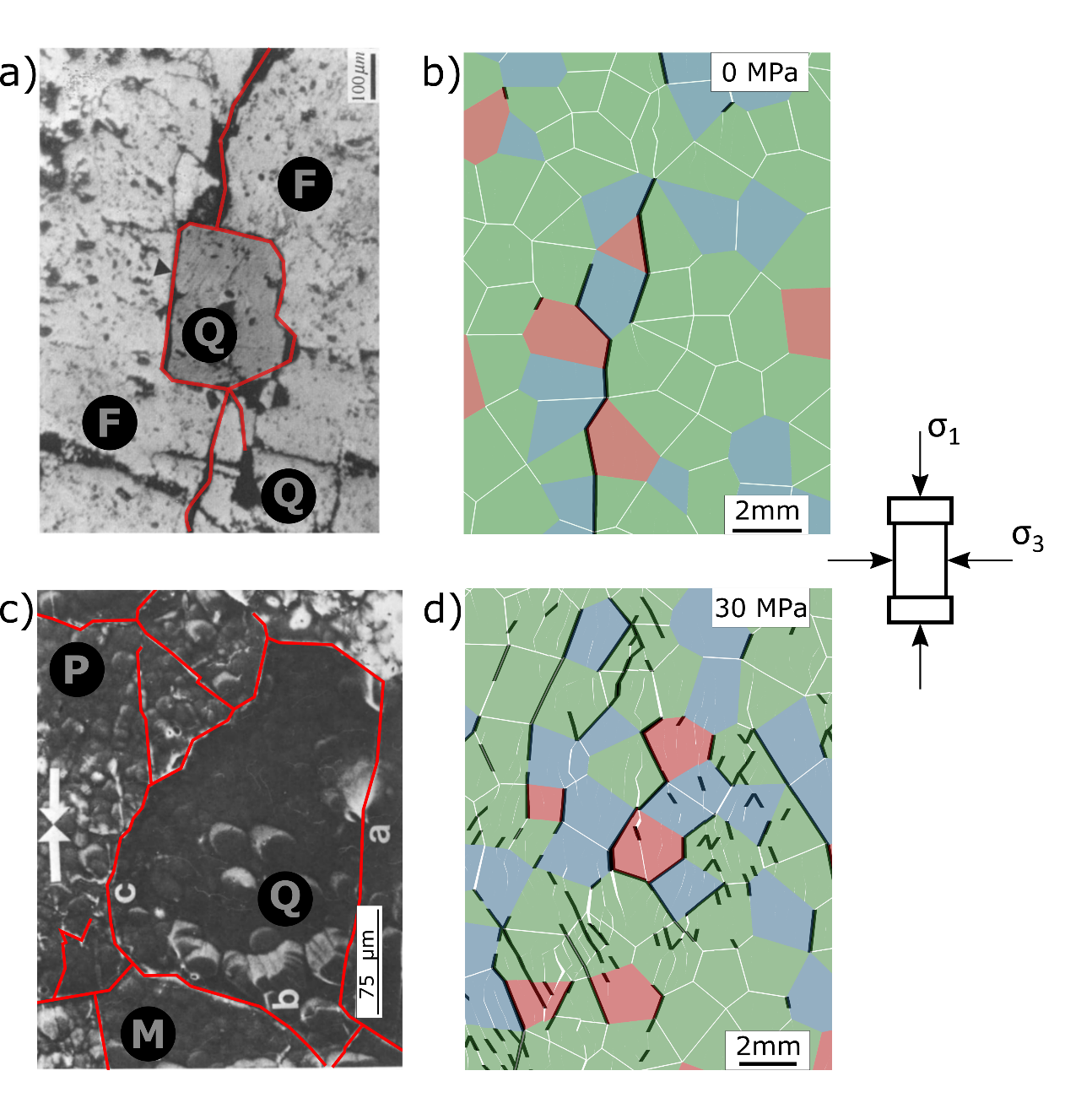
Figure 6. Comparison, at no confinement, between a) direct observation for coarse grained granite (Modified after Lee et al. [49]) and b) peak simulation results. Comparison, at high confinement, between c) direct observation for Westerly Granite at 95% of the failure strength (Modified after Sprunt and Brace [50]) and d) simulation results at peak. Red lines and black lines highlight the microcracks. Q is quartz, F is feldspar, M is microcline, and P is plagioclase.
As also directly observed by Lee et al. [49], in unconfined conditions and at low confinement pressures, the microcracks are mainly intergranular, majority of which are along the feldspar grains (Figure 6a). Under high confinement, intragranular cracking (Figure 6d) initiates from grain boundaries and develops into transgranular cracks that form isolated clusters accumulated within and around the shear band (Figure 7). Crack intersection and the formation of fragmented particles becomes predominant (Figure 7a) and is associated to the accelerated accumulation of damage manifested by significant increase in the crack density along the shear band; dominantly intraphase cracks (Figure 7a), these results are similar to those reported by Sprunt and Brace [50] (Figure 6c) and Haimson and Chang [51] (Figure 7b and d) for Westerly granite.
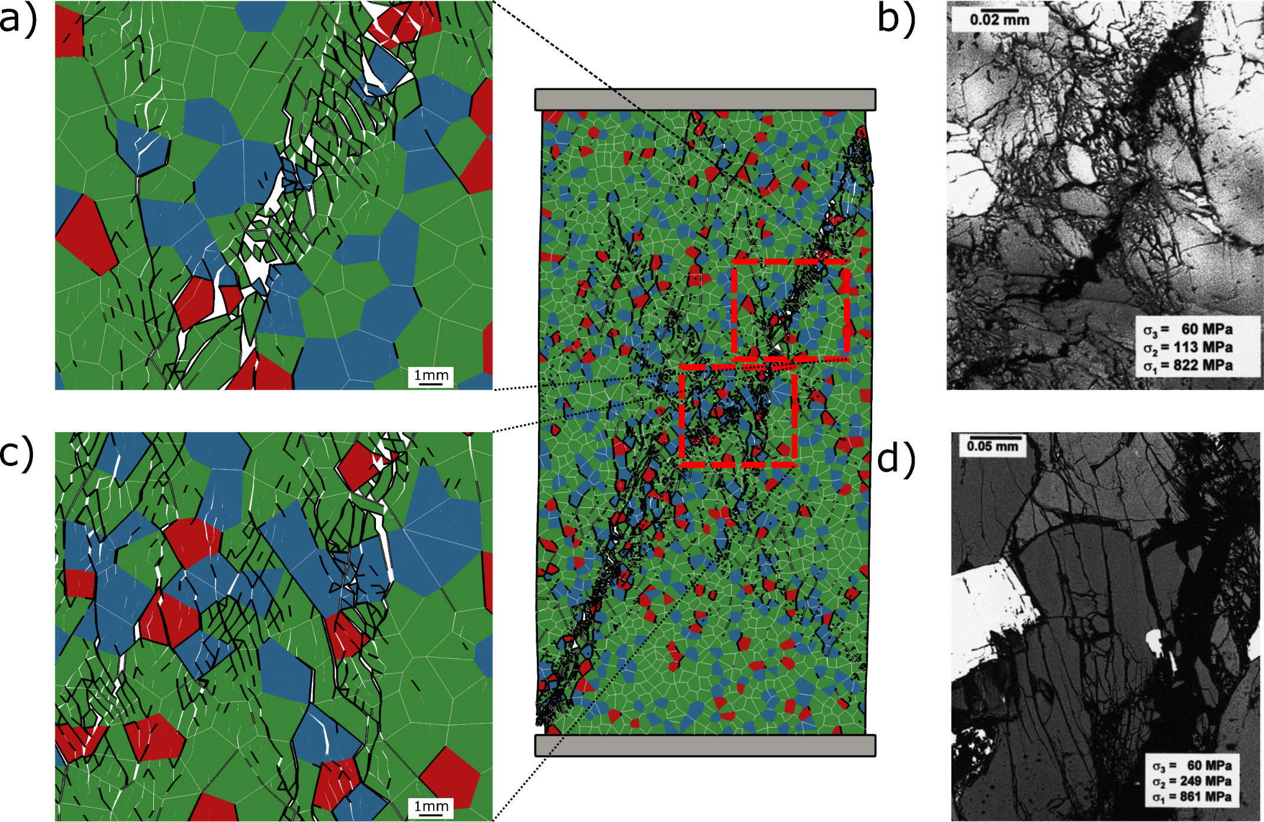
Figure 7. Post-peak simulation results at 30MPa confinement showing (a) clustering of intragranular microcracks with the formation of gouge and fragmented grains along the shear band and (c) localised clustering of intragranular microcracks. The results are compared against direct observations of Westerly granite under true triaxial conditions [51] that show (b) a segment of the main fracture surrounded by crack localization (crushed zone) and (d) localized cluster of subparallel transgranular axial microcracks with excessive breakage within the grain.
The decrease in b-value can be explained by the fact that at high confining pressure the crack growth resulted in an increasing number of intragranular cracks, less sensitive to the polycrystalline microstructure, which translated into larger magnitude AE events and were accompanied by higher crack velocities [41, 47]. On the other hand, at lower confinement and in unconfined condition, the crack growth is dominated by many relatively small events caused by the coalescence of the cracks along the grain boundaries.
The low D-value, in the unconfined condition, is an indication of a rapid and clustered failure, which does not follow the general D-value variation trend as a function of confinement. A closer look at the simulation results (Figure 4 – Panel B) indicates that the post-peak coalescence of cracks initiate as shear dominant microcracks along the edges at the bottom right of the localised failure. This increase of shear dominant microcracks can be explained as a small fragment of the rock begins chipping away and starts sliding out as the cracks coalesce resulting in a higher frequency of shear dominant microcracks than expected. The continuing decrease in b-value and D-value (Figure 3c) with the increase in confining pressure is a sign of significant crack coalesce (localization of cracks).

CONCLUSIONS
In this paper, we implemented GBM in FDEM and examined the advantages that GBM has over conventional FDEM modelling techniques. The GBM empowered FDEM models not only captured the emergent strength properties and complete stress-stain behaviour of the simulated rock sample, but greatly improved our understanding in the microscopic cracking and macroscopic fracturing mechanisms. Specifically, GBM models can simulate preferential crack growth paths at weaker grain boundaries, and the variation of such behavior at different stress conditions, which are difficult to be depicted by the FDEM classical mesh topology [39]. Our simulation results using GBM in FDEM closely represented the failure of rock material as observed in the laboratory. We demonstrated that the path of the macroscopic failure plane is a result of the combination between local stress conditions and the microstructure of the model: at low confining pressure, the cracks are locally deflected along the grain boundaries; while at high confinements, the crack patterns results are less sensitive to the polycrystalline microstructure. Thus, GBM captures both the impact of the microcracks in terms of their associated AE and the coalescence patterns, demonstrating how the model can predict realistic crack patterns.

ACKNOWLEDGEMENTS
This work has been supported through the Queen Elizabeth II Graduate Scholarships in Science and Technology (QEII-GSST), NSERC Discovery Grants 341275, and NSERC/Energi Simulation Industrial Research Chair program. The authors would like to thank Geomechanica Inc. for the use of IRAZU simulation software and their valuable inputs during modelling. The authors would also like to thank the anonymous reviewers for their constructive comments and suggestions.

APPENDIX A
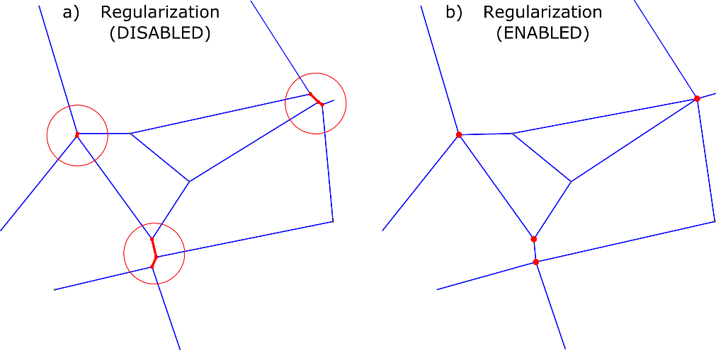
Figure A 1. The influence of regularization on two dimensional Voronoi diagram. (a) The red lines illustrated indicate edges that are below the user threshold, (b) the regularization process removes these small edges and resolves by a two-step process: new vertex positioning, and new region interpolation [33].

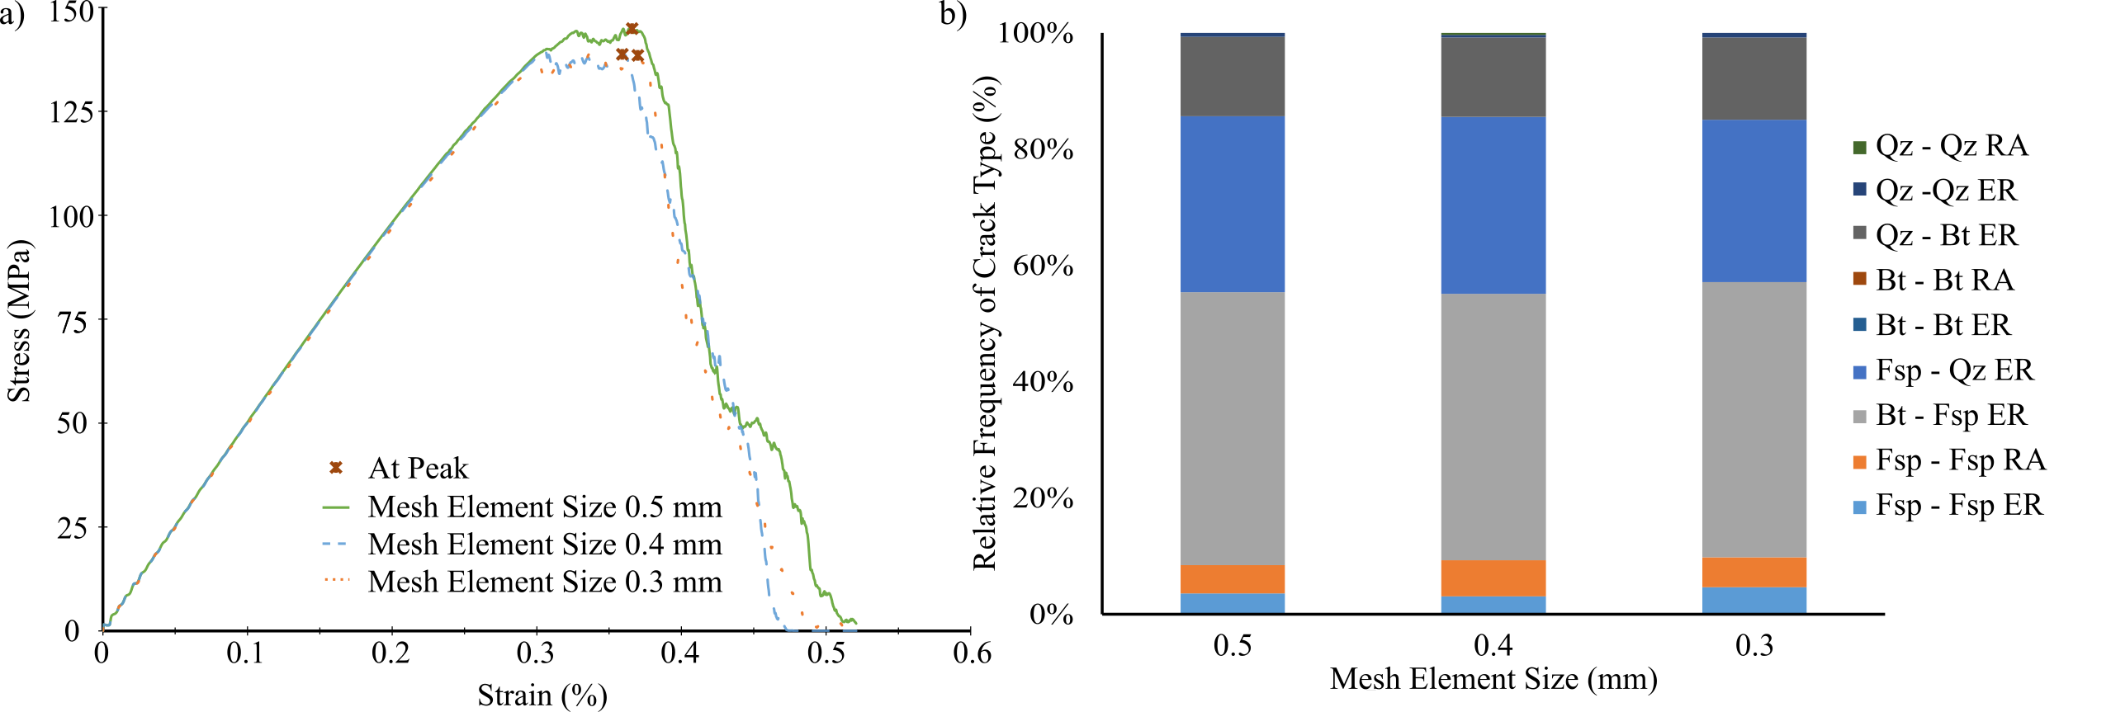
Figure A 2. Results of mesh sensitivity analysis. (a) complete stress-strain curves, and (b) comparison of relative frequency of crack types at peak. It is evident that the mesh element size does not have any significant influence on the overall strength and the relative frequency of the cracks.
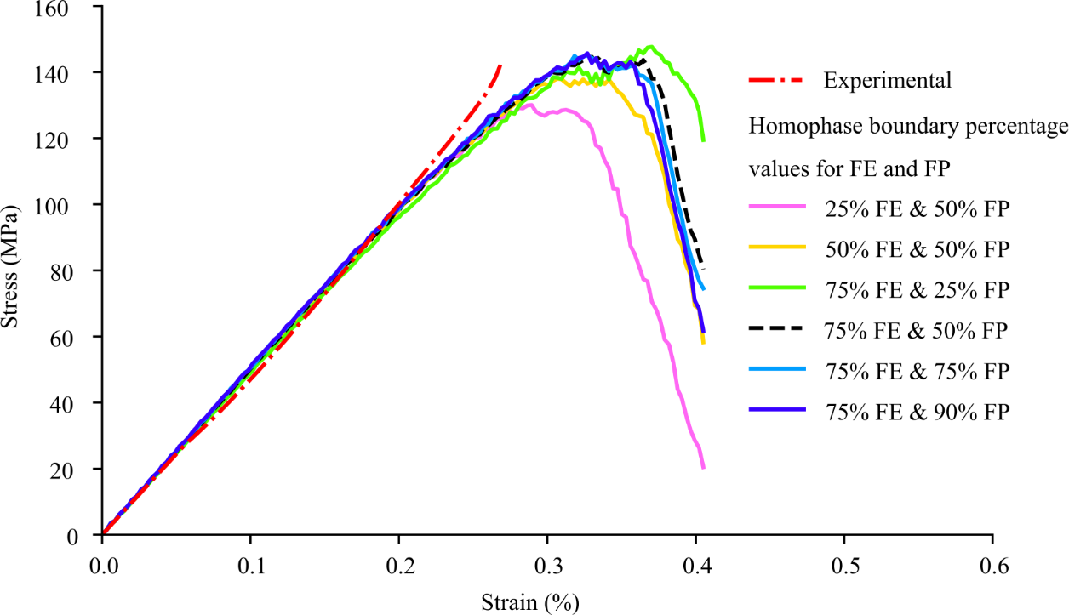
Figure A 3. The simulation results, for the unconfined condition, in the form of stress-strain curves used in calibrating [39] the homophase boundaries. The properties of the mineral phases and interphase boundaries were adopted from Mavko et al. [38], Mahabadi [23], and Zhao et al. [21] and were unchanged during the calibration process. The strength properties of the homophase boundaries, as they represent intrinsic flaws, were taken as 90% of the corresponding mineral phases. The fracture energies (FE) and the fracture penalty (FP) of the homophase boundaries were calibrated iteratively to obtain plausible emergent uniaxial maximum strength and elastic response. The iterative calibration was carried out by altering the values of FE and FP as a percentage of their corresponding mineral phases, and the values of 75% and 50%, respectively, were adopted (dashed black line). Adopting these values allowed the synthetic sample to capture the anticipated emergent response (dash-dot red line).

References
[1] Fritzen F. Microstructural modeling and computational homogenization of the physically linear and nonlinear constitutive behavior of micro-heterogeneous materials. Karlsruhe: KIT Scientific Publishing; 2011.
[2] Benedetti I; Aliabadi M. A three-dimensional cohesive-frictional grain-boundary micromechanical model for intergranular degradation and failure in polycrystalline materials. Computer Methods in Applied Mechanics and Engineering 2013;265:36–62.
[3] Falco S; Yahya N; Todd R; Petrinic N. Explicit Modeling of Crack Initiation and Propagation in the Microstructure of a Ceramic Material Generated with Voronoi Tessellation. In: Kriven WM, editor. Developments in strategic materials and computational design IV: A collection of papers presented at the 37th International Conference on Advanced Ceramics and Composites, January 27-Februrary 1, 2013, Daytona Beach, Florida. Hoboken: Wiley; 2013, p. 185–96.
[4] Griffith A. The Phenomena of Rupture and Flow in Solids. Philosophical Transactions of the Royal Society A: Mathematical, Physical and Engineering Sciences 1921;221(582-593):163–98.
[5] Kranz R. Microcracks in rocks: A review. Tectonophysics 1983;100(1-3):449–80.
[6] Simmons G; Richter D. Microcracks in rocks. The physics and chemistry of minerals and rocks 1976:105–37.
[7] Erarslan N. Microstructural investigation of subcritical crack propagation and Fracture Process Zone (FPZ) by the reduction of rock fracture toughness under cyclic loading. Engineering Geology 2016;208:181–90.
[8] Eberhardt E; Stimpson B; Stead D. Effects of Grain Size on the Initiation and Propagation Thresholds of Stress-induced Brittle Fractures. Rock Mechanics and Rock Engineering 1999;32(2):81–99.
[9] Aurenhammer F. Voronoi diagrams - a survey of a fundamental geometric data structure. ACM Comput. Surv. 1991;23(3):345–405.
[10] Potyondy D. A grain-based model for rock: Approaching the true microstructure. Proceedings of rock mechanics in the Nordic Countries 2010:9–12.
[11] Hofmann H; Babadagli T; Yoon J; Zang A; Zimmermann G. A grain based modeling study of mineralogical factors affecting strength, elastic behavior and micro fracture development during compression tests in granites. Engineering Fracture Mechanics 2015;147:261–75.
[12] Zhou J; Zhang L; Yang D; Braun A; Han Z. Investigation of the Quasi-Brittle Failure of Alashan Granite Viewed from Laboratory Experiments and Grain-Based Discrete Element Modeling. Materials (Basel, Switzerland) 2017;10(7).
[13] Bahrani N; Kaiser P; Valley B. Distinct element method simulation of an analogue for a highly interlocked, non-persistently jointed rockmass. International Journal of Rock Mechanics and Mining Sciences 2014;71:117–30.
[14] Peng J; Wong L; Teh C. Influence of grain size heterogeneity on strength and microcracking behavior of crystalline rocks. Journal of Geophysical Research: Solid Earth 2017;122(2):1054–73.
[15] Peng J; Wong L; Teh C; Li Z. Modeling Micro-cracking Behavior of Bukit Timah Granite Using Grain-Based Model. Rock Mechanics and Rock Engineering 2018;51(1):135–54.
[16] Mayer J; Stead D. Exploration into the causes of uncertainty in UDEC Grain Boundary Models. Computers and Geotechnics 2017;82:110–23.
[17] Lan H; Martin C; Hu B. Effect of heterogeneity of brittle rock on micromechanical extensile behavior during compression loading. J. Geophys. Res. 2010;115(B1):837.
[18] Gao F; Stead D; Elmo D. Numerical simulation of microstructure of brittle rock using a grain-breakable distinct element grain-based model. Computers and Geotechnics 2016;78:203–17.
[19] Gao F; Kang H. Grain-Based Discrete-Element Modeling Study on the Effects of Cementation on the Mechanical Behavior of Low-Porosity Brittle Rocks. Int. J. Geomech. 2017;17(9):4017061.
[20] Wang X; Cai M. Modeling of brittle rock failure considering inter- and intra-grain contact failures. Computers and Geotechnics 2018;101:224–44.
[21] Zhao Q; Tisato N; Grasselli G; Mahabadi O; Lisjak A; Liu Q. Influence of in situ stress variations on acoustic emissions: A numerical study. Geophys. J. Int. 2015;203(2):1246–52.
[22] Lisjak A; Liu Q; Zhao Q; Mahabadi O; Grasselli G. Numerical simulation of acoustic emission in brittle rocks by two-dimensional finite-discrete element analysis. Geophys. J. Int. 2013;195(1):423–43.
[23] Mahabadi O. Investigating the influence of micro-scale heterogeneity and microstructure on the failure and mechanical behaviour of geomaterials. Doctoral dissertation. University of Toronto, Canada; 2012.
[24] Mahabadi O; Randall N; Zong Z; Grasselli G. A novel approach for micro-scale characterization and modeling of geomaterials incorporating actual material heterogeneity. Geophys. Res. Lett. 2012;39(1):n/a-n/a.
[25] Mahabadi O; Tatone B; Grasselli G. Influence of microscale heterogeneity and microstructure on the tensile behavior of crystalline rocks. Journal of Geophysical Research: Solid Earth 2014;119(7):5324–41.
[26] Munjiza A; Owen DRJ; Bicanic N. A combined finite‐discrete element method in transient dynamics of fracturing solids. Engineering Computations 1995;12(2):145–74.
[27] Mahabadi O; Lisjak A; Munjiza A; Grasselli G. Y-Geo: New Combined Finite-Discrete Element Numerical Code for Geomechanical Applications. Int. J. Geomech. 2012;12(6):676–88.
[28] Zhao Q; Lisjak A; Mahabadi O; Liu Q; Grasselli G. Numerical simulation of hydraulic fracturing and associated microseismicity using finite-discrete element method. Journal of Rock Mechanics and Geotechnical Engineering 2014;6(6):574–81.
[29] Zhao Q. Investigating brittle rock failure and associated seismicity using laboratory experiments and numerical simulations. Doctoral dissertation. University of Toronto, Canada; 2018.
[30] Okabe A, Boots B, Sugihara K, Chiu S, Kendall D. Spatial Tessellations. 2nd ed. Hoboken, NJ, USA: John Wiley & Sons, Inc; 2000.
[31] Nygårds M; Gudmundson P. Three-dimensional periodic Voronoi grain models and micromechanical FE-simulations of a two-phase steel. Computational Materials Science 2002;24(4):513–9.
[32] Barbe F; Decker L; Jeulin D; Cailletaud G. Intergranular and intragranular behavior of polycrystalline aggregates. Part 1: F.E. model. International Journal of Plasticity 2001;17(4):513–36.
[33] Quey R; Dawson P; Barbe F. Large-scale 3D random polycrystals for the finite element method: Generation, meshing and remeshing. Computer Methods in Applied Mechanics and Engineering 2011;200(17-20):1729–45.
[34] Raith M, Raase P, Reinhardt J. Guide to thin section microscopy: University of Bonn; 2011.
[35] Geuzaine C; Remacle J-F. Gmsh: A 3-D finite element mesh generator with built-in pre- and post-processing facilities. Int. J. Numer. Meth. Engng 2009;79(11):1309–31.
[36] Lisjak A; Mahabadi O; He L; Tatone BSA; Kaifosh P; Haque S et al. Acceleration of a 2D/3D finite-discrete element code for geomechanical simulations using General Purpose GPU computing. Computers and Geotechnics 2018;100:84–96.
[37] Nasseri M; Grasselli G; Mohanty B. Fracture Toughness and Fracture Roughness in Anisotropic Granitic Rocks. Rock Mechanics and Rock Engineering 2010;43(4):403–15.
[38] Mavko G, Mukerji T, Dvorkin J. The rock physics handbook: Tools for seismic analysis of porous media. 2nd ed. Cambridge, UK, New York: Cambridge University Press; 2009.
[39] Tatone BSA; Grasselli G. A calibration procedure for two-dimensional laboratory-scale hybrid finite–discrete element simulations. International Journal of Rock Mechanics and Mining Sciences 2015;75:56–72.
[40] Nasseri M; Mohanty B; Young R. Fracture Toughness Measurements and Acoustic Emission Activity in Brittle Rocks. In: Dresen G, Stephansson O, Zang A, editors. Rock damage and fluid transport. Basel, Boston: Birkhäuser; 2006, p. 917–45.
[41] Main I; Peacock S; Meredith P. Scattering attenuation and the fractal geometry of fracture systems. Pure appl. geophys. 1990;133(2):283–304.
[42] Turcotte D. Fractals in geology and geophysics. Pure appl. geophys. 1989;131(1-2):171–96.
[43] Fairhurst C; Hudson J. Draft ISRM suggested method for the complete stress-strain curve for intact rock in uniaxial compression. International Journal of Rock Mechanics and Mining Sciences 1999;36(3):279–89.
[44] Mahabadi O; Lisjak A; Grasselli G; Lukas T; Munjiza A. Numerical modelling of a triaxial test of homogeneous rocks using the combined finite-discrete element method. Proc. European Rock Mechanics Symp. EUROCK2010 2010:173–6.
[45] Paterson M, Wong T-F. Experimental rock deformation--the brittle field. 2nd ed. Berlin, New York: Springer; 2005.
[46] Lockner D. The role of acoustic emission in the study of rock fracture. International Journal of Rock Mechanics and Mining Sciences & Geomechanics Abstracts 1993;30(7):883–99.
[47] Barber D, Meredith P. Deformation processes in minerals, ceramics and rocks. London: Unwin Hyman; 1990.
[48] Wiegand D; Redingius B; Ellis K; Leppard C. Pressure and friction dependent mechanical strength – cracks and plastic flow. International Journal of Solids and Structures 2011;48(11-12):1617–29.
[49] Lee S-E; Kim M-I; Park J-H; Park C-K; Kang M; Jeong G-C. Damage process of intact granite under uniaxial compression: Microscopic observations and contact stress analysis of grains. Geosci J 2006;10(4):457–63.
[50] Sprunt E; Brace W. Direct observation of microcavities in crystalline rocks. International Journal of Rock Mechanics and Mining Sciences & Geomechanics Abstracts 1974;11(4):139–50.
[51] Haimson B; Chang C. A new true triaxial cell for testing mechanical properties of rock, and its use to determine rock strength and deformability of Westerly granite. International Journal of Rock Mechanics and Mining Sciences 2000;37(1-2):285–96.

