The rise of real drive emission to mitigate difference of lab tests and on-road emission
S M Ashrafur Rahman^{1,*}, I M Rizwan Fattah^{2,*}, TM Indra Mahlia², Fajle Rabbi Ashik³, Mahmudul Hassan⁴, Tausif Murshed⁵, Md Ashraful Imran⁵, Md Hamidur Rahman⁶, Md Akibur Rahman⁷, Mohammad Al Mahdi Hasan⁸
¹Biofuel Engine Research Facility, Queensland University of Technology (QUT), Brisbane, QLD 4000, Australia. Email- Rahman.ashrafur.um@gmail.com Corresponding Author
²School of Information Systems and Modelling, Faculty of Engineering and Information Technology, University of Technology Sydney, NSW 2007, Australia. Email- IslamMdRizwanul.Fattah@uts.edu.au; TMIndra.Mahlia@uts.edu.au
³BUET-Japan Institute of Disaster Prevention and Urban Safety, Bangladesh University of Engineering and Technology, Dhaka, Bangladesh. Email- fajle.rabbi.ashik@gmail.com
⁴International Training Network (ITN), Bangladesh University of Engineering and Technology, Dhaka, Bangladesh. mhassan.ce.buet@gmail.com
⁵Department of Civil, Environmental, and Geomatics Engineering, Florida Atlantic University, 777 Glades Rd Bldg 36 Boca Raton, FL 33431. Email- mmurshed2019@fau.edu, mimran2020@fau.edu
⁶Asian Disaster Preparedness Center (ADPC), Rajshahi, Bangladesh. Email- sumon.adpc@gmail.com
⁷Department of Chemical Engineering, Bangladesh University of Engineering and Technology. Email- rmdakibur@gmail.com
⁸Griffith University, Brisbane, Australia. Email- mohammadalmahdi.hasan@griffithuni.edu.au

Abstract
Air pollution caused by vehicle emissions has drawn serious concern about public health. Vehicle emissions generally depend on many factors viz. nature of the vehicle, driving style, traffic conditions, emission control technologies, and operational conditions. There is an increasing concern about the certification cycles used by various regulatory authorities. This is due to the fact that exhaust emission certification procedure is carried out in chassis dynamometer for light-duty vehicles and in engine dynamometer for heavy-duty vehicles under laboratory conditions. As a result, the test drive cycles used to measure the vehicle emissions do not represent the real-world driving pattern of the vehicle. Consequently, the Real Driving Emissions (RDE) legislation is being introduced gradually to reduce the gap between type-approval vehicle emissions results and those in the real-world. To measure the key pollutants during driving vehicles are fitted with Portable Emission Measuring Systems (PEMS) that monitors those in real-time. The inclusion of RDE provisions to certification procedure will have a positive influence on the overall air quality of the world.
Keywords: Air pollution; Real Driving Emission; Driving cycles; Portable Emission Measuring Systems; Air quality.

Introduction
As the world progresses, technological development has resulted in increased emissions. In 2016, the global greenhouse gas emissions were 49.6 billion tonnes (Gtoe) CO₂ equivalent [1]. The energy sector contributed almost 3/4th of the total GHG emissions. Among this section, the majority of contributors were industry, transport and building sector. The transport sector contributes to 16.2% of global GHG emissions. Among the transport sector emission, 73.4% comes from the road sub-sector only and rest from aviation and rail (Figure 1). Passenger cars (cars, buses and motorcycles) contributed 60% of total road transport emissions come from passenger travel and road freight contributed the remaining 40%. The recent COVID-19 pandemic has shown that due to the imposed travel restrictions worldwide and reduced energy demand 6% reduction compared to 2019), the GHG emissions are set to drop by 4-8% compared, which is equivalent to 2-3 Gtoe CO₂ emissions [2]. A report claims that to achieve net-zero emission by 2050, the world needs to maintain this emission drop each year from now [3].
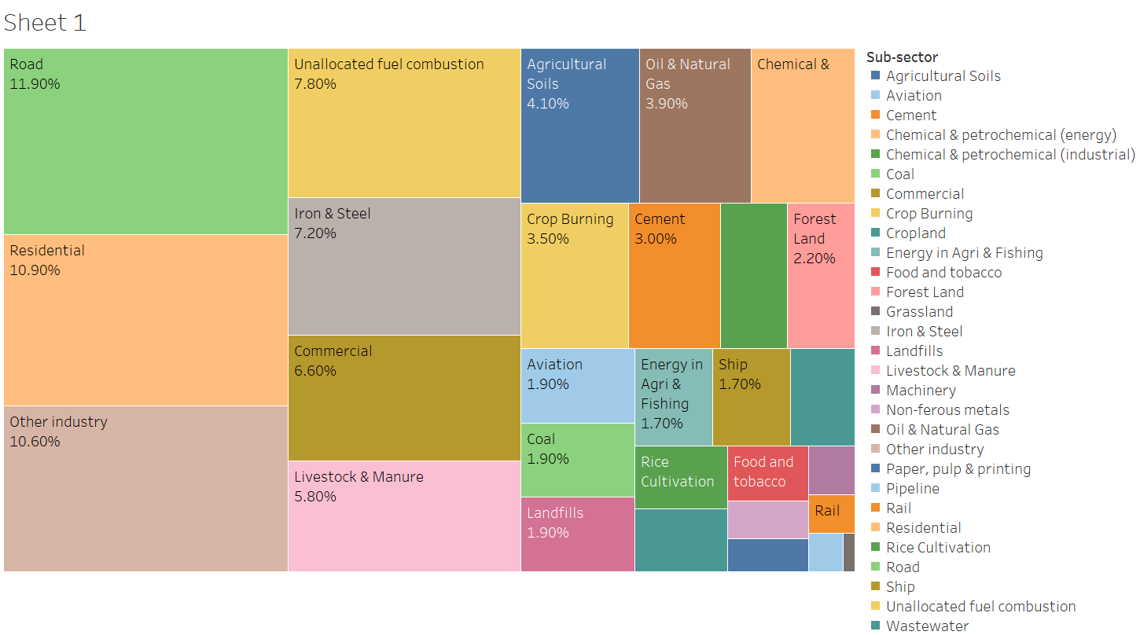
Figure 1. Greenhouse gas emission by sub-sector (2016)
Scientists around the world are trying to find a vaccine for COVID-19. There are several attempts which are very promising. Furthermore, the countries are struggling to maintain strict restrictions (which is hampering the economy). Thus, when the world returns to a normal state, it will be hard to keep the energy demand low and reduce GHG emissions. Decisive actions are needed to reduce transport emissions to achieve the zero-emission target. Thus, the vehicles that are used for everyday transport must follow the emission standards set by the regulatory body. Figure 2 shows the timeline of emission standards for passenger cars for Europe, the United States, China and Japan [4].
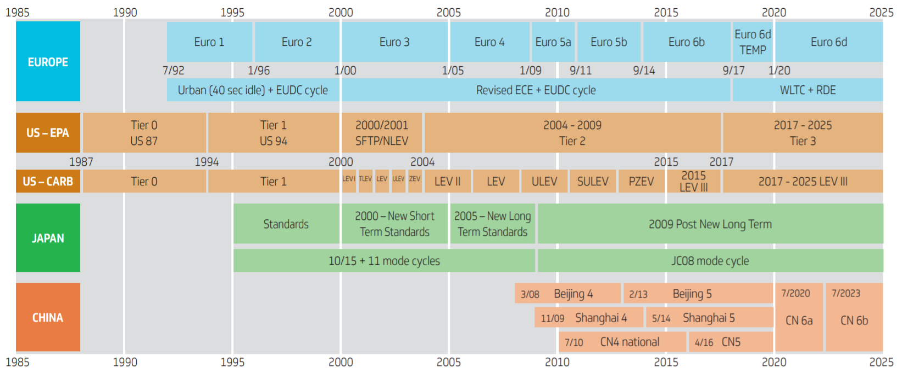
Figure 2. Timeline of emissions standards for passenger cars
There is on-going concern about public health because of air pollution caused by vehicle emissions. It is well recognised that air pollution is a primary risk factor for chronic non-communicable diseases [5]. It is estimated that air pollution will have more impact on global morbidity and mortality than all other known environmental factors combined. Vehicle emission depends on several factors such as nature of vehicle, driving style, traffic conditions, fuel quality and specification, emission control technology, and ambient and operational conditions [6, 7]. These factors determine the amount of pollutant emitted during the driving interval and can not be replicated through engine test cycles. Hence, these pave the way for vehicle development and the consequent recent advance of the vehicle technology and emission control strategies.
The emission levels produced by any vehicle are dependent on the mode of operation and the technology behind the vehicle design [8]. This also depends on driving behaviour and traffic conditions—several factors such as changing lanes, overtaking or merging results in increased engine loads [9]. As a result, the engine operates in a rich fuel-air ratio and thus increases emission [10]. Furthermore, vehicle acceleration and speed also affect emissions. Vehicle acceleration significantly impacts CO and HC emission, especially at high speeds and low vehicle speed in congested traffic results in increased emission. Auxiliary loads such as air conditioning system can increase CO and NOx emission and sometimes results in double emission. Road type is another critical factor, e.g., hill ascents result in high NOx emission. Also, horizontal curvature of roads and roundabouts increases engine load and thus results in increased emission. The test cycles employed to measure the emissions should adequately represent the real-world driving pattern of the vehicle to provide the most realistic estimation of these levels. However, there is an increasing concern about the representative test cycles used by the various vehicle certification and regulatory authorities [9].

Vehicle and engine test cycles
Vehicle emission is one of the primary sources of greenhouse gas (GHG) emission, which contributes to atmospheric pollution in modern cities [11]. The increasing number of passenger cars, especially during the last decade, resulted in a composite traffic problem with severe consequences in terms of vehicular emissions. From the advent of 60s, vehicles are being tested to check their compliance with the standards using standardised tests [12]. These have been known as driving/drive cycles or transient cycles or test cycles. Even though these three terms are used in the literature interchangeably, they might not mean the same test procedures or parameters. Driving test cycles involve testing the whole vehicle and typically comprise of a series of data points representing a speed-time profile that is representative of urban driving [13-16]. In particular, the test cycle consists of a series of test points, where the vehicle in question has to follow a certain speed (Figure 3.a) or a certain rotational speed for the test engine (Figure 3.b) at each point. Thus, in this regard, test cycles are primarily classified as, (a) chassis dynamometer cycles used for vehicle testing, and (b) engine dynamometer cycles used for engine testing. Chassis dynamometer cycles are further classified into simplified 'modal' type and 'true' transient types [12].
In contrast, engine dynamometer cycles are classified as either steady-state type or transient type. It is often impractical to the whole vehicle for heavy-duty and off-road vehicles. As a result, engine tests cycles are carried out for exhaust emission certification procedure in these cases. This is performed in an engine test-bed following a pre-determined speed-time pattern, and the emission results are usually presented in g/kWh. Test cycles typically last from a few minutes to 30 min, with even lengthier cycles being developed. Applying transient cycles for test cycle has an advantage of a relatively wide range of operation in terms of load and speed, which also accounts for serious discrepancies experienced during abrupt speed and load changes. It should be noted that the main objective of a transient cycle is to establish the total amount of emissions and fuel consumption and not indicate the specific parts or conditions under which these results are generated.
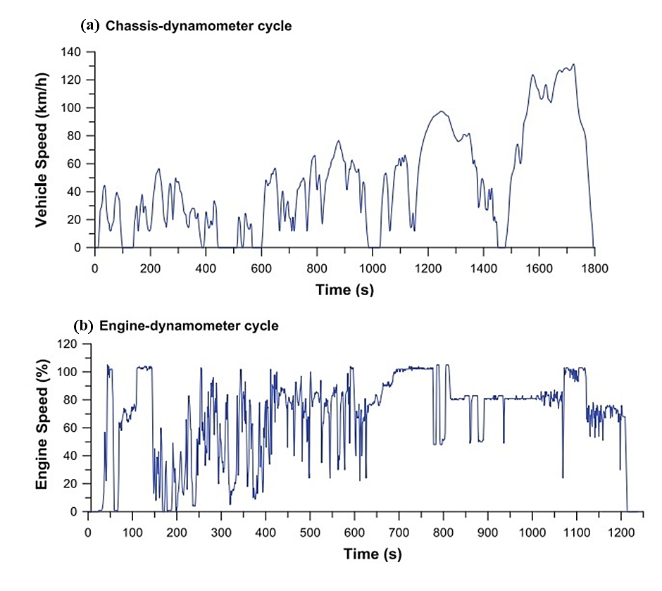
Figure 3. Typical (a) vehicle speed-time cycle for light-duty vehicles and (b) engine speed-time cycle for engine-dynamometer testing [17]
Driving cycles are of crucial importance. In many parts of the world, these cycles serve as a standardised measurement of performance of vehicles in terms of pollutant/ CO₂ emissions and fuel consumption/economy during type approval, i.e. certification procedure. In fact, emission standards strongly rely on the driving cycle and test procedure employed. Manufacturers often design and calibrate their vehicle using the standards set by the test procedures, so that the vehicles meet the standard. This standardised test makes it possible to compare vehicles/engines from different manufacturers under the same operating conditions. Other applications of driving cycles include providing a long term premise for design, tooling and marketing to vehicle manufactures [18]. These also help traffic engineers in designing traffic control systems considering traffic flows and delays [19]. Environmentalists can negotiate specific driving patterns to reduce pollution generated based on these cycles [20]. Another use for driving cycles is in vehicle simulations where these can provide a convenient mean to estimate pollutant emissions and fuel consumption of vehicles within the respective urban areas [14, 19].

  - Chassis dynamometer cycles
As mentioned previously, chassis dynamometer cycles are either modal type which was developed initially or transient type which was adopted at a later stage. Driving surveys were conducted to create a driving cycle in the early 50s. Due to limitation in measurement capabilities, limited modes of driving were identified such as idle, constant rate acceleration, acceleration from and up to specific vehicle speeds, driving at a steady speed and deceleration at constant rates. However, these are often not compatible with real-world driving practice which would result in erroneous emission results. Thus, chassis dynamometer cycles evolved to a sophisticated transient type cycle to represent the driver pattern accurately. These cycles are developed based on collected data from instrumented vehicles analysed appropriately. The other purposes of these cycles include assessing the performance of emission control mechanisms and testing emissions for different types of vehicles [21]. Sophisticated experimental facilities such as automated dynamometer test-bed, fast response exhaust gas analysers, dilution tunnels, etc. are required for the execution of a driving cycle in a laboratory. Figure 4 shows a setup for chassis dynamometer testing. These cycles act as a standard test procedure pollutant and CO₂ emissions and influence the manufacturer's engine calibration procedure heavily. In this regard, there is a strong relationship between the legislated test and anti-pollution measures of modern vehicles. These tests are often carried out in laboratories where technicians can control the influencing variables, e.g. ambient temperature and vehicle speed and eliminate unwanted effect such as weather variables. This ensures the reproducibility of the obtained results making the testing vehicle results comparable and certification process reliable.

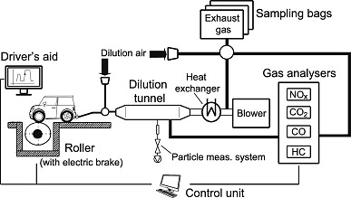
Figure 4 Chassis dynamometer testing setup
  - Engine dynamometer cycles
The cycles mentioned earlier is generally employed to passenger cars, light-duty vans and trucks, and motorcycles where the whole vehicle can be handled easily. However, it is very demanding for heavy-duty vehicles (HDVs) such as buses, trucks, and off-road vehicles to be tested in a chassis dynamometer due to their size and weight. As such, the exhaust emission certification for these vehicles are usually performed on an engine and carried out in an engine dynamometer. The focus is on engine testing because in most cases, they are not designed together, and there might be a multitude of vehicle and engine combination. Advantages and disadvantages of chassis dynamometer and engine dynamometer testing for heavy vehicles is shown in Table 1. This test involves running the engine on a dynamometer over a range of load and speed set points and measuring the emissions according to the predefined procedure [22]. The emission results during engine testing are usually expressed in terms of g/kWh or g/HPh.

Table 1. Advantages and disadvantages of testing of heavy-duty vehicles in different dynamometer setups [12, 23]
Test Method | Advantages | Disadvantages
Chassis dynamometer | - Any vehicle configuration can be tested such as a vehicle with various transmissions  - The vehicle components can be tested as a whole system | - High capital cost for chassis dynamometer setup  - Limited availability of adequate test facility  - Inconsistent with emission targets as they are based on engine dynamometer testing  - Each vehicle category would require separate emission limits
Engine dynamometer | - Cost reduction due to the fact that one engine can be used for a variety of applications  - A single set of emission limits for various applications | - Coupling an engine on a dynamometer is more time consuming  - Drive train subsystems such as transmission and emission control devices can not be tested  - Test results might differ during the certification process

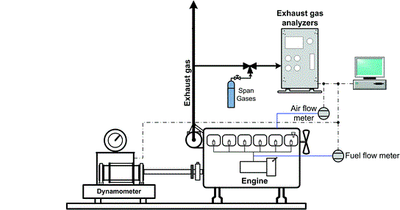
Figure 5 Engine dynamometer testing setup

Test drive cycles
Regulatory and certification authorities often use two basic philosophies when designing a driving cycle [9]. In the first philosophy, the driving cycle consists of a sequence of repetitions of a combination of several vehicles operating modes that are representative of driving models. The Economic Commission for Europe (ECE) and Japanese cycles were designed based on this philosophy. In the other one, the driving cycle consists of a combination of driving modes is a simulation of an actual route. Australia, Canada, United States, Sweden and Switzerland uses this philosophy in their driving cycles.

Passenger and Light-duty vehicles
This section presents essential driving cycles used for light-duty vehicles (LDVs), including passenger cars and is performed in a chassis dynamometer. The work on emission test procedures for LDVs started in Europe in the mid-50s and the first emission standards and test cycles were legislated in the late 60s. However, these cycles were only limited to gasoline engine power vehicles. Even though the cycles were modal at the initial stage, those evolved to a transient form later and included diesel engine powered vehicles as well. In particular, this section will focus on the most important drive cycles from Europe, Australia and worldwide for testing passenger cars and light-duty trucks.

Europe
As mentioned previously, the driving cycle for the certification procedure of LDVs has been in effect in Europe for many decades now [24]. Figure 6 shows the timeline of European test cycles for type-approval (TA). This cycle was initially known as ECE and was devised to represent city driving conditions. The ECE is an urban driving cycle (UDC) and is characterised by low vehicle speed, low engine load, and low exhaust gas temperature. The EUDC (Extra Urban Driving Cycle) portion has been added after the fourth ECE repetition to account for more aggressive, high speed driving modes. The ECE+EUDC cycle, also known as MVEG-A (Motor Vehicle Emissions Group) cycle, was introduced with the Euro 1 emission standard in 1992. From 2000 this has been termed as New European Driving Cycle (NEDC). The cycle consists of a phase representing ECE15 and a phase representing EUDC [9]. Figure 7 represents the speed profile of the ECE+EUDC/NEDC driving cycle. These cycles were valid from 1970 to 2017. In ECE+EUDC, an idling period of 40 s was present before the commencement of cycle, and the beginning of sampling. In NEDC, the start of the cycle and the sampling begins simultaneously with the cold engine start. Many researchers showed that NEDC does not represent the actual driving behaviour of a vehicle in real traffic due to many constant-speed and constant-acceleration segments [15, 25, 26]. Thus, NEDC does not accurately reflect real-world pollutant emissions. Following the pressure built up by the diesel emissions scandal (known as 'dieselgate') in 2015, Worldwide harmonised Light-duty Test Cycle (WLTC) following World-wide harmonised Light-duty Test Procedure (WLTP) was adopted in July 2017 for European TA system (Regulation 2017/1151, 2017) [27]. The rollout to WLTP started in September 2017, and any vehicle registered from the start of September 2018 needed a WLTP rating.

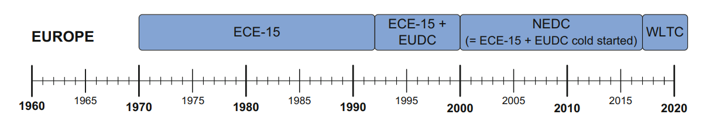
Figure 6 Timeline of European test cycles employed for tailpipe emission TA
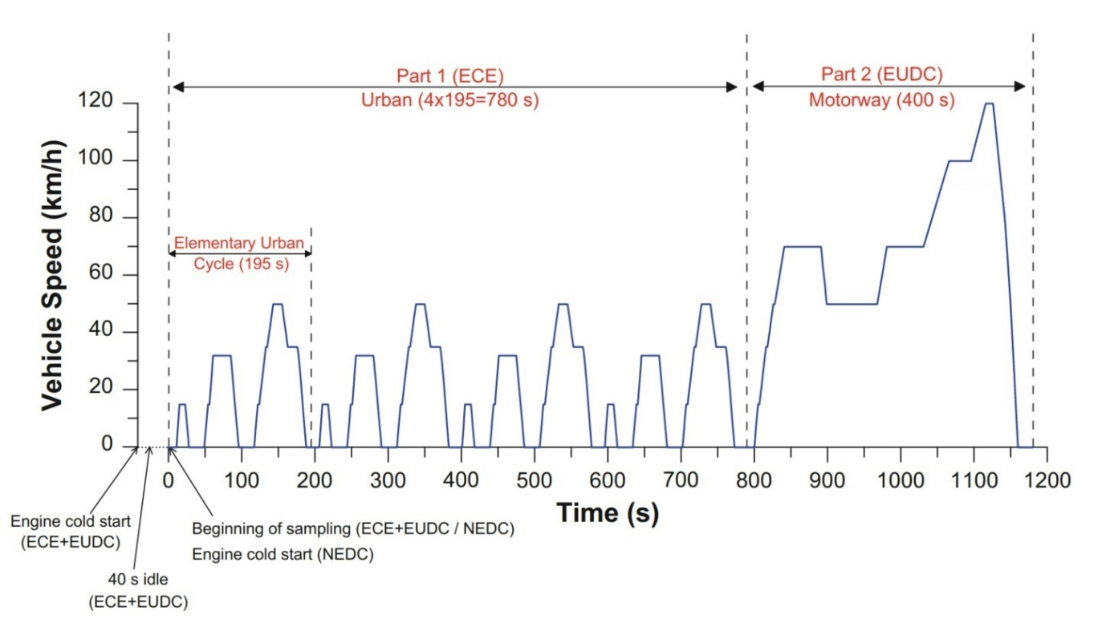
Figure 7 Speed profile of the ECE+EUDC/NEDC driving cycle [28]

United States
The EPA Urban Dynamometer Driving Schedule (UDDS) is commonly called the "LA4" or "the city test". This cycle became the standard driving cycle for TA of LDVs in the United States since 1972, as such known as Federal Test Procedure-72 (FTP-72). It is primarily used for LDV testing where those were defined as 'any motor vehicle either designed primarily for the transportation of property and rated at 6000 lbs GVW or less or designed primarily for the transportation of persons and having a capacity of 12 persons or less' at the time of its implementation [29].
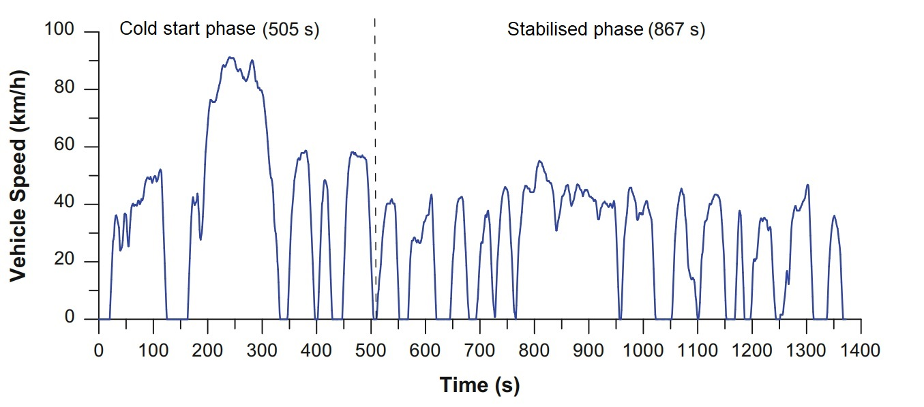
Figure 8 Speed profile of the EPA UDDS/ FTP-72
Another cycle used for LDV certification is the FTP-75 cycle (also known as EPA75) which is derived from the FTP-72 and was introduced in 1975. Since then it has been the 'primary' cycle used in the US for TA of LDVs. FTP75 was formulated by adding a third phase of 505 s, identical to the first phase of FTP-72 but with a hot start. The third phase starts after the engine is stopped for 10 minutes. Figure 9 shows the speed profile of the FTP-75 driving cycle. Diesel-engine vehicles were included as of the model year 1975 for passenger cars. This test provides a more accurate reflection of real world driving experience.
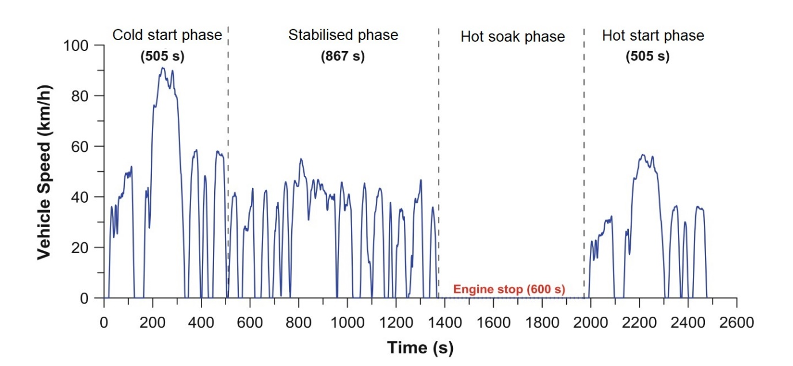
Figure 9 Speed profile of the EPA75/FTP-75 driving cycle

Australia
In Australia, the current new vehicle emissions standard for both petrol and diesel is Euro 5 [30]. The Australian Design Rules (ADRs) dictates six different class of diesel vehicles shown in Table 2. The "Composite Urban Emissions Drive Cycle" (CUEDC) was first introduced for diesel vehicles in 1998. The development of CUEDC was commissioned by the National Environment Protection Commission (NEPC) as part of the Diesel National Environment Protection Measure (DNEPM Project 2.1). This cycle comprises of four segments, each of which represents driving in a different urban traffic condition (congested, minor roads, arterial roads and highway/freeway) [31, 32]. Each of these segments has unique speed profile. They range from frequent starts and stops, with expanded idle periods for the congested flow, through to freeway driving with sustained periods of the cruise at speeds of up to 80~90 km/h, and only infrequent major changes in speed or periods at rest. In 2005, a CUEDC was developed for light-duty petrol vehicles. A "Short Petrol CUEDC" (SPC240) was also developed attempting to replicate the driving modes of the complete Petrol CUEDC in a faster and potentially easier to perform test [33].

Table 2 Australian Design Rule categories for vehicle classification[31, 32]
ADR category | Mass category  (tonnes GVM or GCM) | Vehicle description
MA/MB/MC |  | Passenger car (MA), forward control passenger vehicle (MB), and off-road passenger ≤ 9 seats (MC)
NA/MD | ≤ 3.5 | Light goods vehicle (NA) and light buses (MD)
NB/ MD | > 3.5 ≤ 12 | Medium goods vehicle (NB) and light buses (MD)
ME | > 5 | Heavy bus
NC | > 12 ≤ 25 | Goods vehicle
NCH | > 25 | Heavy goods vehicle

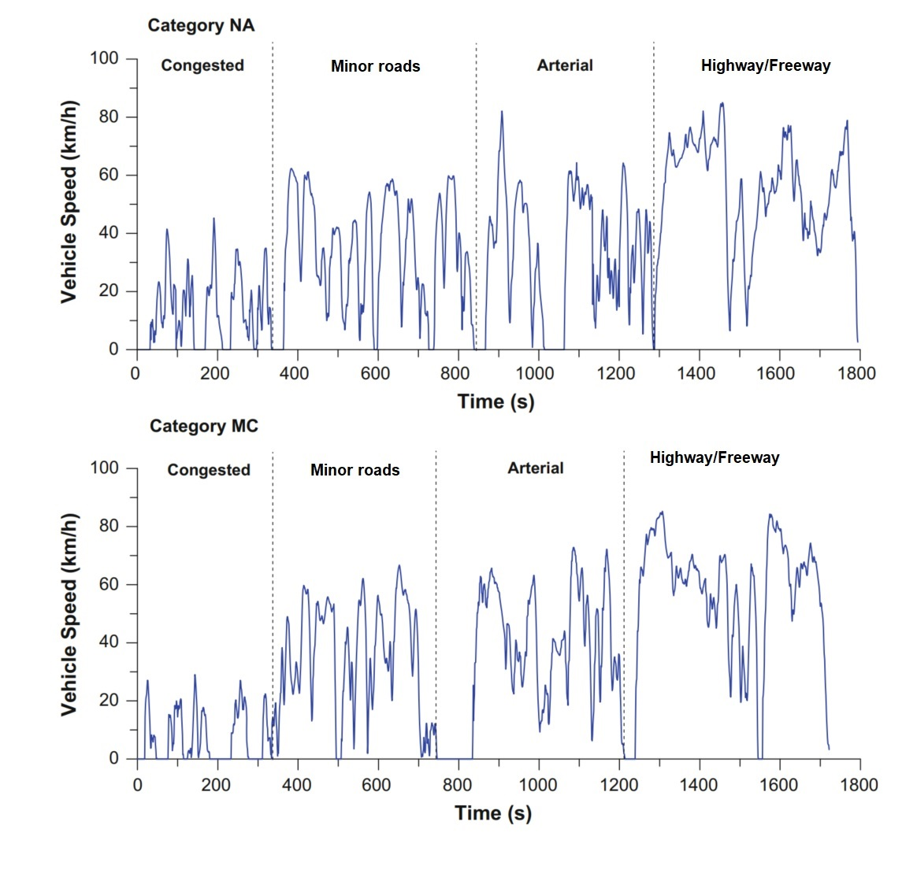
Figure 10 Speed profile of the Composite Urban Emissions Drive Cycle (CEUDC) driving cycle

Worldwide
For many years there have been efforts to harmonise testing procedures on the chassis dynamometer for LDVs [34]. In 2014 the United Nations Economic Commission for Europe (UNECE) adopted the global technical regulation No. 15 concerning the WLTP [35]. As mentioned previously, following WLTP, a new test cycle was developed known as WLTC, which is applicable to LDVs worldwide [34, 36]. As a major contributor to its development, the European Commission has introduced WLTP replacing NEDC in September 2017. A comparison between WLTC and NEDC is shown in Table 3. The WLTP vehicle classification is based on the ratio between rated power and kerb mass (pmr) [37]. Three classes of the vehicle were agreed upon: 1. Class 1: pmr <= 22 W/kg, 2. Class 2: 22 W/kg < pmr <= 34 W/kg, and 3. Class 3: pmr > 34 W/kg. Class 3 is further divided into two subclasses: Class 3a with max vehicle speed < 120 km/h and Class 3b with max vehicle speed ≥ 120 km/h. As such, three different WLTC versions were developed based on the dynamic potentials of the different classes. WLTC for 3 classes of vehicles is shown in Figure 11.

Table 3 Comparison of NEDC with WLTC (Class 3b)
 | NEDC | WLTC (Class 3b)
Cycle time | 20 minutes | 30 minutes
Cycle distance | 11 kilometres (6.83 miles) | 23.25 kilometres (14.44 miles)
Driving | 2 phases: urban driving 66%/extra-urban driving 34%. | 4 phases: urban driving 52%/extra-urban driving 48%.
Average speed | 34 km/h (21.12 mph) | 46.5 km/h (28.89 mph)
Maximum speed | 120 km/h (74.56 mph) | 131 km/h (81.39 mph)
Influence of optional equipment | The options and their impact on regulated emissions and consumption are not taken into account. | Options and their impact on regulated emissions and consumption are taken into account.
Temperature testing | Measurements are taken at temperatures between 20 and 30°C | Measurements are taken at 23°C, then at 14°C for CO₂ emissions

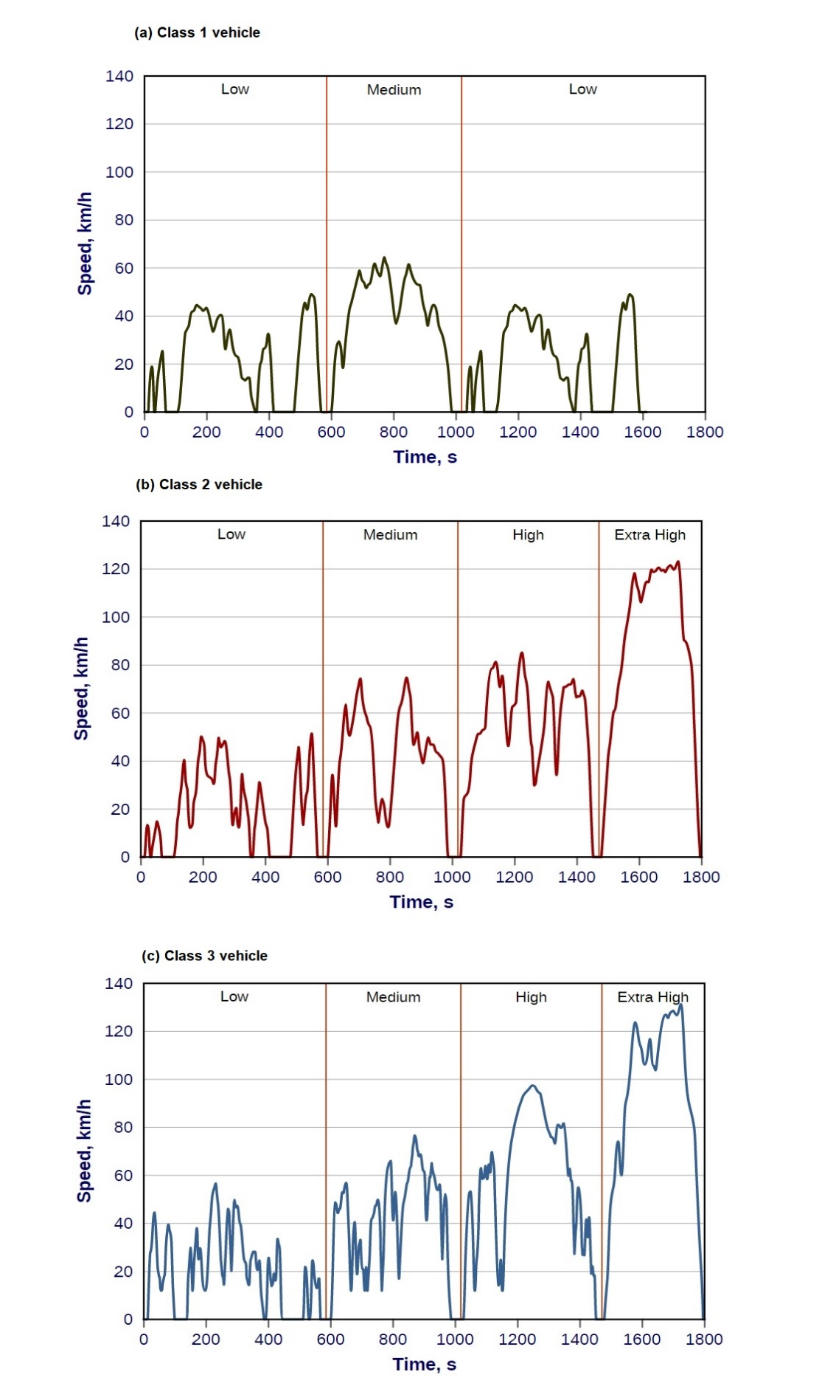
Figure 11 WLTC cycle for Class 1, Class and Class 3(b) vehicles

Heavy-duty vehicles
A heavy-duty vehicle (HDV) contributes more atmospheric oxides of nitrogen (NOx) than an LDV [21]. Since the emission testing for HDVs is more complicated due to high investment, operational and maintenance costs of the device; the HD exhaust emission TA utilises an engine cycle instead of a vehicle cycle [38]. Nevertheless, both types of cycles are still prominent for HDV testing.

Europe
A 'United Nations Economic Commission for Europe (UNECE)' Working Party on Pollution and Energy (GRPE) sub-group was tasked with developing a new exhaust emissions procedure for HDVs for implementation with the Euro III emission standard. They submitted their report on May 1996. Based on their recommendation, the 'Directive 1999/96/EC, equivalent to UNECE R49/03' of 13th December 1999, introduced a new 13-mode steady-state cycle (later termed as ESC) with an additional dynamic load response test for smoke measurements, and a transient cycle. The ESC test cycle, together with the ETC (European Transient Cycle) and the ELR (European Load Response) tests are used for emission certification of HD diesel engines in Europe starting in the year 2000 [39]. Both the ESC and the ETC were found to offer a substantial improvement over the ECE R49 test (a 13-mode steady-state diesel engine test cycle for the Euro II standard) [40].

European Stationary Cycle (ESC)
The ESC replaced the R49 beginning with the emission standard Euro III effective from 2000. The test was referred to as the OICA cycle or ACEA cycle initially. This is a steady-state engine test cycle as such the engine is tested on an engine dynamometer over a series of steady-state modes [41]. In this cycle, the engine has to be operated for the prescribed time in each mode, completing engine speed and load changes in the first 20 s. The specified speed and torque should be held to within ±50 rpm and ±2% of the maximum torque at the test speed, respectively. Emissions are measured during each mode and averaged over the cycle using a set of weighting factors and are expressed in g/kWh [39]. It has to be noted that, only the engine-out emissions are considered in this test, without any after treatment. Figure XX illustrates the sequence of the measuring point and their relative weight (%) in the ESC. The engine speeds A, B, and C are calculated based on specified parameters using preset equations.

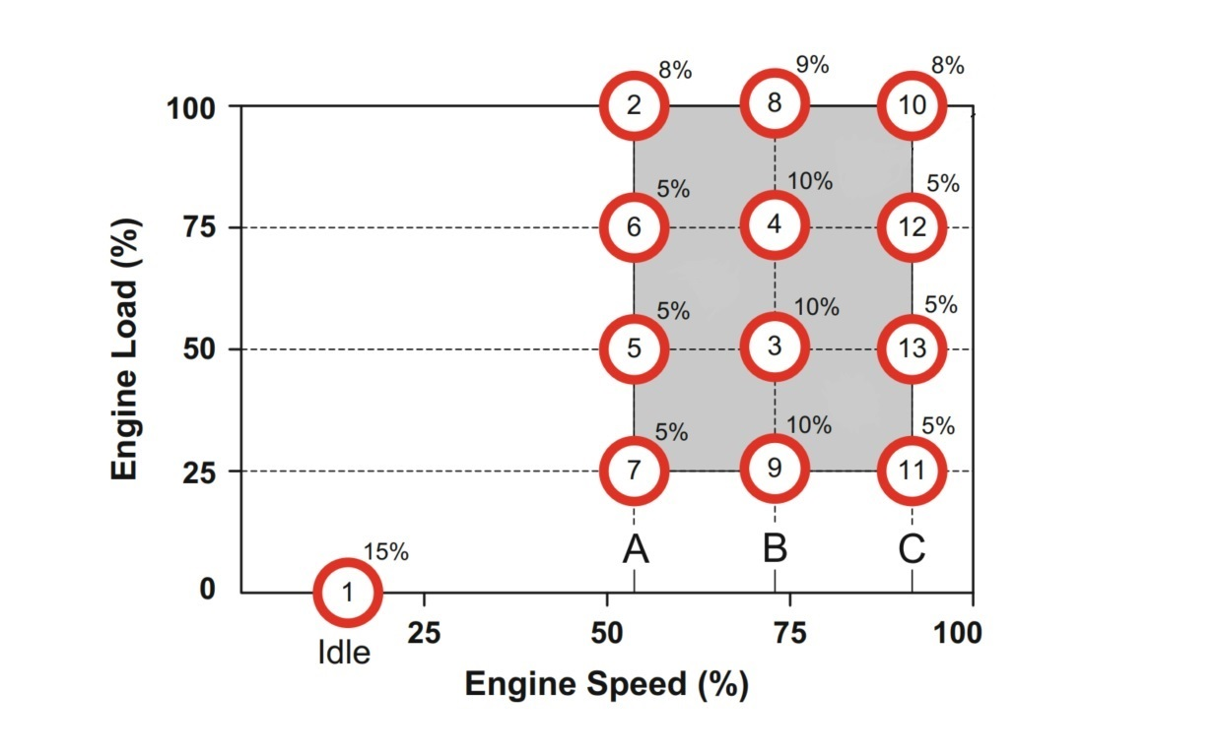
Figure 12 Sequence of measuring point and their relative weight (%) in the European Stationary Cycle (ESC) [39]

European Transient Cycle (ETC)
The ETC was the first transient HD engine dynamometer cycle in the EU for emission certification of HD diesel engines starting in 2000. The complete cycle runs for 1800 s with each phase of 600 s duration. This cycle consists of three parts and allows for a detailed examination of the response to urban (first part), rural (second part) and motorway (third part) driving conditions. The urban phase represents city driving with a maximum speed of 50 km/h, frequent starts, stops and idling. The second phase represents rural driving, starting with a steep acceleration segment and has an average speed of about 72 km/h. The third phase mimics the motorway driving with an average speed of about 88 km/h and fewer changes in engine torque than the urban and rural phases. Figure 13 illustrates normalised engine speed and normalised engine torque vs. time for the ETC Cycle [42].
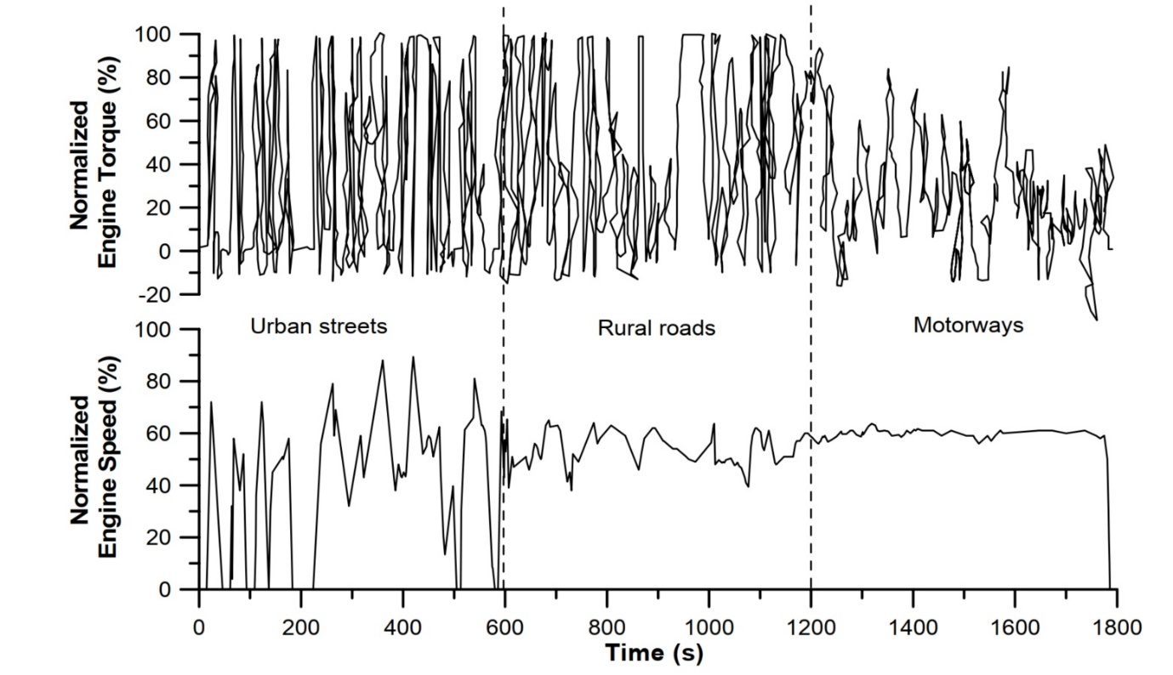
Figure 13 The European Transient Cycle (ETC) for heavy-duty engines [17]

United States
Both Chassis and Engine dynamometer tests are available in the United States for emission testing.

Heavy Duty-Urban Dynamometer Driving Schedule (HD-UDDS)
The EPA Urban Dynamometer Driving Schedule (HD-UDDS) is a chassis dynamometer cycle developed for regulatory emission testing of HDVs [CFR 40, 86, App.I]. This is different from the UDDS mentioned earlier. This test is also known as 'cycle D'. The HD-UDDS schedule was the basis for developing the FTP Transient engine dynamometer cycle mentioned later. The primary parameters of this cycle are:
- Duration: 1060 seconds
- Distance: 5.55 miles = 8.9 km
- Average speed: 18.86 mi/h = 30.4 km/h
- Maximum speed: 58 mi/h = 93.3 km/h

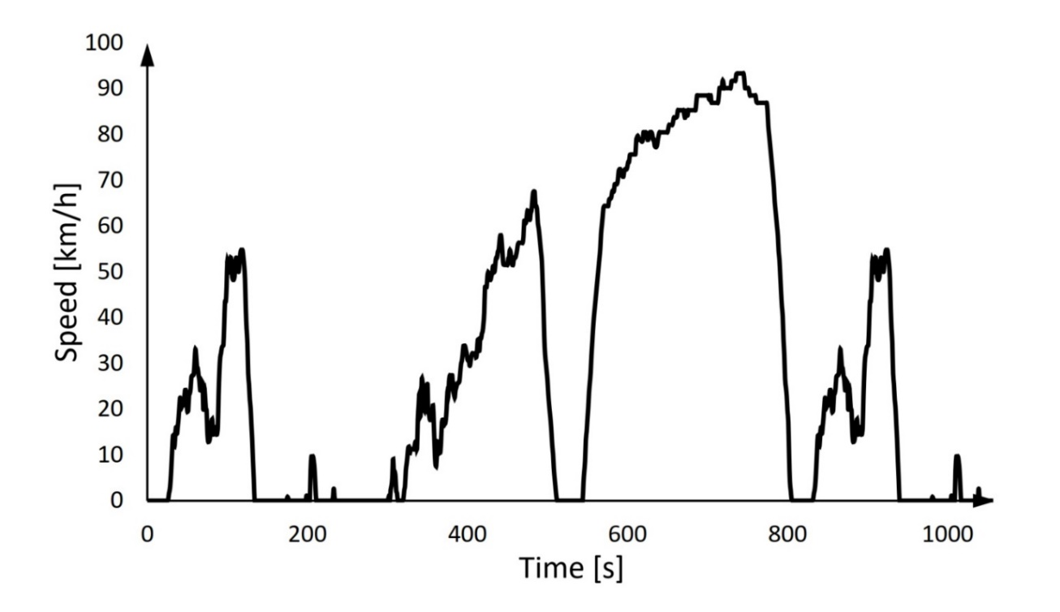
Figure 14 Speed profile of Heavy Duty-Urban Dynamometer Driving Schedule (HD-UDDS) drive cycle [43]

Transient FTP
The FTP (Federal Test Procedure) transient cycle (Transient FTP) is used for regulatory emission testing of HD on-road engines in the United States [CFR Title 40, Part 86.1333] since 1985 [44]. It was derived from data that are now three decades old and does not represent the engines with power density and turbocharger boost typical of today. The FTP cycle consists of four phases, including (1) New York Non-Freeway (NYNF) phase typical of light urban traffic with frequent stops and starts, (2) Los Angeles Non-Freeway (LANF) phase typical of dense urban traffic with few stops, (3) Los Angeles Freeway (LAFY) phase simulating dense expressway traffic in Los Angeles, followed by (4) a repetition of the first NYNF phase [45]. The cycle includes "motoring" segments and, therefore, requires a DC or AC electric dynamometer capable of both absorbing and supplying power. The equivalent average vehicle speed is about 30 km/h, and the equivalent distance travelled is 10.3 km for a running time of 1200 s. The average load factor of the FTP cycle is roughly 20-25% of the maximum engine power available at a given engine speed. Heavy duty diesel engines tested on the FTP cycle produce medium to high exhaust gas temperatures. Generally, the temperature is at a medium level between 250 and 350 °C, but there are hot sections with temperatures reaching as high as 450 °C. The variation of normalised speed and torque for diesel cycle with time is shown in Figure 15. Contrary to the European ETC (and the worldwide WHTC), two versions of the engine FTP cycle are applicable, one for diesel engines, and one for Otto-cycle engines. More specialised transient tests cycles are available in the US, for example, the Manhattan Bus Cycle, New York Composite, Central Business District, etc. [17].

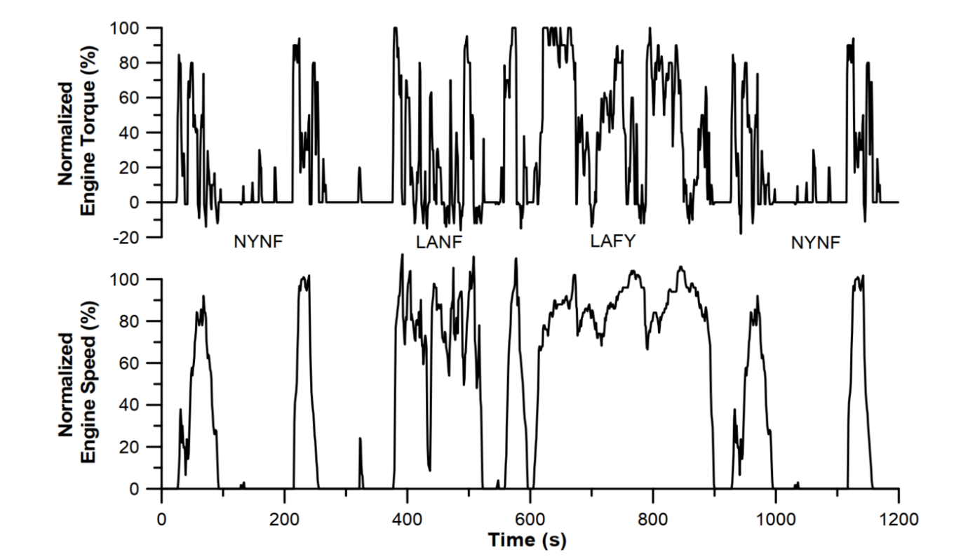
Figure 15 US Transient FTP diesel cycle [17]

Worldwide
In June 1997, at its 34th session, the UNECE Worldwide harmonised Heavy-Duty Certification (WHDC) group was tasked with the development of a 'Worldwide harmonised Heavy-duty Certification' procedure. The team devised a representative worldwide transient vehicle cycle (WTVC) or worldwide harmonised vehicle cycle (WHVC) initially, as shown in Fig. XX, but was never enforced into legislation. It was later transformed into a reference transient engine test cycle known as Worldwide harmonised Transient Cycle (WHTC). This cycle was defined in terms of normalised engine speed and load and was refined with the help of a newly developed drive train model.

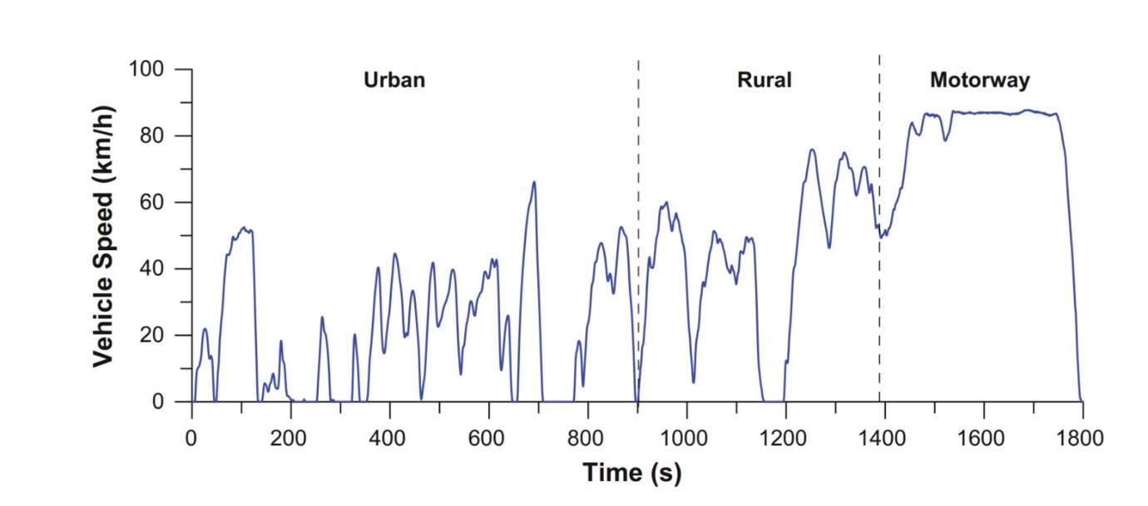
Figure 16 Speed profile of the worldwide WTVC driving cycle [17]
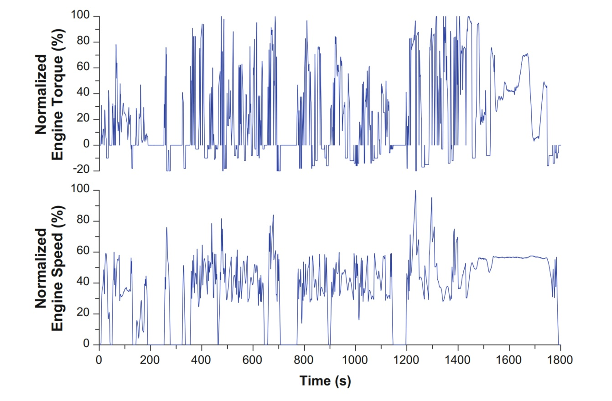
Figure 17 Engine speed/torque profile of the worldwide WHTC transient cycle [12]

Recent controversy
The chassis dynamometer test has been the most popular and standard choice when evaluating vehicles emission for a long time. However, in recent years, researchers have found disrepencies between the chassis dynamometer test results and results obtained from on-road emission testing. In some cases, researchers have found significant increase in emission from on-road emission tests compared to the type emission test discussed earlier [46]. Previously, one of the major drawbacks where the availability of emission measuring system for on-road testing, however, recent improvements in portable emission measuring system, known as PEMS, has enabled researchers to conduct on-road tests. In 2015, US EPA reported that a leading german auto manufacturer was using defeat devices to reduce the vehicle emission during type emission tests, this is known as dieselgate [47]. The vehicle was programmed in a way that it can trace when it is being used in a chassis dynamometer and it would activate its emission controls to reduce the NO_{X} emission. The agency found that, this would result in NO_{X} emission within the standard limits, however, the vehicle in real-life, emits 40-times more NO_{X} emission [48, 49]. In 2017, the company was fined US $2.8b by federal court [50]. This was not the only company to use the defeat devices. Recently in 2020, another giant auto manufacturing company was fined US $1.5b for violating Clean Air Act and California law due the use of cheating means. The vehicle was programmed in a way that while testing, it would increase the fuel mileage and thus reducing the emission levels to meet the standard value. These two incidents and on-going disrepencies found from type emission tests and on-road emission values have resulted in a significant inclination towards real drive emissions in recent years. The development of PEMS to accurately measure real time on-road emission has also helped researchers to move towards RDE tests. The following section will discuss RDE test significance, design policy and will review literature to show why it is important to do on-road emission test to actually reduce the real emissions in order to meet the emission standards.

Real drive emission test

Though stricter emission norms for automobiles has been introduced to improve the ambient air quality, the desired improvement has not been achieved; which can be attributed to the difference between the legislative cycle and real-world vehicle use [51]. To minimise this difference, the RDE norms or in-use compliance standards have been mandated since September 2017 [52, 53]. Several factors, such as road and climate conditions, affect the vehicle performance and makes chassis dynamometer emission testing not a reliable source for real emission from vehicles [54, 55]. Furthermore, chassis dynamometer tests do not account for actual street layout and driver behaviour. If there is a difference in altitude or temperature, it will have impact on parameters such as oxygen content, air intake and air-fuel ratio of the engine and which will vary the vehicles real drive emission [56].

RDE route design
The Commission Regulation (EU) 2016/427 specifies the features of the RDE cycle route and the ambient conditions and Regulation 2016/646 entails trip dynamics requirements.

Table 4 EU RDE Route design specification
 | Unit | Urban | Rural | Motorway
Distance | % of total distance | 29-44 | 33±10 | 33±10
Minimum distance | Km | 16 | 16 | 16
Avg speed | Km/h | Min 15  Max 40 | - | -
Number of stops | # | >10 | - | -
Max speed | Km/h | 60 | 90 | 145
Total test time | Minutes | 90 to 120
Elevating difference | m | 100

Some factors to consider while developing an RDE route:
- Urban driving must be conducted on roads with a maximum speed limit of 60 km/h
- For any reason, if the urban driving section contains any road with speed limit higher than 60 km/h, the vehicle speed shall not cross 60 km/h
- Rural and motorway sections may consists of roads with speed limits less than the classification
- The route must be designed in a way that (by topographical map), the urban section is driven first followed by the rural and finally the motorway sections.
- It is necessary to operate the vehicle above 100 km/h (measured by the GPS) at least for 5 min.
- The vehicle must adequately demonstrate driving between 90 and 110 km/h.
There might be country-specific additional RDE criteria. For example, According to the "Pollutant Emission Limits and Measurement Methods of Light Vehicles (China phase 6)" standard, the proportions of urban, rural and highway are 34%, 33% and 33% respectively [57]. However, it is not always possible to fulfil all the criteria and develop a satisfactory RDE route.

Literature review of RDE tests
Yang et al. [58] evaluated diesel and gasoline vehicle real drive emission. The authors developed an RDE route of 60-km consisting of urban, rural and motorways. The speed limit for the respective parts was 50, 90 and 130 km/h, which falls within the design specification. The vehicles were equipped with different emission reduction techniques. For emission measurement, a PEMS consisting of a Horiba OBS 2200 was used to collect unit to collect instantaneous and cumulative data of gaseous emissions (CO₂, CO, THC, and NOx). The authors reported a higher gaseous emission for urban roads which may be due to poor driving condition and for motorways which may be due to excessive energy demand. CO and THC emission for all the vehicles were below the specific limit (for gasoline CO: 1.00 g/km and THC: 0.10 g/km, for diesel CO: 0.50 g/km and THC: 0.09 g/km). However, NO_{X} emission was above the limits for both vehicle types (gasoline: 0.06 g/km, diesel: 0.08 g/km). Diesel vehicles emitted lower average trip CO₂ compared to gasoline vehicles which might be associated with better thermal efficiency.
Thomas et al. [59] tested EURO V compliant gasoline vehicles fitted with a 3-way catalyst for emission reduction. The RDE tests were performed using PEMS devices: the Horiba OBS-ONE-GS PEMS equipment and the AVL MOVE Gas PEMSiS equipment. The trials started with urbad driving followed by rural and motorway driving section. Urbam, rural and motorway roads were approximately 34%, 33% and 33% of the total route. RDE CO₂ emissions were above the EU passenger cars 2015 CO₂ target (130 g/km). However, RDE CO emissions were 60% lower than the WLTC (well below the Euro 5 limit of 1 g/km) and RDE NO_{X} emission was 34% lower compared to the WLTC emissions.
Wang et al. [60] evaluated volatile organic compounds emission from 4 different types of vehicle which included gasoline cars, light-duty diesel trucks, heavy-duty diesel truck and liquefied petroleum gas-electric hybrid bus. The authors used two routes. Route A was approximately 68 km, including urban, suburban and highway roads while route B was 18 km long route of No. B12 bus in Zhengzhou, China, which includes 29 stations. To simulate passengers dropping off and getting on, the bus was stopped at each station for 10 seconds. For emission measurement, a SEMTECH ECOSTAR PLUS combined with an additional VOC sampling unit was used containing three units: micro proportional sampling system (MPS), gas analyser, particulate matter (PM) analyser. The VOC emissions were different for different vehicles. The major VOC species for vehicles were as following:
Gasoline cars: i-pentane, acetone, propane, and toluene
Light duty diesel truck: mainly long-chain alkanes- dodecane, n-undecane, naphthalene and n-decane, which in total contributes to 70.4% of total species.
Heavy duty diesel truck: naphthalene contributed 31.8% of total VOC, which might be due to the engine operating conditions and the pyrolysation from incomplete combustion (Lin et al., 2019a, 2019b).
LPG bus: short-chain hydrocarbons. Acetone, i-pentane, i-butane, n-butane and propane (46.7% of the total VOCs).
For the gasoline cars, aromatics take up 39.4%, 35.0% and 41.7% of the tailpipe VOCs under the urban, suburban and highway conditions, respectively. The higher aromatic emission at highway may be caused by the lower air/oil ratio of port fuel injection (PFI) under ultra-high-speed working conditions. Heavy-duty diesel trucks emitted 8.6 times higher VOC compared to light duty diesel trucks which can be attributed to poor vehicle maintenance as exhibited by inefficient SCR device. Gasoline and LPG vehicles produced relatively lower VOC emission compared to diesel vehicles. This could be attributed to three-way catalyst converter (TWC) of gasoline vehicles which might have reduced the VOC emissions. Highway operating conditions emitted much lower VOC emissions compared to the urban road conditions.
Du et al. [61] tested the effect of cold-start on primary emission parameters. For the experiment light-duty gasoline vehicles were selected which were equipped with three-way catalytic (TWC) convertor, closed-loop control of fuel injection and gasoline particle filter (GPF). The PEMS used in the tests was a HORIBA OBS-ONE. A route of 75.4 km was selected which consisted urban section (32.6%), rural (32.4%), and the motorway section(35.0%). The altitude of the route is ranged from 192.7-313.2 m, which satisfies the RDE test regulations requirements. The authors reported a significant increase of CO, CO₂ and PN emission at the cold-start compared to a hot-start.
Habib (2014) [62] three vehicles of varying age groups (BS-II/post- 2000; BS-III/post-2005, and BS-IV/post-2010). The fuels used in the vehicles were also different: gasoline, compressed natural gas (CNG) and diesel. The author selected a route of 10 km consisted of heavy traffic, lean traffic and traffic signals. On-road emissions were measured using Aerosol Emission Measurement System (AEMS), which consists of heated duct, dilution tunnel, zero air assembly, heated particle sampling probe and power supply unit. The author reported that diesel emitted the lowest CO where gasoline emitted the highest. CO₂ of gasoline vehicles were dependent upon acceleration and deceleration. Furthermore, the gasoline vehicle emitted higher amount NO_{X} of compared to the other two vehicles.
Cao et al. [63] also evaluated on-road VOC emission; however, they opted for a car chase method. The emission measurement system included exhaust flow meter tube, mobile emission analyser, micro proportional sample system and VOC sampling unit. The test route included arterial roads (19.5 km) and highway roads (14.2 km). The route was divided into three defined driving cycles: arterial road hot start (ARHS), highway hot running (HWHR) and arterial road hot running (ARHR). The test vehicles were light-duty gasoline conformed to diverse emissions standards (Pre-China I to China IV). The authors reported that, for most of the vehicles, hot start resulted in highest VOC emission and highway hot running produced the lowest emission which can be attributed to the low average speed and the effect of the hot start.
Daham et al. [64] investigated the impact of micro-scale driving actions (left and right turns, stops and start at traffic lights, etc.) on on-road vehicle emissions. The authors selected a route of 0.6 km, which consisted of 4 left-hand turns. They used several manual vehicles which conformed to Euro I to IV. They evaluated several driving variations, left turn (anticlockwise) with and without a stop at intersections; right turn (clockwise) with and without a stop at crossroads. The HC emission for the tests was well below the corresponding legislation. However, the NOx emission for all the vehicles were all above the legislative limits. The authors reported that aggressive driving behaviour heavily affects NO_{X} and CO emission, three times increase was observed. Aggressive driving also increased CO₂ emission significantly.
Roso and Martins [65] compared two different methods to develop an RDE cycle: average method and cumulative method. The emissions were evaluated using computational models developed through GT-Suite software. The authors used two vehicles to develop the cycle: bus and passenger vehicle and reported a significant increase of emission for cumulative methods compared to the FTP-75 cycle.
Zhou et al. [56] evaluated the effect of various environmental constraint on real drive NO_{X} emission. If there is a difference in altitude or temperature, it will have impact on parameters such as oxygen content, air intake and air-fuel ratio of the engine and which will vary in-cylinder combustion, amount of pollutants and fuel consumption of vehicles. Emission varies with temperature and speed. For example, with vehicle speed <20 km/h, low altitude NO_{X} emission is higher than that of moderate altitude. High temperature and oxygen enrichment results in reduced NO_{X} emission and thus high altitude produces lower emission. Akard et al. [66] also reported the influence of altitude on CO₂ emission. The authors reported that a change in altitude of 90 meters might result in a change in CO₂ emission by 10gm/mile.
Ren et al. [67] evaluated the effect of various alternative fuels on the emission of buses on their usual daily route. The fuels considered were diesel, 20% Waste cooking biodiesel+ 80% diesel (B20) and Liquid natural gas (LNG). The portable emission measurement system (PEMS) was composed of a gas test unit: on-board emissions measurement system and a particle test unit: engine exhaust particle sizer. Compared to diesel operated bus, B20 and LNG buses had a reduction in PM emissions however NOx and PN emissions were higher.
Braisher et al. [68] evaluated on-road emission against legislative cycles such as NEDC, world harmonised light-duty test cycle (WLTC). The test cell is equipped with the Horiba MEXA-2000SPCS and PN was measured using the pre-series instrument Nanomet3-PS where particle detection was based on aerosol particles corona charging. The selected driving route consists of urban route (max speed of 50 km/h) and short segments (speed 70 km/h). The second route includes a long Autobahn (high-speed road network) route with a max speed of 100 km/h. the complete PEMS evaluation run consists of two urban route and one Autobahn route. The total run time was approximately 90 minutes. Cold start tests were conducted at different ambient temperatures (8 to 28 ºC). The on-road measurements were performed using gasoline operated Euro-5 compliant passenger vehicle. The obtained results show that, 60% of the trip PN emission is generated while the vehicle operates at cold-start period. Braisher et al. [69] reported that during the NEDC cycle, 77% of the total PN emission is generated during the cold-start period. Furthermore, the tests also reveal that driving style is an essential parameter with a substantial impact on the PN emission. The Autobahn trips show a significant change in PN emission (10x increase) when switched from normal to severe driving. This can be attributed to larger accelerations, higher velocities, and higher power demand.
Khalfan et al. [70] evaluated the effect of traffic congestion on vehicle emissions. A portable Fourier Transform Infrared (FTIR) spectrometer was used to measure real-world on-road emissions. The total route distance was 5 km and the speed limit were 48 km/h. Two different cycles were conducted with varying numbers of right and left turns, traffic lights and pedestrian crossings. These dynamic factors would result in numerous stop/start events. The authors reported that congestion affected the CO₂ emission; most of the trips produced more than 180 g/km CO_{2,} which is above NEDC certification limits. THE CO and THC and NO_{X} emissions were dependent upon the traffic speed. These emissions were higher than the legislative limits at lower speeds.
Rosenblatt et al. [71] tested three variant of motorbike on a 30-minute test cycle which consist a cold start phase, intermediate speed and high speed with each stage being weighted equally at 0.33. The authors found that the PM emission was lower than the current Tier 3/LEV III light duty highway vehicle limit of 3 mg/mile. A considerable fraction of CO and HC emissions were produced over the cold start phase and/or high-speed phases whereas NO_{X} emission was most influential over the high-speed stage.
The modern-day vehicles have new technologies that help the driver, for example, adaptive cruise control (ACC), start and stop system. Dvorkin et al. [72] evaluated the effect of on ACC on vehicle emission on-road. The performance of ACC depends upon two factors: platooning and controlled acceleration. When vehicles closely follows each-other to reduce aerodynamic drag it is known as platooning which is most effective in highway conditions where aerodynamic drag dictates road load forces. The author reported that active ACC resulted in less CO₂ g/miles and optimum GHG reduction is achieved when the following distance is 20-40 m and vehicle operating at highway speeds. In another study [73], the authors concluded that, if households switched from conventional vehicles to electric vehicles, they could reduce their GHG emissions significantly.
Andersson et al. [74] evaluated two EURO 6 compliant light-duty diesel vehicles. These vehicles had two different technology installed to reduce NO_{X} emission. One vehicle had Selective Catalytic Reduction (SCR) while the other had Exhaust Gas Recirculation (EGR). Both consisted of Diesel Particulate Filters for particulate matter reduction. Furthermore, the vehicles were tested in two different routes, one with 60% urban condition and another with 60% motorway. The authors reported that both vehicles produced significantly higher NO_{X} and CO₂ emission compared to the EURO 6 legislation limit; however, THC and CO emissions were within the limit.
Wang et al. [75] compared PEMS with mobile monitoring system for on-road emissions. The authors selected heavy duty diesel trucks that complied with China III to China V emission standards. The authors reported that, mobile monitoring system reported similar NO_{X} results compared to that of the PEMS.
Bischoff et al. [76] compared the on-road emission of motorcycles. The authors evaluated two driving style, normal and dynamic driving where the latter represents sporty driving style with increased longitudinal dynamics. The authors reported that, CO and NO_{X} emissions were 58% and 36% higher than that of WMTC certification limits. Furthermore, CO, CO₂ and NO_{X} emissions increased significantly when switched from normal driving to dynamic driving. Table 5 presents a summary of RDE route descriptions and emission results from various literature.

Table 5. Summary of RDE tests

Reference | Vehicle | Comparison Criteria | Route information | Impact on primary emission | Remarks
[77] | Diesel-electric hybrid bus | China City Bus Cycles | 1270 seconds  Average speed 24.3 km/h  Proportions:  Idle 14.6%, Cruise 13.3%, Acceleration 43.6% and Deceleration 28.6% | NO_{X} ↓  THC, CO, PM & PN ↑
[68] | EURO V, gasoline, passenger vehicle | NEDC, WLTC | 90 min, Avg engine rpm: 1494-2256  Idle time variation: 4-24.8%  2 x Urban route & 1 Autobahn route  Equal distance  Cold start test: Urban route 8-28 ⸰C | PN in similar range compared to cycles | Driving style significantly increased PN emission on the same route
[58] | Gasoline and diesel passenger vehicle | Vehicles | 60 km consist of urban, rural and motorway | THC and CO ↓ for all  NO_{X}:  Gasoline: ↑ for rural and motorway  Diesel: significantly ↑ for all roads | Gasoline emission ↑ motorway  Diesel emission ↑  urban
[60] | Gasoline cars, light-duty diesel trucks, heavy duty diesel truck and liquefied petroleum gas-electric hybrid bus | Vehicles VOC | Route A: 68 km  Route B: 18 km, 29 stops of 10s |  | VOC:  highest- Heavy duty diesel truck.  Lowest- Gasoline  Emission of urban roads significantly higher compared to rural and highway.
[62] | Diesel, gasoline and CNG | Vehicles | 10 km consisted of heavy traffic, lean traffic and traffic signals | Gasoline vehicles produced highest CO and NO_{X} | CO₂ of gasoline vehicles varied significantly with acceleration and deceleration
[63] | light-duty gasoline vehicles | China emission standard | Route 33.7 km (arterial road and highway), divided in to 3 cycle Duration:  arterial road hot start (ARHS): 21 min, highway hot running (HWHR):17 min and and arterial road hot running (ARHR): 21 min  Avg speed: ARHS 17.7-22.9 km/h HWHR 42.8-54.9 km/h ARHR  29.6-42.4 km/h |  | Hot start resulted in highest VOC emission and highway hot running produced the lowest emission
[61] | Gasoline vehicles | Cold-start vs hot-start | 75.4 km: urban section (32.6%), rural (32.4%), and the motorway section(35.0%).  Altitude variation: 192.7-313.2 m, The authors reported a significant increase of CO, CO2 and PN emission at the cold-start compared to a hot-start. | CO, CO₂ and PN : Significant ↑ for cold-start | NO_{X} emission depends on driving behavior
[64] | SI gasoline cars with compliance to EURO I to IV | Euro I to IV | four left hand turns, and the total circuit length was 0.6 km with very little other traffic | THC and CO: within legislation limits  NO_{X} and CO increase for aggressive driving
[74] | light-duty diesel  Euro 6b standards | New European Drive Cycle (NEDC), Common Artemis Drive Cycle (CADC), Worldwide Light-duty Test Cycle (WLTC) and 3 'Random cycles' | 60 min (minimum)  Route 1: 60% urban  Route 2: 60% motorway | NO_{X} ↑  THC and CO: similar  CO₂: Significant ↑
[65] | Bus  Passenger car | Average vs Cumulative cycle  FTP-75 | 11.8 km including varied driving conditions including ascents, descents, urban and highway traffics  Bus: 2674-8321 sec, Acceleration 50.86-52.54%, Deceleration 47.46-49.145  Car: 2016-6013 sec,  Acceleration 38.25-50%, Deceleration 50-61.25% | Car: Significant increase of NO_{X}, THC and CO for cumulative cycle, compared to FTP-75  Bus: Significant increase of NO_{X}, HC, CO and soot for cumulative cycle, compared to FTP-75
[78] | Euro 6 standard vehicles | NEDC, WLTP,  Transport for London Urban Inter-Peak Cycle | 105 minutes | NO_{X}:  ↓ compared to EURO 6,  ↑ compared to NEDC, WLTP  CO: ↓  PN: ↓ compared to EURO 6  CO₂: ↑ compared to EURO 6 | CO₂ higher than EURO 6 limits.  Depending on the vehicle technology, some cars were able to control NO_{X} emission from cold start and some were able to control NO_{X} after 2-3 minutes warm up
[66] | Light duty vehicle | Grade variation | Two routes duration 40 mins and 45 mins  90-meter altitude change |  | Altitude difference 10g/mile of CO₂
[72] | 2018 Cadillac CT6 | Adaptive Cruise Control | Most of the driving occurred at highway speeds; over 66% of the data were captured at and above 55 mph | CO₂: ↓ for active ACC
[71] | compact sport bike (296cc),  cruising bike (749cc) and  high performance touring bike (1198cc) |  | 1.1-hr  cold start phase (505s and 7.47km), intermediate speed (525s and 8.45km) and high speed (832s and 14.72 km) | NO_{X}, THC, CO, PM: significant ↑ | PM emission below the current Tier 3/LEV III light duty highway vehicle limit
[59] | Spark ignition passenger vehicles of class M1 (3-way catalyst) | WLTC | 34% urban  33% rural  33% motorway | NO_{X}, CO, and CO₂: ↓
[70] | Euro4 emission compliant manual transmission petrol | Traffic congestion | 5 km, Speed limit 48 km/h  Route A: 8 right and 3 left turn  Route B: 5 right and 6 left turn  3 sets of traffic lights  4 pedestrian crossing | NO_{X}, CO, THC: higher at lower speeds and reduced as the speed increased  CO₂ were higher than the limit
[67] | Bus | Waste cooking biodiesel & LPG | Daily operating route | NO_{X}, PN: ↑  PM: ↓
[56] | Diesel truck | Environmental constraint | altitude ranges <1,000 m, 1,000~1,500 m and 3,000~4,000 temperature range: 10~20 °C | NO_{X}: high altitude reduces emission

Conclusion
The transport sector significantly contributes to global greenhouse gas emission. In order to achieve the zero-emission target, it is important to reduce these emissions. The paper discusses several current techniques to evaluate the vehicle emissions. Conventional testing procedures include engine emission testing and vehicle chassis dynamometer testing. For several decades, these two testing procedures were the most used ones. However, in recent years researchers have found significant difference in emissions reported using type emission tests and on-road emission tests. On-road emission tests have become easier due to the development of portable emission measuring systems. Furthermore, two recent scandals have identified that, auto manufacturing companies use emission cheating devices that would reduce the vehicle emission by tracking when it is being used in chassis dynamometer and enable emission reducing techniques. These has resulted in researchers prioritising on-road emission tests, which are known as Real Drive Emissions (RDE) testing. The paper discusses RDE development methods and reviews past works. From literature review, it is also evident that, driving behavior along with the driving route significantly impacts vehicle emission which is not represented in type emission tests. For example, aggressive driving behavior increased NOX and CO emission three times than that of normal driving behavior. Route characteristics such as traffic lights, right/left turns, round abouts, gradients all found to have significant impact on vehicle emissions. The literature review also indicated that, modern vehicle technologies also affect vehicle emission, start-stop system results in increased emission due to engine not operating in hot condition because of frequent stop and starts. Thus, it is important to consider all these factors when developing a real drive emission cycle to evaluate any vehicle.

References
[1] G. Mengpin, F. Johannes. 4 Charts Explain Greenhouse Gas Emissions by Countries and Sectors. 2020.
[2] S. Evans. Analysis: Coronavirus set to cause largest ever annual fall in CO2 emissions. URL: https://www.carbonbrief.org/analysis-coronavirus-set-to-cause-largest-ever-annual-fall-in-co2-emissions. Date accessed: 24th September, 2020. in: C. Brief, (Ed.).2020.
[3] M. McGrath. Climate change and coronavirus: five charts about the biggest carbon crash. URL: https://www.bbc.com/news/science-environment-52485712. Date accessed: 24th Spetember, 2020. BBC News2020.
[4] Delphi Technologies. Current Emissions Standard Guides. URL: https://www.delphi.com/innovations/emissions-standards-booklets. Date accessed: 24th September, 2020. 2020.
[5] S.G. Al-Kindi, R.D. Brook, S. Biswal, S. Rajagopalan. Environmental determinants of cardiovascular disease: lessons learned from air pollution. Nature Reviews Cardiology. 17 (2020) 656-72.
[6] J. Van Mierlo, G. Maggetto, E. Van de Burgwal, R. Gense. Driving style and traffic measures-influence on vehicle emissions and fuel consumption. Proceedings of the Institution of Mechanical Engineers, Part D: Journal of Automobile Engineering. 218 (2004) 43-50.
[7] V. Franco, M. Kousoulidou, M. Muntean, L. Ntziachristos, S. Hausberger, P. Dilara. Road vehicle emission factors development: A review. Atmospheric Environment. 70 (2013) 84-97.
[8] P. Bielaczyc, J. Woodburn, A. Szczotka. Exhaust Emissions of Gaseous and Solid Pollutants Measured over the NEDC, FTP-75 and WLTC Chassis Dynamometer Driving Cycles. SAE International2016.
[9] S. Samuel, L. Austin, D. Morrey. Automotive test drive cycles for emission measurement and real-world emission levels-a review. Proceedings of the Institution of Mechanical Engineers, Part D: Journal of Automobile Engineering. 216 (2002) 555-64.
[10] P. Kleeman. A fresh look at predicting carbon monoxide impacts at highway intersections. Transport Research Board A1 FC03-AIF06 Joint Summer Meeting, Ann Arbor, Michigan1998.
[11] L.A. Graham, G. Rideout, D. Rosenblatt, J. Hendren. Greenhouse gas emissions from heavy-duty vehicles. Atmospheric Environment. 42 (2008) 4665-81.
[12] E.G. Giakoumis. Driving and engine cycles. Springer2017.
[13] E. Tzirakis, K. Pitsas, F. Zannikos, S. Stournas. Vehicle emissions and driving cycles: Comparison of the Athens Driving Cycle (ADC) with ECE-15 and European Driving Cycle (EDC). (2006).
[14] T.J. Lyons, J.R. Kenworthy, P.I. Austin, P.W.G. Newman. The development of a driving cycle for fuel consumption and emissions evaluation. Transportation Research Part A: General. 20 (1986) 447-62.
[15] M. Kuhler, D. Karstens. Improved Driving Cycle for Testing Automotive Exhaust Emissions. SAE International1978.
[16] H.Y. Tong, W.T. Hung, C.S. Cheung. Development of a driving cycle for Hong Kong. Atmospheric Environment. 33 (1999) 2323-35.
[17] C.D. Rakopoulos, E.G. Giakoumis. Diesel Engine Transient Operation Principles of Operation and Simulation Analysis. 1st ed. 2009. ed. Springer London, London, 2009.
[18] H. Watson, E. Milkins, J. Braunsteins. Development of the Melbourne peak cycle. Second Conference on Traffic Energy and Emissions Melbourne, May 1982 Program and Papers1982.
[19] S.M. Metwalley, S. Abouel-Seoud, A.M. Farahat. Determination of the catalytic converter performance of bi-fuel vehicle. 2011.
[20] K.J. Bullock. Driving cycles. Second Conference on Traffic, Energy and Emissions, Melbourne, Australia Program and Papers, Melbourne, Australia, 1982. pp. 1-18.
[21] Z. Yang, B. Deng, M. Deng, S. Huang. An Overview of Chassis Dynamometer in the Testing of Vehicle Emission. MATEC Web Conf. 175 (2018) 02015.
[22] R.L. McCormick, L.B.A. Ryan, T.L. Daniels, J. Yanowitz, M.S. Graboski. Comparison of Chasis Dynamometer In-Use Emissions with Engine Dynamometer FTP Emissions for Three Heavy-Duty Diesel Vehicles. SAE International1998.
[23] B. Sharpe. Testing methods for heavy-duty vehicle fuel efficiency: Trends from regulatory programs around the world and implications for India. International Council on Clean Transportation, Washington, DC. (2015).
[24] J. May, C. Favre, D. Bosteels. Emissions from Euro 3 to Euro 6 light-duty vehicles equipped with a range of emissions control technologies. Internal Combustion Engines: Performance, Fuel Economy and Emissions. Woodhead Publishing2013. pp. 55-65.
[25] R. Joumard, M. André, R. Vidon, P. Tassel, C. Pruvost. Influence of driving cycles on unit emissions from passenger cars. Atmospheric Environment. 34 (2000) 4621-8.
[26] G. Triantafyllopoulos, A. Dimaratos, L. Ntziachristos, Y. Bernard, J. Dornoff, Z. Samaras. A study on the CO2 and NOx emissions performance of Euro 6 diesel vehicles under various chassis dynamometer and on-road conditions including latest regulatory provisions. Science of The Total Environment. 666 (2019) 337-46.
[27] J. Pavlovic, B. Ciuffo, G. Fontaras, V. Valverde, A. Marotta. How much difference in type-approval CO2 emissions from passenger cars in Europe can be expected from changing to the new test procedure (NEDC vs. WLTP)? Transportation Research Part A: Policy and Practice. 111 (2018) 136-47.
[28] L. Pelkmans, P. Debal. Comparison of on-road emissions with emissions measured on chassis dynamometer test cycles. Transportation Research Part D: Transport and Environment. 11 (2006) 233-41.
[29] W. Berg. Legislation for the reduction of exhaust gas emissions. Traffic and Environment. Springer2003. pp. 175-253.
[30] Australian Automobile Association. 2017 Fuel Economy and Emissions Report. URL: https://www.accc.gov.au/system/files/Australian%20Automobile%20Association%20-%20supplementary%20submission%201%20-%20October%202017_0.pdf. 2017.
[31] S. Brown, C. Bryett, M. Mowle. In-Service Emissions Performance - Drive Cycles. URL: http://nepc.gov.au/system/files/resources/45fee0f3-1266-a944-91d7-3b98439de8f8/files/dve-prepwk-project2-1.pdf. in: National Environment Protection Council, (Ed.). Proposed Diesel Vehicle Emissions National Environment Protection Measure Preparatory Work1999.
[32] P. Anyon, S. Brown, D. Pattison, J. Beville-Anderson, G. Walls, M. Mowle. In-Service Emissions Performance - Phase 2: Vehicle Testing. URL: http://www.nepc.gov.au/system/files/resources/45fee0f3-1266-a944-91d7-3b98439de8f8/files/dve-prepwk-project2-2.pdf. in: National Environment Protection Council, (Ed.). Proposed Diesel Vehicle Emissions National Environment Protection Measure Preparatory Work2000.
[33] DieselNet. Petrol CUEDC & SPC240. https://dieselnet.com/standards/cycles/cuedc_spc240.php. 2020.
[34] B. Ciuffo, A. Maratta, M. Tutuianu, K. Anagnostopoulos, G. Fontaras, J. Pavlovic, et al. Development of the Worldwide Harmonized Test Procedure for Light-Duty Vehicles: Pathway for Implementation in European Union Legislation. Transportation Research Record. 2503 (2015) 110-8.
[35] D. Tsokolis, S. Tsiakmakis, A. Dimaratos, G. Fontaras, P. Pistikopoulos, B. Ciuffo, et al. Fuel consumption and CO2 emissions of passenger cars over the New Worldwide Harmonized Test Protocol. Applied Energy. 179 (2016) 1152-65.
[36] M. Tutuianu, P. Bonnel, B. Ciuffo, T. Haniu, N. Ichikawa, A. Marotta, et al. Development of the World-wide harmonised Light duty Test Cycle (WLTC) and a possible pathway for its introduction in the European legislation. Transportation Research Part D: Transport and Environment. 40 (2015) 61-75.
[37] M. Tutuianu, A. Marotta, H. Steven, E. Ericsson, T. Haniu, N. Ichikawa, et al. Development of a World-wide Worldwide harmonised Light duty driving Test Cycle (WLTC). UN/ECE/WP.29/GRPE/WLTP-IG. 2013.
[38] H. Steven. Development of a worldwide harmonised heavy-duty engine emissions test cycle. TRANS/WP29/GRPE/2001/2. URL: http://www.unece.org.net4all.ch/fileadmin/DAM/trans/doc/2001/wp29grpe/TRANS-WP29-GRPE-42-inf02.pdf. UN ECE-GRPE WHDC Working Group2001.
[39] E. de Jong, T. Vijlbrief, R. Hijkoop, G.-J.M. Gruter, J.C. van der Waal. Promising results with YXY Diesel components in an ESC test cycle using a PACCAR Diesel engine. Biomass and Bioenergy. 36 (2012) 151-9.
[40] T.J. Aarnink, S.Å. Flöysand, P. Gadd, D. Le Breton, N. Mann, A. Marotta, et al. Motor vehicle emission regulations and fuel specifications: Part 2 detailed information and historic review (1970-1996). Report no. 6/97. https://www.concawe.eu/wp-content/uploads/2017/01/2002-00203-01-e.pdf. in: C.A.E.M. Group, (Ed.).1997.
[41] T.C.C. de Melo, M.F.M. de Brito, M.F. Moreira, G.B. Machado, R. Fleischman. Calculation of Uncertainty of Measurement for Diesel Engine ESC Test Emissions. SAE International2013.
[42] E.G. Giakoumis, A.I. Alafouzos. Study of diesel engine performance and emissions during a Transient Cycle applying an engine mapping-based methodology. Applied Energy. 87 (2010) 1358-65.
[43] M.U. KARAOĞLAN, Y. VATANSEVER, N.S. KURALAY. Simulation of 8x8 Heavy Duty Truck for Evaluating Effects of Torque Converter Characteristics on Vehicle Performance. Mechanika. 24 (2018) 232-9.
[44] F. Zhen, N.N. Clark, C.R. Bedick, M. Gautam, W.S. Wayne, G.J. Thompson, et al. Development of a Heavy Heavy-Duty Diesel Engine Schedule for Representative Measurement of Emissions. Journal of the Air & Waste Management Association. 59 (2009) 950-9.
[45] DieselNet. Heavy-Duty FTP Transient Cycle. https://dieselnet.com/standards/cycles/ftp_trans.php. date accessed: 18th October, 2020. 2020.
[46] N. Zacharof, U. Tietge, V. Franco, P.J.E.P. Mock. Type approval and real-world CO2 and NOx emissions from EU light commercial vehicles. 97 (2016) 540-8.
[47] C.J.E.P. Brand. Beyond 'Dieselgate': Implications of unaccounted and future air pollutant emissions and energy use for cars in the United Kingdom. 97 (2016) 1-12.
[48] J.R. Krall, R.D.J.S. Peng. The Volkswagen scandal: Deception, driving and deaths. 12 (2015) 12-5.
[49] G.P. Chossière, R. Malina, A. Ashok, I.C. Dedoussi, S.D. Eastham, R.L. Speth, et al. Public health impacts of excess NOx emissions from Volkswagen diesel passenger vehicles in Germany. 12 (2017) 034014.
[50] B.J.U.T. Snavely. Volkswagen Must pay $2.8 B Criminal Fine for Emissions Cheating. (2017).
[51] G. Duarte, G. Gonçalves, T.J.T.R.P.D.T. Farias, Environment. Analysis of fuel consumption and pollutant emissions of regulated and alternative driving cycles based on real-world measurements. 44 (2016) 43-54.
[52] V. Betageri, R. Mahesh. Effects of the real driving conditions on the NOx emission of a medium duty diesel commercial vehicle. SAE Technical Paper2017.
[53] T. Bodisco, A.J.E. Zare. Practicalities and driving dynamics of a real driving emissions (RDE) Euro 6 regulation homologation test. 12 (2019) 2306.
[54] Y. Pang, M. Fuentes, P.J.A.E. Rieger. Trends in the emissions of Volatile Organic Compounds (VOCs) from light-duty gasoline vehicles tested on chassis dynamometers in Southern California. 83 (2014) 127-35.
[55] L. Chen, Z. Wang, S. Liu, L.J.T.R.P.D.T. Qu, Environment. Using a chassis dynamometer to determine the influencing factors for the emissions of Euro VI vehicles. 65 (2018) 564-73.
[56] H. Zhou, H. Zhao, Q. Feng, Z. Yin, J. Li, K. Qin, et al. Effects of environmental parameters on real-world nox emissions and fuel consumption for heavy-duty diesel trucks using an OBD approach. SAE Technical Paper2018.
[57] Y. Zhang, D. Tian, H. Du, H. Pan, W. Fang, Y. Wang. Design and Research of RDE Test Routes. International Conference on Application of Intelligent Systems in Multi-modal Information Analytics. Springer2019. pp. 1160-9.
[58] Z. Yang, Y. Liu, L. Wu, S. Martinet, Y. Zhang, M. Andre, et al. Real-world gaseous emission characteristics of Euro 6b light-duty gasoline-and diesel-fueled vehicles. 78 (2020) 102215.
[59] D. Thomas, H. Li, X. Wang, B. Song, Y. Ge, W. Yu, et al. Comparison of Tailpipe Gaseous Emissions for RDE and WLTC Using SI Passenger Cars. Proceedings of the SAE Powertrain Fuels and Lubricants Meeting 2017. SAE International2017.
[60] M. Wang, S. Li, R. Zhu, R. Zhang, L. Zu, Y. Wang, et al. On-road tailpipe emission characteristics and ozone formation potentials of VOCs from gasoline, diesel and liquefied petroleum gas fueled vehicles. 223 (2020) 117294.
[61] B. Du, L. Zhang, Y. Geng, Y. Zhang, H. Xu, G. Xiang. Testing and evaluation of cold-start emissions in a real driving emissions test. Transportation Research Part D: Transport and Environment. 86 (2020) 102447.
[62] G. Habib. On-road assessment of light duty vehicles in Delhi city: emission factors of CO, CO2 and NOX. J Atmospheric Environment. 174 (2018) 132-9.
[63] X. Cao, Z. Yao, X. Shen, Y. Ye, X.J.A.E. Jiang. On-road emission characteristics of VOCs from light-duty gasoline vehicles in Beijing, China. 124 (2016) 146-55.
[64] B. Daham, H. Li, G.E. Andrews, K. Ropkins, J.E. Tate, M.C. Bell. Comparison of real world emissions in urban driving for euro 1-4 vehicles using a PEMS. SAE Technical Paper2009.
[65] V.R. Roso, M.E.S. Martins. Simulation of Fuel Consumption and Emissions for Passenger Cars and Urban Buses in Real-World Driving Cycles. SAE Technical Paper2016.
[66] M. Akard, N. Gramlich, T. Nevius, S. Porter. Comparison of Real-World Urban Driving Route PEMS Fuel Economy with Chassis Dynamometer CVS Results. SAE Technical Paper2019.
[67] Y. Ren, D. Lou, Y. Zhang, P. Tan, Z. Hu. Study on Real-World NOx and Particle Emissions of Bus: Influences of VSP and Fuel. SAE Technical Paper2019.
[68] J. Gallus, U. Kirchner, R. Vogt, C. Börensen, T.J.A.E. Benter. On-road particle number measurements using a portable emission measurement system (PEMS). 124 (2016) 37-45.
[69] M. Braisher, R. Stone, P. Price. Particle number emissions from a range of European vehicles. SAE Technical Paper2010.
[70] A. Khalfan, G. Andrews, H. Li. Real World Driving: Emissions in Highly Congested Traffic. Proceedings of the SAE Powertrain Fuels and Lubricants Meeting 2017. SAE International2017.
[71] D. Rosenblatt, J. Stokes, C. Caffrey, K.F. Brown. Effect of Driving Cycles on Emissions from On-Road Motorcycles. SAE Technical Paper2020.
[72] W. Dvorkin, J. King, M. Gray, S. Jao. Determining the greenhouse gas emissions benefit of an adaptive cruise control system using real-world driving data. SAE Technical Paper2019.
[73] K. Laberteaux, K. Hamza. A Study of Greenhouse Gas Emissions Reduction Opportunity in Light-Duty Vehicles by Analysing Real Driving Patterns. SAE Technical Paper2017.
[74] J. Andersson, J. May, C. Favre, D. Bosteels, S. de Vries, M. Heaney, et al. On-road and chassis dynamometer evaluations of emissions from two Euro 6 diesel vehicles. 7 (2014) 919-34.
[75] H. Wang, Y. Wu, K.M. Zhang, S. Zhang, R.W. Baldauf, R. Snow, et al. Evaluating mobile monitoring of on-road emission factors by comparing concurrent PEMS measurements. (2020) 139507.
[76] G. Bischoff, S. Keller, A.J.M.w. Heubuch. Portable Emission Measurement Technology and RDE on Motorcycles as Instruments for Future Challenges. 81 (2020) 54-9.
[77] W. Geng, D. Lou, N. Xu, P. Tan, Z. Hu. Chassis Dynamometer and On-Road Evaluations of Emissions from a Diesel-Electric Hybrid Bus. SAE Technical Paper2017.
[78] R. Williams, J. Andersson, H. Hamje, P. Ziman, K. Kar, C. Fittavolini, et al. Impact of Demanding Low Temperature Urban Operation on the Real Driving Emissions Performance of Three European Diesel Passenger Cars. SAE Technical Paper2018.

