Re-imagining machine learning in dental research: A lesson learned from the COVID-19 pandemic

Jafar Kolahi¹, Mohammad Seyedhamzeh², David G Dunning³, Nader Kalbasi⁴
¹ Independent Research Scientist, Associate Editor of Dental Hypotheses, Isfahan, Iran
² Independent Research Scientist, Associate Editor of Dental Hypotheses, Zanjan, Iran
³ Department of Oral Biology, College of Dentistry, University of Nebraska Medical Center, Lincoln, Nebraska, USA
⁴ Department of Oral and Maxillofacial Pathology, School of Dentistry, Isfahan( Khorasghan) Branch, lslamic Azad University, Isfahan,Iran

At this time human kind is experiencing on a global scale a frightening infectious disease caused by severe acute respiratory syndrome coronavirus 2 (SARS-CoV-2). As of 25 September 2020, more than 32.3 million cases have been reported in 188 countries, resulting in more than 984,000 official reported deaths.^{1,2} During the course of human history, there have been several pandemics e.g. plague and smallpox. However, one of the main differences between COVID-19 and previous pandemics is the availability of computer-based technologies. Paralleling the global growth of COVID-19, studies using computer-based technologies have emerged e.g. machine learning) to fight against SARS-CoV-2. ^{3,4}
The term “machine learning” is a subset of artificial intelligence in which a mathematical model is built using sample data, known as "training data", in order to make forecasts without being obviously programmed to do so. Machine learning algorithms easily identify trends and patterns among multi-dimensional and multi-variety data without any human intervention. Importantly, machine learning algorithms must be chosen carefully for specific purpose and require massive data sets of high quality on which to train.
A good example for utilizing machine learning in biomedical research would be “Chemprop — Machine Learning for Molecular Property Prediction”.⁵ In this project MIT (Massachusetts Institute of Technology) researchers used an artificial neural network and deep learning approach to predict the probability that a molecule will inhibit the SARS-CoV-2 main protease. Figure 1 depicts a structural view of the SARS-CoV-2 main protease--also called 3C-like protease, and its interaction with a potential anti-viral drug, Boceprevir. Boceprevir is a protease-inhibitor used successfully to treat hepatitis caused by hepatitis C virus, created by way of molecular docking using the Molegro Virtual Docker (Molexus IVS, Rørth, Denmark).⁶
However, correct use the Chemprop structure of molecules, Boceprevir (C₂₇H₄₅N₅O₅), requires a conversion to a SMILES format as follows: “CC1([C@@H]2[C@H]1[C@H](N(C2)C(=O)[C@H](C(C)(C)C)NC(=O)NC(C)(C)C)C(=O)NC(CC3CCC3)C(=O)C(=O)N)C” which, in turn, could be used for machine learning. The activity score predicated by Chemprop for Boceprevir was 9.26, indicating it is inactive against SARS-CoV-2 main protease. Also, MIT researchers translated structural information of the spike protein of SARS-CoV-2 into music using machine learning.⁷
Nevertheless, a PubMed search with query “machine learning” and filters yielded these results: dental journals at Oct 16, 2020, revealed only 97 results—see Figure 2. the Journal of Craniofacial Surgery published the most number of articles (11.1 %), followed by the Journal of Dental Research (8%), and then, Oral Surgery, Oral Medicine, Oral Pathology and Oral Radiology (7%). The articles entitled “Predicting oral malodour based on the microbiota in saliva samples using a deep learning approach” ⁸ received the most online attention (Altmetric score: 17). Among 65 articles which received online attention (Altmetric score ≥ 1) there was no correlation between Altmetric score and number of citations: source of citations data, Dimensions, Pearson's r = 0.025, 95% confidence level: -0.207 to 0.256, p = 0.832).
However, the broader dental research community, including clinical practitioners, could pay more attention to machine learning as a futuristic concept for dental diagnosis,⁹ prediction of root caries¹⁰, oncology^{11,12}, orthodontics¹³, radiographic detection of apical lesions¹⁴, caries detection¹⁵, dental altmetrics¹⁶, etc.
Recently a deep learning model (available via Chemprop⁵) was used to successfully predict a new antibiotic to inhibit the growth of Escherichia coli known as Halicin, structurally divergent from conventional antibiotics and exhibiting bactericidal activity against a wide range well-known pathogens in-vivo.¹⁷ This same methodology could be performed rapidly and inexpensively to predict new chemicals against druggable proteins of well-known dental pathogens such as Streptococcus mutans¹⁸ and Enterococcus faecalis¹⁹.
Finally and critically, dental journal editors, grant providers, research managers, educational planners and clinical professionals could direct more attention to artificial intelligence and machine learning as a rapid, effective and inexpensive tool to solve complicated clinical problems.²⁰

Conflicts of interest: None

References
1. Dong E, Du H, Gardner L. An interactive web-based dashboard to track COVID-19 in real time. Lancet Infect Dis. 2020;20(5):533-534. doi:10.1016/S1473-3099(20)30120-1
2. Coronavirus COVID-19 (2019-nCoV). https://gisanddata.maps.arcgis.com/apps/opsdashboard/index.html#/bda7594740fd40299423467b48e9ecf6. Accessed September 25, 2020.
3. Bachtiger P, Peters NS, Walsh SL. Machine learning for COVID-19—asking the right questions. Lancet Digit Heal. 2020;2(8):e391-e392. doi:10.1016/S2589-7500(20)30162-X
4. Lalmuanawma S, Hussain J, Chhakchhuak L. Applications of machine learning and artificial intelligence for Covid-19 (SARS-CoV-2) pandemic: A review. Chaos, Solitons and Fractals. 2020;139:110059. doi:10.1016/j.chaos.2020.110059
5. Chemprop. http://chemprop.csail.mit.edu/. Accessed September 25, 2020.
6. RCSB PDB - 6ZRU: Crystal structure of SARS CoV2 main protease in complex with inhibitor Boceprevir. https://www.rcsb.org/structure/6ZRU. Accessed September 25, 2020.
7. Venugopal V. Scientists have turned the structure of the coronavirus into music. Science (80- ). April 2020. doi:10.1126/science.abc0657
8. Nakano Y, Suzuki N, Kuwata F. Predicting oral malodour based on the microbiota in saliva samples using a deep learning approach. BMC Oral Health. 2018;18(1):128. doi:10.1186/s12903-018-0591-6
9. Mupparapu M, Wu CW, Chen YC. Artificial intelligence, machine learning, neural networks, and deep learning: Futuristic concepts for new dental diagnosis. Quintessence Int (Berl). 2018;49(9):687-688. doi:10.3290/j.qi.a41107
10. Hung M, Voss MW, Rosales MN, et al. Application of machine learning for diagnostic prediction of root caries. Gerodontology. 2019;36(4):395-404. doi:10.1111/ger.12432
11. Kumar S, Awan KH, Patil S, Bharkavi SKI, Raj AT. Potential role of machine learning in oncology. J Contemp Dent Pract. 2019;20(5):529-530. doi:10.5005/jp-journals-10024-2551
12. Sultan AS, Elgharib MA, Tavares T, Jessri M, Basile JR. The use of artificial intelligence, machine learning and deep learning in oncologic histopathology. J Oral Pathol Med. 2020;49(9). doi:10.1111/jop.13042
13. Chen S, Wang L, Li G, et al. Machine learning in orthodontics: Introducing a 3D auto-segmentation and auto-landmark finder of CBCT images to assess maxillary constriction in unilateral impacted canine patients. Angle Orthod. 2020;90(1):77-84. doi:10.2319/012919-59.1
14. Ekert T, Krois J, Meinhold L, et al. Deep Learning for the Radiographic Detection of Apical Lesions. J Endod. 2019;45(7):917-922.e5. doi:10.1016/j.joen.2019.03.016
15. Casalegno F, Newton T, Daher R, et al. Caries Detection with Near-Infrared Transillumination Using Deep Learning. J Dent Res. 2019;98(11):1227-1233. doi:10.1177/0022034519871884
16. Kolahi J, Khazaei S. Altmetric analysis of contemporary dental literature. BDJ. 2018;225(1):68-72. doi:10.1038/sj.bdj.2018.521
17. Stokes JM, Yang K, Swanson K, et al. A Deep Learning Approach to Antibiotic Discovery. Cell. 2020;180(4):688-702.e13. doi:10.1016/j.cell.2020.01.021
18. Horst JA, Pieper U, Sali A, et al. Strategic protein target analysis for developing drugs to stop dental caries. Adv Dent Res. 2012;24(2):86-93. doi:10.1177/0022034512449837
19. Cathro P, Mccarthy P, Hoffmann P, Zilm P. Isolation and identification of Enterococcus faecalis membrane proteins using membrane shaving, 1D SDS/PAGE, and mass spectrometry. FEBS Open Bio. 2016;6(6):586-593. doi:10.1002/2211-5463.12075
20. Schwendicke F, Samek W, Krois J. Artificial Intelligence in Dentistry: Chances and Challenges. J Dent Res. 2020;99(7):769-774. doi:10.1177/0022034520915714

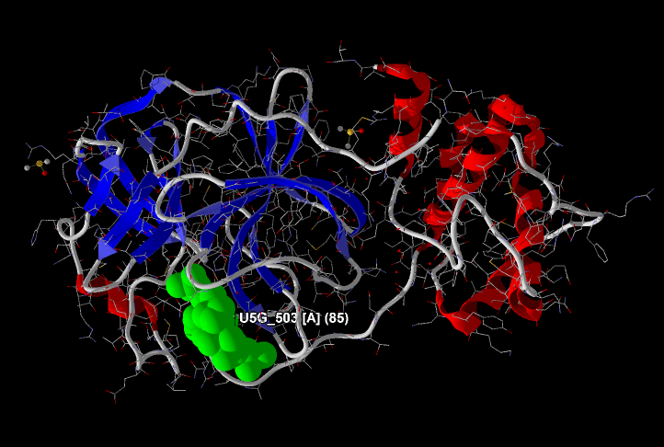
Figure 1. Secondary structure view of the SARS-CoV-2 main protease (3C-like protease) in complex with potential inhibitor Boceprevir (colored by green and labeled as U5G_503 [A] (85)).

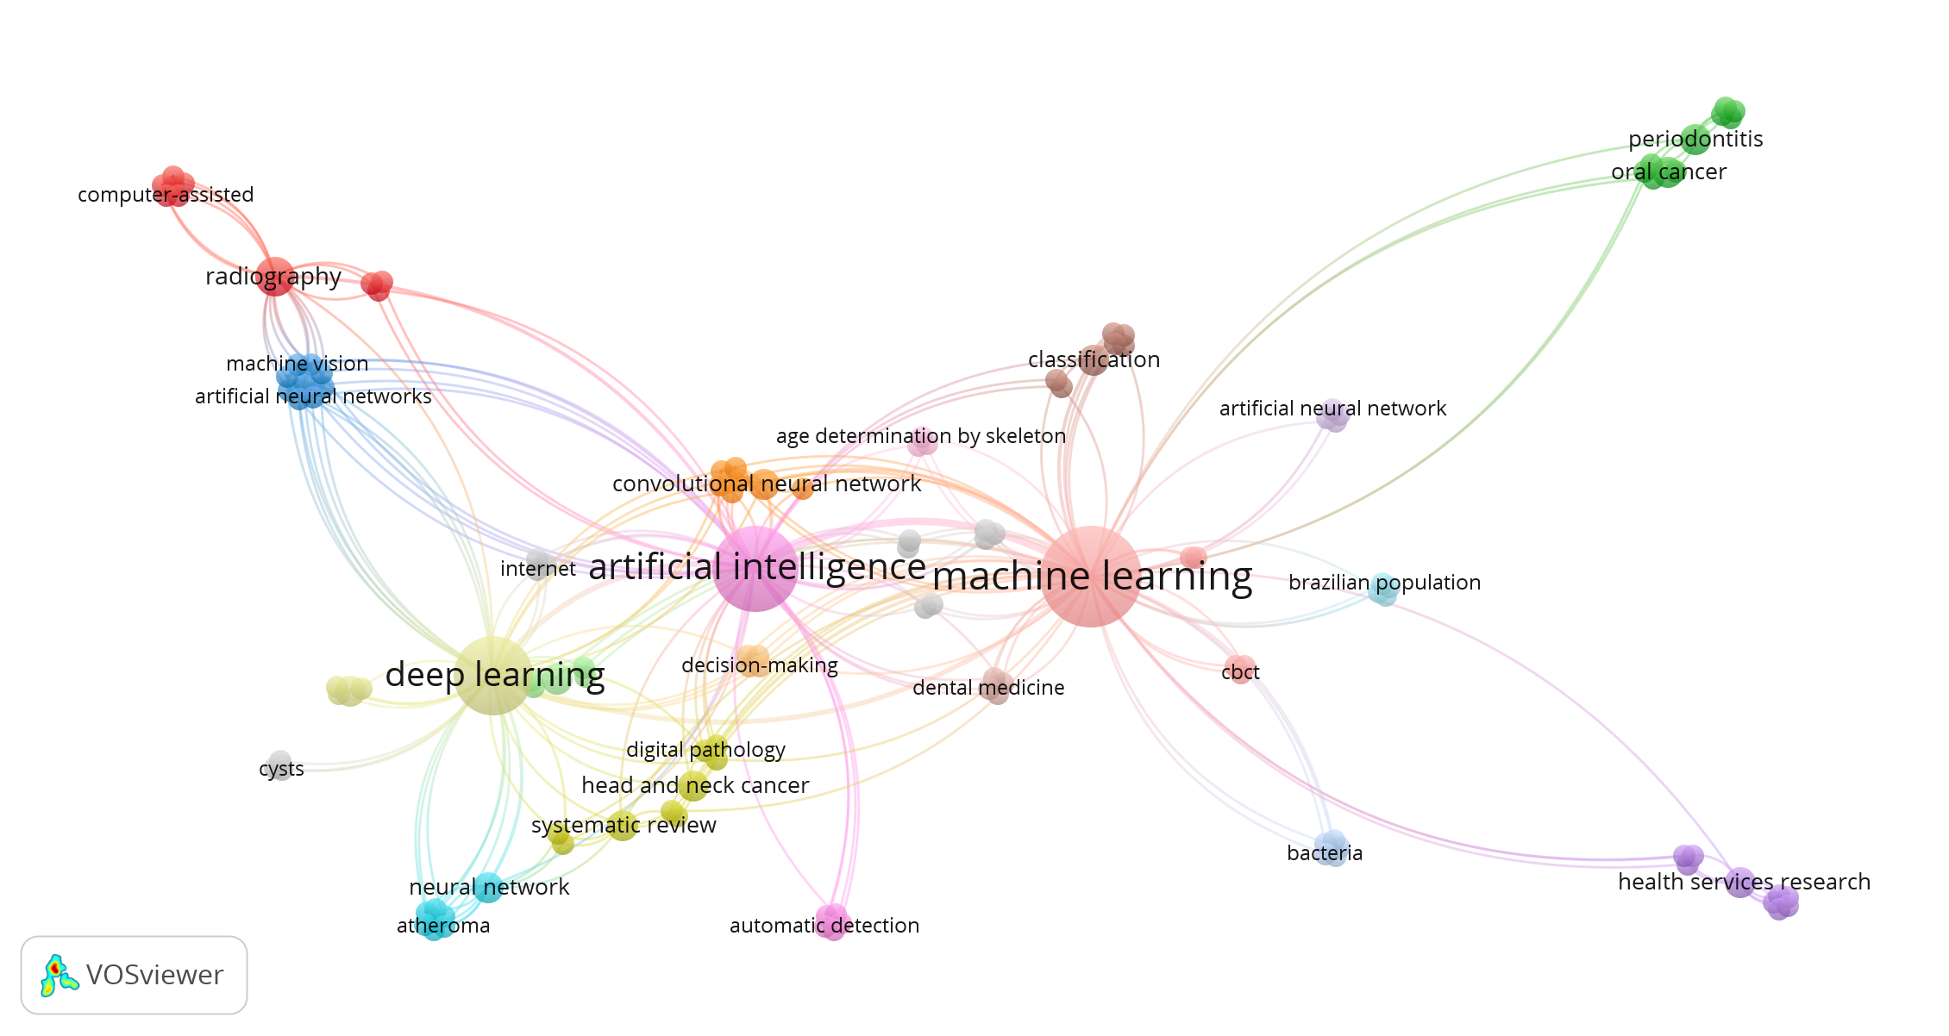

Figure 2. Number of articles published in dental journals regarding machine learning. Also number of articles during next 5 years forecasted using exponential smoothing algorithm (upper part). Author keyword co-occurrence network analysis of machine learning articles (lower part).

