Driver Response to a Dynamic Speed Feedback Sign on Freeway Exit Ramps based on Sign Location, Interchange Type, and Time of Day

by

Md Shakir Mahmud, M.Sc.
Ph.D. Student
Department of Civil and Environmental Engineering
Michigan State University
East Lansing, MI, 48824
Email: mahmudmd@msu.edu

Matthew Motz
M.S. Student
Department of Civil and Environmental Engineering
Michigan State University
East Lansing, MI 48824
E-mail: motzmatt@msu.edu

Travis Holpuch
M.S. Student
Department of Civil and Environmental Engineering
Michigan State University
East Lansing, MI 48824
E-mail: holpucht@msu.edu

Anthony J. Ingle, P.E.
Ph.D. Student
Department of Civil and Environmental Engineering
Michigan State University
East Lansing, MI 48824
E-mail: ingleant@msu.edu

Timothy J. Gates, Ph.D., P.E.
Associate Professor
Department of Civil and Environmental Engineering
Michigan State University
East Lansing, MI 48824
E-mail: gatestim@msu.edu

Peter T. Savolainen, Ph.D., P.E.
MSU Foundation Professor
Department of Civil and Environmental Engineering
Michigan State University
East Lansing, MI 48824
E-mail: pete@msu.edu

Words excluding Tables = 5,876
Tables: 6 x 250 = 1,500
Total Words = 7,376

Date Submitted: August 1, 2020

ABSTRACT
Roadway segments that include horizontal curves experience a disproportionate number of crashes compared to straight segments. Many of these crashes are lane departure-related, and excessive speed is often a contributing factor. One particularly vulnerable area for such crashes is freeway interchange ramps, which require a substantial reduction in speed to be safely negotiated. While dynamic speed feedback signs (DSFS) have been found to be an effective speed and crash reduction countermeasure at horizontal curves, the use of such signs on freeway interchange ramps has been limited nationwide. Consequently, the effectiveness of DSFS as a speed reduction countermeasure in such settings has remained largely untested. A before-and-after field evaluation was performed at three freeway exit ramps to assess the impacts of a DSFS on driver speed selection and braking characteristics while approaching and entering the ramp curves. The effectiveness of the feedback sign was tested across various conditions, including sign location, interchange type, time of day, light condition, and vehicle type. In general, the greatest benefits to driver behavior were achieved with the DSFS positioned at the point of curvature, during which curve entry speeds were reduced by approximately 2 mph compared to the pre-DSFS condition. These findings were consistent between the system- and service-interchanges and across all vehicle types. The DSFS was also found to be most effective during daytime off-peak periods compared to peak periods and at night. Based on the study findings, the continued use of DSFS as a speed reduction treatment at freeway exit ramps is recommended.

Keywords: dynamic speed feedback sign, freeway ramps, horizontal curves, lane departure crashes, driver behavior

INTRODUCTION
Horizontal curves pose a serious safety concern due to the increased probability of lane departures, particularly at high speeds. Historically, a disproportionate number of crashes have occurred on horizontal curves compared to tangent roadway sections. On two-lane rural highways, segments containing horizontal curves have been found to have crash rates that are three times greater than similar tangent segments (1). Furthermore, nearly 25 percent of fatal crashes occur on curves (2), and approximately 75 percent of these fatal crashes were lane departure crashes involving a single vehicle running off the road. In 2018, there were 16,794 lane departure fatal crashes nationally, which accounted for approximately half of the total fatal crashes (3). In Michigan alone, there were 400 fatalities due to lane departures in 2018 (4). Although the crashes on horizontal curves were mostly correlated to the geometric factors (5), lane departure crashes on curves are largely influenced by driver-related factors including driver distraction, impairment, and most importantly, speeding. Approximately half of the fatal crashes on curves were related to speeding and single vehicle run-off-road (6).
One particularly vulnerable area for curve-related lane departure crashes is freeway ramps, which, due to right-of-way constraints and other factors, often include horizontal curves requiring a significant reduction in speed to be safely negotiated. Nationwide, 697 fatal crashes occurred on exit or entrance ramps in 2018 (3), the majority of which are single-vehicle lane departure. Several traffic control strategies have been deployed nationwide to counter lane departure crashes on freeway ramp curves, including signs, warning beacons, and horizontal signing. Despite these efforts, the problem continues to persist and new treatments are needed.
A promising countermeasure to reduce curve speeds on freeway interchange ramps is the dynamic speed feedback sign (DSFS), which uses real-time speed detection to provide targeted warning messages to drivers. These signs have been found to effectively reduce speeds on mainline horizontal curves (5, 7), although their use on freeway interchange ramps has been limited. Thus, the effectiveness of the signs in such settings is not well established. A recent study by Gates et al. (8) presented a before-and-after field evaluation at a freeway interchange ramp using various DSFS messaging and positioning strategies. The study found a significant reduction in curve entry speeds when the DSFS was positioned near or at the point of curvature (PC) and when the speed number display alternated with a “SLOW DOWN” message. While that study provided encouraging results, an expanded evaluation at additional freeway ramp locations was required to further confirm effectiveness of the DSFS.
To that end, research was undertaken to determine the effectiveness of DSFS applications on multiple freeway ramps with significant horizontal curvature. The primary objective of this research was to determine the effect of DSFS on ramp curve speeds across a variety of conditions, including sign locations (point of curvature vs. upstream), times-of-day (peak vs. off-peak), light conditions (daylight vs. darkness), interchange types (system vs. service), and vehicle types (passenger vehicles vs. trucks).

LITERATURE SUMMARY
DSFS relay active real-time speed feedback information to approaching drivers on a digital display. Such devices have been evaluated as a speed- and crash-reduction countermeasure across a variety of settings, including school zones (9), work zones (10, 11), speed transition zones (9, 12, 14), sharp horizontal curves (7, 9, 15), and high-speed arterials (9, 13, 14, 16). Studies have also evaluated the effectiveness of DSFS on driver behavior based on the road geometry (17), sign placement (18), and the message being displayed (19).
Evaluation of DSFS at rural highway curves has been relatively limited. In this setting, DSFS have been found to reduce curve speeds by approximately 2 mph for both passenger cars and trucks (7, 9, 15), and these speed reductions have been sustained over the first 24 months of sign operation (7). The most comprehensive evaluation of crashes involving DSFS use at horizontal curves found a 5 to 7 percent reduction in crashes during the first three years after installation of DSFS at 22 two-lane rural highway curves across seven states (7).
The effectiveness of DSFS also depends on their positioning and message. On straight sections of roadway, the greatest speed reductions are observed upstream of the sign (20, 21), with diminished effects downstream of the sign (21). These findings have led to the recommendation of that the sign be positioned at or before the critical location or hazard (22). The message that the DSFS displays can also impact a driver’s behavior. Full matrix displays that are able to provide messages such as ‘SLOW DOWN’ when the driver is exceeding a certain speed threshold have been found to outperform signs that simply display the driver’s speed (7, 8, 9, 11, 15, 19).
While these studies collectively suggest that DSFS are effective for reducing speeds and speed-related crashes on rural highway curves, none considered the effects of DSFS on interchange ramp curves, thereby further supporting the need for additional research. Further, while prior work by the authors (8) have shown promising effects on driver behavior associated with the use of a DSFS on a single freeway interchange ramp, further research was needed to explore the conditions under which DSFS are most effective when used as a speed warning treatment on freeway ramps.

METHODOLOGY
A before-and-after field evaluation was performed at three freeway ramp curve locations to determine the effectiveness of DSFS on curve entry speeds. The effectiveness of the DSFS was tested across various sign locations (point of curvature vs. upstream), interchange types (system vs. service), vehicle types (passenger vehicles vs. trucks), times-of-day (peak vs. off-peak), and light conditions (daylight vs. darkness). The following subsections detail the various aspects of this evaluation, including sign selection, site selection, sign test conditions, and field data collection.

Test Sign
A single DSFS test sign was utilized for this field study. This sign, which is shown in Figure 1 displaying example messages, was a 40-inch by 31-inch sign with microprismatic reflective yellow sheeting with black “YOUR SPEED” text and a full matrix amber LED feedback display capable of displaying characters of up to 15 inches in height. For testing purposes, the sign included a 140 amp-hour battery system that powered the radar feedback sign for a minimum of three weeks on a single charge. The radar unit was specified by the manufacturer to have a detection range for a typical passenger vehicle of approximately 400 feet, which extended up to 600 feet for trucks. The sign was compliant with the Michigan Department of Transportation’s (MDOT) draft special provision for DSFS. Further details pertaining to sign selection can be found in reference 8.

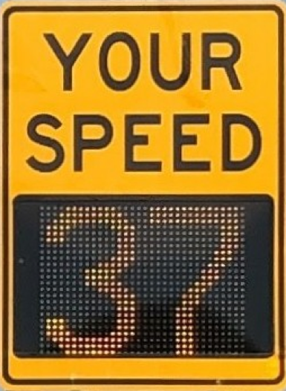
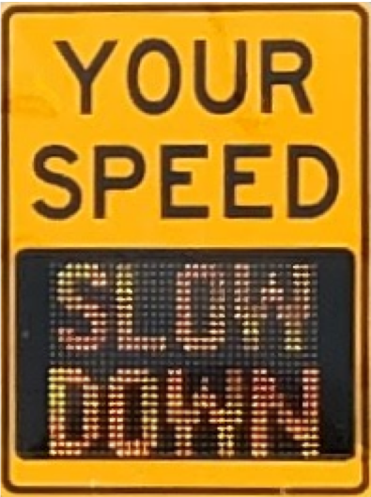
FIGURE 1 Dynamic speed feedback sign for field evaluation.

Site Selection
Three freeway exit ramp locations were selected for this study based on the following criteria:
- High frequency of lane departure crashes,
- Advisory speed of 30 mph or below,
- High traffic volumes, including a considerable proportion of trucks,
- DSFS sign installation capability (i.e., no roadside obstructions or terrain issues), and
- Suitable for data collection.
To compare the signs effects based on the interchange type, it was also desirable to include at least one system interchange and one service interchange. Ultimately, three exit ramp locations were selected for this study, which included westbound (WB) I-96 to southbound (SB) I-69 (Site 1), northbound (NB) US-127 to Round Lake Road (Site 2), and eastbound (EB) I-96 to 36th Street (Site 3). Site 1 was a freeway-to-freeway interchange ramp and the other two were exit ramps at service interchanges. Detailed information on the three study sites is provided in Table 1. A typical plan view of the existing signage layout, DSFS location, and data collection camera locations for each of the three sites is provided in Figure 2. Each of the sites possessed MUTCD compliant warning signage, and were considered representative of freeway exit ramps in Michigan.

TABLE 1 Site characteristics and DSFS test conditions
No | Location | Mainline Speed Limit/Ramp Advisory Speed (mph) | Interchange Type | Feedback Message | DSFS Location
1 | WB I-96 to SB I-69 | 70/30 | System | Speed number with alternating “Slow Down” message and advisory speed panel | Curve PC
2 | NB US-127 to Round Lake Rd | 75/30 | Service | Speed number with alternating “Slow Down” message | Curve PC
3 | EB I-96 to 36th St | 70/20 | Service | Speed number with alternating “Slow Down” message | 350 feet upstream of curve PC
Note: PC = point of curvature
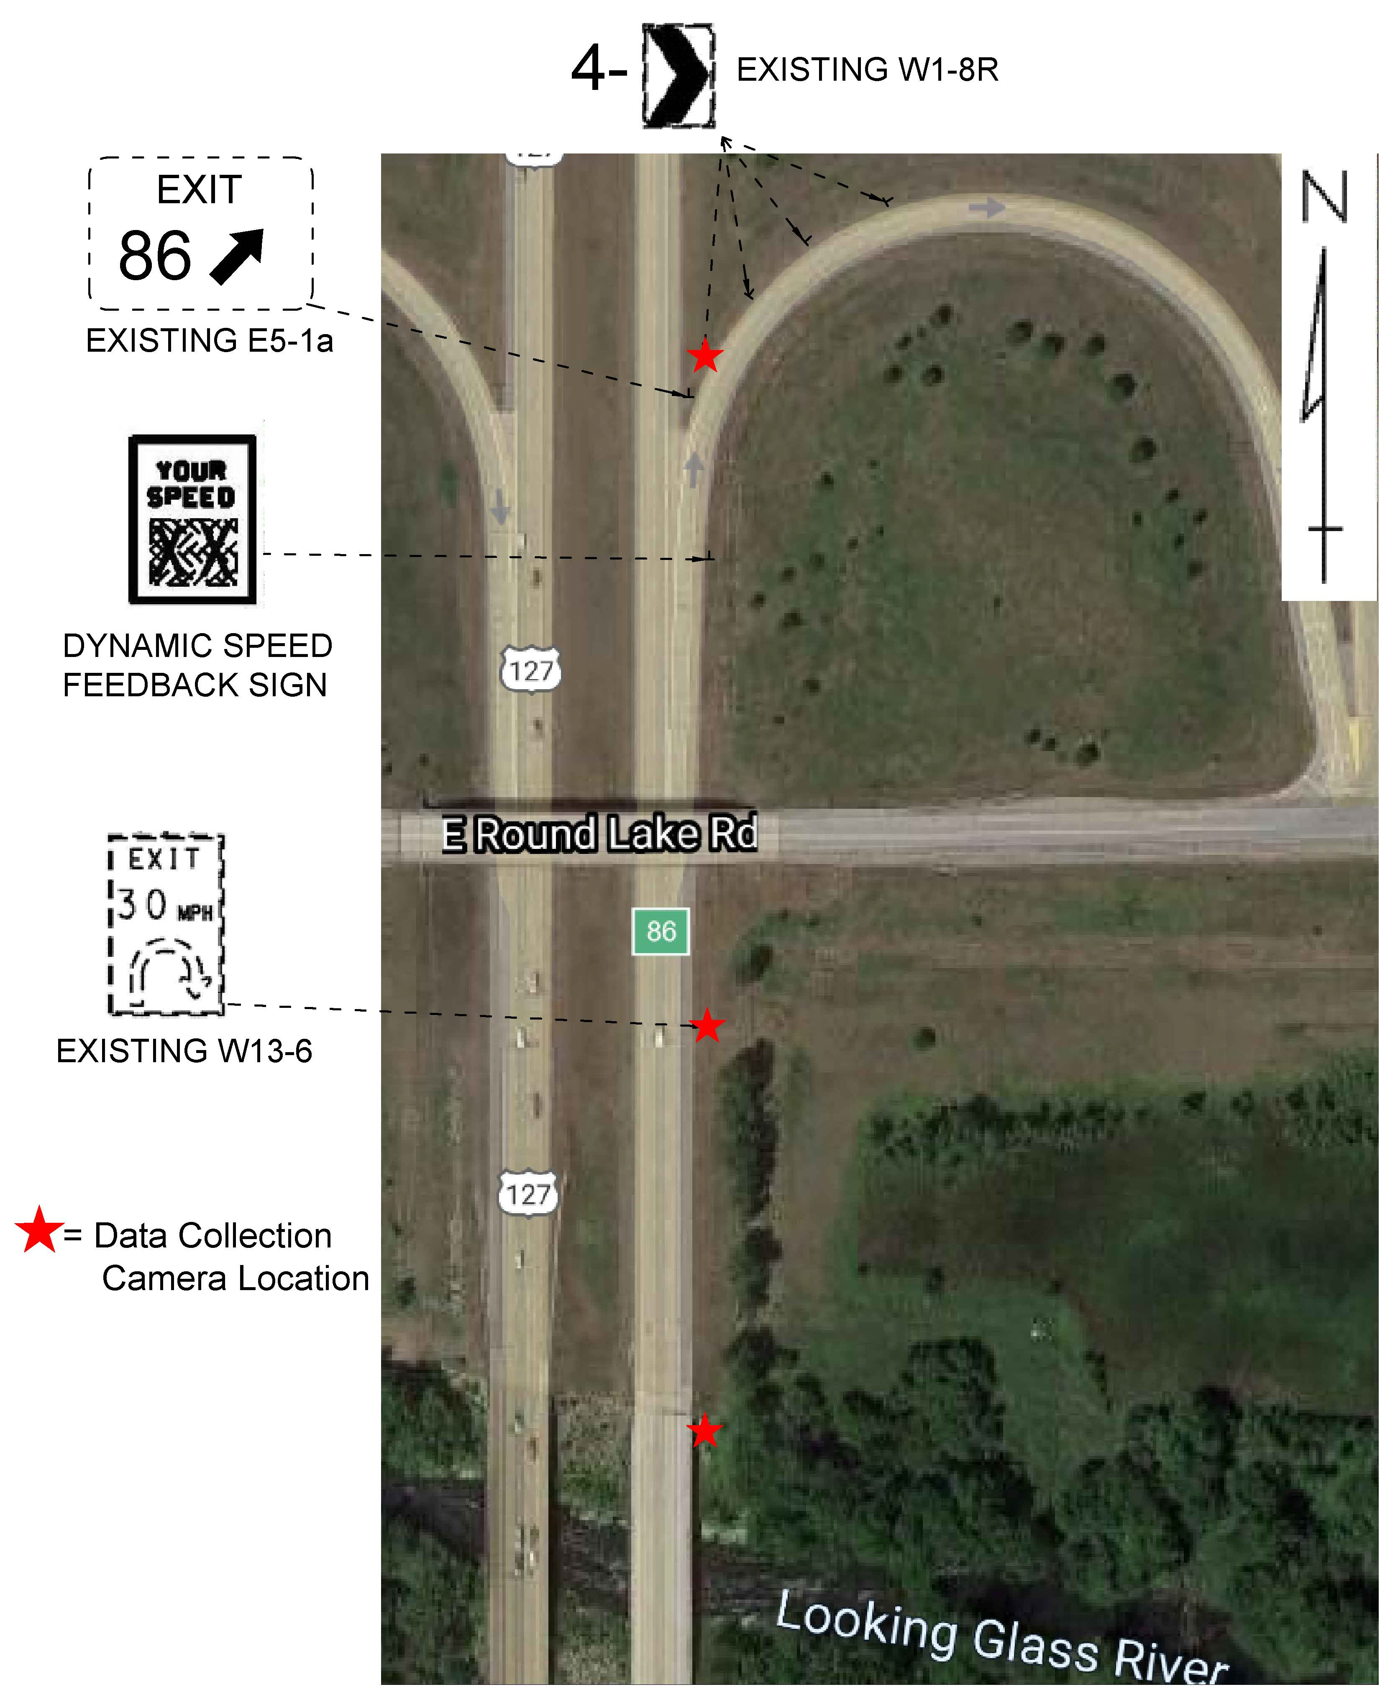
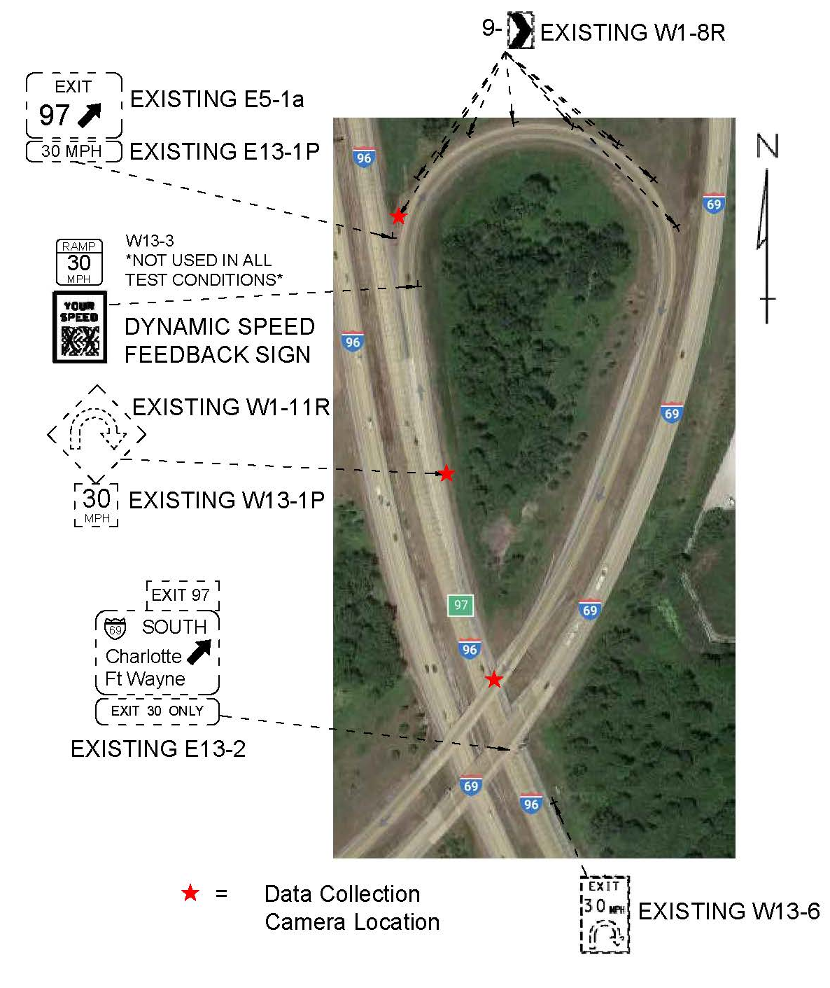
- Site 1. WB I-96 to SB I-69 b. Site 2. NB US-127 to Round Lake Rd

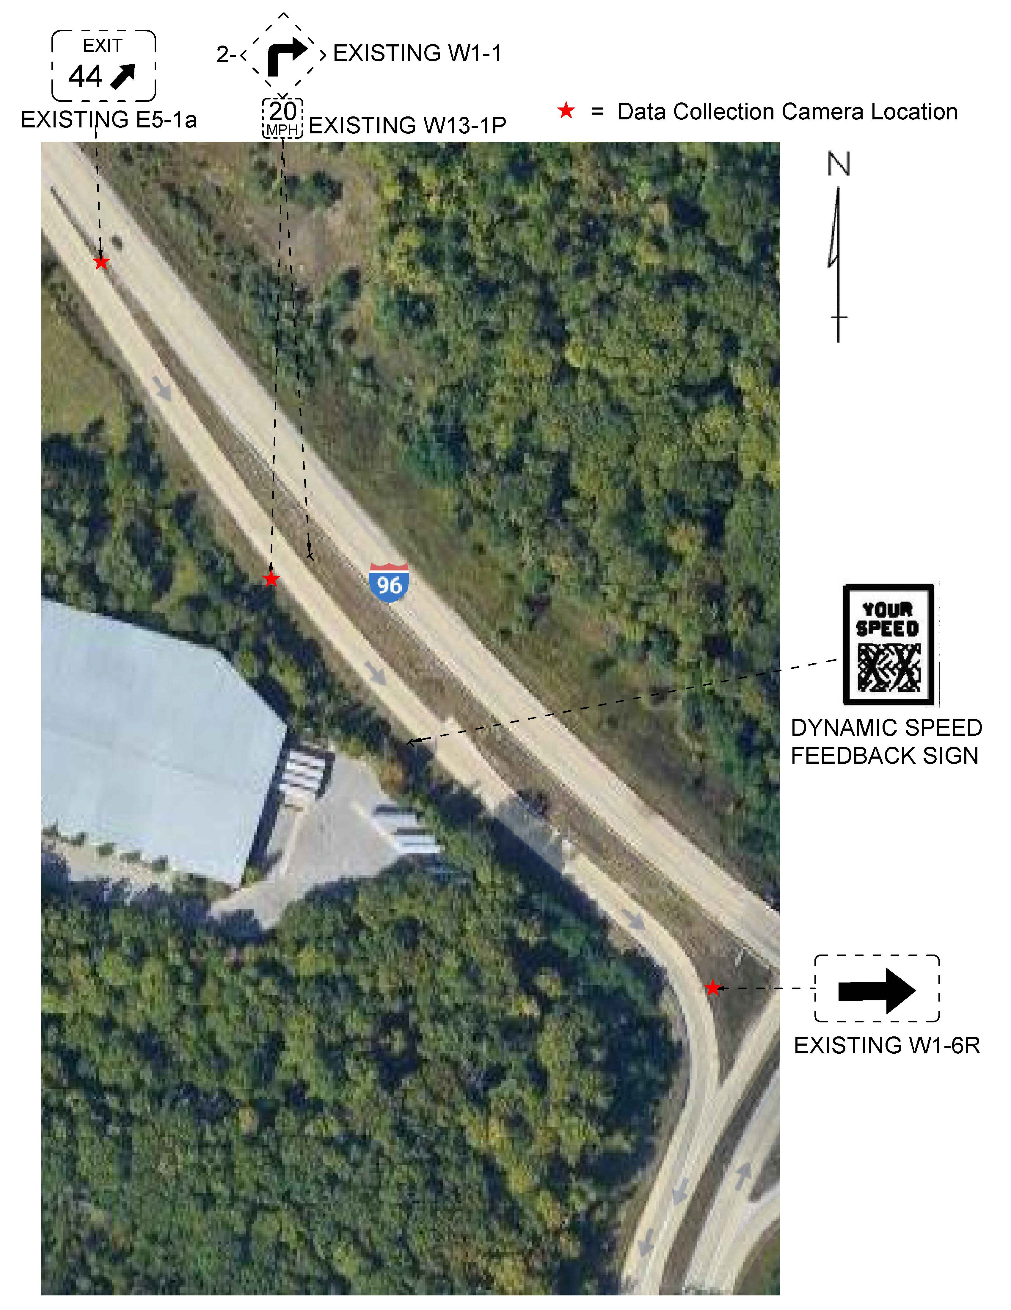
- EB I-96 to 36th Street
FIGURE 2 Freeway exit ramp locations for DSFS field evaluation.

Test Conditions
In addition to testing the general effectiveness of the DSFS as a driver behavior measure, it was also desirable to assess differences in the sign effectiveness across various conditions. One such condition was to vary the DSFS location with respect to the point of curvature between sites. The DSFS was positioned at the point of curvature (PC) at Sites 1 and 2. However, the DSFS was positioned 350 upstream of the curve at site 3. Furthermore, Site 1 was a freeway-to-freeway system interchange, while Sites 2 and 3 were service interchanges, which further allowed for assessment of differences in DSFS effectiveness between interchange types. Finally time-of-day and light condition effects were assessed by using a data collection trailer to measure curve entry speeds before and after installation of the DSFS at Site 2.
One aspect that remained uniform between the three locations was the sign messaging strategy. During all test conditions, the DSFS was programmed to display the speed of vehicles that were approaching below 40 mph, alternating with a “SLOW DOWN” message at 0.5 sec intervals for vehicles traveling 40 mph and above. This messaging strategy followed the current MDOT draft special provision for DSFS and was found in the initial field study to provide the greatest impact on driver behavior (8). A standard advisory speed panel was also installed with the DSFS at Site 1. However, the use of an advisory speed panel was not found to impact the effectiveness of the DSFS during the initial field study (8).

Video Data Collection
Data were collected from each study location in two phases: 1) under the existing site conditions without the DSFS present and 2) after the installation of the DSFS. This data collection was done during clear weather conditions during weekday off-peak hours. The existing signage at the sites were not modified or changed in any way. The sign remained in operation for approximately three weeks at each site. Data collection was delayed until at least seven days after the DSFS installation to mitigate any novelty effect associated with the new device.
A series of three pole-mounted high definition video cameras were installed at various points on the approach to and within the curve. The cameras were temporarily attached to the existing roadside signposts, similar to that shown in Figure 3. The cameras were elevated to a height of 15 feet and aimed towards a predetermined location on the roadway. Each camera recorded approximately 3 hours of video during each data collection period. Data were collected across multiple days before and after DSFS installation at each site. The cameras were installed at the same locations to provide approximately identical views during each data collection period. The three camera setup locations included the following approximate locations:
- 1,000 feet upstream of the curve to provide coverage of the area upstream of the DSFS detection zone;
- 450 feet upstream of the curve to provide coverage of the area where the DSFS typically became illuminated for approaching vehicles; and
- 150 feet after the point of curvature to provide coverage of the entry to the curve and approximately 200 feet beyond the point of curvature.
An example view from each of these three camera locations is displayed in Figure 3.

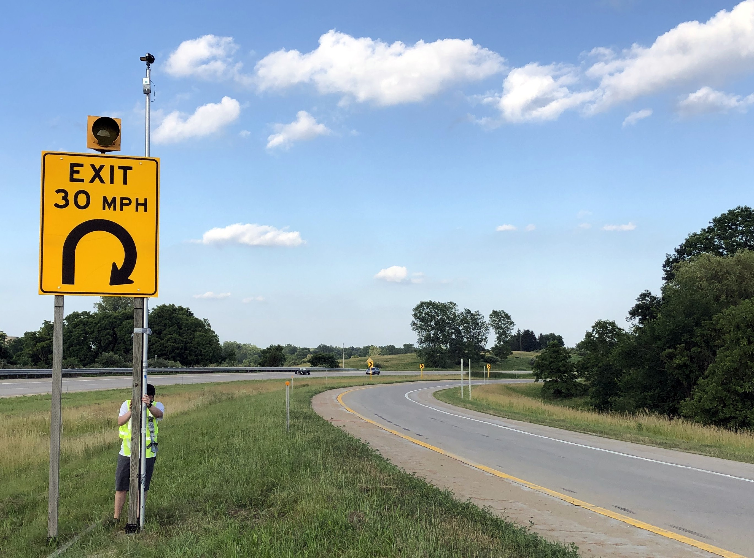 | 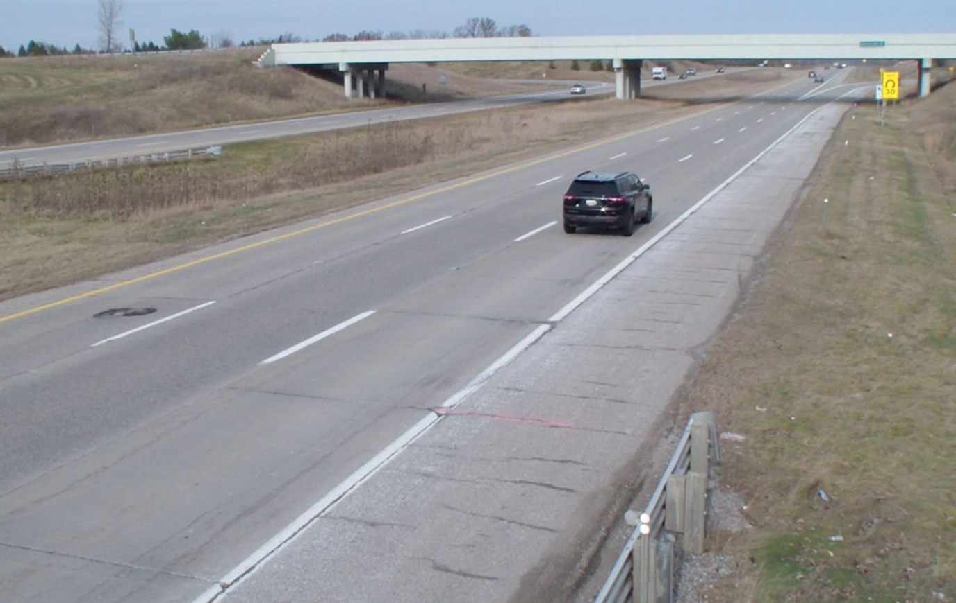
a. Example camera setup | b. View from upstream camera
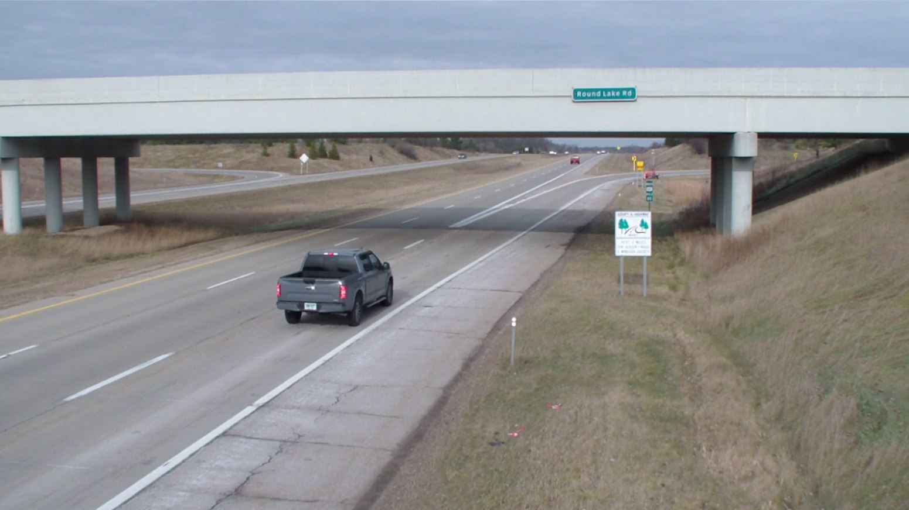 | 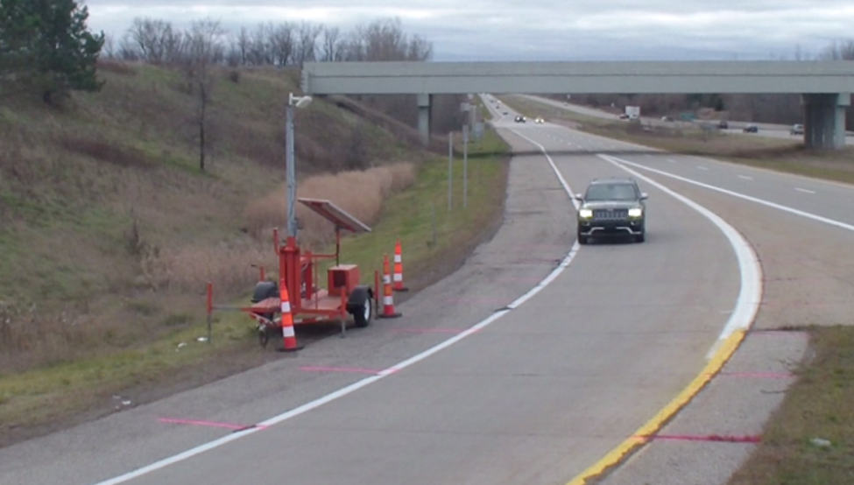
c. View from the middle camera | d. View from curve camera
FIGURE 3 Example camera setup and field of view provided by each camera.

After completion of the field data collection, the videos were manually reviewed by a team of trained technicians to assess various characteristic of driver behavior. The view afforded by the elevated camera setups allows direct observation of numerous vehicular and operational attributes, including vehicle type, headway, speed, and brake lights. Further, various aspects related to the DSFS and site condition were also assessed from the videos, including location of the vehicle at DSFS message onset, DSFS message displayed to each vehicle, traffic volumes, weather, and interference from vehicles parked on the shoulder.
The videos were reviewed and each vehicle was sequentially tracked through the videos across the three camera setups. Quicktime software was utilized, which allowed for frame-by-frame review to determine the relevant vehicular location and time information. The videos were recorded at a rate of 60 frames per second, allowing time to be recorded to the nearest 0.0167 seconds based on the frame number displayed in the video player. Paint marks placed on the shoulder at 50-ft intervals (shown in Figure 3d) were used as field reference markers for determining the relative location of a vehicle with respect to the point of curvature at any point in time. The following information was obtained from the videos for each vehicle traveling through the site:
- Time to traverse the following speed measurement zones:
  - 1000-ft upstream of the point of curvature (prior to the DSFS detection area),
  - At the point of curvature,
- Time headway from the prior vehicle,
- Location (with respect to the point of curvature) of initial braking,
- Whether a message was displayed on the DSFS, and
- Vehicle type:
  - Passenger vehicle (car, SUV, pickup, van, minivan, motorcycle) without a trailer,
  - Passenger vehicle with a trailer,
  - Single unit truck/bus/RV, or
  - Tractor trailer truck.

Speed Trailer Data Collection
Although collection of driver behavior data using video cameras affords vehicle tracking capabilities, their use is limited to daylight conditions and data extraction is very labor-intensive, which further limits sample sizes. Thus, in order to obtain a comprehensive sample of curve entry speeds across various times of day and light conditions, a speed data collection trailer was positioned at Site 1 (US127/Round Lake Rd) just beyond the right shoulder near the point of curvature (Figure 4). The speed trailer utilized an elevated Wavetronix SmartSensor HD side-firing radar unit, which was aimed and calibrated to continuously measure speed and length data for vehicles at the ramp curve entry point.
The speed trailer remained in a fixed position and continuously recorded for a 36 day period from November 6, 2019 through December 12, 2019. Data were collected under the existing site condition, without the DSFS, for the initial 20 days. The DSFS was installed at the point of curvature, immediately in advance of the speed trailer, on November 26, 2019, thus allowing for 16 days of data collection with the DSFS in operation. To limit data file-size, the radar was programmed to bin data into 30 second intervals. To isolate free-flowing vehicles, the data were screened to include only those intervals that included a single vehicle. Further screening was conducted to remove potential mainline observations and other anomalies.
A total of 17,433 vehicles were included in the final dataset for further analysis. The dataset included 16,839 passenger vehicles and 594 heavy vehicles, which were defined in this study as vehicles longer than 32 feet. To account for changes in weather at the site, weather condition data were collected from a nearby National Weather Service station and combined with the speed data. Furthermore, sunrise and sunset data were also included to determine any differential effects of the DSFS on curve entry speeds under varied lighting conditions.

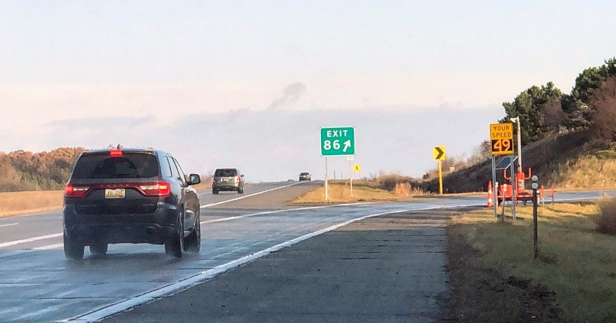
FIGURE 4 DSFS and speed trailer at US-127 exit to Round Lake Rd.

Data Screening
The video data collected from three sites were combined, organized, and coded into a single file for detailed analysis. The data set was screened to include only vehicle observations with a headway of 3 seconds or greater to eliminate the effects of vehicle platooning. Cases where no feedback message was displayed on the DSFS for an approaching vehicle were also removed from the dataset. The final combined data set included a complete record for 1,758 vehicle observations collected from three sites. It should be noted that brake light data could not be discerned from one data collection period due to a slight misalignment of the camera, which reduced the sample size for the braking data to 1,651.
Turning to the speed trailer data, initial analysis found curve entry speeds to vary widely during poor weather conditions, including rain, sleet, ice, and snow. This is not surprising, as it is difficult to characterize the impacts to visibility and pavement surface during such conditions. Thus, the speed trailer data were limited to only those periods that occurred during clear, cloudy, or fair conditions. Using the time-stamps of each data bin, the speed trailer data were also coded for further analysis based on times-of-day (peak vs. off-peak) and light conditions (daylight vs. darkness). For this study, the peak period was defined as 7:00 – 9:00 AM and 3:30 to 6:00 PM. Daylight and darkness were coded based on sunrise (between 7:19 and 8:00 AM) and sunset (between 5:05 and 5:26 PM) for each day during the data collection period. The data were then classified for analytical purposes as follows: peak, daytime off-peak, and nighttime. Thus, all daytime off-peak occurred during daylight periods, all nighttime occurred during dark periods, while peak included a mix of daylight, twilight, and dark periods. In using this coding structure, it was possible to assess whether the DSFS had a variable effect on the behavior of peak (e.g. commuter) vs. off-peak drivers and during different lighting conditions.
To determine any obvious trends in the data, sources for potential bias, and data distributions, the authors initially compared the descriptive statistics (i.e., mean, standard deviation, percentiles, etc.) and simple graphical representations (i.e., frequency distribution, box plot, scatterplot) of the vehicular data across each data collection period. Table 2 presents the descriptive statistics of the combined dataset that included 1,758 vehicle observations from the videos across the three sites and 17,433 observations from the speed trailer.

TABLE 2 Descriptive Statistics
Video Camera Data (N = 1,758)
Variable | Unit | Min | Max | Mean | Std Dev
Speed 1000 feet upstream of the pc | mph | 30.303 | 83.832 | 58.949 | 7.701
Speed at point of curvature (i.e., curve entry) | mph | 17.045 | 57.273 | 38.388 | 5.496
Speed within 15 mph of advisory speed |  | 0 | 1 | 0.656 | 0.475
Braking first initiated 200-600 ft prior to PC* |  | 0 | 1 | 0.321 | 0.467
Passenger vehicle without trailer |  | 0 | 1 | 0.820 | 0.385
Passenger vehicle with trailer |  | 0 | 1 | 0.018 | 0.132
Single unit truck/bus/RV |  | 0 | 1 | 0.039 | 0.194
Tractor trailer truck |  | 0 | 1 | 0.123 | 0.329
Existing site condition (No DSFS) |  | 0 | 1 | 0.557 | 0.497
DSFS at point of curvature - I-96/I-69 |  | 0 | 1 | 0.136 | 0.343
DSFS at point of curvature - US-127/Round Lake Rd |  | 0 | 1 | 0.133 | 0.340
DSFS at 350 ft upstream of point of curvature - I-96/36th |  | 0 | 1 | 0.173 | 0.379
Speed Trailer Data (N = 17,433)
Variable | Unit | Min | Max | Mean | Std Dev
Speed at point of curvature (i.e., curve entry) | mph | 25.100 | 54.900 | 39.039 | 5.459
Passenger vehicle |  | 0 | 1 | 0.966 | 0.181
Heavy vehicle (longer than 32 ft) |  | 0 | 1 | 0.034 | 0.181
Daytime Off-Peak (9:00 AM – 3:30 PM) |  | 0 | 1 | 0.394 | 0.489
Peak (7:00 AM – 9:00 AM; 3:30 PM – 6:00 PM) |  | 0 | 1 | 0.178 | 0.382
Nighttime (6:00 PM – 7:00 AM) |  | 0 | 1 | 0.428 | 0.495
No DSFS |  | 0 | 1 | 0.557 | 0.497
DSFS at point of curvature |  | 0 | 1 | 0.443 | 0.497
*Sample size, N= 1,651

ANALYSIS
Several measures of effectiveness related to curve entry speed and brake response were analyzed to determine the effects of the DSFS as a function of sign location, interchange type, and time-of-day. Three primary analyses were performed using appropriate statistical procedures. The dependent variables for these analyses included:
- Speed at the point of curvature (i.e., curve entry),
- Probability of initial brake response occurring between 200 and 600 ft upstream of the PC; this range was selected as it afforded a comfortable braking distance prior to curve entry and also corresponded with the detection range of the DSFS radar, and
- Probability of a vehicle entering the curve within 15 mph of the advisory speed.
Preliminary models suggested only minor differences in DSFS effectiveness between passenger vehicles and heavy vehicles and further analysis of vehicle-specific DSFS effects was not performed. For all models, the upstream approach speed was included as a covariate to control for general driving behavior. All analyses were performed using RStudio. Curve entry speeds were analyzed using linear regression including a random effect (intercept) term, with the form shown in equation 1:

$Y_{i}= β_{0}+β_{1}X_{i1}+β_{2}X_{i2}+…+β_{k}X_{ik}+ε_{i}+δ_{i}$ (1)

where Y_{i} is the measured speed at the point of curvature for vehicle i, $X_{i1}$ to $X_{ik}$ are independent variables affecting this speed (including DSFS test condition), β₀ is an intercept, β₁ to β_{k} are estimated regression coefficients for each independent variables, and $ε_{i}$ is a normally distributed error term with variance $σ^{2}$. The $δ_{i}$ term is a random intercept term, which accounts for important unobserved factors affecting driver behavior during the data collection periods. A site-specific random intercept term was utilized in the video speed data models to account for the unobserved differences between sites. As the speed trailer was only used at a single site, a date-specific random intercept term was utilized for these models to account for unobserved day-to-day differences.
Binary logistic regression was utilized to analyze the binary response variables, which included the probability of braking 200-600 ft in advance of the curve and the probability of a vehicle entering the curve below within 15 mph of the advisory speed. The binary logistic regression model has the form:

$Y_{i}=logit\left(P_{i}\right)=ln\left(\frac{P_{i}}{1- P_{i}}\right)= β_{0}+β_{1}X_{i1}+β_{2}X_{i2}+…+β_{k}X_{ik}$+ $δ_{i}$ (2)

where the response variable, Y_{i}, is the logistic transformation of the probability of vehicle i braking 200-600 ft in advance of the curve, or entering the curve within 15 mph of the advisory speed. This probability is denoted as P_{i}. As in the linear regression model, $X_{i1}$ to $X_{ik}$ are independent variables affecting driver behaviour (including DSFS test condition), β₀ is an intercept, β₁ to β_{k} are estimated regression coefficients for each independent variables, and $δ_{i}$is a random intercept term similar to the previous one discussed earlier.

RESULTS AND DISCUSSION
The linear regression results for curve entry speeds (e.g. at the point of curvature) obtained from the video data are displayed in Table 3, while the binary logistic regression results for excessive curve entry speeds and brake response location are displayed in Tables 4 and 5, respectively. Again, to control for unobserved variations between the sites, a site-specific random effect (intercept) was included in each model.

TABLE 3 Random Intercept Linear Regression Results for Curve Entry Speed
Response Variable: Speed At Point of Curvature (N=1,758)
Parameter | Estimate | Std. Error | t-value | p-value
Intercept | 14.983 | 1.175 | 12.746 | <0.001
Speed 1000-ft Upstream of the Point of Curvature | 0.414 | 0.014 | 29.208 | <0.001
Passenger Vehicle with No Trailer | Base Condition
Passenger Vehicle With Trailer | -1.339 | 0.665 | -2.015 | 0.044
Single Unit Truck/ Bus | -1.969 | 0.463 | -4.252 | <0.001
Tractor Trailer Truck | -3.290 | 0.309 | -10.648 | <0.001
Existing Site Condition (No DSFS) | Base Condition
DSFS at Point of Curvature - I-96/I-69 | -2.290 | 0.299 | -7.665 | <0.001
DSFS at Point of Curvature - US-127/Round Lake Rd | -1.975 | 0.331 | -5.970 | <0.001
DSFS at 350 ft upstream of Point of Curvature - I-96/36th | 0.967 | 0.283 | 3.415 | <0.001

TABLE 4 Random Intercept Logistic Regression Results for Excessive Curve Entry Speed
Response Variable: Speed at Point of Curvature within 15 mph of the Advisory Speed (N=1,758)
Parameter | Estimate | Std. Error | t-value | p-value | Exp(B)
Intercept | 12.846 | 1.390 | 9.245 | <0.001 | 379268
Speed 1000-ft Upstream of the Point of Curvature | -0.201 | 0.014 | -13.936 | <0.001 | 0.818
Passenger Vehicle with No Trailer | Base Condition
Passenger Vehicle With Trailer | 1.959 | 0.977 | 2.006 | 0.045 | 7.092
Single Unit Truck/ Bus | 1.650 | 0.486 | 3.395 | 0.001 | 5.207
Tractor Trailer Truck | 2.387 | 0.411 | 5.809 | 0.000 | 10.881
Existing Site Condition (No DSFS) | Base Condition
DSFS at Point of Curvature - I-96/I-69 | 0.548 | 0.296 | 1.851 | 0.064 | 1.730
DSFS at Point of Curvature - US-127/Round Lake Rd | 0.901 | 0.275 | 3.276 | 0.001 | 2.462
DSFS at 350 ft upstream of Point of Curvature - I-96/36th | -0.300 | 0.215 | -1.395 | 0.163 | 0.741

TABLE 5 Random Intercept Logistic Regression Results for Brake Response Location
Response Variable: Braking Began 200-600 ft Before Curve (N=1,651)
Parameter | Estimate | Std. Error | t-value | p-value | Exp(B)
Intercept | -2.357 | 0.500 | -4.713 | <0.001 | 0.095
Speed 1000-ft Upstream of the Point of Curvature | 0.026 | 0.008 | 3.155 | 0.002 | 1.026
Passenger Vehicle with No Trailer | Base Condition
Passenger Vehicle With Trailer | -0.148 | 0.408 | -0.364 | 0.716 | 0.862
Single Unit Truck/ Bus | -0.379 | 0.309 | -1.230 | 0.219 | 0.685
Tractor Trailer Truck | -0.087 | 0.191 | -0.458 | 0.647 | 0.419
Existing Site Condition (No DSFS) | Base Condition
DSFS at Point of Curvature - I-96/I-69 | 0.368 | 0.155 | 2.375 | 0.018 | 1.445
DSFS at Point of Curvature - US-127/Round Lake Rd | 0.599 | 0.151 | 3.953 | <0.001 | 1.820
DSFS at 350 ft upstream of Point of Curvature - I-96/36th | -0.120 | 0.149 | -0.803 | 0.422 | 0.887
Note: Each model included a random intercept for site. Represents data collected from video cameras.

First, as expected, the speed of vehicles measured 1,000 ft prior to the curve was strongly correlated with each of the driver response variables. Specifically, this suggests that faster drivers tended to maintain such behaviors regardless of the DSFS presence at the site, and is aligned with prior behavioral research. Further discussion of the primary variables of interest, including the effects of sign location, interchange type, and time of day on DSFS performance are provided in the sections that follow.

Effect of Sign Location
The parameter estimates in Table 3 indicate that curve entry speeds were approximately 2.0 to 2.3 mph lower with the DSFS present at the two ramp locations where the sign was positioned directly at the point of curvature. The DSFS installed at the point of curvature also decreased the occurrence of excessive curve entry speeds, as indicated in Table 4. Specifically, compared to the existing site condition, drivers were 1.7 to 2.5 times more likely to enter the curve within 15 mph of the curve advisory speed with the DSFS installed at the point of curvature. Furthermore, Table 5 suggests that the DSFS also improved brake response when posted at the point of curvature. With the DSFS at this location, drivers were 1.4 to 1.8 times more likely to initiate braking between 200 and 600 ft upstream of the curve. It is also worth noting that the DSFS had a similar effect on driver response across all vehicle categories. These results are aligned with prior findings associated with DSFS use in similar freeway ramp settings (8).
In contrast, the DSFS was found to be ineffective across all measures of driver response when posted 350 ft upstream of the point of curvature. At this particular ramp location, curve entry speeds were found to increase by approximately 1 mph with the DSFS present. The DSFS had no significant effect on reducing excessive curve entry speeds or improving brake response location at this particular site.

Effect of Interchange Type
It was also of interest to compare the effects of DSFS on driver response across different interchange types, including freeway-to-freeway system interchanges and service interchanges. This effect was evaluated by comparing the DSFS results between the I-96/I-69 (system interchange) and US-127/Round Lake Road (service interchange) ramps. Each of these ramps was a cloverleaf-type interchange with a 30 mph ramp advisory speed. The DSFS was installed directly at the point of curvature in both cases, which, as previously noted, elicited improved driver response compared to the further upstream sign location.
Considering curve entry speeds, the DSFS had a slightly (0.3 mph) greater speed reduction effect at the I-96 freeway-to-freeway interchange. However, the DSFS was somewhat more effective at reducing excessive curve entry speeds and improving brake response when used at the US-127 service interchange. These findings suggest that the DSFS is equally effective at system and service interchange exit ramps when installed at the point of curvature. Figure 5 provides a graphical representation of the site-specific marginal effects, which demonstrate the effects of the DSFS on curve entry speeds related to the sign location and interchange type.

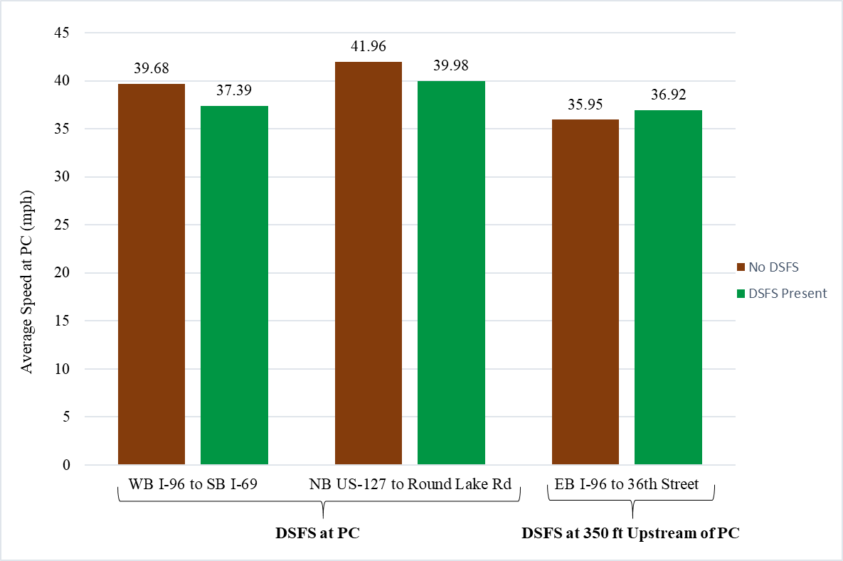
FIGURE 5 Mean curve entry speeds by site and DSFS presence.

Effect of Time of Day
Analysis of the speed trailer data allowed for an assessment of the effects of the DSFS on curve entry speeds across various times of day and light conditions. Again, these data are specific to the US127/Round Lake Rd exit ramp, where the speed trailer, along with the DSFS for a portion of the 36 days, were positioned near the point of curvature. Separate regression models were generated for curve entry speeds based on time of day and light condition, including peak, daytime off-peak, and nighttime. Using these separate models, it was possible to assess whether the DSFS had different effects on the behavior of peak (e.g. commuter) vs. off-peak drivers and during different lighting conditions. The linear regression results for curve entry speeds are displayed in Table 6. Again, to control for unobserved variations between each daily data collection period, a date-specific random effect (intercept) was included in each model.
Table 6 presents several interesting findings related to the effectiveness of the DSFS by time-of-day. Most notably, the DSFS has the greatest effect on reducing curve entry speeds during daytime off-peak periods. The magnitude of this DSFS speed reduction effect (0.9 mph) is nearly double that observed during peak periods (0.5 mph) and triple that observed during nighttime periods (0.3 mph). This finding suggests that the DSFS has the greatest effects on non-commuter drivers compared to commuter drivers, who are generally more familiar with the site. It should be noted that preliminary models did not show any discernable differences in the DSFS effects on curve entry speeds across the vehicle type categories. Graphical representations of the curve entry speeds by time-of-day and DSFS presence are provided in Figure 6.

TABLE 6 Random Intercept Linear Regression Results for Curve Entry Speed by Peak/Off-Peak Period and Light Condition
Daytime Off-Peak (9:00 AM – 3:30 PM) (N=6,869)
Parameter | Estimate | Std. Error | t-value | p-value
Intercept | 40.176 | 0.301 | 133.566 | <0.001
Passenger Vehicle | Base Condition
Heavy Vehicle | -4.911 | 0.294 | -16.727 | <0.001
Existing Site Condition (No DSFS) | Base Condition
DSFS at Point of Curvature | -0.914 | 0.442 | -2.068 | 0.048
Peak (7:00 AM – 9:00 AM and 3:30 PM to 6:00 PM) (N=3,096)
Parameter | Estimate | Std. Error | t-value | p-value
Intercept | 39.694 | 0.292 | 135.733 | <0.001
Passenger Vehicle | Base Condition
Heavy Vehicle | -5.597 | 0.517 | -10.825 | <0.001
Existing Site Condition (No DSFS) | Base Condition
DSFS at Point of Curvature | -0.488 | 0.435 | -1.123 | 0.270
Nighttime (6:00 PM – 7:00 AM) (N=7,468)
Parameter | Estimate | Std. Error | t-value | p-value
Intercept | 38.249 | 0.241 | 158.946 | <0.001
Passenger Vehicle | Base Condition
Heavy Vehicle | -3.671 | 0.453 | -8.110 | <0.001
Existing Site Condition (No DSFS) | Base Condition
DSFS at Point of Curvature | -0.286 | 0.359 | -0.796 | 0.432
Response variable: Speed at point of curvature (curve entry). Each model included a random intercept for the date. Represents data collected by the speed trailer at US-127/Round Lake Rd.
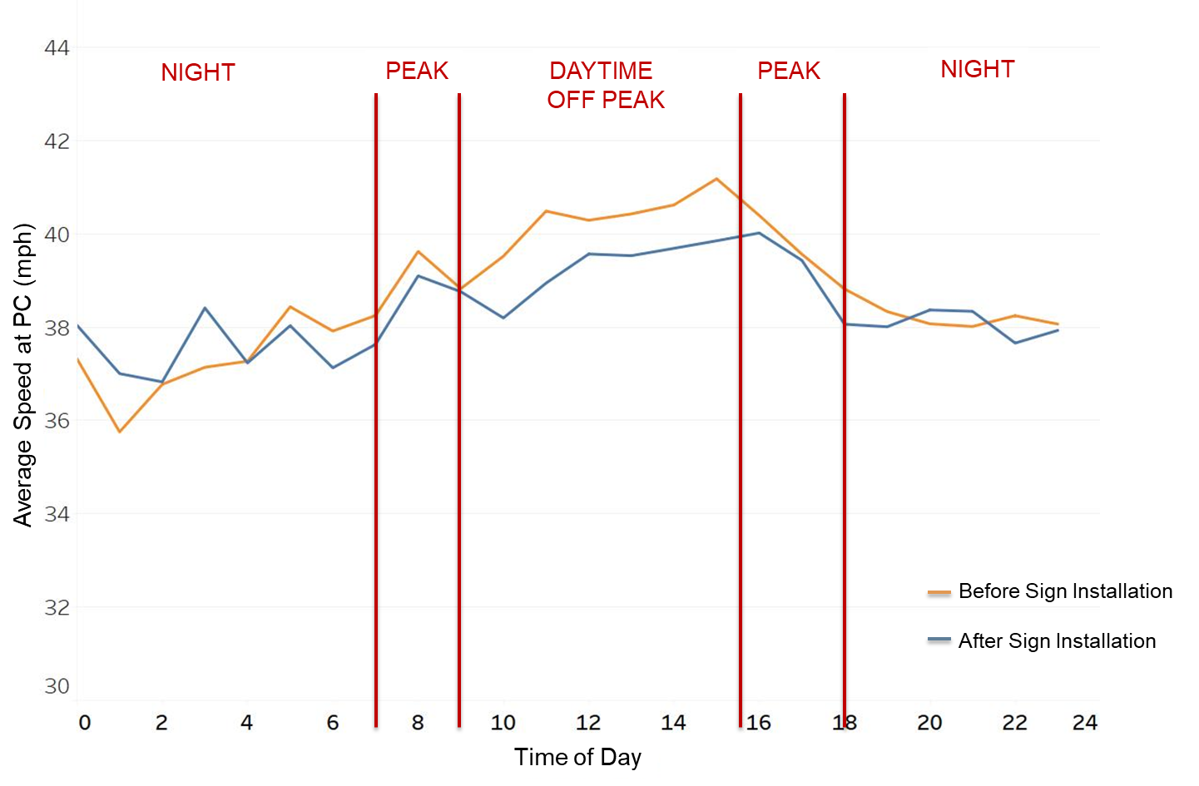
FIGURE 6 Mean curve entry speeds by DSFS presence and time of day.

It is important to note that unlike the video data, it was not possible to track vehicles through the site, as the speed trailer only records a single speed measurement for each vehicle. Thus, it was not possible to correlate driver speeding tendencies upstream of the site with their curve entry speed. As a driver’s upstream speed was found to be highly correlated with curve entry speed during the analysis of the video data, the inability to control for general speed selection tendencies was an important limitation to any inference drawn from the speed trailer data.

SUMMARY, CONCLUSIONS, AND RECOMMENDATIONS
A series of field evaluations were performed at three freeway interchange ramps with significant horizontal curvature to assess the impacts of a dynamic speed feedback sign on driver speed selection and brake response while approaching and entering the curve. A single speed feedback sign with a 15-inch full-matrix display was utilized at each of the three exit ramp locations. The sign was programmed to display the same feedback message at each location, which included the speed number for all approaching vehicles, which alternated with a SLOW DOWN message for vehicles approaching above 40 mph. The effectiveness of the feedback sign was tested across various sign locations (at the point of curvature vs. 350 ft upstream), interchange types (system vs. service), times-of-day (peak vs. off-peak), light conditions (daylight vs. darkness), and vehicle types (passenger vehicles vs. trucks).
Compared to the pre-DSFS site condition, the DSFS reduced curve entry speeds and improved brake response at two of the three ramp locations. In general, the greatest benefits to driver behavior were achieved when the DSFS was positioned at the point of curvature, during which curve entry speeds were reduced by approximately 2 mph. These findings were consistent between the system- and service-interchanges and across all vehicle types. The feedback sign was found to have an ineffective impact on driver behavior when positioned 350-ft upstream of the point of curvature. Consistent with prior speed research (8), it was concluded that drivers are more likely to disregard speed warning messages when provided too far in advance of the hazard.
The DSFS was also found to be most effective during daytime off-peak periods than during peak periods and during darkness. This finding suggests that the DSFS has the greatest effects on non-commuter drivers, and may be reflective of such drivers being more likely to respond to the speed warning message due to a reduced familiarity with the ramp geometry. On the other hand, commuter drivers are less likely to respond to the DSFS due to familiarity with the site, which may also at least partially explain the lack of an effect for nighttime drivers.
Based on the study findings, the continued use of DSFS as a speed reduction treatment at freeway ramp curves is recommended. Specifically, the sign should be positioned to provide adequate time for drivers to perceive and react to the message, such that comfortable braking can be accommodated prior to reaching the curve. However, the authors caution against placing the sign at too great a distance upstream of the curve, as drivers may be more likely to disregard such an early warning message.
Finally, this study has provided useful insights into the effectiveness of DSFS on freeway interchange ramps that include significant horizontal curvature. However, further evaluation of DSFS at freeway ramps under an expanded set of conditions is recommended. This includes the assessment of DSFS under varying ramp geometries, evaluating whether the behavioral effects are sustained over the long-term, effect of size of the sign, and the effect of mainline separation distance on the ability for the radar to detect ramp vehicles. Testing of the DSFS with different sign positions at additional sites is also recommended. Furthermore, future research should also include an assessment of the effectiveness of the DSFS on reducing the frequency and/or severity of lane departure crashes on freeway exit ramps.

DISCLAIMER
Funding for this research was provided by the Michigan Department of Transportation (MDOT). This publication is disseminated in the interest of information exchange. MDOT expressly disclaims any liability, of any kind, or for any reason, that might otherwise arise out of any use of this publication or the information or data provided in the publication. MDOT further disclaims any responsibility for typographical errors or accuracy of the information provided or contained within this publication. MDOT makes no warranties or representations whatsoever regarding the quality, content, completeness, suitability, adequacy, sequence, accuracy or timeliness of the information and data provided, or that the contents represent standards, specifications, or regulations.

CONTRIBUTIONS
The authors confirm contribution to the paper as follows: study concept and design: Timothy Gates, Md Shakir Mahmud, and Anthony Ingle; data collection: Timothy Gates, Matt Motz, and Travis Holpuch; analysis and interpretation of results: Md Shakir Mahmud, Timothy Gates, and Peter Savolainen; draft manuscript preparation: Md Shakir Mahmud, Matt Motz, and Timothy Gates. All authors reviewed the results and approved the final version of the manuscript.

REFERENCES
- Glennon, J.C., T. Neuman, and J. Leisch. Safety and Operational Considerations for Design of Rural Highway curves. FHWA. FHWA/RD-86-035. December 1985
- Torbic, D.J., D.W. Harwood, D.K. Gilmore, R. Pfefer, T.R. Neuman, K.L. Slack, and K.K. Hardy. NCHRP Report 500: Guidance for Implementation of the AASHTO Strategic Highway Safety Plan. Volume 7: A Guide for Reducing Collisions on Horizontal Curves. Transportation Research Board of the National Academies, Washington, D.C., 2004.
- U.S. Department of Transportation, National Highway Traffic Safety Administration (NHTSA). (2020). Traffic Safety Performance (Core Outcome) Measures For Michigan. https://cdan.nhtsa.gov/SASStoredProcess/guest, Accessed April 2020.
- Michigan Traffic Crash Facts: Data Query Tool, Michigan Office of Highway Safety Planning. https://www.michigantrafficcrashfacts.org/querytool#q1;0;2018;;0,14:1, Accessed April 2020.
- Donnell, E., R. J. Porther, L. Li, I. Hamilton, S. C. Himes, J. Wood. Reducing Roadway Departure Crashes at Horizontal Curve Sections on Two-Lane Rural Highways. 2019. FHWA-SA-19-005.
- Council, F.M., R. Srinivasan, S. Masten, D. Carter, M. Reurings. Development of a Speeding-Related Crash Typology: Summary Report. 2005. Federal Highway Administration, FHWA-HRT-10-039.
- Hallmark, S., Hawkins, N., & Smadi, O. (2015). Evaluation of Dynamic Speed Feedback Signs on Curves: A National Demonstration Project. (No. FHWA-HRT-14-020; IHRB Project TR-579; InTrans Project 08-320). United States. Federal Highway Administration.
- Gates, T. J., M. S. Mahmud, A. J. Ingle, M. Motz, T. Holpuhch, P. T. Savolainen. Evaluation of Alternative Messages and Sign Locations on Driver Response to a Dynamic Speed Feedback Sign on a Freeway Interchange Ramp. Transportation Research Record: Journal of the Transportation Research Board, 2020. doi:10.1177/0361198120959076.
- Ullman, G. L. and E. R. Rose. Evaluation of Dynamic Speed Display Signs. Transportation Research Record: Journal of the Transportation Research Board, 2005. 1918(1): 92-97. doi:10.1177/0361198105191800112.
- Garber, N. J., and S. T. Patel. Effectiveness of Changeable Message Signs in Controlling Vehicle Speeds in Work Zones. Publication FHWA/VA-95-R4. FHWA, U. S. Department of Transportation, 1994.
- Mattox, J. H., W. A. Sarasua, J. H. Ogle, R. T. Eckenrode, and A. Dunning. Development and Evaluation of Speed-Activated Sign to Reduce Speeds in Work Zones. Transportation Research Record: Journal of the Transportation Research Board, 2007. 2015(1): 3-11. doi:10.3141/2015-01.
- Cruzado, I., E. T. Donnell. Evaluating Effectiveness of Dynamic Speed Display Signs in Transition Zones of Two-Lane, Rural Highways in Pennsylvania. Transportation Research Record, 2009. 2122(1), 1–8. https://doi.org/10.3141/2122-01
- Ardeshiri A., M. Jeihani. A speed limit compliance model for dynamic speed display sign. Journal of Safety Research, 2014 Dec. 51:33-40. DOI: 10.1016/j.jsr.2014.08.001.
- Karimpour, A., R. Kluger, & Y. J. Wu. Traffic sensor data-based assessment of speed feedback signs. Journal of Transportation Safety & Security, 2020. pp. 1-24.
- Bertini, R. L., C. M. Monsere, C. Nolan, P. G. Bosa, and T. A. El-Seoud. Field Evaluation of the Myrtle Creek Advanced Curve Warning System. Publication FHWA-OR-RD-03-13. FHWA, U. S. Department of Transportation, 2006.
- Hallmark, S. L., N. Hawkins, & S. Knickerbocker. Use of DSFS as a speed transition zone countermeasure in small, rural communities. In 2015 IEEE 18th International Conference on Intelligent Transportation Systems, 2015, September. (pp. 1448-1454). IEEE.
- Khan, G., A. R. Bill, M. Chitturi, and D. A. Noyce. Horizontal Curves, Signs, and Safety. Transportation Research Record: Journal of the Transportation Research Board, 2012. 2279(1): 124-131. doi:10.3141/2279-15
- Zhao, X. H., L. H. Huang, W. Guan, and J. Rong. Evaluation of Effects of Warning Sign Position on Driving Behavior in Horizontal Sharp Curves. Advances in Mechanical Engineering, 2015. 7(2): 971290. doi:10.1155/2014/971290
- Gehlert, T., C. Schulze, and B. Schlag. Evaluation of different types of dynamic speed display signs. Transportation Research Part F: Traffic Psychology and Behaviour, 2012. 15(6): 667-675. doi:https://doi.org/10.1016/j.trf.2012.07.004.
- Walter, L., and J. Broughton. Effectiveness of speed indicator devices: An observational study in South London. Accident Analysis & Prevention, 2011. 43(4): 1355-8.
- Santiago-Chaparro, K. R., M. Chitturi, A. Bill, and D. A. Noyce. Spatial Effectiveness of Speed Feedback Signs. Transportation Research Record: Journal of the Transportation Research Record, 2012. 2281(1): 8-15.
- Ardeshiri, A., and M. Jeihani. A Speed Limit Compliance Model for Dynamic Speed Display Sign. Journal of Safety Research, 2014. 51: 33-40.

