An overview of solutions for airborne viral transmission reduction related to HVAC systems including liquid desiccant air-scrubbing
A. Giampieri*, J. Ling-Chin, Z. Ma, A. P. Roskilly, A.J. Smallbone
Department of Engineering, Durham University, Durham, DH1 3LE, United Kingdom
* Corresponding author. Email: alessandro.giampieri@durham.ac.uk
Abstract
The world is facing on-going challenges due to the spread of the coronavirus SARS-CoV-2, which is affecting the health of people worldwide and the economy of countries. Social distancing, lockdown and quarantine measures have been implemented globally to limit the spread of the virus with a profound impact on people’s lives. These are interventions which are not considered to be permanent and reproducible in the long-term. As more evidence is growing around the airborne transmission routes of the virus, as previously identified for other viruses such as tuberculosis, measles, influenza and coronaviruses, the role of heating, ventilation and air-conditioning (HVAC) systems in buildings, enclosed spaces and public transport in limiting the transmission of airborne pathogens has become a topic of significant relevance. Although the HVAC strategies recommended by professional engineering associations are capable of minimising the transmission of airborne pathogens, they are also responsible for an increase in energy consumption and possibly in a reduction of thermal comfort for occupants. The objective of the study is to review the role of HVAC in airborne viral transmission, to estimate the energy penalty associated with the implementation of the main HVAC strategies for transmission reduction and understand the potential of liquid desiccant technology as an air scrubber. That is capable to a) energy-efficiently control temperature and humidity in buildings, enclosed spaces and public transport; b) increase the indoor air quality by offering the conditions of temperature and humidity less favourable to the growth, proliferation and infectivity of microorganisms; and c) inactivate pathogens. The main factors involved in the process of the inactivation of viruses or pathogens by liquid desiccant solutions are also described together with possible modifications to the solutions to increase their heat and mass transfer and sanitising characteristics. The study is ended by an economic evaluation of the potential energy benefits resulting from the use of liquid desiccant technology. It is concluded that the technology could be particularly favourable in those buildings where humidity control and/or moisture removal is required or in buildings where viruses are more likely to be present, such as in healthcare facilities/operating rooms, or in the event of an airborne viral outbreak.

Keywords: COVID-19; airborne viral transmission; HVAC energy consumption; humidity control; liquid desiccant; economic analysis.

Abbreviations
ASHRAE | American Society of Heating, Refrigerating and Air-Conditioning Engineers
CaCl₂ | Calcium chloride
CIBSE | Chartered Institution of Building Services Engineers
COP | Coefficient of performance
COVID-19 | Coronavirus disease 19
HCO₂K | Potassium formate
HEPA | High-efficiency particulate air filter
HVAC | Heating, ventilation and air-conditioning
IAQ | Indoor air quality
IBV | Infectious bronchitis virus
IL | Ionic liquid
LiBr | Lithium bromide
LiCl | Lithium chloride
MERS-CoV | Middle East respiratory syndrome coronavirus
MERV | Minimum efficiency reporting value
PRRSV | Porcine reproductive and respiratory syndrome virus
REHVA | Federation of European Heating, Ventilation and Air Conditioning Associations
SARS-CoV-1 | Severe acute respiratory syndrome coronavirus 1
SARS-CoV-2 | Severe acute respiratory syndrome coronavirus 2
TEG | Triethylene glycol
TGEV | Transmissible gastroenteritis virus
UVA | Long-wave ultraviolet light
UVB | Middle-wave ultraviolet light
UVC | Short-wave ultraviolet light
UVGI | Ultraviolet germicidal irradiation
WHO | World Health Organization

Introduction
The severe acute respiratory syndrome coronavirus 2 (SARS-CoV-2) is a coronavirus of the β family with a diameter of 80–160 nm, responsible for causing the disease COVID-19 [1]. As of 22nd December 2020, it killed over 1,700,000 people with over 77,000,000 of reported cases [2]. As for other human coronaviruses (i.e. SARS-CoV-1 and MERS-CoV), SARS-CoV-2 has been identified as responsible for the infection of the respiratory tract and pneumonia [3]. Respiratory illnesses and diseases, such as flu, asthma, tuberculosis, etc., are worldwide recognised as responsible for large morbidity and mortality [4] and often associated with poor indoor air quality [5].

Since the outbreak of the disease in 2020, different strategies have been implemented worldwide to limit its spread. These strategies, such as self-distancing rules (lockdown and quarantine measures), frequent use of hand sanitisers, etc. were initially drawn based on the previous knowledge on transmission routes of influenza and human coronaviruses [6]. Main control infection strategies in buildings or enclosed spaces can be categorised as pathogen elimination, engineering and administrative control and personal protection [7], as shown in Figure 1 from the most effective to the least, as identified by the US Centre for Disease Control and Prevention (CDC) [8].

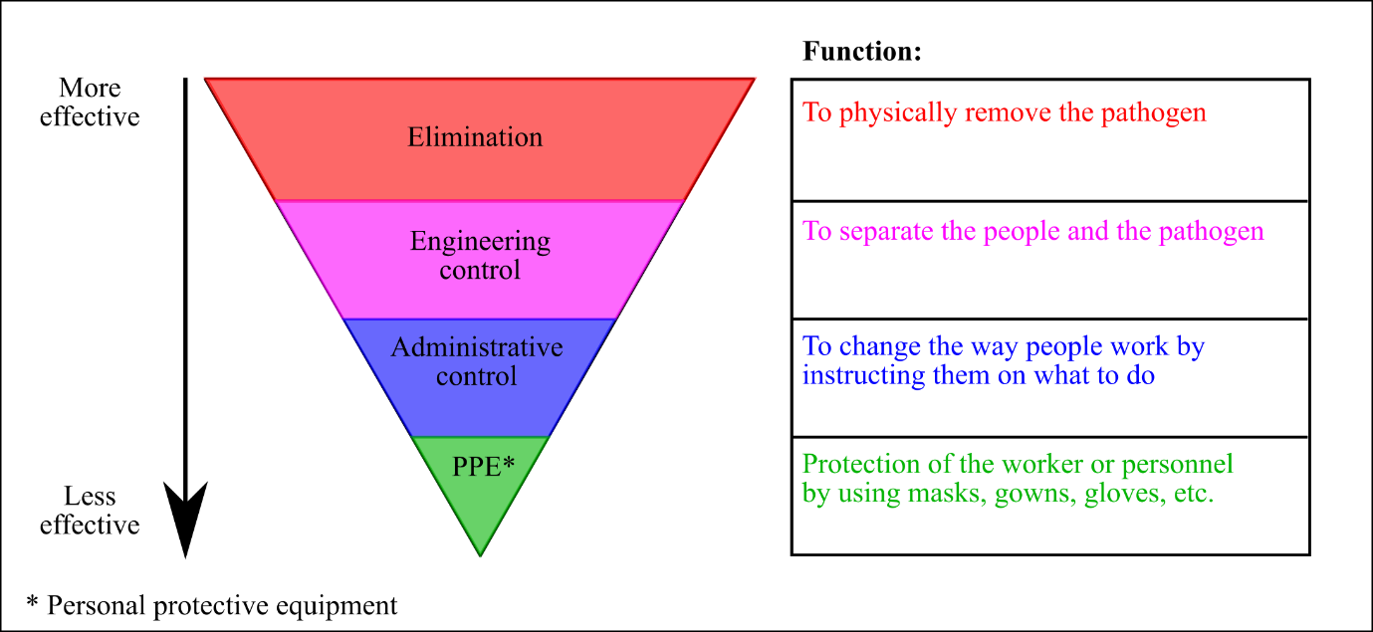
Figure 1. Hierarchy of infection control strategies, adapted from [8, 9].

Although beneficial in minimising the spread of viruses, these strategies strongly affect the economics of the different countries worldwide and cannot be thought of as permanent and reproducible long-term measures. As the world is progressively facing the implementation of lockdown measures, there are still many specific examples across public transport, schools, hospitals and other public spaces where self-distancing measures may not be possible or effective, specifically in high-footfall enclosed spaces. In addition, the main established infection engineering control strategies, such as increased ventilation rates, no use of air recirculation, etc. [1], are responsible for an increase in the energy consumption with a corresponding negative effect on the environment. As such, the identification of an engineering control strategy which is able to purify the air from microorganisms while ensuring high energy performance in buildings and public transport is a top priority [10]. In such a scenario, the liquid desiccant technology could be interesting because it offers the sanitising properties of desiccant solutions [11] with the parallel benefit of higher energy efficiency in controlling the temperature and humidity of the air supplied [12]. Following the outbreak of SARS-CoV in 2003, the technology was identified as a potential solution for supporting the need for energy-efficient and healthier buildings [11].

This study focuses on the major factors affecting the transmission of the virus SARS-CoV-2, identifying some common patterns with the transmission of other airborne viruses, such as influenza, and the characteristics and drawbacks of the HVAC strategies that have been identified for the reduction of airborne viral transmission in buildings, enclosed spaces and public transport. An analysis of the energy and economic penalty imposed by these HVAC practices was carried out to highlight the potential benefits which can result from the use of liquid desiccant technology compared to more conventional strategies. As such, the article is structured as follows. Section 2 describes the scope of the research, while Section 3 reviews the primary transmission routes of the virus and the effect of temperature and humidity on it. The review of the HVAC practices recommended by professional engineering associations is presented in Section 4, where the characteristics, drawbacks and energy impact are analysed to show the potential of liquid desiccant as a technology able to provide both thermal comfort and high air quality efficiently in buildings or public transport, as described in Section 5.

2 Scope
The research was based on the study of potential HVAC strategies for the limitation of the transmission of SARS-CoV-2 or other airborne viruses in public transport or buildings (commercial and public, such as schools, offices, shopping areas, gyms, pools, etc.), to highlight their abilities and drawbacks and the energy impact associated with their implementation. It was found that although the strategies currently suggested by professional engineering associations, such as Chartered Institution of Building Services Engineers (CIBSE) [13], Federation of European Heating, Ventilation and Air Conditioning Associations (REHVA) [1] and American Society of Heating, Refrigerating and Air-Conditioning Engineers (ASHRAE) [14], have the potential to minimise the transmission of airborne viruses, they can also adversely affect other factors, such as increased energy consumption and reduced thermal comfort. As such, the scope of using liquid desiccant technology as a strategy for airborne viral transmission reduction was identified, as shown in Figure 2.

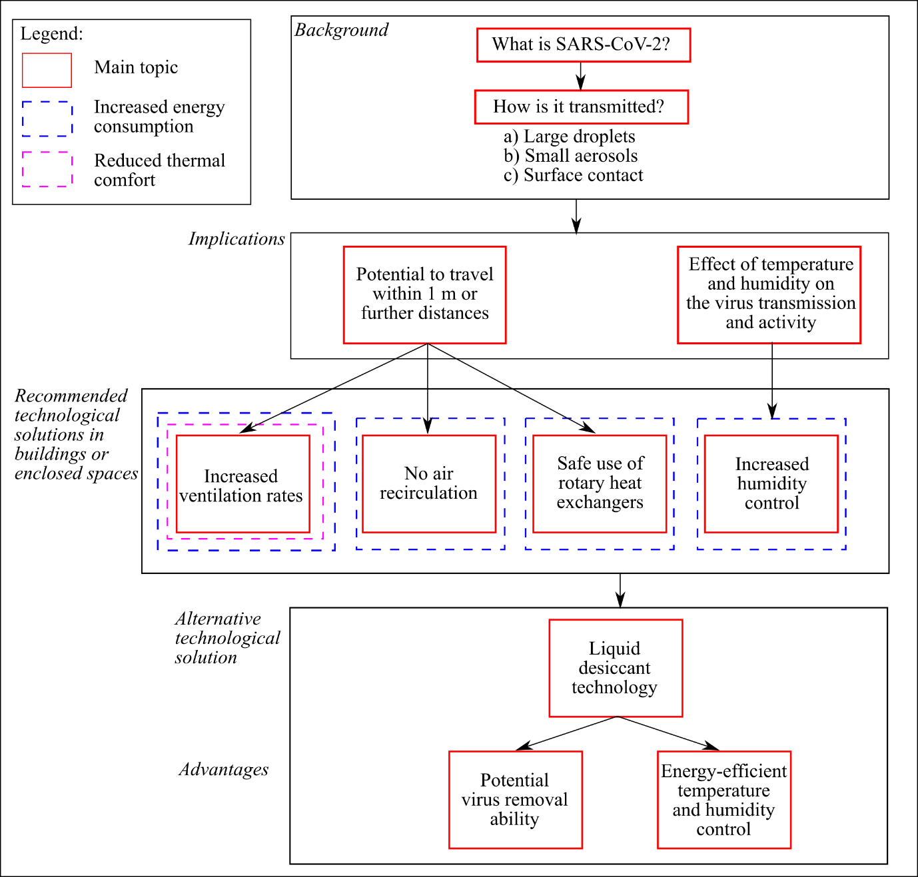
Figure 2. Scope of the research.

3 Transmission routes

3.1 Droplet and aerosol
The virus SARS-CoV-2 showed to be highly contagious with high secondary infection rates, high number of fatalities and rapid spread [15], of which transmission is primarily through the air. Based on the assumption that the transmission of the virus might be similar to that of other human coronaviruses, such as SARS-CoV-1 [16] and MERS-CoV [6], the potential routes for the transmission of SARS-CoV-2 have been identified or hypothesised [1]:
- via large droplets. These droplets (characterised by diameter larger than 10 μm) are usually formed from respiratory activities, such as breathing (1 m/s), speaking (5 m/s), coughing (10 m/s) and sneezing (20–50 m/s), and deposit on a short distance close to the emitter [1]. It is reported that an initial velocity of the droplet of 10 m/s would result in a deposition length of 1.5 m [1]. The deposition length of the large droplets is primarily affected by the respiratory activity and the resulting size of the particle [17]. Large droplets can be responsible for virus infection (i) via direct contact/inhalation or (ii) via surface (fomite) contact (i.e. hand-to-hand, hand-to-surface, etc.). Transmission routes of large droplets involve the inhalation or direct inoculation in the nasal or upper zones of the respiratory tract (mouth and nose) [18]. In addition, the virus-laden droplets that fell on surfaces (or objects) could be passed by self-inoculation by first touching the infected surface and then touching the eyes, mouth and nose (also known as fomite transmission). Although different studies have identified the survival characteristics of SARS-CoV-2 on surfaces, such as stainless steel, plastic, glass, etc. [19-21], no evidence of fomite transmission has been found yet at the current state of research [22] and its potential as transmission route was considered low by Mondelli et al. [23].
- via small aerosols (characterised by a diameter lower than 5–10 μm) [24]. The droplets expelled from the respiratory activities evaporate in the air forming aerosols, also sometimes referred to as droplet nuclei, which can travel large distances, being able to remain suspended in the air due to the low effect of the gravity on them, and which motion is influenced by the airflow direction [25]. The definition of the critical size for the particle to behave as aerosol or droplet is somewhat uncertain [18] because of the inability to clearly distinguish the behaviour of the expelled particles in the range 5–10 μm [24]. The World Health Organization (WHO) considers 5 μm as the threshold value for small aerosols [26]. Virus-laden aerosol can also be generated from aerosol-generating procedures in hospitals (such as intubation and extubation procedures, bronchoscopy, etc. [27]) or by fast tapping water and toilet flushes [26]. Compared to droplets, smaller size particles are responsible for deposition in lower zones of the respiratory tract [28], a phenomenon usually associated with diseases characterised by increased severity and fatality [24].
- via faecal-oral transmission [26]. Evidence of the potential transmission route of the virus was identified [29] by identification of the virus on samples collected from faeces [30, 31] and wastewater [32]. Previous studies on the outbreak of SARS-CoV-1 also identified the faecal-oral transmission as a transmission route, as for example in the residential building Amoy garden in Hong Kong, where aerosolised faecal waste was considered as responsible for the virus transmission [33].

Different behaviours are, in general, observed for droplets and aerosols in terms of dispersion efficiencies, suspension time in the air and capacity to penetrate into lower parts of the human respiratory tract [25, 34]. Figure 3 shows the production of droplets and aerosols and their main transmission routes together with the related trajectories of transmission in the air and the relationship between particle size and suspension time.

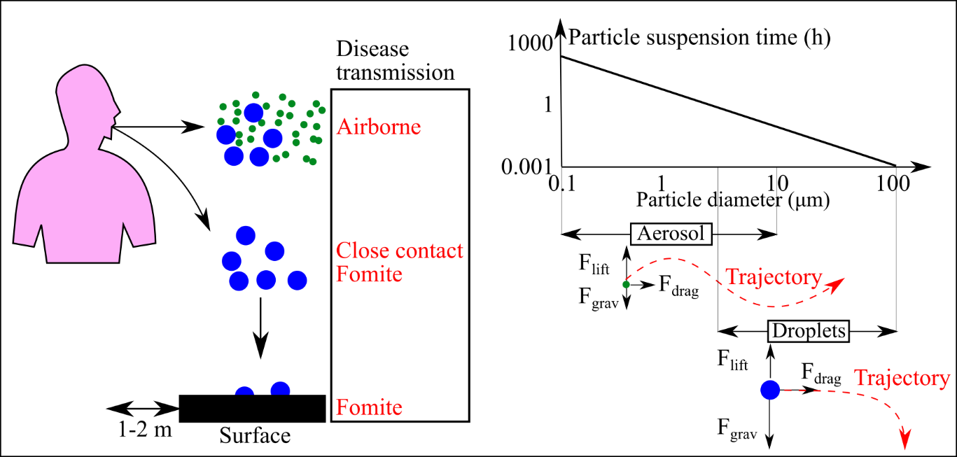
Figure 3. Droplet and aerosol production and transmission, adapted from [18, 34, 35].

As studied by Wells [36], the settling time of exhaled or expelled particles is affected by various factors, such as size, time and evaporation [24]. The motion of the particles is the result of different forces acting on them, such as gravity, temperature and humidity, Brownian motion, electrical and electromagnetic forces, turbulence, etc. [37]. For larger droplets (usually larger than 20 μm), ballistic trajectories due to gravity are mainly observed [25]. Due to the characteristics of their movement in the air, engineering practices for infection control based on the use of ventilation air and pressure differentials are not effective on such particles and do not affect their short-range transmission [38]. As the diameter of the exhaled or expelled particle decreases, the effect of the gravity on the particles becomes less important, increasing their suspension time and resulting in the potential to travel further in buildings or enclosed spaces [25].

In the first instance, the WHO considered large droplets and fomite as the main transmission routes for SARS-CoV-2 [39]. Current main guidelines to limit the spread of the virus, such as the use of personal protective equipment (PPE), social distancing, use of hand sanitisers and handwashing, disinfection of surfaces, etc. are based on this primary consideration on the main transmission routes [40]. Following the primary stance of the WHO on the topic, a growing number of studies has identified a direct link between aerosol transmission and SARS-CoV-2 infection [41, 42]. The conflicting information and discussion about whether SARS-CoV-2 is airborne and how to limit its transmission affects the development of engineering control practices and the guidelines on how to operate air-conditioning systems in buildings and enclosed spaces. The current research lacks in clearly proving the evidence of the airborne transmission of SARS-CoV-2 due to the uncertainty in estimating the relative contribution of different transmission modes to the large spread of the virus but the airborne transmission of the virus cannot be ruled out [34]. On the 9th of July 2020, 239 experts (physicians, epidemiologists, engineers and aerosol scientists) from 32 countries signed a letter suggesting the growing evidence around the airborne transmission of SARS-CoV-2 [43], which resulted in a partial reconsideration from the WHO of the potential risk of transmission coming from aerosol, particularly in crowded and not adequately ventilated buildings [44, 45].

3.2 Airborne transmission
Airborne transmission by aerosols has been recognised as a potential route for the transmission of many viruses, as for example tuberculosis and aspergillosis [7], influenza [46], smallpox [10], chickenpox [47], adenovirus [17], rhinovirus [48], Ebola [49], tuberculosis [50], etc. For the influenza virus, the potential of being transmitted by both large droplets and small aerosols was recognised [46, 51, 52] and airborne transmission by aerosols was identified as the main mechanism of transmission in various outbreaks in hospitals [53, 54], schools [55], airplanes [56], etc. Moser et al. [56] identified a connection between the outbreak of influenza on an airplane delayed for three hours on the ground due to engine failure and the resulting lack of ventilation air onboard. Similarly, the airborne transmission by aerosols for the influenza A virus subtype H1N1 (responsible for the 2009 swine flu pandemic) was recognised as feasible by analysis of pig and guinea pig infection models [57]. Pyankov et al. [58] investigated the airborne transmission by aerosols capacity of various strains of influenza, identifying a different behaviour of survival of the virus between the various strains. Whilst airborne transmission by aerosols of viruses has been largely demonstrated, it was reported how for some viruses, such as influenza, that it is difficult to discern the predominant transmission route because this could be also affected by additional factors [25]. Different research has also investigated the airborne transmission by aerosols of coronaviruses, such as SARS-CoV-1 [16, 33] and MERS-CoV [59]. Studies were conducted on a ‘superspreading’ event of SARS-CoV-1 at the Prince of Wales hospital in Hong Kong [60, 61], where the role of ventilation air was identified as the primary cause of the spread of the virus. Similarly in a study on the airborne transmission by aerosols of MERS-CoV, Pyankov et al. [59] identified the stability of the virus to survive as an aerosol in the air, showing higher survival characteristics compared to influenza virus. An outbreak of the virus in a restaurant in Guangzhou, China, was recognised among the evidence corroborating the airborne transmission by aerosols of SARS-CoV-2, since the direction of the flow of the air direction was consistent with this type of transmission route, as shown in Figure 4 [62, 63].

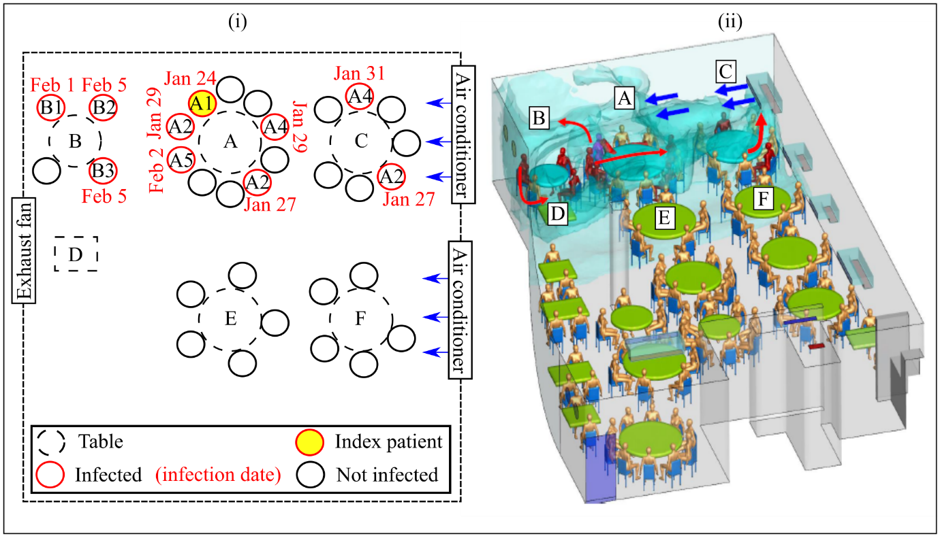
Figure 4. Outbreak of SARS-CoV-2 in a restaurant in Guangzhou: (i) tables and customers disposition, (ii) CFD simulation of airflow, adapted from [62, 63].

As shown in Figure 4, the index patient A1 (that was primarily infected with COVID-19 in Wuhan) was located in Table A. No other direct or indirect exposure was identified between the index patient and the other infected patients of Tables B and C, located as distant as 4 m. The air-conditioning system in the restaurant is composed of five fan-coil units and one exhaust fan. The only ventilation in the floor is obtained by infiltration or by natural ventilation if windows are open. Based on tracer gas measurements, it was estimated that the outdoor air rate supplied to the floor was ranging between 0.75 and 1.04 L/s per person, corresponding to 0.56–0.77 air changes per hour, ACH [63]. By using CFD simulation models previously employed for the analysis of SARS-CoV-1 outbreak cases, the airflow of the air expelled by the infected customer was reproduced, indicating that the air movement could have formed a cloud envelope, responsible for the infection. No infection of other customers of the restaurants located outside the zone where the tables A, B and C were located was reported.

The identification of the viral traces in the air exhaust fan of a building HVAC system was also recognised as proof of airborne transmission of SARS-CoV-2 [64]. Nissen et al. [65] detected viral traces of SARS-CoV-2 on swab samples collected from ward vent openings and filters of the exhaust ventilation system in a COVID-19 ward in Sweden, showing the capacity of the airborne particles to travel long distances (up to 50 m) although their infective characteristics were not determined. The combined effect of the airborne transmission of SARS-CoV-2 in crowded and confined buildings, enclosed spaces or public transports together with low ventilation rates might have played a key role in the large transmission of the virus. In a study by Qian et al. [66], it was identified how the main clusters of COVID-19 outbreaks in China took place in indoor spaces and public transport. A similar study conducted in Japan identified how, apart from healthcare facilities (where the largest number of infection clusters was identified), the largest number of virus outbreaks was identified in bars, restaurants, workplaces, gyms and public transport [67]. Different studies identified the connection between outbreaks of COVID-19 and venues with low ventilation rates or limited social distancing, such as meat and poultry facilities [68], trains [69], buses [70], cruise ships [71], choir rehearsal [72], bath centre [73], call centre [74], churches [75], fitness dance classes [76], mountain chalets [77], etc. Some actions involving the production of a significant amount of large droplets and small aerosols, such as singing, loud speaking, exercising, etc., were regarded as potentially responsible for these high rates of infection [67]. Miller et al. [72] analysed a superspreading event happened during a choir rehearsal at the Skagit Valley Chorale, identifying the action of singing, responsible for the emission of large amounts of aerosolised virus, the low ventilation rates and the duration of the event (2.5 hours) as the main factors for the large transmission of the virus. The duration of the contact is hence likely to be another primary factor in the transmission characteristics of the virus, as suggested by Park et al. [74] for the outbreak of COVID-19 in a call centre, where the infected cases of transmission were associated with larger contact times while almost no transmission was reported to other people in limited contact (in elevators, lobby, etc.).

For public transport, social distancing is often unviable due to the limited space available for occupants. Based on the analysis of samples collected from buses and subway trains in Barcelona, Moreno et al. [78] identified that RNA traces of SARS-CoV-2 were present in 30 out of the total 82 analysed samples, although the infectivity of these traces was not determined. Traces of SARS-CoV-2 were also found on samples collected from the filter of the air-conditioning system of the bus, as further evidence of airborne transmission of the virus. The main factors identified as responsible for the spread of viruses in public transport are the vicinity to an infected person, together with the time spent aboard and the effect of ventilation and recirculation of potentially contaminated air [78, 79].

The identification of airborne transmission as a potential route of transmission of the SARS-CoV-2 would affect the HVAC engineering practices [7] required to limit the transmission of the virus in buildings, enclosed spaces or public transport. More intense protection strategies would be required for airborne transmission by aerosols [10]. Therefore, further research on the identification of the transmission routes for the virus is required with the practical implication of identifying the best strategies to limit its spread (i.e. social distancing, face masks, etc.), each with a different cost and characteristics [25] and implementing the best decision-making practices.

3.3 Effect of temperature and humidity
An overview of the effects of external factors on reducing the transmission of viruses is shown in Table 1 [80].

Table 1. Effect of external factors on the transmission of viruses, adapted from [80].
 | Factor | Effect
Physical | Heat | Inactivation is directly proportion to temperature
 | Light | Light, especially its UV component, is germicidal
 | Desiccation or drying | Inactivation depends on the strain and type of virus
 | Aggregation/adsorption | Protection from inactivation
 | Pressure | High pressure induces activation
Chemical | pH | Worst stability at extreme pH values
 | Salinity | Increased salt concentrations are virucidal
 | Ammonia | Virucidal
 | Inorganic ions | Some (e.g. Pt, Pd, Rh) are virucidal
 | Organic matter | Dissolved, colloidal and solid organic matter protect from inactivation
 | Enzymes | Proteases and nucleases contribute to inactivation
Biological | Microbial activity | Contributes to inactivation
 | Protozoal predation | Contributes to removal/death
 | Biofilms | Adsorption to biofilms protect from inactivation, while microbial activity in biofilms may be virucidal
 | Type of virus | Stability varies according to the strain and type of virus

As shown in Table 1, high temperature is associated with increased inactivation of viruses. More complex is the relationship with the humidity. Different studies tried to identify if a similar behaviour was observed for the virus SARS-CoV-2 and to address the effect of the air conditions (temperature, T, relative humidity, RH, and moisture content, ω) on its transmission, investigating its potential seasonality [81] and the effect of HVAC strategies in buildings and enclosed spaces [82]. Additional factors connected to the air conditions in outdoor (such as wind [83] and sunlight [84]) and indoor [82] settings, have also been studied and might have played an important role in the transmission of the virus. The presence of particulate matter (PM) in the air has also been suggested as a potential factor [85]. It was hinted that PM might increase the suspension and accumulation of virus-laden aerosol in the air [34].

The control of the temperature and humidity in the air supplied to buildings is a primary factor for thermal comfort, air quality and building conservation [86]. Particularly, an environment characterised by a too high or too low value of RH would be responsible for the growth of viruses, bacteria, moulds, etc. [87], as shown in Figure 5.

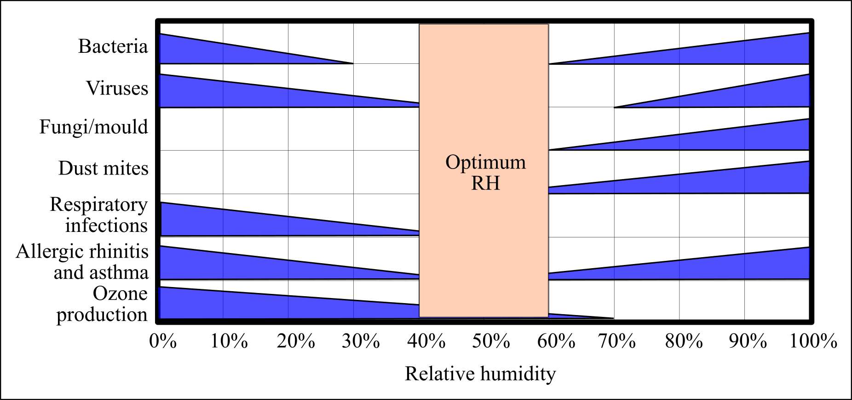
Figure 5. Optimum relative humidity range for minimising adverse health effects, adapted from [87].

Related to the transmission of viruses, the control of the RH of the air supplied between 40% and 60% is recommended due to the need to (i) limit their infectivity, (ii) limit their mobility and (ii) improve the defence mechanisms of the human respiratory system. As shown in Figure 5, it is commonly reported that an environment characterised by intermediate RH (ranging between 40% and 70%) is able to minimise the activity of both lipid and non-lipid membrane viruses [7]. In current practice, RH does not exceed 60% in buildings to avoid the growth of mould.

Various studies investigated the effect of temperature and humidity on different typologies of viruses, primarily influenza [88-93], but also tuberculosis [94], hepatitis A virus (AHV) [95], etc. As reported by Marr et al. [93], the temperature is widely recognised as a primary factor for influenza virus survival and transmission. Irwin et al. [91] identified a correlation inversely proportional between the temperature and the life of the influenza virus. Prussin et al. [96] observed a reduction of the activity of the enveloped virus Φ6 at high temperatures regardless of the RH. The main mechanisms suggested for the inactivation of the virus at high temperature were the denaturation of the surface proteins and of the nucleic acids of the virus [93].

By analysing the effect of temperature and humidity on the reproduction of the influenza virus on guinea pigs, Lowen et al. [88] identified how low values of RH (20% or 35%) and temperature (5 °C) were responsible for the highest transmission characteristics of the virus. In follow-on research activities, Lowen et al. [89] examined the effect of the temperature and RH on the viability of the influenza virus in hot and humid climates. It was observed that while the RH had a direct relationship with the virus deactivation at 20 °C, this effect was not present at higher temperatures (30 °C). This phenomenon has been motivated due to the variation of the main transmission route of the virus (airborne in mild climates and droplet in hot and humid climates). As analysed by Marr et al. [93], these last two studies (as many others) were conducted on animal models and, as such, the conclusions might be different when extrapolated to humans. Based on the simulation of coughs, Noti et al. [90] studied the effect of the humidity on nebulised influenza virus in an examination room. It was observed a reduction of the virus activity for RH higher than 40%, which is recommended by the authors in indoor spaces.

It was established by different studies a different behaviour between enveloped viruses with a lipid membrane (which prefer low RH for proliferation) and non-enveloped viruses (which prefer high RH [97, 98]). Common coronaviruses (enveloped viruses with a lipid membrane) proliferate in conditions of low RH, while an environment characterised by high RH significantly reduces their viability [35]. Casanova et al. [99] studied the effect of the survival of transmissible gastroenteritis coronavirus (TGEV) and mouse hepatitis virus (MHV) on stainless steel. It was observed a direct proportion between the temperature and the inactivation of the viruses, while for the humidity the highest inactivation was obtained in the RH intermediate range (50% was considered in the research). Whilst the virus survived approximately 3 days in intermediate humidity condition (temperature of 20 °C and RH of 50%), this was prolonged up to 28 days with a low RH (20%). Chan et al. [100] studied the viability of SARS-CoV-1 in temperature and humidity condition similar to that of indoor buildings (temperature ranging between 22 and 25 °C and RH between 40 and 50%), reporting the capacity of the virus to survive up to 5 days in such conditions with a reduction in the virus life when temperature and/or humidity is increased. Similarly, it was observed high stability of MERS-CoV at 20 °C and 40% RH, while it was significantly decreased at 70% RH [101]. It is also important to note that most of the research was conducted by using non-pathogenic viruses as surrogates for their pathogenic relatives for health and safety reasons, which will have a distinctive structure [102].

Additional research is required to further address the effect of the temperature and humidity on viability and transmission of SARS-CoV-2 since at the current state it has not been clearly determined whether temperature and humidity affect its transmission. The published research on the topic is inconclusive and often controversial, as reviewed by Yuan et al. [103], where various studies were analysed to highlight the inconsistency of the current research on the topic. The authors motivated that with the methodology used for data collection (i.e. most of the studies tried to identify a direct relationship between outdoor air condition and epidemiological data for a limited time of collection). Additional factors, such as international travel, implemented mitigation strategies (i.e. lockdown, quarantine, social distancing and contact tracing), rate of urbanisation, etc. might have played a key role in the large spread of the virus in different climates [103, 104]. Although low temperature and humidity have been associated with higher infection rates [81], outbreaks in conditions of high temperature and humidity were also identified, as in the study previously shown on the outbreak of COVID-19 in a bath centre [73]. However, the time of contact could have played a primary role in the transmission of the virus [74], together with the air distribution in the bath centre.

In terms of humidity, it was identified by various studies that the moisture content (which is influenced by the temperature, RH and pressure of the air), ω, and not RH might be a primary factor on the survival and transmission of the virus, as previously observed for influenza [105, 106]. However, it was suggested by Marr et al. [93] that the combined effect of temperature and RH could provide a sounder explanation of the mechanistic effect of inactivation of viruses due to the effect of (i) high temperature and (ii) droplets evaporation (related to RH). When droplets are exhaled from the respiratory tract, they are saturated (RH close to 100%), resulting in the evaporation of the water from the respiratory droplets as they contact with the atmosphere [107]. Based on the actual knowledge, it is still unclear whether RH or ω are main factors for the survival and transmission of SARS-CoV-2 and to what extent. Zhang et al. [34] analysed the outdoor air conditions during the outbreaks of SARS-CoV-2 in Wuhan, Rome and New York, identifying no clear effect of humidity on virus survival and transmission. As reported, it was identified how all the three evaluated cases showed high RH but low temperature, resulting in a low value of ω, which might, therefore, be an important factor in the survival and transmission of the virus. The complex interaction between temperature and humidity and virus survival should be further investigated to further clarify the mechanisms involved [96]. In a recent preprint study by Morris et al. [108], a U-shaped correlation (already detected for other viruses, such as influenza [109]) between the stability of SARS-CoV-2 and RH was observed, with reduced viability of the virus for intermediate values of RH. It was previously hypothesised for the influenza virus that this behaviour is due to the effect of salts and proteins on the evaporation of the exhaled droplets [92]. It was suggested how the identified behaviour would justify the high spread of the virus in cold and humid indoor environments, such as food processing plants [110] and ice rinks [26].

As recognised for the influenza virus, environments with high RH produce larger droplets (to which the viral particle is attached), resulting in less distance travelled and depositing on surfaces in less time [93]. As such, the mobility of droplets in humid environments would be more limited, reducing the spread of airborne viruses in buildings, enclosed spaces or public transports. On the contrary, the exhaled particles significantly reduce their size by evaporation in dry environments, producing droplet nuclei that could travel airborne long distances. It is, however, important to note that, although the mobility of the droplet nuclei is affected by RH, the primary factor in the evaporation and the length of transmission of the particle after being expelled is the size of the droplet (which is related to the respiratory activity that produces it) [17, 24].

To conclude, an air characterised by low RH (lower than 40%) affects the self-cleaning mechanism of the airways in the respiratory system, also known as mucociliary clearance [111], by inhibiting the operation of the cilia, as reported by Kudo et al. [112] on their study on the response of the immune system to influenza virus. In addition, it was identified how low RH is responsible for the inhibition of the reparation of the lungs cells damaged by the virus and the reduction of the capacity of the cells to limit the spread of the virus [112]. The optimal mucociliary clearance at ambient temperature is at 100% RH, while less resistance to infection to pathogens is offered with lower temperature and humidity [113]. It is also important to note that the optimal control of RH would be beneficial for eyes and upper airways [114].

Although it is not currently seen as a priority, the realisation of an environment less likely to favour the spread of the disease by controlling the temperature and humidity of the air supplied within the optimal range, as recommended by ASHRAE [38], is believed to have a positive effect on indoor air quality and minimisation of the transmission and infectivity of viruses, although more laboratory-based research on the subject is required to estimate at what extent.

4 Limitation strategies: characteristics, drawbacks and energy impact
In light of the conclusions from the transmission modes of airborne viruses, such as SARS-CoV-2 and influenza, various air purification strategies for airborne viral transmission reduction in buildings and enclosed spaces were suggested by professional engineering associations [1, 13, 14, 115]. Table 2 reviews the characteristics and drawbacks of the main indoor air purification strategies, as reviewed by Yu et al. [116].

Table 2. Methods for indoor air purification, based on [116].
Strategy | Characteristics | Drawbacks
Dilution | - Increase of outdoor air and air change rates to increase the dilution of the pollutant or microorganisms in the air | - Energy consumption is associated with increased ventilation rates
Filtration | - Filters are used to remove pollutants and microorganisms from the air with HEPA filters used for high-efficiency removal | - The filtering characteristics depends on the typology of filter  - Filters responsible for an increase in pressure drop
Adsorption | - Main materials for removal of contaminants are activated carbon, zeolite, activated alumina, silica gel and molecular sieves | - Activated carbon loses removal efficiency over time with the reduction of efficiency after regeneration
Use of light | - Light reduces the viability of microorganisms. Ultraviolet light can deactivate viruses by disrupting their DNA or RNA chain | - Potential risk from the use of ultraviolet light  - Absence of design standard
Photocatalytic oxidation | - Degradation of contaminants into products such as CO₂ and H₂O by use of photocatalysts operating at room temperature | - Low efficiency of the process  - More research required to investigate the mechanism of the reaction
Non-thermal plasma and air ionisation | - By using negative and positive ions, the activity of the pathogen or contaminant is reduced  - Different typologies available: negative air ionisation, bipolar ionisation, surface charging, etc. | - Unsteady operation with low efficiency  - More research required on the impact of the uptake of negative ions on the respiratory system

The effective use of ventilation air, filters and light has been identified as the most used engineering practices for indoor air purification, and as such further described in the following sections. As shown in Table 2, other technologies, such as photocatalytic oxidation, non-thermal plasma and bipolar ionisation, have been identified as promising interventions. In particular, bipolar ionisation was tested in the exhaust of a fan coil unit supplying air to a hotel room and proved as efficient in removing the virus bacteriophage MS2 (used as a surrogate of SARS-CoV-2) [117]. Whilst being promising, most of these technologies are in their research and development phase and have not been further advanced. On the contrary, the engineering control practices in HVAC systems, such as the increased ventilation air, higher filter efficiency and use of light, are further discussed.

4.1 Ventilation
The dilution of the air in which SARS-CoV-2 or any other virus or pathogen might be present is seen as one of the more practical solutions to minimise the risk of airborne transmission. This can be obtained by realising HVAC practices able to enhance the safety of the occupants of buildings or enclosed spaces towards reducing the potential spread of COVID-19. Figure 6 shows the main guidelines recommended by REHVA for the operation of the HVAC in buildings [1].

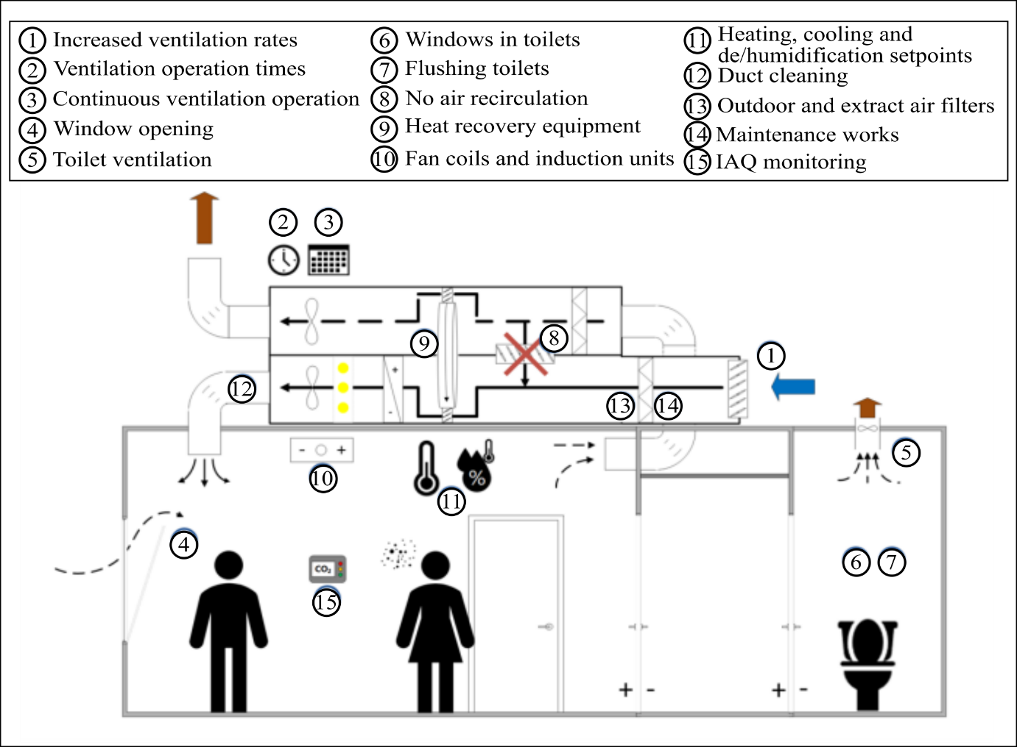
Figure 6. HVAC building practices recommended by REHVA, adapted from [1].

The main recommended strategies for ventilation air in buildings involve the increase of the ventilation air supplied by increasing the outside air fraction, the air changes per hour, the use of natural ventilation with windows and to prolong the hours of operation of the system [1, 13, 14, 118]. The effect of the increase of the ventilation rate on the dilution of the air and the transmission of the virus can be expressed by the Wells-Riley equation [119]:

 | $$P=1-exp⁡\left(-\frac{I⋅q⋅p⋅t}{Q}\right)$$ | (1)
where P is the risk of cross-infection, I is the number of infectors, p is the pulmonary ventilation rate of each susceptible (m³/h), Q is the ventilation rate (m³/h), q is the quanta produced by one infector (quanta/h) and t is the duration of the exposure (h). Although the quanta production rate q of the infector for COVID-19 has not been clearly determined yet (with an estimated value between 14 and 48 quanta/h [120]), it is clear from Eq. (1) how the increase in the ventilation air could exponentially reduce the risk of cross-infection in buildings, enclosed spaces or public transport, with an effect correlated to the exposure time, the respiratory activity and the number of infectors.

For mechanically ventilated buildings, the increase in the ventilation air flow rate can be obtained by increasing the opening of the air damper in the air handling unit [118]. Although beneficial in diluting the contaminants present in the air, this practice is often complicated and responsible for a significant increase in energy consumption. The ventilation rate, Q (L/s), i.e. the amount of intake air supplied to the building, can be defined as in Eq. (2) [121]:

 | $$Q=\frac{ACH⋅V⋅1000}{3600}$$ | (2)
where ACH is the air change rate (number of air changes per hour), defined as the ratio between the ventilation air flow rate and the volume of the conditioned space, V (m³). It is usually recommended by various regulations, standards and guidelines a minimum value of outdoor ventilation air in mechanically-ventilated buildings or enclosed spaces of 8–10 L/s per person [122], whilst a value of 1–3 L/s per person has been identified as responsible in superspreading events of SARS-CoV-2 outbreaks [123].

The ACH is a primary index for the evaluation of the ventilation performance and one of the biggest determinants for air dilution in buildings [124]. It has a primary effect on the time required to clear a space, i.e. the higher the ACH, the lower the time required to remove the contaminants present [6]. It is reported an ACH of 12 in isolation rooms, whilst it can be as low as 1 in commercial buildings [119]. A detailed list of ACHs for different typologies of buildings is reported in [125]. Although able to dilute the contaminants potentially present in the air, the effectiveness of the ventilation might not be increased by an increase of the ventilation air due to the poor design of the ventilation system [126].

In hot and humid climates, the increase in the ACH is responsible for higher latent loads, resulting in an energy inefficiency of the air handling unit [127]. The required ventilation air increase would be significant and responsible for an increase in energy consumption and a decrease of the indoor thermal comfort, depending on the outdoor air conditions. It is reported that an increase in the ACH of only 1% is responsible for an increase in the energy costs for heating and cooling ranging between £75 and £110 per year [126]. The relationship between the ventilation air and the energy requirement for air-conditioning, E_{A/C} (kWh), is expressed in Eq. (3) [128]:

 | $$E_{A/C}=\frac{ρ_{a}⋅Q⋅\left[\left(c_{pa}+ω_{a}c_{pw}\right)⋅∆T+h_{fg}⋅∆ω\right]⋅∆t}{1000}$$ | (3)
where ρ_{a}, c_{pa} and ω_{a} are the density (kg/m³), specific heat capacity (kJ/kg) and moisture content (kg_{H2O}/kg_{da}) of the moist air, respectively, c_{pw} is the specific heat capacity of the water (kJ/kg), h_{fg} is the latent heat of vaporisation (kJ/kg), Q is the ventilation rate (L/s), ΔT and Δω represent the variation in temperature and moisture content, respectively, between the inlet and outlet air and Δt is the operation time of the ventilation system (h). It is also recommended to increase the operating hours of the HVAC system, as for example for 2 hours before and after the time of occupation of the building or running it for 24 hours per day with lower ventilation rates [1], to further dilute the virus potentially present at the expense of a negative impact on energy consumption.

An increase in natural ventilation (i.e. maintaining windows wide open for prolonged hours) is also recommended to increase the dilution of the air in buildings and enclosed spaces [1]. In the case of a virus outbreak, natural ventilation is an easy to implement strategy able to provide high ventilation rates at low energy cost [119]. However, this strategy results in poor thermal comfort for the occupants (in terms of indoor temperature and humidity variation) and the absence of the filtering function provided by air handling unit, which results in higher importance of the outdoor air quality (potential presence of allergens, pollutants and insects) [38]. In addition, larger use of natural ventilation may result in an increase of the energy consumption for heating in the cooler months [13]. As such, it cannot be considered as a long-term procedure for ventilation management in buildings or public transport.

It is fundamental that the ventilation systems are effective in diluting the air and are well-maintained, with air properly distributed in the building with the delivery of fresh air to breathing zones, avoidance of cross-contamination between zones and efficient removal of pollutants [119, 129]. The direction of the air is hence a primary factor that should be optimised to limit the transmission of viruses in buildings or enclosed spaces, by (i) reducing the cross-contamination between zones and rooms and (ii) limiting the risk of contaminant build-up in stale air. In studies related to the airborne transmission of viruses, such as tuberculosis [130] and measles [131], it was identified that poorly designed and maintained HVAC systems are potentially responsible for the spread of diseases, presenting a negative effect on the dispersion of infective particles [35]. The choice of the ventilation strategy in buildings (recirculation, mixing or displacement) has hence an impact on virus transmission, as reviewed by Lipinski et al. [132]. Displacement ventilation strategies supply the air at floor level and exhaust it at ceiling level, being therefore able to reduce the risk of contamination of airborne pathogens by avoiding air mixing due to thermal stratification [129]. On the contrary, recirculation ventilation strategies, such as split air-conditioning, ceiling fans and hybrid systems, are potentially responsible for virus transmission due to the recirculation of the air and the velocity of the turbulent airflow produced [132]. In particular, systems not supplying any outdoor air, such as split air-conditioning and passive chilled beams (100% recirculated air), are considered as potentially responsible for the transmission of pathogens if additional outdoor air is not supplied [13]. Similarly, mixing ventilation strategies, such as air handling units and ventilation systems with heat recovery, can be responsible for the long-distance movement of pathogens (by means of turbulent airflows), which can accumulate on filters if adequate maintenance is not performed [132].

An example of good ventilation practice is the use of room pressure differentials in healthcare facilities, where the pressure difference is used to control airflow between zones and ensure that the clean air flows into less-clean spaces, limiting in this way the transmission of the virus by avoiding its cross-contamination [38]. This air management is performed by realising negative pressure differences in spaces, such as in isolation rooms, where high values of ACH (a value of 12 is usually recommended) are required and no air recirculation is performed [126]. In the case of a virus outbreak, REHVA recommends creating negative pressure in toilets by keeping the air extraction system on all the time, preventing the transmission of pathogens to adjacent rooms [1].

Conventional centralised HVAC systems employ recirculation of air to reduce the energy consumption to heat or cool the air within the temperature range required for indoor comfort and limit the capacity of the heating and cooling system, resulting in reduced capital costs for the system [133]. As an example, it was reported a typical ratio of 80% of recirculated air and 20% of outdoor air in the USA for mechanically ventilated buildings (classrooms and offices) [129]. In the event of an outbreak of COVID-19, the recirculation of air could be responsible for reintroducing the virus in the building, spreading it to different floors or zones of the building where it was not present previously [35]. It is therefore recommended to not recirculate the air in buildings in such circumstances [1, 13, 14]. This can be obtained by closing the damper of air recirculation and sealing it for the time of the virus outbreak to minimise the leaks [14]. However, the total elimination of air recirculation may not be possible in buildings, enclosed spaces or public transports, due to the limited capacity of the HVAC system to treat outdoor air. In these cases, the use of recirculation should be limited as much as possible [133]. When HVAC systems recirculate air at room level rather than at building level, such as in local fan coil units, split units, and induction systems, the effect of the recirculation of air on the virus transmission is less important [133].

As described in Section 3.3, the humidity affects the survival and activity of viruses together with the self-defence mechanisms of the human body and the movement of the airborne particles. Although not currently considered a priority, the effective control of humidity in buildings, enclosed spaces and public transports (between 40% and 60% RH) would be beneficial in terms of increased air control quality and providing a negative environment for virus proliferation. In cold winter weather, it is recommended the use of humidifiers to increase the RH of the air (that otherwise would be too low with conventional air handling unit practices based on direct heating) [38]. However, the implementation of this technological solution is complicated for retrofitting because of the need for the addition of water storage [134] and requires proper selection, operation and maintenance [38]. In addition, conventional humidifiers (evaporative, spray and steam) are potential sites of accumulation and amplification of microorganisms and odours [11].

The use of heat exchangers in buildings, such as rotary heat exchangers and enthalpy wheels, has been also considered as potentially responsible for the increase of the transmission of the virus. In the case of poor design and limited maintenance, a leakage might be present and responsible for re-entering the virus-laden air into the building [1]. As such, it was recommended to only use heat recovery systems able to effectively separate return and supply air (as in twin coil systems)and not in presence of leaks.
For public transports, it was identified how the design of the air management systems method together with the arrangement of the seats played a key role in the transmission of airborne viruses, such as influenza [135]. As such, the use of natural ventilation (by keeping windows opened and increasing the opening of doors) in combination with increased ACH was suggested in public transport [136], together with a reduction of the occupants. If possible, no use of recirculation air was also recommended [136, 137].

4.2 Filtration
Filters are an economical and easy to implement strategy used to efficiently remove contaminants and improve air quality in buildings. Table 3 shows the classification of filters used in HVAC system depending on their minimum efficiency rating value (MERV) and the efficiency of particle removal and potential application for various particle sizes.

Table 3. Efficiency of various filters of HVAC systems for different particle sizes and related application, adapted from [138-140].
MERVª | Filter efficiency dependent on particle size (μm) |  |  | Particle size range | Typical contaminant | Typical application
 | 0.3–1 | 1–3 | 3–10
1 | - | - | < 20% | > 10 μm | Pollen, carpet fibers, dust mites, lint | Light residential, split air-condtioning
2 | - | - | < 20%
3 | - | - | < 20%
4 | 1% | 9% | 15%
5 | - | - | 20–35% | 3–10 μm | Some mould spores, cooking dust, pollen | Typical residential, typical commercial, paint or finishing booths
6 | - | - | 35–50%
7 | 17% | 46% | 50–70%
8 | - | - | > 70%
9 | - | < 50% | > 85% | 1–3 μm | Mould spores, fine dust, welding fumes | Industrial, better residential, better commercial
10 | - | 50–65% | > 85%
11 | - | 65–80% | > 85%
12 | - | > 80% | 90%
13 | < 75% | > 90% | 90% | 0.3–1 μm | Bacteria, smoke and other microscopic particles | Hospitals, smoking lounges
14 | 75–85% | > 90% | 90%
15 | 85–95% | > 90% | 90%
16 | > 95% | > 95% | > 95%
17^{b} | > 99.97% | - | - | < 0.3 μm | Viruses | Cleanrooms, surgery, aeroplanes
18^{b} | > 99.99% | - | -
19^{b} | > 99.999% | - | -
20^{b} | > 99.9999% | - | -
ª Minimum efficiency rating value; ^{b} High-efficiency particle air (HEPA) filters.

It is clear from Table 3 how the majority of commercial and residential buildings are equipped with filters characterised by a MERV lower than 13. Although effective in filtering dust or spores, these filters do not remove fungi, bacteria and viruses [141]. It is recognised the beneficial effect of filters with high MERV to reduce the possibility of airborne transmission with SARS-CoV-2 virus [118]. CIBSE recommends the use of filters to limit the spread of viruses but also declares that this technological solution must not be thought as able to eliminate the risk of transmission of the virus [13].

Although able to limit the transmission of small-sized particles, such as airborne viruses, due to their higher filtering characteristics, the use of high-efficiency particle air (HEPA) filters may not be a feasible strategy in HVAC units of most buildings due to their increased resistance to airflow and the resulting increase in pressure drop [142], which imposes an energy penalty for the operation of the fans that blow the air through the filters, as shown in Eq. (4) [128]:

 | $$E_{fan}=\frac{Q⋅{∆P}_{fan}⋅∆t}{η_{e}⋅1000}$$ | (4)

where E_{fan} is the energy consumption for the operation of the fan (kWh), Q is the air volume flow rate through the fan (m³/s), ΔP_{fan} is the total pressure rise from the fan inlet to the outlet (Pa), Δt is the operation time of the fan (h) and η_{e} is the overall efficiency of the fan and motor system.

It is reported that the replacement of conventional filters with HEPA filters would result in an increase of ΔP_{fan} between 3 and 5 times [143], resulting in significant energy consumption. The increase in ΔP_{fan} may not be accommodated by the majority of the HVAC systems, resulting in being complex for retrofitting [1], and is not recommended for use in public transports, because it would be detrimental for the HVAC equipment. In addition, filters also represent a site of accumulation and amplification of microorganisms [11, 138], which results in a decrease in the efficiency of the filter and in its deterioration [116], requiring high maintenance costs [45]. As such, HEPA filters are not commonly used in commercial or residential buildings but only for specific applications, such as in healthcare facilities or airplanes [35], and are not further considered in the case study of Section 5.2.

4.3 Use of light
The use of light has also been identified as a potential engineering control strategy for air cleaning due to its characteristics to inactivate microorganisms, such as bacteria, viruses and fungi [118, 144]. Schuit et al. investigated the potential of using sunlight to inactivate influenza virus [145] and SARS-CoV-2 [84], identifying an inverse correlation between the level of sunlight and virus transmission. Although potentially interesting considering the large availability of sunlight, further research is required to fully understand the characteristics of sunlight to inactivate coronaviruses [118].

On the other hand, the use of the ultraviolet light (UV) spectrum to kill or inactivate microorganisms has been largely reported, particularly for short-wave UVC light (characterised by photons with wavelength ranging between 220 and 280 nm) [38]. Ultraviolet germicidal irradiation (UVGI) technique employs UVC light for the inactivation of microorganisms based on the disruption of their DNA at the molecular level, affecting their reproduction characteristics [146]. It was reported the characteristics of a 222 nm UVC light to inactivate human coronaviruses and that to achieve a 90% viral inactivation it would require exposures of 8–25 minutes [147]. Most of the commercial UVGI systems employ low-pressure mercury lamps emitting UVC light at 253.7 nm (close to the peak value of effectiveness at about 265 nm) [146], as shown in Figure 7 where the germicidal efficiency of UV treatment at different wavelengths (top) and the species-dependent effect on various microorganisms (bottom) are represented.

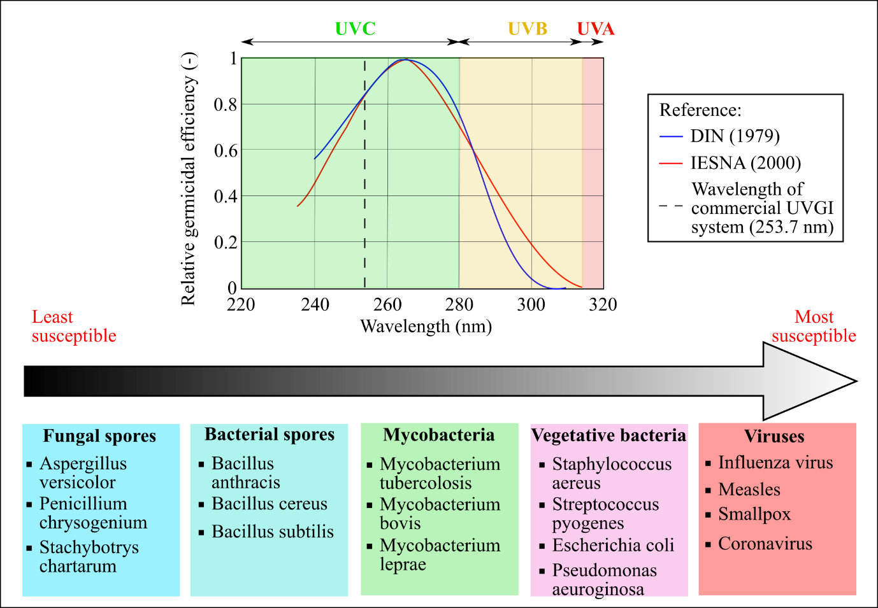
Figure 7. Effect of UV light on germicidal characteristics (top) and susceptibility to UVC inactivation of microorganisms, adapted from [146].

Main configurations of UVGI systems used in buildings (healthcare facilities, laboratories, etc.) are upper-room (for the disinfection of the whole room surface and of the air) and in-duct (in HVAC units for surface disinfection of cooling coils and for air disinfection) [140], with a dose of UV light specific to the application (low UV dose for coil disinfection and high UV dose for air disinfection) [148]. In-duct UVGI systems for air disinfection should be located on the exhaust air duct of the HVAC unit to reduce the transmission of microorganisms before recirculating or exhausting the air [149], although more research is required to evaluate the effect of air velocity and UVC light intensity on the virus inactivation characteristics of in-duct UVGI, particularly for coronaviruses [150].

Although considered beneficial to reduce the viability of microorganisms and increase the indoor air quality, the use of UVGI technology for air disinfection presents drawbacks, such as the absence of design standards, the risk to occupants and objects (degradation of the materials which are exposed to UVC light) and the capital and operating costs [140] and its implementation should be evaluated case by case, depending on the occupancy and geometry of the space, the type of ventilation system, etc. [150]. In particular, UVGI technology is not recommended for use in public transport, as the vehicle should be redesigned to account for the safety of the occupants [137]. As such, the use of UVGI as a standalone technology for air disinfection is limited, whilst it is beneficial as a supplement to HEPA or high MERV filters [149]. For this reason, the use of UVGI in HVAC systems is not considered in the case study of Section 5.2, although its application in combination with liquid desiccant technology for air sterilisation is promising and further described in Section 5.1.

To conclude, Table 4 summarises the main recommended or identified strategies to limit the transmission of the SARS-CoV-2 in buildings or enclosed spaces, together with their main effects and drawbacks.

Table 4. Summary of the main HVAC strategies to limit the transmission of SARS-CoV-2.
Strategy | Effect | Drawback
Increased outdoor air | Positive effect on the removal of contaminants | - Energy consumption increase  - Reduced thermal comfort  - Importance of outdoor air
Increased air change per hour | Positive effect on the removal of contaminants | - Energy consumption increase  - Reduced thermal comfort
Temperature and humidity control | Air supplied with conditions not favourable for virus activity and transmission | - Complicated retrofitting for humidification  - Energy consumption increase  - Humidifiers potential site of accumulation of microorganisms
Filters | Positive effect on virus removal, depending on the MERV of the filter | - Complicated retrofitting for HEPA filters  - Energy consumption increase  - Potential breeding site for viruses
UV light | Capacity of UV light to kill or deactivate microorganisms | - Implementation feasibility is case-specific  - Safety concerns  - Increase in capital and operating cost

As clear from Table 4, although the recommended strategies have the capacity to reduce the transmission of SARS-CoV-2 or airborne viruses in general, these also negatively affect primarily the energy consumption of HVAC systems and potentially the indoor air quality in buildings or public transport. Towards the realisation of future low-carbon HVAC systems, alternative technologies able to provide safety for the occupants without negatively affecting the energy consumption should be evaluated.

5 Potential scrubbing technology: liquid desiccant

5.1 Working principle and sanitising characteristics
Liquid desiccant solutions could be employed as a potential alternative strategy for the inactivation of SARS-CoV-2 or other airborne pathogens in buildings, enclosed spaces or public transports. Liquid desiccant is a technology that uses hygroscopic solutions, usually LiCl, LiBr, CaCl₂, HCO₂K, TEG, etc., to dehumidify the air [12]. A schematic diagram of a liquid desiccant system in its conventional configuration is shown in Figure 8, where the desiccant solution depending on its temperature and concentration is able to produce dry and hot/humid (usually as scavenging air) in the dehumidifier and regenerator, respectively. The water vapour absorption process performed by droplets of the liquid desiccant solution in the dehumidifier is somewhat similar but opposed to the droplet evaporation process described in Section 3.3, where the low vapour pressure of the desiccant solution enables the mass transfer of moisture from the air to the solution [151].

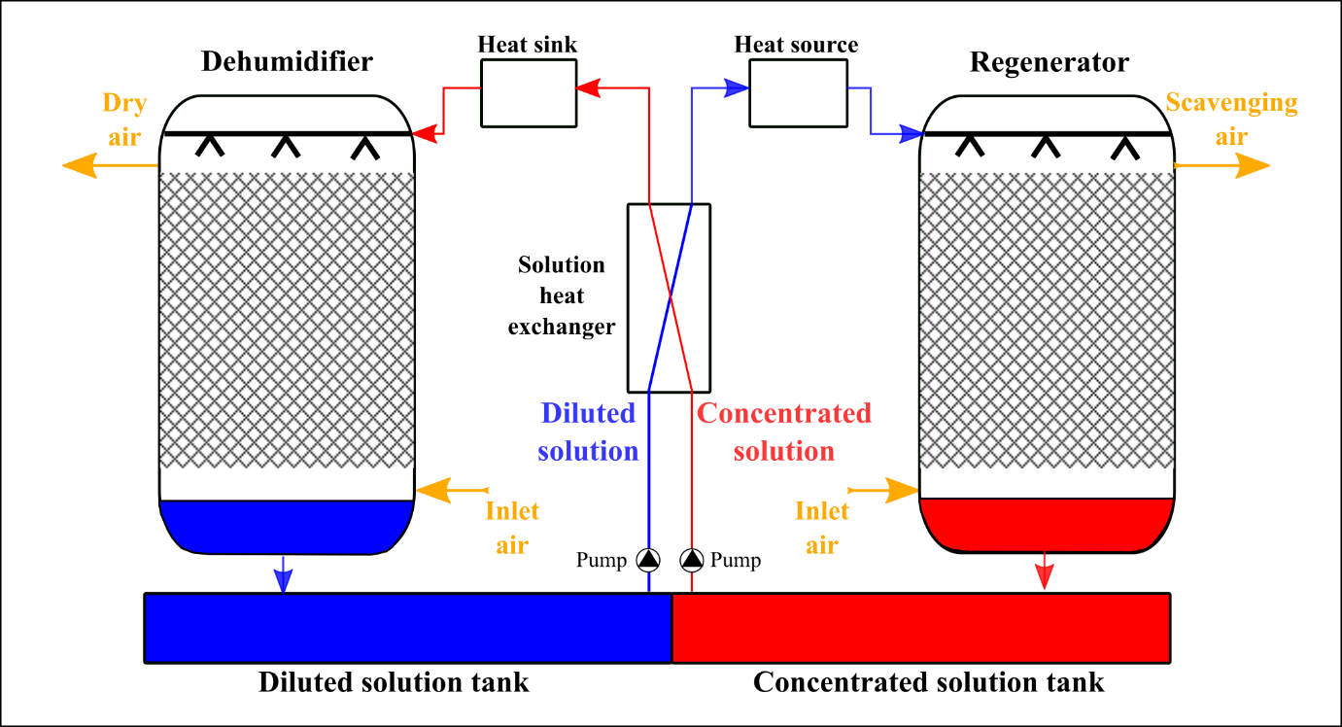
Figure 8. Conventional schematics of liquid desiccant technology.

The liquid desiccant technology is usually driven by low-grade heat sources, such as industrial waste heat [152], solar [153] and geothermal energy [154], to energy-efficiently control moisture and temperature, particularly for processes where moisture control and moisture removal is required. It has therefore found application in buildings with high latent loads (such as gyms and swimming pools [155]), in buildings where moisture control is essential for the conservation of goods (such as art galleries, libraries, museums and archives [156]), in hospitals and healthcare facilities [157], in refrigeration and cold rooms [158], in greenhouses [159], etc.

Desiccant solutions have been identified as a potential tool to increase the indoor air quality (IAQ) in buildings or enclosed spaces due to their bacteriostatic, bactericidal and antiviral characteristics, in addition to the capacity to remove volatile organic compounds (VOCs) and capture particulate matter (PM) [11]. In addition, their moisture control capacity makes of the liquid desiccant a very appealing technology in the case of an airborne viral outbreak, being able to provide to the building’s occupants thermal comfort, indoor air quality and safety without resulting responsible for an increase in energy consumption. Compared to conventional technologies for humidity control (i.e. cooling-based dehumidification and humidifiers), the liquid desiccant technology does not use water storage systems, resulting in limited breeding sites for microorganisms [11]. As an example of application, Liu et al. [160] developed an air-conditioning system able to independently control the temperature and humidity of the air supplied to a residential building, which is able to provide both dehumidification in summer and heating/humidification in winter. It was recognised how liquid desiccant technology could significantly increase the IAQ in buildings or enclosed spaces by supplying 100% outdoor air with no significant difference in electricity consumption compared to the operation with recirculated air [161]. In hybrid HVAC systems, the decoupling of sensible heat removal (usually performed by vapour-compression cooling) and latent heat removal (performed by liquid desiccant) result in higher energy and economic performance in terms of increase of the coefficient of performance (COP), reduced size and capital cost, etc. [162]. It was also investigated the potential use of desiccant systems (solid or liquid) to condition the temperature and humidity of the air supplied to buses [163]. In combination with an evaporative cooling system, the technology is able to supply the air within the temperature and humidity range required and be driven by the heat available from the engine.

A literature review of the sanitising properties of liquid desiccants showed that different studies focused on the analysis of the bacteria, fungi and virus deactivation characteristics of the conventional desiccant solutions (such as LiCl and TEG), as shown in Tables 5 and 6 for experiments conducted in air-conditioning systems and in a laboratory environment on cell infections, respectively. For completeness, no research on the sanitising characteristics of other commonly used desiccant solutions, such as CaCl₂ and HCO₂K, was identified in the literature, although it cannot be completely ruled out.

Slayzak et al. [164] studied the capacity of a low-flow liquid desiccant system to inactivate the Bacillus subtilis and Bacillus cereus spores. In the context of the development of technological solutions against chemical and biological weapons for increased security in buildings, it was proved that a liquid desiccant solution, such as LiCl, has the capacity to capture and inactivate spores used as surrogates for anthrax. After capturing the contaminants from the supply air (dehumidifying it), the liquid desiccant solution is heated and then sent to the regenerator where it desorbs the moisture, becoming concentrated. As reported in the patent by Slayzak et al. [165], the technology would represent an example of a regenerable filter that is able to provide continuous removal of gaseous, aerosols and particulate microorganisms, including bacteria, fungi and viruses. Compared to conventional filters, such as HEPA, electrostatic precipitator, photocatalytic oxidation, etc., the liquid desiccant technology could be able to inactivate different types of contaminants without requiring large, expensive and energy-consuming technological solutions [165]. It was identified in the research a direct proportionality between the inactivation of the spores and the temperature and concentration of the desiccant solution.

Wang et al. [166] studied the effect of two desiccant solutions (TEG and LiCl) on the activity of fungi, such as Cladosporium, Aspergillus and Penicillium, identifying how the inactivation process is directly proportional to the concentration of the solution and inversely proportional to its temperature. Park et al. [124] investigated the capacity of a liquid desiccant system to remove microorganisms (bacteria and fungi) and VOCs (toluene and formaldehyde) from the air. It was reported that the solution can remove bacteria with an efficiency ranging between 77.5% and 81.3%, while the capacity to remove fungi was lower (ranging between 38.8% and 44%). Compared to the conventional variable air volume (VAV) system, it was reported that the liquid desiccant technology could increase the ACH up to 3.1 times, resulting in a beneficial effect for the dilution of contaminants in the air. The manufacturer of liquid desiccant systems Alfa Laval [167] investigated the operation of a liquid desiccant system combined with UVGI process to reduce the activity of surrogates of seven bacteria commonly found in healthcare facilities, such as Staphylococcus epidermidis, Klebsiella aerogenes, Escherichia coli, Enterobacter cloacae, Salmonella Typhimurium, Pseudomonas fluorescens and Listeria innocua. By calculating the logarithmic reduction of the microorganisms at the outlet of the desiccant system, it was identified how the technology would be able to effectively control the analysed bacteria. It was reported how the technology could find application in the food processing industry where a higher risk of bacterial contamination is present [168]. The integration of the liquid desiccant technology with UVC light was also studied by Bang et al. [169], which evaluated the effectiveness of the technology to inactivate bacteria (Legionella and Staphylococcus) and fungi (Penicillium, Aspergillus and Cladosporium). Whilst bacteria were reduced by 78.3%, no effect was identified on fungi. As described by Slayzak et al. [165], the microbes inactivation characteristics of the liquid desiccant technology could be further enhanced by using additional purification systems, such as ionisation, electrostatic precipitators, inertial filters, etc., depending on the typology of pathogen or contaminant considered.

Following the outbreak of SARS-CoV-1, different studies were conducted in China for the development of air-conditioning systems able not only to energy-efficiently control temperature and humidity of the air supplied to the building but also to sanitise it and remove viruses, bacteria or fungi [11]. Lu et al. [170] investigated the capacity of a combined liquid desiccant and UVC radiation system to purify and sterilise the air. It was reported by Fu et al. [11] that by employing such technology would significantly reduce the bacteria present (reduction higher than 90%). In the review article by Fu et al. [11], it was also reported a study by the Chinese CDC Virus Institute on the effect of a LiBr-LiCl mixture to inactivate SARS-CoV-1. Since the genetic material of the SARS-CoV-1 virus after treatment with the desiccant solution was highly unstable, it was hypothesised that the solution could have an effect of direct chemical damage on the virus.

Different potential mechanisms have been suggested for the action of the desiccant solution on the contaminant, as reported in the technology patented by Slayzak et al. [165]. It is important to note that the technology was designed to be effective against spores, such as Bacillus spores. However, it was reported that the spores, in general, are harder to deactivate microorganism, the same conclusion could be applied to easier to deactivate microorganisms, such as viruses, bacteria, fungi, etc. Primarily, it was suggested that the desiccant solution is responsible for the reduction of water activity, a_{W} [12, 165]. A 45% wt. LiCl desiccant solution at 40 °C has a_{W} equal to 0.1, whilst it is reported in literature how bacteria growth is limited for values of a_{W} lower than 0.9 [165]. It was identified the removal of water molecules from the capsid as responsible for the inactivation process of bacteria [107]. However, a different behaviour was identified for viruses, characterised by structural differences compared to bacteria [107] and able to survive in conditions of very low a_{W} [171].

Slayzak et al. [165] suggested that the presence of lithium ions could be responsible for the inhibition of the viral activity, as also suggested by the research of Skinner et al. [172] and further illustrated in Table 6. In terms of the research on the capacity of LiCl to inactivate the replication of viruses on cell culture, Skinner et al. [172] investigated the effect of LiCl on various DNA and RNA viruses. It was observed the capacity of such solution to inhibit the replication of the analysed DNA viruses (pseudorabies and vaccinia virus) on baby hamster kidney cells with an effect directly proportional to the dose of LiCl. However, the same effect was not observed for RNA viruses (encephalomyocarditis, EMC, and influenza). In addition, it was suggested that the inhibition of the virus was specific to the presence of the Li ions since a similar effect was observed after treatment with lithium sulphate (Li₂SO₄) but not with potassium chloride (KCl) and sodium chloride (NaCl). In the recent years, various in vitro studies on the capacity of LiCl to inactivate viruses in cell culture were conducted, such as avian coronavirus infectious bronchitis virus, IBV [173, 174], porcine deltacoronavirus [175], TGEV [176], type II porcine reproductive and respiratory syndrome virus [177], porcine epidemic diarrhoea virus [178], foot-and-mouth virus [179], feline calicivirus [180] and mammalian orthoreoviruses [181]. The capacity of LiCl to inhibit different DNA and RNA viruses with an effect dependent on the dose was identified, particularly for coronaviruses [176]. Harrison et al. [173] studied the capacity of LiCl to inactivate IBV, an avian virus of the coronavirus family, identifying how the inhibition effect was correlated with the dose of LiCl in the replication stage, whilst no effect was detected in the attachment and entry stages. As such, the LiCl is thought to operate on a cellular level by affecting the production of viral proteins and inhibit the reproduction ability of the virus, rather than killing it with direct virucidal characteristics. The temperature was also detected as a primary factor on the inactivation of the virus. Similarly, Ren et al. [176] studied the effect of LiCl on another family of coronaviruses, TGEV, identifying how the inhibition of coronaviruses could be a common feature for LiCl. It was hypothesised that LiCl could have a beneficial effect on inactivation of viruses inducing apoptosis of the infected cells (such as IBV, SARS-CoV-1, equine coronavirus, etc.) by inhibiting the apoptosis process mediated by caspases 3-related pathways. Although the use of LiCl for the treatment of COVID19-infected patients is promising [182], the current research was performed in vitro and/or on surrogate viruses, requiring more research to fully understand the mechanisms involved in the process of inactivation of the virus performed by LiCl and how these inactivation characteristics could be exploited in the realisation of a sanitising air scrubber.

As reported by Slayzak et al. [165] and detected by Harrison et al. [173], the action of the desiccant solution on the virus inactivation could be the result of the coactive effect of the antiviral characteristics of the LiCl solution and of the treatment at high temperature. After direct contact with the virus-laden air, the desiccant solution is sent to the regenerator where it desorbs moisture at relatively high temperature (45–60 °C), stimulating the inactivation of the pathogen. In addition, the exposure time of the virus in the desiccant solution could also affect the inactivation [165], as detected for the treatment to LiCl of feline calicivirus [180]. Studies were also conducted on the capacity of TEG to inactivate influenza virus [183, 184], showing how not only the LiCl could be responsible for the inactivation of viruses but other additional factors might be involved, such as the dehumidification of the virus-laden air, the increase in the salt concentration, etc.

It was also suggested by Slayzak et al. [165] that the chemistry of the desiccant solution could be modified to enhance its capacity to inactivate the virus. Metal ions could be added to the liquid desiccant to further increase the sanitising characteristics of the solution without affecting the performance of the technology [165]. In the recent years, metal nanoparticles, such as silver, gold, zinc oxide (ZnO), titanium oxide (TiO₂), copper oxide (CuO), aluminium oxide (Al₂O₃), magnesium oxide (MgO), etc. were investigated because of their inhibitory activity against bacteria, fungi and virus [185]. The use of particles with antimicrobial characteristics, such as iodine, chlorine and metals, were also studied for application in filters and surgical masks [186]. These nanoparticles could be added in suspension to the liquid desiccant solution with a resulting increase in the mass transfer process, which could further enhance the removal of viruses or pathogens from the air. Various studies are reported in the literature on the addition of surfactants and nanoparticles to increase the heat and mass transfer performance of desiccant systems [187-191]. Abu-Hamdeh and Almitani studied the addition of ZnO, Fe₃O₄, and Al₂O₃ nanoparticles to water to increase the performance of an evaporative cooling system used in combination with liquid desiccant technology [192]. Langroudi et al. [190] studied the addition of γ-Al₂O₃ nanoparticles to a LiBr solution, identifying an increase in the heat and mass transfer coefficients higher than 20%. Shoaib et al. [191] added nanoparticles of CuO (0.35% vol.) to a CaCl₂ desiccant solution, showing an enhancement of the mass transfer process. As investigated by Dong et al. [193], nanoparticles of TiO₂ can also be used for the self-coating of the dehumidifier of a liquid desiccant system to increase the mass transfer of the process.

In addition, Slayzak et al. [165] suggested that Lewis acids, such as aluminium chloride (AlCl₃), zinc chloride (ZnCl₂), iron chlorides (FeCl₂ and FeCl₃) and other chlorides acids from the transition metal and lanthanide groups, could be added as homogeneous catalysts in the desiccant solution to increase the chemical reaction of virus inactivation. By increasing the acidity of the desiccant solution, the denaturation of the surface proteins of the virus and the hydrolysis of its viral genome might be stimulated, resulting in the inactivation of the virus [194]. Various studies identified how extreme pHs are responsible for the inactivation of viruses, such as influenza, herpes simplex virus type 1 (HSV-1) and type 2 (HSV-2) [195], virus bacteriophage Φ6 [194], SARS-CoV-1 [196], etc. Darnell et al. [196] described how alkaline (pH higher than 12) and acidic (pH lower than 3) conditions would enable inactivation of SARS-CoV-1 virus, together with treatment with heat (at a temperature higher than 65 °C) and UVC light (at a wavelength of 254 nm). In addition, the presence of chloride could be beneficial as antibacterial. SARS-CoV-2 has been tested highly sensitive to disinfectant products, such as chloride [197].

It was reported by Slayzak et al. [165] that negatively charged ions, such as sulphate ion (SO₄²⁻), phosphate ion (PO₄³⁻), pyrophosphate ion (P₂O₇⁴⁻), etc., and organic compounds as salts, such as HCO₂K, or in polar form could also be advantageous to inactivate the viruses. As such, innovative solutions, such as ionic liquids (ILs), could be studied in the future as liquid desiccants not only because of their higher dehumidification ability, lower corrosion, higher solubility, flexibility, etc. which could result in a higher performance of the liquid desiccant technology [12] but also because of their potential capacity to inactivate viruses, as demonstrated for the enveloped virus Φ6 by Sommer et al. [198]. Because of the flexibility of these solutions, namely the opportunity of changing cations and/or anions according to the process requirement, it would be possible to investigate a solution able to produce an energy-efficient temperature and humidity control process while ensuring high sanitising characteristics [12]. Recently, Maekawa et al. [161] screened various ILs to investigate the more appropriate fluid for use in air-conditioning systems, identifying the high potential of a quaternary ammonium type IL ([Ch][DMPO₄]), characterised by high dehumidification ability, no corrosion to metal and low cost. Quaternary ammonium compounds are also used as cationic surfactants because of their capacity to inactivate enveloped viruses by acting on their lipid surface [199].

Although various hypothesises on the forces acting on the process of inactivation of viruses were suggested, the mechanisms behind the virus scrubbing characteristics of liquid desiccant solutions and how to improve their effectiveness are still not completely clear. Further research must be conducted to evaluate the potential of using desiccant solutions as inactivators of airborne viruses, such as SARS-CoV-2 and influenza, by evaluating the main factors involved in the inhibition of viruses, including the influence of different salts, concentration and temperature of the solution, exposure time, etc.

Table 5. Literature review of the use of desiccant solutions for bacteria, fungi and virus removal in air-conditioning systems.
Ref. | Year | LD* | Research/experiment | Conclusion
[164] | 2003 | LiCl | Tests conducted on the reduction capacity of a 40% wt. LiCl solution on spores of Bacillus subtilis and cereus, as surrogates for anthrax spores | The spores were reduced of about 99.99% after treatment at 60 °C for 4–6 hours, while no effect was identified after treatment with deionised water
[200]** | 2004 | LiCl  LiBr | Development of direct contact liquid desiccant dehumidification system able to increase IAQ by removing bacteria and viruses | It was reported the capacity of a mixture LiBr-LiCl to deactivate the SARS-CoV-1 virus
[170]** | 2005 | LiBr | Development of immune air-conditioning system based on the combination of liquid desiccant technology with evaporative or refrigeration cooling | It was reported a significant reduction (-90%) of the bacteria after direct contact with the liquid desiccant solution
[165] | 2007 | LiCl | Patent on the development of a regenerable filter for capture and inactivation of contaminants, such as surrogates of anthrax (Bacillus cereus and Bacillus subtilis) | It was reported the capacity of the LiCl solution to inactivate the spores with a direct correlation between the temperature and concentration of the solution and the inactivation of the spores
[166] | 2011 | TEG  LiCl | Tests on the capacity of LiCl (35.9–39.5% wt.) and TEG (79.9–89.5% vol.) aqueous solutions to inactivate airborne fungi in an air-conditioning system | It was proved the capacity of the solutions to inactivate the fungi. Higher capacity was observed for TEG in the operating range in most of the cases
[124] | 2017 | LiCl | Test conducted on the capacity of a 36% wt. LiCl solution to remove VOCs (toluene and formaldehyde) and microorganisms, such as bacteria and fungi | It was reported a fungi removal efficiency of 38.8–44.4%, whilst bacteria removal efficiency was 77.5–81.3%. Mechanisms involved in bacteria and fungi removal were also suggested
[201] | 2018 | LiCl | Test conducted on the capacity of a 36% wt. LiCl solution to remove bacteria and fungi by direct contact in cellulose structured packing | The fungi removal efficiency was low (7.4–8%), whilst higher removal capacity was detected for bacteria (61.9–82.8%)
[167] | 2018 | LiCl | Tests conducted on the capacity of the liquid desiccant solution combined with UVGI technology to reduce the concentration of surrogates for pathogens connected with healthcare-acquired infections | It was reported the capacity to reduce the concentration of all the microorganisms (Staphylococcus epidermidis, Klebsiella aerogenes, E. coli, Enterobacter cloacae, Salmonella Typhimurium, Pseudomonas fluorescens, Listeria innocua)
[169] | 2020 | LiCl | Tests conducted on the capacity of the liquid desiccant solution in combination with UVGI technology to inactivate bacteria and moulds from the air and on the packing of the direct evaporative cooler | It was reported the capacity of a LiCl solution to inactivate 78.3% of the airborne bacteria, whilst no effect was identified on moulds. A significant reduction was obtained in the packing
*Liquid desiccant, ** Paper reviewed in [11].

Table 6. In vitro experiments of cell culture on the virus inhibition capacity of commonly used liquid desiccant solutions.
Ref. | Year | LD* | Experiment | Result
[183] | 1943 | TEG | Tests conducted on bacteria (pneumococcus Type I and Beta hemolytic streptococcus group A) and mouse adapted influenza virus | It was identified a significant reduction of the bacteria and virus survival. Bacteria were reduced by 60% after 1 to 2 hours of treatment, while influenza virus showed a reduction over 90% after 40 to 60 minutes of treatment
[172] | 1980 | LiCl | Tests conducted on the replication of various DNA (pseudorabies and vaccinia virus) and RNA (EMC and influenza) viruses. | It was proved the capacity of LiCl to inhibit the replication of DNA viruses but not that of the considered RNA viruses. Potential mechanisms involved in the inhibition process and potential applications of LiCl were suggested.
[173] | 2007 | LiCl | In vitro experiment on the effect of LiCl on the replication of avian coronavirus infectious bronchitis virus (IBV) on Vero and DF-1 cells | The capacity to reduce the progeny virus production, the synthesis of the IBV protein and the IBV genomic and subgenomic RNA levels was observed, although with no direct virucidal effect. Direct correlation between temperature and virus inactivation observed
[174] | 2009 | LiCl | In vitro experiment on the effect of glycyrrhizin diammonium and LiCl on IBV infection in vitro | It was observed the capacity of LiCl to inhibit the replication stage of the IBV with an effect correlated with the dose. No cellular apoptosis detected after treatment with LiCl
[202] | 2010 | LiCl | Tests conducted on the antiviral effect diammonium glycyrrhizinate and LiCl on cell infection by pseudorabies herpesvirus | After treatment on the cells infected from the virus and on the virus itself, it was observed a reduction of the infective characteristics with an effect proportional to the dose
[176] | 2011 | LiCl | Tests conducted on cell infection by TGEV, PEDV (porcine coronavirus) and bovine rotavirus (PRV) | Cell infection was inhibited with an effect dependent on the dose, although no direct action on TGEV and no effect if LiCl was preincubated with host cells were observed. It was observed inhibition of the apoptosis of cells infected with TGEV
[203] | 2015 | LiCl | Tests conducted on swine testis (ST) cell infection by porcine parvovirus (PPV) | It was reported the capacity of LiCl to inhibit the replication of the virus with an effect correlated to the dose. The effect was observed in the early phase of the virus replication
[177] | 2015 | LiCl | Tests conducted on MARC-145 cells infected by porcine reproductive and respiratory syndrome virus (PRRSV) treated with LiCl | It was observed that LiCl suppressed the synthesis of viral RNA and proteins, although but no effect was observed on the PRRSV attachment and entry stage. LiCl inhibited the replication of the virus at an early stage with an effect directly correlated to the dose
[204] | 2015 | LiCl | Tests conducted on MARC-145 and PAM-CD163 cells infected by PRRSV | It was observed that LiCl reduces PRRSV production but it does not affect the virus attachment and entry stage
[180] | 2015 | LiCl | Test conducted on the viral replication of the RNA virus feline calicivirus (FCV) on Crandell-Reese feline kidney (CRFK) cells | It was observed the capacity of LiCl to suppress FCV at the early stage of infection with an effect directly correlated to the dose and the treatment time, while no effect was detected on the attachment and entry stage of the virus.
[205] | 2015 | LiCl | Tests conducted on feline kidney cells infected by canine parvovirus of type 2 | It was observed that viral DNA and proteins of canine parvovirus were suppressed in a dose-dependent manner by LiCl together with the viral entry into cells

[181] | 2016 | LiCl | In vitro experiment conducted on the antiviral activity of LiCl on a mammalian orthoreovirus (MRV) isolate from porcine in Vero cells | It was observed the capacity of LiCl to suppress MRV with an effect directly correlated to the dose, while no significant effect was identified for the viral attachment and entry stage. LiCl targets the early stage of replication of the virus, possibly inhibiting the production of viral RNA and/or proteins
[179] | 2016 | LiCl | In vitro experiment on the inhibition capacity of LiCl on BHK-21 cells infected by foot-and-mouth disease virus (FMDV) | It was observed the capacity of LiCl to inhibit FMDV replication at the early stage of virus replication, while no effect was identified for the viral attachment and entry stage. The inhibition effect was directly correlated with the dose of LiCl
[178] | 2018 | LiCl | In vitro experiment on the inhibition capacity of LiCl on Vero cells infected by coronavirus porcine epidemic diarrhea virus (PEDV) | It was observed a reduction of entry and replication stage of PEDV with an effect dependent on the dose of LiCl. No effect on the attachment of the virus to the host cell was observed
[175] | 2019 | LiCl | Tests conducted on the inhibition capacity of LiCl on porcine kidney cells infected with porcine deltacoronavirus (PDCoV) | It was observed the capacity of LiCl to inhibit PDCoV replication at the early stage of replication with an effect directly correlated to the dose. It was observed an effect on the capacity to regulate apoptosis of the infected cells
*Liquid desiccant

5.2 Case study
To estimate the energy and economic penalty imposed by the recommended HVAC strategies and identify the potential of using the liquid desiccant as an alternative technological solution for airborne viral transmission reduction, an analysis of case studies for different typologies of buildings or public transports was conducted. The main assumptions for the calculations were:
- The operation of the HVAC unit was considered based on the main guidelines: (i) operation at maximum ACH (as reported for different types of buildings or public transports in [125, 163, 206]), (ii) 100% outdoor air supply and (iii) prolonged operation (for 2 hours before and after the time of occupation of the venue) at minimum ACH. On the contrary, the conventional operation of the HVAC unit was considered as running at minimum ACH for the time of occupation of the venue with a ratio of 80% of recirculated air and 20% of outdoor air [129].
- The annual energy consumption for air-conditioning of the ventilation air was based on Eqs. (2) and (3) considering 100 days of heating demand and 60 days of cooling demand. The average temperature and relative humidity of the outdoor air in winter were considered as 5 °C and 80% RH, while in summer as 21 °C and 70% RH. The COP of the vapour compression cooling system was assumed as 2.4.
- The energy consumption for the operation of the fans was estimated based on Eq. (4), considering ΔP_{fan} as 200 Pa for a MERV 12 filter [207] and η_{e} as 0.7, operating 300 days per year.
- The cost of electricity and natural gas were assumed as £0.11/kWh and £0.03/kWh, respectively.
- The capital cost of the liquid desiccant technology was based on the equation for the specific cost depending on the air volume supply air developed in [208], while the annual operating cost was estimated as 5% of the capital cost [208].

The results of the calculation of the increase in annual operating costs of the HVAC unit due to modifications in operation to reduce airborne viral transmission, ΔOPEX, are shown in Table 7 for some selected applications in buildings or public transports.

Table 7. Estimation of the increase of annual operating costs due to recommended HVAC practices in buildings or public transports.
Venue | Volume (m³) | Occupation time (hours) | T_{Indoor} (°C) | RH_{Indoor} (%) | ACH minimum | ACH maximum | ΔOPEX (£)
Office | 25,000 | 12 | 23 | 50 | 6 | 10 | 125,124.3
Gym | 5,000 | 16 | 20 | 50 | 6 | 15 | 45,645.7
Bus | 95.16 | 18 | 21 | 60 | 4 | 10 | 672.6
Train | / | 18 | 21 | 60 | 0.83* | 1.2* | 2,846.5
* Air volume flow rate (m³/s) per train carriage [206].

It is clear from Table 7 how the implementation of the recommended guidelines for airborne viral transmission reduction would negatively impact the energy consumption and economics of the HVAC operation, particularly in large scale buildings, such as in offices, malls, etc., and where large air change rates are supplied, such as in gyms, hospitals, etc., resulting in significant costs. Based on the estimation of the capital and operating cost of the liquid desiccant technology for the different application cases, the payback period of replacing the conventional HVAC system (operating accordingly to the main guidelines for airborne viral transmission reduction) was estimated, as shown in Figure 9.

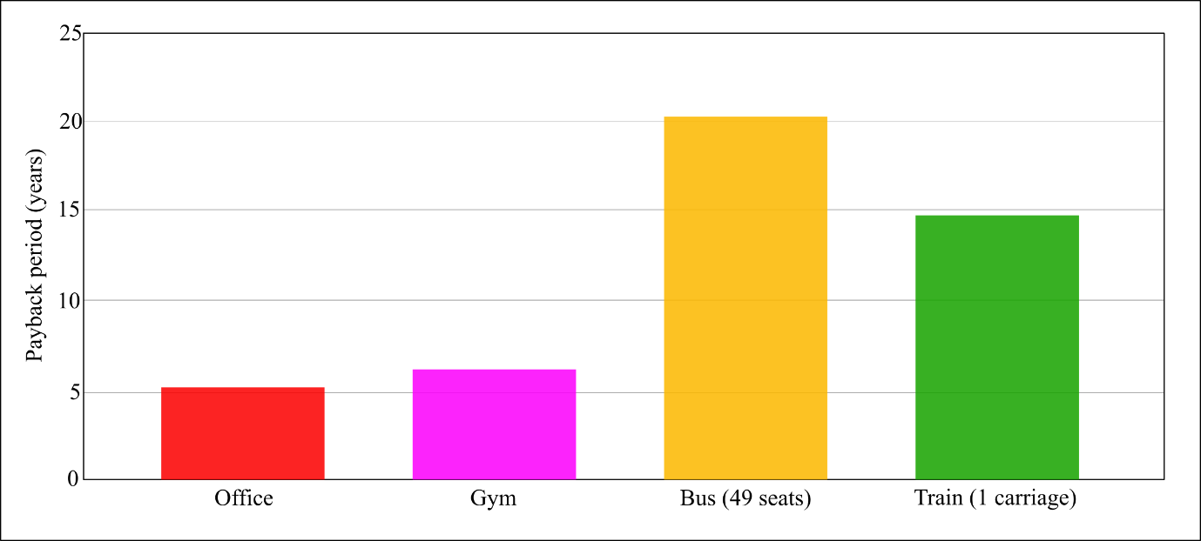
Figure 9. Payback period of the use of liquid desiccant technology in some selected building or public transport applications.

It is clear from Figure 9 how the payback period can be significant, particularly for public transport applications. This is mainly due to the high capital cost of liquid desiccant technology at the current state of market development. The best economic performances were obtained for large scale buildings, such as offices (with a payback period of 5.05 years), and for the gym (6.12 years), where the dehumidification demand is larger. As such, the technology would present higher energy benefits in large buildings where humidity control or moisture removal is required, such as in gyms, pools, food processing, libraries, museums, etc. [156]. In addition, the virus-scrubbing characteristics of the technology would be particularly beneficial in buildings where there is a higher probability of the presence of viruses or microorganisms, such as healthcare facilities and operating rooms, or in high-footfall enclosed spaces, in the case of a virus outbreak.

6 Conclusion
COVID-19 is a respiratory disease caused by the virus SARS-CoV-2 that has affected millions of people worldwide. Although lacking in research clearly proving how the virus is transmitted and what parameters affect that, the most probable transmission modes currently identified are droplet and fomite transmission. Social distancing, personal protective equipment, quarantine and lockdown measures, have been identified as effective strategies to contain the transmission of the virus. However, growing evidence for the airborne transmission has been observed, resulting in higher relevance for HVAC strategies in spaces with high occupancy and showing the importance of including the occupant’s safety into the paradigm of future low-energy buildings and public transports.

Main established HVAC strategies to limit the spread of the COVID-19 in buildings and enclosed spaces include the increase of outdoor air and air change rates, the use of higher capacity filters, the use of UV light, etc. Although able to reduce airborne viral transmission, these strategies are responsible for an increase in energy consumption and a decrease in thermal comfort, making them not-appealing as long-term strategies. In the view of identifying HVAC technologies able to provide a healthy environment for the occupants without affecting energy consumption, this paper demonstrated the potential of the liquid desiccant technology for use in crowded buildings (schools, gyms, libraries, etc.), enclosed spaces (elevators, locker rooms, etc.) and public transport, particularly for large scale buildings where large air change rates are supplied and humidity control and/or moisture removal is required. The technology could provide benefits in terms of (i) efficient use of energy such as low-grade heat sources, (ii) capacity to independently control temperature and humidity of the supply air, (iii) supply 100% outdoor air, (iv) control of humidity within the range of values less favourable to the growth, proliferation and infectivity of microorganisms (RH between 40% and 60%) and (v) virus inactivation characteristics of the desiccant solutions. The study showed how some conventional desiccant solutions, such as TEG and LiCl, have been largely studied due to their sanitising characteristics. The potential factors involved in the virus inactivation process performed by desiccant solutions (high temperature, increased salinity, effect of Li and Cl ions, exposure time, etc.) were suggested together with possible modifications of the solutions to enhance their sanitising characteristics. As a matter of fact, metal ions, such as titanium and copper oxide, could be added to conventional desiccant solutions with beneficial effects in terms of both increased heat and mass transfer and antimicrobial activity. The paper is the first step towards the development of a novel airborne pathogen scrubber system able to draw in the contaminated air, neutralise the airborne particles in the air (viruses, bacteria, fungi, particulates, etc.) thanks to the deactivation action of the liquid desiccant solution and push the sanitised air to the environment or recirculate it back to space.

Acknowledgments
This project was funded through the Engineering and Physical Science Research Council (EPSRC) of the United Kingdom (EP/R511523/1, EP/T022906/1).

Data supporting this publication is openly available under an ‘Open Data Commons Open Database License’. Data underpinning this article can be found at xx.

References
1. Kurnitski, J., F. Franchimon, and J. Hogeling, How to operate and use building services in order to prevent the spread of the coronavirus disease (COVID-19) virus (SARS-CoV-2) in workplaces. REHVA COVID-19 guidance document. REHVA: Federation of European Heating, Ventilation and Air Conditioning Associations, 2020.
2. COVID-19 coronavirus pandemic. [cited 2020 28 August]; Available from: https://www.worldometers.info/coronavirus/.
3. Wu, D., et al., The SARS-CoV-2 outbreak: what we know. International Journal of Infectious Diseases, 2020.
4. Mourtzoukou, E. and M.E. Falagas, Exposure to cold and respiratory tract infections. The International Journal of Tuberculosis and Lung Disease, 2007. 11(9): p. 938-943.
5. Jones, A.P., Indoor air quality and health. Atmospheric environment, 1999. 33(28): p. 4535-4564.
6. UK, G., Transmission characteristics and principles of infection prevention and control. 2020.
7. Aliabadi, A.A., et al., Preventing airborne disease transmission: review of methods for ventilation design in health care facilities. Advances in preventive medicine, 2011. 2011.
8. Hierarchy of controls. [cited 2020 16 December]; Available from: https://www.cdc.gov/niosh/topics/hierarchy/default.html.
9. Morawska, L., et al., How can airborne transmission of COVID-19 indoors be minimised? Environment international, 2020. 142: p. 105832.
10. Li, Y., et al., Engineering control of respiratory infection and low-energy design of healthcare facilities. Science and Technology for the Built Environment, 2015. 21(1): p. 25-34.
11. Fu, H.-X. and X.-H. Liu, Review of the impact of liquid desiccant dehumidification on indoor air quality. Building and Environment, 2017. 116: p. 158-172.
12. Giampieri, A., et al., Thermodynamics and economics of liquid desiccants for heating, ventilation and air-conditioning–An overview. Applied Energy, 2018. 220: p. 455-479.
13. CIBSE COVID-19 Ventilation guidance. Version 4. 2020.
14. Schoen, L.J., Guidance for Building Operations During the COVID-19 Pandemic. ASHRAE Journal, 2020.
15. Liu, Y., R.M. Eggo, and A.J. Kucharski, Secondary attack rate and superspreading events for SARS-CoV-2. The Lancet, 2020. 395(10227): p. e47.
16. Yu, I.T.-S., et al., Severe acute respiratory syndrome beyond Amoy Gardens: completing the incomplete legacy. Clinical infectious diseases, 2014. 58(5): p. 683-686.
17. Xie, X., et al., How far droplets can move in indoor environments–revisiting the Wells evaporation–falling curve. Indoor air, 2007. 17(3): p. 211-225.
18. Kohanski, M.A., L.J. Lo, and M.S. Waring. Review of indoor aerosol generation, transport, and control in the context of COVID‐19. in International forum of allergy & rhinology. 2020. Wiley Online Library.
19. Van Doremalen, N., et al., Aerosol and surface stability of SARS-CoV-2 as compared with SARS-CoV-1. New England Journal of Medicine, 2020. 382(16): p. 1564-1567.
20. Dehbandi, R. and M.A. Zazouli, Stability of SARS-CoV-2 in different environmental conditions. The Lancet Microbe, 2020. 1(4): p. e145.
21. Aboubakr, H.A., T.A. Sharafeldin, and S.M. Goyal, Stability of SARS‐CoV‐2 and other coronaviruses in the environment and on common touch surfaces and the influence of climatic conditions: A review. Transboundary and emerging diseases, 2020.
22. Meiksin, A., Dynamics of COVID-19 transmission including indirect transmission mechanisms: a mathematical analysis. Epidemiology & Infection, 2020. 148.
23. Mondelli, M.U., et al., Low risk of SARS-CoV-2 transmission by fomites in real-life conditions. The Lancet Infectious Diseases, 2020.
24. Gralton, J., et al., The role of particle size in aerosolised pathogen transmission: a review. Journal of Infection, 2011. 62(1): p. 1-13.
25. Tellier, R., et al., Recognition of aerosol transmission of infectious agents: a commentary. BMC infectious diseases, 2019. 19(1): p. 101.
26. Jayaweera, M., et al., Transmission of COVID-19 virus by droplets and aerosols: A critical review on the unresolved dichotomy. Environmental Research, 2020: p. 109819.
27. Jackson, T., et al., Classification of aerosol-generating procedures: a rapid systematic review. BMJ open respiratory research, 2020. 7(1): p. e000730.
28. Weber, T.P. and N.I. Stilianakis, Inactivation of influenza A viruses in the environment and modes of transmission: a critical review. Journal of infection, 2008. 57(5): p. 361-373.
29. Xu, Y., et al., Characteristics of pediatric SARS-CoV-2 infection and potential evidence for persistent fecal viral shedding. Nature medicine, 2020. 26(4): p. 502-505.
30. Zhang, J., S. Wang, and Y. Xue, Fecal specimen diagnosis 2019 novel coronavirus–infected pneumonia. Journal of medical virology, 2020. 92(6): p. 680-682.
31. Wang, W., et al., Detection of SARS-CoV-2 in different types of clinical specimens. Jama, 2020. 323(18): p. 1843-1844.
32. Larsen, D.A. and K.R. Wigginton, Tracking COVID-19 with wastewater. Nature Biotechnology, 2020. 38(10): p. 1151-1153.
33. Abdullah, A.S., et al., Lessons from the severe acute respiratory syndrome outbreak in Hong Kong. Emerging Infectious Diseases, 2003. 9(9): p. 1042.
34. Zhang, R., et al., Identifying airborne transmission as the dominant route for the spread of COVID-19. Proceedings of the National Academy of Sciences, 2020.
35. Correia, G., et al., Airborne route and bad use of ventilation systems as non-negligible factors in SARS-CoV-2 transmission. Medical Hypotheses, 2020: p. 109781.
36. Wells, W.F., On air-borne infection. Study II. Droplets and droplet nuclei. American Journal of Hygiene, 1934. 20: p. 611-18.
37. Morawska, L. Droplet fate in indoor environments, or can we prevent the spread of infection? in Proceedings of Indoor Air 2005: the 10th International Conference on Indoor Air Quality and Climate. 2005. Springer.
38. ASHRAE, Position Document on Infectious Aerosols. 2020.
39. Organization, W.H., Modes of transmission of virus causing COVID-19: implications for IPC precaution recommendations: scientific brief, 27 March 2020. 2020, World Health Organization.
40. Kumar, P. and L. Morawska, Could fighting airborne transmission be the next line of defence against COVID-19 spread? City and Environment Interactions, 2020: p. 100033.
41. Morawska, L. and J. Cao, Airborne transmission of SARS-CoV-2: The world should face the reality. Environment International, 2020: p. 105730.
42. Allen, J.G. and L.C. Marr, Recognizing and controlling airborne transmission of SARS‐CoV‐2 in indoor environments. Indoor air, 2020. 30(4): p. 557.
43. Morawska, L. and D.K. Milton, It is time to address airborne transmission of COVID-19. Clinical Infectious Diseases, 2020. 7.
44. WHO. Coronavirus disease (COVID-19): How is it transmitted? 2020 [cited 2020 12 September]; Available from: https://www.who.int/news-room/q-a-detail/coronavirus-disease-covid-19-how-is-it-transmitted.
45. Can HVAC systems help prevent the transmission of COVID-19? 2020, McKinsey & Company.
46. Cowling, B.J., et al., Aerosol transmission is an important mode of influenza A virus spread. Nature communications, 2013. 4(1): p. 1-6.
47. Schaffner, W., An outbreak of airborne nosocomial varicella. Pediatrics, 1982. 70: p. 550-556.
48. Myatt, T.A., et al., Detection of airborne rhinovirus and its relation to outdoor air supply in office environments. American journal of respiratory and critical care medicine, 2004. 169(11): p. 1187-1190.
49. Osterholm, M.T., et al., Transmission of Ebola viruses: what we know and what we do not know. MBio, 2015. 6(2).
50. Houk, V.N., Spread of tuberculosis via recirculated air in a naval vessel: the Byrd study. Annals of the New York Academy of Sciences, 1980. 353: p. 10.
51. Tellier, R., Review of aerosol transmission of influenza A virus. Emerging infectious diseases, 2006. 12(11): p. 1657.
52. Tellier, R., Aerosol transmission of influenza A virus: a review of new studies. Journal of the Royal Society Interface, 2009. 6(suppl_6): p. S783-S790.
53. Wong, B.C., et al., Possible role of aerosol transmission in a hospital outbreak of influenza. Clinical infectious diseases, 2010. 51(10): p. 1176-1183.
54. Zhao, X., et al., Airborne Transmission of Influenza Virus in a Hospital of Qinhuangdao During 2017–2018 Flu Season. Food and environmental virology, 2019. 11(4): p. 427-439.
55. Coleman, K.K. and W.V. Sigler, Airborne influenza A virus exposure in an elementary school. Scientific Reports, 2020. 10(1): p. 1-7.
56. Moser, M.R., et al., An outbreak of influenza aboard a commercial airliner. American journal of epidemiology, 1979. 110(1): p. 1-6.
57. Zhang, H., et al., Airborne spread and infection of a novel swine-origin influenza A (H1N1) virus. Virology journal, 2013. 10(1): p. 1-7.
58. Pyankov, O.V., O.G. Pyankova, and I.E. Agranovski, Inactivation of airborne influenza virus in the ambient air. Journal of aerosol science, 2012. 53: p. 21-28.
59. Pyankov, O.V., et al., Survival of aerosolized coronavirus in the ambient air. Journal of Aerosol Science, 2018. 115: p. 158-163.
60. Li, Y., et al., Role of air distribution in SARS transmission during the largest nosocomial outbreak in Hong Kong. Indoor air, 2005. 15(2): p. 83-95.
61. Tomlinson, B. and C. Cockram, Sars: Experience at prince of wales hospital, hong kong. The Lancet, 2003. 361(9368): p. 1486-1487.
62. Lu, J., et al., COVID-19 outbreak associated with air conditioning in restaurant, Guangzhou, China, 2020. Emerging infectious diseases, 2020. 26(7): p. 1628.
63. Li, Y., et al., Evidence for probable aerosol transmission of SARS-CoV-2 in a poorly ventilated restaurant. medRxiv, 2020.
64. Ong, S.W.X., et al., Air, surface environmental, and personal protective equipment contamination by severe acute respiratory syndrome coronavirus 2 (SARS-CoV-2) from a symptomatic patient. Jama, 2020. 323(16): p. 1610-1612.
65. Nissen, K., et al., Long-distance airborne dispersal of SARS-CoV-2 in COVID-19 wards. Scientific reports, 2020. 10(1): p. 1-9.
66. Qian, H., et al., Indoor transmission of SARS‐CoV‐2. Indoor Air, 2020: p. 1-7.
67. Furuse, Y., et al., Clusters of Coronavirus Disease in Communities, Japan, January-April 2020. Emerging Infectious Diseases, 2020. 26(9).
68. Dyal, J.W., COVID-19 Among Workers in Meat and Poultry Processing Facilities―19 States, April 2020. MMWR. Morbidity and mortality weekly report, 2020. 69.
69. Hu, M., et al., The risk of COVID-19 transmission in train passengers: an epidemiological and modelling study. Clinical Infectious Diseases, 2020.
70. Leclerc, Q.J., et al., What settings have been linked to SARS-CoV-2 transmission clusters? Wellcome Open Research, 2020. 5(83): p. 83.
71. Xu, P., et al., Transmission routes of Covid-19 virus in the Diamond Princess Cruise ship. medRxiv, 2020.
72. Miller, S.L., et al., Transmission of SARS‐CoV‐2 by inhalation of respiratory aerosol in the Skagit Valley Chorale superspreading event. Indoor air, 2020.
73. Luo, C., et al., Possible transmission of severe acute respiratory syndrome coronavirus 2 (SARS-CoV-2) in a public bath center in Huai’an, Jiangsu Province, China. JAMA network open, 2020. 3(3): p. e204583-e204583.
74. Park, S.Y., et al., Early Release-Coronavirus Disease Outbreak in Call Center, South Korea. 2020.
75. Saidan, M.N., et al., Estimation of the probable outbreak size of novel coronavirus (COVID-19) in social gathering events and industrial activities. International Journal of Infectious Diseases, 2020.
76. Jang, S., S.H. Han, and J.-Y. Rhee, Cluster of coronavirus disease associated with fitness dance classes, South Korea. Emerging infectious diseases, 2020. 26(8): p. 1917.
77. Danis, K., et al., Cluster of coronavirus disease 2019 (Covid-19) in the French Alps, 2020. Clinical Infectious Diseases, 2020.
78. Moreno, T., et al., Tracing surface and airborne SARS-CoV-2 RNA inside public buses and subway trains. Environment International, 2020: p. 106326.
79. Zhen, J., et al., Transmission of respiratory viruses when using public ground transport: A rapid review to inform public health recommendations during the COVID-19 pandemic. 2020.
80. Bosch, A., R.M. Pintó, and F.X. Abad, Survival and transport of enteric viruses in the environment, in Viruses in foods. 2006, Springer. p. 151-187.
81. Shokouhi, M., et al., Temperature, humidity, and latitude analysis to predict potential spread and seasonality for COVID-19. 2020.
82. Ahlawat, A., A. Wiedensohler, and S.K. Mishra, An overview on the role of relative humidity in airborne transmission of SARS-CoV-2 in indoor environments. Aerosol and Air Quality Research, 2020. 20.
83. Feng, Y., et al., Influence of wind and relative humidity on the social distancing effectiveness to prevent COVID-19 airborne transmission: A numerical study. Journal of aerosol science, 2020: p. 105585.
84. Schuit, M., et al., Airborne SARS-CoV-2 is Rapidly Inactivated by Simulated Sunlight. The Journal of Infectious Diseases, 2020.
85. Setti, L., et al., SARS-Cov-2RNA Found on Particulate Matter of Bergamo in Northern Italy: First Evidence. Environmental Research, 2020: p. 109754.
86. Wolkoff, P., Indoor air humidity, air quality, and health–An overview. International journal of hygiene and environmental health, 2018. 221(3): p. 376-390.
87. Sterling, E., A. Arundel, and T. Sterling, Criteria for human exposure to humidity in occupied buildings. ASHRAE transactions, 1985. 91(1): p. 611-622.
88. Lowen, A.C., et al., Influenza virus transmission is dependent on relative humidity and temperature. PLoS Pathog, 2007. 3(10): p. e151.
89. Lowen, A.C., et al., High temperature (30 C) blocks aerosol but not contact transmission of influenza virus. Journal of virology, 2008. 82(11): p. 5650-5652.
90. Noti, J.D., et al., High humidity leads to loss of infectious influenza virus from simulated coughs. PloS one, 2013. 8(2): p. e57485.
91. Irwin, C.K., et al., Using the systematic review methodology to evaluate factors that influence the persistence of influenza virus in environmental matrices. Applied and environmental microbiology, 2011. 77(3): p. 1049-1060.
92. Yang, W., S. Elankumaran, and L.C. Marr, Relationship between humidity and influenza A viability in droplets and implications for influenza’s seasonality. PloS one, 2012. 7(10): p. e46789.
93. Marr, L.C., et al., Mechanistic insights into the effect of humidity on airborne influenza virus survival, transmission and incidence. Journal of the Royal Society Interface, 2019. 16(150): p. 20180298.
94. Xiao, Y., et al., The influence of meteorological factors on tuberculosis incidence in Southwest China from 2006 to 2015. Scientific reports, 2018. 8(1): p. 1-8.
95. Lee, S.J., et al., Effect of temperature and relative humidity on the survival of foodborne viruses during food storage. Applied and environmental microbiology, 2015. 81(6): p. 2075-2081.
96. Prussin, A.J., et al., Survival of the enveloped virus Phi6 in droplets as a function of relative humidity, absolute humidity, and temperature. Applied and environmental microbiology, 2018. 84(12).
97. Yang, W. and L.C. Marr, Mechanisms by which ambient humidity may affect viruses in aerosols. Applied and environmental microbiology, 2012. 78(19): p. 6781-6788.
98. Kim, S.W., et al., Effects of humidity and other factors on the generation and sampling of a coronavirus aerosol. Aerobiologia, 2007. 23(4): p. 239-248.
99. Casanova, L.M., et al., Effects of air temperature and relative humidity on coronavirus survival on surfaces. Applied and environmental microbiology, 2010. 76(9): p. 2712-2717.
100. Chan, K.-H., et al., The effects of temperature and relative humidity on the viability of the SARS coronavirus. Advances in virology, 2011. 2011.
101. Van Doremalen, N., T. Bushmaker, and V. Munster, Stability of Middle East respiratory syndrome coronavirus (MERS-CoV) under different environmental conditions. Eurosurveillance, 2013. 18(38): p. 20590.
102. Bolashikov, Z.D. and A.K. Melikov. Methods for indoor air disinfection and purification from airborne pathogens for application in HVAC systems. in Proceedings of The sixth international conference on indoor air quality, ventilation & energy conservation in buildings. 2007.
103. Yuan, S., S. Jiang, and Z.-L. Li, Do Humidity and Temperature Impact the Spread of the Novel Coronavirus? Frontiers in Public Health, 2020. 8: p. 240.
104. Rohde, R., The Relationship between Coronavirus (COVID-19) Spread and the Weather. Berkeley Earth: Berkeley, CA, USA, 2020.
105. Shaman, J., et al., Absolute humidity and the seasonal onset of influenza in the continental United States. PLoS Biol, 2010. 8(2): p. e1000316.
106. Shaman, J. and M. Kohn, Absolute humidity modulates influenza survival, transmission, and seasonality. Proceedings of the National Academy of Sciences, 2009. 106(9): p. 3243-3248.
107. Niazi, S., et al., The role of respiratory droplet physicochemistry in limiting and promoting the airborne transmission of human coronaviruses: A critical review. Environmental Pollution, 2020: p. 115767.
108. Morris, D.H., et al., Mechanistic theory predicts the effects of temperature and humidity on inactivation of SARS-CoV-2 and other enveloped viruses. bioRxiv, 2020.
109. Schaffer, F., M. Soergel, and D. Straube, Survival of airborne influenza virus: effects of propagating host, relative humidity, and composition of spray fluids. Archives of virology, 1976. 51(4): p. 263-273.
110. Günther, T., et al., Investigation of a superspreading event preceding the largest meat processing plant-related SARS-Coronavirus 2 outbreak in Germany. Available at SSRN 3654517, 2020.
111. Wanner, A., M. Salathé, and T.G. O'Riordan, Mucociliary clearance in the airways. American journal of respiratory and critical care medicine, 1996. 154(6): p. 1868-1902.
112. Kudo, E., et al., Low ambient humidity impairs barrier function and innate resistance against influenza infection. Proceedings of the National Academy of Sciences, 2019. 116(22): p. 10905-10910.
113. Bustamante-Marin, X.M. and L.E. Ostrowski, Cilia and mucociliary clearance. Cold Spring Harbor perspectives in biology, 2017. 9(4): p. a028241.
114. Wolkoff, P. and S.K. Kjærgaard, The dichotomy of relative humidity on indoor air quality. Environment international, 2007. 33(6): p. 850-857.
115. Guo, M., et al., Review and comparison of HVAC operation guidelines in different countries during the COVID-19 pandemic. Building and Environment, 2020: p. 107368.
116. Yu, B., et al., Review of research on air-conditioning systems and indoor air quality control for human health. International journal of refrigeration, 2009. 32(1): p. 3-20.
117. Unwanted guests: bipolar ionisation in hotel rooms. 2020 [cited 2020 16 December]; Available from: https://www.cibsejournal.com/technical/unwanted-guests-bipolar-ionisation-in-hotel-rooms/.
118. Dietz, L., et al., 2019 novel coronavirus (COVID-19) pandemic: Built environment considerations to reduce transmission. Msystems, 2020. 5(2).
119. Qian, H. and X. Zheng, Ventilation control for airborne transmission of human exhaled bio-aerosols in buildings. Journal of thoracic disease, 2018. 10(Suppl 19): p. S2295.
120. Dai, H. and B. Zhao. Association of the infection probability of COVID-19 with ventilation rates in confined spaces. in Building Simulation. 2020. Springer.
121. Chartier, Y. and C. Pessoa-Silva, Natural ventilation for infection control in health-care settings. 2009: World Health Organization.
122. Clark, D., Ventilation rates in offices-mechanical and natural. Cundall Johnston & Partners LLP, London, 2013: p. 2-8.
123. EMG: Simple summary of ventilation actions to mitigate the risk of COVID-19, 1 October 2020. 2020.
124. Park, J.-Y., et al., Empirical analysis of indoor air quality enhancement potential in a liquid-desiccant assisted air conditioning system. Building and Environment, 2017. 121: p. 11-25.
125. Covid Safe Ventilation of Buildings. 2020 [cited 2020 12 December]; Available from: https://www.puravent.co.uk/blog/covid-safe-ventilation/.
126. Memarzadeh, F. and W. Xu. Role of air changes per hour (ACH) in possible transmission of airborne infections. in Building Simulation. 2012. Springer.
127. Lstiburek, J., Residential ventilation and latent loads. ASHRAE journal, 2002. 44(4): p. 18.
128. Vadoudi, K. and S. Marinhas, Development of Psychrometric diagram for the energy efficiency of Air Handling Units. The REHVA European HVAC Journal, 2018: p. 5.
129. Zhang, J., Integrating IAQ control strategies to reduce the risk of asymptomatic SARS CoV-2 infections in classrooms and open plan offices. 2020, Taylor & Francis.
130. Menzies, D., et al., Hospital ventilation and risk for tuberculous infection in Canadian health care workers. Annals of Internal Medicine, 2000. 133(10): p. 779-789.
131. Riley, E., G. Murphy, and R. Riley, Airborne spread of measles in a suburban elementary school. American journal of epidemiology, 1978. 107(5): p. 421-432.
132. Lipinski, T., et al., Review of ventilation strategies to reduce the risk of disease transmission in high occupancy buildings. International Journal of Thermofluids, 2020: p. 100045.
133. LOOMANS, M., et al., COVID-19 and recirculation. REHVA Journal, 2020. 2020(5): p. 5-9.
134. Kawamoto, K., et al., Field study on humidification performance of a desiccant air-conditioning system combined with a heat pump. Energies, 2016. 9(2): p. 89.
135. Zhu, S., et al., An advanced numerical model for the assessment of airborne transmission of influenza in bus microenvironments. Building and Environment, 2012. 47: p. 67-75.
136. Coronavirus recommendations: how to use the bus A/C correctly. [cited 2020 16 December]; Available from: https://www.sustainable-bus.com/news/coronavirus-recommendations-how-to-use-the-bus-a-c-correctly/.
137. ASHRAE Technical Report. Transportation. [cited 2020 16 December]; Available from: https://www.ashrae.org/technical-resources/transportation.
138. Al-abdalall, A.H., S.A. Al-dakheel, and H.A. Al-Abkari, Impact of Air-Conditioning Filters on Microbial Growth and Indoor Air Pollution, in Energy-efficient and Sustainable Buildings. 2019, IntechOpen.
139. Association, N.A.F., NAFA user's guide for ANSI/ASHRAE 52.2. 1999.
140. Dreiling, J.B., An evaluation of ultraviolet germicidal irradiation (UVGI) technology in health care facilities. 2008.
141. Kowalski, W., Ultraviolet germicidal irradiation handbook: UVGI for air and surface disinfection. 2010: Springer science & business media.
142. Kowalski, W.J. and W.P. Bahnfleth, MERV filter models for aerobiological applications. Air Media, Summer, 2002. 1.
143. Sleiti, A.K., S.F. Ahmed, and S.A. Ghani, Spreading of SARS-CoV-2 via Heating, Ventilation, and Air Conditioning Systems—An Overview of Energy Perspective and Potential Solutions. Journal of Energy Resources Technology, 2021. 143(8).
144. Hobday, R. and S. Dancer, Roles of sunlight and natural ventilation for controlling infection: historical and current perspectives. Journal of hospital infection, 2013. 84(4): p. 271-282.
145. Schuit, M., et al., The influence of simulated sunlight on the inactivation of influenza virus in aerosols. The Journal of infectious diseases, 2020. 221(3): p. 372-378.
146. ASHRAE, H.A.S.H., Hvac applications handbook. IP Edition, 2011.
147. Buonanno, M., et al., Far-UVC light (222 nm) efficiently and safely inactivates airborne human coronaviruses. Scientific Reports, 2020. 10(1): p. 1-8.
148. Mathur, A. UVC in the building environment: perspectives on building codes, energy consumption and cost benefits. 2020 [cited 2020 10 December]; Available from: https://www.nist.gov/system/files/documents/2020/03/23/Panel%20IV%20Ashish%20Mathur%20presentation.pdf.
149. Memarzadeh, F., R.N. Olmsted, and J.M. Bartley, Applications of ultraviolet germicidal irradiation disinfection in health care facilities: effective adjunct, but not stand-alone technology. American journal of infection control, 2010. 38(5): p. S13-S24.
150. CIBSE, Leading light: ensuring effective use of UV technology in buildings. 2020.
151. Wang, Z., et al., Coupled thermal transport and mass diffusion during vapor absorption into hygroscopic liquid desiccant droplets. International Journal of Heat and Mass Transfer, 2019. 134: p. 1014-1023.
152. Kassem, T.K., et al., Solar powered dehumidification systems using desert evaporative coolers. Int. J. Eng. Adv. Technol., 2013. 3: p. 115-128.
153. Gommed, K. and G. Grossman, Experimental investigation of a liquid desiccant system for solar cooling and dehumidification. Solar energy, 2007. 81(1): p. 131-138.
154. Peng, C.P. and J.R. Howell, Optimization of liquid desiccant systems for solar/geothermal dehumidification and cooling. Journal of Energy, 1981. 5(6): p. 401-408.
155. Kozubal, E., et al., Low-Flow Liquid Desiccant Air-Conditioning: Demonstrated Performance and Cost Implications. 2014, National Renewable Energy Lab.(NREL), Golden, CO (United States).
156. Harriman, L.G., The dehumidification handbook. 1990.
157. Lazzarin, R., A. Gasparella, and G. Longo. Analysis of an innovative HVAC System for a Hospital. in Proc. 20th Int. Congr. of Refrigeration. 1999.
158. Piegay, M., Refrigeration Applications Utilizing Liquid Desiccant Dehumidification Systems. 2017: 2017 IIAR Technical Papers.
159. Lychnos, G. and P.A. Davies, Modelling and experimental verification of a solar-powered liquid desiccant cooling system for greenhouse food production in hot climates. Energy, 2012. 40(1): p. 116-130.
160. Liu, X., Y. Jiang, and T. Zhang, Temperature and humidity independent control (THIC) of air-conditioning system. 2014: Springer Science & Business Media.
161. Maekawa, S., et al., Design of Quaternary Ammonium Type-Ionic Liquids as Desiccants for an Air-Conditioning System. Green Chemical Engineering, 2020.
162. Zhang, T., X. Liu, and Y. Jiang, Development of temperature and humidity independent control (THIC) air-conditioning systems in China—A review. Renewable and Sustainable Energy Reviews, 2014. 29: p. 793-803.
163. Pesaran, A.A., Y.O. Parent, and D. Bharathan, Non-CFC air conditioning for transit buses. SAE transactions, 1992: p. 750-759.
164. Slayzak, S., et al., Liquid desiccant regenerable filters for indoor environmental quality and security. 2003, NATIONAL RENEWABLE ENERGY LAB WESTERVILLE OH.
165. Slayzak, S.J., et al., Using liquid desiccant as a regenerable filter for capturing and deactivating contaminants. 2007, Google Patents.
166. Wang, Y.-F., T.-W. Chung, and W.-M. Jian, Airborne fungi inactivation using an absorption dehumidification system. Indoor and Built Environment, 2011. 20(3): p. 333-339.
167. Laval, A., Pure Air liquid desiccant system.
168. Leach, P.M., M.A. Harvey, and J. Bell, Airborne microorganisms neutralizing system and method of neutralizing airbone microorganism. 2020, Google Patents.
169. Bang, J.-I., et al., Sterilization effectiveness of in-duct ultraviolet germicidal irradiation system in liquid desiccant and indirect/direct evaporative cooling-assisted 100% outdoor air system. Building and Environment, 2020. 186: p. 107350.
170. Shikui, L. and Z. Xiaoshong, Construct and Preliminary Analysis of Immune Air Conditioning System [J]. Building Energy & Environment, 2005. 2.
171. Cook, N., et al., FSA Project FS101074: a critical review of the effect of heat, pH and water activity on the survival of Hepatitis A and E viruses. A Report to the United Kingdom Food Standards Agency July, 2014.
172. Skinner, G., et al., The effect of lithium chloride on the replication of Herpes simplex virus. Medical Microbiology and Immunology, 1980. 168(2): p. 139-148.
173. Harrison, S.M., et al., Lithium chloride inhibits the coronavirus infectious bronchitis virus in cell culture. Avian Pathology, 2007. 36(2): p. 109-114.
174. Li, J., et al., Comparative analysis of the effect of glycyrrhizin diammonium and lithium chloride on infectious bronchitis virus infection in vitro. Avian Pathology, 2009. 38(3): p. 215-221.
175. Zhai, X., et al., Antiviral effect of lithium chloride and diammonium glycyrrhizinate on porcine deltacoronavirus in vitro. Pathogens, 2019. 8(3): p. 144.
176. Ren, X., et al., Action mechanisms of lithium chloride on cell infection by transmissible gastroenteritis coronavirus. PloS one, 2011. 6(5): p. e18669.
177. Cui, J., et al., Inhibitory effects of lithium chloride on replication of type II porcine reproductive and respiratory syndrome virus in vitro. Antiviral therapy, 2015. 20(6): p. 565-572.
178. Li, H.-j., et al., Antiviral effect of lithium chloride on porcine epidemic diarrhea virus in vitro. Research in veterinary science, 2018. 118: p. 288-294.
179. Zhao, F.R., et al., Lithium chloride inhibits early stages of foot‐and‐mouth disease virus (FMDV) replication in vitro. Journal of Medical Virology, 2017. 89(11): p. 2041-2046.
180. Wu, H., et al., Antiviral effect of lithium chloride on feline calicivirus in vitro. Archives of virology, 2015. 160(12): p. 2935-2943.
181. Chen, Y., et al., Novel antiviral effect of lithium chloride on mammalian orthoreoviruses in vitro. Microbial pathogenesis, 2016. 93: p. 152-157.
182. Murru, A., et al., Lithium’s antiviral effects: a potential drug for CoViD-19 disease? International Journal of Bipolar Disorders, 2020. 8: p. 1-9.
183. Robertson, O., et al., The lethal effect of triethylene glycol vapor on air-borne bacteria and influenza virus. Science, 1943. 97(2510): p. 142-144.
184. Rudnick, S.N., et al., Inactivating influenza viruses on surfaces using hydrogen peroxide or triethylene glycol at low vapor concentrations. American journal of infection control, 2009. 37(10): p. 813-819.
185. Brandelli, A., A.C. Ritter, and F.F. Veras, Antimicrobial activities of metal nanoparticles, in Metal Nanoparticles in Pharma. 2017, Springer. p. 337-363.
186. Quan, F.-S., et al., Universal and reusable virus deactivation system for respiratory protection. Scientific reports, 2017. 7(1): p. 1-10.
187. Ali, A., K. Vafai, and A.R. Khaled, Comparative study between parallel and counter flow configurations between air and falling film desiccant in the presence of nanoparticle suspensions. International journal of energy research, 2003. 27(8): p. 725-745.
188. Wen, T., et al., Experimental and numerical study on the regeneration performance of LiCl solution with surfactant and nanoparticles. International Journal of Heat and Mass Transfer, 2018. 127: p. 154-164.
189. Wen, T. and L. Lu, A review of correlations and enhancement approaches for heat and mass transfer in liquid desiccant dehumidification system. Applied Energy, 2019. 239: p. 757-784.
190. Omidvar Langroudi, L., H. Pahlavanzadeh, and S. Nanvakenari, An investigation of heat and mass transfer enhancement of air dehumidification with addition of γ-Al2O3 nano-particles to liquid desiccant. Iranian Journal of Chemical Engineering (IJChE), 2016. 13(4): p. 96-112.
191. Shoaib, N., et al., Experimental Study of Dehumidification Process by CaCl2 Liquid Desiccant Containing CuO Nanoparticles. International Journal of Air-Conditioning and Refrigeration, 2020. 28(01): p. 2050009.
192. Abu-Hamdeh, N.H. and K.H. Almitani, Solar liquid desiccant regeneration and nanofluids in evaporative cooling for greenhouse food production in Saudi Arabia. Solar Energy, 2016. 134: p. 202-210.
193. Qi, R., et al., A new approach to enhance the heat and mass transfer of liquid desiccant dehumidification with a titanium dioxide superhydrophilic self-cleaning coating. Journal of Cleaner Production, 2016. 112: p. 3555-3561.
194. Lin, K., C.R. Schulte, and L.C. Marr, Survival of MS2 and Φ6 viruses in droplets as a function of relative humidity, pH, and salt, protein, and surfactant concentrations. Plos one, 2020. 15(12): p. e0243505.
195. Nishide, M., et al., Effects of electrolytes on virus inactivation by acidic solutions. International Journal of Molecular Medicine, 2011. 27(6): p. 803-809.
196. Darnell, M.E., et al., Inactivation of the coronavirus that induces severe acute respiratory syndrome, SARS-CoV. Journal of virological methods, 2004. 121(1): p. 85-91.
197. La Rosa, G., et al., Coronavirus in water environments: Occurrence, persistence and concentration methods-A scoping review. Water Research, 2020: p. 115899.
198. Sommer, J., et al., Virucidal or not virucidal? That is the question—Predictability of ionic liquid’s virucidal potential in biological test systems. International journal of molecular sciences, 2018. 19(3): p. 790.
199. Lin, Q., et al., Sanitizing agents for virus inactivation and disinfection. View, 2020: p. e16.
200. Weirong, Z., et al., Pilot study of the impact of liquid desiccant dehumidification on IAQ. Hv & Ac, 2004(11): p. 28.
201. Dong, H.-W. and J.-W. Jeong, Removal Effect of Bio-contaminants in a Packaged Liquid Desiccant-assisted Air Conditioning Unit. 2018.
202. Sui, X., J. Yin, and X. Ren, Antiviral effect of diammonium glycyrrhizinate and lithium chloride on cell infection by pseudorabies herpesvirus. Antiviral research, 2010. 85(2): p. 346-353.
203. Chen, Y., et al., Antiviral effect of lithium chloride on infection of cells by porcine parvovirus. Archives of virology, 2015. 160(4): p. 1015-1020.
204. Hao, H.-p., et al., LiCl inhibits PRRSV infection by enhancing Wnt/β-catenin pathway and suppressing inflammatory responses. Antiviral Research, 2015. 117: p. 99-109.
205. Zhou, P., et al., Antiviral effect of lithium chloride on infection of cells by canine parvovirus. Archives of virology, 2015. 160(11): p. 2799-2805.
206. A rapid review of the engineering appraoches to mitigate the risk of COVID-19 tranmission on public transport. 2020, National engineering policy centre.
207. Nassif, N. The impact of air filter pressure drop on the performance of typical air-conditioning systems. in Building Simulation. 2012. Springer.
208. Giampieri, A., et al., Techno-economic analysis of the thermal energy saving options for high-voltage direct current interconnectors. Applied Energy, 2019. 247: p. 60-77.

