System-based reliability analysis of stainless steel frames under gravity loads
Itsaso Arrayago^{a*}, Kim J.R. Rasmussen^{b}
ª Dept. of Civil and Environmental Engineering, Universitat Politècnica de Catalunya, Spain
^{b} School of Civil Engineering, The University of Sydney, Australia
* Corresponding author: Itsaso Arrayago, Jordi Girona 1-3, Building C1, 08034 Barcelona, Spain, itsaso.arrayago@upc.edu

ABSTRACT
Current structural codes for steel and stainless steel structures such as AISC 360-16, AISC 370-21, AS 4100 and Eurocode 3 are based on the traditional two-step member-based design approach, in which internal actions are first obtained from a structural analysis, usually elastic, and the strength of each member and connection is subsequently checked using a structural design standard. However, the most recent versions of these standards already incorporate preliminary versions of the direct, or one-step, system-based design alternative, which is based on the design-by-analysis concept and allows evaluating the strength of structures directly from numerical simulations, although the standards in their current form do not provide reliability requirements for structural systems. Therefore, it is necessary to build a rigorous structural reliability framework to investigate acceptable target reliability indices for structural systems and to provide adequate system safety factors and system resistance factors. While this framework has been developed based on advanced Finite Element analysis for hot-rolled and cold-formed carbon steel structures in recent years in the form of the Direct Design Method (DDM), the framework does not exist for stainless steel structures. This paper presents an extension of the DDM to the analysis of stainless steel structures, in which system reliability calibrations are presented for six stainless steel portal frames under gravity loads covering the three most common stainless steel families and different failure modes using advanced numerical simulations. From the derived reliability calibrations, suitable system safety factors $γ_{M,s}$ and system resistance factors $ϕ_{s}$ are proposed for the direct design of stainless steel frames in the European, US and Australian design frameworks under gravity loads.

KEYWORDS
advanced analysis; probability-based design; reliability calibrations; stainless steel structures; structural reliability

HIGHLIGHTS
- Extension of the Direct Design Method to stainless steel structures is presented.
- Rigorous reliability framework is built and presented for the analysis of stainless steel structures under gravity loads.
- Six cold-formed stainless steel portal frames are analysed, including different stainless steel families and failure modes.
- System reliability calibrations are presented for the Eurocode, US and Australian design frameworks, covering different live-to-dead load ratios.
- System safety factors $γ_{M,s}$ and system resistance factors $ϕ_{s}$ are proposed for the target reliability indices typically adopted in national design frameworks.

INTRODUCTION
The most commonly accepted approach for determining structural reliability, i.e. the probability of failure of a system of structural members, is to assess the reliability of a structural system by requiring the probability of loads Q exceeding the structural resistance R (or reaching a certain limit state more generally) to be less than an adopted target value, in which models for resistance and loading are individually defined. Current design of structures is based on traditional limit state criteria following a two-step approach where internal actions are first determined from a structural analysis, usually elastic, and limit states are subsequently checked for members and connections such that the ultimate capacity of the structure is reached when the first member or connection reaches its ultimate limit state. Provisions for these checks are given by structural codes for the particular materials, e.g. steel [1-4], in which design parameters and their random variations are modelled by nominal or characteristic values based on partial coefficient methods. However, the exponential growth of the computational power of standard desktop computers and rapid advances in design software during the past decades have made it possible to accurately predict the behaviour and failure of complex structural systems, providing engineers with the opportunity to progress from the current two-step member-based design method to a direct system-based design-by-analysis approach. One of these system-based methods is the Direct Design Method (DDM), which is based on a geometric and material nonlinear (advanced) analysis that incorporates effects known to substantially affect the behaviour and strength of systems, like residual stresses and geometric imperfections. Typically, the analysis is performed using the Finite Element Method. With the DDM, the strength of structures can be directly evaluated from numerical simulations, eliminating the need for subsequently checking member and connection resistances. The DDM ensures a more uniform reliability of the complete structure across a range of structural systems [5], can be applied equally to simple and complex geometries, and as such encourages innovation, and has the potential to lead to lighter and more economical designs [6-9].
A few structural codes for carbon steel (AS 4100 [3], AISC 360-16 [4]) and stainless steel (AISC 370-21 [10]) already incorporate provisions for analysis-based design, but do not provide adequate reliability requirements for structural systems. In this context, a new part of Eurocode 3 is being developed for steel structures, Part 1-14: Design assisted by finite element analysis [11], which will include provisions for how to create finite element models to be used in design. The design equations in these cases are given by Eq. 1 and Eq. 2 for the Eurocode and the US/Australian design frameworks, respectively, where $R_{k}$ and $R_{n}$ are the characteristic and nominal resistances of the system, respectively, $Q_{ki}$ and $Q_{ni}$ denote the characteristic and nominal structural loads, respectively, $γ_{i}$ is the corresponding load factor and finally, $γ_{M,s}$ and $ϕ_{s}$ are the safety factor and the resistance factor of the system, respectively.
$$\frac{R_{k}}{γ_{M,s}}≥\sum{{γ_{i}Q}_{ki}}$$ | Eq. 1
$$ϕ_{s}R_{n}≥\sum{{γ_{i}Q}_{ni}}$$ | Eq. 2

Although the abovementioned standards require that “a comparable or higher level of reliability” than existing member-based provisions be achieved when designing by analysis, they do not include provisions or guidance on acceptable target reliability indices β for structural systems, nor do they provide system-based safety factors or give guidance on how to determine these. Thus, a framework for determining appropriate system safety factors $γ_{M,s}$ or system resistance factors $ϕ_{s}$ based on rigorous structural reliability considerations is fundamental for the variety of structural types and materials covered by these design codes. In recent years, design recommendations have been proposed for hot-rolled carbon steel frames [6,7], cold-formed steel frames [8,9], steel storage rack frames [12] and steel scaffolds [13] in the framework of the Direct Design Method. However, such reliability analysis framework does not exist for stainless steel structures. This is being addressed in the NewGeneSS project [14], which is developing the basis of the DDM design method for stainless steel structures. With significant strain-hardening properties, high mean-to-nominal resistance ratios (overstrength ratios) and noticeable nonlinear stress-strain response, stainless steel structures require independent reliability calibrations. While these are structures with potentially higher resistance reserve due to strain-hardening and high overstrength ratios, the material nonlinearities can also cause premature stiffness losses that can increase deflections and further amplify second-order effects. This is apparent in international design standards, which provide different design equations and safety factors (or resistance factors) for equivalent design situations for stainless steel and carbon steel members, with the factors for stainless steel structural members being generally more conservative.
This paper presents the derivation of appropriate system safety factors $γ_{M,s}$ and resistance factors $ϕ_{s}$ to adopt in the design-by-advanced analysis of stainless steel cold-formed portal frames subjected to gravity load combinations. Section 2 describes the characteristics of the nominal frames considered in the analysis, while in Section 3, Finite Element (FE) models developed for both nominal frames and subsequent simulation studies are described, including the validation of the FE model. In Section 4, the full reliability analysis framework for stainless steel frames is described, covering the probabilistic models for the different random variables considered and the system reliability assessment. Finally, the reliability calibration results are presented and discussed in Section 5, and suitable system safety factors $γ_{M,s}$ and resistance factors $ϕ_{s}$ are proposed for the Eurocode, US and Australian design frameworks investigated.

SYSTEM STRENGTH OF STAINLESS STEEL FRAMES

DESCRIPTION OF NOMINAL FRAMES
This study considers single-storey, single-bay stainless steel portal frames of the type shown in Figure 1. Such portal frames are typically found in industrial settings and comprise the great majority of steel buildings constructed [15]. The study on stainless steel frames presented in this paper is based on six different frames, for which the typical nominal dimensions for the overall layout were chosen to reproduce frame geometries commonly used in practise [16]. The portal frames are assumed to be connected through five uniformly distributed longitudinal purlins along the rafters and longitudinal bracings at the mid-height of the columns, as shown in Figure 1, as well as a wind bracing system in the roof planes and the vertical walls. All portal frames comprised members made from cold-formed rectangular hollow section (RHS) tubes, with the same section geometries for columns and rafters. The six frames covered the three most common stainless steel families: while for Frames 1 and 2 the common austenitic stainless steel grade EN 1.4301 (ASTM 304) was chosen, Frames 3 and 4 correspond to the typical duplex grade EN 1.4462 (ASTM 2205) and Frames 5 and 6 represent the ferritic grade EN 1.4003 (ASTM UNS S40977).
The nominal overall frame geometries (span length s, heights at the eaves H₁ and at the roof ridge H₂) and cross-section definitions (cross-section height H, width B and thickness t) for each frame are summarized in Table 1, and were selected to produce a variety of failure modes, as discussed in Section 2.2. Note that Frames 1, 3 and 5 have the same overall frame and cross-section definition but correspond to different stainless steel families to illustrate the effect of the material in system reliability calculations. The definitions of initial imperfections, connection stiffness, material properties and residual stresses adopted in the nominal stainless steel portal frames investigated in this paper are based on relevant standards and the literature, and are described in detail in the following sections.

Initial geometric imperfections
Initial geometric imperfections relevant to cold-formed stainless steel frames include frame out-of-plumbness imperfections, member out-of-straightness imperfections and local cross-sectional imperfections. These three types of initial imperfections can influence the strength and stiffness of stainless steel frames, although frame and member imperfections generally cause the most significant reductions in failure loads of the tubular type of members considered in this paper. Consequently, relevant international design standards include clauses providing design values for these initial geometric imperfections and requirements on how to include them in numerical simulations, with small differences among the standards. When determining the strength of the nominal frames, the most critical combination of the different directions of each geometric imperfection type (i.e. combination resulting in the lowest frame strength) was determined and adopted for the nominal structural models. In determining frame imperfections in the Eurocode design framework, EN 1993-1-14 [11] refers to prEN 1993-1-1 [1], which defines a design (or nominal) value of the basic out-of-plumbness angle φ of 1/200, and adopts a nominal member out-of-straightness imperfection with a shape derived from the relevant elastic buckling mode and an amplitude e₀ of L/1000 when local imperfections are combined with member imperfections, where L is the length of the member. Alternatively, AS 4600 [3], AISC 360-16 [4] and AISC 370-21 [10] specify a slightly lower out-of-plumbness angle φ of 1/500 for advanced analysis, with the same nominal member imperfection amplitude e₀ of L/1000 with a half-sinusoidal shape along the member length. The design values adopted in the nominal models for frame and member imperfection amplitudes are reported in Table 1.
While the Eurocode design framework requires local imperfections to be incorporated in the developed finite element models [11], the nominal frame models specified in the US and Australian frameworks do not include local imperfections. However, since EN 1993-1-14 [11] only provides guidance on the magnitudes of local imperfections for outstand elements and distortional buckling in cold-formed sections, the imperfection amplitudes w₀ given by the modified Dawson & Walker model [17] have been adopted in this paper, as shown in Table 1 for the different cross-sections considered. It should be noted that even for those cases in which local imperfections do not need to be explicitly incorporated in the nominal models (i.e. US and Australian frameworks), the structural analysis models developed in this study for the reliability calibrations incorporate all three imperfections (as described in Section 3) and thus, the influence of the local imperfections is implicitly present in the derived system safety factors (or system resistance factors).

Connection behaviour
Joints of portal frames comprising cold-formed hollow section tubes are complex and often use welded connection solutions, as defined in the CIDECT design guide for RHS connections [18]. The guide includes recommended details for unstiffened and stiffened welded knee connections suitable for rigid portal frames. According to the guide, the rotation capacity of unstiffened connections can be low and thus, stiffened knee connection should be used in structures requiring significant rotational capacity. Test data for stiffened welded knee connections is scarce and limited to carbon steel hollow sections [19,20,21]. The moment-rotation curves provided in [19] can be reasonably described by a bi-linear curve similar to that shown in Figure 2, which is defined by two stiffness parameters K₁, K₂ and two moment capacities, M₁ and M₂. Results reported in [19] indicate that while M₁ remained below the plastic capacity of the cross-sections (at approximately 75-80% levels), these stiffened welded connections reached moments exceeding the section flexural capacity by 110-155%. Although there are no equivalent studies of stainless steel stiffened welded connections, recent tests on stainless steel portal frames with RHS sections reported in [22,23] adopted welded column-to-rafter connections with auxiliary steel plates equivalent to those defined in [18,19]. For the connections at the bases [22,23], steel plates were welded to the bottom edges of the columns, which were then bolted to a pair of load cells. The moment reactions reached during the tests at the bases were below the section capacity, but bending moments comparable to the flexural strength of the sections were attained for some of the specimens at the column-to-rafter (eave) connections.
Considering these findings, the connections adopted for the present study represent the behaviour of stiffened welded connections equivalent to those described in [18,19,22,23], and following the approach adopted in [9], the moment-rotation responses of the connections at column bases, eaves and apex have been modelled using the bi-linear curve shown in Figure 2. The parameters defining the nominal connection response for each frame are summarized in Table 1. The parameters were chosen from the stiffness values reported in [22,23] for similar stainless steel RHS connections and with moments M₁ and M₂ adapted from [19] for the flexural capacities of the cross-section geometries and materials adopted in this study. Note that this study does not consider joint failure but assumes the ultimate moment and ductility capacities of the joints are not reached at the failure states of the frames.

Material properties
Stainless steel alloys show pronounced nonlinearity in their stress-strain response with considerable strain-hardening, which is most commonly described through two-stage material models [24,25] and a series of material parameters. Basic nominal material properties for different stainless steel grades such as the Young’s modulus E, yield stress $f_{y}$, ultimate tensile strength$f_{u}$ and strain-hardening exponent n are provided in the different structural standards for the Eurocode design framework [2,26], the Australian framework [28] and the US framework [29]. Additional guidance on the modelling of the nonlinear stress-strain response of stainless steel alloys (i.e. to estimate the required additional material parameters such as ultimate strain $ε_{u}$ and the strain-hardening exponent m) is provided in [10,11,29], which was based on the comprehensive studies conducted in [24,25]. Although the yield stress $f_{y}$ and ultimate tensile strength$f_{u}$ values provided in structural and material standards correspond to the unformed material, it is well known that cold-formed structural sections undergo significant plastic deformations during manufacturing, which result in a notable increase of the yield stress and a reduction in ductility [30]. Thus, some international design standards already include predictive models to account for these yield stress enhancements [2,26], based on the work presented in [30]. With the aim of developing realistic advanced nominal models, adhering to the provisions given in the different standards, the enhanced material properties of the cold-formed tubes as per [2,26] have been considered in the nominal frame models developed in this study.
The values of the nominal material parameters for the stainless steel grades chosen for the present study (austenitic grade EN 1.4301/ASTM 304, duplex grade EN 1.4462/ASTM 2205 and ferritic grade EN 1.4003/ASTM UNS S40977) are summarized in Table 2, Table 3 and Table 4 for the Eurocode, US and Australian design frameworks, respectively. Basic material parameters have been directly extracted from the corresponding structural and material Standards, while the remaining parameters, including the enhanced nominal yield stress $f_{y,enh}$, the ultimate strain $ε_{u}$ and the strain-hardening exponent m have been calculated based on the nominal basic material properties and the predictive models given in [10,11,29] and [2,26], respectively. The nominal frame models for the three design frameworks have been built considering enhanced material properties as per the predictive models in [2,26] because considering the basic material parameters for cold-formed elements would result in too conservative predictions of the nominal system strength. Note that since duplex stainless steel grades are currently out of the scope of the AS/NZS 4673 [28] Specification, the basic material properties given in the ASCE 8 [29] Specification for the ASTM 2205 grade have been adopted for Frames 3 and 4 in the Australian design framework (see Table 4). In the same line, the nominal yield stress $f_{y}$ and ultimate strength $f_{u}$ values adopted in this study for the ferritic frames (Frames 5 and 6) in the US framework were extracted from the AS/NZS 4673 [28] Specification, since grade EN 1.4003 is not currently covered by ASCE 8 [29].

Residual stresses
Residual stresses in cold-formed stainless steel structural sections are generated during the fabrication processes due to non-uniform plastic deformations, and they can significantly affect the resistance of stainless steel structures [31]. For the cold-formed rectangular hollow section members considered in this paper, membrane residual stresses are low in magnitude and have been shown to have a negligible influence on the structural response, while bending residual stresses are more important [31]. According to prEN 1993-1-14 [11], FE models should include the effect of residual stresses as initial strains or stresses following the appropriate patterns for each section and material type. Similarly, the AS/NZS 4600 [3], AISC 360-16 [4] and AISC 370-21 [10] specifications also state that the numerical models shall include the influence of residual stresses by explicitly modelling these effects in the analysis or by reducing the stiffness of all structural components. prEN 1993-1-14 [11] defines residual stress patterns for a number of cross-section and material types, but since no pattern is given for cold-formed stainless steel SHS and RHS sections, the model proposed in [31] has been adopted in this study. It assumes residual stress magnitudes equal to $0.37f_{y}$ for the corner regions of the cross-section and $0.63f_{y}$ for the flat regions, with a rectangular block distribution through thickness and tensile stresses at the outer surfaces of the sections. The same residual stress pattern has also been adopted for the nominal system models developed for the Australian and US design frameworks.

FAILURE BEHAVIOUR OF NOMINAL FRAMES
The overall dimensions and support conditions of the six stainless steel frames investigated in this paper were chosen to cover different failure modes under gravity loads. It is worth mentioning that although the ultimate failure loads corresponding to the nominal frames for each of the design frameworks investigated were slightly different, as it is further discussed in Section 5.1, the failure modes observed for each frame were essentially identical for the three design frameworks considered.
Frames 1, 3 and 5 representing austenitic, duplex and ferritic stainless steel alloys, respectively, have the same overall and cross-section dimensions, with relatively low spans and heights, and compact cross-sections (see Table 1). These frames showed non-sway failure modes associated with spatial yielding at the critical cross-sections, and will allow evaluating the influence of the stainless steel material properties, including strain-hardening, and internal force redistribution in reliability calibrations. The frames showed considerable vertical deflections at the apex sections, while the observed lateral drifts were small. Important influence of material nonlinearity was observed for the frames, especially for the austenitic Frame 1, with a considerable redistribution of internal forces. At the ultimate limit state of the austenitic and ferritic Frames 1 and 5, spatial plastic hinges first formed in the columns near the left and right eave connections, followed by plastic hinges near the apex. The failure of the frames occurred soon thereafter when yielding initiated at the base of the right columns. Despite having the same nominal cross-section, Frame 3 showed remarkably lower redistribution capacity when compared to the equivalent Frames 1 and 5, owing to the considerably higher local slenderness of the cross-section due to the higher yield stress exhibited by duplex stainless steel grades (see Table 2, Table 3 and Table 4). Thus, spatial plastic hinges featuring local buckling deformations were observed sequentially near the right eave, left eave and apex connections for Frame 3, and the frame failed before any yielding was observed at the right column base. In line with the findings reported in [19], local failures were observed on the inside of the eaves connections at advanced stages of frame deformations, and formed in the columns adjacent to the connections. Stresses and local deformations were more pronounced at the right eave for Frames 1, 3 and 5, despite the fact that the loading configuration adopted for these frames was symmetric. Since initial out-of-plumb imperfections were introduced towards the right side of the nominal frames, slightly non-symmetrical failure modes were observed. These imperfections were not sufficient to trigger sway failure modes, given the high rotational stiffness of the bases, but caused slightly higher internal forces at the right columns.
On the other hand, Frames 2, 4 and 6 corresponding to austenitic, duplex and ferritic stainless steel alloys exhibit longer spans and pinned support conditions (see Table 1), which resulted in in-plane sway failure modes and allowed evaluating the influence of interaction between material nonlinearities and second order effects in reliability calibrations. The cross-sections comprising these sway frames showed local slenderness values close to the limiting cross-section slenderness between fully effective and slender cross-sections, and thus they were not capable of developing strain-hardening or bending moment redistribution. These frames showed large lateral drifts and vertical deflections at the apex at their respective ultimate limit states, as well as interaction between second order effects and material nonlinearities, particularly for the austenitic Frame 2. Failure occurred when the capacity of the critical cross-sections at the right eave joints was reached, attaining stress levels similar to the corresponding nominal enhanced yield stress $f_{y,enh}$ for each case. At the ultimate limit state, stress values close to $f_{y,enh}$ were also observed in the vicinity of the apex joints. As for the non-sway frames, the global sway imperfection of the nominal frame was introduced towards the right-side of the frame, which triggered the failure of the frames to occur near the right eave connection.

FINITE ELEMENT MODELS AND SIMULATIONS

DEVELOPMENT OF FINITE ELEMENT MODELS
Numerical simulations to estimate the system strengths of stainless steel frames were carried out based on advanced finite element models developed using the general-purpose software ABAQUS [32]. Duo-pitched single-storey, single-bay portal frames equivalent to those described in Section 2, with members comprising cold-formed rectangular hollow sections, were modelled using S4R shell elements. These elements have been widely used in the simulation of cold-formed stainless steel members [33,34] and frames [23].
Portal frame models consisted of four independent tubes representing column and rafter members, which were then connected to each other with a system of connector elements available in the ABAQUS library [32] (rigid BEAM, HINGE and UJOINT connector elements), following the approach adopted in [9]. BEAM type connectors provide a rigid beam connection between two nodes, while HINGE type connectors join the position of two nodes, provide a constraint between one rotational degree of freedom and a rigid behaviour for the remaining degrees of freedom. UJOINT type connectors also join the positions of two nodes, but provide a universal constraint between two rotational degrees of freedom. Both HINGE and UJOINT type connector elements allow assigning different types of user-defined connection behaviours (e.g. elastic, plastic, friction, damage, etc.), but while the UJOINT connector element provides a constraint in two rotational degrees of freedom (i.e. rotations about the out-of-plane and in-plane axes), the HINGE connector element only constrains one degree of freedom (i.e. rotations about the out-of-plane axis). To model the different connections, five reference points simulating the joint points were first created at the theoretical position of the different joints (base, eave and apex connections), defined as the intersections of the centrelines of adjoining members. Then, each of the end faces of the column and rafter members were kinematically constrained to new reference points located at a distance of 1 mm from the position of the joint reference points, as illustrated in Figure 3. The reference points corresponding to the bottom faces of the columns were connected to the ground reference points through HINGE type connector elements constraining rotations about the out-of-plane axis following a user-defined moment-rotation curve, while the reference points from the upper faces of the columns were connected to the eaves joint reference points through rigid BEAM type connector elements. The reference points of the bottom faces of the rafters were linked to the eave joint reference points by means of UJOINT type connector elements, as shown in Figure 3, which constrained rotations about the out-of-plane axis by user-defined moment-rotation curves while assigning a rigid behaviour to the remaining degrees of freedom. Finally, the apex connections were modelled by a combination of a rigid BEAM type connector element (between the reference points corresponding to the upper end face of the left rafter and the apex joint reference points) and a UJOINT type connector element (between the apex joint reference points and the reference points corresponding to the upper end face of the right rafter) constraining the out-of-plane axis rotations. Appropriate bi-linear connector behaviour with the corresponding K₁, K₂, M₁ and M₂ parameters, as defined in Figure 2, were assigned to each HINGE and UJOINT connectors (i.e. user-defined moment-rotation curves).
The out-of-plane displacement of the points corresponding to the connections of the portal frames with the longitudinal purlins and longitudinal bracings (see Figure 1) was restrained in the FE models, which corresponded to the apex and eaves joint points, the mid-height sections of the columns and the mid-length sections of the rafters. Initial geometric imperfections were introduced following different approaches: while the global out-of-plumb imperfections were defined by directly modifying the position of the relevant finite element nodes, member and local imperfections were introduced from prior linear buckling analyses. In all cases, appropriate imperfection amplitudes were assigned, as indicated in Sections 2.1.1 and 4.1.1 for nominal frames and structural analysis models, respectively.
Material properties were assigned through nonlinear true stress vs true plastic strain relationships calculated from the material model given in [10,11,29] with the appropriate material parameters for each case, as discussed in Section 2.1.3. Additionally, residual stresses were introduced in the finite element models as initial stresses using the *INITIAL CONDITIONS, TYPE-STRESS option in ABAQUS [32], with the stress pattern and magnitude adopted from the model proposed in [31] for cold-formed rectangular hollow sections. Gravity loads were applied at the upper faces of the rafters as TRVEC surface traction loads with the appropriate downwards direction and finally, the geometrically and materially nonlinear analyses were performed using the Static Riks method until the collapse of the frames was reached. Due to the extensive computational effort required for the finite element simulations, to minimise the computing time while ensuring accurate solutions, a mesh convergence study was performed prior to running the simulations for two of the frames investigated, Frames 1 and 2. The mesh convergence study indicated that a mesh size of approximately 25 mm × 25 mm, with around 20,000 elements, provided the most suitable compromise between computational cost and accuracy of the results.

VALIDATION OF FINITE ELEMENT MODELS
The developed finite element model was validated against the tests conducted by Arrayago et al. [22,23] on austenitic single-span, single-storey stainless steel frames with flat roofs and cold-formed rectangular hollow sections. Although this Section only describes the key aspects of the experimental programme, more detailed information can be found in [22,23]. The frames tested were 2 m high and spanned 4 m, and were subjected to vertical and horizontal loading conditions: frames were first loaded with two vertical point loads at the rafters, and an imposed displacement was subsequently applied at the support bases while maintaining the vertical loads constant at the second loading step. Thus, the developed ABAQUS script was slightly modified to replicate the geometry and loading conditions adopted in the tests, although the main considerations discussed in the previous section were still valid. The material properties defined in the finite element model were those obtained from tensile coupon tests and reported in [22,23]. Likewise, global sway imperfections with the measured amplitudes were introduced in the models, combined with the reference amplitudes of L/1000 for initial member imperfections [11], since no information was available on the amplitude of these imperfections.
The welded rafter-to-column connections in the experimental specimens were stiffened using welded steel plates, and hence were modelled as rigid knee connections by assigning high initial stiffness values K₁ to the bi-linear models described in Section 2.1.2. Similarly, the rotational stiffness values measured from experimental results and reported in [22,23] were assigned at the base connections. Following the experimental set-up, the out-of-plane displacement of the loading sections and the right knee connections was restrained, as was the horizontal in-plane displacement of the reference point at the right rafter-to-column connection joint. Vertical loads were applied as point loads at the indicated locations [22,23] and the horizontal loading was introduced by imposing a prescribed displacement at the column supports. Finite element analyses were performed in two steps, following the experimental approach: for the first step the Static General method was employed to solve the geometrically and materially nonlinear analyses, while for the second horizontal loading step the Static Riks method was adopted.
The comparison between the experimental and numerical vertical load-deflection and horizontal load-displacement curves is presented in Figure 4 for the four specimens reported in [22,23], while Table 5 reports the numerical-to-experimental load ratios for the vertical and horizontal loading steps (F_{v,FE}/F_{v,exp} and F_{h,FE}/F_{h,exp}), as well as for the vertical deflection and horizontal displacement ratios (d_{v,FE}/d_{v,exp} and d_{h,FE}/d_{h,exp}). The calculated mean ratios and corresponding coefficients of variation (COV), in conjunction with the load-displacement histories reported in Figure 4, indicate that the developed FE model is capable of accurately replicating the behaviour of the stainless steel frames.

SYSTEM STRENGTH RELIABILITY CALIBRATIONS
This Section presents the adopted statistical models for the random variables that mainly affect the system strength of stainless steel structures as well as the loads. The Section also provides a description of the methodology used in the reliability calibration of portal frames under gravity loads for the Eurocode and US/Australian design frameworks.

STATISTICS OF UNCERTAIN VARIABLES

Variables affecting the resistance
In the calibration of the system partial safety factors and system resistance factors for stainless steel frames, the system strength distributions were estimated from extensive simulations that accounted for the variability of the different geometric and material random variables defining the frames. The statistics of the random variables, including geometric properties, imperfections and connection stiffness are summarized in Table 6, while the variability models for the material parameters are reported in Table 7 for the three stainless steel families investigated.
The statistical characteristics of the random variables defining the cross-section geometry (H, B and t), member (e₀) and local ($γ_{2}$) imperfections, and the amplification factor Y for residual stress distributions in RHS stainless steel specimens adopted in this study were extracted from [35], in which extensive databases on stainless steel structural members were collated and analysed, and suitable probabilistic models were proposed. Note that the residual stress pattern has been assumed to be deterministic in this study, but assigned a random magnitude by applying a random amplification factor Y to the stress distribution values defined in the model proposed in [31]. Although measurements on stainless steel frame imperfections exist [22,23], they are very limited and insufficient to estimate the stochastic variability of the out-of-plumbness φ. However, since the fabrication workshops for stainless steel structures are generally specialized and high-end, it can be assumed that the distributions provided for frame imperfection amplitudes in cold-formed carbon steel frames represent an upper bound for stainless steel structural frames. From a significantly broader database of measurements, a normal out-of-plumb angle distribution is proposed in [9] with a mean and a standard deviation of zero and 1/610, respectively, to characterize frame imperfection uncertainties in carbon steel frames, (see Table 6). Similarly, without available measurements to characterize the variability of the parameters defining the behaviour of stainless steel stiffened welded connections, the models accounting for the uncertainties related to the K₁, K₂, M₁ and M₂ parameters (as discussed in Section 2.1.2) were chosen based on the information available in the literature for steel connections. Following the assumptions made in [9] to characterize the variability of cold-formed joints, this study also assumes that the means of the K₁, K₂, M₁ and M₂ parameters are equal to their nominal values and that they can be modelled by log-normal distributions, as reported in Table 6. The coefficients of variation adopted in the present study have also been based on the values assumed in [9], with a COV of 0.30 for the initial stiffness K₁, which shows the largest uncertainty relative to the other parameters defining the behaviour of connections, and COVs of 0.15, 0.10 and 0.15 for K₂, M₁ and M₂, respectively.
The statistical characterization of the material parameters defining the stress-strain behaviour of stainless steel alloys is summarized in Table 7, based on the results reported in [35]. Note that the overstrength ratios (mean-to-nominal ratios) for the enhanced yield stress $f_{y,enh}$ and ultimate tensile strength$f_{u}$ reported in Table 7 refer to the nominal values corresponding to the European structural and material standards [2,26,27], which implies that the equivalent overstrength ratios relative to the ASCE 8 [29] or AS/NZS 4673 [28] specifications would be higher owing to the lower nominal values codified in these standards (as per the values reported in Table 2 against those given in Table 3 and Table 4). Although this study uses the European yield stress $f_{y}$ and ultimate tensile strength$f_{u}$ as reference values to model the actual $f_{y}$ and $f_{u}$ values, it would have been possible to follow alternative approaches based on the ASCE 8 [29] or AS/NZS 4673 [28] nominal values and associated overstrength ratios.
The analysis presented in this paper assumed deterministic overall frame properties (frame span, column height and height at apex), while perfect correlation between all members for the random cross-sectional properties (height H, width B and thickness t), material properties (Young’s modulus E, yield stress $f_{y}$, ultimate tensile strength$f_{u}$, ultimate strain $ε_{u}$ and strain-hardening exponents n and m) and residual stress magnitudes were adopted. The assumption of perfect correlation has been shown to be usually conservative for reliability evaluations [6]. Additionally, member and local imperfections and the parameters governing the behaviour of connections (K₁, K₂, M₁ and M₂) were defined as random variables with no correlation.

Model uncertainty
One of the most important stochastic variables in the calibration of safety or resistance factors for direct analysis is model uncertainty. Model uncertainty arises from assumptions and approximations made in determining the strength of a structure using advanced FE models and might have a substantial influence on the computed resistances [36]. Thus, it is important that it is considered in reliability analyses. According to prEN 1993-1-14, Annex A [11], the model uncertainty of advanced analysis $γ_{FE}$ or $θ$ can be estimated by comparing experimental data to the results predicted from advanced analysis, provided that the experimental specimen is similar in the failure mode and in the controlling parameters (relative slenderness, post-buckling behaviour, geometric nonlinearity, material characterisation, etc.). In those cases in which experimental results are available, the model factor may be calculated based on statistical evaluation according to the rules given in the EN 1990 Annex D [37], as per clause (4) in prEN 1993-1-14, Annex A [11]. However, for the case of complex structural systems such as frames, the availability of experimental results to be adopted as benchmarks are considerably scarce, and in such cases more generic statistical characterizations found in the literature need to be adopted for model uncertainties. The approaches adopted by different authors to account for model uncertainty include unbiased normal distributions with a COV of 0.05 [8] and log-normal distributions with a mean and COV of 1.0 and 0.05, respectively [38,39].
The finite element model developed for the present study was validated against four tests on stainless steel frames, as described in Section 3.2, with a mean and COV of the FE-to-experimental results equal to 1.02 and 0.024, respectively (see Table 5). Although these results indicate that the FE models were capable of replicating the behaviour of stainless steel frame tests, there was insufficient information to derive a probabilistic characterization of the model uncertainty. Thus, the model uncertainty statistics adopted in this study for the reliability calibrations were assumed to be log-normally distributed with mean and COV of 1.0 and 0.05 [38,39]. In order to incorporate the model uncertainty in the statistics of the frame strength, simulation results were combined with the model uncertainty by multiplying each simulated system strength by a randomly generated value of model uncertainty factor [8] based on a log-normal distribution with mean of 1.0 and a COV of 0.05.

Load statistics
The statistical distributions adopted in the literature for gravity loads (i.e. permanent (dead) loads and imposed (live) loads) in the different design frameworks tend to be consistent in terms of the distribution types adopted, although have considerably different mean-to-nominal and COV values, especially for imposed loads. This can be explained by the limited amount of available imposed load surveys and the considerably different nominal imposed load values prescribed for equivalent floor uses in international standards EN 1991-1-1 [40], ASCE 7 [41] and AS/NZS 1170-1 [42]. In general, the permanent loads are assumed to be normally distributed with mean values equal or very close to the characteristic or nominal value of the action and small coefficients of variation for the three design frameworks considered [38,39,43], as per the values reported in Table 8. Imposed live loads are the most uncertain of the stochastic variables, and although different studies and authors consistently adopt Extreme Type I (Gumbel) statistical distributions, a variety of mean-to-nominal and COV values can be found in the literature. For the US framework, most studies have adopted a mean-to-nominal value equal to 1.0 with a COV of 0.25 for imposed loads [5,6,8,43], while for the Eurocode framework the literature includes mean-to-nominal values ranging between 0.40, 0.60 and 0.70, with coefficients of variations between 0.2 and 0.6 [38,44,45].
The approach followed in this study to define the mean-to-nominal and COV values for imposed loads in the different design frameworks was to use the nominal values provided in each relevant load standard (i.e. EN 1991-1-1 [40], ASCE 7 [41] and AS/NZS 1170-1 [42] for the Eurocode, US and Australian frameworks, respectively). Following the recommendations in [40,41,42], the nominal load values were multiplied by reduction factors that account for different tributary areas, which are also slightly different in the three loading standards. For each category of floor use defined in EN 1991-1-1 [40] (including residential activities, office areas, restaurants, theatres, museums, gymnastic rooms and shopping areas) the reduced nominal imposed loads were calculated for the three load standards and for tributary areas ranging between 50-200 m², and averaged reduced nominal loads were calculated for this range of areas for each standard to produce imposed loads $q_{k,i,av}(EN)$, $q_{n,i,av}(ASCE)$ and $q_{n,i,av}(AU)$, where i represents the different floor use categories. Loads for the US framework were normalized for each category by the corresponding reduced nominal loads according to the Eurocode and Australian frameworks, ${q_{n,i,av}(ASCE)}/{q_{k,i,av}(EN)}$ and ${q_{n,i,av}(ASCE)}/{q_{k,i,av}(AU)}$, and finally averaged load ratios were calculated from the different floor use categories.
Results indicated that, on average, imposed live loads corresponding to the US framework represent 80% of the loads in the Eurocode framework, while similar values were obtained for the US and the Australian design frameworks. From these relationships, the mean-to-nominal values adopted for the reliability calibrations derived in this study corresponded to 1.0 for the US and the Australian design frameworks and 0.80 for the Eurocode framework; i.e. EN 1991-1-1 [40], the standard with the most conservative (highest) nominal loads on average. For the three cases, the same coefficient of variation of 0.25 and an Extreme Type I distribution were adopted [43]. The adoption of a mean-to-nominal imposed load equal to 0.80 for the Eurocode framework is more conservative than some of the values reported in the literature, which results in lower values of estimated probabilities of failure [38,44,45]. The information about the final statistical distributions adopted for imposed live loads in the three design frameworks is summarized in Table 8.

SYSTEM RELIABILITY ANALYSIS METHOD
The most commonly accepted approach to quantify the safety of a structure is to determine its probability of failure $P_{f}$ (i.e. the probability of loads Q exceeding the structural resistance R or reaching a certain limit state). This probability of failure or structural reliability can be evaluated through direct Monte Carlo simulations [47], but since such simulations generally require prohibitive computational effort, the study presented in this paper is based on the more efficient reliability analysis method proposed in [6], which is summarized in this section.
The probability of failure of a structural system can be determined from $P_{f}=P(R-Q≤0)$, where R is the system resistance and Q represents the loads applied. By defining the limit state function $g=R-Q$, then $P_{f}=P(g≤0)$, since $g≤0$ defines the failure domain. Seeing that this paper intends to extend the Direct Design Method to stainless steel frames for three different design frameworks (the Eurocode, US and Australian frameworks), the three different load combinations given in Eq. 3 to Eq. 5 have been considered, as prescribed in EN 1990 [37], ASCE 7 [41] and AS/NZS 1170-0 [46], respectively. In these equations G_{k}, D_{n} and G_{n} represent permanent (dead) loads while Q_{k}, L_{n} and Q_{n} refer to imposed (live) loads. Note that the subscripts “k” and “n” emphasize that these loads are the characteristic or nominal values provided in the relevant codes, and that load notations consistent with the different standards have been adopted for the corresponding design frameworks.
Eurocode framework: $1.35G_{k}+1.50Q_{k}$ | Eq. 3
US framework: $1.20D_{n}+1.60L_{n}$ | Eq. 4
Australian framework: $1.20G_{n}+1.50Q_{n}$ | Eq. 5

The limit state functions are reformulated to account for permanent loads and imposed loads as per $g=R-G-Q$ or $g^{*}=R-D-L$, and the probability of failure of each structural system can be computed following the steps listed below. Note that only a summary of the procedure is provided in this paper, since the adopted methodology has been extensively reported in the literature [5,6,8,9]. However, the DDM methodology has only been applied to the Australian and US design frameworks, and thus the details for its extension to the Eurocode framework are highlighted:
- Determine the probabilistic models (distribution type and parameters) for the system resistance R under gravity loads accounting for all the relevant uncertainties. For this, extensive simulations are carried out using the finite element model described in Section 3 and the statistics of the random variables reported in Section 4.1. By adopting the Latin-Hypercube sampling (LHS) technique, the number of required simulations to determine the probabilistic models for R is reduced to 200 cases per frame.
- Re-write the LRFD design equations (Eq. 1 and Eq. 2) for the gravity load combinations considered in the Eurocode, US and Australian design frameworks as per Eq. 6 to Eq. 8, in which $γ_{M,s}$ is the system safety factor and $ϕ_{s}$ is the system resistance factor.
Eurocode framework: | $$\frac{R_{k}}{γ_{M,s}}=1.35G_{k}+1.50Q_{k}$$ | Eq. 6
US framework: | $${ϕ_{s}R}_{n}=1.20D_{n}+1.60L_{n}$$ | Eq. 7
Australian framework: | $${ϕ_{s}R}_{n}=1.20G_{n}+1.50Q_{n}$$ | Eq. 8

- For a range of $γ_{M,s}$ and $ϕ_{s}$ values, define the relationship between the nominal resistance R_{n} and the nominal permanent and imposed gravity loads through the Load Scale Method and the LRFD design equations [12]. The nominal loads G_{k}, Q_{k}, D_{n}, L_{n}, G_{n} and Q_{n} can be re-written in terms of the nominal resistances R_{k} and R_{n} as per in Eq. 9 to Eq. 11, where $α$ is the imposed-to-permanent (live-to-dead) load ratio, $α={Q_{k}}/{G_{k}}$, $α={L_{n}}/{D_{n}}$ or $α={Q_{n}}/{G_{n}}$.
Eurocode framework: | $G_{k}=\frac{R_{k}}{γ_{M,s}\left(1.35+1.50α\right)}$ and $Q_{k}=\frac{αR_{k}}{γ_{M,s}\left(1.35+1.50α\right)}$ | Eq. 9
US framework: | $D_{n}=\frac{{ϕ_{s}R}_{n}}{1.20+1.60α}$ and $L_{n}=\frac{α{ϕ_{s}R}_{n}}{1.20+1.60α}$ | Eq. 10
Australian framework: | $G_{n}=\frac{{ϕ_{s}R}_{n}}{1.20+1.50α}$ and $Q_{n}=\frac{α{ϕ_{s}R}_{n}}{1.20+1.50α}$ | Eq. 11

- Re-define the probabilistic models for permanent and imposed loads from the relationships defined in Step (3) and the models available in the literature and reported in Table 8.
- Compute the probability of failure $P_{f}$ using the First-Order Reliability Method (FORM) [47]. The reliability index $β$ is commonly adopted as a measurement of the probability of failure, and can be calculated for each value of $γ_{M,s}$ and $ϕ_{s}$ considered. The reliability index is related to the probability of failure $P_{f}$ through $β=Φ^{-1}(1-P_{f})$, where $Φ^{-1}$ is the inverse standard normal distribution function.
Using the reliability analysis method described above, system reliability indices $β$ can be computed and the relationships between system reliability indices $β$ and system safety factors $γ_{M,s}$ or system resistance factors $ϕ_{s}$ can be established for a range of imposed-to-permanent (live-to-dead) load ratios $α$. This is addressed in the following section for the six stainless steel frames investigated in this paper.

RELIABILITY CALIBRATION RESULTS FOR THE ULTIMATE LIMIT STATE
This Section presents the results for the reliability calibration of stainless steel frames subjected to gravity loads. The system strength distributions are provided first for the six portal frames, and the reliability calibration results corresponding to the Eurocode, US and Australian frameworks are subsequently presented and compared.

SYSTEM STRENGTH OF STAINLESS STEEL FRAMES UNDER GRAVITY LOADS
System strength distributions for stainless steel frames under gravity loads were obtained from numerical simulations accounting for the variability of the random variables defined in Section 4.1 and using the FE models described in Section 3. The ultimate loads of the frames were determined from the load-vertical deflection and load-lateral drift curves obtained from the finite element simulations for the apex joint reference points: for those frames showing load-deflection curves with a clear peak point, this peak load was adopted as the ultimate load; on the contrary, where no clear peak point existed the load at which the stiffness of the curve fell below a value of 5% of the initial stiffness was defined as the ultimate load [9,48]. It is worth noting that the ultimate loads of frames showing sway failure modes (Frames 2, 4 and 6) were typically obtained as the peak loads, while for those frames reaching advanced stages of yielding (Frames 1, 3 and 5) the stiffness limit criteria governed. The histograms for the system strengths are reported in Figure 5 for the six fames analysed, and suggest the system strengths of frames under gravity loads can be accurately fitted by log-normal distributions, consistent with those obtained in other studies [6,8,9,13]. The fit of the log-normal distributions was carried out by means of the Statistics and Machine Learning Toolbox in MATLAB [49], based on the maximum likelihood method. The Anderson-Darling (AD) goodness-of-fit tests were used to evaluate the resulting distributions at the 5% significance level [50]. It is important to highlight that the obtained system strength distributions are valid for the analysis of the structural reliability of stainless steel frames regardless of the design framework considered, since they are based on the geometric, material, imperfection and connection properties defined from probabilistic models established from measurements on real stainless steel structures and members. The differences between the reliability calibration results presented in the next sections result from the different nominal system resistances obtained for each design framework, as well as the different load combinations and load statistics assumed for the three frameworks.
Mean values of the system strengths R_{m} and corresponding COVs are summarized in Table 9, together with the nominal frame resistances for the three design frameworks investigated in this study R_{n,EN}, R_{n,US} and R_{n,AU}, which were determined from finite element simulations following Sections 2.1 and 3, and the corresponding mean-to-nominal resistance ratios R_{m}/R_{n,i}. The results in Table 9 show that the nominal resistances are very similar regardless the adopted design framework for Frames 5 and 6, since the nominal material properties are similar for ferritic stainless steels in the Eurocode and Australian/US frameworks. However, for the remaining frames representing austenitic (Frames 1 and 2) and duplex (Frames 3 and 4) stainless steels, the nominal resistances are lower for the Australian/US frameworks than for the Eurocode framework owing to the significantly lower nominal material properties specified for the considered EN 1.4301/ASTM 304 and EN 1.4462/ASTM 2205 grades, as per the yield stress values reported in Table 2, Table 3 and Table 4. Analysing the mean-to-nominal resistance ratios reported in Table 9, it is evident that austenitic and ferritic stainless steel frames failing in non-sway modes (Frames 1 and 5) present a higher strength reserve (i.e. higher mean-to-nominal resistance ratios) than the frames failing in sway modes (Frames 2 and 6) due to the partial load redistribution occurring in the non-sway frames and the overstrength ratios that these stainless steel families present (see Table 7). On the contrary, the R_{m}/R_{n,i} strength reserve in the case of the non-sway duplex Frame 3 is lower than for the other stainless steel non-sway frames (Frames 1 and 5) due to the limited redistribution capacity of this frame, as discussed in Section 2.2, and the lower overstrength ratios exhibited by duplex stainless steels. Consequently, the R_{m}/R_{n,i} ratios observed for the duplex stainless steel Frame 3 and Frame 4 are equal within each design framework. The results also indicate that the uncertainty (COV) of the system resistance of all frames is around 0.09-0.12. Note that the higher mean-to-nominal resistance ratios observed for Frames 1 to 4 in the US and Australian frameworks are caused by the lower nominal material properties provided for austenitic and duplex grades in the ASCE 8 [29] and AS/NZS 4673 [28] specifications.

RELIABILITY CALIBRATION RESULTS FOR FRAMES UNDER GRAVITY LOADS
Following the procedure described in Section 4.2, the results of the reliability calibrations for stainless steel portal frames under gravity loads are presented in this section for the three design frameworks. These results are based on the probabilistic models for system resistance presented in Section 5.1 and the nominal system resistances calculated according to the relevant provisions for each design framework, as discussed in Section 2.
Derived$β-γ_{M,s}$ curves for the Eurocode design framework are presented in Figure 6 for the six stainless steel portal frames investigated in this paper, considering imposed-to-permanent load ratios ${Q_{k}}/{G_{k}}$ between 1.0 and 3.0. In the figure, the target reliability index $β_{0}=3.8$ corresponding to the minimum value recommended in EN 1990 [37] for consequence class CC2 for a 50-year reference period for the ultimate limit state is also indicated, which is commonly considered in reliability analyses carried out in the Eurocode framework. The results shown in Figure 6 demonstrate that the reliability index $β$ increases with increasing system safety factor $γ_{M,s}$, as would be expected, while for a given value of system safety factor $γ_{M,s}$ the reliability index $β$ decreases as the imposed-to-permanent load ratio ${Q_{k}}/{G_{k}}$ increases. This is because imposed loads show higher variability than permanent loads (see statistical parameters in Table 8) and thus not only is the reliability of a structure dependent on the imposed-to-permanent load ratio, but the reliability reduces when the variable loads become dominant.
Likewise, Figure 7 and Figure 8 present the ${β-ϕ}_{s}$ curves derived for the six stainless steel portal frames for the US and Australian design frameworks, respectively, for the same imposed-to-permanent load ratios ${L_{n}}/{D_{n}}$ or ${Q_{n}}/{G_{n}}$ as those considered for the Eurocode framework. The target reliability index $β_{0}=2.5$ is included in the figures for the US and Australian design frameworks since this target reliability index historically has been adopted for steel structures in the US and Australian frameworks [51,52]. The curves shown in Figure 7 and Figure 8 decrease with increasing system resistance factor $ϕ_{s}$ which is the opposite trend to that observed in Figure 6 for the Eurocode design framework, because the resistance factor is equivalent to the inverse of the safety factor $γ_{M,s}$. However, it can be seen that for a given value of resistance factor $ϕ_{s}$ the reliability index decreases with increasing values of ${L_{n}}/{D_{n}}$ or ${Q_{n}}/{G_{n}}$, as also found for the Eurocode framework. Comparisons between the $β-γ_{M,s}$ and the ${β-ϕ}_{s}$ curves derived for the different design frameworks indicate that the values of the derived reliability indices are generally lower in Figure 7 and Figure 8 than for the Eurocode design framework in Figure 6 for equivalent design situations, suggesting that the Eurocode design framework may be a more conservative design approach than the US and Australian frameworks. This finding is further investigated in the following Section.

COMPARISON, DISCUSSION AND RECOMMENDATIONS
This Section presents a comparison between the reliability calibrations corresponding to the three design frameworks investigated in this paper and a discussion of the reliability index $β$ values obtained for the different frames. Subsequently, recommendations for the system safety factor $γ_{M,s}$ and resistance factors $ϕ_{s}$ to be adopted for the analysis-based design of stainless steel frames under gravity loads are provided.
Figure 9 compares the derived $β-γ_{M,s}$ curves corresponding to the Eurocode framework for the six stainless steel frames analysed in this paper with the equivalent ${β-1/ϕ}_{s}$ curves for the US and Australian frameworks. In the figure, each frame is represented by a different colour, while each design framework is plotted with a different line style. Since the reliability index $β$ depends on the imposed-to-permanent load ratio ${Q_{k}}/{G_{k}}$, it is not possible to achieve a uniform level of reliability for different ${Q_{k}}/{G_{k}}$ ratios with a single value of $γ_{M,s}$ or $ϕ_{s}$. Equally, it would not be practical for engineering practice to have different safety factors for different load ratios. Thus, the results presented in Figure 9 are for the imposed-to-permanent load ratio of ${Q_{k}}/{G_{k}}=2$ (or ${L_{n}}/{D_{n}}=2$, ${Q_{n}}/{G_{n}}=2$), which corresponds to a typical load ratio for hollow section steel structures [8]. Four different target reliability indices $β_{0}$ have been highlighted in the Figure: 3.8, 3.3, 3.0 and 2.5. The first two values (3.8 and 3.3) correspond to the minimum values recommended in EN 1990 [37] for consequence classes CC2 and CC1, while values 3.0 and 2.5 refer to the target reliability indices traditionally adopted in the US and Australian frameworks [51,52]. The probabilities of failure corresponding to these target reliability indices are 7.23·10⁻⁰⁵, 4.83·10⁻⁰⁴, 1.35·10⁻⁰³ and 6.21·10⁻⁰³, respectively.
From the $β-γ_{M,s}$ and ${β-1/ϕ}_{s}$ curves reported in Figure 9 it can be appreciated that the Eurocode framework is the one providing the highest reliability indices owing to the lower 0.80 mean-to-nominal values adopted by this framework for the imposed variable load (see Table 8), which means that the nominal imposed loads specified in EN 1991-1-1 [40] are in general more conservative than for the equivalent load standards ASCE 7 [41] and AS/NZS 1170-1 [42]. The relatively high reliability indices for the Eurocode are followed by the US framework, and the lowest indices are observed for the Australian framework. Given that the US and Australian frameworks have the same mean-to-nominal values for the imposed loads (as shown in Table 8), differences between the US and Australian ${β-1/ϕ}_{s}$ curves can be explained by the slightly more conservative load combination adopted by the ASCE 7 [41] Specification over the AS/NZS 1170.0-02 [46] standard, as indicated by the load factors affecting the imposed loads in Eq. 4 and Eq. 5. Despite the differences observed between the three design frameworks, the relative reliability indices obtained for the six stainless steel frames are similar within each of the design frameworks, and are consistent with the mean-to-nominal resistance ratios R_{m}/R_{n,i} reported in Table 9. The lowest reliability levels are observed in all frameworks for the frames showing sway failure modes (Frames 2, 4 and 6), while the $β-γ_{M,s}$ curves for frames showing non-sway failure modes (Frames 1, 3 and 5) are typically higher. However, the high overstrength ratios (mean-to-nominal yield stress ratios) for austenitic and duplex alloys result in higher reliability indices for Frames 1, 2, 4 and 5 in the US and Australian frameworks. The adoption of more accurate and consistent nominal yield stress values across the different design frameworks would lead to more uniform reliabilities for the different stainless steel families.
Table 10 summarizes the required system safety factors $γ_{M,s}$ and system resistance factors $ϕ_{s}$ derived for the different design frameworks and the four target reliability indices considered in the analysis, $β_{0}$= 3.8, 3.3, 3.0 and 2.5, corresponding to the imposed-to-permanent load ratio of ${Q_{k}}/{G_{k}}=2$. For comparison purposes, the inverse values of the reported system safety factors $1/{γ_{M,s}}$ and system resistance factors $1/{ϕ_{s}}$ are also included as comparable measures of equivalent system resistance factors $ϕ_{s}$ and system safety factors $γ_{M,s}$, respectively. It is worth noting that some of the system safety factors $γ_{M,s}$ reported in Table 10 for the Eurocode framework show values below unity, particularly for the lowest target reliability indices considered. This means that the resistance reserve R_{m}/R_{n} existing in the investigated stainless steel frames is sufficient to meet some of the lowest reliability requirements without the need to apply additional resistance reduction through the $γ_{M,s}$ factor, which can be attributed to the high yield overstrength ratios generally obtained for stainless steels (see values reported in Table 7), or equivalently, can be attributed to the excessively low nominal yield stress values considered in the standards. Likewise, and for similar reasons, some of the system resistance factors $ϕ_{s}$ shown in Table 10 are above unity for the lowest target reliability indices analysed. Note that the results reported in Table 10 were calculated accounting for model uncertainties as described in Section 4.1.2. Equivalent analyses without considering model uncertainty produced uncertainty (COV) of the system resistance of all frames in the range from 0.07 to 0.10; lower that the range (0.09–0.12) obtained in Section 5.1 when model uncertainly was considered. The lower uncertainty of the system resistance resulted in an average 2.5% change of the system safety factors and system resistance factors reported in Table 10.
The required system safety factors $γ_{M,s}$ reported in Table 10 for the target reliability index of $β_{0}=3.8$ prescribed in EN 1990 [37] range between 1.10 and 1.17, with the lowest values aligned with non-sway frames (Frames 1, 3 and 5). Similarly, to meet a target reliability index of $β_{0}=2.5-3.0$ for the US and Australian frameworks, system resistance factors $ϕ_{s}$ ranging between 0.88–1.02 and 0.85–0.97 would be required, respectively. On average, to achieve a $β_{0}=3.8$ value for stainless steel frames under gravity loads a $γ_{M,s}$ of 1.15 may be adopted for the Eurocode framework, while $ϕ_{s}$ factors of 0.95 and 0.90 are recommended for the US and Australian frameworks, respectively. Note that the inverse of the system safety factor proposed for the Eurocode framework 1/1.15=0.87 is not far from the resistance factors 0.90 and 0.95 recommended for the US and Australian frameworks. It should be noted that the recommended $γ_{M,s}$ and $ϕ_{s}$ factors are to be used only when designing stainless steel frames under gravity loads. Since calibrations for other load combinations including wind loads typically show lower reliability indices than for structures in which gravity loads govern [53], independent calibrations are necessary for stainless steel frames under combined gravity and wind loads for the recommendation of suitable $γ_{M,s}$ and $ϕ_{s}$ factors.

CONCLUSIONS
System-based design approaches represent a change in the paradigm of structural design with a strong potential not only for the design of lighter and more efficient new structures, but also for the reassessment and reinforcement of existing structures. Provisions for analysis-by-design approaches have been incorporated in several international design codes for steel structures [3,4,10], but no specific reliability requirements or acceptable target reliability indices are provided for structural systems. Although system-based design recommendations have been proposed for different types of steel structures, including hot-rolled and cold-formed frames as well as rack and scaffolding structures, in the form of the Direct Design Method (DDM), the Method has not yet been extended to stainless steel structures, and there is no developed system reliability framework for this material. This paper presents the first step in the extension of the DDM to stainless steel structures, presenting a system reliability analyses of stainless steel portal frames under gravity loads using advanced nonlinear numerical simulations.
The system reliability calibration is based on six typical single-bay, single-storey stainless steel frames, which cover the most common failure modes, and include the three most common stainless steel grades (austenitic EN 1.4301/ASTM 304, duplex EN 1.4462/ASTM 2205 and ferritic EN 1.4003/ASTM UNS S40977 grades). The study was based on extensive finite element simulations that accounted for the variability of the random variables affecting the system resistance (including geometric properties, imperfections, material properties, connection behaviour and model uncertainty), from which the probabilistic characteristics of the ultimate frame strengths were determined. Results showed that high mean-to-nominal strength ratios exist for stainless steel frames due to the considerably low nominal material properties specified for these materials, especially for austenitic and duplex grades. From the system strength probabilistic distributions, and in conjunction with First-Order Reliability Method (FORM) techniques, system safety factors $γ_{M,s}$ and system resistance factors $ϕ_{s}$ were derived for the direct design of stainless steel frames under gravity loads according to the European, US and Australian design frameworks, considering a range of target system reliability indices $β_{0}$. The results suggested that a system safety factor of $γ_{M,s}=1.15$ may be adopted for the Eurocode framework to achieve a target reliability index of $β_{0}=3.8$, while resistance factors of $ϕ_{s}=$ 0.95 and 0.90 are appropriate for the US and Australian frameworks, respectively. These recommendations are based on the results obtained from reliability calibrations in this paper and can be of assistance to specification committees in defining suitable values for $γ_{M,s}$ and $ϕ_{s}$, although the choice of target reliability indices ultimately rest with these committees and will affect the safety and resistance factors. Further research to determine $γ_{M,s}$ and $ϕ_{s}$ factors for stainless steel frames under combined gravity and wind loads is underway.

ACKNOWLEDGEMENTS
This project has received funding from the European Union’s Horizon 2020 Research and Innovation Programme under the Marie Sklodowska-Curie Grant Agreement No. 842395.

REFERENCES
[1] European Committee for Standardization (CEN). prEN 1993-1-1. Eurocode 3: Design of Steel Structures – Part 1-1: General Rules and Rules for Buildings. Final Document. Brussels, Belgium, 2019.
[2] European Committee for Standardization (CEN). EN 1993-1-4:2006+A1:2015. Eurocode 3: Design of Steel Structures – Part 1-4: General Rules. Supplementary Rules for Stainless Steels, including Amendment A1. Brussels, Belgium, 2015.
[3] AS 4100 Steel Structures. Standards Australia, Sydney, Australia, 2020.
[4] American Institute of Steel Construction (ANSI/AISC). AISC 360-16. Specification for Structural Steel Buildings. Illinois, USA, 2016.
[5] Zhang H., Liu H., Ellingwood B.R. and Rasmussen K.J.R. System reliabilities of planar gravity steel frames designed by the inelastic method in AISC 360-10. Journal of Structural Engineering (ASCE) 144(3):04018011, 2018.
[6] Zhang H., Shayan S., Rasmussen K.J.R. and Ellingwood B.R. System-based design of planar steel frames, I: Reliability framework. Journal of Constructional Steel Research 123, 135–143, 2016.
[7] Zhang H., Shayan S., Rasmussen K.J.R. and Ellingwood B.R. System-based design of planar steel frames, II: Reliability results and design recommendations. Journal of Constructional Steel Research 123, 154–161, 2016.
[8] Liu W., Zhang H. and Rasmussen K.J.R. System reliability-based Direct Design Method for space frames with cold-formed steel hollow sections. Engineering Structures 166, 79–92, 2018.
[9] Sena Cardoso F., Zhang H., Rasmussen K.J.R. and Yan S. Reliability calibrations for the design of cold-formed steel portal frames by advanced analysis. Engineering Structures 182, 164–171, 2019.
[10] American Institute of Steel Construction (ANSI/AISC). AISC 370. Specification for Structural Stainless Steel Buildings. Illinois, USA, 2021.
[11] Working Group 22 for Eurocode 3 CEN/TC 250/SC3/WG22. prEN 1993-1-14. Eurocode 3: Design of steel structures – Part 1-14: Design assisted by finite element analysis. Brussels, Belgium. Under development.
[12] Sena Cardoso F., Zhang H. and Rasmussen K.J.R. System reliability-based criteria for the design of steel storage rack frames by advanced analysis: Part II – Reliability analysis and design applications. Thin-Walled Structures 141, 725–739, 2019.
[13] Wang C., Zhang H., Rasmussen K.J.R., Reynolds J. and Yan S. Reliability-based limit state design of support scaffolding systems. Engineering Structures 216, 110677, 2020.
[14] NewGeneSS, New Generation Design Methods for Stainless Steel Structures. Marie Sklodowska-Curie Fellowship 2018, funded by the European Union’s Horizon 2020 Research and Innovation Programme under Grant Agreement No. 842395.
[15] Henderson J.R. Design of steel portal frame buildings to Eurocode 3. SCI Publication P399. UK, 2015.
[16] Salter P.R., Malik A.S. and King C.M. Design of single-span steel portal frames to BS 5950-1:2000. SCI Publication P252. UK, 2004.
[17] Gardner L. and Nethercot D.A. Numerical modelling of stainless steel structural components - A consistent approach. Journal of Structural Engineering (ASCE) 130(10), 1586–1601, 2004.
[18] Packer J.A., Wardenier J., Kurobane Y., Dutta D. and Yeomans N. Design guide for rectangular hollow section (RHS) joints under predominantly static loading. CIDECT Design Guide No. 3. Verlag TÜV Rheinland GmbH, Köln, Germany, 1992.
[19] Wilkinson T. and Hancock G.J. Tests to examine plastic behaviour of knee joints in cold-formed RHS. Journal of Structural Engineering (ASCE) 126(3), 297–305, 2000.
[20] Mang F., Steidl G. and Bucak O. Design of welded lattice joints and moment resisting knee joints made of hollow sections. International Institute of Welding, Document XV-463-80. University of Karlsruhe, Germany, 1980.
[21] Wardenier J. Hollow section joints. Delft University Press. Delft, The Netherlands, 1982.
[22] Arrayago I., González-de-León I., Real E. and Mirambell E. Tests on stainless steel frames. Part I: Preliminary tests and experimental set-up. Thin-Walled Structures 157,107005, 2020.
[23] Arrayago I., González-de-León I., Real E. and Mirambell E. Tests on stainless steel frames. Part II: Results and analysis. Thin-Walled Structures (accepted), 2020.
[24] Arrayago I., Real E. and Gardner L. Description of stress–strain curves for stainless steel alloys. Materials and Design 87, 540–552, 2015.
[25] Rasmussen K.J.R. Full-range stress–strain curves for stainless steel alloys. Journal of Constructional Steel Research 59(1), 47–61, 2003.
[26] Steel Construction Institute (SCI). Design Manual for Structural Stainless Steel. Fourth Edition. UK, 2017.
[27] European Committee for Standardization (CEN). EN 10088-4. Stainless Steels Part 4: Technical Delivery Conditions for Sheet/Plate and Strip of Corrosion Resisting Steels for Construction Purposes. Brussels, Belgium, 2009.
[28] AS/NZS 4673 Cold-formed stainless steel structures. Standards Australia, Sydney, Australia, 2001.
[29] American Society of Civil Engineers (ASCE). SEI/ASCE 8. Specification for the Design of Cold-Formed Stainless Steel Structural Members. Virginia, USA, 2021.
[30] Rossi B., Afshan S. and Gardner L. Strength enhancements in cold-formed structural sections – Part II: Predictive models. Journal of Constructional Steel Research 83, 189–196, 2013.
[31] Gardner L. and Cruise R.B. Modeling of residual stresses in structural stainless steel sections. Journal of Structural Engineering (ASCE) 135(1), 42–53, 2009.
[32] ABAQUS. version 6.10. Simulia, Dassault Systèmes, France, 2010.
[33] Arrayago I., Picci F., Mirambell E. and Real E. Interaction of bending and axial load for ferritic stainless steel RHS columns. Thin-Walled Structures 91, 96–107, 2015.
[34] Huang Y. and Young B. Design of cold-formed lean duplex stainless steel members in combined compression and bending. Journal of Structural Engineering (ASCE) 141(5): 04014138, 2015.
[35] Arrayago I., Rasmussen K.J.R. and Real E. Statistical analysis of the material, geometrical and imperfection characteristics of structural stainless steels and members. Journal of Constructional Steel Research (accepted), 2020.
[36] Holický M., Retief J.V. and Sýkora M. Assessment of model uncertainties for structural resistance. Probabilistic Engineering Mechanics 45, 188–197, 2016.
[37] European Committee for Standardization (CEN). EN 1990:2005. Eurocode: Basis of Structural Design. Brussels, Belgium, 2005.
[38] Gulvanessian H. and Holicky, M. Eurocodes: using reliability analysis to combine action effects. Proceedings of the Institution of Civil Engineers, Structures & Buildings 158(SB4), 243–252, 2005.
[39] Joint Committee on Structural Safety (JCSS). Probabilistic Model Code, Zurich, Switzerland, 2001.
[40] European Committee for Standardization (CEN). EN 1991-1-1:2002. Eurocode 1: Actions on structures – Part 1-1: General actions. Densities, self-weight, imposed loads for buildings. Brussels, Belgium, 2002.
[41] American Society of Civil Engineers (ASCE). ASCE 7. Minimum design loads and associated criteria for buildings and other structures. Virginia, USA, 2016.
[42] AS/NZS 1170-1. Structural design actions, Part 1: Permanent, imposed and other actions. Standards Australia, Sydney, Australia, 2016.
[43] Ellingwood B.R., MacGregor J.G., Galambos T.V. and Cornell C.A. Probability based load criteria: Load factors and load combinations. Journal of Structural Division 108(5), 978–997, 1982.
[44] Honfi D., A. Mårtensson A. and Thelandersson S. Reliability of beams according to Eurocodes in serviceability limit state. Engineering Structures 35, 48–54, 2012.
[45] Holický M. Implementation of Eurocodes. Handbook 3: Action effects for buildings. Chapter I – Self-weight and imposed loads on buildings. Leonardo da Vinci Pilot Project CZ/02/B/F/PP-134007, 2005.
[46] AS/NZS 1170.0 Structural design actions, Part 0: General principles. Standards Australia, Sydney, Australia, 2002.
[47] Melchers R.E. Structural reliability analysis and prediction. John Wiley & Sons, 1999.
[48] Ziemian R.D., McGuire W. and Deierlein G.G. Inelastic limit states design. Part I: planar frame studies. Journal of Structural Engineering (ASCE) 118(9), 2532–2549, 1992.
[49] MATLAB version 9.8.0 (R2020a). The MathWorks Inc., Natick, Massachusetts, 2020.
[50] Lefebvre M. Applied Probability and Statistics. Springer Science+Business Media LLC, 2006.
[51] Ellingwood B.R. Acceptable risk bases for design of structures. Progress in Structural Engineering and Materials 3(2), 170–179, 2001.
[52] Ellingwood B.R. LRFD: implementing structural reliability in professional practice. Engineering Structures 22, 106–15, 2000.
[53] Ellingwood B.R. and Tekie P.B. Wind load statistics for probability-based structural design. Journal of Structural Engineering 125(4), 453–463, 1999.

FIGURES

H₂  s  H₁ | H₂  H₁  s  p  p
Figure 1. General layout of investigated frames.

Figure 2. Constitutive moment-rotation model adopted for connection behaviour.

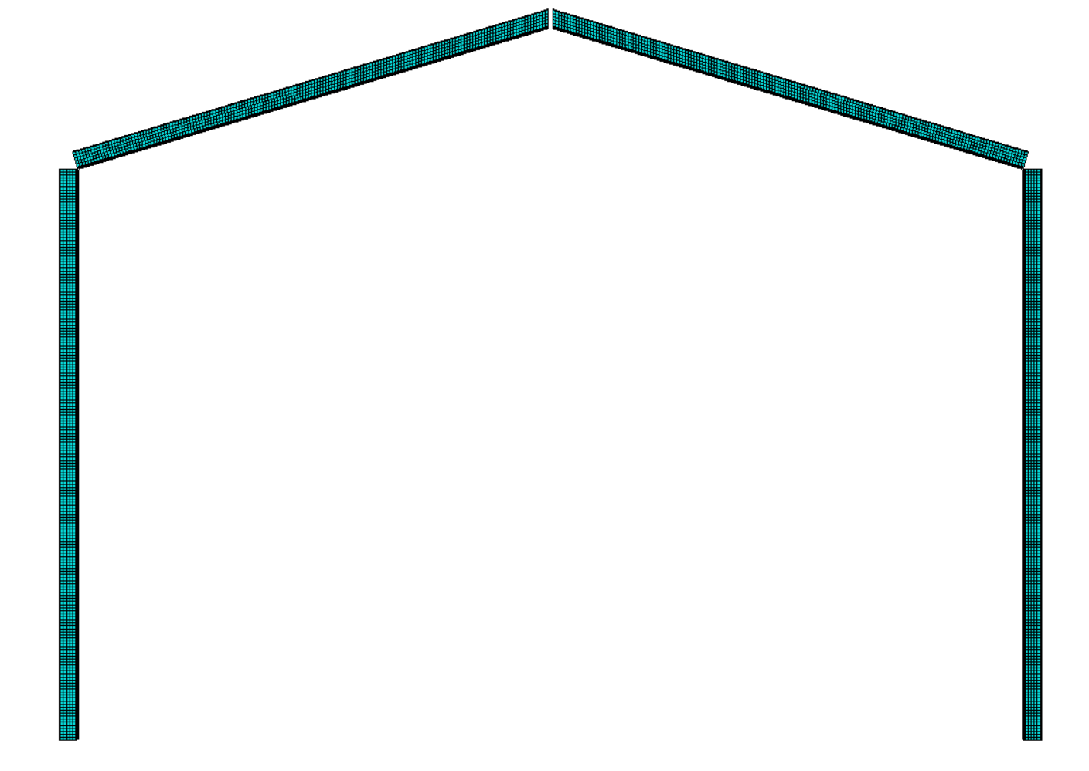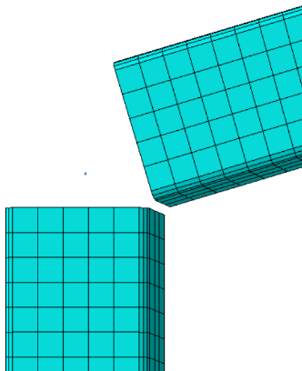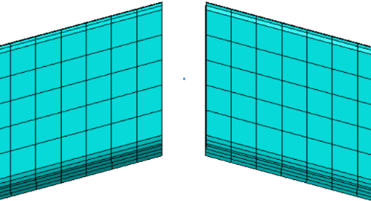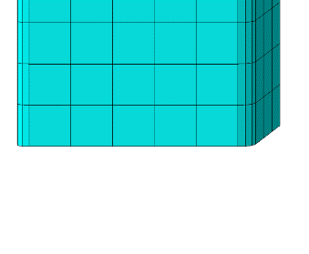
p
p
×
×
×
beam conn.
[1 mm]
ujoint conn.
[1 mm]
×
×
×
ujoint conn.
[1 mm]

beam conn.
[1 mm]

×
×
Hinge connection
[1 mm]
Figure 3. Overall view of developed FE model and definition of vertical loading and joints.

Figure 4. Comparison of FE and experimental load-deflection and load-displacement curves.

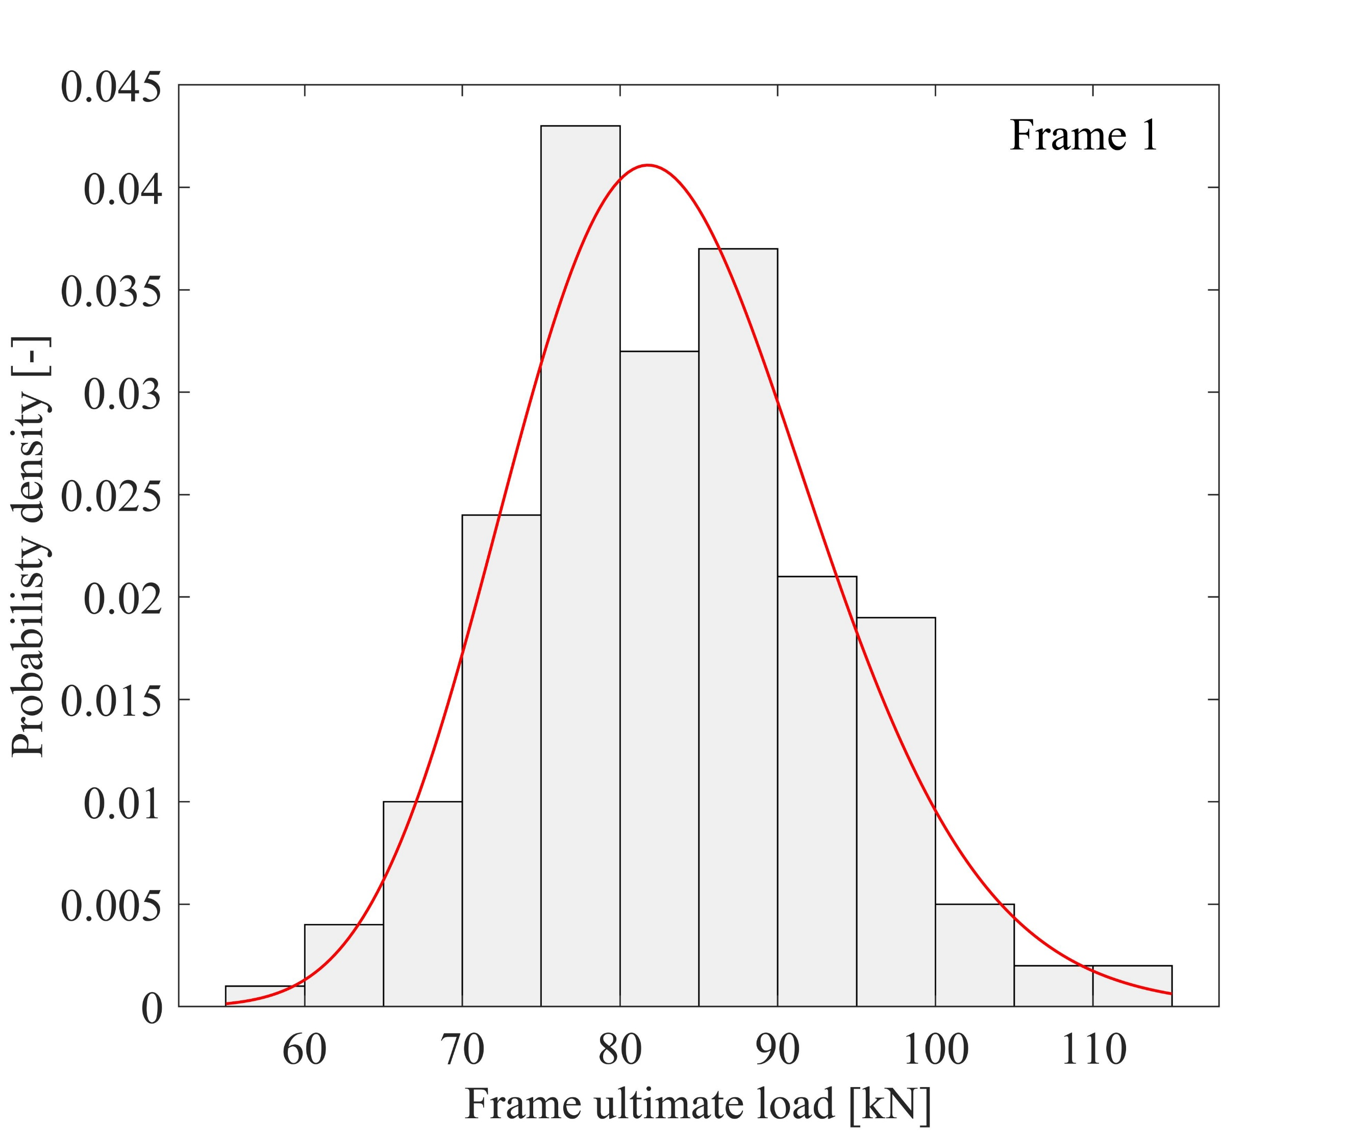 | 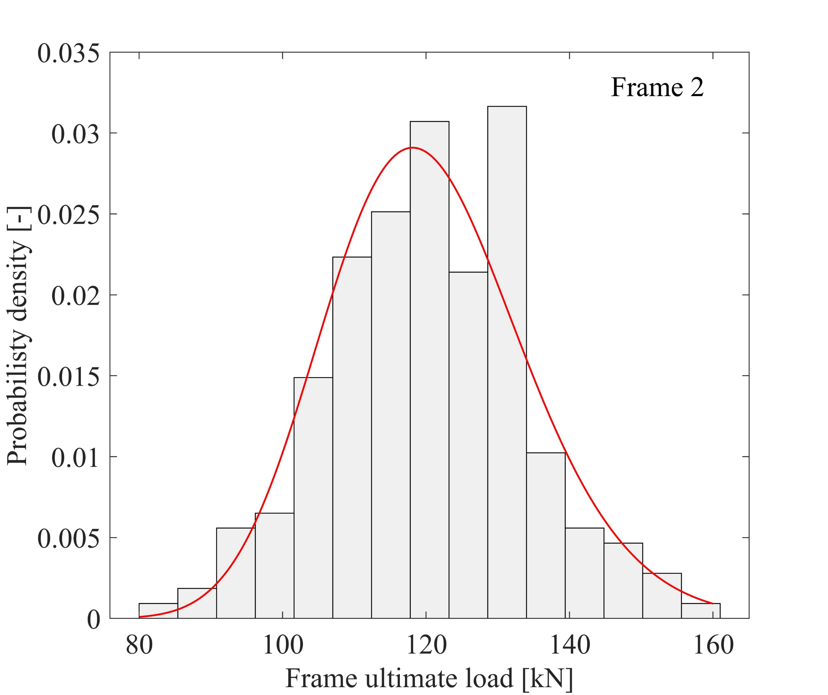
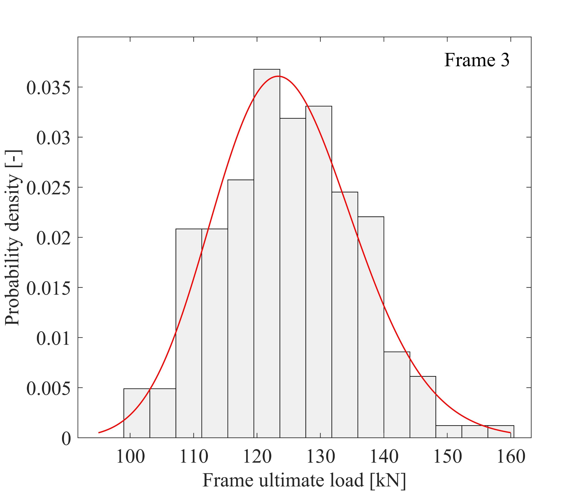 | 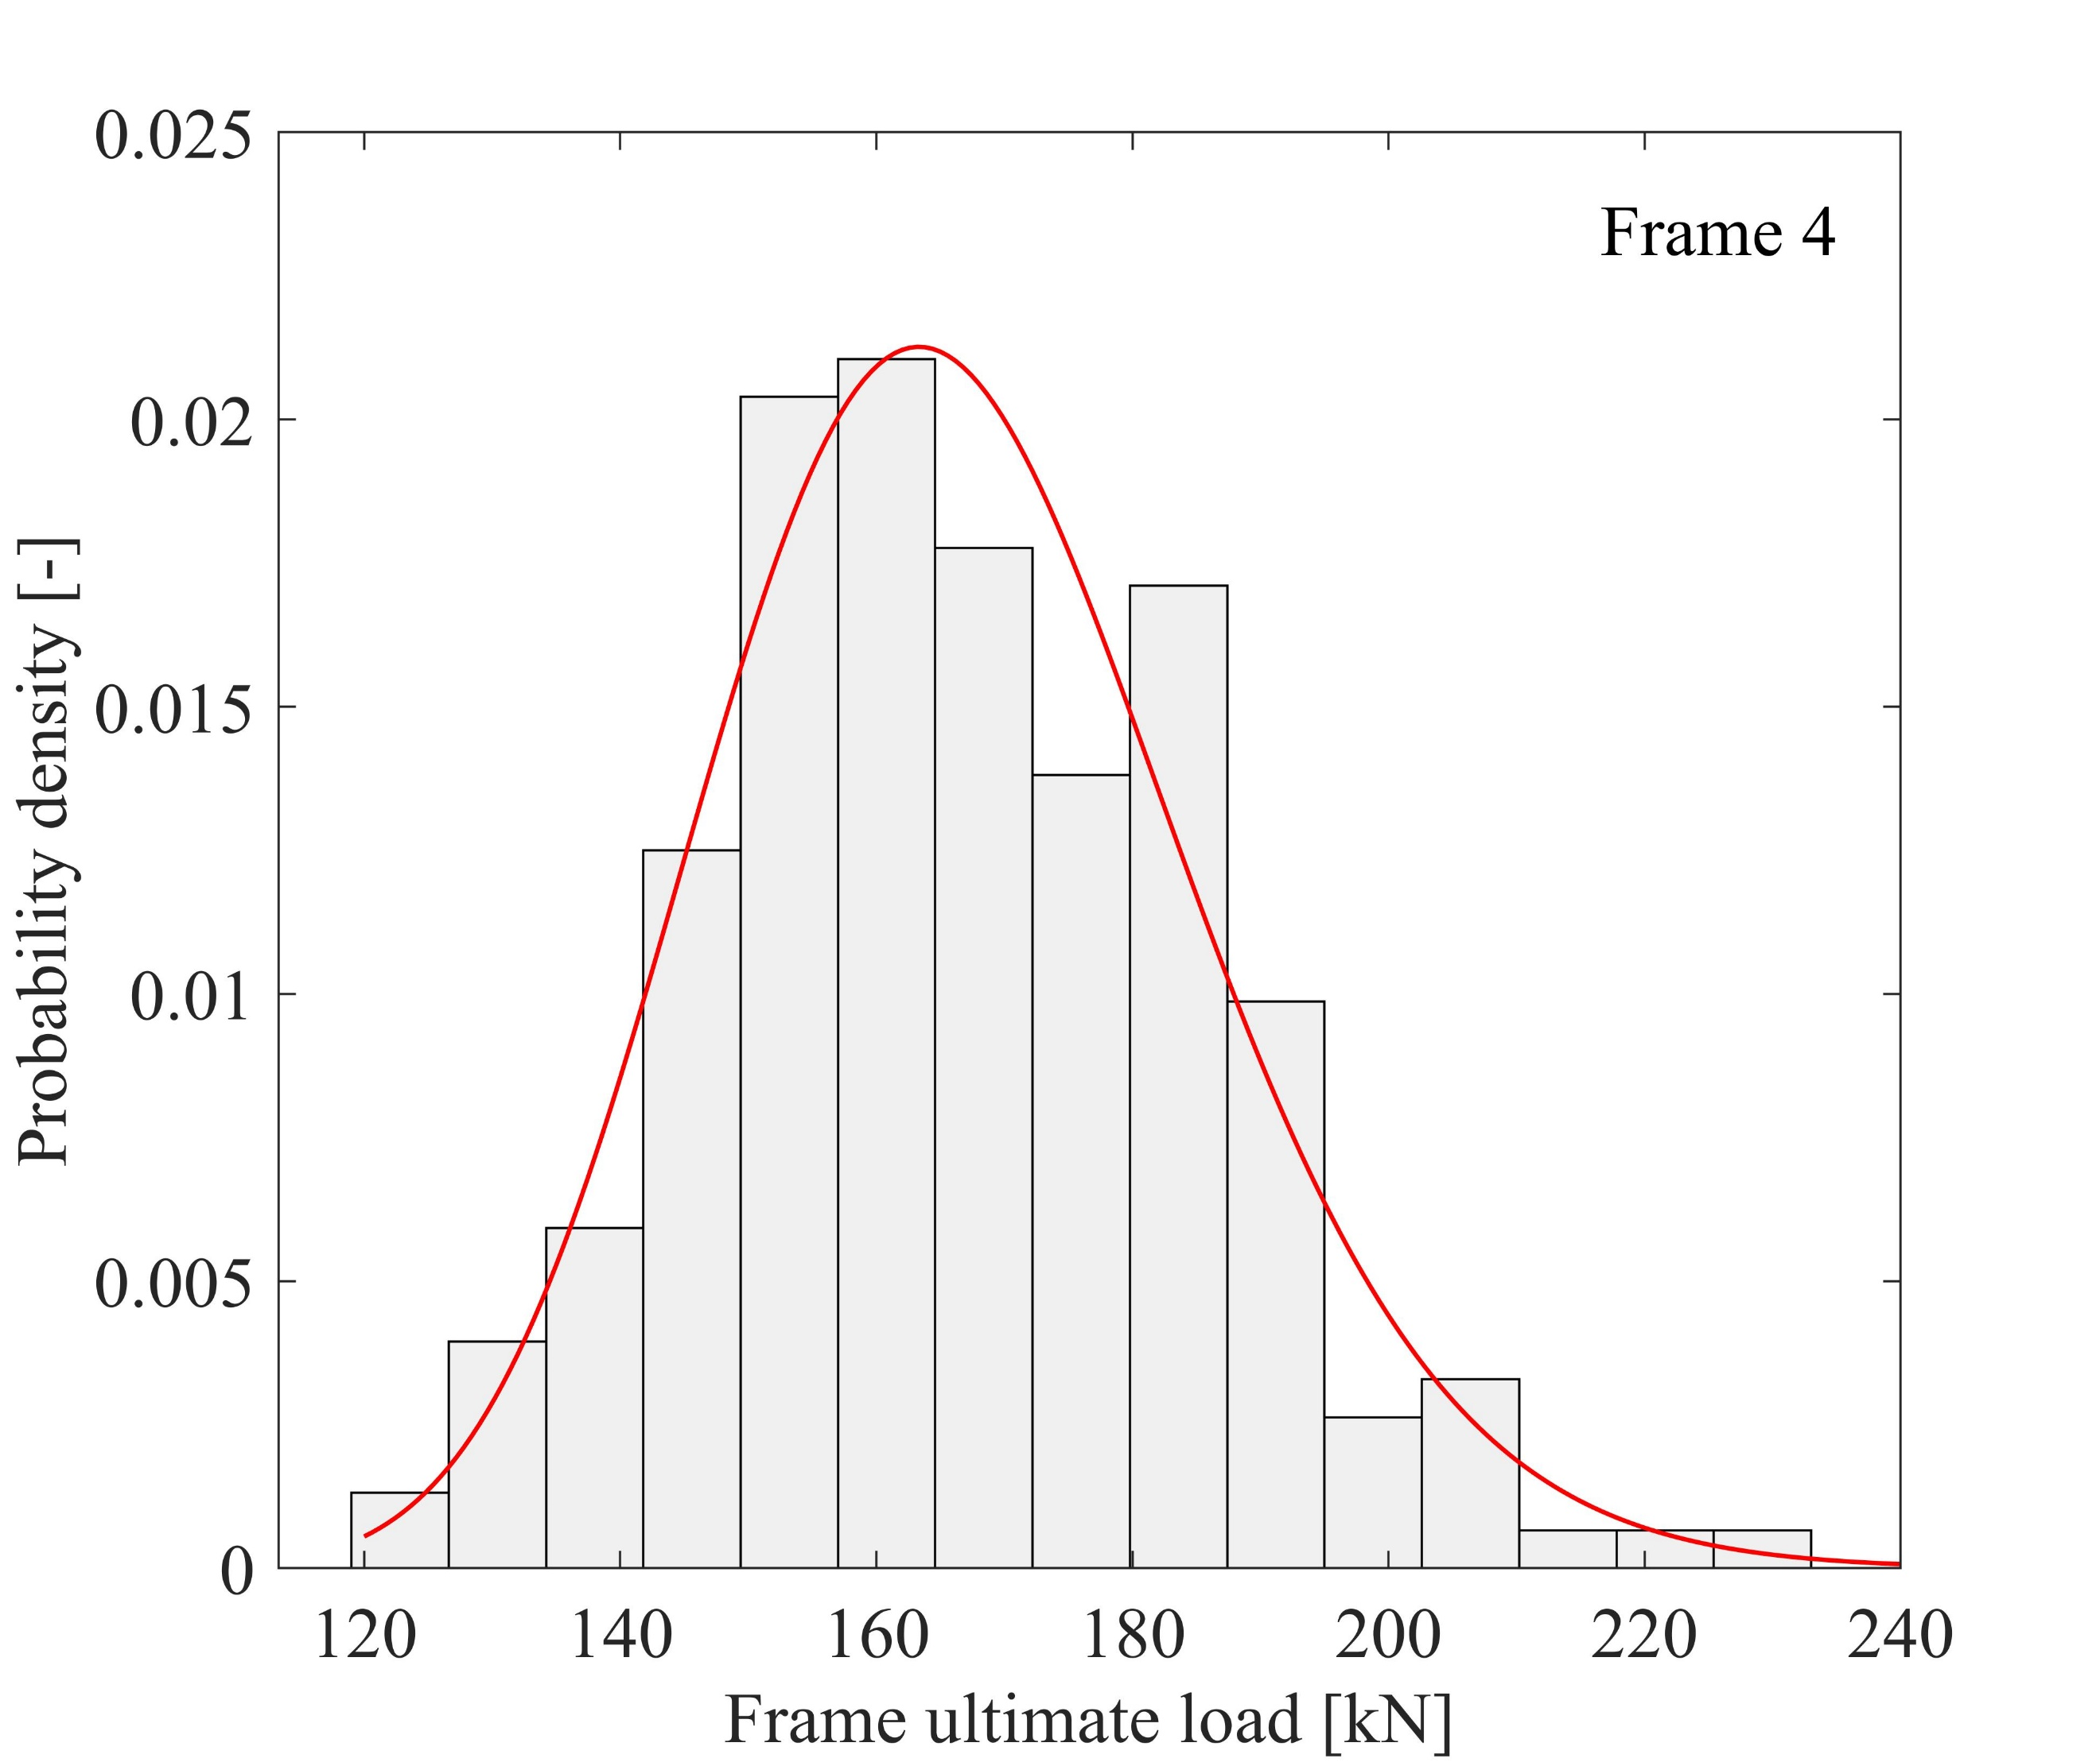
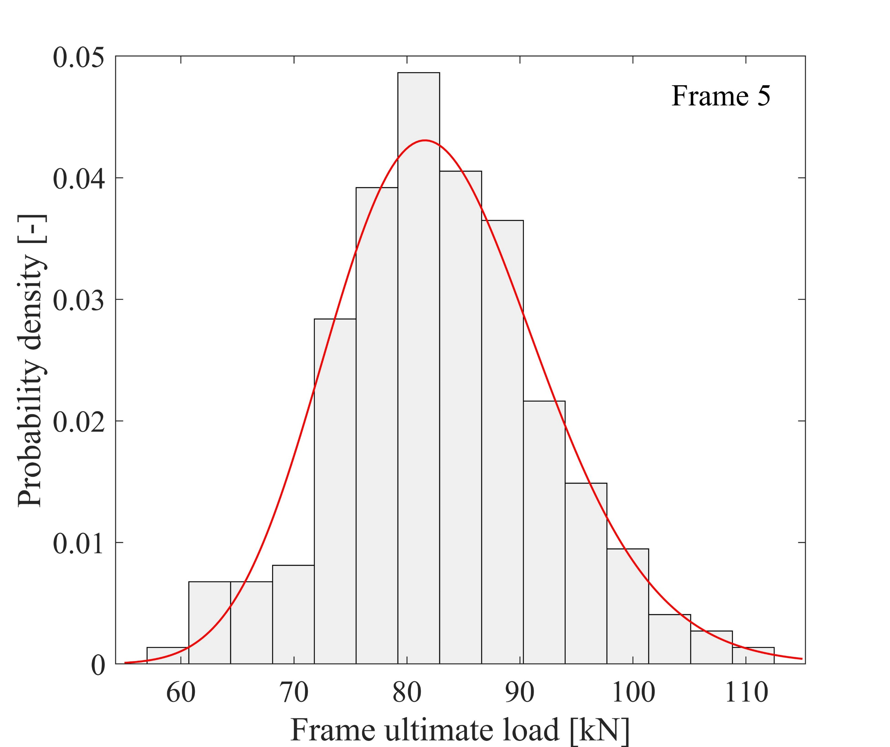 | 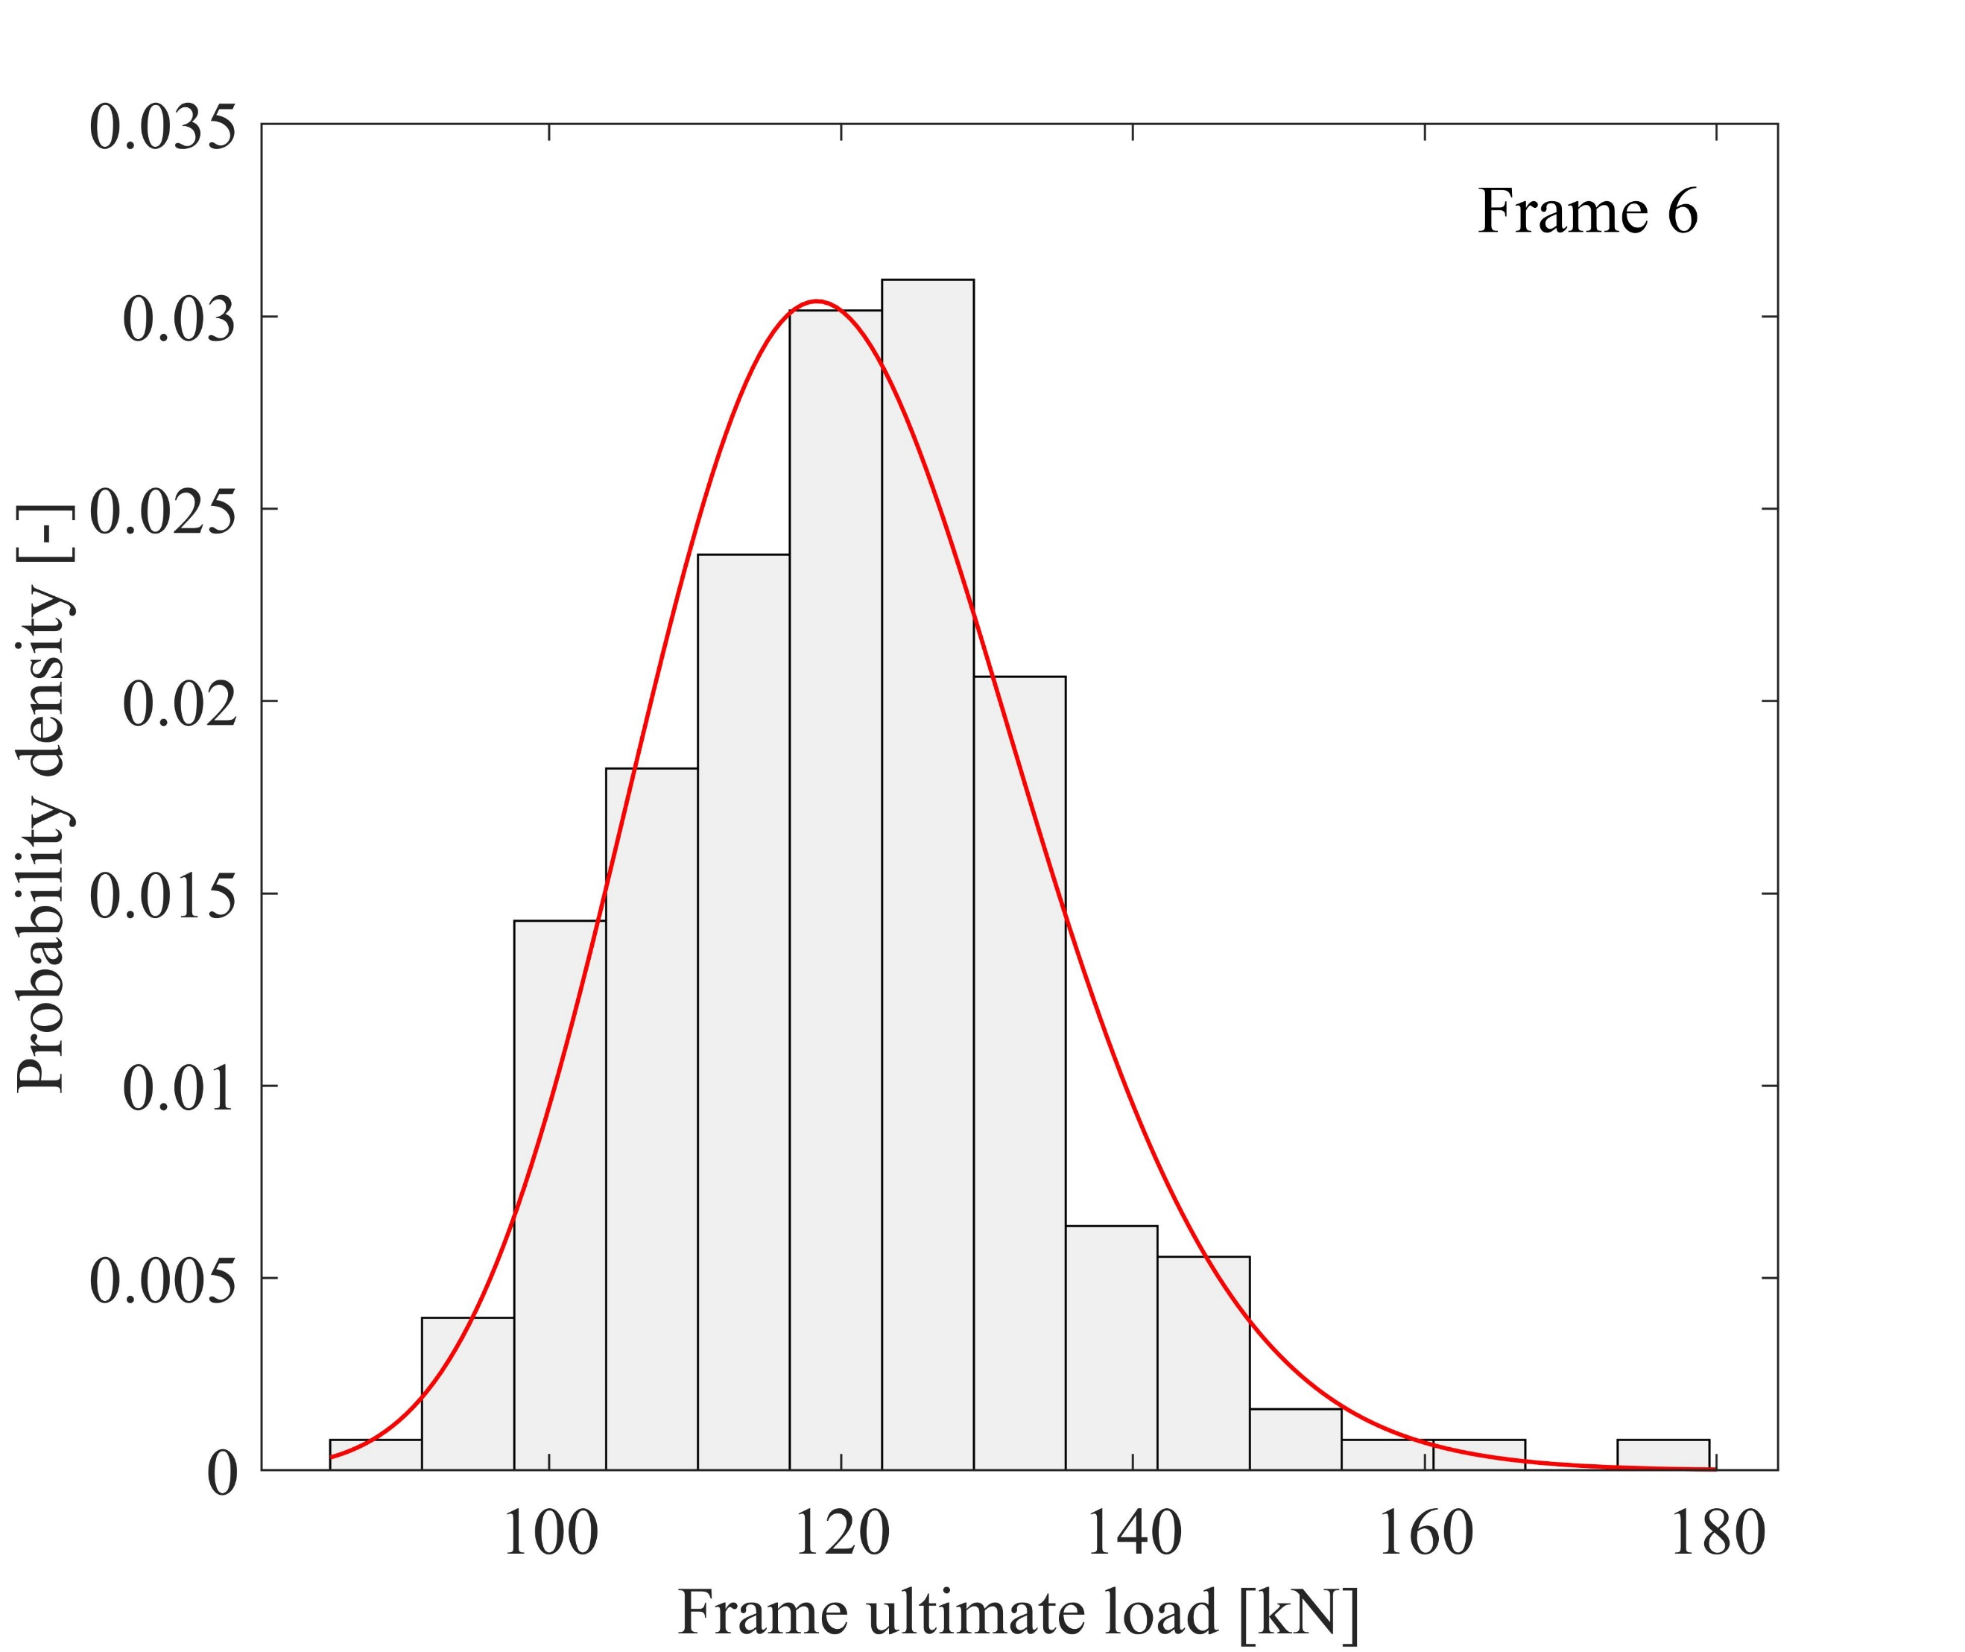
Figure 5. Histograms for system strength of stainless steel frames under gravity loads.

Figure 6. $β-γ_{M,s}$ curves for stainless steel frames under gravity loads in the Eurocode framework for different Q_{k}/G_{k} ratios.

Figure 7. $β-ϕ_{s}$ curves for stainless steel frames under gravity loads in the US framework for different L_{n}/D_{n} ratios.

Figure 8. $β-ϕ_{s}$ curves for stainless steel frames under gravity loads in the Australian framework for different Q_{n}/G_{n} ratios.

Figure 9. Comparison of $β-γ_{M,s}$ and$β-{1/ϕ}_{s}$ curves for stainless steel frames under gravity loads for Q_{k}/G_{k}=2, L_{n}/D_{n}=2 or Q_{n}/G_{n}=2.

TABLES
Table 1. Key parameters for nominal stainless steel frames.
 |  | Austenitic  stainless steel |  | Duplex  stainless steel |  | Ferritic  stainless steel
Variable group | Variable | Frame 1 | Frame 2 | Frame 3 | Frame 4 | Frame 5 | Frame 6
Overall frame geometry | s [m] | 8.0 | 10.0 | 8.0 | 12.0 | 8.0 | 11.0
Overall frame geometry | H₁ [m] | 4.8 | 6.4 | 4.8 | 6.6 | 4.8 | 6.5
Overall frame geometry | H₂ [m] | 6.0 | 7.0 | 6.0 | 7.4 | 6.0 | 7.2
Cross-section definition | H [mm] | 150 | 250 | 150 | 250 | 150 | 250
Cross-section definition | B [mm] | 100 | 150 | 100 | 150 | 100 | 150
Cross-section definition | t [mm] | 4 | 4 | 4 | 4 | 4 | 4
Initial geometric imperfections | Frame imp. φ [-] | 1/200⁺  1/500* | 1/200⁺  1/500* | 1/200⁺  1/500* | 1/200⁺  1/500* | 1/200⁺  1/500* | 1/200⁺  1/500*
Initial geometric imperfections | Member imp. e₀ [mm] | L/1000 | L/1000 | L/1000 | L/1000 | L/1000 | L/1000
Initial geometric imperfections | Local imp. w₀ [mm] | 0.017 | 0.040 | 0.030 | 0.072 | 0.017 | 0.043
Joint behaviour at bases | K_{1,base} [kNm/rad] | 4000 | Pinned | 4000 | Pinned | 4000 | Pinned
Joint behaviour at bases | K_{2,base} [kNm/rad] | 400 | - | 400 | - | 400 | -
Joint behaviour at bases | M_{1,base} [kNm] | 26.3 | - | 41.4 | - | 27.0 | -
Joint behaviour at bases | M_{2,base} [kNm] | 40.4 | - | 63.4 | - | 41.4 | -
Joint behaviour at eaves | K_{1,eave} [kNm/rad] | 6400 | 7000 | 6400 | 9000 | 6400 | 8000
Joint behaviour at eaves | K_{2,eave} [kNm/rad] | 640 | 700 | 640 | 900 | 640 | 800
Joint behaviour at eaves | M_{1,eave} [kNm] | 23.9 | 50.0 | 37.6 | 86.4 | 24.6 | 51.5
Joint behaviour at eaves | M_{2,eave} [kNm] | 37.4 | 78.2 | 58.7 | 135.1 | 38.4 | 80.5
Joint behaviour at apex | K_{1,apex} [kNm/rad] | 6600 | 7500 | 6600 | 9500 | 6600 | 8500
Joint behaviour at apex | K_{2,apex} [kNm/rad] | 660 | 160 | 660 | 950 | 660 | 850
Joint behaviour at apex | M_{1,apex} [kNm] | 25.4 | 53.1 | 39.9 | 91.8 | 26.1 | 54.8
Joint behaviour at apex | M_{2,apex} [kNm] | 37.4 | 78.2 | 58.7 | 135.1 | 38.4 | 80.5
⁺: Frame imperfection corresponding to EN 1993-1-1 [1] and EN 1993-1-14 [11].
*: Frame imperfection corresponding to AS 4100 [3], AISC 360 [4] or AISC 370 [10].

Table 2. Nominal material parameters for frames in the Eurocode framework [2,27].
 | Austenitic  EN 1.4301 |  | Duplex  EN 1.4462 |  | Ferritic  EN 1.4003
Variable | Frame 1 | Frame 2 | Frame 3 | Frame 4 | Frame 5 | Frame 6
E [MPa] | 200000 | 200000 | 200000 | 200000 | 200000 | 200000
$f_{y}$ [MPa] | 230 | 230 | 500 | 500 | 280 | 280
$f_{y,enh}$ [MPa] | 297 | 279 | 507 | 503 | 299 | 300
n [-] | 7 | 7 | 8 | 8 | 14 | 14
$f_{u}$ [MPa] | 550 | 550 | 700 | 700 | 450 | 450
$ε_{u}$ [mm/mm] | 2.5 | 2.4 | 3.0 | 3.0 | 2.9 | 2.9
m [-] | 0.46 | 0.49 | 0.28 | 0.28 | 0.20 | 0.20

Table 3. Nominal material parameters for frames in the US framework [29].
 | Austenitic  ASTM 304 |  | Duplex  ASTM 2205 |  | Ferritic  ASTM UNS S40977
Variable | Frame 1 | Frame 2 | Frame 3 | Frame 4 | Frame 5 | Frame 6
E [MPa] | 193000 | 193000 | 200000 | 200000 | 200000 | 200000
$f_{y}$ [MPa] | 205 | 205 | 450 | 450 | 280* | 280*
$f_{y,enh}$ [MPa] | 271 | 254 | 465 | 454 | 299 | 296
n [-] | 7 | 7 | 8 | 8 | 14 | 14
$f_{u}$ [MPa] | 515 | 515 | 655 | 655 | 435* | 435*
$ε_{u}$ [mm/mm] | 2.5 | 2.4 | 3.0 | 2.9 | 3.0 | 2.6
m [-] | 0.47 | 0.51 | 0.29 | 0.31 | 0.17 | 0.25
*: Nominal material parameters correspond to the AS/NZS 4673 [28] Specification.

Table 4. Nominal material parameters for frames in the Australian framework [28].
 | Austenitic  ASTM 304 |  | Duplex  ASTM 2205 |  | Ferritic  ASTM UNS S40977
Variable | Frame 1 | Frame 2 | Frame 3 | Frame 4 | Frame 5 | Frame 6
E [MPa] | 195000 | 195000 | 200000* | 200000* | 195000 | 195000
$f_{y}$ [MPa] | 205 | 205 | 450* | 450* | 280 | 280
$f_{y,enh}$ [MPa] | 273 | 255 | 465 | 454 | 299 | 296
n [-] | 7.5 | 7.5 | 8* | 8* | 9 | 9
$f_{u}$ [MPa] | 520 | 520 | 655* | 655* | 435 | 435
$ε_{u}$ [mm/mm] | 2.5 | 2.4 | 3.0 | 2.9 | 2.9 | 2.9
m [-] | 0.48 | 0.51 | 0.29 | 0.31 | 0.19 | 0.19
*: Nominal material parameters correspond to the ASCE 8 [29] Specification.

Table 5. Comparison of FE and experimental results.
Specimen | F_{v,FE}/F_{v,exp} | d_{v,FE}/d_{v,exp} | F_{h,FE}/F_{h,exp} | d_{h,FE}/d_{h,exp}
Specimen 1 | 1.00 | 1.01 | 1.00 | 1.02
Specimen 2 | 1.00 | 1.02 | 1.00 | 0.99
Specimen 3 | 1.00 | 0.99 | 1.00 | 1.05
Specimen 4 | 1.00 | 1.03 | 1.00 | 1.01
Mean | 1.00 | 1.01 | 1.00 | 1.02
COV | 0.000 | 0.017 | 0.000 | 0.024

Table 6. Statistics of random variables defining frame strength.
Random  variable type | Random  variable | Mean | St. Deviation | COV | Statistical distribution | Reference
Cross-section definition | H [mm] | 1.002·H_{n} | 0.012·H_{n} | 0.012 | Normal | [35]
Cross-section definition | B [mm] | 1.002·B_{n} | 0.010·B_{n} | 0.010 | Normal | [35]
Cross-section definition | t [mm] | 0.974·t_{n} | 0.028·t_{n} | 0.029 | Normal | [35]
Initial geometric imperfections | Frame imp.  φ [-] | 0.0 | 1/610 | - | Normal | [9]
Initial geometric imperfections | Member imp.  e₀ [mm] | L/3232 | L/5369 | 0.602 | Log-normal | [35]
Initial geometric imperfections | Local imp.  γ₂ [-] | 0.041 | 0.026 | 0.636 | Log-normal | [35]
Residual  stresses | Scale Factor Y | 0.875 | 0.161 | 0.184 | Normal | [35]
Joint behaviour | K₁ [kNm/rad] | 1.0·K_{1,n} | 0.30·K_{1,n} | 0.300 | Log-normal | [9]
Joint behaviour | K₂ [kNm/rad] | 1.0·K_{2,n} | 0.15·K_{2,n} | 0.150 | Log-normal | [9]
Joint behaviour | M₁ [kNm] | 1.0·M_{1,n} | 0.10·M_{1,n} | 0.100 | Log-normal | [9]
Joint behaviour | M₂[kNm] | 1.0·M_{2,n} | 0.15·M_{2,n} | 0.150 | Log-normal | [9]
Model uncertainty | θ or γ_{FE} | 1.0 | 0.05 | 0.05 | Log-normal | [38,39]
Note: the subscript n represents the nominal value and L is the length of the member.

Table 7. Statistics of material random variables for cold-formed stainless steel alloys [35].
Alloy family | Random variable | Mean | St. Deviation | COV | Statistical distribution
Austenitic  cold-formed | E [MPa] | 193084 | 11039 | 0.057 | Normal
Austenitic  cold-formed | $$f_{y}$$ | 1.30·$f_{y,enh,n}$ | 0.195·$f_{y,enh,n}$ | 0.150 | Log-normal
Austenitic  cold-formed | n [-] | 6.0 | 2.1 | 0.342 | Log-normal
Austenitic  cold-formed | $$f_{u}$$ | 1.10·$f_{u,n}$ | 0.11·$f_{u,n}$ | 0.100 | Log-normal
Austenitic  cold-formed | $ε_{u}$ [mm/mm] | 0.39 | 0.15 | 0.373 | Normal
Austenitic  cold-formed | m [-] | 3.1 | 1.3 | 0.426 | Log-normal
Duplex  cold-formed | E [MPa] | 205025 | 8700 | 0.042 | Normal
Duplex  cold-formed | $$f_{y}$$ | 1.15·$f_{y,enh,n}$ | 0.173·$f_{y,enh,n}$ | 0.150 | Log-normal
Duplex  cold-formed | n [-] | 6.3 | 2.1 | 0.332 | Log-normal
Duplex  cold-formed | $$f_{u}$$ | 1.10·$f_{u,n}$ | 0.11·$f_{u,n}$ | 0.100 | Log-normal
Duplex  cold-formed | $ε_{u}$ [mm/mm] | 0.24 | 0.14 | 0.579 | Normal
Duplex  cold-formed | m [-] | 4.2 | 1.9 | 0.462 | Log-normal
Ferritic  cold-formed | E [MPa] | 198572 | 15582 | 0.078 | Normal
Ferritic  cold-formed | $$f_{y}$$ | 1.30·$f_{y,enh,n}$ | 0.195·$f_{y,enh,n}$ | 0.150 | Log-normal
Ferritic  cold-formed | n [-] | 10.1 | 5.4 | 0.536 | Log-normal
Ferritic  cold-formed | $$f_{u}$$ | 1.10·$f_{u,n}$ | 0.11·$f_{u,n}$ | 0.100 | Log-normal
Ferritic  cold-formed | $ε_{u}$ [mm/mm] | 0.13 | 0.11 | 0.852 | Normal
Ferritic  cold-formed | m [-] | 3.5 | 2.2 | 0.619 | Log-normal

Table 8. Statistics of gravity loads for different design frameworks.
Design framework | Load case | Mean | COV | Statistical distribution
Eurocode framework | Permanent load G | 1.0·G_{k} | 0.10 | Normal
Eurocode framework | Imposed variable load Q | 0.8·Q_{k} | 0.25 | Extreme Type I
US  framework | Dead load D | 1.05·D_{n} | 0.10 | Normal
US  framework | Imposed live load L | 1.0·L_{n} | 0.25 | Extreme Type I
Australian framework | Dead load G | 1.05·G_{n} | 0.10 | Normal
Australian framework | Imposed live load Q | 1.0·Q_{n} | 0.25 | Extreme Type I

Table 9. Summary of statistics for system strength of stainless steel frames under gravity loads.
Frame | Nominal EN resistance  R_{n,EN} [kN] | Nominal US resistance  R_{n,US} [kN] | Nominal AU resistance  R_{n,AU} [kN] | Mean system strength  R_{m} [kN] | COV of system strength | R_{m}/R_{n,EN} | R_{m}/R_{n,US} | R_{m}/R_{n,AU} | Statistical distribution
Frame 1 | 66.3 | 60.8 | 60.9 | 83.5 | 0.117 | 1.26 | 1.37 | 1.37 | Log-normal
Frame 2 | 101.9 | 94.4 | 95.6 | 120.5 | 0.113 | 1.18 | 1.28 | 1.26 | Log-normal
Frame 3 | 106.1 | 98.6 | 98.6 | 124.8 | 0.089 | 1.18 | 1.27 | 1.27 | Log-normal
Frame 4 | 140.7 | 131.4 | 131.4 | 166.5 | 0.114 | 1.18 | 1.27 | 1.27 | Log-normal
Frame 5 | 66.6 | 66.2 | 66.5 | 83.2 | 0.112 | 1.25 | 1.26 | 1.25 | Log-normal
Frame 6 | 101.0 | 102.4 | 101.0 | 120.5 | 0.111 | 1.19 | 1.18 | 1.19 | Log-normal

Table 10. Required system safety factors $γ_{Ms}$ and system resistance factors $ϕ_{s}$ for stainless steel frames under gravity loads
(for Q_{k}/G_{k}=2, L_{n}/D_{n}=2 or Q_{n}/G_{n}=2) for different target reliability indices β₀ and different design frameworks.
 |  | Eurocode framework |  | US framework |  | Australian framework
Frame | Reliability index β₀ | Required system safety factor $γ_{Ms}$ | $$1/{γ_{Ms}}\sim ϕ_{s}$$ | Required system resistance factor $ϕ_{s}$ | $$1/{ϕ_{s}}\sim γ_{Ms}$$ | Required system resistance factor $ϕ_{s}$ | $$1/{ϕ_{s}}\sim γ_{Ms}$$
Frame 1 | 3.8 | 1.10 | 0.91 | 0.83 | 1.21 | 0.79 | 1.27
Frame 1 | 3.3 | 0.97 | 1.03 | 0.94 | 1.06 | 0.90 | 1.11
Frame 1 | 3.0 | 0.90 | 1.11 | 1.02 | 0.98 | 0.97 | 1.03
Frame 1 | 2.5 | 0.79 | 1.26 | 1.16 | 0.86 | 1.11 | 0.90
Frame 2 | 3.8 | 1.17 | 0.86 | 0.77 | 1.29 | 0.73 | 1.37
Frame 2 | 3.3 | 1.03 | 0.97 | 0.88 | 1.13 | 0.83 | 1.20
Frame 2 | 3.0 | 0.95 | 1.05 | 0.95 | 1.05 | 0.90 | 1.11
Frame 2 | 2.5 | 0.84 | 1.19 | 1.08 | 0.92 | 1.02 | 0.98
Frame 3 | 3.8 | 1.13 | 0.89 | 0.80 | 1.25 | 0.76 | 1.31
Frame 3 | 3.3 | 1.00 | 1.00 | 0.91 | 1.10 | 0.86 | 1.16
Frame 3 | 3.0 | 0.93 | 1.08 | 0.98 | 1.02 | 0.93 | 1.07
Frame 3 | 2.5 | 0.82 | 1.21 | 1.11 | 0.90 | 1.06 | 0.95
Frame 4 | 3.8 | 1.17 | 0.86 | 0.77 | 1.30 | 0.73 | 1.37
Frame 4 | 3.3 | 1.03 | 0.97 | 0.88 | 1.14 | 0.84 | 1.20
Frame 4 | 3.0 | 0.95 | 1.05 | 0.95 | 1.06 | 0.90 | 1.11
Frame 4 | 2.5 | 0.84 | 1.19 | 1.08 | 0.93 | 1.03 | 0.97
Frame 5 | 3.8 | 1.10 | 0.91 | 0.76 | 1.31 | 0.73 | 1.38
Frame 5 | 3.3 | 0.97 | 1.03 | 0.87 | 1.15 | 0.83 | 1.21
Frame 5 | 3.0 | 0.90 | 1.11 | 0.94 | 1.06 | 0.89 | 1.12
Frame 5 | 2.5 | 0.80 | 1.26 | 1.07 | 0.94 | 1.02 | 0.98
Frame 6 | 3.8 | 1.15 | 0.87 | 0.72 | 1.40 | 0.69 | 1.44
Frame 6 | 3.3 | 1.02 | 0.98 | 0.82 | 1.22 | 0.79 | 1.27
Frame 6 | 3.0 | 0.94 | 1.06 | 0.88 | 1.13 | 0.85 | 1.17
Frame 6 | 2.5 | 0.83 | 1.20 | 1.00 | 1.00 | 0.97 | 1.03

