Membrane Technologies and Applications to Produced Water Treatment

Authors:
Xiaoyi Chen (University at Buffalo, The State University of New York, xchen225@buffalo.edu)
Fan Shi (Department of Energy, National Energy Technology Laboratory, fan.shi@netl.doe.gov)
Kevin Resnik (Department of Energy, National Energy Technology Laboratory, kevin.resnik@netl.doe.gov)
David Hopkinson (Department of Energy, National Energy Technology Laboratory, david.hopkinson@netl.doe.gov)
*Haiqing Lin (University at Buffalo, The State University of New York, haiqingl@buffalo.edu)
*Shouliang Yi (Department of Energy, National Energy Technology Laboratory, shouliang.yi@netl.doe.gov)

* Corresponding authors: S. Yi (shouliang.yi@netl.doe.gov) and H. Lin (haiqingl@buffalo.edu).

X.1. Introduction
The last decade has witnessed tremendous growth in hydraulic fracturing of oil and gas wells, increasing energy production and transforming the energy industry in the United States. However, such practices consume a large quantity of freshwater.^{1, 2} Many hydraulic fracturing wells are in drought-prone areas, such as Colorado, Texas, and California, where the growth of energy production itself has also been constrained by the lack of water. While consuming freshwater, hydraulic fracturing also produces significant amounts of wastewater or produced water, which accounts for 10-25% of the water injected in the well.
The produced water generally contains inorganic ions (such as Na⁺, Ca²⁺, and Mg²⁺) and organic additives used in hydraulic fracturing such as foaming agents, biocides, and corrosion inhibitors.³⁻⁵ The composition of the produced water is specific to each reservoir and varies with production time. For example, the produced water from Marcellus shale contains 4 - 7600 mg/L suspended solid, 680 - 345,000 mg/L total dissolved solid, 1 - 1530 mg/L total organic carbon, and 4.6 - 802 mg/L oil/grease.^{3, 6-8}
Currently, produced water is usually pretreated and trucked away for disposal or deep well re-injection, which is energy-intensive and expensive and presents a potential impact on freshwater quality.⁹⁻¹¹ Membranes have emerged as one of the leading technologies to treat the produced water for reuse due to high energy efficiency, small footprint, and low cost.^{12, 13} Membranes allow pure water to permeate through for reuse and reject contaminants such as dissolved solids and organic matter. The retentate with significantly reduced volume can then be disposed or re-injected into deep wells. Membranes with a range of pore sizes have been explored, including microfiltration (MF), ultrafiltration (UF), nanofiltration (NF), and reverse osmosis (RO). Membrane processes for the treatment of produced water can be classified based on different driving forces, such as hydraulic pressure, osmotic pressure, and temperature. Most membranes for water treatment are made of polymers, and ceramic membranes are an attractive alternative in harsh conditions. Based on the requirement for the permeate quality and the constituents of the produced water, a membrane process can be used individually or combined with other processes.
Various technologies to treat produced water have been extensively reviewed in the literature, including membranes and physical, biological, thermal, or chemical treatments.^{2, 14, 15} Fundamental principles of membrane technology, such as separation mechanism, fouling behavior, system configuration, and energy efficiency, had been described.^{13, 16-21} The advantages and drawbacks of membranes against the competing technologies were discussed. Without intending to exhaustively review the membrane technology for produced water treatment, this chapter aims to provide examples of state-of-the-art membranes and processes for treating the produced water. The challenges of the membrane technology are described, and various strategies of membrane design and modification to overcome the challenges are presented.

X.2. Pressure-Driven Membrane Separation
X.2.1. MF and UF Membranes
MF and UF membranes operate at low pressures, where the hydraulic pressure drives the water through the membrane while the pollutants larger than the membrane pore size are retained.¹⁵ MF membranes with pore sizes of 0.1 - 3 µm separate suspended solids, while UF membranes with pore sizes of 1 - 50 nm can remove large molecules such as proteins, starch, viruses, colloid silica, grease, oil, and other organic matters.
Polymeric and ceramic MF membranes have been widely used to reduce the water turbidity and suspended particles. Polymeric membranes show a high removal efficacy and low energy requirement and are generally cost-effective. Some drawbacks include the ease of fouling by oil (which decreases the flux and filtration capacity) and sensitivity to both polar and chlorinated solvents (which limit their applications). By contrast, the ceramic MF membranes have great mechanical strength, excellent separation performance, and great thermal and chemical resistance.^{15, 22-28} Zhong et al. investigated the treatment of produced water that contained oil, water, and sludge using a ceramic MF membrane composed of zirconia (ZrO₂) combined with traditional chemical method-flocculation as pretreatment.²⁸ The pretreatment decreased the membrane fouling and increased water flux and permeate quality. The oil concentration reduced from 200 mg L⁻¹ in the feed to 8.7 mg L⁻¹ in the permeate, and the treated produced water can meet the National Discharge Standard. Zsirai et al. conducted a pilot-scale study of a range of multi-channel ceramic MF membranes to treat the produced water from the Arabian Gulf.²⁵ The silicon carbide (SiC) based membranes provided a higher permeability than the titanium dioxide (TiO₂) based membranes. Chemical cleaning-in-place (CIP) was applied between each run, and the effect of the various cleaning protocols on the flux was studied.²⁹ Backflushing during the CIP was shown to be the most influencing factor. The flux was retained despite the tendency of the ceramic membrane to become hydrophobic as the number of filtration cycles increased. Ferreira et al. adopted ozonation and photoperoxidation as pretreatment of the produced water to migrate the membrane fouling.²³ The 3-h exposure to UV radiation of the produced water improved the permeate flux from 84 to 182 L/m² h (LMH), indicating the great potential of the advanced oxidation process as a pretreatment to reduce fouling.
UF membrane systems can be mobile for on-site treatment. Common UF membrane materials include polyacrylonitrile (PAN), poly(ether sulfone) (PES), polysulfone (PSf), cellulose acetate (CA), poly(vinylidene fluoride) (PVDF), aromatic polyamides, and poly(vinyl pyrrolidone) (PVP). One of the great challenges for UF membranes is fouling, resulting in pore-blocking and cake layer formation and thus decreased water permeance.^{30, 31} The fouling behavior depends on the foulants in the feed, membrane surface properties (such as pore sizes and interaction with the foulants), and operating conditions. The fouled membranes need periodic cleaning and eventually replacement to maintain productivity, which increases the operation cost. Various strategies have been explored to alleviate fouling, including feed pretreatment, selection of membranes without affinity towards foulants, and membrane surface modification to repel foulants.
One common strategy to improve antifouling properties of UF membranes is to modify the surface with hydrophilic materials, such as poly(ethylene glycol) (PEG), zwitterionic materials, and hydrophilic graphene oxide (GO), as the hydrophilic surface forms a hydration layer, a barrier for foulants to deposit onto the surface.³²⁻³⁶ Figure 1a shows the covalent grafting of PEG-NH₂ using bio-adhesive polydopamine (PD) onto PSf membranes. The grafting often decreases pure-water permeance due to the additional transport resistance. However, with a careful optimization of the coating layer thickness and improved antifouling properties, the modification dramatically improved water flux during the filtration of oil emulsion as a model foulant (cf. Figure 1b).³⁷ This facile modification with aqueous solutions was adapted to post-modify commercial UF membrane modules, which were then used to treat the produced water from the Barnett shale gas basin.³² At the beginning of the filtration, both modules showed similar water fluxes of ~ 43 LMH (cf. Figure 1c), and the modified module exhibited water permeance 20% higher than the unmodified module (cf. Figure 1d). On the other hand, after the 60-h operation, the modified module showed water permeance and flux 50% higher than the unmodified module due to the improved antifouling properties from the PD-g-PEG grafting.

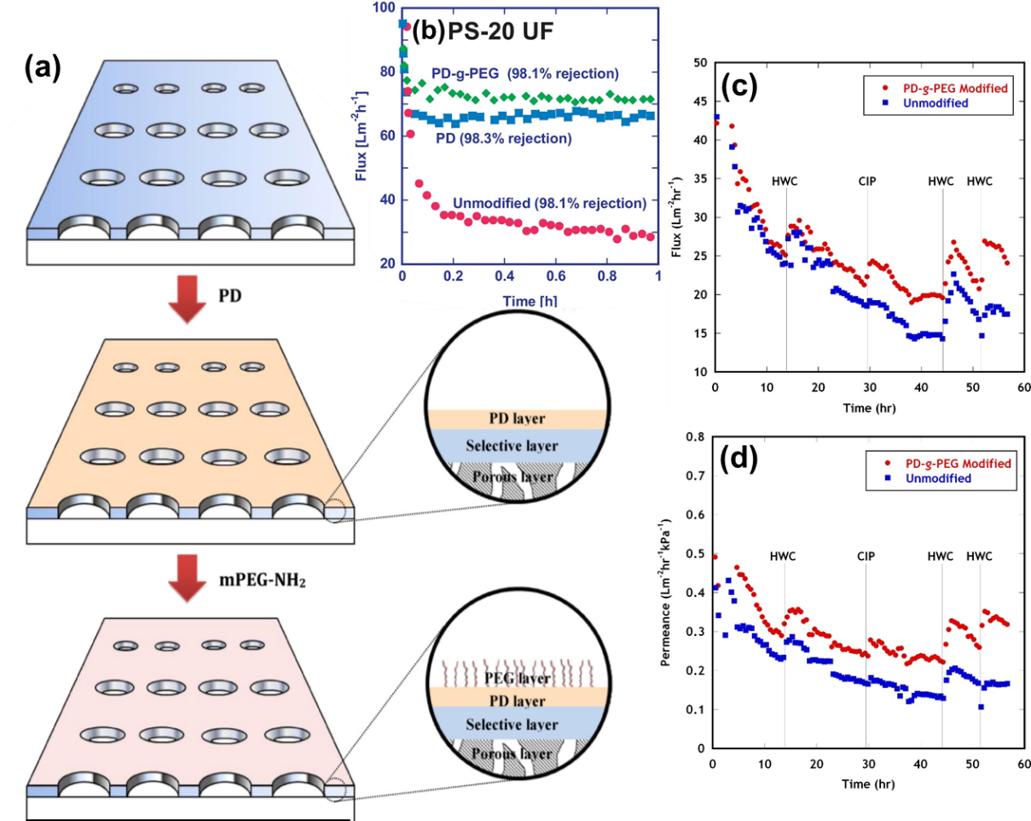
Figure X.1: (a) Schematic illustration of membrane surface modification by PD-g-PEG. (b) Comparison of fouling behavior of the unmodified and modified PSf UF membranes in the oil emulsion filtration.³⁷ (c) Water flux and (d) permeance over the operating time for the unmodified and PD-g-PEG-modified UF modules in a pilot test. HWC and HCP denote chemically enhanced hot water cleaning and clean-in-place, respectively.³² Copyright 2012 and 2013 Elsevier.

PEG can also be incorporated in the polymer matrix during the membrane formation to increase hydrophilicity. For example, PVDF membranes were fabricated using a vapor-induced phase separation (VIPS) technique with PEG as an additive in the casting solutions.³⁸ Figure 2a shows that the introduction of PEG changed the membranes from an asymmetric, microvoid-containing structure to a symmetric, microvoid-free structure. Increasing the air exposure time increased the granular sizes and the mean pore size because of the increased PEG diffusion to the membrane/water interface. The introduction of PEG increased pure-water permeance (cf. Figure 2b), and PVDF/PEG-30 exhibited the highest water permeance. When challenged with 1 g/L oil/water emulsion prepared from crude oil, PVDF/PEG-30 exhibited the highest permeance in a multi-cycled filtration with water-cleaning every 30 min due to the improved hydrophilicity and increased pore size (Figure 2c).

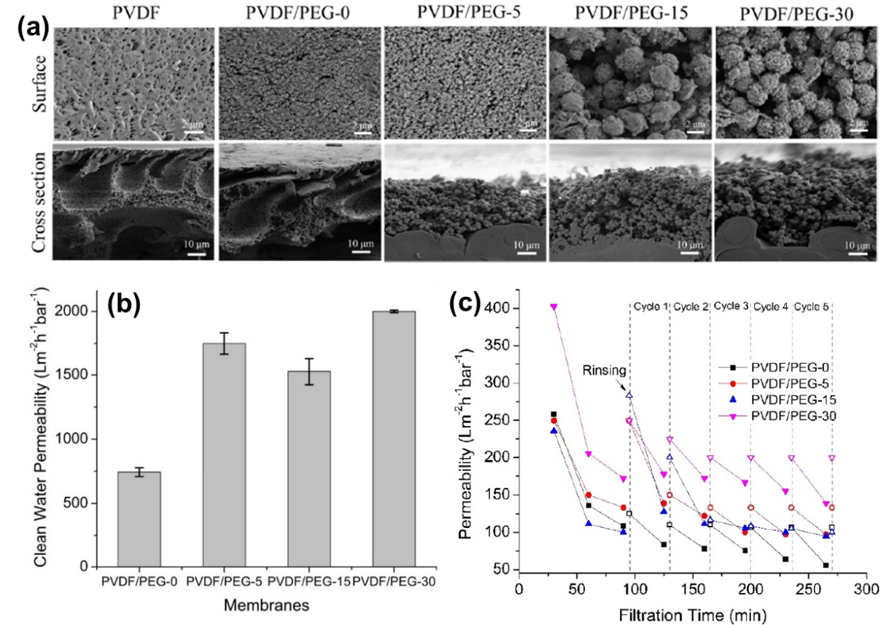
Figure X.2: (a) SEM images of the surface and cross-section of the PVDF membranes fabricated with various air exposure times (in minutes). (b) Pure water permeance and (c) produced-water permeance of the PVDF/PEG membranes.³⁸

Zwitterionic materials have been widely used in membrane surface modification to mitigate fouling owing to their strong hydrophilicity.^{33, 35, 39, 40} These materials contain both cations and anions (such as sulfobetaine, carboxybetaine, and phosphorylcholine) and form hydration layers via electrostatic interaction with water molecules. For example, a zwitterionic polymer, 3-(3-4-dihydroxyphenyl)-l-alanine (l-DOPA), was coated on PES UF membranes by dip coating.⁴¹ Figure 3a shows that the modification improved surface hydrophilicity (as indicated by the decreased water contact angle), and increasing the coating time increased the hydrophilicity. Figure 3b displays that the modification increased negative charges on the surface. When challenged by produced water, the modified membranes showed higher normalized water permeance than the unmodified membrane (cf. Figure 3c), validating the improved antifouling properties. Figure 3d shows that surface modification also increased the flux recovery after 30-min backflushing with DI water.

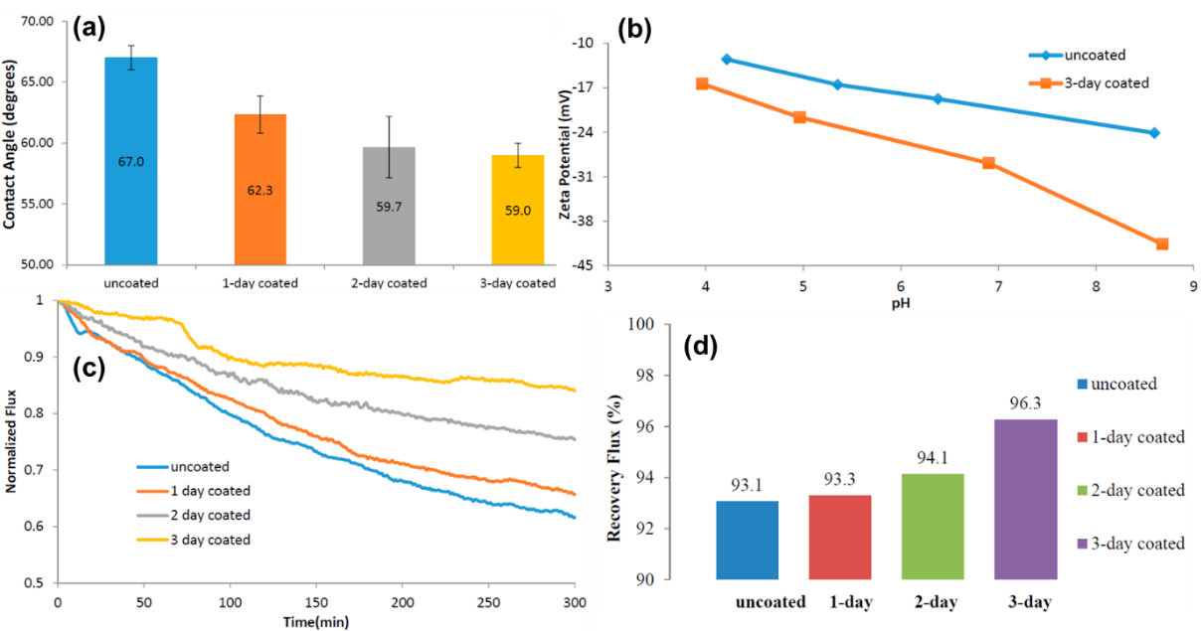
Figure X.3: (a) Water contact angles of the uncoated and zwitterion-coated membranes. (b) Zeta potential of the uncoated and 3-day coated membranes at pH values from 4 to 9. Comparison of (c) the normalized flux and (d) recovery of water flux after cleaning for the uncoated and coated membranes when challenged by the produced water.⁴¹

Produced water may contain highly charged bituminous clays, causing severe fouling through the interaction with the charged membranes. To this end, the membrane surface can be modified with electrically neutral and hydrophilic chemicals. For example, tubular ceramic membranes were modified with hydrophilic poly(ethylene oxide)-based silane (PEOTMS, as shown in Figure 4a,b,c).⁴² The surface modification increased the flux recovery ratio (FRR defined as the ratio of the first recorded flux after backflush to the last recorded flux before the next backflush) and water flux because of the reduced foulant adhesion to the membrane surface, as shown in Figure 4d,e.

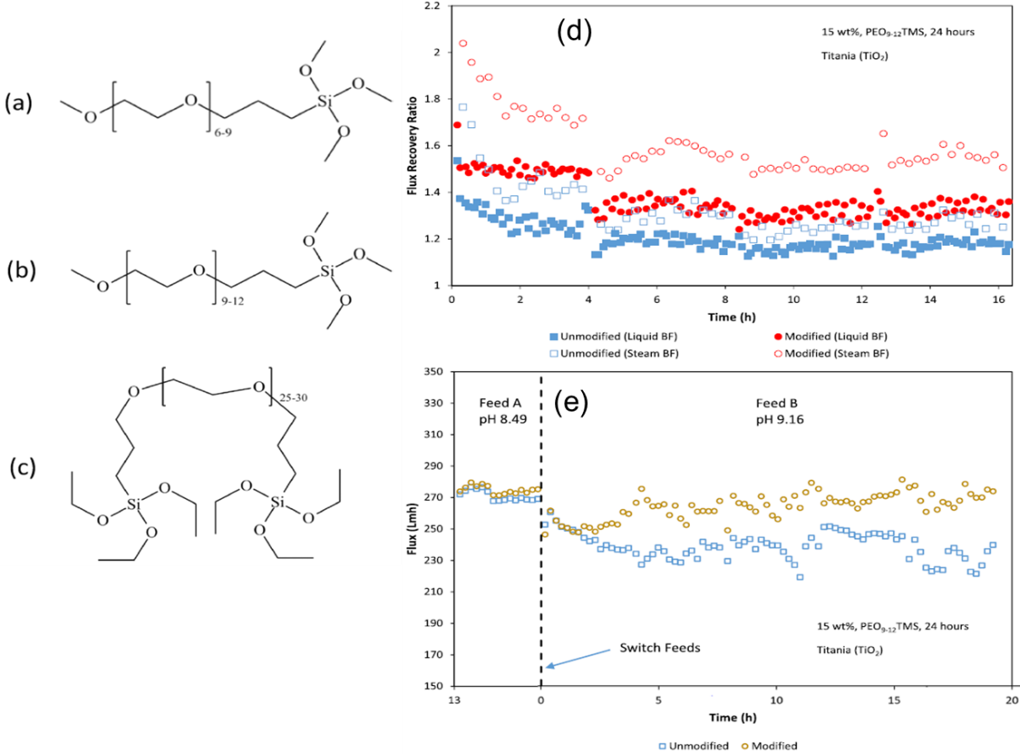
Figure X.4: Chemical structure of (a) PEO₆₋₉TMS, (b) PEO₉₋₁₂TMS, and (c) BIS-PEO₂₅₋₃₀TES. (d) FRR and (e) permeate flux over the operating time for the modified membrane when challenged with produced water.⁴² Copyright (2019) American Chemical Society.

X.2.2 NF and RO Membranes
NF and RO membranes are widely used to desalinate the produced water,^{14, 44} and state-of-the-art commercial membranes are thin-film composite (TFC) membranes with a polyamide selective layer, which rejects ions and dissolved organic carbon (DOC). NF membranes have an excellent rejection of divalent ions, such as over 90% for Ca²⁺, Mg²⁺, and SO₄²⁻, and low rejection of monovalent ions, such as ~ 23% for Cl⁻ and Na⁺.⁴⁵ By contrast, RO membranes can reject monovalent ions by 99% or higher, and thus, they can be used as the last step to obtain reusable water from the produced water.^{2, 14}
Figure 5a shows an example UF-RO integrated process consisting of a submerged hollow fiber PVDF UF membrane and RO membrane to treat produced water.⁴⁶ The UF membrane was operated in a constant flux mode with periodic backwashing, while the transmembrane pressure (TMP) was monitored. Figure 5b displays the change of TMP in the multi-cycled filtration of produced water at different fluxes. At low fluxes of 20 and 35 LMH, the TMP increased slowly and remained low, indicating that the fouling was mild and the backflushing was able to clean the membrane. At fluxes higher than 50 LMH, the TMP increased rapidly due to the severe fouling.

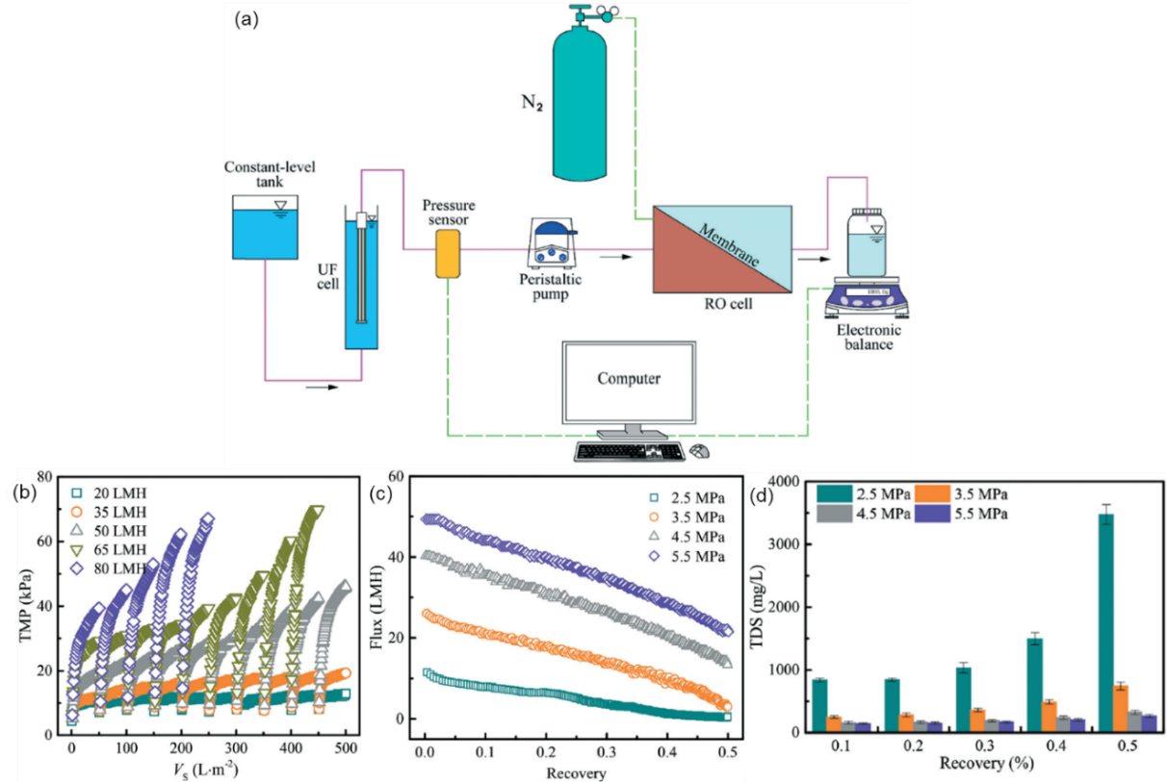
Figure X.5: (a) Schematic diagram of the UF-RO system for treating Weiyuan shale gas flowback and produced water.⁴⁶ (b) TMP of the UF membrane as a function of the cumulative filtration volume normalized by membrane area at different fluxes. (c) Water flux and (d) TDS of the permeate of the RO membrane as a function of the feed pressure and water recovery rate. Copyright 2018 RSC.

Figure 5c shows the water flux of the RO membrane as a function of the pressure and water recovery rate. Water flux increased with increasing operating pressure (or driving force) and decreased with increasing water recovery rate due to the increased osmosis pressure of the retentate. For example, water flux at 2.5 MPa decreased to near zero at a recovery rate of 50%. Figure 5d shows that increasing the recovery rate decreased permeate quality due to the increased salinity in the retentate. Nevertheless, the produced water treated using the combined UF-RO process at over 2.5 MPa met the U.S. standards for surface water discharge.
Similar to UF membranes, NF/RO membranes are also subject to fouling, which can be mitigated by incorporation of hydrophilic materials to increase surface hydrophilicity.^{47, 48} Figure 6a illustrates the schematic of fabricating membranes from polybenzimidazole (PBI) and hydrophilic GO in three steps, including solution preparation, blade casting, and phase inversion.^{36, 47} The incorporation of GO in PBI improved surface hydrophilicity, surface roughness, and water permeance. Figure 6b-e compares the membrane surface of PBI-based membrane (M_{PBI}) and PBI-GO-based membrane (${\text{M}}_{\text{PBI}}^{\text{GO 1.00}}$) after immersing in water for 45 days and 180 days. ${\text{M}}_{\text{PBI}}^{\text{GO 1.00}}$ showed a virtually clean surface, while M_{PBI} showed significant bio-fouling on the surface. In the multi-cycle filtration of an oil-in-water emulsion, ${\text{M}}_{\text{PBI}}^{\text{GO 1.00}}$ exhibited 53% higher FRR than M_{PBI}. Though both membranes showed comparable water permeance at the beginning, ${\text{M}}_{\text{PBI}}^{\text{GO 1.00}}$ exhibited water permeance 68% higher than M_{PBI} after the 3rd cycle of filtration, demonstrating the improved antifouling properties by incorporating GO.

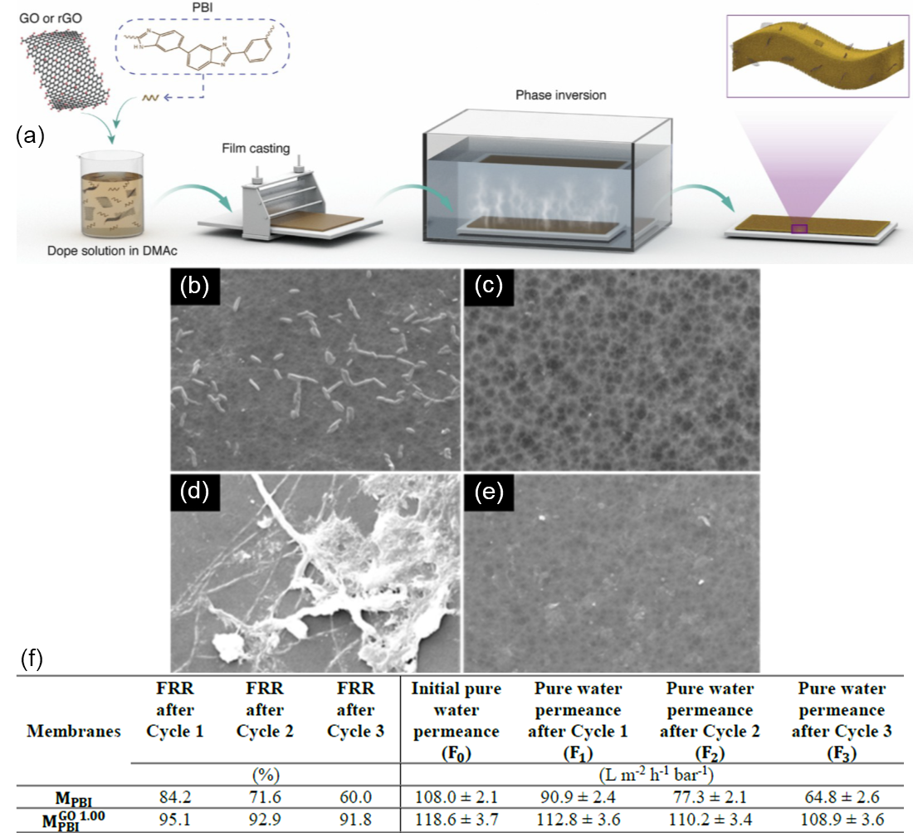
Figure X.6. (a) Schematic of membrane fabrication, including solution mixing, casting, and phase inversion. SEM images at 1600× magnification of the fouled membrane surface for (b) M_{PBI} after immersing in water for 45 days, (c) ${\text{M}}_{\text{PBI}}^{\text{GO 1.00}}$ after immersing in water for 45 days, (d) M_{PBI} after immersing in water for 180 days, and (e) ${\text{M}}_{\text{PBI}}^{\text{GO 1.00}}$ after immersing in water for 180 days. (f) FRR and water permeance over the multi-cycled filtration.⁴⁷

Another strategy to mitigate fouling is to design responsive membranes, whose properties can be tuned reversibly by the external stimulus (such as pH, temperature, light, and ionic strength).⁴⁹⁻⁵¹ For example, magnetically responsive membranes were demonstrated to mitigate fouling when treating coalbed methane produced water.⁵²⁻⁵⁴ Figure 7a shows the proposed mechanism to improve antifouling properties, where superparamagnetic nanoparticles (carboxyl shell Fe₃O₄) were covalently bonded to poly(2-hydroxyethyl methacrylate) (polyHEMA) grafted from NF-270 membrane surface. In an oscillating magnetic field, the orientation of the magnetic nanoparticles changed accordingly, creating small-scale mixing and alleviating the fouling. Figure 7b shows that the responsive membranes exhibited a slower decline of water permeance than the unmodified membrane. Figure 7c compares the permeate quality of the unmodified and responsive membranes. The permeate quality of the unmodified membrane dramatically decreased in the first 400 min, and the responsive membranes showed a much more stable rejection rate than the unmodified one. The next step to move this technology for practical applications is to demonstrate the feasibility by long-term field tests of the responsive membranes with oscillating magnetic fields.

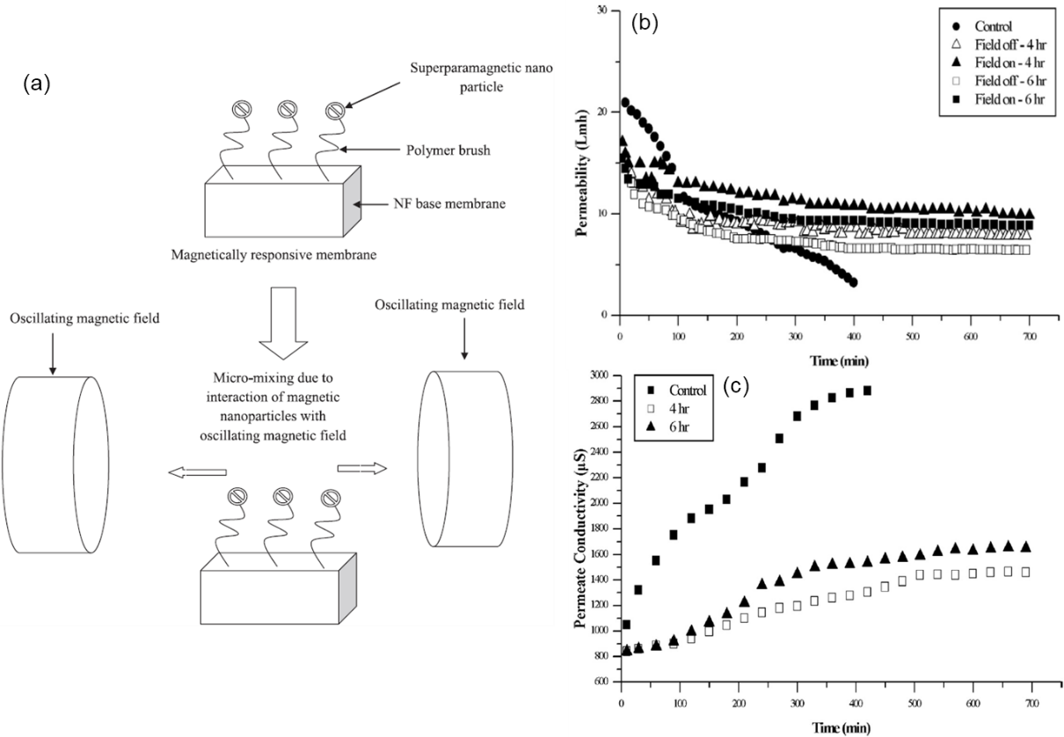
Figure X.7: (a) Schematic of the antifouling effect of magnetically responsive NF membranes. (b) Water permeance and (c) permeate conductivity for the unmodified and responsive membranes when treating produced water. The magnetic field was intermittently applied for 10 s in each 130 s. Copyright 2019 Elsevier.

Novel membranes have also been developed as an alternative to conventional polyamide-based NF membranes, such as TFC membranes based on bicontinuous cubic (Q₁), lyotropic liquid crystals (LLC).⁴⁸ Figure 8a shows the schematic of the cross-linked Q₁ LLC with hydrophilic nanopores, where the pore wall is generated by the cationic imidazolium head groups in the LLC monomer. Because of the high charge density and small pore size, the TFC Q₁ membrane rejects ions while providing the passage for low-molecular-weight neutral organic solutes. The TFC Q₁ membrane outperformed the NF90 membrane for treating the produced water. Figure 8b shows that the TFC Q₁ membranes exhibited a much smaller decrease of water permeance than NF membranes. While the final water flux of the TFC Q₁ membrane was lower than that of the NF90 at high pressures, TFC Q1 exhibited much higher water permeability than the polyamide layer of the NF90 (cf. Figure 8c). Figure 8d also compares the rejection of total dissolved solids (TDS) and DOC between the TFC Q₁ and NF90 membranes. The salt-organic separation (SOS) efficiency is defined as the ratio of the TDS rejection to the DOC rejection. TFC Q1 membranes showed lower TDS rejection but higher SOS efficiency than NF90, which could be beneficial if the DOC is valuable to recover.

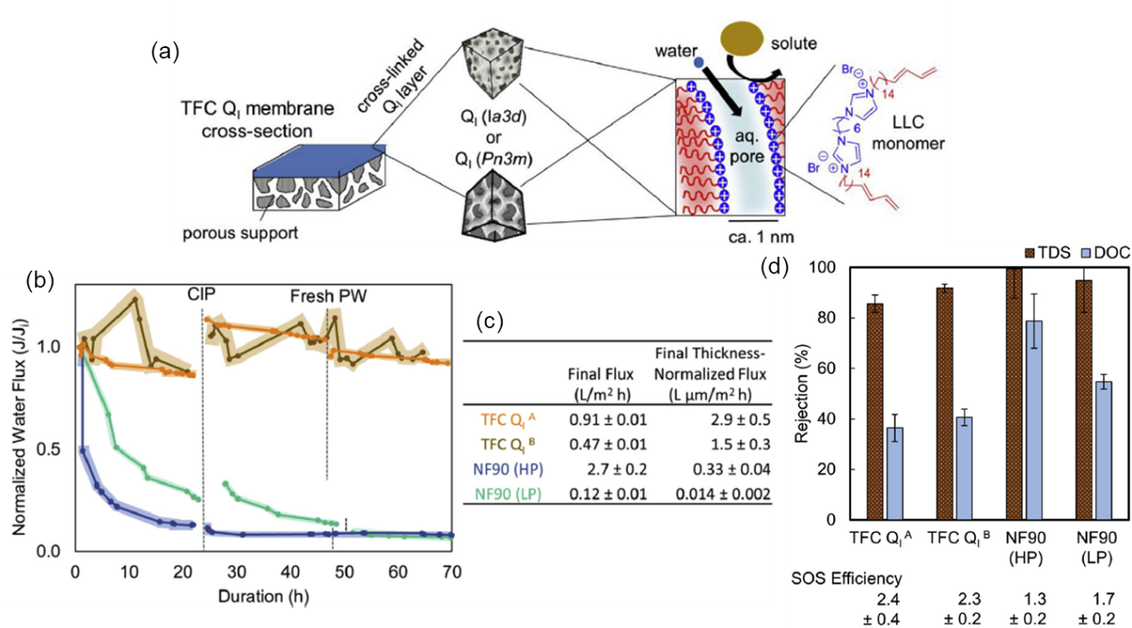
Figure X.8: (a) Schematic of TFC Q₁ membrane, including a porous support and a selective layer of cross-linked Q₁ LLC. (b) Comparison of normalized water flux over time and (c) final flux after 66-h operation between TFC Q1 and NF90 membranes when treating the produced water. (d) Rejection of TDS and DOC by TFC Q₁ membranes at 400 psi and NF90 membranes at 400 psi (HP) and 160 psi (LP). Copyright Elsevier 2019.

X.3. Osmotically Driven Membrane Separation
While pressure-driven RO has been widely used in water purification treatment, osmotically driven forward osmosis (FO) has been recently applied in many industrial applications, including water/wastewater treatment and desalination.⁵⁵⁻⁵⁹ In a typical FO process, a draw solution with high osmotic potential is used to draw water across a semi-permeable membrane from a feed source. Advantages of FO over conventional RO membrane technology include lower hydrodynamic pressure and higher water recovery.
X.3.1. Fundamentals
Figure X.9 shows the FO process, where water permeates across a semi-permeable membrane between two aqueous solutions with different solute concentrations. The osmotic pressure difference, Δπ, drives water from the solution with the lower osmotic potential to the solution with the higher osmotic potential in both FO and pressure-retarded osmosis (PRO), as opposed to the pressure-driven RO process. For both PRO and RO processes, an external hydraulic pressure can be applied at high salinity side to recover mechanical energy.

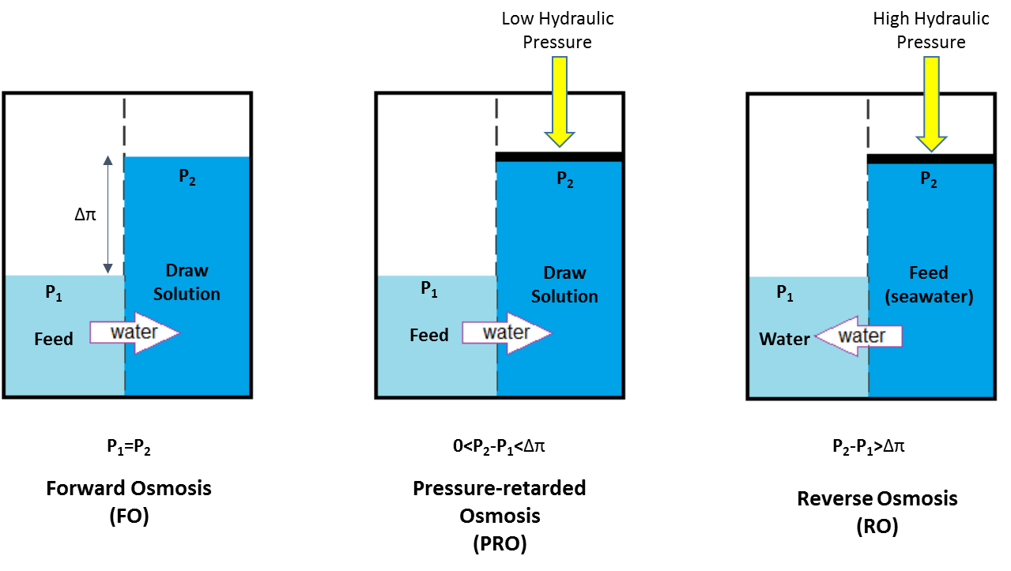
Figure X.9. The principle of the osmotically driven membrane processes.

For a typical FO system, a draw solution, such as brine, presents higher osmotic pressure than a feed with a lower salinity. Then, the Δπ drives water flux without external hydraulic pressure (Δp = p_{draw} - p_{feed} = 0), as shown in Figure X.10. The water flux first decreases with increasing Δp, under PRO (Δp < Δπ), till Δp = Δπ, where there is no water flux. As Δp keeps increasing (Δp > Δπ), a reversed water flux increases (RO).⁶⁰ Water transport driving force in RO process need to overcome the osmotic pressure gradient that favors water transport from the permeate to the feed. Hence RO process requires more energy than FO.

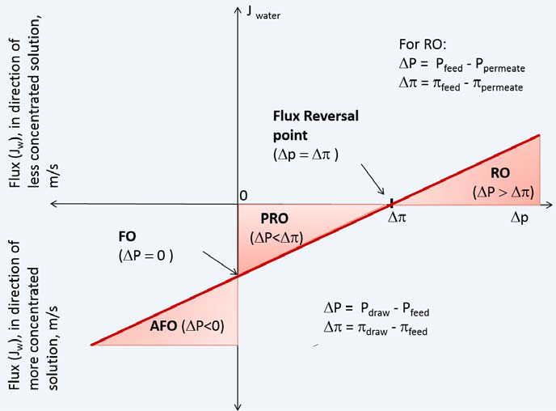
Figure X.10. Correlation of water flux with external hydraulic pressure of osmotic processes.⁶⁰

The water flux in terms of osmotic and hydraulic pressures can be described by the following equation:
$$J_{w}=A(∆π-∆p)$$
where J_{w} is water flux and A is the hydraulic permeability of the membrane. In practical operations, J_{w} depends on complicated operating parameters, including the nature of the membrane,⁶¹⁻⁶³ types of feed,^{21, 58, 64-66} and draw solutions,⁶⁷⁻⁶⁹ as well as the fluid dynamics within the process itself.⁷⁰
X.3.2. Draw Solutes Development for FO Process
The FO process requires a draw solution with a high osmotic pressure. In many industrial applications, synthetic draw solutions are used and recycled. Generally, an FO unit always combines with a draw solution regeneration procedure. Therefore, the practical operation of the FO process heavily depends on the selection of an effective draw solution. The criteria of draw solution selection include, but not limited to, osmotic pressure, viscosity, internal concentrative polarization, availability, costs, regeneration, and toxicity. Potential synthetic draw solutions are:⁶⁷
- gases and volatile compounds, e.g. NH₃-CO₂,
- inorganic draw solutions, e.g., salts,
- organic draw solutions, e.g., organic ionic liquids, organic ionic salts, polyelectrolytes, polymers, hydrogels, and
- functionalized nanoparticles (NPs)
Draw solutions can be categorized as non-responsive and responsive types according to their regeneration behaviors.⁶⁸ During the regeneration, non-responsive draw solutions (i.e., inorganic salts) do not have significant changes, while the responsive draw solutions (such as volatile liquids) can have phase changes. Nowadays, responsive draw solutions are widely used because of their easy regeneration. Figure X.11 shows a hybrid FO system with draw solution regeneration and examples of different types of draw solutions.
In addition to draw solutions, to increase FO water flux, many recent studies also investigated on the optimization of FO membranes with physical features, including thickness, porosity, and tortuosity of membrane. More details can be found in recent reviews papers.^{61, 63, 71-73}

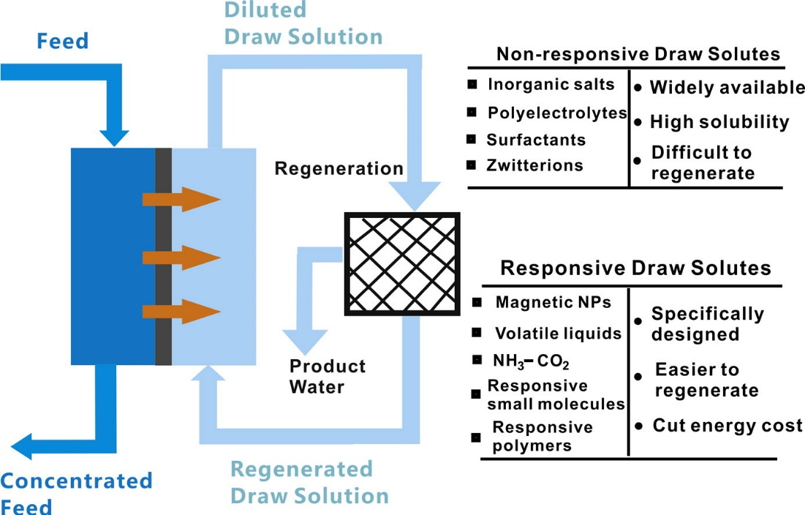
Figure X.11. A hybrid FO and draw solution regeneration process and different types of draw solutions.⁶⁸ Copyright 2016 Elsevier.

X.3.3. FO Applications to Produced Water Treatment
FO technology has been applied from lab-scale setup to full-scale industrial implementation.^{60, 66, 74} As shown in Figure X.12,⁷⁴ in the early stage of FO, osmotic hydration bags were commercial products in 1970s. In the past decade, FO technologies were used in food and beverage industries, mainly to treat the products (milk, juice, whey).⁷⁵ After 2015, many novel FO technologies have been developed for wastewater reclamation, brackish water/seawater desalination, and other industrial processes, including industrial scale-up of zero liquid discharge (ZLD) concept. Bell et al. systematically studied the membrane fouling and performance for an extended time of treating produced water using cellulose triacetate (CTA) and polyamide TFC membranes.⁷⁶ While both membranes had over 90% rejection of neutral hydrophobic compounds, the polyamide membrane exhibited a higher rejection of small organic molecules than CTA. FO is also subject to fouling, and the pretreatment of complex streams is necessary to protect the FO membranes from excessive fouling and degradation.

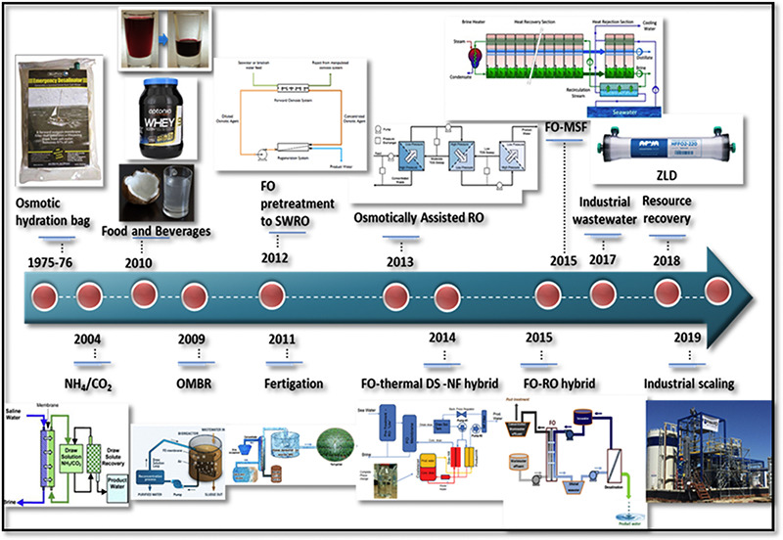
Figure X.12. FO for industrial applications.⁷⁴ Copyright 2020 Elsevier.

X.4. Thermally Driven Membranes
While the RO membrane exhibits high salt rejection, it requires high pressures to overcome the osmotic pressure difference, and thus, the RO process is not economical if the produced water has the TDS over 45,000 mg/L.⁷⁷⁻⁸⁰ However, the produced water from most shale gas sources may contain TDS of 98,900- 394,600 mg/L.^{8, 34, 81-83} To this end, the membrane distillation (MD) process has been extensively investigated, where water in the feed is heated and evaporates, diffuses through an air-filled porous hydrophobic membrane, and then condenses on the cool permeate-side of the membrane. The membranes can have almost 100% rejection of non-volatile solutes such as ions. The MD process circumvents the osmotic pressure issue and is capable of treating the brine containing up to 350,000 mg TDS. Furthermore, it can utilize low-grade or waste heat to drive the distillation, lowering the costs.
MD can operate in various modes, such as direct contact MD (DCMD), air gap MD (AGMD), and sweeping gas MD. The key to this technology is thermally stable, hydrophobic membranes that are resistant to pore wetting, fouling, and scaling.⁸⁴ Commercial MD membranes have symmetric and porous structure and are often made of hydrophobic polymers such as polytetrafluoroethylene (PTFE), PVDF, and polypropylene (PP).^{13, 85} The wetting causes the leakage of the high-salinity feed, reducing the salt rejection. The salts can precipitate from the highly saline feed at high water recovery, causing scaling formation and pore-plugging. Both fouling and scaling decrease water permeance. More importantly, they can reduce the hydrophobicity of the membrane surface, leading to wetting and thus reduced salt rejection.
Various strategies have been developed to mitigate wetting by improving hydrophobicity of the membrane surface, such as grafting nanoparticles and coating with low surface energy materials.^{86, 87} For example, Figure X.13a shows omniphobic PVDF membranes prepared by a four-step process.⁸⁸ First, PVDF membranes were treated using an alkaline solution to generate hydroxyl groups on the surface. Second, positively charged (3-aminopropyl)triethoxysilane (APTES) was grafted onto the treated PVDF membrane. Third, the negatively charged silica nanoparticles (SiNPs) were coated. Finally, perfluoro-decyl trichlorosilane (FDTS) was coated on the SiNPs-modified surface. Figure X.13b,c confirms that the SiNPs coating increased the membrane surface roughness.

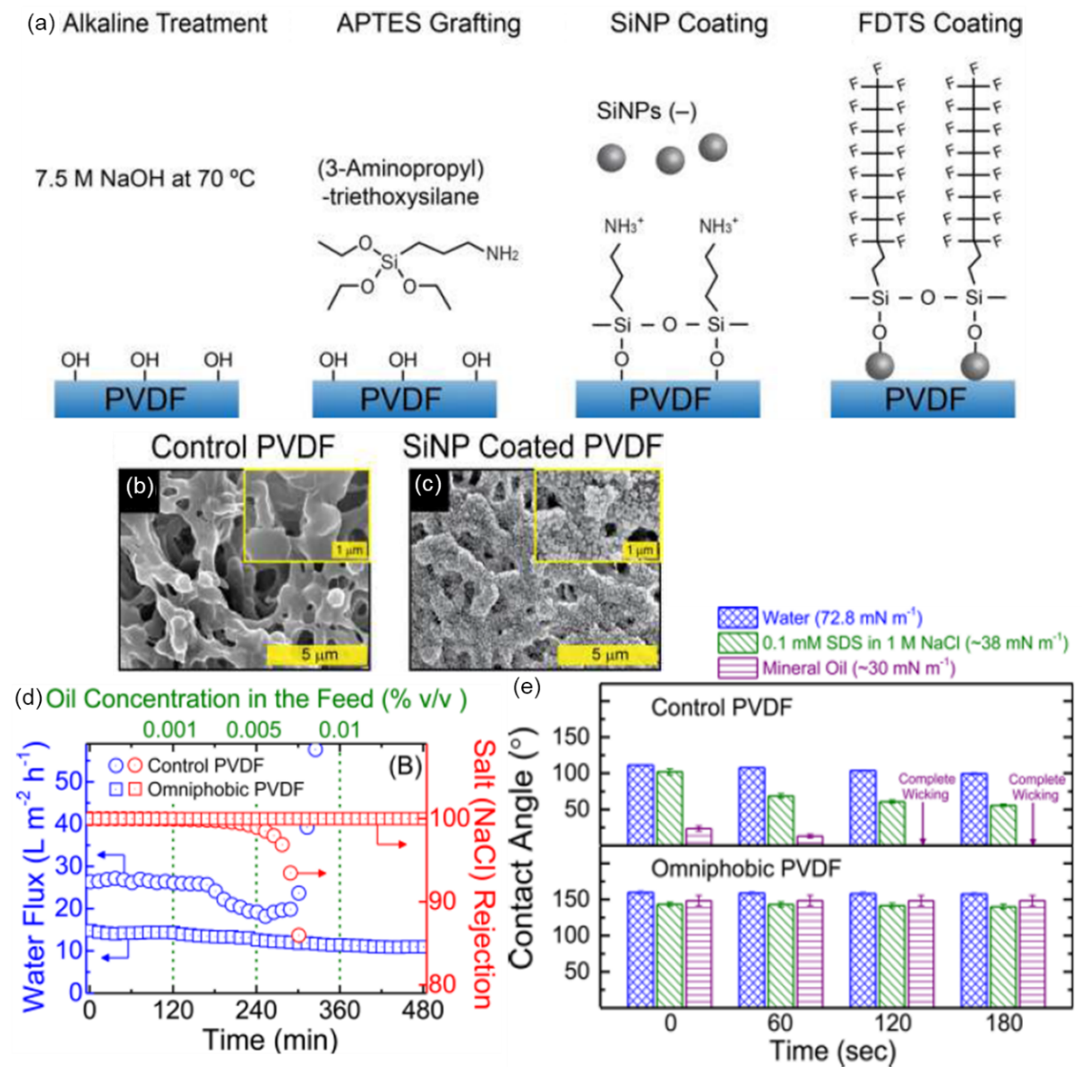
Figure X.13: (a) Schematic of fabricating omniphobic PVDF membranes, including alkaline treatment, APTES grafting, SiNP coating, and FDTS coating. SEM image of the membrane surface for (b) control PVDF and (c) SiNP coated PVDF. (d) Water flux and NaCl rejection of the control and omniphobic PVDF in DCMD at 60 ºC. The feed contained 1M NaCl and mineral oil with increasing concentration over time. DI water at 20 ºC was used as a permeate solution. (e) Contact angles of the control and omniphobic membranes over time measured with water, SDS in NaCl solution, and mineral oil. Copyright 2016 ACS.

Figure X.13d compares the performance of the control and modified membrane in the DCMD using saline feed containing varying concentrations of oil. The omniphobic membrane showed stable water flux and ~100% salt rejection when the oil concentration increased up to 0.01% v/v. By contrast, the unmodified membrane suffered from a dramatic reduction of salt rejection due to the wetting when challenged with 0.005% oil in feed. Figure X.13e directly compares the wettability of the control and modified membranes by measurement of contact angles for water, sodium dodecyl sulfate (SDS) solution, and mineral oil. The contact angles of PVDF decreased with time, while the modified membrane showed stable contact angles.
Electrospun membranes consisting of ultrafine fibers with high porosity, controllable pore size, and good mechanical strength have attracted significant interest for MD applications. Furthermore, the electrospun membranes can be treated with CF₄ plasma to achieve omniphobic surface.⁸⁹ Figure X.14a shows the replacement of the CH₂-CF₂ groups in PVDF electrospun nanofiber membranes (ENMs) by the CF₂-CF₂ and CF₃ groups and the decreased surface free energy, as evidenced by the spherical to semi-spherical droplets of liquids. In the 24-h AGMD test with produced water, the modified membranes exhibited higher water flux than the neat ENMs (cf. Figure X.14b). The membrane with 15-min plasma treatment (P/CF-15) showed water flux 80% higher than the neat ENMs. Furthermore, when SDS solutions of 0.1 to 0.7 mM were added to the feed, the P/CF-15 exhibited stable water flux and nearly 100% salt rejection. By contrast, commercial PVDF membrane (C-PVDF) showed an increased water flux and decreased salt rejection when 0.3 mM SDS solution was added because of its lack of resistance to the SDA wetting.

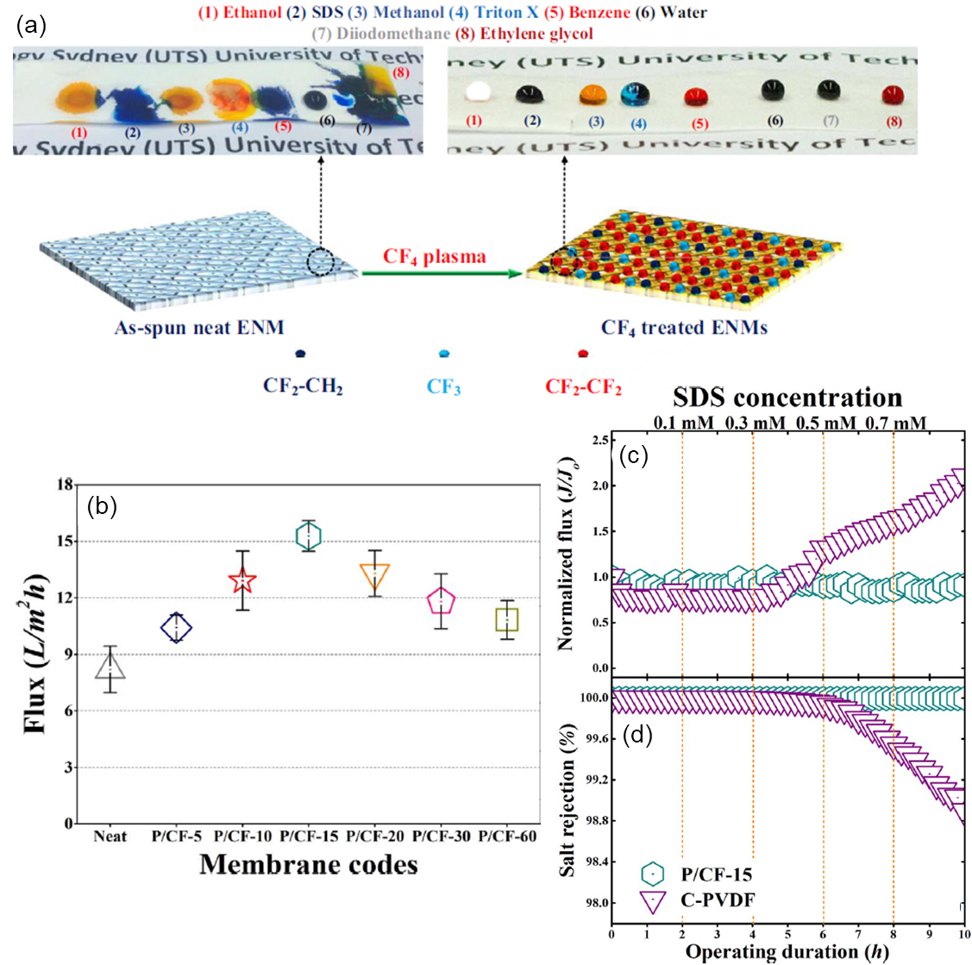
Figure X.14: (a) Schematic of the neat and CF₄ plasma-treated ENMs and their surface hydrophobicity with various liquids.⁸⁹ (b) Comparison of water flux in the neat and CF₄ plasma-treated ENMs in 24-h tests of AGMD with produced water. (c) Normalized water flux and (d) salt rejection of the commercial PVDF membrane (C-PCDF) and CF₄ plasma-treated membrane (P/CF-15) challenged by produced water containing SDS. Copyright 2017 Elsevier.

MD process also requires the membrane with low heat conductivity to retain the temperature difference between the feed and permeate or driving force for water transport.^{90, 91} Figure X.15 shows Janus composite hollow fiber membranes (J-HFMs) with both high water permeance and low heat loss.^{90, 92-97} As shown in Figure X.15a-e, J-HFMs consisted of a thin hydrophobic outer layer of PVDF and superhydrophobic silica nanoparticles (PVDF/Si-R) and a thick hydrophilic inner layer of PVDF/PEG. The hydrophobic outer layer functioned as a barrier to protect the membrane from wetting, while the porous hydrophilic layer facilitates the water vapor transfer through the membrane. When challenged with a high-salinity feed containing 35,000 mg/L NaCl, the J-HFMs outperformed a neat PVDF HFMs in terms of the permeate flux and energy efficiency, as shown in Figure X.15f. Additionally, after the 200-h DCMD with produced water, the Janus-HFMs exhibited the permeate flux of 15.2 kg/(m² h) and salt rejection of 98.4% with good resistance to fouling and scaling (Figure X.15g). Figure X.15h shows that the performance of the J-HFMs during DCMD can be effectively regenerated by cleaning every 12 h, as evidenced by the stable flux and high salt rejection (i.e., 99.8%) at the end of the 72-h operation.

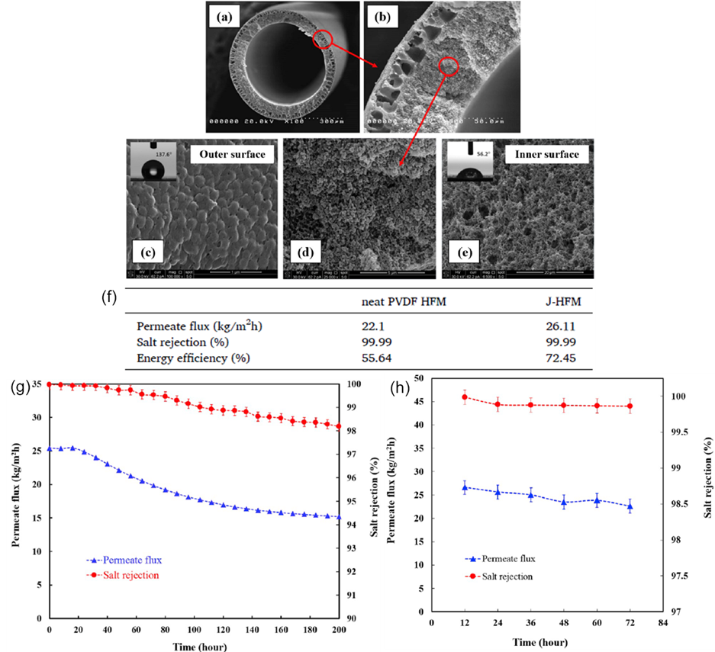
Figure X.15: SEM images of the Janus-HFMs, including (a-b) and (d) cross-section, (c) hydrophobic PVDF/Si-R outer surface, and (e) hydrophilic PVDF/PEG inner surface.³⁸ (f) Performance comparison between the neat PVDF HFMs and J-HFMs. Permeate flux and salt rejection of J-HFMs (g) during a continuous 200-h DCMD and (h) during a 72-h DCMD with the membrane regeneration every 12 h. The produced water was sampled from Permian Basin with TDS of 154,220 mg/L. Copyright 2020 Elsevier.

X.5 Conclusion and Future Outlook
This chapter provides an updated overview of advanced membranes for various processes for the treatment of produced water, including hydraulic pressure-driven, osmotic pressure-driven, and thermal-driven processes. For membrane processes to be competitive, the key is to develop membranes with high water permeance, superior rejection, and excellent long-term stability against the produced water, which is the focus of this short review. Different membrane systems can also be integrated together to combine their advantages to improve the separation efficiency. However, it is beyond the scope of this review to discuss the processes and techno-economic analysis.
In the pressure-driven processes, MF and UF membranes remove large particles such as grease and suspended solids; NF membranes reject divalent ions and most organics, generating permeate reusable for oil industry, irrigation, and livestock; and RO membranes provide potable water. Membranes can be combined to improve treatment efficiency. One of the great challenges of these membranes is fouling by the contaminants in the produced water, which can be mitigated by membrane surface modification to improve hydrophilicity (such as grafting with PEG, zwitterions, and GO) without significantly increasing transport resistance to water. Surface modification methods fall into two categories of “grafting to” and “grafting from.” In the former method, materials with superior antifouling properties are covalently bonded to the surface to achieve superior properties. The challenge would be to control the grafting density. The deposition of PD on the membrane surface also belongs to this category. In the “grafting from” approach, an initiator is often grafted on the surface, and then the monomers can be polymerized. The grafting density and the polymer chain length can be well controlled, while the challenge is to functionalize the surface with the initiators with desired quantities.
In the osmotically driven processes, FO has emerged as an exciting technology for produced water treatment, though it is faced with challenges, such as salinity build-up, low membrane flux, membrane fouling, and system scale-up. The strategies to overcome these challenges rely heavily on the improvements of membrane separation properties (water flux, concentration polarization, and fouling mitigation), draw solutions (osmotic pressure, reverse solute flux and regeneration), and the integration of the FO with other processes such as RO, NF, and MD.
Thermally driven MD membranes provide a unique approach for treating high-salinity produced water, particularly if waste heat is available. The challenge is to develop membranes with resistance to wetting (leading to salt leakage), scaling (lowering water permeance and promoting wetting), and fouling. Hydrophobic membranes are used, and membranes are often modified to improve omniphobicity to mitigate wetting.

References
1. Rahm, B. G.; Bates, J. T.; Bertoia, L. R.; Galford, A. E.; Yoxtheimer, D. A.; Riha, S. J., Wastewater management and Marcellus Shale gas development: Trends, drivers, and planning implications, J. Environ. Manage. 2013, 120, 105-113.
2. Shaffer, D. L.; Chavez, L. H. A.; Ben-Sasson, M.; Castrillon, S. R. V.; Yip, N. Y.; Elimelech, M., Desalination and reuse of high-salinity shale gas produced water: drivers, technologies, and future directions, Environ. Sci. Technol. 2013, 47 (17), 9569-9583.
3. Orem, W.; Tatu, C.; Varonka, M.; Lerch, H.; Bates, A.; Engle, M.; Crosby, L.; McIntosh, J., Organic substances in produced and formation water from unconventional natural gas extraction in coal and shale, Int. J. Coal Geol. 2014, 126, 20-31.
4. Liu, Y.; Zou, C.; Li, C.; Lin, L.; Chen, W., Evaluation of β-cyclodextrin–polyethylene glycol as green scale inhibitors for produced-water in shale gas well, Desalination 2016, 377, 28-33.
5. Kahrilas, G. A.; Blotevogel, J.; Stewart, P. S.; Borch, T., Biocides in Hydraulic Fracturing Fluids: A Critical Review of Their Usage, Mobility, Degradation, and Toxicity, Environ. Sci. Technol. 2015, 49 (1), 16-32.
6. Barbot, E.; Vidic, N. S.; Gregory, K. B.; Vidic, R. D., Spatial and Temporal Correlation of Water Quality Parameters of Produced Waters from Devonian-Age Shale following Hydraulic Fracturing, Environ. Sci. Technol. 2013, 47 (6), 2562-2569.
7. Blondes, M. S.; Gans, K. D.; Rowan, E. L.; Thordsen, J. J.; Reidy, M. E.; Engle, M.; Kharaka, Y.; Thomas, B., US Geological Survey National Produced Waters Geochemical Database v2. 2 (PROVISIONAL) Documentation, USGS Energy Resources Program: Produced Waters, USGS 2016, 16.
8. Shih, J.-S.; Saiers, J. E.; Anisfeld, S. C.; Chu, Z.; Muehlenbachs, L. A.; Olmstead, S. M., Characterization and analysis of liquid waste from Marcellus shale gas development, Environ. Sci. Technol. 2015, 49 (16), 9557-9565.
9. Zhao, S.; Hu, S.; Zhang, X.; Song, L.; Wang, Y.; Tan, M.; Kong, L.; Zhang, Y., Integrated membrane system without adding chemicals for produced water desalination towards zero liquid discharge, Desalination 2020, 114693.
10. Fakhru’l-Razi, A.; Pendashteh, A.; Abdullah, L. C.; Biak, D. R. A.; Madaeni, S. S.; Abidin, Z. Z., Review of technologies for oil and gas produced water treatment, J. Hazard. Mater. 2009, 170 (2-3), 530-551.
11. Igunnu, E. T.; Chen, G. Z., Produced water treatment technologies, Int. J. Low-Carbon Tec. 2014, 9 (3), 157-177.
12. Kundua, P.; Mishra, I. M., Treatment and reclamation of hydrocarbon-bearing oily wastewater as a hazardous pollutant by different processes and technologies: a state-of-the-art review, Rev. Chem. Eng. 2019, 35 (1), 73-108.
13. Chang, H.; Li, T.; Liu, B.; Vidic, R. D.; Elimelech, M.; Crittenden, J. C., Potential and implemented membrane-based technologies for the treatment and reuse of flowback and produced water from shale gas and oil plays: A review, Desalination 2019, 455, 34-57.
14. Estrada, J. M.; Bhamidimarri, R., A review of the issues and treatment options for wastewater from shale gas extraction by hydraulic fracturing, Fuel 2016, 182, 292-303.
15. Jimenez, S.; Mico, M. M.; Arnaldos, M.; Medina, F.; Contreras, S., State of the art of produced water treatment, Chemosphere 2018, 192, 186-208.
16. Al-Ghouti, M. A.; Al-Kaabi, M. A.; Ashfaq, M. Y.; Da'na, D. A., Produced water characteristics, treatment and reuse: A review, J. Water Process. Eng. 2019, 28, 222-239.
17. Wei, X. C.; Zhang, S. C.; Han, Y. X.; Wolfe, F. A., Treatment of petrochemical wastewater and produced water from oil and gas, Water Environ. Res. 2019, 91 (10), 1025-1033.
18. Jepsen, K. L.; Bram, M. V.; Pedersen, S.; Yang, Z. Y., Membrane fouling for produced water treatment: A review study from a process control perspective, Water 2018, 10 (7), 28.
19. Ali, A.; Quist-Jensen, C. A.; Drioli, E.; Macedonio, F., Evaluation of integrated microfiltration and membrane distillation/crystallization processes for produced water treatment, Desalination 2018, 434, 161-168.
20. Camarillo, M. K.; Domen, J. K.; Stringfellow, W. T., Physical-chemical evaluation of hydraulic fracturing chemicals in the context of produced water treatment, J. Environ. Manage. 2016, 183, 164-174.
21. Munirasu, S.; Haija, M. A.; Banat, F., Use of membrane technology for oil field and refinery produced water treatment - A review, Process Saf. Environ. Protect. 2016, 100, 183-202.
22. Weschenfelder, S. E.; Fonseca, M. J. C.; Borges, C. P., Treatment of produced water from polymer flooding in oil production by ceramic membranes, J. Pet. Sci. Eng. 2021, 196, 108021.
23. Ferreira, A. D. F.; Coelho, D. R. B.; dos Santos, R. V. G.; Nascimento, K. S.; Presciliano, F. A.; da Silva, F. P.; Campos, J. C.; da Fonseca, F. V.; Borges, C. P.; Weschenfelder, S. E., Fouling mitigation in produced water treatment by conjugation of advanced oxidation process and microfiltration, Environ. Sci. Pollut. Res. 2020, in press.
24. Maguire-Boyle, S. J.; Huseman, J. E.; Ainscough, T. J.; Oatley-Radcliffe, D. L.; Alabdulkarem, A. A.; Al-Mojil, S. F.; Barron, A. R., Superhydrophilic Functionalization of Microfiltration Ceramic Membranes Enables Separation of Hydrocarbons from Frac and Produced Water, Sci. Rep. 2017, 7 (1), 12267.
25. Zsirai, T.; Al-Jaml, A. K.; Qiblawey, H.; Al-Marri, M.; Ahmed, A.; Bach, S.; Watson, S.; Judd, S., Ceramic membrane filtration of produced water: Impact of membrane module, Sep. Purif. Techn. 2016, 165, 214-221.
26. Ebrahimi, M.; Kovacs, Z.; Schneider, M.; Mund, P.; Bolduan, P.; Czermak, P., Multistage filtration process for efficient treatment of oil-field produced water using ceramic membranes, Desalination Water Treat. 2012, 42 (1-3), 17-23.
27. Ebrahimi, M.; Willershausen, D.; Ashaghi, K. S.; Engel, L.; Placido, L.; Mund, P.; Bolduan, P.; Czermak, P., Investigations on the use of different ceramic membranes for efficient oil-field produced water treatment, Desalination 2010, 250 (3), 991-996.
28. Zhong, J.; Sun, X.; Wang, C., Treatment of oily wastewater produced from refinery processes using flocculation and ceramic membrane filtration, Sep. Purif. Techn. 2003, 32 (1), 93-98.
29. Zsirai, T.; Qiblawey, H.; Buzatu, P.; Al-Marri, M.; Judd, S. J., Cleaning of ceramic membranes for produced water filtration, J. Pet. Sci. Eng. 2018, 166, 283-289.
30. Miller, D. J.; Dreyer, D. R.; Bielawski, C. W.; Paul, D. R.; Freeman, B. D., Surface modification of water purification membranes, Angew. Chem. Int. Ed. 2017, 56 (17), 4662-4711.
31. Shahkaramipour, N.; Tran, T. N.; Ramanan, S.; Lin, H., Membranes with surface-enhanced antifouling properties for water purification, Membranes 2017, 7 (1), 13.
32. Miller, D. J.; Huang, X.; Li, H.; Kasemset, S.; Lee, A.; Agnihotri, D.; Hayes, T.; Paul, D. R.; Freeman, B. D., Fouling-resistant membranes for the treatment of flowback water from hydraulic shale fracturing: A pilot study, J. Membr. Sci. 2013, 437, 265-275.
33. Kirschner, A.; Chang, C.; Kasemset, S.; Emrick, T.; Freeman, B. D., Fouling-resistant ultrafiltration membranes prepared via co-deposition of dopamine/zwitterion composite coatings, J. Membr. Sci. 2017, 541 (1), 300-311.
34. Dreyer, D. R.; Miller, D. J.; Freeman, B. D.; Paul, D. R.; Bielawski, C. W., Perspectives on poly(dopamine), Chem. Sci. 2013, 4 (10), 3796-3802.
35. Shahkaramipour, N.; Jafari, A.; Tran, T.; Stafford, C. M.; Cheng, C.; Lin, H., Maximizing the grafting of zwitterions onto the surface of ultrafiltration membranes to improve antifouling properties, J. Membr. Sci. 2020, 601, 117909.
36. Chen, X.; Deng, E.; Park, D.; Pfeifer, B. A.; Dai, N.; Lin, H., Grafting activated graphene oxide nanosheets onto ultrafiltration membranes using polydopamine to enhance antifouling properties, ACS Appl. Mater. Interfaces 2020, 12 (42), 48179-48187.
37. McCloskey, B. D.; Park, H. B.; Ju, H.; Rowe, B. W.; Miller, D. J.; Freeman, B. D., A bioinspired fouling-resistant surface modification for water purification membranes, J. Membr. Sci. 2012, 413-414, 82-90.
38. Nawi, N. I. M.; Chean, H. M.; Shamsuddin, N.; Bilad, M. R.; Narkkun, T.; Faungnawakij, K.; Khan, A. L., Development of hydrophilic PVDF membrane using vapour induced phase separation method for produced water treatment, Membranes 2020, 10 (6), 17.
39. Shahkaramipour, N.; Lai, C. K.; Venna, S. R.; Sun, H.; Cheng, C.; Lin, H., Membrane surface modification using thiol-containing zwitterionic polymers via bioadhesive polydopamine, Ind. Eng. Chem. Res. 2018, 57 (6), 2336-2345.
40. Li, P.; Ge, Q., Membrane surface engineering with bifunctional zwitterions for efficient oil–water separation, ACS Appl. Mater. Interfaces 2019, 11 (34), 31328-31337.
41. Babayev, M.; Du, H. B.; Botlaguduru, V. S. V.; Kommalapati, R. R., Zwitterion-modified ultrafiltration membranes for permian basin produced water pretreatment, Water 2019, 11 (8), 15.
42. Atallah, C.; Mortazavi, S.; Tremblay, A. Y.; Doiron, A., Surface-modified multi-lumen tubular membranes for SAGD-produced water treatment, Energy Fuel. 2019, 33 (6), 5766-5776.
43. Wandera, D.; Wickramasinghe, S. R.; Husson, S. M., Modification and characterization of ultrafiltration membranes for treatment of produced water, J. Membr. Sci. 2011, 373 (1-2), 178-188.
44. Riley, S. M.; Oliveira, J. M. S.; Regnery, J.; Cath, T. Y., Hybrid membrane bio-systems for sustainable treatment of oil and gas produced water and fracturing flowback water, Sep. Purif. Techn. 2016, 171, 297-311.
45. Eboagwu, U. Evaluation of Membrane Treatment Technology to Optimize and Reduce Hypersalinity Content of Produced Brine for Reuse in Unconventional Gas Wells. Texas A & M University, 2012.
46. Guo, C.; Chang, H. Q.; Liu, B. C.; He, Q. P.; Xiong, B. Y.; Kumar, M.; Zydney, A. L., A combined ultrafiltration-reverse osmosis process for external reuse of Weiyuan shale gas flowback and produced water, Environ. Sci.-Wat. Res. Technol. 2018, 4 (7), 942-955.
47. Alammar, A.; Park, S.-H.; Williams, C. J.; Derby, B.; Szekely, G., Oil-in-water separation with graphene-based nanocomposite membranes for produced water treatment, J. Membr. Sci. 2020, 603, 118007.
48. Dischinger, S. M.; Rosenblum, J.; Noble, R. D.; Gin, D. L., Evaluation of a nanoporous lyotropic liquid crystal polymer membrane for the treatment of hydraulic fracturing produced water via cross-flow filtration, J. Membr. Sci. 2019, 592, 117313.
49. Ramanan, S. N.; Shahkaramipour, N.; Tran, T.; Zhu, L.; Venna, S. R.; Lim, C.-K.; Singh, A.; Prasad, P. N.; Lin, H., Self-cleaning membranes for water purification by co-deposition of photo-mobile 4, 4′-azodianiline and bio-adhesive polydopamine, J. Membr. Sci. 2018, 554, 164-174.
50. Himstedt, H. H.; Qian, X.; Weaver, J. R.; Wickramasinghe, S. R., Responsive membranes for hydrophobic interaction chromatography, J. Membr. Sci. 2013, 447, 335-344.
51. Kota, A. K.; Kwon, G.; Choi, W.; Mabry, J. M.; Tuteja, A., Hygro-responsive membranes for effective oil–water separation, Nat. Commun. 2012, 3 (1), 1-8.
52. Himstedt, H. H.; Sengupta, A.; Qian, X. H.; Wickramasinghe, S. R., Magnetically responsive nano filtration membranes for treatment of coal bed methane produced water, J. Taiwan Inst. Chem. Eng. 2019, 94, 97-108.
53. Lin, L.; Jiang, W.; Xu, X.; Xu, P., A critical review of the application of electromagnetic fields for scaling control in water systems: mechanisms, characterization, and operation, npj Clean Water 2020, 3 (1), 25.
54. Himstedt, H. H.; Yang, Q.; Dasi, L. P.; Qian, X.; Wickramasinghe, S. R.; Ulbricht, M., Magnetically activated micromixers for separation membranes, Langmuir 2011, 27 (9), 5574-5581.
55. Gwak, G.; Kim, D. I.; Hong, S., New industrial application of forward osmosis (FO): Precious metal recovery from printed circuit board (PCB) plant wastewater, J. Membr. Sci. 2018, 552, 234-242.
56. Ansari, A. J.; Hai, F. I.; Price, W. E.; Drewes, J. E.; Nghiem, L. D., Forward osmosis as a platform for resource recovery from municipal wastewater - A critical assessment of the literature, J. Membr. Sci. 2017, 529, 195-206.
57. Roy, D.; Rahni, M.; Pierre, P.; Yargeau, V., Forward osmosis for the concentration and reuse of process saline wastewater, Chem. Eng. J. 2016, 287, 277-284.
58. Valladares Linares, R.; Li, Z.; Sarp, S.; Bucs, S.; Amy, G.; Vrouwenvelder, J. S., Forward osmosis niches in seawater desalination and wastewater reuse, Water Res. 2014, 66, 122-139.
59. Yang, Q.; Wang, K. Y.; Chung, T. S., Dual-layer hollow fibers with enhanced flux as novel forward osmosis membranes for water production, Environ. Sci. Techn. 2009, 43 (8), 2800-2805.
60. Korenak, J.; Basu, S.; Balakrishnan, M.; Hélix-Nielsen, C.; Petrinic, I., Forward osmosis in wastewater treatment processes, Acta Chim. Slov. 2017, 64 (1), 83-94.
61. Kim, B.; Gwak, G.; Hong, S., Review on methodology for determining forward osmosis (FO) membrane characteristics: Water permeability (A), solute permeability (B), and structural parameter (S), Desalination 2017, 422, 5-16.
62. Zhao, S.; Huang, K.; Lin, H., Impregnated membranes for water purification using forward osmosis, Ind. Eng. Chem. Res. 2015, 54 (49), 12354-12366.
63. Tran, T.; Pan, S.; Chen, X.; Lin, X.; Blevins, A. K.; Ding, Y.; Lin, H., Zwitterionic hydrogel-impregnated membranes with polyamide skin achieving superior water/salt separation properties, ACS Appl. Mater. Interfaces 2020, 12 (43), 49192-49199.
64. Rastogi, N. K., Opportunities and challenges in application of forward osmosis in food processing, Crit. Rev. Food Sci. Nutr. 2016, 56 (2), 266-291.
65. Qasim, M.; Darwish, N. A.; Sarp, S.; Hilal, N., Water desalination by forward (direct) osmosis phenomenon: A comprehensive review, Desalination 2015, 374, 47-69.
66. Coday, B. D.; Cath, T. Y., Forward osmosis: Novel desalination of produced water and fracturing flowback, J. Am. Water Works Assoc. 2014, 106 (2), E55-E66.
67. Johnson, D. J.; Suwaileh, W. A.; Mohammed, A. W.; Hilal, N., Osmotic's potential: An overview of draw solutes for forward osmosis, Desalination 2018, 434, 100-120.
68. Cai, Y.; Hu, X. M., A critical review on draw solutes development for forward osmosis, Desalination 2016, 391, 16-29.
69. Luo, H.; Wang, Q.; Zhang, T. C.; Tao, T.; Zhou, A.; Chen, L.; Bie, X., A review on the recovery methods of draw solutes in forward osmosis, J. Water Process. Eng. 2014, 4 (C), 212-223.
70. Lee, K. L.; Baker, R. W.; Lonsdale, H. K., Membranes for power generation by pressure-retarded osmosis, J. Membr. Sci. 1981, 8 (2), 141-171.
71. Xu, W.; Chen, Q.; Ge, Q., Recent advances in forward osmosis (FO) membrane: Chemical modifications on membranes for FO processes, Desalination 2017, 419, 101-116.
72. Alsvik, I. L.; Hägg, M. B., Pressure retarded osmosis and forward osmosis membranes: Materials and methods, Polymers 2013, 5 (1), 303-327.
73. Yip, N. Y.; Tiraferri, A.; Phillip, W. A.; Schiffman, J. D.; Elimelech, M., High performance thin-film composite forward osmosis membrane, Environ. Sci. Techn. 2010, 44 (10), 3812-3818.
74. Suwaileh, W.; Pathak, N.; Shon, H.; Hilal, N., Forward osmosis membranes and processes: A comprehensive review of research trends and future outlook, Desalination 2020, 485, 114455.
75. Haupt, A.; Lerch, A., Forward osmosis application in manufacturing industries: A short review, Membranes 2018, 8 (3), 1-33.
76. Bell, E. A.; Poynor, T. E.; Newhart, K. B.; Regnery, J.; Coday, B. D.; Cath, T. Y., Produced water treatment using forward osmosis membranes: Evaluation of extended-time performance and fouling, J. Membr. Sci. 2017, 525, 77-88.
77. Chang, Y.; Myerson, A., The diffusivity of potassium chloride and sodium chloride in concentrated, saturated, and supersaturated aqueous solutions, AIChE J. 1985, 31 (6), 890-894.
78. Lester, Y.; Ferrer, I.; Thurman, E. M.; Sitterley, K. A.; Korak, J. A.; Aiken, G.; Linden, K. G., Characterization of hydraulic fracturing flowback water in Colorado: implications for water treatment, Sci. Total Environ. 2015, 512, 637-644.
79. Semiat, R.; Hasson, D., Water desalination, Rev. Chem. Eng. 2012, 28 (1), 43-60.
80. Beh, J. J.; Ooi, B. S.; Lim, J. K.; Ng, E. P.; Mustapa, H., Development of high water permeability and chemically stable thin film nanocomposite (TFN) forward osmosis (FO) membrane with poly(sodium 4-styrenesulfonate) (PSS)-coated zeolitic imidazolate framework-8 (ZIF-8) for produced water treatment, J. Water Process. Eng. 2020, 33, 15.
81. Blondes, M. S.; Gans, K. D.; Engle, M.; Kharaka, Y.; Reidy, M. E.; Saraswathula, V.; Thordsen, J. J.; Rowan, E. L.; Morrissey, E. A. U.S. Geological Survey National Produced Waters Geochemical Database v2.3: U.S. Geological Survey data release, https://doi.org/10.5066/F7J964W8; 2018.
82. Rosenblum, J.; Thurman, E. M.; Ferrer, I.; Aiken, G.; Linden, K. G., Organic chemical characterization and mass balance of a hydraulically fractured well: From fracturing fluid to produced water over 405 days, Environ. Sci. Technol. 2017, 51 (23), 14006-14015.
83. Rosenblum, J. S.; Sitterley, K. A.; Thurman, E. M.; Ferrer, I.; Linden, K. G., Hydraulic fracturing wastewater treatment by coagulation-adsorption for removal of organic compounds and turbidity, J. Environ. Chem. Eng. 2016, 4 (2), 1978-1984.
84. Liu, F.; Hashim, N. A.; Liu, Y.; Abed, M. M.; Li, K., Progress in the production and modification of PVDF membranes, J. Membr. Sci. 2011, 375 (1-2), 1-27.
85. Deshmukh, A.; Boo, C.; Karanikola, V.; Lin, S. H.; Straub, A. P.; Tong, T. Z.; Warsinger, D. M.; Elimelech, M., Membrane distillation at the water-energy nexus: limits, opportunities, and challenges, Energy Environ. Sci. 2018, 11 (5), 1177-1196.
86. Tran, T.; Chen, X.; Doshi, S.; Stafford, C. M.; Lin, H., Grafting polysiloxane onto ultrafiltration membranes to optimize surface energy and mitigate fouling, Soft Matter 2020, 16, 5044-5053.
87. Tran, T.; Tu, Y.-C.; Hall-Laureano, S.; Lin, C.; Kawy, M.; Lin, H., “Nonstick” membranes prepared by facile surface fluorination for water purification, Ind. Eng. Chem. Res. 2020, 59 (12), 5307-5314.
88. Boo, C.; Lee, J.; Elimelech, M., Omniphobic polyvinylidene fluoride (PVDF) membrane for desalination of shale gas produced water by membrane distillation, Environ. Sci. Technol. 2016, 50 (22), 12275-12282.
89. Woo, Y. C.; Chen, Y.; Tijing, L. D.; Phuntsho, S.; He, T.; Choi, J. S.; Kim, S. H.; Shon, H. K., CF₄ plasma-modified omniphobic electrospun nanofiber membrane for produced water brine treatment by membrane distillation, J. Membr. Sci. 2017, 529, 234-242.
90. Zou, L.; Gusnawan, P.; Zhang, G.; Yu, J., Novel Janus composite hollow fiber membrane-based direct contact membrane distillation (DCMD) process for produced water desalination, J. Membr. Sci. 2020, 597, 117756.
91. Ullah, R.; Khraisheh, M.; Esteves, R. J.; McLeskey, J. T.; AlGhouti, M.; Gad-el-Hak, M.; Vahedi Tafreshi, H., Energy efficiency of direct contact membrane distillation, Desalination 2018, 433, 56-67.
92. Yang, H.; Wei, F.; Hu, K.; Lyu, J., Effects of mud slurry on flow resistance of cohesionless coarse particles, Powder Technol. 2017, 310, 1-7.
93. Figoli, A.; Ursino, C.; Galiano, F.; Di Nicolò, E.; Campanelli, P.; Carnevale, M. C.; Criscuoli, A., Innovative hydrophobic coating of perfluoropolyether (PFPE) on commercial hydrophilic membranes for DCMD application, J. Membr. Sci. 2017, 522, 192-201.
94. Puranik, A. A.; Rodrigues, L. N.; Chau, J.; Li, L.; Sirkar, K. K., Porous hydrophobic-hydrophilic composite membranes for direct contact membrane distillation, J. Membr. Sci. 2019, 591, 117225.
95. Khayet, M.; Mengual, J. I.; Matsuura, T., Porous hydrophobic/hydrophilic composite membranes: Application in desalination using direct contact membrane distillation, J. Membr. Sci. 2005, 252 (1), 101-113.
96. Feng, X.; Jiang, L. Y.; Matsuura, T.; Wu, P., Fabrication of hydrophobic/hydrophilic composite hollow fibers for DCMD: Influence of dope formulation and external coagulant, Desalination 2017, 401, 53-63.
97. Bonyadi, S.; Chung, T. S., Flux enhancement in membrane distillation by fabrication of dual layer hydrophilic–hydrophobic hollow fiber membranes, J. Membr. Sci. 2007, 306 (1), 134-146.

