Title page
Monitoring, intelligent perception and early warning of vortex-induced vibration of suspension bridge
Danhui Dan^{1, 2, *, &}, Houjin Li^{1, a, &}
Affiliations:
¹ School of Civil Engineering, Tongji University, 1239 Siping Road, Shanghai, 200092, China;
² Key Laboratory of Performance Evolution and Control for Engineering Structures of Ministry of Education, Tongji University, 1239 Siping Road, Shanghai 200092，P. R. China
&These authors contributed equally to this work.
*Corresponding author, Professor. Email: dandanhui@tongji.edu.cn
- Mail Address: Room 709, Bridge Building, Tongji University, 1239 Siping Road, Shanghai, PR China
- Mobile: 86-13918075836
- Fax: 86-21-55042363

Coauthor email:
- a: 1932246@tongji.edu.cn;

Acknowledgement: This study is funded by the National Natural Science Foundation of China (51878490); the National Key R&D Program of China (2017YFF0205605); Shanghai Urban Construction Design Research Institute Project ‘Bridge Safe Operation Big Data Acquisition Technology and Structure Monitoring System Research’; and the Opening Project of National Key Laboratory for Bridge Structural Health and Safety (BHSKL18-05-GF).
The authors declare that we have no conflict of interest.

Monitoring, intelligent perception and early warning of vortex-induced vibration of suspension bridge

Danhui Dan^{1, 2, *, &}, Houjin Li^{1, a, &}
¹ School of Civil Engineering, Tongji University, 1239 Siping Road, Shanghai, 200092, China;
² Key Laboratory of Performance Evolution and Control for Engineering Structures of Ministry of Education, Tongji University, 1239 Siping Road, Shanghai 200092，P. R. China

Abstract: Vortex-induced vibration(VIV) is a serious problem of suspension bridges and other long-span bridges during the service period. It can cause the excessive amplitude of the structure under low wind speed, which not only affects the driving comfortableness and safety but also makes the structure face the risk of fatigue failure. The previous research on the identification and evaluation of bridge VIV events during the service period is based on the offline batch processing and analysis of monitoring data, which can not realize real-time perception, calculation, and early warning online. In this paper, according to the vibration characteristics of single-mode sinusoidal-like vibration of engineering structure during VIV, an intelligent monitoring and early warning method for VIV of suspension bridge based on recursive Hilbert transform is proposed. Firstly, the real-time acceleration integral algorithm is used to realize the real-time calculation from the acceleration monitoring data to the dynamic displacement of the stiffening beam, and then the recursive Hilbert transform is used to obtain the real-time analytical signal of the structural displacement during VIV; based on its single-mode near-circular trajectory characteristic, the VIV index and the real-time analysis method are proposed to characterize the development trend of VIV events. This online extraction algorithm can realize the first time warning and the whole process tracking and perception of VIV events. Furthermore, this article also provides a real-time online identification method of key motion parameters such as the instantaneous frequency, phase and amplitude of the structure during VIV, which lays a foundation for real-time monitoring of the whole process of VIV and further evaluation and management decision-making. The accuracy, reliability and engineering feasibility of the proposed method are verified by numerical simulation and VIV monitoring data of a real bridge.
Keywords: Suspension bridge, Vortex-induced vibration(VIV), Acceleration integral, Recursive Hilbert transform, Intelligent perception, Real-time online calculation

Introduction
Vortex-induced vibration(VIV) is mainly caused by periodic vortex separation when the air flows through the bluff body section. In the initial stage of VIV, the vortex separates and reacts to the structure; when the vibration develops to a certain extent, the nonlinear self-excited force caused by fluid-structure interaction plays a major role in resonance. For suspension bridges and other cable-supported bridges, the increase of span will lead to the increase of structural flexibility and the decrease of damping ratio, which makes them more prone to VIV events [1,2]. Generally, this kind of single-mode large scale vibration will occur in a low wind speed range of 6m/s-12m/s. Although VIV normally does not lead to structural collapse, it may cause serious fatigue problems to the key components of the engineering structure [3]. For bridge structures, VIV will directly affect driving comfortableness and safety. VIV events have occurred in many cable-supported bridges in recent years, such as the Yi Sun-sin bridge in South Korea, the Xihoumen Bridge in China, and the Great Belt Bridge in Denmark, etc. [2,4,5]. This kind of event often causes widespread social concern and discussion. However, based on the cognition that bridge VIV belongs to limited amplitude vibration, this kind of vibration is allowed to occur in the bridge design process, and it is mainly controlled by limiting the maximum amplitude. When vortex vibration occurs in a bridge, the usual way is to block
the traffic and then control the vibration. This lagging treatment method can not meet the concerns of the public, nor the management needs of owners. Therefore, if the real-time on-line monitoring, perception, and early warning of bridge VIV events can be realized, it will not only greatly meet the practical concerns of users, owners and managers, but also provide direct support for traffic management decision-making of the traffic management department.
Recent research of bridge VIV mechanism is mainly carried out by wind tunnel experiment and numerical simulation based on computational fluid dynamics (CFD). Among them, the purpose of the bridge VIV wind tunnel experiment research is to explore the bridge VIV self-excited force model, evaluate the amplitude of the bridge VIV, and study the influence of the main girder section geometry on VIV [6,7], but due to the existence of size effect, it could be so difficult to accurately simulate the turbulence field and vortex shedding excitation of real bridges VIV events in wind tunnel experiments that it is not feasible to difficult to accurately predict the vibration response of real bridges [8]. The computational fluid dynamics (CFD) method is difficult to accurately give the initial flow field condition and structural parameters, and it is also difficult to simulate the influence of time-varying damping, which will cause the results of CFD modeling and simulation based on Reynolds number deviate from the reality [9]. In summary, wind tunnel test and computational fluid dynamics are still the semi-theoretical and semi-empirical method, which is not competent for the identification and early warning for real bridge VIV.
At present, many long-span bridges have established structural health monitoring systems. These monitoring systems realize the real-time acquisition of structural response, environment, load and other data during the operation of the bridge, but how to further use the monitoring information to real-time online identify the abnormal operation status of the structure has not been well researched. In recent years, some VIV events of suspension bridges are recorded by the monitoring system deployed on the bridge. Therefore, some research on using monitoring data to identify the VIV characteristics and regularity are carried out after the events. Li et al. [10,11] used cluster analysis of wind environment monitoring data collected by the Xihoumen Bridge Health Monitoring System to identify wind speed and direction data during VIV and analyzed the relationship between wind velocity field and bridge VIV; Xu et al. [7] also analyzed the data of acceleration and wind field obtained from the monitoring system of Xihoumen Bridge, established the distribution model of average wind speed and wind direction within the bridge site during VIV, and proposed the RMS index and ratio index of resonance frequency based on the acceleration monitoring data to distinguish VIV events; Based on their research, Cao et al. [12] tried to predict VIV with a fixed evaluation standard of RMS of acceleration equals to 5cm/s²; Huang et al. [6] used the random decrement method to process the real bridge monitoring signal, defined the peak coefficient of variation (COV) of the processed signal as the characteristic index, calculated the index based on the long-term monitoring data, and established the statistical quantile value as the threshold value to establish the VIV criterion.
These works are all based on the monitoring data during the period of VIV, which is verified and screened after the event, and they are all statistically analyzed by batch processing after the event. The quality of the relationship model based on this is obviously subject to the quality of the monitoring data with the VIV label. At the same time, the identification methods of VIV events given by these studies have not been tested by blind measurement in advance, there are some defects as follows: (1) The distinguish index is calculated based on the statistical analysis of batch data, which can not realize the real-time state perception of the whole process of VIV events and the timely alarm of VIV; (2) The basic kinematic and dynamic parameters of the bridge can not be monitored in real-time; (3) It is unable to monitor and reproduce the vibration attitude of the whole bridge in real-time; (4) The criteria of VIV are obtained from the statistical analysis of long-term accumulated monitoring data, it is only applicable to the VIV events of a specific bridge, specific location acceleration monitoring data and specific modal frequency, lack of universal applicability, and can not be used for other bridges. Due to the above shortcomings, this kind of research work is still at the theoretical level, which is not suitable for the real bridge VIV monitoring system, and can not be used to solve the problems of on-line monitoring, perception and early warning of VIV events.
For this reason, this paper presents an online monitoring, intelligent perception and real-time warning scheme for VIV events, which can be widely used in all kinds of engineering structures. Firstly, the real-time recursive acceleration integral algorithm proposed by Zheng & Dan et al. [13] is used to realize the online displacement monitoring of the real bridge, and then the analytical signal of VIV displacement and its complex plane trajectory are obtained by the established real-time recursive Hilbert transform method, based on this, the VIV event characterization index is proposed to realize the identification, early warning and tracking of VIV, as well as the real-time high-precision measurement of the whole process VIV parameters. The effectiveness of the proposed scheme is verified by simulation examples and real bridge monitoring data.

Monitoring and perception based on characteristics of VIV signals
  - Characteristics of structures VIV response signal
VIV is a wind-induced vibration phenomenon of the structure. For long-span bridges, periodic vortex shedding occurs when the steady airflow passes through the bridge section. When the frequency of vortex shedding is close to the natural frequency of the bridge, VIV may be excited. The VIV of bridge has the following characteristics: (1) VIV is usually a limited amplitude vibration at low wind speed; (2) When the excitation frequency is close to the natural frequency of the bridge, the VIV locking phenomenon will occur, which will make the bridge vibrate greatly; (3) The vibration amplitude is related to bridge section shape, damping, mass and Schmidt number; (4) The vortex shedding can also cause bending vibration and torsion vibration.
In order to explore the vibration laws of bridge during VIV, previous researchers have proposed many mechanical models of bridge VIV based on numerical simulation, wind tunnel test and engineering experience, the vertical vibration of the bridge during VIV can be described by the following dynamic equations:
$$\begin{aligned}m\ddot{u}+c\dot{u}+ku=F_{y}\#\left(1\right)\end{aligned}$$
Where $u$ is the vibration displacement, $m$ is the structural mass per unit length, $c$ is the structural damping, $k$ is the linear stiffness of the structure, $F_{y}$ is the vertical self-excited force of the bridge. According to previous studies [14,15,16], it can be expressed as the following forme:
$$\begin{aligned}F_{y}=\frac{ρD^{2}}{m}\left[Y_{1}\left(k\right)·\left(1-ε\left(K\right){\ddot{u}}^{2}-ε_{t}w_{r}^{2}\right)·\dot{u}+Y_{2}\left(k\right)u\right]\#\left(2\right)\end{aligned}$$
Where, $ρ$ is the fluid density,$D$ is the height of the bridge section,$U$ is the wind velocity, and $Y_{1}\left(k\right)$，$Y_{2}\left(k\right)$，$ε\left(K\right)$ are statistical parameters based on wind tunnel tests. $ε_{t}$ is the nonlinear damping of bridge under VIV, $w_{r}=w(t)/U$, which is a dimensionless vertical turbulence term.
Based on various kinds of vortex-induced force models and engineering experience, when VIV occurs, according to its frequency locking characteristics, the vibration displacement $u$ of the bridge can be approximately expressed as a narrow-band harmonic model [1]:
$$\begin{aligned}u\left(t\right)=a\left(t\right)\sin\left(ωt+ϕ\right)+noise\#\left(3\right)\end{aligned}$$
Where $t$ is the time, $ω$ is the frequency of bridge vibration during VIV, $ϕ$is the phase, $a(t)$is the amplitude of VIV.
According to the research of khalak et al. [17], the amplitude coefficient $a(t)$ of VIV is affected by the phase difference between the structural displacement response and the vortex induced force, which is an amplitude modulated signal that changes slowly with time and can be written as:
$$\begin{aligned}a\left(t\right)=a_{0}+\sum_{m=1}^{M}{a_{m}\cos\left(ω_{m}t+ϕ_{m}\right)}\#\left(4\right)\end{aligned}$$
Where $a_{0}$is the initial amplitude, $a_{m}$, $ω_{m}$and $ϕ_{m}$are the amplitude, frequency and phase of the m-th AM signal component respectively, and M is the number of AM signal components. Under the condition of single-mode narrow-band signal, $ω_{m}≪ω$.
When vortex vibration occurs, the structural vibration response approximately presents the characteristics of a single-frequency variable amplitude harmonic signal; Most of the vibration energy is concentrated in a certain frequency, with the spectrum value is much larger than the other frequencies, which is very similar to the spectrum of single-mode vibration signal. On the contrary, there are many modal components in the non VIV displacement response of the structure under random environment excitation. The vibration signal is non-stationary, time-varying and random, it behaves as multi-modal random vibration. According to this difference ,The single-mode signal characteristic of structural vibration response caused by VIV can consequently be used as the distinguishing condition of VIV and non VIV to monitor and identify VIV events.
  - Content of monitoring and perception
As mentioned above, the vibration characteristics of the bridge under a normal state are obviously different from those under VIV. Therefore, the monitoring and perception of VIV events of the engineering structure can be distinguished according to this characteristic. One of the simplest methods is to identify the VIV characteristics from the real-time vibration acceleration data obtained from the bridge vibration monitoring system. Usually, the acceleration response of different parts of the structure is measured in real-time by using the acceleration sensor group pre-installed on the stiffening beam of the suspension bridge, and then the real-time data is transmitted to the central monitoring server of the bridge health monitoring system, and the monitoring program deployed is used for online calculation to realize the monitoring and perception of VIV events.
In the aspect of perception, specifically, for the acceleration data of VIV period, we can realize the perception of the whole process of the VIV event from two aspects of online calculation.
The first is the perception of the "nature" of the whole process of VIV event, including the identification of the emergence and extinction of the VIV at the first time, with the aim of making early warning or remove the alarm for the bridge owner and the vehicles on the bridge; and the real-time tracking of the evolution process when the VIV occurs, including the growing period (the amplitude increasing gradually), the stable period (the amplitude basically unchanged), and the degradation period(the amplitude gradual decay).
The other is the perception of the "quantity" of the parameters of VIV events. It includes the understanding of the dynamic behavior of the bridge during the non VIV period, that is repeating the behavior of bridge before the VIV event and the tracking after the VIV event, which is mainly reflected in the tracking of the vibration response and modal parameters. This perception includes also the real-time monitoring of the kinematic, dynamic and other related mechanical parameters of the bridge during VIV.
In this way, the comprehensive monitoring and perception of bridge VIV events can be realized, and then the VIV of bridge can be evaluated and intervened, as shown in Fig. 1.
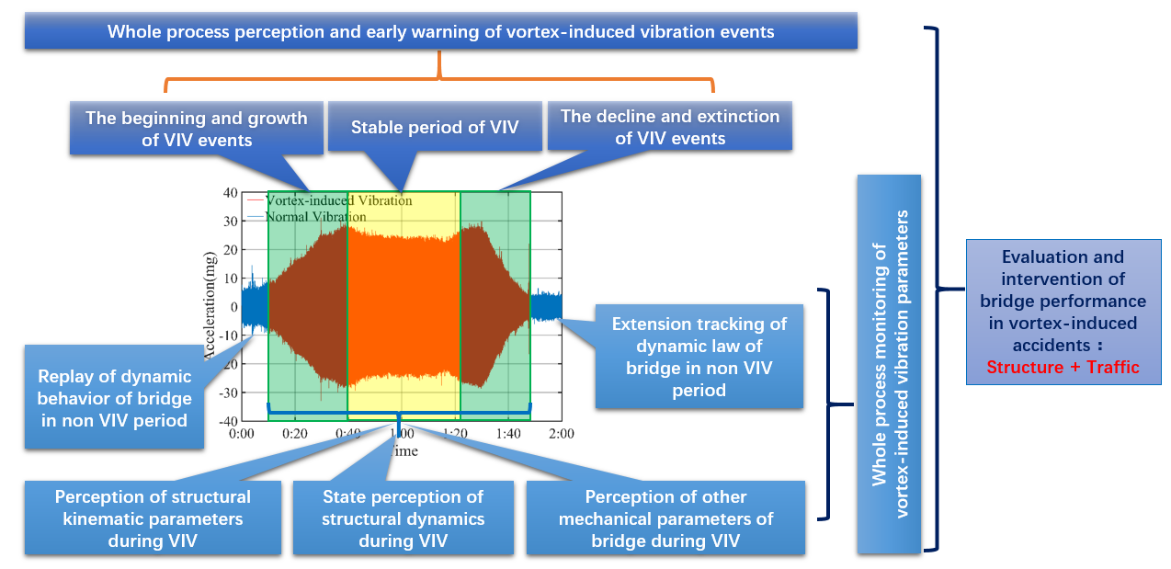
Fig. 1: Comprehensive monitoring and perception of bridge VIV events
  - Qualitative perception of VIV events based on VIV index
In order to realize the whole process perception of the "nature" of VIV events, it is necessary to define a VIV index to distinguish VIV from non VIV, mark the whole process of VIV events, and quantify the strength of VIV. This VIV index can be defined according to the single-mode characteristics of the vibration response signal.
We do Hilbert transform on signal $u(t)$:
$$\begin{aligned}v\left(t\right)=H\left(u\left(t\right)\right)\#\left(5\right)\end{aligned}$$
Where $H(∙)$ is the transform operator.
Then the analytic signal $z(t)$ can be obtained:
$$\begin{aligned}z\left(t\right)=u\left(t\right)+iv\left(t\right)=A\left(t\right)e^{iΦ\left(t\right)}\#\left(6\right)\end{aligned}$$
Where i is the imaginary unit; its amplitude and phase are respectively $A(t)$ and$Φ(t)$, which are given by the following formula:
$$\begin{aligned}A\left(t\right)=a\left(t\right)=a_{0}+\sum_{m=1}^{M}{a_{m}\cos\left(ω_{m}t+ϕ_{m}\right)}\#\left(7\right)\end{aligned}$$
$$\begin{aligned}Φ\left(t\right)=ωt+ϕ\left(t\right)\#\left(8\right)\end{aligned}$$
Under the condition of $ω_{m}≪ω$, the radial variation of the trajectory of analytical signal $z(t)$ is far less than the circumferential variation, so its trajectory approximately presents circular motion in a short time; if this condition is not met, the trajectory of $z(t)$ will present a chaotic shape far away from the circle. Therefore, the VIV index can be defined as the ratio $Rratio$ of the minimum amplitude $A_{min}$ and the maximum amplitude $A_{max}$ of the analytical signal in a given sampling time $T_{s}$:
$$\begin{aligned}Rratio=\frac{A_{min}}{A_{max}}\#\left(9\right)\end{aligned}$$
More generally, assume that there is only one AM component, then:
$$\begin{aligned}Rratio=\frac{A_{min}}{A_{max}}=\frac{a_{0}-a_{m}}{a_{0}+a_{m}}\#\left(10\right)\end{aligned}$$
It can be seen that the index $Rratio$ is a number between 0 and 1. Within the specified time $T_{s}$, the closer $Rratio$ to 0, the farther the signal is away from the single-mode narrow-band signal characteristics, and the closer $Rratio$ to 1, the more obvious the single-mode narrow band feature of signal is.
Considering the characteristics of VIV response signal in general cases. On the one hand, the signal is single-mode, which means only one mode has a high signal-to-noise ratio, and the other modes are submerged in the noise level; on the other hand, the amplitude change rate of single-mode is far less than the phase change rate. Therefore, the trajectory of Hilbert's analytic signal of vortex response is approximately circular in one period. In the case of non VIV, the signal contains multiple modal components and large noise interference, and the trajectory of the analytical signal will be far away from the circular chaotic shape. Two simple numerical examples are given in Fig. 2. The trajectory of the ideal analytical single-mode tuning signal is shown in Fig. 2(a), and Fig. 2(b) shows the trajectory of the tuning analytic signal containing two modes. It can be seen from the figure that in one period, the single-mode trajectory presents a standard circle, while the multi-mode trajectory presents an irregular shape.
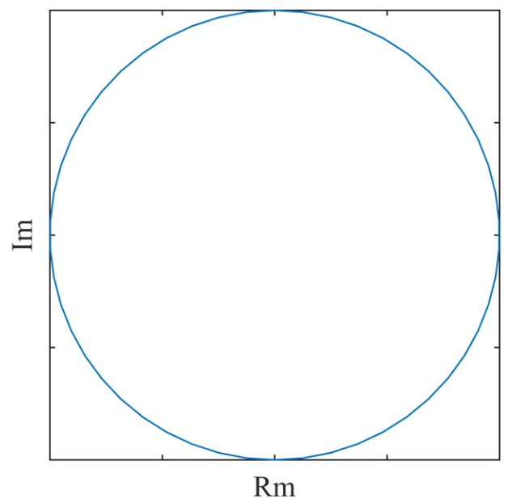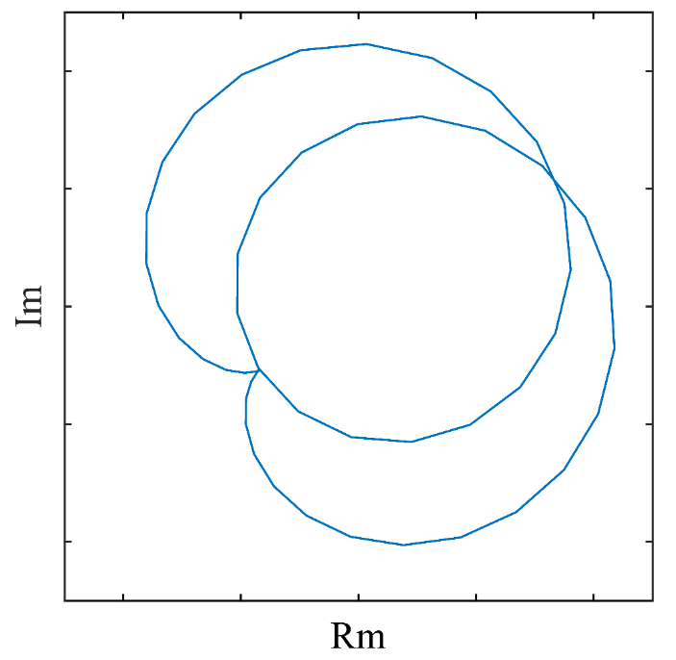
(a) | (b)
Fig. 2: Trajectories of ideal analytic signals. (a) Single-mode. (b) Multi-mode.

It can also be seen from Fig. 2 that in a shorter sampling time (less than one period), the trajectory of ideal analytical single-mode signal approximately moves in a circle, and the VIV index $Rratio$ given by Eq. 9 has good single-mode characterization ability. The $Rratio$ value of theoretical single frequency constant amplitude sinusoidal vibration is 1, while the ratio value of the multi-mode signal is far less than 1, and the trajectory changes greatly with time, there is no regular pattern for the multi-mode signal.

In the actual state of bridge VIV, although the vibration response presents a single-mode due to the frequency locking effect, the interference of other modes and noise still exists, so the VIV index $Rratio$ will fluctuate slightly around a number less than 1; in the case of non VIV, the bridge vibrates under the coupling influence of traffic load and environmental random vibration, and the vibration response signal is multi-mode under the background of broadband noise, Its $Rratio$ should fluctuate at a low level close to 0. Therefore, the state of VIV and non VIV can be distinguished by setting multi-level threshold, and the strength characteristics of VIV can also be qualitatively judged by the value of the index.
  - Quantitative perception of VIV events
In addition to the qualitative understanding of VIV events, the quantitative perception and measurement of various parameters describing VIV events are also the requirements of VIV control and safety warning. It is necessary to further identify these parameters based on the acceleration vibration monitoring data on the main girder of suspension bridge.
Acceleration is a parameter to describe the strength of vibration, but from the perspective of engineering, researchers prefer to get the dynamic displacement value of vibration, which belongs to the category of kinematic parameters. The technology of direct monitoring dynamic displacement includes camera measuring method, GPS observation method, linear variable differential transformer (LVDT) etc. Because of their shortcomings of insufficient measurement accuracy, high cost, poor real-time performance and the need for fixed displacement observation reference point, those methods can not meet the displacement monitoring requirements of long-span bridges. Another method of estimating the amplitude of VIV displacement is carried out in conjunction with wind tunnel tests. The aerodynamic parameters of the real bridge can be estimated firstly via wind tunnel tests, and then to establish the single degree of freedom dynamic equation of the real bridge to calculate the VIV amplitude of the bridge under the frequency locking condition [18 - 19]. Due to the lack of model accuracy and time-varying parameters, the prediction accuracy is poor.
For long-span bridge health monitoring systems, it is more common to choose acceleration sensors for vibration monitoring. This is not only because acceleration sensor technology can well meet the needs of bridge engineering vibration monitoring, but also because it has the advantages of low price and convenient installation and maintenance. Therefore, the structural displacement can be obtained by acceleration integral. This method can be divided into two categories: frequency domain integration and time domain integration. Because of Fourier transform and inverse transform operation, the frequency domain integration results in large truncation error. The time domain integration method directly processes the acceleration signal, but there are always problems of baseline drift and noise interference, and the acceleration integration algorithm based on signal batch processing can not realize the on-line real-time measurement of VIV. Therefore, the online time domain acceleration integration algorithm is needed to monitor the VIV displacement. As the key of VIV monitoring, it will be discussed in detail later.
Besides the dynamic displacement of the measuring points, it is also necessary to monitor the movement posture parameters of the whole bridge in real time. For long-span suspension bridges, real-time monitoring of torsional motion of cross-section is an important monitoring content related to structural safety. Therefore, It is necessary to arrange three vibration acceleration sensors at the same time in each control section of the main girder of suspension bridge, two of which are arranged on both sides and the other is a transverse acceleration sensor. Through the online acceleration integration technology, the real-time synchronous displacement in the corresponding direction of each measuring point is obtained, and then the translational, pitching and torsional angles of each section are obtained through the geometric relationship, forming the monitoring of the motion attitude of each section; the spline curve interpolation technology can realize the real-time monitoring of the longitudinal motion attitude of the whole bridge during the VIV of the bridge.
In addition to the kinematic parameters of VIV events, the description parameters of VIV events also include amplitude, phase, locking frequency etc. In fact, the dynamic displacement signal obtained by integration can be transformed by Hilbert transform to obtain the analytical signal of displacement response, and then those above parameters can be calculated by using the properties of the analytical signal. More specifically, $u(t)$ and $v(t)$ are the real part and imaginary part of the analytical signal corresponding to the integral displacement signal, then the instantaneous phase $Φ(t)$ of VIV is given by:
$$\begin{aligned}Φ\left(t\right)=\tan^{-1}\left(\frac{v\left(t\right)}{u\left(t\right)}\right)\#\left(11\right)\end{aligned}$$
The instantaneous frequency $f(t)$ can be calculated by calculating the first derivative of instantaneous phase with respect to time:
$$\begin{aligned}f\left(t\right)=\frac{dΦ\left(t\right)}{2πdt}\#\left(12\right)\end{aligned}$$
The real-time amplitude $A_{t}$ of bridge during VIV can be obtained by calculating the modulus of the real and imaginary parts of the analytic signal in the complex field:
$$\begin{aligned}A\left(t\right)=\sqrt{u^{2}\left(t\right)+v^{2}\left(t\right)}\#\left(13\right)\end{aligned}$$
Certainly, the displacement signal obtained by integration can be used for the quantitative perception of the VIV events and parameters measurement. The advantage is not only that the process is simplified and the amount of calculation is saved, but also that the noise level of the signal is reduced after the numerical integration process, which leads to a significant improvement in the identification quality of the VIV index $Rratio$ and those description parameters of the VIV events.
  - Online monitoring and perception scheme for VIV events
In fact, both the integral algorithm of acceleration and the Hilbert transform algorithm are batch processing algorithms, which need to complete a certain length of acceleration signal sampling. In other words, the batch processing algorithm not only has poor real-time performance, but also has a large amount of calculation, which is not suitable for an online monitoring environment, and can not meet the requirement of real-time online warning of VIV events.
In order to realize online monitoring, perception and early warning of VIV events of suspension bridge, it is necessary to design a set of data processing scheme for real-time acceleration to calculate the VIV index and parameters, and realize the target of early warning and whole process tracking of VIV events based on the index. The core of this data processing scheme is to replace the batch acceleration integral algorithm and the Hilbert transform algorithm with the online recursive algorithm, which has the advantages of real-time and high efficiency. Fig. 3 shows the diagram of this data processing scheme.

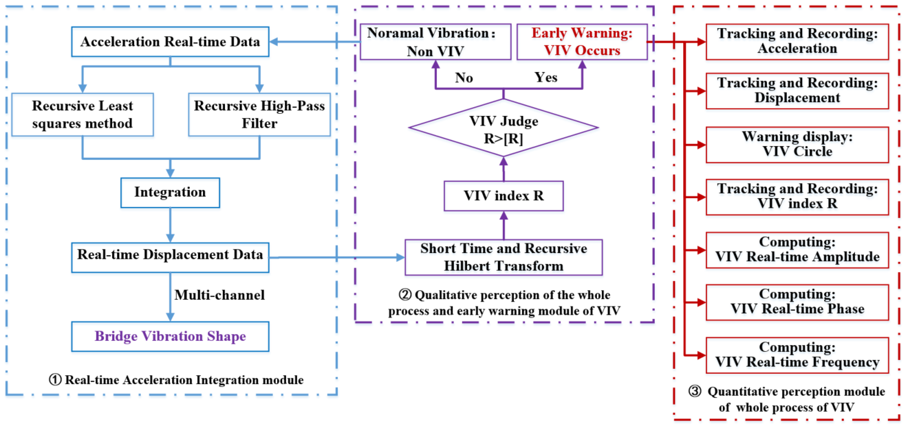
Fig. 3: Diagram of the real-time online data processing scheme for bridge VIV events.

In the online data processing scheme given in Fig. 3, the whole process can be divided into three main functional modules:
  - Real-time acceleration integral module;
  - Qualitative perception and early warning module;
  - Quantitative perception module of the whole process parameters of VIV event.
The real-time acceleration integral module is used to realize real-time online calculation of dynamic displacement. The calculation frequency of the displacement signal can be the same as the acceleration sampling frequency, or it can be an integer numerator. This module can be realized by using the real-time acceleration integral algorithm proposed by Zheng et al. [13]. In this method, recursive least square method is used for baseline correction, recursive high pass filter is used to filter the low-frequency noise in the monitoring acceleration signal, and then the acceleration is integrated. Zheng et al. has verified the effectiveness of the algorithm in many ways. Therefore, this paper will only show the parameter configuration and performance performance of the algorithm in the application of VIV monitoring.
The qualitative perception and early warning module is responsible for a short-time recursive Hilbert transform and deep processing of real-time dynamic displacement signal. The complex plane analytical signal of the dynamic displacement is obtained, and then the VIV index $Rratio$ is calculated within the specified time, finally, the VIV is judged online based on the index. The short-time recursive Hilbert algorithm is the core of this module, which will be introduced in the next section.
The quantitative perception module is to calculate all kinds of parameters of VIV events online and in real-time, including kinematic parameters and dynamic parameters. In this module, the real-time acceleration and displacement are displayed; and the trajectory of analytic signal in complex plane and VIV index $Rratio$ are tracked in real time; the real-time frequency, phase and amplitude of the bridge during VIV are further output. The specific on-line calculation method will be introduced in the next section.

Key technologies of VIV real-time monitoring
  - Acceleration integral algorithm and key parameters
In order to understand the real-time displacement and the motion attitude of the bridge during VIV, it is necessary to integrate the real-time acceleration of the synchronous multi-point acceleration monitoring signals of the bridge. As mentioned above, the real-time acceleration integration algorithm proposed by Zheng et al. is adopted. Firstly, the sampling frame and calculation frame of acceleration integration need to be determined. The length of the sampling frame depends on the real-time requirement of the displacement result, which can be taken as an integral multiple of the sampling period of acceleration sensor. The length of the calculation frame depends on the calculation accuracy and the computing ability of the computer equipment. The longer the calculation frame is, the higher the quality of the calculation result is. In the integration process, the total length of the calculation frame is unchanged and updated dynamically by adding the latest acceleration sampling frame into the calculation frame and discharging the oldest sampling frame. The algorithm first uses the least square method to fit the potential baseline of the calculation frame and correct it, then uses the high pass filter to eliminate the low-frequency noise, and finally carries out the time-domain integration. By repeating the above operations twice, the velocity and displacement of the same length of the sampling frame can be obtained in turn, and the real-time online integration based on the acceleration monitoring data can be realized.
The key to the implementation of this method is how to eliminate the noise in the acceleration monitoring signal and reduce the manual intervention as much as possible to achieve the real-time online performance of the algorithm. According to the research of Kanamori and Shanks et al. [20,21], the following recursive high pass filter is selected:
$$\begin{aligned}y_{j}=\frac{1+q}{2}\left(x_{j}-x_{j-1}\right)+qy_{j-1}\#\left(14\right)\end{aligned}$$
Where $x_{j}$ and $y_{j}(j=1,2,3…)$ are the input and output signal respectively, $q$ is the filter parameter, and $q∈(0,1)$.
The transfer function amplitude $H(ω)$ of the filter can be express as :
$$\begin{aligned}H\left(ω\right)=\frac{1+q}{2}\frac{1-e^{-iωΔt}}{1-qe^{-iωΔt}}\#\left(15\right)\end{aligned}$$
Where $ω$ is the filtering frequency, $△t$ is the sampling time interval. For the sensor equipment of bridge health monitoring system, this value is the fixed value; e is the natural constant.
In order to ensure the accuracy of integration, the value of $H(ω)$ should be as close as possible to 1, usually $|H\left(ω\right)|$ is chosen in the range of 0.97~0.99; therefore, the effect of the filter is mainly controlled by the parameters of $ω$ and $q$. The filter parameter $q$ can be determined by setting the concerned filter cutoff frequency $ω_{c}$. And then use equation (6) to eliminate the low-frequency noise online. For a long-span suspension bridge, the first order natural frequency $f_{s}$ of the bridge can be calculated to determine the filter cutoff frequency $f_{c}$:
$$\begin{aligned}f_{c}=αf_{s}\#\left(16\right)\end{aligned}$$
Where $α$ is the filtering proportion coefficient, which can be set in the range of $1/5\sim 1/3$ for long-span bridges. In this range, the filter can completely remove the low-frequency noise in the vibration signal, while retaining the structural vibration information.
  - Real-time recursive Hilbert transform and overcoming its end effect
Taking the displacement data$u\left(t\right)$ obtained by integration as the real part and its Hilbert transform $v\left(t\right)$ as the imaginary part, the analytic signal is constructed as:
$$\begin{aligned}z\left(t\right)=u\left(t\right)+iv\left(t\right)\#\left(17\right)\end{aligned}$$
Where $v(t)$ is the Hilbert transform of the time domain signal $u\left(t\right)$, $v\left(t\right)=H(u(t))$, and $i$ is the imaginary unit.
For discrete monitoring data, the continuous signals $u\left(t\right)$ and $v(t)$ can be expressed by the discrete forms $u\left(n\right)$ and $v(n)$, $n=0,1,…,N-1$, where $N$ is the length of the calculation frame.
The discrete Hilbert transform impulse response operator $h\left(m\right)$ can be obtained by the inverse transform of discrete Fourier transform operator $H(n)$:
$$\begin{aligned}h\left(m\right)=\frac{1}{N}\sum_{n=0}^{N-1}{H\left(n\right)e^{iω}}=\frac{1}{N}\sum_{n=0}^{N-1}{-i sgn\left(\frac{N}{2}-n\right)sgn\left(n\right)e^{iω}}=\frac{2}{N}\sum_{n=1}^{\frac{N}{2}-1}{\sin\left(ω\right)}\#\left(18\right)\end{aligned}$$
Where $m=0,1,…,N-1$; $ω=2πmn/N$, $sgn\left(.\right)$ is the sign function.
Furthermore, the closed form of impulse response $h(m)$ can be express as:
$$\begin{aligned}h\left(m\right)=\frac{2}{N}\sin^{2}\left({πm}/2\right)\cot\left({πm}/N\right)\#\left(19\right)\end{aligned}$$
So the Hilbert transform of discrete displacement signal can be defined as:
$$\begin{aligned}v\left(m\right)=u\left(m\right)⊗h\left(m\right)=u\left(m\right)⊗\left[\frac{2}{N}\sin^{2}\left({πm}/2\right)\cot\left({πm}/N\right)\right]\#\left(20\right)\end{aligned}$$
Where, $⊗$ is the convolution operator. The convolution $y(m)$ of any discrete signal $x_{1}\left(m\right)$ and $x_{2}\left(m\right)$ is defined as follows:
$$\begin{aligned}y\left(m\right)=x_{1}\left(m\right)⊗x_{2}\left(m\right)≜\sum_{n=0}^{N-1}{x_{1}\left(n\right)x_{2}\left(m-n\right)}\#\left(21\right)\end{aligned}$$
Therefore, the Hilbert transform formula corresponding to each discrete signal point of the current calculation frame $\left\{u\left(n\right)\right\},n=0,1,…,N-1$ is obtained:
$$\begin{aligned}v\left(m\right)≜\sum_{n=0}^{N-1}{u\left(n\right)h\left(m-n\right)}\#\left(22\right)\end{aligned}$$
According to the definition, the results of Hilbert transform at time points $N-1$ and $N$ can be obtained:
$$\begin{aligned}v\left(N-1\right)≜\sum_{m=0}^{N-1}{u\left(m\right)h\left(N-1-m\right)}\#\left(23a\right)\end{aligned}$$
$$\begin{aligned}v\left(N\right)≜\sum_{n=0}^{N-1}{u\left(n\right)h\left(N-1-n\right)}\#\left(23b\right)\end{aligned}$$
Where $m=n+1$, which represents the input of the new sampling frame and the output of the last sampling frame, the recursive Hilbert transform can be written as:
$$\begin{aligned}v\left(N\right)-v\left(N-1\right)=\sum_{n=0}^{N-1}{h\left(N-1-n\right)u\left(n\right)}-\sum_{m=0}^{N-1}{h\left(N-1-m\right)u\left(m\right)}\#\left(24\right)\end{aligned}$$
Thereupon,
$$\begin{aligned}v\left(N\right)=v\left(N-1\right)+h\left(0\right)u_{new}-h\left(N-1\right)u_{old}+\sum_{m=1}^{N-1}{\left[h\left(N-m\right)-h\left(N-m-1\right)\right]u\left(m\right)}\#\left(25\right)\end{aligned}$$
Where$h\left(N-1\right)$，$h\left(0\right)$，$h\left(N-m+1\right)-h\left(N-m\right)$ are constants. In the calculation process, only the last calculation result $v\left(N-1\right)$ of the previous step needs to be saved. According to the dynamic update of the sampling frame, the recursive calculation can be completed by inputting the latest sampling frame $u_{new}$, discharging the value of the last sampling frame $u_{old}$ and dynamically updating the value of the intermediate frame $u\left(m\right)$. This is the recursive Hilbert transform algorithm based on sampling points, as shown in Fig. 4.
Fig. 4: Diagram of the recursive Hilbert transform algorithm.

In the existing batch processing algorithm of discrete signal Hilbert transform, $N$ data points need to be generated at the same time in one calculation, and its amount of multiplication is $N^{3}$, which means the amount of multiplication for each data point is $N^{2}$. In contrast, the recursive algorithm based on sampling points only generates one data point at a time, which keeps the calculation frequency the same as the sampling frequency of the signal, and the amount of calculation is ${(N-1)}^{2}+2$. When $N$ is large, its computational amount is greatly reduced compared with the batch processing algorithm. It is very suitable for the online environment that needs to ensure the quality of Hilbert transform and real-time calculation.
The above recursive algorithm can be further improved to the block-based recursive formulation. Which means several sampling points compose a sampling frame, and the calculation frame is composed of several sampling frames. In this method, the calculated frames are recombined by inputting the sampled frames in real time, and then the signal is calculated in each sampled frame instead of each sampled point. The advantage of this method is that it can adjust the output speed of the calculation results and the single step time of calculation to ensure that it is less than the acquisition time of the sampling frame to meet the real-time requirements.
Compared with the batch Hilbert transform algorithm and the recursive Hilbert transform algorithm, although both algorithms can realize the calculation of analytical signal, and then can both be used for VIV identification and VIV index calculation, but due to the existence of Gibbs end effect, there are still some differences in the processing quality between the two algorithms. The Gibbs end effect means that when the Hilbert transform is carried out, the analytic signal trajectory will deviate from the standard circle trajectory obviously at the end and the head parts, and its signal amplitude (the modulus of analytic signal) also fluctuates at the end.
The block-based recursive Hilbert transform algorithm can simultaneously process and weaken the end effect in each real-time calculation step. Specifically, in the initialization stage, the batch Hilbert transform is used to get the calculation result of the first calculation frame. Then, input the new sampling frame, and the corresponding analytic signal is obtained by recursive Hilbert transform. After eliminating the front-end fluctuation segment of the analytic signal, the remaining stable segment is used to connect to the iteration step, to achieve dynamic and more stable update and calculation.

Numerical validation
A sinusoidal acceleration signal with a frequency of 0.2268Hz and sampling time interval $△t=0.02s$ is constructed to illustrate the feasibility of the real-time online bridge VIV intelligent perception scheme.
$$\begin{aligned}a_{i}=\sin\left(0.4536π×0.02i\right),i=1,2,3…\#\left(26\right)\end{aligned}$$
The theoretical velocity and displacement are as follows:
$$\begin{aligned}v_{i}=-\frac{\cos\left(0.4536π×0.02i\right)}{0.4536π},i=1,2,3…\#\left(27\right)\end{aligned}$$
$$\begin{aligned}d_{i}=-\frac{\sin\left(0.4536π×0.02i\right)}{{\left(0.4536π\right)}^{2}},i=1,2,3…\#\left(28\right)\end{aligned}$$

  - Integration of ideal sine acceleration signal
For the ideal sine acceleration signal, the filtering cutoff frequency less than the first natural frequency can meet the filtering requirements. Therefore, the high pass filter cutoff frequency $f_{c}=0.11Hz$ is selected, recursive filter parameter $q=0.997$, transfer function amplitude $\left|H\left(ω\right)\right|=0.975$. The integration results show that there is a time lag of 0.22s and an amplitude attenuation of 1.8% between the integral displacement and the theoretical displacement. Because the calculation frame length of acceleration is insufficient at the beginning of the calculation, the calculation can be started by filling a large number of zeros at the front end of the data. After the initial calculation for about 60 s, the program can get stable integration results. It can be seen from the calculation of integration error (Fig. 5(b)) that the acceleration integration error keeps at a low level after 60 s. The expression of integral error is as follows:
$\begin{aligned}Err\left(t\right)=\frac{\left|D_{e}\left(t\right)-D_{t}\left(t\right)\right|}{\max\left(D_{t}\left(t\right)\right)}\#\left(29\right)\end{aligned}$
Where $D_{e}(t)$ is the integral displacement at time $t$ after phase correction, $D_{t}(t)$ represents the theoretical displacement at time $t$, $max⁡(D_{t}(t))$ represents the theoretical displacement amplitude of the sinusoidal acceleration signal.
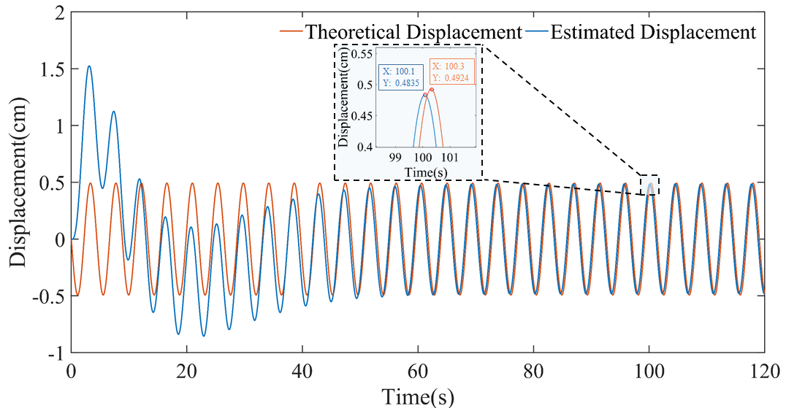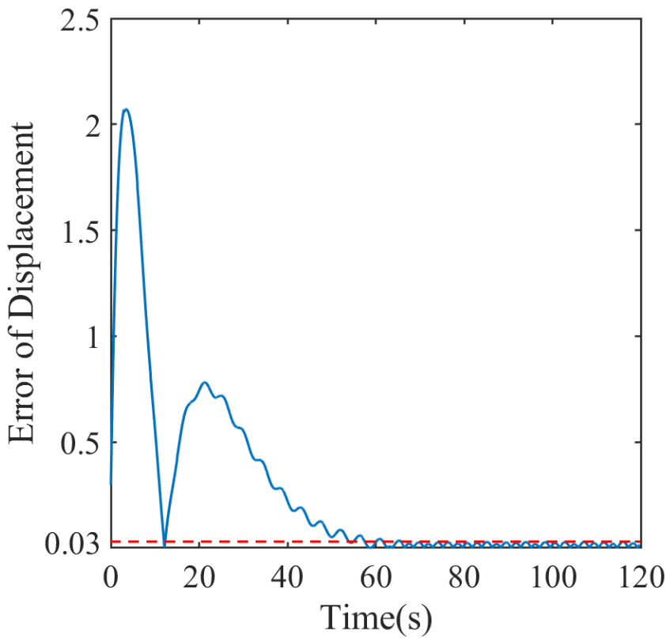
(a) | (b)
Fig. 5: (a) Integral displacement and theoretical displacement of sinusoidal signal. (b) Displacement integral error.
  - “VIV event” recognition of ideal sinusoidal signal
Noise with different signal-to-noise ratio is added to the ideal sinusoidal acceleration signal to simulate the single-mode narrow-band acceleration response signal of the structure during VIV, and it is used to test the effectiveness of the VIV perception schema proposed in this paper. Firstly, the noisy acceleration signal needs to be integrated into the displacement signal on line, then the analytical signal is obtained by recursive Hilbert transform, and finally the VIV parameters are identified according to the previous method. In the calculation, it is necessary to eliminate a large error section in the initial stage of integration and select the integral displacement signal from 60s to 120s for calculation.
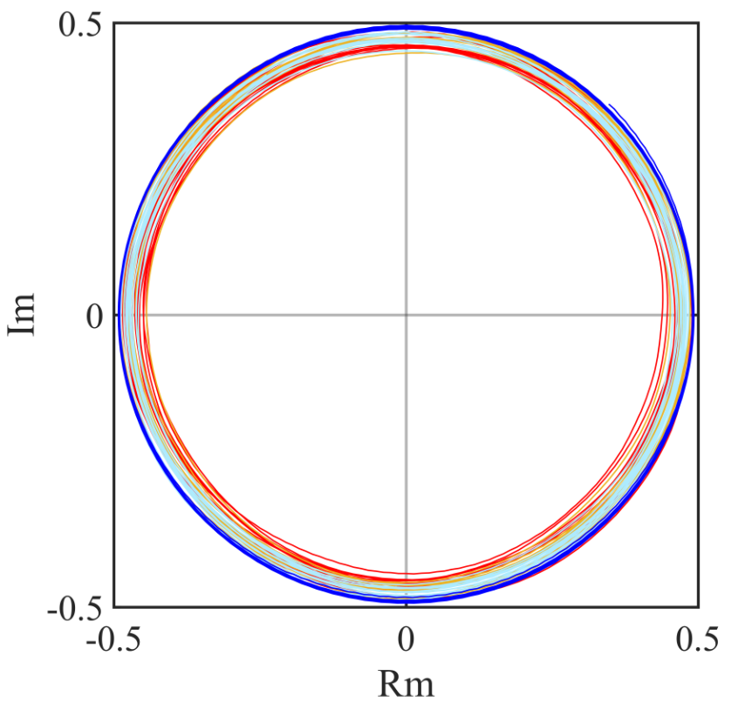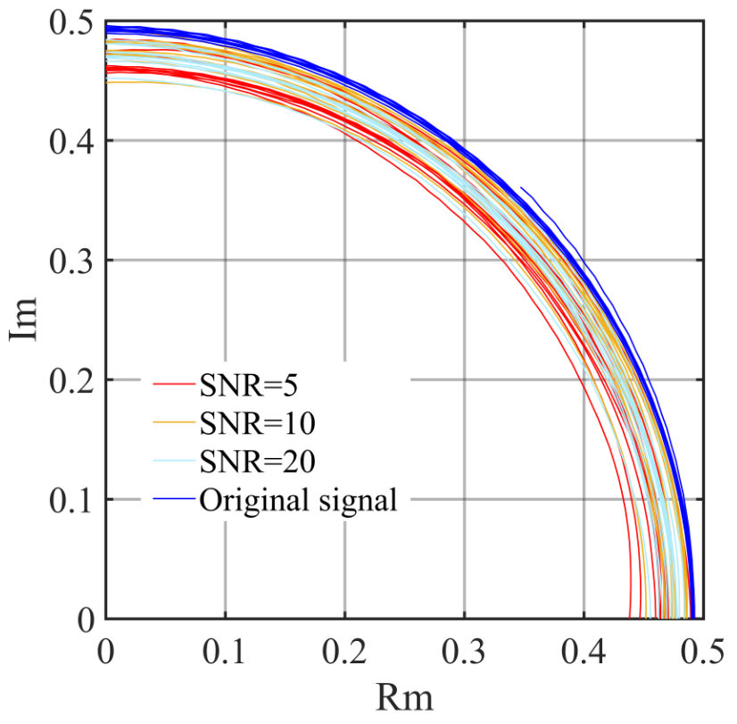
(a) | (b)
Fig. 6: (a) Complex plane analytic signal trajectories. (b) local trajectories.

Fig. 6(a) shows the trajectories of the analytical signal in the selected stage, the coordinates of each sampling point in the figure are given by its real and imaginary parts, and Fig. 6(b) shows an enlarged view of its partial trajectories. It can be seen from the figure that the trajectory of the analytical signal after Hilbert transform of the standard sinusoidal signal is a standard circle, which can be used for VIV identification intuitively and accurately. Although the VIV circle extracted by Hilbert transform has a certain offset after adding Gaussian white noise with SNR = 5, SNR = 10 and SNR = 20 to the ideal sinusoidal signal, but overall, the VIV index $Rratio$ is still close to 1, and the recognition error decreases with the increase of SNR. This shows that the proposed VIV index can well express the characteristics of the single-mode narrow-band signal.
  - Comparison of results between recursive Hilbert transform and batch Hilbert transform
For the purpose of comparing the processing effect of traditional batch Hilbert transform and recursive Hilbert transform proposed in this paper, we selected a 120 second integral displacement signal to calculate the corresponding analytical signal when the displacement error is small enough. The trajectories obtained by two algorithms after deducting the Gibbs end effect are shown in Fig. 7. The outer red envelope circle is the batch processing method to identify the VIV circle, and the inner multi-color VIV circle is the recursive processing result, each color represents the input and calculation result of one sampling frame, the length of frame $N=50$.

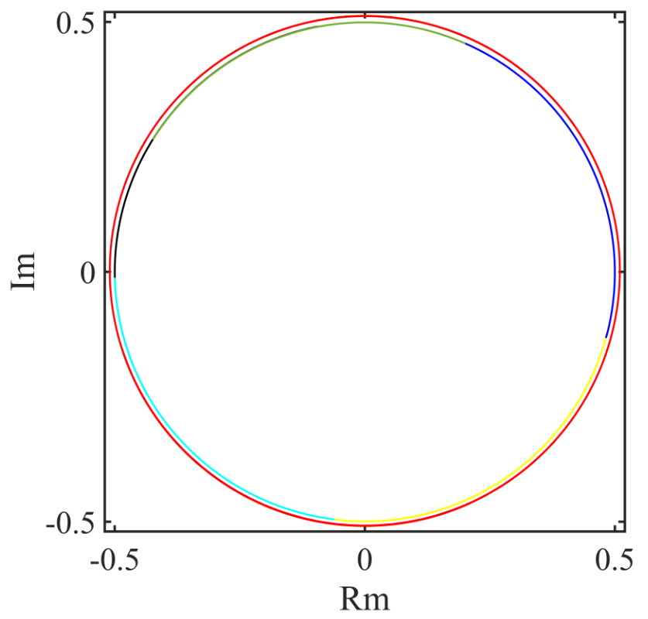
Fig. 7: Vortex circle of batch Hilbert transform and recursive Hilbert transform.

In Fig. 7, the batch processing results are slightly enlarged to distinguish the calculation results of the two methods. Actually, the VIV circles processed by the two methods are completely coincident. It also can be seen from this figure that the trajectories of the analytical signals obtained by the two algorithms are all standard circular curves. This proves from another aspect that the two methods can be used to recognize the perception of VIV events, but because of the better real-time performance of recursive algorithm, it is more suitable for the online monitoring condition.
The time-varying amplitude of the analytical signal obtained by the two methods is plotted in Fig. 8. Fig. 8(a) shows the amplitude time history curve of 120 second analytical signal obtained by batch processing algorithm. Theoretically, the ideal amplitude of the sinusoidal signal after Hilbert transform should be 1, but the amplitude curve in Fig. 8(a) shows large fluctuation at the end. The fluctuation amplitude gradually decreases from the end to the middle, the length of the significant fluctuation part at both ends accounts for about 75% of the total length, and a small section (about 30 seconds) curve in the middle basically approaches 1. The distortion of the amplitude caused by the end effect will obviously lead to the distortion of VIV index calculation, even worse, it will lead to the deviation of VIV identification. As we can see, only a small section of processing results in the middle can be used for VIV index calculation. Although the proportion of the end wave segment decreases when the signal becomes longer, it will cause a rapid increase in the amount of calculation, which limits its application in practice.
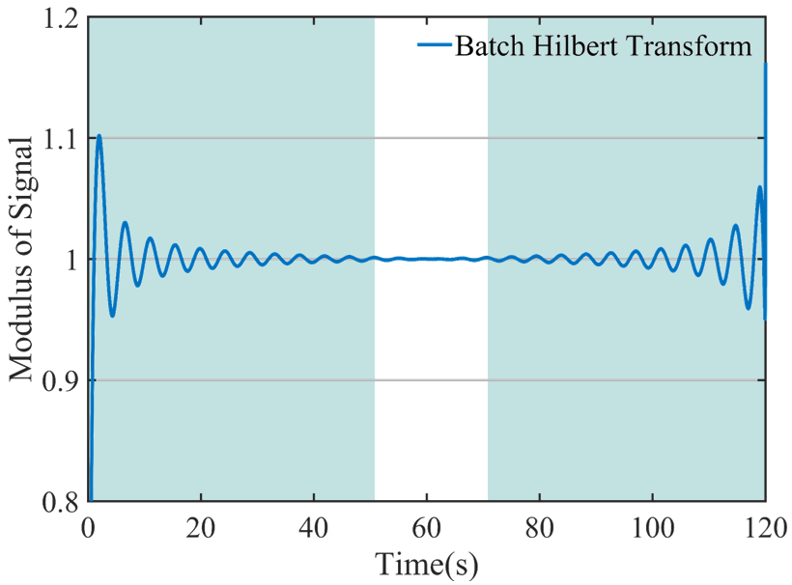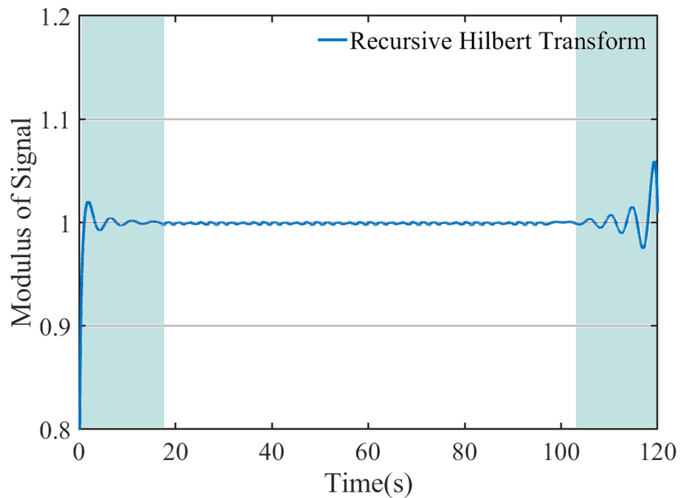
(a) | (b)
Fig. 8: Comparison of end effects between the two algorithms. (a) Signal modulus of batch Hilbert transform. (b) Signal modulus of Recursive Hilbert transform.

Fig. 8(b) shows the processing results of the module of the analytical signal by block-based recursive Hilbert transform algorithm. Through the recursive Hilbert transform of ideal sinusoidal signal for many times, we found that when the calculation frame length is 2000, the sampling frame length is 50 and the deletion length of the front-end fluctuation segment of the signal result after each transformation is 300, the calculation result has high accuracy, and the length of the fluctuation segment is small. It can be seen from Fig. 8(b) that the module of signal processed by the block-based recursive method fluctuates only at the beginning and end of the initial and final calculation frames. Moreover, the length of the fluctuation segment is very short, and the proportion of the fluctuation segment will keep decreasing with the increase of the data calculation length.
It can be seen that the block-based recursive Hilbert transform has the following advantages: (1) the high accuracy and stability of this algorithm, it can be very accurate for VIV index calculation and VIV identification regardless of the signal length; (2) the calculation error range and error size are far smaller than the traditional batch Hilbert transform algorithm; (3) real-time calculation and analysis can be carried out with the continuous input of monitoring signal. The above three advantages are of great significance for the real-time online monitoring of engineering structures.
  - Calculation of ideal VIV signal parameters
After completing the VIV judgment, the parameters of VIV are calculated. Fig. 9(a) shows that the phase of theoretical sinusoidal VIV signal is a regular triangular waveform, and the signal period is always constant, $T=1/{f_{s}}=4.4s$. The frequency of the vibration signal can be stably output after the initial calculation for a period of time as shown in Fig. 9(b). this is mainly because the calculation frame for the instantaneous frequency is slightly longer than that in the acceleration integration process.
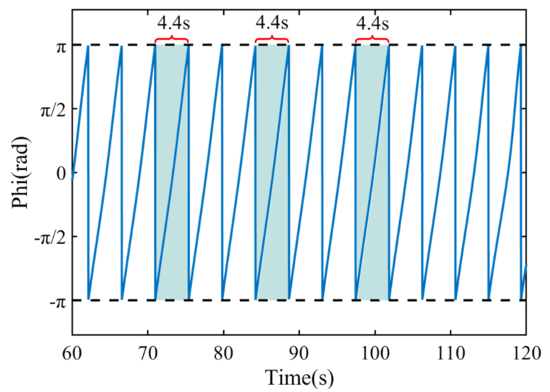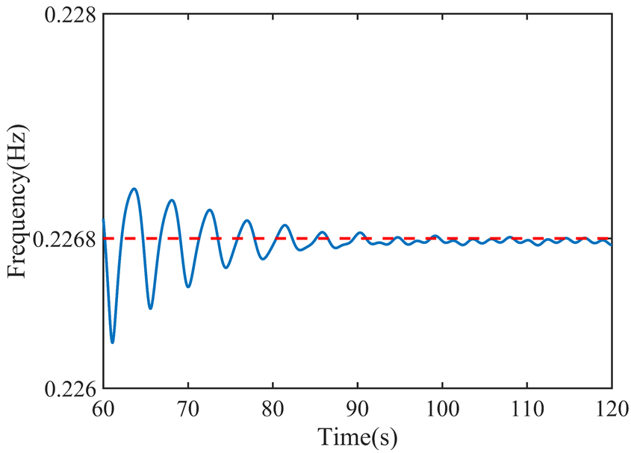
(a) | (b)
Fig. 9: (a)Instantaneous phase. (b) instantaneous frequency.

The real-time displacement signal and the standard circular trajectory in the complex plane are obtained by integrating the ideal sinusoidal acceleration signal and applying the block-based Hilbert transform, which shows that this method can identify VIV accurately and reliably. What’s more, the real-time phase and instantaneous frequency calculation of the numerical signal also show that this method can be used to measure the VIV accurately and reliably.

4. Practical application
Tiger-gate Bridge is a suspension bridge with a span of 302 + 888 + 348.5m. A severe VIV event occurred on the bridge on May 5, 2020. After taking some measures to suppress the vibration, there are still several VIVs occasionally. In order to know the VIV status of the bridge in time, the owner has installed a permanent health monitoring system on the bridge. The monitoring contents of VIV mainly include acceleration, wind velocity and wind direction. Seven bidirectional (vertical and horizontal) acceleration sensors are arranged at the eighth equinox on the upstream side of the main span, from V8 to V14 are vertical channels, H1-H7 are horizontal channels; and 7 vertical sensors are arranged at the eighth equinox on the downstream side of the main span, numbered V1-V7, as shown in Fig. 10. All sensors sample synchronously, and the sampling frequency is 50 Hz.
The system successfully monitored several subsequent VIV events and obtained the primary structural VIV response data. These valuable monitoring data create conditions for the research of the long-span suspension bridge VIV. This paper tries to use the acceleration monitoring data of the whole day on June 12, 2020 to verify our proposed monitoring, intelligent perception and early warning schema for bridge VIV event. Through preliminary observation, a VIV event with large amplitude and long duration occurred from 0:00 to 2:00 in the morning of that day.

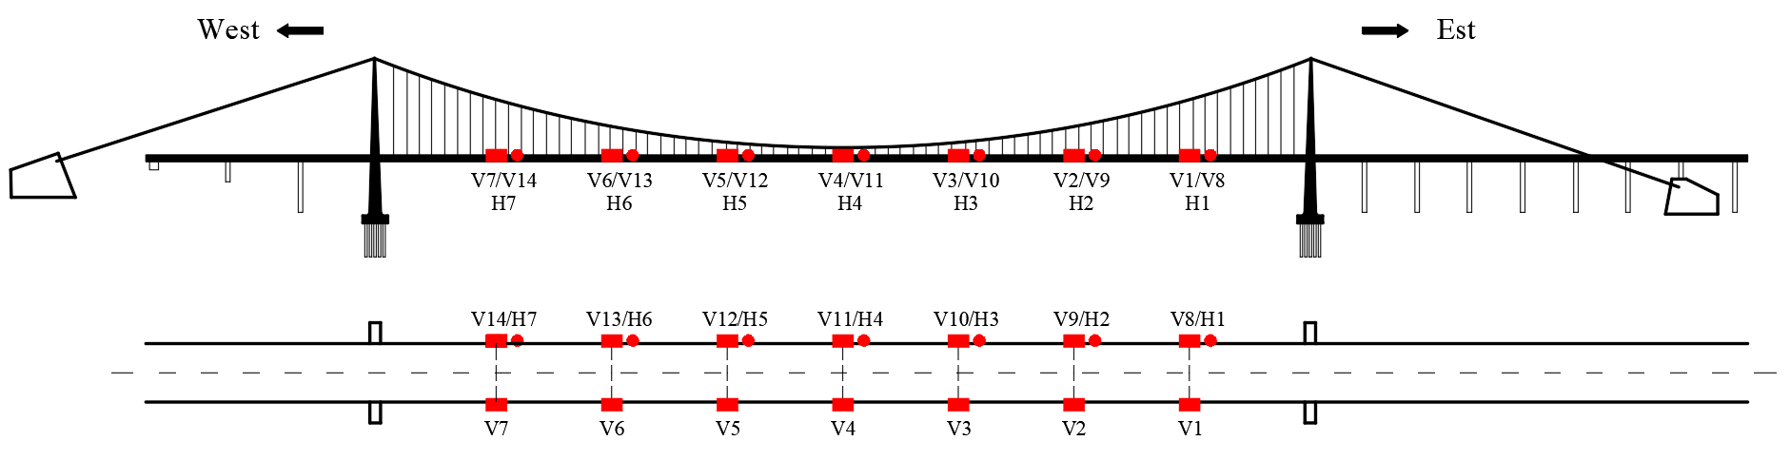
Fig. 10: Arrangement of acceleration sensors on Tiger-gate bridge.

  - Measurement of real-time displacement and full bridge vibration attitude
All the 24-hour acceleration monitoring data of the day is integrated firstly by the real-time acceleration integration algorithm mentioned in section 2.1. The acceleration time-history curve of acceleration V2 channel and the spectrums of its typical stages are shown in Fig. 11. It can be seen that the locking frequency of the structure during VIV $f_{s}=0.2268Hz$, the first order natural frequency of the structure is $f_{1}=0.1348Hz$. Based on these characteristic frequencies, through many attempts, the filter cutoff frequency is determined as $ω_{c}=0.1π$, which is far smaller than the fundamental frequency of the structure, moreover, the recursive filter parameter $q$ is set as 0.99; the transfer function amplitude $\left|H\left(ω\right)\right|=0.975$. Under these parameters, the accuracy of integration reaches the highest level.
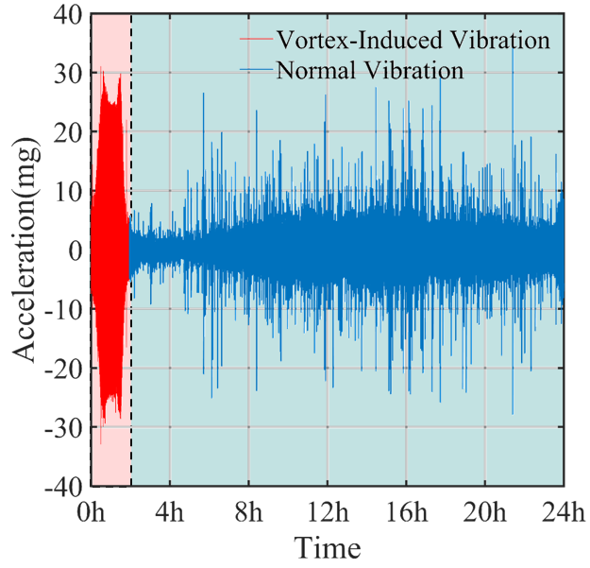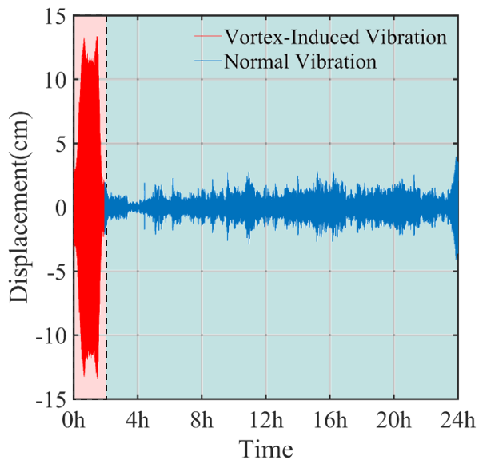
(a) | (b)
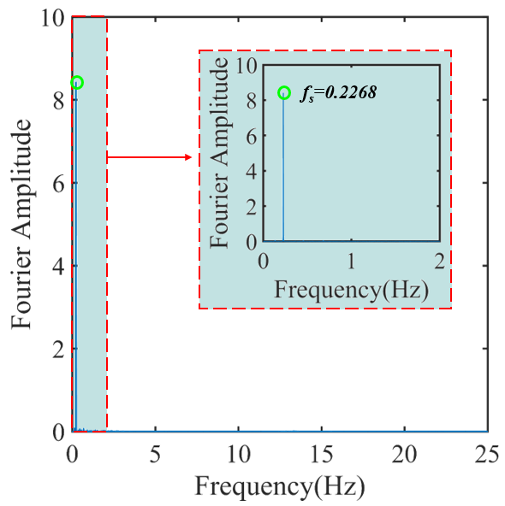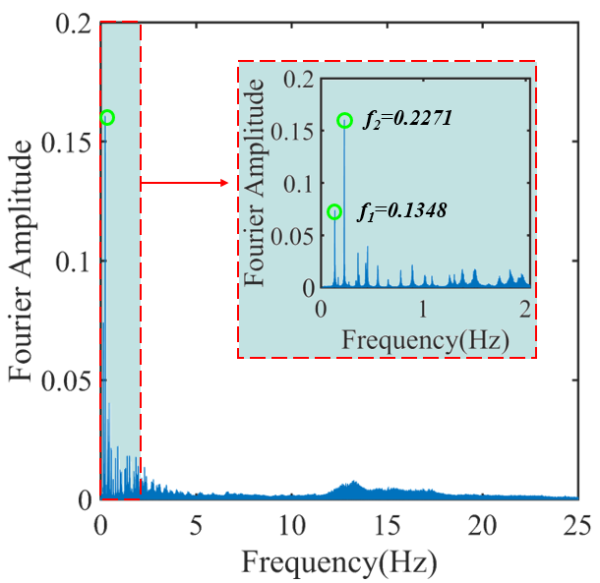
(c) | (d)
Fig. 11: (a) Acceleration time-history curve of V2 channel. (b) Displacement time-history curve of V2 channel. (c) Spectrum during VIV. (d) Spectrum during non VIV.

The real-time acceleration integration is operated on the acceleration data of V2 channel, and the 24-hour displacement time-history is obtained in Fig. 11(b). As we can see, the multiple recursive least squares algorithm realized the baseline correction and high pass filter well eliminated the low-frequency noise in the original acceleration signal. The integration result has no baseline drift, directly reflected in the mean displacement, which is close to 0. Furthermore, from the displacement time-history, we can preliminarily judge that VIV occurs from 0h and 2h as shown in Fig. 12(a), and we can roughly see the whole process of VIV generation, stable vibration and attenuation. More specifically, the acceleration amplitude of vortex stabilized section is about 25mg, and the integral displacement of stabilized section is about 12cm.
In order to compare the accuracy of the integral displacement, the displacement time-history obtained by the batch frequency domain integration method is also given in Fig. 12(b), which may be called the theoretical displacement. According to the single-mode vibration characteristics of VIV, the calculation formula of displacement $d$ obtained by frequency domain integration of batch processing can be given by the following formula:
$$\begin{aligned}d=\frac{a}{4π^{2}{\left(f_{s}+∆f\right)}^{2}}\#\left(30\right)\end{aligned}$$
Where $a$ is the acceleration signal of VIV, $f_{s}$ is the locking frequency, and $∆f$ is other interference frequency components.
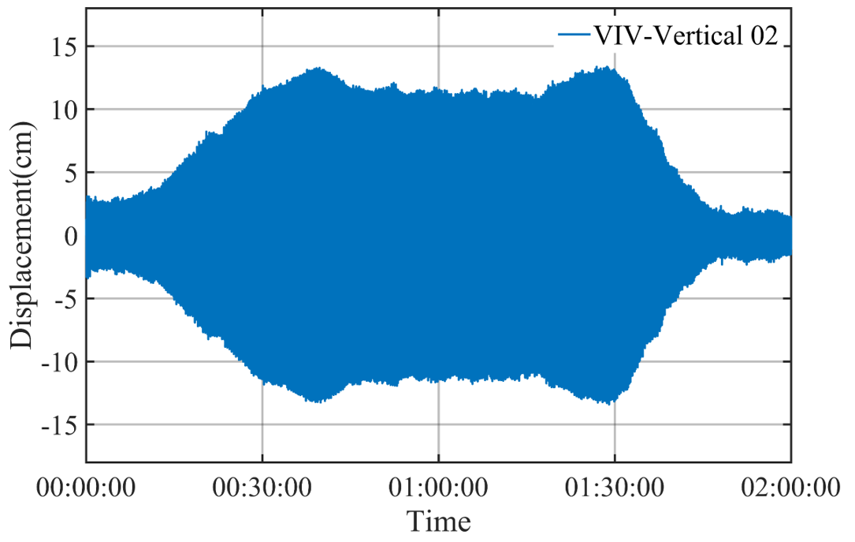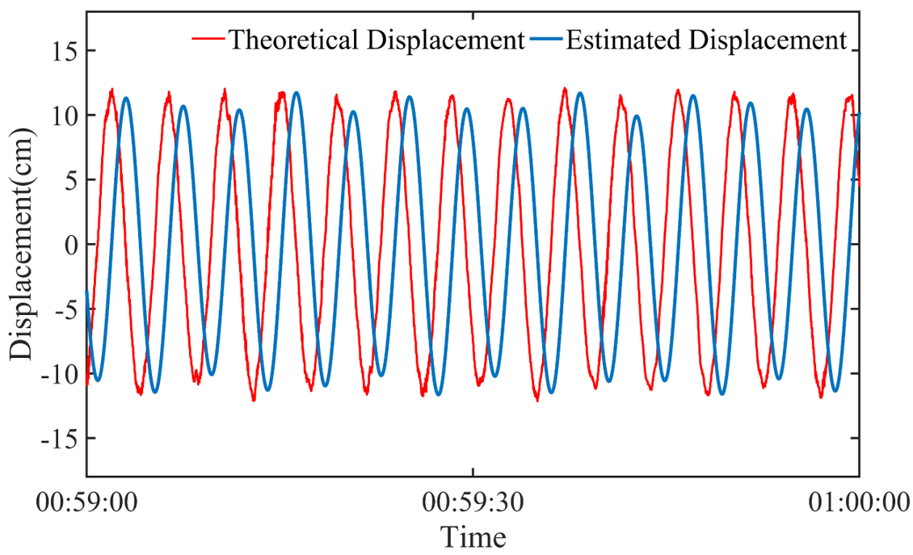
(a) | (b)
Fig. 12: (a) Displacement time-history curve during VIV period. (b) Comparison of integral displacement and theoretical displacement during VIV stability period.

Fig. 12(b) shows that the integral value is well consistent with the theoretical value in the whole vibration process, which indicates that the integral result well retains the spectrum structure of the original vibration signal. There is a small difference in the displacement amplitude, mainly because the fixed frequency $f_{s}=0.2268Hz$ is used in the calculation of theoretical displacement, but in the actual situation of bridge vibration, the change of aerodynamic stiffness and damping will constantly change the structure frequency. At the same time, besides this fixed frequency, the signal inevitably has some other interference frequency components, this results in the theoretical value being larger than the integral value. In addition, there is a stable phase difference between the theoretical displacement and the integral displacement, but it does not affect the VIV identification and vibration parameter calculation. In a word, the online acceleration integration algorithm adopted in this paper is not only suitable for online monitoring environment with good real-time performance, but also has high accuracy, small phase lag, which is significant for VIV monitoring, intelligent perception and early warning of suspension bridge.
The online real-time integration of single channel acceleration monitoring data above can obtain the vibration displacement time-history of the bridge at the designated position, so as to monitor the local vibration state of the girder during VIV. In order to further monitor the vibration behavior of the whole bridge during VIV, the synchronous monitoring data of multiple longitudinal accelerometers arranged on the main girder of the bridge can be integrated synchronously to obtain the dynamic displacement information of multiple corresponding positions on the main girder. With the help of spline interpolation technology, the real-time dynamic deflection curve with the displacement of each measuring point as the control point can be obtained. This dynamic image of deflection shows more intuitively the whole bridge motion attitude to facilitate the bridge operation management department and the public. For example, the evolution process of the vibration deflection curve of the main girder during VIV in Fig. 13, it is derived from an animation of the motion attitude of the main girder with a time length of about 4.4S. It can be seen from the figure that the vibration mode of the main girder during VIV is mainly the third-order vibration mode, and the longitudinal vibration deflection curve of the bridge is not completely symmetrical, and there is a certain lag in the left side vibration of the main girder, which is worthy of attention.
The significance of the above results is that based on the real-time deflection curve information of the whole bridge, not only the structural aerodynamic characteristics of the main girder can be inferred, but also the health status of the main girder can be judged, which can provide guidance for the operation and maintenance of the bridge. More importantly, the active or semi-active control measures for the VIV of the suspension bridge can be further attempted relying on the real-time monitoring of longitudinal motion attitude of the bridge.
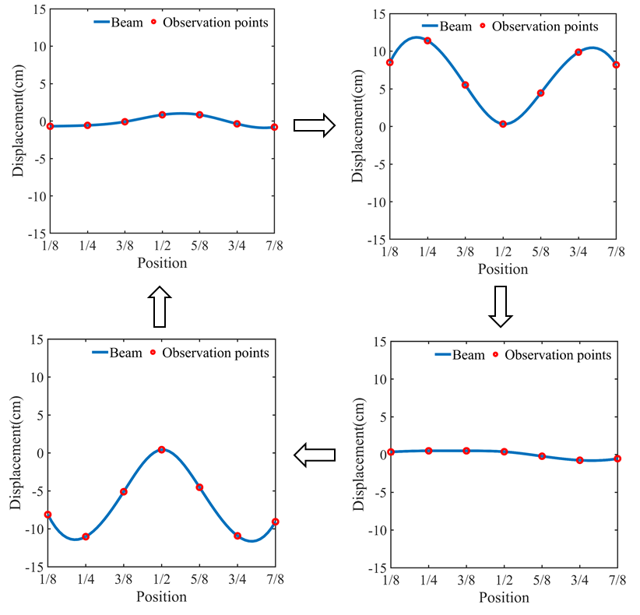
Fig. 13: Longitudinal motion attitude of single period VIV.

  - VIV index and trajectory of analytical signal
Through the recursive Hilbert transform algorithm, the acceleration signal and displacement signal of V2 channel are processed respectively, and the analytic signals are obtained. Select the analytic signal segment (00:59:00-01:00:00) in the VIV stage and the analytic signal segment (02:19:00-02:20:00) in the non VIV stage, and draw their trajectory circle respectively, as shown in Fig. 14.
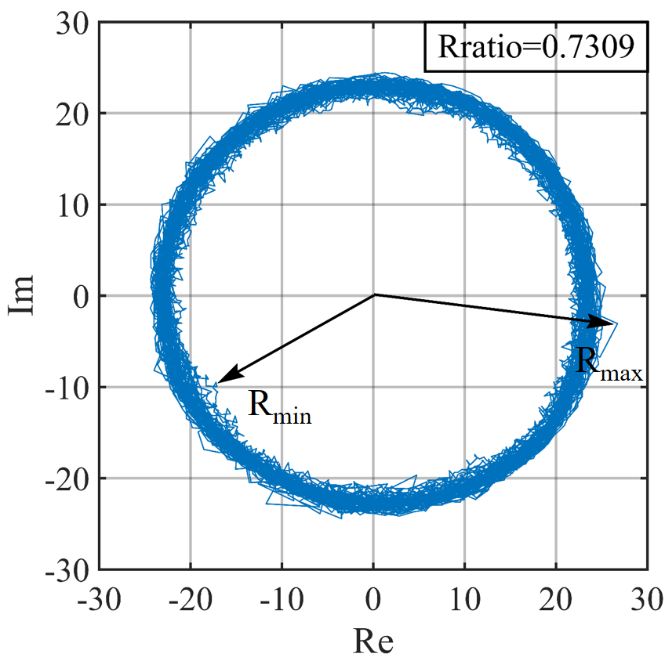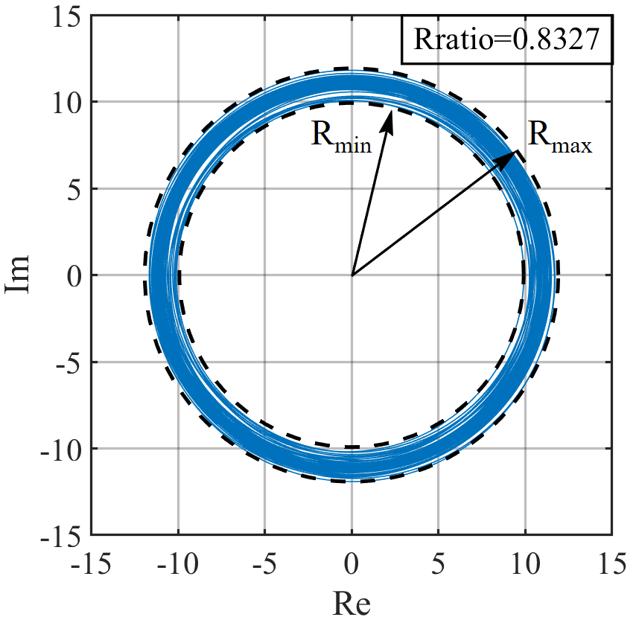
(a) | (b)

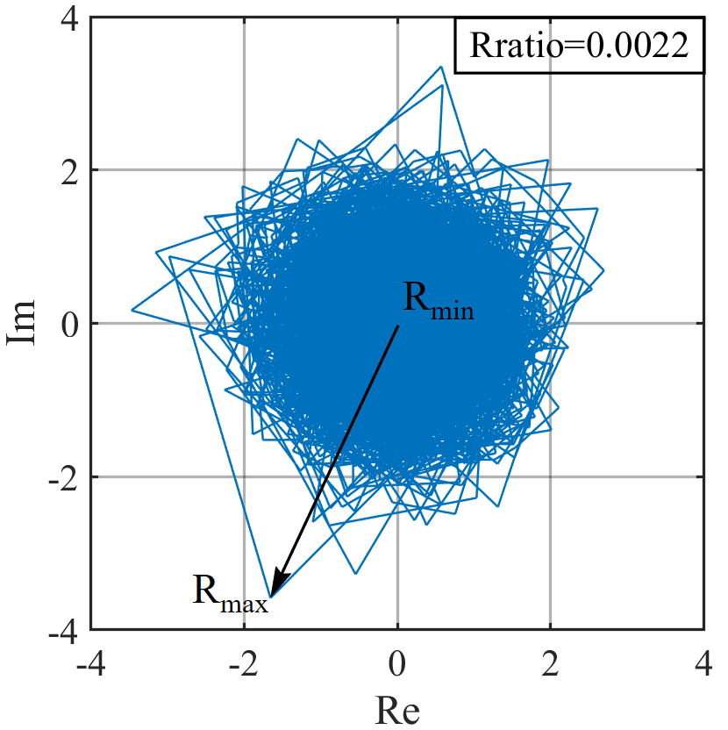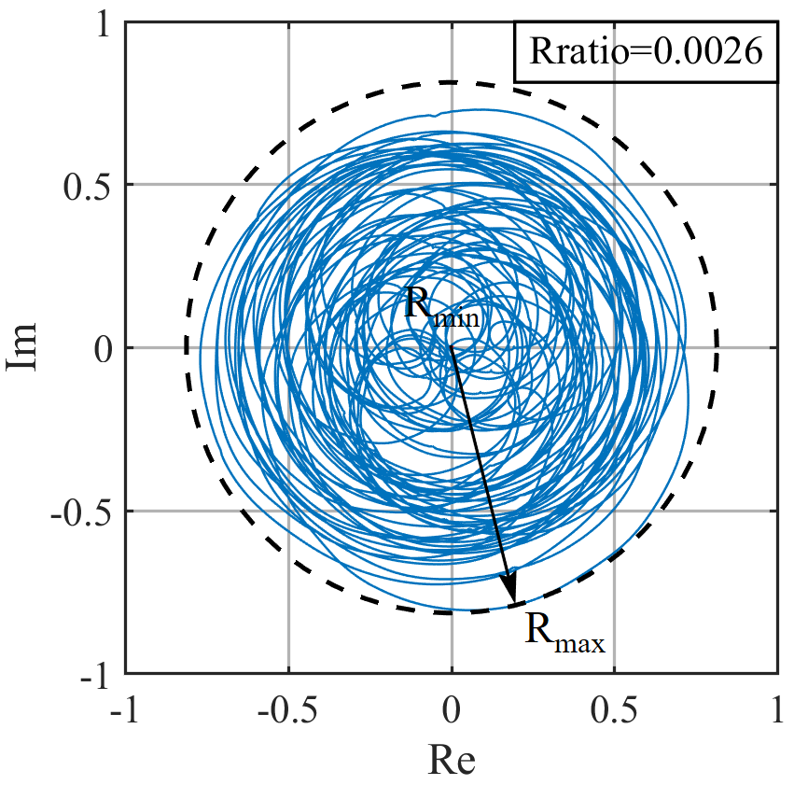
(c) | (d)
Fig. 14: Trajectories of VIV analytical signal by Recursive Hilbert transform processing. (a) Acceleration in VIV period; (b) Displacement in VIV period; (c) Acceleration in non VIV period; (d) Displacement in non VIV period.

It can be seen from Fig. 14 that trajectories in complex planes derived from the recursive Hilbert transform during VIV present obvious circular characteristics, while the trajectories in the non VIV period are disordered, and it is nearly fully filled in the area of the circle. And another interesting phenomenon, there are obvious differences in the shape of the trajectory corresponding to different signals. The analytical acceleration signal in the VIV period has obvious burr and the shape also fluctuates, but the trajectory circle of displacement analytic signal is very smooth and has obvious characteristics. This is mainly because in the process of real-time acceleration integration, after many times of high pass filtering and baseline correction, the noise level is greatly reduced, which makes the corresponding trajectory of analytical signal appear smooth, which is more conducive to the calculation of VIV index. For the acceleration and displacement signals in the non VIV period, the shape difference of the trajectory corresponding to the analytical signal is also obvious, the former trajectory is zigzag and sharp, while that of the latter is smooth.
Fig. 14 also presents the value of the VIV index $Rratio$ in the VIV period and the non VIV period. According to the local signal of VIV period (00:59:00-01:00:00), the VIV index is 0.8327, while the VIV index of non VIV period (02:19:00-02:20:00) is 0.0026. As mentioned above, the larger the VIV index is, the more obvious the VIV characteristics are, and the more certain the occurrence of vortex vibration events is. Therefore, it can be confirmed that there is obvious VIV phenomenon in the period of 00:59:00-01:00:00, while the value of VIV index is very small in the period of 02:19:00-02:20:00, which is defined as the environmental random vibration.
  - Perception and measurement of VIV event
The whole process of VIV is accurately perceived before, during, and after VIV through the calculation of real-time VIV index and parameters of VIV signal after real-time recursive Hilbert transform. The recursive algorithm is proved to be suitable for on-line monitoring environment, which is not only fast, but also the end effect is reduced, and the stability of the algorithm is better. Further integration with real-time acceleration integral algorithm into a global system can realize on-line real-time monitoring, intelligent perception and early warning of VIV events, the time lag of the system can be controlled in the second level. For the purpose of ensuring the real-time performance of VIV warning and parameter calculation, it is also necessary to ensure that the total calculation time spent on the data block to be processed (i.e. sampling frame) is less than the total acquisition time of the data block. Therefore, we set the sampling frame length as 1 second to ensure the real-time performance.
The acceleration data of V2 channel between 0h and 2h are calculated in real time condition in this way, and the real-time curve of VIV index is obtained as shown in Fig. 15. The VIV events can be judged by setting appropriate VIV index thresholds. The two dashed lines in Fig. 15 show the two-level warning threshold of VIV index, which are 0.3 and 0.6 respectively, to realize the two-level warning mechanism of VIV. The threshold setting is based on the observation of the track circle shape of the recursive Hilbert analytic signal. When $Rratio$ = 0.3, the track circle is basically circular, which can be used as the first level warning index for VIV prevention. When $Rratio$ = 0.6, the recursive Hilbert circle presents a standard circle shape, which indicates that there is obvious VIV, so it can be used as a secondary warning index for VIV.
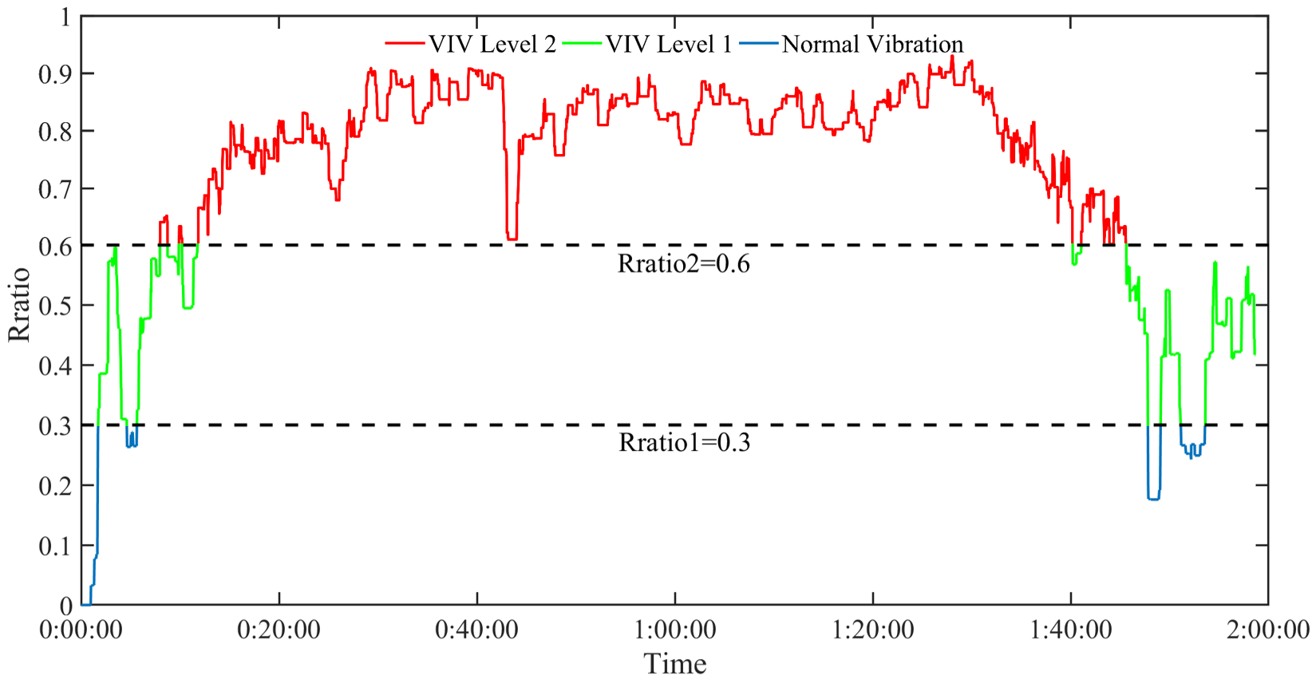
Fig. 15: Diagram of VIV index Rratio.

The rationality of the two-level warning threshold setting based on VIV index can also be verified by various time-history tracking charts of VIV parameters. The real-time identification and tracking of these parameters can be carried out after the occurrence of VIV event warning. As mentioned above, the analytic signal at each sampling time can be obtained by recursive Hilbert transform, and then the instantaneous phase, frequency and amplitude can be calculated in real time according to equations (11), (12) and (13). In Fig. 16, their real-time tracking diagram of V2 channel in the process of VIV are drawn.
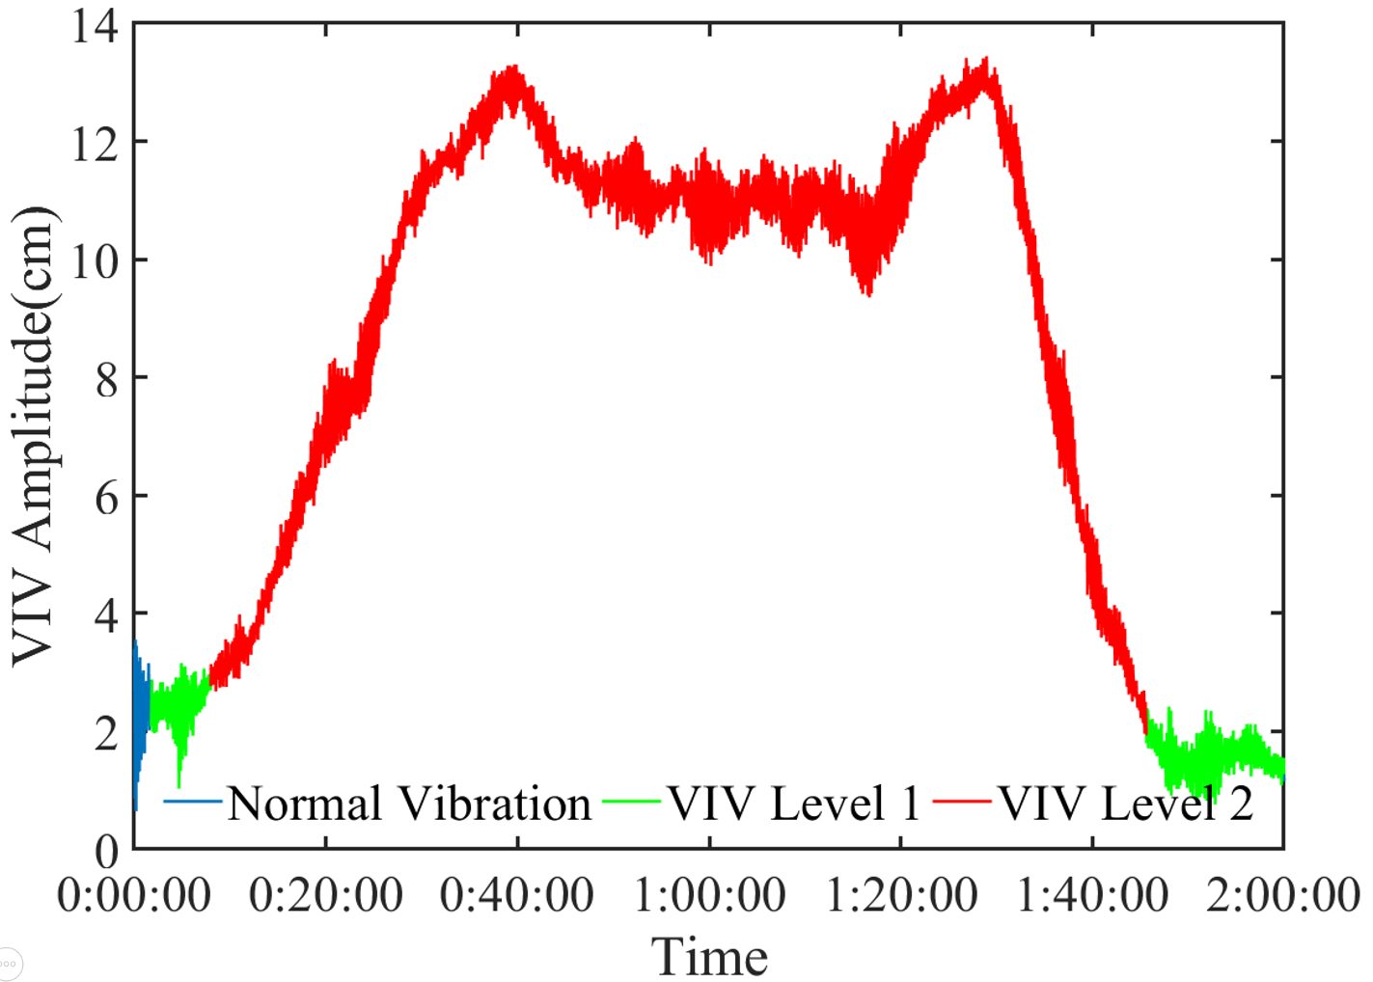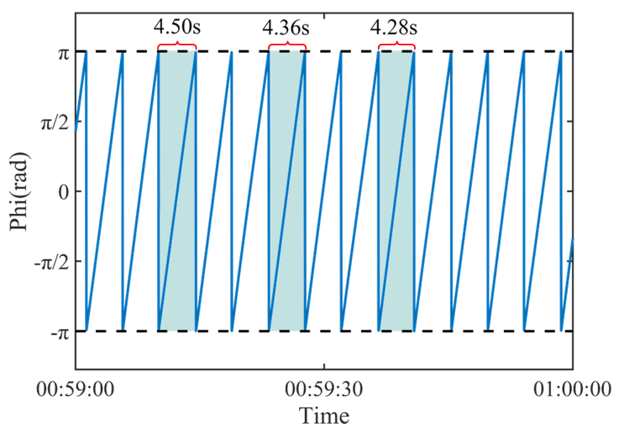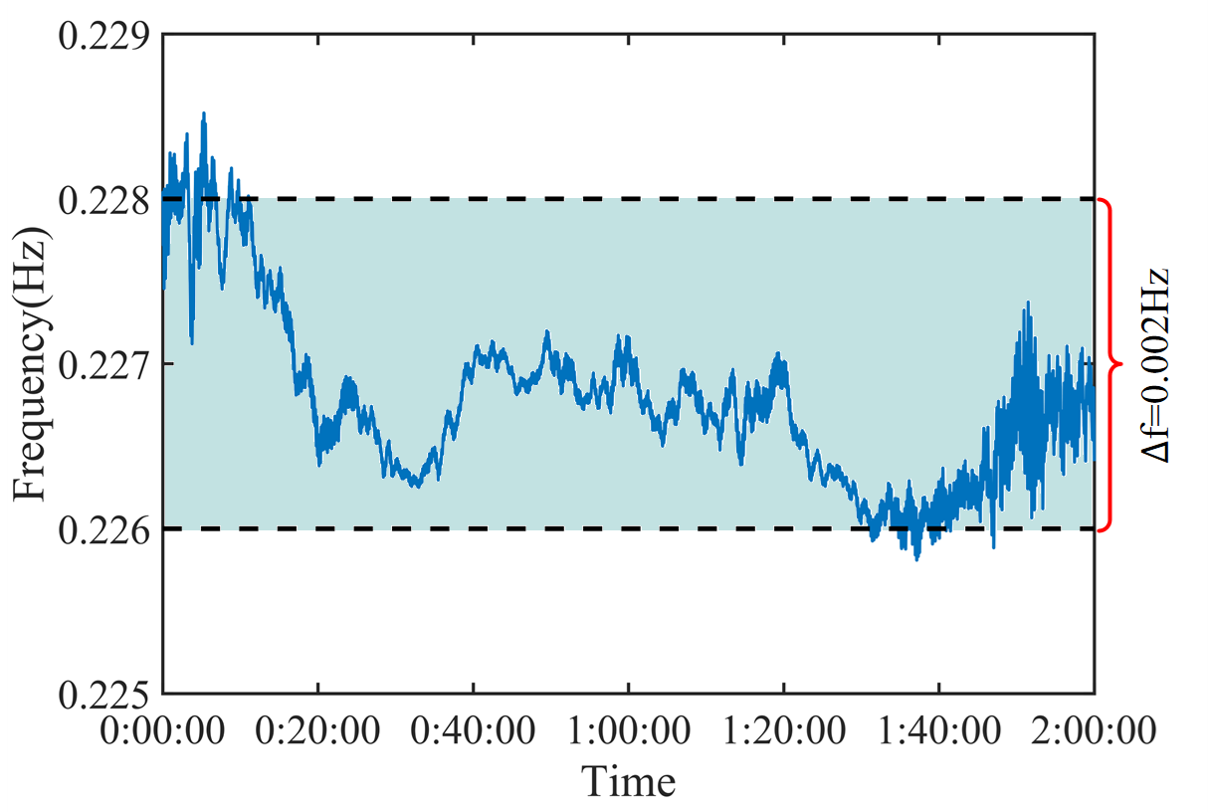
(a) | (b) | (c)
Fig. 16: Real-time tracking and perception of VIV parameters. (a) Real-time amplitude. (b) Instantaneous phase. (c) Instantaneous frequency.

In Fig. 16(a), the blue part of the amplitude time-history is the normal vibration of the bridge, which corresponds to the situation that the VIV index is less than 0.3; the green part is the VIV level 1 of the bridge, which needs to be given the primary VIV warning in order to attract the attention of the management department; the red part is the obvious VIV of the structure, which needs to be given the secondary warning in order to control the structure vibration and take the traffic control measures in time. According to the fine perception criteria of VIV events, the accurate time period of VIV was determined from 00:07:58 to 01:45:36 on June 12.
Fig. 16(b) shows the instantaneous phase time-history of VIV in a short time. Because the vibration signal during VIV is similar to sinusoidal signal, its instantaneous phase also has obvious serrated waveform, and its period is equal to the period of locking vibration mode of VIV. In each period, the phase changes between - π and π in a nearly linear manner. In fact, the locking frequency is not completely fixed during the VIV period, which is time-varying. Therefore, in the phase time-history, there is a slight change in the period of each vibration cycle.
Fig. 16(c) shows the instantaneous frequency of the bridge during VIV by deriving the vibration phase. As we can see, the instantaneous frequency of the bridge during VIV is not completely fixed. In this case, there is a small fluctuation of 0.002Hz around the locking frequency during the whole period of VIV. Moreover, with the development of VIV process, this small change presents a certain law, that is, at the beginning of VIV, the instantaneous frequency is higher, and the fluctuation range is larger; with the development of VIV, its value gradually decreases, and the fluctuation also decreases, when the VIV reaches stability, the frequency is basically stable; at the end of VIV, the instantaneous frequency begins to produce large fluctuations. The possible explanation for this phenomenon is that the aerodynamic stiffness and damping caused by VIV may not be fixed, but have a small variation range, which needs further research.
  - Discussions
Combined with the previous numerical case study and real bridge monitoring data verification, it is proved that the proposed method can be used for VIV identification and monitoring early warning of suspension bridge. The vibration displacement monitoring of suspension bridge girder is no longer a difficult problem by adopting the real-time acceleration integration algorithm, and the vibration parameters and operation state of the bridge can be comprehensively understood according to the multi-channel synchronous integration. Furthermore, the short-time recursive Hilbert transform can be used to identify and track the VIV indexes in real time, and realize the early warning of VIV events and intelligent perception of the whole process, as well as the real-time tracking and identification of various parameters in the process of bridge VIV, including rich vibration information such as instantaneous frequency, phase and amplitude.
The key point of the proposed scheme is the criterion of VIV. It should be noted that the vertical vibration amplitude of the main girder at V2 measuring point is reflected from Fig. 16(a) above, but the VIV cannot be judged by this parameter alone. Actually, when the instantaneous amplitude of the bridge is at a low level, obvious signs of VIV can be seen from the time-history trajectory diagram of VIV index and the VIV circle. Some of the previous studies on VIV identification can only make effective judgment when the amplitude of VIV reaches the peak value, which is too late at this time. It is meaningless to carry out bridge management and control according to this time point.
According to the calculation results of single channel vibration monitoring signal, the real-time VIV warning with time lag less than seconds can be realized. More importantly, the VIV monitoring, intelligent perception and early warning technology proposed in this paper can accurately identify the generation of VIV when the amplitude is low and difficult to judge by naked eyes and body feeling, and can send advanced warning information. Which can win enough time for bridge owners to make control decisions and implement control measures, and then effectively avoid the occurrence of bridge engineering accidents and the loss of public property.
More than that, the method proposed in this paper which is easy to apply, has low cost, high recognition frequency, and rich and intuitive results. In addition to the acceleration monitoring information, velocity, displacement and other monitoring signals can also be used to monitor and identify VIV. It should also be pointed out that this method can also be used for real-time monitoring and intelligent perception of VIV of other engineering structures in addition to suspension bridges, such as cables, towers, high-rise buildings, and model experiments in wind tunnel laboratories.

5. Conclusions
This paper proposes a real-time monitoring, intelligent perception and early warning technology for VIV of suspension bridge based on recursive Hilbert transform and real-time recursive acceleration integral algorithm. Through real-time online processing of vibration acceleration monitoring signal of suspension bridge, VIV events can be identified and early warned, and some key VIV parameters can be identified and tracked synchronously and accurately. The results show that the proposed method can accurately and efficiently judge the start and end time of VIV events, accurately measure the key vibration parameters such as instantaneous frequency, phase and amplitude during the bridge VIV period, and realize the real-time online intelligent perception of the whole process of bridge VIV.
The method proposed in this paper has abundant functions, which can not only identify and early warn VIV events, but also sense VIV parameters comprehensively and quantitatively with high quality. Relying on the key algorithms under online environment and the definition of VIV index, this technology has good real-time performance, suitable for online monitoring system, and can gain enough early warning time for the control of VIV events of suspension bridge. At the same time, because the algorithm only depends on the narrow-band single-mode signal characteristics of the structural vibration response during VIV, it does not need to know the specific structure, the location of the measuring point or the VIV observation history in advance. Therefore, this method has good universality, and can realize the monitoring, intelligent perception and early warning of VIV of any engineering structure. The work of this paper has got the attention of the Xihoumen Bridge owner, and has been carried out the application research on this bridge.
Acknowledgement: This study is funded by the National Natural Science Foundation of China (51878490); the National Key R&D Program of China (2017YFF0205605); Shanghai Urban Construction Design Research Institute Project ‘Bridge Safe Operation Big Data Acquisition Technology and Structure Monitoring System Research’; and the Opening Project of National Key Laboratory for Bridge Structural Health and Safety (BHSKL18-05-GF).

Reference
[1] Sarpkaya, T. (2004). A critical review of the intrinsic nature of vortex-induced vibrations. Journal of fluids and structures, 19(4), 389-447.
[2] Li, H., Laima, S., Ou, J., Zhao, X., Zhou, W., Yu, Y., ... & Liu, Z. (2011). Investigation of vortex-induced vibration of a suspension bridge with two separated steel box girders based on field measurements. Engineering Structures, 33(6), 1894-1907.
[3] Cantero, D., Øiseth, O., & Rønnquist, A. (2018). Indirect monitoring of vortex-induced vibration of suspension bridge hangers. Structural Health Monitoring, 17(4), 837-849.
[4] Hwang, Y. C., Kim, S., & Kim, H. K. (2020). Cause investigation of high-mode vortex-induced vibration in a long-span suspension bridge. Structure and Infrastructure Engineering, 16(1), 84-93.
[5] Larsen, A., Esdahl, S., Andersen, J. E., & Vejrum, T. (2000). Storebælt suspension bridge–vortex shedding excitation and mitigation by guide vanes. Journal of Wind Engineering and Industrial Aerodynamics, 88(2-3), 283-296.
[6] Huang, Z., Li, Y., Hua, X., Chen, Z., & Wen, Q. (2019). Automatic identification of bridge vortex-induced vibration using random decrement method. Applied Sciences, 9(10), 2049.
[7] Xu, S., Ma, R., Wang, D., Chen, A., & Tian, H. (2019). Prediction analysis of vortex-induced vibration of long-span suspension bridge based on monitoring data. Journal of Wind Engineering and Industrial Aerodynamics, 191, 312-324.
[8] Hua, X. G., Chen, Z. Q., Chen, W., Niu, H. W., & Huang, Z. W. (2015). Investigation on the effect of vibration frequency on vortex-induced vibrations by section model tests. Wind and Structures, 20(2), 349-361.
[9] Kang, Z., Zhang, C., Chang, R., & Ma, G. (2019). A numerical investigation of the effects of Reynolds number on vortex-induced vibration of the cylinders with different mass ratios and frequency ratios. International Journal of Naval Architecture and Ocean Engineering, 11(2), 835-850.
[10] Li, S., Laima, S., & Li, H. (2017). Cluster analysis of winds and wind-induced vibrations on a long-span bridge based on long-term field monitoring data. Engineering Structures, 138, 245-259.
[11] Li, H., Laima, S., Zhang, Q., Li, N., & Liu, Z. (2014). Field monitoring and validation of vortex-induced vibrations of a long-span suspension bridge. Journal of Wind Engineering and Industrial Aerodynamics, 124, 54-67.
[12] Cao, S., Zhang, Y., Tian, H., Ma, R., Chang, W., & Chen, A. (2020). Drive comfort and safety evaluation for vortex-induced vibration of a suspension bridge based on monitoring data. Journal of Wind Engineering and Industrial Aerodynamics, 204, 104266.
[13] Zheng, W., Dan, D., Cheng, W., & Xia, Y. (2019). Real-time dynamic displacement monitoring with double integration of acceleration based on recursive least squares method. Measurement, 141, 460-471.
[14] Xu, K., Ge, Y., Zhao, L., & Du, X. (2018). Calculating vortex-induced vibration of bridge decks at different mass-damping conditions. Journal of Bridge Engineering, 23(3), 04017149.
[15] Ehsan, F., & Scanlan, R. H. (1990). Vortex-induced vibrations of flexible bridges. Journal of Engineering Mechanics, 116(6), 1392-1411.
[16] Zhu, Q., Xu, Y. L., Zhu, L. D., & Li, H. (2018). Vortex-induced vibration analysis of long-span bridges with twin-box decks under non-uniformly distributed turbulent winds. Journal of Wind Engineering and Industrial Aerodynamics, 172, 31-41.
[17] Khalak, A., & Williamson, C. H. (1999). Motions, forces and mode transitions in vortex-induced vibrations at low mass-damping. Journal of fluids and Structures, 13(7-8), 813-851.
[18] Scanlan, R. H. (1981). State-of-the-art methods for calculating flutter, vortex-induced, and buffeting response of bridge structures (No. FHWA-RD-80-50 Final Rpt.).
[19] Marra, A. M., Mannini, C., & Bartoli, G. (2011). Van der Pol-type equation for modeling vortex-induced oscillations of bridge decks. Journal of Wind Engineering and Industrial Aerodynamics, 99(6-7), 776-785.
[20] Kanamori, H., Maechling, P., & Hauksson, E. (1999). Continuous monitoring of ground-motion parameters. Bulletin of the Seismological Society of America, 89(1), 311-316.
[21] Shanks, J. L. (1967). Recursion filters for digital processing. Geophysics, 32(1), 33-51.

