Controlled three-dimensional polystyrene nano- and micro-structures fabricated by three-dimensional electrospinning

Michel Vong¹, Ewan Speirs¹, Chanakan Klomkliang¹, Ibukun Akinwumi¹, Wiwat Nuansing^{2,3}, Norbert Radacsi^{1*}

¹The School of Engineering, Institute for Materials and Processes, The University of Edinburgh, Robert Stevenson Road, Edinburgh, EH9 3FB, U.K.
²School of Physics, Institute of Science, Suranaree University of Technology, Nakhon Ratchasima, 30000, Thailand
³SUT CoE on Advanced Functional Materials (SUT-AFM), Suranaree University of Technology, Nakhon Ratchasima, 30000, Thailand

*Corresponding author. Tel.: +441316513571. E-mail address: n.radacsi@ed.ac.uk

ABSTRACT
The combination of electrospinning with 3D printing technology opens new pathways for nano- and microfabrication, which can be applied in a wide range of application. This simple and inexpensive method was proven to fabricate 3D fibrous polystyrene structures with controlled morphology and micro to nano-fibre diameter. The controllable movement of the nozzle allows precise positioning of the deposition area of the fibres during electrospinning. A programmed circular nozzle pattern results in the formation of 3D polystyrene cylinder shapes with fibre diameters down to 560 nm. The assembly of the fibrous structures starts instantaneously, and a 4 cm tall and 5 cm wide sample can be produced within a 10-minute electrospinning process. The product exhibits high stability at ambient conditions. The shape, size, and thickness of fibrous polystyrene structures can be easily controlled by tuning the process parameters. It is assumed that the build-up of 3D fibrous polystyrene structure strongly depends on charge induction and polarization of the electrospun fibres.

Keywords: 3D structure; 3D electrospinning; three-dimensional; electrospinning; nanooprinting; Polystyrene

INTRODUCTION
Electrospinning is a simple and efficient process to manufacture micro and nanosized fibres. By applying a high voltage to a polymeric solution, a Taylor cone is formed at the tip of a metallic nozzle and nanofibres are ejected from it.^{1,2} Characteristics of the electrospun fibres, such as nature of the polymer, diameter, surface to volume ratio, porosity, pore-interconnectivity, length, shape and structure, are widely controllable.^{3–9} It is also a versatile technique that allows manufacturing of ceramic and composite fibres.^{10–13} Hence, electrospinning has been researched for different applications in various fields due to its simplicity and promising potentials. Potential applications include areas in biomedicine (e.g. wound dressing, bone screw hole and drug delivery), biosensors, cosmetics, protective clothing, catalyst, filtration, adsorption (e.g. dye removal and chromatography), batteries and fuel cells.^{14–27}
The electrospun fibres are randomly aligned and comes in the form of a flat two-dimensional (2D) non-woven mat because of the bending instability, inherent to electrospinning.^{1,2} Thus, research has been carried out to circumvent this chaotic 2D deposition. Near-field electrospinning can be used to control the exact positioning of the fibres onto the collector by electrospinning at a short distance between the metallic nozzle and the collector.²⁸ With this technique, precise deposition and integration of oriented fibres into functional devices is achievable.^{29,30} A three-dimensional (3D) structure is more desirable than a 2D mat for some applications. A 3D electrospun scaffold is beneficial for bioengineering as it resembles the fibrous structure of the natural extracellular matrix and provides contact guidance for cells.^{31,32} It has also been used for energy harvesting and filtration applications.^{33,34} It is still a challenge to obtain a 3D fibrous macro-structure via electrospinning but we can distinguish four main approaches to achieve this.³⁵ The main methods are increasing the electrospinning time and stacking multiple layers of fibres,³⁶ post-treatment of the 2D non-woven mats,³⁷ use of a template-assisted collector³⁸ or direct self-assembly of the electrospun polymer.^{39–42} These methods either require several time-consuming steps to obtain the 3D structure or have no control over the final shape of the 3D structure. Electrospinning of designed 3D structures can be achieved by combining traditional electrospinning with the manoeuvrability of extrusion based 3D printing. By using a nozzle able to move in the x-y plane, movement and control of the deposition area during the electrospinning process is possible.
In this paper, the fabrication of a 3D structure made of polystyrene (PS) fibres using 3D electrospinning, without any auxiliary collecting templates or post-processing steps, is investigated. The study is done by designing a specific nozzle pattern using a computer-aided design (CAD) software, then electrospinning this structure. In this work, the nozzle follows a circular pattern and the desired electrospun structure is a cylinder. The effect of the solution properties, polymer concentration, applied voltage, working distance, flow rate, and nozzle speed on the 3D structures shape and fibres morphology are investigated. It is observed that the improper control of any of these parameters would prevent 3D assembly of the electrospun polymer, and result in a flat 2D deposition. The microscopic properties of the electrospun fibres are investigated via Scanning Electron Microscopy (SEM) and the macroscopic shape of the 3D structure is recorded.

EXPERIMENTAL
Materials
The polymer polystyrene (PS) was obtained from Sigma-Aldrich. The weight average molecular weight (M_{w}) of PS was 280,000 g.mol⁻¹. The solvents dimethylformamide (DMF) and tetrahydrofuran (THF) were acquired from Alfa Aesar and Fisher Scientific respectively. DMF was 99% pure and THF was 99.5 % pure. The additives phosphoric acid 85 % in water (H₃PO₄) and ethanol (99.99 %) (EtOH) were received from Acros Organics and Fisher Scientific respectively.
All products were used without further purification.

Solution preparation
PS was dissolved in a solvent mixture of 1:1 by weight DMF/THF by stirring for 4 hours under ambient conditions. Several concentrations were prepared: 5.0 wt%, 7.5 wt%, 10.0 wt%, 12.5 wt% and 15.0 wt%. An amount of 100 µL of additives were then added (EtOH or H₃PO₄) to 50 mL of solution. The different solutions prepared are summarized in Table 1. Each batch started from a fresh solution, and each electrospinning experiment ran for 10 minutes.
Table 1: Summary of all electrospun solutions
Composition | PS Concentration  [wt%] | Additives  [100μL in 50mL solution]
PS in 1:1 DMF/THF | 15.0 | N/A
PS in 1:1 DMF/THF | 15.0 | EtOH
PS in 1:1 DMF/THF | 15.0 | H₃PO₄
PS in 1:1 DMF/THF | 12.5 | H₃PO₄
PS in 1:1 DMF/THF | 10.0 | H₃PO₄
PS in 1:1 DMF/THF | 7.5 | H₃PO₄
PS in 1:1 DMF/THF | 5.0 | H₃PO₄

Electrospinning apparatus
The electrospinning apparatus was combined with extrusion based 3D printing technology to allow for control of various patterns and electrospinning structures. The apparatus (see Figure 1) (NovaSpider, CIC nanoGUNE, Spain) itself consists of a syringe pump, a nozzle and a high voltage DC power supply. The nozzle is capable of movements in the x-y axis, with a resolution of 0.02 mm, while the collector (print bed) can be set along the z-axis. In this study, the nozzle head was moving along the x-y axes while the collector plate was fixed along the z axis during the electrospinning process but could be changed at will, therefore the electrospinning process here will be referred to as ‘3D electrospinning’.
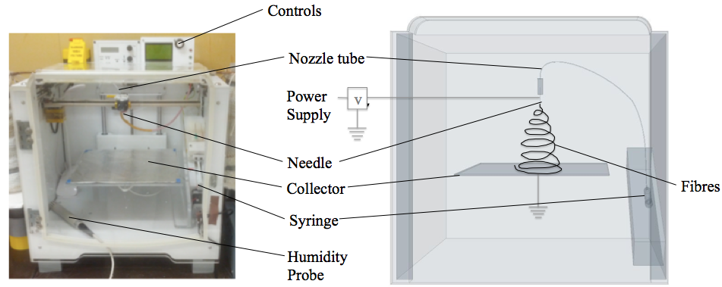
Figure 1. Photo (left) and schematic drawing (right) Y-Z plane of the 3D electrospinner.
The collector plate held a sheet of aluminium foil connected to the ground, and possibly to a negative voltage supply. The solution was loaded into a syringe whose needle was connected to the positive power supply and had an inner diameter of 0.603 mm. All experiments were carried out at room temperature, and the relative humidity was between 40-45 %.

2D pattern design: Gcode / Slicer
The nozzle pattern was generated by using a Computer Aided Design (CAD) software (Onshape). The designed pattern was a hollow cylinder of 5.5 cm. The model was exported as an STL file. The model was then processed with a 3D printing slicing software (Simplify3D) to get a gcode file readable by the 3D electrospinner. The gcode is thus giving the pattern of the nozzle, the moving speed of the nozzle, the working distance and the flow rate of the syringe. The applied voltage to the nozzle was controlled on a separate power supply. The pattern (the movement of the nozzle) was fixed to be a circular motion of 5.5 cm, as seen in Figure 2, and the time of experiment to 10 minutes.
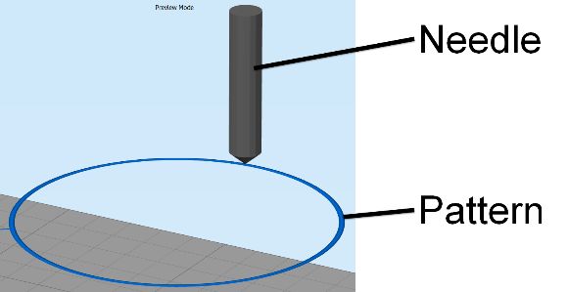
Figure 2: Pattern of the nozzle as seen by the 3D printing slicing software (Simplify3D). A circle of 5.5 cm was designed as the nozzle pattern.
Characterization
Digital camera
The macroscopic shape of the 3D structure after electrospinning was captured using a digital camera (EOS 6D, Canon Inc., Japan). The electrospinning process of the 3D structures was captured with the same camera.

Scanning Electron Microscope (SEM)
The shape and size of the electrospun PS fibres were observed with a Scanning Electron Microscope (SEM) (JSM-6010PLUS/LV, JEOL Ltd., Japan) at an accelerating voltage of +20 kV. Prior to observation, the samples were coated with 20 nm of Gold using a Sputter coater (Desk III, Denton Vacuum, USA). The diameters of the fibres were measured with an image processing program (Fiji - ImageJ). The mean diameter was typically taken using more than 100 fibres per sample.

RESULTS AND DISCUSSION

Formation mechanism of the 3D structure
The presence of additives during the electrospinning of polystyrene fibres is essential for obtaining 3D structure. Under ambient conditions, PS solution without additives produces flat, 2D structures with electrospinning³⁹. Adding EtOH to the solution also resulted in flat structures, which is in contrast with the suggestions of Sun et al.⁴⁰. As previous studies showed, the mechanism for the self-assembly of electrospun fibres is based on the rapid solidification of the fibres, which allows the structure to be self-standing, and the polarization and electrostatic induction of the deposited fibres^{40,43}. The top of the deposited mat gets negatively charged because of the strong electric field. This negative top then becomes a preferential deposition site and attracts the positively charged jet coming out of the nozzle. As the fibres at the top of the layer have the same charge, they would naturally repel each other during the build-up and fabricate a non-compact structure. Using additives into the solution can increase the polarizability of the electrospun fibres, leading to repulsive forces between fibres. As H₃PO₄ is more conductive than EtOH^{44,45}, this would explain why the solution doped with H₃PO₄ gives 3D structures, while the solutions doped with EtOH or without any doping agent result in 2D (flat) structures. Therefore, H₃PO₄ was used in this study as a doping agent. The static induction and polarization effect can be proven by using a charged rod to attract or repel the electrospun fibres. This test was done under two different conditions: after electrospinning, when the structure was already built up and the electric field turned off, and during the electrospinning process, when the high voltage was still applied on the moving nozzle. The test after electrospinning was carried out on a sample that was electrospun for 3 minutes. It was observed that both a positively or negatively charged rod would attract the top of the deposited fibre mat. This is in contrast with the work of Sun et al.⁴⁰, who stated that the fibres would be attracted to the positive rod but repelled by the negative rod. This difference in behaviour might be because the rods used in our study had a high voltage (±5 kV), powerful enough to induce a charge on the 3D structure. It was also observed that the electrospun structure were barely attracted or repelled by a charged rod 12 hours after the experiment. This could be another explanation for the difference in results with previous works. This result shows the ease of inducing a charge on the fibres, during or right after electrospinning. In the second test, the charged rod was placed about 1.5 cm above the collector, under the way of the circular pattern of the nozzle. Despite the additional charged rod, it was observed that the 3D structures would still be built up along the circular pattern of the nozzle. The electrospun fibres reacted to the charged rod only when close to its vicinity (see video in supplementary material). They were attracted to the positively charged rod, being compacted to the rod and slowly pulling it toward the collector where a short circuit would then happen. The fibres could still be deposited onto the negatively charged rod however, they would not be compacted on the rod, but rather self-standing as they were repelled because of their similar charge with the negative rod (see video in supplementary material). This test confirms that during electrospinning, the top of the 3D structure, including the fibres that were just electrospun, are immediately induced with a negative charge because of the high positive voltage at the nozzle. This explains why the charge induction effect is not limited to the first layer of electrospun fibres and why the 3D structures can be built up relatively high.
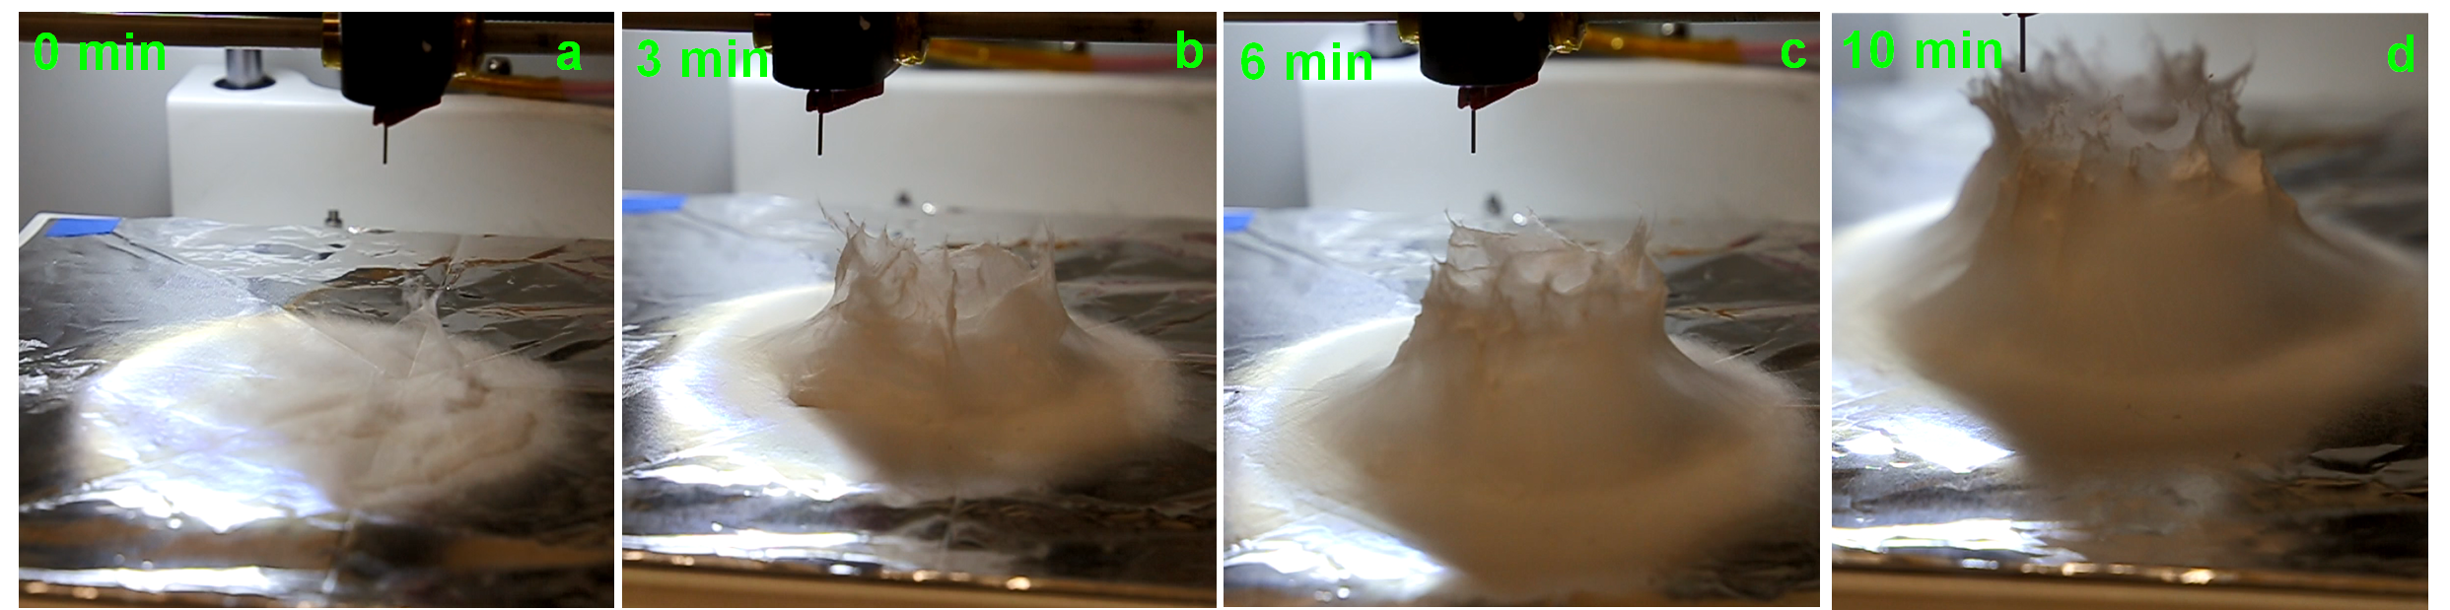
Figure 3: Growth process of the electrospun PS fibres stack. The electrospinning was performed at a voltage of +20 kV, a working distance of 5 cm and a flow rate of 5.0 mL.h⁻¹ at a nozzle moving speed of 12.0 mm.s⁻¹ for 10 minutes. The 3D build-up starts after an initial layer of fibres have been deposited onto the collector as seen in a. The build-up follows the circular pattern of the nozzle, forming a hollow cylinder.
The growth process of the electrospun 3D structure was recorded using a digital camera. Pictures at different time interval are shown in Figure 3, more pictures can be seen in the supplementary information S1. The 3D build-up of electrospun fibres starts only after an initial layer of flat fibres has been deposited onto the collector, which is in line with another study reported in literature⁴¹. This initial layer is necessary to prevent the following electrospun fibres to touch the grounded collector and neutralize the pulling force of the collector towards the charged fibres. It is also from this first layer that the polarization and charge induction effect can start. In our case, the initiation of the 3D build-up can be seen a few seconds after the start of this experiment. Then, similar to the self-assembly of PS fibres electrospun by Li and Long, the 3D structure grew up in small branches.³⁹ The difference in our experiment was that the nozzle was moving in a circular pattern. As such, the branches, attracted by the positively charged nozzle, were dragged along the circular pattern of the nozzle and some fibres were growing downwards towards the previous layers of the 3D structure and sticking to it. The weight of the fibres also played a role in compacting the 3D structure. This is how the structure is built up as bulk, instead of a single thread of fibres wrapped over itself. Furthermore, the electric field at the collector is the highest at the point directly under the nozzle (see Figure 8). This, along with the fact that the deposited fibres are negatively polarized, explains why the 3D structure is able to build-up along the shape of the nozzle pattern. The whole formation mechanism is illustrated in Figure 4.
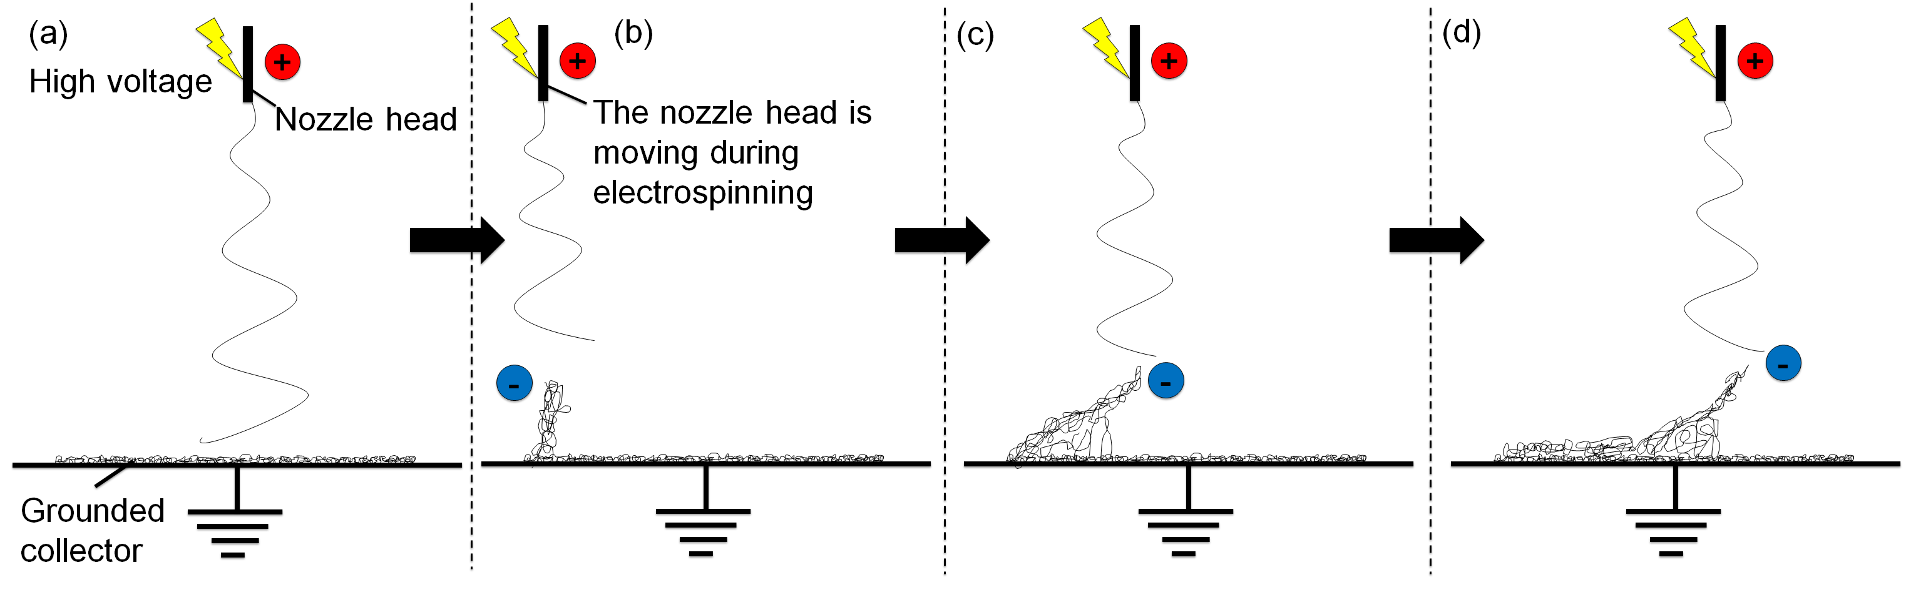
Figure 4: Simplified formation mechanism of the 3D structure. a) An initial layer of fibres covers the grounded collector. b) The negatively induced fibres repel each other and are attracted by the positively charged nozzle; thus the build-up of the structure. c) The negative fibres branches are dragged along the nozzle-pattern. Some fibres are growing downwards the previous layer and stick to it. d) The fibres far away from the nozzle are no longer attracted to it; thus the fibres settle and consolidate the structure
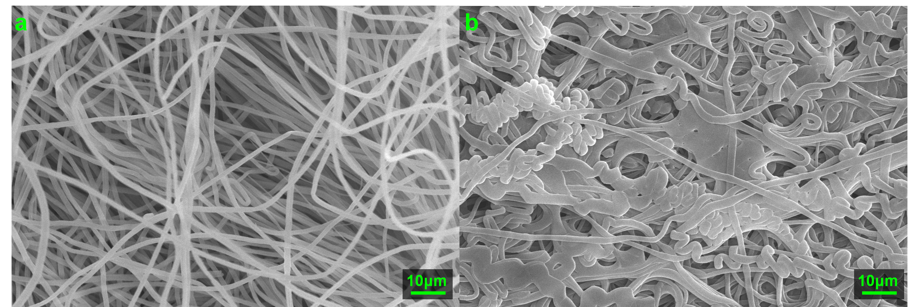
Figure 5: SEM pictures of the sample shown in Figure 3. a) Fibres taken from the inside lower part of the 3D structure b) Fibres taken from the top of the 3D structure, much closer to the nozzle tip.
In a 10-minute experiment at a working distance of 5 cm, the 3D structures could be as high as 4 cm. However, this also mean the fibres getting at the top of the structure would have less travel length and time to dry. This can be directly observed by comparing the shape and morphology of the fibres at the inner bottom and at the top of the 3D structure as seen in Figure 5. The lower part of the structure is spongy, soft and made of single, randomly oriented fibres, while the top of the structure is brittle and made of fused fibres. The resulting 3D structures are self-standing even after 4 months of storage at ambient conditions. The experiments were done at ambient conditions, at a relative humidity of 40-45 %.
The following process parameters were identified to be key for the 3D electrospinning: solution concentration, potential difference, working distance, flow rate and nozzle moving speed of the electrospinner. It is not possible to obtain a structure shaped exactly like the nozzle pattern because of the whipping instability, inherent to electrospinning. The parametric study aimed to optimize the shape of the final 3D structure, so that it was as close as possible to the nozzle pattern, a 5.5 cm hollow cylinder. The criteria for a good sample were based on the overall shape itself (distorted cylinder or not), the height of the structure, whether or not the structure was hollow, the speed of building up and to some extent, the morphology of the fibres.

Solution concentration (c)
Five different solution concentrations have been electrospun at a working distance of 5 cm, a voltage of +20 kV, a flow rate of 5.0 mL.h⁻¹ and a nozzle speed of 12.0 mm.s⁻¹ at ambient conditions. H₃PO₄ was added in a 0.2 v/v% volume ratio. The PS concentrations were 5.0 wt%, 7.5 wt%, 10.0 wt%, 12.5 wt% and 15.0 wt%. In that range of concentration, the electrospinning jet was stable and no solution dripping was observed.
The 15.0 wt% PS solution is the only one that would give a cylinder shape with a hollow inside. 7.5 wt%, 10.0 wt% and 12.5 % would give a full cylinder shape rather than a hollow cylinder. Mit-uppatham et al. explained a higher solution concentration, and thus viscosity, would give the electrospun jet greater resistance towards thinning of its diameter.⁴⁶ This would result in a longer straight jet trajectory before the bending instability and would in turn result in a smaller deposition area. This explains why only the higher concentrated PS solution could have a hollow cylinder shape. The other lower concentrations had a deposition area big enough to partly cover the inside of the cylinder. Another consequence of the wider deposition area was the final height of the 3D structure after 10 minutes of electrospinning. The 3D structure electrospun with 7.5 wt% and 10.0 wt% PS were smaller in height than the ones prepared with 12.5 wt% and 15.0 wt% PS. Another explanation would be the lower amount of polymer provided to the 3D structure, which would effectively result in a smaller 3D structure after the same time of experiment. The top of the smaller 3D structures was also not brittle as the travel length was still sufficient for the fibres to dry properly. At the lowest concentration of 5.0 wt%, no 3D structures were built up. It is necessary to provide a significant amount of fibres at once to get a 3D build-up of the PS solution. If not, the charge induction and polarization effect would not be strong enough and this would result in a flat deposition of the electrospun fibres, as there would be no repulsion between fibres to get the 3D build-up. The resulting deposition area was bigger than for the higher concentrations. As PS is a poor conductor, some charges were still retained by the deposited fibres and diverted the electrospinning jet to regions of lower potential.⁴⁷ The overall shapes of the 3D structures electrospun with different PS concentration solutions is summarized in Figure 6.
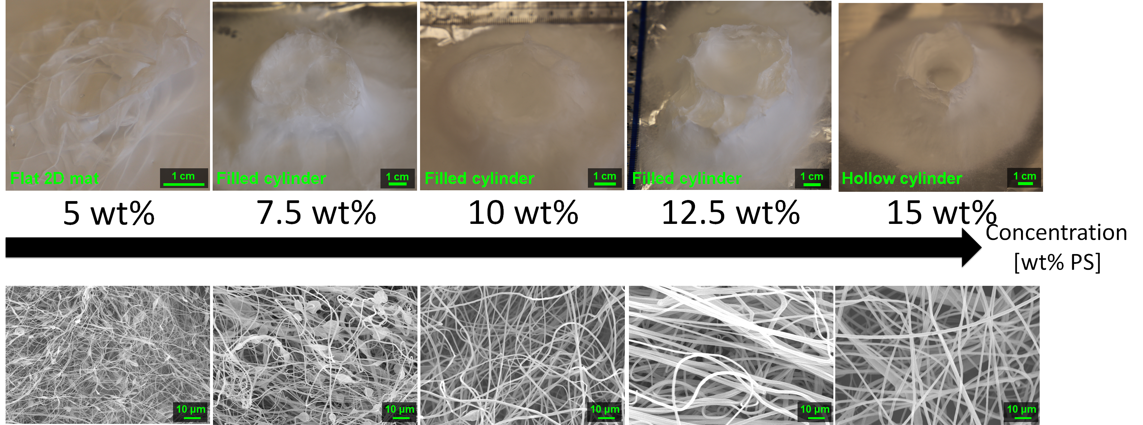
Figure 6: Evolution of the 3D structure shape and the fibres shape and morphology as the weight concentration of PS is increased from 5.0 wt% to 15.0 wt%. The solutions were electrospun at a voltage of +20 kV, a working distance of 5 cm and a flow rate of 5.0 mL.h⁻¹, at a nozzle speed of 12.0 mm.s⁻¹ for 10 minutes. No 3D build-up were observed at low polymer concentration. The fibres mean diameter decreased with decreasing concentration. Presence of beads was observed at low concentration.
The fibres mean diameter increases with polymer concentration as seen in Figure 7, the lesser concentrated PS solution giving smaller fibres. The mean diameter as measured on SEM are 0.55 ± 0.25 μm, 0.79 ± 0.30 μm, 1.09 ± 0.31 μm, 1.40 ± 0.44 μm and 1.87 ± 0.34 μm for the 5.0 wt%, 7.5 wt%, 10.0 wt%, 12.5 wt% and 15.0 wt% PS solution respectively. This trend has been observed several times by other researchers^{48–50}. The electrospun jet of the lesser concentrated solutions could stretch and thin more because of the lower viscosity, resulting in smaller fibres. Even though the concentrations of 5.0 wt% and 7.5 wt% had fibre diameters in the sub-micron scale, these electrospun solutions gave mixtures of fibres and beads. This trend has been already observed^{51,52}, and as Lee et al. suggested, it might be due to the lower solution viscosity that leads to a less stable jet formation.⁵³

Figure 7: Evolution of the fibre mean diameters as the PS concentration is increased from 5.0 to 15.0 wt% in 1:1 DMF/THF. The electrospinning parameters were a voltage of +20 kV, a working distance of 5 cm and a flow rate of 5.0 mL.h⁻¹ for 10 minutes. Mean fibres diameter increases with the polymer concentration.
The 15.0 wt% PS solution was selected, as it was the only solution yielding a hollow cylinder as designed in the nozzle pattern.

Applied voltage
The effect of the applied voltage on the nozzle was tested in a range of 6 kV to 20 kV, with increments of 1 kV. All the other parameters were fixed. The working distance was 5 cm, the flowrate was 5.0 mL.h⁻¹, the nozzle speed was 12.0 mm.h⁻¹, and 15.0 %PS in 1:1 DMF/THF doped with H₃PO₄ was electrospun at ambient condition. Examples of electric field simulations are shown for applied voltages of 6, 15 and 20 kV (see Figure 8).
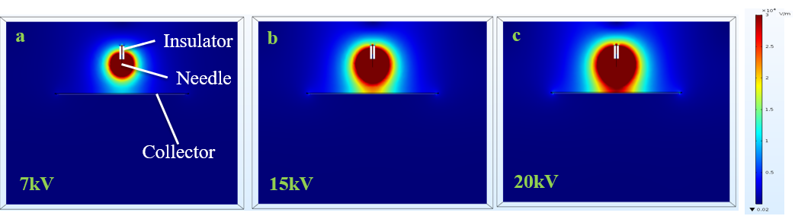
Figure 8. Y-Z Plane and comparison of the electric field intensity. The maximum electric field strength generated from the needle at an applied voltage of (a) 7kV, (b) 15kV and (c) 20kV at a working distance of 5 cm are 9.01 x 10⁶, 1.93 x 10⁷ and 2.57 x 10⁷ V/m . This simulation shows how the electrostatic field strength increases with increasing applied voltage at a constant working distance. The dark red region shows the region with an electric field strength greater than 30000 V/m. The electric field magnitude across the collector also increases with applied voltage.
The electrospinning jet was not stable at +6 kV, resulting in lots of dripping of the solution. The 3D structures and stable electrospinning were obtained when the applied voltage was higher than +7 kV.
A few differences were observed with the final shape and height of the resulting cylinders after electrospinning. Only the sample made at +10 kV seemed to show a structure shape closer to the designed 5.5 cm diameter hollow cylinder, as its outside wall was thinner and vertical. However, the time needed to go from a flat electrospinning to a clear 3D build-up decreased as the applied voltage increased. Typically, the 3D build-up would happen in less than 20 seconds when the applied voltage was higher than +15 kV and a flat electrospinning time of 4 minutes 30 seconds was necessary before the 3D structuring was observed at the voltage of +8 kV. As explained earlier, the 3D build-up is due to the polarization and static induction of the deposited mat. If a lower voltage is applied, more time would be necessary for the top of the deposited mat to get properly polarized, acquire enough negative charges to attract the positively charged jet, and thus build-up the 3D structure.
The polymers, under SEM observation, showed a similar fibre shape but different fibre diameters. The measured mean diameters were 2.53 ± 0.51, 1.65 ± 0.42, 1.34 ± 0.27, 1.32 ± 0.22, 1.29 ± 0.26, 1.42 ± 0.26, 1.61 ± 0.23, 1.42 ± 0.26, 1.67 ± 0.25, 1.44 ± 0.24, 1.50 ± 0.31, 1.89 ± 0.63, 1.88 ± 0.41, 1.88 ± 0.34 μm for the applied voltage from 7 to 20 kV, respectively (Figure 10). The effect of applied voltage on the fibre diameters is one of the most controversial and contradicted in electrospinning experiments. Electrospun fibres have been observed to be thicker with both increasing voltage^{54–56} and decreasing voltage^{55,57,58} or having a critical voltage value where the trend would be reversed.⁵⁹ The applied voltage influences the electric field, which can have multiple effect on the electrospun jet. In this study, at the working distance of 5 cm, there was no linear trend between the mean fibres diameter and the applied voltage. Instead, the fibre diameter was decreasing until the voltage of +11 kV where it would then increase up to a stable range at voltages higher than +18 kV. This would mean that up to +11 kV, increasing the voltage results in a stronger electric field which would lengthen the elongation of the jet and decrease the fibre diameters, by allowing more stretching and splitting of the fibres.⁶⁰ Further increasing the voltage up to +18 kV could result on a decrease of the size of the initial Taylor cone or a higher jet velocity. These two reasons together can counteract the effect of the lengthened jet and lead to bigger fibres. At voltages between 18 kV and 20 kV, the above mentioned effects might cancel out each other.
As minimal differences were observed with the final shape of the electrospun cylinder (see Figure 9), the high voltage of +20 kV was chosen to minimize the time necessary before the start of the 3D build-up. This high voltage was also selected to make sure a stable electrospinning process could be obtained for further studies that would have required a higher working distance or a higher flow rate. Pictures and fibres morphology of the samples electrospun at the other applied voltage are in the supplementary info (Figure S2 to S4).
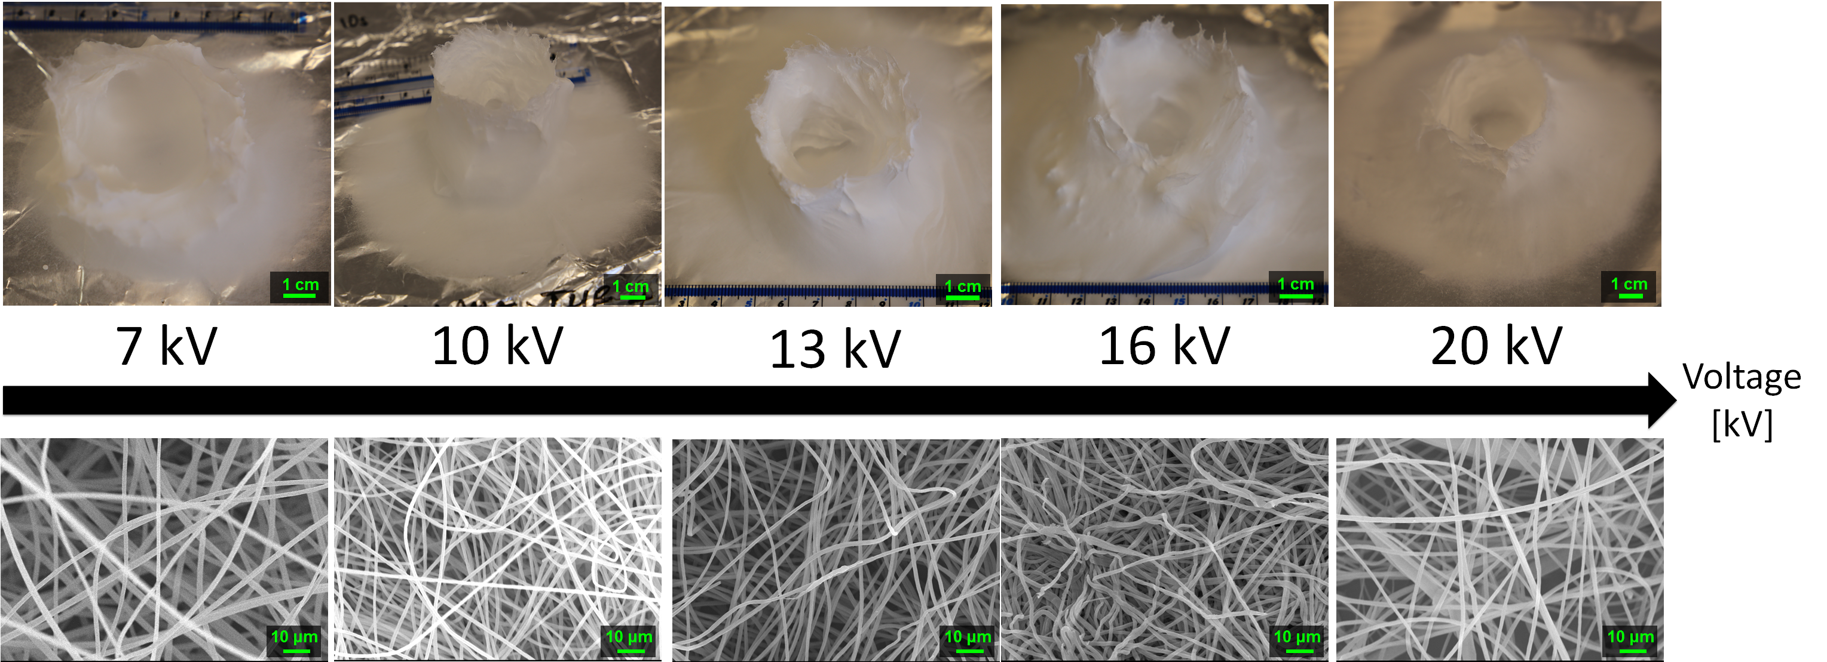
Figure 9. Evolution of the 3D structure shape and the fibres shape and morphology as the voltage is increased from +7 kV to +20 kV. 15.0 wt% PS in 1:1 DMF/THF was electrospun at a working distance of 5 cm, a flow rate of 5.0 mL.h⁻¹ for 10 minutes. The sample processed at +10 kV had the closest representation to the designed cylinder, having thin walls and the least amount of fibres coverage inside the cylinder. Other than that, the applied voltage had little effect on the cylinder shape. The fibres diameters had no linear correlation with the applied voltage.

Figure 10. Evolution of the fibre mean diameters as the voltage is increased from +7 kV to 20 kV. 15.0 wt% PS in 1:1 DMF/THF was electrospun at a working distance of 5 cm, a flow rate of 5.0 mL.h⁻¹ for 10 minutes. There was a critical voltage at which point the mean fibres diameter would increase again, up to a stable range after 17 kV.

Working distance (WD)
Investigations on the effect of working distance on the 3D build-up were done at a flow rate of 5.0 mLh⁻¹ and a nozzle speed of 12.0 mm.s⁻¹. The voltage was fixed at +20 kV for most distances except for the low distance of 1 cm. A voltage of +10 kV was used for the working distance of 1 cm, this was necessary to avoid short circuit between the charged nozzle and the collector plate.
Working distances above 10 cm would not result in a stable 3D build-up. At 10 cm, a fibres network between the moving nozzle belt and the collector plate (see Figure 11) is observed. At 15 cm, the fibres were only deposited on the nozzle collecting belt, and no structure was observed on the collector plate. At high working distance, the nozzle collecting belt can act as a preferential collector because of its closer proximity to the nozzle tip. Then, the electrospun fibres deposited onto the collecting belt can get negatively polarized and act as a preferential deposition sites. Leaving the electrospinning for too long in that condition would result in a short circuit inside the device.
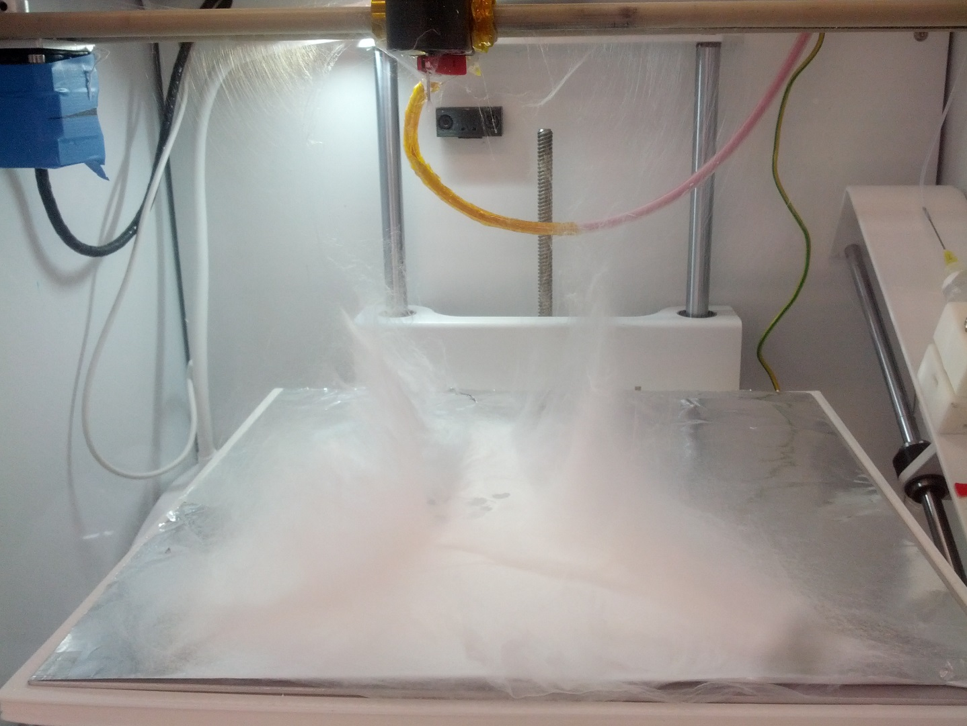
Figure 11: At a working distance of 10 cm, the electrospun fibres were attracted to the rubber belt of the moving nozzle. 15.0 wt% PS in 1:1 DMF/THF was electrospun at 20 kV, a flow rate of 5.0 mL.h⁻¹, at ambient conditions.
Working distances below 2 cm were not yielding 3D structures. Below 2 cm, sparks are likely to occur due to the high electric field. Furthermore, the drying of the electrospun fibres is not complete for working distances under 2 cm. This results in a deposition of wet fibres onto the collector that would then merge and form a solid brittle deposition. It is worth noting that the deposition area of the fibres was smaller at lower working distances. At low working distances, the electrospinning jet is at the early stage of the whipping instability and the jet cone spread is still small.^{61,62}
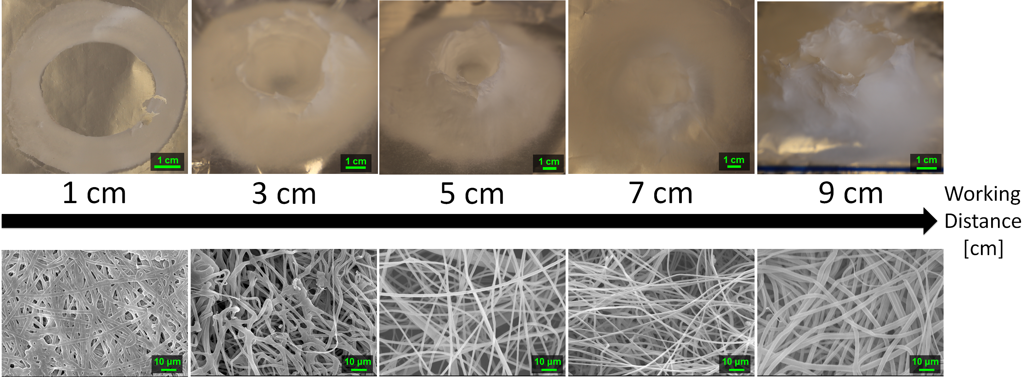
Figure 12: Evolution of the 3D structure shape and the fibres shape and morphology as the working distance is increased from 1 cm to 9 cm. 15.0 wt% PS in 1:1 DMF/THF was electrospun at a voltage of +20 kV, a flow rate of 5.0 mL.h⁻¹ for 10 minutes. At low working distances and ambient conditions, flight time of the electrospun jet was insufficient and fibres were fused together. On the contrary, increasing the working distance too much is detrimental to the overall shape of the electrospun cylinder.
For intermediate working distance, between 3 and 7 cm, a 3D build-up was observed. This range of working distance can be seen as a transition between the low and high working distance. In effect, cylinders electrospun at 3 cm and 4 cm were small and most of the top part were constituted of solid brittle fibres that did not have enough travel time to dry. The shape of the build-up was still a hollow cylinder, which again is because of the lower whipping instability at low working distance. On the other end, increasing the working distance too much would decrease the quality of the cylinder shape obtained, resulting in a filling of the hollow inside of the cylinder or a more distorted cylinder. Cha et al. observed that the deposition area of their electrospun polymer fibres would increase as the working distance is increased.⁶³ This is because of the bending and whipping instability, characteristic of the electrospun jet, that gets wider and wider as more travel time and length is given to the jet. The structure electrospun at 6 cm did not have a hollow inside. The shape of the samples electrospun between 7 and 9 cm was closer to an elliptic cylinder than a circular one. It is possible to define a major and a minor axis for these elliptic samples by measuring the shortest and largest inner diameters. For example, the sample electrospun at 9 cm (see Figure 12) had a major axis of 82 mm and a minor axis of 64 mm. As seen previously, the nozzle collecting belt can act as a deposition site when the working distance is too high. At these intermediate working distances, the presence of the nozzle collecting belt influenced the electric field and altered the travel path of the electrospun jet, resulting in a distorted, elliptic shape.
The final height of the 3D structure is directly correlated to the working distance as seen in Figure 13. As explained before, the top of the structure is made of fused and brittle fibres because of the lessened travel and drying time. Because these fibres are fused together, the negatively charged fibres are unable to repel each other. This effect stalls the build-up process of the 3D structure. As an example, the height of the 3D structures goes from ~16mm to ~70mm when the working distance is increased from 3 to 9 cm.

Figure 13: Evolution of the 3D structure height as the working distance is increased from 1 cm to 9 cm. 15.0 wt% PS in 1:1 DMF/THF was electrospun at a voltage of +20 kV, a flow rate of 5.0 mL.h⁻¹ for 10 minutes. The working distance had a linear correlation with the height of the electrospun 3D structure.
The measured mean fibres diameters were 1.92 ± 0.67 μm, 1.69 ± 0.30 μm, 1.87 ± 0.34 μm, 1.69 ± 0.45 μm, 1.60 ± 0.39 μm, 2.25 ± 0.81 μm, 2.89 ± 0.92 μm and 1.39 ± 0.29 μm for working distances of 3 cm, 4 cm, 5 cm, 6 cm, 7 cm, 8 cm, 9 cm and 10 cm respectively (see Figure 14). The size of the electrospun samples at 1 and 2 cm were not measured as they were mostly made of fused fibres. As a general behaviour in electrospinning, it has been observed that increasing the working distance would result in a decrease of the fibres diameter. The main reason for this was the increased travel length of the jet which would allow better drying and more stretching and thinning of the fibres.⁵⁷ However, beaded fibres and non-smooth fibres have been observed when the working distance was too high.⁵
At 8 and 9 cm, this trend is not observed. This is because even though the applied voltage was the same, the electric field was weakened and this led to a reduction of the stretching of the jet. Bosworth et al. observed this behaviour for high working distance and obtained higher fibres diameter.⁶⁴ Tong and Wang also explained that a higher working distance would not necessarily lead to a longer travelling distance.⁶⁵ This is due to the three-dimensional spiralling trajectory of the jet, where the travel length of the jet is not only dependant only on the height and can be significantly increased within the normal plane. At 10 cm however, the fibres diameters are at the lowest of the working distance study. In the case of this study, the travel path of the fibres that reached the collector may have been much longer with the working distance of 10 cm. This can be hinted by the size of the deposition area, which was much larger than in other experiments, and covered about ¾ of the collector plate (about 20 cm x 20 cm). The increased travel length would thus result in a decrease of the fibre diameters.
A working distance of 5 cm was selected as the optimal distance as it gave the most accurate cylinder and the obtained fibres diameter was among the lowest. Pictures and fibres morphology of the samples electrospun at the other working distances are in the supplementary info (Figure S5 to S7).

Figure 14: Evolution of the fibre mean diameters as the working distance is increased from 3 cm to 10 cm. 15.0 wt% PS in 1:1 DMF/THF was electrospun at a voltage of +20 kV, a flow rate of 5.0 mL.h⁻¹ for 10 minutes. The working distance had no linear correlation with the mean fibre diameter.

Solution flow rate (f)
Flow rates of 1.0, 2.0, 3.0, 4.0, 5.0, 7.5, 10.0 and 20.0 mL.h⁻¹ were tested at a working distance of 5 cm, a voltage of 20 kV and a nozzle speed of 12 mm.s⁻¹. Using low flow rates has similar effect on the 3D build-up than using low polymer concentration solutions. In both case, a low amount of polymer fibres is deposited onto the collector. As seen in Figure 15, the lowest flow rates of 1.0 mL.h⁻¹ would not yield any 3D structure. The flat electrospun mat done at 2.0 mL.h⁻¹ can be seen in the supplementary information (Figure S8). This might be because of the lesser amount of fibres getting negatively charged by static induction and polarization and this lower amount of negatively charged fibres cannot act as a preferential collector site for the incoming electrospun fibres. Instead, a wider flat deposition area was observed which is characteristic of charge retention by the fibres mat which repels the electrospun jet.⁴⁷ For flow rate of 3.0 and 4.0 mL.h⁻¹, it was observed that the 3D structure got an overall lower height after the same time of experiment. Similar to the effect of low polymer concentration, less polymer fibres would result in less repulsion between fibres and a lower quantity of fibres to build up the structure.
At flow rates higher than 7.5 mL.h⁻¹, the structure of the cylinder is also questionable as the inside of the cylinder is partly covered. Deitzel et al. noticed at high flow rate, for low molecular weight polymer, the jet radius would shrink slowly.⁶⁶ As such, because the initial jet is wide enough to cover the inside of the ring, if the jet radius shrinks at a slower pace, then the inside of the ring would be covered with more fibres. This would then result in a non-hollow cylinder. The drying of the fibres is another problem at a high flow rate even though no dripping was observed during electrospinning. A significant part of the resulting cylinders electrospun at 10.0 mL.h⁻¹ and 20.0 mL.h⁻¹ are made of a hard crest of non-dried polystyrene, similar to when the 3D structure gets too close to the nozzle tip (see Figure 5). This hard crest would cover the whole surface of the 3D structure, even though the total height of the structure is smaller than 3 cm.
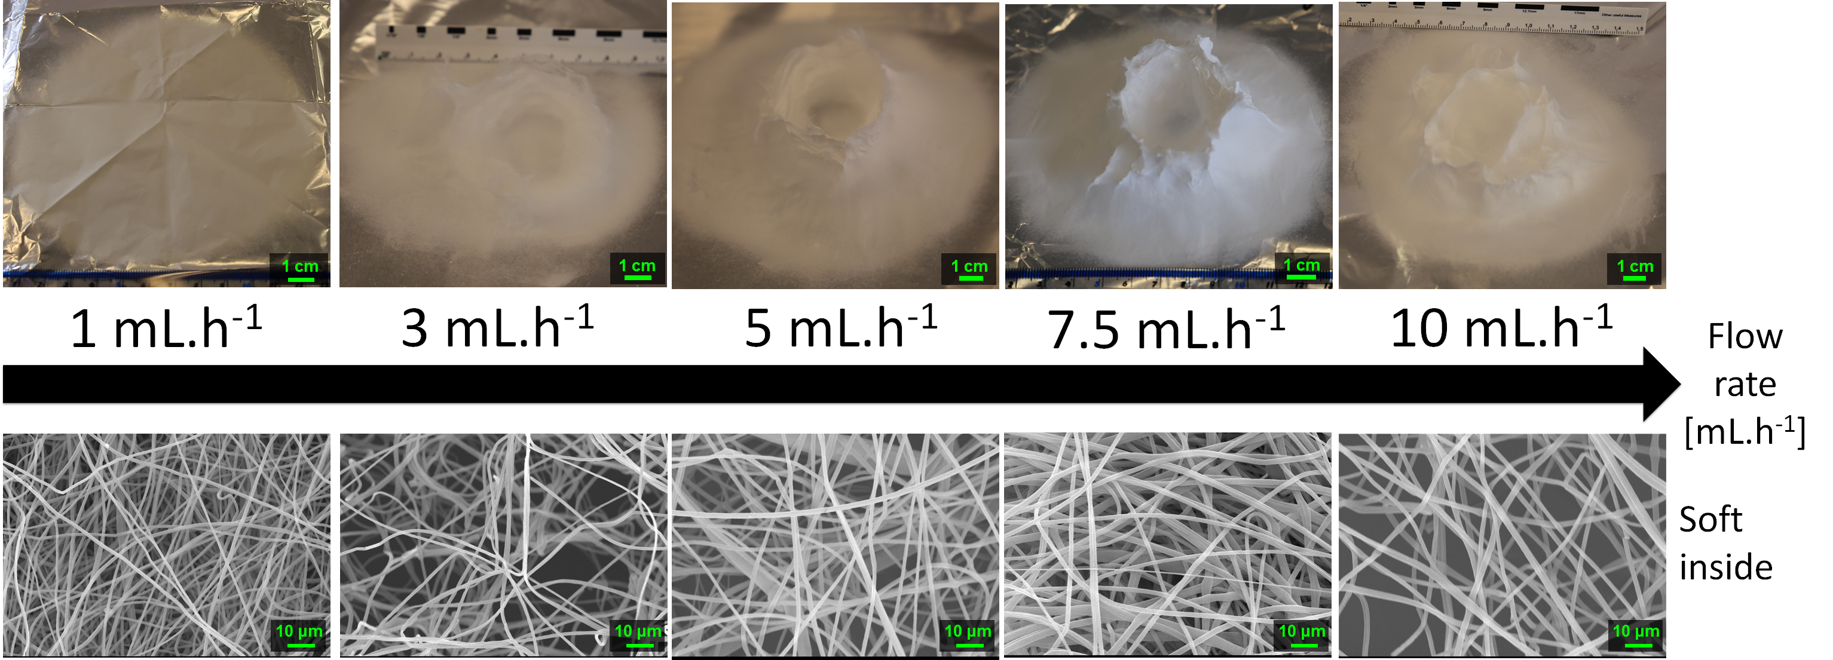
Figure 15: Evolution of the 3D structure shape and the fibres shape and morphology as the flow rate is increased from 1.0 mL.h⁻¹ to 10.0 mL.h⁻¹. 15.0 wt% PS in 1:1 DMF/THF was electrospun at a voltage of +20 kV and a working distance of 5 cm for 10 minutes. A minimum flow rate is necessary to allow 3D build-up to happen. Increasing the flow rate too much hinders the controlled build-up of the 3D structure.

Figure 16: Evolution of the fibre mean diameters as the flow rate is increased from 1.0 to 20.0 mL.h⁻¹. 15.0 wt% PS in 1:1 DMF/THF was electrospun at a voltage of +20 kV, a working distance of 5 cm for 10 minutes. Mean fibre diameters increases with the flow rate, the amount of polymer supplied.

The mean fibres diameters were 1.13 ± 0.24, 1.22 ± 0.35, 1.29 ± 0.25, 1.43 ± 0.23, 1.87 ± 0.34, 1.65 ± 0.37, 2.11 ± 0.41, 2.78 ± 0.81 μm for flow rates of 1, 2, 3, 4, 5, 7.5, 10 and 20 mL.h⁻¹ respectively (see Figure 16). As Zargham et al. explained, higher flowrates led to a greater volume of solution being ejected from the needle tip.⁶⁷ This higher volume of solution would also need a longer time to dry and the jet would need more stretching to achieve a lower diameter. Considering the applied voltage and working distance were the same, the travel time was also the same in the flow rate study. This would explain why increasing flow rates lead to an increase in the fibres diameter. They further stated that increasing the flow rate at a constant voltage would be detrimental as the amount of charged ions would not be enough for sufficient stretching of the solution.
Even though higher flow rates would give higher production rates, the flow rate of 5.0 mL.h⁻¹ was chosen from this point to allow better control of the 3D structure and the fibres morphology. Pictures and fibres morphology of the samples electrospun at the other flow rates are in the supplementary info (Figure S8 and S9).

Nozzle moving speed
Investigations on the effect of the moving speed of the nozzle were done at a fixed voltage of +20 kV, a working distance of 5 cm and a flow rate of 5.0 mL.h⁻¹. The default moving speed of the nozzle was set to 12.0 mm.s⁻¹ (default value of the software).
Several slower speeds were tested (0.6, 3.3, 6.0 and 9.0 mm.s⁻¹). As the speed was lowered, the shape of the final 3D structure got further away from the designed cylinder. Evidences of discrepancies appeared as more filling of the inside of the cylinder and not vertical building of the outer walls of the cylinder as seen in Figure 17. It is worth noting that this experiment was also tried with a static single-nozzle electrospinning device under the same experimental conditions: a flow rate of 5.0 mL.h⁻¹, a voltage of +20 kV, a working distance of 5 cm and a nozzle moving speed of 0 mm.s⁻¹. The fibres were observed to build-up as a single branch until they touched the nozzle at which point the electrospinning would stop and dripping of the solution would occur.
A doubled moving speed of 24.0 mm.s⁻¹ resulted in an overall smaller 3D structure of about 2~3 cm high, instead of 3~4 cm. No matter the nozzle moving speed, the negatively induced fibres are attracted by the positively charged nozzle and are dragged along the pathway of the nozzle. At high moving speed, the growing branches are forced onto a smaller slope and this results in an overall lower structure. The effect of the nozzle moving speed on the growth of the electrospun branches is illustrated in the supplementary information (Figure S10).
The mean diameters were 2.08 ± 0.76, 1.48 ± 0.38, 1.47 ± 0.19, 1.57 ± 0.33, 1.87 ± 0.34 μm for nozzle speeds of 0.6, 3.3, 6.0, 9.0, 12.0 mm.s⁻¹ respectively (see Figure 18). The largest fibre diameters were obtained for the slowest nozzle speed and even fused fibres were obtained. A slow nozzle speed would increase the amount of electrospun solution in a single position, thus decreasing the drying speed and yielding bigger fibre diameters. This effect is similar to increasing the flow rate. All the other samples electrospun at different increasing nozzle moving speed have similar fibres diameter. A moving nozzle has no direct influence on the jet elongation and drying except from spreading the polymer jet over a wider area on the collector. It is interesting to note that using a moving nozzle enables electrospinning of individual fibres at high flow rate.
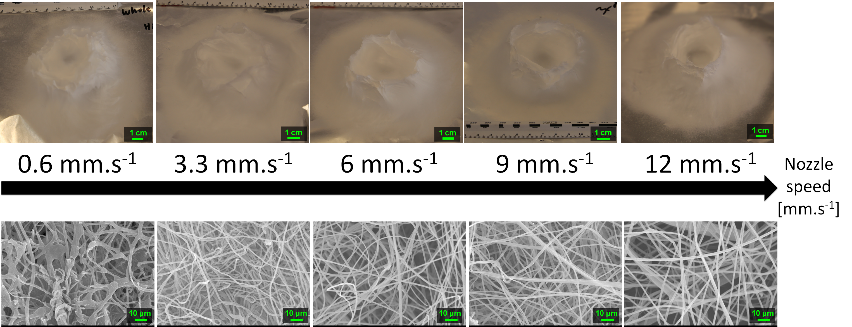
Figure 17: Evolution of the 3D structure shape and the fibres shape and morphology as the nozzle speed is increased from 0.6 mm.s⁻¹ to 12.0 mm.s⁻¹. 15.0 wt% PS in 1:1 DMF/THF was electrospun at a voltage of +20 kV, a working distance of 5 cm and a flow rate of 5.0 mL.h⁻¹ for 10 minutes. Low nozzle speed was detrimental to both the 3D structure and the fibres shape and morphology.

Figure 18: Evolution of the fibre mean diameters as the nozzle speed is increased from 0.6 to 12.0 mm.s⁻¹. 15.0 wt% PS in 1:1 DMF/THF was electrospun at a voltage of +20 kV, a working distance of 5 cm and a flow rate of 5.0 mL.h⁻¹ for 10 minutes. Low nozzle speed is detrimental to the drying and thus stretching of the fibres, resulting in bigger fibres.

CONCLUSIONS
This study explored the use of a 3D electrospinner in the fabrication of 3D fibrous architecture. Rapid electrospinning of 3D structures with controllable cylinder shape has been successfully achieved without the aid of any auxiliary template. The electrospun 3D structures have typical height of approximately 3~4 cm from a 10-minute electrospinning process. The build-up of the 3D fibrous polystyrene structure is associated with the charge induction and polarization of the fibres, and their interaction with the electrospinning environment, including the charged nozzle. The behaviour of the electrospun fibrous 3D structure in the vicinity of a charged rod, during and after electrospinning, has been investigated and goes in line with this theory. Proper tuning of the process parameters, including solution concentration, applied voltage, working distance, flow rate and nozzle moving speed, is critical to achieve a 3D build-up instead of the traditional 2D deposition in electrospinning. The parameters must be adjusted to provide a decent amount of polymer, high enough to have enough repulsion between fibres and low enough for proper drying of the fibres, to control the size of the deposition area and to control the speed of the vertical fibres growth. The PS fibres diameters of the 3D structures are between 790 nm – 2.89 μm, the evolution of the fibres morphology and diameter with the process parameters is similar in behaviour with the fibres obtained with a traditional 2D electrospinner. 3D electrospinning technology opens new horizons in nano- and micro-fabrication.

CONFLICT OF INTEREST
There are no conflicts to declare.

ACKNOWLEDGEMENT
The authors would like to thank Professor Vasileios Koutsos and Professor Khellil Sefiane of the University of Edinburgh, Dr. Giuseppino Fortunato of EMPA and Dr. Lu Wang of Anhui Normal University for their helpful comments. The SEM results were obtained using the EPSRC Centre for Doctoral training in “Soft Matter and Functional Interfaces” SEM.

REFERENCES
1 S. Thenmozhi, N. Dharmaraj, K. Kadirvelu and H. Y. Kim, Mater. Sci. Eng. B, 2017, 217, 36–48.
2 S. Agarwal, A. Greiner and J. H. Wendorff, Prog. Polym. Sci., 2013, 38, 963–991.
3 C. L. Casper, J. S. Stephens, N. G. Tassi, D. B. Chase and J. F. Rabolt, Macromolecules, 2004, 37, 573–578.
4 J. Fang, H. Niu, T. Lin and X. Wang, Chinese Sci. Bull., 2008, 53, 2265–2286.
5 Z. Li and C. Wang, One-Dimensional nanostructures, Springer, Heidelberg, 1st edn., 2013.
6 W. Liu, C. Huang and X. Jin, Nanoscale Res. Lett., 2015, 10, 237–246.
7 T. Nitanan, P. Opanasopit, P. Akkaramongkolporn, T. Rojanarata, T. Ngawhirunpat and P. Supaphol, Korean J. Chem. Eng., 2012, 29, 173–181.
8 J. Lin, B. Ding, Y. Jianyong and Y. Hsieh, ACS Appl. Mater. Interfaces, 2010, 2, 521–528.
9 S. Moon, J. Choi and R. J. Farris, Fibers Polym., 2008, 9, 276–280.
10 G. Cadafalch Gazquez, V. Smulders, S. Veldhuis, P. Wieringa, L. Moroni, B. Boukamp and J. ten Elshof, Nanomaterials, 2017, 7, 16.
11 K. Yuan, C. Feng, X. Gan, Z. Yu, X. Wang, L. Zhu, G. Zhang and D. Xu, Ceram. Int., 2016, 42, 16633–16639.
12 B. Komur, F. Bayrak, N. Ekren, M. S. Eroglu, F. N. Oktar, Z. A. Sinirlioglu, S. Yucel, O. Guler and O. Gunduz, Biomed. Eng. Online, 2017, 16, 40.
13 Y. Gao, Y. Wang, Y. Wang and W. Cui, Mar. Drugs, 2016, 14, 192.
14 S. Calamak, E. A. Aksoy, C. Erdogdu, M. Sagıroglu and K. Ulubayram, J. Nanoparticle Res., 2015, 17, 87.
15 M. Bao, X. Wang, H. Yuan, X. Lou, Q. Zhao and Y. Zhang, J. Mater. Chem. B, 2016, 4, 5308–5320.
16 B. Ardeshirzadeh, N. A. Anaraki, M. Irani, L. R. Rad and S. Shamshiri, Mater. Sci. Eng. C, 2015, 48, 384–390.
17 P. Zhang, X. Zhao, X. Zhang, Y. Lai, X. Wang, J. Li, G. Wei and Z. Su, ACS Appl. Mater. Interfaces, 2014, 6, 7563–7571.
18 S.-J. Kim, S.-J. Choi, J.-S. Jang, N.-H. Kim, M. Hakim, H. L. Tuller and I.-D. Kim, ACS Nano, 2016, 10, 5891–5899.
19 X. Sheng, L. Fan, C. He, K. Zhang, X. Mo and H. Wang, Int. J. Biol. Macromol., 2013, 56, 49–56.
20 N. R. Dhineshbabu, G. Karunakaran, R. Suriyaprabha, P. Manivasakan and V. Rajendran, Nano-Micro Lett., 2014, 6, 46–54.
21 Y. Yang, W. Zhang, F. Yang, D. E. Brown, Y. Ren, S. Lee, D. Zeng, Q. Gao and X. Zhang, Green Chem., 2016, 18, 3949–3955.
22 D. Hu, Y. Huang, H. Liu, H. Wang, S. Wang, M. Shen, M. Zhu and X. Shi, J. Mater. Chem. A, 2014, 2, 2323.
23 H. Hadi Najafabadi, M. Irani, L. Roshanfekr Rad, A. Heydari Haratameh and I. Haririan, RSC Adv., 2015, 5, 16532–16539.
24 S. Haider, F. F. Binagag, A. Haider and W. A. Al-Masry, J. Polym. Res., 2014, 21, 371.
25 S. R. Dods, O. Hardick, B. Stevens and D. G. Bracewell, J. Chromatogr. A, 2015, 1376, 74–83.
26 S. Jayaraman, V. Aravindan, P. Suresh Kumar, W. Chui Ling, S. Ramakrishna and S. Madhavi, ACS Appl. Mater. Interfaces, 2014, 6, 8660–8666.
27 S. Hong, M. Hou, H. Zhang, Y. Jiang, Z. Shao and B. Yi, Electrochim. Acta, 2017, 245, 403–409.
28 G. Luo, K. S. Teh, Y. Liu, X. Zang, Z. Wen and L. Lin, ACS Appl. Mater. Interfaces, 2015, 7, 27765–27770.
29 B. Sun, Y.-Z. Long, S.-L. Liu, Y.-Y. Huang, J. Ma, H.-D. Zhang, G. Shen and S. Xu, Nanoscale, 2013, 5, 7041.
30 Y.-K. Fuh, J.-C. Ye, P.-C. Chen, H.-C. Ho and Z.-M. Huang, ACS Appl. Mater. Interfaces, 2015, 7, 16923–16931.
31 Y. Yu, S. Hua, M. Yang, Z. Fu, S. Teng, K. Niu, Q. Zhao and C. Yi, RSC Adv., 2016, 6, 110557–110565.
32 S. Naghieh, E. Foroozmehr, M. Badrossamay and M. Kharaziha, Mater. Des., 2017, 133, 128–135.
33 L. Dimesso, C. Spanheimer, W. Jaegermann, Y. Zhang and A. L. Yarin, J. Appl. Phys., , DOI:10.1063/1.3693575.
34 Q. Zhang, J. Welch, H. Park, C.-Y. Wu, W. Sigmund and J. C. M. Marijnissen, J. Aerosol Sci., 2010, 41, 230–236.
35 B. Sun, Y. Z. Long, H. D. Zhang, M. M. Li, J. L. Duvail, X. Y. Jiang and H. L. Yin, Prog. Polym. Sci., 2014, 39, 862–890.
36 S. Soliman, S. Pagliari, A. Rinaldi, G. Forte, R. Fiaccavento, F. Pagliari, O. Franzese, M. Minieri, P. Di Nardo and S. Licoccia, Acta Biomater., 2010, 6, 1227–1237.
37 J. Lee, J. Jang, H. Oh, Y. H. Jeong and D.-W. Cho, Mater. Lett., 2013, 93, 397–400.
38 S. J. Kim, D. H. Jang, W. H. Park and B.-M. Min, Polymer (Guildf)., 2010, 51, 1320–1327.
39 M. M. Li and Y. Z. Long, Nano-Scale Amour. Mater., 2011, 688, 95–101.
40 B. Sun, Y.-Z. Long, F. Yu, M.-M. Li, H.-D. Zhang, W.-J. Li and T.-X. Xu, Nanoscale, 2012, 4, 2134.
41 C. A. Bonino, K. Efimenko, S. I. Jeong, M. D. Krebs, E. Alsberg and S. A. Khan, Small, 2012, 8, 1928–1936.
42 M. Cheng, Z. Qin, S. Hu, H. Yu and M. Zhu, Cellulose, 2017, 24, 219–229.
43 H. Y. Mi, X. Jing, H. X. Huang and L. S. Turng, Mater. Lett., 2017, 204, 45–48.
44 D. T. Chin and H. H. Chang, J. Appl. Electrochem., 1989, 19, 95–99.
45 M. Farrokhi-Rad, Ceram. Int., 2015, 42, 3361–3371.
46 C. Mit-Uppatham, M. Nithitanakul and P. Supaphol, J. Polym. Sci. Part B Polym. Phys., 2005, 43, 3699–3712.
47 W.-E. Teo, R. Inai and S. Ramakrishna, Sci. Technol. Adv. Mater., 2011, 12, 13002.
48 V. Beachley and X. Wen, Mater. Sci. Eng. C, 2009, 29, 663–668.
49 Z. Khan and F. M. Kafiaha, in Membrane Technology for Water and Wastewater Treatment, Energy and Environment, eds. A. F. Ismail and T. Matsuura, IWA Publishing, 2016, pp. 309–318.
50 M. . Demir, I. Yilgor, E. Yilgor and B. Erman, Polymer (Guildf)., 2002, 43, 3303–3309.
51 G. Eda and S. Shivkumar, J. Appl. Polym. Sci., 2007, 106, 475–487.
52 H. Fong, I. Chun and D. H. Reneker, in Polymer, 1999, vol. 40, pp. 4585–4592.
53 K. H. Lee, H. Y. Kim, H. J. Bang, Y. H. Jung and S. G. Lee, Polymer (Guildf)., 2003, 44, 4029–4034.
54 C. Zhang, X. Yuan, L. Wu, Y. Han and J. Sheng, Eur. Polym. J., 2005, 41, 423–432.
55 S. Zhao, X. Wu, L. Wang and Y. Huang, J. Appl. Polym. Sci., 2004, 91, 242–246.
56 L. Li and Y. Lo Hsieh, Polymer (Guildf)., 2005, 46, 5133–5139.
57 X. Y. Yuan, Y. Y. Zhang, C. Dong and J. Sheng, Polym. Int., 2004, 53, 1704–1710.
58 K. H. Chang and H. L. Lin, J. Polym. Res., 2009, 16, 611–622.
59 C.-M. Wu, H.-G. Chiou, S.-L. Lin and J.-M. Lin, J. Appl. Polym. Sci., 2012, 126, E89–E97.
60 A. Haider, S. Haider and I.-K. Kang, Arab. J. Chem., , DOI:10.1016/j.arabjc.2015.11.015.
61 T. Subbiah, G. S. Bhat, R. W. Tock, S. Parameswaran and S. S. Ramkumar, J. Appl. Polym. Sci., 2005, 96, 557–569.
62 K. P. Matabola and R. M. Moutloali, J. Mater. Sci., 2013, 48, 5475–5482.
63 D. Il Cha, K. W. Kim, G. H. Chu, H. Y. Kim, K. H. Lee and N. Bhattarai, Macromol. Res., 2006, 14, 331–337.
64 L. A. Bosworth and S. Downes, J. Polym. Environ., 2012, 20, 879–886.
65 H.-W. Tong and M. Wang, J. Appl. Polym. Sci., 2011, 120, 1694–1706.
66 J. M. Deitzel, C. Krauthauser, D. Harris, C. Pergantis and J. Kleinmeyer, in Polymeric Nanofibers, 2006, vol. 918, pp. 56–73.
67 S. Zargham, S. Bazgir, A. Tavakoli, A. S. Rashidi and R. Damerchely, J. Eng. Fiber. Fabr., 2012, 7, 42–49.

