Mode I Fracture in Nanocomposite Laminates within Multistage Traction-Separation Law
Pouyan Ghabezi ª, and Mohammad Reza Farahani ^{b}
ª Mechanical Engineering, National University of Ireland Galway, Ireland,

^{b} School of Mechanical Engineering, College of Engineering, University of Tehran, Tehran, Iran.
Abstract: The main focus of this work is to investigate and compare the effect of adding nanoparticles to composite laminates on fracture process zone characterization including bridging and cohesive laws according to a multistage traction-separation law. To do this, three different methods have been utilized (Corrected Beam Theory, Experimental Compliance Method and Modified Compliance Calibration) to calculate the energy release rates in Mode I fracture. The numerical investigation of mode I fracture in nanocomposite laminates was done based on the multistage traction-separation law derived from double cantilever beam tests.

Key words: Fracture, Traction-separation law, Nanocomposite, Mode I

- Introduction
Delamination propagation in fibre-reinforced composites is often followed by fiber bridging mechanisms e.g. fibers crossing over from one crack face to its opposite, because of fiber debonding and pull-out, and applying closure stresses to the crack faces [, ]. Fiber bridging effects on the magnitude of fracture toughness as crack propagates. Fracture resistance curves in mode I and II fracture, R-curves, are defined to explain the bridging mechanisms as after crack initiation (G_{i,0}) and during crack propagation, the energy release rate value rises until it reaches a plateau, namely steady state fracture toughness (G_{i,ss}) []. The novelty of the present work is use of a novel traction-separation law [] developed by the authors for modeling of Mode I delamination initiation and propagation in laminated composite materials in presence of nanoparticles experimentally and numerically by Abaqus software. The constitutive parameters of cohesive elements were utilized to model mode I fracture in nano-Alumina/glass/epoxy composite laminates through Double Cantilever Beam (DCB) test.

Materials
Vacuum assisted resin transfer molding (VARTM) method was used to manufacture the nanocomposite samples with 0, 0.2, 0.43, 1, 2.1, and 4.1 Wt%. The preform was comprise of six glass fiber layers (surface density: 200g/m²), a layer of Dacron fabric and a distribution layer (enhancement layer). Epoxy-based resin EPH 1012 and its hardener, EPH 112, were applied as the matrix (Young’s modulus=2.73 GPa, Yield Stress=74.62 MPa). In this work, Alpha -alumina nanoparticles with 99% purity, average nanoparticle size of ~80nm, and specific surface area of smaller than 10m²/g were added to the matrix to enhance the mechanical properties of the composite laminates.
- Tests and Results
The configuration and different areas of DCB samples are presented in Fig. 1. The actual thickness, width and length of samples were equal to 4.5±1.0mm, 20mm and 250mm, respectively. To prevent the application of moment on composite samples during DCB test, two steel hinges were attached to the edge of the pre-cracked DCB sample. The DCB tests in compliance with ASTM D5528-01, 2007 standard were conducted on the nanocomposite laminates by a hydraulic machine (WDW-300E; load accuracy: 0.001mm; load cell: 15kN; UTM-300E controlling system).
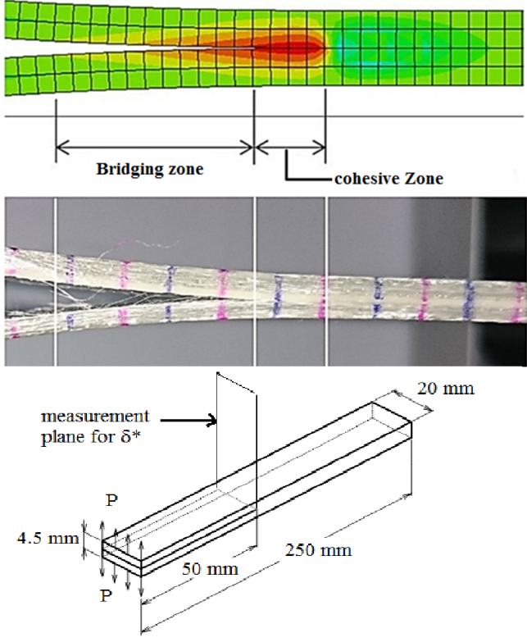
Fig. 1: DCB test dimension and setup.
The distance between the loading line and the crack tip, 50mm was indicated as the crack length (α₀) in double cantilever beam specimens. Crack growth (α), displacement at loading point (δ), and opening displacement at pre-crack tip (δ*) were monitored visually during the DCB tests in different time intervals using a high-resolution camera. Vertical thin lines were marked on the side edges of the DCB test samples with 5mm spacing to help measure the displacements (Fig. 1). During each test, the force-displacement curve (P-δ) and relative displacement of pre-crack tip (δ*) along with crack propagation were recorded as a function of time [].
In this work, the energy release rates in the nanocomposites were calculated according to Corrected Beam Theory (CBT), Experimental Compliance Method (ECM) and Modified Compliance Calibration (MCC) proposed by ASTM D5528-01 standard. The critical bridging stress (σ_{c,I}) and critical crack opening displacement (δ*_{c,I}) of bridging principles as well as the energy release rates calculated by the all three methods are shown in Fig. 2. According to experimental results, there is an inconsistency between the magnitude of energy release rate parameters calculated by ECM and those of CBT and MCC.
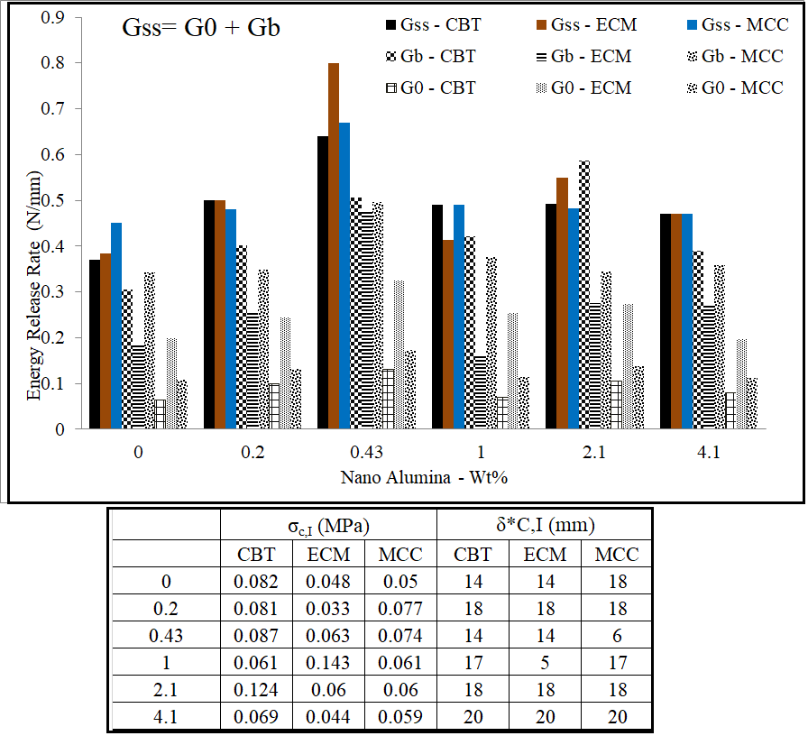
Fig. 2: Energy release rate parameters. Experimental bridging law parameters
- Traction - Separation law
A multistage cohesive model was used in this research [4] to simulate the inter-laminar behavior of nanocomposite laminates (Fig. 3).
$σ_{M,I}$ and $σ_{N,I}$ parameters were extracted with respect to the experimental behavior of the stress-displacement experimental curves obtained for different specimens while $σ_{N,I}$ and $σ_{M,I}$ can be measured respectively for $δ_{3,I}$ and $δ_{2,I}$ displacements.
(1) | $$δ_{2,I}=δ_{1,I}+\frac{1}{3}({δ^{*}}_{C,I}-δ_{1,I})$$
(2) | $$δ_{3,I}=δ_{1,I}+\frac{2}{3}({δ^{*}}_{C,I}-δ_{1,I})$$
The section under the curve in Fig. 3 between δ_{I}=0 and δ_{I}=δ_{1,I} presents value of G_{I,0}:
(3) | $$G_{I,0}=\frac{1}{2}σ_{C,I}δ_{0,I}+σ_{C,I}(δ_{1,I}-δ_{0,I})$$
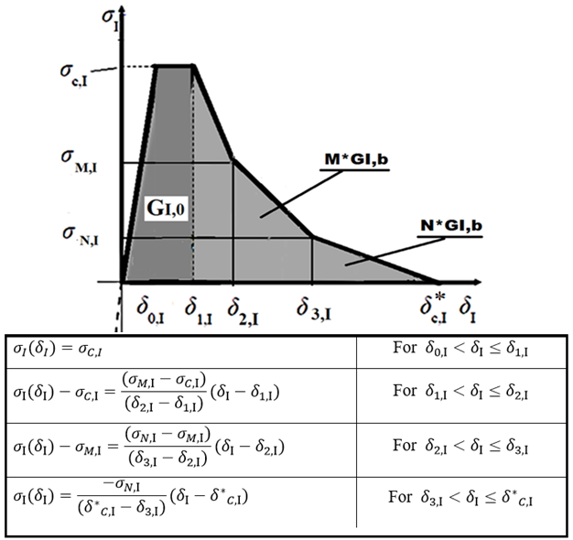
Fig. 3: Multistage traction separation model for Mode I fracture [4].
The total consumed energy at the end of fracture process zone equals the desirable energy release rate value, which is the same as at the steady state fracture toughness (G_{I,SS}) and is defined as the area under the σ_{I}-δ_{I} curve, which is obtained by the following relationship:
(4) | $$G_{I,SS}=\frac{1}{2}σ_{C,I}δ_{0,I}+σ_{C,I}\left(δ_{1,I}-δ_{0,I}\right)+\left(δ_{2,I}-δ_{1,I}\right)\frac{σ_{C,I}-σ_{M,I}}{2}+\frac{1}{2}\left(δ_{2,I}-δ_{1,I}\right)\left(σ_{M,I}\right)+\left(δ_{3,I}-δ_{2,I}\right)\frac{σ_{M,I}-σ_{N,I}}{2}+\frac{1}{2}\left(δ_{3,I}-δ_{2,I}\right)\left(σ_{N,I}\right)+\frac{1}{2}\left({δ^{*}}_{C,I}-δ_{3,I}\right)σ_{N,I}$$
In order to analyze double cantilever beam test in the nanocomposites, cohesive elements based upon the multistage traction-separation law have been introduced along the crack path at the center of the adhesive layer assuming a cohesive fracture. The mesh for the interface elements used in the zone close to the pre-crack tip was smaller than the one of other zones (elements type: COH3D8, 8-node three-dimensional cohesive element, Mesh size: 0.05 mm for the cohesive element, the selected mesh technique for cohesive element was sweep). The composite model had a length of 250mm, width of 20mm, average thickness of 4.5mm, ad length of pre-crack was 50mm according to ASTM D5528-01, 2007. As boundary conditions, the center of the lower tab was fixed and the center of the upper tab was loaded through an imposed vertical displacement. For the description of the constitutive behavior of cohesive elements utilized for modeling of the interface layer, the proposed fracture process zone laws were utilized. To perform this, 1200 displacement values and their corresponding damage evolution parameters according to equation 9 were imported within Abaqus to introduce damage and failure for fiber-reinforced composites (Type = Displacement, Softening = Tabular) ) (Fig. 4).
Damage evolution control parameter (D) was introduced in the softening section, which is variable between 0 and 1 range (0 indicates no damage, and 1 shows full damage and failure in the composite laminate), to consider reversibility (without loading) (Fig. 4).
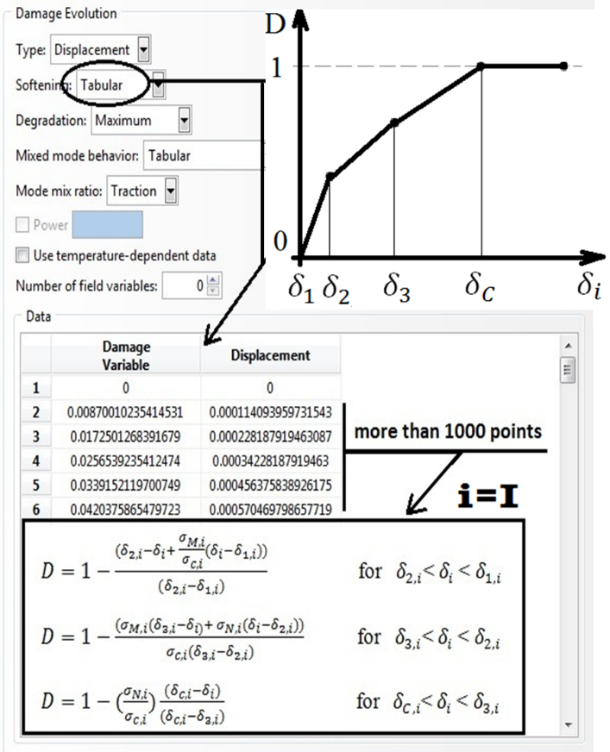
Fig. 4: Definition of damage evolution (tabular) in finite element software.
The force-deflection curves are represented by values from the top node in the DCB test simulation which was subjected to a prescribed displacement. This node represents the behavior of the beam structure. The global response of the DCB configuration is presented in Table 1, as experimentally measured and numerically predicted. According to the experimental and numerical results for the maximum load-bearing capacity of the DCB specimens including nanoparticles, adding nanoparticles to the resin increased the maximum load-bearing capacity from 0.056kN for N-Com-0 to 0.062 kN for N-Com-0.43 samples. Adding higher content of nanoparticles (up to 4.1wt%) showed a slight loss in the load-bearing capacity. This is because of an increase in nanoparticle content and greater probability of nanoparticle agglomeration in the matrix, and thus higher stress concentration in agglomerated points. From the numerical simulation results, it can be seen that the MCC method was able to predict the maximum load capacity of the samples more accurately.
Table 1: Numerical and experimental evaluation of maximum force (kN).
N-Com-0.43 |  | N-Com-0.2 |  | N-Com-0
FEM | Exp. | FEM | Exp. | FEM | Exp.
0.065 | 0.062 | 0.06 | 0.055 | 0.059 | 0.056 | CBT
0.064 | 0.062 | 0.059 | 0.055 | 0.057 | 0.056 | ECM
0.059 | 0.062 | 0.056 | 0.055 | 0.0567 | 0.056 | MCC
N-Com-4.1 |  | N-Com-2.1 |  | N-Com-1
FEM | Exp. | FEM | Exp. | FEM | Exp.
0.067 | 0.06 | 0.07 | 0.06 | 0.062 | 0.06 | CBT
0.063 | 0.06 | 0.065 | 0.06 | 0.064 | 0.06 | ECM
0.062 | 0.06 | 0.059 | 0.06 | 0.061 | 0.06 | MCC
- Conclusion
In this work, the main objective was investigation on the effectiveness of nano-Alumina particles content on the bridging and cohesive parameters in laminated nano-composites Mode I fracture. Post-processing of the experimental measurements include construction of the R-curves (Energy release rate versus crack length) and reconstruction of these curves in terms of the pre-crack tip opening displacement was applied to derived the corresponding bridging laws through the J-integral approach. For the calculation of the energy release rate in Mode I fracture, three different data reduction schemes were utilized (CBT, ECM and MCC). The experimental bridging laws for nano-composite samples were converted into a proposed traction-separation model applicable to user defined interface/cohesive finite elements. The proposed model can appropriately predict fracture behavior of nano composite laminate in mode I fracture.
References

[] M., Elices, G.V., Guinea, J., Gómez, J., Planas, The cohesive zone model: advantages, limitations and challenges, Eng. Fract. Mech., 2002, 69(2): 137–163.
[] H., Hosseini-Toudeshky, M.S., Goodarzi, B., Mohammadi, Prediction of through the width delamination growth in post-bukled laminates under fatigue loading using de-cohesive law, Struct. Eng. Mech., Int. J., 2013, 48(1), 41-56.
[] K. N., Anyfantis, Analysis and Design of Composite‐to‐Metal Adhesively Bonded Joints, Phd. Thesis, national technical university of Athens school of naval architecture and marine engineering, 2012.
[] P., Ghabezi, M., Farahani, A Cohesive Model with a Multi-Stage Softening Behavior to Predict Fracture in Nano Composite Joints, Eng. Fract. Mech., 2019, 2019, 106611
[] K. N., Anyfantis, N.G., Tsouvalis, A novel traction–separation law for the prediction of the mixed mode response of ductile adhesive joints, Int. J. Solid Struc., 2012, 49(1): 213-226.

