Correlating Indoor and Outdoor Temperature and Humidity in a Sample of Buildings in Tropical Climates

Jin Panª, Julian Tang^{b}, Miguela Caniza^{c}, Jean-Michel Heraud^{d}, Evelyn Koay^{e}, Hong Kai Lee^{f}, Chun Kiat Lee^{g}, Yuguo Li^{h}, Alejandra Nava Ruiz^{i}, Carlos Francisco Santillan-Salas^{j}, Linsey C. Marrª

ª Civil and Environmental Engineering, Virginia Tech, Blacksburg, VA 24061, USA
^{b} Infection, Immunity and Inflammation, University of Leicester, Leicester, UK
^{c} Global Infectious Diseases Program, Department of Infectious Diseases, St. Jude Children’s Research Hospital, Memphis, TN 38105, USA
^{d} Virology Unit, Institut Pasteur de Madagascar, Antananarivo 101, Madagascar
^{e} Department of Pathology, Yong Loo Lin School of Medicine, National University of Singapore
^{f} Singapore Immunology Network (SIgN), Agency for Science, Technology and Research (A*STAR), Singapore 138648
^{g} Department of Laboratory Medicine, National University Health System, 119074, Singapore
^{h} Department of Mechanical Engineering, The University of Hong Kong, Pokfulam Road, Hong Kong, China
^{i} Pediatra Infectólogo, Epidemiólogo, Hospital de Especialidades Pediátricas, Tuxtla Gutiérrez Chiapas, México
^{j} Instituto Nacional de Salud del Niño San Borja, Lima, Peru
* Corresponding author. E-mail address: lmarr@vt.edu (L. Marr).

ABSTRACT
The incidence of several respiratory viral infections has been shown to be related to climate. Because humans spend most of their time indoors, measures of indoor climate, rather than outdoor climate, may be better predictors of disease incidence and transmission. Therefore, understanding the relationship between indoor and outdoor climate will help illuminate their influence on the seasonality of diseases caused by respiratory viruses. Indoor-outdoor relationships between temperature and humidity have been documented in temperate regions, but little information is available for tropical regions, where seasonal patterns of respiratory viral diseases differ. We have examined indoor-outdoor correlations of temperature, relative humidity (RH), and absolute humidity (AH) over a 1-year period in each of seven tropical cities. Across all cities, the average monthly indoor temperature was 25±3°C (mean ± standard deviation) with a range of 20–30°C. The average monthly indoor RH was 66±9% with a range of 50–78%, and the average monthly indoor AH was 15±3 g/m³ with a range of 10–23 g/m³. Indoor AH and RH were linearly correlated with outdoor AH when the air-conditioning (AC) was off, suggesting that outdoor AH may be a good proxy of indoor humidity in the absence of AC. All indoor measurements were more strongly correlated with outdoor measurements as distance from the equator increased. Such correlations were weaker during the wet season, especially when AC was in operation. These correlations will provide insight for assessing the seasonality of respiratory viral infections using outdoor climate data, which is more widely available than indoor data, even though transmission of these diseases mainly occurs indoors.

Key words: temperature, humidity, indoor, respiratory virus, climate, outdoor

1. INTRODUCTION
Temperature and humidity are associated with a variety of human health maladies. Both factors have been found to contribute to cardiovascular disease;¹⁻⁵ and humidity, which affects heat stress and hydration rate, has also been linked to heat-related deaths and all-cause mortality.⁶⁻⁸ These factors are also associated with the incidence of certain respiratory infections caused by viruses such as SARS-CoV-2,^{9,10} influenza virus,^{11,12} and respiratory syncytial virus (RSV).^{13,14} The seasonality of some respiratory viral infections has been attributed to the effect of temperature and humidity on virus stability and transmissibility and also on immune responses.¹⁵
Although numerous studies have suggested that there is an association between meteorological conditions, various health conditions, and respiratory viral disease seasonality,¹⁵ nearly all such studies are based on data from outdoor weather stations or output from meteorological models. Given the scarcity of indoor temperature and humidity data, using outdoor measurements has been common practice in the study of climate and health. However, as humans spend most of their time indoors, especially in more developed countries,¹⁶ the indoor climate, rather than the outdoor climate, is likely to be a better indicator of health.^{17,18} Most respiratory virus transmission likely occurs indoors.^{14,19} Of course, indoor temperature and humidity are influenced by outdoor conditions, but indoor conditions may also be controlled by heating, ventilation, and air conditioning (HVAC) or other regulatory systems²⁰ and are affected by human activities, resulting in discrepancies between indoor and outdoor measurements. Therefore, whether indoor conditions can be represented by outdoor measurements remains questionable.
There have been several recent studies on indoor-outdoor climate correlations. Two of them based their analyses on data from the northeastern US and drew similar conclusions: indoor temperature is better correlated with outdoor temperature during warm seasons than cool seasons, and outdoor absolute humidity (AH) is a good indicator of indoor AH across all seasons.^{17,21} They also concluded that outdoor relative humidity (RH) is not a strong predictor of indoor RH year-round. Another study examined the indoor-outdoor correlation in several locations across a range of latitudes, with a focus on temperate regions.¹⁸ The study suggested that actual moisture content (e.g., AH) outdoors was a better proxy for indoor exposure than was RH, regardless of season. Two other studies developed models to predict indoor temperature based on outdoor temperature.^{22,23} Both studies found a positive correlation between indoor and outdoor temperature, but outdoor temperature alone was not able to fully explain the variability of indoor temperature, even when augmented with solar radiation and dewpoint temperature. Nonetheless, there is little information about indoor-outdoor correlations of temperature and humidity in tropical regions.
Tropical cities have very different meteorological patterns from those in temperate regions. Thus, climate-health seasonality in tropical regions, including that involving respiratory viruses, has been found to differ substantially from that in temperate regions.²⁴⁻²⁶ For example, tropical influenza seasonality is not as strong as in temperate regions.²⁷⁻²⁹ The seasonal peaks of influenza incidence that are commonly observed in temperate regions are smaller and less distinctive in tropical regions.^{19,30} Additionally, the peak timing of both influenza and RSV is more diverse in tropical regions than in temperate regions.³¹
Given the stark differences in climate between tropical and temperate regions, it is crucial to study indoor-outdoor relationships more carefully in order to achieve a global understanding of climate impacts on health. To investigate the relationship between indoor and outdoor temperature and humidity in tropical regions, we collated indoor and outdoor climate data from seven tropical cities, plus one temperate location for reference, and conducted correlation analyses between indoor and outdoor measures. We also explored the seasonal and latitudinal variation of such correlations with the influence of air conditioning (AC) use. The results reveal how well the indoor climate can be represented by outdoor measurements, enabling further advances in the study of climate-health relationships.

2. MATERIALS AND METHODS

2.1 Indoor measurements
Through personal contacts and St. Jude Children’s Research Hospital’s PRINCIPAL network, we selected seven study locations in the tropics (latitude -23.5° to 23.5°). Additionally, Blacksburg, Virginia, USA (latitude 37.23°N) served as a temperate reference location. At each location, we installed three to five temperature and humidity data loggers (HOBO UX100-011A, Onset Corporation; Bourne, MA, USA) in office/academic buildings, hospitals, or residences for at least 12 months. We instructed our collaborators to place the loggers away from vents and out of direct sunlight in a room that is frequently occupied on most days of the week. Loggers were typically located on a shelf or mounted on a wall at a height of 1–2.5 m above the floor. We recorded whether there was an HVAC system in the sampled buildings. In the tropical cities, the buildings sampled had either AC only without heating or lacked indoor climate control. None of the buildings had humidifiers or dehumidifiers. Figure 1 shows a detailed map of the sampling locations, indicating the number of loggers placed in each type of setting and the presence or absence of an HVAC system. Three of the loggers were placed in different rooms of the same hospital in Tuxtla Gutierrez, so measurements from these are not independent of one another. We do not expect the co-location of the sensors in one city to affect the overall trends.

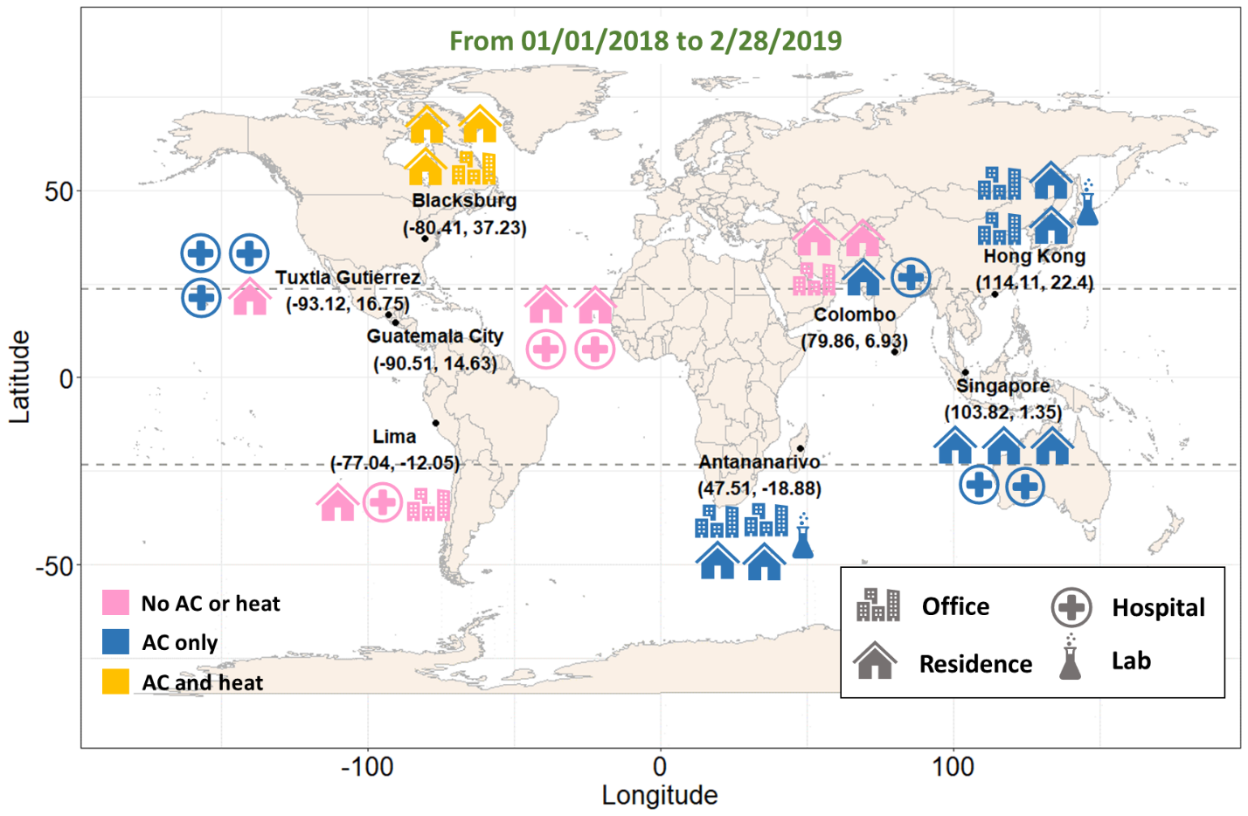
Figure 1. Locations of 35 temperature and humidity loggers distributed across eight cities (seven tropical and one temperate). The room/building type is indicated by an icon (office, hospital, residence, and lab), and the presence of air conditioning (AC) and/or heating systems is indicated by the color of the icon. Three of the loggers were placed in different rooms of the same hospital in Tuxtla Gutierrez. The two dashed lines bound the tropical region.

The HOBO data loggers recorded temperature (T, °C) and relative humidity (RH, %) hourly between 1 January 2018 and 28 February 2019 except in Colombo, where the batteries of the loggers died earlier than expected. Placement of the loggers began a month late in Tuxtla Gutierrez and ended a month early in Lima. Prior to distributing them, we confirmed that the sensors’ measurements agreed within the manufacturer’s specifications by placing them in a constant temperature room, synchronized them, and installed fresh batteries. According to the manufacturer, the sensor measures T with an accuracy of ±0.21°C from 0°C to 50°C, and RH with an accuracy of ±2.5% over the range of 10% to 90% and an accuracy of ±5% at RH below 10% or above 90%. For each hourly measurement, we calculated absolute humidity (AH, g/m³) based on T (°C) and RH (%) according to Equation (1):³²
$$AH=\frac{1322.7×exp\left(\frac{17.625×T}{T+243.04}\right)×\left(\frac{RH}{100}\right)}{T+273.15}$$ | Equation (1)

For additional analyses, we calculated daily averages from the hourly measurements (T, RH, and AH).

2.2 Outdoor measurements
We obtained outdoor measurements of temperature and humidity from the closest airport weather station to each city (Table S1). Using code written in Python 3.7, we scraped outdoor data from Weather Underground. The raw data for each city included T, RH, and dew point temperature (T_{d}), except for Tuxtla Gutierrez, where only T and T_{d} were recorded. For Tuxtla Gutierrez, we calculated RH (%) from T (°C) and T_{d} (°C) according to Equation (2):³²
$$RH=100×\frac{exp\left(\frac{17.625×T_{d}}{243.04+T_{d}}\right)}{exp\left(\frac{17.625×T}{243.04+T}\right)}$$ | Equation (2)

Then, we calculated AH (g/m³) for all cities using Equation (1). The temporal resolution of outdoor measurements varied by city, from 15 minutes to 24 hours. Therefore, we calculated the daily average of outdoor measurements for consistency across cities.

2.3 Statistical analyses
We scraped outdoor data matching the timeframe of all available indoor data, resulting in 424 observations (Colombo has 334 observations). We compared indoor and outdoor conditions using a t-test with a significance level of 0.05. To address our research objectives, we separated the data by season or the operating status of HVAC systems. For season-specific analyses, we divided the data into two seasons: wet season (May to October) and dry season (November to April) in the Northern Hemisphere, and vice versa in the Southern Hemisphere.^{33,34} Singapore does not have distinct wet or dry seasons.
For HVAC-specific analyses, we defined three system statuses: “AC on,” “AC off,” and “heat on.” We were not able to record directly the on/off times of HVAC systems in this study, so we assigned a status based on humidity observations. Because AC systems remove water vapor from outdoor air that enters the indoor environment, we established a criterion to differentiate “AC on” and “AC off” conditions. When indoor AH minus outdoor AH was less than or equal to -5 g/m³, we assigned the status “AC on,” and vice versa. The “heat on” status only occurred in Blacksburg, the reference location, as none of the buildings in tropical cities had a heating system. When indoor T minus outdoor T was greater than or equal to 15°C, we assigned the “heat on” status. We verified that the assignments matched expectations for the hour of day and time of year in each location by trying several different cutoff values and selecting the ones that generated the most sensible results (e.g., in residences, AC was on during the summer in the evenings on weekdays, when people were expected to be at home).
We tested indoor-outdoor differences using both a Student’s t-test, which assumes that the underlying data are normally distributed, and a Wilcoxon test, a nonparametric test that does not require a normal distribution, using a significance level of 0.05 (Table S4). The two tests produced similar results in terms of identifying differences. To evaluate the relationship between indoor and outdoor measurements, we used an ordinary least squares regression (OLS) model. We also computed the Pearson correlation coefficient (r) to evaluate the strength of the linear correlation by season and by HVAC status. Additionally, we constructed a multivariate OLS model to analyze the collective influence of multiple variables, including building type, season, and AC status, on the respective indoor measurements. We adopted Spearman’s correlation (ρ), a nonparametric test assessing monotonic relationship regardless of linearity, to assess the monotonicity between indoor and outdoor variables while AC was on. We conducted all statistical analyses in Python 3.7 and generated all figures using Python 3.7 and R 3.6.1.

3. RESULTS
We recorded indoor temperature and humidity in 35 rooms across seven tropical cities and one temperate location over one year and compiled outdoor temperature and humidity data from weather stations at nearby airports. Monthly averages and standard deviations of both indoor and outdoor T, RH, and AH for all cities appear on a world map (Figure 2), and the annual averages are shown in Table 1.

Table 1 Yearly means in 2018 (standard deviation) of indoor and outdoor measurements.
City | Indoor |  |  |  | Outdoor
 | T (℃) | RH (%) | AH (g/m³) |  | T (℃) | RH (%) | AH (g/m³)
Blacksburg* | 22.3 (2.2) | 42.2 (14.7) | 8.4 (3.4) |  | 12.3 (10.3) | 64.2 (19.9) | 8.2 (5.5)
Antananarivo | 23.5 (2.5) | 57.3 (12.3) | 12.0 (2.7) |  | 19.4 (4.7) | 74.4 (19.1) | 12.1 (2.7)
Colombo | 29.4 (1.8) | 73.3 (8.4) | 21.4 (1.9) |  | 27.7 (2.4) | 78.8 (1.1) | 20.9 (2.0)
Guatemala | 22.8 (1.7) | 61.6 (7.3) | 12.6 (1.8) |  | 19.3 (3.5) | 75.3 (16.3) | 12.2 (1.8)
Hong Kong | 24.0 (3.0) | 63.7 (10.8) | 14.1 (4.0) |  | 23.6 (5.7) | 69.3 (14.1) | 15.4 (5.5)
Lima | 23.4 (3.1) | 67.6 (8.4) | 14.1 (1.3) |  | 26.2 (3.3) | 73.4 (13.9) | 17.7 (1.2)
Singapore | 27.0 (2.3) | 67.6 (9.9) | 17.6 (4.0) |  | 27.9 (2.1) | 81.0 (10.6) | 21.6 (1.4)
Tuxtla Gutierrez | 22.7 (2.4) | 68.8 (7.2) | 13.9 (1.5) |  | 25.6 (4.1) | 64.2 (8.9) | 15.3 (2.6)
All tropical cities | 24.7 (2.5) | 65.7 (9.4) | 15.1 (2.7) |  | 24.2 (3.9) | 73.8 (13.2) | 16.5 (2.8)
*Blacksburg is a temperate location used for reference.

3.1 Temperature
For cities closer to the equator, such as Colombo and Singapore, the monthly average outdoor temperature was steadily high throughout the year, ranging from 23°C to 30°C with little seasonality (Figure 2a). In Guatemala City and Tuxtla Gutierrez, which are in between the Tropic of Cancer and the equator, weak temperature seasonality was apparent, as shown by outdoor temperatures that were 4–7°C higher in the wet season than in the dry season. Although Guatemala City is only ~350 km from Tuxtla Gutierrez, its outdoor temperature was 7–10°C lower than Tuxtla Gutierrez’s because of its higher altitude (1500 m vs. 500 m). In tropical cities that are farther from the equator, such as Hong Kong and Antananarivo, the monthly average outdoor temperature ranged from 15°C to 30°C and was 10–15°C higher in the respective hemisphere’s summer compared to winter, showing a stronger seasonality than in other tropical cities.
Indoor conditions were more consistent across locations. The monthly average indoor temperature of all tropical cities fell within the range of 20–30°C, averaging 24.7±2.5°C (mean ± standard deviation). In Guatemala City and Antananarivo, the indoor temperatures were 0–5°C higher than outdoors, as opposed to other tropical cities where the difference was smaller.

3.2 Humidity
Indoor and outdoor RH were highest in Colombo and Singapore, where the monthly averages were above 70%. In both cities, indoor RH was slightly lower than outdoor RH (Figure 2b). The outdoor RH of Guatemala City, Antananarivo, and Tuxtla Gutierrez was similar; all monthly averages exceeded 62%. However, Guatemala City’s and Antananarivo’s indoor RH was 10–15% lower than its outdoor RH, whereas indoor RH was higher than outdoor RH in Tuxtla Gutierrez. In Hong Kong, outdoor RH ranged from 54% to almost 80%, showing a relatively large seasonal difference, but indoor RH was still lower than outdoor RH.
The average monthly indoor RH in tropical cities was 66±9%, considerably higher than in the temperate city, which averaged 42±15%. Over the course of the year, the indoor RH of each tropical city followed the same temporal trend as its respective outdoor RH. In contrast, indoor RH was substantially lower than outdoor RH in the temperate location (Blacksburg) during wintertime, when heating is the norm. Although some tropical cities exhibited seasonality, their seasonal fluctuations in RH were much weaker compared to those in Blacksburg.
Outdoor AH varied widely among cities. In Singapore and Colombo, outdoor AH remained above 18 g/m³ throughout the year without obvious seasonality. Outdoor AH in Guatemala (10–13 g/m³) and Tuxtla Gutierrez (12–18 g/m³) was much lower. Outdoor AH in Antananarivo and Hong Kong was 14–21 g/m³ and 8–22 g/m³, respectively; it exhibited strong seasonality in both cities. There was a large difference in AH (up to 13 g/m³) between the wet and dry seasons in these two cities.
The average monthly indoor AH in tropical cities was 15±3 g/m³ (8±3 g/m³ in the temperate city). In Guatemala City and Colombo, where there was little AC control (two rooms in Colombo had individual AC units), indoor AH followed the trend of outdoor AH over the year, with indoor AH slightly higher than outdoor AH. In Hong Kong, indoor AH was generally 5–10 g/m³ lower than outdoor AH during the wet season due to the removal of water vapor by AC systems but was roughly equal to outdoor AH during the dry season. In Antananarivo, the difference between indoor and outdoor AH was not significant regardless of season, unlike in Tuxtla Gutierrez where indoor AH was lower than outdoor AH year-round. In Singapore, AC was in use during most of the year, so its indoor AH was always lower than outdoor AH by 4–5 g/m³ on average.

Figure 2. Monthly time series of indoor and outdoor (a) T (°C), (b) RH (%), and (c) AH (g/m³) for all cities

3.3 Correlation between indoor and outdoor temperature and humidity
We analyzed daily (24-hour average) indoor-outdoor correlations between four sets of variables: indoor T vs. outdoor T, indoor RH vs. outdoor RH, indoor AH vs. outdoor AH, and indoor RH vs. outdoor AH. The reason for examining the fourth set is that we expect outdoor water vapor to penetrate indoors, resulting in nearly the same AH indoors and outdoors; and because indoor temperatures fall in a narrow range, indoor RH should be strongly correlated with indoor AH. Thus, we propose that outdoor AH can serve as a proxy for indoor RH.
Figure 3 shows scatterplots of the indoor-outdoor relationships for three representative cities. Guatemala City represents cities with low penetration of AC systems, such as Colombo in this study. Hong Kong represents cities with greater penetration of AC systems, such as Antananarivo and Tuxtla Gutierrez. Because of its proximity to the equator, Singapore had a slightly different climate pattern compared to other tropical cities in this study. The slope and R² for all eight cities are presented in Table S2.

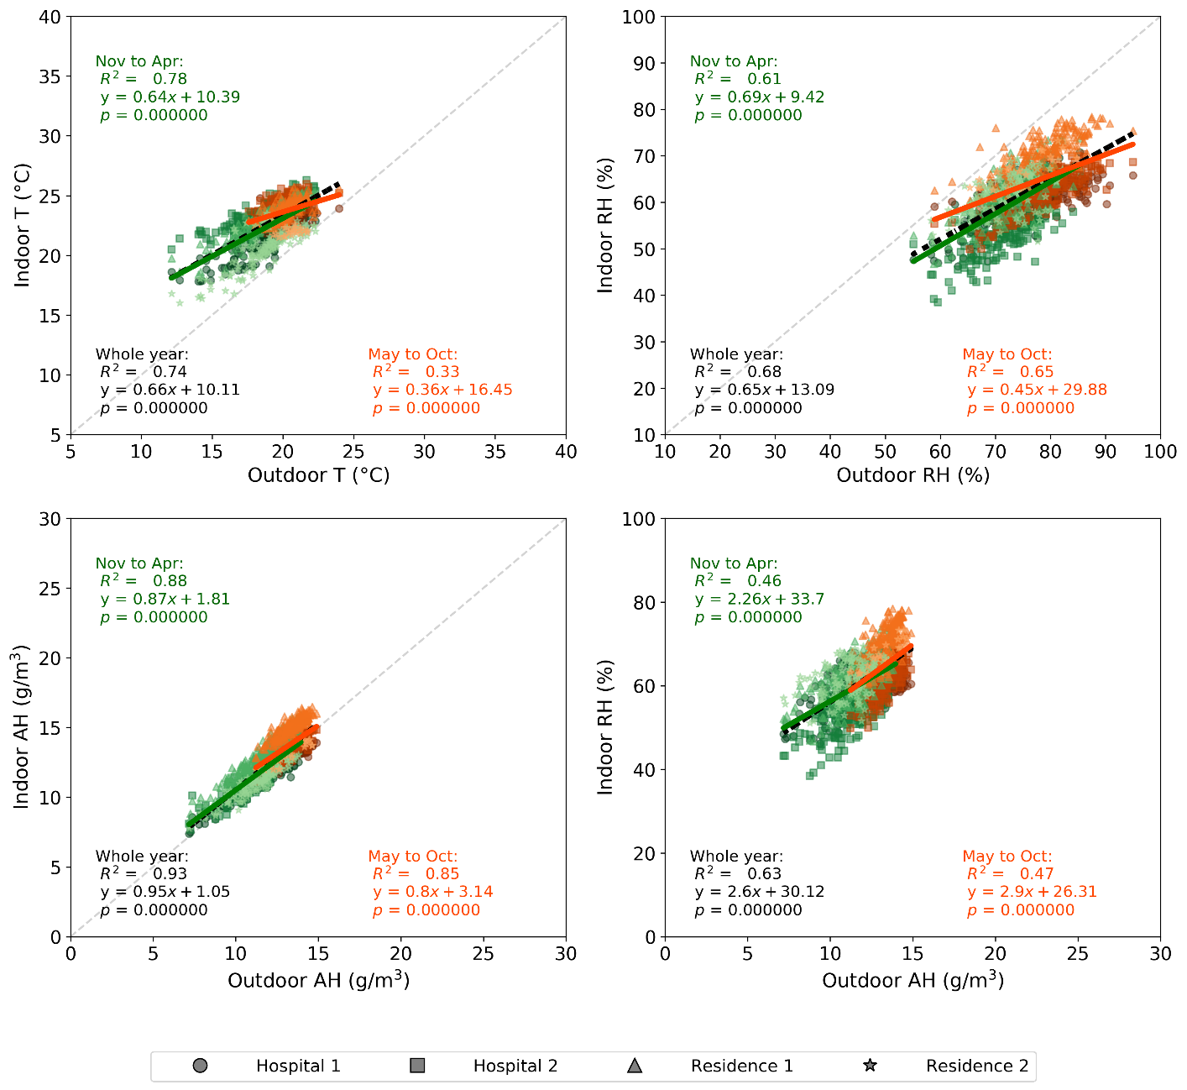
(a) Guatemala City
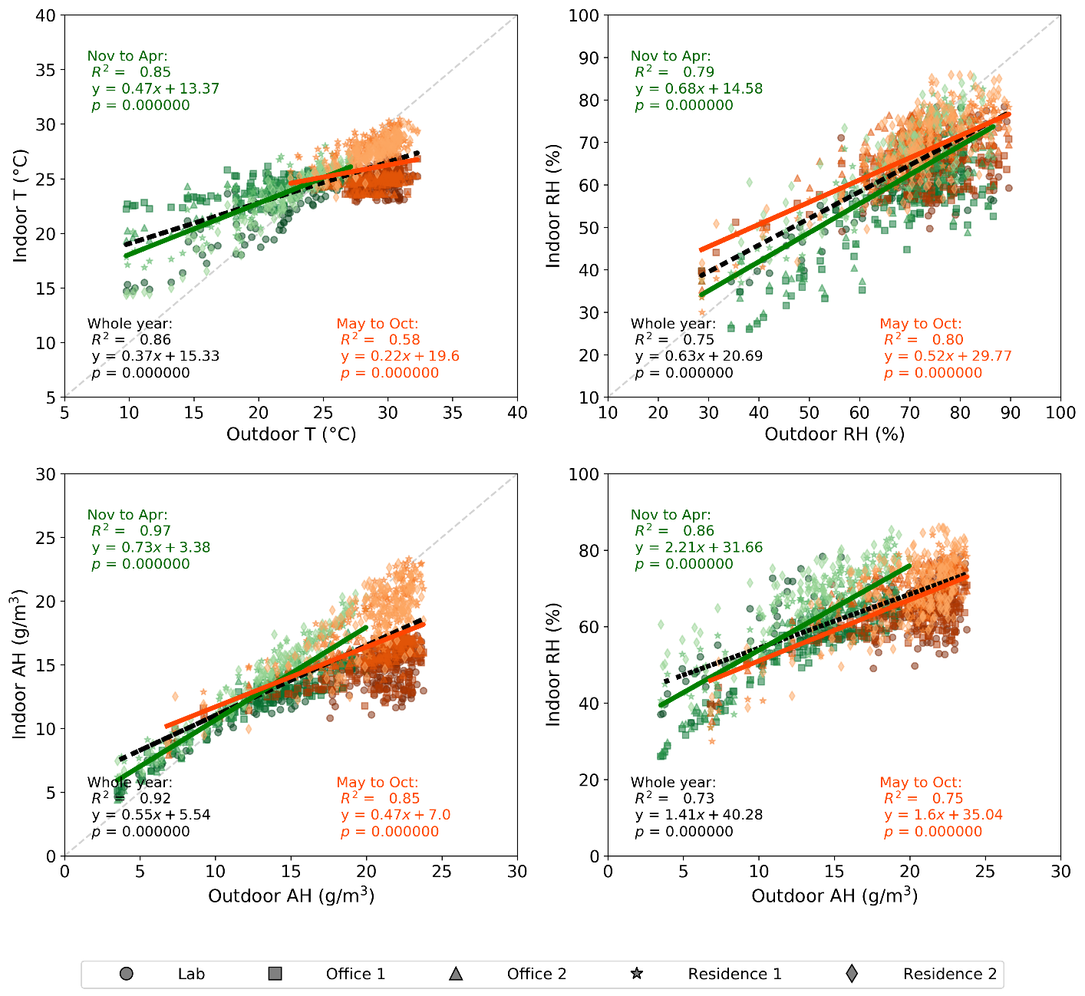
(b) Hong Kong
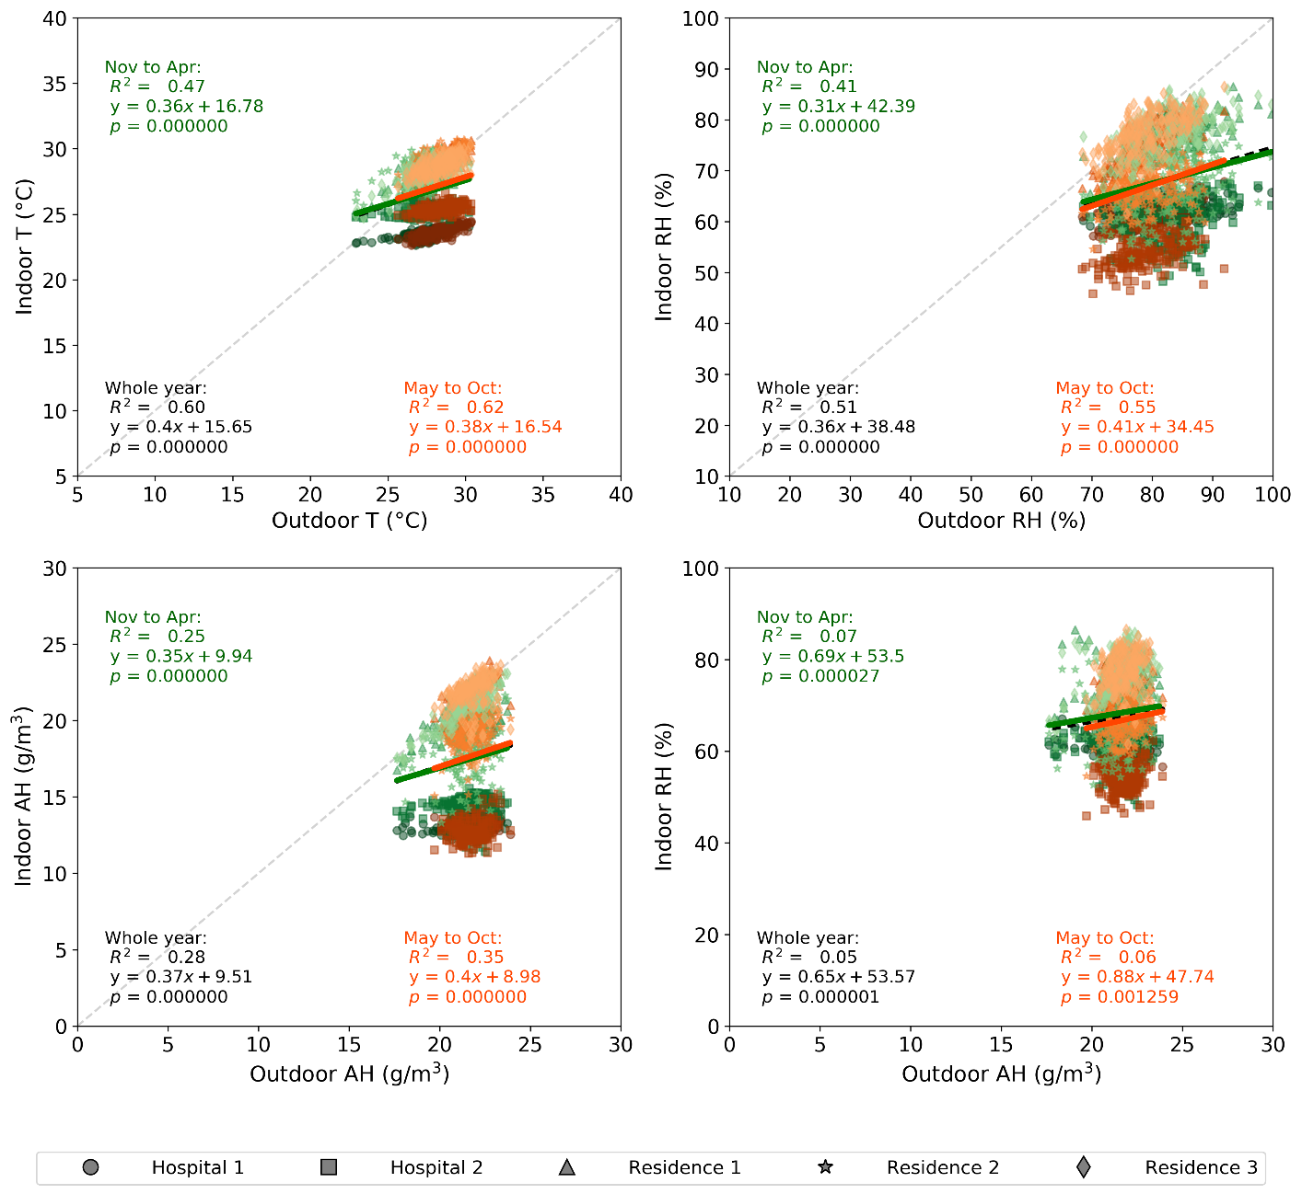
(c) Singapore
Figure 3. Correlation between daily indoor and outdoor measurements of temperature and humidity in (a) Guatemala City, (b) Hong Kong, and (c) Singapore, separated by season. Green markers represent the dry season (November to April) and orange markers represent the wet season (May to October). Least-squares linear regression lines are shown in their respective colors, and the 1:1 line is shown by a gray dashed line where relevant.

Table 2. Variation of Pearson’s r by building type, latitude, and season in cities ordered north to south. Multiple values in a cell indicate that there were multiple sensors in a certain building type. p < 0.05 except in Lima.
(a) Wet season.
Latitude | Building type | Correlation
 |  | Indoor T (°C)  vs.  Outdoor T (°C) | Indoor RH (%)  vs.  Outdoor RH (%) | Indoor AH (g/m³)  vs.  Outdoor AH (g/m³) | Indoor RH (%)  vs.  Outdoor AH (g/m³)
Blacksburg  (37.2 °N) | Residence | 0.35, 0.85, 0.75 | 0.47, 0.37, 0.55 | 0.65, 0.58, 0.87 | 0.66, 0.21, 0.69
 | Office | 0.71 | 0.56 | 0.83 | 0.74
Hong Kong  (22.4 °N) | Residence | 0.21, 0.53 | 0.37, 0.24 | 0.37, 0.16 | 0.33, 0.18
 | Office | -0.02, 0.22 | 0.22, 0.34 | 0.13, 0.51 | 0.13, 0.41
 | Lab | 0.01 | 0.41 | 0.18 | 0.25
Tuxtla Gutierrez  (16.8 °N) | Residence | 0.24 | 0.69 | 0.52 | 0.42
 | Hospital | 0.22, 0.11, -0.01 | 0.64, 0.38, 0.61 | 0.02, 0.02, 0.24 | 0.17, 0.10, 0.29
Guatemala City  (14.6 °N) | Residence | -0.11, 0.59 | 0.46, 0.47 | 0.63, 0.69 | 0.58, 0.67
 | Hospital | 0.06, 0.60 | 0.38, 0.63 | 0.69, 0.71 | 0.50, 0.52
Colombo  (6.9 °N) | Residence | 0.65, 0.56, 0.27 | 0.62, 0.50, 0.33 | 0.62, 0.51, 0.61 | 0.41, 0.35, 0.47
 | Office | 0.69 | 0.58 | 0.26 | 0.30
 | Hospital | 0.05 | 0.25 | 0.16 | 0.21
Singapore  (1.4 °N) | Residence | 0.51, 0.38, 0.41 | 0.54, 0.08, 0.33 | 0.36, 0.15, 0.09 | 0.30, 0.12, 0.11
 | Hospital | 0.45, 0.25 | 0.32, 0.09 | 0.07, 0.06 | 0.04, 0.06
Lima  (12.0 °S) | Residence | 0.15 | 0.42 | -0.15 | -0.10
 | Office | 0.21 | 0.34 | -0.10 | 0.01
 | Hospital | 0.01 | 0.16 | -0.12 | 0.06
Antananarivo  (18.9 °S) | Residence | 0.49, 0.70 | 0.37, 0.54 | 0.52, 0.58 | 0.41, 0.44
 | Office | 0.57, 0.59 | 0.43, 0.45 | 0.62, 0.62 | 0.57, 0.50
 | Lab | 0.18 | 0.18 | 0.14 | 0.16
(b) Dry season.
Latitude | Building type | Correlation
 |  | Indoor T vs. Outdoor T | Indoor RH vs. Outdoor RH | Indoor AH vs. Outdoor AH | Indoor RH vs. Outdoor AH
Blacksburg  (37.2 °N) | Residence | 0.18, 0.25, 0.24 | 0.42, 0.36, 0.35 | 0.73, 0.65, 0.79 | 0.75, 0.63, 0.76
 | Office | 0.52 | 0.54 | 0.95 | 0.94
Hong Kong  (22.4 °N) | Residence | 0.80, 0.87 | 0.69, 0.71 | 0.93, 0.93 | 0.88. 0.76
 | Office | 0.57, 0.83 | 0.72, 0.73 | 0.88, 0.93 | 0.87, 0.91
 | Lab | 0.85 | 0.69 | 0.92 | 0.69
Tuxtla Gutierrez  (16.8 °N) | Residence | 0.84 | 0.75 | 0.93 | 0.43
 | Hospital | 0.66, 0.28, 0.47 | 0.66, 0.40, 0.46 | 0.72, 0.70, 0.70 | 0.11, 0.54, 0.54
Guatemala City  (14.6 °N) | Residence | 0.43, 0.52 | 0.46, 0.27 | 0.72, 0.72 | 0.37, 0.39
 | Hospital | 0.44, 0.70 | 0.32, 0.54 | 0.74, 0.70 | 0.29, 0.50
Colombo  (6.9 °N) | Residence | 0.59, 0.40, 0.24 | 0.55, 0.47, 0.35 | 0.83, 0.80, 0.84 | 0.47, 0.54, 0.73
 | Office | 0.65 | 0.55 | 0.72 | 0.47
 | Hospital | 0.14 | 0.35 | 0.78 | 0.69
Singapore  (1.4 °N) | Residence | 0.49, 0.31, 0.49 | 0.54, 0.06, 0.41 | 0.40, 0.11, 0.54 | 0.30, 0.06, 0.35
 | Hospital | 0.46, 0.27 | 0.31, 0.15 | 0.14, 0.01 | 0.11, -0.02
Lima  (12.0 °S) | Residence | 0.25 | 0.24 | 0.39 | -0.12
 | Office | 0.15 | -0.02 | 0.30 | -0.37
 | Hospital | -0.01 | -0.11 | 0.40 | -0.46
Antananarivo  (18.9 °S) | Residence | 0.56, 0.75 | 0.38, 0.54 | 0.60, 0.66 | 0.31, 0.40
 | Office | 0.58, 0.59 | 0.35, 0.44 | 0.63, 0.63 | 0.45, 0.33
 | Lab | 0.22 | 0.32 | 0.14 | 0.07

In Guatemala City, both indoor and outdoor temperature fell within a relatively small range of 12°C to 27°C (Figure 3a). An increase of 1°C in outdoor temperature was associated with an average increase of ~0.7°C in indoor temperature (slope: 0.66, R² = 0.74). The goodness of fit between indoor and outdoor temperature was better during the dry season than the wet season (R² of 0.78 vs. 0.33), probably due to the much narrower range of values observed during the wet season. Its indoor AH was nearly the same as outdoor AH and an increase of 1 g/m³ outdoors was related to an increase of 0.95 g/m³ indoors (slope: 0.95, R² = 0.93), suggesting that the majority of the indoor water vapor came from outdoors in Guatemala City. Unlike its temperature profile, there was no significant difference of goodness of fit between wet and dry season regarding indoor-outdoor AH correlation. Guatemala City’s outdoor and indoor RH spanned similar ranges: 50–90% outdoors and 40–80% indoors. However, the indoor-outdoor correlation of RH was weaker than indoor T vs. outdoor T and indoor AH vs. outdoor AH, and there was no apparent seasonal difference. Among the four sets of comparisons, indoor AH vs. outdoor AH displayed the best goodness of fit (R² = 0.88 in the dry season and 0.85 in the wet season). Indoor and outdoor RH were less strongly correlated, and indoor RH was only weakly correlated with outdoor AH.
In Hong Kong, T, RH, and AH spanned a much wider range than in Guatemala City, and differences between the dry season and wet season were more evident (Figure 3b). The indoor temperature changed by only 0.37 °C for every 1 °C change in outdoor temperature (slope = 0.37, R² = 0.86), implying a weaker influence of outdoor temperature on indoor temperature. The correlation between indoor and outdoor temperature was stronger in the dry season (R² = 0.85 vs. R² = 0.58), again probably attributable to the much narrower range of temperatures in the wet season. The slope of the indoor-outdoor AH correlation was only 0.55, much less than in Guatemala City. Therefore, we speculate that some dehumidification processes were taking place, such that there was a smaller change in indoor AH given a 1 g/m³ change in outdoor AH. Such dehumidification effects were stronger in the wet season than the dry season (slope = 0.47 vs. slope = 0.73), as AC systems were more widespread and more commonly used in Hong Kong during the wet season. These effects may also contribute to a weaker indoor-outdoor AH correlation in the wet season than in the dry season (R² = 0.85 vs. R² = 0.97). The indoor RH vs. outdoor AH correlation was also strong in Hong Kong, especially during the dry season (R² = 0.86). In general, the linear correlations of all combinations were much stronger in Hong Kong compared to Guatemala City, except indoor AH vs. outdoor AH, which was roughly equal in both cities.
In Singapore, the range of each of T, RH, and AH was narrow because its climate does not vary much over the year. Therefore, the indoor-outdoor correlations in Singapore (Figure 3c) exhibited substantial differences from those in Guatemala City and Hong Kong. The linear correlation was weak for indoor-outdoor combinations regardless of the season due to the clustering of the values in a narrow range (R² < 0.6). Interestingly, some indoor measurements, especially T and AH, in residential buildings were clearly higher than those in hospital buildings, which implied some potential influence on indoor-outdoor correlations from building type. We surmise that the difference is due to heavier use of AC in hospital buildings compared to residential buildings.
The strength of correlations between indoor and outdoor conditions varied by building type, by latitude, and by season (Table 2, Figure S1). The indoor-outdoor correlation was in general stronger in the dry season than in the wet season, especially for the relationship between indoor AH and outdoor AH in many locations (r ≥ 0.7 for most data points in the wet season) (Table 2, Figure S1). The strength of the indoor-outdoor correlation increased with latitude in the dry season, more so for indoor RH vs. outdoor RH than for indoor RH vs. outdoor AH. However, there was no significant trend in the wet season, in part because the use of AC systems in some cities regulated the indoor environment. The strength of indoor-outdoor correlations in residential buildings was similar to that in the office buildings. However, due to our limited sample size, we do not know if this observation applies more broadly.

3.4 Influence of AC systems on the correlation
To investigate the influence of AC systems, we further stratified the data depending on whether the AC system was turned on and then analyzed the same correlations described in the previous section (Figure 4, Table S3, and Table 3).

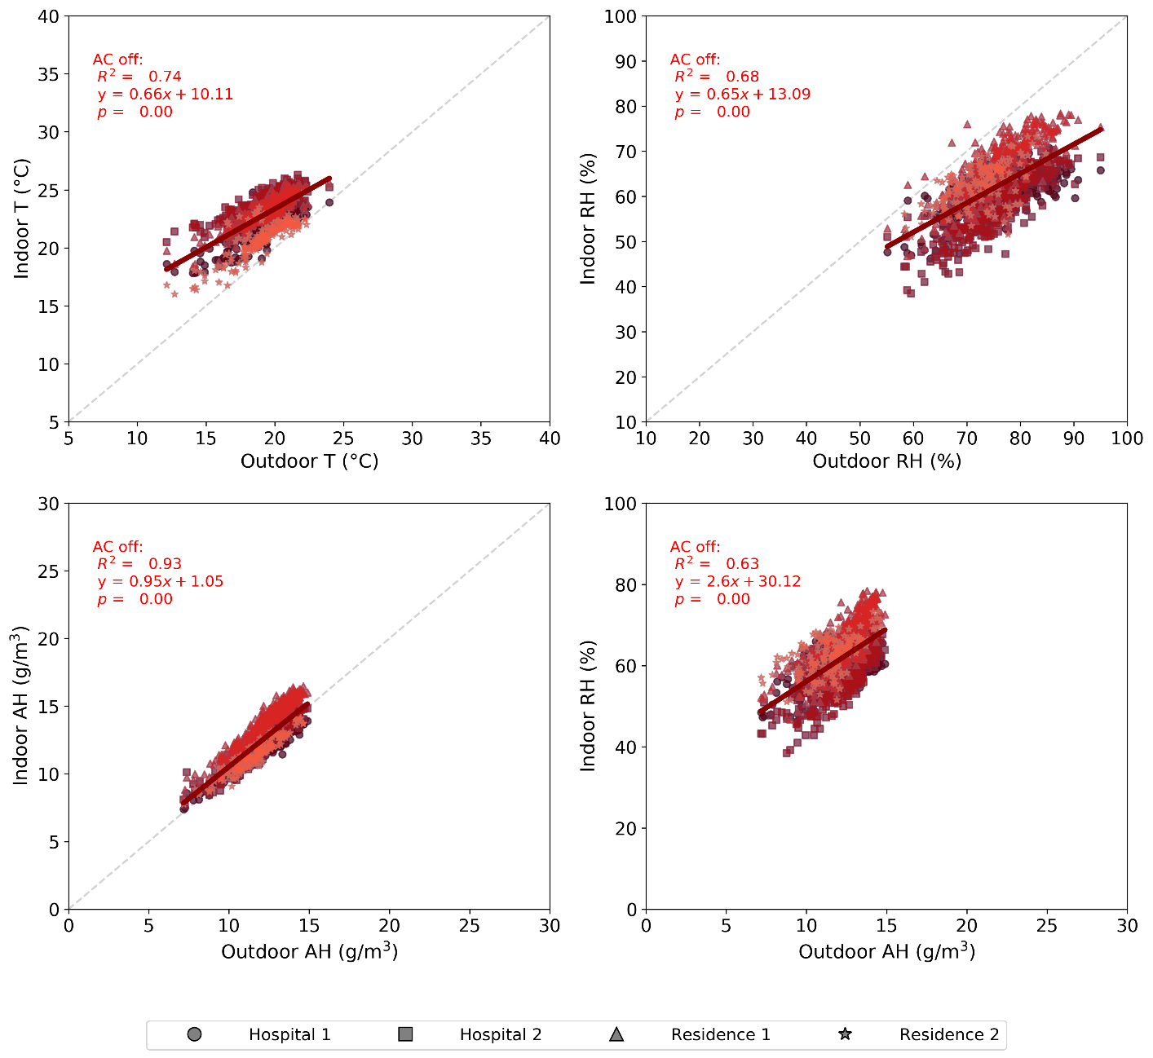
(a) Guatemala City
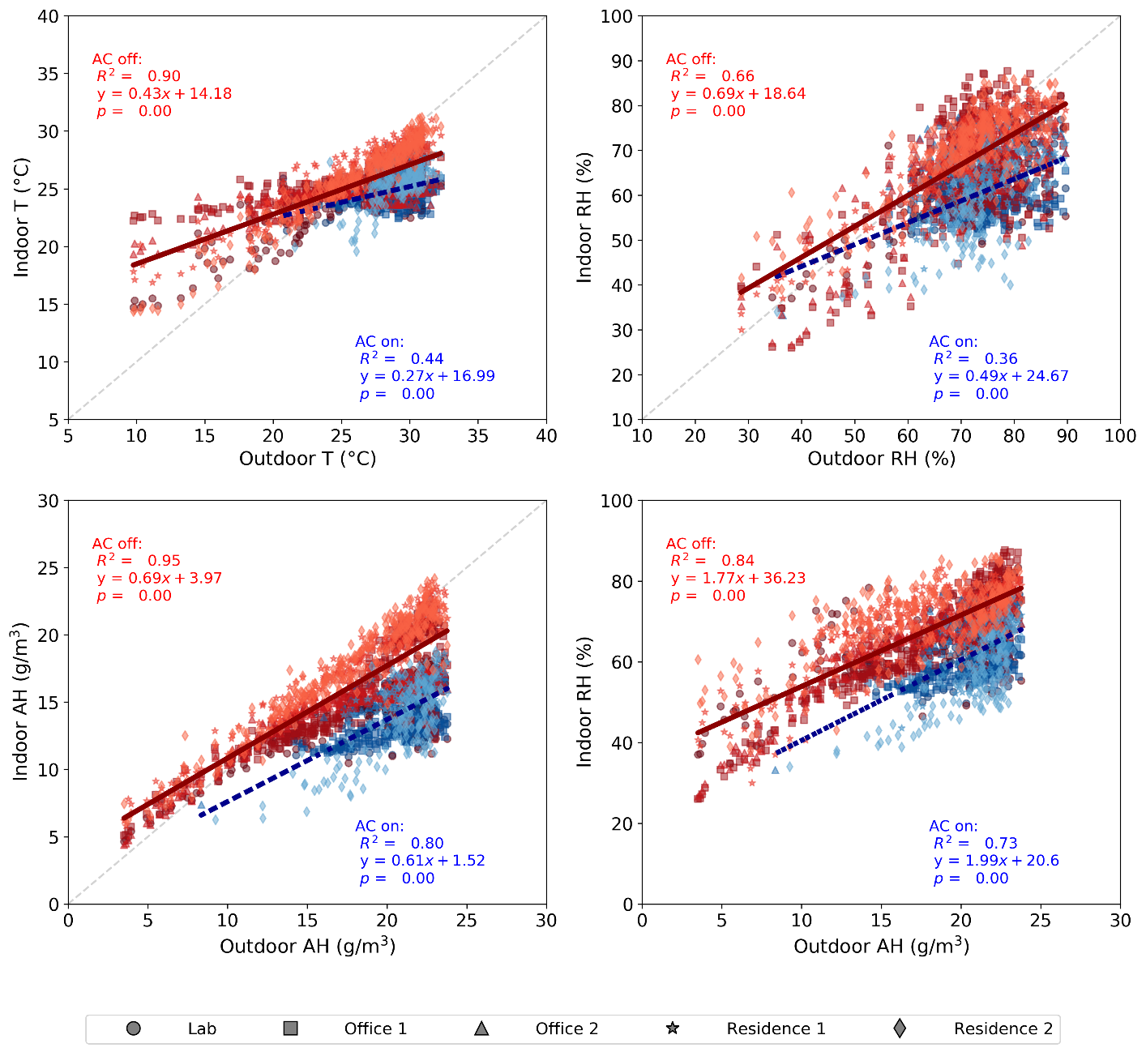
(b) Hong Kong
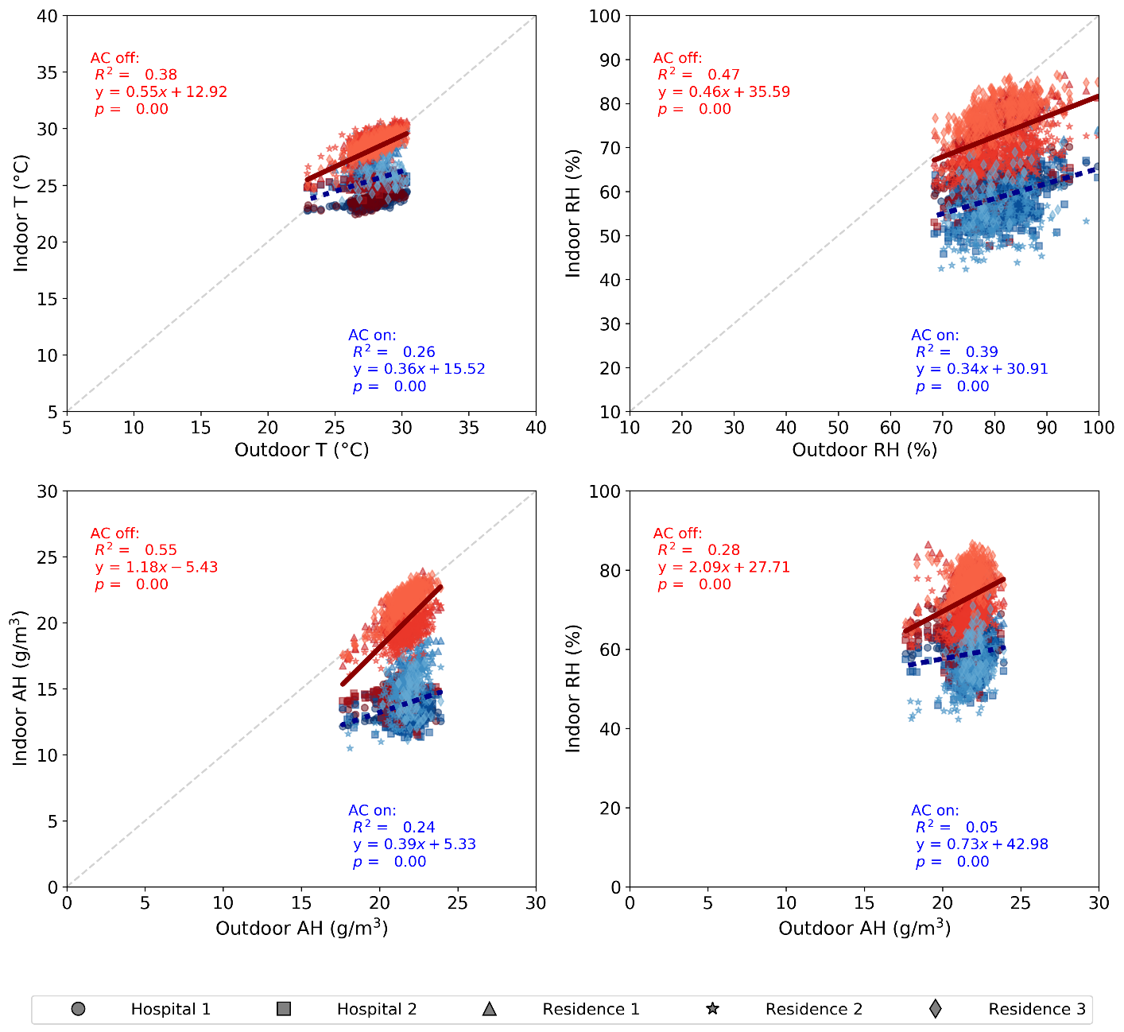
(c) Singapore
Figure 4. Correlation between daily indoor and outdoor measurements of temperature and humidity in (a) Guatemala City, (b) Hong Kong, and (c) Singapore, separated by AC use. Blue markers represent “AC on” status and red markers represent “AC off” status. Least-squares linear regression lines are shown in their respective colors, and the 1:1 line is shown by a gray dashed line where relevant.

Table 3. Variation of Pearson’s r by building type, by latitude, and by AC status. Multiple values in a cell indicate that there were multiple sensors in a certain building type. Buildings that lacked AC are indicated by “NA”. They are included to facilitate direct comparison with Table 2. p < 0.05 except in Lima.
(a) AC on
Latitude | Building type | Correlation
 |  | Indoor T vs. Outdoor T | Indoor RH vs. Outdoor RH | Indoor AH vs. Outdoor AH | Indoor RH vs. Outdoor AH
Blacksburg  (37.2 °N) | Residence | 0.61, 0.77, 0.69 | 0.36, 0.27, -0.05 | 0.64, 0.29, 0.90 | 0.33, 0.19, 0.77
 | Office | 0.42 | 0.45 | 0.40 | 0.21
Hong Kong  (22.4 °N) | Residence | -0.01, 0.44 | 0.36, 0.46 | 0.61, 0.64 | 0.51, 0.60
 | Office | 0.23, 0.19 | 0.20, 0.33 | 0.50, 0.58 | 0.45, 0.47
 | Lab | 0.15 | 0.47 | 0.41 | 0.42
Tuxtla Gutierrez  (16.8 °N) | Residence | NA | NA | NA | NA
 | Hospital | 0.13, 0.11 | 0.64, 0.50 | 0.94, 0.65 | 0.88, 0.60
Guatemala City  (14.6 °N) | Residence | NA | NA | NA | NA
 | Hospital | NA | NA | NA | NA
Colombo  (6.9 °N) | Residence | 0.72 | 0.21 | 0.28 | 0.33
 | Office | 0.49 | 0.56 | 0.69 | 0.28
 | Hospital | -0.09 | 0.26 | 0.64 | 0.30
Singapore  (1.4 °N) | Residence | 0.34, 0.43, 0.14 | 0.31, 0.41, 0.30 | 0.64, 0.54, 0.18 | 0.49, 0.53, 0.09
 | Hospital | 0.45, 0.26 | 0.35, 0.20 | 0.18, 0.05 | 0.13, 0.06
Lima  (12.0 °S) | Residence | NA | NA | NA | NA
 | Office | NA | NA | NA | NA
 | Hospital | NA | NA | NA | NA
Antananarivo  (18.9 °S) | Residence | 0.08, 0.74 | 0.58, 0.56 | 0.91, 0.94 | 0.88, 0.77
 | Office | 0.25, 0.42 | 0.50, 0.27 | 0.70, 0.80 | 0.69, 0.73
 | Lab | 0.21 | 0.15 | 0.49 | 0.42
(b) AC off
Latitude | Building type | Correlation
 |  | In T vs. Out T | In RH vs. Out RH | In AH vs. Out AH | In RH vs. Out AH
Blacksburg  (37.2 °N) | Residence | 0.23, 0.76, 0.84 | 0.59, 0.44, 0.51 | 0.87, 0.77, 0.95 | 0.87, 0.64, 0.89
 | Office | 0.84 | 0.63 | 0.96 | 0.93
Hong Kong  (22.4 °N) | Residence | 0.83, 0.90 | 0.68, 0.69 | 0.92, 0.92 | 0.76, 0.69
 | Office | 0.62, 0.71 | 0.60, 0.57 | 0.92, 0.93 | 0.92, 0.91
 | Lab | 0.85 | 0.64 | 0.95 | 0.76
Tuxtla Gutierrez  (16.8 °N) | Residence | 0.33 | 0.75 | 0.76 | 0.49
 | Hospital | 0.48, -0.04, 0.33 | 0.47, 0.37, 0.50 | 0.69, 0.62, 0.66 | -0.01, 0.68, 0.60
Guatemala City  (14.6 °N) | Residence | 0.35, 0.53 | 0.48, 0.30 | 0.81, 0.76 | 0.63, 0.50
 | Hospital | 0.37, 0.62 | 0.35, 0.55 | 0.83, 0.79 | 0.49, 0.62
Colombo  (6.9 °N) | Residence | 0.61, 0.44, 0.22 | 0.60, 0.52, 0.42 | 0.84, 0.83, 0.86 | 0.51, 0.60, 0.75
 | Office | 0.66 | 0.58 | 0.68 | 0.45
 | Hospital | 0.16 | 0.40 | 0.79 | 0.71
Singapore  (1.4 °N) | Residence | 0.53, 0.41, 0.55 | 0.58, 0.12, 0.42 | 0.45, 0.32, 0.50 | 0.32, 0.20, 0.32
 | Hospital | 0.64, 0.36 | 0.65, 0.55 | 0.78, 0.70 | 0.76, 0.58
Lima  (12.0 °S) | Residence | 0.06 | 0.20 | 0.34 | -0.27
 | Office | 0.02 | -0.10 | 0.32 | -0.46
 | Hospital | -0.08 | -0.19 | 0.38 | -0.48
Antananarivo  (18.9 °S) | Residence | 0.64, 0.78 | 0.38, 0.55 | 0.79, 0.84 | 0.28, 0.43
 | Office | 0.64, 0.67 | 0.41, 0.46 | 0.85, 0.84 | 0.57, 0.46
 | Lab | 0.37 | 0.40 | 0.38 | 0.22

In Guatemala City, none of the buildings in our sample had AC. In this situation, all indoor and outdoor climate metrics were well correlated, especially indoor AH and outdoor AH (R² = 0.93). The correlations were slightly weaker between indoor RH and outdoor RH/AH. As shown by the results for Hong Kong, our criterion for “AC on” highlighted periods when outdoor T was greater than 25 °C, but not all such points, as residences were not commonly air conditioned during the workday. Use of AC tended to shift both indoor RH and AH toward lower values. Compared to “AC on” periods, the indoor-outdoor correlations were stronger when the AC was off. Under these conditions, indoor AH was very strongly correlated with outdoor AH (R² = 0.95), and indoor RH was more strongly correlated with outdoor AH than with outdoor RH (R² =0.84 vs. R² = 0.66).
In Singapore, no pattern or trend was observed between indoor and outdoor climate; however, the use of AC can explain the clustering of measurements and separation by different building type to some extent. It seemed that these measurements clustered by whether AC systems were in use, and the AC systems tended to run longer in the office buildings as evidenced by a lower average daily indoor temperature and AH than in residential buildings. For both Hong Kong and Singapore (indoor AH or T vs. outdoor AH or T) when AC was on, the indoor AH varied between 13-18 g/m³, regardless of outdoor AH. Indoor temperature hovered around 25ºC, regardless of outdoor T. This is expected, as AC removes heat and moisture so that the indoor temperature and humidity are maintained at a relatively constant level.
The Pearson’s r values were modestly higher when AC was off compared to when AC was on across all cities regardless of building type (Table 3, Figure S2). In particular, the correlation between indoor AH and outdoor AH in most buildings was quite strong (r > 0.7) when AC was off. Similar to season-specific observations, the correlations were stronger at higher latitudes, especially when AC was off.

3.5 Multivariate analyses
We also considered the influence of multiple variables on indoor climate using multivariate OLS regression. Table 4 and Table 5 present the results of all correlations, including R² and coefficients of each independent variable. We used type-II Analysis of Variance (ANOVA) to verify whether the independent variables have significant influence on the respective indoor measurements.
The multivariate OLS model, which utilized outdoor measurements, building type, and season, performed similarly to the single-variable OLS one, which utilized outdoor measurements only and considered data by season, as their R² values were close. However, the multivariate OLS analysis generated higher R² values than single-variable OLS based on wet season data in most tropical cities. Interestingly, the R² of indoor RH vs. outdoor AH were greatly elevated using the multivariate OLS model in Guatemala City and Antananarivo. We conjecture that the indoor RH was more dependent on the characteristics of different building types, including the insulation of building envelopes, the ventilation rate, or even the habits of the residents, in these two cities than in other cities. Moreover, the R² of all correlations were much higher in Singapore and Lima with the multivariate OLS than with the single-variable OLS model. These results indicated that all indoor measurements in these two cities were influenced by the building type. In addition, ANOVA results of the multivariate OLS model suggested a non-significant influence of season on indoor RH vs. outdoor RH and indoor AH vs. outdoor AH in Singapore. This was expected because Singapore has very little seasonality. As shown in Figure 3c, there were differences between residential buildings and hospitals. Thus, the addition of building type in the model can better interpret such patterns. Lima exhibited weak indoor-outdoor correlations for all four relationships, in part because the outdoor weather station was far away from the indoor sampling sites; availability of outdoor climate data in Lima was limited. Therefore, including building type, a more relevant variable to the indoor measurements in Lima, can improve the goodness of fit.
We further changed the independent variables in the multivariate OLS model to outdoor measurements, building type, and AC status (instead of season) to investigate the influence of AC in combination with other variables. The multivariate OLS model performed similarly to the single-variable OLS model with AC off but did much better with AC on. The multivariate OLS model in Singapore, which has no seasonality but high usage of AC, achieved much higher R² values than its respective single-variable OLS model when we discarded season and included AC status as an independent variable.
Table 4. Parameters based on multivariate ordinary least squares regression between indoor measurements, outdoor measurements, building type, and season. Building type (residence, office, hospital, lab) and season (wet, dry), which were categorical variables, were converted to dummy variables in the analysis.
City | Parameters | Correlation
 |  | Indoor T (°C)  vs.  Outdoor T (°C) | Indoor RH (%)  vs.  Outdoor RH (%) | Indoor AH (g/m³)  vs.  Outdoor AH (g/m³) | Indoor RH (%)  vs.  Outdoor AH (g/m³)
Blacksburg  (37.2 °N) | R² | 0.21 | 0.70 | 0.81 | 0.74
 | Intercept | 20.82 | 9.72 | 2.95 | 2.95
 | Building type: residence | 0.27 | 8.61 | 1.73 | 1.73
 | Season: wet | 0.36 | 17.91 | 0.98 | 0.98
 | Outdoor variable | 0.09 | 0.28 | 0.44 | 0.44
Hong Kong  (22.4 °N) | R² | 0.68 | 0.63 | 0.84 | 0.65
 | Intercept | 12.92 | 17.28 | 2.66 | 32.56
 | Building type: office | 1.20 | 0.10‡ | 1.05 | 0.42‡
 | Building type: residence | 2.56 | 6.30 | 3.90 | 6.63
 | Season: wet | -0.46 | 4.19 | -0.88 | -7.16
 | Outdoor variable | 0.42 | 0.60 | 0.62 | 1.92
Tuxtla Gutierrez  (16.8 °N) | R² | 0.61 | 0.31 | 0.57 | 0.28
 | Intercept | 19.42 | 51.93 | 9.03 | 54.92
 | Building type: residence | 4.80 | -7.76 | 2.14 | -8.51
 | Season: wet | 0.82 | -0.09‡ | 0.22 | -1.31
 | Outdoor variable | 0.08 | 0.28 | 0.29 | 1.03
Guatemala City  (14.6 °N) | R² | 0.52 | 0.69 | 0.85 | 0.62
 | Intercept | 11.33 | 14.19 | 1.40 | 29.43
 | Building type: residence | -0.43 | 6.49 | 1.08 | 6.41
 | Season: wet | 0.53 | 3.18 | 0.56 | 1.78
 | Outdoor variable | 0.59 | 0.58 | 0.86 | 2.36
Colombo  (6.9 °N) | R² | 0.57 | 0.57 | 0.85 | 0.49
 | Intercept | 9.62 | 23.04 | 3.95 | 31.95
 | Building type: office | 2.83 | -9.07 | 0.61 | -9.07
 | Building type: residence | 2.19 | -5.12 | 1.00 | -5.12
 | Season: wet | -0.09‡ | 1.86 | 0.22 | 0.92
 | Outdoor variable | 0.65 | 0.69 | 0.79 | 2.18
Singapore  (1.4 °N) | R² | 0.87 | 0.63 | 0.87 | 0.59
 | Intercept | 14.30 | 30.58 | 4.83 | 43.21
 | Building type: residence | 4.12 | 13.54 | 7.23 | 13.53
 | Season: wet | 0.20 | -0.35‡ | 0.12‡ | -1.80
 | Outdoor variable | 0.36 | 0.36 | 0.39 | 0.79
Lima  (12.0 °S) | R² | 0.67 | 0.64 | 0.57 | 0.65
 | Intercept | 20.88 | 81.03 | 11.69 | 100.45
 | Building type: office | 2.20 | -10.30 | -0.50 | -10.30
 | Building type: residence | 0.84 | -7.00 | -0.66 | -6.99
 | Season: wet | 4.62 | -9.42 | 1.63 | -8.39
 | Outdoor variable | -0.04‡ | -0.04 | 0.11 | -1.27
Antananarivo  (18.9 °S) | R² | 0.78 | 0.83 | 0.81 | 0.76
 | Intercept | 12.97 | -4.75 | 1.05 | 16.94
 | Building type: office | -2.35 | 23.71 | 3.80 | 23.72
 | Building type: residence | -1.77 | 24.45 | 4.35 | 24.45
 | Season: wet | 0.74 | -1.96 | 0.02‡ | -6.84
 | Outdoor variable | 0.61 | 0.58 | 0.63 | 2.04
‡ p > 0.05 tested by type-II ANOVA, indicating this variable did not have significant influence on the respective indoor measurements.

Table 5. Parameters based on multivariate ordinary least squares regression between indoor measurements, outdoor measurements, building type, and AC status. Building type (residence, office, hospital, lab) and AC status (on, off), which were categorical variables, were converted to dummy variables in the analysis. Guatemala and Lima, where we sampled buildings without AC, are not shown here.
City | Parameters | Correlation
 |  | Indoor T (°C)  vs.  Outdoor T (°C) | Indoor RH (%)  vs.  Outdoor RH (%) | Indoor AH (g/m³)  vs.  Outdoor AH (g/m³) | Indoor RH (%)  vs.  Outdoor AH (g/m³)
Blacksburg  (37.2 °N) | R² | 0.39 | 0.60 | 0.88 | 0.82
 | Intercept | 18.41 | 17.29 | 2.11 | 18.66
 | Building type: residence | 0.21 | 8.79 | 1.58 | 7.98
 | AC: on | -0.28 | -1.68 | -3.19 | -13.57
 | Heat: on | 3.08 | -16.23 | 0.28 | -3.45
 | Outdoor variable | 0.22 | 0.36 | 0.62 | 2.33
Hong Kong  (22.4 °N) | R² | 0.72 | 0.60 | 0.89 | 0.62
 | Intercept | 12.93 | 17.55 | 2.66 | 36.28
 | Building type: office | 0.96 | 0.28‡ | 0.64 | -0.48‡
 | Building type: residence | 1.78 | 7.00 | 2.57 | 3.95
 | AC: on | -1.50 | 1.48 | -2.63 | -5.03
 | Outdoor variable | 0.44 | 0.62 | 0.67 | 1.63
Tuxtla Gutierrez  (16.8 °N) | R² | 0.58 | 0.32 | 0.60 | 0.29
 | Intercept | 19.35 | 19.35 | 8.46 | 56.14
 | Building type: residence | 4.84 | 4.84 | 2.10 | -8.75
 | AC: on | -0.76 | -0.76 | -1.86 | -4.72
 | Outdoor variable | 0.10 | 0.10 | 0.33 | 0.92
Colombo  (6.9 °N) | R² | 0.57 | 0.56 | 0.85 | 0.48
 | Intercept | 20.18 | 19.67 | 3.42 | 29.70
 | Building type: office | 2.86 | -9.07 | 0.61 | -9.07
 | Building type: residence | 2.26 | -5.12 | 1.00 | -5.12
 | AC: on | -1.60 | -14.70 | -6.34 | -17.12
 | Outdoor variable | 0.27 | 0.74 | 0.82 | 2.31
Singapore  (1.4 °N) | R² | 0.87 | 0.67 | 0.90 | 0.63
 | Intercept | 14.10 | 39.19 | 5.77 | 47.75
 | Building type: residence | 3.25 | 2.27 | 3.24 | 1.95
 | AC: on | -0.91 | -11.83 | -4.19 | -12.14
 | Outdoor variable | 0.40 | 0.39 | 0.54 | 1.10
Antananarivo  (18.9 °S) | R² | 0.79 | 0.85 | 0.89 | 0.76
 | Intercept | 11.36 | -3.13 | 1.04 | 26.95
 | Building type: office | -2.92 | 20.53 | 2.59 | 20.64
 | Building type: residence | -2.34 | 21.26 | 3.14 | 21.36
 | AC: on | -1.64 | -9.11 | -3.47 | -8.83
 | Outdoor variable | 0.74 | 0.59 | 0.73 | 1.14
‡ p > 0.05 tested by type-II ANOVA, indicating this variable did not have significant influence on the respective indoor measurements.

4. DISCUSSION
Correlations between indoor and outdoor temperature and humidity in tropical regions are influenced by many parameters including season, AC use, and latitude. In general, latitude is an important factor in the correlations, as the three representative cities – Guatemala City, Hong Kong, and Singapore – exhibited very different patterns. The further the city from the equator, the stronger the linear correlation. This is in part because cities further from the equator experience a stronger seasonality pattern, exhibiting a wider range in their parameter values. Other factors that were not considered in this study, such as human behavior and socioeconomic status, are also likely to influence the pattern.
Seasonal differences have been reported in the temperate regions, where indoor and outdoor temperatures are more strongly correlated during warm seasons than cool seasons,^{17,21} as the natural indoor-outdoor temperature differential is smaller when the weather is warmer. We observed the same pattern in our reference temperate city, Blacksburg. However, this trend did not apply to tropical cities. This is likely due to the use of heating systems in temperate regions (increasing the indoor-outdoor temperature differential), but not tropical cities during cool seasons (dry seasons in tropics).
Indoor AH vs. outdoor AH had the strongest linear correlation among other indoor-outdoor combinations regardless of building type and latitude, especially during the dry season. This result matches the findings in studies of cities with temperate climates.^{17,18} It is partially due to a generally unchanging daily outdoor AH and less use of AC systems in the dry season than in the wet season. This result suggests that outdoor AH may serve as a good indicator of indoor AH for tropical cities except those with widespread use of AC, such as Singapore. Consistent with previous studies,^{17,18} outdoor RH was a poor indicator of indoor RH because indoor RH is determined by both T and AH, resulting in greater variability. However, outdoor AH is a reasonable predictor of indoor RH when AC was off and/or during the dry season. Since indoor RH and AH are associated with many health problems,⁶ as well as impacting airborne virus survival,^{35,36} it is useful to know that they can be predicted by outdoor parameters.
Season and the use of AC systems influenced the linearity and correlations between indoor and outdoor measurements. Where AC was not in use, such as in Guatemala City, there was very little difference between the dry season and wet season, whereas for cities with greater penetration of AC (such as Hong Kong and Singapore), AC use can better explain the trend and the clustering of measurements than season given generally higher Pearson’s r when AC was off.
When AC is running, the indoor temperature should be regulated around its set-point, and humidity should also be somewhat controlled, so we first assumed constant values of temperature and humidity for AC-controlled indoor conditions. However, a non-zero slope with p < 0.05 (Figure 4) indicates that indoor variables are still correlated with outdoor variables even with the control of AC. We further analyzed the indoor-outdoor correlation using Spearman’s ρ without assuming a linear relationship (Table S5). Statistics suggested that indoor and outdoor variables were still correlated (p < 0.05) with AC in use except in Colombo and Tuxtla Gutierrez, where the number of days with AC use is small. These results indicated that the influence of AC on the indoor environment did not totally override the influence of outdoor conditions and other potential parameters. Hence, we applied a multivariate OLS model to achieve a better understanding of the collective influence of these variables on the indoor variables. The multivariate OLS model produced a better goodness of fit than the single-variable OLS model, especially for the cities with heavy AC usage. However, the multivariate model also increases the complexity of data interpretation. For example, the coefficients of the categorical variables (building type, AC status) do not have any physical meaning and are thus less explanatory. Additionally, the multicollinearity among independent variables, such as the correlation between outdoor measurements, AC status, and season, can be a potential issue. Principal component analyses or similar approaches would reduce the multicollinearity, but these analyses further complicate the interpretation and explanation of variables, especially for a small data set such as that in our study.
While this study presents the most comprehensive set of indoor-outdoor data in tropical regions to date, the limited sample size restricted us from drawing more robust conclusions. For example, we observed that there was no difference of indoor measurements between residential buildings and office buildings in most cities (p > 0.05), but we collected measurements from at most three of one type of building in any one city. A larger study might detect differences, although differences in building construction and maintenance practices between cities and within a city might also contribute to a less consistent result in terms of building type.
In addition, we did not include demographic and socio-economic information in the analysis. Notably, the affluence of each city differed, so the penetration rate of AC varied. As we did not track occupancy nor the activities of occupants in each building, we were not able to determine behavioral influences, including actual AC usage, on indoor climate. Humans themselves contribute to indoor heat and water vapor,^{37,38} and variation in human behavior may help explain the inconsistency of correlations among different locations even if their outdoor climates were similar (Table S2 and Table S3).
In terms of broader impacts, it is useful to consider these findings in the context of the COVID-19 pandemic. Initial studies have shown that transmission of COVID-19 is related to outdoor temperature and humidity. In general transmission appears to be slower at higher temperature and/or higher humidity,³⁹⁻⁴² consistent with results for influenza and SARS. Several studies have found that COVID-19 spreads faster in locations whose temperature falls in the range of 3-17°C and AH lies in the range of 3-9 g/cm³.^{10,43-46} These studies focused on temperate climate zones in the Northern Hemisphere, suggesting that the conditions corresponded to low indoor RH. However, these results should be viewed with caution because the datasets were restricted to early-stage outbreaks. It remains to be seen how strongly climate affects COVID-19 incidence and transmission and whether the disease settles into a seasonal pattern.
However, all these studies used outdoor meteorological data in their analyses. Because the transmission of COVID-19⁴⁷ and other respiratory viral diseases occurs mainly indoors, it is critical to consider the indoor environment, either through direct measurements or inferring them using the relationship between outdoor and indoor measurements, such as presented here. Doing so will advance our understanding of the influence of temperature and humidity on the seasonality of certain infectious diseases.

CONCLUSION
We have examined indoor-outdoor correlations of temperature, relative humidity (RH), and absolute humidity (AH) over a 1-year period in a sample of buildings in seven tropical cities. Across all cities, the average monthly indoor temperature was 25±3°C (mean ± standard deviation) with a range of 20–30°C. The average monthly indoor RH was 66±9% with a range of 50–78%, and the average monthly indoor AH was 15±3 g/m3 with a range of 10–23 g/m3. The average monthly outdoor temperature, RH, and AH were 24±4°C, 74±13%, 17±3 g/m3, respectively, and the ranges were much larger than seen indoors. The range of outdoor measurements differed greatly among cities. In general, indoor AH and outdoor AH were more strongly correlated than other variables between indoors and outdoors. Indoor AH and RH were linearly correlated with outdoor AH when the air-conditioning (AC) was off, suggesting that outdoor AH may be a good indicator of indoor humidity, both AH and RH, under these conditions. For cities further from the equator, almost all correlations became stronger. Multivariate analyses revealed that building characteristics have a greater influence on indoor climate in some cities and that accounting for AC use improves model prediction. The results of this work can be used to advance our understanding of the relationship between outdoor climate, indoor climate, and health.

ACKNOWLEDGMENTS
This research was supported by a grant from the Alfred P. Sloan Foundation as part of its Microbiology of the Built Environment program. The authors thank Kaisen Lin for helpful discussions; Julia Gohlke, Archit Manuja, and AJ Prussin II for handling sensors; and the reviewers for their detailed feedback that helped strengthen this paper.

REFERENCES
1. Conlon KC, Rajkovich NB, White-Newsome JL, Larsen L, O’Neill MS. Preventing cold-related morbidity and mortality in a changing climate. Maturitas. 2011;69(3):197-202.
2. Schwartz J, Samet JM, Patz JA. Hospital admissions for heart disease: The effects of temperature and humidity. Epidemiology. 2004;15(6):755-761.
3. Lin S, Luo M, Walker RJ, Liu X, Hwang S-A, Chinery R. Extreme high temperatures and hospital admissions for respiratory and cardiovascular diseases. Epidemiology. 2009;20(5):738-746.
4. Turner LR, Barnett AG, Connell D, Tonga S. Ambient temperature and cardiorespiratory morbidity: A systematic review and meta-analysis. Epidemiology. 2012;23(4):594-606.
5. The Eurowinter Group. Cold exposure and winter mortality from ischaemic heart disease, cerebrovascular disease, respiratory disease, and all causes in warm and cold regions of Europe. Lancet. 1997;349(9062):1341-1346.
6. Davis RE, McGregor GR, Enfield KB. Humidity: A review and primer on atmospheric moisture and human health. Environ Res. 2016;144:106-116.
7. Anderson BG, Bell ML. Weather-related mortality: How heat, cold, and heat waves affect mortality in the United States. Epidemiology. 2009;20(2):205-213.
8. Zhang K, Li Y, Schwartz JD, O׳Neill MS. What weather variables are important in predicting heat-related mortality? A new application of statistical learning methods. Environ Res. 2014;132:350-359.
9. Wu Y, Jing W, Liu J, et al. Effects of temperature and humidity on the daily new cases and new deaths of COVID-19 in 166 countries. Sci Total Environ. 2020;729:139051-139051.
10. Sajadi MM, Habibzadeh P, Vintzileos A, Shokouhi S, Miralles-Wilhelm F, Amoroso A. Temperature, humidity, and latitude analysis to estimate potential spread and seasonality of coronavirus disease 2019 (COVID-19). JAMA Netw Open. 2020;3(6):e2011834-e2011834.
11. Davis RE, Rossier CE, Enfield KB. The impact of weather on influenza and pneumonia mortality in New York City, 1975–2002: A retrospective study. PLoS One. 2012;7(3):e34091.
12. Shaman J, Pitzer VE, Viboud C, Grenfell BT, Lipsitch M. Absolute humidity and the seasonal onset of influenza in the continental United States. PLoS Biol. 2010;8(2):e1000316.
13. Tang JW, Lai FYL, Wong F, Hon KLE. Incidence of common respiratory viral infections related to climate factors in hospitalized children in Hong Kong. Epidemiol Infect. 2010;138(2):226-235.
14. Tang JW, Loh TP. Correlations between climate factors and incidence—a contributor to RSV seasonality. Rev Med Virol. 2014;24(1):15-34.
15. Moriyama M, Hugentobler WJ, Iwasaki A. Seasonality of respiratory viral infections. Annu Rev Virol. 2020;7:1.
16. Klepeis NE, Nelson WC, Ott WR, et al. The National Human Activity Pattern Survey (NHAPS): a resource for assessing exposure to environmental pollutants. J Expo Sci Environ Epidemiol. 2001;11(3):231-252.
17. Nguyen JL, Schwartz J, Dockery DW. The relationship between indoor and outdoor temperature, apparent temperature, relative humidity, and absolute humidity. Indoor Air. 2014;24(1):103-112.
18. Nguyen JL, Dockery DW. Daily indoor-to-outdoor temperature and humidity relationships: A sample across seasons and diverse climatic regions. Int J Biometeorol. 2016;60(2):221-229.
19. Tang JW, Loh TP. Influenza seasonality. Curr Treat Options Infect Dis. 2016;8(4):343-367.
20. Höppe P, Martinac I. Indoor climate and air quality. Int J Biometeorol. 1998;42(1):1-7.
21. Tamerius JD, Perzanowski MS, Acosta LM, et al. Socioeconomic and outdoor meteorological determinants of indoor temperature and humidity in New York City dwellings. Weather Clim Soc. 2013;5(2):168-179.
22. Quinn A, Tamerius JD, Perzanowski M, et al. Predicting indoor heat exposure risk during extreme heat events. Sci Total Environ. 2014;490:686-693.
23. White-Newsome JL, Sánchez BN, Jolliet O, et al. Climate change and health: Indoor heat exposure in vulnerable populations. Environ Res. 2012;112:20-27.
24. Epstein PR. Climate and health. Science. 1999;285(5426):347.
25. McMichael AJ, Woodruff RE, Hales S. Climate change and human health: present and future risks. Lancet. 2006;367(9513):859-869.
26. Haines A, Kovats RS, Campbell-Lendrum D, Corvalan C. Climate change and human health: Impacts, vulnerability and public health. Public Health. 2006;120(7):585-596.
27. Viboud C, Alonso WJ, Simonsen L. Influenza in tropical regions. PLoS Med. 2006;3(4):e89.
28. Tamerius JD, Nelson Martha I, Zhou Steven Z, Viboud C, Miller Mark A, Alonso Wladimir J. Global influenza seasonality: Reconciling patterns across temperate and tropical regions. Environ Health Perspect. 2011;119(4):439-445.
29. Tamerius JD, Shaman J, Alonso WJ, et al. Environmental predictors of seasonal influenza epidemics across temperate and tropical climates. PLoS Pathog. 2013;9(3):e1003194.
30. Dowell SF. Seasonality – still confusing. Epidemiol Infect. 2012;140(1):87-90.
31. Bloom-Feshbach K, Alonso WJ, Charu V, et al. Latitudinal variations in seasonal activity of influenza and respiratory syncytial virus (RSV): a global comparative review. PLoS One. 2013;8(2):e54445.
32. Alduchov OA, Eskridge RE. Improved magnus form approximation of saturation vapor pressure. J Appl Meteorol. 1996;35(4):601-609.
33. Worbes M. Annual growth rings, rainfall-dependent growth and long-term growth patterns of tropical trees from the Caparo Forest Reserve in Venezuela. Journal of Ecology. 1999;87(3):391-403.
34. De Silva CS, Rushton KR. Groundwater recharge estimation using improved soil moisture balance methodology for a tropical climate with distinct dry seasons. Hydrological Sciences Journal. 2007;52(5):1051-1067.
35. Tang JW. The effect of environmental parameters on the survival of airborne infectious agents. J R Soc Interface. 2009;Suppl 6(Suppl 6):S737-746.
36. Marr LC, Tang JW, Van Mullekom J, Lakdawala SS. Mechanistic insights into the effect of humidity on airborne influenza virus survival, transmission and incidence. J R Soc Interface. 2019;16(150):20180298-20180298.
37. Tetelin A, Pouget V, Lachaud J, Pellet C. Dynamic behavior of a chemical sensor for humidity level measurement in human breath. IEEE Trans Instrum Meas. 2004;53(4):1262-1267.
38. Buettner K. Diffusion of Water and Water Vapor Through Human Skin. J Appl Physiol. 1953;6(4):229-242.
39. Qi H, Xiao S, Shi R, et al. COVID-19 transmission in Mainland China is associated with temperature and humidity: A time-series analysis. Sci Total Environ. 2020;728:138778.
40. Ward MP, Xiao S, Zhang Z. Humidity is a consistent climatic factor contributing to SARS-CoV-2 transmission. Transbound Emerg Dis. 2020;00(67):3069-3074.
41. Ma Y, Zhao Y, Liu J, et al. Effects of temperature variation and humidity on the death of COVID-19 in Wuhan, China. Sci Total Environ. 2020;724:138226.
42. Wang J, Tang K, Feng K, et al. Impact of temperature and relative humidity on the transmission of COVID-19: a modelling study in China and the United States. BMJ Open. 2021;11:e043863.
43. Gupta S, Raghuwanshi GS, Chanda A. Effect of weather on COVID-19 spread in the US: A prediction model for India in 2020. Sci Total Environ. 2020;728:138860.
44. Bukhari Q, Jameel Y. Will coronavirus pandemic diminish by summer? Available at SSRN 3556998. 2020.
45. Ficetola GF, Rubolini D. Containment measures limit environmental effects on COVID-19 early outbreak dynamics. Sci Total Environ. 2021;761:144432.
46. Poole L. Seasonal influences on the spread of SARS-CoV-2 (COVID-19), causality, and forecastabililty (3-15-2020). Available at SSRN 3554746. 2020.
47. Qian H, Miao T, Liu L, Zheng X, Luo D, Li Y. Indoor transmission of SARS-CoV-2. Indoor Air. 2020;00:1-7.

