Highly Sensitive, Ambient Temperature CO Sensor using Polyaniline/Tin Oxide/Palladium Composites
Vinay Kishnani^{1,#}, Gulshan Verma^{1,#}, Rohit K. Pippara^{2,#}, Anshul Yadav³, Pankaj Singh Chauhan⁴, Ankur Gupta^{1,*}
¹Department of Mechanical Engineering, Indian Institute of Technology Jodhpur, Rajasthan-342037, India
²Post Graduate Engineer Trainee, Thermax Ltd, India
³Membrane Science and Separation Technology Division, CSIR-Central Salt and Marine Chemicals Research Institute, Bhavnagar - 364002, Gujarat, India
⁴Department of Nanotechnology, Centre of Advanced Studies, AKTU, Lucknow-226031, India

#Equal Contribution
*Corresponding Author: ankurgupta@iitj.ac.in

Abstract- In the present work, we report an excellent gas sensing performance of the unique nanocomposite films prepared with the help of different materials such as semiconductor metal-oxide, polymer and metal for carbon monoxide gas sensing at ambient temperature. The fabrication of SnO₂/PANI/Pd nanocomposite film was performed using the hydrothermal route. The fabricated films were characterized with various analytical techniques such as X-ray diffraction (XRD), Field emission scanning electron microscope (FESEM), and Raman spectroscopy, Fourier transform infrared spectroscopy (FTIR) etc. Furthermore, DFT results are used to examine the transport and electronic properties of all prepared films. The computing results show that after hybridizing with Pd and SnO₂, the response of the fabricated SnO₂ and polyaniline (PANI) films to CO gas molecules is considerably improved. At room temperature, sensing characterization of the fabricated sensing films was carried out by using target gas concentrations with varying ppm level of 50 to 300. At ambient temperature, the SnO₂/PANI/Pd film has the maximum sensitivity ~400.8% out of all the fabricated films at 0.3% of the target gas. Our findings show that SnO₂, SnO₂/Pd, PANI, and SnO₂/PANI/Pd composite sensing films have a bright future in the gas sensing application with incredibly-higher sensitivity towards CO gas.

Keywords- Room temperature sensor, SnO₂, PANI, Carbon monoxide sensor.

Introduction
Semiconductor metal oxides are used as a gas sensor material due to their properties of high sensitivity, fast response, and good stability, viz. ZnO [1], TiO₂[2], CeO₂[3], WO₃[4], SnO₂[5], doping of the noble metals takes place for enhancing the sensing proficiency of semiconductor metal oxides. Practically tin-oxide (SnO₂) is frequently used as the semiconductor metal oxide to sense harmful gases due to its high sensitivity and compactness of the sensing device. The most comprehensive approach to getting better sensor response and selectivity towards CO is doping of SnO₂ with Pd. The hydroxyl group (–OH) present at the surface promotes the sensing of CO in Pd-doped SnO₂ at room temperature [6]. Usually, these materials consume high power because they work at high functioning temperatures, due to which these materials are not applicable for detecting explosive gases. To overcome these drawbacks conducting polymers, with exclusive chemical and physical properties as well as adaptability and process ability [7],[8],[9],[10], broadly studied in chemical sensor, biological sensor, and gas sensor [11],[12],[13]. Among all conducting polymers, polyaniline (PANI) is a desirable candidate; it shows conductivity in a doped state due to its conjugate structure and all the relative desirable properties viz. High chemical/environmental, thermal, and electrical steadiness with reasonable cost makes it the most desirable conducting polymers. Also, it is used for energy conversion and storage[14]. While conducting polymers are used for sensing many different gases at room temperature, it persists in some drawbacks viz. relative low sensitivity and reversible conductance [15],[16],[17]. To enhance the sensing property of semiconductor oxides/ conducting polymers, various composites of polymers among inorganic nanoparticles were synthesized to fabricate nanocomposite sensors of polymers/inorganic compounds [18],[19],[20],[21]. Over the last decade, lots of advancements were made to fabricate PANI-based chemo resistive sensors [22]. The dissociation of CO enhances due to Pd deposition through the surface diffusion of CO from Pd to SnO_{2;} at the heated sample, carbon gets contaminated when CO exposes towards the surface [23]. The working temperature has a significant impact on gas sensing capacities; by doping Pd over SnO₂ thick film, CO response gets improved. The low-temperature range response decreases for the increase in temperature; high-temperature range condition response firstly increases to maximum value then decreases [24]. Guo et al.[25] used a theoretical approach to determine the sensing characteristics of graphene/PANI composite and found that it exhibits more sensitivity towards the NH₃ gas than CO, NO, and H₂ molecules, NH₃ showed excellent adsorption energy (-2.8 eV) and an increase in electrical conductivity than other gases. Roy et al. [26] fabricated a gas sensor of PANI-MWCNT composite through in situ polymerization to detect CO at ambient temperature and found that composite shows good reproducibility and high sensitivity and rapid recovery cycle and response for a different concentration of CO at room temperature. Liu et al. [27] prepared a thin film of PANI-TiO₂-Au ternary composite through in-situ self-assembly method and found higher recovery/response rate, good stability, selectivity, low detectable concentration and repeatability with better reversibility for PANI-TiO₂-Au in comparison to PANI-TiO₂ based sensor. For the synthesis of PANI and SnO₂, Li et al. used a hydrothermal path [28]. The use of a polymeric film consisting of PANI/SnO₂ in the supercapacitor field was also investigated [29]. Nasresfahani et al. [30] investigated the effect of gold nanoparticles over PANI fiber for the sensing of CO at room temperature and found that Au/PANI sensor shows high response, broad dynamic range, short detection limit, good response time, and good selectivity, which shows that Au nanoparticles enhanced the sensing properties of PANI due to high surface energy of gold nanoparticles. In another research work, a simple hydrothermal path for fabricating nanocomposite sensing films consisting of SnO₂, Pd, and reduced graphene oxide (rGO) for the detection of methane gas [31]. Wang et al. [32] fabricated a nanocomposite film of PANI doped TiO₂ to evaluate gas sensitivity of CO under ultraviolet ir-radiation at ambient temperature and the data reveals that photo-assisted sensing of CO enhanced due to the doping of PANI in TiO₂. Furthermore, Kroutil et al. [33] proposed a simple technique to synthesize composite sensing film consisting of PANI, which was found to be valuable for the low-cost assessment of fabricated films in gas sensing application.
The present work involves the fabrication of novel nano-composites films consisting of different materials such as semiconductor metal-oxide, polymer and metal. SnO₂, PANI, and a nanocomposite of SnO₂/PANI sensing films have been fabricated, and their sensing output has been compared. At room temperature, sensing characterization was carried out using gas concentrations with varying ppm levels of 50 to 300. The sensing response of all fabricated films to gas interaction is studied, and sensing characteristics are determined based on the obtained response graphs. Furthermore, we have used DFT results to examine the transport and electronic properties of all prepared films such as SnO₂, SnO₂/Pd, PANI, PANI/SnO₂, and SnO2/Pd/PANI nanocomposite in near vicinity towards the molecules of carbon monoxide gas. Our findings show that SnO₂, SnO₂/Pd, PANI, and PANI/SnO₂ nano–composite sensing films have a bright future in the gas sensing application with incredibly-higher sensitivity.

Materials and Methods

Synthesis of SnO₂ Nanosheets
SnO₂ nanosheets are synthesized from purified stannous-chloride (SnCl₂.2H2O), ethanol (C₂H₅OH), pellets of sodium-hydroxide (NaOH), and Deionized water. To fabricate SnO₂, 5-mL of ethanol (C₂H₅OH) based solution and 15-ml of Deionized-water are mixed together in a container made up of borosilicate material and Ultrasonication technique has been used to create a lucid solution. The ethanol-based solution was then supplemented with 30mg of purified stannous-chloride (SnCl₂.2H2O). A fresh solution of 0.4 M was made by gradually adding 0.3g NaOH to 20ml water. Following continuous magnetic stirring, the obtained solution was then mixed in a drop-by-drop manner to stannous-chloride based solution until the pH was corrected to 13. The mixture was further moved to a 100ml container (which is packed with the help of Teflon-tape), and heated at 180ºC for 12 hours. It is then removed from the oven and placed in an open atmosphere until it comes back to ambient-temperature. To thoroughly remove chlorine ions, the thick residue left during centrifugation was rinsed twice with DI water and ethanol. The residue had a pale brown color. Finally, the residue is dried for 1 hour in an oven at a temperature of 80°C. The resulting SnO₂ particles are pale brownish yellow in color.

Synthesis of PANI
PANI was synthesized via the chemical oxidation technique using aniline (C₆H₅NH₂), ammonium-persulphate ((NH₄)₂S₂O₈), ice bath (0-5ºC), water (H₂O), and hydrochloric-acid 1N (HCl). In most cases, aniline (C₆H₅NH₂) is mixed in an acid-based solution and oxidized with ammonium-persulphate ((NH₄)₂S₂O₈). The following is a description of the technique in detail: A 3-mL of aniline (C₆H₅NH₂), was combined with 200-mL of hydrochloric acid in a container made of boro-silicate materials and stored in an ice–bath maintained at a temperature ranging from 0˚C to 5 ̊C. The acid-based solution is then thoroughly mixed to produce a light-brown color. Another fresh solution was prepared in a 250mL container with 11g of ammonium-persulphate and 100 mL DI water, which was thoroughly mixed until a transparent solution was achieved and then placed in the ice bath. Now, an ammonium-based solution was constantly stirred and mixed in the acidic medium that had been held in an ice-bath. The color of the solution looks to be blue. After the preparation of ammonium-solution, the combination was placed in an ice bath for eight hours. After centrifuging twice with DI water, the final precipitate was produced. The residue was placed in an oven for six hours at a temperature of 70°C in order to get polyaniline powder.

Synthesis of SnO₂/Pd
Materials required are SnCl₂ .2H₂O, PdCl₂, NaOH pellets, C₂H₅OH, and DI water. In order to fabricate SnO₂/Pd, a solution containing 5-mL ethanol (C₂H₅OH) was mixed with 15-mL of H₂O; in order to produce a clear-solution. The prepared solution was then supplemented with 0.035g of palladium-dichloride and 30-mg stannous-chloride. A fresh solution of 0.4 M was made by gradually adding 0.3g NaOH to 20ml water. Following continuous magnetic stirring, the obtained solution was then mixed in a drop-by-drop manner to stannous-chloride based solution until the pH was corrected to 13. The mixture was further moved to a 100ml container (which is packed with the help of Teflon-tape), and heated at 180ºC for 12 hours. It is then removed from the oven and placed in an open atmosphere until it comes back to ambient-temperature. To thoroughly remove chlorine ions, the thick residue left during centrifugation was rinsed twice with DI water and ethanol. Finally, the residue is dried for 1 hour in a vacuum at 80°C. The resulting grey color of Pd-doped-SnO₂ particles are obtained.

Synthesis of PANI/SnO₂
The following materials are used to synthesize PANI/SnO₂; (a) sodiumdodeyl-benzene sulphate (‎C₁₈H₂₉NaO₃S), (b) hydrochloric acid (HCl), (c) ammonium-persulphate ((NH₄)₂S₂O₈), (d) aniline (C₆H₅NH₂), (e) Deionized water, (f) SnO₂ powder, and (g) an ice bath. To fabricate PANI/SnO_{2,} a 4-gm of sodiumdodeyl-benzene sulphate were mixed properly with 70ml of HCl in a 250-ml container made up of boro-silicate material. Followed by the mixing of 0.5-gm powder of SnO₂ with 1-ml of aniline (C₆H₅NH₂) into the acid-based solution. The solution is thoroughly mixed for half an hour under magnetic stirring to achieve a yellow color, allowing the SnO₂ nano-particles to be dissolved by the aniline (C₆H₅NH₂). The prepared solution is then stored in an ice–bath maintained at a temperature ranging from 0˚C to 5˚C. In a container, a fresh solution containing 3.5 g ammonium persulphate ((NH₄)₂S₂O₈) and 30 ml DI water are thoroughly mixed until the solution becomes transparent. Following that, both prepared solutions are mixed together under constant stirring conditions until the solution is pale yellow in color. After the preparation of ammonium-solution, the combination was placed in an ice bath for eight hours. After centrifuging twice with DI water, the final precipitate with dark greenish color was obtained. The residue was placed in hot air oven for six hours at a temperature of 70°C to get polyaniline/SnO₂ powder.

Synthesis of PANI/SnO₂/Pd
To prepare a PANI/SnO₂ /Pd, a 4-gm of sodiumdodeyl-benzene sulphate were mixed properly with 70ml of HCl in a 250-ml container made up of boro-silicate material. Followed by the mixing of 0.5-gm powder of SnO₂ with 1-ml of aniline into the acid-based solution. The solution is thoroughly mixed for half an hour under magnetic stirring to achieve a yellow color, allowing the SnO₂/Pd nano-particles to be dissolved by the aniline (C₆H₅NH₂). The prepared solution is then stored in an ice–bath maintained at a temperature ranging from 0˚C to 5˚C. In a container, a fresh solution containing 3.5 g ammonium persulphate ((NH₄)₂S₂O₈) and 30 ml DI water are thoroughly mix until the solution becomes transparent. Following that, both prepared solutions are mixed together under constant stirring conditions until the solution is pale grey in color. After the preparation of ammonium-solution, the combination was placed in an ice bath for eight hours. After centrifuging twice with DI water, the final precipitate with dark greenish color was obtained. The residue was placed in hot air oven for six hours at a temperature of 70°C to get polyaniline/SnO₂/Pd powder.

Computational details
Density–functional theory (DFT) method was utilized for studying the adsorption of CO gas on the hybrid nano-structures of SnO₂, SnO₂/Pd, PANI, PANI/SnO₂, and PANI/SnO₂/Pd. Mulliken population studies, as well as complete geometry optimization and energy measurements, were performed. For obtaining the exchange-correlation function, the Perdew, Burke, and Ernzerh (PBE) methodology of generalized gradient approximation (GGA) is used. The adsorption-energy quantitatively describes the results of interaction strength of the adsorbent-adsorbate. The adsorption energy of H₂ on the surface of SnO₂, SnO₂/Pd, PANI, PANI/SnO₂ nano-structures is calculated using the following formula:
$Energy \left(E\right)=E_{a}-E_{b}-E_{c}$ (1)
Here, E_{a} represents the overall number of energies in between the gas-adsorbate, E_{b} represents the energies associated with adsorbate, and E_{c} represents the energies associated with the gas-molecule.

Experimental setup for sensing carbon-monoxide
To analyze the carbon monoxide sensing properties of the fabricated layers, a sensing unit is prepared. Figure 1 depicts the set-up diagram of the gas sensor. These fabricated layers were coated over the inter-digitated electrode present on the silicon wafer. These electrodes are further attached to an electrometer (6517A, Keithley Instruments) used for measuring any changes in the resistance value. Power-supply, temperature-controlling unit, and target gas tank and its controller are all included in the sensing setup, which is then connected to a data acquisition unit for analyzing these sensing data. For measuring the change in resistance, a constant voltage of 1 Volt is useful. Further, the contaminated air from the chamber can be removed using a vacuum pump. Drop-casting was used for all of the films. The Cu electrodes were constructed on a PCB panel, and the sensing material was drop cast on top of it, similar sensing setup is used in previous research work [34]. Inter-digitated electrodes contain Cu fingers with a thickness of 1 mm and a spacing of 0.8 mm.
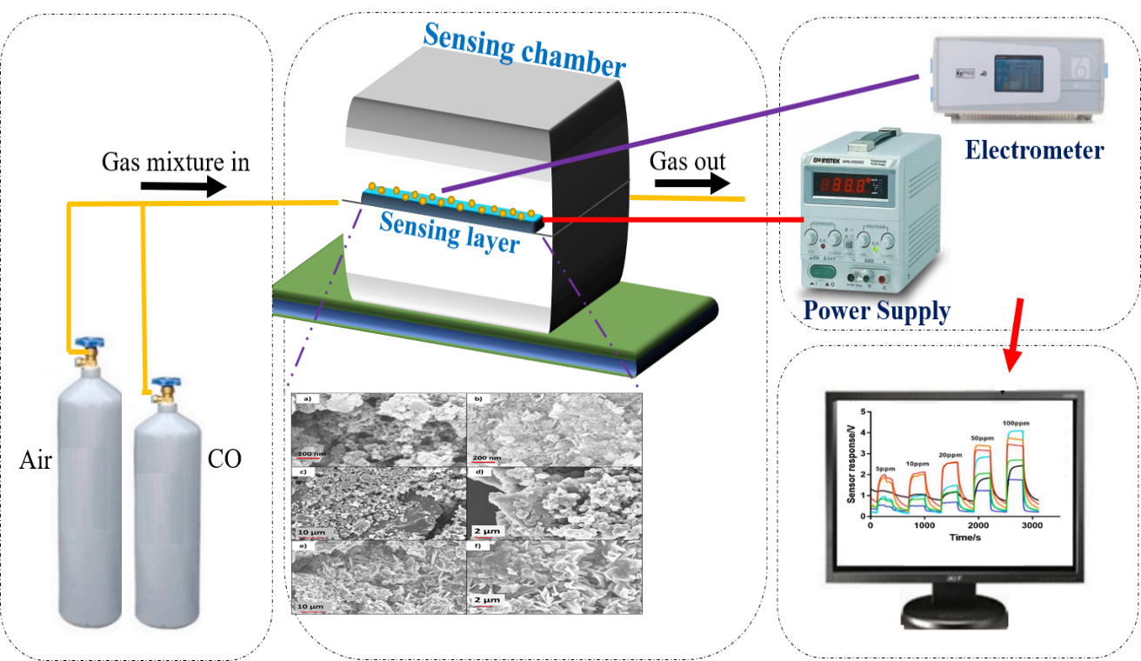
Fig. 1 The schematic view of experimental set-up for carbon-monoxide detection.

Results and Discussion

DFT calculation
To get the stable geometries of the most energetic state of the sensor, the prepared sensing films are optimized by calculating DFT results. DFT calculation of CO adsorption on clean SnO₂ (110) and Pd doped SnO₂ reported that CO adsorption is more on the surface of sensing film made-up of Pd-doped SnO₂ and most stable sites for the CO adsorption found to be where carbon atom bonded with Pd atom, so the bond got weaken due to the increase in C-O distance and stretching frequency also got decreased [35]. Figure 2 shows the optimized geometry obtained via DFT analysis.
(A) (B)
(C) (D)
(E)
Fig. 2 Representation of Optimized-geometries of fabricated sensing films containing SnO₂, SnO₂-Pd, PANI, PANI-SnO₂, PANI-SnO₂-Pd respectively (where black represent carbon, dark blue represent palladium, red represent oxygen, grey represent hydrogen, blue represent nitrogen, white represent silver, purple represent zinc).
The mechanisms of adsorption of carbon monoxide gas-molecule on the surface of fabricated nano-structure are addressed in the Table 1 that summarizes the details of the adsorption energies and the minimum binding distance of the carbon monoxide molecules on the surface of fabricated nano-structures. According to DFT calculations for sensing carbon-monoxide gas, the ascending order of adsorbing abilities of the fabricated films are represented as SnO₂, SnO₂-Pd, PANI, and PANI-SnO₂ shown in the table 1. This conclusion is useful to verify experimental results. Figure 3 shows DFT results of the interaction of CO gas with the fabricated films.
Table 1. The adsorption–energy (E_{ad}), binding–distance (d) of the carbon monoxide molecules on the surface of fabricated nano-structures.
System | Minimum binding distance | Adsorption energy
CO and SnO₂ | 2.1 A˚ | - 1.1 eV
CO and SnO₂-Pd | 1.76 A˚ | - 1.3 eV
CO and PANI | 2.46 A˚ | - 1.8 eV
CO and PANI-SnO₂ | 2.46 A˚ | - 1.8 eV

- (b)

(c)
(d)
Fig. 3 Carbon monoxide interaction with the fabricated sensing films containing SnO₂, SnO₂-Pd, PANI, PANI-SnO₂ respectively (where black-colour represent carbon, dark blue represent palladium, red represent oxygen, grey represent hydrogen, blue represent nitrogen, white represent silver, purple represent zinc).

Structural Characterization

FESEM and EDAX analysis
Figure 4 depicts field emission scanning electron microscope (FESEM) photographs of the fabricated layers with (a) a honeycomb–like granular surface characteristics of PANI with the inclusion of nano-fibers, which indicates fibrous shape with high porosity; furthermore, it is obvious that the surface is not uniform, which aids in increasing gas sensing effectiveness [36], (b) shows the FESEM image of plain SnO₂ nano-sheets with approximately 200nm length, (c) examines the surface morphology of PANI/SnO₂ nano-sheets. It was observed that the irregular nano-structure layer of PANI is coated over SnO₂. The fibrous structure of PANI helps to agglomerate SnO₂ nanoparticles, hence increasing the interfacial area [37], (d) depicts the FESEM view for the prepared Polyaniline and Pd-doped SnO₂. EDX analysis was used to indicate the existence of a dopant in prepared nanocomposites. SnO₂ and PANI are both present in SnO₂/PANI/Pd, as seen in Fig 5.
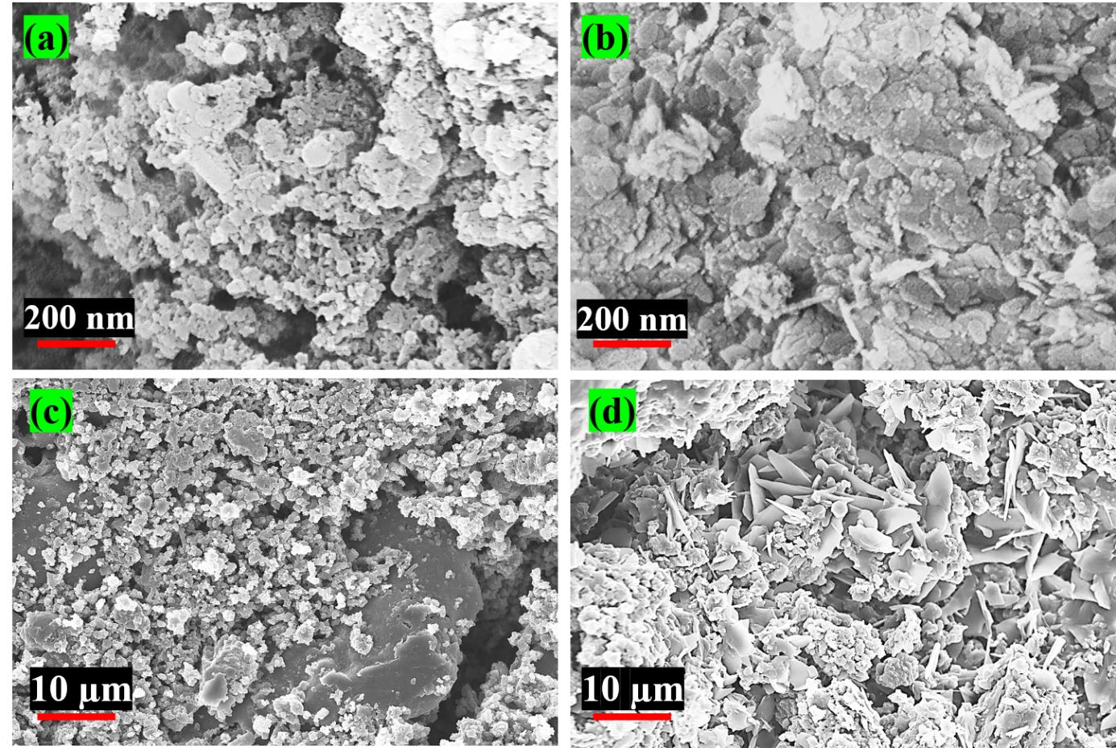
Fig. 4 Scaning electron microscope photograph of fabricated layers, (a)Polyaniline, (b) Tin-oxide, (c) PANI-doped SnO₂, and (d) PANI and Pd-doped SnO₂
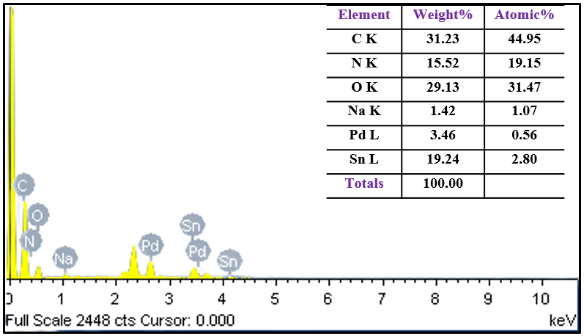
Fig. 5 SnO₂/PANI/Pd nanocomposite analysis using EDX.

RAMAN spectroscopy
Raman–spectroscopy technique is used to offer details on the consistency and external states of all thin films that have been prepared. Through the Raman spectra, various modes such as rotational, vibrational and low frequency etc. of a unit cell of SnO₂ can be demonstrated. Moreover, it is observed that SnO₂ has 18 vibrational branches. The Raman spectra of the fabricated SnO₂ nano-sheet can be seen in figure 6 (a). It was observed that the two strongest peaks in the Raman spectra are obtained at 531 cm⁻¹ and 630 cm⁻¹ respectively. The peak obtained at 531 cm⁻¹ is due the expansion and peak at 630 cm⁻¹ is associated with the contractions of vibrational modes of Sn–O single bond. Furthermore, a strong peak in the Raman spectra of SnO₂ nano sheets at 237 cm⁻¹ confirms the existence of the nano-phase that is absent in the bulk crystals of SnO₂ [38]. From figure 6(b), the Raman spectrum of the fabricated SnO₂/Pd layer can be seen. Similar spectral features were observed in the wave-number of 400–1200 cm⁻¹. Sn–O single bonds are responsible for the most extreme peaks obtained at 480 cm⁻¹ and 571 cm⁻¹. Manjulaet et al. reported a similar peak obtained at 1073 cm⁻¹ because of the existence of Pd in the prepared film [39]. The Raman spectrum of the fabricated SnO₂/Pd film shows observable line broadening and shifting, when compared to SnO₂. The decrease in the size of SnO₂ crystals causes this behavior. The Heisenberg uncertainty theory establishes a relationship between photon-momentum (Δp) and photon-position (Δx). The following is the mathematical expression;
$∆p×∆x ≥ \frac{h^{2}}{4}$ (2)
Where, ‘h' denotes the Planck constant. The further molecules that are collected within a particle as the crystalline size of the material shrinks, the higher the molecule's momentum distribution. Because of the decrease in the crystal–size of material, more molecules are collected within a particle, and therefore, the distribution of molecular momentum is raised respectively. Furthermore, due to the non-symmetric broadening caused by dispersion of molecules, the band can change to a lower wavenumber [40].
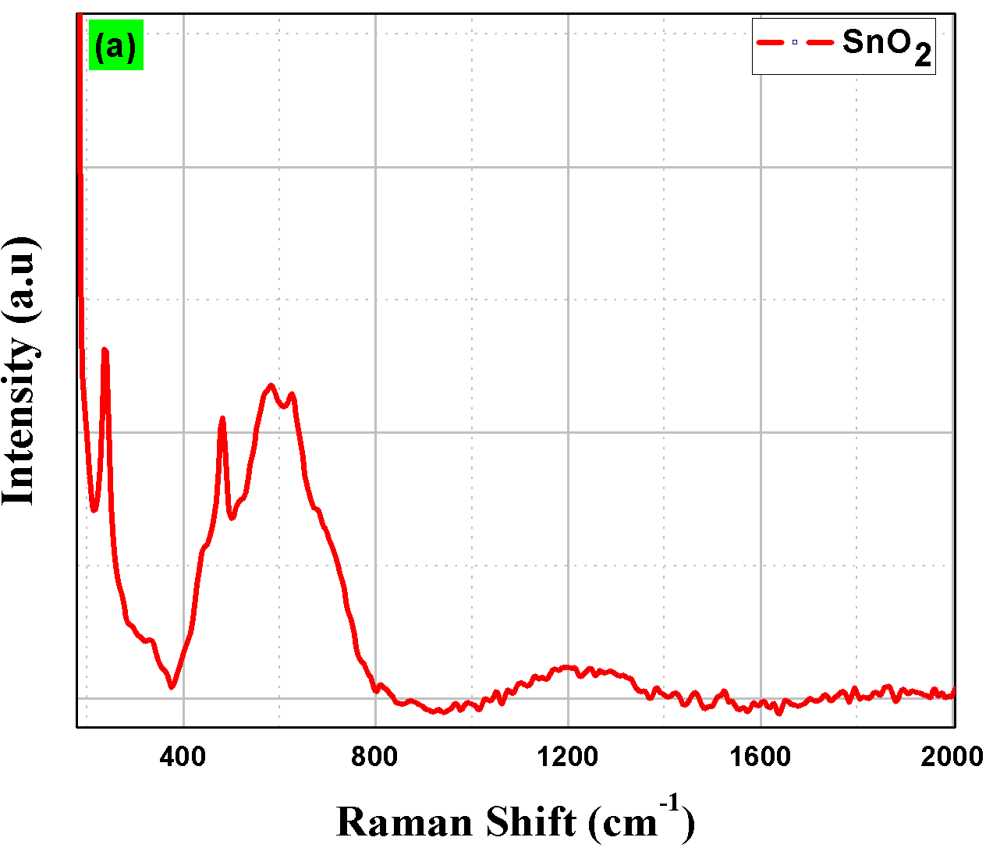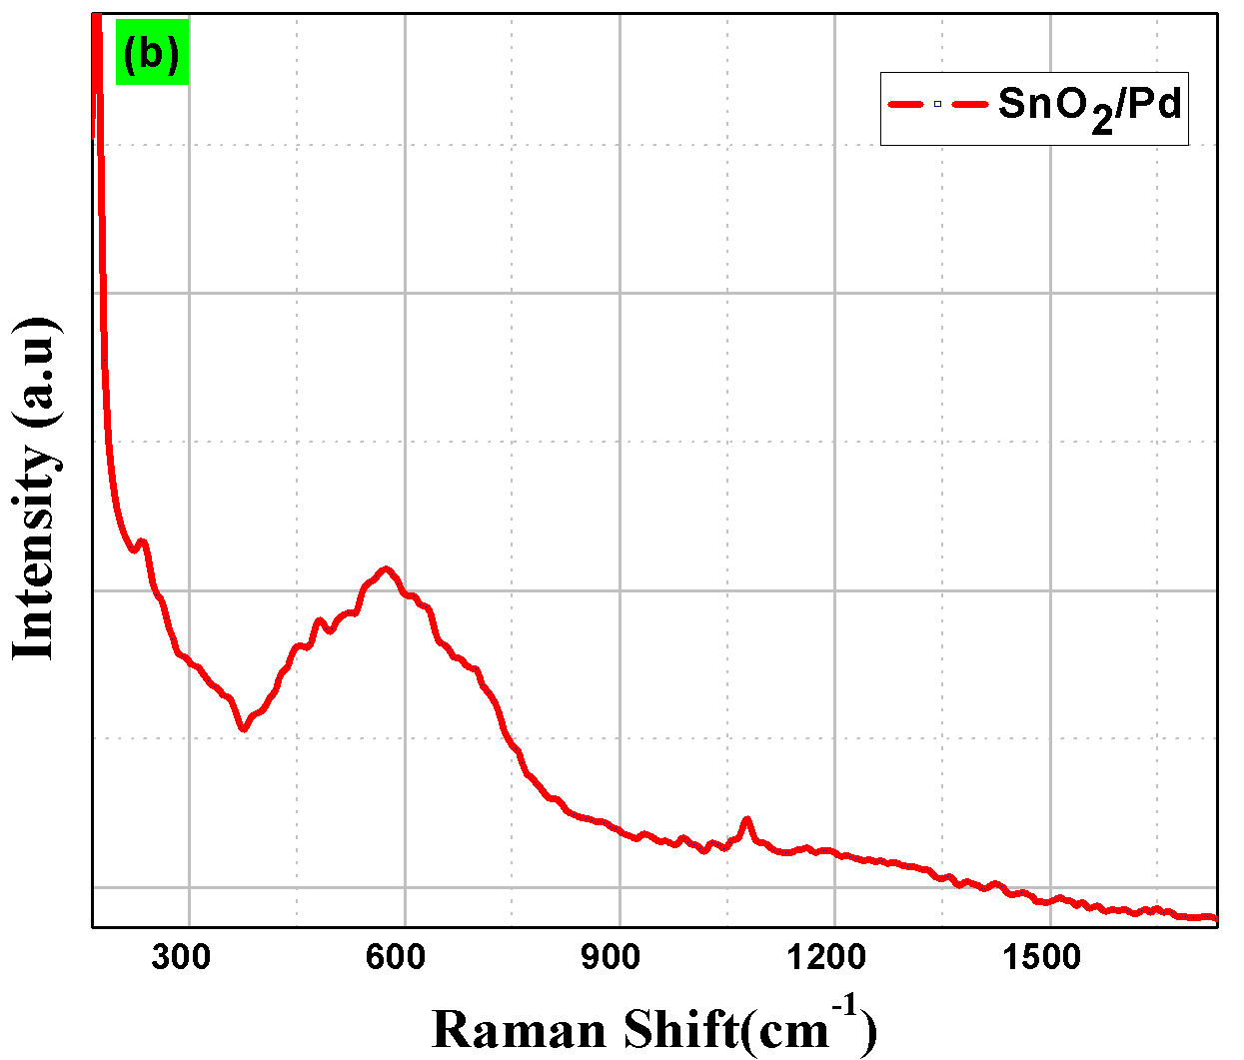
Fig. 6 Raman spectrum of (a) SnO₂, and (b) SnO₂/Pd samples.
The Raman spectrum of Polyaniline is shown in Figure 7(a). Poly-aniline (PANI) as a conducting polymer was synthesized by oxidative polymerization of an acidic solution with ammonium persulphate. To prepare the PANI film, oxidative polymerization technique is used which is associated with the mixing in acid-based solution containing ammonium persulphate. PANI contains benzenoid and quinoid in its chemical structure. The emeraldine-base is formed when an equivalent amount of quoined and benzoin is present in an equivalent ratio. Dopants applied to the polymer have a substantial impact on the strength of RAMAN peaks. A peak at 1500 cm⁻¹ is seen because of vibration and stretching of di-imine in the structure of quoined. The existence of a C-N bond shows a significant peak obtained at 1187 cm⁻¹, and a Carbon-Carbon single bond causes a peak at 1607 cm⁻¹. DohyukYoo et al. [41] reported the similar-spectroscopy. The Raman spectra of SnO₂/PANI are shown in Figure 7(b) with peaks obtained at 1639 cm⁻¹, 1188 cm⁻¹ and 1429 cm⁻¹ for single bonds of Carbon–Carbon, single bonds of Carbon–Nitrogen, and triple bonds of Carbon–Nitrogen. Another peak obtained at 818 cm⁻¹ is observed because of the existence of Sn–O single bonds. These findings indicate that a SnO₂/PANI film has both tin-oxide and polyaniline properties.
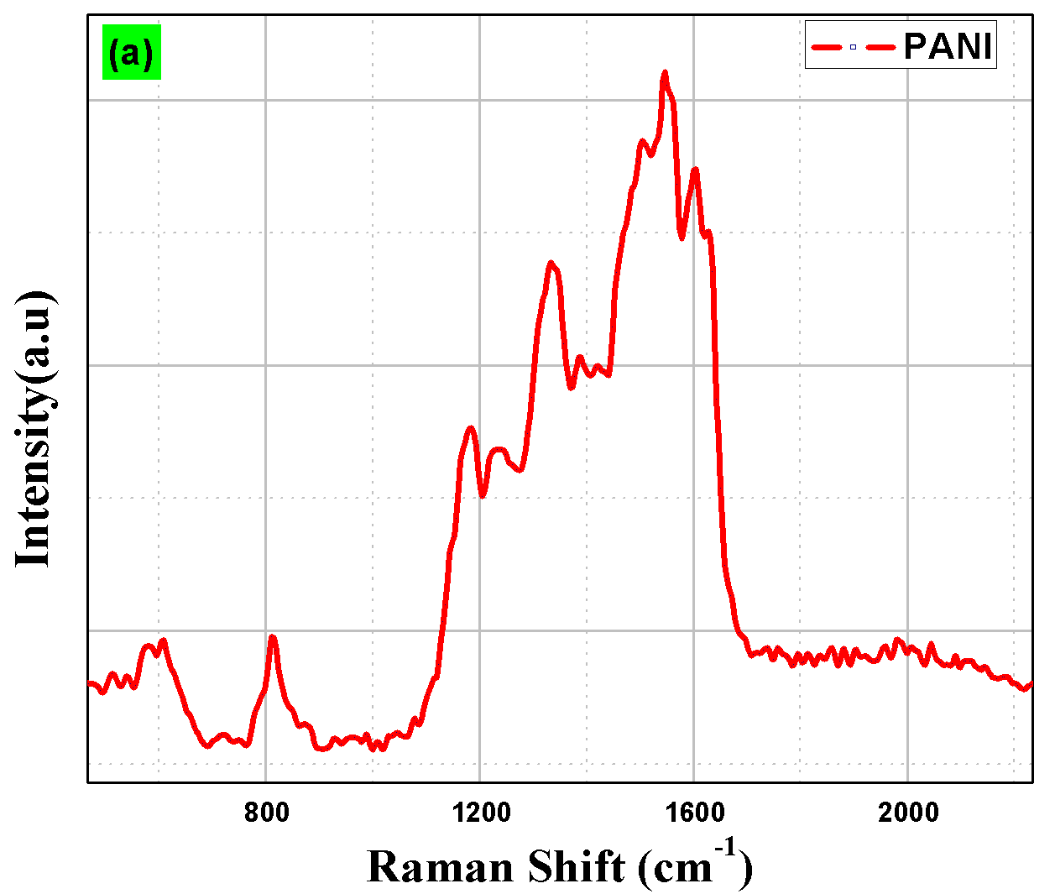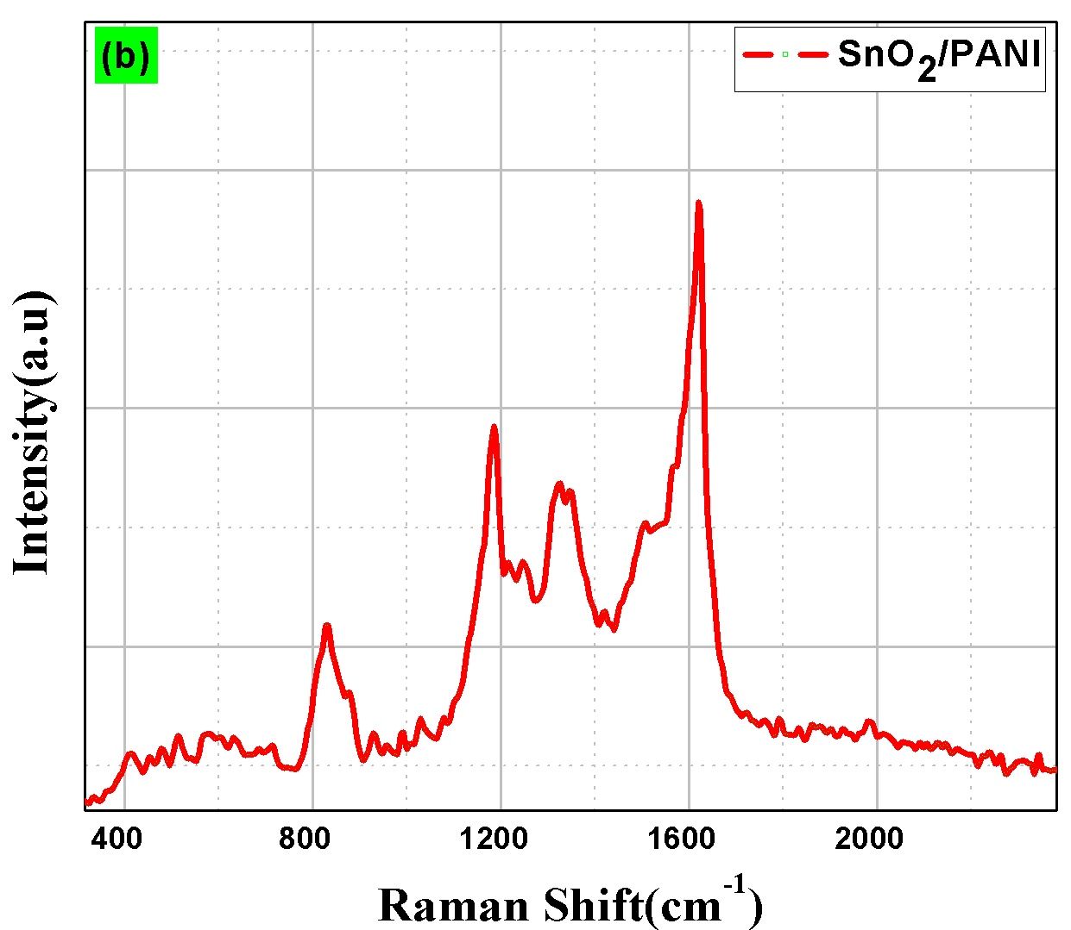
Fig. 7 Raman spectrum of (a) PANI and (b) SnO₂ /PANI samples.
From figure 8, the Raman spectrum of SnO₂/PANI/Pd nanocomposite-based film can be seen. It was observed that due to the presence of Sn–O bonds in the hybrid film, an intense peak is obtained at 486 cm⁻¹. The presence of single bonds of Carbon–Carbon, single bonds of Carbon–Nitrogen, and triple bonds of Carbon–Nitrogen, triggers the three sharp peaks obtained at 1187 cm⁻¹, 1324 cm⁻¹, and 1629 cm⁻¹, respectively depicted from the figure 8(a). The Raman spectrum of all films are compared in the figure 8(b). It was observed that as the crystal size increases with doping, the amplitude of the peak decreases, resulting in less scattering. Broadening and wavelength shifts are noticeable effects that can be explained using the Heisenberg uncertainty principle.
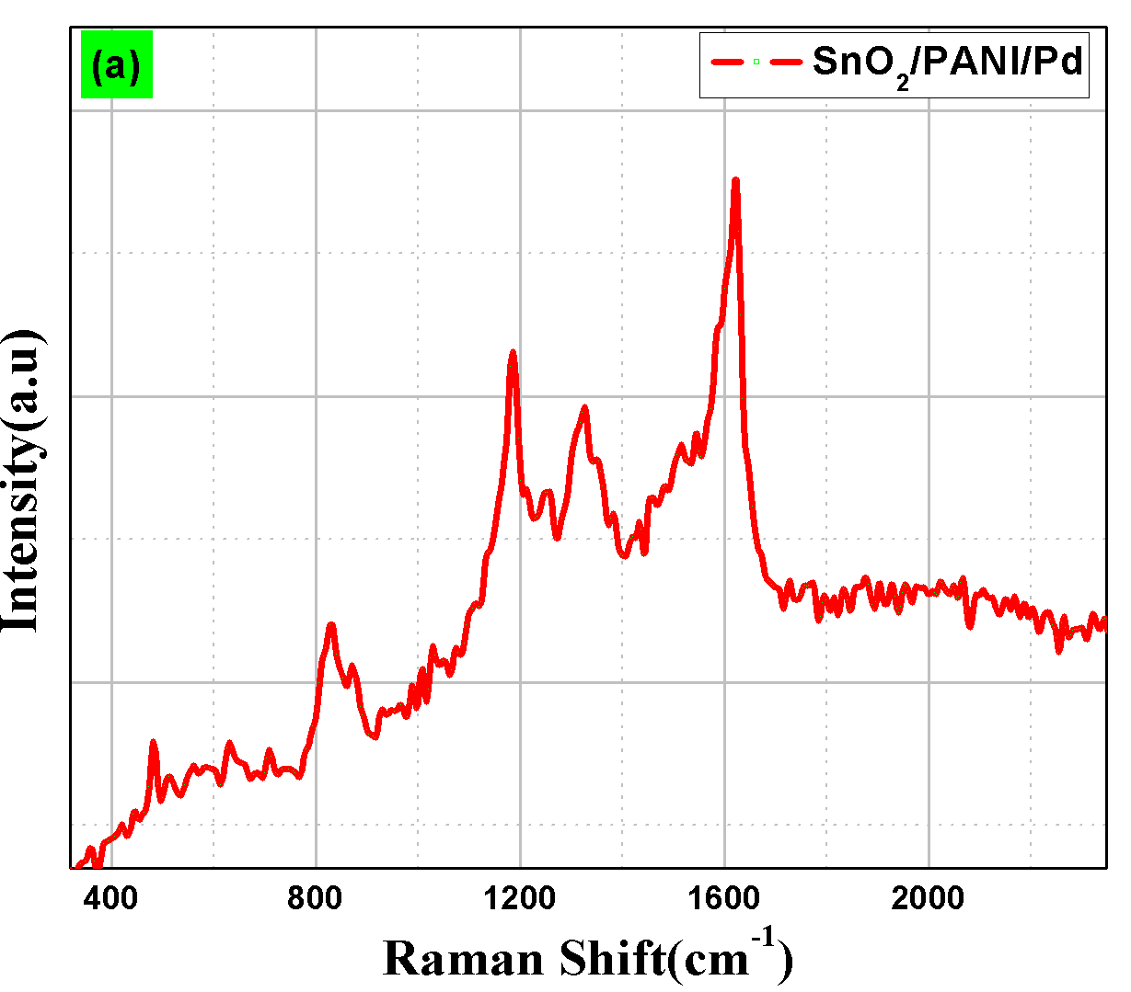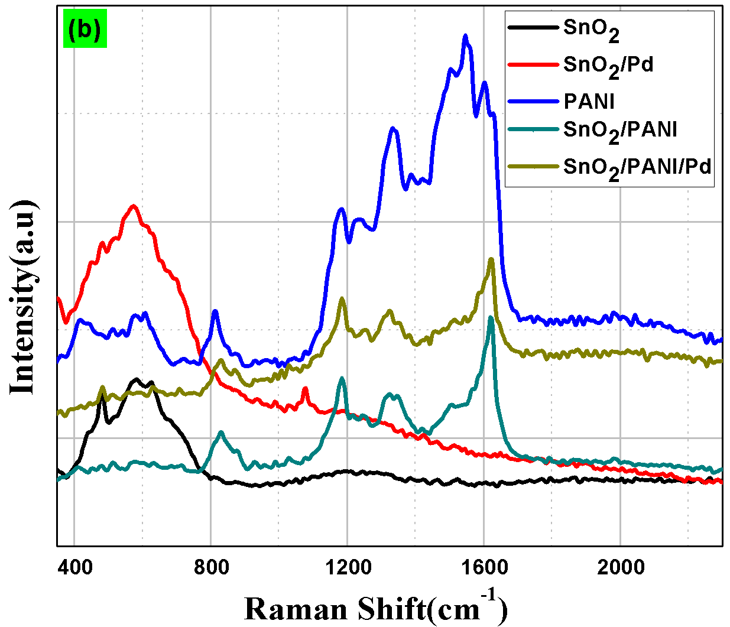
Fig. 8 Raman spectra of (a) SnO₂/PANI/Pd sample, and (b) combined spectrum of all the fabricated films.

X-Ray Diffraction Study
Figure 9 (a) depicts the XRD pattern of the SnO₂ nano-sheets. It shows the rough-patterns, due to the existence of anisotropy in the crystal structure. Few more smaller peaks can also be seen in the XRD analysis of SnO₂ nano-sheets. From figure 9(a), the notable peaks can be seen for the plane <110> at 27º, <101> for 32º, and <211> at 57º which is compared to the data file (JCPDS 41–1445) to confirm the presence of rutile SnO₂ [42]. The peak (110) is higher than the peak (101), indicating that (110) is the primary reveal surface. Since the surface of (110) has a high specific energy, it supports the case for better gas sensing efficiency. From figure 9(b), the notable peaks can be seen for the plane <110> at 27º, <101> for 32º, and <211> at 57º for SnO₂ and an intense peak of 46º because of the addition of Pd in the prepared film.
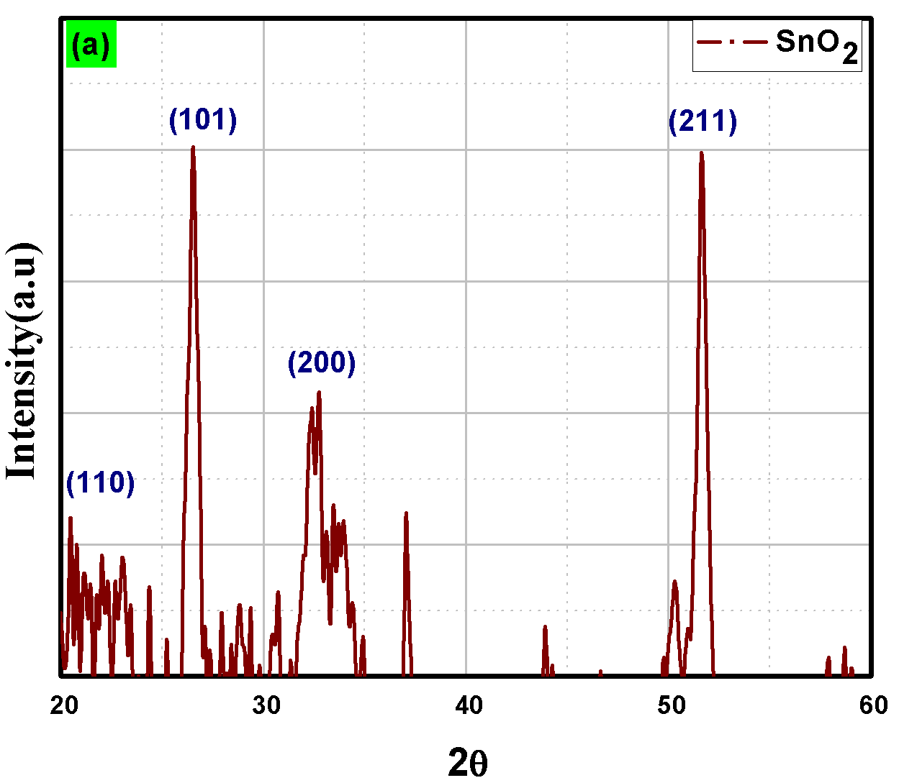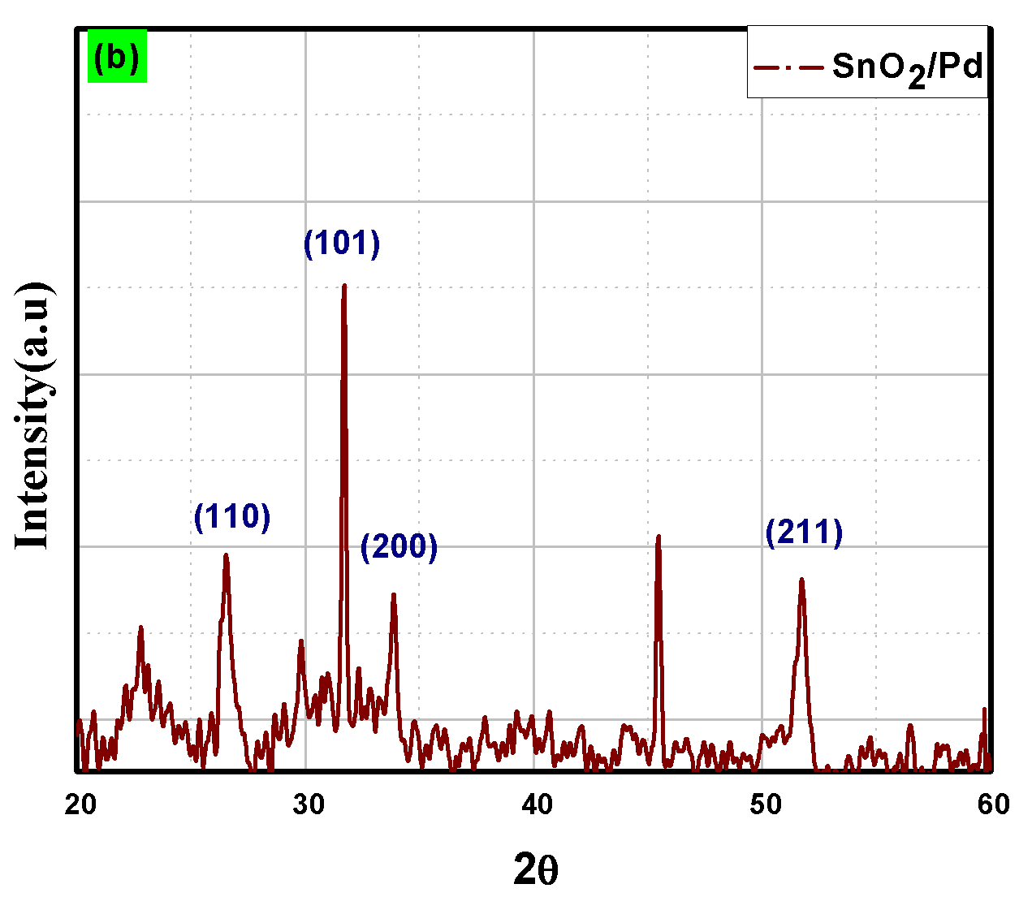
Fig. 9 XRD pattern of (a) tin oxide SnO₂ Nano sheet and (b) doped palladium and tin oxide SnO₂ + Pd.

The XRD of polyanailine thin film is depicted in the figure 10(a). Tai et al. also reported the similar results [43]. During the analysis, a broad peak at 23º was discovered, indicating that PANI is amorphous. PANI's low crystalline structure and conductive nature can also be verified through this analysis. From figure 10(b), depicts the XRD pattern of SnO₂/PANI. At 20˚, the peak of SnO₂ in <110> plane is seen superimposed to the peak of PANI. The other-peaks shows no response because of the incorporation of polyaniline into SnO₂.
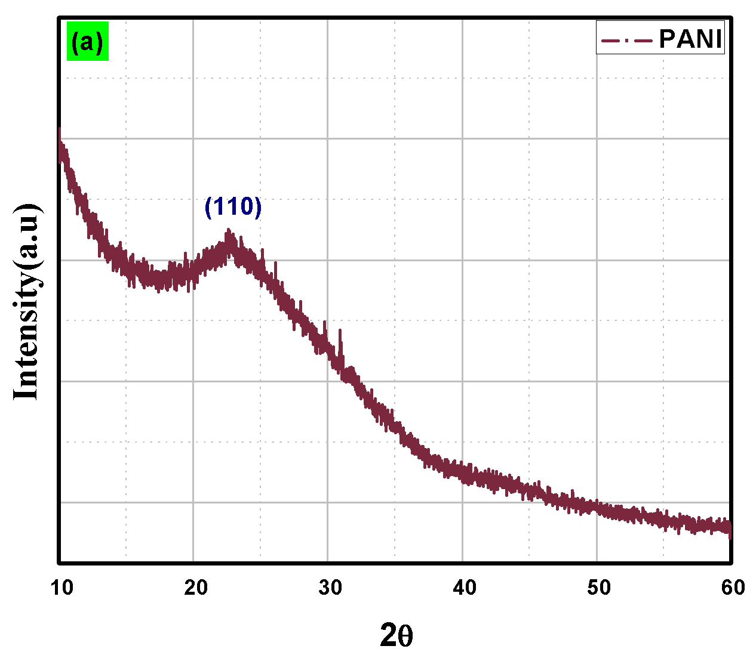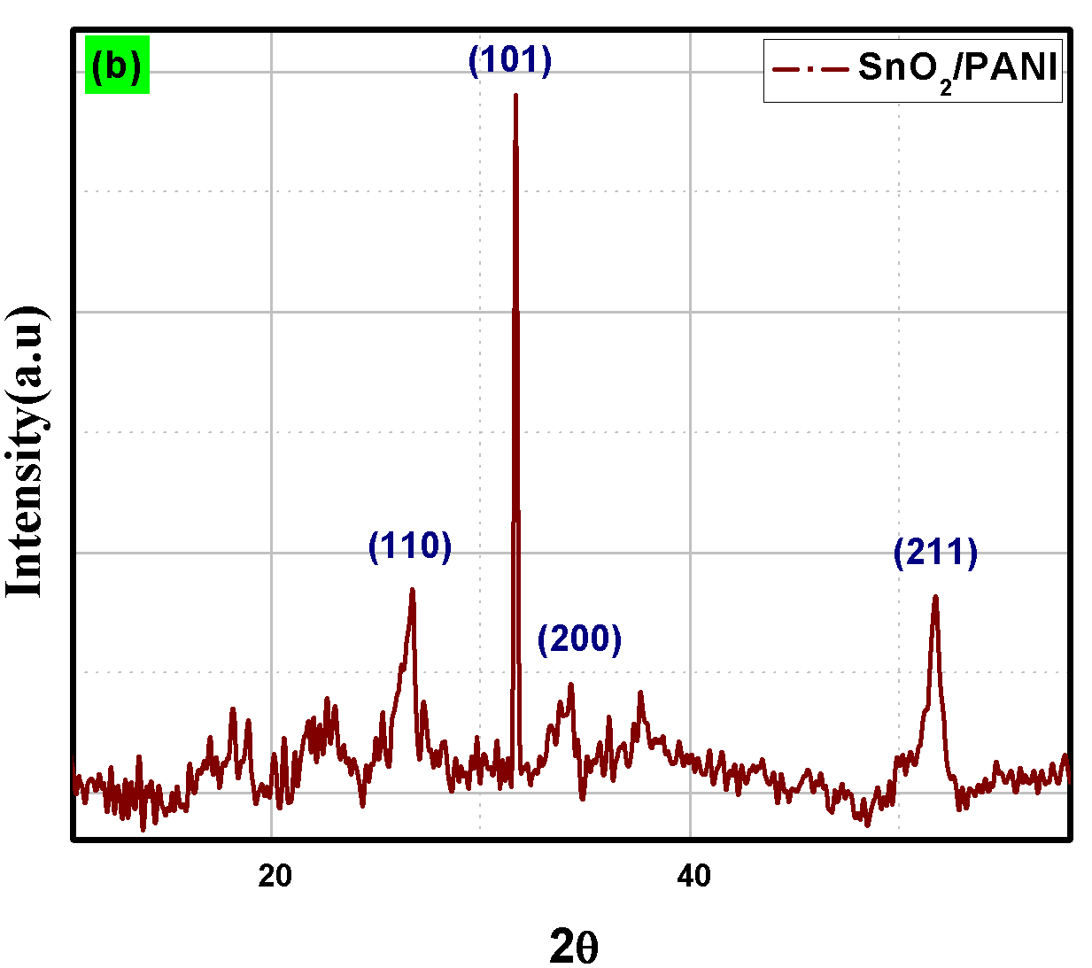

Fig. 10 XRD pattern of (a) PANI and (b) SnO₂ + PANI.
The sharp peak obtained at 32˚ was observed in this hybrid nanocomposite consisting of SnO₂+Pd/PANI associated with the <101> plane as shown in the figure 11. The notable peaks can be seen for the planes <110> at 27 º, <200> for 34 º, <211> at 52 º, <310> for 62 º, and <301> at 65º.
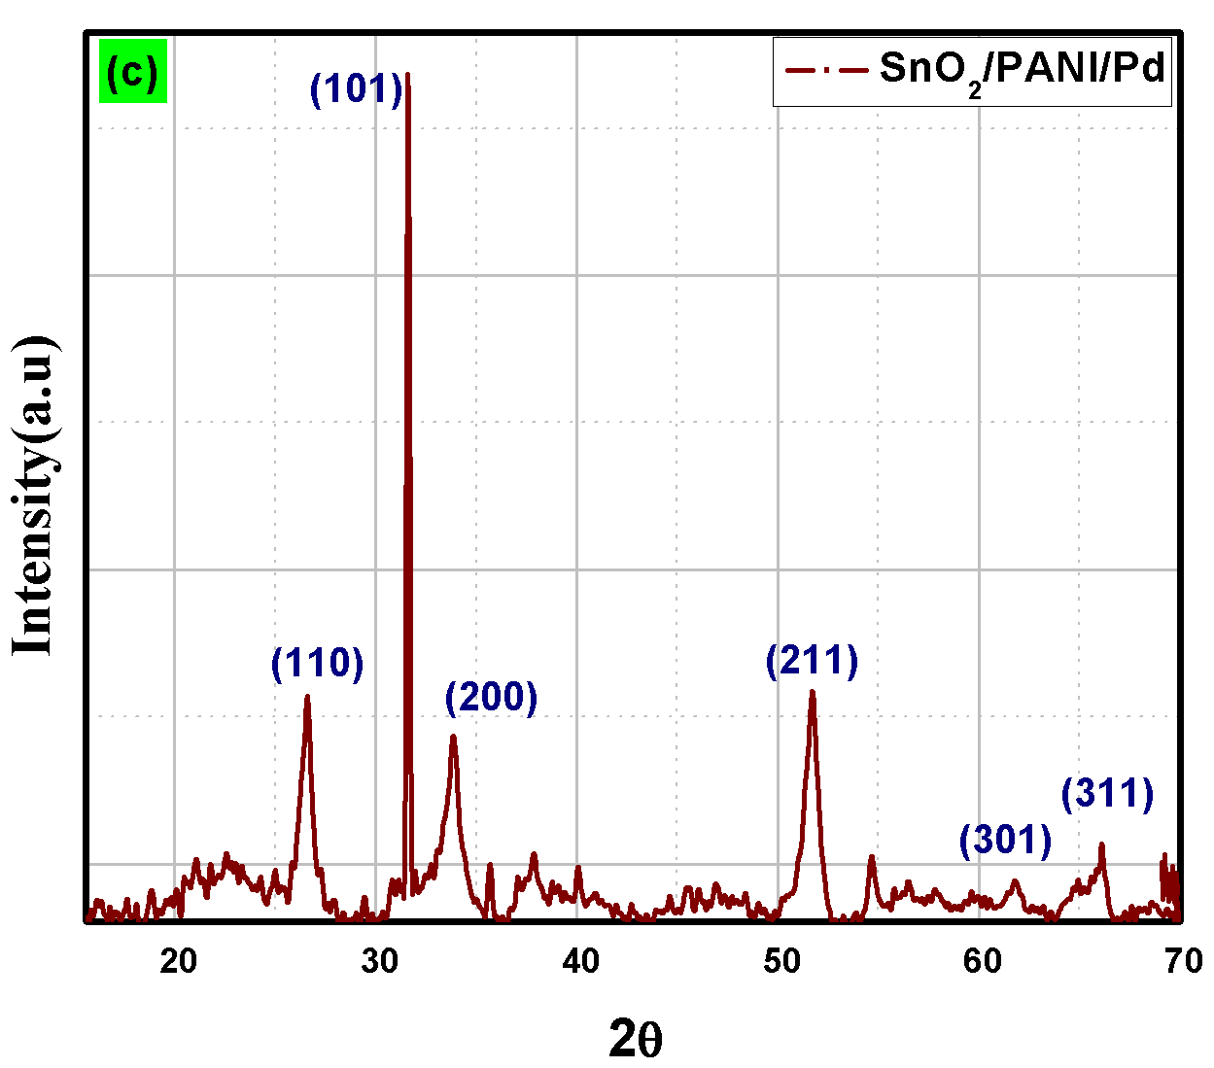
Fig. 11 XRD pattern of SnO₂ +Pd/ PANI.

FTIR Analysis
Figure 12, depicts the FTIR spectroscopy results in the range of 0-4000 cm⁻¹ wavenumber. These results help in explaining the chemical interaction of the synthesized nanocomposite. The FTIR analysis of SnO₂/Pd composite film is shown in Fig.12(a). The strong band of stretching vibration is obtained for the surface–hydroxyl group at 3384 cm⁻¹. Some peaks obtained at 1604 cm⁻¹, and between 500 cm⁻¹ to 600 cm⁻¹ are associated with the Sn–OH bond and O–Sn–O bond respectively. Figure 12(b) depicts the bands at 479 and 583, because of the Sn–O–Sn symmetrical vibration, Sn–O–Sn and O–Sn–O asymmetrical bond in SnO₂ respectively. The band at 1604 cm⁻¹ is associated with Sn–OH. The presence of SnO₂ is evidenced by these peaks.
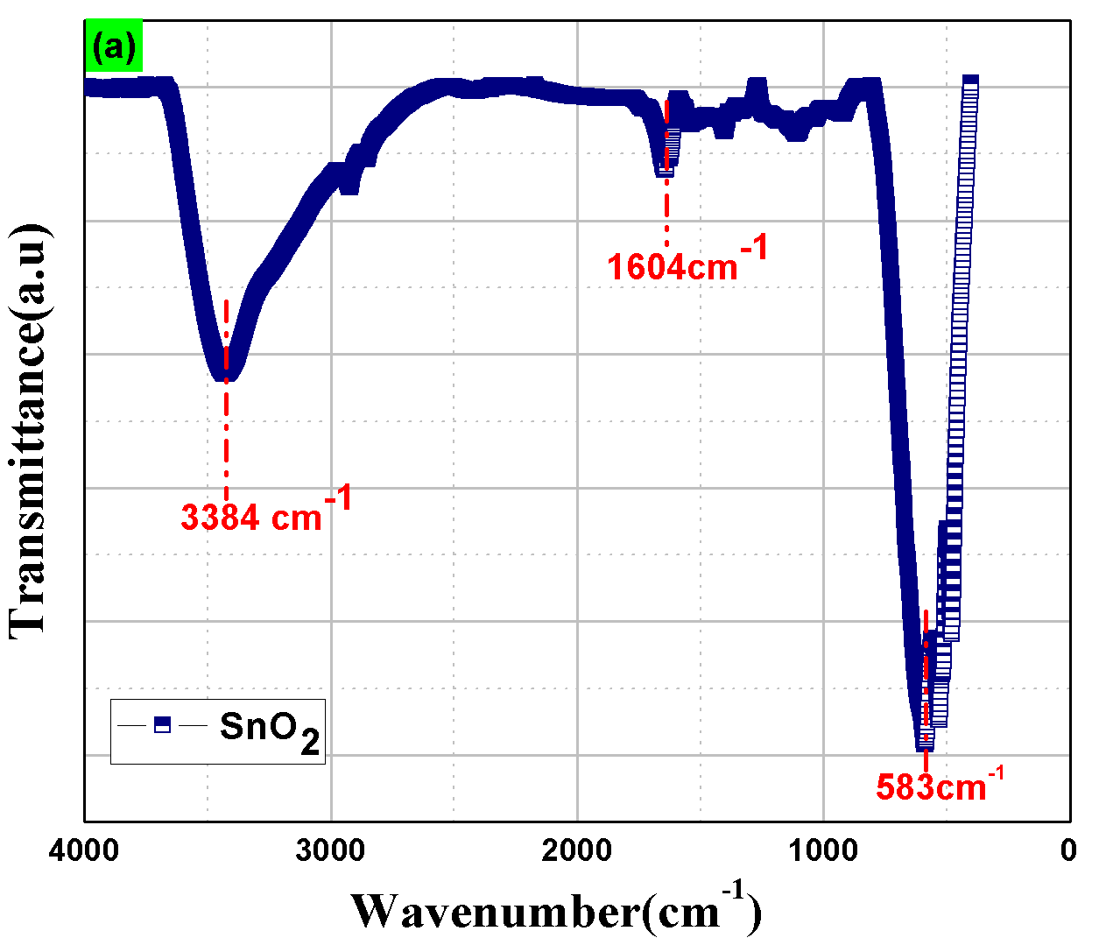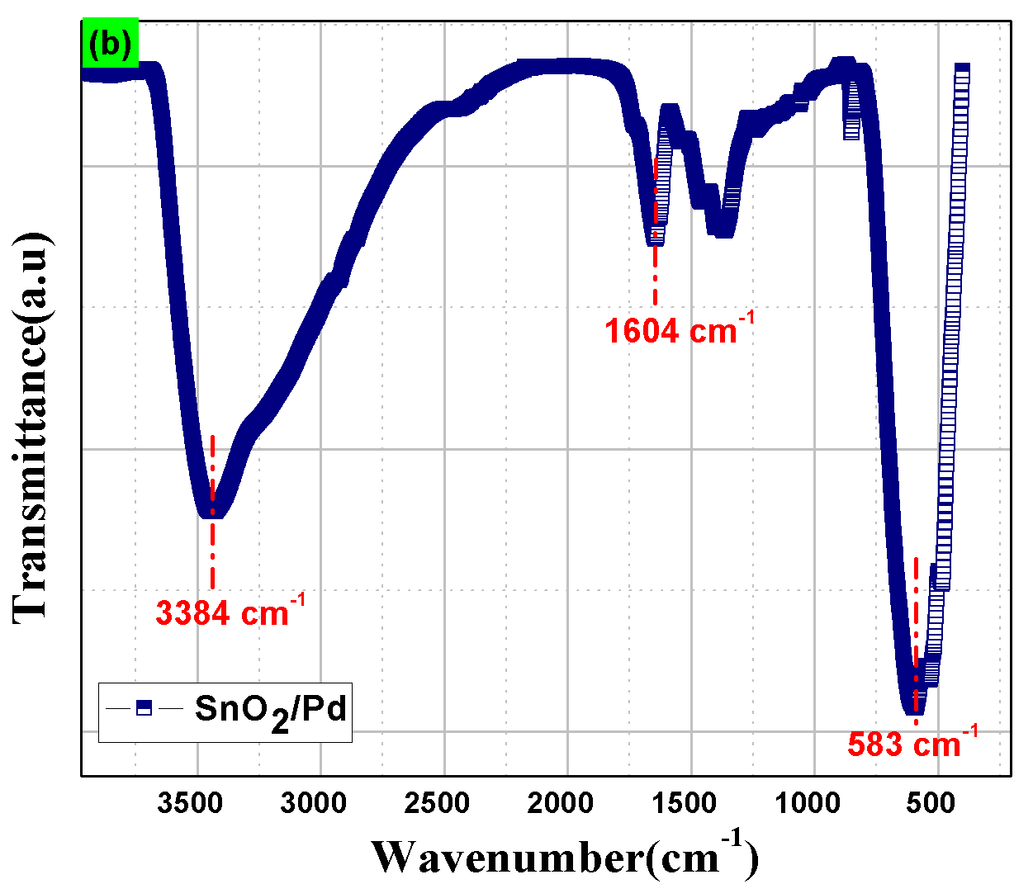
Fig. 12 FTIR spectra of (a) SnO₂ and (b) SnO₂/Pd.
The FTIR analysis of plain PANI, SnO₂/PANI and SnO₂/ PANI/Pd nanocomposite films are shown in Figure 13. The steep peak position at 792 cm⁻¹ is related to N–H out-of-plane bending vibrations as depicted in figure 13(a). The band obtained at 1486 and 1576 cm⁻¹ is associated with the existence of vibrations of benzenoid and quinoid respectively; that confirm that the PANI is in emeraldine salt form. Some other bands observed at 3374 cm⁻¹, 1274 cm⁻¹, are associated with the broadening of the N–H bond, C–N bond in the aromatic ring of polyaniline. Similarly, the band at 1156 cm⁻¹, and in between 2924 to 3343 cm⁻¹ is associated vibration of N =Q= N bond (Q represent Quinoid ring), C–H bond respectively. The FTIR analysis of SnO₂/PANI composite film is shown in Fig.13(b). At 575 cm⁻¹, a band was discovered, which represents the symmetric stretching of Sn-O-Sn. A peak representing PANI protonation at 1287 cm⁻¹ shows at 1287 cm⁻¹ shows the the conducting qualities of PANI. Other bands found at 1156 cm⁻¹ and between 1445 and 1565 cm⁻¹ are in-plane C–H bond vibrations and polyaniline distinguishing peaks, respectively. PANI corresponds to the stretching mode of the C=N bond at 1565 cm⁻¹ and the stretching mode vibration band of the C=C bond at 1445 cm⁻¹. The C-N bond in the benzenoid ring stretches to a maximum of 1314 cm⁻¹. Similarly, the C-H bond is indicated by the peak at 812 cm⁻¹. FTIR analysis of PANI/SnO₂/Pd reveals comparable peaks, but with poor transmittance as depicted in fig.13(c). The Pd-doped samples show no additional peaks, indicating that the Pd dopant utilized occupied a substituent position in the SnO₂ lattice. Due to the benzenoid and quinonoid structure, the ratio of intensity in PANI/SnO₂ and PANI/SnO₂/Pd composites is reduced when compared to pure PANI. This demonstrates that the fabricated nano-composite film is in a stable state, which can be linked to the material's strong gas sensing performance.
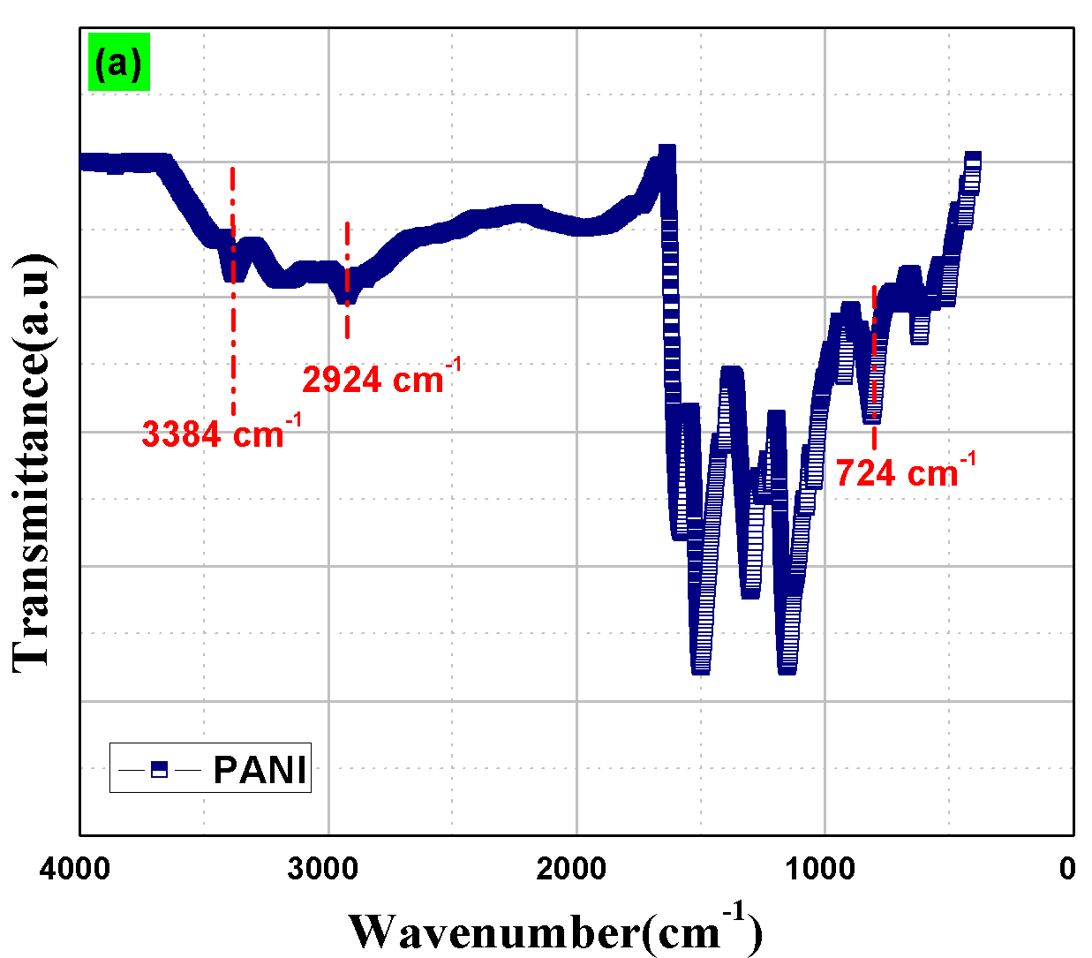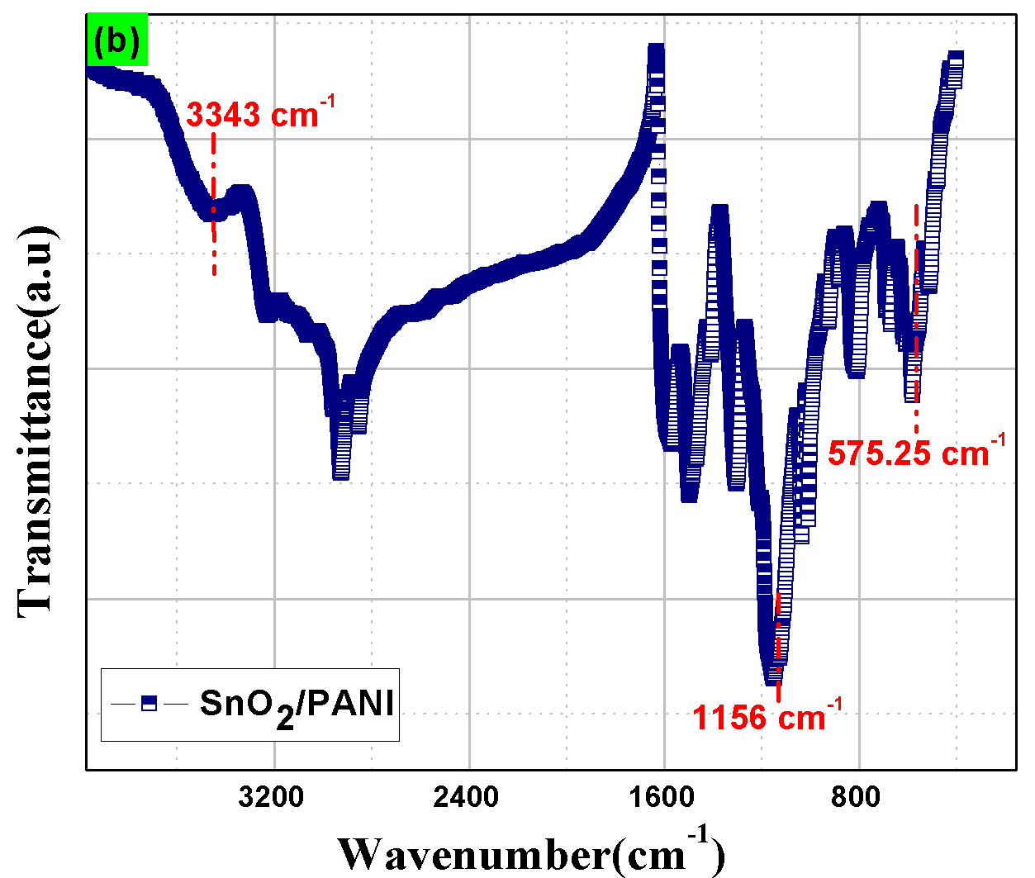
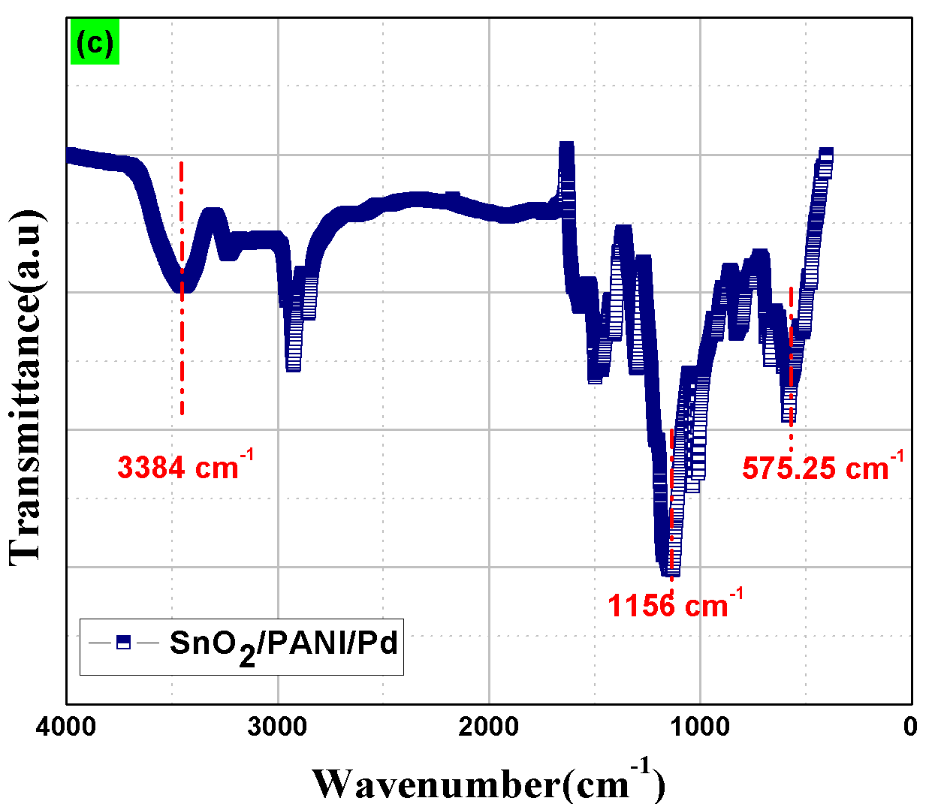
Fig. 13 FTIR spectra of (a) PANI, (b) SnO₂/PANI, and (c) SnO₂/PANI/Pd.

Gas sensing characterization
It has been discovered that all fabricated sensing film depicts a dynamic-response towards carbon monoxide. With changes in concentration level of target gas, the electrical resistance of the prepared films increased. The film SnO₂/PANI/Pd showed no response to CO gas. Below is a detailed description of the sensing behavior.
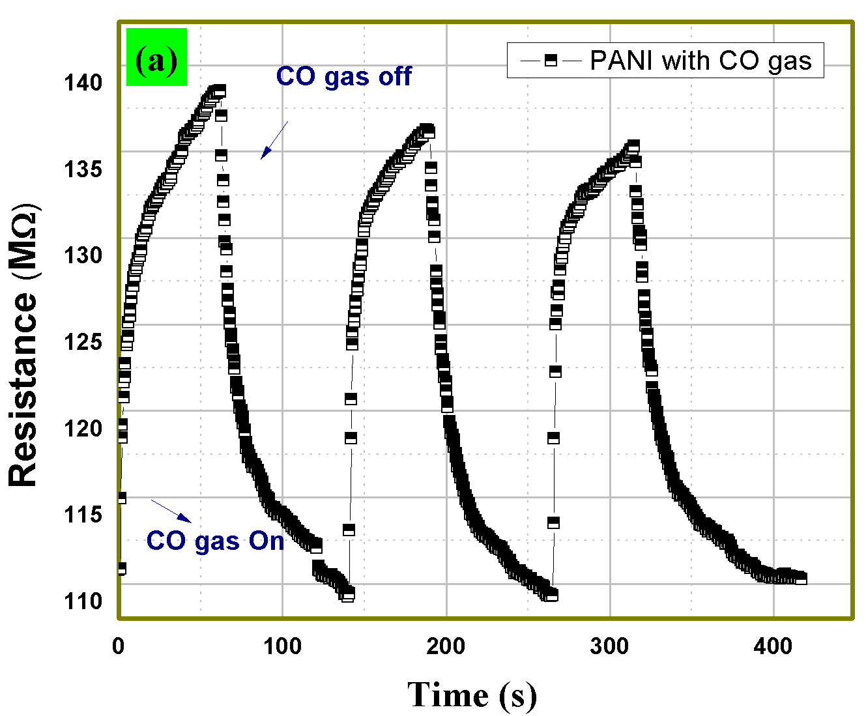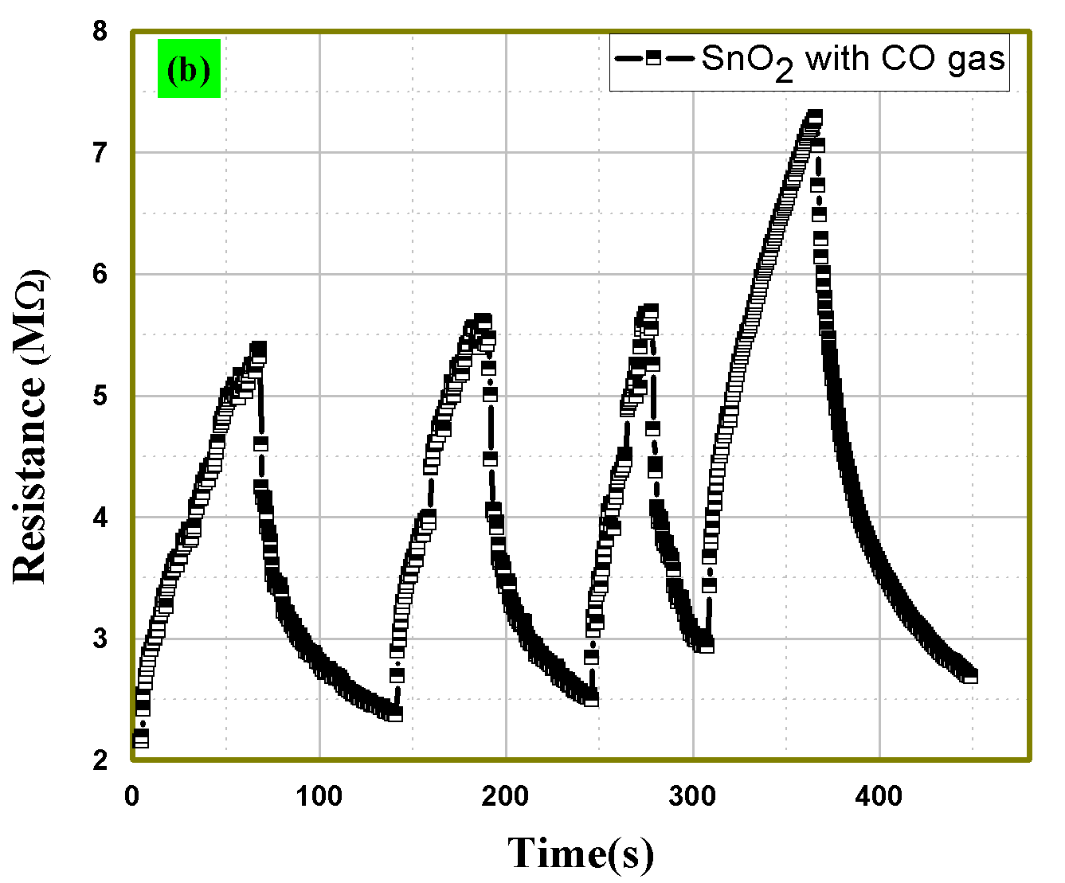
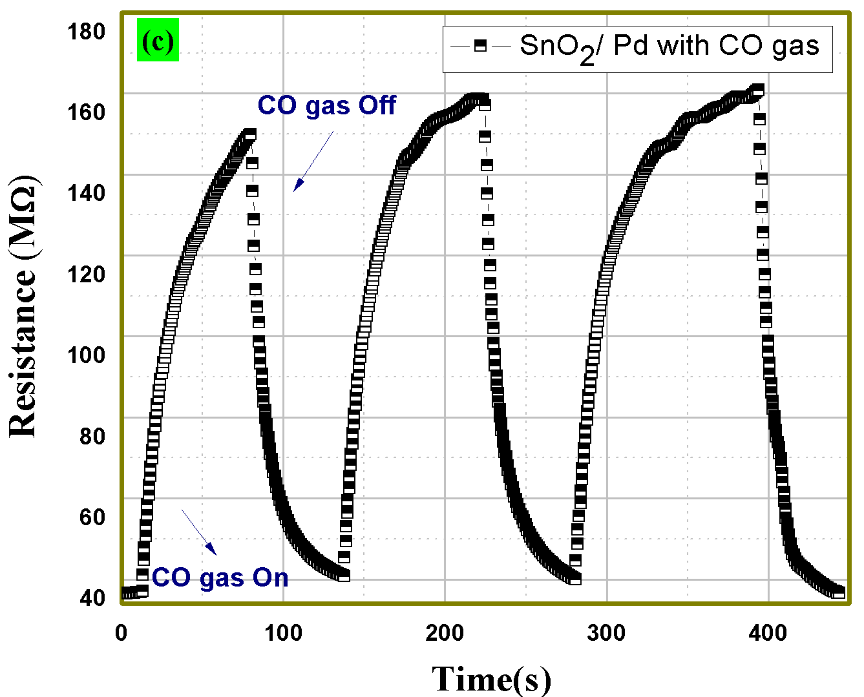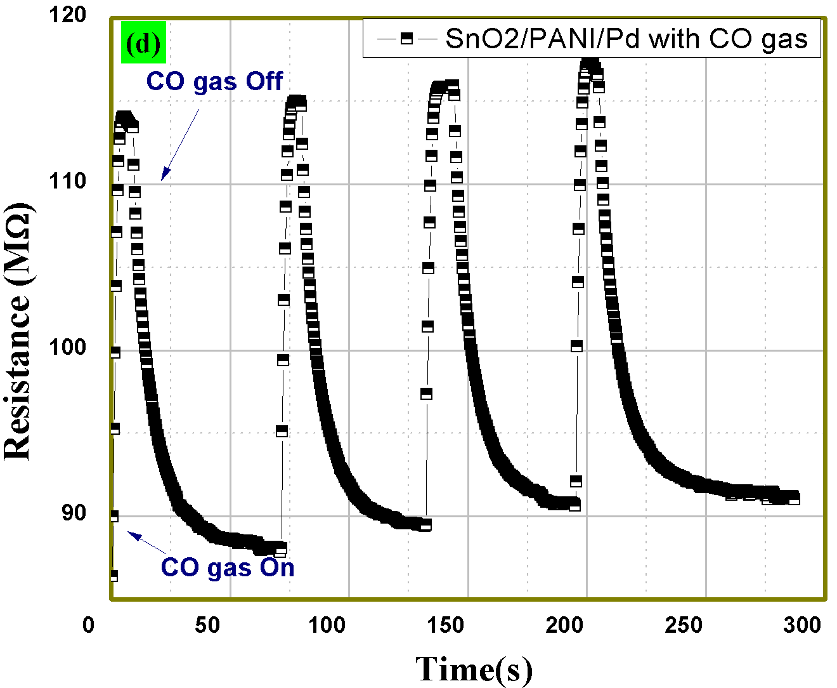

Fig. 14 Relationship between Resistance and time for a)PANI, b) SnO₂, c) SnO₂/Pd, and d) SnO₂/PANI/Pd with CO at 50 ppm.
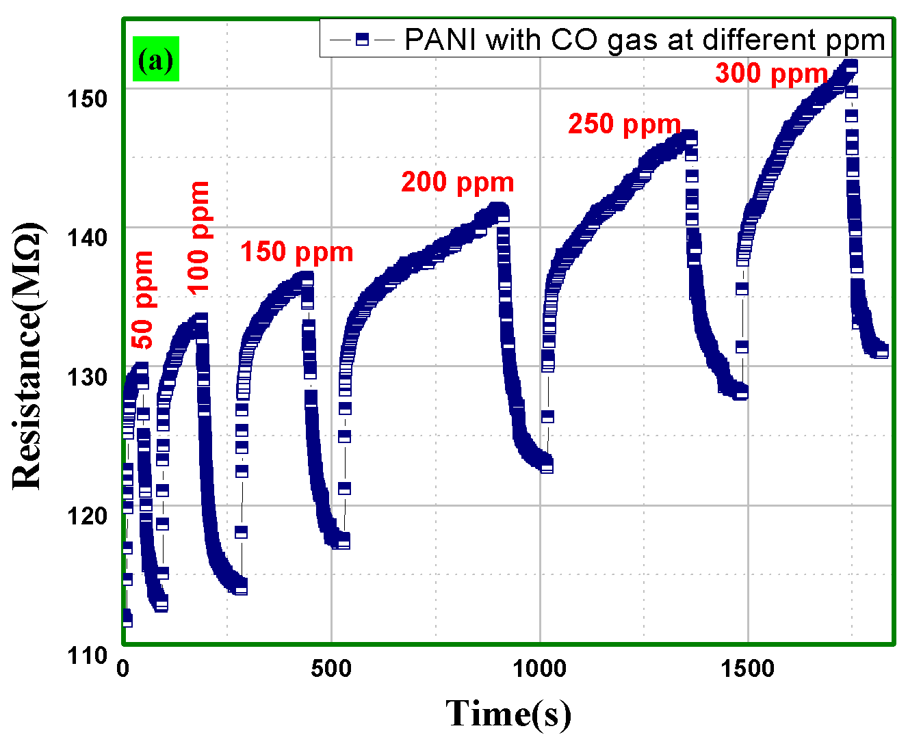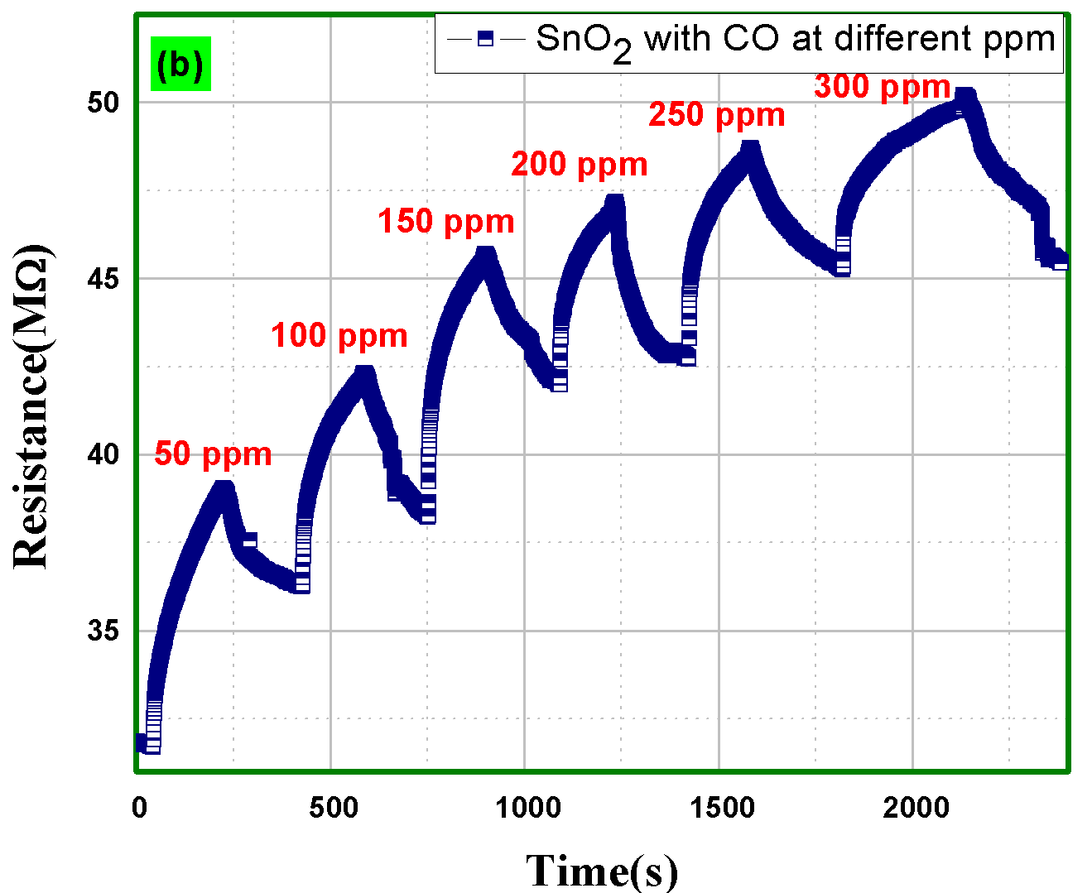
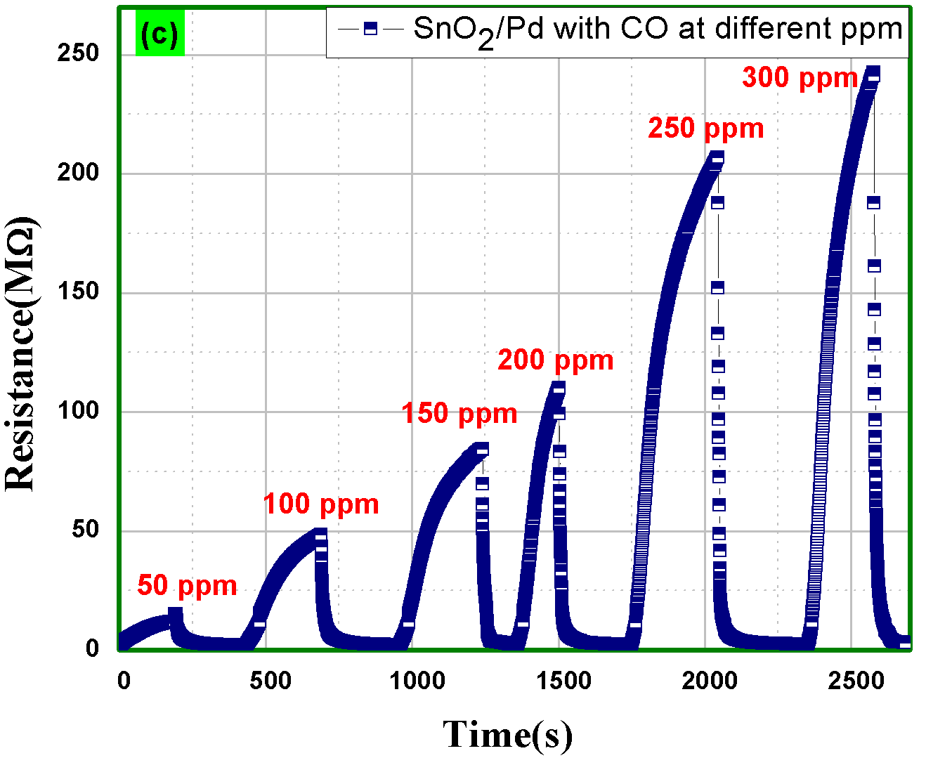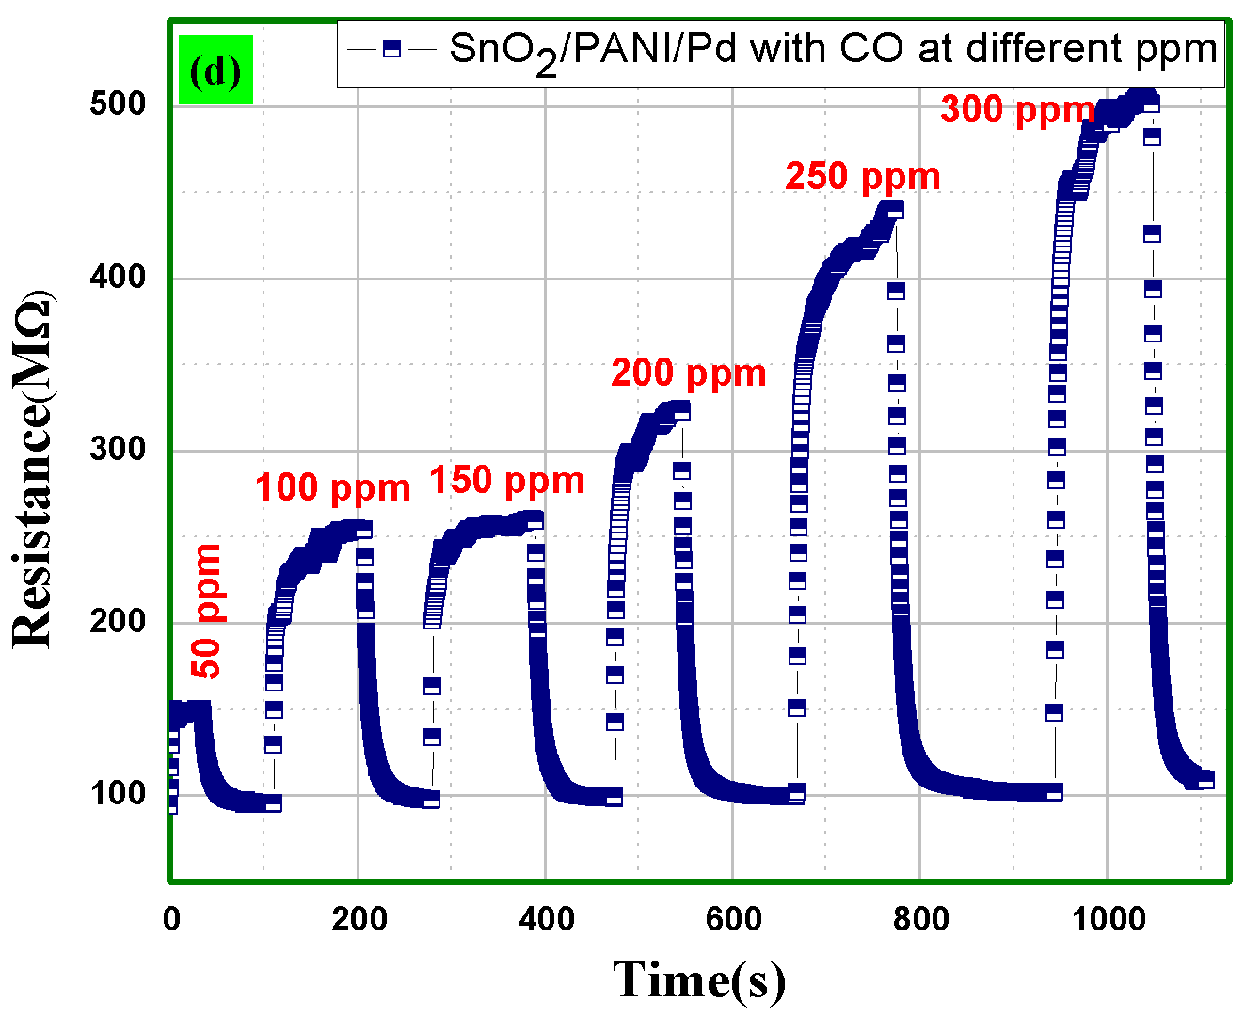
Fig. 15 Relationship between Resistance and time for (a) PANI, (b) SnO₂, and (c) SnO₂/Pd (d) SnO₂/PANI/Pd with CO different ppm levels.
Figure 14, shows the response of CO gas with the fabricated nanocomposite at 50 ppm. Figure 15, depicts that all the prepared sensing films exhibit cyclic response towards CO gas interaction, even at higher ppm levels of CO gas range from 50 to 300. Figure 15, shows that with the increase in the level of CO concentration, the prepared films SnO₂/Pd and SnO₂/PANI/Pd show high repeatability. With increasing ppm levels of gas, we can also see a rise in saturation resistance.

Sensitivity
Figure 16, represents the relationship of sensitivity w.r.t cycle. Sensitivity is described as the ratio of change in sensing film resistance over time (when a gas interacts) to the initial resistance (when no gas interacts). The sensitivity of a sensing film can be calculated by the following formula;
$Sensitivity(S)=\left|\frac{R_{a}-R_{g}}{R_{a}}\right|×100$ (3)
Where, R_{a}, R_{g} represent instantaneous resistance and initial resistance, during and after the interaction of target gases respectively. From figure 16(a), the nano-composite film made up of SnO₂/Pd marks the maximum sensitivity in contrast to the other films at low ppm whereas SnO₂/PANI/Pd films show the highest value of sensitivity in figure 16(b). Also, SnO₂/Pd film shows relatively good sensitivity whereas PANI film shows least sensitivity on increasing the concentration of CO gas ppm level.
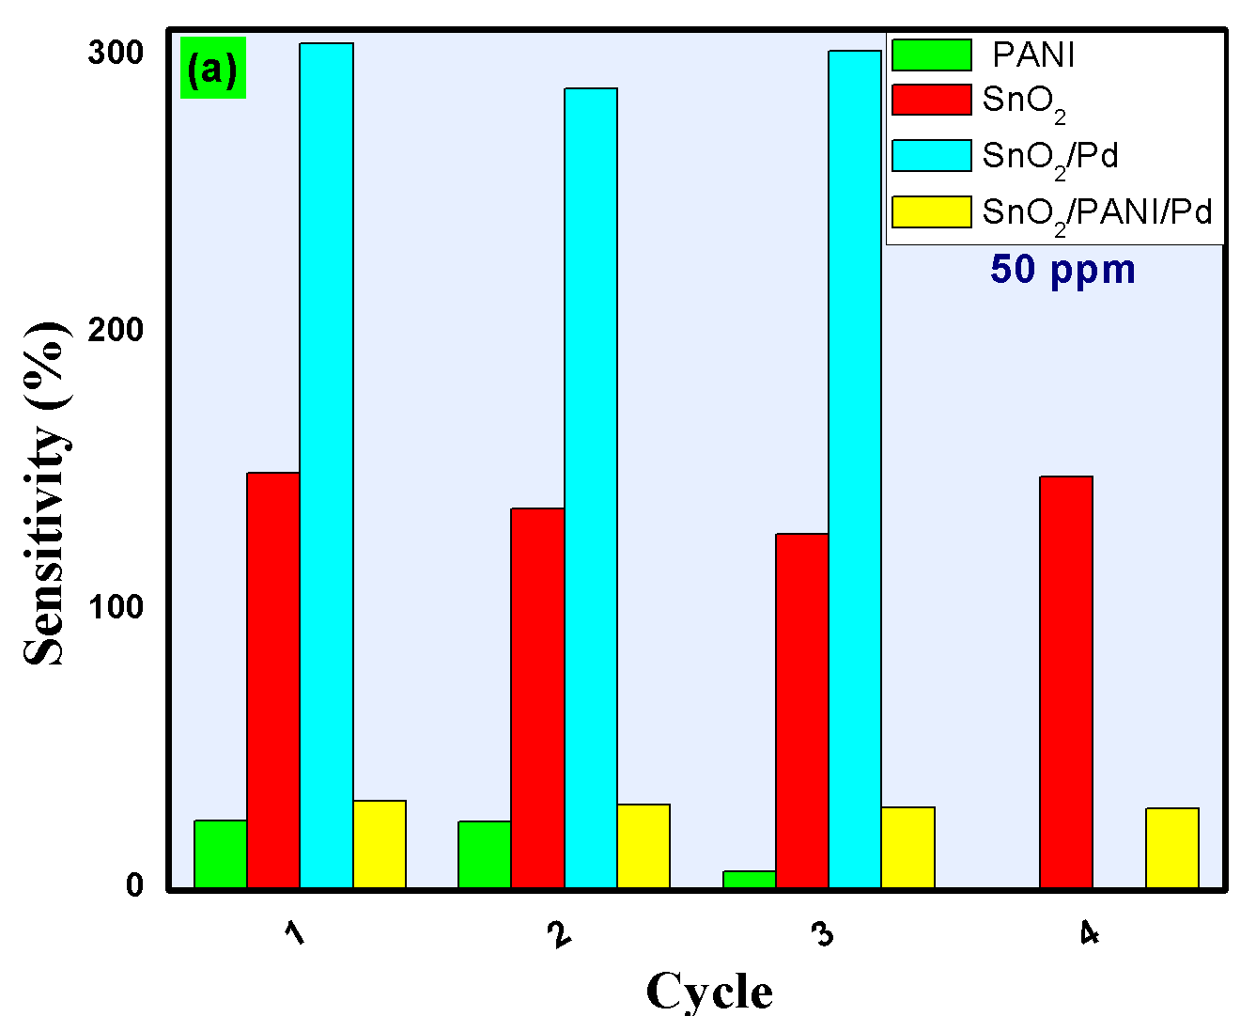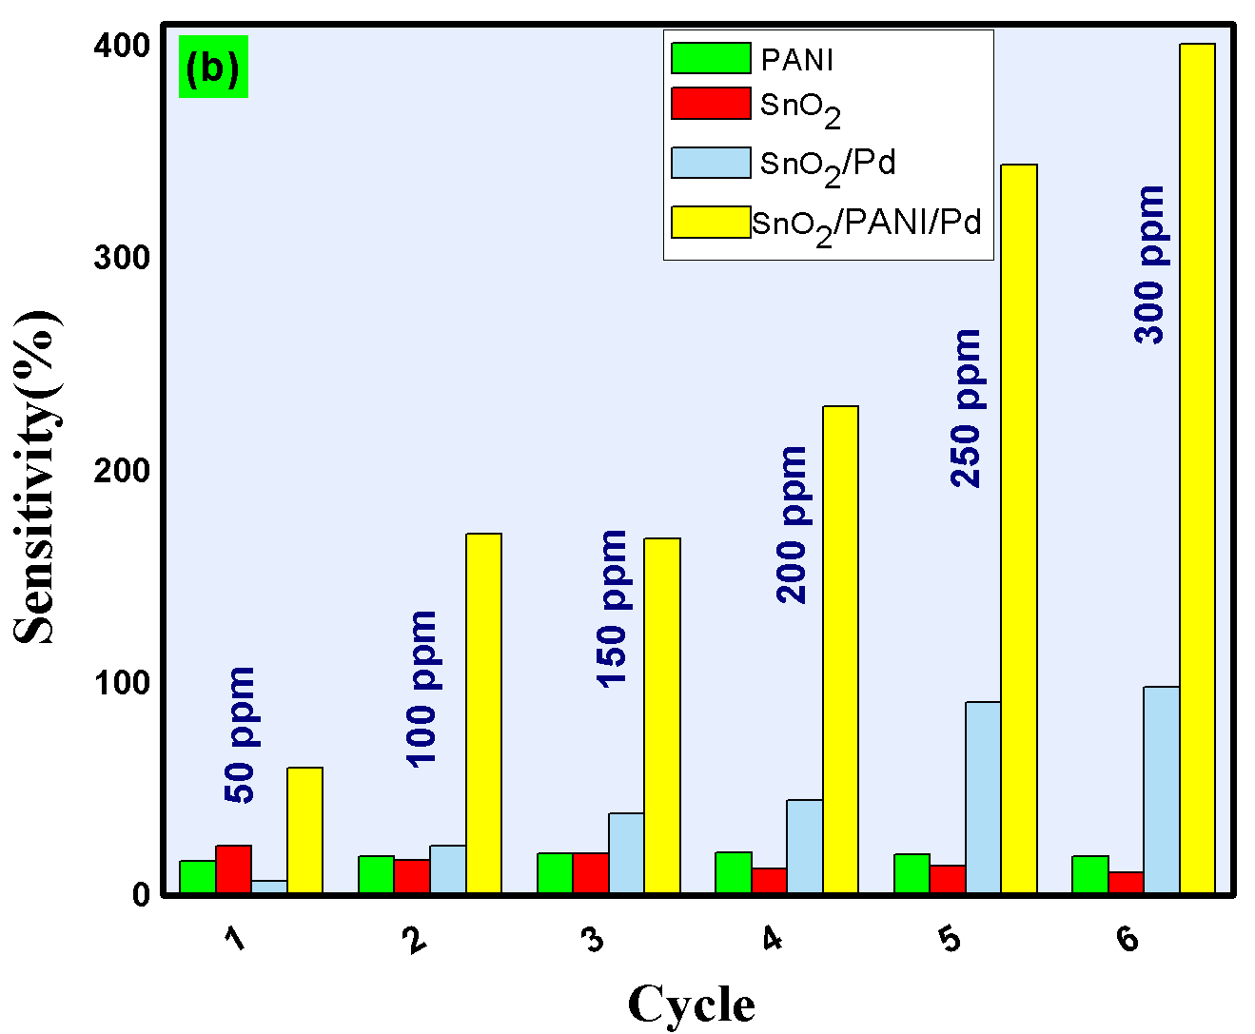
Fig. 16 Relationship between Sensitivity and cycle, (a) at 50 ppm, (b) at various ppm level for CO gas (cycle 1–50 ppm to cycle 6–300 ppm).

Response/Recovery time
Another important parameter for determining the gas-sensing characteristic is the response time-recovery time of a sensing film. The time needed for a gas sensor to exceed 90% of its total resistance response, after being exposed to any target gas is known as response time. The time desired for a gas sensor to reach back to 90% of its starting resistance, after the target gas has been removed is known as recovery time. Figure 17(a, b), shows the fastest response time of SnO₂/PANI/Pd whereas SnO₂ shows fastest recovery time. With CO gas at various ppm levels, the nano-composite made up of SnO₂/Pd also reveals a great response and recovery time. Also, the prepared SnO₂/PANI/Pd nano-composite shows a 88.56 second response and a 62.64 second recovery time at 300 ppm. But the results reveal that the film prepared by pure PANI has the fastest recovery time as compared to others from figure 17(c, d).

Performance Factor
Figure 18, shows the results of the performance–factor. It is described as the ratio of sensitivity divided by total cycle–time, i.e., the addition of response and recovery times. The below figure indicates that the results for the polymer based nano-composite. SnO₂/Pd and SnO₂/PANI/Pd film are showing best response at lower ppm and at higher ppm level respectively. Table 2, summarizes the comparison of previously reported research papers for the CO gas detection.

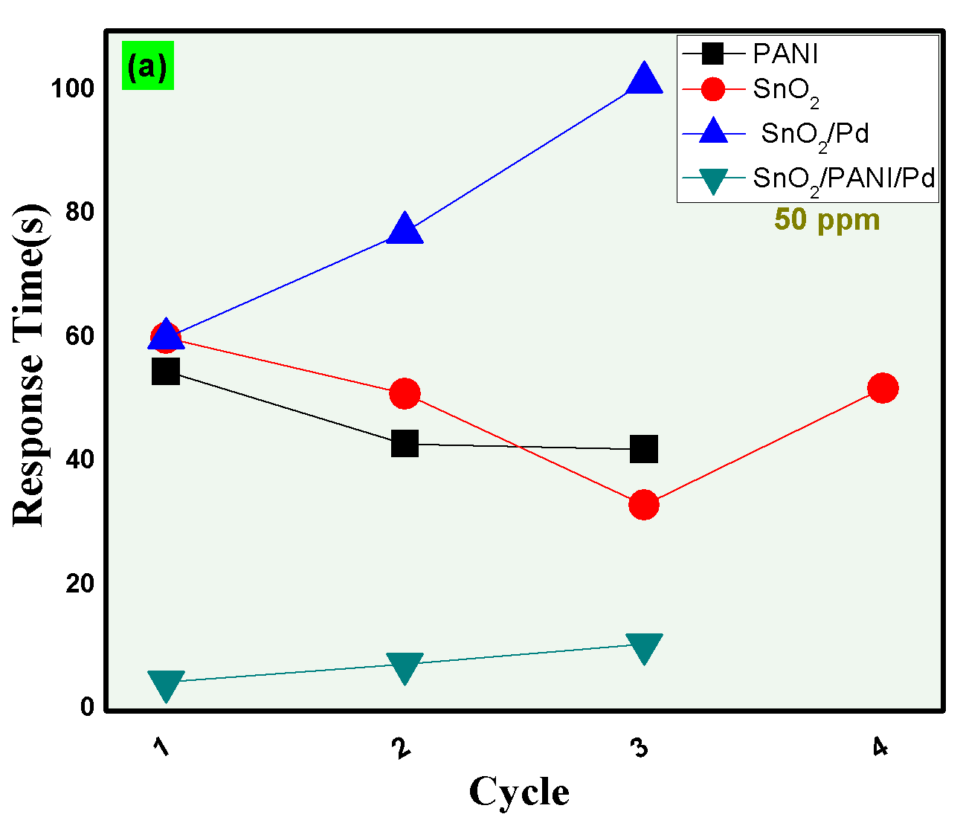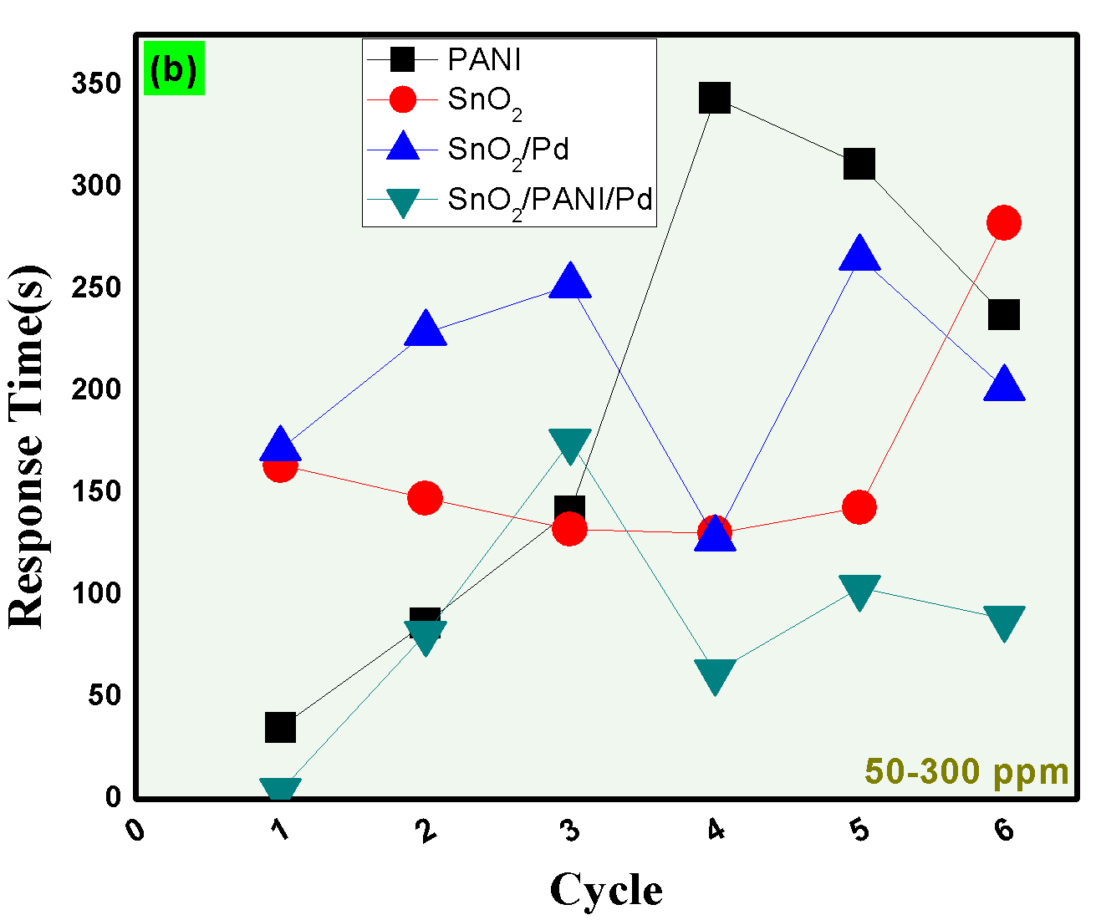
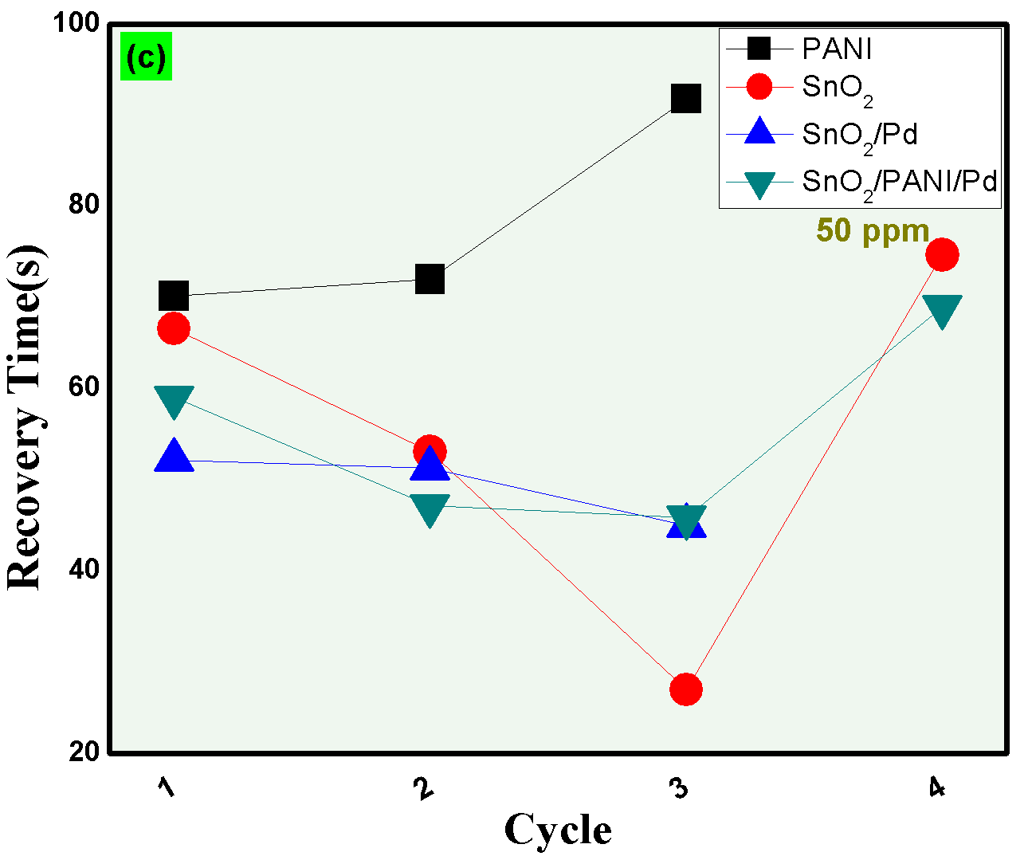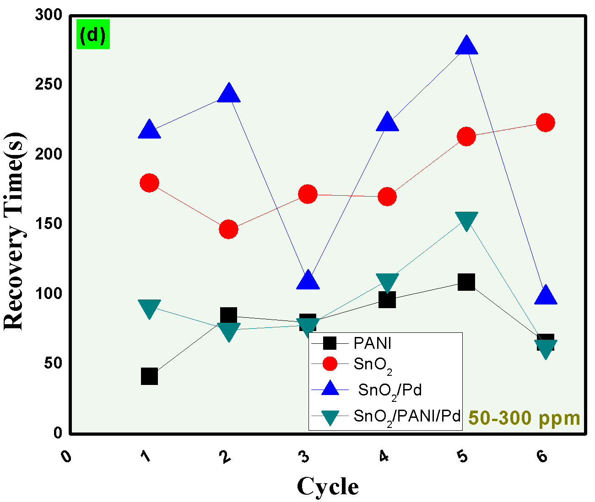
Fig. 17 (a,c) Response/Recovery time vs cycle graph at 50 ppm, and (b,d) Response/Recovery time vs cycle graph at different ppm (50 to 300) with CO gas.
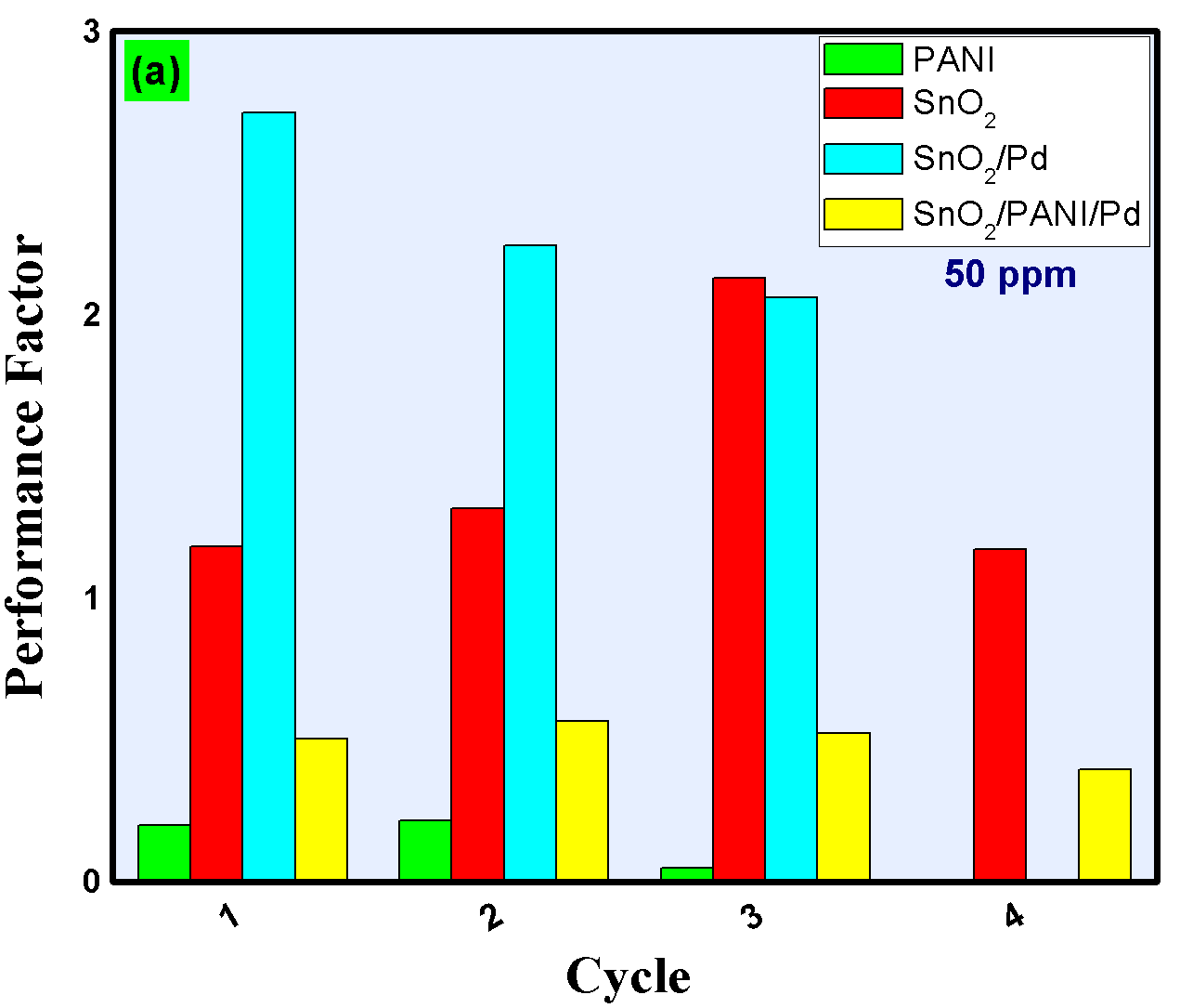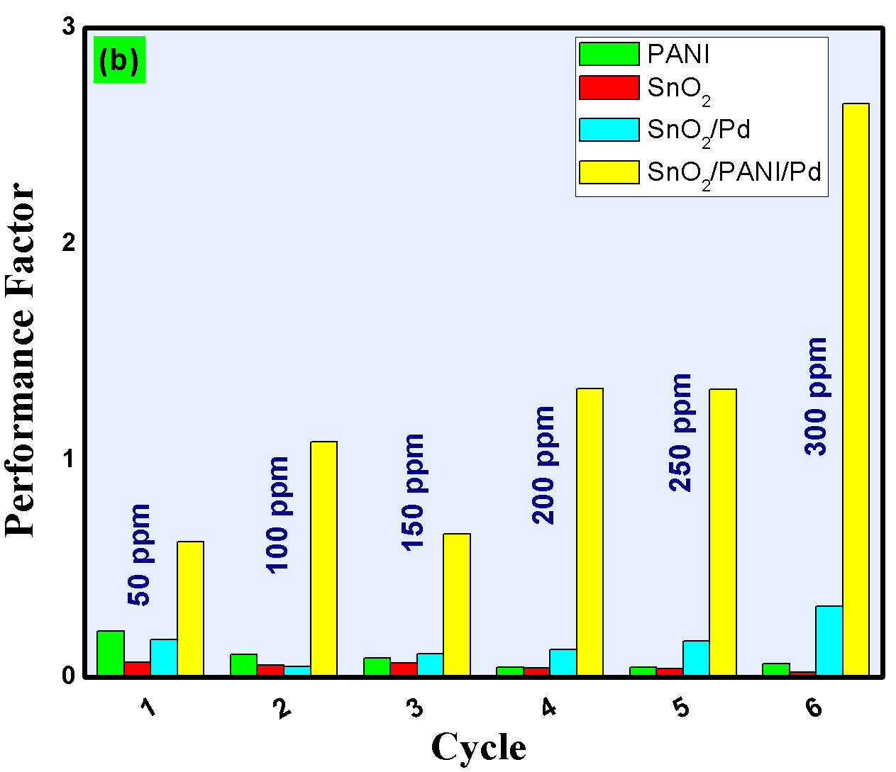
Fig. 18 Performance factors (a) at 50 ppm, and (b) at various level of ppm with CO gas.

Sensing Mechanism
When carbon monoxide gas is fed in the gas sensing chamber having SnO₂/Pd and SnO₂ prepared films, the resistance of the films increases noticeably with high stability. The detecting concept is associated with the reduction of molecules of carbon monoxide with oxygen on the prepared film's surface. The surface of SnO₂ absorbs oxygen (O₂) molecules from the ambient atmosphere. According to the operating temperature, such adsorption resulted in the removal of electrons from the conduction-band (CB) of tin oxide, resulting in the generation of various chemisorbed oxygen anions (such as O₂⁻, O⁻, O²⁻).
$O_{2\left(gas\right)} ↔ O_{2\left(adsorbed\right)} → O_{2\left(adsorbed\right)} +e_{{SnO}_{2}}^{-} → O_{2\left(adsorbed\right)}^{-}$ (4)
$O_{2(gas)} ↔ O_{2(adsorbed)}→ O_{2(adsorbed)} +2e_{{SnO}_{2}}^{-}→ O_{(adsorbed)}^{-}$ (5)
$O_{2(gas)} ↔ O_{2(adsorbed)}→ O_{2(adsorbed)} +{3e}_{{SnO}_{2}}^{-}→ O_{(adsorbed)}^{2-}$ (6)
Because of the very small band gap of SnO₂ film, the thermally accelerated electrons are transferred from the VB (valence-band) to vacant CB (conduction-band), overcoming the required activation energy barrier which in turn enhances the concentration of electrons in the conduction band.
$2CO + O_{2(adsorbed)}^{-} →2CO_{2} + e^{-}$ (7)
$CO + O_{2(adsorbed)}^{-} →CO_{2} + e^{-}$ (8)
The electron depletion layer functions as a potential barrier between adjacent grains in the presence of air, increasing sensor resistance. When a carbon monoxide is passed to the sensing chamber, the oxygen adsorbed on the oxide surface reacts with carbon monoxide gas. The trapped electrons are transported back to the CB (conduction-band) of SnO2, leading to a reduction in depletion layer thickness and a considerable reduction in gas sensing resistance. Decorating the SnO₂ surface with Pd metal was one technique to boost sensor sensitivity [44]. The alteration in the depth of the electron depletion layer became more sensitive as a result, amplifying the change in resistance of SnO₂ sensors.
Two sensitization mechanisms can be triggered by the Pd-doped SnO₂ surface. The chemical sensitization produced by surface atom movement is one mechanism, whereas the electronic sensitization generated by interfacial electronic redistribution is another [45]. Electrons are produced by SnO₂ particles in the electron sensitivity process and then migrate to Pd nanoparticles due to a variation in work function. As a result, the Pd nanoparticles get an abundance of electrons, causing the electron depletion layer to grow. Because the potential barrier height between adjacent grains rises, a SnO₂ sensor doped with Pd becomes more sensitive to changes in the external atmosphere. The spillover effect, which describes the catalytic process of metal-supported catalysts, causes chemical sensitization of Pd metals through atom transport in the interfacial region. For the adsorption of molecules of carbon monoxide and oxygen gases, loaded Pd metal particles will have more active sites than SnO₂ particles in this procedure. Because of the strong catalytic or conductive nature of Pd metal, resulting in considerably greater adsorption and simpler dissociation of these molecules. In the presence of air, chemically adsorbed ionic oxygen species on metal particles will migrate toward the SnO₂ particles, resulting in an expanded depletion area at the outer surface region of tin-oxide. The carbon monoxide gas is easily adsorbed to these Pd metals and is quickly oxidised by ionic oxygen species densely present near the metal nanoparticles. The number and speed of electron transfers, which are directly related to the gas sensor's sensitivity and response speed, may be considerably improved by the spill-over effect of Pd metals. Figure 19, shows the schematic representation of gas sensing using SnO₂/Pd film.
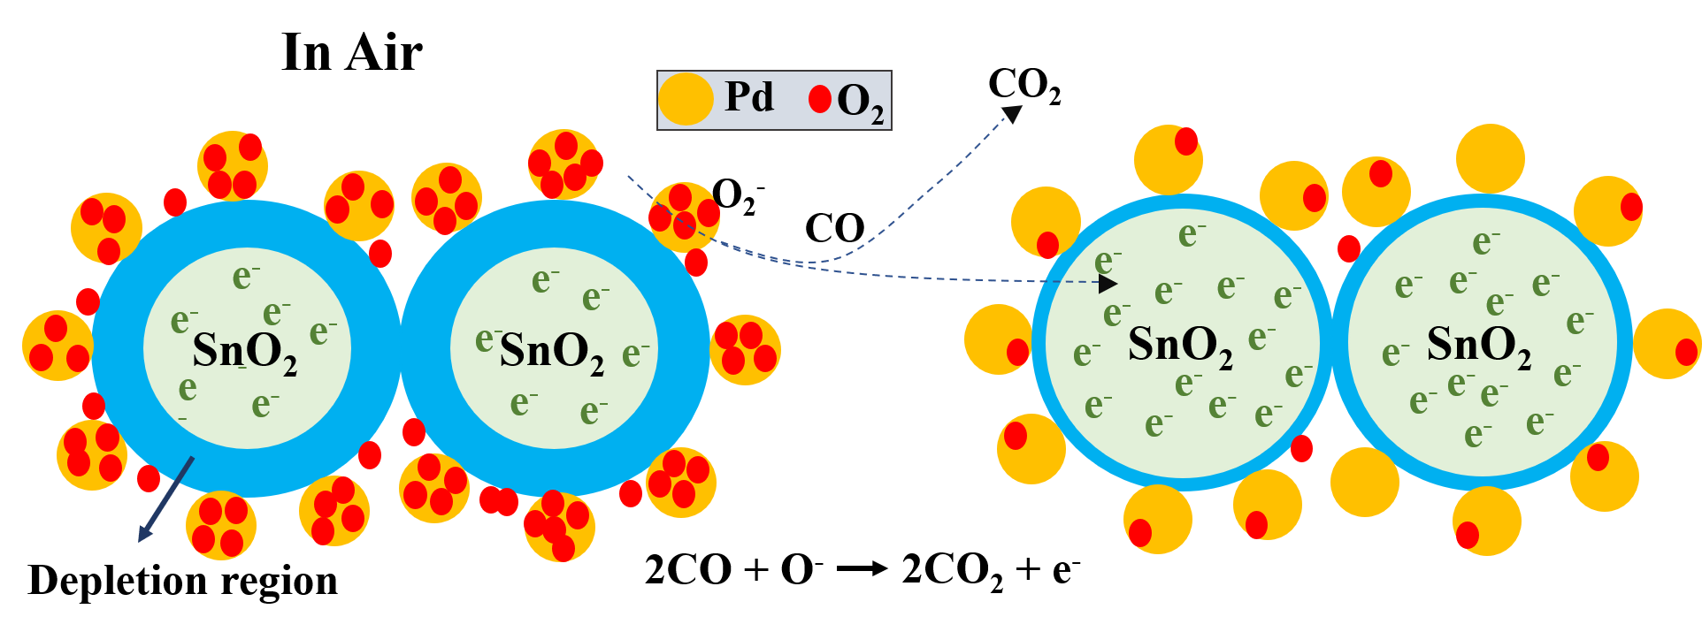
Fig. 19 Representation of sensing mechanisms of SnO₂/Pd film.
The reduction of CO molecules with the imine (=N−) and amine (−NH−) groups is the gas sensing mechanism of SnO₂/PANI and PANI. After PANI was deposited, the resistances of the SnO2/PANI composite coating to both air and carbon monoxide gas decreased considerably. The variance of composite coating resistance in carbon monoxide and air increased as the temperature dropped. This increase can be attributed to the formation of broader depletion layers at the intersection of SnO₂ and PANI materials by forming a p-n heterojunction. The resistance of the SnO₂/PANI film reduces as the operating temperature rises, displaying n-type semiconductor sensing behaviour. This indicates that SnO₂ dominates the SnO₂/PANI sensing mechanism. Similarly, when air passes over the SnO₂/PANI/Pd film, the NH⁺ group (present in PANI) loses its H atom and returns to its original imine (=N−) state. Furthermore, we notice the better stability of SnO₂/PANI/Pd film as PANI comes in the category of p–type semiconductor. This is because the composite film SnO₂/PANI/Pd contains imine (=N−) as well as oxygen groups when reacting with gas at low ppm, resulting in a fast response. Figure 20 shows the band diagram of SnO₂ and SnO₂/Pd.
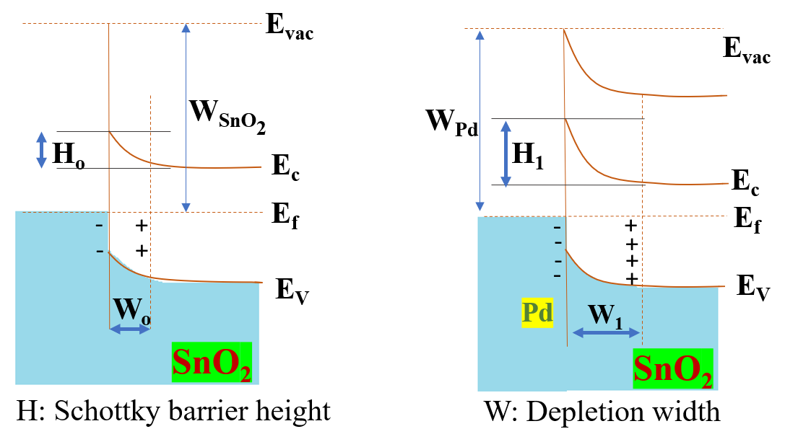
Fig. 20 Representation of energy band diagram of SnO₂ (left) and SnO₂/Pd (right).
Table 2. Comparision of previous reported research paper based on differ nanocomposites comprise of SnO₂ and PANI for CO gas sensing.
Sensing Materials | Concentration range (ppm) | Response | Response time | Recovery time | References
Ti/SnO₂ | 300-700 | 32% | 24 s | 29 s | [46]
Polyaniline-polyimide | 1000 | 163% | - | - | [47]
PANI-Co₃O₄ | 50 | 8.6% | 140 s | 90 s | [48]
CNT-PANI | 167-500 | 8% | 150 s | 350 s | [49]
PANI-MWCNT | 500 | 6.8% | 76 s | 210 s | [26]
2.5 % Au-PANI | 6000 | 27% | 180 s | 200 s | [30]
PANI/zeolite | 1000 | 7% | - | - | [50]
PANI/SnO₂ | 25-200 | 65% | - | - | [51]
SnO₂/MoSe₂ | 100 | 9.2% | 20 s | 16 s | [52]
SnO₂ doped MoO₃ | 300 | 2.4% | 1430 s | 1524 s | [53]
PANI/Co₃O₄/GO | 0-60 | 0.3473 | 68 s | 106 s | [54]
7%PdO/SnO₂/CuO | 100 | 6% | 70 s | 10 s | [55]
PdO/SnO₂ | 2000 | 4.16% | - | - | [56]
In/Pd-doped SnO₂ | 1 | 3 | 15 s | 20 s | [57]
SnO₂ /CuO | 500 | 13 | 17 s | 78 s | [58]
PdO-doped SnO₂ | 20-500 | 1.4-24.3% | - | - | [59]
Pd-SnO₂ nanoceramics | 100 | 15 | 20 s | 60 s | [60]
Pd-SnO₂-graphene oxide | 1600 | 1.1 | 120 s | 120 s | [61]
Pd-SnO₂ | 50 | 5 | 30 s | 40 s | [62]
SnO₂/PANI/Pd | 50-300 | ~30-400.8% | 11-88 | 45-62 | Current work

Conclusions
The present study describes a novel functionalized film for gas sensing applications that features a distinctive grouping of metal, semiconductor, and polymer. At ambient temperature, the SnO₂/PANI/Pd film has the maximum sensitivity ~400.8% of all the fabricated films at 0.3% of the target gas, while both SnO₂/Pd and SnO₂/PANI/Pd nanocomposite film made up of has good performance factor. The performance of these prepared nanocomposites films are also investigated at a higher ppm level. Comparison from the previously reported works demonstrated in the table-2 confirms the better gas sensing potential of the fabricated functional films. In this work, we have also presented the Density-functional theory based analysis to explain the interaction mechanisms of carbon monoxide gas with the surfaces of SnO₂, Pd-doped SnO₂, PANI, PANI-doped SnO₂, and PANI/SnO₂/Pd nano-structures.
Acknowledgements
Corresponding author would like to acknowledge the affiliating institute (IIT Jodhpur) to provide the research seed grant (I/SEED/AKG/20190022) which was helpful in accomplishing the reported work. Authors would also like to acknowledge Prof. Shantanu Bhattacharya, Mechanical Engineering Department, Indian Institute of Technology, Kanpur, India for providing assistance in gas sensing characterisation.
Conflicts of Interest

The authors declare no conflict of interest. The funders had no role in the design of the study; in the collection, analyses, or interpretation of data; in the writing of the manuscript, or in the decision to publish the results.

References
[1] A. Gupta and S. Bhattacharya, “On the growth mechanism of ZnO nano structure via aqueous chemical synthesis,” Appl. Nanosci., vol. 0, no. 0, p. 0, 2018, doi: 10.1007/s13204-018-0782-0.
[2] X. He, X. Zhao, and B. Liu, “The synthesis and kinetic growth of anisotropic silver particles loaded on TiO 2 surface by photoelectrochemical reduction method,” Appl. Surf. Sci., vol. 254, no. 6, pp. 1705–1709, Jan. 2008, doi: 10.1016/j.apsusc.2007.07.114.
[3] R. Bene, I. V. Perczel, F. Réti, F. A. Meyer, M. Fleisher, and H. Meixner, “Chemical reactions in the detection of acetone and NO by a CeO2 thin film,” Sensors Actuators, B Chem., vol. 71, no. 1–2, pp. 36–41, Nov. 2000, doi: 10.1016/S0925-4005(00)00592-X.
[4] V. Srivastava and K. Jain, “Highly sensitive NH3 sensor using Pt catalyzed silica coating over WO3 thick films,” Sensors Actuators, B Chem., vol. 133, no. 1, pp. 46–52, Jul. 2008, doi: 10.1016/j.snb.2008.01.066.
[5] B. Renganathan, G. Gobi, D. Sastikumar, R. Srinivasan, and A. C. Bose, “Optical fiber coated with nanocrystalline tin oxide for ammonia vapour sensing,” Sens. Lett., vol. 8, no. 2, pp. 292–296, 2010, doi: 10.1166/sl.2010.1266.
[6] A. V. Marikutsa, M. N. Rumyantseva, L. V. Yashina, and A. M. Gaskov, “Role of surface hydroxyl groups in promoting room temperature CO sensing by Pd-modified nanocrystalline SnO2,” J. Solid State Chem., vol. 183, no. 10, pp. 2389–2399, Oct. 2010, doi: 10.1016/j.jssc.2010.07.017.
[7] H. Tai, Y. Jiang, G. Xie, J. Yu, and X. Chen, “Fabrication and gas sensitivity of polyaniline-titanium dioxide nanocomposite thin film,” Sensors Actuators, B Chem., vol. 125, no. 2, pp. 644–650, Aug. 2007, doi: 10.1016/j.snb.2007.03.013.
[8] K. Mondal, B. Balasubramaniam, A. Gupta, A. A. Lahcen, and M. Kwiatkowski, “Carbon Nanostructures for Energy and Sensing Applications,” J. Nanotechnol., vol. 2019, pp. 10–13, 2019, doi: https://doi.org/10.1155/2019/1454327 Editorial.
[9] A. Gupta, S. Gangopadhyay, K. Gangopadhyay, and S. Bhattacharya, “Palladium-functionalized Nanostructured Platforms for Enhanced Hydrogen Sensing,” Nanomater. Nanotechnol., vol. 6, 2016, doi: 10.5772/63987.
[10] G. Cao, Nanostructures and nanomaterials: synthesis, properties and applications. 2004.
[11] D. W. Hatchett and M. Josowicz, “Composites of intrinsically conducting polymers as sensing nanomaterials,” Chemical Reviews, vol. 108, no. 2. American Chemical Society , pp. 746–769, Feb. 2008, doi: 10.1021/cr068112h.
[12] J. Li, H. Xie, and Y. Li, “Fabrication of gold nanoparticles/polypyrrole composite-modified electrode for sensitive hydroxylamine sensor design,” J. Solid State Electrochem., vol. 16, no. 2, pp. 795–802, Feb. 2012, doi: 10.1007/s10008-011-1431-7.
[13] A. Gupta, S. S. Pandey, M. Nayak, A. Maity, S. B. Majumder, and S. Bhattacharya, “Hydrogen sensing based on nanoporous silica-embedded ultra dense ZnO nanobundles,” RSC Adv., vol. 4, no. 15, pp. 7476–7482, 2014, doi: 10.1039/c3ra45316b.
[14] H. Wang, J. Lin, and Z. X. Shen, “Polyaniline (PANi) based electrode materials for energy storage and conversion,” Journal of Science: Advanced Materials and Devices, vol. 1, no. 3. Elsevier B.V., pp. 225–255, Sep. 2016, doi: 10.1016/j.jsamd.2016.08.001.
[15] S. Weng, J. Zhou, and Z. Lin, “Preparation of one-dimensional (1D) polyaniline-polypyrrole coaxial nanofibers and their application in gas sensor,” Synth. Met., vol. 160, no. 11–12, pp. 1136–1142, Jun. 2010, doi: 10.1016/j.synthmet.2010.02.037.
[16] A. Gupta, P. K. Parida, and P. Pal, “Functional Films for Gas Sensing Applications : A Review,” in Sensors for Automotive and Aerospace Applications, Springer Singapore, 2019, pp. 7–37.
[17] P. Pal, A. Yadav, P. S. Chauhan, P. K. Parida, and A. Gupta, “Reduced graphene oxide based hybrid functionalized films for hydrogen detection: Theoretical and experimental studies,” Sensors Int., vol. 2, p. 100072, 2021, doi: 10.1016/j.sintl.2020.100072.
[18] M. A. Chougule et al., “Polypyrrole thin film: Room temperature ammonia gas sensor,” IEEE Sens. J., vol. 11, no. 9, pp. 2137–2141, 2011, doi: 10.1109/JSEN.2011.2112765.
[19] A. Gupta, S. S. Pandey, and S. Bhattacharya, “High aspect ZnO nanostructures based hydrogen sensing,” AIP Conf. Proc., vol. 1536, no. 2013, pp. 291–292, 2013, doi: 10.1063/1.4810215.
[20] R. K. Pippara, P. S. Chauhan, A. Yadav, V. Kishnani, and A. Gupta, “Room temperature hydrogen sensing with Polyaniline/SnO2/Pd Nanocomposites,” Micro Nano Eng., p. 126915, 2021, doi: 10.1016/j.mne.2021.100086.
[21] D. R. Miller, S. A. Akbar, and P. A. Morris, “Nanoscale metal oxide-based heterojunctions for gas sensing: A review,” Sensors and Actuators, B: Chemical, vol. 204. Elsevier, pp. 250–272, Dec. 2014, doi: 10.1016/j.snb.2014.07.074.
[22] V. Kumar, A. Mirzaei, M. Bonyani, K. H. Kim, H. W. Kim, and S. S. Kim, “Advances in electrospun nanofiber fabrication for polyaniline (PANI)-based chemoresistive sensors for gaseous ammonia,” TrAC - Trends in Analytical Chemistry, vol. 129. Elsevier B.V., p. 115938, Aug. 2020, doi: 10.1016/j.trac.2020.115938.
[23] “CO adsorption on Pd clusters deposited on pyrolytically prepared SnO 2 studied by XPS.” .
[24] Y. Chen, H. Qin, and J. Hu, “CO sensing properties and mechanism of Pd doped SnO 2 thick-films,” Appl. Surf. Sci., vol. 428, pp. 207–217, Jan. 2018, doi: 10.1016/j.apsusc.2017.08.205.
[25] Z. Guo, N. Liao, M. Zhang, and W. Xue, “Theoretical approach to evaluate graphene/PANI composite as highly selective ammonia sensor,” Appl. Surf. Sci., vol. 453, pp. 336–340, Sep. 2018, doi: 10.1016/j.apsusc.2018.05.108.
[26] A. Roy et al., “Polyaniline-multiwalled carbon nanotube (PANI-MWCNT): Room temperature resistive carbon monoxide (CO) sensor,” Synth. Met., vol. 245, pp. 182–189, Nov. 2018, doi: 10.1016/j.synthmet.2018.08.024.
[27] C. Liu, H. Tai, P. Zhang, Z. Ye, Y. Su, and Y. Jiang, “Enhanced ammonia-sensing properties of PANI-TiO2-Au ternary self-assembly nanocomposite thin film at room temperature,” Sensors Actuators, B Chem., vol. 246, pp. 85–95, Jul. 2017, doi: 10.1016/j.snb.2017.01.046.
[28] Y. Li, Y. Guo, R. Tan, P. Cui, Y. Li, and W. Song, “Synthesis of SnO2 nano-sheets by a template-free hydrothermal method,” Mater. Lett., vol. 63, no. 24–25, pp. 2085–2088, 2009, doi: 10.1016/j.matlet.2009.06.060.
[29] Z. A. Hu, Y. L. Xie, Y. X. Wang, L. P. Mo, Y. Y. Yang, and Z. Y. Zhang, “Polyaniline/SnO2 nanocomposite for supercapacitor applications,” Mater. Chem. Phys., vol. 114, no. 2–3, pp. 990–995, 2009, doi: 10.1016/j.matchemphys.2008.11.005.
[30] S. Nasresfahani, Z. Zargarpour, M. H. Sheikhi, and S. F. Nami Ana, “Improvement of the carbon monoxide gas sensing properties of polyaniline in the presence of gold nanoparticles at room temperature,” Synth. Met., vol. 265, p. 116404, Jul. 2020, doi: 10.1016/j.synthmet.2020.116404.
[31] S. Nasresfahani, M. H. Sheikhi, M. Tohidi, and A. Zarifkar, “Methane gas sensing properties of Pd-doped SnO2/reduced graphene oxide synthesized by a facile hydrothermal route,” Mater. Res. Bull., vol. 89, pp. 161–169, 2017, doi: 10.1016/j.materresbull.2017.01.032.
[32] Z. Wang, X. Peng, C. Huang, X. Chen, W. Dai, and X. Fu, “CO gas sensitivity and its oxidation over TiO2 modified by PANI under UV irradiation at room temperature,” Appl. Catal. B Environ., vol. 219, pp. 379–390, Dec. 2017, doi: 10.1016/j.apcatb.2017.07.080.
[33] J. Kroutil et al., “Performance Evaluation of Low-Cost Flexible Gas Sensor Array with Nanocomposite Polyaniline Films,” IEEE Sens. J., vol. 18, no. 9, pp. 3759–3766, 2018, doi: 10.1109/JSEN.2018.2811461.
[34] A. Lazauskas, L. Marcinauskas, and M. Andrulevicius, “Modification of Graphene Oxide/V2O5· nH2O Nanocomposite Films via Direct Laser Irradiation,” ACS Appl. Mater. Interfaces, vol. 12, no. 16, pp. 18877–18884, 2020, doi: 10.1021/acsami.0c02066.
[35] P. Bechthold, M. E. Pronsato, and C. Pistonesi, “DFT study of CO adsorption on Pd-SnO 2 (110) surfaces,” Appl. Surf. Sci., vol. 347, pp. 291–298, Aug. 2015, doi: 10.1016/j.apsusc.2015.03.149.
[36] D. S. Sutar, N. Padma, D. K. Aswal, S. K. Deshpande, S. K. Gupta, and J. V. Yakhmi, “Preparation of nanofibrous polyaniline films and their application as ammonia gas sensor,” Sensors Actuators, B Chem., vol. 128, no. 1, pp. 286–292, 2007, doi: 10.1016/j.snb.2007.06.015.
[37] G. D. Khuspe et al., “Facile method of synthesis of polyaniline-SnO2 hybrid nanocomposites: Microstructural, optical and electrical transport properties,” Synth. Met., vol. 178, pp. 1–9, 2013, doi: 10.1016/j.synthmet.2013.06.022.
[38] J. Wang, H. qing Fan, H. wa Yu, and X. Wang, “Synthesis and Optical Properties of SnO2 Structures with Different Morphologies via Hydrothermal Method,” J. Mater. Eng. Perform., vol. 24, no. 9, pp. 3426–3432, Sep. 2015, doi: 10.1007/s11665-015-1637-4.
[39] P. Manjula, L. Satyanarayana, Y. Swarnalatha, and S. V. Manorama, “Raman and MASNMR studies to support the mechanism of low temperature hydrogen sensing by Pd doped mesoporous SnO2,” Sensors Actuators, B Chem., vol. 138, no. 1, pp. 28–34, 2009, doi: 10.1016/j.snb.2009.02.051.
[40] H. C. Choi, Y. M. Jung, and S. Bin Kim, “Size effects in the Raman spectra of TiO2 nanoparticles,” Vib. Spectrosc., vol. 37, no. 1, pp. 33–38, 2005, doi: 10.1016/j.vibspec.2004.05.006.
[41] D. Yoo, J. J. Lee, C. Park, H. H. Choi, and J. H. Kim, “N-type organic thermoelectric materials based on polyaniline doped with the aprotic ionic liquid 1-ethyl-3-methylimidazolium ethyl sulfate,” RSC Adv., vol. 6, no. 43, pp. 37130–37135, 2016, doi: 10.1039/c6ra02334g.
[42] W. Chen, Q. Zhou, T. Gao, X. Su, and F. Wan, “Pd-doped SnO2-based sensor detecting characteristic fault hydrocarbon gases in transformer oil,” J. Nanomater., vol. 2013, 2013, doi: 10.1155/2013/127345.
[43] H. Tai, Y. Jiang, G. Xie, and J. Yu, “Preparation, Characterization and Comparative NH3-sensing Characteristic Studies of PANI/inorganic Oxides Nanocomposite Thin Films,” J. Mater. Sci. Technol., vol. 26, no. 7, pp. 605–613, 2010, doi: 10.1016/S1005-0302(10)60093-X.
[44] D. D. Trung et al., “Effective decoration of Pd nanoparticles on the surface of SnO2 nanowires for enhancement of CO gas-sensing performance,” J. Hazard. Mater., vol. 265, pp. 124–132, 2014, doi: 10.1016/j.jhazmat.2013.11.054.
[45] S. Park and W. Kang, “ Ethanol Gas Sensing Properties of In 2 O 3 Nanowires Coated with Co 3 O 4 Nanoparticles ,” J. Korean Inst. Surf. Eng., vol. 49, no. 1, pp. 75–80, 2016, doi: 10.5695/jkise.2016.49.1.75.
[46] W. Zeng, Y. Li, B. Miao, L. Lin, and Z. Wang, “Recognition of carbon monoxide with SnO2/Ti thick-film sensor and its gas-sensing mechanism,” Sensors Actuators, B Chem., vol. 191, pp. 1–8, 2014, doi: 10.1016/j.snb.2013.09.092.
[47] S. Watcharaphalakorn, L. Ruangchuay, D. Chotpattananont, A. Sirivat, and J. Schwank, “Polyaniline/polyimide blends as gas sensors and electrical conductivity response to CO-N2 mixtures,” Polym. Int., vol. 54, no. 8, pp. 1126–1133, 2005, doi: 10.1002/pi.1815.
[48] T. Sen, N. G. Shimpi, and S. Mishra, “Room temperature CO sensing by polyaniline/Co3O4 nanocomposite,” J. Appl. Polym. Sci., vol. 133, no. 42, pp. 4–11, 2016, doi: 10.1002/app.44115.
[49] Y. Wanna, N. Srisukhumbowornchai, A. Tuantranont, A. Wisitsoraat, N. Thavarungkul, and P. Singjai, “The effect of carbon nanotube dispersion on CO gas sensing characteristics of polyaniline gas sensor,” J. Nanosci. Nanotechnol., vol. 6, no. 12, pp. 3893–3896, 2006, doi: 10.1166/jnn.2006.675.
[50] N. Densakulprasert, L. Wannatong, D. Chotpattananont, P. Hiamtup, A. Sirivat, and J. Schwank, “Electrical conductivity of polyaniline/zeolite composites and synergetic interaction with CO,” Mater. Sci. Eng. B Solid-State Mater. Adv. Technol., vol. 117, no. 3, pp. 276–282, 2005, doi: 10.1016/j.mseb.2004.12.006.
[51] K. S. Jian et al., “High response CO sensor based on a polyaniline/SnO2 nanocomposite,” Polymers (Basel)., vol. 11, no. 1, 2019, doi: 10.3390/POLYM11010184.
[52] Z. Yang, D. Zhang, and D. Wang, “Carbon monoxide gas sensing properties of metal-organic frameworks-derived tin dioxide nanoparticles/molybdenum diselenide nanoflowers,” Sensors Actuators, B Chem., vol. 304, p. 127369, 2020, doi: 10.1016/j.snb.2019.127369.
[53] R. Nadimicherla, H. Y. Li, K. Tian, and X. Guo, “SnO2 doped MoO3 nanofibers and their carbon monoxide gas sensing performances,” Solid State Ionics, vol. 300, pp. 128–134, 2017, doi: 10.1016/j.ssi.2016.12.022.
[54] J. Peng, J. Liao, X. Yang, and W. Feng, “Fiber-optic dual Fabry-Pérot interferometric carbon monoxide sensor with polyaniline/Co3O4/graphene oxide sensing membrane,” Chinese Chem. Lett., vol. 31, no. 8, pp. 2145–2149, 2020, doi: 10.1016/j.cclet.2019.11.050.
[55] S. Javanmardi, S. Nasresfahani, and M. H. Sheikhi, “Facile synthesis of PdO/SnO2/CuO nanocomposite with enhanced carbon monoxide gas sensing performance at low operating temperature,” Mater. Res. Bull., vol. 118, no. March, p. 110496, 2019, doi: 10.1016/j.materresbull.2019.110496.
[56] K. C. Lee, Y. J. Chiang, Y. C. Lin, and F. M. Pan, “Effects of PdO decoration on the sensing behavior of SnO2 toward carbon monoxide,” Sensors Actuators, B Chem., vol. 226, pp. 457–464, 2016, doi: 10.1016/j.snb.2015.12.011.
[57] T. Zhang, L. Liu, Q. Qi, S. Li, and G. Lu, “Development of microstructure In/Pd-doped SnO2 sensor for low-level CO detection,” Sensors Actuators, B Chem., vol. 139, no. 2, pp. 287–291, 2009, doi: 10.1016/j.snb.2009.03.036.
[58] A. Kumar, A. Sanger, A. Kumar, and R. Chandra, “Highly sensitive and selective CO gas sensor based on a hydrophobic SnO2/CuO bilayer,” RSC Adv., vol. 6, no. 52, pp. 47178–47184, 2016, doi: 10.1039/c6ra06538d.
[59] C. Wang, P. Zhao, and S. Liu, “PdO/SnO2 hollow nanospheres for carbon monoxide detection,” Phys. Status Solidi Appl. Mater. Sci., vol. 212, no. 8, pp. 1789–1794, 2015, doi: 10.1002/pssa.201431892.
[60] M. Wang et al., “ Preparation and Extraordinary Room-Temperature CO Sensing Capabilities of Pd–SnO 2 Composite Nanoceramics ,” J. Nanosci. Nanotechnol., vol. 18, no. 6, pp. 4176–4181, Dec. 2017, doi: 10.1166/jnn.2018.15033.
[61] M. Shojaee, S. Nasresfahani, and M. H. Sheikhi, “Hydrothermally synthesized Pd-loaded SnO2/partially reduced graphene oxide nanocomposite for effective detection of carbon monoxide at room temperature,” Sensors Actuators, B Chem., vol. 254, pp. 457–467, Jan. 2018, doi: 10.1016/j.snb.2017.07.083.
[62] S. Zhu et al., “Mechanism study on extraordinary room-temperature CO sensing capabilities of Pd-SnO2 composite nanoceramics,” Sensors Actuators, B Chem., vol. 285, pp. 49–55, Apr. 2019, doi: 10.1016/j.snb.2019.01.027.

