On the Enhanced Thermal and Mechanical Properties of Graphite-embedded Polydimethylsiloxane Composite
Nikhil Sheshkar¹, Gulshan Verma¹, Chandan Pandey¹, Atul Kumar Sharma¹, Ankur Gupta^{1,*}
¹Department of Mechanical Engineering, Indian Institute of Technology Jodhpur-342037, Rajasthan, India
*Corresponding Author: ankurgupta@iitj.ac.in

Abstract
This work reports the facile fabrication of graphite embedded polydimethylsiloxane (PDMS) composites with the help of in-situ polymerization and investigates the impact of graphite fillers on their mechanical and thermal characteristics. The extensive characterization is performed with the help of FESEM, TGA, and DSC. Mechanical properties are investigated with the help of compressive test. It investigates the possibility of manipulating the PDMS properties by unswervingly modifying the concentration of conductive graphite nanofiller, which improves filler dispersion in the PDMS and increases the interaction of graphite nanofillers with PDMS, thereby enhancing the mechanical and thermal characteristics of the manufactured composites. The current study investigates the impact of graphite concentrations ranging from 2.5%–20% on the mechanical properties of pure PDMS polymer during compression testing. Further, the thermal conductivity, thermal diffusivity, and specific heat of graphite-embedded PDMS were around 82%, 505% and 1040% respectively higher than that of the pure PDMS, while the mechanical properties for the compressive module as 3.2 MPa to 4.9 MPa with the elastic behavior up to 40% strain.
Keywords: Polydimethylsiloxane, in-situ polymerization, elastomers

Introduction
The rapid progress in the field of miniaturization and integration of portable devices, such as micro/nano-generators [1], micro/nano-actuators, flexible sensors [2] etc., leads to increase in the heat dissipation issues [3], [4]. Polymer materials have the ability to be used in such fields because of their outstanding versatility and ease of fabrication. Along with the excellent overall efficiency, good biocompatibility, inertness to various chemicals, temperature stability, adhesion capacity towards other materials. However, due to their low intrinsic electrical and thermal conduction efficiency, they are not suitable for use in high power-density devices [5]. Silicon-based devices were widely preferred due to their small size, high stability and sensitivity, outstanding signal/noise ratio, limited hysteresis and ability to work in dynamic conditions [6]. These devices have been used in a variety of applications including biomedical sciences [7], [8], automotive [9], [10], and environmental field [11]. Despite their widespread usage, they were restricted for a long time due to limitations associated with them. Some disadvantages included high fabrication costs due to the need for cleanroom infrastructure, high brittleness, which limited their spectrum of assessment in biomedical applications, and saturation in their responses over time. Polymer-based nanocomposites have acknowledged considerable attention in the last two decades due to their importance in the current manufacturing technology.
Soft elastomeric silicone such as Poly-dimethylsiloxane (PDMS), has shown high advantages in different of applications, including structural engineering, wearable and flexible electronics, biomedical and tissue engineering, and many more, due to excellent versatility, stable operating temperature in the range of -343 –to– 693 K, resistance to climate changes, bio-compatibility, liquidity nature, and dielectric properties [12],[13]. Additional benefits of PDMS include environmental friendliness, better tolerance in extreme conditions, and good processability. As compared to other materials, PDMS has a lower modulus of elasticity (0.4-3.5 MPa), which means it can have more versatility and stretchability. As a result of its low modulus of elasticity and high stretchability, PDMS can be an excellent substrate material used in the fabrication of flexible devices [14],[15]. Pure PDMS has poor mechanical properties and low tear resistance, therefore severely limiting its practical application. Many approaches have been used in the past to improve the thermal stability and electrical conductivity of polymers, which includes the incorporation of various active particles, the addition of nanofillers and the formation of inter-penetrating structures [16]. Adsorption of polymer molecules at the surface of active particles connects them to the polymer matrix and to one another. The various factors that affect the reinforcement are adhesion forces, specific surface area, particle concentration, and polymer molecular weight.
The conductive network in the matrix defines the conduction properties of the polymer composites. While zero-dimensional (0-D) particles such as metal, carbon particles etc. have been widely used to enhance the polymers’ conductivities, the increase in conductivity is generally modest due to their low aspect ratio. In this case, constructing a conductive network with low filler loading is challenging [17]. Increased filler loading improves polymer conductivities but degrades composite processing and mechanical characteristics. One dimensional (1-D) particles, such as carbon nanotube (CNT), are appealing due to the presence of high aspect ratio structures in contrast to 0-D conductive particles [18]. Though, the high aspect ratio causes the diffusion challenging in the polymer matrix. Furthermore, high thermal and electrical resistance limits the improvement of conductivity of the composites beyond the percolation threshold [19]. On comparing the 0-D and 1-D particles, two dimensional (2-D) particles, such as graphene are highly appealing as these particles overcome the limitation possessed by the 0-D and 1-D conductive particles [20]. These conductive fillers also increase the performance of polymer composites, which could be useful in the areas of energy production and stretchable electronics [21]. Battegazzore et al. prepared a flexible nanocomposite sheet via impregnating PDMS in the porous graphite nano-plates. The fabrication of PDMS/GNP nanosheets tends to be an efficient technique which finds its application in the modern flexible electronics due to its versatility [22]. Sliva et al. described the fabrication of PDMS/graphite composites using additive manufacturing to regenerate a 3D structure for a number of tissues in biomedical applications, such as bone and cartilage [23]. Li et al. define a method for producing porous, robust, and cyto-compatible three-dimensional scaffold based on PDMS/reduced graphene oxide (RGO). The scaffold will lead to the growth and development of human adipose stem cells (ADSCs) into an osteogenic lineage cells, indicating its ability as an Osseo-integrated structure [24]. The presence of other nanostructured materials in the PDMS-based composites such as TiO₂, ZrO₂ and Al₂O₃ can enhance heat resistance, thermal conductance, resistance to abrasion and many more [25], [26]. Therefore, it expands the application of PDMS-based composites in various fields. Because of their tiny size and resulting increase in surface area, nanofillers have been widely employed in elastomeric based composites, enabling major improvements in polymer matrix properties at modest filler loadings. The orientation, dispersions, aspect ratio, and size of nanofillers, as well as the interaction mechanisms of fillers, are all elements that influence the reinforcing capability of composites.
This paper focuses on the recent state of the art applications in the field of graphite based elastomeric composites. To the best of the authors’ knowledge, the mechanical characterization of PDMS and graphite-embedded composite has not hitherto been reported in the literature.
In the present study, we prepared PDMS/graphite composites using a simple physical blending technique known as in-situ polymerization. This paper discusses the impact of graphite material on the mechanical/thermal characteristics and physical structure of PDMS-based composites. Also, the possibility of manipulating the material properties of PDMS/graphite composites by directly modifying the concentration of conductive graphite nanofiller, improves filler dispersion in the PDMS and increases the interaction of Graphene nanofillers with PDMS. Thus, enhancing the characteristics of the manufactured composites. The mechanical strength of such composites is a function of the structural characteristics of the nanofillers. Therefore, we analyzed mechanical properties in terms of finding out modulus of elasticity and elongation at break, compression test, specific heat capacity, and conductivity measurement. The remainder of the paper is divided into four parts. In Section 2, we go over the various materials and procedures for preparing PDMS/graphite composites with different graphite nanofiller concentrations. The experimental characterization information is presented in section 3 and is used to analyze the results, which are discussed in section 4.

Material and method
In this section, we present the information of various materials and methods used for the preparation of PDMS/Graphite composites in varying the concentration of graphite nanofillers. The mechanical properties of the PDMS and PDMS/graphite are examined by manufacturing composite mold. These molds were prepared according to the ASTM standard for tensile and compressive testing. PDMS comes as a two-part kit containing a Sylgard 184 silicone elastomer base (monomer) and curing agent (cross-linker), which was procured from (Dow Europe GMBH CIO DOW SILICONES, GERMANY) and 20 μm graphite particles with 99.5% purity, were used to fabricate all test specimens. Tensile test specimens are made in accordance with ASTM D412 specifications. Compression test specimens are made in accordance with ASTM D575-91 specifications. The Avery Denison T42U was used for the compression test. Universal testing machine. For specific heat tests, a type K thermocouple was used.

Designing and printing of 3D mold
The dumbbell-shaped tensile test specimens were manufactured as per the American Society for Testing of Materials (ASTM) D412 Type C Standards, where these dumbbell-shaped end segments are fixed to the Universal testing machine, and the narrowed central neck part of the specimen was examined. For performing the compressive testing, the test specimens were manufactured according to the ASTM D575-91 standard. The design of the mold for both tensile and compressive tests is prepared using an additive manufacturing technique. Figure 1(a) The CAD model of the tensile and compressive mold in CREO software, Figure 1(b) depicts the images of 3D printed mold made up of the acrylonitrile butadiene styrene (ABS) material.
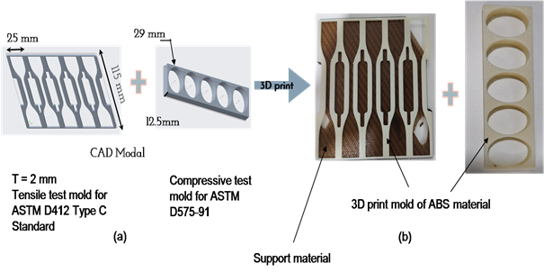
Figure 1 (a) CAD model. (b) 3D print mold.

Samples Preparation of PDMS
PDMS comes as a two-part kit containing a Sylgard 184 silicone elastomer base (monomer) and curing agent (cross-linker). The silicone elastomer and the curing agent were blended in a 10:1 weight ratio to prepare a Si matrix for the composite. Ultrasonicator was used to shear mix the cross-linker and monomer for 10 minutes, followed by degassing for 25 minutes and loading the sample in a desiccator to remove trapped air bubbles. Following that, the degasified mixture was transferred to a 3D-printed mold. It was then allowed to cure at 65˚C for 3 hours. The cured sample was then removed from the mold. The same procedure was used to prepare the PDMS/graphite composite sample by incorporating graphite nanofillers into the PDMS. Figure 2 illustrates the comprehensive steps involved in the fabrication of PDMS/graphite composite.
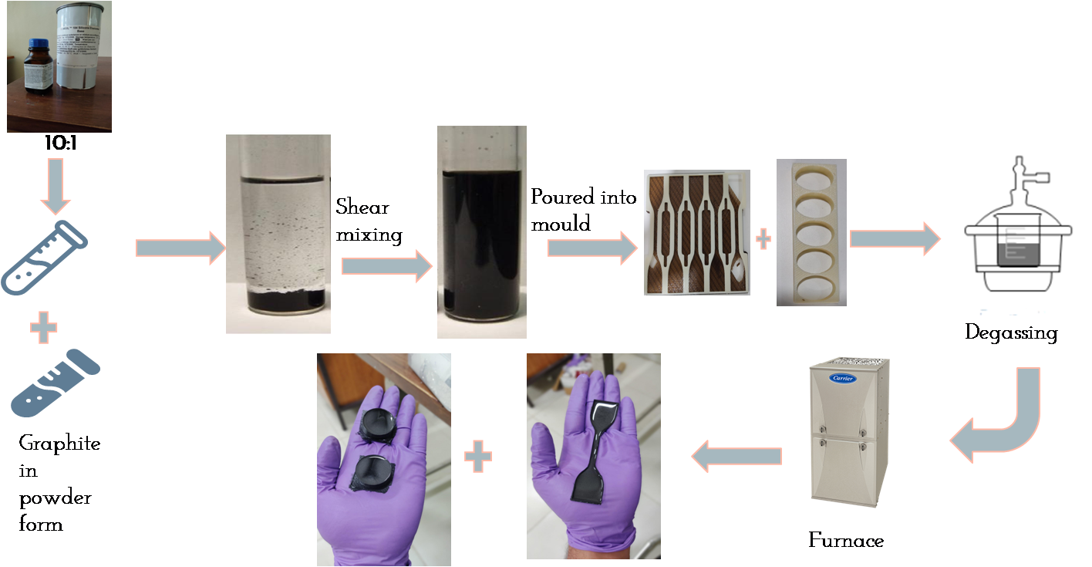
Figure 2 Represents the procedure used for the preparation of PDMS-Graphite composite (tensile and compressive test specimens)

Experimental characterization
In this section, the pure PDMS and PDMS/graphite composites samples were continuously monitored throughout the fabrication process based on their transparency to check for tears, bubbles, or other defects that might affect the mechanical properties. All the samples which are subjected to the mechanical testing are carefully checked for the presence of any deformities so as to ensure proper uniformity in the test results.

Compressive Test
The compressive strength testing of the pure PDMS and PDMS/Graphite composites were conducted in accordance with the ASTM D-1229-03 standard on a universal testing machine (Company: Ametek Llyod Load capacity-45 kN). The crosshead moved at a rate of 20mm/min. The data was collected under a maximum of 45 KN load conditions during the process. The specimen thickness was reduced from 12mm to 3mm and was tested at room temperature. Figure 3 shows the UTM set up with the specimen.
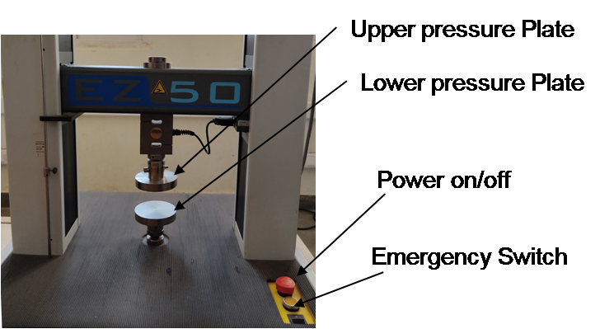
Figure 3 Ametek Llyod Universal. Testing. Machine. of. 50. KN load capacity.

Thermal properties
To investigate the thermal properties of pure PDMS and PDMS/graphite composites, five samples with a diameter of 28mm and a thickness of 12mm were made by varying the concentration of graphite in the composite. The thermal diffusivities (α), thermal conductivity(λ), and specific heat (Cp) of all samples were measured by Thermal Conductivity Analyzers (Hot Disk, Sweden). The thermal conductivities (λ) of the sample can be verified by using a formula; λ=α ×ρ ×Cp. Figure 4 depicts the thermal conductivity measurement unit. All specimens were subjected to thermo gravimetric analysis (TGA) using TA Q500 Instruments, which were heated from ambient temperature to 800 °C at a rate of 10 C/ min in a N₂ atmosphere.
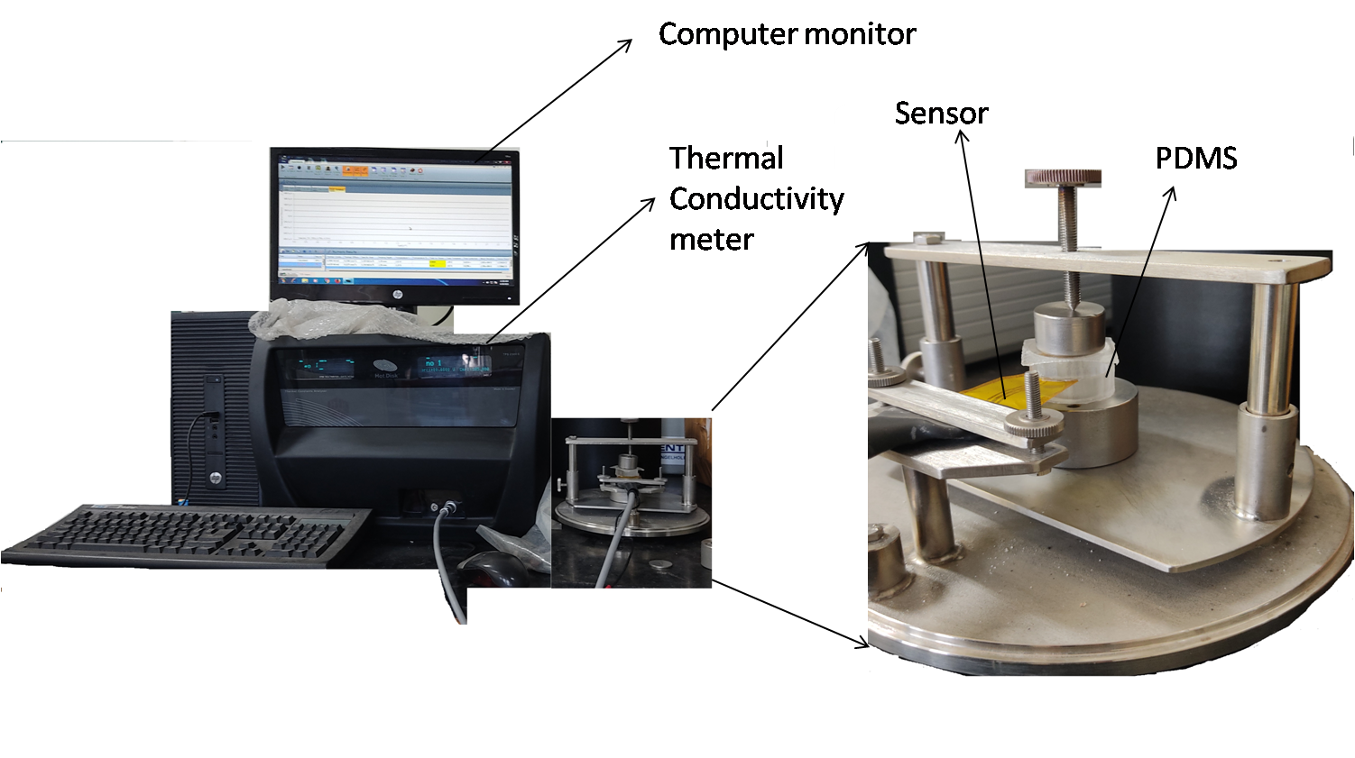
Figure 4 Thermal Conductivity Measurement

Result and discussion

Structural Characterization
A scanning electron microscope (SEM-Carl Zeiss, EDS-Oxford instruments) was used to study the surface morphology of all samples as well as the micro-distribution of the nanoparticles in the composites. The images were obtained at magnifications of 300X at an accelerating voltage of 20 kV. The analysis describes the distribution of particles and intermolecular bonding on the composite and the filler material makes an irregular surface. Figure 5 depicts the SEM views of PDMS/graphite composite that reveals the surface morphologies.
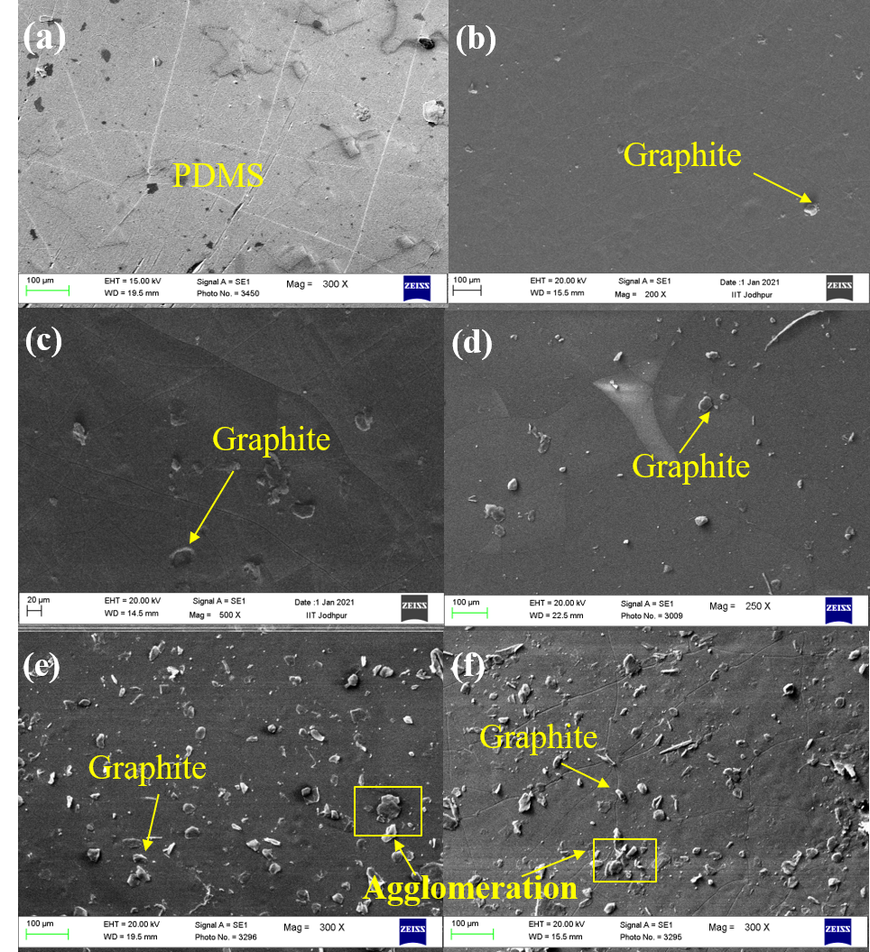

Figure 5 Scanning electron microscope images of (a) pure PDMS, (b) 2.5 wt%, (c) 5 wt%, (d) 10 wt%, (e) 15 wt%, (f) 20 wt% PDMS/graphite composite.
The structural properties of nanofillers, as well as the qualities of the composite material as a whole, are heavily influenced by its structural qualities. As the reinforcing concentration is raised, the filler material produces either huge irregular or small aggregates. Such aggregates are created during the preparation process. The fractured surfaces of pure PDMS and PDMS/graphite composites were analyzed using SEM. The SE image of the pure PDMS and PDMS after graphite addition is shown in Fig. 5. A uniform distribution of the graphite particles with less density is observed for graphite concentration up to 10% (Fig. 5b-d). However, an increase in graphite concentration beyond 10% leads to the agglomeration of the graphite particles, which also might be the cause of a reduction in mechanical properties. From Fig. 5, various SEM results are observed, such as the modes of fractures, interfacial bond in the composite sample, and the distribution of the particles. Graphite particles inside the matrix are marked clearly. The compressive strength of the composites improved as the proportion of filler in the matrix increased until 15 % reinforcement was achieved, indicating an increase in graphite content in PDMS. Furthermore, the higher compressive strength attained with 15% graphite superiority could be attributed to effective interfacial bonding between graphite and the PDMS, as illustrated in Figure 5 (e), in contrast to a larger filler content. Following that, bonding and particle dispersion become less uniform, potentially lowering the composite's strength. Figures 5(e) and 5(f) depict improper bonding of higher percentage composites. Additionally, agglomeration of the filler particles may occur as a result of additional reinforcement, resulting in a loss in mechanical characteristics.

Compression Test
The compression test is carried out on the six distinct samples, consisting of 2.5, 5, 10, 15 and 20 wt % graphite nanofillers in PDMS and pure PDMS. Up to 40% strain, all six curves are linear, but after that, they become nonlinear. Figure 6 (a, b) displays the stress–strain, and stress-strain up to elastic limit relation of PDMS and PDMS/graphite composite at 2.5–20 wt %. At 9 mm compression, 15 wt% PDMS/graphite can bear the highest compressive load, followed by PDMS/graphite composites of 10 wt% and 5 wt%. figure 6(c) depicts the result of compressive modulus.

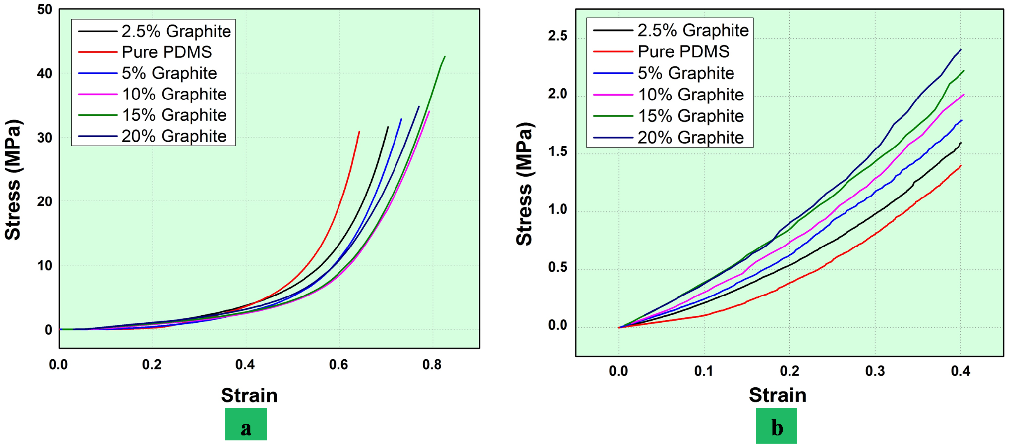

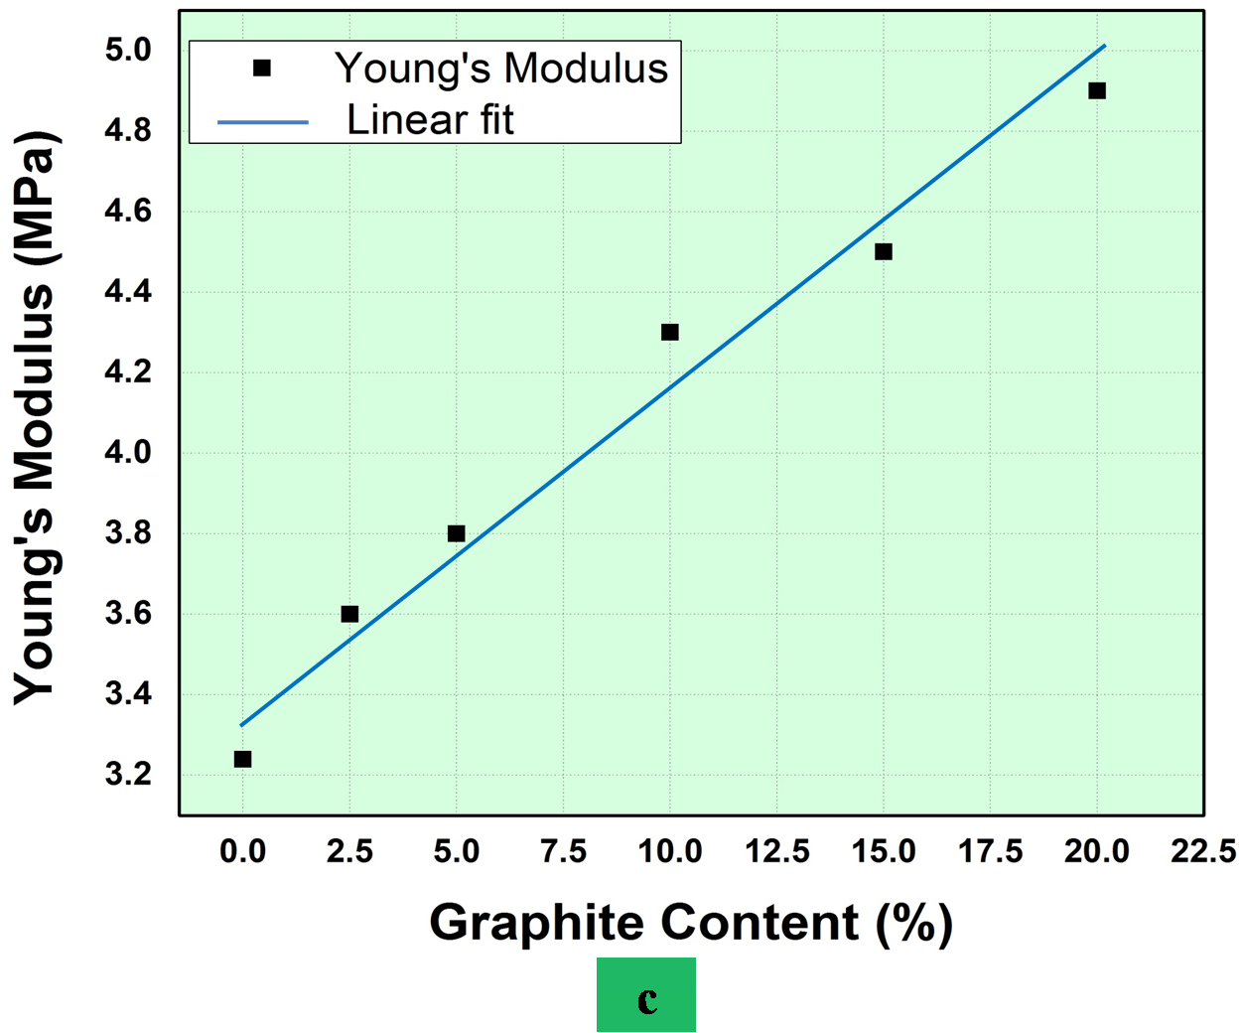
Figure 6 Relation between (a) stress-strain curve, (b) at 40 % strain (c) compressive modulus.

Table 1. Compressive test results of pure PDMS and PDMS/graphite composite at 40% strain.
Filler content in PDMS | Stress (MPa) | Strain | Young’s Modulus (MPa)
Pure PDMS | 30.882 | 0.40046 | 3.2
2.5% PDMS/Graphite | 31.591 | 0.40052 | 3.6
5% PDMS/Graphite | 32.812 | 0.40158 | 3.8
10% PDMS/Graphite | 33.983 | 0.40364 | 4.3
15% PDMS/Graphite | 42.557 | 0.40374 | 4.5
20% PDMS/Graphite | 34.740 | 0.40038 | 4.9

Thermal Properties

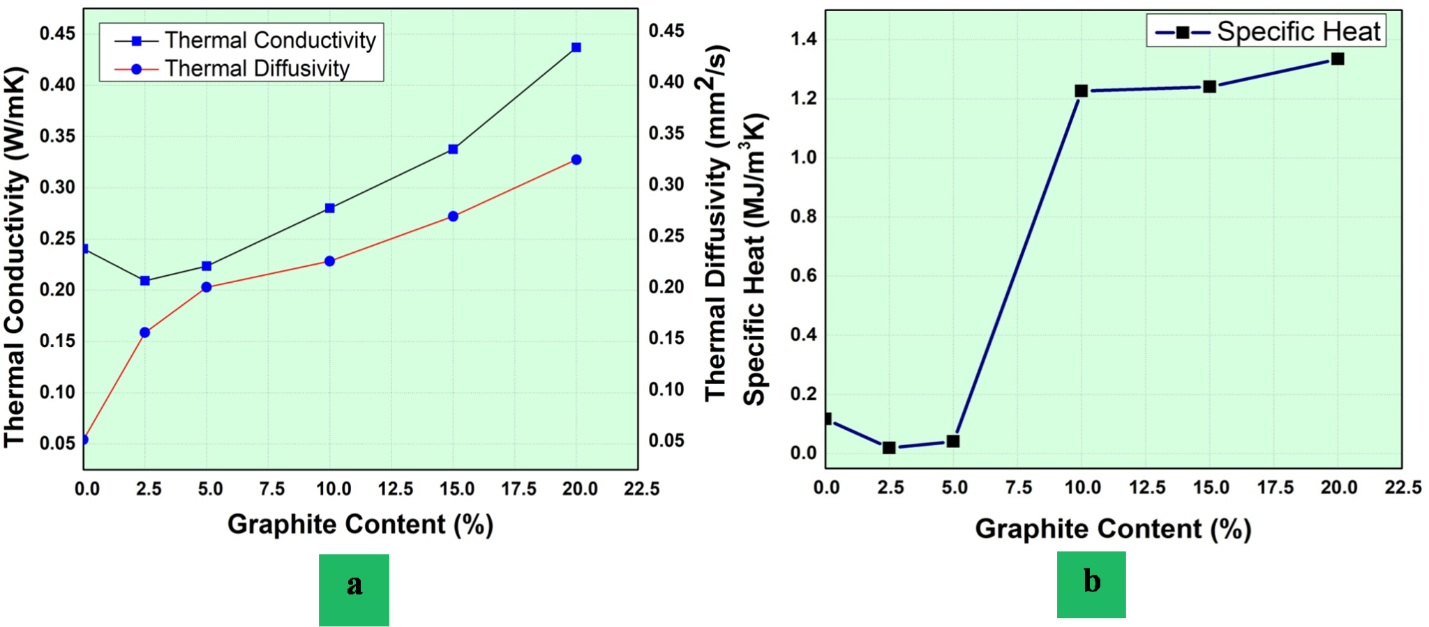

Figure 7 (a) Thermal conductivity and thermal diffusivity of composite, (b) Specific heat change in samples with varying graphite concentration.
For investigating the effect of Graphene, the thermal conductivity of PDMS/graphite composites with varying concentrations of Graphite under various conditions was investigated. Figure 7(a), shows that with the increase of graphite nanofillers into the polymer matrix, the thermal conductivity of the PDMS/graphite composites increases. Pure PDMS has a thermal conductivity of 0.2405 W/mK, which is insufficient to satisfy the thermal management challenges of various contemporary electronic devices. In comparison to the pure PDMS, the thermal conductivity of PDMS/graphite composite samples having 2.5%, 5%, 10%, 15% and 20% graphite was enhanced to 0.2094, 0.2235, 0.2801, 0.3376 and 0.4370 W/mK, respectively. The sample with 20 wt% graphite nanofiller in the PDMS/graphite composite shows an 81.7 % enhancement of thermal conductivity w.r.t pure PDMS. The reason for the improvement of thermal conductivity is the formation of a graphite nanofiller network inside the polymer matrix. Moreover, the creation of a small thermal interface and the high aspect ratio aided the formation of a cross-linked graphite interconnect network with higher thermal transport efficiency.
Table 2. Thermal properties of pure PDMS and PDMS/graphite composite.
Filler content in PDMS | Thermal Conductivity (W/mK) | Thermal Diffusivity (mm²/s) | Specific Heat (MJ/m³K)
Pure PDMS | 0.240 | 0.054 | 0.117
2.5% PDMS/Graphite | 0.209 | 0.159 | 0.019
5% PDMS/Graphite | 0.224 | 0.203 | 0.041
10% PDMS/Graphite | 0.280 | 0.228 | 1.226
15% PDMS/Graphite | 0.338 | 0.272 | 1.241
20% PDMS/Graphite | 0.437 | 0.327 | 1.334

DSC and TGA measurements
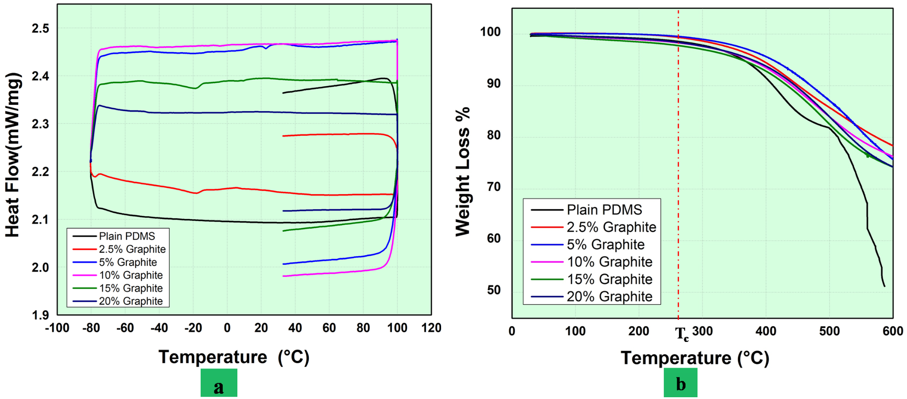
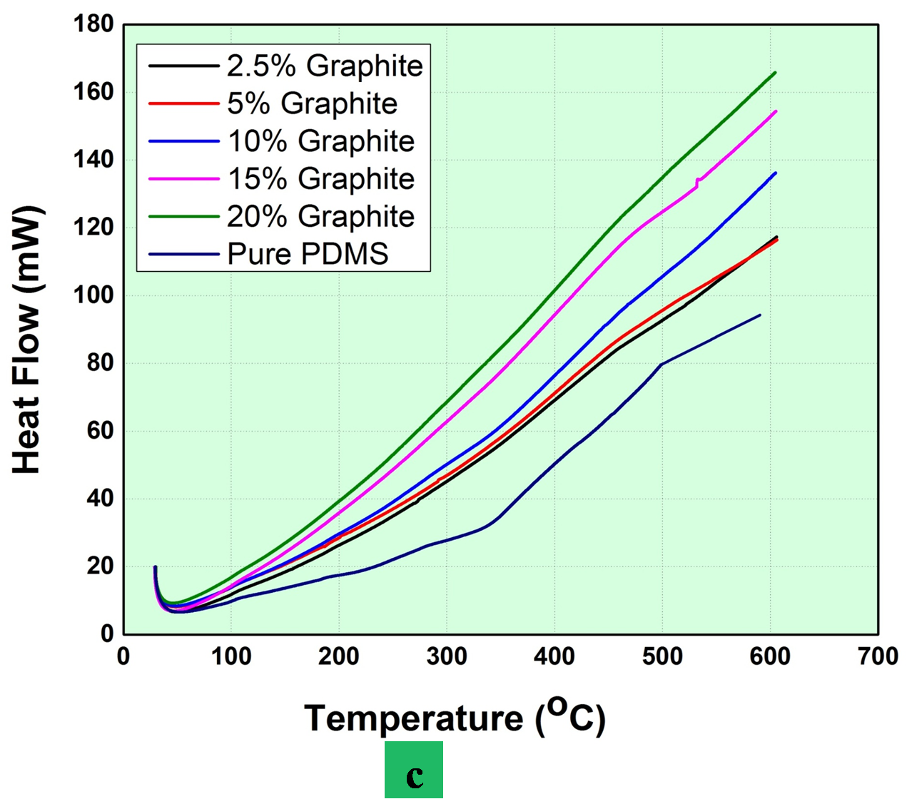
Figure 8 (a) DSC, (b) and (c) TGA results for pure and PDMS/graphite composites.

Except in the case of extremely low molecular weights of polymer, PDMS is a semi-crystalline polymer with a high crystallinity, based on cooling conditions. The filler has a considerable impact on crystallization in PDMS based composites. The effects of the nanofillers on the thermal characteristics of Polydimethylsiloxane, particularly crystallization and glass transition, are the main focus of this study. According to earlier research, both the existence of a nanofiller and crystallization can influence the strength and temperature in semicrystalline polymers [27]. In DSC, generally three measurement routes are followed, such as (i) rapid cooling, (ii) standard cooling, (iii) isothermal crystallization heating. We employed the standard cooling procedure to determine the thermal properties associated with the PDMS based composites. The prepared PDMS based sample is cooled to -80˚C at a constant rate of 10 K/min and then heated up to a temperature of 100˚C at 10 K/min, again cooled to 30˚C i.e., melt state associated with PDMS. From figure 8, between pure and different filler fractions of PDMS/graphite composite, DSC tests revealed no significant glass transition temperature because of the instrument operating temperature constraint. The heat flow of 2.5%, 5%, 10%, 15% and 20% of PDMS/graphite composites is around 2.761%, 18.334 %, 18.232 %, 14.438% and 11.715% greater than the pure PDMS sample respectively.
Figure 8 depicts that the heat flow in the PDMS/graphite composite is greater than that in pure PDMS. Fourier's law of heat has a direct relationship between heat flow and thermal resistance i.e., Q= ΔT/R [28]. At a certain temperature ramp, “Q” is defined as the rate of heat flow for a PDMS sample w.r.t rate of heat flow of reference sample. “R” is defined as the thermal resistance and “ΔT” is the difference of temperature between the sample-reference. As a result, the lower the effective thermal resistance, the higher the heat flow. Furthermore, no phase change, such as crystallization, has been seen, indicating that the graphite nanofillers are very well accommodated inside the PDMS.
The decomposition losses of pure PDMS and PDMS/graphite composites occurred primarily at ~ 500 °C as shown in the figure 8(b). Figure 8(c), depicts the relation between the heat flow and temperature. In all cases, the 1% weight loss (T_{c}) was obtained around 265 °C. Decomposition of the pure PDMS proceeded in two steps, indicating that there is a chemical-based transition that might be related to depolymerization of the material. However, similar processes are not observed in any PDMS/graphite composites, implying that the substance undergoes immediate decomposition. This finding suggests that graphite nanofiller were used to cross-link the pure PDMS polymer chains.

Conclusion
In the current study, the mechanical properties of graphite reinforced PDMS composite material were evaluated. The compression testing methods were carried out with ASTM D412 Type-C and ASTM D1229-03 standard, respectively. The effects of graphite on simple PDMS polymers were studied at concentrations ranging from 2.5% – 20%. These experiments yielded mechanical characteristics such as compressive modulus, thermal diffusivity, conductivity, and specific heat. The thermal conductivity, thermal diffusivity and specific heat of graphite-filled PDMS was around 82%, 505% and 1040% respectively higher than that of the pure PDMS, while mechanical properties for compressive module as 3.2 MPa to 4.9 MPa with the elastic behavior up to 40% strain. The compressive modulus of the 20% graphite-filled material was around 42% higher than that of the pure PDMS, and varied linearly with the increased graphite content percentage filler. Current study on graphite inclusion in simple PDMS provides succinct data for designing sensors and actuators, photothermal and electrothermal based actuators, and electronic systems. Furthermore, the testing and manufacture of compressive approaches for pure PDMS and PDMS/graphite composite samples may aid in the advancement of future structural systems. The findings reported in this work will be helpful in the design and development of composite-based prosthetics, diaphragms and pressure sensors.
Acknowledgements
Corresponding author would like to acknowledge the affiliating institute (IIT Jodhpur) to provide the research seed grant (I/SEED/AKG/20190022) which was helpful in accomplishing the reported work.
Conflicts of Interest

The authors declare no conflict of interest. The funders had no role in the design of the study; in the collection, analyses, or interpretation of data; in the writing of the manuscript, or in the decision to publish the results.
References
[1] S. Nambiar and J. T. W. Yeow, “Conductive polymer-based sensors for biomedical applications,” Biosens. Bioelectron., vol. 26, no. 5, pp. 1825–1832, 2011, doi: 10.1016/j.bios.2010.09.046.
[2] A. Gupta and P. Pal, “Flexible Sensors for Biomedical Application,” in Environmental, Chemical and Medical Sensors, 2018, pp. 287–314.
[3] J. Wang et al., “Flexible and wearable PDMS-based triboelectric nanogenerator for self-powered tactile sensing,” Nanomaterials, vol. 9, no. 9, 2019, doi: 10.3390/nano9091304.
[4] X. Xu, J. Chen, J. Zhou, and B. Li, “Thermal Conductivity of Polymers and Their Nanocomposites,” Adv. Mater., vol. 30, no. 17, pp. 1–10, 2018, doi: 10.1002/adma.201705544.
[5] L. Xie and Y. Zhu, “Tune the Phase Morphology to Design Conductive Polymer Composites: A Review,” Polym. Polym. Compos., vol. 16, no. 2, pp. 101–113, 2008, doi: 10.1002/pc.
[6] Y. Xu, X. Hu, S. Kundu, A. Nag, N. Afsarimanesh, and S. Sapra, “Silicon-Based Sensors for Biomedical Applications: A Review,” sensors, vol. 19, pp. 1–22, 2019, doi: doi:10.3390/s19132908.
[7] G. Kaur, R. Adhikari, P. Cass, M. Bown, and P. Gunatillake, “Electrically conductive polymers and composites for biomedical applications,” RSC Adv., vol. 5, no. 47, pp. 37553–37567, 2015, doi: 10.1039/c5ra01851j.
[8] R. K. Singh, A. Kumar, R. Kant, A. Gupta, E. Suresh, and S. Bhattacharya, “Design and fabrication of 3-dimensional helical structures in polydimethylsiloxane for flow control applications,” Microsyst. Technol., vol. 20, no. 1, pp. 101–111, 2014, doi: 10.1007/s00542-013-1738-7.
[9] G. Kumar Verma and M. Z. Ansari, “Design and simulation of piezoresistive polymer accelerometer,” IOP Conf. Ser. Mater. Sci. Eng., vol. 561, no. 1, 2019, doi: 10.1088/1757-899X/561/1/012128.
[10] A. K. Naskar, J. K. Keum, and R. G. Boeman, “Polymer matrix nanocomposites for automotive structural components,” Nat. Nanotechnol., vol. 11, no. 12, pp. 1026–1030, 2016, doi: 10.1038/nnano.2016.262.
[11] B. P. Sahoo and D. K. Tripathy, “Properties and applications of polymer nanocomposites: Clay and carbon based polymer nanocomposites,” Prop. Appl. Polym. Nanocomposites Clay Carbon Based Polym. Nanocomposites, pp. 1–222, 2017, doi: 10.1007/978-3-662-53517-2.
[12] A. Camenzind, T. Schweizer, M. Sztucki, and S. E. Pratsinis, “Structure & strength of silica-PDMS nanocomposites,” Polymer (Guildf)., vol. 51, no. 8, pp. 1796–1804, 2010, doi: 10.1016/j.polymer.2010.02.030.
[13] R. Kumar, R. Kant, S. Singh, A. Gupta, and S. Bhattacharya, “A novel helical micro-valve for embedded micro-fluidic applications,” MICROFULID NANOFLUID, 2015, doi: 10.1007/s10404-015-1543-y.
[14] A. Nag, S. C. Mukhopadhyay, and J. Kosel, “Wearable Flexible Sensors: A Review,” IEEE Sens. J., vol. 17, no. 13, pp. 3949–3960, 2017, doi: 10.1109/JSEN.2017.2705700.
[15] A. K. Sharma, N. Sheshkar, and A. Gupta, “Static and dynamic stability of dielectric elastomer fiber composites,” Mater. Today Proc., vol. 44, pp. 2043–2047, 2021, doi: 10.1016/j.matpr.2020.12.151.
[16] C. Chen, X. Bu, Q. Feng, and D. Li, “Cellulose nanofiber/carbon nanotube conductive nano-network as a reinforcement template for polydimethylsiloxane nanocomposite,” Polymers (Basel)., vol. 10, no. 9, pp. 4–13, 2018, doi: 10.3390/polym10091000.
[17] M. Karkri, L. Ibos, and B. Garnier, “Comparison of experimental and simulated effective thermal conductivity of polymer matrix filled with metallic spheres: Thermal contact resistance and particle size effect,” J. Compos. Mater., vol. 49, no. 24, pp. 3017–3030, 2015, doi: 10.1177/0021998314559062.
[18] P. Bhawal, S. Ganguly, T. K. Das, S. Mondal, L. Nayak, and N. C. Das, “A comparative study of physico-mechanical and electrical properties of polymer-carbon nanofiber in wet and melt mixing methods,” Mater. Sci. Eng. B Solid-State Mater. Adv. Technol., vol. 245, no. April 2018, pp. 95–106, 2019, doi: 10.1016/j.mseb.2019.05.020.
[19] B. Mensah, K. C. Gupta, H. Kim, W. Wang, K. U. Jeong, and C. Nah, “Graphene-reinforced elastomeric nanocomposites: A review,” Polym. Test., vol. 68, pp. 160–184, 2018, doi: 10.1016/j.polymertesting.2018.04.009.
[20] A. A. Balandin, “Thermal properties of graphene and nanostructured carbon materials,” Nat. Mater., vol. 10, no. 8, pp. 569–581, 2011, doi: 10.1038/nmat3064.
[21] L. Zhao, Y. Yin, B. Jiang, Z. Guo, C. Qu, and Y. Huang, “Fast room-temperature self-healing siloxane elastomer for healable stretchable electronics,” J. Colloid Interface Sci., vol. 573, pp. 105–114, 2020, doi: 10.1016/j.jcis.2020.03.125.
[22] D. Battegazzore and A. Fina, “Flexible and Highly Conductive Composites By Impregnation of Polydimethylsiloxane in Graphite Nanoplates Paper,” pp. 1–10.
[23] M. Silva, I. S. Pinho, J. A. Covas, N. M. Alves, and M. C. Paiva, “3D printing of graphene-based polymeric nanocomposites for biomedical applications,” Funct. Compos. Mater., vol. 2, no. 1, 2021, doi: 10.1186/s42252-021-00020-6.
[24] J. Li, X. Liu, J. M. Crook, and G. G. Wallace, “Development of a porous 3D graphene-PDMS scaffold for improved osseointegration,” Colloids Surfaces B Biointerfaces, vol. 159, pp. 386–393, 2017, doi: 10.1016/j.colsurfb.2017.07.087.
[25] M. Alkahtany, “Color Stability , Physical Properties and Antifungal Effects of ZrO2 and TiO2 Nanoparticle Additions to Pigmented Polydimethylsiloxanes,” 2016.
[26] A. Lamberti, “Microfluidic photocatalytic device exploiting PDMS/TiO 2 nanocomposite,” Appl. Surf. Sci., vol. 335, pp. 50–54, 2015, doi: 10.1016/j.apsusc.2015.01.239.
[27] P. Klonos et al., “Morphology, crystallization and rigid amorphous fraction in PDMS adsorbed onto carbon nanotubes and graphite,” Polymer (Guildf)., vol. 139, pp. 130–144, 2018, doi: 10.1016/j.polymer.2018.02.020.
[28] J.-S. Boisvert et al., “Photosensitised PDMS for femtosecond laser writing,” OSA Contin., vol. 3, no. 5, p. 1334, 2020, doi: 10.1364/osac.386533.

