Biofuels, Electrofuels, Electric or Carbon-free?: A review of current and emerging Sustainable Energy Sourcing for Aviation (SESA)
Pimchanok Su-ungkavatin^{1*}, Ligia Barna¹, Lorie Hamelin¹
¹ Toulouse Biotechnology Institute (TBI), INSA, INRAE UMR792, and CNRS UMR5504, Federal University of Toulouse, 135 Avenue de Rangueil, F-31077, Toulouse, France
* Corresponding author e-mail address: su-ungka@insa-toulouse.fr
Abstract
Climate neutrality is becoming a core long-term competitiveness factor within the aviation industry, as demonstrated by the several innovations and targets set within that sector, prior to and especially after the COVID-19 crisis. Ambitious timelines are set, involving important investment decisions to be taken in a 5-years horizon time. Here, we provide an in-depth review of alternative energy sourcing technologies for aviation revealed to date, which we classified into three main categories, namely liquid fuels (biofuels, electrofuels), electric aviation (all electric and hybrid), and carbon-free options (hydrogen-based, solar-powered). For liquid fuels, 10 pathways were reviewed, for which we supply the detailed process flow picturing all input, output, and co-products generated. The market uptake and use of these co-products were also investigated, along with the overall international regulations and targets for future aviation. As most of the inventoried pathways require hydrogen, we further reviewed six existing and emerging carbon-free hydrogen production technologies. Our review also details the five key battery technologies available (lithium-ion, advanced lithium-ion, solid-state battery, lithium-sulfur, lithium-air) for aviation, as well as the possible configuration schemes for electric propulsion (parallel electric hybrid, series electric hybrid, all electric, partial turboelectric and full turboelectric) and reflects upon the inclusion of hydrogen-powered fuel cells with these configurations. Our review studied these three categories of energy sourcing pathways as modular technologies, yet these still have to be used in a hybridized fashion with conventional fossil-based kerosene. This is among others due to an aromatics content below the standardized requirements for biofuels and electrofuels, to a too low energy storage capacity in the case of batteries, or a sub-optimal gas turbine engine in the case of cryogenic hydrogen. Yet, we found that the latter was the only available option, based on the current and emerging technologies reviewed, for a long-range aviation completely decoupled of fossil carbon. The various challenges and opportunities associated with all these technologies are summarized in this study.
Keywords: Batteries; Fuel cells; Hydrogen; Kerosene; Regulatory frameworks; Sustainable Aviation Fuels (SAF)
1. Introduction
With ca. 900 Mt carbon dioxide (CO₂) emissions per year, the global aviation industry represents approximately 2% of all-human induced CO₂ emission activities [1–3] and accounts for ca. 12% of emissions from all transport sources [4]. The Carbon Offsetting and Reduction Scheme for International Aviation (known as CORSIA) has been launched as one of many measures to achieve, for the aviation sector, a carbon (C) neutral growth by the year 2020 (CNG2020). Despite growing public concerns on the contribution of the flying industry to climate [5–7], the aviation traffic was, prior to the COVID-19 outbreak, forecasted to grow 4.3% per annum and the number of passengers to increase by as much as 20 trillion revenue passenger kilometers (RPK) by 2038 [8,9].
The aviation sector itself acknowledges the need of finding sustainable alternatives to fossil fuels. For instance, the International Civil Aviation Organization (ICAO) launched the CORSIA initiative in 2016, with the vision to achieve the CNG2020 target. It thereby became the first economic sector to adopt a global, universal, and binding system to control its GHG emissions. In addition, the International Air Transport Association (IATA) and the Air Transport Action Group (ATAG) have set CO₂ emission reduction goals of 50% by 2050 (relative to 2005 levels).
In the literature, several terminologies are used to designate aviation fuels, such as jet fuels or kerosene. In industry, it is referred to as Jet A or Jet A-1 (depending on the freezing point; [10]). Through this study, the term kerosene (C₈-C₁₆ hydrocarbons) is used to refer to liquid aviation fuels in general, whether these are fossil-based or not.
Fossil-free aviation fuels deriving from bio-based feedstock are drawing great interest in achieving GHG emission reduction targets for the aviation industry [11]. Bio-derived aviation fuels generated from different technology pathways must be certified by the American Society for Testing and Materials International (ASTM) (ASTM D7566 – Standard Specification for Aviation Turbine Fuel Containing Synthesized Hydrocarbons) or equivalent standards (e.g. Standard 90-091 of United Kingdom’s Ministry of Defense; [12]) before it can be used in commercial aircraft. So far, there are only six certified pathways, namely the Fischer-Tropsch (FT) process, hydroprocessed esters and fatty acids (HEFA), direct sugar to hydrocarbon (DSHC), alcoholic fermentation (AF), syngas fermentation (SF), and catalytic hydrothermolysis jet (CHJ). These bio-derived fuels are here termed as aviation biofuels. They can be used as drop-in fuels, i.e. they are, up to a certain blending limit, interchangeable with conventional kerosene, and do not require adaptation of the fuel distribution network or of the engine. Besides avoiding the use of fossil carbon, aviation biofuels proved to lower soot formation during combustion, as they provide more straight-chain chemical groups than conventional kerosene [2,13]. This cleaner burning implies, on the long-term, an increased engine performance, and better fuel efficiency [13]. On the other hand, this predominance of straight-chain hydrocarbons implies a low content of aromatics in the fuel, a condition known to cause some elastomers of the engine seals to shrink, leading to eventual fuel leak [14,15]. Reflecting this risk, ASTM D7566 requires a minimum aromatics content of 8% by volume. This implies that to date, aviation biofuels have been commercially used only as blends with conventional kerosene, with blending rates varying between 10% (DSHC) and 50% (all other certified biofuels) of the total fuel volume [14].
Besides biofuels, additional alternatives for fossil free aviation include power-to-liquid electrofuels (sometimes known as synthetic fuels, or powerfuels). Aviation electrofuels require a source of C and hydrogen (H₂ ) in order to generate hydrocarbon liquid fuels having similar properties with fossil-based kerosene. Hydrogen may be produced via water- splitting technologies such as water electrolysis [16], thermochemistry [17] or bio-photolysis [18]. Carbon may stem from biomass-free options such as direct capture from carbon dioxide (CO₂) in the atmosphere (typically termed Direct Air Capture, DAC) [19,20], or involve biogenic carbon through the use of syngas stemming from biomass gasification, or syngas through high-temperature co-electrolysis [21]. It may also stem from CO₂ captured from a point source (industrial process) [22–24]. Liquid fuels are then produced through the FT process [21] or methanol (CH₃OH) synthesis [25,26].
Other alternative technologies are here labelled as carbon-free options, as they intrinsically intend to decouple aviation energy sourcing from a carbon source. This includes the use of electric batteries for aviation, a rapidly developing area of research for using either fully electric propulsion or hybrid electric propulsions [27,28]. One challenge this poses is the development of energy-dense batteries as light and compact as possible. Additionally, hydrogen (both gases and cryogenic forms) [29,30] and solar energy sources [31] are currently being researched as alternative options for use in commercial flights.
Here, we refer to the biofuels, electrofuels and carbon-free alternatives for fueling aviation as “sustainable energy sourcing for aviation” (SESA). One commonly used denomination is “sustainable aviation fuels” (SAF), but we refrained from using it for two reasons. First, this term is typically used to represent biofuels only (e.g. [32]). Second, some of the emerging technologies (e.g. batteries) do not fit within the concept of fuel, hence we here propose the more inclusive SESA terminology instead.
Although reviews have been published to document the process flows and to some extent the sustainability aspects of SESA alternatives to kerosene, there are typically focused on only one of the three SESA categories distinguished herein. Aviation biofuels have been the most widely reviewed. One notable review is the one of [33], where the conversion processes are extensively described, with key technological advances and challenges. In addition to that, economic and environmental aspects of biofuel pathways are comprehensively discussed by [34] and [15]. Similarly, an overview of the state-of-the-art in the implementation of biofuels within the aviation sector was presented by [35]. Although not as extensively reviewed, the main synthesis pathways for a variety of electrofuels were qualitatively discussed in [36], with regards to the required physical and chemical properties of these fuels when used in airplanes. The studies of [37] as well as [38], albeit not focusing on the aviation sector per se, carried out an economic analysis for a variety of electrofuels documenting several technologies and variations in plant size. However, the electrofuels investigated in these studies can be considered only as intermediates for aviation fuel production. The recent work of [39], on the other hand, represent a notable advance where a general overview of both carbon-free and biofuels options are described. Albeit valuable, the study of Bauen [39] remains largely qualitative and do not detail the technical conversion pathways and processes involved, besides completely excluding electrofuels. Moreover, all of the above-mentioned studies, with the exception of [15,40], completely overlook the co-products generated along the production process. Yet, these do generate market interactions that in turn are part of the overall economic and environmental performance of these new alternatives, and accordingly must be understood.
In the perspective of bridging this gap, and in the vision of supplying an harmonized comparative background to assess the environmental consequences of current and emerging options for fueling the aviation sector, the present study aims at presenting a comprehensive review of both biofuels, electrofuels, and carbon-free alternatives. More specifically, the objectives of this work are to i) detail the production pathway at the process level, for each type of technology/energy source within the three SESA categories, ii) document the co-products generated in these pathways, as well as their potential market uptake, and iii) supply an overview of the current legislation and public announcements regarding fossil-free aviation.
2. Aviation biofuel pathways
In this section, the main conversion pathways of aviation biofuels currently produced or under development are presented, based on an extensive literature review including scientific papers, company reports, and patents.
Three categories are distinguished according to the feedstock used: carbohydrate, lignocellulosic and oil-based biomass.
Fig. 1 presents an overview of eight different biofuels pathways, six being already certified by ASTM. These pathways involve different blending rates (Table S1). Some pathways are well developed, documented and applied in large-scale production (pilot/demonstration plants), while some, such as the CHJ pathway, are less extensively documented. These are briefly described herein, and additional insights on e.g. the biofuels properties or the leading industrial producers to date are available in the supplementary material 1 (SM1) (Tables S1-S2).
2.1 Pathways involving carbohydrate-rich feedstock
This category comprises three pathways (Fig. 1). They greatly rely upon carbohydrate-rich feedstocks such as sugarcane, sorghum, maize dextrose, maize, etc., but can be also used with less dense carbohydrate sources such as molasses. Simple mechanical pretreatment for particle size reduction (milling, chopping, grinding, etc.) may be performed for sugar-rich feedstock (e.g. sugarcane, maize, fodder beet). For lignocellulosic-rich feedstock (e.g. straw, woody crops and/or residues), this mechanical pretreatment is followed by delignification. In this step, the lignin fraction is typically separated from cellulose and hemicellulose by an alkaline deacetylation, followed by vacuum filtration [40,41].The remaining lignin may be utilized in various applications such as the generation of heat and electricity, or the production of syngas (through gasification) for liquid fuel productions [42,43]. The cellulose and hemicellulose fractions are further processed with enzymatic or acid hydrolysis approaches to recover C₅ and C₆ sugars. As a result, an hydrolysate is produced and further used as input for the aqueous phase reforming (APR), DSHC and AF pathways.
2.1.1 Aqueous phase reforming (APR)
In this pathway, the generated hydrolysate (Fig. 2) first undergoes a purification and concentration process. In this step, numerous techniques may be applied, for instance, alkaline solvents for ash and residual lignin removal, and filtration for insoluble solid residues removal [44,45]. Depending on the initial feedstock characteristics, the sugar-rich hydrolysate produced in the concentration step undergoes an hydrotreating process to convert sugars and organic acids through hydrogenation (forming polyhydric alcohols) and/or hydrogenolysis (forming shorter-chain compounds) [42,46,47]. Oxygen is then removed from the obtained molecules through two successive steps: the APR followed by a condensation process.
In the APR process, the aqueous phase is reacted in the presence of a catalyst under a large variety of operating conditions. A temperature range of 175–300 °C and pressure range of 10 – 90 bar are necessary [42] when catalysts such as Cu, Re, Ni, Fe, Co, Ru, Pd, Rh, or Pt are used [46]. Examples of specific operating conditions in the literature are summarized in the SM1. The reactions happening within this process strongly depend upon the specific configuration and typically include dehydrogenation of alcohols, hydrogenation of carbonyls, deoxygenation, hydrogenolysis and cyclization. As a result of this step, the water-soluble oxygenated compounds are converted into a liquid mixture (APR liquid), which is a complex mixture of hydrocarbons and undesired oxygenated hydrocarbons (e.g. alcohols, aldehydes, ketones). These may be separated at this stage or fed directly to the subsequent condensation step [47] as illustrated in Fig. 2. A gas phase rich in H₂, CO₂, CO and light alkanes is also produced (Fig. 2), which can be directly used for heat and power production [41]. Alternatively, the H₂ produced in the gas stream could be separated and recirculated to the process [41,48], prior to burning the light alkanes (C₁-C₄) for heat and electricity [41,46,48]. The exact mixture of both gas and liquid output is rather difficult to predict given the complex mixture of hydrocarbons and oxygenated hydrocarbons involved [49].
Through condensation reactions, the liquid mixture from the APR process is upgraded to longer-chain hydrocarbons. For example, base condensation is applied for the production of gasoline and kerosene. The liquid condensate may, prior to distillation, undergo hydrotreating according to the desired hydrocarbon fuels output. The resulting products are polyhydric alcohols or shorter-chain compounds depending on the hydrotreating approaches used. Dehydration of alcohols into alkanes and oligomerization (using solid phosphoric acid or zeolite as catalyst) is used for kerosene production [42]. Hydrogenation and/or isomerization might also be required to ensure conformity with the specific market requirements (e.g. the mandatory ASTM D1655 for aviation fuel blends to be used in commercial aviation) [46]. As illustrated in Fig. 2, these processes can be combined in different configurations and with different operating conditions to fit with the desired final product. Finally, the generated products are subsequently condensed and distillated to produce the desired aviation fuels, here as synthetic paraffinic kerosene (SPK) or as synthetic aromatic kerosene (SAK), along with hydrocarbons co-products including naphtha, and diesel [41,42].
2.1.2 Direct sugar to hydrocarbon (DSHC)
The DSHC pathway allows to produce aviation biofuels without an alcohol intermediate (Fig. 3). The sugars derived from the biomass feedstock input are converted to C₁₅H₂₄ (denoted as isoprenoid farnesene) through fermentation, subsequently hydrogenated to farnesane (C₁₅H₃₂), which can be used as aviation fuel [50,51]. The joint venture between Amyris and Total is the main global developer of the DSHC pathway with carbohydrate-rich feedstock such as maize, sugar beet, sugarcane [52]. These companies engineered microorganisms capable of fermenting both C₅ and C₆ sugars [53,54]. Accordingly, lignocellulosic-rich substrates can also be used as a feedstock in this pathway. Additional examples of industrial partnerships developed to produce aviation biofuels via the DSHC pathway are described in the SM1.
The fermentation process with the engineered yeasts takes place at operating temperatures of 30-34 °C [53]. A liquid/solid centrifugation process separates the yeast cells and fermentation broth. The supernatant, consisting of farnesene oil, farnesene emulsion and fermentation broth, is collected for further purification. Within the purification process, the collected supernatant is heated in the de-emulsification unit (65-70 °C) with the addition of surfactant and is transferred to liquid/liquid centrifugation in order to separate the oil and aqueous phases [53]. The distillation stage separates the contaminants into a heavy fraction containing triglyceride, monoglyceride and salts, and a light fraction of the distilled farnesene. Distilled farnesene then undergoes hydrogenation in the presence of catalysts such as Ni, Pd, Ru, Pt, Mo, Zn, etc. [55]. The purification step may be combined with hydroprocessing in downstream operations for achieving high recovery efficiency (97% reported) [53] (not shown in Fig. 3). The farnesane produced can be used as diesel fuel for terrestrial transport or as aviation kerosene, although the former tends to be preferred due to the low blending ratio allowed for the kerosene obtained from this pathway (10% by volume; Table S1). Alternatively, the farnesene can be chemically converted to produce a variety of products including fragrances, flavors, cosmetics, lubricants, etc. The co-products derived from the separation and purification step (Fig. 3) are reported to be used in anaerobic digestion for biogas production [54], where the biogas is subsequently led to a steam methane reforming (SMR) process in order to produce part of the hydrogen needed for the hydrogenation step.
2.1.3 Alcoholic fermentation (AF)
This pathway is based upon the fermentation of the hydrolysate derived from carbohydrate-rich biomass (e.g. molasses, sugarcane, sweet sorghum, sugar beets, food waste, inedible fodder maize) and lignocellulosic-based biomass (e.g. wheat/rice straw) to produce alcohols [56–58]. The generated alcohol, typically isobutanol, is then further upgraded to aviation biofuel through a series of four key processes (Fig. 4) described below. The solid residue (often referred to as distiller grains) not converted to alcohol is generally dried and sold as a protein-rich ingredient for animal feed [59–61].
In the fermentation step, bacteria, in particular Clostridia and a modified strain of E. coli, are commonly used for isobutanol production through the acetone-butanol-ethanol (ABE) fermentation process [62], albeit other microorganisms are also possible in the presence of yeast S. cerevisiae [63] or engineered yeast (details in SM1). Fermentation temperatures from 20 °C to 95 °C are reported, depending upon the microorganisms used [60,63–65]. After the fermentation, the broth containing the desired alcohols, microorganisms and other organic compounds is separated into an alcoholic fraction and distiller grains (by e.g. membrane separations, distillation, solid/liquid separation, etc.) [60]. The alcohol obtained from the fermentation stage will typically not be pure but consists of a mixture of C₂-C₆ alcohols including ethanol, propanol, butanol, isobutanol and pentanol [60].
The produced isobutanol is typically converted into isobutenes in the presence of dehydration catalysts such as inorganic strong acids, metal oxides, zeolites, acidic resins, etc. at operating temperatures ranging from 250-350 °C. [57,66]. Isobutene monomers are oligomerized in the presence of acid- or metal-based catalysts, which results in a liquid mixture of longer chains alkenes (C₁₀-C₁₆) and shorter chains (C₄-C₈) ones. Shorter chains alkenes are separated and recycled to the oligomerization unit [57]. The heavier olefin fractions (C₁₀-C₁₆) are then fed to the hydrogenation process (Fig. 4) [67]. The hydrogenated hydrocarbons are distilled into distinct fractions, namely the alcohol-to-jet SPK (ATJ-SPK) along with an isooctane co-product [68]. Emerging advances of the AF process are presented in the SM1.
2.2 Pathways handling residual and lignocellulosic biomass feedstock
Some pathways can be considered as specifically targeting residual (often lignocellulosic) biomasses such as primary forestry residues, crop residues, municipal solid waste (MSW), etc., although these can also technically be used in the previously described biofuels pathways prior to pre-treatments. These low-value residues have attracted tremendous attention due to their potential to avoid the competition with food production [69], and their potential important bio-physical availability [70–72]. The pathways described herein use thermochemical conversion processes to convert lignocellulosic biomasses into kerosene. The vision is whether to first convert residual biomasses to gas, and then convert this gas into liquid fuels through so-called Gas-to-Liquids (GtL) processes, or to convert the biomass into a bio-oil to be further processed to kerosene.
2.2.1 Biomass-to-gas via gasification
Gasification and anaerobic digestion are the two most known technologies to convert biomasses into gas. Although the exact amount of carbon from the biomass that will convert to gas, as well as the gas composition itself, will heavily depend upon the technology, process conditions and biomass composition, anaerobic digestion can be expected to convert ca. 60% of the biomass carbon into biogas [73] while gasification is expected to convert at least 75% of the carbon into syngas [74]. Moreover, syngas contains a lower share of CO₂ than biogas [73,74], hence less carbon to be potentially recovered from this more stable gaseous form.
Prior to gasification, biomass must be pretreated into fine particles (80-100 mm) by mechanical techniques (including chopping, grinding) in order to enhance the efficiency of moisture removal, which in turns facilitates the biomass conversion to syngas [75–77]. Gasification typically occurs at temperatures of 600-1,000 °C or even higher with controlled amount of oxidizing agent such as air, steam, oxygen, their mixture or supercritical water [76,78]. The appropriate amount of oxidizer is an important parameter for a high syngas production and for limiting the amount of by-products generation (e.g. char) [76]. During the gasification process, carbonaceous materials are transformed through several reactions including drying, pyrolysis (PL), combustion and reduction of feedstock to produce syngas, water vapor, tar, and a solid co-product denoted as char [79].
Syngas, based on the experimental data compiled by [74] for fixed bed gasifiers, is a gaseous mixture of H₂ (10-20%), CO (15-23%), CO₂ (8-18%), CH₄ (1-4%) and N₂ (42-60%). Syngas impurities are composed of tar particles, nitrogenous compounds (NH₃, HCN), sulfur compounds (H₂S, COS, CS₂), hydrogen halides (HCl, HF), and trace metals (Na, K) [80]. Hence, syngas needs to be further conditioned to reform tar contaminants, and remove particulate matters and acid gases prior to utilization in downstream gas-to-liquid processes (Figs. 5 and 6). Depending on the gas-to-liquid process to be used, additional steps to adjust for the H₂/CO ratio of the cleaned syngas may be required. While it could be completely avoided for the SF pathway, the FT typically requires to adjust the H₂/CO ratio to ~2.0 for avoiding the formation of methane. In addition, syngas must be strictly purified from acid gas and ash to avoid catalyst deactivation during the FT step as well as downstream corrosion [76]. Details on gasification and syngas conditioning and cleanup processes are presented in the SM1.
2.2.1.1 Gas-to-liquid: Syngas fermentation (SF)
The syngas deriving from waste gases from industrial processes and/or gasified biomass can be converted into various intermediate products (e.g. alcohols, organic acids) through fermentation process (Fig. 5) after cleanup/conditioning as above described. Different microorganisms can be used to obtain a panel of co-products [81]. Typically, the objective is to convert syngas into ethanol, which is subsequently upgraded into kerosene.
Microorganisms such as acetogenic Clostridium spp. convert syngas into several intermediates including ethanol, 2,3-butanediol (2,3-BDO), and acetic acid [65,82,83]. Optimum fermentation conditions intensively depend upon the microorganisms used [84], however, pressures higher than ambient pressure are preferred for enhancing the syngas transfer between the gas and the liquid phase [85]. After the fermentation, the broth including co-products and microbial biomass is fractionated through several processes depending on the co-products formed. For example, distillation is typically used for ethanol recovery [83], while simulated moving bed chromatography may be used for 2,3-BDO recovery [86].
The fermentation residue comprising microbial biomass, and other organic fractions (also known as distillation grains) is filtered [87]. The filtered liquid stream consisting of soluble nutrient mixtures can be further recycled back to the fermentation reactor while the filtrated insoluble sludge is typically sent to anaerobic digestion. The resulting biogas can be used for internal steam and power generation [83,86].
Ethanol may be upgraded to kerosene through a variety of processes. First, ethanol is converted to ethylene in the presence of catalysts such as γ-alumina (Al₂O₃), transition metal oxides, or zeolites at operating temperatures of 320-500 °C [88]. Oligomerization then converts the produced ethylene to linear long-chain olefins at operating temperatures of 100-300 °C, also in the presence of catalysts [89]. Nickel complexes are commonly used as catalysts for industrial ethylene oligomerization (e.g. used in the Shell Higher Olefin Process; SHOP) [89,90]. Aluminum-based catalysts (tri-ethyl-aluminum) generate, through the Gulf and Ethyl process, linear α-olefins and by-products (alkanes and branched α-olefins) [90].
The longer-chain olefins generated are afterwards hydrogenated into alkanes. Copper, zinc chromite or sulfide are utilized as catalysts for high-pressure hydrogenation with temperature ranges of 150 and 200 °C and under a pressure of 200-350 bar [90]. Hydrogenated hydrocarbons are further distilled to recover the C₈-C₁₆ fraction known as ATJ-SPK. In addition, naphtha and diesel can be obtained as co-products [86].
The SF pathway, when deriving from lignocellulosic biomass, has an overall reported energy efficiency of 57%, while the FT pathway has an overall reported energy efficiency of 45% [91].
The fermentation pathway provides numerous advantages such as operating conditions near the ambient temperature and pressure [92]. However, the main challenge with the SF pathway is the low solubility of syngas in the fermentation medium, which limits the mass transfer to the liquid phase, in turns resulting in the generation of untargeted (or less desired) products [93,94].
2.2.1.2 Gas-to-Liquid: Fischer-Tropsch (FT) process
The FT technology has been extensively used for the production of synthetic liquid fuels and chemicals (e.g. naphtha; [95]). FT consists of a series of catalytic processes (Fig. 6) which convert purified syngas (mostly composed of H₂ and CO) into liquid fuels. During the FT synthesis, the purified syngas is passed over catalysts in specific process conditions to form a variety of hydrocarbons (ranging from gases to waxes) following three main reactions [96]:
2H₂ + CO → (CH₂) + H₂O (1)
(2n+1)H₂ + nCO → C_{n}H_{2n+2} + nH₂O (2)
(2n)H₂ + nCO → C_{n}H_{2n} + nH₂O (3)
The hydrocarbon product composition is strongly influenced by the operating temperature, pressure, syngas composition, and used catalyst [68,98–101]. The FT process can be categorized into high temperature (HTFT) and low temperature (LTFT). Gasoline, solvent oil and olefins as shorter-hydrocarbon compounds can be generated through HTFT process with operating temperatures of 310-340 °C. LTFT will typically involve operating temperature of 210-260 °C and generate an hydrocarbon mixture consisting of ca. 50% solid wax, the remaining consisting of a liquid phase containing aromatics and cycloparaffins [102]. The wax can later be processed to produce naphtha, kerosene and diesel, among others [76,101]. It should be noted that the wax is sometimes defined as C₂₀ [103], C₂₁ [104], C₂₂ [105] or C₂₃ [102] and heavier fractions. Common catalysts used are transition metals like Fe, Co, Ni and Ru. Fe and Co are widely used catalysts, with distinct selectivity. For example, Fe-based LTFT generates higher olefins concentration as Co-based LTFT, but with lower hydrocarbon conversion and more CO₂ production. Cobalt-based catalyst is often preferred for GtL FT due to its high activity and selectivity to linear paraffins [68,106–108].
There are three fractions generated from the FT process: gaseous, liquid and wax phases. The gaseous phase contains CO, H₂, CO₂, and N_{2.} It can either be fractionated for H₂ recovery or be recycled back to the FT unit in order to maximize kerosene yield [106] (Fig. 6). The liquid hydrocarbons from FT undergo an hydrotreating process including deoxygenation, decarboxylation and decarbonylation in the presence of supported base metal- or supported noble metal- catalysts [109]. Additional hydrogenation may be applied for transforming olefins and residual oxygenated molecules into saturated hydrocarbons. Wax (C₂₀₋₂₃₊) produced in FT unit are transformed to smaller molecules by hydrocracking followed by isomerization into branched hydrocarbons. Obtained hydrocarbons with different lengths are distilled to produce naphtha, kerosene, diesel and lubricants [64,102,110].
This technology allows the use of lignin deriving from lignocellulosic biomass as primary feedstock for bio-based kerosene production (SPK). SPK derived from the FT process, denoted as FT-SPK, consists of a high proportion of n- and iso-paraffins with a maximum of 15% by weight of cycloparaffins resulting in a high cetane number, high specific energy, and high thermal stability. FT-SPK provides a high quality kerosene in the absence of sulfur, nitrogen, and other impurities [14,47].
2.2.2 Hydrotreated depolymerized cellulosic jet (HDCJ)
Residual biomass can be converted into liquid fuels via a PL process, denoted as HDCJ-PL, or via hydrothermal liquefaction (HTL) for wet substrates, denoted as HDCJ-HTL (Figs. 1 and 7).
The PL process converts dry biomass into bio-oil, gases, and biochar, the proportion and composition depending on the process conditions and the nature of the feedstock [111]. Biomass feedstock, finely ground (< 5 mm), is dried to achieve less than 10% moisture content by weight, often seen as mandatory for the PL process, especially in the perspective of quality bio-oil production intended for use as a transport fuel [112–114]. Fast PL is conducted at relatively high temperatures (450-550 °C) and ambient pressure with short residence time of the gas phase (typically less than 2s) [115]. Fast PL is proposed for maximizing the production of liquid hydrocarbons (bio-oil) while lower temperatures PL mainly produce a solid product known as biochar [116].
In the HTL process, residual biomass reacts with water at temperature ranging from 200-450 °C and pressures of 50-280 bar [117] with or without a catalyst. This process is suitable for the conversion of relatively wet biomasses (5-35% dry matter content) into bio-crude oil; drying pretreatment processes are therefore not necessary [115,117–120]. During the HTL process, bio-oil is produced through multiple reactions such as hydrolysis, dehydration, decarboxylation, condensation, cyclisation or, polymerization. The produced bio-oil contains lower oxygen (in oxygenated compounds) and moisture content with higher heating value in comparison to the PL bio-oil [51,121,122] Moreover, PL bio-oil has higher acidity and weaker thermal stability relative to the HTL bio-oil [122]; therefore it requires more extensive upgrading processes. More details about the HDCJ processes and examples of industrial developments can be retrieved in the SM1.
During the upgrading process of the bio-oil to kerosene (Fig. 7), distillation, centrifugation and extraction are preliminary processes for the fractionation of the bio-oil into a gaseous phase, a liquid bio-crude oil phase (the main output), an aqueous phase and solid residue (e.g. tar). Subsequently, other upgrading processes are performed, for example, emulsification, catalytic cracking and/or, steam reforming [123]. The liquid bio-crude oil phase is further refined by hydrotreating to increase its alkane composition, by reduction of heteroatom-containing molecules and by hydrogenation of unsaturated molecules. Hydrotreated hydrocarbons are distilled into liquid fuels including naphtha, kerosene and diesel.
2.3 Pathways involving oil feedstock
Oil feedstock may be derived from many sources, for example, non-edible oil crops (e.g. camelina, jatropha, carinata, pongamia, pennycress) or oleochemical wastes (e.g. waste cooking oils; WCO, waste animal fats, greases stemming from municipal waste facilities). Crops are converted to oil through several processes such as, mechanical processes (e.g. chopping, pressing, chipping), chemical extraction with solvent and/or enzymatic methods [124].
2.3.1 Hydroprocessed renewable jet (HRJ)/ Hydroprocessed esters and fatty acids (HEFA)
Triglycerides containing saturated and/or unsaturated fatty acids can be converted to liquid hydrocarbons (naphtha, kerosene, diesel) by hydroprocessing under various conditions [114,125,126], as illustrated in Fig. 8. In the literature, this is typically referred to as hydroprocessed esters and fatty acids (HEFA) when related to terrestrial biofuels production, and as hydroprocessed renewable jet (HRJ) when related to aviation fuels. In term of process pathway, these terminologies are here considered as equivalent.
Waste fats and oils with different degrees of unsaturation are firstly hydrogenated to saturate the double bonds leading to the production of propane along with free fatty acids. The hydrogenated fatty acids are subsequently converted into straight chain hydrocarbons through hydrotreating processes including deoxygenation, decarboxylation and decarbonylation with the formation of H₂O, CO₂ and CO, respectively [40,127,128]. Subsequently, the hydrocarbons produced are transformed by isomerization and hydrocracking reactions. Isomerization converts straight chain hydrocarbons into highly branched alkanes exhibiting a low freezing point, a desired property as a blending component. Long chain hydrocarbons are broken through an hydrocracking process to desirable carbon length compounds (e.g. in the range of C₈ to C₁₆ aviation kerosene) [129]. The product is distilled into naphtha, kerosene and diesel [130,131].
Several parameters have an impact on product generation during the HRJ/HEFA process, for instance, the type of catalyst used, the fatty acids profile of the feedstock used and the operating conditions [130,132,133]. A variety of research and industrial experiments resulting in the production of aviation biofuels with the HRJ/HEFA pathway under various conditions are summarized in the SM1.
The HRJ/HEFA pathway is considered as a relatively mature technology at commercial scale. However, the availability and the cost of the sustainable oleochemical feedstock, in particular if waste-based or relying on limited marginal lands to grow the feedstock, may become a limiting factor in the perspective of increased biofuels demand in the future.
2.3.2 Catalytic hydrothermolysis jet (CHJ)
The CHJ pathway, similarly to the HTL process, is based on high temperature water chemistry (hydrothermal processes), converting oil-based feedstock into a mixture of straight, branched and cyclic hydrocarbons as shown in Fig. 9. The process is composed of four steps including hydrothermal pre-conditioning, catalytic hydrothermolysis (CH), upgrading through hydrotreatment and products fractionation.
During the pre-conditioning stage, the oil-based material is cracked resulting in the production of free fatty acids with the removal of heteroatoms (S, N, metals, etc.) in the presence of steam and catalyst under operating temperatures of 150-300 °C and pressures of 5-50 bar [134]. These generated fatty acids are converted in a CH unit at elevated temperature (240-450 °C) and pressure (15-250 bar) [134]. Within the CH unit, numerous reactions take place including cracking, hydrolysis, decarboxylation, isomerization, and cyclization to produce a mixture of paraffin and cyclic hydrocarbons. In a nutshell, the outputs of the CH unit consist of an organic phase and an aqueous phase. The aqueous phase is composed mostly of low molecular weight carboxylic acids (C₂-C₅), glycerol, and some of small polar molecules [134]. They are transformed through decarboxylation and dehydration into alkene products. These intermediates could be upgraded to aviation biofuels through alcohol recovery stage (oligomerization, hydrogenation and distillation) as described above. The organic phase, referred to as CH bio-crude, is further decarboxylated, hydrogenated, and finally distilled into several product fractions including naphtha, kerosene (denoted as catalytic hydrothermolysis synthesized kerosene; CH-SK) and diesel [135].
Aviation biofuels obtained with this process contain high density aromatics, iso-paraffins and cycloparaffins [134,136]. Additional details on the CHJ pathway and its industrial developments are presented in the SM1.
3. Aviation liquid electrofuels
This pathway (Fig. 10) is known as power-to-liquid electrofuels, also denoted as synthetic fuels, where a liquid fuel is produced from hydrogen and carbon sources. Aviation electrofuels thus involve the storage of electrical energy within chemical bonds in the form of liquid fuels, providing more energy density and lower aircraft weight, compared to emerging electric and carbon-free alternatives (e.g. solar powered aviation) [137].
3.1 Hydrogen supply
There are several pathways to produce hydrogen with different resources, e.g. from fossil fuel resources through steam reforming and/or partial oxidation, from non-fossil resources through biomass gasification or fermentation, and from water-splitting technologies [138–142]. Today, around one-third of global hydrogen supply is obtained as a by-product from industrial processes (e.g. chlorine production from electrolysis of brine; [143–145]). Here, the focus is on hydrogen production decoupled from a carbon source, and as the main product driving the production process.
Water is a promising resource generating growing interest for hydrogen production. Several pathways are possible, such as electrochemistry (including water electrolysis and photo electrolysis) [146,147], thermochemistry [148], or biological water-splitting such as bio-photolysis [18,141] as summarized in Fig. 11. The latter, along with photo-electrolysis, have however not been considered any further herein, being still in early development stages.
Water electrolysis, in particular if powered with fluctuating power in excess of demand, has attracted growing attention as a process to generate so-called green hydrogen [140,149]. There are different water electrolysis technologies available such as alkaline electrolysis [150], proton/polymer exchange membrane (PEM) electrolysis [151], or solid oxide electrolysis (SOE) [152,153] (details on these technologies are presented in the SM1).
3.2 Carbon sourcing
The supply of CO₂ may stem from a variety of sources including air (DAC), gas mixture from gasified/digested biomass (as detailed in section 2.2.1), mine gases, or from industrial waste (such as biofuel/bioethanol production, waste gases from steel production and cement industry, from biogas upgrading process, etc.) [83,154]. Except DAC, these C sources involve the recovery at point sources and requires CO₂ capture technologies, further described in the SM1. There are two major technical approaches for DAC. One is based on the absorption of CO₂ using low-toxicity solvents such as water (through a scrubbing process) and alkaline aqueous solutions (NaOH, Ca(OH)₂ KOH) with a CO₂ strong affinity. In addition to water and alkaline solutions, amino acid salt, ammonia, polyglycol ether and ionic liquids can also be used as solvent for CO₂ extraction [155]. The solvent-based technology is mature and is already applied in large-scale plants, however, the solvent regeneration is a high energy-consuming process. The second approach utilizes an alkaline carbonate bonded to a mesoporous solid support in which the sorbents can be easily regenerated. The most promising technology is the use of supported amine materials; this solid sorbent-based approach revealed higher sorption performance with higher capacities and selectivity, and lower heating requirement compared to the solvent-based method [20,156]. However, the tradeoff is the high operational expenditure resulting from sorbent degradation [156].
3.3 Liquid hydrocarbon synthesis
In this step, hydrogen is combined with CO₂ to produce syngas. This happens with a reverse water gas shift reaction (i.e. reaction (6) below, from left to right) in the direct electrolysis pathway (Fig. 10a) or through a co-electrolysis process where water thermal splitting and reverse water gas shift reactions jointly occur, thereby converting steam and CO₂ into syngas [157] (Fig. 10b). This is in particular possible with high temperature electrolysis using SOE (600-1,000 °C) [157]. Co-electrolysis provides high conversion and energy efficiencies utilizing the industrial waste heat derived from other industrial processes such as the FT synthesis [40,153]. As shown in (Fig. 10c), a third option is to thermochemically combine H₂ (from H₂O) and CO₂ for syngas production through the direct use of concentrated solar radiation as energy source. Nuclear and geothermal resources are also possible [158]. Here, the H₂O and CO₂ conversion into syngas is carried out by multi-step thermochemical cycles such as cerium-chlorine, copper-chlorine, sulfur-iodine, iron-chlorine, etc. [139,159–161]. This was demonstrated in the SOLARJET project [139], with a 4 kW solar reactor prototype. The upscaling of this solar thermochemical reactor (50 kW) is being performed within the SUN-to-LIQUID project [142,162], where syngas is to be produced from concentrated solar energy.
To produce liquid fuels, the syngas is further used in either the FT or methanol synthesis process, as depicted in Figs. 10a-c (and Table S3). For the FT route, the syngas-to-kerosene conversion is exactly as descried for biofuels (Fig. 6).
In the methanol route, syngas is converted at temperatures of 150-300 °C and under pressures in the range of 10-100 bar in the presence of copper-based catalysts (e.g. Cu/ZnO) [163]. The hydrogenation of CO/CO₂ can be described by the following reactions [164]:
CO + 2H₂ → CH₃OH ∆H_{298K} = -91 kJ mol⁻¹ (4)
CO₂ + 3H₂ → CH₃OH + H₂O ∆H_{298K} = -50 kJ mol⁻¹ (5)
The water gas shift reaction occurs simultaneously according to the following reaction [164]:
CO + H₂O ↔ CO₂ + H₂ ∆H_{298K} = -41 kJ mol⁻¹ (6)
Subsequently, the methanol is condensed and separated by distillation. It can then be processed to the desired chemicals and fuels [163,164]. This conversion and upgrading of methanol to desired fuels and chemicals comprises several processes depending on the preferred target product. For instance, methanol may be used for olefin synthesis (an alkene intermediate to produce kerosene) via di-methyl ether, oligomerization and hydrotreating [26,163,165]. The methanol generated from syngas could also serve for the production of gasoline (denoted as methanol-to-gasoline), as currently done in commercial plants, for example ExxonMobil [166]. However, no aviation electrofuels have yet been produced via the methanol pathway [26]. On the other hand, FT-SPK has already been tested and approved by ASTM D7566 as a blending constituent.
4. Co-products generation in liquid fuels production pathways (biofuels and electrofuels)
The technologies previously described (sections 2 and 3, Figs. 2-10) generate, besides the desired fuels, multiple co-products, no matter which route is used. As such, biofuel/electrofuel production pathways are to be seen as refineries rather than mere kerosene suppliers (Table S2). Their co-products include liquid fuels (other than kerosene), chemicals, animal feed, etc. and their generation depends on the specific technologies and operating conditions being used within a given conversion route as illustrated in Table 1. These co-products represent an additional market or value generation opportunity for the production plant. These co-products are here grouped in three major categories: chemicals, liquid fuels, and other products.
4.1 Chemicals
Various chemical compounds are generated as co-products during production processes. Those that have been reported by biofuel producers are detailed here.
4.1.1 Propane
Propane (C₃H₈) is formed as a co-product in the HRJ/HEFA pathway (Fig. 8). Propane is used in a variety of applications, for instance as a fuel for commercial boilers, camping stoves, heating animal houses (e.g. piglet nursery) in livestock production etc. Propane is generally pressurized and stored as liquid in storage vessels or tanks. Due to its high energy density and high quality combustion characteristics, propane is also used as alternative vehicle fuel for internal combustion engine [167,168]. Propane is categorized as one of the bulk component of liquefied petroleum gas (LPG) in combination with other gases such as butane, isobutene, isopentane. Currently, propane is typically generated as a co-product of natural gas processing and petroleum refinery [90].
4.1.2 Naphtha
Naphtha is a mixture of liquid hydrocarbons comprising carbon compounds ranging from C₅-C₉ [169]. Naphtha is the main combustible component of both gasoline and kerosene. It has a great potential for diverse industrial purposes including plastic production or its used as a cleaning extraction or dilution agent [170,171]. Naphtha is traditionally generated as a co-product in fractional distillation processes from the petrochemical industry, including the production of (fossil-based) kerosene for aviation fuel. The market price of naphtha is thus closely tight to the price of crude oil [172].
Most of the biofuel pathways involve the production of naphtha as a co-product (all except AF and DSHC; Figs. 2, 5-9). It can be recirculated within the process, for instance in the FT pathway it can be fed into the partial oxidation unit and reformed as syngas feedstock to produce greater amount of aviation fuel [172]. Additional examples of such bio-based naphtha uses are described in the SM1.
4.1.3 2,3-Butanediol (optional)
2,3-BDO (C₄H₁₀O₂) is a bulk commodity chemical. It is seen as a promising fuel additive or gasoline blendstock for enhancing the octane number [173]. 2,3-BDO is readily convertible to butadiene, butane, methyl-ethyl ketone (MEK) which could be used as intermediates in a variety of product manufactures. In particular, MEK is used in several applications such as solvents in surface coating, printing inks, dewaxing agent, liquid fuel additive, indirect food additive for adhesives and polymers [174]. According to [173,175,176], 2,3-BDO will reach a global market around $220 million by the year 2027.
2,3-BDO is usually produced on the industrial scale by conventional chemical (or synthetic) methods [177,178]. In the production of aviation biofuel, 2,3-BDO is involved in the SF pathway (Fig. 5). It is not directly generated (hence the optional label above), but can be recovered providing adjustments to the product separation step prior to ethanol production, if favorable market conditions makes it desirable [173]. For recovery, the fermentation broth including liquid mixture or a mixed alcohol stream containing 2,3-BDO would be processed with separation techniques such as fractional distillation, evaporation, pervaporation, adsorption [173,179]. For instance, LanzaTech has patented the production of 2,3-BDO from CO-rich industrial waste gases (from the steel industry) by fermentation (Table S2). Their commercial ethanol/2,3-BDO production plant has a production capacity of 30-50 million gallons and costed $75-125 million. In partnership with Orochem Technologies (USA), LanzaTech seeks to economically convert its 2,3-BDO into MEK or 1,3-butadiene through thermocatalytic processes [173].
4.1.4 Isobutene (optional)
Isobutene (C₄H₈) may be optionally recovered in the AF pathway. It is produced after dehydration of alcohols, just prior the oligomerization process (Fig. 4). If the market conditions are favorable to isobutene, a choice could be made to stop the process after the dehydration process for a certain proportion of the stream, and not continue further to kerosene production. Isobutene production thus implies less bio-based kerosene production; hence its “optional” label.
Isobutene is used as a building block in the manufacturing of several industrial products namely fuel additive, butyl rubber, plastic and lubricants, domestic gas, chemicals and cosmetics, etc. Isobutene can be reacted with methanol leading to methyl tert-butyl ether (MTBE) or with ethanol leading to the production of the gasoline additive ethyl tert-butyl ether (ETBE), used as an anti-knocking agent for the automotive industry [180]. The isobutene polymerization generates butyl rubber that can be used as precursor in several products such as window seals, bottle stoppers, protective gloves, etc. Isobutene is also one of the main constituents of LPG. Moreover, isooctane (a gasoline blendstock) could be generated by dimerization of isobutene [180].
Currently, isobutene as a key chemical building block, is massively obtained from petrochemical sources. Being a major precursor in various industrial applications with continuous demand, its market is worth $25 billion with 15 million tonnes produced annually and used as cosmetic ingredients and specialty fuels [181].
4.2 Liquid fuels
4.2.1 Isooctane
Isooctane is a co-product produced in the AF pathway (Fig. 4), during the oligomerization/hydrogenation steps. Isooctane represents a large share of gasoline composition and has properties (e.g. high energy content, high antiknock quality) that make it suitable as a blending component for the production of premium-grade fuels [182]. Isooctane is typically produced through the dimerization of isobutene and isopentene generated as by-products from steam cracking of naphtha and light gas oil in refineries, dimer separation and hydrogenation in conventional industrial processes [182]. Isooctane is further used as a feedstock to produce gasoline, in a process where it is blended with naphtha [183].
The major market for the isooctane co-product generated in the production of aviation biofuels appears to be its use as drop-in blending component for the automotive industry, with a global market reaching $99 billion in 2019 [184]. Yet, new markets are also emerging. For instance, high purity solvents or specialty fuels used for racing and classic cars [185].
4.2.2 Gasoline
Gasoline is a refined product of petroleum consisting of hydrocarbon mixtures, additives and blending agents. The gasoline composition strongly depends on various parameters such as the crude oil sources, the refinery process available and product specification defined by octane rating [186]. Gasoline may be generated in particular in the AF (Fig. 4) and FT (Figs. 6 and 10) pathways. In the latter, gasoline is not directly produced as a co-product, but can be produced from the isooctane generated as explained above. Similarly, gasoline (C₅-C₁₂ hydrocarbon ranged) can also be produced from the APR, SF, HDCJ, HRJ/HEFA and CHJ pathways (Figs. 2, 5, 7-9); it is not directly visible in the figures, but is captured within the naphtha fraction. The fraction generated strongly depends upon the operating conditions which in turn can, to some extent, be adjusted according to the market value of bio-based kerosene, diesel and gasoline. For instance, in the production of aviation biofuel through LTFT process, the proportions of gasoline observed correspond to approximately 10-15% of product distillation output [187]. Additional information about renewable gasoline is described in the SM1.
4.2.3 Diesel
Diesel is a key fuel powering compression ignition engines. As for gasoline, it is derived from petroleum refining, and its exact composition is influenced by market demands and prices.
Diesel with carbon distribution ranging C₁₀-C₂₀ is produced in aviation biofuel pathways such as SF, FT (Figs. 2 and 5-9) and in considerable volumes. It is optionally produced in the SF pathway, derived from ethanol upgrading processes. Furthermore, diesel is also generated as the co-product from the FT process where the volume produced is also depended upon the operating conditions [187].
The main market for the diesel co-product appears to be as a renewable fuel for terrestrial transport as reflected by several recent examples of purchasing agreements and collaboration deals detailed in the SM1. In California alone, the estimated consumption of renewable diesel was approximately 300 million gallons in 2016 and is forecasted to reach around 1 billion gallons by 2030 [188].
4.3 Others
4.3.1Waxes
Waxes are generated as a co-product in the FT pathway (Figs. 6 and 10). They consist primarily of straight chain alkanes (C₂₀₋₂₃₊) which are typically not used in fuel refinery due to their physical properties with i.e. high melting point, low viscosity and hardness. During the LTFT route, the heavy fraction of the FT syncrude accounts for 20-30% weight of total hydrocarbons. The molecular mass of the wax fraction generated is higher relative to the wax produced in the HTFT process [187]. These wax fractions can be cracked into lower molecular weight compounds appropriate for use as liquid fuels or may be sold as precursor of a variety of products. These heavy alkanes have a high potential commercial value due to their competitive prices and versatility in both industrial and medical applications including petroleum jellies, lithium grease, engine oil, industrial gear oil, industrial cleaners, adhesives, etc. [189]. Examples of wax purchase agreements are listed in the SM1.
4.3.2 High-protein animal feed
An animal feed co-product is generated in the AF pathway (Fig. 4), where the protein-rich solid residues derived from the fermentation broth can be further processed. Upon drying, these are often referred to as distiller dried grains, and typically have a high concentration of crude protein with an amino acid profile suitable for animal feed [59]. Ten pounds of animal feed can be produced from one gallon of aviation biofuel [61]. As in the case of the distiller dried grains co-generated with bio-based alcohol (e.g. ethanol) production, the access to the feed market is real and already in place [190].
Table 1 Summary of the co-products generated in the various liquid biofuels production pathways for aviation
Co-product | Conversion pathways | Production status | Market uptake and Displacement
Chemicals
Propane | HRJ/HEFA | Generated from triglyceride hydrogenation | • One of the main LPG constituents  • Used as fuel in numerous applications  (e.g. commercial boiler, burner, etc.)  • Displaces fossil-based propane from petrochemical sources (natural gas processing, crude oil refinery)
Naphtha | APR  AF  SF  FT  HDCJ  HRJ/HEFA  CHJ | Generated along with aviation biofuel (final production step) | • Gasoline blending component  • Precursors for plastics manufacturing  • Can be recycled in the FT unit to produce additional aviation fuel  • Displaces fossil-based naphtha from petrochemical sources
2,3-butanediol | SF | Generated along with ethanol, may be recovered through a separation process prior to the ethanol production (optional) | • Conversion to various precursors namely MEK, 1,3-butadiene, etc.  • Displaces 2,3-BDO from chemical engineering (or synthetic) methods
Isobutene | AF | Derived from isobutanol, which can be further processed the dehydration (optional) | • Precursor for numerous products such as butyl rubber, plastics, isooctane, etc.  • One of the main LPG constituents  • Dimerization for isooctane production  • Polymerization in butyl rubber production  • Displaces isobutene from petrochemical sources
Liquid fuels
Isooctane | AF | • Generated along with aviation biofuel (final production step) | • (Premium-grade) gasoline production  • Displaces fossil-based isooctane from petrochemical sources
Gasoline | AF  FT | • Derived from isobutanol in the AF process, which can be further upgraded to isooctane (optional)  • Generated along with aviation fuel (final production step) | • Transportation fuel  • Displaces fossil-based gasoline derived from petrochemical source
Diesel | APR  AF  FT  HRJ/HEFA | • Generated along with aviation fuel from APR, FT and HEFA processes  • Derived from isobutanol in the AF process, which can be further upgraded to diesel (optional) | • Transportation fuel  • Displaces fossil-based diesel derived from petrochemical sources
Others
Waxes | FT | • Generate along with aviation biofuel (final production step) | • Raw materials for various products such as petroleum jellies, adhesive, etc.  • Displaces petrochemical-based waxes
High-protein animal feed | AF | • Derived from fermentation residues and may require further processing such as evaporation/drying | • High protein and nutrient concentrations derived from dried distiller grains  • Displaces marginal carbohydrate, protein and lipid sources (maize, soybean meals and palm oil) in animal feed
5. Electric and Carbon-free aviation
Solutions for electric and carbon-free aviation are also emerging as mitigation strategies for climate change, local air quality and noise mitigation. These include electric-, hydrogen- as well as solar-powered aviation; the most promising research & development projects are mentioned below and summarized in Fig. 12.
5.1 Electric aviation
Electric propulsion can be distinguished by two key features. First, it involves the use of an electric motor to supply mechanical power to the aircraft propeller (Fig. 13). Second, as also illustrated in Fig. 13 presenting the configurations that have been tested or studied, electric aviation often, albeit not always, involve energy storage technologies such as batteries. As highlighted in Fig. 13, electric propulsion does not purely rely on electricity through battery (or fuel cell) technologies, but often involve liquid fuels, whether conventional fossil kerosene, and a proportion of biofuels or electrofuels.
Accordingly, two terms are often used, namely the concept of “all electric” involving electric motor only as well as no liquid fuels, and the concept of “hybrid electric” where a gas turbine may be additionally involved as well as liquid fuels. The all electric concept is also denoted as “full electric” (e.g. in [27,28,191]). As shown in Fig. 13 and throughout this section, the term propeller is used to represent devices generating thrust either by propeller in the turboprop or by fans in the turbofans. It also encompasses the generation of shaft power in the case of turboshaft engines. The term gas turbine refers to the turboshaft, turboprop and turbofan engines collectively. Converter refers to the devices converting the voltage of the electrical power source, sometimes denoted as power electronic [192], and considers that one type of converter is inverter, which converts direct current (DC) to alternate current (AC).
To represent the proportion of electrical energy or electric power in total energy or power, two parameters are used [193,194]), respectively degree of energy hybridization (H_{E}) and degree of power hybridization (H_{P}). H_{E} and H_{P} vary varied from 0 to 1 depending on the conceptual designs [193,195]. The case of an all electric configuration (Fig. 13c) involves that (H_{P}=1) because the propeller is powered by an electric motor only, but also involve that (H_{E}=1) because it relies solely on energy sourcing technologies (batteries, fuel cells) without any liquid fuel combustion [193]. In conventional aircrafts, gas turbines are powered by liquid fuels combustion, meaning that both H_{E} and H_{P} equals to zero. In the case of a partial turboelectric approach (Fig. 13d), H_{E} would be zero as there are no energy storage devices involved, which H_{P} would be between 0 and 1 because both a gas turbine and an electric motor are used to supply energy to the propeller. In this particular case, however, a clear standard for attributing the appropriate non-zero and non-one hybridization value is still missing [193,195].
Electric aircrafts relying on batteries have gained substantial interest in the recent years. The so-called “more electric” architecture involving the use of energy storage technologies has already been applied in aircrafts for services other than propulsion (e.g. flight control system and cabin environmental control system) [192,196,197], for instance in the Airbus 350 and Boeing 787 [192,193]. Batteries have been introduced in these aircrafts in order to reduce fuel consumption and thus aircraft CO₂ emissions (H_{P} < 0.05) [192,193].
In the hybrid electric propulsion, gas turbine and electric motor are used to independently generate power from fuel combustion and batteries, respectively [198]. As AC power is required for most of the electric motors that can be used in aviation, converters are required [199]. The parallel and series hybrid electric concepts are the two main configurations that have been tested (Figs. 13a and b), however, a series-hybrid scheme has also been demonstrated (not depicted in Fig. 13) [199,200]. The parallel electric hybrid configuration (Fig. 13a) involves two power outputs, hence a mechanical transmission (typically gearbox) is required to integrate and control these two mechanical power sources prior to the propeller [199,201,202]. In the series electric hybrid configuration, the generator powered by the gas turbine produces both electricity for the electric motor(s) which is directly linked to the propeller (H_{P} = 1), and to charge battery on-board (0 < H_{E} <1) [28,193,203] (Fig. 13b). The series electric hybrid system involves additional fuel for recharging battery during flight resulting in increasing the overall weight and cost operation as a tradeoff of this configuration [28]. The choice of architecture is dependent upon numerous factors. For instance, if on-ground charging infrastructure is available at airports, the parallel electric hybrid configuration might be preferred, while the series configuration would be favored in the opposite case [28]. Emission reduction from fuel combustion might be greater for the series configuration (25-50% reduction compared to conventional aircrafts powered by fossil kerosene) in comparison with the parallel configuration (10-20% reduction) [204]. The parallel configuration also involves greater complexity [199,200] and may involve power losses in the mechanical-electrical energy conversion (through the converter).
In all electric systems (Fig. 13c), energy storage devices are the only propulsion source for the aircraft [205]. However, the amount of power that can be stored in currently available batteries, which have a rather low energy storage density (at best ca. 5 MJ kg⁻¹ battery in comparison to 43 MJ kg⁻¹ required for liquid fuels in ASTM D1655 and ADTM D7566; [206–208]; Table 2), especially in comparison to the maximum power required during the takeoff phase [209]. Hence, liquid fuels are still required (configurations of Figs. 13a, b, d, and e) for commercial airplanes (typically with carrying capacity >30 passengers). Liquid biofuels/electrofuels with the acceptable aromatic content (minimum 8% as ASTM D7566) might be used instead of conventional kerosene in the future.
Several projects have been launched to demonstrate the feasibility of 100% electric or hybrid electricity/kerosene propulsion systems (Fig. 12). For example, the company magniX (Canada) designed and demonstrated high-power density electric propulsion system with the world’s first fully electric commercial seaplane, tested on flight in December 2019 (6-passenger aircraft; flight range of 1,000 km) [210]. In May 2020, magniX together with Harbour Air successfully tested an all electric powered system carrying up to 9 passengers for a reported flight range of ca. 160 km (e-Caravan; retrofitted from Ceravan 208) [211,212]. It is, at the time of writing, the largest all electric aircraft with successful test flight. The startup Eviation (Israel) launched Alice, a nine-passenger all electric aircraft with an autonomy range of 650 miles (1,046 km), expected to be in service by 2022 [213]. The aircraft relies on a battery that can be fully charged within 70 minutes and is expected to be FAA certificated (FAA: USA Federal Aviation Administration) by 2022 [213]. However, a fire incident has occurred during Alice ground test in January 2020 caused by a fault with a ground-based battery system [214]. In Europe, EasyJet and Wright Electric are developing since 2017 an all electric aircraft (186 seats), and announced it will start using electric aircraft to cover short-haul routes by 2030 [215]. Additional details on these emerging developments along with specifications on these technologies are presented in the SM1. Despite this growing momentum, there are limitations to battery-powered aircrafts. First, they cover essentially short-haul flights due to the limited energy storage capacity. The common lithium-ion batteries (Li-ion) have a maximum specific energy density of 400 Wh kg⁻¹ (1.4 MJ kg⁻¹) at pack level [196,216], which is relatively low in comparison with conventional kerosene, having a maximum specific energy density of ca. 12,000 Wh kg⁻¹. To overcome the challenge, numerous researches have intensively studied and developed high performance batteries including advanced lithium metal/silicon anode (Adv. Li-ion) [196], solid-state electrolyte battery (SSB) [216,217], lithium sulfur (Li-S) [218,219], lithium air (Li-air) [220,221] without increasing the aircraft weight. Other issues include the charging time of batteries and the possibility to be recycled after their limited lifetime (>1,000 cycles for current Li-ion battery; [196]). Table 2 details the emerging battery technologies for aviation applications.
Turboelectric propulsion (Figs. 13d and e) is another configuration for electric aviation. Here, no secondary energy source (e.g. battery) to liquid fuels are involved [27,195]. A gas turbine drives the generator that powers electric motors for thrust or shaft power generation. In the full turboelectric system (hence, H_{E} = 0, H_{P} =1) [193,222], the generic gas turbine term denotes a turboshaft engine. In the partial turboelectric concept, the generated power from the gas turbine is partially delivered to the generator ultimately feeding the electric motor(s), and the remaining is delivered to directly to the other motors [27,193,223]. Albeit this turboelectric propulsion concept can improve the propulsive efficiency of electrically-driven propellers, the integration of the electric system introduces weight (although lighter than the all electric configuration as it does not involve batteries) [224,225]. To enhance the overall performance in terms of fuel burnt and weight, this configuration concept has been integrated with optimized aircraft design, for instance in NASA’s STARC-ABL aircraft design (Single-aisle Turboelectric Aircraft with an Aft Boundary-Layer Propulsors) [224]. This allowed a 12% reduction of fuel burnt compared to the conventional aircraft concept (conventional kerosene configuration (Fig. 13g) and airframe design) [224]. NASA’s N3-X aircraft is another turboelectric concept with blended wing, providing ca. 63% energy and 90% NO_{x} reductions [226]. This architecture has been proposed as the upcoming technology to meet environmental goals [27,227], where liquid biofuels and electrofuels can be used instead of kerosene.
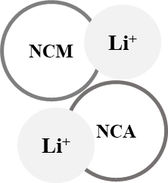
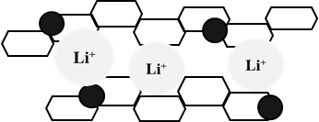
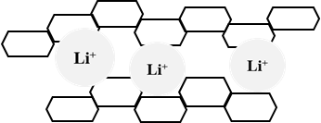
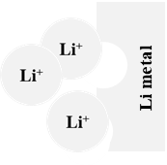
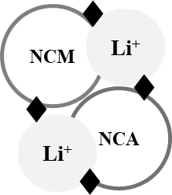
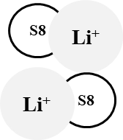
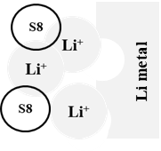
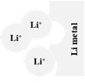
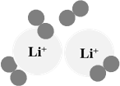
Table 2 Battery technology outlook for aviation
Battery cell chemistry
Cathode (+)
Lithium metal oxide such as
LFP, LMO, Li-NCM
Li-NCA³
Lithium metal oxide
with Ni-rich fraction
(e.g. Li-NCM811)^{4,5,6}

Lithium metal oxide
With Ni-rich fraction
(e.g. Li-NCM811)^{4,5,6}

Sulfur
Graphene
Acetylene black^{6,7,8}

Porous carbon
(e.g. carbon nanotube)¹⁰

Anode (-)
Graphite (with silicon)

Lithium metal or
Silicon^{5,11}
Graphite
Silicon³
Lithium metal
Graphite^{5,12}
Lithium metal^{5,12,13}

Electrolyte
Organic liquid
(e.g. lithium salt-LiPF₆)³
Organic liquid
(e.g. lithium salt-LiPF₆)³

Inorganic solid
(e.g. Li₁₀SnP₂S₁₂)
Organic solid
(e.g. polycarbonate)⁵
Organic liquid
(e.g. LiN(SO₂CF₃)₂)^{3,5}

Organic liquid
(e.g. LiPF₆, LiCO₄)
Aqueous solution
(e.g. H₂SO₄)¹⁰
Binder
PAA
PVDF^{6,8}

PVDF^{6,8}
PVDF⁶

PEI
PVP⁸

PAA⁸

Conductive additive
Carbon black^{3,6}
Not specified
Not specified
Gravimetric (Wh kg⁻¹)¹
300¹⁴
450¹⁴
400-500¹⁵
300-400¹⁴
Volumetric (Wh L⁻¹)¹
700¹⁴
1,200¹⁴
Not specified
400¹⁴
1,350⁹
Life-time cycle (cycle)²
1,000¹⁴
120¹⁴
500¹⁵
100¹⁴
Not specified
Nominal cell voltage (V)
3.7¹⁴
3.8
(Li-metal anode)¹⁴
3.8¹⁵
2.1¹⁴
2.9¹⁴
Development status
Commercial scale
(TRL 9)^{14,16}

Demonstration scale
(TRL 7) ^{14,16}

Technology validation
Small-scale prototype
(TRL 3-4) ^{14,16}

Small-scale prototype
(TRL 4) ^{14,16}

Technology concept
(TRL 1-2) ^{14,16}

Cell properties
Status
Lithium-ion (Li-ion)
Advanced Li-ion
Solid-state battery (SSB)
Lithium-sulfur (Li-S)
Lithium-air (Li-air)
silicon
Solid electrolyte
Oxygen (O₂)
Li₂O
Not specified
Carbon black^{3,6}
Carbon black^{3,6}

¹ Energy density is reported at the cell level derived from published papers and reports which were available at the time of writing.² Life-cycle of battery is represented for 100% Depth of Discharge (DoD).
LFP: Lithium Ferro Phosphate; LMO: Lithium Manganese Oxide; NCA: Nickel-Cobalt-Aluminum; NCM: Nickel-Cobalt-Manganese; PAA: Polyacrylic acid; PEI: Polyethyleneimine; PVDF: Polyvinylidene fluoride; PVP: Polyvinyl pyrrolidone; TRL: Technology Readiness Level. Sources: ³[228]; ⁴[229]; ⁵[230]; ⁶[231]; ⁷[231]; ⁸[232]; ⁹[206]; ¹⁰[233]; ¹¹[234]; ¹²[235]; ¹³[236]; ¹⁴[196]; ¹⁵[237]; ¹⁶[238]
5.2 Hydrogen powered aviation
The energy density of hydrogen, in terms of energy-to-weight ratio (MJ kg⁻¹) is three-fold that of conventional kerosene, rendering it suitable for longer flights in large planes supporting high payload capacity. Despite being lighter, hydrogen, in its cryogenic liquid form, has an energy-to-volume ratio (MJ L⁻¹) four-fold lower than fossil kerosene, which implies obvious storage challenges[239]. The different pathways for hydrogen production through water-splitting technologies are presented in Fig. 11.
Cryogenic hydrogen (referred as liquid hydrogen; LH₂) can be used either in fuel cells or in internal combustion engines [27], which require cryogenic storage (-253 °C) to maintain hydrogen in a liquid form [240]. This is due to hydrogen’s high specific volume at standard atmospheric pressure and temperature. The use of LH₂ for transport, in particular aviation, raises important concerns about safety, and involves stringent procedures and requirements with regards to safety regulation certification [30]. One additional inconvenient of hydrogen relates to the weight penalty induced by the cryogenic system infrastructure. Lightweight cryogenic storage tank with cooling system advancement is necessary for tackling this challenge [204]. On top of this, fuselage has to be redesigned to accommodate the cryogenic hydrogen tank.
Fuel cell propulsion system could be employed in the place of the gas turbine as illustrated in Figs. 13a and b [199,241], where LH₂ is converted to electricity that in turns powers an electric motor, which involves a modification of the propulsion system [204]. Unlike the internal combustion engine where air is involved in the combustion process (thus involving nitrogen outputs such as nitrogen oxides; NO_{x}); the only two by-products from fuel cell systems are water vapor and a small amount of heat. This, however, involves non-negligible cooling requirements [242,243]. Additionally, fuel cell propulsion is unlikely to be competitive for heavy payload and long distances, with 4-times the weight of current aircraft engines to generate the same power output [242,243].
In comparison with batteries, fuel cells serve as energy converters, not as energy storage, and can continuously produce electricity as long as hydrogen is fed to the fuel cell. The produced electricity in excess of what is needed for propelling the aircraft can additionally be stored in batteries as a back-up energy source [204]. Hydrogen fuel cells also provide the advantage of short refueling time in comparison with batteries with less risks of reducing the lifetime [30]. Hydrogen fuel cell designs for aircrafts are being developed by Airbus in ZEROe concepts (a hybrid hydrogen combustion and hydrogen fuel cell propulsion system). These aircrafts are expected to enter in service (with carrying capacity of 100-200 passengers) by 2035 [244]. Various projects have been intensively studied in developing and improving hydrogen fuel cell technologies, as detailed in the SM1.
The direct use of LH₂ in internal combustion engines has already been demonstrated for aviation. In fact, Russian manufacturer Tupolev manufactured, in 1989, the first hydrogen-powered aircraft using gaseous H₂ (from a LH₂ tank), and liquefied natural gas (LNG) fuel in an internal combustion engine to propel the Tupolev 155 (Tu-155) [245]. Gas turbine engines, to be powered by hydrogen combustion, must however be redesigned to optimize the engine performance [204,246]. This for instance includes adaptations such as integrating high pressure pumps and heat exchangers to warm LH₂ up, among others [204,246]. Moreover, hydrogen turbine engines with low-NO_{x} emissions are already expected as the next improvement of this technology [30,204,243].
Finally, hybrid systems with direct LH₂ use at take-off and fuel cells during cruise could also be used, among others for short range flights [243].
5.3 Solar powered aviation
Solar photovoltaic (PV) systems are used to produce electricity for propulsion and for charging batteries as a back-up energy source for periods without sun. Solar panel installed on the wings convert the solar energy into electricity, which is directly used to propel and charge batteries during daylight time. Excess electricity is stored in batteries to supply overnight power.
To date, solar powered aviation was not used for passengers’ transportation, but rather for unmanned applications. Airbus Defence and Space announced the world’s first operational High Altitude Pseudo-Satellite (HAPS) Unmanned Aircraft System/ Unmanned Aerial Vehicle (UAS/UAV) flight (Zephyr project). A first model has completed a maiden flight in 2018 for 26 days straight [247]. Other successful demonstrations for solar powered UAS/UAV include the Odysseus drone (first flight in April 2019 [248]) and the Silent Falcon UAS/UAV (commercialized in 2015 [31]; five to seven hours flight) (Fig. 12). Notably, Solar Impulse has become the first solar airplane flying more than 40,000 km around the world without fuel from June 2012 to July 2016, however, it is a one-seat plane (pilot) and was not built to carry passengers [249].
6. Regulatory frameworks/ Sustainability policies
The use of SESA (here referred as biofuels) remains minimal, with less than 1% of total aviation fuel demand [1]. However, there are global and regional policies in place to encourage and regulate the use of SESA. The regulatory context on alternatives implemented at the point of writing is summarized herein, with a greater focus on schemes affecting the EU countries.
6.1 The EU Renewable Energy Directive (RED)
The EU Renewable Energy Directive (RED) adopted in 2009 established an overall policy framework for the production and promotion of energy from renewable sources. It is a binding regulation for EU Member States. The RED requires all EU countries to ensure a share of at least 10% of final energy consumed in transportation to stem from renewable sources by 2020 [250]. The RED (or RED-I) target, however, does not fully include the aviation sector, by limiting the amount of energy consumed by this sector to a specific share, depending on the Member State (this share is at maximum 6.18% of the gross final consumption of energy in aviation in 2005). The RED was further amended with the Directive 2015/1513 to, among others, recognize the opportunity of biofuels/electrofuels to enhance the consumption of non-fossil derived fuels within the aviation sector. This translated in the so-called ‘voluntary opt-in’ [251]. The Member States could implement this opt-in differently: in form of a certificate system for fuel suppliers, or as a tax exemption for reaching the 10% of final energy consumption from renewable sources by 2020 [252]. The amendment was taken up by the Netherlands and UK [252,253]. The revised RED for the period 2021-2030, denoted as the RED-II, requires a minimum share of 14% of final energy consumption in transport sector to be derived from renewable energy by 2030, and is set as an obligation for fuel suppliers [254]. The new directive introduces a slight incentive for using non-food biomass for aviation and maritime fuels production through a multiplication factor of 1.2 in the calculation of renewable energy not stemmed from feedstock intended for food and feed consumption. Exactly as the original RED, RED-II only partly accounts the aviation sector in the calculation of the final energy consumption [254].
6.2 The EU Emission Trading System (EU ETS)
The EU ETS is one of the EU’s policy instrument to mitigate climate change [255]. It is a mandatory cap-and-trade system and covers approximately 40% of total EU GHG emissions from industrial activities, including the aviation sector. The EU ETS aims at achieving economy-wide emission reduction targets through tradable allowances putting a price on carbon emissions. This system counts biofuels/electrofuel (to the extent it complies with the sustainability criteria defined in the RED) as having zero emissions, making it easier for aircraft operators to not overpass their cap. Aircraft operators ETS emissions continuously rose and were 27% higher in 2019 compared to 2013 due to the increasing demands in air transportation [256]. Since passenger flights were accounted for 85% of commercial aviation CO₂ emissions in 2019 [257]. This is therefore expected to be decreased as the COVID-19 crisis corresponding with approximately declined 21.8% year-on-year change in passenger load factor for the month of September 2019 level [258]. Overall, emissions allowances to airline operators covered by the EU ETS are distributed as follows: 85% are granted as free allowances allocated on the basis of airline efficiency in transporting passengers and cargo while 15% are auctioned, for a price of ca. €25 for one tonne of CO₂ at the end of 2019 [259]. The flights operated within the European Economic Area (EEA) as intra-EU flights (arriving at and departing from the EU airports) are presently accounted in the EU ETS, while flights to and from non-EEA countries are exempted until the end of 2023 [260]. The aviation cap for these free allowances is annually limited by 97% of emissions in the reference year 2012 and restricted to 95% for 2013-2020. For CO₂ emissions exceeding the cap, the aircraft operators have to purchase EU emission unit allowances (EUAs) at auction, or from other sectors, leading to additional costs for the airlines. CO₂ emissions are significantly dependent upon the carried weight, namely the revenue tonne kilometer (RTK). The EU allowances are used to fund emission-saving projects in lower-income countries, such as the development of innovative renewable energy technologies or, modernization in power sector and energy system [253,261].
6.3 The European Advanced Biofuels Flightpath Initiative (EABFI)
The EABFI was launched in 2011 as a partnership between the European Commission and major European stakeholders including airlines and biofuel producers. The objective is to promote the commercialization of biofuel in terms of production, storage and distribution in an endeavor to support the European Commission’s ambition to reach energy security [262]. Concretely, this translates in the objective of reaching 2 million tonnes of biofuel consumption per annum by 2020 through the construction of advanced biofuels production plants in Europe. The EABFI is a shared and voluntary commitment to promote the biofuel deployment through appropriate financial mechanisms [263]. However, the aforementioned goal has not been met. The EABFI is working on an updated roadmap towards 2030 [262,264].
6.4 EU climate law
In the framework of the European Green Deal, the EU launched its first proposal for a Climate Law [265]. This law makes it legally binding for the EU to achieve a balance between GHG emissions and emissions removals (so-called neutrality) by 2050. The current proposal of the Climate Law covers all GHGs. As it stands now, there are no clear measures specifically applying to the aviation sector. The use of DAC technologies for electrofuels implying the removal of CO₂ from the atmosphere could become interesting under such framework, although according to [266] it would not qualify as CO₂ removal since in this case it is not intended to be a permanent removal. Carbon-free technologies like batteries and cryogenic hydrogen, on the other hand, would likely be favored by such legislative framework.
6.5 The French SESA targets as an example of national initiative
France was one of the first country to announce the ambition of making its aviation industry “the cleanest in the world”.
At the end of 2017, France planned to facilitate the production, distribution and deployment for aviation biofuels, corresponding to a “Commitment to Green Growth” with five industrial partnerships including Air France, Airbus, Safran, Total and Suez Environment [267]. The intention, as stated in the French “National Low Carbon Strategy” of March 2019 is the deployment of 2% and 5% biofuels of the expected gross demand of the aviation fuel in 2025 and 2030, respectively [268]. Accordingly, aviation biofuels should be produced from resources listed in Annex IX of the EU RED-II [254]. The HRJ/HEFA from WCO, being a mature technology, is the pathway that received the most focus, starting production in 2020. At the 2050 horizon, alternative liquid fuels from other advanced pathways (both aviation biofuels and electrofuels) are considered to substitute 50% of conventional kerosene [268].
In addition, in early 2020, French government officials announced an additional 1.5 billion euros aid from COVID-19 pandemic [269], with about half of the funds to support research and development into cleaner aviation technologies, for instance, the improvement of engine efficiency with a 30% reduction in fuel consumption for the early 2030s. Investments into transition to electric- and hydrogen-powered aviation have been mentioned, along with the advancement of biofuel/electrofuel in order to reduce GHG emissions [269].
6.6 Carbon Offsetting and Reduction Scheme for International Aviation (CORSIA)
It was launched in 2016 by ICAO in the endeavor of meeting international goals in terms of GHG mitigation. The aviation industry organizations including IATA and ATAG have set goals of CO₂ emission reduction by 50% in 2050 (relative to 2005 level). It covers all states that are ICAO members. CORSIA aims to offset the emission from international aviation that is not covered under the Paris Agreement. The aircraft operators with emissions greater than 10,000 tonnes CO₂ need to prepare the emission monitoring plans and emission reports to verify all their international flights on an annual base, from 1 January 2019. Governments will collaborate with ICAO to inform the number of offset credits they require. The aircraft operators will be required to purchase the emission units in order to offset the CO₂ emissions which exceed the 2019-2020 baseline [137].
The aircraft operators could be entitled to the emission reduction by the aircraft technology development, operational improvement and deployment of biofuels, to achieve their CO₂ offsetting requirements. The sustainability criteria for alternative aviation fuels has been developed under CORSIA Eligible Fuels, which will support the maximum use of biofuels and long-term investment in their productions [270].
ICAO’s CORSIA is being implemented since 2019, with 2019 and 2020 serving as the emission baseline for the scheme. The compensation phase thus begins in 2021. This market-based measure encouraged the airlines and other aircraft operators to use SAF (denoted as biofuels in this review) as defined in CORSIA Eligible Fuels [271]. The objective of CORSIA is to reach CNG2020 onwards in the aviation sector, in an endeavor to stabilize the net CO₂ emissions from international aviation [271]. CORSIA is composed of three implementation phases: the pilot phase (2021-2023), a first phase (2024-2026) and a second phase (2027-2035). During the pilot and first phases, the offsetting requirements will be applicable for ICAO member states that have volunteered to participate in the scheme. A total of 81 states have officially participated in the pilot phase, representing approximately 76% of international aviation activities in term of RTK [253]. The second phase is legally binding for all ICAO member states, with the exception of least developed countries and, states with small share of international traffic (less than 0.5% of air traffic), unless they volunteer to participate.
ICAO has launched a detailed requirement for the monitoring, reporting and verification (MRV) of emissions for the CORSIA scheme [272]. It proposes default life cycle assessment (LCA) emission values for five (biomass-based) certified production pathways, these being backed up by a detailed methodological study [273]. However, the calculated default life cycle emission for lower carbon aviation fuels (here referred as electrofuels) and the latest certified CHJ pathway have not been announced at the time of writing.
7. Challenges for SESA
The SESA approaches detailed in this review are compared and contrasted in Fig. 14. Below, additional challenges for SESA in the future low GHG economies are further elaborated.
7.1 Availability of sustainable biomass feedstock
In the perspective of a sustainable transition towards GHG neutral economies, the procurement of sustainable feedstock not inducing additional arable land demand is a key concern when it comes to biofuels [274], including for aviation biofuels [253,275]. In this context, residual biomasses generated increased attention as they can be decoupled from the need for additional arable land (e.g. [72,276,277]). Residual biomasses have the potential to feed the future low fossil carbon aviation, and several examples have been documented and even show-cased (Table 3). Numerous aviation biofuel producers such as LanzaTech or Neste have adapted their technologies to flexibly incorporate residual biomasses (Table S2).
Table 3 Documented examples of residual biomasses used in the production of aviation fuels
Feedstock | Residues/wastes | Conversion pathway | Comments | References
Carbohydrate | Molasses | AF | • Co-product from sugar production, albeit already sold as an ingredient for the feed industry | [56]
 | Food waste | AF | • Organic waste from food processing industries, restaurants and household | [58,61]
 | MSW¹ | FT | • Organic portion of household waste | [108]
 | Anaerobic sludge (digestate) | HDCJ | • Digestate from anaerobic digesters  • The digestate is used as an input for bio-crude oil production by HTL¹, subsequently upgraded to kerosene | [118]
 | Algae biomass | HDCJ | • Grown in wastewater  • For bio-crude oil production by HTL, subsequently upgraded to kerosene | [278]
 | Swine manure | HDCJ | • For bio-crude oil production by fast pyrolysis, subsequently upgraded to kerosene | [112]
Lignocellulose | Forestry waste | AF  FT | • Pretreatment requirement  • Gasification and syngas conditioning requirements | [57,61,110]
 | Wheat/rice straw | AF  DSHC | • Pretreatment requirement  • Pretreatment and hydrolysis requirements | [61,279]
 | Maize stover | SF, FT  DSHC  APR | • Gasification and syngas conditioning requirements  • Pretreatment and hydrolysis requirements  • Pretreatment and hydrolysis requirement | [45,50,85]
 | Woody chips | SF, FT  DSHC  APR | • Gasification and syngas conditioning requirements  • Pretreatment and hydrolysis requirement  • Pretreatment and hydrolysis requirement | [54,85,280]
 | Bagasse | SF  DSHC | • Gasification and syngas conditioning requirements  • Pretreatment and hydrolysis requirements | [54,83]
 | Eucalyptus tips | FT | • Gasification and syngas conditioning requirements | [98]
 | Wood sawdust | HDCJ | • For bio-crude oil production by HTL, subsequently upgraded to kerosene | [121]
 | Maize stalk | HDCJ | • Pretreatment requirement  • For bio-crude oil production by HTL, subsequently upgraded to kerosene | [119]
 | Straw stalk | HDCJ | • For bio-crude oil production by fast pyrolysis, subsequently upgraded to kerosene | [281]
Oil/Fat | Waste cooking oil (WCO) | HRJ/HEFA  CHJ | • Collected from restaurants, food processing industries | [136,282,283]
 | Non-edible sunflower oil | HRJ/HEFA | • Extracted from sunflower residual wastes | [133]
 | Tall oil pitch | HRJ/HEFA | • Residue from the distillation of tall oil | [284]
 | Animal fats | HRJ/HEFA | • Slaughterhouse waste | [284]
 | Palm fatty acid distillate | HRJ/HEFA | • Co-product of palm oil production | [284]
 | Brown grease | CHJ | • Derived from grease trap waste | [136]
¹ MSW: Municipal Solid Waste; HTL: Hydrothermal liquefaction
Yet, a key question remains whether the residual biomass potential is large enough to supply the demand. We estimated, on the basis of the ICAO projections for 2045 [285], a rough global aviation fuel demand of 16.73 EJ y⁻¹ (compared to 7.85 EJ y⁻¹ in 2019; details in SM2). If this should be fully produced through a biofuel pathway (i.e. disregarding the ASTM D7566 standard on aromatics), we evaluated, considering the FT-SPK pathway, that at least 53.29 EJ y⁻¹ of biomass feedstock is required (details in SM2). This alone represents ca. 27% of the global residual biomass potential (at maximum ca. 200 EJ y⁻¹ based on the meta-study of [70]). Yet, the transition towards GHG neutral economies implies other demands for this limited potential. One example is the plastic sector; based on a forecast from [286], supplying the future plastic demand without petrochemical resources would also imply a rough biomass demand of ca. 20 EJ y⁻¹ (details in SM1).
Further, while some biofuel pathways such as the FT-SPK can use most types of residual biomasses, other pathways are less flexible, such as the HRJ/HEFA pathway requiring oil feedstock. At present, aviation biofuels are mainly obtained from the HRJ/HEFA pathway [284]. This pathway has the advantage to have a greater yield, in terms of PJ of biomass converted into PJ of kerosene, than other biofuels pathways (an overall energy efficiency ca. 75% for HRJ/HEFA in comparison to 40% for FT-SPK; [68,287]). The current production capacity of HRJ/HEFA is reaching ca. 100,000 tonnes SPK y⁻¹ derived from dedicated oilseed crops and a variety of oil/fat residues [284]. According to recent forecasts [288], this production capacity will be approximately 390 and nearly 430 Mt y⁻¹ in 2030 and 2040, respectively. One question is to which extent this new capacity will be based upon waste feedstock versus dedicated oilseed crops. Moreover, basing new investment strategies upon food waste poses the risk of rebound effects encouraging whether the generation of waste, or inducing unforeseen additional demand for the most competitive oil feedstock (often identified as palm oil, e.g. [277]) if no waste oil can be supplied. Globally, the potential of waste fats, oils, and greases has been estimated to ca. 1 EJ y⁻¹ [289]. On the other hand, competing bioeconomy sectors (e.g. bio-based polypropylene; [290]) also aspire to use these fat waste resources.
7.2 Uncertain deployment of DAC
Liquid fuel pathways (biofuels, electrofuels) have the advantage of not requiring heavy infrastructure changes in comparison to the other options discussed in this review. These imply two sources of carbon: biomass and captured-C, either from the atmosphere through DAC or from industrial point sources. While the latter may, as sustainable biomass, be limited, the potential of DAC is theoretically very large, to the extent the technology is deployed.
There are currently 15 DAC plants operating worldwide, capturing more than 9,000 tonnes CO₂ y⁻¹ [19,291]. To produce 16.73 EJ (2045 demand) of electrofuels (FT pathway), approximately 2,030 Mt CO₂ captured would be needed (details in SM2). Keith et al.[19] provide the design and engineering costs for a plausible advanced DAC plant to be implemented at industrial scale, capturing 1 Mt CO₂ y⁻¹ when operated at full capacity. Taking the plant of Keith et al. as a basis, it implies that ca. 2,030 DAC plants would need to operate to supply the C needed for future aviation demand by biomass-free FT electrofuels. Yet, the costs of DAC [292] are often pinpointed as a barrier for massive deployment [293,294], along with uncertainties on the markets for CO₂ to ensure a revenue offsetting the costs of capture. Keith et al. [19] report, for the 1 Mt CO₂ y⁻¹ industrial plant they describe, current levelized costs ranging from US$ 94-232 t⁻¹ CO₂ (range reflecting different technology choices), while other studies report that levelized costs below €50 t⁻¹ CO₂ are achievable by mid-century [295,296]. For comparison, the first commercial-scale DAC plant built in 2017 (with storage of the captured carbon) costed US$ 600 t⁻¹ CO₂, foreseen to decrease to US$ 200 t⁻¹ CO₂ as additional plants are built [297]. It is further argued that DAC costs are minor when reported to a country gross domestic product (GDP) [298], or to global GDP (an emergency massive DAC deployment would imply an investment of 1.2 - 1.9% global annual GDP; [299]).
Nevertheless, DAC technologies are improving and maturing, reflecting among others their vital role in stabilizing warming at 1.5°C above pre-industrial levels [300–302]. On-going reported improvements include new contactors and tower designs [292,303], optimized operating conditions (e.g. kinetics stability, process stability; [303]), new materials development (e.g. composites of potassium carbonate and γ-Al₂O₃; [292], amine-oxide hybrid materials; [304]), or alternative regeneration processes (e.g. electrochemistry; [305]).
Assuming a favorable techno-economic environment, the potential of DAC is theoretically unlimited. Potentials up to 40 Gt CO₂ y⁻¹ (40,000 Mt CO₂ y⁻¹) by the end of the century have been reported [306], albeit the meta-study of Fuss et al. [297] suggests a potential limited to 0.5 - 5 Gt CO₂ y⁻¹ (500 - 5,000 Mt CO₂ y⁻¹). For comparison, the global annual CO₂ fossil emissions were ca. 36 Gt CO₂ in 2019 [307].
7.3 Need for sustainable hydrogen
All pathways described herein involve hydrogen, with the exception of electric SESA, unless part of an hybridized system involving a share of liquid biofuels or electrofuels. Hydrogen is used whether for hydrogenation of aviation biofuels (Figs. 2-9), electrofuels (Fig. 10), as well as for fossil-based kerosene production [308], although more H₂ is used for biofuels than fossil kerosene (3 to 75-fold more, depending on the pathway; [242]). Yet, some alternatives will require significantly more H₂, namely electrofuels and LH₂ pathways.
Electrofuels, in particular, require H₂ for the reverse water gas shift reaction (Eq. 6 and its adjustment in SM1; 12 mole of H₂ needed to react with 12 mole of CO₂ to produce 12 mole of CO) and more importantly for the FT synthesis (Eq. 3 and its adjustment in SM2; 25 mole H₂ required to react with the 12 mole of CO produced, in order to produce 1 mole kerosene). This involves that approximately 1,392 Mt H₂ is required to produce 16.73 EJ (2045 demand) with this pathway (details in SM2), involving 12,525 – 16,282 Mt of water (or 12.5 – 16.3 billion m³). This clearly exceeds the current capacity of H₂ produced by water electrolysis, which amounts to 1.4 Mt H₂ y⁻¹ [309]. Furthermore, the amount of water needed is not negligible either, representing ca. 100% of Australia’s freshwater withdrawals (year 2016; [310]).
Albeit not discussed in this study, hydrogen can also stem from biomass-based hydrocarbons through a gasification process, a process that can also be applied to fossil resources (e.g. coal) [311]. This, however, implies accessing limited biomasses as discussed in 7.1. Renewable H₂ can also be produced through biogas/biomethane reformation (instead of natural gas) [243], which again implies interactions with biomass to produce the biogas.
Hydrogen fuels (LH₂), on the other hand, are not dependent upon a carbon intermediate, and therefore require less hydrogen when reported by MJ of fuel (details in SM2).
7.4 Need for sustainable electricity
Several of the SESA pathways presented in this manuscript involve important electricity requirements, in particular for electrofuels. Electricity consumption for DAC alone may need between 0.24 and 0.39 MWh tonne CO₂ captured⁻¹ [20]. Water electrolysis, on the other hand, requires 30 - 80 kWh kg H₂⁻¹ (Table S4), depending on the technologies. To produce the 16.73 EJ demand in 2045 with current technologies for electrofuels, an estimated range of 53,361 - 83,977 TWh electricity is needed (i.e. 3.19 - 5.04 kWh electricity MJ⁻¹ electrofuel), depending on the DAC and electrolysis technology considered (detailed calculations in SM2). No matter the electrolysis-DAC technological combination selected, water electrolysis always represents ca. 99% of the consumption; the electricity consumption for DAC thus appears negligible in comparison. Industrial symbiosis in the case of high-temperature water splitting technologies such as SOE electrolysis, thermochemical cycle could be an viable approach to minimize electricity consumption by the introduction of waste heat generated. The 3.19 - 5.04 kWh MJ⁻¹ electrofuel derived herein lies in the wide range of estimates found in the literature (0.56 – 24.20 kWh MJ⁻¹ electrofuel; SM2). It should be highlighted that 54,000 TWh electricity y⁻¹ is not a negligible quantity in comparison, the annual electricity consumption of China was 6,800 TWh in 2018 [312]. In other words, at least ca. 8 times the current annual electricity consumption of China would be required to supply the electricity needed just for producing the H₂ needed for a demand of 16.73 EJ of electrofuels per year. On the other hand, supplying 16.73 EJ of fuels with LH₂ would require only ca. 5,299 - 8,366 TWh electricity, including the compression requirements for ground storage (detailed in SM1 and SM2).
It may be argued that the important electricity needs are acceptable as long as supplied with decarbonized power (hydropower, solar, wind). This, however, must be thoughtfully planned and ensured, prior to launching large-scale investments in electrofuels.
7.5 Limits of current quantification methods for environmental impacts
To compare the different SESA technologies covered in this study, it must be ensured that the same service is supplied (amount of passengers and freight transported over a given distance and time), which may require different number of aircraft (e.g. smaller electric planes), type of aircraft (e.g. to accommodate onboard hydrogen storage systems [29]; infrastructure (e.g. charging), blending with fossil kerosene, etc. Current comparative studies assessing the environmental impacts of alternative fuels often only compare impacts per MJ fuel (e.g. [313–315]), which cannot be applied for SESA that are not purely based upon liquid fuels. Further, the requirements for blending with fossil kerosene are typically completely ignored (e.g. [313–315]).
Another key issue is the evaluation of the global warming potential related to the non-CO₂ emissions generated during propulsion. Lee et al. [316] illustrate that the greatest share of cumulative radiative forcing from global aviation between 1750 and 2018 is due to these non-CO₂ effects, and in particular on the radiative forcing effect of NO_{x}, and more importantly of the cirrus induced by condensation contrails. The latter is highly influenced by the water vapor saturation of the air, and the aerosols emitted during combustion, both influenced by the type of SESA. In particular, hydrogen used in H₂ internal combustion engines or fuel cells, can generate approximately 2.6 times more water emissions relative to conventional kerosene [242,317]. Water emissions from aviation already perturb the radiative equilibrium of water vapor in the low stratosphere [318], and the exact effect that deploying hydrogen aviation would have on this equilibrium and ultimately on global warming still remain to be assessed.
In addition, there is a need to account for both the propulsion-related emissions and those associated with the overall life cycle of a given SESA alternative. Battery-electric aviation, in particular, might be seen as zero-emissions, if batteries are the sole energy source. However, the impacts of the additional raw materials demanded for manufacturing the batteries is not zero, and is potentially non-negligible, in particular in the perspective of ensuring a continuous supply. In fact, cobalt, lithium, natural graphite, and silicon metal, all dominant active materials in the Li-based batteries (Table 2), are classified as critical raw materials (CRMs) in the EU, according to both economic importance and supply risk [319].
7.6 Other impacts
Noise is another impact of aviation especially for residential developments around airports. Novel propulsion systems including battery-electric and hydrogen aviation are foreseen to mitigate and minimize noise impact [242,320,321], facilitating their use in densely populated areas [275,320]. Battery-electric aviation has been reported to reduce noise by at least 65%, relative to conventional jet or piston engines [27].
Carbon-free SESA technologies will induce the need for additional infrastructure, among other to charge batteries or store hydrogen. The recharging time, which is mainly dependent upon the charging point (e.g. power outlet, cable, vehicle’s adapter) and the battery capacity, is one key challenge of battery-electric aviation to meet desired flight turnaround times.
Similarly, hydrogen refueling stations should be developed with important flow rates to maintain flight turnaround times and prevent hydrogen boil-off issues [242,243]. According to [241], onsite hydrogen production (through water electrolysis) may be possible in a foreseeable future to produce the needed hydrogen on-demand. Cryogenic storage (whether on ground or onboard), which implies the storage of liquefied hydrogen below -253°C in a double-walled vessel with vacuum insulation [29], implies the need for reliable components including valves, and pumps allowing to ensure these cryogenic conditions as well as safety concerns [322].
Finally, additional initiatives, albeit marginal, do exist and have not been covered within this review. This includes liquefied natural gas (LNG; eventually stemming from non-fossil methane) [323] and liquid ammonia [324].
8. Prospects for SESA
8.1 Fossil-free aviation appears unlikely at present but challenges may be overcome
All pathways documented in this study require blending with fossil C, with exception of hydrogen aviation as shown in Fig. 13f. Albeit, hydrogen can be used as standalone fuel, the integration of either fuel cells or hydrogen combustion engines remains an engineering challenge. Among others, novel airframes such as blended-wing-body design are required to accommodate onboard LH₂ storage systems [242].
One of the key limiting factors of liquid fuels free of fossil carbon is their low fuel density (below ASTM’s minimum specific requirement of 775 kg m⁻³ [325]) and their low (<8%) aromatics content [68,326], which shrinks engine seals. The latter effect is notably observed with the commonly used nitrile rubber material [325,327]. To overcome this, a certain research focus has been placed on the development of new sealing materials preventing leakages [325,328].
The use of 100% alternative liquid fuels is also being investigated through the possibility of combining synthesized aromatic kerosene (SAK) with HRJ/HEFA-SPK [329]. SAK is produced through the APR pathway (Fig. 2) by converting oxygenated compounds to aromatics in the presence of heterogeneous catalysts such as the aluminosilicate zeolite ZSM-5 (not represented in Fig. 2) [330], a pathway currently under the ASTM approval process [331].
Besides aromatics, cycloalkanes (e.g. cyclohexane, cyclooctane) have been shown to supply suitable volume swelling properties [332]. These compounds, that could be blended in the fuel, have been produced through multiple pathways and from numerous renewable feedstock, for instance through hydrodeoxygenation of lignocellulosic biomass [333,334] and are thought to alleviate emissions of soot and particulate matter from fuels containing aromatics.
8.2 Prospects towards low fossil carbon economies
A large deployment of SESA is likely to be disruptive, at the light of the challenges presented in section 7, but is yet a pre-requisite of the transition towards low fossil carbon economies. Ensuring this deployment remains within the limits of sustainability will require strategic environmental assessments, as well as thoughtful spatial integration with other activities (e.g. heat integration) to ensure overall efficiency.
8.3 Electric and fuel cells propulsion development
Motors and generators are key elements for parallel hybrid-electric and turboelectric configurations [335] (Fig. 13), with additional converters in the case of electric configurations, whether from battery or fuel cell. Further research for the high power-to-weight ratio of electric components is essential to be able to fit with the aircraft weight and volume constraints [222]. A thermal management system, in particular the removal of the generated waste heat, is another key challenge for further research [335]. Alongside, certification standards must be developed to assure the safety and use of batteries (or fuel cells).
The development of high-performance, long-lived batteries with thermal stability is one of the numerous technological challenges to be solved before mass production scale [230]. To this end, options for higher storage capacity are being investigated, as for instance reflected by research on nickel-rich NCM (Nickel-Cobalt-Manganese)-811 [196,230], alternative anode material to graphite (e.g. silicon, lithium metal) [336], approximate solid-state electrolytes in SSB [237], prevention of polysulfide shuttle effects in Li-S batteries [337,338], and improvement of moisture sensitivity in Li-air batteries [221,339].
High power density fuel cells need to be developed to attain the power requested in propulsion system, and to improve the weight and volume constraints in commercial aircraft. Current power density of fuel cells is ca. 0.75 kW kg⁻¹, whereas 2 kW kg⁻¹ would be required for commercial aircraft [29,241,243].
Another key are of development is the optimization of the aircraft configuration, in order to optimally integrate the electrical propulsion system and, batteries into the aircraft [340], which in turn is dependent on the electric propulsion configuration (Fig. 13). This is also studied in combination with other approaches to improve the overall propulsion efficiency has also been investigated by the integration of innovative approaches (e.g. boundary layer ingestion, wingtip propulsors, blended-wing-body aircraft) [341].
Finally, research on the recycling of batteries may also important in order to ensure the sustainability of this SESA, and in particular, the pressure on the critical raw materials demanded for manufacturing the batteries.
8.4 Further improvement of hydrogen aviation
Hydrogen is used in fuel cells or internal combustion engines. In addition to engine developments, airframe designs are required for accommodating cryogenic hydrogen storage, which is beyond the current aircraft capacities. Hydrogen tanks can be placed either inside or outside the fuselage (referred to as integral or non-integral, respectively) [242,342]. Drag penalty can be reduced with the integral method [242] (hydrogen storage inside the fuselage), which may have an impact on overhead luggage storage for short-to-medium ranged airplanes [322]. Placed outside the fuselage, the passenger-carrying capacity remains unchanged, however, the drag is likely to be increased.
Development in new materials (e.g. polymer matrix composites; [343]) for hydrogen tanks is needed making it as light as possible. With the newly developed materials, the gravimetric energy density is expected to reach 10 - 21 kWh kg⁻¹ of hydrogen storage system [204,243]. If these values are achieved, the system becomes highly competitive with conventional storage systems (ca. 8.9 kWh kg⁻¹) [344]. Additionally, developments to improve the insulation system for cryogenic LH₂ allowing to minimize boil-off losses (e.g. vaporization) have been demonstrated [342].
As for battery-electric SESA, developments are needed to optimize the integration of propulsion system and hydrogen storage system, as well as for certifications and regulations ensuring safety over the overall supply chain.
The optimal hybridization between fuel cells and hydrogen combustion engines at the different phases of the flight (i.e. takeoff and climb phase powered by hydrogen turbines; cruise powered by fuel cells) is also being investigated in order to reduce fuel consumption and NO_{x} emissions [243].
Similarly, improvements are being performed on hydrogen internal combustion system to reduce NO_{x} emission. For instance, technological and environmental improvements have been obtained with a micro-mix combustor [227,243] or lean direct injection [345].
8.5 Other innovations towards sustainable aviation
The Taxibot, a pilot-controlled towing vehicle, is applied for assisting taxiing-aircraft between the terminals and the runway and vice versa while the aircraft’s engines are switched off [346,347]. It is an emerging pushback approach to minimize fuel consumption (by 50 to 85% reduction while taxiing) and noise (60% reduction to below 80 dB) [242,347]. Approximately 21 million tonnes of CO₂ emission of the world’s airliners are estimated to be reduced during the taxi phase of flights if the TaxiBot is adopted [347]. The Taxibot is in operation at Schiphol [346], Delhi and Bangalore airports [348], and serves Lufthansa [349] and Spice Jet airliners [348].
Declaration of competing interest
The authors declare that they have no known competing financial interests or personal relationships that could have appeared to influence the work reported in this paper.
Acknowledgments
This work was carried out within the framework of the research project Cambioscop (https://cambioscop.cnrs.fr), partly financed by the French National Research Agency, Programme Investissement d’Avenir (ANR-17-MGPA-0006) and Region Occitanie (18015981). Pimchanok Su-ungkavatin was additionally funded by the French Ministry for Europe and Foreign Affairs (Doctoral grant).
Author contributions
Pimchanok Su-ungkavatin: Conceptualization, Visualization, Data curation, Formal analysis, Investigation, Methodology, Original draft preparation, Review & editing. Ligia Barna: Supervision, Writing – review & editing. Lorie Hamelin: Conceptualization, Funding acquisition, Investigation, Resources, Supervision, Writing – Review & editing.
References
[1] IATA. Fact Sheet Climate and CORSIA 2018:1–2.
[2] ATAG. Aviation and climate change. 2019.
[3] Mengpin G, Johannes F. 4 Charts Explain Greenhouse Gas Emissions by Countries and Sectors | World Resources Institute. World Resources Institute 2020. https://www.wri.org/blog/2020/02/greenhouse-gas-emissions-by-country-sector?utm_source=twitter&utm_medium=worldresources&utm_campaign=socialmedia&utm_term=e93c0580-6270-4921-afb6-07c2f0c40960 (accessed August 25, 2020).
[4] ATAG. Beginner’s Guide to Sustainable Aviation Fuel. 2017.
[5] AirBus. E-Fan X - Electric flight - Airbus. AirBus 2020. https://www.airbus.com/innovation/future-technology/electric-flight/e-fan-x.html (accessed January 9, 2020).
[6] Lane J. Aviation biofuels: which airlines are doing what, with whom? : Biofuels Digest. Biofuel Digest 2012. https://www.biofuelsdigest.com/bdigest/2012/06/05/aviation-biofuels-which-airlines-are-doing-what-with-whom/ (accessed August 25, 2020).
[7] Loh C. Which US Airlines Are Using Sustainable Aviation Fuel? - Simple Flying. Simple Flying 2020. https://simpleflying.com/us-airlines-sustainable-aviation-fuel/ (accessed August 25, 2020).
[8] ATAG. Aviation 2050 goal and the Paris Agreement 2019:1–3.
[9] Airbus. Global Market Forecast: Cities, Airports and Aircraft 2019-2038. 2019.
[10] American Petroleum Institute. Kerosene / Jet Fuel. 2010.
[11] IRENA. Biofuels for aviation technology brief. 2017.
[12] Defence M of. Defence Standard 91-091 Turbine Fuel , Kerosene Type , Jet A- 1 ; NATO Code : F-35 ; Joint Service Designation : AVTUR 2019.
[13] Chen JT, Abdullah LC, Tahir PMd. Biomass valorization for better aviation environmental impact through biocomposites and aviation biofuel. Structural Health Monitoring of Biocomposites, Fibre-Reinforced Composites and Hybrid Composites, 2019, p. 19–31. https://doi.org/10.1016/b978-0-08-102291-7.00002-2.
[14] Baena-Zambrana S, Repetto SL, Lawson CP, Lam JK-W. Behaviour of water in jet fuel - A literature review. Progress in Aerospace Sciences 2013;60:35–44.
[15] Wei H, Liu W, Chen X, Yang Q, Li J, Chen H. Renewable bio-jet fuel production for aviation: A review. Fuel 2019;254. https://doi.org/10.1016/j.fuel.2019.06.007.
[16] Buttler A, Spliethoff H. Current status of water electrolysis for energy storage, grid balancing and sector coupling via power-to-gas and power-to-liquids: A review. Renewable and Sustainable Energy Reviews 2018;82:2440–54. https://doi.org/10.1016/j.rser.2017.09.003.
[17] Furler P, Marxer D, Scheffe J, Reinalda D, Geerlings H, Falter C, et al. Solar kerosene from H2O and CO2. AIP Conference Proceedings 2017;1850. https://doi.org/10.1063/1.4984463.
[18] Ghiasian M. Biophotolysis-Based Hydrogen Production by Cyanobacteria. Springer International Publishing; 2019. https://doi.org/10.1007/978-3-030-14463-0_5.
[19] Keith DW, Holmes G, St. Angelo D, Heidel K. A Process for Capturing CO2 from the Atmosphere. Joule 2018:1–22. https://doi.org/10.1016/j.joule.2018.05.006.
[20] Realmonte G, Drouet L, Gambhir A, Glynn J, Hawkes A, Köberle AC, et al. An inter-model assessment of the role of direct air capture in deep mitigation pathways. Nature Communications 2019;10:1–12. https://doi.org/10.1038/s41467-019-10842-5.
[21] Sunfire. Breakthrough for power-to-x: Sunfire puts first co-electrolysis into operation and starts scaling. Sunfire GmbH Press Release 2019:1–3.
[22] Padurean A, Cormos CC, Agachi PS. Pre-combustion carbon dioxide capture by gas-liquid absorption for Integrated Gasification Combined Cycle power plants. International Journal of Greenhouse Gas Control 2012;7:1–11. https://doi.org/10.1016/j.ijggc.2011.12.007.
[23] Stec M, Tatarczuk A, Więcław-Solny L, Krótki A, ͆ciązko M, Tokarski S. Pilot plant results for advanced CO<inf>2</inf> capture process using amine scrubbing at the Jaworzno II Power Plant in Poland. Fuel 2015;151:50–6. https://doi.org/10.1016/j.fuel.2015.01.014.
[24] Hornberger M, Spörl R, Scheffknecht G. Calcium Looping for CO2 Capture in Cement Plants - Pilot Scale Test. Energy Procedia 2017;114:6171–4. https://doi.org/10.1016/j.egypro.2017.03.1754.
[25] Andika R, Nandiyanto ABD, Putra ZA, Bilad MR, Kim Y, Yun CM, et al. Co-electrolysis for power-to-methanol applications. Renewable and Sustainable Energy Reviews 2018;95:227–41. https://doi.org/10.1016/j.rser.2018.07.030.
[26] Schmidt P, Weindorf W. Power-to-Liquids: Potentials and Perspectives for the Future Supply of Renewable Aviation Fuel. Dessau-Roßlau 2016:1–36.
[27] Misra A. Energy Conversion and Storage Requirements for Hybrid Electric Aircraft. 40th International Conference and Expo on Advanced Ceramics and Composites 2016.
[28] Hoelzen J, Liu Y, Bensmann B, Winnefeld C, Elham A, Friedrichs J, et al. Conceptual design of operation strategies for hybrid electric aircraft. Energies 2018;11:1–26. https://doi.org/10.3390/en11010217.
[29] Baroutaji A, Wilberforce T, Ramadan M, Olabi AG. Comprehensive investigation on hydrogen and fuel cell technology in the aviation and aerospace sectors. Renewable and Sustainable Energy Reviews 2019;106:31–40. https://doi.org/10.1016/j.rser.2019.02.022.
[30] Bruce S, Temminghoff M, Hayward J, Palfreyman D, Munnings C, Burke N. Opportunities for Hydrogen in Commercial Aviation. CSIRO 2020.
[31] ByeAerospace. Silent Falcon Solar Electric UAV - Bye Aerospace. Bye Aerospace 2020. https://byeaerospace.com/silent-falcon/ (accessed January 12, 2020).
[32] Chiaramonti D. Sustainable aviation fuels: The challenge of decarbonization. Energy Procedia, vol. 158, 2019, p. 1202–7. https://doi.org/10.1016/j.egypro.2019.01.308.
[33] Gutiérrez-Antonio C, Gómez-Castro FI, de Lira-Flores JA, Hernández S. A review on the production processes of renewable jet fuel. Renewable and Sustainable Energy Reviews 2017;79:709–29. https://doi.org/10.1016/j.rser.2017.05.108.
[34] Wang W-C, Tao L, Markham J, Zhang Y, Tan E, Batan L, et al. Review of Biojet Fuel Conversion Technologies. 2016.
[35] Hari TK, Yaakob Z, Binitha NN. Aviation biofuel from renewable resouces routes opportunities and challenges. Renewable and Sustainable Energy Reviews 2015;42:1234–44.
[36] Goldmann A, Sauter W, Oettinger M, Kluge T, Schröder U, Seume JR, et al. A study on electrofuels in aviation. Energies 2018;11:1–23. https://doi.org/10.3390/en11020392.
[37] Brynolf S, Taljegard M, Grahn M, Hansson J. Electrofuels for the transport sector: A review of production costs. Renewable and Sustainable Energy Reviews 2018;81:1887–905. https://doi.org/10.1016/j.rser.2017.05.288.
[38] Hansson J, Hackl R, Taljegard M, Brynolf S, Grahn M. The potential for electrofuels production in Sweden utilizing fossil and biogenic CO 2 point sources. Frontiers in Energy Research 2017;5:1–12. https://doi.org/10.3389/fenrg.2017.00004.
[39] Bauen A, Bitossi N, German L, Harris A, Leow K. Sustainable Aviation Fuels. Johnson Matthey Technology Review 2020:263–78. https://doi.org/10.1595/205651320x15816756012040.
[40] Wang WC, Tao L. Bio-jet fuel conversion technologies. Renewable and Sustainable Energy Reviews 2016;53:801–22. https://doi.org/10.1016/j.rser.2015.09.016.
[41] Davis R, Tao L, Scarlata C, Tan ECD, Ross J, Lukas J, et al. Process Design and Economics for the Conversion of Lignocellulosic Biomass to Hydrocarbons: Dilute-Acid and Enzymatic Deconstruction of Biomass to Sugars and Catalytic Conversion of Sugars to Hydrocarbons. 2015.
[42] Blommel PG, Cortright RD. Production of Conventional Liquid Fuels from Sugars. Energy 2008;August 25:1–14.
[43] Chheda, J N, Powell, J. B. Direct aqueous phase reforming of bio-based feedstocks. US 9303226 B2, 2016.
[44] Xing R, Subrahmanyam A V., Olcay H, Qi W, Van Walsum GP, Pendse H, et al. Production of jet and diesel fuel range alkanes from waste hemicellulose-derived aqueous solutions. Green Chemistry 2010;12:1933–46. https://doi.org/10.1039/c0gc00263a.
[45] Virent. Virent, Inc. 2019. https://www.virent.com/ (accessed January 28, 2020).
[46] Chheda JN, Powell JB. Direct aqueous phase reforming of biobased feedstocks. US 9,303,226 B2, 2011.
[47] Wang T, Tan J, Qiu S, Zhang Q, Long J, Chen L, et al. Liquid fuel production by aqueous phase catalytic transformation of biomass for aviation. Energy Procedia 2014;61:432–5. https://doi.org/10.1016/j.egypro.2014.11.1142.
[48] Qiao M, Woods E, Myren P, Cortright R. Solvolysis of biomass and stabilization of biomass hydrolysate. US 2013/0019859 A1, 2013.
[49] Coronado I, Stekrova M, Reinikainen M, Simell P, Lefferts L, Lehtonen J. A review of catalytic aqueous-phase reforming of oxygenated hydrocarbons derived from biorefinery water fractions. International Journal of Hydrogen Energy 2016;41:11003–32. https://doi.org/10.1016/j.ijhydene.2016.05.032.
[50] Davis R, Biddy M, Tan E, Tao L, Jones S. Biological conversion of sugars to hydrocarbons technology pathway. National Renewable Energy Laboratory 2013:14.
[51] Mawhood R, Gazis E, de Jong S, Hoefnagels R, Slade R. Production pathways for renewable jet fuel: a review of commercialization status and future prospects. Biofuels, Bioproducts and Biorefining 2016;10:462–84. https://doi.org/10.1002/bbb.1644.
[52] Lane J. Amyris, Total to commercialize renewable, low-carbon jet fuel technology; Total takes 75% stake in JV. Biofuels Digest 2015. https://www.biofuelsdigest.com/bdigest/2015/06/30/amyris-total-to-commercialize-renewable-low-carbon-jet-fuel-technology/ (accessed February 27, 2020).
[53] Renninger, Neil Stephen; Mcphee DJ. Fuel compositions comprising farnesane and farnesane derivatives and method of making and using same, 2011.
[54] Amyris. Integrated Biorefinery Project Summary. 2013.
[55] Ohler, Nicholas L., Vazquez R. Stabilization and hydrogenation methods for microbial-derived olefins. US 9,611,189 B2, 2017.
[56] Qureshi N, Lolas A, Blaschek HP. Soy molasses as fermentation substrate for production of butanol using Clostridium beijerinckii BA101. Journal of Industrial Microbiology and Biotechnology 2001;26:290–5. https://doi.org/10.1038/sj.jim.7000131.
[57] Peters MW, Taylor JD. Renewable jet fuel blendstock from isobutanol. US8,975,461 B2, 2015.
[58] Ma K, Ruan Z, Shui Z, Wang Y, Hu G, He M. Open fermentative production of fuel ethanol from food waste by an acid-tolerant mutant strain of Zymomonas mobilis. Bioresource Technology 2016;203:295–302. https://doi.org/10.1016/j.biortech.2015.12.054.
[59] David PR, Alto P. Compositions and methods for producing fermentation products and residuals. US 7,309,602 B2, 2007.
[60] Evanko WA, Eyal AM, Glassner DA, Miao F, Aristidou AA, Evans K, et al. Recovery of higher alcohols from dilute aqueous solutions. US 8,101,808 B2, 2012.
[61] Gevo. Gevo’s Biofuels 2019. https://gevo.com/biofuels-reduce-greenhouse-gas-emissions/ (accessed November 17, 2019).
[62] Jang YS, Malaviya A, Lee J, Im JA, Lee SY, Lee J, et al. Metabolic engineering of Clostridium acetobutylicum for the enhanced production of isopropanol-butanol-ethanol fuel mixture. Biotechnology Progress 2013;29:1083–8. https://doi.org/10.1002/btpr.1733.
[63] Buijs NA, Siewers V, Nielsen J. Advanced biofuel production by the yeast saccharomyces cerevisiae. Current Opinion in Chemical Biology 2013;17:480–8. https://doi.org/10.1016/j.cbpa.2013.03.036.
[64] Wang T, Li K, Liu Q, Zhang Q, Qiu S, Long J, et al. Aviation fuel synthesis by catalytic conversion of biomass hydrolysate in aqueous phase. Applied Energy 2014;136:775–80. https://doi.org/10.1016/j.apenergy.2014.06.035.
[65] Liu K, Atiyeh HK, Stevenson BS, Tanner RS, Wilkins MR, Huhnke RL. Mixed culture syngas fermentation and conversion of carboxylic acids into alcohols. Bioresource Technology 2014;152:337–46. https://doi.org/10.1016/j.biortech.2013.11.015.
[66] Taylor JD, Jenni MM, Peters MW. Dehydration of fermented isobutanol for the production of renewable chemicals and fuels. Topics in Catalysis 2010;53:1224–30. https://doi.org/10.1007/s11244-010-9567-8.
[67] Choo HP, Liew KY, Liu HF, Seng CE. Hydrogenation of palm olein catalyzed by polymer stabilized Pt colloids. Journal of Molecular Catalysis A: Chemical 2001;165:127–34. https://doi.org/10.1016/S1381-1169(00)00367-8.
[68] Wei H, Liu W, Chen X, Yang Q, Li J, Chen H. Renewable bio-jet fuel production for aviation: A review. Fuel 2019;254. https://doi.org/10.1016/j.fuel.2019.06.007.
[69] Karan SK, Hamelin L. Crop residues may be a key feedstock to bioeconomy but how reliable are current estimation methods? Resources, Conservation and Recycling 2021;164:105211. https://doi.org/10.1016/j.resconrec.2020.105211.
[70] Slade R, Bauen A, Gross R. Global bioenergy resources. Nature Climate Change 2014;4:99–105. https://doi.org/10.1038/nclimate2097.
[71] Karan SK, Hamelin L. Towards local bioeconomy: A stepwise framework for high-resolution spatial quantification of forestry residues. Renewable and Sustainable Energy Reviews 2020;134:110350. https://doi.org/10.1016/j.rser.2020.110350.
[72] Hamelin L, Borzęcka M, Kozak M, Pudełko R. A spatial approach to bioeconomy: Quantifying the residual biomass potential in the EU-27. Renewable and Sustainable Energy Reviews 2019;100:127–42. https://doi.org/10.1016/j.rser.2018.10.017.
[73] Hamelin L, Naroznova I, Wenzel H. Environmental consequences of different carbon alternatives for increased manure-based biogas. Applied Energy 2014;114:774–82. https://doi.org/10.1016/j.apenergy.2013.09.033.
[74] Amaro J, Rosado DJM, Mendiburu AZ, dos Santos LR, de Carvalho Jr. JA. Modeling of syngas composition obtained from fixed bed gasifiers using Kuhn–Tucker multipliers. Fuel 2021;287:119068. https://doi.org/10.1016/j.fuel.2020.119068.
[75] Hu J, Yu F, Lu Y. Application of fischer-tropsch synthesis in biomass to liquid conversion. Catalysts 2012;2:303–26. https://doi.org/10.3390/catal2020303.
[76] Chiodini A, Bua L, Carnelli L, Zwart R, Vreugdenhil B, Vocciante M. Enhancements in Biomass-to-Liquid processes: Gasification aiming at high hydrogen/carbon monoxide ratios for direct Fischer-Tropsch synthesis applications. Biomass and Bioenergy 2017;106:104–14. https://doi.org/10.1016/j.biombioe.2017.08.022.
[77] Susastriawan AAP, Saptoadi H, Purnomo. Small-scale downdraft gasifiers for biomass gasification: A review. Renewable and Sustainable Energy Reviews 2017;76:989–1003. https://doi.org/10.1016/j.rser.2017.03.112.
[78] Luo X, Wu T, Shi K, Song M, Rao Y. Biomass gasification: An overview of technological barriers and socio-environmental impact. In: Yun Y, editor. Gasification for low-grade feedstock, 2018. https://doi.org/10.5772/intechopen.74191.
[79] Klinghoffer NB, Castaldi MJ, Nzihou A. Influence of char composition and inorganics on catalytic activity of char from biomass gasification. Fuel 2015;157:37–47. https://doi.org/10.1016/j.fuel.2015.04.036.
[80] Abdoulmoumine N, Adhikari S, Kulkarni A, Chattanathan S. A review on biomass gasification syngas cleanup. Applied Energy 2015;155:294–307. https://doi.org/10.1016/j.apenergy.2015.05.095.
[81] Sun X, Atiyeh HK, Huhnke RL, Tanner RS. Syngas fermentation process development for production of biofuels and chemicals: A review. Bioresource Technology Reports 2019;7:100279. https://doi.org/10.1016/j.biteb.2019.100279.
[82] Mohammadi M, Younesi H, Najafpour G, Mohamed AR. Sustainable ethanol fermentation from synthesis gas by Clostridium ljungdahlii in a continuous stirred tank bioreactor. Journal of Chemical Technology and Biotechnology 2012;87:837–43. https://doi.org/10.1002/jctb.3712.
[83] Handler RM, Shonnard DR, Griffing EM, Lai A, Palou-Rivera I. Life Cycle Assessments of Ethanol Production via Gas Fermentation: Anticipated Greenhouse Gas Emissions for Cellulosic and Waste Gas Feedstocks. Industrial and Engineering Chemistry Research 2016;55:3253–61. https://doi.org/10.1021/acs.iecr.5b03215.
[84] Kundiyana DK, Huhnke RL, Wilkins MR. Syngas fermentation in a 100-L pilot scale fermentor: Design and process considerations. Journal of Bioscience and Bioengineering 2010;109:492–8. https://doi.org/10.1016/j.jbiosc.2009.10.022.
[85] Schultz M, Obern J. Methods and systems for the production of hydrocarbon products. WO 2010/058508 A2, 2012. https://doi.org/10.7868/s0002337x14020092.
[86] Ave L. A hybrid catalytic route to fuels from biomas syngas: Final report. 2017.
[87] LanzaTech. LanzaTech | Capturing carbon. Fueling growth. LanzaTech 2019. https://www.lanzatech.com/ (accessed November 15, 2019).
[88] Morschbacker A. Bio-ethanol based ethylene. Polymer Reviews 2009;49:79–84. https://doi.org/10.1080/15583720902834791.
[89] Finiels A, Fajula F, Hulea V. Nickel-based solid catalysts for ethylene oligomerization-a review. Catalysis Science and Technology 2014;4:2412–26. https://doi.org/10.1039/c4cy00305e.
[90] Pechstein J, Kaltschmitt M. Liquid Hydrocarbon Fuels Derived from Alcohols. Energy from Organic Materials (Biomass) 2019:1023–46. https://doi.org/10.1007/978-1-4939-7813-7_1039.
[91] Griffin DW, Schultz MA. Fuel and chemical products from biomass syngas: A comparison of gas fermentation to thermochemical conversion routes. Environmental Progress and Sustainable Energy 2012;31:219–24. https://doi.org/10.1002/ep.11613.
[92] Liu K, Atiyeh HK, Tanner RS, Wilkins MR, Huhnke RL. Fermentative production of ethanol from syngas using novel moderately alkaliphilic strains of Alkalibaculum bacchi. Bioresource Technology 2012;104:336–41. https://doi.org/10.1016/j.biortech.2011.10.054.
[93] Devarapalli M, Atiyeh HK, Phillips JR, Lewis RS, Huhnke RL. Ethanol production during semi-continuous syngas fermentation in a trickle bed reactor using Clostridium ragsdalei. Bioresource Technology 2016;209:56–65. https://doi.org/10.1016/j.biortech.2016.02.086.
[94] Shen N, Dai K, Xia XY, Zeng RJ, Zhang F. Conversion of syngas (CO and H2) to biochemicals by mixed culture fermentation in mesophilic and thermophilic hollow-fiber membrane biofilm reactors. Journal of Cleaner Production 2018;202:536–42. https://doi.org/10.1016/j.jclepro.2018.08.162.
[95] Boerrigter H. Economy of Biomass-to-Liquids ( BTL ) plants An engineering assessment 2006:29.
[96] Gruber H, Groß P, Rauch R, Reichhold A, Zweiler R, Aichernig C, et al. Fischer-Tropsch products from biomass-derived syngas and renewable hydrogen. Biomass Conversion and Biorefinery 2019. https://doi.org/10.1007/s13399-019-00459-5.
[97] Gruber H, Groß P, Rauch R, Reichhold A, Zweiler R, Aichernig C, et al. Fischer-Tropsch products from biomass-derived syngas and renewable hydrogen. Biomass Conversion and Biorefinery 2019. https://doi.org/10.1007/s13399-019-00459-5.
[98] Hanaoka T, Miyazawa T, Shimura K, Hirata S. Jet fuel synthesis from Fischer-Tropsch product under mild hydrocracking conditions using Pt-loaded catalysts. Chemical Engineering Journal 2015;263:178–85. https://doi.org/10.1016/j.cej.2014.11.042.
[99] Bradin D. Process for producing renewable jet fuel composition. US 9,422,494 B2, 2016.
[100] Dayton, David C, Turk B, Gupta R. Syngas cleanup, conditioning, and utilization. In: Brown RC, editor. Thermochemical processing of biomass: conversion into fuels, chemicals, and power, Wiley and Sons Ltd; 2019. https://doi.org/10.1002/9781119417637.ch5.
[101] Rahardjo BS. The Assessment of Syngas Utilization by Fischer Tropsch Synthesis in the Slurry-Bed Reactor Using Co/SiO2 Catalyst. International Journal of Engineering and Applied Sciences 2012;4:20–39.
[102] de Klerk A. Fischer-Tropsch fuels refinery design. Energy and Environmental Science 2011;4:1177–205. https://doi.org/10.1039/c0ee00692k.
[103] Marchese M, Giglio E, Santarelli M, Lanzini A. Energy performance of Power-to-Liquid applications integrating biogas upgrading, reverse water gas shift, solid oxide electrolysis and Fischer-Tropsch technologies. Energy Conversion and Management: X 2020;6:100041. https://doi.org/10.1016/j.ecmx.2020.100041.
[104] A.M. Subiranas. Combining Fischer-Tropsch Synthesis (FTS) and Hydrocarbon Reactions in one Reactor. 2009.
[105] Bouchy C, Hastoy G, Guillon E, Martens JA. Fischer-Tropsch waxes upgrading via hydrocracking and selective hydroisomerization. Oil and Gas Science and Technology 2009;64:91–112. https://doi.org/10.2516/ogst/2008047.
[106] Srinivas S, Malik RK, Mahajani SM. Fischer-Tropsch synthesis using bio-syngas and CO2. Energy for Sustainable Development 2007;11:66–71. https://doi.org/10.1016/S0973-0826(08)60411-1.
[107] van Steen E, Claeys M. Fischer-Tropsch catalysts for the biomass-to-liquid process. Chemical Engineering and Technology 2008;31:655–66. https://doi.org/10.1002/ceat.200800067.
[108] Fulcrum Bioenergy. Fulcrum BioEnergy. 2020 2015. http://fulcrum-bioenergy.com/ (accessed March 4, 2020).
[109] de Klerk A. Fischer-Tropsch jet fuel process. US 2010/0108568 A1, 2010.
[110] Red Rock Biofuels. Red Rock Biofuels 2018. https://www.redrockbio.com/ (accessed March 4, 2020).
[111] Brassard P, Godbout S, Hamelin L. Framework for consequential life cycle assessment of pyrolysis biorefineries: A case study for the conversion of primary forestry residues. Renewable and Sustainable Energy Reviews 2021;138:110549. https://doi.org/10.1016/j.rser.2020.110549.
[112] Jeong YW, Choi SK, Choi YS, Kim SJ. Production of biocrude-oil from swine manure by fast pyrolysis and analysis of its characteristics. Renewable Energy 2015;79:14–9. https://doi.org/10.1016/j.renene.2014.08.041.
[113] Wang T, Qiu S, Weng Y, Chen L, Liu Q, Long J, et al. Liquid fuel production by aqueous phase catalytic transformation of biomass for aviation. Applied Energy 2015;160:329–35. https://doi.org/10.1016/j.apenergy.2015.08.116.
[114] Baldino AC, Berg R, Pavlenko N, Searle S. Advanced alternative fuel pathways: Technology overview and status 2019.
[115] Mohan D, Pittman CU, Steele PH. Pyrolysis of wood/biomass for bio-oil: A critical review. Energy and Fuels 2006;20:848–89. https://doi.org/10.1021/ef0502397.
[116] Bridgwater A V., Czernik S, Piskorz J. An Overview of Fast Pyrolysis. Progress in Thermochemical Biomass Conversion 2008:977–97. https://doi.org/10.1002/9780470694954.ch80.
[117] Ramirez JA, Brown RJ, Rainey TJ. A review of hydrothermal liquefaction bio-crude properties and prospects for upgrading to transportation fuels. Energies 2015;8:6765–94. https://doi.org/10.3390/en8076765.
[118] Vardon DR, Sharma BK, Scott J, Yu G, Wang Z, Schideman L, et al. Chemical properties of biocrude oil from the hydrothermal liquefaction of Spirulina algae, swine manure, and digested anaerobic sludge. Bioresource Technology 2011;102:8295–303. https://doi.org/10.1016/j.biortech.2011.06.041.
[119] Shi W, Gao Y, Song S, Zhao Y. One-pot conversion of bio-oil to diesel- and jet-fuel-range hydrocarbons in supercritical cyclohexane. Industrial and Engineering Chemistry Research 2014;53:11557–65. https://doi.org/10.1021/ie501682r.
[120] Watson J, Wang T, Si B, Chen WT, Aierzhati A, Zhang Y. Valorization of hydrothermal liquefaction aqueous phase: pathways towards commercial viability. Progress in Energy and Combustion Science 2020;77. https://doi.org/10.1016/j.pecs.2019.100819.
[121] Nazari L, Yuan Z, Souzanchi S, Ray MB, Xu C. Hydrothermal liquefaction of woody biomass in hot-compressed water: Catalyst screening and comprehensive characterization of bio-crude oils. Fuel 2015;162:74–83. https://doi.org/10.1016/j.fuel.2015.08.055.
[122] Dimitriadis A, Bezergianni S. Hydrothermal liquefaction of various biomass and waste feedstocks for biocrude production: A state of the art review. Renewable and Sustainable Energy Reviews 2017;68:113–25. https://doi.org/10.1016/j.rser.2016.09.120.
[123] Zhang Q, Chang J, Wang T, Xu Y. Review of biomass pyrolysis oil properties and upgrading research. Energy Conversion and Management 2007;48:87–92. https://doi.org/10.1016/j.enconman.2006.05.010.
[124] Karaj S, Müller J. Optimizing mechanical oil extraction of Jatropha curcas L. seeds with respect to press capacity, oil recovery and energy efficiency. Industrial Crops and Products 2011;34:1010–6. https://doi.org/10.1016/j.indcrop.2011.03.009.
[125] Ben Amara A, Kaoubi S, Starck L. Toward an optimal formulation of alternative jet fuels: Enhanced oxidation and thermal stability by the addition of cyclic molecules. Fuel 2016;173:98–105. https://doi.org/10.1016/j.fuel.2016.01.040.
[126] Buffi, M., Valera-Medina, A., Marsh, R., Pugh, D., Giles, A., Runyon, J., chiaramonti. D. Emissions characterization tests for HRJ fuel from used cooking oil and its blends.pdf. Applied Energy 2017;201:84–93. https://doi.org/10.1016/j.apenergy.2017.05.104.
[127] Li T, Cheng J, Huang R, Zhou J, Cen K. Conversion of waste cooking oil to jet biofuel with nickel-based mesoporous zeolite Y catalyst. Bioresource Technology 2015;197:289–94. https://doi.org/10.1016/j.biortech.2015.08.115.
[128] Chen RX, Wang WC. The production of renewable aviation fuel from waste cooking oil. Part I: Bio-alkane conversion through hydro-processing of oil. Renewable Energy 2019;135:819–35. https://doi.org/10.1016/j.renene.2018.12.048.
[129] Yang J, Xin Z, He Q (Sophia), Corscadden K, Niu H. An overview on performance characteristics of bio-jet fuels. Fuel 2019;237:916–36. https://doi.org/10.1016/j.fuel.2018.10.079.
[130] Verma D, Rana BS, Kumar R, Sibi MG, Sinha AK. Diesel and aviation kerosene with desired aromatics from hydroprocessing of jatropha oil over hydrogenation catalysts supported on hierarchical mesoporous SAPO-11. Applied Catalysis A: General 2015;490:108–16. https://doi.org/10.1016/j.apcata.2014.11.007.
[131] Ameen M, Azizan MT, Yusup S, Ramli A, Yasir M. Catalytic hydrodeoxygenation of triglycerides: An approach to clean diesel fuel production. Renewable and Sustainable Energy Reviews 2017;80:1072–88. https://doi.org/10.1016/j.rser.2017.05.268.
[132] Rabaev M, Landau M V., Vidruk-Nehemya R, Koukouliev V, Zarchin R, Herskowitz M. Conversion of vegetable oils on Pt/Al2O3/SAPO-11 to diesel and jet fuels containing aromatics. Fuel 2015;161:287–94. https://doi.org/10.1016/j.fuel.2015.08.063.
[133] Zhao X, Wei L, Julson J, Qiao Q, Dubey A, Anderson G. Catalytic cracking of non-edible sunflower oil over ZSM-5 for hydrocarbon bio-jet fuel. New Biotechnology 2015;32:300–12. https://doi.org/10.1016/j.nbt.2015.01.004.
[134] Li L, Coppola E, Rine J, Miller JL, Walker D. Catalytic hydrothermal conversion of triglycerides to non-ester biofuels. Energy and Fuels 2010;24:1305–15. https://doi.org/10.1021/ef901163a.
[135] Li L. Method of converting triglycerides to biofuels. US 7,691,159 B2, 2010.
[136] McGarvey E, Tyner WE. A stochastic techno-economic analysis of the catalytic hydrothermolysis aviation biofuel technology. Biofuels, Bioproducts and Biorefining 2018;12:474–84. https://doi.org/10.1002/bbb.1863.
[137] ATAG. Sustainable Aviation Fuel (SAF) 2019. https://www.atag.org/our-activities/sustainable-aviation-fuels.html (accessed November 10, 2019).
[138] Guo XM, Trably E, Latrille E, Carrre H, Steyer JP. Hydrogen production from agricultural waste by dark fermentation: A review. International Journal of Hydrogen Energy 2010;35:10660–73. https://doi.org/10.1016/j.ijhydene.2010.03.008.
[139] Marxer D, Furler P, Scheffe J, Geerlings H, Falter C, Batteiger V, et al. Demonstration of the entire production chain to renewable kerosene via solar thermochemical splitting of H2O and CO2. Energy and Fuels 2015;29:3241–50. https://doi.org/10.1021/acs.energyfuels.5b00351.
[140] Nabgan W, Tuan Abdullah TA, Mat R, Nabgan B, Gambo Y, Ibrahim M, et al. Renewable hydrogen production from bio-oil derivative via catalytic steam reforming: An overview. Renewable and Sustainable Energy Reviews 2017;79:347–57. https://doi.org/10.1016/j.rser.2017.05.069.
[141] Nikolaidis P, Poullikkas A. A comparative overview of hydrogen production processes. Renewable and Sustainable Energy Reviews 2017;67:597–611. https://doi.org/10.1016/j.rser.2016.09.044.
[142] Hoes M, Ackermann S, Theiler D, Furler P, Steinfeld A. Additive-Manufactured Ordered Porous Structures Made of Ceria for Concentrating Solar Applications. Energy Technology 2019;7. https://doi.org/10.1002/ente.201900484.
[143] International Energy Agency. The future of hydrogen Seizing today’s opportunities. 2019.
[144] Campanari S, Guandalini G, Coolegem J, Ten Have J, Hayes P, Pichel AH. Modeling, Development, and Testing of a 2 MW Polymeric Electrolyte Membrane Fuel Cell Plant Fueled with Hydrogen from a Chlor-Alkali Industry. Journal of Electrochemical Energy Conversion and Storage 2019;16:1–9. https://doi.org/10.1115/1.4042923.
[145] Haneda T, Akisawa A. Technological assessment of PEFC power generation system using by-product hydrogen produced from a caustic soda plant. International Journal of Hydrogen Energy 2017;42:3240–9. https://doi.org/10.1016/j.ijhydene.2016.10.142.
[146] Park JH, Kim S, Bard AJ. Novel carbon-doped TiO 2 nanotube arrays with high aspect ratios for efficient solar water splitting. Nano Letters 2006;6:24–8. https://doi.org/10.1021/nl051807y.
[147] Joy J, Mathew J, George SC. Nanomaterials for photoelectrochemical water splitting – review. International Journal of Hydrogen Energy 2018;43:4804–17. https://doi.org/10.1016/j.ijhydene.2018.01.099.
[148] Safari F, Dincer I. A review and comparative evaluation of thermochemical water splitting cycles for hydrogen production. Energy Conversion and Management 2020;205:112182. https://doi.org/10.1016/j.enconman.2019.112182.
[149] Acar C, Dincer I. Review and evaluation of hydrogen production options for better environment. Journal of Cleaner Production 2019;218:835–49. https://doi.org/10.1016/j.jclepro.2019.02.046.
[150] Ursúa A, Gandía LM, Sanchis P. Hydrogen production from water electrolysis: Current status and future trends. Proceedings of the IEEE 2012;100:410–26. https://doi.org/10.1109/JPROC.2011.2156750.
[151] Carmo M, Fritz DL, Mergel J, Stolten D. A comprehensive review on PEM water electrolysis. International Journal of Hydrogen Energy 2013;38:4901–34. https://doi.org/10.1016/j.ijhydene.2013.01.151.
[152] Choi IH, Hwang KR, Han JS, Lee KH, Yun JS, Lee JS. The direct production of jet-fuel from non-edible oil in a single-step process. Fuel 2015;158:98–104. https://doi.org/10.1016/j.fuel.2015.05.020.
[153] Song Y, Zhang X, Xie K, Wang G, Bao X. High-Temperature CO2 Electrolysis in Solid Oxide Electrolysis Cells: Developments, Challenges, and Prospects. Advanced Materials 2019;1902033:1–18. https://doi.org/10.1002/adma.201902033.
[154] Malins C. What role is there for electrofuel technologies in European transport’s low carbon future? Cerulogy 2017.
[155] Li B, Duan Y, Luebke D, Morreale B. Advances in CO2 capture technology: A patent review. Applied Energy 2013;102:1439–47. https://doi.org/10.1016/j.apenergy.2012.09.009.
[156] Keith DW. Why capture CO2 from the atmosphere? Science 2009;325:1654–5. https://doi.org/10.1126/science.1175680.
[157] Zheng Y, Wang J, Yu B, Zhang W, Chen J, Qiao J, et al. A review of high temperature co-electrolysis of H2O and CO2 to produce sustainable fuels using solid oxide electrolysis cells (SOECs): Advanced materials and technology. Chemical Society Reviews 2017;46:1427–63. https://doi.org/10.1039/c6cs00403b.
[158] Bhandari R, Trudewind CA, Zapp P. Life cycle assessment of hydrogen production via electrolysis - A review. Journal of Cleaner Production 2014;85:151–63. https://doi.org/10.1016/j.jclepro.2013.07.048.
[159] Bhandari R, Trudewind CA, Zapp P. Life cycle assessment of hydrogen production via electrolysis - A review. Journal of Cleaner Production 2014;85:151–63. https://doi.org/10.1016/j.jclepro.2013.07.048.
[160] Parhad PS, Nirukhe AB. Hydrogen production method by multi-step copper-chlorine thermochemical cycle. WO 2013/054340 A2, 2013.
[161] Furler P, Scheffe JR, Steinfeld A. Syngas production by simultaneous splitting of H 2O and CO 2via ceria redox reactions in a high-temperature solar reactor. Energy and Environmental Science 2012;5:6098–103. https://doi.org/10.1039/c1ee02620h.
[162] SUN to LIQUID project - SUN to LIQUID project n.d. http://www.sun-to-liquid.eu/ (accessed February 27, 2020).
[163] Hankin A, Shah N. Process exploration and assessment for the production of methanol and dimethyl ether from carbon dioxide and water. Sustainable Energy & Fuels 2017;1:1541–56. https://doi.org/10.1039/c7se00206h.
[164] Andika R, Nandiyanto ABD, Putra ZA, Bilad MR, Kim Y, Yun CM, et al. Co-electrolysis for power-to-methanol applications. Renewable and Sustainable Energy Reviews 2018;95:227–41. https://doi.org/10.1016/j.rser.2018.07.030.
[165] Yurchak S. Developmbnt of mobil’s H-IXBD-HKD methanol-to-gasoline (MTG) process. vol. 36. 1988. https://doi.org/10.1016/S0167-2991(09)60521-8.
[166] ExxonMobil. Synthetic Fuel Process | ExxonMobil Chemical 2019. https://www.exxonmobilchemical.com/en/catalysts-and-technology-licensing/synthetic-fuels (accessed February 18, 2020).
[167] Ashok B, Denis Ashok S, Ramesh Kumar C. LPG diesel dual fuel engine - A critical review. Alexandria Engineering Journal 2015;54:105–26. https://doi.org/10.1016/j.aej.2015.03.002.
[168] Neste. Neste delivers first batch of 100% renewable propane to European market - Green Car Congress. Green Car Congress 2018. https://www.neste.com/releases-and-news/renewable-solutions/neste-delivers-first-batch-100-renewable-propane-european-market (accessed November 19, 2019).
[169] Pyl SP, Schietekat CM, Reyniers MF, Abhari R, Marin GB, Van Geem KM. Biomass to olefins: Cracking of renewable naphtha. Chemical Engineering Journal 2011;176–177:178–87. https://doi.org/10.1016/j.cej.2011.04.062.
[170] Piehl JA, Zyada A, Bravo L, Samimi-Abianeh O. Review of Oxidation of Gasoline Surrogates and Its Components. Journal of Combustion 2018;2018. https://doi.org/10.1155/2018/8406754.
[171] Tamm DC, Devenish GN, Finelt DR, Kalt AL. Analysis of Gasoline Octane Costs Prepared for. 2018.
[172] Neste. Neste MY Renewable NaphthaTM – a more sustainable component | Neste. Neste 2019. https://www.neste.com/companies/products/renewable-products/neste-renewable-naphtha-0 (accessed November 25, 2019).
[173] Simpson SD, Tran PL, Mihalcea CD, Fung JMY, Liew F. Production of butanediol by anaerobic microbial fermentation on carbon monoxide 2009;2:46pp.
[174] U.S. Food and Drug Administration. CFR - Code of Federal Regulations Title 21 n.d. https://www.accessdata.fda.gov/scripts/cdrh/cfdocs/cfcfr/CFRSearch.cfm?fr=173.220 (accessed October 19, 2020).
[175] Białkowska AM. Strategies for efficient and economical 2,3-butanediol production: new trends in this field. World Journal of Microbiology and Biotechnology 2016;32. https://doi.org/10.1007/s11274-016-2161-x.
[176] TransparencyMarketResearch. Market Research Report. Albany, New York, USA: 2019.
[177] Chen, S.C., Chu, C. C., Lin, F.S., Chou JY. Process for preparing 1,4-butanediol. 5426250, 1995.
[178] Inc. N. Butanediol THF - Report abstract 2009.
[179] Ji XJ, Huang H, Ouyang PK. Microbial 2,3-butanediol production: A state-of-the-art review. Biotechnology Advances 2011;29:351–64. https://doi.org/10.1016/j.biotechadv.2011.01.007.
[180] Van Leeuwen BNM, Van Der Wulp AM, Duijnstee I, Van Maris AJA, Straathof AJJ. Fermentative production of isobutene. Applied Microbiology and Biotechnology 2012;93:1377–87. https://doi.org/10.1007/s00253-011-3853-7.
[181] GlobalBioenergies. First batch of isobutene from renewable resources delivered to Arkema. Global Bioenergies 2015. https://www.global-bioenergies.com/first-batch-of-isobutene-from-renewable-resources-delivered-to-arkema/?lang=en (accessed January 29, 2020).
[182] Goortani BM, Gaurav A, Deshpande A, Ng FTT, Rempel GL. Production of isooctane from isobutene: Energy integration and carbon dioxide abatement via catalytic distillation. Industrial and Engineering Chemistry Research 2015;54:3570–81. https://doi.org/10.1021/ie5032056.
[183] Gevo. Bio-Based Gasoline for High-Performance Engines. Gevo Inc 2019. https://gevo.com/products/renewable-gasoline/ (accessed January 29, 2020).
[184] Bhoot K. Isooctane Market to Increase Considerably. Communal News 2019. https://communalnews.com/isooctane-market-to-increase-considerably/ (accessed March 4, 2020).
[185] HCS Group. HCS Group signs purchase agreement with Gevo on renewable isooctane. HCS Group 2019. https://www.h-c-s-group.com/hcs-group-signs-purchase-agreement-with-gevo-on-renewable-isooctane/ (accessed November 27, 2019).
[186] Samimi A, Kavousi K, Zarinabadi S, Bozorgian A. Optimization of the Gasoline Production Plant in order to Increase Feed. Progress in Chemical and Biochemical Research 2020;3:7–19. https://doi.org/10.33945/sami/pcbr.2020.1.2.
[187] de Klerk A. Aviation Turbine Fuels Through the Fischer–Tropsch Process. Elsevier Inc.; 2016. https://doi.org/10.1016/b978-0-12-804568-8.00010-x.
[188] honeywell. Honeywell Green DieselTM Ecofining Process. Honeywell 2016:2016. https://www.uop.com/processing-solutions/renewables/green-diesel/ (accessed January 29, 2020).
[189] Durkin T, Kersey K, Paolini J. Synthesis of Green Hydrocarbons Using the AIR TO FUELS TM Technology Synthesis of Green Hydrocarbons Using the AIR TO FUELS TM 2019.
[190] BusinessWire. Gevo and Land O’Lakes Purina Feed Sign Off-Take and Marketing Agreement | Business Wire. Business Wire 2012. https://www.businesswire.com/news/home/20120110005824/en/Gevo-Land-O’Lakes-Purina-Feed-Sign-Off-Take (accessed December 12, 2019).
[191] Baumeister S, Leung A, Ryley T. The emission reduction potentials of First Generation Electric Aircraft (FGEA) in Finland. Journal of Transport Geography 2020;85:102730. https://doi.org/10.1016/j.jtrangeo.2020.102730.
[192] Domone J. The challenges and benefits of the electrification of aircraft. 2018.
[193] Rossi N. Conceptual Design of Hybrid-Electric Aircraft. Politecnico di Milano, 2017.
[194] Ribeiro J, Afonso F, Ribeiro I, Ferreira B, Policarpo H, Peças P, et al. Environmental assessment of hybrid-electric propulsion in conceptual aircraft design. Journal of Cleaner Production 2020;247. https://doi.org/10.1016/j.jclepro.2019.119477.
[195] Vratny PC. Conceptual Design Methods of Electric Power Architectures for Hybrid Energy Aircraft 2018:1–166.
[196] The Faraday Institute. Faraday Report: High-energy battery technologies. 2020.
[197] Thomson R, Sachdeva N, Nazukin M, Martinez N. Aircraft Electrical Propulsion – The Next Chapter of Aviation? Think: Act 2017:1–32.
[198] Gil AA, Silva HL. Hybrid-Electric Aircraft: Conceptual Design, Structural and Aeroelastic Analyses. 2017.
[199] Modular Approach to Hybrid Electric Propulsion Architecture (MAHEPA). D1 . 1 : Concept of Modular Architecture for Hybrid Electric Propulsion of Aircraft December , 2017. 2017.
[200] XIE Y, SAVVARISAL, ANTONIOS T, DAN Z, JASON G. Review of hybrid electric powered aircraft, its conceptual design and energy management methodologies. Chinese Journal of Aeronautics 2020. https://doi.org/10.1016/j.cja.2020.07.017.
[201] Boggero L, Corpino S, De Martin A, Evangelista G, Fioriti M, Sorli M. A virtual test bench of a parallel hybrid propulsion system for UAVs. Aerospace 2019;6. https://doi.org/10.3390/AEROSPACE6070077.
[202] Chen PT, Pai PH, Yang CJ, Huang KD. Development of transmission systems for parallel hybrid electric vehicles. Applied Sciences (Switzerland) 2019;9. https://doi.org/10.3390/app9081538.
[203] Elmousadik S, Ridard V, Secrieru N, Joksimovic A, Maury C, Carbonneau X, et al. New Preliminary Sizing Methodology for a Commuter Airplane with Hybrid-Electric Distributed Propulsion Souha. Advanced Aircraft Efficiency in a Global Air Transport System (AEGATS 18) 2018:1–11.
[204] Roland Berger. A future fuel for aviation? 2020.
[205] International Air Transport Association (IATA). Aircraft Technology Roadmap to 2050 2019:1–51.
[206] Zackrisson M, Fransson K, Hildenbrand J, Lampic G, O’Dwyer C. Life cycle assessment of lithium-air battery cells. Journal of Cleaner Production 2016;135:299–311. https://doi.org/10.1016/j.jclepro.2016.06.104.
[207] ASTM. ASTM D1655-19a, Standard Specification for Aviation Turbine Fuels. West Conshohocken, Pennsylvania, U.S.: 2019. https://doi.org/10.1520/D1655-19A.
[208] ASTM. ASTM D7566-19b, Standard Specification for Aviation Turbine Fuel Containing Synthesized Hydrocarbons. West Conshohocken, Pennsylvania, U.S.: 2019. https://doi.org/10.1520/D7566-19B.
[209] The National academies press. Commercial aircraft propulsion and energy systems research: Reducing global carbon emissions. National Academies Press; 2016. https://doi.org/10.17226/23490.
[210] magniX. magniX. MagniX 2019. https://www.magnix.aero/ (accessed December 12, 2019).
[211] Grad P. Groundbreaking all-electric plane paving way to greener aviation. Tech Xplore 2020. https://techxplore.com/news/2020-05-groundbreaking-all-electric-plane-paving-greener.html (accessed August 25, 2020).
[212] Campbell M. World’s largest all-electric plane generates zero carbon emissions | Living. LIVING 2020. https://www.euronews.com/living/2020/06/01/world-s-largest-all-electric-plane-generates-zero-carbon-emissions (accessed August 25, 2020).
[213] Eviation. Alice | Eviation. Eviation 2019. https://www.eviation.co/alice/ (accessed December 13, 2019).
[214] Alcock C. Eviation’s Alice Electric Aircraft Caught Fire in Prescott, Arizona | Business Aviation News: Aviation International News. AIN Online 2020. https://www.ainonline.com/aviation-news/business-aviation/2020-01-24/eviations-electric-alice-aircraft-catches-fire-during-ground-tests (accessed August 25, 2020).
[215] easyJet. easyJet’s partner Wright Electric begins engine development program for 186 seat electric aircraft. EasyJet 2020. https://mediacentre.easyjet.com/story/13660/easyjet-s-partner-wright-electric-begins-engine-development-program-for-186-seat-electric-aircraft (accessed February 1, 2020).
[216] Meeus M. Overview of Battery Cell Technologies Overview of battery technologies Bridging the Innovation Gap, 2018.
[217] Ulvestad A. A Brief Review of Current Lithium Ion Battery Technology and Potential Solid State Battery Technologies 2018.
[218] Deng Y, Li J, Li T, Gao X, Yuan C. Life cycle assessment of lithium sulfur battery for electric vehicles. Journal of Power Sources 2017;343:284–95. https://doi.org/10.1016/j.jpowsour.2017.01.036.
[219] Perathoner S, Centi G. Advanced nanocarbon materials for future energy applications. Emerging Materials for Energy Conversion and Storage 2018:305–25. https://doi.org/10.1016/B978-0-12-813794-9.00009-0.
[220] Hansson N, Bradley M, Campbell M, Cherry DAJ, Cox K, Angelo DD, et al. Boeing Technical Journal Environmental Impacts of Aerospace Batteries International Organization for Standardization. Boeing Technical Journal Environmental 2018:1–12.
[221] Imanishi N, Yamamoto O. Perspectives and challenges of rechargeable lithium–air batteries. Materials Today Advances 2019;4. https://doi.org/10.1016/j.mtadv.2019.100031.
[222] Sahoo S, Zhao X, Kyprianidis K. A review of concepts, benefits, and challenges for future electrical propulsion-based aircraft. Aerospace 2020;7. https://doi.org/10.3390/aerospace7040044.
[223] Duffy KP, Jansen RH. Turboelectricand Hybrid Electric Aircraft Drive Key Performance Parameters. 2018 AIAA/IEEE Electric Aircraft Technologies Symposium, EATS 2018 2018. https://doi.org/10.2514/6.2018-5023.
[224] Welstead JR, Felder JL. Conceptual design of a single-aisle turboelectric commercial transport with fuselage boundary layer ingestion. 54th AIAA Aerospace Sciences Meeting 2016;0:1–17. https://doi.org/10.2514/6.2016-1027.
[225] Jansen RH, Brown G V., Felder JL, Duffy KP. Turboelectric aircraft drive key performance parameters and functional requirements. 51st AIAA/SAE/ASEE Joint Propulsion Conference 2015. https://doi.org/10.2514/6.2015-3890.
[226] Rosario R Del. A Future with Hybrid Electric Propulsion Systems: A NASA Perspective. Turbine Engine Technology Symposium 2014:1–21.
[227] Nalianda D, Singh R. Turbo-Electric distributed propulsion - Opportunities, benefits and challenges. Aircraft Engineering and Aerospace Technology 2014;86:543–9. https://doi.org/10.1108/AEAT-03-2014-0035.
[228] United Nation. Special issue on strategic battery raw materials. 2020.
[229] Igogo T, Sandor D, Mayyas A, Engel-cox J. Supply chain of raw materials used in the manufacturing of light-duty vehicle lithium-ion batteries. Clean Energy Manufacturing Analysis Center, National Renewable Energy Laboratory; 2019.
[230] Schmuch R, Wagner R, Hörpel G, Placke T, Winter M. Performance and cost of materials for lithium-based rechargeable automotive batteries. Nature Energy 2018;3:267–78. https://doi.org/10.1038/s41560-018-0107-2.
[231] Wang L, Wu H, Hu Y, Yu Y, Huang K. Environmental sustainability assessment of typical cathode materials of lithium-ion battery based on three LCA approaches. Processes 2019;7. https://doi.org/10.3390/pr7020083.
[232] Azimi N, Xue Z, Zhang SS, Zhang Z. 5 - Materials and technologies for rechargeable lithium-sulfur batteries. Elsevier Ltd.; 2015. https://doi.org/10.1016/B978-1-78242-090-3.00005-5.
[233] Wang F, Deng Y, Yuan C. Life cycle assessment of lithium oxygen battery for electric vehicles. Journal of Cleaner Production 2020;264:121339–121339. https://doi.org/10.1016/j.jclepro.2020.121339.
[234] Wu Z, Kong D. Comparative life cycle assessment of lithium ‑ ion batteries with lithium metal , silicon nanowire , and graphite anodes. Clean Technologies and Environmental Policy 2018;20:1233–44.
[235] Yuan H, Huang JQ, Peng HJ, Titirici MM, Xiang R, Chen R, et al. A Review of Functional Binders in Lithium–Sulfur Batteries. Advanced Energy Materials 2018;8:1–20. https://doi.org/10.1002/aenm.201802107.
[236] Dobley A. Catalytic Batteries. Elsevier B.V.; 2013. https://doi.org/10.1016/B978-0-444-53880-2.00001-6.
[237] The Faraday Institution. Solid-State Batteries: The Technology of the 2030s but the Research Challenge of the 2020s 2020.
[238] Meeus M. Overview of Battery Cell Technologies Overview of battery technologies Bridging the Innovation Gap, 2018.
[239] Rao AG, Yin F, Werij HGC. Energy Transition in Aviation: The Role of Cryogenic Fuels. Aerospace 2020;7:181. https://doi.org/10.3390/aerospace7120181.
[240] Zohuri B. Hydrogen energy: Challenges and solutions for a cleaner future. Hydrogen Energy: Challenges and Solutions for a Cleaner Future 2018:1–283. https://doi.org/10.1007/978-3-319-93461-7.
[241] Barnes P. General Aviation Aircraft : Fuel cell hybrids for electric propulsion. 2019.
[242] Bruce S, Temminghoff M, Hayward J, Palfreyman D, Munnings C, Burke N. Opportunities for Hydrogen in Commercial Aviation. Csiro 2020.
[243] McKinsey. Hydrogen-powered aviation A fact-based study of hydrogen technology, economics, and climate impact by 2050. 2020. https://doi.org/10.2843/766989.
[244] Airbus. ZEROe - Hydrogen - Airbus 2020. https://www.airbus.com/innovation/zero-emission/hydrogen/zeroe.html (accessed November 12, 2020).
[245] Browne M. Clean Hydrogen Beckons Aviation Engineers. The New York Times 1988.
[246] Huygevelde N, Garruzzo F. Hydrogen for Aviation: Webinar 2020.
[247] Airbus. Zephyr - UAV - Airbus. Airbus 2020. https://www.airbus.com/defence/uav/zephyr.html (accessed January 10, 2020).
[248] Aurora Flight Sciences. Odysseus -- High Altitude, Ultra-long Endurance, Pseudo-Satellite -- HAPS -- Aurora Flight Sciences. Aurora Flight Sciences 2019. https://www.aurora.aero/odysseus-high-altitude-pseudo-satellite-haps/ (accessed January 11, 2020).
[249] SolarImpulse. Solar Impulse Foundation: 1000 profitable solutions for the environment. Solar Impulse 2020. https://solarimpulse.com/ (accessed January 13, 2020).
[250] EU. Directive 2009/38/EC - Works Council 2009:28–44.
[251] Council of the European Union EP. Directive (EU) 2015/1513 of the European Parliament and of the Council of 9 September 2015 amending Directive 98/70/EC relating to the quality of petrol and diesel fuels and amending Directive 2009/28/EC on the promotion of the use of energy from renewabl. 2015. http://eur-lex.europa.eu/pri/en/oj/dat/2003/l_285/l_28520031101en00330037.pdf.
[252] Meijerink O, Valk M, Junginger M. The voluntary RED opt-in for aviation biofuels 2016:1–101.
[253] EEA, EASA, EUROCONTROL. European Aviation Environmental Report 2019. 2019. https://doi.org/10.2822/309946.
[254] European Union. Directive (EU) 2018/2001 of the European Parliament and of the Council on the promotion of the use of energy from renewable sources. Official Journal of the European Union 2018;2018:1–128.
[255] European Parliament. Directive 2008/101/EC of the European Parliament and of the Council of 19 November 2008 amending Directive 2003 87 EC so as to include aviation activities in the scheme for greenhouse gas emission allowance trading within the Community. Official Journal of the European Union 2008;L:3–21. https://doi.org/ISSN 1725-2555.
[256] State of the aviation ETS _ Transport & Environment n.d.
[257] Graver B, Rutherford DAN, Zheng S. CO 2 EMISSIONS FROM COMMERCIAL AVIATION 2020.
[258] IATA. Air Passenger Demand Analysis- September 2020. IATA Economics 2020:1–4.
[259] Ministry of Ecological and Solidarity Transition. French strategy for energy and climate: Multi annual energy plan 2019-2023 and 2024-2028. 2020.
[260] European Union. Regulation (EU) 2017/2392 of the European Parliment and of the Council. Official Journal of the European Union 2017;2017:12–25. https://doi.org/10.1016/j.jclepro.2010.02.014.
[261] Reuters. EU nations aim high with plan to tax air travel. Sustainable Business 2019. https://www.reuters.com/article/us-climate-change-eu-airlines/eu-nations-aim-high-with-plan-to-tax-air-travel-idUSKCN1TL1I7 (accessed March 5, 2020).
[262] European Commission. Launch of the European Advanced Biofuels Flightpath. European Commission 2011:2–3.
[263] Cesar V. The European Advanced Biofuels Flight path Initiative. Montreal, Canada: 2011.
[264] EC. 2 million tons per year : A performing biofuels supply chain for EU aviation August 2013 Update 2013:1–37.
[265] European Commission. Proposal for a regulation of the European Parliament and of the Council: EU 2018/1999 (European Climate Law). 2020.
[266] Tanzer SE, Ramírez A. When are negative emissions negative emissions? Energy and Environmental Science 2019;12:1210–8. https://doi.org/10.1039/c8ee03338b.
[267] Ministry of Ecological and Solidarity Transition, Ministry of Economy and Finance. Engagements pour la croissance verte. 2017.
[268] Ministry of Ecological and Solidarity Transition, Ministry in Charge of Transport, Ministry of Agriculture and Food. Feuille de route française pour le déploiement des biocarburants aéronautiques durables. n.d.
[269] Présentation du plan de soutien à l’aéronautique | economie.gouv.fr n.d. https://www.economie.gouv.fr/plan-soutien-aeronautique# (accessed November 10, 2020).
[270] ICAO. ICAO document INTERNATIONAL CIVIL AVIATION ORGANIZATION CORSIA Sustainability Criteria for CORSIA Eligible Fuels C RSIA Carbon Offsetting and Reduction Scheme for International Aviation 2019.
[271] International Civil Aviation Organization (ICAO). ICAO document CORSIA methodology for calculating actual life cycle emissions values. 2019.
[272] ICAO. Carbon Offsetting and Reduction Scheme for International Aviation (CORSIA). 2019.
[273] ICAO CAEP. CORSIA Eligible Fuels – Life Cycle Assessment Methodology. 2019.
[274] Stafford W, Lotter A, Brent A, Maltitz G von. Biofuels technology: A look forward. 2017.
[275] IATA. IATA Sustainable aviation fuel roadmap. 2015.
[276] Teigiserova DA, Hamelin L, Thomsen M. Review of high-value food waste and food residues biorefineries with focus on unavoidable wastes from processing. Resources, Conservation and Recycling 2019;149:413–26. https://doi.org/10.1016/j.resconrec.2019.05.003.
[277] Tonini D, Hamelin L, Astrup TF. Environmental implications of the use of agro-industrial residues for biorefineries: application of a deterministic model for indirect land-use changes. GCB Bioenergy 2016;8:690–706. https://doi.org/10.1111/gcbb.12290.
[278] Chen WT, Zhang Y, Zhang J, Yu G, Schideman LC, Zhang P, et al. Hydrothermal liquefaction of mixed-culture algal biomass from wastewater treatment system into bio-crude oil. Bioresource Technology 2014;152:130–9. https://doi.org/10.1016/j.biortech.2013.10.111.
[279] Energy CL. Evaluation of Amyris Direct Sugar to Hydrocarbon (DSHC) Fuel 2014.
[280] Xing R, Subrahmanyam A V., Olcay H, Qi W, Van Walsum GP, Pendse H, et al. Production of jet and diesel fuel range alkanes from waste hemicellulose-derived aqueous solutions. Green Chemistry 2010;12:1933–46. https://doi.org/10.1039/c0gc00263a.
[281] Weng Y, Qiu S, Ma L, Liu Q, Ding M, Zhang Q, et al. Jet-Fuel range hydrocarbons from biomass-derived sorbitol over Ni-HZSM-5/SBA-15 catalyst. Catalysts 2015;5:2147–60. https://doi.org/10.3390/catal5042147.
[282] Li T, Cheng J, Huang R, Zhou J, Cen K. Conversion of waste cooking oil to jet biofuel with nickel-based mesoporous zeolite Y catalyst. Bioresource Technology 2015;197:289–94. https://doi.org/10.1016/j.biortech.2015.08.115.
[283] Xu JNFU. Xu_2019 Integrated catalytic conversion of waste triglycerides to liquid hydrocarbons for aviation biofuels.pdf n.d.
[284] Neste. Neste. Neste 2019. https://www.neste.us/ (accessed January 29, 2020).
[285] International Civil Aviation Organization (ICAO). ICAO Long-Term Traffic Forecasts: Passenger and Cargo. vol. April. International Civil Aviation Organization (ICAO); 2018.
[286] Ellen Mac Arthur Foundation. The new plastics economy: rethinking the future of plastics & catalysing action. 2017.
[287] O’Connell A, Kousoulidou M, Lonza L, Weindorf W. Considerations on GHG emissions and energy balances of promising aviation biofuel pathways. Renewable and Sustainable Energy Reviews 2019;101:504–15. https://doi.org/10.1016/j.rser.2018.11.033.
[288] The Royal Society. Sustainable synthetic carbon based fuels for transport POLICY BRIEFING Sustainable synthetic carbon based fuels for transport: Policy briefing. 2019.
[289] Staples MD, Malina R, Barrett SRH. The limits of bioenergy for mitigating global life-cycle greenhouse gas emissions from fossil fuels. Nature Energy 2017;2:1–8. https://doi.org/10.1038/nenergy.2016.202.
[290] Moretti C, Junginger M, Shen L. Environmental life cycle assessment of polypropylene made from used cooking oil. Resources, Conservation and Recycling 2020;157:104750. https://doi.org/10.1016/j.resconrec.2020.104750.
[291] International Energy Agency (IEA). Direct Air Capture. IEA 2020.
[292] Sanz-Pérez ES, Murdock CR, Didas SA, Jones CW. Direct Capture of CO2 from Ambient Air. Chemical Reviews 2016;116:11840–76. https://doi.org/10.1021/acs.chemrev.6b00173.
[293] Supekar SD, Lim T-H, Skerlos SJ. Costs to achieve target net emissions reductions in the US electric sector using direct air capture. Environ Res Lett 2019;14:084013. https://doi.org/10.1088/1748-9326/ab30aa.
[294] Pritchard C, Yang A, Holmes P, Wilkinson M. Thermodynamics, economics and systems thinking: What role for air capture of CO2? Process Safety and Environmental Protection 2015;94:188–95. https://doi.org/10.1016/j.psep.2014.06.011.
[295] Fasihi M, Efimova O, Breyer C. Techno-economic assessment of CO2 direct air capture plants. Journal of Cleaner Production 2019;224:957–80. https://doi.org/10.1016/j.jclepro.2019.03.086.
[296] Breyer C, Fasihi M, Aghahosseini A. Carbon dioxide direct air capture for effective climate change mitigation based on renewable electricity: a new type of energy system sector coupling. Mitig Adapt Strateg Glob Change 2020;25:43–65. https://doi.org/10.1007/s11027-019-9847-y.
[297] Fuss S, Lamb WF, Callaghan MW, Hilaire J, Creutzig F, Amann T, et al. Negative emissions—Part 2: Costs, potentials and side effects. Environ Res Lett 2018;13:063002. https://doi.org/10.1088/1748-9326/aabf9f.
[298] Mortensen AW, Mathiesen BV, Hansen AB, Pedersen SL, Grandal RD, Wenzel H. The role of electrification and hydrogen in breaking the biomass bottleneck of the renewable energy system – A study on the Danish energy system. Applied Energy 2020;275:115331. https://doi.org/10.1016/j.apenergy.2020.115331.
[299] Hanna R, Abdulla A, Xu Y, Victor DG. Emergency deployment of direct air capture as a response to the climate crisis. Nature Communications 2021;12:368. https://doi.org/10.1038/s41467-020-20437-0.
[300] Rogelj J, Luderer G, Pietzcker RC, Kriegler E, Schaeffer M, Krey V, et al. Energy system transformations for limiting end-of-century warming to below 1.5 °C. Nature Climate Change 2015;5:519–27. https://doi.org/10.1038/nclimate2572.
[301] Millar RJ, Fuglestvedt JS, Friedlingstein P, Rogelj J, Grubb MJ, Matthews HD, et al. Emission budgets and pathways consistent with limiting warming to 1.5 °C. Nature Geoscience 2017;10:741–7. https://doi.org/10.1038/ngeo3031.
[302] Rogelj J, Popp A, Calvin KV, Luderer G, Emmerling J, Gernaat D, et al. Scenarios towards limiting global mean temperature increase below 1.5 °C. Nature Climate Change 2018;8:325–32. https://doi.org/10.1038/s41558-018-0091-3.
[303] Jones CW. CO2 capture from dilute gases as a component of modern global carbon management. Annual Review of Chemical and Biomolecular Engineering 2011;2:31–52. https://doi.org/10.1146/annurev-chembioeng-061010-114252.
[304] Didas SA, Choi S, Chaikittisilp W, Jones CW. Amine-Oxide Hybrid Materials for CO2 Capture from Ambient Air. Accounts of Chemical Research 2015;48:2680–7. https://doi.org/10.1021/acs.accounts.5b00284.
[305] Stern MC, Simeon F, Herzog H, Hatton TA. Post-combustion carbon dioxide capture using electrochemically mediated amine regeneration. Energy and Environmental Science 2013;6:2505–17. https://doi.org/10.1039/c3ee41165f.
[306] Chen C, Tavoni M. Direct air capture of CO2 and climate stabilization: A model based assessment. Climatic Change 2013;118:59–72. https://doi.org/10.1007/s10584-013-0714-7.
[307] Friedlingstein P, O’Sullivan M, Jones MW, Andrew RM, Hauck J, Olsen A, et al. Global Carbon Budget 2020. Earth System Science Data 2020;12:3269–340. https://doi.org/10.5194/essd-12-3269-2020.
[308] Lanning W C, Okala B. Process and catalyst for hydrogenation of kerosene to remove color and fluorescence, 1957. https://doi.org/10.1145/178951.178972.
[309] United States Department of Energy. Hydrogen strategy enabling a low-carbon economy. 2020.
[310] Ritchie H, Roser M. Water Use and Stress. Our World in Data 2017. https://ourworldindata.org/water-use-stress (accessed June 29, 2021).
[311] Baharudin L, Watson MJ. Hydrogen applications and research activities in its production routes through catalytic hydrocarbon conversion. Reviews in Chemical Engineering 2017;34:43–72. https://doi.org/10.1515/revce-2016-0040.
[312] IEA. Data and statistics. Explore energy data by category, indicator, country or region. Electricity consumption, People’s Republic of China 1990-2018. 2021. https://www.iea.org/data-and-statistics/?country=CHINA&fuel=Electricity%20and%20heat&indicator=TotElecCons (accessed March 10, 2021).
[313] Michailos S. Process design, economic evaluation and life cycle assessment of jet fuel production from sugar cane residue. Environmental Progress and Sustainable Energy 2018;37:1227–35. https://doi.org/10.1002/ep.12840.
[314] Ganguly I. ‘Woods-to-Wake’ Life Cycle Assessment of residual woody biomass based jet-fuel using mild bisulfite pretreatment. Biomass and Bioenergy 2018:10.
[315] de Jong S. On the production costs, climate impact and future supply of renewable jet fuels 2018.
[316] Lee DS. The contribution of global aviation to anthropogenic climate forcing for 2000 to 2018. Atmospheric Environment 2021:29.
[317] Gauss M, Isaken ISA, Wong S, Wang WC. Impact of H2O emissions from cryoplanes and kerosene aircraft on the atmosphere. Journal of Geophysical Research: Atmospheres 2003;108:1–11. https://doi.org/10.1029/2002jd002623.
[318] Grassl H, Brockhagen D. Climate forcing of aviation emissions in high altitudes and comparison of metrics. An update according to the Fourth Assessment Report, IPCC 2007. 2007.
[319] European Commission. Study on the EU’s list of Critical Raw Materials (2020), Factsheets on Critical Raw Materials. 2020. https://doi.org/10.2873/11619.
[320] ICAO. Electric, Hybrid, and Hydrogen Aircraft-State of Play 2016:124–30.
[321] Guynn MD, Freh JE, Olson ED. Evaluation of a Hydrogen Fuel Cell Powered Blended-Wing-Body Aircraft Concept for Reduced Noise and Emissions 2004.
[322] Rondinelli S, Sabatini R, Gardi A. Challenges and Benefits offered by Liquid Hydrogen Fuels in Commercial Aviation Aviation 2014. https://doi.org/10.13140/2.1.2658.9764.
[323] Rao AG. Advanced hybrid engines for aircraft development: AHEAD project. 2015.
[324] Szondy D. Reaction Engines testing ammonia as carbon-free aviation fuel. NEW ATLAS 2020.
[325] Moses CA. Comparative evaluation of semi-synthetic jet fuels: Final Report. 2008.
[326] Kosir S, Heyne J, Graham J. A machine learning framework for drop-in volume swell characteristics of sustainable aviation fuel. Fuel 2020;274:117832. https://doi.org/10.1016/j.fuel.2020.117832.
[327] FAA, Boeing, University of Dayton Research Institue. Impact of Alternative Jet Fuel and Fuel Blends on Non-Metallic Materials Used in Commercial Aircraft Fuel Systems CLEEN Project Final Report – Submitted by The Boeing Company. n.d.
[328] Miller B, Johnson D, Thompson T, Rosenberg FL, Driver J, Biscardi GP, et al. R&D Control Study: Plan for Future Jet Fuel Distribution Quality Control and Description of Fuel. U.S. Department of Transportation Federal Aviation Admistration; 2014.
[329] Canteenwalla P, Davison CR, Chishty WA, Ginestra C, Dally B. Testing of Synthesized Aromatic Kerosene (SAK) Aviation Fuel Blends at Simulated Altitudes. Proceedings of the ASME Turbo Expo, vol. 3, 2016. https://doi.org/10.1115/GT2016-57570.
[330] Virent Inc. Catalytic Upgrading of Thermochemical Intermediates to Hydrocarbons: Conversion of Lignocellulosic Feedstocks to Aromatic Fuels and High Value Chemicals. 2017.
[331] Virent Inc. BioForm ® SAK Jet Fuel. 2015.
[332] Kosir ST, Behnke L, Heyne JS, Stachler RD, Flora G, Zabarnick S, et al. Improvement in jet aircraft operation with the use of high-performance drop-in fuels. AIAA Scitech 2019 Forum 2019:1–27. https://doi.org/10.2514/6.2019-0993.
[333] Cheng F, Brewer CE. Producing jet fuel from biomass lignin: Potential pathways to alkyl-benzenes and cycloalkanes. Renewable and Sustainable Energy Reviews 2017;72:673–722. https://doi.org/10.1016/j.rser.2017.01.030.
[334] Zhang X, Lei H, Zhu L, Wu J, Chen S. From lignocellulosic biomass to renewable cycloalkanes for jet fuels. Green Chemistry 2015;17:4736–47. https://doi.org/10.1039/c5gc01583a.
[335] National Academies of Sciences, Enginerring and M. Reducing Global Carbon Emissions Commercial Aircraft Propulsion and Energy Systems Research. National Academies Press; 2016. https://doi.org/10.17226/23490.
[336] Foss CEL, Müssig S, Svensson AM, Vie PJS, Ulvestad A, Mæhlen JP, et al. Anodes for Li-ion batteries prepared from microcrystalline silicon and enabled by binder’s chemistry and pseudo-self-healing. Scientific Reports 2020;10:1–8. https://doi.org/10.1038/s41598-020-70001-5.
[337] Sundén B. Battery technologies. Elsevier; 2019. https://doi.org/10.1016/B978-0-12-816950-6.00004-X.
[338] Wang C, Zhu K, Chi Z, Ke F, Yang Y, Wang A, et al. How far away are lithium-sulfur batteries from commercialization? Frontiers in Energy Research 2019. https://doi.org/10.3389/fenrg.2019.00123.
[339] Li OL, Ishizaki T. Development , Challenges , and Prospects of Carbon-Based Electrode for Lithium-Air Batteries. Elsevier Inc.; 2018. https://doi.org/10.1016/B978-0-12-813794-9.00004-1.
[340] Roland Berger. Aircraft Electrical Propulsion – Onwards and Upwards. 2018.
[341] Heidmann J, Bowman C, Kascak P, Jankovsky A, Jansen R. A NASA Perspective on electric propulsion technologies for commercial aviation. 2016.
[342] Khandelwal B, Karakurt A, Sekaran PR, Sethi V, Singh R. Progress in Aerospace Sciences Hydrogen powered aircraft : The future of air transport. Progress in Aerospace Sciences 2013;60:45–59. https://doi.org/10.1016/j.paerosci.2012.12.002.
[343] Mital SK, Gyekenyesi JZ, Arnold SM, Sullivan RM, Manderscheid JM, Murthy PLN. Review of Current State of the Art and Key Design Issues With Potential Solutions for Liquid Hydrogen Cryogenic Storage Tank Structures for Aircraft Applications October 2006. NASA 2006.
[344] Winnefeld C, Kadyk T, Hanke-rauschenbach R. Modelling and Designing Cryogenic Hydrogen Tanks for Future Aircraft Applications. Energies 2018:1–23. https://doi.org/10.3390/en11010105.
[345] Marek CJ, Smith TD, Kundu K. Using Lean Direct Injection 2005:1–27.
[346] Smart Airport Systems (SAS). TaxiBot Semi-Robotic Towing Tractor to Trial at Schiphol Airport. 2021.
[347] Airport International. Airports International: TaxiBot trials first production vehicle. Airports International 2013:1–4.
[348] Times of India. Air India becomes first airline to use “TaxiBot” on A320 aircraft with passengers onboard - Times of India. 2019.
[349] Lufthansa LEOS. TaxiBot Information - Lufthansa LEOS- Pilot controlled dispatch towing - without engines running. n.d.

Fig. 1 Main conversion pathways in the production of aviation biofuels. (*) Indicates that the pathway is certified by ASTM.
Fig. 2 Process flow diagram for the aqueous phase reforming (APR) pathway
Fig. 3 Process flow diagram for direct sugar to hydrocarbon (DSHC) pathway
Fig. 4 Process flow diagram for the alcoholic fermentation (AF) from different types of feedstocks (a, b and c)
Fig. 5 Process flow diagram for biomass gasification and syngas fermentation (SF) pathway
Fig. 6 Process flow diagram for biomass gasification and Fischer-Tropsch (FT) pathway
Fig. 7 Process flow diagram for hydrotreated depolymerized cellulosic jet (HDCJ) pathway
Fig. 8 Process flow diagram for hydroprocessed renewable jet/hydroprocessed esters and fatty acids (HRJ/HEFA) pathway
Fig. 9 Process flow diagram for catalytic hydrothermolysis jet (CHJ) pathway
Fig. 10 Electrofuels production process by water electrolysis (a), co-electrolysis (b) and solar thermochemical process (c)
Fig. 11 Water splitting hydrogen production technologies. AED: Average Energy Demand, calculated from a of compilation of several references (see Table S4 in SM).
Fig. 12 Summary of inventoried electric and carbon-free aviation projects announced to date (December 2020)
Fig. 13 Basic configuration schemes for aviation propulsion systems. Dotted lines and boxes represent the hydrogen fuel cell configuration. DC stands for direct current, AC for alternative current. *Gas turbine here denotes whether turboshaft, turboprop and turbofan engines.
Fig. 14 Strengths and challenges/prospects of three existing approaches for low fossil-carbon aviation
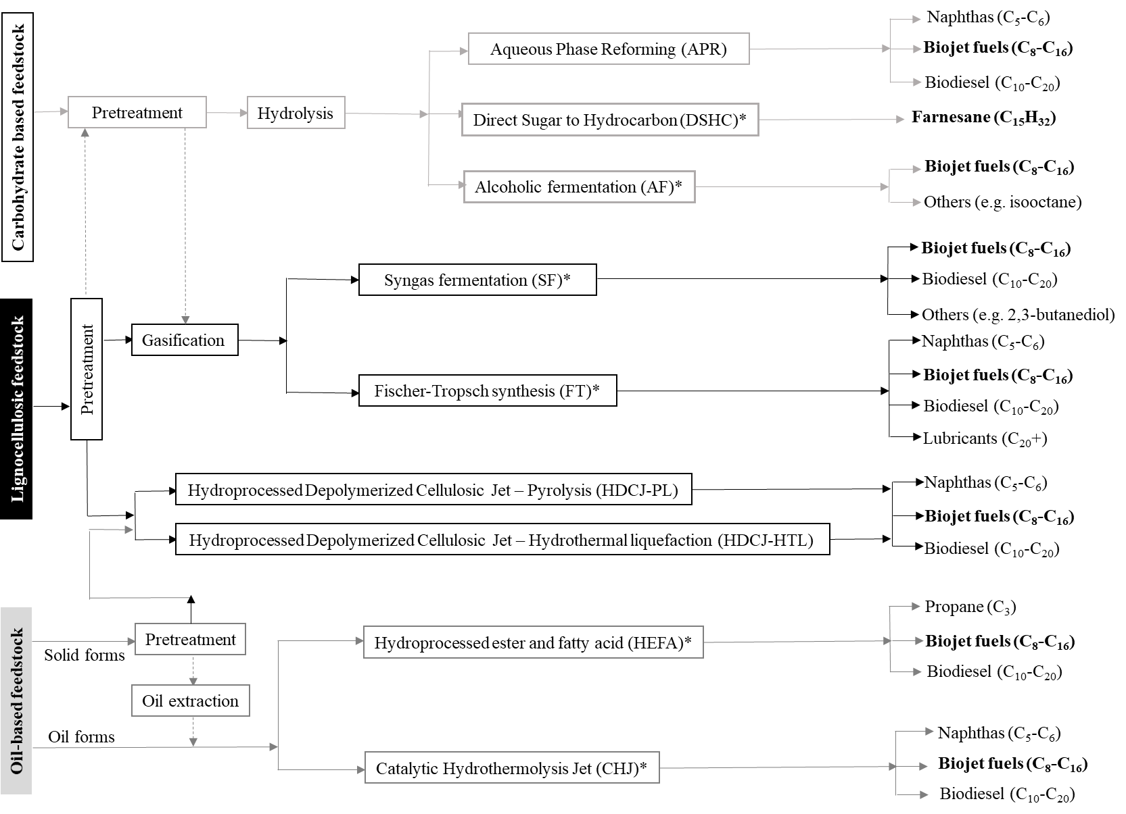
Fig. 1 Main conversion pathways in the production of aviation biofuels. (*) Indicates that the pathway is certified by ASTM.
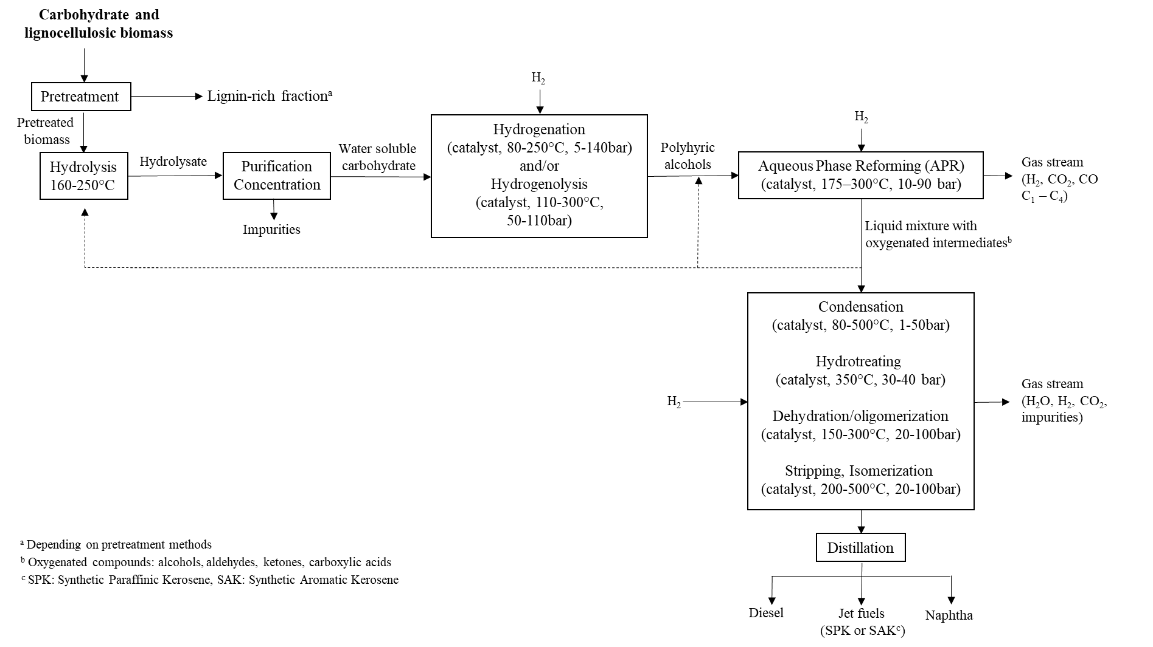
Fig. 2 Process flow diagram for the aqueous phase reforming (APR) pathway
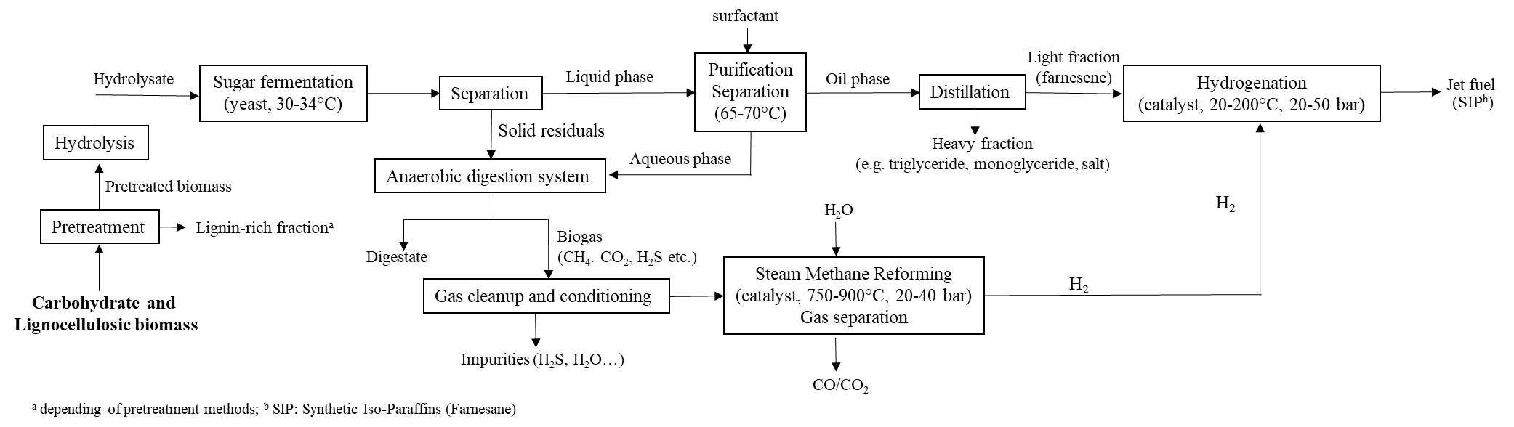
Fig. 3 Process flow diagram for direct sugar to hydrocarbon (DSHC) pathway
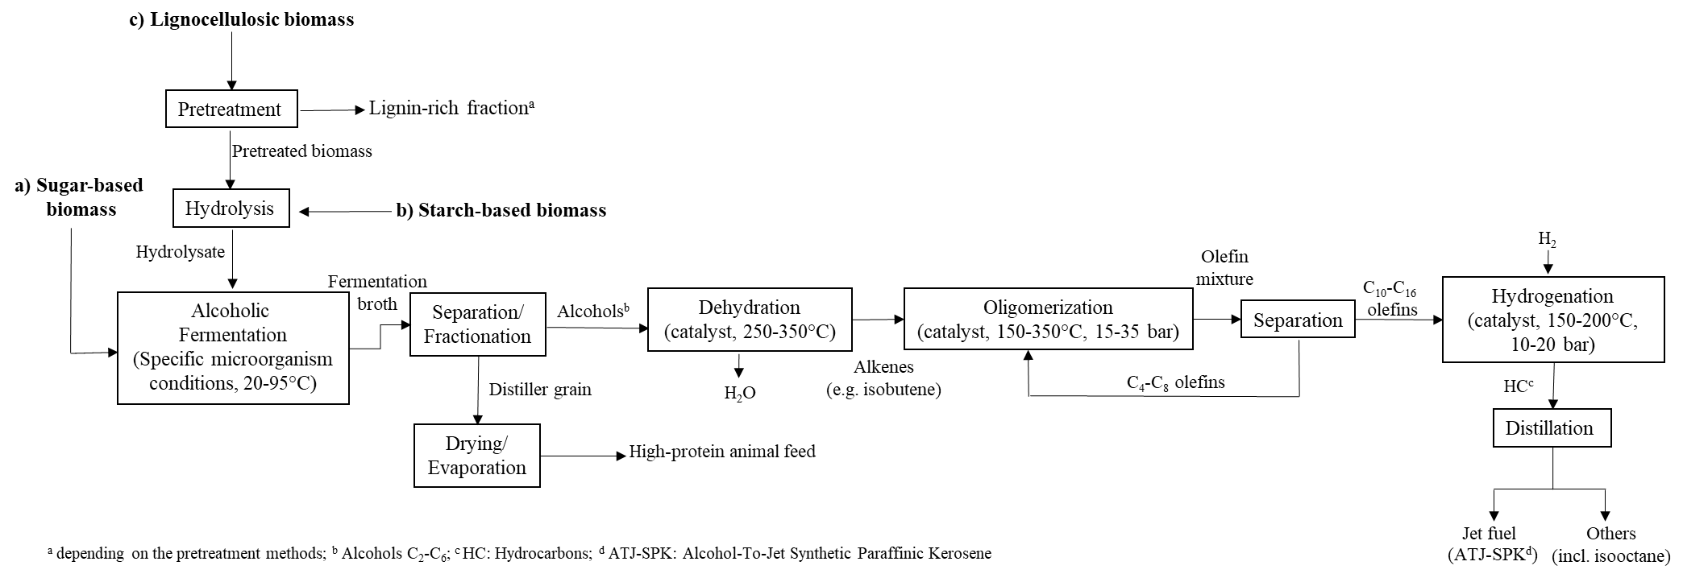
Fig. 4 Process flow diagram for the alcoholic fermentation (AF) from different types of feedstocks (a, b and c)
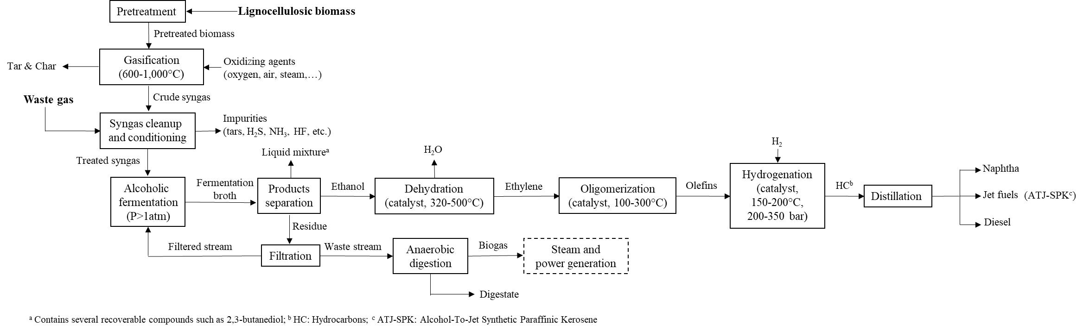
Fig. 5 Process flow diagram for biomass gasification and syngas fermentation (SF) pathway
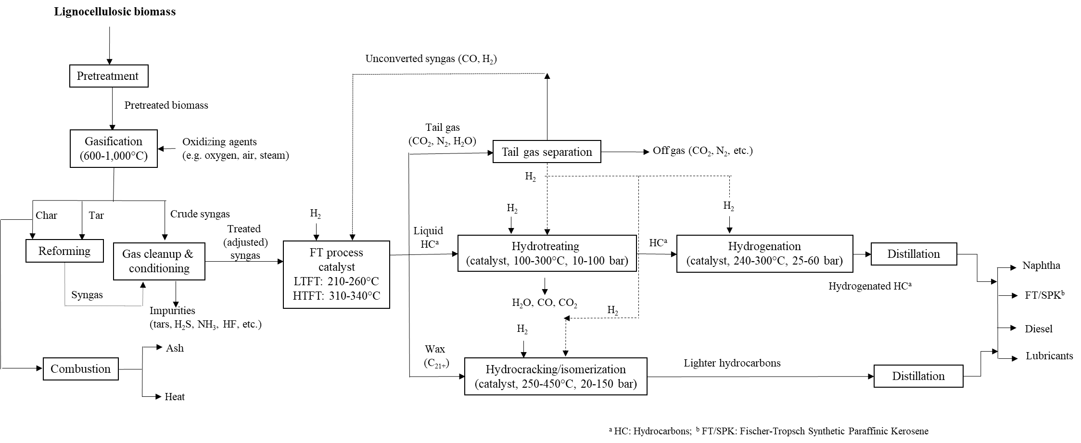
Fig. 6 Process flow diagram for biomass gasification and Fischer-Tropsch (FT) pathway
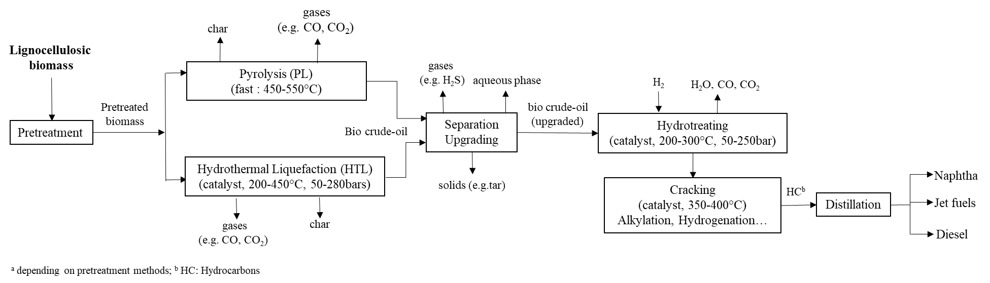
Fig. 7 Process flow diagram for hydrotreated depolymerized cellulosic jet (HDCJ) pathway
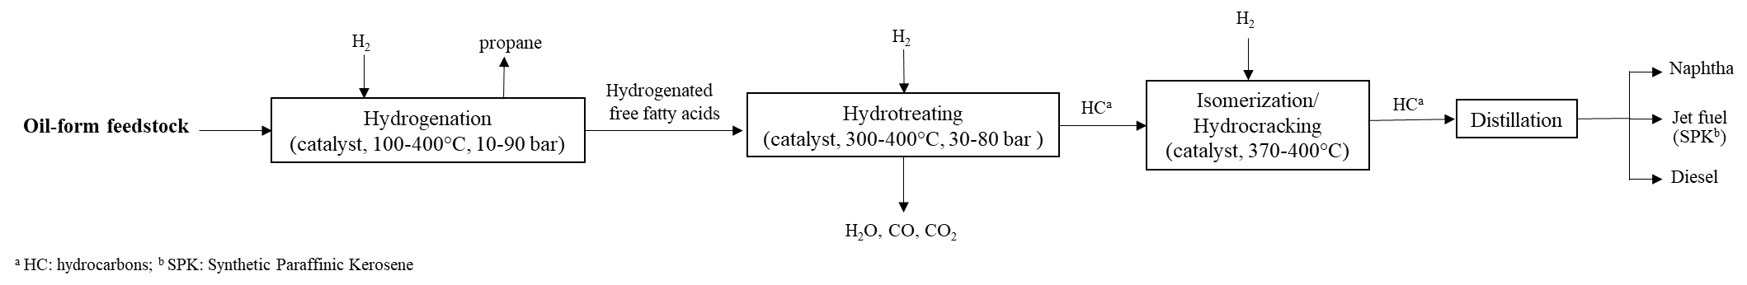
Fig. 8 Process flow diagram for hydroprocessed renewable jet/hydroprocessed esters and fatty acids (HRJ/HEFA) pathway
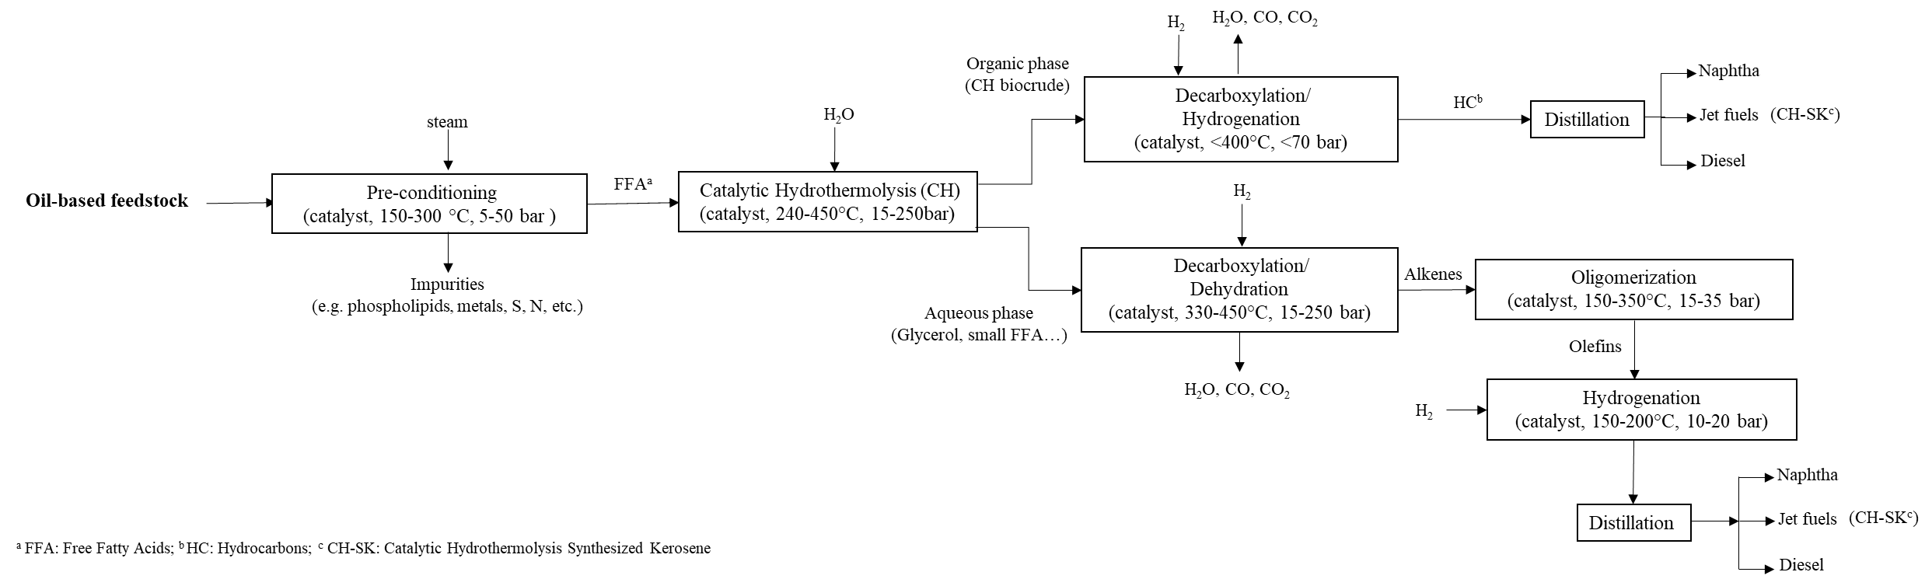
Fig. 9 Process flow diagram for catalytic hydrothermolysis jet (CHJ) pathway
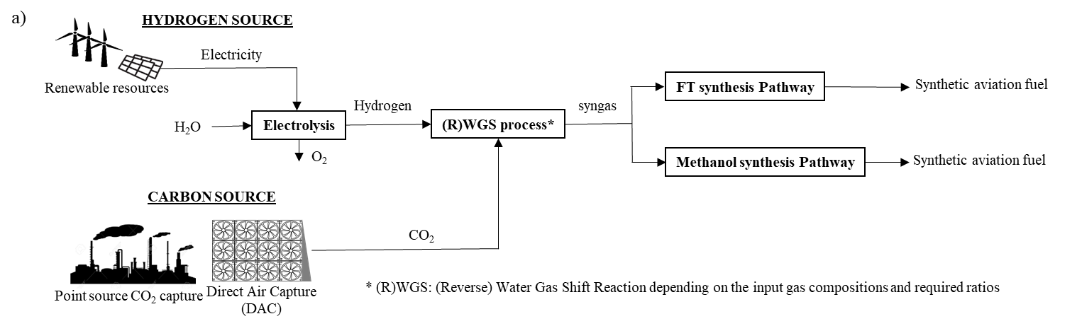
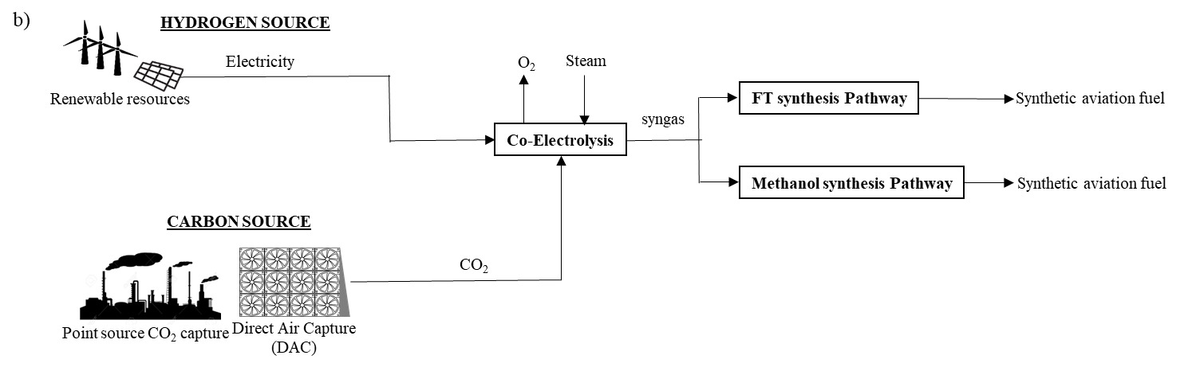
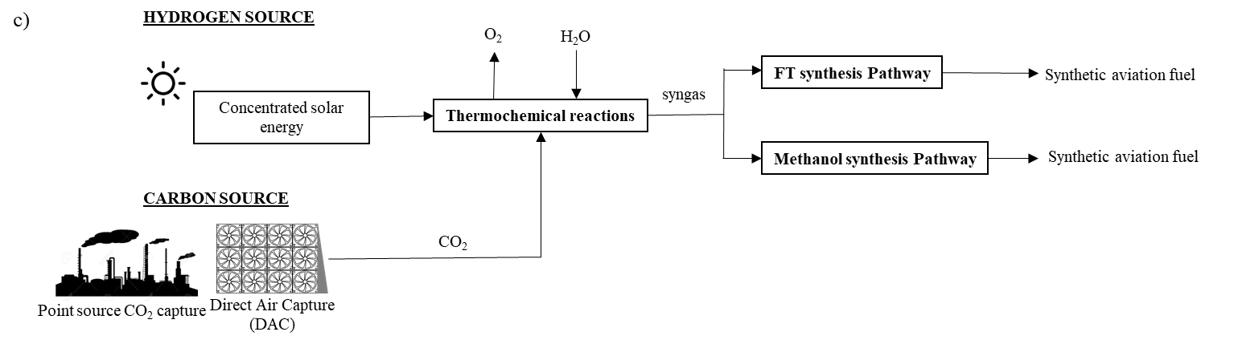
Fig. 10 Electrofuels production process by water electrolysis (a), co-electrolysis (b) and solar thermochemical process (c)
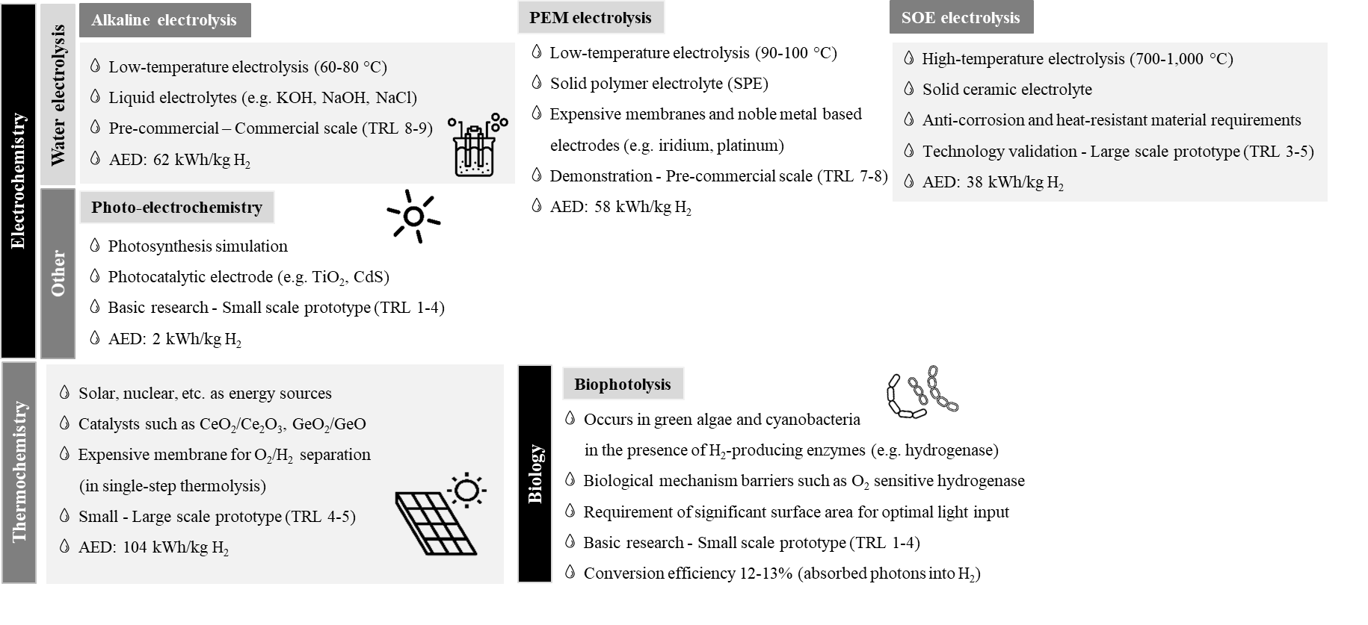
Fig. 11 Water splitting hydrogen production technologies. AED: Average Energy Demand, calculated from a of compilation of several references (see Table S4 in SM).
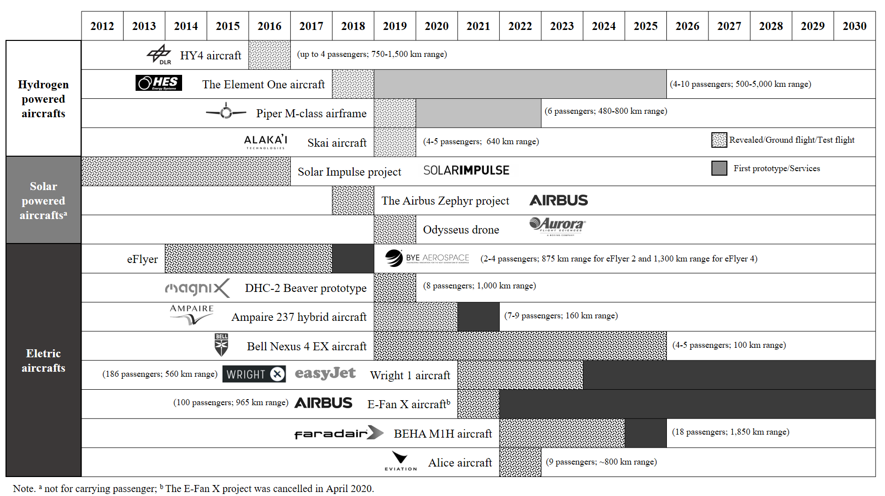
Fig. 12 Summary of inventoried electric and carbon-free aviation projects announced to date (December 2020)
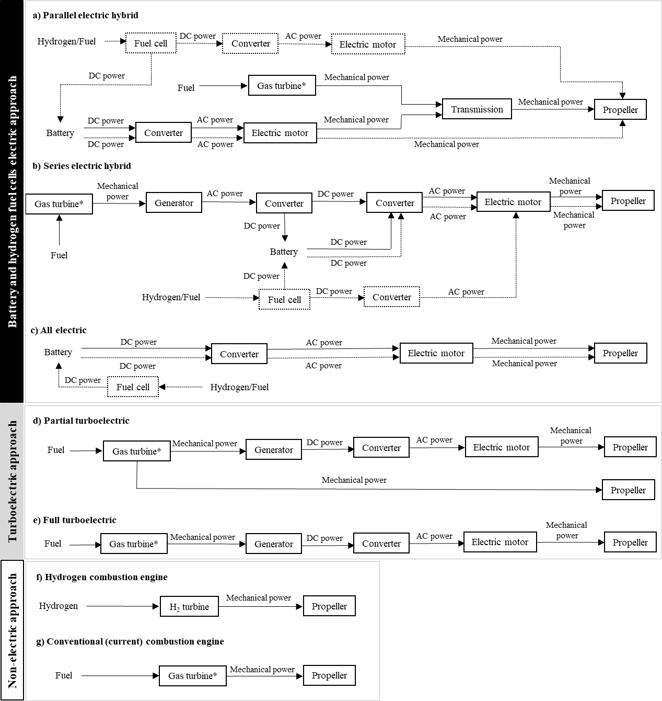
Fig. 13 Basic configuration schemes for aviation propulsion systems. Dotted lines and boxes represent the hydrogen fuel cell configuration. DC stands for direct current, AC for alternative current. *Gas turbine here denotes whether turboshaft, turboprop and turbofan engines.
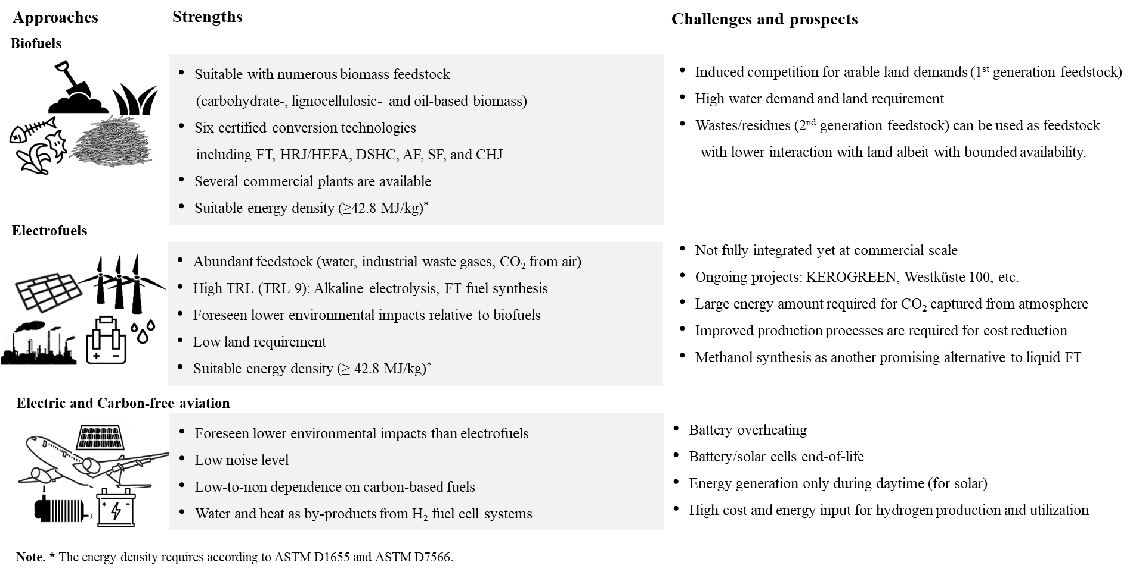
Fig. 14 Strengths and challenges/prospects of three existing approaches for low fossil-carbon aviation

