A New Interface To Cope With Unreliable Airspeed Indications:
A Behavioral And Eye-Tracking Study.

Eve F. Fabre ¹*, Patrick Braca ², Vsevolod Peysakhovich ¹ and Frédéric Dehais ¹
¹ Laboratory of Human Factor & Neuroergonomics, Department of Aerospace Vehicles Design and Control, ISAE-Supaero, Toulouse, France
² Air France, Roissy CDG, France

* Correspondence: Eve F. Fabre; eve.fabre@isae-supaero.fr

Abstract
When unreliable airspeed events occur, the pilot flying (PF) is required to fly the aircraft using the thrust and the pitch parameters that are displayed in two distanced locations of the flight deck. The Sycopaero interface was designed to limit the PF’s workload by automatically displaying thrust and pitch values specific to aircraft configuration on the Primary Flight Display. Participants performed a simulated flight scenario in which they lost airspeed information during take-off with and without the Sycopaero interface. Both behavioral and ocular results demonstrate that the Sycopaero interface significantly lowers PFs’ mental workload and improves their monitoring performance. Taken together, these results suggest that the Sycopaero interface may be an efficient solution in case of unreliable airspeed events.
Keywords: Sycopaero, unreliable airspeed event, aviation, workload, pilot flying

- Introduction
Over the last decades, the automatization and complexity of aircraft have increased drastically (Lee, 2006). While this evolution helped significantly improve air safety (Boeing, 2012), it also led to the emergence of new types of accidents linked to breakdowns in human-automation coordination, where pilots lack knowledge and have trouble understanding about the current and future state of the automation (e.g., Dehais, et al., 2015; Parasuraman, & Manzey, 2010; Sarter, et al., 2007), as it sometimes happens when an unreliable airspeed event (UAE) occurs (Silva & Nicholson, 2012).
Most of the time, UAEs translate into abnormally large Mach number or indicated airspeed fluctuations and differences between the indications for the two pilots. In the worst-case scenario, all pitot probes are affected at the same time, which makes the detection of the failure more difficult as the information between the sources seems consistent. Abnormal behavior of the autothrust and/or the autopilot can also be observed (e.g., disconnection), which triggers a reversion of the flight control laws resulting in a lower flight envelope protection compared to a nominal flight situation. As a failure of the autopilot and/or the autothrust can trigger a total loss of control of the aircraft, UAEs have to be quickly detected and properly handled (BEA, 2012; Silva & Nicholson, 2012).
When the pilots detect an UAE, the pilot flying (PF) is required to disconnect the autothrust, the autopilot and the flight directors, resulting in a decreased automation level. The PF also has to adjust manually the thrust and the pitch of the aircraft according to predefined settings that can be found in the flight crew operating manual and are usually provided by the pilot monitoring (BEA, 2012). In Airbus 320 aircraft, the thrust information (N1) is displayed in the Electronic Centralized Aircraft Monitor (ECAM) located in the middle of the flight desk, while the pitch of the aircraft is displayed in the Primary Flight Display (PFD) located in front of the pilots. UAEs were found to significantly increase airline pilots’ stress, both because they feel less protected due to the sudden drop in automation and because they are not always able to understand what is happening (BEA, 2012). They also trigger a sudden increase in workload, due to 1) the effort associated with the understanding of the failure and 2) the operation of the aircraft in degraded conditions (e.g., the recovery procedure and the repeated switch of attention between the ECAM and the PFD; Fitts, et al., 1949; BEA, 2012). Workload and stress are likely to affect the pilots’ cognitive skills, to undermine their reasoning and piloting performances and therefore to negatively affect flight safety (Goode, 2003; Sarter, et al., 1997). Even though the airspeed failure is properly handled by the pilots, the increased workload and stress associated with the operation of the aircraft in degraded conditions are likely to trigger fatigue in the mid and long term and substantially increase the risk of action selection errors and execution errors (Silva & Nicholson, 2012), which are the main causes of accident in these conditions (e.g., DGATP, 1996; NTSB, 1974; DGAC, 1996; BEA, 2012).
While one’s first reaction may be to blame the pilots for not always being able to handle UAEs, it is important to ask the question as to the extent to which an appropriate interface could have supported the pilots in these very stressful and hazardous conditions and prevented these terrible accidents (Silva & Nicholson, 2012). The lesson to be learned from these accidents is that the human operator was not considered as an entire element of the overall system when designing automated systems, thus, these problems are the result of a failure to design for a coordinated team effort across human and machine agents as one cooperative system (Sarter, et al., 1997). Instead, the human operator is considered as a providential who will take-over when automation fails (Gateau, et al., 2016). Unfortunately, the technological response to these accidents often consists in implementing even more automation rather than improving the integration of the human in the control and decision loop (Billings, 1996; Chialastri, 2012). However, in the case of unreliable airspeed indication, human-centered solutions could be designed and based on basic flying procedures that are taught to pilots from their ab-initio training.
In reaction to the accident of Air France Flight 447 (BEA, 2012), Airbus developed a system called Back-Up Speed Scale (BUSS©) designed to cope with the potential danger of unreliable speed events. The BUSS© consists of displaying speed information based on the angle of attack as a function of the slat/flap configuration. While this system was recently found to be useful in case of the UAEs (ATSB, 2018), the EASA still advises against its use above flight level 250 and recommends to refer to the pitch and thrust tables in case of strong turbulence (EASA, 2018a). Moreover, the BUSS © was found to be likely to display erroneous information when two angle-of-attack sensors are affected by icing conditions at the same time, making its use potentially dangerous in these specific conditions (EASA, 2018a). A simpler and more reliable solution may be to display the thrust and pitch values presented in the flight manual directly into the PFD, as a function of the altitude, the weight, the flight phase and the configuration of both flaps and slats of the aircraft.
The present study aimed at evaluating the impact of the Sycopaero interface on PFs in the occurrence of an identified UAE. This interface consisted of displaying both the pitch and the thrust indications corresponding to the four flight configurations (i.e., TOGA for Take Off/Go-Around, climb, level off and descent/final approach) into the PFD to facilitate both the monitoring and the aircraft operation. Participants had to perform a simulated flight scenario as PF (in which the airspeed information was lost in a collision with birds during take-off, forcing them to return to the departure airport) with (i.e., Sycopaero scenario) and without (i.e., control scenario). The subjective mental workload of the participants was assessed in each scenario using the NASA-TLX questionnaire (Hart, 2006). The mean speed and the speed variations were measured in both scenarios. Participants’ ocular activity was also measured with a remote eye-tracker set up in the flight simulator. This technique is particularly suited to investigate the attentional processes of the operators (Helleberg & Wickens, 2003; Peysakhovich, et al., 2018) as it provides objective and quantitative evidence of the user’s visual and (overt) attentional processes reflecting their mental processes (Duchowski, 2002). Consequently, it appeared to be the most suitable technique for assessing the extent to which the Sycopaero interface modulates the attentional processes of the PF. We predicted that the loss of reliable airspeed would be associated with a lower perceived mental demand and lower speed variability in the Sycopaero flight scenario then in the control scenario. We also predicted that the participants would spend less time monitoring the thrust information using the ECAM’s indicator (N1) and retrieve this information from the thrust indicator duplicated in the PFD (N1d). Consequently, we expected to observe respectively an increase and a decrease in dwell time percentages for the N1d and the ECAM. Furthermore, we also expected to observe a decrease in transition rate between the attitude indicator (AI) and the N1d and a decrease in transition rates between the AI and the ECAM.

- Material and Method
  - Participants
Twenty professional pilots (11, 5 and 4 pilots operating respectively Airbus, Boeing and ATR/MEP aircraft); and two student pilots (Pilatus PC-12) who completed their training the same week took part in this study (22 males; Age: M = 34.67 years, SD = 9.21). Thirteen of them had an Airline Transport Pilot License and the remaining 9 had a Commercial Pilot License (Flight hours: M = 4328, SD = 3052). They all had a previous experience in an Airbus simulator. They were recruited via advertisement and received no financial compensation for their participation. All had a normal or corrected-to-normal vision. None of them reported a prior history of neurological disorder.
  - Ethics Statement
All participants were informed of their rights and gave written informed consent for participation in the study according to the Helsinki Declaration. The experimental protocol was reviewed and approved by a regional ethics committee (CERNI no.2018-108).
  - Material
    - Interfaces
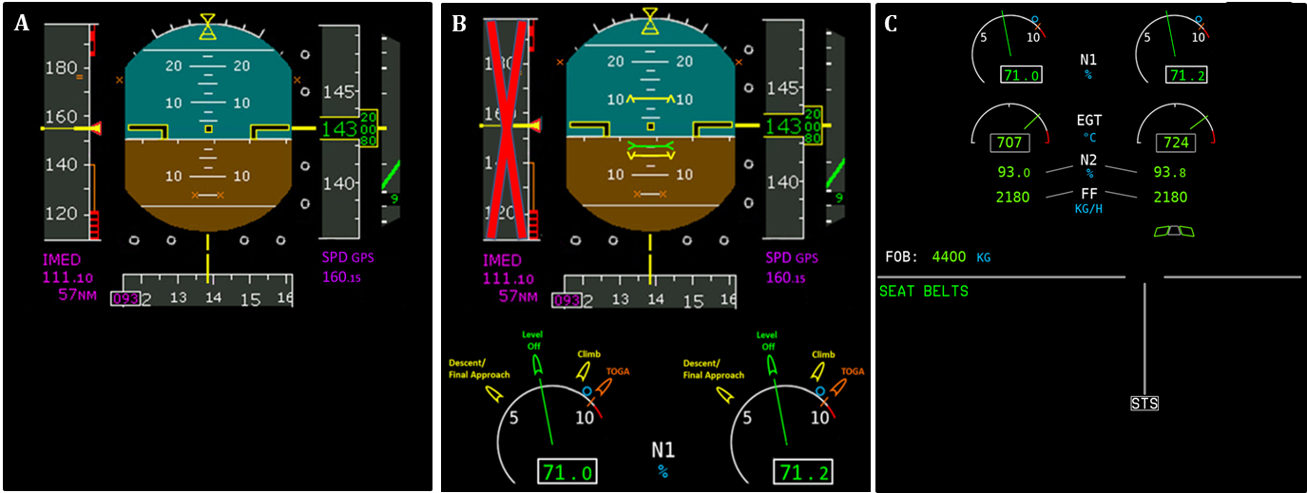
In this experiment, we compared the performances of the participants in a flight scenario performed with the Sycopaero interface (Figure 1.B.) to the performances in the same flight with the interface that is currently displayed when an unreliable speed event occurs (i.e., control interface; Figure 1.A.). The Sycopaero interface consisted of displaying the pitch and the thrust values for the climb, cruise (i.e., level off), descent and approach phases as a function of the current aircraft, flap/slat configuration, landing gear configuration and estimated weight of the aircraft (see Figure 1.B.). The pitch values are symbolized by three colored lines with two arrowheads at their extremities and displayed directly on the PFD: the pitch value of the level-off is a green line with the arrowheads pointing to the center of the line, while the climb and the descent pitch values are yellow lines with the arrowheads pointing up and down respectively. The pitch value of TOGA was not displayed as pilots know this value by heart. The thrust information (N1) is displayed on the ECAM (see Figure 1.C.). As the latter is quite far from the PFD (see Figure 3), we decided to duplicate the N1 (i.e., N1d) and to place it directly into the PFD in order to minimize the workload associated with monitoring (i.e., only one area to monitor instead of two). Four notches were placed around the half-circles representing the thrust in the N1d (see Figure 1.B.). The color code of the notches is the same as the pitch value lines: the notch representing the cruise thrust value is colored in green, the notches representing the thrust values of descent and climb are colored in yellow and the notch representing the TOGA thrust value is colored in amber. The color code recommended by the EASA (2018b; see Part 25.1321) and the FAA (2010; see Part 25.1322) for flight deck design was applied. Yellow and amber inks were used to indicate marginal conditions or to alert of situations where caution, recheck, or unexpected delay is necessary. Green was used to indicate that monitored equipment/processes are within tolerance or a condition is satisfactory and that it is all right to proceed with an operation or transaction. Finally, the airspeed indicator was crossed out in order to prevent the pilots from consulting it. The design process is described in details in the supplementary materials.
Figure 1.
    - Flight simulator.
The experiment was conducted in a simplified A320 flight simulator called XXX at XXX.
    - Eye Tracker.
A Smart Eye Pro (Smart Eye AB, Gothenburg, Sweden) remote eye-tracking system, with a 60-Hz sampling rate and five-camera set-up with two IR flash illuminators was used in the present study. Eleven points were used for calibration.
  - Procedure
After they gave their written consent, participants were handed a booklet describing four different new interfaces/warning systems. Only one of them was the Sycopaero interface that was going to be tested during the experiment. The three remaining interfaces/systems were fictional (see supplementary materials) and were presented to the participants in order to prevent them from predicting the failure they would have to handle during the experiment. Participants took the left seat of the PEGASE flight simulator. They were then asked to perform one landing procedure and one take-off procedure to become acquainted with the PEGASE flight simulator. Once they felt at ease, the eye-tracker was calibrated. Participants were asked to look at the 11 different calibration points located around the flight deck and the exterior. Each participant was calibrated to obtain overall accuracy of at least 1.5°. This level of accuracy ensured a sufficient level of precision to detect the subparts of the PFD (13° x 17°) with: the speed and altitude indicators (3.5° x 10°), the AI (6° x 10°) and the N1d area (i.e., the lower part of the PFD; 5° x 13°). Once calibration was completed, the experiment started. Just after take-off, participants who performed the flight as PF heard a loud noise. The experimenter who served as a “pseudo” pilot monitoring, informed participants that the aircraft had just collided with birds, which resulted in the destruction of all pitot probes (see Figure 2). Then the former provided participants with the thrust and the pitch values to be applied (that could also be retrieved in the flight crew operating manual) and informed them that 1) they had been cleared by the ATC to perform a go-around procedure and to land on the same runway they took off and that 2) no other aircraft was present in the area they were operating the aircraft.
They had to perform a go-around procedure at an altitude of 3000 feet to return to the departure airport and land on the same runway they took off from. A thick cloud layer between 1000 and 2000 feet prevented the pilots from flying by sight, forcing them to rely on the flight instruments only. Participants had to perform this flight scenario twice: once with the Sycopaero interface (i.e., Sycopaero scenario) and once with the control interface (i.e., control scenario). Half of the participants started the experiment with the Sycopaero scenario, while the other half started with the control scenario.
In the control scenario participants had to perform the rest of the flight with the standard instrumentation found in Airbus aircraft (i.e., the BUSS was not part of the instrumentation), while in the Sycopaero scenario, the thrust and pitch values were directly displayed into the PFD (see Figure 1.B.). Participants’ ocular activity was recorded in both scenarios. After each flight scenario, participants filled out the NASA-TLX questionnaire aiming at evaluating the subjective mental demand (Hart, 2006). At the end of the experiment, participants were debriefed and asked to give their views on the interface and how they thought it could be improved.
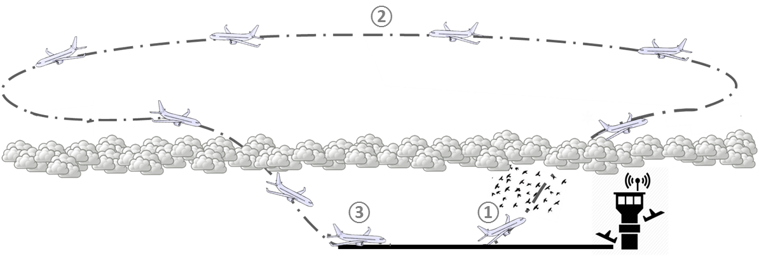
Figure 2.

- Results
  - Behavioral results
    - Speed variations
The speed of the aircraft and the standard deviations of the speed were measured in both scenarios from the moment the aircraft took-off to the moment it touched the runway for landing. After ensuring that the data were normally distributed, two two-tailed paired Student t-tests were conducted on the mean speeds and the standard deviations of the speed measured in the Sycopaero scenario and the control scenario. The analysis revealed no significant differences in mean speed [t (21) = .20, p = .84; control scenario: M = 148.93 knots, SD = 9.22; Sycopaero scenario: M = 149.40 knots, SD = 8.24] or in speed standard deviation [t (21) = - .48, p = .63; control scenario: M = 9.74 knots, SD = 5.45; Sycopaero scenario: M = 9.21 knots, SD = 4.31].
    - NASA-TLX.
Two-tailed paired Student t-tests and Wilcoxon signed-rank tests were conducted on the raw NASA-TLX data when the latter were respectively normally and non-normally distributed. Overall, the analysis revealed a significant reduction of the workload when the scenario was performed with the Sycopaero interface [t (21) = 4.17, p < .001; M = 32.23, SD = 13.07] compared to the control scenario (M = 47.00, SD = 21.32).
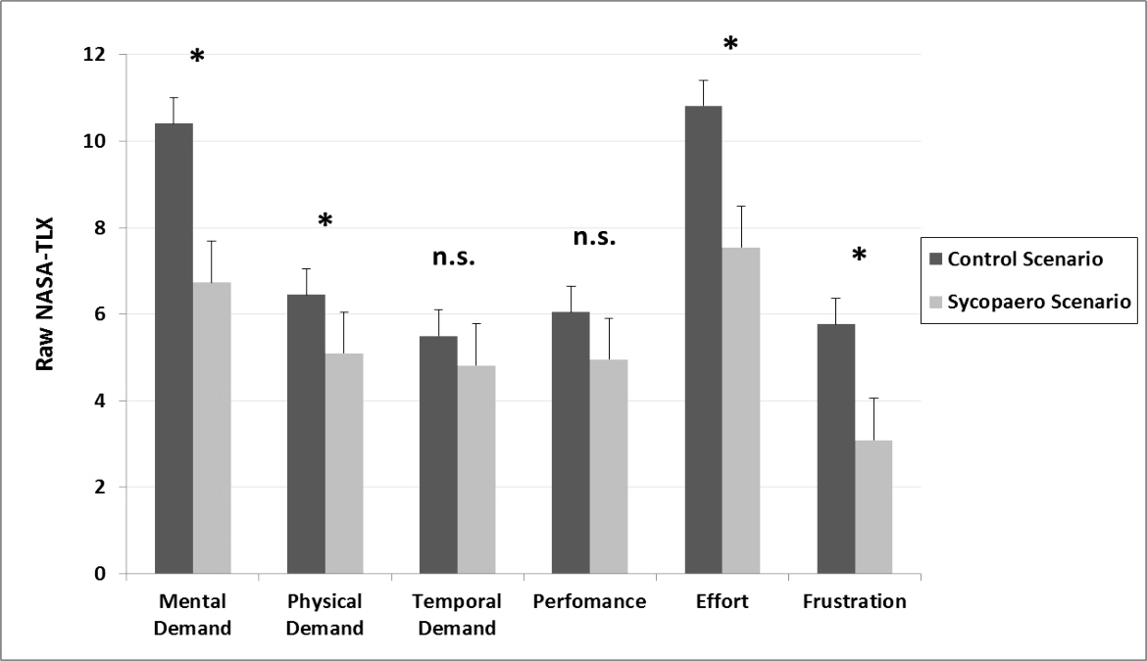
The analysis of the NASA-TLX sub-scales revealed higher perceived mental demand [t (21) = 5.30, p < .001; M = 10.41, SD = 4.11], physical demand [t (21) = 2.81, p < .05; M = 6.45, SD = 3.90], effort [t (21) = 4.46, p < .001; M = 10.82, SD = 4.49] and frustration [T = 15, z = - 2.564, p < .05; M = 5.77, SD = 4.23] in the control scenario than in the Sycopaero scenario [mental demand: M = 6.73, SD = 3.13; physical demand: M = 5.09, SD = 3.28; M = 7.55, SD = 4.57; effort: M = 7.55, SD = 4.57; frustration: M = 3.09, SD = 2.24]. No significant differences in perceived temporal demand [T = 44, z = - 1.248, p = .212; control scenario: M = 5.50, SD = 4.82; Sycopaero scenario: M = 4.81, SD = 2.86] and perceived performance [T = 62, z = - 1.620, p = .105; control scenario: M = 6.05, SD = 2.80; Sycopaero scenario: M = 4.95, SD = 3.60] were found (see Figure 3).
Figure 3.
    - Post-experimental debriefing.
During the debriefing, all 22 participants reported that the interface was very natural to use, well-designed and that it made them feel safer in this very stressful situation. All reported that they thought crossing-out the airspeed indicator was a good idea, because it helped them remember that this information − they are used to monitor continuously − was no longer valid, which lowered their cognitive charge. With the exception of one pilot who declared that he had some difficulty adapting to the N1d, the remaining twenty-one pilots reported that duplicating the N1 in the PFD made the monitoring easier and lessened their workload. They were pleased that the N1 was not removed from the ECAM when the Sycopaero interface appeared. They found reassuring that the Sycopaero interface did not upset their routine, allowing them to continue monitoring thrust in the ECAM if they wished to.
  - Oculometric results
    - Dwell times.
In order to compare the ocular activity of the pilots during the two versions of the flight scenario, 6 areas of interest (AOIs) were created (see Figure 4). They corresponded to the main flight instruments: the ECAM, the navigator display (ND), the flight control unit (FCU) and the exterior (EXT). As the introduction of the Sycopaero interface had modified the PFD, we divided the PFD into two separate areas: one area corresponding to the Sycopaero interface (SYC) comprising the N1d and the AI in the center of the PFD, and an area comprising the remaining parts of the PFD (PFDr).
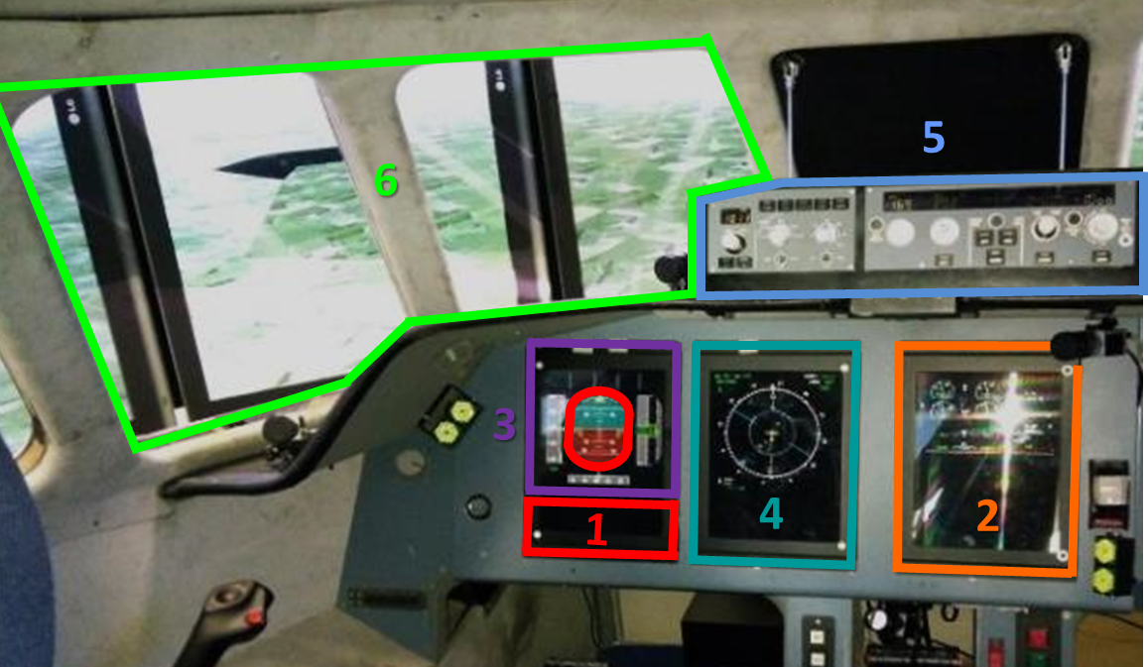
Figure 4.
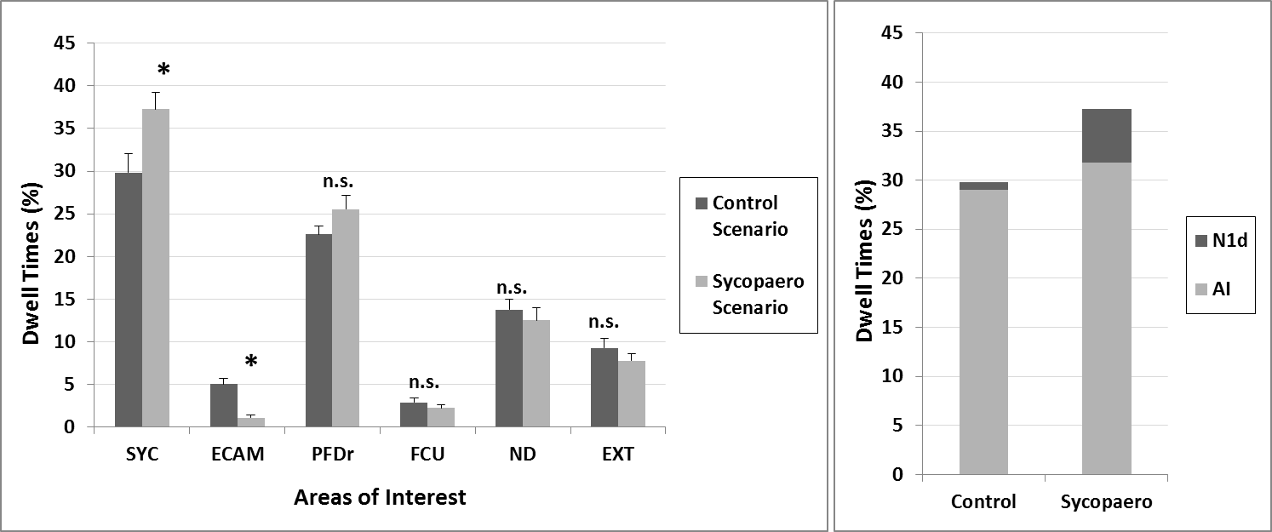
The dwell time percentages to the 6 AOIs and the area of “non-interest” (i.e., the area regrouping the zones of the cockpit not included in the AOIs) were measured in the control scenario and the Sycopaero scenario from the moment the aircraft took-off to the moment it touched the runway for landing. A 2 x 6 [Scenario (Sycopaero; control) x AOIs (SYC, ECAM, PFDr, ND, FCU, EXT)] ANOVA Tukey-HSD post-hocs were conducted on the dwell times. A significant main effect of scenario [F (1, 21) = 7.56, p < .05, ηp² = .26] was found with longer dwell times on the AOIs in the Sycopaero scenario (M = 14.40%, SD = 28.55) compared to the control scenario (M = 13.88%, SD = 26.61). The analysis revealed a significant Scenario x AOIs interaction [F (5, 105) = 17.20, p < .001, ηp² = .45; see Figure 5.A.], with longer dwell times on the Sycopaero Area (SYC) and shorter dwell times on the ECAM in the scenario with the Sycopaero interface (SYC: M = 37.25%, SD = 9.27; ECAM: M = 1.09%, SD = 1.18) than in the control scenario (SYC: M = 29.82%, SD = 10.42, p < .001; ECAM: M = 5.01%, SD = 3.18, p < .01). No significant differences were found for the remaining AOIs between the scenario with the Sycopaero interface and the control scenario (Figure 5.A). The analysis also revealed a main effect of AOIs [F (1, 21) = 97.22, p < .001, ηp² = .82]. For the sake of clarity, the details of these results were reported in the supplementary materials (see Tables 1 and 2). A 2 x 2 [Scenario (Sycopaero; control) x AOIsyc (N1d; AI)] ANOVA was also performed on the dwell times and revealed a main effect of scenario [F (1, 21) = 39.78, p < .001, ηp² = .65; see Figure 5.B.] with longer dwell times on the two AOIs composing the SYC area (AOIsyc) with the Sycopaero interface (M = 18.62%, SD = 15.53) than without it (M = 14.91%, SD = 16.25).
A
B
Figure 5.

The analysis also revealed a main effect of AOIsyc [F (1, 21) = 123.95, p < .001, ηp² = .85], with more time spent on the AI (M = 30.43%, SD = 10.71) than on the N1d (M = 3.11%, SD = 3.94). The Scenario x AOIsyc interaction [F (1, 21) = 1.03, p = .32, ηp² = .05] did not reach significance.
    - Transitions between the areas.
Complementary analyses were conducted to investigate the transitions between the three areas of interest: N1d, the ECAM and the AI; and an area covering the remaining areas of interest (AOIr) in order to investigate how the introduction of the N1d impacted the joint monitoring of the thrust and the attitude. As the ND is located next to the ECAM and pilots’ gaze had to pass through the ND to access the ECAM, this may have interfered with the measurements of the saccades between the ECAM and the remaining areas of interest. To prevent this, a unique area merging the ECAM and the ND was created, assuming that introducing the Sycopaero interface would not modify the number of transitions between the ND and the remaining areas of interest. A 2 x 12 [Scenario (Sycopaero; control) x Transition (AOIr→ECAM/ND; AOIr→AI; AOIr→N1d; ECAM/ND→AOIr; ECAM/ND→AI; ECAM/ND→N1d; AI→AOIr; AI→ECAM/ND; AI→N1d; N1d→AOIr; N1d→ECAM/ND; N1d→AI)] ANOVA was conducted on the data, revealing a significant Scenario x Transition interaction [F (11, 231) = 7.26, p < .001, ηp² = .26; see Figure 6], with an increase in AI→N1d transitions (M = 82.47%, SD = 9.86, p < .01) and N1d→AI transitions (M = 17.72%, SD = 10.23, p < .001) in the Sycopaero scenario compared to the control scenario (AI→N1d: M = 70.81% , SD = 23.07; N1d→AI: M = 5.06%, SD = 4.91). Tukey-HSD post-hoc analysis revealed no significant differences in transition rates for the remaining AOIs between the Sycopaero scenario and the control scenario (p_{s} > .36).
The details of this analysis were presented in the supplementary materials (see Table 4). The analysis also revealed a main effect of transitions [F (11, 231) = 239.46, p < .001, ηp² = .91]. The details of this result were reported in the supplementary materials for sake of clarity (see Table 3.). The main effect of condition did not reach significance [F (1, 21) = 1.00, p = .32, ηp² = .05].
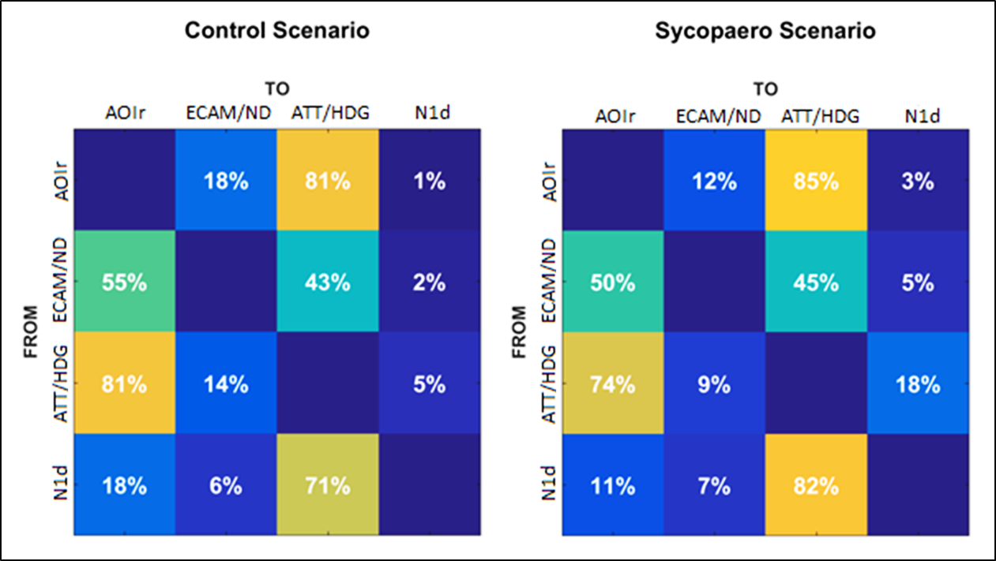
Figure 6.
B
A

- Discussion
The present study aimed at testing the efficiency of a new interface called Sycopaero, designed to support PF and lower their workload in the event of identified airspeed failure. All pilots were able to safely land the aircraft in both scenarios. Moreover, no differences in mean speed or speed standard deviation were found between the Sycopaero scenario and the control scenario. These results are reassuring as they demonstrate the effectiveness of the intensive training pilots receive to manage this type of failure since the accident of Air France flight 447 (BEA, 2012). Despite the absence of difference in flight performance, during the post-experimental debriefing participants reported that the interface was very natural to use, well-designed and that it made them feel safer in this very stressful situation. Analysis of the raw NASA-TLX data (Hart, 2006) revealed that overall participants estimated that the Sycopaero interface significantly reduced the mental workload in the occurrence of a pitot probes failure. More specifically, participants reported lower mental demand, physical demand, effort and frustration in the Sycopaero scenario than in the control scenario. Taken together, these results suggest that the Sycopaero interface was very well accepted by the participants operating as PF and lowered their mental workload, which is a key point when facing an UAE (Silva & Nicholson, 2012).
Participants’ ocular activity was analyzed in order to assess how the Sycopaero interface impacted the way PFs allocate their attentional resources in the occurrence of an UAE with and without the Sycopaero interface (Duchowski, 2002). Proportionally to the duration of the flight scenarios, participants were found to spend significantly more time monitoring the areas of interest (i.e., main flight instruments) with the Sycopaero interface than with the control interface. In case of an UAE, the thrust and the pitch values corresponding to the current condition of the aircraft (i.e., altitude, weight and flap/slat configuration) are required to maintain the balance of the aircraft and to prevent it from stalling. This information has to be retrieved from the flight crew operating manual by the pilot monitoring (BEA, 2012). The time necessary to retrieve this information before being able to stabilize and secure the aircraft is particularly stressful and associated with an important workload. Displaying the thrust and pitch data directly into the PFD via the Sycopaero interface facilitated the retrieval of the relevant flight parameters, eliminating the division of attentional resources and enabling almost immediately the PF to stabilize and secure the aircraft (Fitts, et al., 1949). Participants were also found to spend proportionally more time monitoring the N1d and less time monitoring the ECAM with than without the Sycopaero interface. Moreover, the analysis of the transition rate matrices between the merged areas of interest revealed that the transition rates between the ATT/HDG area (i.e., attitude and heading indicators) and the N1d in the PFD tended to increase (+ 12%). These results suggest that the participants most often monitored the thrust on the N1d and at least partially abandoned the usual N1 indicator located in the ECAM. The interface appears to have limited the scattering of the participants’ attentional resources over different and distant flight instruments, and facilitated the monitoring during this type of UAE (Wickens, et al., 2017). These results are also bolstered by the pilots’ comments during the post-experimental debriefing. With the exception of one pilot who declared that he had some difficulty adapting to N1d, the remaining twenty-one pilots reported that duplicating the N1 in the PFD made the monitoring easier and lessened their workload. Moreover, they positively valued the decision not to delete the N1 indicator in the ECAM, indicating that they found it reassuring. More generally, no differences in dwell time percentages and transition rates were found for the remaining areas of interest between the two scenarios. This result demonstrates that the introduction of the Sycopaero interface did not disrupt the participants’ monitoring of the remaining flight instruments (i.e., the areas aside from the ECAM and the SYC areas). Taken together, these results suggest that the Sycopaero interface, by locating the critical indicators directly in the PFD, facilitated the retrieval of the thrust and pitch information, increased the time spent monitoring the areas of interest (i.e., main flight instruments) and did not distort the way the attentional resources were allocated to the main fight instruments in PFs. The present study suggests that this new and easy-to-implement human-machine interface may be a suitable solution for supporting the PF when reliable airspeed information is no longer available, and may help prevent disastrous accidents in the future.
Further investigation is nevertheless needed before this interface could be implemented in commercial aircraft. The present experiment aimed at investigating how the Sycopaero interface impacts the mental workload and the performance of PF when an unreliable speed event occurs and is immediately identified. While we did not investigate its impact on the pilots monitoring, it is very likely that the interface would also benefit them, as the simplification of the aircraft stabilization procedure may 1) lower both their stress and workload and 2) enable them to almost directly focus on the correction of the airspeed failure. Nevertheless, this assumption should be confirmed experimentally. In the present study, we chose to use a scenario where the UAE was immediately detected and understood and were only able to investigate its impact on the mental workload associated with the aircraft operation. The present study does not allow to conclude on whether the Sycopaero interface would facilitate the detection and/or understanding of UAEs. Therefore, this interface should be tested on both PFs and pilots monitoring using different scenarios where the UAE is hard to detect and/or understand, as it happened in the AF447 accident for instance. Further research is also needed to status on the way the Sycopaero interface should be displayed in the event of an airspeed failure. We think that the automatic display of the Sycopaero interface when the system detects airspeed inconsistencies (as it was implemented in the present study) may provide valuable assistance to the pilots. It may also be interesting to enable the pilots to manually activate the interface in case of doubt and/or decide whether they want to cross-out the airspeed indicator or not, but these assumptions should be confirmed experimentally. Finally, UAEs are an important problem in both general and military aviation. It would be interesting to investigate whether the Sycopaero is a suitable solution to this problem in other aviation fields. In closing, the present study advocates for widespread use of the eye-tracking method for the evaluation of the human-machine interfaces before they are implemented in cockpits. This kind of scientific approach would enable maximal interface efficiency and contribute to increased flight safety.

References
ATSB (2018). Managing the use of pitot probe covers at Brisbane Airport. Safety Advisory Notice Number: AO -2018-053-SAN-003.

Billings, C. E. (1996). Human-centered aviation automation: Principles and guidelines.

Chialastri, A. (2012). Automation in aviation. INTECH Open Access Publisher.

BEA (2012). Final Report: On the accident on 1st June 2009 to the Airbus A330-203 registered F-GZCP operated by Air France flight AF 447 Rio de Janeiro – Paris. https://www.bea.aero/docspa/2009/f-cp090601e3.en/pdf/f-cp090601e3.en.pdf.

Boeing (2012). Statistical Summary of Commercial Jet Airplane Accidents. Worldwide Operations 1959-2011, 2011 Statistical Summary.

Dehais, F., Peysakhovich, V., Scannella, S., Fongue, J., & Gateau, T. (2015, April). Automation surprise in aviation: Real-time solutions. In Proceedings of the 33rd annual ACM conference on Human Factors in Computing Systems (pp. 2525-2534). ACM. Doi: https://doi.org/10.1145/2702123.2702521.

DGATP (1996). Final report, Boeing 757-200 Accident, Aeroperu, 2 October 1996. Lima, Peru. https://www.baaa-acro.com/sites/default/files/import/uploads/2017/09/N52AW.pdf

DGAC (1996). Reporte final accidente aereo birgenair, vuelo alw-301, febrero 06, 1996. http://www.fss.aero/accident-reports/dvdfiles/DO/1996-02-06-DO.pdf

Duchowski, A. T. (2002). A breadth-first survey of eye-tracking applications. Behavior Research Methods, Instruments, & Computers, 34(4), 455-470. Doi: https://doi.org/10.3758/BF03195475

EASA (2018a). Airworthiness Directive No 2018-0189. ATA 34 – Navigation – Back Up Speed Scale / Aircraft Flight Manual – Amendment. https://ad.easa.europa.eu/blob/EASA_AD_2018_0189.pdf/AD_2018-0189_1.

EASA (2018b). Certification Specifications and Acceptable Means of Compliance for Large Aeroplanes, CS-25 Amendment 22. https://www.easa.europa.eu/sites/default/files/dfu/CS-25%20Amendment%2022.pdf

FAA (2010). Flight Crew Alerting, Advisory Circular No 25.1322-1.

Fitts, P. M., Jones, R. E., & Milton, J. L. (1949). Eye Fixations of Aircraft Pilots. III. Frequency, Duration, and Sequence Fixations When Flying Air Force Ground-Controlled Approach System (GCA). AIR MATERIEL COMMAND WRIGHT-PATTERSON AFB OH.

Gateau, T., Chanel, C. P. C., Le, M. H., & Dehais, F. (2016, October). Considering human's non-deterministic behavior and his availability state when designing a collaborative human-robots system. In 2016 IEEE/RSJ International Conference on Intelligent Robots and Systems (IROS) (pp. 4391-4397). IEEE. Doi: ttp://dx.doi.org/10.1109/IROS.2016.7759646

Goode, J. H. (2003). Are pilots at risk of accidents due to fatigue?. Journal of safety research, 34(3), 309-313. Doi: https://doi.org/10.1016/S0022-4375(03)00033-1

Hart, S. G. (2006, October). NASA-task load index (NASA-TLX); 20 years later. In Proceedings of the human factors and ergonomics society annual meeting (Vol. 50, No. 9, pp. 904-908). Sage CA: Los Angeles, CA: Sage Publications. https://doi.org/10.1177/154193120605000909

Helleberg, J. R., & Wickens, C. D. (2003). Effects of data-link modality and display redundancy on pilot performance: An attentional perspective. The International Journal of Aviation Psychology, 13(3), 189-210. Doi: https://doi.org/10.1207/S15327108IJAP1303_01

Lee, J. D. (2006). Human factors and ergonomics in automation design. Handbook of human factors and ergonomics, 1570-1596.

NTSB (1974). Aircraft Accident Report, Northwest Airline Incorporated, Boeing 727-25, N274US, Near Thiells, New York, December 1, 1974. NTSB-AAR-75-B.

Parasuraman, R., & Manzey, D. H. (2010). Complacency and bias in human use of automation: An attentional integration. Human factors, 52(3), 381-410. Doi: https://doi.org/10.1177/0018720810376055

Peysakhovich, V., Lefrançois, O., Dehais, F., & Causse, M. (2018). The neuroergonomics of aircraft cockpits: the four stages of eye-tracking integration to enhance flight safety. Safety, 4(1), 8. Doi:http://dx.doi.org/10.3390/safety4010008

Sarter, N. B., Woods, D. D., & Billings, C. E. (1997). Automation surprises. Handbook of human factors and ergonomics, 2, 1926-1943.

Sarter, N. B., Mumaw, R. J., & Wickens, C. D. (2007). Pilots' monitoring strategies and performance on automated flight decks: An empirical study combining behavioral and eye-tracking data. Human factors, 49(3), 347-357. Doi: https://doi.org/10.1518/001872007X196685

Silva, S., & Nicholson, R. K. (2012, September). Categorization of unreliable airspeed events using Rasmussen’s human performance model. In 28th International Congress of the Aeronautical Sciences.

Wickens, C. D., Goh, J., Helleberg, J., Horrey, W. J., & Talleur, D. A. (2017). Attentional models of multitask pilot performance using advanced display technology. In Human Error in Aviation (pp. 155-175). Routledge. Doi: https://doi.org/10.1518/hfes.45.3.360.27250

Figures Legend
Figure 1. Illustrations of the PFD in (A) the control scenario and (B) the Sycopaero scenario. In the Sycopaero scenario, the airspeed indicator was crossed-out to indicate that the airspeed was unreliable and the thrust indicator was duplicated at the bottom of the PDF (N1d) to facilitate the joint monitoring of the thrust and the attitude. (C) Illustration of the ECAM in both scenarios.

Figure 2. Illustration of the flight scenario with ① the bird-strike following take-off, ② go-around at 3000 feet and ③ touch-down.

Figure 3. Illustration of the raw NASA-TLX subscales for the control scenario (dark grey) and the Sycopaero scenario (light grey).

Figure 4. Illustration of the PEGASE flight deck with the six areas of interest.

Figure 5. Illustrations of the dwell times as a function of the duration of the flight scenario (%) (A) for the 6 areas of interest and in total and for the control scenario (dark grey) and the Sycopaero scenario (light grey); (B) for the N1d and the AI composing the Sycopaero area in the control scenario (left) and the Sycopaero scenario (right).

Figure 6. Transition matrices for the four areas of interest: the ECAM and ND merged area (ECAM/ND), the AI and heading merged area (ATT/HDG), the N1d and the AOIr in (A) the control scenario and (B) the Sycopaero scenario.

Supplementary materials

MATERIAL & METHOD
Sycopaero Interface Design
To design and develop the Sycopaero interface, we followed a participatory design model (Demirbilek & Demirkan, 2004). In the first phase of the design model, the three designers and three airline pilots met to discuss the characteristics of the Sycopaero interface. Pilots contributed ideas as to which information should be displayed and how it should be displayed on the flight displays. For instance, the pilots agreed that thrust (i.e., N1) and pitch settings should be displayed in the PFD, as the flight crew operating manual requires them to use this information to operate the aircraft safely in the event of airspeed failure (Fitts, et al., 1949). The pilots also advised to cross-out the airspeed indicator to help the pilots remember that airspeed information was unreliable. Then, the designers worked on finding an optimal solution to the design of the interface, combining both the information gathered during phase one, findings from the field (e.g., Golberg & Kotval, 1999) and industry recommendations (EASA, 2018b; FAA, 2010). In a second phase (i.e., second participatory session) called the concept refinement phase, the various conceptual solutions were presented to the same pilots as in phase one, using a PowerPoint mock-up. During this session, pilots were asked to make comments, make a critical analysis and suggest possible modifications to the conceptual solutions sketched by the designers (Demirbilek & Demirkan, 2004). The pilots recommended making the pitch indication signs thinner and the thrust indication signs more precise. The designers made the changes recommended by the pilots. In the third phase, the interface was implemented in the PEGASE flight simulator (Fabre et al., 2017) for the test with the three expert pilots. The fourth phase consisted of experimentally evaluating the interface.
Fictional interfaces
They included a new Traffic Collision Avoidance System (TCAS; Williamson, & Spencer, 1989) consisting in vibrating the pilots’ seat in the event of a collision threat, a new interface enabling written communication in the bottom of the PFD, a new interface designed to help detect radio altimeter failures (Pengyu, & Yi, 2001) and a new alarm system designed to trigger faster reactions in case of an imminent collision with the ground that had already been tested in a previous study (i.e., gesture alarm; Fabre, et al., 2020).

RESULTS.
Dwell time percentages. A significant main effect of AOI [F (1, 105) = 97.22, p < .001, ηp² = .82] was found. The details of the results are reported in the Table 1 below.
Table S1. Summary of the Tukey post-hoc analysis on dwell times for the main effect of AOI.

The analysis revealed a significant Scenario x AOIs interaction [F (5, 105) = 17.20, p < .001, ηp² = .45]. The details of the results are reported in the Table 2. Besides the significant differences reported in the result section, no significant differences were found for the remaining AOIs between the scenario with the Sycopaero interface and the control scenario (p_{s} > .11).
Table S2. Summary of the p-values of Tukey post-hoc analysis on dwell time percentages for the AOI x Scenario interaction. A) For the control scenario, B) for the Sycopaero scenario and C) for the Sycopaero scenario versus the control scenario.

Transitions between the areas. The analysis revealed a main effect of transition [F (11, 231) = 239.46, p < .001, ηp² = .91]. The details of the results are reported in Table 3.
Table S3. Summary of the Tukey post-hoc analysis on dwell time percentages for the main effect of transition.

The ANOVA also revealed a significant Scenario x Transition interaction [F (11, 231) = 7.26, p < .001, ηp² = .26]. The details of the results are reported in the Table 4. Besides the significant differences reported in the results section, the post-hoc analysis revealed no significant differences in transition rates for the remaining AOIs between the Sycopaero scenario and the control scenario.
Table S4. Summary of p-values of the Tukey post-hoc analysis on transition rates for the Transition x Scenario interaction. A) For the control scenario, B) for the Sycopaero scenario and C) for the Sycopaero scenario versus the control scenario.

