The effect of building retrofit measures on CO2 emissions reduction – A case study with U.S. Medium office buildings

Yingli Loua, Yizhi Yanga, Yunyang Yeb, Wangda Zuoa,c,*, Jing Wanga

a Department of Civil, Environmental and Architectural Engineering, University of Colorado Boulder, Boulder, CO 80309, U.S.A.

b Pacific Northwest National Laboratory, Richland, WA 99354, U.S.A.

c National Renewable Energy Laboratory, Golden, CO 80401, U.S.A

* Corresponding author. Email address: Wangda.Zuo@colorado.edu (Wangda Zuo)

# Abstract

Building retrofit has great potential to reduce CO2 emissions since buildings are responsible for 36% of emissions in the United States. Several existing studies have examined the effect of building retrofit measures on CO2 emission reduction. However, these studies oversimplified emission factors of electricity by adopting constant annual emission factors. This study uses hourly emission factors of electricity to analyze the effect of building retrofit measures on emission reduction using U.S. medium office buildings as an example. We analyzed CO2 emission reduction effects of eight building retrofit measures that related to envelop and mechanical system in five locations: Tampa, San Diego, Denver, Great Falls, and International Falls. The main findings are: (1) estimating CO2 emission reduction with constant emission factors overestimates the emission reduction for most measures in San Diego, while it underestimates the emission reduction for most measures in Denver and International Falls; (2) The same retrofit measure may have different effects in CO2 emission reduction depending on the climates. For instance, *improving lighting efficiency* and *improving equipment efficiency* have less impacts in emission reduction in cold climates than hot climates; and (3) The most energy efficient measure may not be the most emission efficient measure. For example, in Great Falls, the most energy efficient measure is *improving equipment efficiency*, but the most emission efficient measure is *improving heating efficiency*.

**Keywords**: CO2 emissions, Building, Retrofit, Building energy model, Simulation

# Introduction

The United States (U.S.) is the second-largest contributor to CO2 emissions [1] and reducing emissions in the U.S. is necessary to mitigate the risk of catastrophic climate change. The U.S. outlined a pathway to reduce CO2 emissions by 50% below 2005 levels by 2030 [2], and 80% below 2005 levels by 2050 [3]. In 2018, the U.S. buildings sector accounted for 36% of energy-related CO2 emissions [4], thus, buildings are critical for the emission reduction. Langevin et al. [5] found that the combination of aggressive efficiency measures, electrification, and high renewable energy penetration can reduce CO2 emissions in the building sector of the U.S. by 72%–78% relative to 2005 levels.

Several existing studies have examined CO2 emission reduction effect of building retrofit measures. In the case study conducted by Tettey et al. [6], CO2 emission reduction is about 6–8% when the building insulation material is changed from rock wool to cellulose fiber. Murray et al. [7] treated CO2 emission factors of electricity as an uncertainty variable and investigated the optimal set of building measures to minimize emissions for the Swiss building stock. An average CO2 emission factor of electricity in Spain was adopted by Garriga et al. [8] to study the optimal carbon-neutral retrofit of residential communities in Barcelona, Spain. Huang et al. analyzed the CO2 emission payback periods of external overhang shading in a university campus in Hong Kong [9]. An average emission factor of electricity in recent years in Hong Kong was adopted in this research. An average emission factor of electricity in the last five years in Finland was used by Niemelä et al. [10] to determine the cost-optimal renovation from the CO2 emission reduction potential perspectives. Life-cycle CO2 emission reduction of energy measures in new commercial buildings were studied by Kneifel and state-level annual emission factor of electricity was adopted in this study [11].

However, CO2 emission factor of electricity is oversimplified in existing studies and a constant factor in the whole year is adopted. In fact, the emission factors can potentially change every day, even every hour, especially in areas with a high renewable energy penetration. For example, if solar power generation is prevalent in one area, CO2 emission factors of electricity will be low during the daytime and high at nighttime. If a region has extensive hydropower generation, emission factors of electricity will be lower during the rainy season than the dry season. As a result, using a constant average emission factor may underestimate or overestimate emission reduction of some building retrofit measures.

In this study, hourly CO2 emission factors of electricity is adopted to analyze the effect of building retrofit measures on emission reduction. U.S. medium office buildings are used as an example in this study. This paper is organized as follows: Section 2 introduces the design of the case study including location selection, building retrofit measures selection, and the method to estimate emission reduction effect of individual measures. Section 3 analyzes the hourly CO2 emission reduction by applying individual measures using one location as an example. And the annual CO2 emission reduction effect of individual measures in all locations is analyzed in Section 3. Section 4 discusses the impact of climates on emission reduction effect, the difference between energy efficient measures and emission efficient measures, and the difference between using the hourly CO2 emission factors of electricity and the annual factor. Finally, interesting findings are concluded in Section 5.

# 2. Study Design

This section first introduces studied locations and building retrofit measures. Then, we introduce the method to estimate the CO2 emission reduction effect of individual measures. The DOE Commercial Prototype Building Models for medium office buildings [12] are used to estimate the CO2 emissions. Fig. 1 shows the geometry and thermal zones of the model, which has a rectangle shape with three stories. Each story contains five thermal zones. Table 1 summarizes key model parameters.

|  |  |
| --- | --- |
| Screen Clipping |  |
| (a) Geometry | (b) Thermal zones |

Fig. . Geometry and thermal zones of the prototype medium office building model

Table . Key parameters of the prototype medium office building model

| **Parameter Name** | **Value** |
| --- | --- |
| Total floor area | 4982 m2 (49.91 m 33.27 m $×$ 3) |
| Aspect ratio | 1.5 |
| Number of floors | 3 |
| Window-to-wall ratio | 33% |
| Floor-to-floor height | 3.96 m |
| Envelop type | Exterior walls: steel-frame walls  Roof: built-up roof |
| HVAC system type | Heating: gas furnace inside the packaged air conditioning unit  Cooling: packaged air conditioning unit  Terminal Units: VAV terminal box with damper and electric reheating coil |
| Service water heating type | Storage tank using natural gas as fuel |

## 2.1. Location selection

The selected location should cover different climates and compositions of electricity generation. Using this principle, five locations are selected: (1) Tampa, Florida; (2) San Diego, California; (3) Denver, Colorado; (4) Great Falls, Montana; and (5) International Falls, Minnesota. As shown in Fig. 2, they represent five different climates (from hot humid to very cold). Their compositions of electricity generation vary from fossil fuel dominated (e.g., Tampa) to renewable energy dominated (e.g., Great Falls).

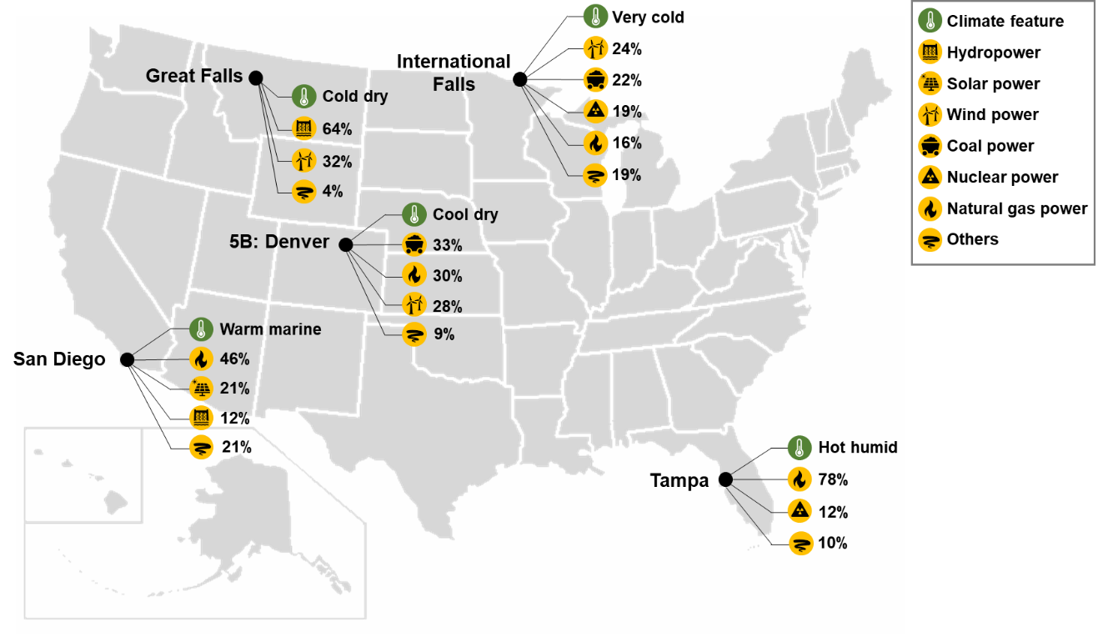

Fig. . Location selection for the case study [12][13]

## 2.2. Building retrofit measure selection

This subsection introduces building retrofit measures that are examined in this study. Existing research has provided a rich set of building retrofit measures for U.S. commercial buildings [14][15][16]. Based on our previous research [17][18], eight building retrofit measures for U.S. medium office buildings are included in this study, as shown in Table 2. The abbreviation for each measure will be used in the rest of this paper. The values of model inputs will be introduced in Section 2.3.

Table . Building retrofit measures examined in the case study

| **Building Retrofit Measure** | **Abbreviation** | **Model Input** |
| --- | --- | --- |
| Add wall insulation | WALL | Wall insulation R-value |
| Add roof insulation | ROOF | Roof insulation R-value |
| Replace windows | WINDOW | Window U-factor,  Window SHGC |
| Replace interior lights with higher efficiency lights | LIGHT | Lighting power density |
| Replace office equipment with higher efficiency equipment | EQUIP | Plug load density |
| Replace cooling coil with higher efficiency coil | COOLING | Coefficient of performance (COP) |
| Replace heating burner with higher efficiency burner | HEATING | Burner efficiency |
| Replace service hot water system with higher-efficiency system | SWH | Heater thermal efficiency |

## 2.3 CO2 emission reduction

CO2 emission reduction effect of the individual measure ($R_{i}$) can be obtained by using the following formula:

|  |  |
| --- | --- |
| $R_{i}=\frac{C_{b}-C_{r,i}}{C_{b}}×100\%$, | (1) |

where, is CO2 emissions of baseline building model; and is CO2 emissions of retrofit building model by applying the retrofit measure $i$. The $C_{b}$ and $C_{r,i}$ can be obtained through a two-phase workflow illustrated in Fig. 3. The details of energy prediction phase and CO2 emission estimation phase will be introduced in subsections 2.3.1 and 2.3.2.

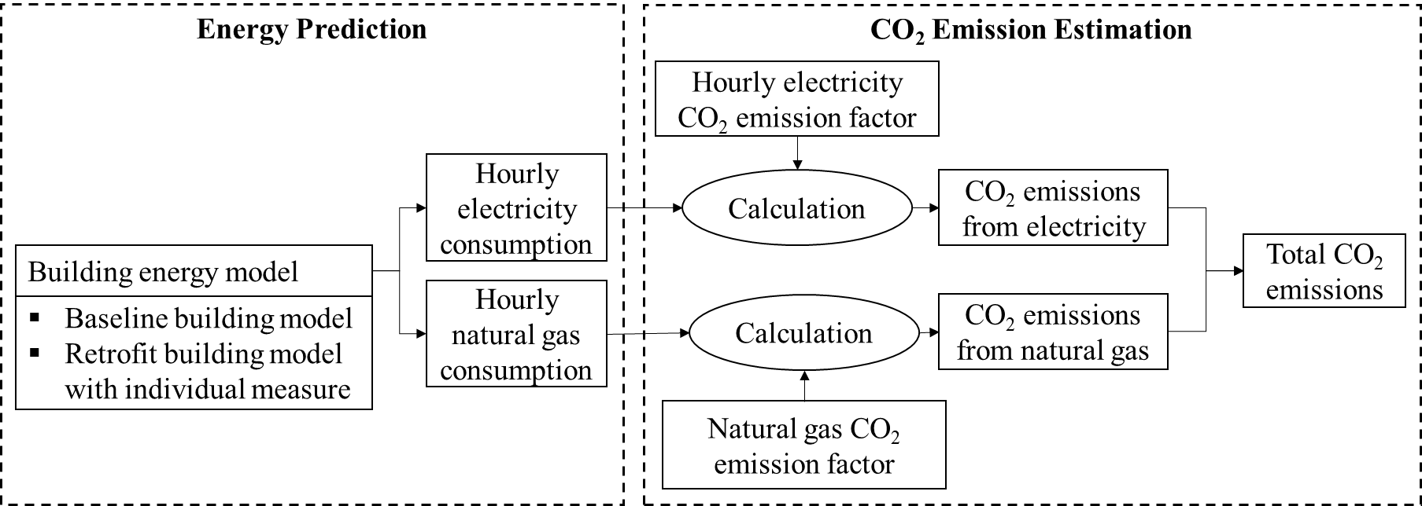

Fig. . Workflow to estimate CO2 emissions of the building

The model input values of baseline models are based on ASHRAE Standard 90.1-2007 [19]. The model input values of retrofit models are based on Advanced Energy Design Guide 50% Energy Savings [20]. Table 3 shows model input values of baseline models and retrofit models, which result in 45 models (5 locations $×$ (1 baseline model + 8 retrofit models)).

Table . Model input values of baseline models and retrofit models

| **Model Input** | **Unit** | **Tampa** | | **San Diego** | | **Denver** | | **Great Falls** | | **International Falls** | |
| --- | --- | --- | --- | --- | --- | --- | --- | --- | --- | --- | --- |
| **Base1** | **Retr2** | **Base1** | **Retr2** | **Base1** | **Retr2** | **Base1** | **Retr2** | **Base1** | **Retr2** |
| Wall insulation R-value | m2-K/W | 1.04 | 2.75 | 1.71 | 2.75 | 2.37 | 4.19 | 2.37 | 4.76 | 2.37 | 4.76 |
| Roof insulation R-value | m2-K/W | 3.47 | 4.52 | 3.47 | 4.52 | 3.47 | 5.50 | 3.47 | 5.50 | 3.47 | 6.29 |
| Window U-factor | W/m2-K | 4.09 | 2.56 | 3.52 | 2.33 | 2.73 | 1.99 | 2.73 | 1.99 | 2.38 | 1.87 |
| Window SHGC | - | 0.25 | 0.25 | 0.25 | 0.25 | 0.4 | 0.26 | 0.4 | 0.35 | 0.45 | 0.40 |
| Lighting power density | W/m2 | 10.76 | 8.07 | 10.76 | 8.07 | 10.76 | 8.07 | 10.76 | 8.07 | 10.76 | 8.07 |
| Plug load density | W/m2 | 8.07 | 5.92 | 8.07 | 5.92 | 8.07 | 5.92 | 8.07 | 5.92 | 8.07 | 5.92 |
| COP | - | 3.23 | 3.37 | 3.23 | 3.37 | 3.23 | 3.37 | 3.23 | 3.37 | 3.23 | 3.37 |
| Burner efficiency | - | 0.80 | 0.90 | 0.80 | 0.90 | 0.80 | 0.90 | 0.80 | 0.90 | 0.80 | 0.90 |
| Heater thermal efficiency | - | 0.81 | 0.90 | 0.81 | 0.90 | 0.81 | 0.90 | 0.81 | 0.90 | 0.81 | 0.90 |

1 Base: Baseline model (Source: ASHRAE Standard 90.1–2007 [19])

2 Retr: Retrofit model (Source: AEDG 50% Energy Savings [20])

### 2.3.1. Energy prediction

As shown in Fig. 3, this study predicts energy consumption for (1) baseline building models and (2) retrofit building models by adopting individual measures. In this study, the baseline models are the DOE Commercial Prototype Building Models for medium office buildings [12], which have been introduced in the beginning of Section 2. Retrofit models are the updated baseline models by adopting individual measures listed in Table 2. The model input values of individual measures are listed in Table 3. Two types of data are extracted after model simulation: (1) hourly electricity consumption and (2) hourly natural gas consumption.

### 2.3.2. CO2 emission estimation

Using the electricity and gas consumption data obtained in previous subsection, this subsection introduces the method to estimate CO2 emissions of baseline models and retrofit models. As shown in Fig. 3, CO2 emissions from electricity are calculated by multiplying hourly electricity consumption with hourly emission factors of electricity, and CO2 emissions from natural gas are calculated by multiplying hourly natural gas consumption with one natural gas emission factor. Hourly CO2 emission factors of electricity are obtained from the National Renewable Energy Laboratory (NREL) website [13]. For example, Fig. 4 shows the hourly emission factors of electricity in Great Falls. And Fig. *5* shows hourly emission factors of electricity in two typical days (summer day: 2020-06-19 and winter day 2020-12-21) for the five studied locations. Hourly emission factors of electricity in Great Falls during summer is almost always zero because there is abundant hydropower during that time. The natural gas emission factor is a fixed value in the whole year for five studied locations, which is 180 kg/MWh [21].

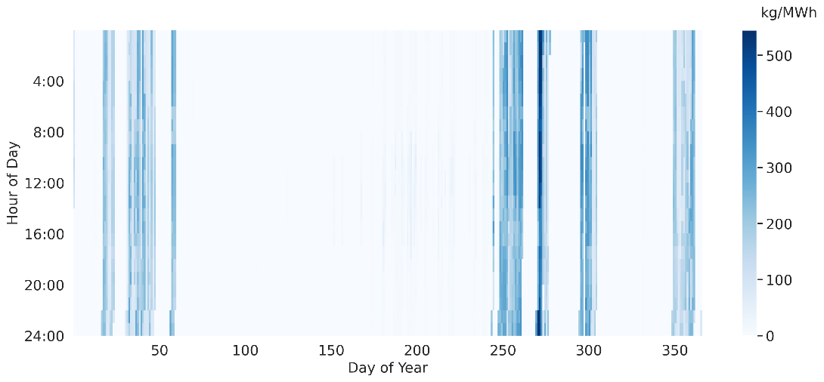

Fig. . Hourly CO2 emission factors of electricity in Great Falls

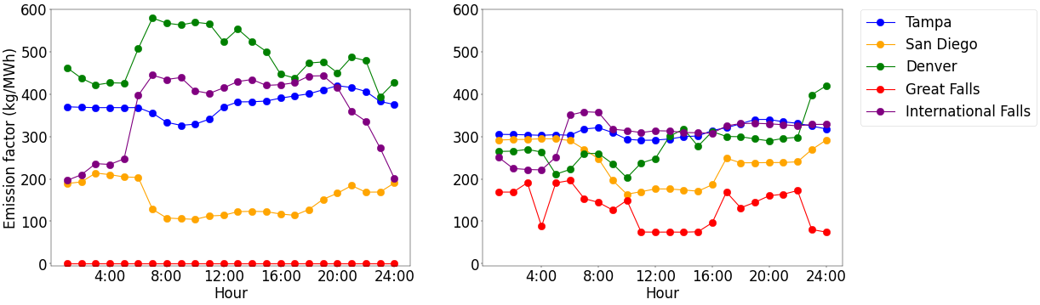

(a) Summer day (b) Winter day

Fig. 5. Hourly CO2 emission factors of electricity in two typical days

# 3. Results

## 3.1. Energy prediction

This subsection shows the prediction results of hourly electricity and natural gas consumption in 2020 for baseline models and retrofit models. We use the baseline model in Great Falls as an example to illustrate the hourly electricity and natural gas consumption, as shown in Fig. 6 and Fig. 7. To make the two types of energy consumption comparable, the unit of natural gas consumption is converted from MJ to kWh. The electricity consumption is much higher than the natural gas consumption in Great Falls. And electricity consumption is relatively even throughout the year, while natural gas consumption primarily concentrates in winter. Impacted by the occupant schedule of the medium office building, electricity consumption is concentrated around 6:00 to 22:00 in winter and 8:00 to 16:00 in summer; natural gas consumption is concentrated around 7:00 to 22:00 in winter and almost no consumption in summer. Fig. 6 and Fig. 7 also shows that there is a periodic change in the electricity and natural gas consumption: electricity and natural gas consumption is intensive during the workday, while they are almost zero over the weekend.

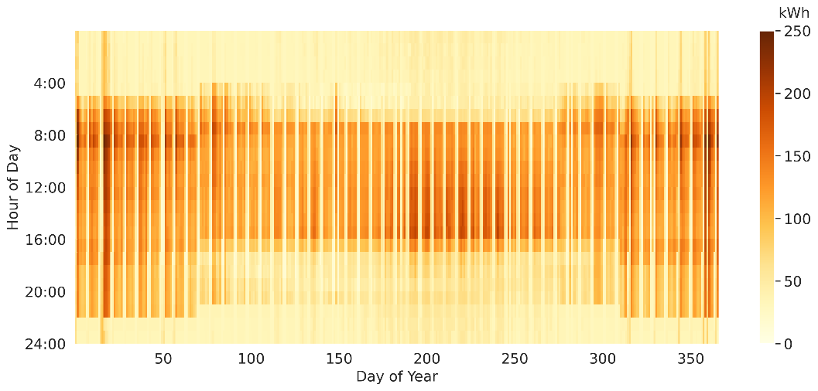

Fig. 6. Hourly electricity consumption of the baseline model in Great Falls

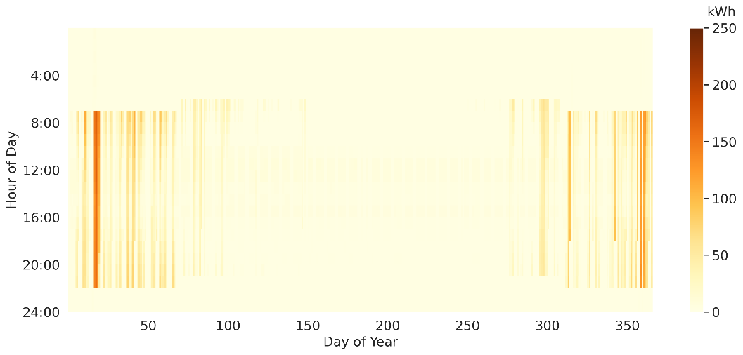

Fig. 7. Hourly natural gas consumption of the baseline model in Great Falls

## 3.2. CO2 emission estimation

Based on the hourly electricity and natural gas consumption predicted in subsection 3.1, hourly CO2 emissions of baseline models and retrofit models in five locations can be obtained by following the method introduced in subsection 2.3.2. Here we use Great Falls as an example to discuss the relationship between energy consumptions and CO2 emissions. The hourly CO2 emissions of the baseline model in Great Falls is shown in Fig. 8. There are some interesting findings in two different time scales for Great Falls.

For a period of one year, the change of CO2 emissions is not consistent with the energy consumption. The emissions in Great Falls mainly occur on some days during winter while almost always zero during summer. On the contrary, Fig. 6 shows that electricity consumption is intensive during the whole year in Great Falls. This inconsistency is due to time-variant emission factors: hourly CO2 emission factors of electricity in Great Falls are almost always zero during summer and high in winter, as shown in Fig. 4. As a result, the emissions from electricity consumption in summer are almost always zero despite of the amount of electricity consumption. Emissions from natural gas are also almost always zero during summer because low natural gas consumption as shown in Fig. 7. Therefore, total CO2 emissions in Great Falls during summer are almost always zero.

For a period of one day, the change of CO2 emissions is consistent with the energy consumption. Fig. 8 shows that emissions from the building mainly happen during the daytime. Electricity and natural gas consumption from the building also mainly happens during the daytime, as shown in Fig. 6 and Fig. 7. Since hourly emission factors of electricity in Great Falls in one day are almost constant and the natural gas emission factor is a constant value, emissions are consistent with the energy consumption in one day. It is worth to mention this phenomenon may not occur for other location, such as San Diego, where electricity is largely provided by solar.

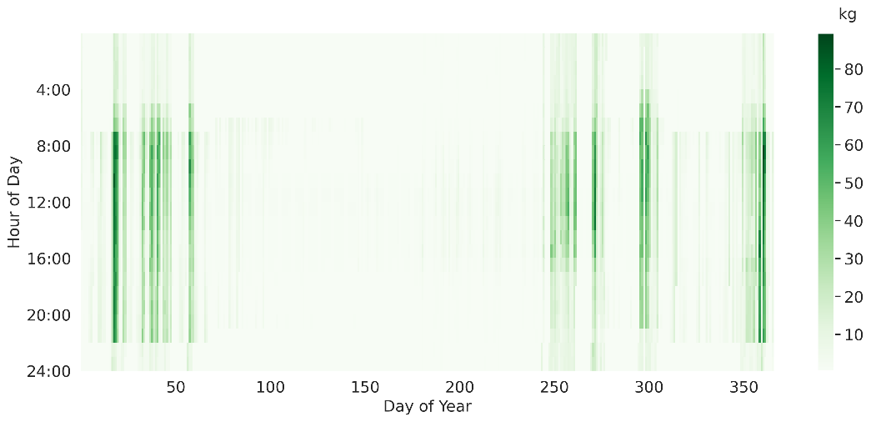

Fig. . Hourly CO2 emissions of the baseline model in Great Falls

Fig. 9 shows annual CO2 emissions of baseline building models and retrofit building models in five studied locations. “MEASURE_e” represents emissions from electricity and “MEASURE_g” represents emissions from natural gas. There are some interesting findings among different locations.

First, the CO2 emissions in San Diego and Great Falls are 52% to 86% lower than the other three locations. It is because hourly emission factors of electricity in San Diego and Great Falls are lower than the other three locations, as shown in Fig. 5.

Moreover, International Falls has the largest CO2 emissions from natural gas, followed by Great Falls, Denver, San Diego, and Tampa. CO2 emissions from natural gas grow up as the climate gets colder since energy used for heating is natural gas. When the climate gets colder, heating loads increase accordingly [22][23]. So, natural gas consumption used for heating increases when the climate gets colder, which leads to the increase of CO2 emissions.

The CO2 emissions from natural gas only account for a small part of total emissions in Tampa, San Diego, Denver, and International Falls, but it accounts for more than 30% of total emissions in Great Falls. One of the reasons is that natural gas consumption in Great Falls is large due to the cold climate feature mentioned above. Another reason is that hourly emission factors of electricity in Great Falls are very low due to the high penetration of hydropower and wind power.

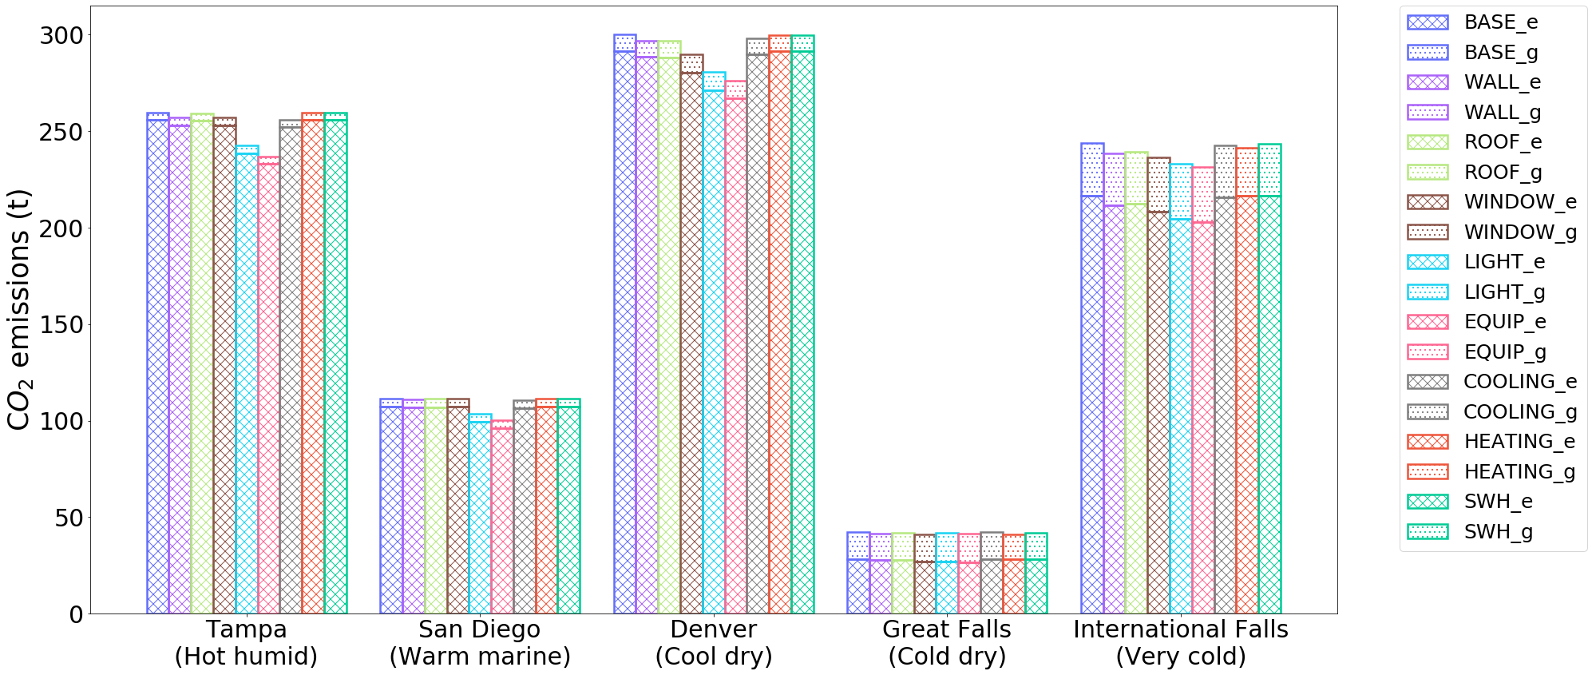

Fig. . Annual CO2 emissions of baseline models and retrofit models

## 3.3. CO2 emission reduction

CO2 emission reduction by applying individual measures can be obtained by subtracting emissions of the retrofit building from emissions of the baseline building. For example, CO2 emission reductions by applying individual measures in Great Falls are shown in Fig. 10. Blue color means that this measure reduces emissions, while red color indicates the increase of emissions. Fig. 10 shows that: (1) building retrofit measures in Great Falls reduce CO2 emissions in winter due to the high emissions factors of electricity; (2) HEATING reduces CO2 emissions more significantly than the other seven measures since natural gas is used for heating; (3) COOLING hardly reduce CO2 emissions since emissions factors of electricity in summer is almost zero when cooling is needed; (4) SWH also has little impact on CO2 emissions because only a little amount of energy is used for service water heating; (5) by improving the efficiency, LIGHT and EQUIP reduce electricity consumption and related internal heat gain. This can reduce the cooling load in cooling season but increase the heating load in heating season. As a result, they reduce CO2 emissions in the spring and fall when cooling is still needed and electricity comes from fossil fuel. And they increase CO2 emissions when natural gas is used for heating; and (6) by reducing the solar heat gain and increasing insulation, WINDOW reduces cooling load but increase the heating load. Therefore, it reduces CO2 emissions in the spring and fall, and increases CO2 emissions when heating is needed.

|  |  |
| --- | --- |
| WALL |  |
| ROOF |  |
| WINDOW |  |
| LIGHT |  |
| EQUIP |  |
| COOLING |  |
| HEATING |  |
| SWH |  |

Fig. . CO2 emission reduction by applying individual measures in Great Falls

The relative reduction of each measure is calculated using the CO2 emission reduction effect ($R_{i}$) defined in equation (1). The results are shown in Fig. 11. The difference of $R_{i}$ are small in cold locations (within 2% for Great Falls and within 5% for International Falls). The difference is relatively large in the other three locations (from 8% in Denver to 10% in San Diego) since EQUIP and LIGHT have significant impacts on $R_{i}$. The reason for this phenomenon is explained in Section 4. The EQUIP and LIGHT are the top two in four locations except Great Fall where the top two emission efficient measures are HEATING and WINDOWS.

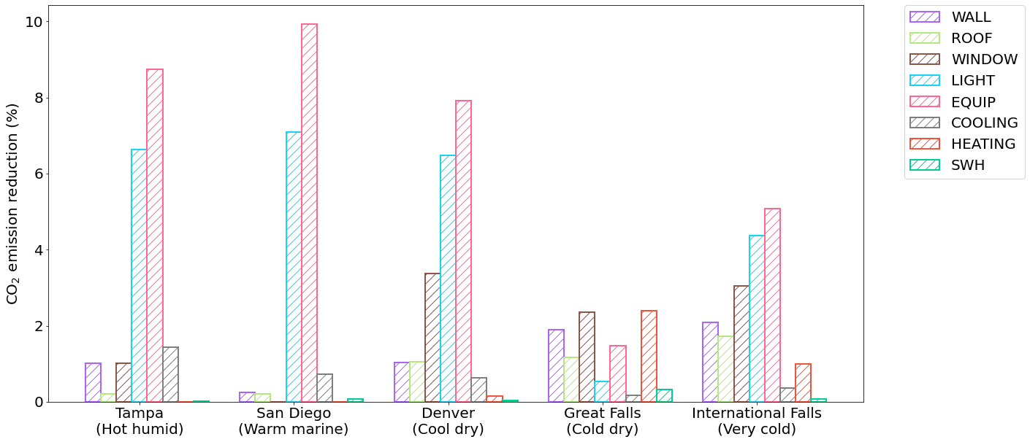

Fig. 11. CO2 emission reduction effect ($R_{i}$) by applying individual measures

# 4. Discussion

## 4.1. Impact of climate on CO2 emission reduction

In cold climates, improving lighting efficiency and improving equipment efficiency is less effective in emission reduction than hot climates. Using EQUIP as an example, Fig. 13. shows the hourly CO2 emission factors of electricity, the reduction of electricity consumption, the reduction of natural gas consumption, and the reduction of CO2 emissions in Tampa and International Falls. Both locations have similar emission factors in electricity generation (Fig. 13 a). However, the reduction of electricity consumption by applying EQUIP is more effective in hot climate, such as Tampa (Fig. 13 b), since it also reduces the cooling load due to the reduced internal heat gain from the equipment. For cold climate like International Falls, additional heating will be needed when internal heat gain resulted from equipment is reduced. This also leads an increase of gas consumption in the cold climate location, as shown in Fig. 13 (c). As a combined effect, Fig. 13 (d) shows larger emission reduction resulted by improving efficiency of lighting and equipment in Tampa than International Falls.

|  |  |
| --- | --- |
| **Tampa (hot humid)** | **International Falls (very cold)** |
|  |  |
| (a) Hourly CO2 emission factors of electricity | |
|  |  |
| (b) Electricity reduction | |
|  |  |
| (c) Natural gas reduction | |
|  |  |
| (d) CO2 emission reduction | |

Fig. 13. Energy and CO2 emission reduction by applying EQUIP in hot and cold locations

## 4.2. Measures to reduce energy and emission

Due to the variability of CO2 emission factors, the most energy efficient measure is not necessarily the most emission efficient measure. For instance, the most energy efficient measure in Great Falls is EQUIP (Fig. 14) while the most emission efficient measure is HEATING (Fig. 11). While improving equipment efficiency significantly reduces electricity consumption in summer, this large energy reduction does not lead to corresponding emission reduction since electricity in Great Fall in summer mainly comes from hydropower with zero emission. Because the energy used for heating is natural gas in Great Falls, improving heating efficiency can directly reduce emissions so that it becomes the most emission efficient measure.

A different example is San Diego, whose most emission efficient measure is the same as the most energy efficient measure: EQUIP. There are two reasons. First, San Diego has little heating needs. Therefore, the emission reduction effect of HEATING is minimal. Second, nearly 46% of electricity still comes from natural gas. As a comparison, Great Falls gets 96% of its electricity from hydropower or wind. Thus, reducing electricity consumption by adopting efficient equipment can still lead to a good amount emission reduction in San Diego.

Fig. 14. Site energy reduction by applying individual measures

## 4.3. Impact of using hourly CO2 emission factor

By comparing the CO2 emission reduction difference between using our method and existing method (adopting annual factor), we find that estimating CO2 emission reduction with the constant annual emission factor will overestimate or underestimate the reduction. Fig. 12 shows the estimation bias on emission reductions using the annual emission factors by comparing with the one using hourly factors. It tends to overestimate the emission reduction in San Diego (up to 1550 kg), underestimate in Denver (up to 692 kg) and International Falls (up to 1165 kg), both over- or underestimate in Tampa and Great Fall. The largest difference occurs in San Diego and the smallest difference in Tampa.

As shown in Fig. 5, San Diego has plenty of solar power during the daytime, thus, hourly CO2 emission factors during daytime are lower than both the hourly emission factors during nighttime and the annual factor. This will lead to an overestimated emission for energy used in the daytime if the annual factor is adopted. As a result, it will also overestimate the emission reduction for the proposed energy efficiency measures since they mainly reduce energy consumption in the daytime.

On the contrary, hourly emission factors in Denver and International Falls during daytime are higher than both the hourly emission factors at nighttime and the annual factors (Fig. 5). Since electricity consumption mainly occurs during the day, applying annual emission factors to the reduced electricity consumption will underestimate the CO2 emission reduction.

Tampa’s electricity source is dominated by natural gas (78%) and nuclear (12%), which leads to a relative constant hourly emission factors as shown in Fig. 5. Thus, using hourly or annual emission factors only results in a relatively small difference in the predicted emission reduction.

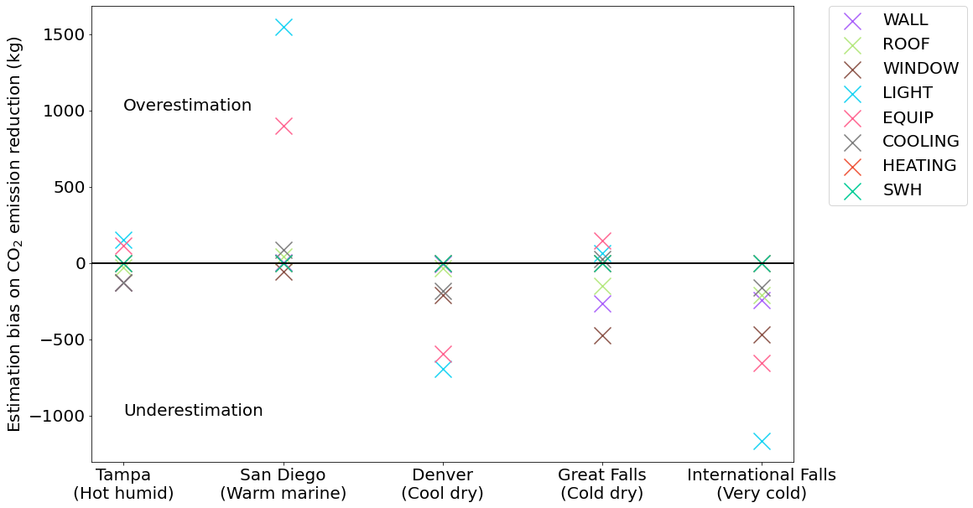

Fig. 12. Estimation bias on CO2 emission reduction using the annual emission factor

# 5. Conclusion

This study analyzes the CO2 emission reduction of building retrofit measures that related to envelop and mechanical system in five locations: Tampa, San Diego, Denver, Great Falls, and International Falls. Instead of using the constant annual CO2 emission factor of electricity, this study uses hourly emission factors. The results show that (1) using the constant emission factor cause estimation bias: it overestimates the emission reduction for most measures in San Diego, while it underestimates the reduction for most measures in Denver and International Falls. (2) The same retrofit measure may have different CO2 emission reduction depending on the climates: improving lighting and equipment efficiency has less impacts in CO2 emission reduction in cold climates than hot climates. (3) The most energy efficient measure is not necessarily the most emission efficient measure: in Great Falls, the most energy efficient measure is improving equipment efficiency, but the most emission efficient measure is improving heating efficiency.

This study analyzes the CO2 emission reduction effect of building retrofit measures based on one-year simulation data. However, the composition of electricity generation may change over time, and CO2 emission factors will change accordingly. Since the effects of building retrofit measures will last for a few decades, it would be interesting to study the CO2 emission reduction effect of building retrofit measures over a longer time frame.

# Acknowledgement

This research was supported by the National Science Foundation under Awards No. CBET-2110171.

# Reference

[1] The World Bank, CO2 emissions, (2020). https://data.worldbank.org/indicator/EN.ATM.CO2E.KT?most_recent_value_desc=true&view=chart.

[2] White House Briefing Room, Fact sheet: President Biden sets 2030 greenhouse gas pollution reduction target aimed at creating good-paying union jobs and securing US leadership on clean energy technologies. White house fact Sheet, 2021. https://www.whitehouse.gov/briefing-room/statements-releases/2021/04/22/fact-sheet-president-biden-sets-2030-greenhouse-gas-pollution-reduction-target-aimed-at-creating-good-paying-union-jobs-and-securing-u-s-leadership-on-clean-energy-technologies/.

[3] The White House, United States mid-century strategy for deep decarbonization, 2016. https://unfccc.int/files/focus/long-term_strategies/application/pdf/mid_century_strategy_report-final_red.pdf.

[4] U.S. Energy Information Administration, Annual Energy Outlook 2018, 2019. https://www.eia.gov/outlooks/archive/aeo18/.

[5] J. Langevin, C.B. Harris, J.L. Reyna, Assessing the potential to reduce US building CO2 emissions 80% by 2050, Joule. 3 (2019) 2403–2424.

[6] U.Y.A. Tettey, A. Dodoo, L. Gustavsson, Effects of different insulation materials on primary energy and CO2 emission of a multi-storey residential building, Energy Build. 82 (2014) 369–377.

[7] P. Murray, J. Marquant, M. Niffeler, G. Mavromatidis, K. Orehounig, Optimal transformation strategies for buildings, neighbourhoods and districts to reach CO2 emission reduction targets, Energy Build. 207 (2020) 109569.

[8] S.M. Garriga, M. Dabbagh, M. Krarti, Optimal carbon-neutral retrofit of residential communities in Barcelona, Spain, Energy Build. 208 (2020) 109651.

[9] Y. Huang, J. Niu, T. Chung, Energy and carbon emission payback analysis for energy-efficient retrofitting in buildings—Overhang shading option, Energy Build. 44 (2012) 94–103.

[10] T. Niemelä, R. Kosonen, J. Jokisalo, Energy performance and environmental impact analysis of cost-optimal renovation solutions of large panel apartment buildings in Finland, Sustain. Cities Soc. 32 (2017) 9–30.

[11] J. Kneifel, Life-cycle carbon and cost analysis of energy efficiency measures in new commercial buildings, Energy Build. 42 (2010) 333–340.

[12] Commercial Prototype Building Models, United States Dep. Energy. (2021). https://www.energycodes.gov/development/commercial/prototype_models.

[13] Modeled data for a suite of forward-looking scenarios of the U.S. electricity sector, Natl. Renew. Energy Lab. (2021). https://cambium.nrel.gov/?project=579698fe-5a38-4d7c-8611-d0c5969b2e54.

[14] B. Jason Glazer PE, Development of maximum technically achievable energy targets for commercial buildings, ASHRAE Trans. 123 (2017) 32.

[15] B. Griffith, N. Long, P. Torcellini, R. Judkoff, D. Crawley, J. Ryan, Assessment of the technical potential for achieving net zero-energy buildings in the commercial sector, National Renewable Energy Lab.(NREL), Golden, CO (United States), 2007.

[16] N. Wang, S. Goel, A. Makhmalbaf, N. Long, Development of building energy asset rating using stock modelling in the USA, J. Build. Perform. Simul. 11 (2018) 4–18.

[17] Y. Ye, Y. Lou, W. Zuo, E. Franconi, G. Wang, How do electricity pricing programs impact the selection of energy efficiency measures?–A case study with US Medium office buildings, Energy Build. 224 (2020) 110267.

[18] Y. Ye, K. Hinkelman, Y. Lou, W. Zuo, G. Wang, J. Zhang, Evaluating the Energy Impact Potential of Energy Efficiency Measures for Retrofit 5 Applications: A Case Study with US Medium Office Buildings 6, in: Build. Simul., Tsinghua University Press, 2021: pp. 1–17.

[19] ASHRAE, Standard 90.1-2007, Energy Standard for Buildings except Low Rise Residential Buildings, 2007.

[20] Advanced Energy Design Guide for Small to Medium Office Buildings: Achieving 50% Energy Savings Towards a Net Zero Energy Building, Am. Soc. Heating, Refrig. Air-Conditioning Eng. (2014). https://www.ashrae.org/technical-resources/aedgs/50-percent-aedg-free-download.

[21] Carbon Dioxide Emissions Coefficients, United States Energy Inf. Adm. (2016). https://www.eia.gov/environment/emissions/co2_vol_mass.php.

[22] K.K.W. Wan, D.H.W. Li, D. Liu, J.C. Lam, Future trends of building heating and cooling loads and energy consumption in different climates, Build. Environ. 46 (2011) 223–234.

[23] D.H.W. Li, L. Yang, J.C. Lam, Impact of climate change on energy use in the built environment in different climate zones–a review, Energy. 42 (2012) 103–112.