Methods of Stabilization of Gas Condensates
Ibukun Makinde, Ph.D.

ibukunmakinde@rocketmail.com; ibkmak@gmail.com

Introduction
Gas condensates are liquid mixtures of high-boiling hydrocarbons of various structures, separated from natural gases during their production at gas condensate fields. When transporting gas through pipelines, the following gas quality conditions should be met:
- During transportation, gases should not cause corrosion of pipelines, fittings, instruments, etc.
- The quality of the gas must ensure its transportation in a single-phase state i.e., liquid hydrocarbons, gas condensates and hydrates should not form in the pipelines.
In order for gas condensates to meet the above-mentioned quality conditions during storage or transportation, they must be stabilized. Gas condensate stabilization is the process of “boiling off” light hydrocarbons from the condensate that would otherwise increase the vapor pressure when conditions are fluctuating.
Initially, reservoirs with high pressure (approx. 10 – 60 MPa) and temperature, contain gasoline-kerosene fractions in the vapor state and some higher molecular weight liquid components of oil as well. During production, the pressure drops significantly to approximately 4 – 8 MPa, and raw unstable gas condensate is released. The unstable gas condensate contains not only C5 hydrocarbons and higher, but also dissolved gases of the methane-butane fraction. Some of the methane and ethane fractions are pumped back to maintain pressure in the formation. Also, crude condensate contains non-hydrocarbon gases such as CO2, H2S and N2 as well.

Stable and Unstable Gas Condensates
The main indicator of the quality of stable gas condensates, is the saturated vapor pressure (Reid Vapor Pressure – RVP), which is characterized by the presence of light hydrocarbons in it. To fully assess the commercial qualities of gas condensates, it Is necessary to determine factors such as the fractional composition, content of sulfur compounds, aromatic hydrocarbons and high-boiling paraffins, pour point, etc.
Depending on the saturated vapor pressure, gas condensates are divided into two types: unstable and stable. Unstable (also called deethanized) gas condensates have saturated vapor pressure (Reid Vapor Pressure – RVP) above 0.093 MPa, and contain C₃, C₄, C₅₊ and in some cases, little quantity of C₂. On the other hand, stable (also called debutanized) gas condensates should have saturated vapor pressure (Reid Vapor Pressure – RVP) not higher than 0.093 MPa in the winter, and not higher than 0.067 MPa in the summer. They consist mainly of C₅₊ hydrocarbons. Increase in temperature, increases volatility of gas condensate components, the stability of gas condensates is therefore climate-dependent.
Stable gas condensates serve as raw materials for processing liquid fuels and petrochemical products. The properties of stable gas condensates are determined by their fractional and chemical compositions. The fractional composition of condensates is very diverse. Some consist almost entirely of gasoline fractions, while others contain diesel fractions as well.

Goals of Gas Condensate Stabilization
Raw gas condensates produced in the fields are subject to stabilization for several reasons. Some of the major goals of gas condensate stabilization are the following:
- To reduce the vapor pressure of the condensate, thereby lessening evaporation losses during storage or shipment in atmospheric vessels;
- To “sweeten” the condensate (removing the H₂S and CO₂ fractions), in order to meet the required specifications;
- To enable recovery of methane, ethane and liquefied petroleum gas for other purposes.

Methods of Gas Condensate Stabilization
The two major methods of gas condensate stabilization are:
- Multi-Stage Flash Vaporization
- Rectification (Distillation)
In this article, note that for method (ii), stabilization using one and two fractionating columns were the type of models considered.

Multi-Stage Flash Vaporization
This is the based on the principle of stage-wise pressure reductions and temperature increments, leading to separation of lighter fractions of the gas condensate from the heavier fractions. Stabilization of gas condensates by this method involves decreasing the solubility of low-boiling hydrocarbons in condensates, by increasing temperature and lowering pressure. Multiple flash vaporization stages can be used to stabilize gas condensates. The choice of the number of stages depends on the content of low-boiling hydrocarbons in the condensate. The more they are, the more stages are needed. This is explained by the fact that, as the number of stages increases, the share of separation on each of them decreases. This decrease in the share of separation entails a decrease in the entrainment of the condensate hydrocarbons to the gas phase. During multi-stage flash vaporization, the pressure in the subsequent stage is always less than the pressure at the previous stage.

Advantages of Multi-Stage Flash Vaporization
Some of the advantages of this method are:
- Simplicity of the models;
- Low metal and energy consumption.

Disadvantages of Multi-Stage Flash Vaporization
Some of the disadvantages of multi-stage flash vaporization are:
- Loss of light fractions of the condensates;
- Inability to produce liquefied gases that meet standard requirements;
- The collection and utilization of separated gases are associated with high energy costs;
- Poor separation of hydrocarbons. Separation gets better with increase in the number of stages.

Stabilization of Gas Condensates by Rectification (Distillation)
This is gas condensate stabilization with the use of fractionating or rectification columns. The columns can also be called “condensate stabilizers”.

Advantages of Stabilization of Gas Condensates by Rectification (Distillation)
Some of advantages of this method are the following:
- Preliminary separation and deethanization of unstable condensates at high pressures facilitate the utilization of gas streams;
- It is possible to produce liquefied gases that meet standard requirements, without the need for artificial cooling;
- Rational use of the energy of unstable condensates;
- Commercial condensates obtained are characterized by low saturated vapor pressure, which reduces its loss during transportation and storage.

Disadvantages of Stabilization of Gas Condensates by Rectification (Distillation)
The demerits of using the distillation method to stabilize gas condensates are the following:
- Complexity of the models;
- High metal and energy consumption.

Gas Condensate Stabilization – Case Studies
In this work, data from four different gas condensate fields were considered. Therefore, there were four case studies altogether for each gas condensate field. The models of gas condensate stabilization employed for each of the cases were two-stage flash vaporization as well as stabilization using one and two fractionating columns (rectification). All simulations were done with a commercial process simulation software. The composition of gas condensates for the fields considered are shown in Table 1 below.

Table 1 Composition of Gas Condensates
 | Field A | Field B | Field C | Field D
Components | Composition (%) | Composition (%) | Composition (%) | Composition (%)
CH₄ | 6.99 | 2.60 | 10.73 | 13.94
C₂H₆ | 4.96 | 5.97 | 6.56 | 10.90
C₃H₈ | 7.67 | 12.70 | 15.49 | 21.31
I-C₄H₁₀ | 2.76 | - | 7.51 | 9.30
N-C₄H₁₀ | 6.54 | 13.17 | 11.47 | 11.98
I-C₅H₁₂ | 6.63 | - | 7.20 | 5.54
N-C₅H₁₂ | 6.57 | 2.11 | 7.35 | 4.50
N-C₆H₁₄ | 53.18 | 63.43 | 33.69 | 22.53
CH₃OH | 0.01 | 0.02 | - | -
CO₂ | 0.54 | - | - | -
H₂S | 3.04 | - | - | -
N₂ | 0.08 | - | - | -

Models of Gas Condensate Stabilization
Three different process models were designed for stabilizing unstable gas condensates from each of the four fields under consideration. Each model will be briefly explained in the following subsections.

Model 1 – Two-Stage Flash Vaporization
In this model, the condensate pressure is reduced progressively at each separation stage. The condensate is heated to evaporate the light components, and is flashed at a specific pressure in a high-pressure separator. The condensate from the high-pressure separator is then flashed again at a lower pressure in a low-pressure separator. Further separation occurs in the low-pressure separator, and light as well as heavier components are again obtained. The heavier fractions are recycled back into the gas stream for more separation, and the process is repeated. The condensates finally obtained, are cooled and the pressure is lowered to atmospheric pressure. An example of this model is illustrated in Figure 1.
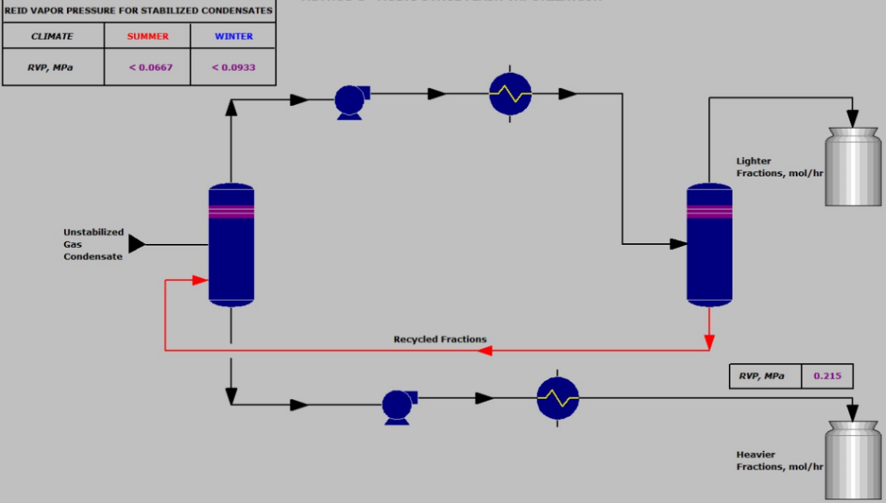
Figure 1 Model 1 – Two-Stage Flash Vaporization

Model 2 – Condensate Stabilization with One Fractionating Column
This is a gas condensate stabilization unit with rectification. Unstable condensates are throttled through the heat exchangers to the evaporator. The temperature at the output from the unidirectional heat exchanger (approx. -10°C), determines the amount of liquid removed in the evaporator, and it in turn determines the critical condensation temperature (dew point) of the gaseous products. Here, the evaporator is used as a separator for separating liquid and vapor. The separated liquid is divided into two streams. One stream is recycled and directed to the recuperative heat exchanger, where methane-ethane fractions are mainly removed. The other stream (without heating) enters the fractionating column. The column has a pressure of approximately 1 MPa. The temperature in the upper part of the column is approximately 81°C and in the lower part, approximately 180°C. A broad fraction of light fractions are obtained from the top of the column, while stable condensates are removed from the bottom of the column. An example of this model is shown in Figure 2.
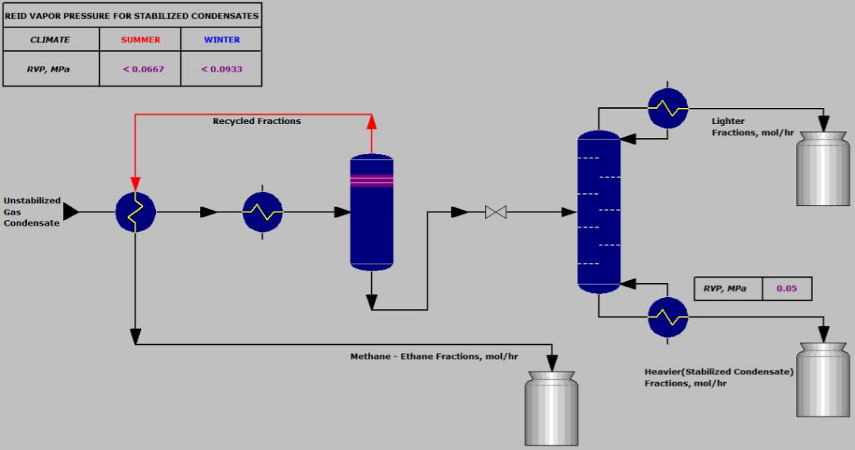
Figure 2 Model 2 – Condensate Stabilization with One Fractionating Column

Model 3 – Condensate Stabilization with Two Fractionating Columns
The first stage of stabilization in this model is the degassing of the condensates in the separator. The separated liquid from the separated is divided into two streams. One of them is heated in the heat exchanger, and enters the feed section of the stripping column. Some methane-ethane fractions are removed from the other streams. The pressure in the stripping column is approximately 1.9 – 2.5 MPa, the temperature at the upper part is around 15 – 20°C, while the temperature at the bottom is roughly 170 – 180°C. The distillates of the stripping column are mainly methane-ethane fractions, and the residues (bottoms) are deethanized condensates. The deethanized condensates from the stripping column are then sent to the stabilizer, which is operating according to the scheme of a complete fractionating column. Propane-butane fractions are mainly obtained from the top of the stabilizer, while stable condensates are removed from the bottom. The pressure in the stabilizer is about 1 – 1.6MPa. An example of this model is depicted in Figure 3.
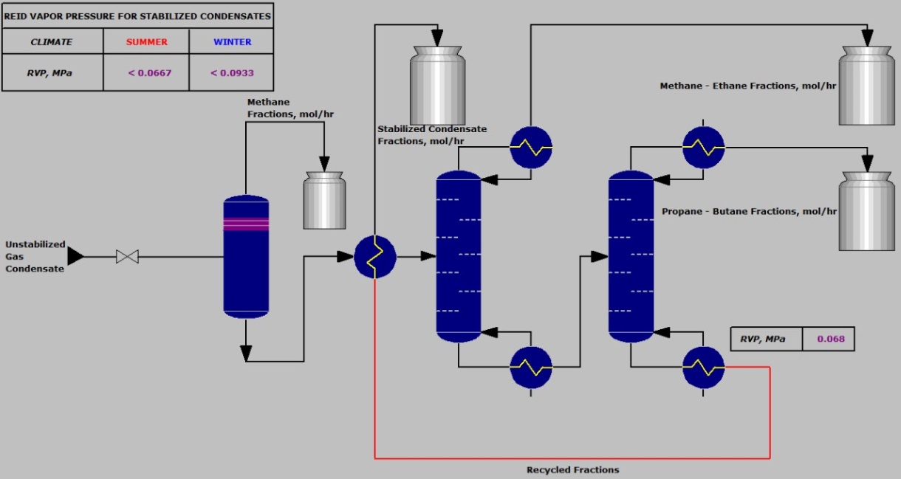
Figure 3 Model 3 – Condensate Stabilization with Two Fractionating Columns

Discussion of Results
In this work, the two key yardsticks used to gauge the stability of gas condensates are Reid Vapor Pressure (RVP) and fraction of light hydrocarbons in the stable condensates.
Reid Vapor Pressure (RVP) is the pressure exerted on by vapors on the walls of the vessel, when fuel is evaporated in a confined space. It characterizes the volatility of gasoline fractions and the qualities of fuels. RVP depends on the chemical and fractional composition of fuels. As a rule, the higher the fraction of light hydrocarbons in fuel, the higher the Reid Vapor Pressure. RVP also increases, with increasing temperature. Therefore, as mentioned earlier, the stability of gas condensates is climate-dependent.
The results of the gas condensate stabilization for the different fields, using the three different process models, are presented in tables in the following subsections.

Case Study – Field A
The results for Field A are presented in Table 2. For RVP (in MPa), the color red indicates that it meets the standard requirements for stabilized condensates in the summer and winter, while the color blue indicates that it meets the standard requirement for stabilized condensates in the winter only. Black color indicates that the gas condensate is still unstable according to standard requirements.
Here, it is observed that Model 2 – condensate stabilization with one fractionating column, generates stable condensates, with a value of RVP that meets standard requirements in the winter and in the summer. The fraction of light hydrocarbons in the stable gas condensates is the least here as well, compared to the other two models. Model 3 – condensate stabilization with two fractionating columns, produces stable condensates, with RVP value that meets standard requirement in the winter only. Model 1 – two-stage flash vaporization however, produces unstable gas condensates according to standard requirements.
Table 2 Results – Field A
Stabilization Model | Reid Vapor Pressure (RVP), MPa (<0.067 for Summer & <0.093 for Winter) | Fraction of light hydrocarbons in stable condensates, mass %
Model 1 | 0.132 | 9.5906
Model 2 | 0.060 | 0.7537
Model 3 | 0.074 | 4.4719

Case Study – Field B
The results for Field B are presented in Table 3. For RVP (in MPa), the color red indicates that it meets the standard requirements for stabilized condensates in the summer and winter, while the color blue indicates that it meets the standard requirement for stabilized condensates in the winter only. Black color indicates that the gas condensate is still unstable according to standard requirements.
For this case, it is observed that Models 2 and 3 – condensate stabilization with one and two fractionating columns, generate stable condensates, with RVP values that meet standard requirements in the winter and in the summer. However, Model 2 produces more stable condensates compared to Model 3. Also, the fraction of light hydrocarbons in the stable gas condensates for Model 2 is the lowest, compared to the other two models. Model 1 – two-stage flash vaporization, produces unstable gas condensates according to standard requirements.
Table 3 Results – Field B
Stabilization Model | Reid Vapor Pressure (RVP), MPa (<0.067 for Summer & <0.093 for Winter) | Fraction of light hydrocarbons in stable condensates, mass %
Model 1 | 0.187 | 19.094
Model 2 | 0.040 | 0.6817
Model 3 | 0.066 | 0.8132

Case Study – Field C
The results for Field C are presented in Table 4. For RVP (in MPa), the color red indicates that it meets the standard requirements for stabilized condensates in the summer and winter, while the color blue indicates that it meets the standard requirement for stabilized condensates in the winter only. Black color indicates that the gas condensate is still unstable according to standard requirements.
In this instance, it is observed that Model 2 – condensate stabilization with one fractionating column, generates stable condensates, with a value of RVP that meets standard requirements in the winter and in the summer. The fraction of light hydrocarbons in the stable gas condensates is the least here as well, compared to the other two models. Model 3 – condensate stabilization with two fractionating columns, produces stable condensates, with RVP value slightly above the summer limit, but meeting the standard requirement in the winter. Model 1 – two-stage flash vaporization however, generates unstable gas condensates according to standard requirements.
Table 4 Results – Field C
Stabilization Model | Reid Vapor Pressure (RVP), MPa (<0.067 for Summer & <0.093 for Winter) | Fraction of light hydrocarbons in stable condensates, mass %
Model 1 | 0.215 | 22.790
Model 2 | 0.050 | 0.7004
Model 3 | 0.068 | 0.8173

Case Study – Field D
The results for Field D are presented in Table 5. For RVP (in MPa), the color red indicates that it meets the standard requirements for stabilized condensates in the summer and winter, while the color blue indicates that it meets the standard requirement for stabilized condensates in the winter only. Black color indicates that the gas condensate is still unstable according to standard requirements.
Here, it can be seen that Models 2 and 3 – condensate stabilization with one and two fractionating columns, generate stable condensates, with RVP values that meet standard requirements in the winter and in the summer. However, Model 2 produces slightly more stable condensates compared to Model 3. Also, the fraction of light hydrocarbons in the stable gas condensates for Model 2 is the lowest, compared to the other two models. According to standard requirements, unstable gas condensates are produced by Model 1 – two-stage flash vaporization.
Table 5 Results – Field D
Stabilization Model | Reid Vapor Pressure (RVP), MPa (<0.067 for Summer & <0.093 for Winter) | Fraction of light hydrocarbons in stable condensates, mass %
Model 1 | 0.254 | 28.205
Model 2 | 0.065 | 0.8066
Model 3 | 0.067 | 0.8112

From observations, Models 2 and 3 produce stable condensates that meet standard requirements, almost in all cases. Though Model 2 generated slightly better RVP values in all cases, both models can be considered suitable for appropriate gas condensate stabilization. Also, Model 2 is more economically feasible, cost wise than Model 3. The approximate total cost, including installation for Model 2 is almost half of the cost for Model 3. This is shown in Table 6.
Table 6 Cost Analysis – Models 2 & 3
Stabilization Model | Approx. Total Cost (incl. installation), USD
Model 2 | 123,139
Model 3 | 226,136

Conclusions
Gas condensate stabilization helps to reduce the Reid Vapor Pressure (RVP) of condensates to the required specifications. It is a significant primary gas condensate processing procedure. Gas condensate stabilization reduces losses and improves the quality of condensates during transportation, storage and shipping. Therefore, the process of gas condensate stabilization is technologically and economically important.
The following conclusions can be drawn from the case studies in this article:
- Models 2 and 3 – condensate stabilization with one and two fractionating columns, are suitable for proper gas condensate stabilization that meets standard requirements;
- In terms of the yardsticks for gauging gas condensate stability, adherence to standard requirements in the winter and summer, as well as cost wise, Model 2 – condensate stabilization with one fractionating column, is the most suitable;
- Model 1 – two-stage flash vaporization produced unstable gas condensates, according to standard requirements. However, if more stages were included in the model, it should generate stable condensates.

