Impact of global measured spectrum variation on solar photovoltaic efficiencies
Geoffrey S. Kinsey, Nicholas C. Riedel-Lyngskær, Matthew Boyd, Marília Braga, Raul R. Cordero, Benjamin C. Duck, Christopher J. Fell, Sarah Feron, George Georghio, Nipon Ketjoy, Atse Louwen, Takashi Minemoto, Guilherme Neves, Gustavo Nofuentes Garrido, Basant R. Paudyal, Carlos D. Rodríguez Gallegos, Ricardo Rüther, Wilfried van Sark, Miguel A. Sevillano-Bendezú, Jorge A. Tejero, Marios Theristis, Jan A. Töfflinger, Márcia A. Yamasoe

Abstract
In comparisons of solar photovoltaic performance, variation in the spectrum of sunlight is often neglected. A single spectrum, AM1.5, is used as the standard condition both for comparison of competing solar cell technologies and evaluation of energy generation from solar power plants. The addition of solar spectrum variation provides a more relevant basis for comparison and reduces prediction error and its financial impacts. Ground-level measurements collected worldwide have been pooled to provide an extensive – though by no means comprehensive – sampling of the global variation in spectral irradiance. Applied to nine solar cell types, the resulting variation in solar cell performance indicates that a single spectrum is not sufficient for comparison of cells with different spectral responses. The performance of different cell types diverges from that under standard conditions. Increases in the degree of sun tracking decrease efficiency for cells with a narrow spectral response. Cells with two or more junctions tend to have efficiencies below that obtained under AM1.5. Of the nine cell types, silicon exhibits the least spectral sensitivity: relative site variation ranges from 1% in Golden, USA to 9% in Agder, Norway, with a median of 3%.
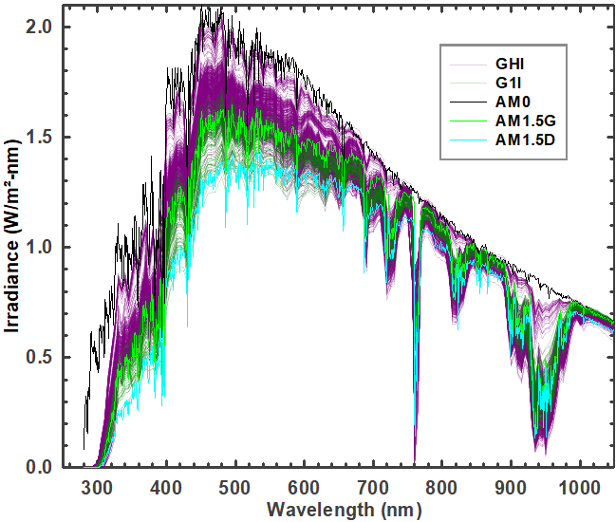 | 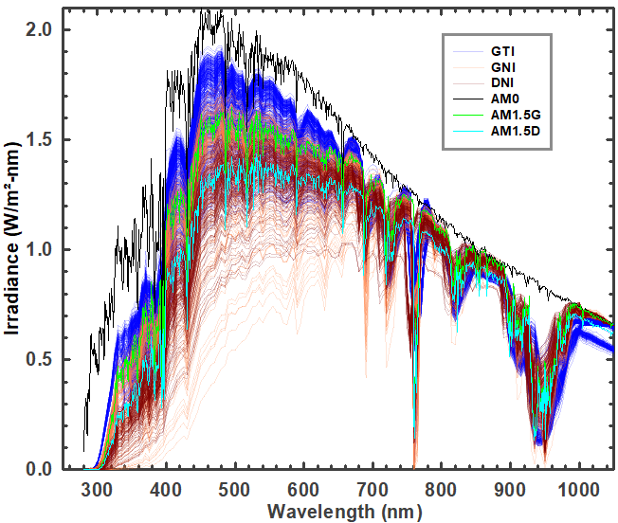
(a) | (b)
Figure 1. Weekly sums of spectral irradiance measured at the sites in Table 1: (a) global horizontal irradiance (GHI) and global one-axis irradiance (G1I); (b) global tilt irradiance (GTI), global normal irradiance (GNI), and direct normal irradiance (DNI). The spectra are normalized at either 880 nm or 1050 NM; AM1.5 values are substituted outside the measurement ranges. Standard spectra (AM0¹, AM1.5G, AM1.5D²) are shown for reference.

Introduction
To anyone who has ever watched a sunset or gazed upon a deep blue sky, the idea of variation in the spectrum of sunlight is hardly surprising. What is perhaps more surprising is the limited extent to which this variation is considered in solar photovoltaic operations. When comparing of solar photovoltaic (PV) efficiencies, assessing generation of solar power plants, or evaluating performance warranty claims, a single standard spectrum (known as AM1.5) is the reference. While use of a single standard spectrum has its advantages, including providing continuity over the years and consistency across academia and industry, neglecting spectrum variation adds to the uncertainty in solar energy generation^{3–11}.
Three factors determine the efficiency of a solar photovoltaic cell: temperature, irradiance, and the spectrum of irradiance (the spectral irradiance)¹². Temperature and (broadband) irradiance are routinely measured at solar installations and forecasted to determine grid availability of solar energy. Measurements of spectral irradiance are comparatively sparse, conducted mostly by research groups. Reliance on a single spectrum extends beyond the laboratory: to determine if a power plant is meeting its contractual obligations, the “performance ratio” is commonly used. This is calculated as the energy produced divided by the (broadband) irradiance and the efficiency under the AM1.5 spectrum; spectrum variation is neglected.
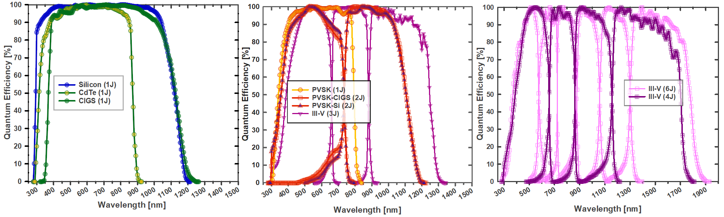
(a) | (b) | (c)
Figure 2. Solar cell quantum efficiencies digitized at 5-nm intervals from the Solar Cell Efficiency Tables: (a) silicon (Si), cadmium telluride (CdTe), and copper indium gallium selenide (CIGS); (b) perovskite (PVSK), perovskite-CIGS tandem (PVSK-CIGS), perovskite-silicon tandem (PVSK-Si), and a three-junction III-V; (c) four-, and six-junction III-Vs.
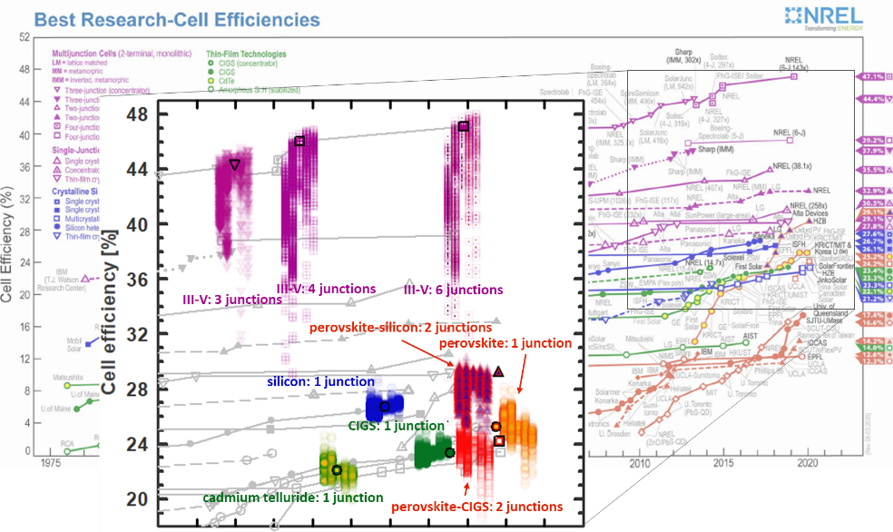
Figure 3. Efficiencies under measured spectral irradiance, compared against the values under Standard Test Conditions (symbols with black border). Symbols are arranged in order of increasing sun tracking: GHI, GTI, G1I, GNI, DNI. Lateral positions are adjusted to improve visibility. Best Research-Cell Efficiency chart courtesy of NREL.
Concerns with over-reliance on a single spectrum date to at least the 1990s⁵. As the solar industry has grown, the requirement to specify the impact of temperature and irradiance variation has been codified into international standards¹³, data sheets¹⁴, and warranty terms¹⁵. Meanwhile, the impact of spectral variation has often been treated as a secondary concern, or neglected¹⁶. The international standard for solar module power rating defines four temperatures and four irradiances, but only one spectrum¹⁷. The persistence of this approach is partly due to the perceived expense in obtaining spectral irradiance measurements, as well as a legacy assumption that the impact on silicon, solar energy’s workhorse material, is negligible. As the solar market has come to exceed US$150 billion, and impending rapid climate change makes every kWh of renewable energy more precious, it is worth revisiting these assumptions. As detailed in [¹⁸], for a single 100-MW PV plant that displaces fossil-fuel generation, a mere 2% variation in operating performance is equivalent to about €150,000 in annual revenue and ~1,500 tons of avoided CO₂, or nine flights between New York and Paris. As of 2021, the world has installed PV capacity equivalent to eight thousand such plants¹⁹. In the past two decades, as solar cell designs using novel materials have proliferated, evidence for a need to evaluate performance using energy yield calculations that incorporate spectral variation^{6–8,20–46} has increased. However, given the limited amount of measured spectral irradiance data available, previous studies have had to rely on relatively small data sets or synthetic spectra^{7,18,33,47}.
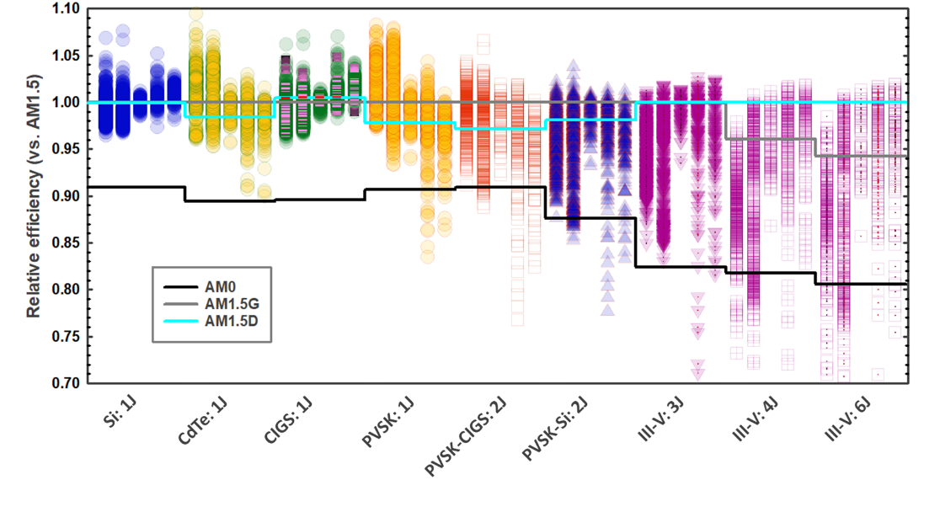
Figure 4. Relative efficiency as a function of cell type and number of junctions: silicon (Si), cadmium telluride (CdTe), CIGS, perovskite (PVSK), perovskite-CIGS tandem (PVSK-CIGS), perovskite-silicon tandem (PVSK-Si), and three-, four, and six-junction III-V multijunctions. For each cell type, data is grouped by orientation: from left to right, GHI, GTI, G1I, GNI, DNI. Lines indicate the relative efficiency of each type under the three standard solar spectra. AM0 is the standard spectrum outside Earth’s atmosphere¹.

Measured spectral irradiance
Researchers have pooled their data from sixteen sites in Asia, Australia, Europe, and North & South America that span a range of latitudes, elevations, atmospheric conditions, and sensor configurations. Spectral irradiance is typically measured by spectroradiometers, instruments which employ optical diffraction to measure irradiance across a series of narrow wavelengths. Diffraction can sample only a finite total wavelength range, so spectroradiometers for solar applications typically measure wavelength ranges of around 300-1100 nm or 900-1700 nm (Table 1). An alternative approach is to use a “solar spectral irradiance meter” that takes measured irradiance at a relatively small number of specific wavelengths as inputs to a model to construct the full spectrum⁴⁸. This is the instrument used for locations in Table 1 where the wavelength range is described as 280-4000 nm.
An alternative to this direct measurement of spectral irradiance is the use of synthetic spectra. Synthetic spectra are generated by applying atmospheric models to inputs of atmospheric properties (see Appendix)^{10,49–53}. Local measurement of the input parameters is complemented with satellite remote sensing^{52,53}. While synthetic spectra have demonstrated the ability to predict solar energy generation under a narrow set of field conditions^{54–56}, ground-level measurements such as those presented here are needed to fine-tune the models and verify that the synthetic spectra are accurate across the range of operating conditions worldwide. Synthetic spectra have previously been applied to analysis of the nine cell types in [¹⁸]. Comparison of results from measured spectral irradiance to those using synthetic spectra^{52,53} from the USA’s National Solar Radiation Database⁵⁷ are included in the Appendix.
Spectroradiometers can be mounted in orientations with varying degrees of solar tracking. Measurement of spectral irradiance has applications beyond solar PV, including monitoring of pollution⁵⁸ and the radiative forcing due to water vapor and other greenhouse gases⁵⁹. As such, the most common orientation is horizontal, with the sensor exposed to the “global” spectrum arriving from the full hemisphere of the sky (global horizontal irradiance, “GHI”). For solar applications, preferred orientations are those that match the “plane of array” in which solar modules are mounted. The most common mounting orientation for PV modules is either a fixed tilt (global tilted irradiance, or “GTI”) or one-axis tracking (global one-axis irradiance, “G1I”). Two-axis tracking keeps the surface perpendicular (normal) to the sun’s rays and global normal irradiance (“GNI”) is obtained. Finally, to capture irradiance coming only from the vicinity of the solar disc, two-axis tracking is combined with optics that exclude scattered sunlight and direct normal irradiance (“DNI”) is obtained.
The AM1.5 standard spectrum is defined for a wavelength range of 280-4000 nm². Spectroradiometers generally measure only some portion of this range (Table 1). As detailed in the Appendix, for values outside the measurement range, AM1.5 values were substituted. The spectra, grouped by mounting orientation, are shown in Figure 1. The spectrum for global horizontal irradiance (GHI), measured with sensors pointed at the dome of the sky is, not surprisingly, the “bluest”. As the degree of solar tracking increases, the sensors begin to follow the sun to the horizons and irradiance shifts increasingly to the “red” and infrared; visible wavelengths (400-700 nm) are diminished.
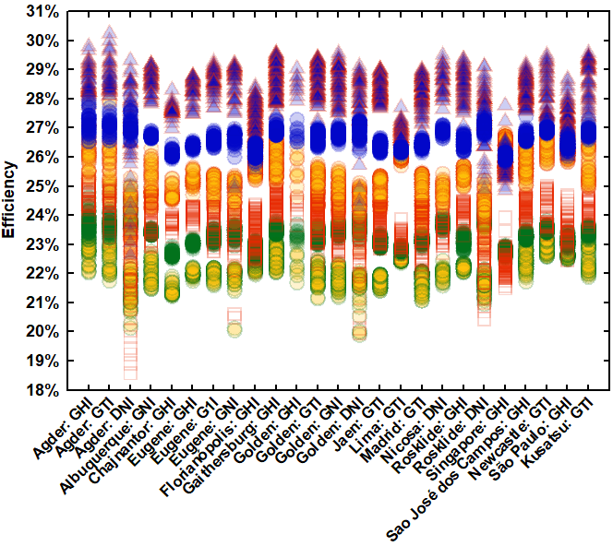 | 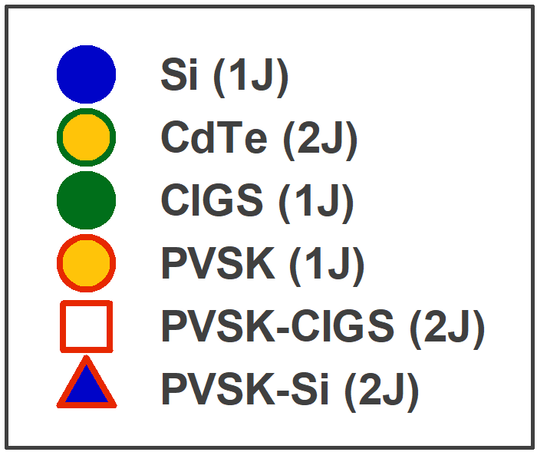
Figure 5. Efficiency as a function of location and orientation for cells with one or two junctions. Results for the III-V multijunctions are included in the Appendix.

Analysis
Nine solar cell types are evaluated using their current-best characteristics, as given in the Solar Cell Efficiency Tables⁶⁰ and NREL’s Best Research-Cell Efficiency Chart⁶¹. Four single-junction cells (silicon⁶², cadmium telluride⁶³, CIGS⁶⁰, and perovskite⁶⁴) are evaluated, along with five two-terminal multijunctions (perovskite-CIGS56, perovskite-silicon⁶⁵, and three-, four- and six- junction III-Vs^{60,63,66}. Multijunctions convert solar energy using two or more semiconductor junctions. Stacking the junctions increases the cell voltage while splitting the conversion of sunlight into current in each junctions. The two-terminal configuration implies a series connection, so the overall device current is limited by whichever junction is producing the least current. As a result, two-terminal multijunctions have more sensitivity to spectrum variation.
Efficiencies are calculated using the open-circuit voltage (V_{OC}) and fill factor (FF) confirmed under Standard Test Conditions (25° C, AM1.5 spectrum). Variations in spectral irradiance are assumed to affect only the cell short-circuit current. Second-order effects, such as changes to voltage or fill factor with changing irradiance⁶⁷, or increases in fill factor in multijunctions due to current mismatch³¹ are not considered here. The short-circuit current is derived from a cell’s spectral response and quantified using the cell quantum efficiency, which is a measure of the percentage of incoming photons at each wavelength that are absorbed and converted into current. Quantum efficiencies obtained from the Solar Cell Efficiency Tables are digitized at 5-nm wavelength intervals. Since the amplitude of the published quantum efficiencies is often normalized, the amplitudes are scaled to obtain the short-circuit current confirmed under the standard spectrum, AM1.5G (AM1.5D, for the III-V multijunctions)¹⁸. To determine the short-circuit current under a given spectrum, measured spectra are converted to 5-nm intervals to pair with the digitized quantum efficiencies. The spectral irradiance combined with the quantum efficiency yields a cell’s spectral current density¹⁸. Integrated across all wavelengths, the spectral current density gives the short-circuit current density, J_{SC} [A/cm²]. The product V_{OC}⋅FF⋅J_{SC} is then the cell power density [W/cm²]. Dividing by the broadband irradiance [W/cm²] obtains the efficiency.
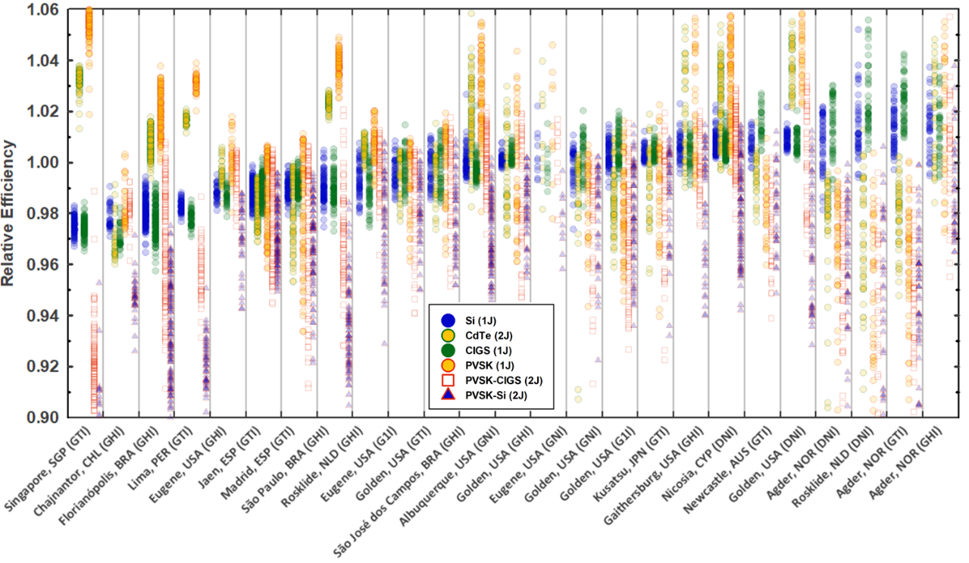
Figure 6. Relative efficiency vs. location and orientation for cells with one or two junctions. Data is sorted by increasing median efficiency of silicon.
Efficiencies from the measured spectra are shown in Figure 3, against a backdrop of the confirmed values under AM1.5G (AM1.5D, for III-V multijunctions). The corresponding relative efficiency, as a function of cell type, are shown in Figure 4. Cells with a single junction (Si, CdTe, CIGS, and PVSK) demonstrate efficiencies centered about their efficiency under the AM1.5 standard spectrum. As the number of junctions increases, the degree of spectrum sensitivity increases, and the relative efficiencies in Figure 4 drop. For cells with two or more junctions, the performance under AM1.5, rather than being an average value (as with the single junction cells), tends to be more of an upper bound of the performance under measured spectra. Series-connected multijunctions can be tuned (by varying the thickness and/or composition of the individual junctions) to optimize current matching of each junction under a single target spectrum. Cells tuned to perform best under AM1.5, therefore, may have been tuned away from optimum performance in operating conditions. Re-tuning the designs for spectral conditions in operation may require different thicknesses and material compositions.
Designing for operation under AM1.5, alone, may therefore be having an adverse effect on the development of these serially connected multijunctions. Rating cell efficiency under a single spectrum is a bit like rating vehicle efficiency based only on highway driving. As with temperature and broadband irradiance¹³, rating under more than one condition enables interpolation and extrapolation to other spectral conditions. Figure 4 suggests that AM0, the standard spectrum in space applications¹, could also be used to bracket (terrestrial) spectrum variation¹⁸. Fortunately, characterization under two spectra does not require two measurements: if the quantum efficiency of a cell is known, efficiency under a single condition can be translated to that under a second condition using a calculation known as spectral mismatch correction⁶⁸.
Cells with a wider spectral response are more tolerant to the increased spectral variation that arises from sun tracking. As expected, Figure 4 shows that increasing the sun tracking tends to benefit single-junction cells with a wider spectral response range (silicon, CIGS), but is a detriment to cells with a narrower spectral response (CdTe, perovskite, e.g.) ^{18,33,34}. For cells with more than one junction, the result is more mixed, as losses due to current mismatch between the junctions trade against the wider spectral response of the overall stack.
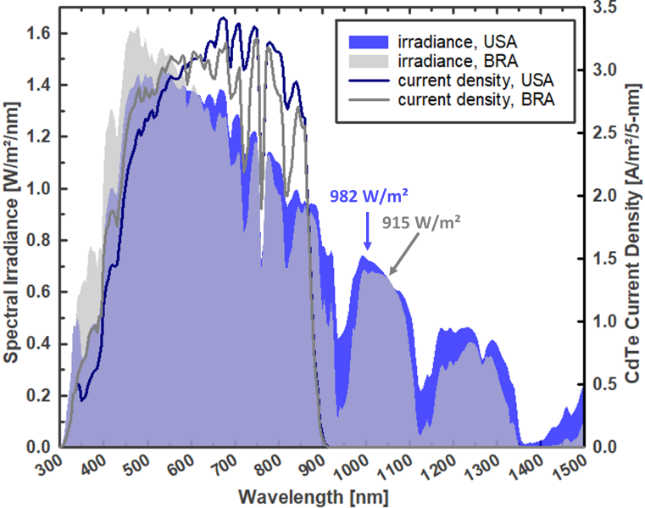
Figure 7. Spectral irradiance and the resulting current density for cadmium telluride from selected weekly sums in Albuquerque (USA) and Sao José dos Campos (BRA). Cadmium telluride has a spectral response range of ~300-900 nm. The two current density lines form equal areas.
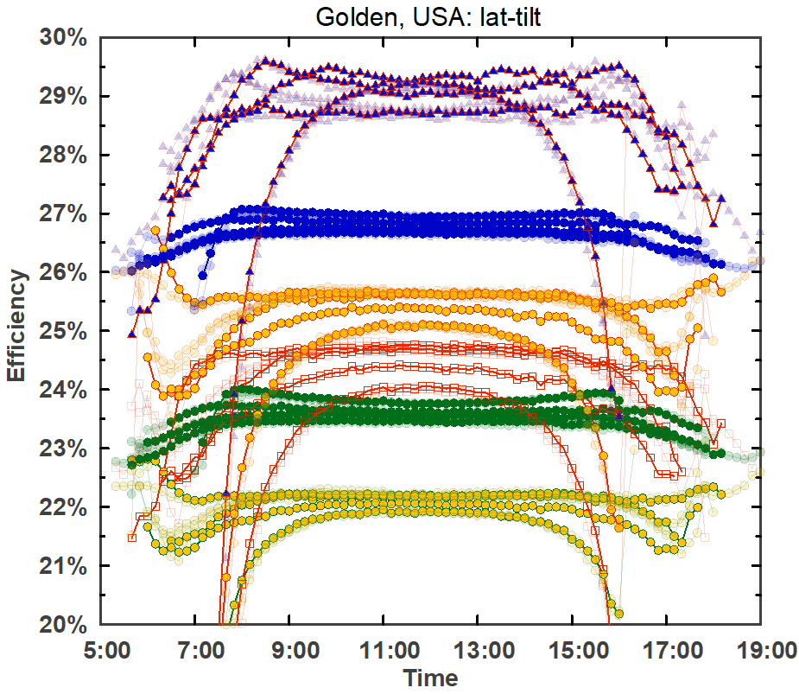 | 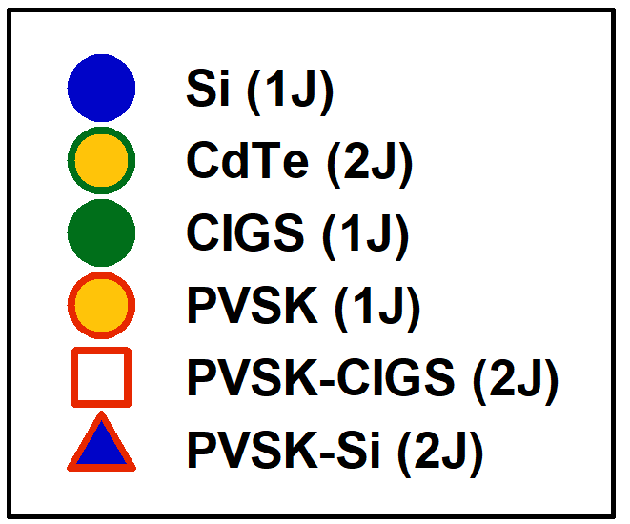 | 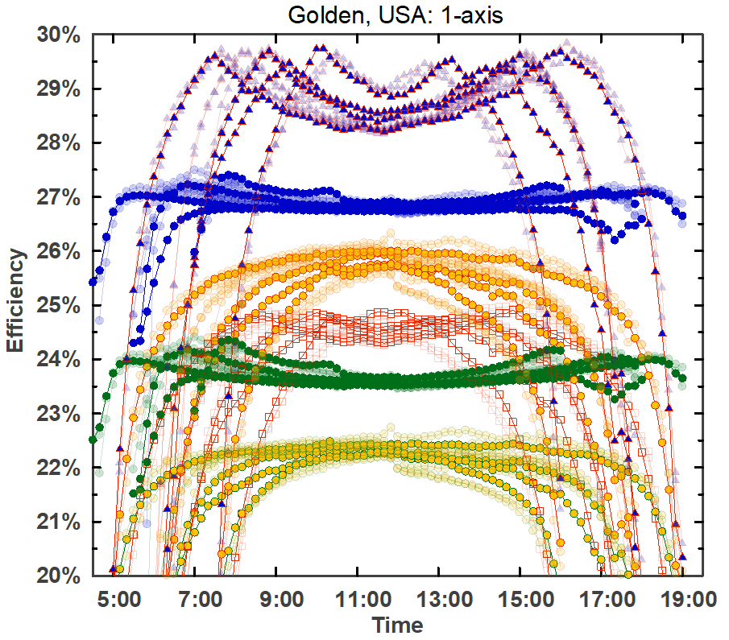
(a) |  | (b)
Figure 8. Seasonal and daily efficiency variation in Golden, USA for (a) global tilt irradiance (GTI) and (b) global one-axis irradiance (G1I). Seasonal changes are delineated using one month of 2020 data for March, June, September, and December. To illustrate year-over-year variation, data from 2018 and 2019 is semi-transparent in the background.
The largest increases in relative efficiency are seen in cells with the narrowest spectral response (cadmium telluride and single-junction perovskite). Since efficiency is the ratio of power out to power in, it should be noted that efficiency rise due to spectrum variation may be due either to an increase in the power provided by the cell, or a decrease in the irradiance outside the cell’s spectral response range: higher efficiency does not always imply higher power. This is illustrated in Figure 7, where two spectra are presented that deliver the same output power in a cadmium telluride cell, but different efficiencies. While the broadband irradiance for Albuquerque is 7% higher, the excess falls outside the spectral response range of cadmium telluride. As a result, the two current densities integrate to the same value: 302 A/m², giving a cell output power density of 210 W/m² for both. The efficiency, however, is 21.5% for Albuquerque and 23.0% for Sao José dos Campos.

Table 1. Relative weekly efficiency variation for the locations in this study. The orientations are global horizontal irradiance (GHI), global tilted irradiance (GTI), global, 1-axis tracking irradiance (G1I), global normal irradiance (GNI), and direct normal irradiance (DNI).
 |  |  |  |  | Silicon (1) |  | CdTe (1) |  | CIGS (1) |  | PVSK (1) |  | PVSK-CIGS (2) |  | PVSK-Si (2) |  | III-V (3) |  | III-V (4) |  | III-V (6)
Standard absolute efficiencies: |  |  | AM0 |  | 24.3% |  | 19.8% |  | 20.9% |  | 22.9% |  | 22.0% |  | 25.6% |  | 36.6% |  | 37.6% |  | 38.0%
 |  |  | AM1.5G |  | 26.7% |  | 22.1% |  | 23.4% |  | 25.2% |  | 24.2% |  | 29.2% |  | 44.4% |  | 44.2% |  | 44.4%
 |  |  | AM1.5D |  | 26.7% |  | 21.8% |  | 23.5% |  | 24.6% |  | 23.5% |  | 28.6% |  | 44.4% |  | 46.0% |  | 47.1%
Location & orientation |  | Range [nm] | Year | # Weeks | Relative efficiencies $\left(\frac{η{-η}_{STC}}{η_{STC}}\right)$:
Agder, NOR | GHI | 280-4000 | 2020 | 45 | -1% to 7% |  | 0% to 11% |  | -1% to 6% |  | 0% to 12% |  | -1% to 4% |  | -5% to 2% |  | -15% to 1% |  | -35% to -6% |  | -46% to -6%
Agder, NOR | GTI | 280-4000 | 2020 | 50 | -1% to 8% |  | -2% to 11% |  | -1% to 7% |  | -3% to 11% |  | -4% to 7% |  | -4% to 4% |  | -7% to 2% |  | -37% to 1% |  | -48% to 1%
Agder, NOR | DNI | 280-4000 | 2020 | 48 | -1% to 5% |  | -9% to 1% |  | 1% to 7% |  | -16% to 0% |  | -23% to 0% |  | -22% to 1% |  | -29% to 3% |  | -28% to 2% |  | -40% to 2%
Albuquerque, USA | GNI | 350-1700 | 2013-2015 | 53 | 0% to 1% |  | -3% to 3% |  | 0% to 1% |  | -4% to 4% |  | -5% to 2% |  | -5% to 0% |  | -8% to 1% |  | -13% to 1% |  | -14% to 1%
Chajnantor, CHL | GHI | 290-1800 | 2016-2017 | 40 | -3% to -1% |  | -4% to -1% |  | -4% to -2% |  | -3% to 0% |  | -4% to -1% |  | -7% to -3% |  | -11% to -7% |  | -12% to -9% |  | -14% to -10%
Eugene, USA | GHI | 350-1050 | 2020-2021 | 40 | -2% to 0% |  | -2% to 1% |  | -2% to -1% |  | -2% to 2% |  | -3% to 0% |  | -6% to -1% |  | -5% to -1% |  | -10% to -3% |  | -8% to -3%
Eugene, USA | G1I | 300-1050 | 2019 | 53 | -1% to 1% |  | -2% to 1% |  | -2% to 1% |  | -4% to 1% |  | -6% to 0% |  | -5% to 0% |  | -4% to 1% |  | -8% to 1% |  | -7% to 1%
Eugene, USA | GNI | 300-1050 | 2020-2021 | 52 | -3% to 1% |  | -9% to 0% |  | -2% to 2% |  | -12% to 1% |  | -15% to 0% |  | -15% to 0% |  | -14% to 2% |  | -13% to 1% |  | -14% to 2%
Florianópolis, BRA | GHI | 295-1100 | 2018-2020 | 144 | -4% to -1% |  | -1% to 2% |  | -4% to -1% |  | 0% to 4% |  | -9% to 1% |  | -12% to -2% |  | -13% to -2% |  | -19% to -6% |  | -20% to -6%
Gaithersburg, USA | GHI | 335-1650 | 2016-2018 | 110 | 0% to 2% |  | 0% to 6% |  | 0% to 2% |  | 0% to 7% |  | -2% to 3% |  | -6% to 1% |  | -14% to 1% |  | -30% to -6% |  | -32% to -6%
Golden, USA | GHI | 280-4000 | 2021 | 10 | -1% to 2% |  | -2% to 4% |  | -1% to 2% |  | -2% to 5% |  | -2% to 2% |  | -4% to 0% |  | -5% to -2% |  | -4% to -4% |  | -4% to -4%
Golden, USA | GTI | 350-1050 | 2019 | 53 | -1% to 1% |  | -3% to 2% |  | -2% to 1% |  | -4% to 2% |  | -5% to 2% |  | -5% to 1% |  | -4% to 2% |  | -9% to 0% |  | -10% to 0%
Golden, USA | G1I | 350-1650 | 2019 | 52 | 0% to 1% |  | -4% to 2% |  | 0% to 1% |  | -6% to 2% |  | -8% to 2% |  | -7% to 1% |  | -6% to 1% |  | -13% to 0% |  | -14% to 0%
Golden, USA | GNI | 290-1650 | 2020-2021 | 77 | -1% to 1% |  | -4% to 1% |  | -1% to 2% |  | -5% to 2% |  | -7% to 2% |  | -6% to 1% |  | -6% to 1% |  | -12% to 1% |  | -13% to 1%
Golden, USA | DNI | 350-1050 | 2020 | 53 | -2% to 2% |  | -10% to 0% |  | -1% to 3% |  | -14% to 0% |  | -18% to -1% |  | -17% to 0% |  | -18% to 1% |  | -16% to 1% |  | -20% to 1%
Jaen, ESP | GTI | 350-1050 | 2017-2019 | 115 | -2% to 0% |  | -3% to -1% |  | -2% to 0% |  | -4% to 1% |  | -6% to 0% |  | -5% to 0% |  | -5% to 0% |  | -8% to 0% |  | -7% to 0%
Kusatsu, JPN | GTI | 295-1050 | 2019 | 51 | 0% to 2% |  | -1% to 7% |  | -1% to 2% |  | -1% to 8% |  | -2% to 2% |  | -6% to 1% |  | -15% to 2% |  | -37% to -3% |  | -41% to -4%
Lima, PER | GTI | 295-1050 | 2020-2021 | 53 | -2% to -1% |  | 1% to 2% |  | -3% to -1% |  | 2% to 4% |  | -7% to -1% |  | -10% to -5% |  | -11% to -5% |  | -16% to -10% |  | -16% to -8%
Madrid, ESP | GTI | 350-1050 | 2016-2017 | 89 | -2% to 0% |  | -5% to 0% |  | -2% to 0% |  | -7% to 1% |  | -9% to 1% |  | -8% to 0% |  | -8% to 0% |  | -8% to -1% |  | -7% to 0%
Newcastle, AUS | GTI | 350-1700 | 2016 | 52 | 0% to 2% |  | 2% to 6% |  | 0% to 2% |  | 2% to 8% |  | -4% to 3% |  | -7% to 1% |  | -13% to -2% |  | -28% to -10% |  | -29% to -10%
Nicosia, CYP | DNI | 280-4000 | 2017 | 35 | 0% to 2% |  | -2% to 2% |  | 0% to 3% |  | -4% to 1% |  | -6% to 0% |  | -5% to 1% |  | -5% to 2% |  | -3% to 2% |  | -7% to 2%
Rosklide, NLD | GHI | 300-1050 | 2020-2021 | 53 | -2% to 1% |  | 0% to 1% |  | -3% to 1% |  | -1% to 2% |  | -4% to 1% |  | -7% to 1% |  | -9% to 1% |  | -13% to -4% |  | -11% to -6%
Rosklide, NLD | DNI | 300-1050 | 2020-2021 | 65 | 0% to 3% |  | -5% to 0% |  | 1% to 4% |  | -10% to 0% |  | -16% to -1% |  | -15% to 0% |  | -18% to 2% |  | -17% to 1% |  | -25% to 2%
São José dos Campos, BRA | GHI | 340-1700 | 2019-2020 | 104 | -1% to 3% |  | -2% to 6% |  | -1% to 2% |  | -2% to 7% |  | -3% to 2% |  | -5% to 0% |  | -11% to 0% |  | -34% to -2% |  | -39% to -2%
São Paulo, BRA | GHI | 350-1050 | 2013-2015 | 84 | -3% to 0% |  | 2% to 3% |  | -3% to 1% |  | 3% to 5% |  | -7% to 2% |  | -11% to -2% |  | -12% to -2% |  | -18% to -8% |  | -19% to -9%
Singapore, SGP | GTI | 350-1050 | 2019 | 120 | -3% to -2% |  | 1% to 4% |  | -3% to -2% |  | 2% to 6% |  | -11% to -1% |  | -15% to -5% |  | -17% to -5% |  | -23% to -11% |  | -26% to -11%
Of practical importance to project developers and grid operators is the variation for their specific location and mounting orientation. Absolute efficiency values as a function of site location are given in Figure 5. Relative values are given in Figure 6, ranked in order of increasing median efficiency for silicon. The performance of CIGS, with a similar spectral response, follows the increase with silicon; all other efficiencies diverge.
Seasonal and daily variation in Golden, USA is shown in Figure 8. Figures for additional sites, and for annual variation, are included in the Appendix. For the solar power plant operator, unexpected variation can be costly. Power plants employ meteorological (“met”) stations to monitor temperature, wind, and plane-of-array (broadband) irradiance. In larger plants, there are typically multiple broadband irradiance instruments⁶⁹. In the absence of spectral irradiance monitoring, however, the variation shown in Figure 8 is necessarily confused with other uncertainties, such as module or inverter degradation, soiling, cable corrosion, etc. Unexplained losses of a few percent can trigger costly contract disputes or warranty claims. Conversely, a plant that finds itself with unplanned gains may have to shed that excess power, due to cabling and power electronics that are undersized, or a grid operator unprepared to receive it. Implementing monitoring procedures for spectral irradiance like those for temperature and broadband irradiance will reduce these losses.
So long as the cost of electricity storage exceeds that of renewable generation⁷⁰ and efforts to “electrify everything”⁷¹ to blunt impending climate disruptions continue to grow, solar power will be most valuable at the times it is most difficult to produce. An (extreme) example is the winter storm that hit the Texas, USA grid in February 2021. Temperatures below freezing caused loss of generation from (insufficiently weatherized) sources that depend on moving parts and the unimpeded flow of liquids: natural gas, coal, nuclear, and wind. As generators fell offline and electricity prices spiked by factors of more than five⁷², solar generation was the only source to deliver increased output⁷³. As such, it can be hard to predict exactly when solar energy will be most valuable; efforts to quantify and minimize daily and seasonal spectral variation losses are needed to maximize the availability and value of solar power to grid operations. Silicon produces the most stable output under spectrum variation: its weekly site-level variation ranges from 1% to 8%, with a median of 3% (Table 1). Though this is the smallest of the cells evaluated, the median is equivalent to 10° C of temperature variation, or four years of module degradation⁷⁴.

Conclusion
The measured spectral irradiance data collected here provides an outline of the variation affecting photovoltaic performance worldwide. Solar cells vary in their response to spectrum variation, so characterization under more than one spectrum is suitable for comparison. Cells with a wider spectral response demonstrate an increase in efficiency with increases in sun tracking.
Spectrum sensitivity increases with the number of junctions and efficiency correspondingly declines. For cells with two or more junctions, efficiencies under the standard spectrum are less representative and potentially misleading: the practice of optimizing for AM1.5 may be reducing the potential for outdoor operation. Characterization under both AM0 and AM1.5 would serve to bracket the outdoor performance range and better inform cell development.

Acknowledgements
The authors are grateful for the data provided online by NREL, the University of Oregon, Sandia National Laboratories, and NIST.

Appendix

Substitution of AM1.5 for values outside the measurement range
AM1.5 values are used outside the measurement ranges. Other approaches are possible, but the resulting performance variation is therefore a lower bound. Normalization of the weekly spectral irradiance magnitudes was made at either 880 nm or 1050 nm, wavelengths at which atmospheric variation is at a minimum: the difference between AM1.5 and the solar constant in space (AM0) is less than 1% at these wavelengths^{1,2}. 1050 nm was used for most locations, but 880 nm was used in cases (Singapore, e.g.) where the atmospheric absorption in the near infrared is substantially higher than for AM1.5, so normalization at 1050 nm could result in anomalous values that exceed AM0. For the four- and six-junction III-Vs, any data for which one or more junctions falls outside the measurement range is excluded from the results.
The sensitivity of the cell performance variation to this method was evaluated using data from the instruments that measure data beyond 1050 nm. Data from 1050-4000 nm was substituted with AM1.5 values; the results are shown in Figure 9.
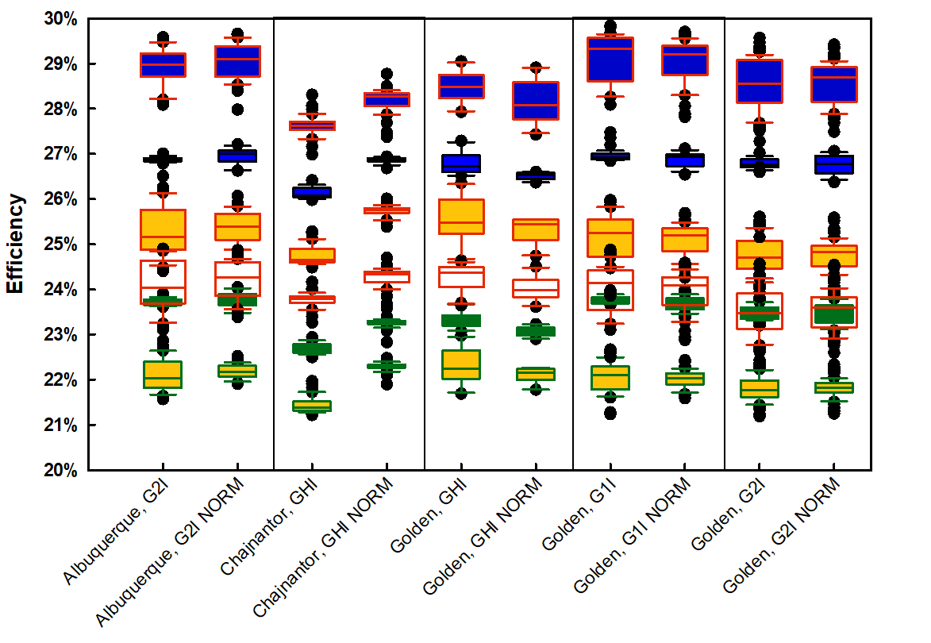
Figure 9. Sensitivity of performance variation to the normalization method. For each site, the left-hand data contains the full measurement range (Table 1); for the right-hand data (labeled “NORM”), measured values beyond 1050 nm have been substituted with AM1.5 values.

Measured vs. synthetic spectra
Models for solar spectral irradiance have been developed to enable synthesis of spectral using input atmospheric conditions. Inputs include site pressure and aerosol, water vapor, ozone, and CO₂ levels. The outputs are corroborated with a growing body of measurements from both satellite (NOAA/NASA GOES-R) and the ground-based spectroradiometer data presented here. The National Solar Radiation Database at NREL hosts Spectral On-Demand, a tool accessible online as part of the satellite-derived data in the NSRDB Data Viewer. Spectral On-Demand generates synthetic spectra for points within the area defined by NREL’s Physical Solar Model: longitude: -25°E to -175°W, latitude: -20°S to 60°N. In Figure 10, synthetic spectra are compared to measured spectra for two orientations in Golden, USA.
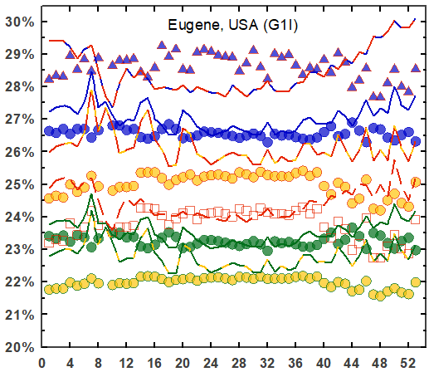 | 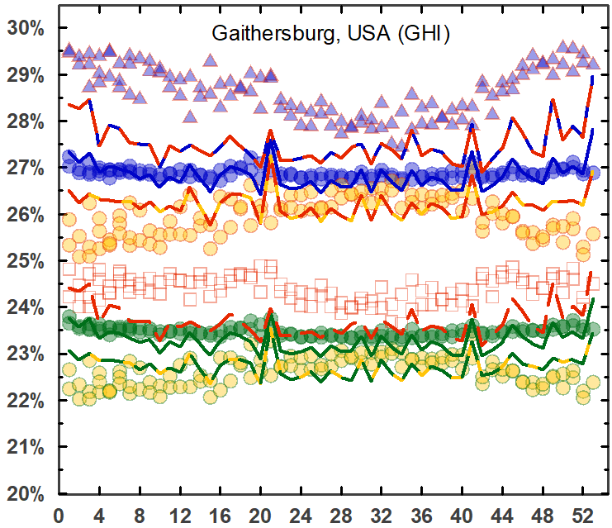 | 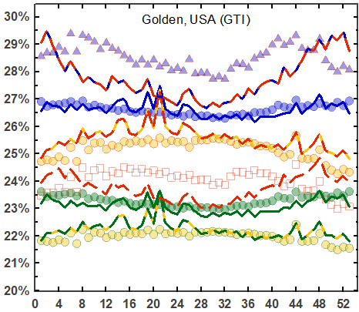
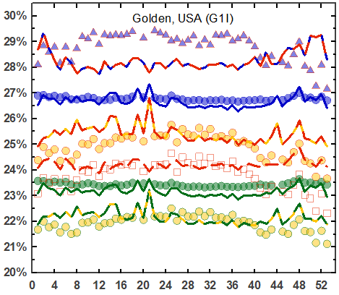 |  | 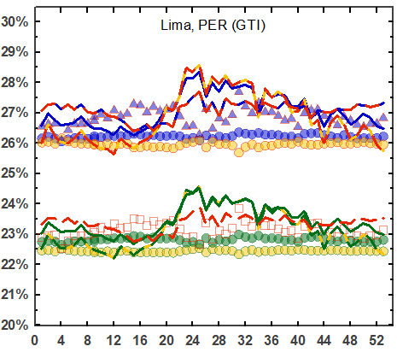

Figure 10. Measured (symbols) vs. synthetic spectra (lines) for sites available from NREL’s Physical Solar Model⁷⁵ (currently, longitude: -25°E to -175°W, latitude: -20°S to 60°N).

Absolute efficiency for III-V multijunctions
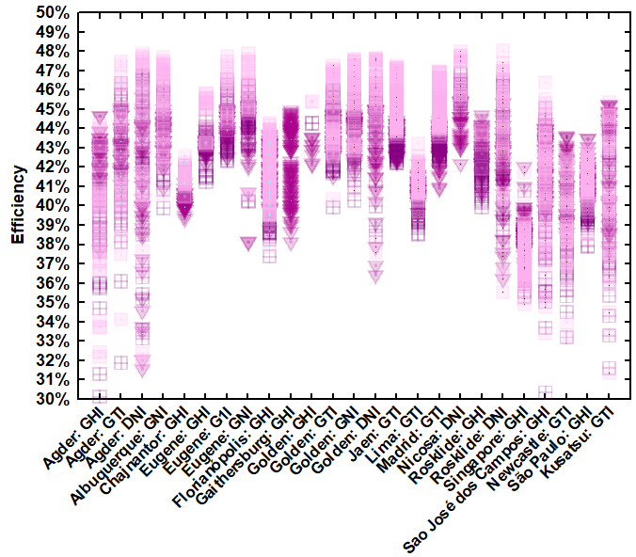 | 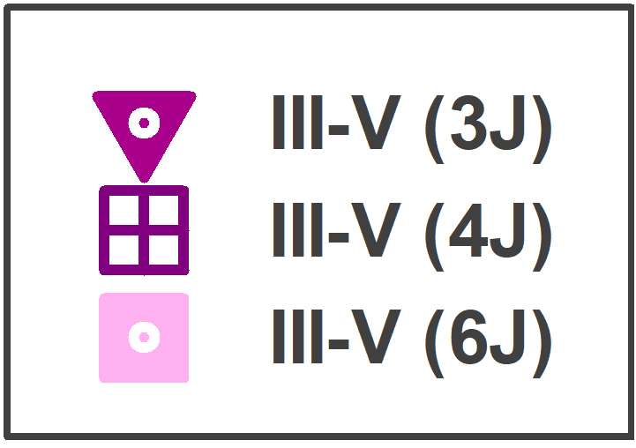

Figure 11. Efficiency as a function of location and orientation for III-V multijunction cells.

Annual efficiency variation: absolute efficiency vs. week of the year for one- and two-junction cells
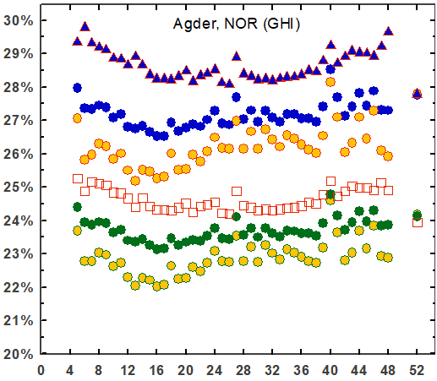 | 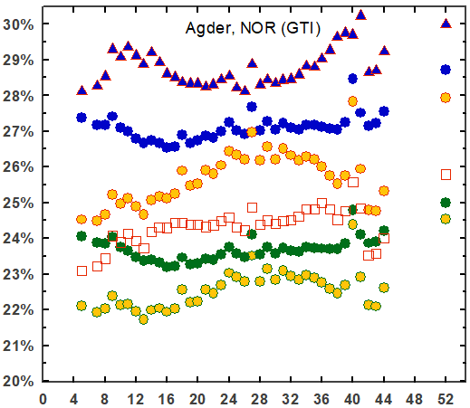 | 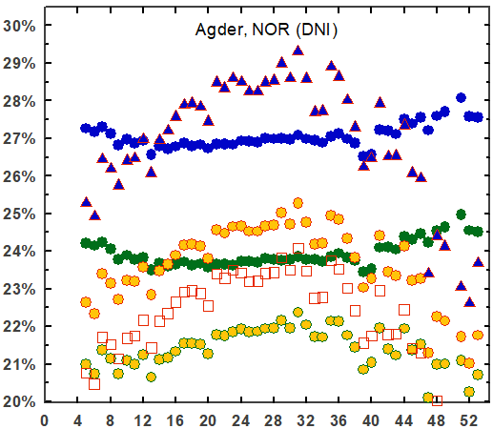
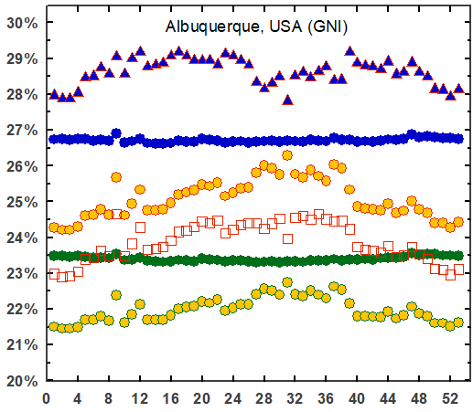 | 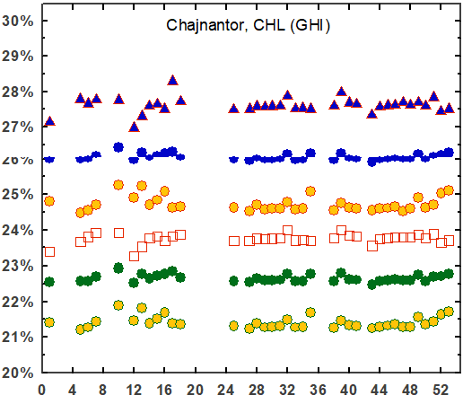 | 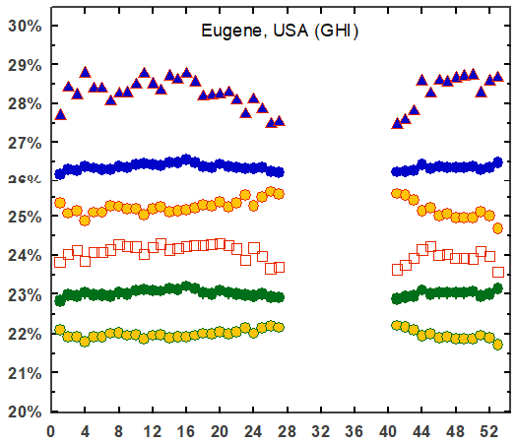
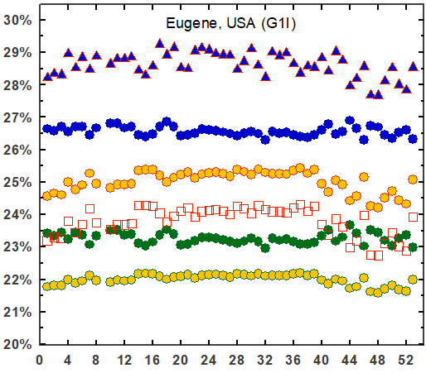 | 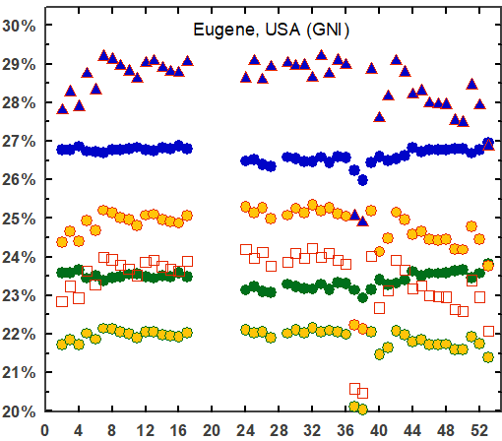 | 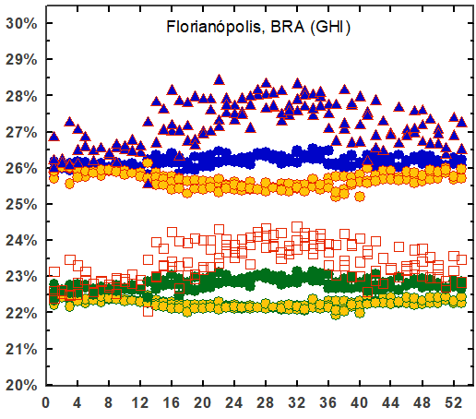
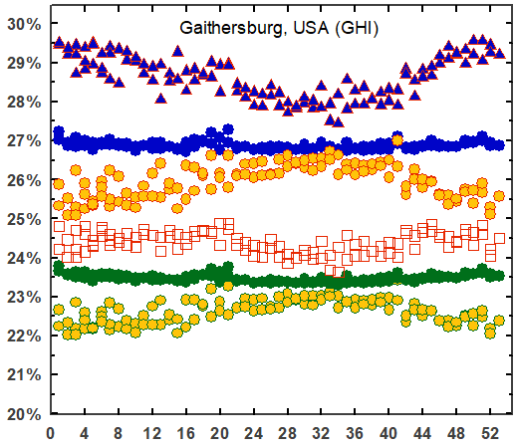 |  | 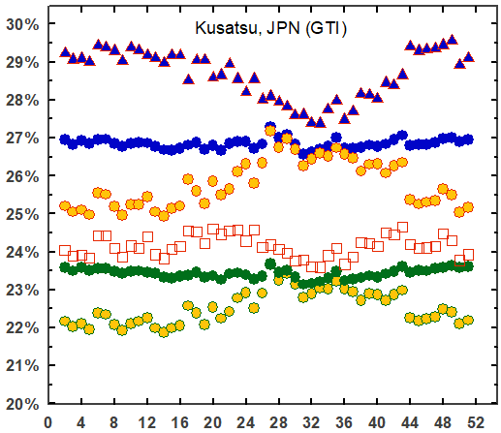

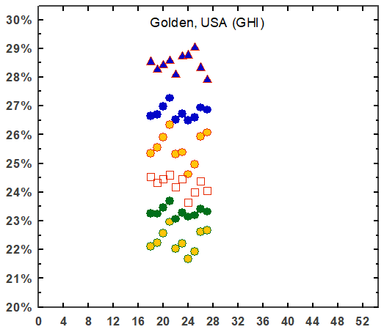 | 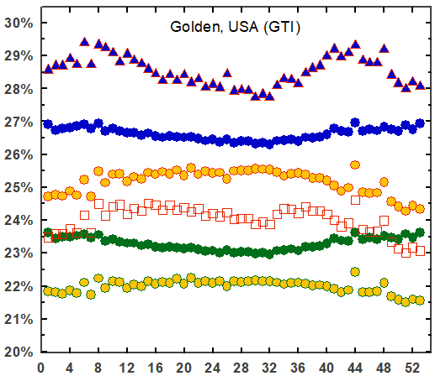 | 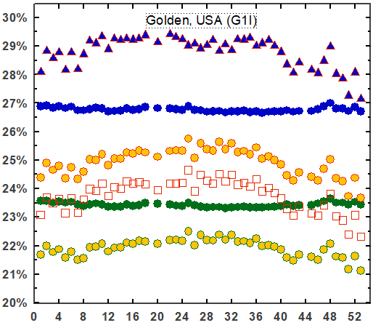
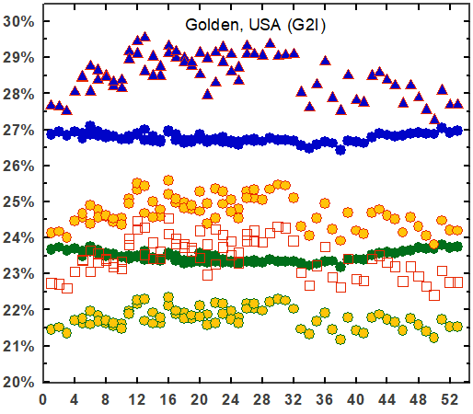 | 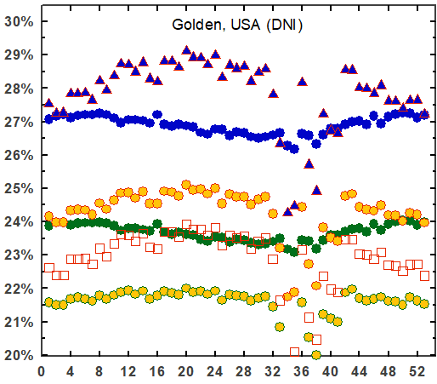 | 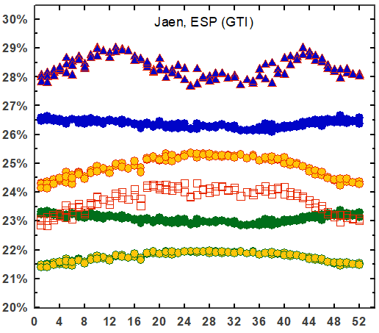
 | 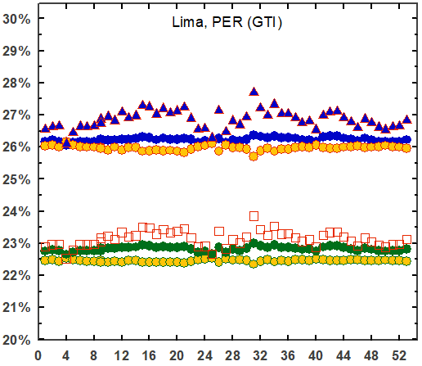 | 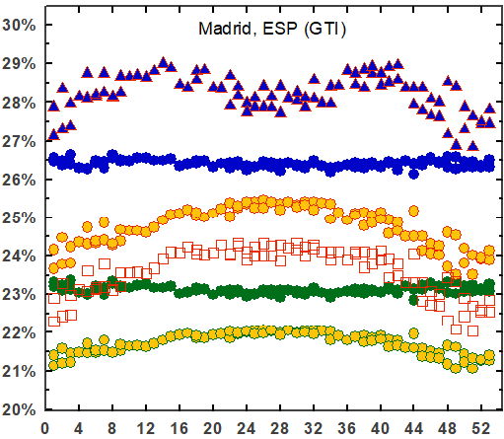
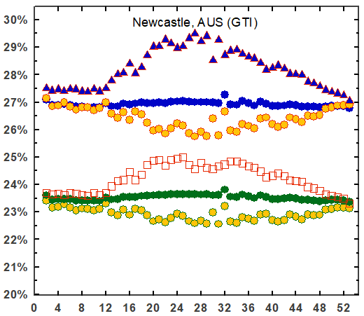 | 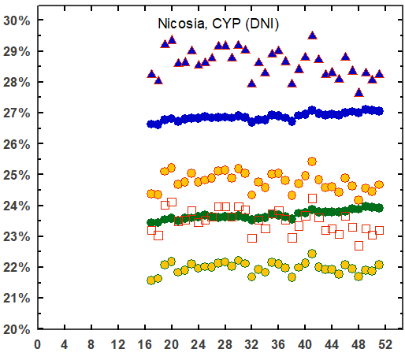

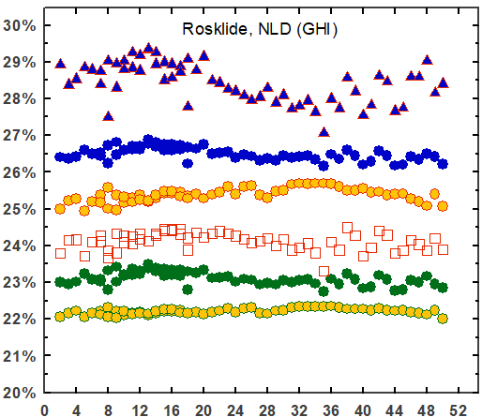 | 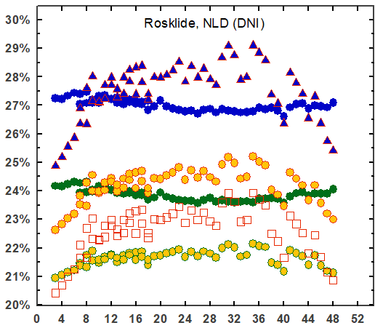 | 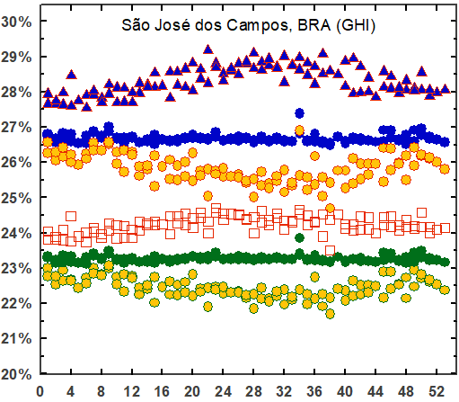
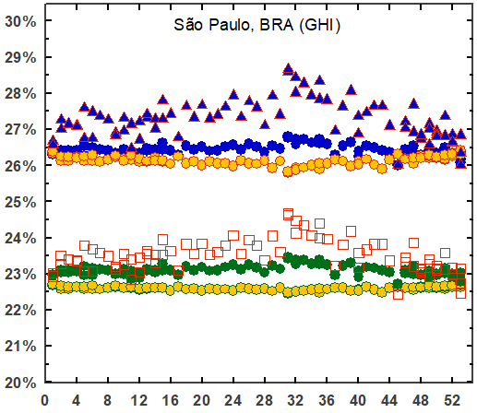 | 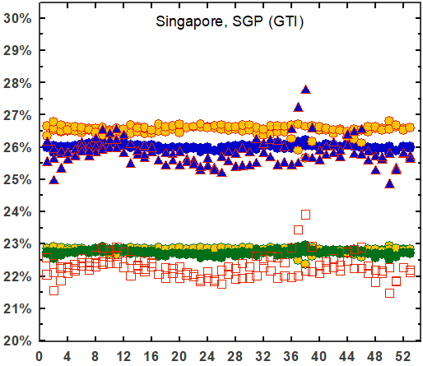

References
1. ASTM. ASTM E490-00a (2019), Solar Constant and Zero Air Mass Solar Spectral Irradiance Tables. ASTM International (2004).
2. ASTM G173-03. G173-03(2012) Standard Tables for Reference Solar Spectral Irradiances: Direct Normal and Hemispherical on 37° Tilted Surface. ASTM International (2012).
3. Faine, P., Kurtz, S. R., Riordan, C. & Olson, J. M. The influence of spectral solar irradiance variations on the performance of selected single-junction and multijunction solar cells. Solar Cells 31, 259–278 (1991).
4. Krauter, S. & Hanitsch, R. Actual optical and thermal performance of PV-modules. Solar Energy Materials and Solar Cells 41–42, 557–574 (1996).
5. Nann, S. & Emery, K. Spectral effects on PV-device rating. Solar Energy Materials and Solar Cells (1992) doi:10.1016/0927-0248(92)90083-2.
6. Schweiger, M. Impact of spectral irradiance on energy yield of PV modules measured in different climates. 4th PV Performance Modelling and Monitoring 17 Workshop (2015) doi:10.13140/RG.2.2.33591.73122.
7. Kinsey, G. S. Spectrum sensitivity, energy yield, and revenue prediction of PV modules. IEEE Journal of Photovoltaics 5, (2015).
8. Nofuentes, G., García-Domingo, B., Muñoz, J. v. & Chenlo, F. Analysis of the dependence of the spectral factor of some PV technologies on the solar spectrum distribution. Applied Energy 113, 302–309 (2014).
9. Minemoto, T., Nagae, S. & Takakura, H. Impact of spectral irradiance distribution and temperature on the outdoor performance of amorphous Si photovoltaic modules. Solar Energy Materials and Solar Cells (2007) doi:10.1016/j.solmat.2007.02.012.
10. Myers, D. R., Emery, K. & Gueymard, C. Revising and validating spectral irradiance reference standards for photovoltaic performance evaluation. in International Solar Energy Conference (2002). doi:10.1115/SED2002-1074.
11. Hirata, Y. & Tani, T. Output variation of photovoltaic modules with environmental factors—I. The effect of spectral solar radiation on photovoltaic module output. Solar Energy 55, 463–468 (1995).
12. IEC. IEC 60904-1 Ed. 2.0 b:2006 - Photovoltaic devices - Part 1: Measurement of photovoltaic current-voltage characteristics. IEC https://webstore.ansi.org/Standards/IEC/IEC60904Ed2006?gclid=Cj0KCQjw7MGJBhD-ARIsAMZ0eeuLqyJsaU8ouzY8cQhNxdJTJaTpIaxiyA_XhrmcN8dzjFlLhwwzBW0aAsRIEALw_wcB (2006).
13. IEC. IEC 60891 Ed. 2.0 b:2009 - Photovoltaic devices - Procedures for temperature and irradiance corrections to measured I-V characteristics. https://webstore.ansi.org/Standards/IEC/IEC60891Ed2009 (2009).
14. Trina Solar. Utility Scale Solar Panels - Trina Solar. https://www.trinasolar.com/us/product/utility (2021).
15. Jinko Solar. LIMITED WARRANTY. www.jinkosolar.com (2020).
16. IEC. IEC 61724 Ed. 1.0 b:1998 - Photovoltaic system performance monitoring - Guidelines for measurement, data exchange and analysis. https://webstore.ansi.org/Standards/IEC/IEC61724Ed1998?gclid=Cj0KCQjwpreJBhDvARIsAF1_BU1KSlCweyVqr2NGsnJJEWBJBzH1TJVw28jHUdoGUdo2Bgb9_RMeodQaAgkpEALw_wcB (1998).
17. IEC. IEC 61853-1 Ed. 1.0 b:2011 - Photovoltaic (PV) module performance testing and energy rating - Part 1: Irradiance and temperature performance measurements and power rating. https://webstore.ansi.org/Standards/IEC/IEC61853Ed2011?gclid=CjwKCAjwybyJBhBwEiwAvz4G7zGGe1v53mSa7VebpR9Olf3ZvBe-uj7mNzKvhAxoSPOoTrqdBclnCRoCoqIQAvD_BwE (2011).
18. Kinsey, G. S. Solar cell efficiency divergence due to operating spectrum variation. Solar Energy 217, 49–57 (2021).
19. IEA. Snapshot 2020 - IEA-PVPS. https://iea-pvps.org/snapshot-reports/snapshot-2020/ (2020).
20. Fernandez, E. F., Cruz, F. A., Mallick, T. K. & Sundaram, S. Effect of Spectral Irradiance Variations on the Performance of Highly Efficient Environment-Friendly Solar Cells. IEEE Journal of Photovoltaics (2015) doi:10.1109/JPHOTOV.2015.2434593.
21. Alonso-Abella, M., Chenlo, F., Nofuentes, G. & Torres-Ramírez, M. Analysis of spectral effects on the energy yield of different PV (photovoltaic) technologies: The case of four specific sites. Energy (2014) doi:10.1016/j.energy.2014.01.024.
22. Huld, T. & Gracia Amillo, A. M. Estimating PV module performance over large geographical regions: The role of irradiance, air temperature, wind speed and solar spectrum. Energies (2015) doi:10.3390/en8065159.
23. Norton, M., Amillo, A. M. G. & Galleano, R. Comparison of solar spectral irradiance measurements using the average photon energy parameter. Solar Energy 120, 337–344 (2015).
24. Dirnberger, D., Blackburn, G., Müller, B. & Reise, C. On the impact of solar spectral irradiance on the yield of different PV technologies. Solar Energy Materials and Solar Cells 132, 431–442 (2015).
25. Cornaro, C. & Andreotti, A. Influence of Average Photon Energy index on solar irradiance characteristics and outdoor performance of photovoltaic modules. Progress in Photovoltaics: Research and Applications (2013) doi:10.1002/pip.2194.
26. Ishii, T., Otani, K., Takashima, T. & Xue, Y. Solar spectral influence on the performance of photovoltaic (PV) modules under fine weather and cloudy weather conditions. Progress in Photovoltaics: Research and Applications (2013) doi:10.1002/pip.1210.
27. Kinsey, G. S. Spectrum sensitivity, energy yield, and revenue prediction of PV and CPV modules. in 2015 IEEE 42nd Photovoltaic Specialist Conference, PVSC 2015 (2015). doi:10.1109/PVSC.2015.7355850.
28. Lee, M., Ngan, L., Hayes, W. & Panchula, A. F. Comparison of the effects of spectrum on cadmium telluride and monocrystalline silicon photovoltaic module performance. in 2015 IEEE 42nd Photovoltaic Specialist Conference, PVSC 2015 (2015). doi:10.1109/PVSC.2015.7356174.
29. Simon, M. & Meyer, E. L. The effects of spectral evaluation of c-Si modules. Progress in Photovoltaics: Research and Applications (2011) doi:10.1002/pip.973.
30. Philipps, S. P. et al. Energy harvesting efficiency of III-V triple-junction concentrator solar cells under realistic spectral conditions. Solar Energy Materials and Solar Cells (2010) doi:10.1016/j.solmat.2010.01.010.
31. Reynolds, S. & Smirnov, V. Modelling Performance of Two- and Four-terminal Thin-film Silicon Tandem Solar Cells under Varying Spectral Conditions. in Energy Procedia (2015). doi:10.1016/j.egypro.2015.12.321.
32. Minemoto, T., Nagae, S. & Takakura, H. Impact of spectral irradiance distribution and temperature on the outdoor performance of amorphous Si photovoltaic modules. Solar Energy Materials and Solar Cells 91, 919–923 (2007).
33. Ripalda, J. M., Chemisana, D., Llorens, J. M. & García, I. Location-Specific Spectral and Thermal Effects in Tracking and Fixed Tilt Photovoltaic Systems. iScience 23, (2020).
34. Kinsey, G. S. Preprint: Solar cell efficiency divergence due to operating spectrum variation. https://engrxiv.org/yfx9r/ (2020) doi:10.31224/osf.io/yfx9r.
35. Riedel-Lyngskar, N. et al. Spectral Albedo in Bifacial Photovoltaic Modeling: What can be learned from Onsite Measurements? 2021 IEEE 48th Photovoltaic Specialists Conference (PVSC) 0942–0949 (2021) doi:10.1109/PVSC43889.2021.9519085.
36. Neves, G., Vilela, W., Pereira, E., Yamasoe, M. & Nofuentes, G. Spectral impact on PV in low-latitude sites: The case of southeastern Brazil. Renewable Energy 164, 1306–1319 (2021).
37. Amillo, A. M. G., Huld, T., Vourlioti, P., Müller, R. & Norton, M. Application of satellite-based spectrally-resolved solar radiation data to PV performance studies. Energies (2015) doi:10.3390/en8053455.
38. Futscher, M. H. & Ehrler, B. Modeling the Performance Limitations and Prospects of Perovskite/Si Tandem Solar Cells under Realistic Operating Conditions. ACS Energy Letters (2017) doi:10.1021/acsenergylett.7b00596.
39. Louwen, A., de Waal, A. C., Schropp, R. E. I., Faaij, A. P. C. & van Sark, W. G. J. H. M. Comprehensive characterisation and analysis of PV module performance under real operating conditions. Progress in Photovoltaics: Research and Applications 25, 218–232 (2017).
40. Braga, M., Rafael Do Nascimento, L. & Rüther, R. Spectral Impacts on the Performance of mc-Si and New-Generation CdTe Photovoltaics in the Brazilian Northeast.
41. Conde, L. A. et al. Spectral effects on the energy yield of various photovoltaic technologies in Lima (Peru). Energy 223, 120034 (2021).
42. Braga, M., do Nascimento, L. R. & Rüther, R. Spectral modeling and spectral impacts on the performance of mc-Si and new generation CdTe photovoltaics in warm and sunny climates. Solar Energy 188, 976–988 (2019).
43. Sirisamphanwong, C. & Ketjoy, N. Impact of spectral irradiance distribution on the outdoor performance of photovoltaic system under Thai climatic conditions. Renewable Energy 38, 69–74 (2012).
44. Representative identification of spectra and environments (RISE) using k‐means - Looney - 2021 - Progress in Photovoltaics: Research and Applications - Wiley Online Library. https://onlinelibrary.wiley.com/doi/10.1002/pip.3358.
45. Looney, E. E. et al. Representative identification of spectra and environments (RISE) using k-means. Progress in Photovoltaics: Research and Applications 29, 200–211 (2021).
46. Braga, M., do Nascimento, L. R. & Ruther, R. Spectral Impacts on the Performance of mc-Si and New-Generation CdTe Photovoltaics in the Brazilian Northeast. Conference Record of the IEEE Photovoltaic Specialists Conference 1226–1231 (2019) doi:10.1109/PVSC40753.2019.8981152.
47. Peters, I. M., Liu, H., Reindl, T. & Buonassisi, T. Global Prediction of Photovoltaic Field Performance Differences Using Open-Source Satellite Data. Joule 2, 307–322 (2018).
48. Tatsiankou, V., Hinzer, K., Schriemer, H., Haysom, J. & Beal, R. A novel instrument for cost-effective and reliable measurement of Solar Spectral Irradiance. 2015 IEEE 42nd Photovoltaic Specialist Conference, PVSC 2015 (2015) doi:10.1109/PVSC.2015.7356407.
49. Gueymard, C. A. SMARTS2: a simple model of the atmospheric radiative transfer of sunshine: algorithms and performance assessment. Report No. FSEC-PF-270-95 (1995).
50. Myers, D. R. & Gueymard, C. A. Description and availability of the SMARTS spectral model for photovoltaic applications. in Organic Photovoltaics V (2004). doi:10.1117/12.555943.
51. Myers, D. R., Emery, K. & Gueymard, C. Terrestrial solar spectral modeling tools and applications for photovoltaic devices. in Conference Record of the IEEE Photovoltaic Specialists Conference (2002). doi:10.1109/pvsc.2002.1190943.
52. Xie, Y. & Sengupta, M. A Fast All-sky Radiation Model for Solar applications with Narrowband Irradiances on Tilted surfaces (FARMS-NIT): Part I. The clear-sky model. Solar Energy (2018) doi:10.1016/j.solener.2018.09.056.
53. Xie, Y., Sengupta, M. & Wang, C. A Fast All-sky Radiation Model for Solar applications with Narrowband Irradiances on Tilted surfaces (FARMS-NIT): Part II. The cloudy-sky model. Solar Energy (2019) doi:10.1016/j.solener.2019.06.058.
54. Kinsey, G. S., Stone, K., Brown, J. & Garboushian, V. Energy prediction of Amonix CPV solar power plants. Progress in Photovoltaics: Research and Applications 19, (2011).
55. Kinsey, G. S. Weighing the merits of solar power plants using concentration photovoltaics - PV Tech. PV Tech https://www.pv-tech.org/technical-papers/weighing-the-merits-of-solar-power-plants-using-concentration-photovoltaics/ (2012).
56. Kinsey, G. S. et al. Advancing efficiency and scale in CPV Arrays. IEEE Journal of Photovoltaics 3, (2013).
57. Sengupta, M. et al. The National Solar Radiation Data Base (NSRDB). Renewable and Sustainable Energy Reviews (2018) doi:10.1016/j.rser.2018.03.003.
58. Ponce, A. M. et al. Chemical composition of aerosol particles from direct emissions of vegetation fires in the Amazon Basin: water-s... Cite this paper Chemical composition of aerosol particles from direct emissions of vegetation "res in the Amazon Basin: water-soluble species and trace elements.
59. JD, H., AR, W., R, T. & JW, H. An influence of solar spectral variations on radiative forcing of climate. Nature 467, 696–699 (2010).
60. Green, M. A. et al. Solar cell efficiency tables (Version 53). Progress in Photovoltaics: Research and Applications (2019) doi:10.1002/pip.3102.
61. NREL. Best Research-Cell Efficiency Chart | Photovoltaic Research | NREL. https://www.nrel.gov/pv/cell-efficiency.html (2020).
62. Green, M. A. et al. Solar cell efficiency tables (version 50). Progress in Photovoltaics: Research and Applications (2017) doi:10.1002/pip.2909.
63. Green, M. A., Emery, K., Hishikawa, Y., Warta, W. & Dunlop, E. D. Solar cell efficiency tables (Version 45). Progress in Photovoltaics: Research and Applications (2015) doi:10.1002/pip.2573.
64. Green, M. A. et al. Solar cell efficiency tables (Version 55). Progress in Photovoltaics: Research and Applications (2020) doi:10.1002/pip.3228.
65. Green, M. A. et al. Solar cell efficiency tables (version 56). Progress in Photovoltaics: Research and Applications (2020) doi:10.1002/pip.3303.
66. Green, M. A., Emery, K., Hishikawa, Y., Warta, W. & Dunlop, E. D. Solar cell efficiency tables (version 42). Progress in Photovoltaics: Research and Applications (2013) doi:10.1002/pip.2404.
67. Kinsey, G. S. et al. Concentrator multifunction solar cell characteristics under variable intensity and temperature. Progress in Photovoltaics: Research and Applications 16, (2008).
68. IEC 60904-7. IEC 60904-7 Edition 3.0 Part 7: Computation of the spectral mismatch correction for measurements of photovoltaic devices. International Electrotechnical Commission (2008).
69. Kipp & Zonen. Solar Irradiance Monitoring in Solar Energy Projects. https://www.kippzonen.com/Download/810/Brochure-Solar-Irradiance-Monitoring-in-Solar-Energy-Projects.
70. IRENA. Electricity storage and renewables: Costs and markets to 2030. /publications/2017/Oct/Electricity-storage-and-renewables-costs-and-markets.
71. NREL. Electrification Futures Study: A Technical Evaluation of the Impacts of an Electrified U.S. Energy System | Energy Analysis | NREL. https://www.nrel.gov/analysis/electrification-futures.html.
72. Herscher, R. Texas Electricity Bills Skyrocket Due To Winter Storm : Live Updates: Winter Storms 2021 : NPR. NPR https://www.npr.org/sections/live-updates-winter-storms-2021/2021/02/21/969912613/after-days-of-mass-outages-some-texas-residents-now-face-huge-electric-bills (2021).
73. Penney, V. How Texas’ Power Generation Failed During the Storm, in Charts - The New York Times. New York Times https://www.nytimes.com/interactive/2021/02/19/climate/texas-storm-power-generation-charts.html (2021).
74. SunPower. SunPower product performance. Products https://us.sunpower.com/products/solar-panels (2020).
75. NREL. NSRDB Data Viewer. https://maps.nrel.gov/nsrdb-viewer/?aL=x8CI3i%255Bv%255D%3Dt%26Jea8x6%255Bv%255D%3Dt%26Jea8x6%255Bd%255D%3D1%26VRLt_G%255Bv%255D%3Dt%26VRLt_G%255Bd%255D%3D2%26mcQtmw%255Bv%255D%3Dt%26mcQtmw%255Bd%255D%3D3&bL=clight&cE=0&lR=0&mC=4.740675384778373%2C22.8515625&zL=2.

AUTHOR NAMES & AFFILIATIONS:

