Impact of measured spectrum variation on solar photovoltaic efficiencies worldwide
Geoffrey S. Kinsey, Nicholas C. Riedel-Lyngskær, Jorge Aguilera, Matthew Boyd, Marília Braga, Raul R. Cordero, Benjamin C. Duck, Christopher J. Fell, Sarah Feron, George Georghio, Nipon Ketjoy, Atse Louwen, Takashi Minemoto, Guilherme Neves, Gustavo Nofuentes Garrido^{b}, Basant R. Paudyal, Enio Bueno Pereira^{f}, Yves Poissant, Thomas Reindl, Carlos D. Rodríguez-Gallegos^{g}, Ricardo Rüther, Wilfried van Sark, Miguel A. Sevillano-Bendezú, Jorge A. Tejero, Marios Theristis, Jan A. Töfflinger, Waldeir Amaral Vilela^{f}, Márcia A. Yamasoe

Abstract
In ratings of solar photovoltaic performance, variation in the spectrum of sunlight is often neglected. A single spectrum, AM1.5, is used as the sole basis not only for record laboratory efficiencies, but also for commercial module power ratings, the performance metrics for solar power plants, and warranty claims. Incorporation of solar spectrum variation would improve accuracy and reduce the financial consequences of prediction errors. Ground-level measurements of spectral irradiance collected worldwide have been pooled to provide an extensive – though by no means comprehensive – sampling of the variation. Applied to nine solar cell types, the resulting divergence in solar cell performance illustrates that a single spectrum is insufficient for comparison of cells with different spectral responses. In contrast with single-junction cells such as silicon and cadmium telluride, cells with two or more semiconductor junctions tend to have efficiencies below that obtained under AM1.5. Increases in the degree of sun tracking are shown to decrease efficiency for cells with a narrower spectral response. Of the nine cell types, silicon exhibits the least spectral sensitivity: relative site variation ranges from 1% in Golden, USA to 14% in Edmonton, Canada, with a mean of 4%.
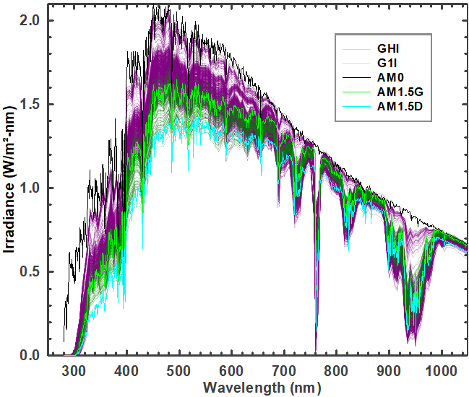 | 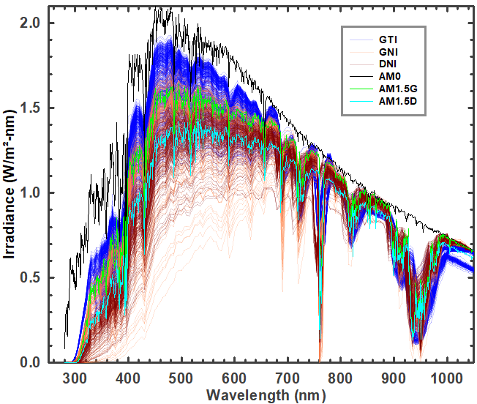
(a) | (b)
Figure 1. Weekly sums of spectral irradiance measured at the sites in Table 1: (a) global horizontal irradiance (GHI) and global one-axis irradiance (G1I); (b) global tilt irradiance (GTI), global normal irradiance (GNI), and direct normal irradiance (DNI). The spectra are normalized at either 880 nm or 1050 nm; AM1.5 values are substituted outside the measurement ranges. Standard spectra (AM0¹, AM1.5G, AM1.5D²) are shown for reference.

Introduction
To anyone who has ever watched a sunset or gazed upon a deep blue sky, the idea of variation in the spectrum of sunlight is hardly surprising. Perhaps more surprising is the limited extent to which this variation is considered in solar photovoltaic operations. When comparing solar photovoltaic (PV) efficiencies, assessing generation of solar power plants, or evaluating performance warranty claims, a single standard spectrum (known as AM1.5, Appendix A) is the reference. While use of a single standard spectrum has its advantages, including providing continuity over the years and consistency across academia and industry, the neglect of spectrum variation adds to the uncertainty in solar energy generation^{3–11}.
Three parameters determine the efficiency of a solar photovoltaic cell: temperature, irradiance, and the spectrum of irradiance (the spectral irradiance)¹². Temperature and (broadband) irradiance are routinely measured at solar installations and forecasted to determine grid availability of solar energy. Measurements of the third parameter, spectral irradiance, are comparatively sparse, conducted mostly by research groups. The power output of solar modules is rated using the single spectrum and residential, commercial, and utility-scale PV systems are designed accordingly. To determine if an operating solar power plant is meeting its contractual obligations, the “performance ratio” is commonly used. This is calculated as the energy generated in a given time period divided by the (broadband) irradiance and the efficiency under the AM1.5 spectrum; spectrum variation is neglected.
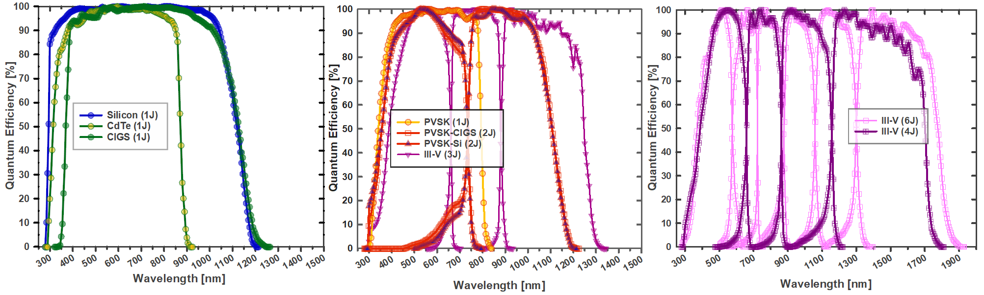
(a) | (b) | (c)
Figure 2. Solar cell quantum efficiencies digitized at 5-nm intervals from the Solar Cell Efficiency Tables: (a) silicon (Si), cadmium telluride (CdTe), and copper indium gallium selenide (CIGS); (b) perovskite (PVSK), perovskite-CIGS tandem (PVSK-CIGS), perovskite-silicon tandem (PVSK-Si), and a three-junction III-V; (c) four-, and six-junction III-Vs.
The AM1.5 spectrum was codified in the USA in 1982¹³; concerns with over-reliance on it date to at least the 1990s^{5,11}. Since that time, the information gap between spectral irradiance and temperature & broadband irradiance called out in [⁵] has persisted. Growth of the solar industry has led to temperature and broadband irradiance variation requirements being codified into international standards¹⁴, data sheets¹⁵, and warranty terms¹⁶. Meanwhile, the impact of spectral variation has often been treated as a secondary concern, or neglected¹⁷. The current international standard for solar module power rating defines four temperatures and four irradiances, but only one spectrum¹⁸. The persistence of this gap is due partly to the perceived expense in obtaining spectral irradiance measurements and a legacy assumption that the relative impact on silicon, solar energy’s workhorse material, is negligible.
As the solar market has come to exceed €150 billion annually, and impending rapid climate change makes every kWh of renewable energy more precious, it is worth revisiting these assumptions. Variation of mere tenths of a percent now imply billions of euros gained or lost over the decades of operation - before the cost of carbon is included¹⁹. As detailed in [²⁰], for a single 100-MW PV plant that displaces fossil-fuel generation, a 2% variation in operating performance is equivalent to about €150,000 in annual revenue and ~1,500 tons of avoided CO₂, or nine flights between New York and Paris. As of 2021, the world has installed PV capacity equivalent to eight thousand such plants²¹. In the past two decades, as new solar cell designs using novel materials have proliferated²², evidence for a need to incorporate spectral variation^{6–8,23–51} has grown harder to ignore. However, given the limited amount of measured spectral irradiance data available, previous studies have had to rely on relatively small data sets or synthetic spectra^{7,20,36,52}.

Measured spectral irradiance
A coalition of solar researchers has pooled their data from sites in Asia, Australia, Europe, and the Americas that span a range of latitudes, elevations, atmospheric conditions, and sensor orientations. Spectral irradiance is typically measured by spectroradiometers, instruments which employ optical diffraction to measure irradiance across a series of narrow wavelengths. A given diffractive optic can sample only a limited total wavelength range, so spectroradiometers for solar applications often measure wavelength ranges of around 300-1100 nm or 900-1700 nm⁵³ (Table 1). A pair of spectroradiometers spanning 300-1700 nm measures about 97% of the power in the extraterrestrial (AM0) spectrum¹. An emerging alternative is to use a “solar spectral irradiance meter” that takes measured irradiance at a relatively small number of specific wavelengths as inputs to a model to reconstruct the full spectrum^{54,55}. This is the instrument used for locations in Table 1 where the wavelength range is described as 280-4000 nm.
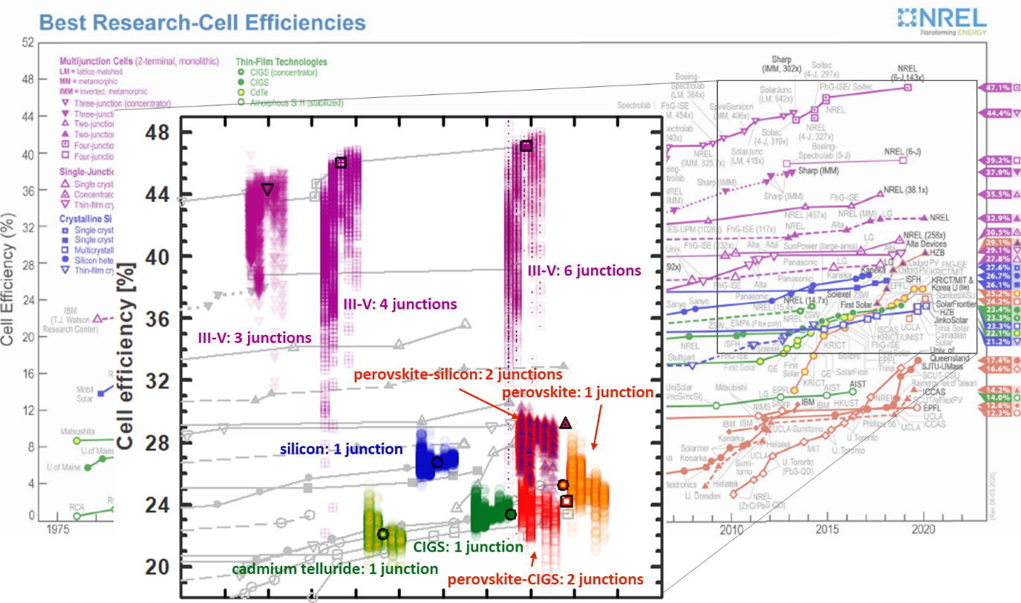
Figure 3. Efficiencies under measured spectral irradiance, compared against the values under Standard Test Conditions (symbols with black border). Symbols are arranged in order of increasing sun tracking: GHI, GTI, G1I, GNI, DNI. Lateral positions are adjusted to improve visibility. Best Research-Cell Efficiency chart courtesy of NREL.
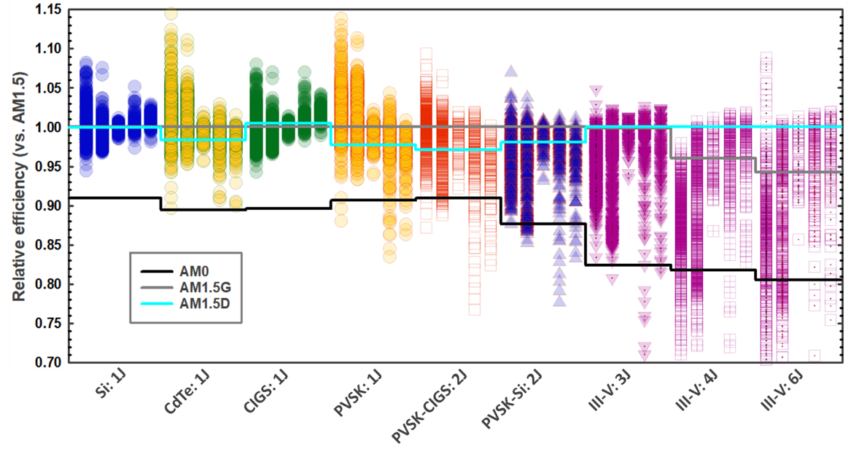
Figure 4. Relative efficiency as a function of cell type and number of junctions: silicon (Si), cadmium telluride (CdTe), CIGS, perovskite (PVSK), perovskite-CIGS tandem (PVSK-CIGS), perovskite-silicon tandem (PVSK-Si), and three-, four, and six-junction III-V multijunctions. For each cell type, data is grouped by orientation: from left to right, GHI, GTI, G1I, GNI, DNI. Lines indicate the relative efficiency of each type under the three standard solar spectra. AM0 is the standard spectrum outside Earth’s atmosphere¹.
In parallel with direct measurement of ground-level spectral irradiance is the formulation of synthetic spectra. Synthetic spectra are generated by applying atmospheric models using inputs of atmospheric properties (Appendix E)^{10,56–60}. Limited site-level measurement of the atmospheric parameters is expanded using satellite remote sensing to provide synthetic spectra over extended geographic areas ^{59,60}. While synthetic spectra have demonstrated the ability to predict solar energy generation under a narrow set of field conditions^{61–63}, ground-level measurements such as those presented here are needed to fine-tune the models and verify that the synthetic spectra remain accurate across the range of atmospheric conditions worldwide. Synthetic spectra have previously been applied to analysis of the nine cell types in [²⁰]. Comparison of results from measured spectral irradiance to those using synthetic spectra^{59,60} from the USA’s National Solar Radiation Database⁶⁴ are included in Appendix E.
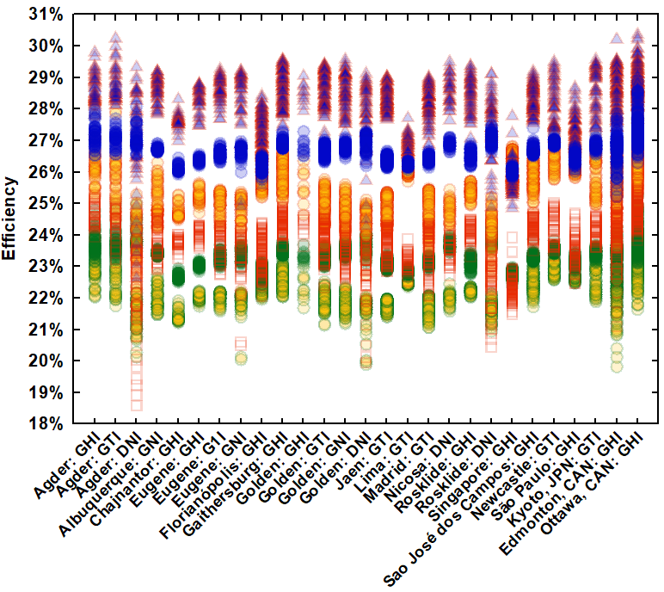 | 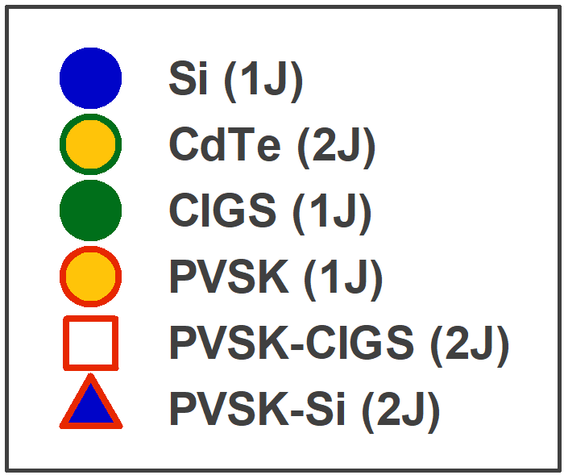
Figure 5. Efficiency as a function of location and orientation for cells with one or two junctions. Results for the III-V multijunctions are included in Appendix D.
Spectral irradiance sensors can be mounted in orientations with varying degrees of solar tracking. Measurement of spectral irradiance has applications beyond solar PV, including monitoring of pollution⁶⁵ and the radiative forcing arising from water vapor and other greenhouse gases^{66,67}. As such, the most common orientation is horizontal, with the sensor exposed to the “global” spectrum arriving from the full hemisphere of the sky (global horizontal irradiance, “GHI”). For solar applications, preferred orientations are those that match the “plane of array” in which solar modules are mounted. The most common mounting orientation for PV modules is either a fixed tilt (global tilted irradiance, or “GTI”) or one-axis tracking (global one-axis irradiance, “G1I”). Two-axis tracking keeps the surface perpendicular (normal) to the sun’s rays and global normal irradiance (“GNI”) is obtained. Finally, to capture irradiance coming only from the vicinity of the solar disc, two-axis tracking is combined with optics that exclude scattered sunlight and direct normal irradiance (“DNI”) is obtained.
The AM1.5 standard spectrum is defined for a wavelength range of 280-4000 nm². Spectroradiometers generally measure only some portion of this range (Table 1). As detailed in Appendix B, for values outside the measurement range, AM1.5 values were substituted. The spectra, grouped by mounting orientation, are shown in Figure 1. The spectrum for global horizontal irradiance (GHI), measured with sensors pointed at the dome of the sky is, not surprisingly, the “bluest”. As the degree of solar tracking increases, the sensors begin to follow the sun to the horizons and irradiance shifts increasingly to the “red” and infrared; visible wavelengths (400-700 nm) are diminished.

Analysis
Nine solar cell types are evaluated using their current-best characteristics, as given in the Solar Cell Efficiency Tables⁶⁸ and NREL’s Best Research-Cell Efficiency Chart²² (Appendix C). Four single-junction cells (silicon⁶⁹, cadmium telluride⁷⁰, CIGS⁶⁸, and perovskite⁷¹) are evaluated, along with five two-terminal multijunctions (perovskite-CIGS56, perovskite-silicon⁷², and three-, four- and six- junction III-Vs^{68,70,73}. Multijunctions convert solar energy using two or more semiconductor junctions. Stacking the junctions increases the cell voltage while splitting the conversion of sunlight into current in each junction. The two-terminal configuration implies a series connection, so the overall device current is limited by whichever junction is producing the least current. As a result, two-terminal multijunctions have more sensitivity to spectrum variation.
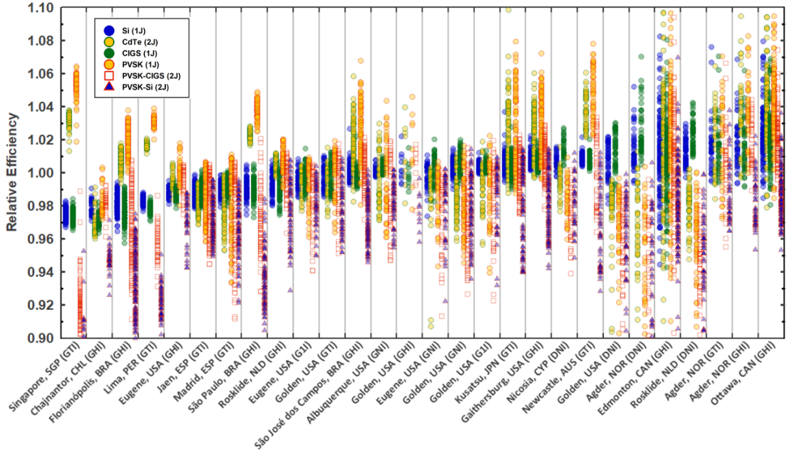
Figure 6. Relative efficiency vs. location and orientation for cells with one or two junctions. Data is sorted by increasing median efficiency of silicon. Location names are approximate.
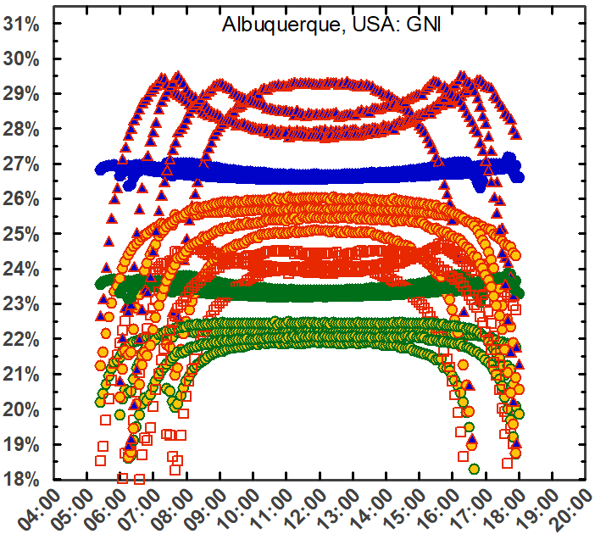 | 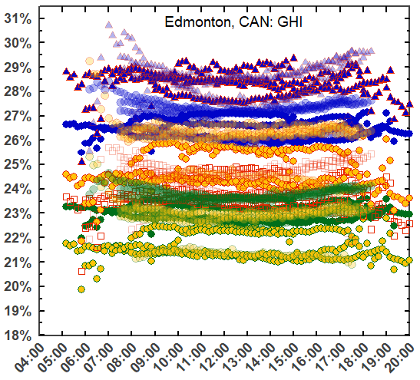 | 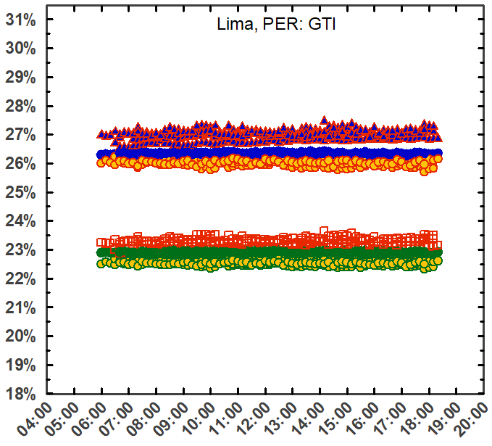
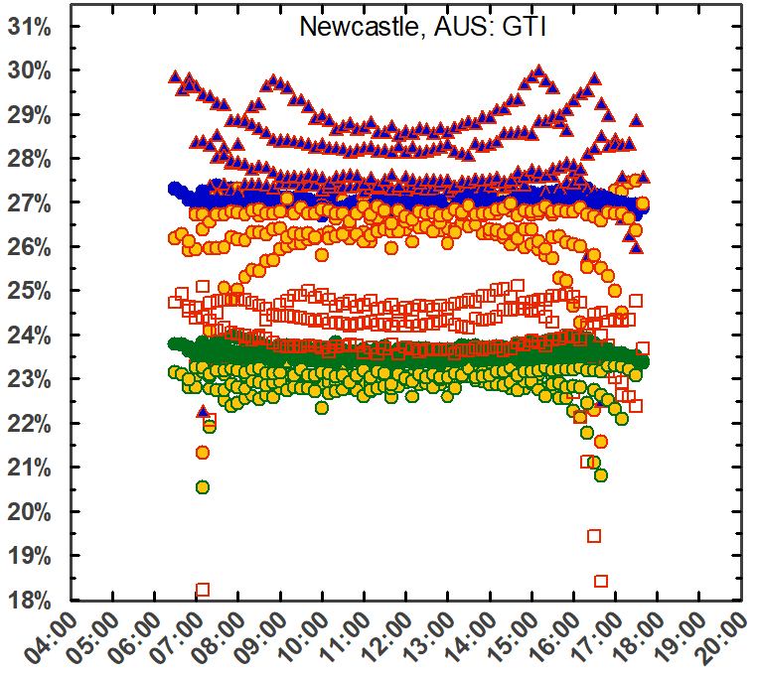 | 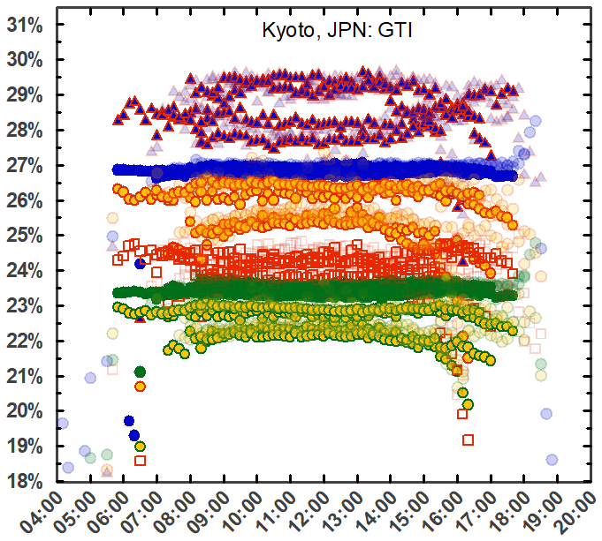 | 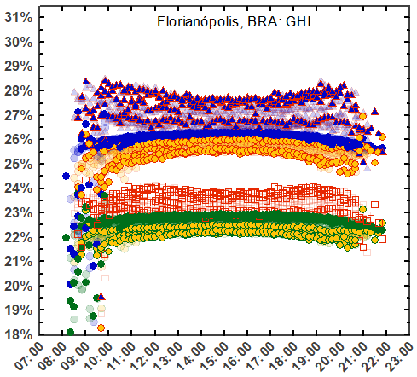
Figure 7. Seasonal and diurnal efficiency variations for cells with one or two junctions. Seasonal changes are delineated using one month of data for March, June, September, and December. Where available, data from additional years is semi-transparent in the background. Results for remaining locations are shown in Appendix F. (Refer to Figure 6 for the legend.)
Efficiencies from the measured spectra are shown in Figure 3, against a backdrop of the confirmed values under AM1.5G (AM1.5D, for III-V multijunctions). The corresponding relative efficiencies are shown in Figure 4. Cells with a single junction (Si, CdTe, CIGS, and PVSK) demonstrate efficiencies clustered about their efficiency under the AM1.5 standard spectrum. As the number of junctions increases, the degree of spectrum sensitivity increases, and the relative efficiencies in Figure 4 drop. For cells with two or more junctions, the performance under AM1.5, rather than being an average value (as with the single-junction cells), tends to be more of an upper bound of the performance under measured spectra. Series-connected multijunctions can be tuned (by varying the thickness and/or composition of the individual junctions) to optimize current matching of each junction under a single target spectrum. Cells tuned to perform best under AM1.5, therefore, may have been tuned away from optimum performance in operating conditions. Re-tuning the designs for spectral conditions in operation may require different thicknesses and material compositions.
Designing for operation under AM1.5, alone, may therefore be having an adverse effect on the development of these serially connected multijunctions. Rating cell efficiency under a single spectrum is a bit like rating vehicle efficiency based only on highway driving⁷⁴. As with temperature and broadband irradiance¹⁴, rating under more than one condition enables interpolation and extrapolation to other spectral conditions. Figure 4 suggests that AM0, the standard spectrum in space applications¹, could be re-purposed to bracket terrestrial spectrum variation²⁰. Fortunately, characterization under two spectra does not require two measurements: if the quantum efficiency of a cell is known, efficiency under a single condition can be translated to that under a second condition using a calculation known as “spectral mismatch correction⁷⁵.
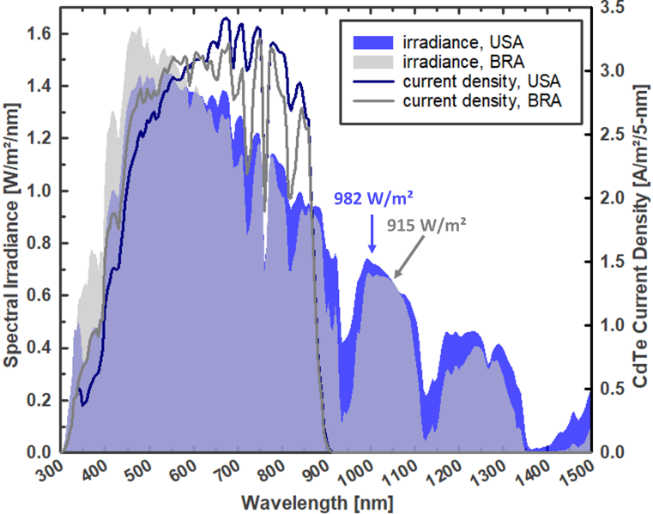
Figure 8. Spectral irradiance and the resulting current density for cadmium telluride from selected weekly sums in Albuquerque (USA) and Sao José dos Campos (BRA). Cadmium telluride has a spectral response range of ~300-900 nm. The two current density lines form equal areas.
Cells with a wider spectral response are more tolerant to the increased spectral variation that arises from sun tracking. As expected, Figure 4 shows that increasing the sun tracking tends to benefit single-junction cells with a wider spectral response range (silicon, CIGS), but is a detriment to cells with a narrower spectral response (CdTe, perovskite, e.g.) ^{20,36,37}. For cells with more than one junction, the result is more mixed, as losses due to current mismatch between the junctions trade against the wider spectral response of the overall stack.
The largest increases in relative efficiency are seen in cells with the narrowest spectral response (cadmium telluride and single-junction perovskite). Since efficiency is the ratio of power out to power in, it should be noted that efficiency rise due to spectrum variation may be due either to an increase in the power provided by the cell, or a decrease in the irradiance outside the cell’s spectral response range: higher efficiency does not always imply higher power. This is illustrated in Figure 8, where two spectra are presented that deliver the same output power in a cadmium telluride cell, but different efficiencies. While the broadband irradiance for Albuquerque is 7% higher, the excess falls outside the spectral response range of cadmium telluride. As a result, the two current densities integrate to the same value: 302 A/m², giving a cell output power density of 210 W/m² for both. The efficiency, however, is 21.5% for Albuquerque and 23.0% for Sao José dos Campos.
The fuel transportation costs for solar energy are tough to beat. Inherent variability in the supply, however, brings challenges. Of prime importance to project developers, power plant managers, and grid operators is the variation for their specific location and mounting orientation. Site-specific absolute efficiency values are given in Figure 5. Relative values are given in Figure 6, ranked in order of increasing median efficiency for silicon. The performance of CIGS, with a similar spectral response, follows the increase with silicon; all other efficiencies diverge.
Seasonal and diurnal variations are shown in Figure 7. Figures for additional sites, and for annual variation, are included in Appendix F. For the power plant operator, unexpected variation in power, be it losses or gains, can be costly. Solar power plants employ meteorological (“met”) stations to monitor temperature, wind, and plane-of-array (broadband) irradiance. In larger plants, there are often multiple broadband irradiance instruments⁷⁶. In the absence of spectral irradiance monitoring, however, the variation shown in Figure 7 is necessarily confounded with other uncertainties: module and inverter degradation, soiling, cable corrosion, etc.⁷⁷ Unexplained losses of a few percent can trigger costly contract disputes or warranty claims. Conversely, a plant that finds itself with unplanned gains may have to shed that excess power, due to cabling and power electronics that are undersized, or a grid operator unprepared to receive it. Implementing site monitoring procedures for spectral irradiance in line with those established for temperature and broadband irradiance will reduce these losses.
Table 1. Relative weekly efficiency variation at the sensor locations (source shown in brackets). The orientations are global horizontal irradiance (GHI), global tilted irradiance (GTI), global, 1-axis tracking irradiance (G1I), global normal irradiance (GNI), and direct normal irradiance (DNI). Location names are approximate.
Cell type (number of junctions): |  |  |  | Silicon  (1) | CdTe  (1) | CIGS  (1) | PVSK  (1) | PVSK-CIGS (2) | PVSK-Si  (2) | III-V  (3) | III-V  (4) | III-V  (6)
Standard absolute efficiencies: |  |  | AM0 | 24.3% | 19.8% | 20.9% | 22.9% | 22.0% | 25.6% | 36.6% | 37.6% | 38.0%
 |  |  | AM1.5G | 26.7% | 22.1% | 23.4% | 25.2% | 24.2% | 29.2% | 44.4% | 44.2% | 44.4%
 |  |  | AM1.5D | 26.7% | 21.8% | 23.5% | 24.6% | 23.5% | 28.6% | 44.4% | 46.0% | 47.1%
Location & orientation [source] |  | Range [nm] | Years | Relative efficiencies $\left(\frac{η{-η}_{STC}}{η_{STC}}\right)$:
Agder, NOR | GHI | 280-4000 | 2020 | -1% to 7% | 0% to 11% | -1% to 6% | 0% to 12% | -1% to 4% | -5% to 2% | -15% to 1% | -35% to -6% | -46% to -6%
Agder, NOR | GTI | 280-4000 | 2020 | -1% to 8% | -2% to 11% | -1% to 7% | -3% to 11% | -4% to 7% | -4% to 4% | -7% to 2% | -37% to 1% | -48% to 1%
Agder, NOR | DNI | 280-4000 | 2020 | -1% to 5% | -9% to 1% | 1% to 7% | -16% to 0% | -23% to 0% | -22% to 1% | -29% to 3% | -28% to 2% | -40% to 2%
Albuquerque, USA [h] | GNI | 350-1700 | 2013-2015 | 0% to 1% | -3% to 3% | 0% to 1% | -4% to 4% | -5% to 2% | -5% to 0% | -8% to 1% | -13% to 1% | -14% to 1%
Chajnantor, CHL | GHI | 290-1800 | 2016-2017 | -3% to -1% | -4% to -1% | -4% to -2% | -3% to 0% | -4% to -1% | -7% to -3% | -11% to -7% | -12% to -9% | -14% to -10%
Edmonton, CAN | GHI | 280-4000 | 2018-2020 | -6% to 8% | -10% to 12% | -6% to 8% | -12% to 13% | -13% to 9% | -12% to 7% | -11% to 5% | -42% to -4% | -54% to 9%
Eugene, USA | GHI | 350-1050 | 2020-2021 | -2% to 0% | -2% to 1% | -2% to -1% | -2% to 2% | -3% to 0% | -6% to -1% | -5% to -1% | -10% to -3% | -8% to -3%
Eugene, USA | G1I | 300-1050 | 2019 | -1% to 1% | -2% to 1% | -2% to 1% | -4% to 1% | -6% to 0% | -5% to 0% | -4% to 1% | -8% to 1% | -7% to 1%
Eugene, USA | GNI | 300-1050 | 2020-2021 | -3% to 1% | -9% to 0% | -2% to 2% | -12% to 1% | -15% to 0% | -15% to 0% | -14% to 2% | -13% to 1% | -14% to 2%
Florianópolis, BRA | GHI | 295-1100 | 2018-2020 | -4% to -1% | -1% to 2% | -4% to -1% | 0% to 4% | -9% to 1% | -12% to -2% | -13% to -2% | -19% to -6% | -20% to -6%
Gaithersburg, USA | GHI | 335-1650 | 2016-2018 | 0% to 2% | 0% to 6% | 0% to 2% | 0% to 7% | -2% to 3% | -6% to 1% | -14% to 1% | -30% to -6% | -32% to -6%
Golden, USA | GHI | 280-4000 | 2021 | -1% to 2% | -2% to 4% | -1% to 2% | -2% to 5% | -2% to 2% | -4% to 0% | -5% to -2% | -4% to -4% | -4% to -4%
Golden, USA | GTI | 350-1050 | 2019 | -1% to 1% | -3% to 2% | -2% to 1% | -4% to 2% | -5% to 2% | -5% to 1% | -4% to 2% | -9% to 0% | -10% to 0%
Golden, USA | G1I | 350-1650 | 2019 | 0% to 1% | -4% to 2% | 0% to 1% | -6% to 2% | -8% to 2% | -7% to 1% | -6% to 1% | -13% to 0% | -14% to 0%
Golden, USA | GNI | 290-1650 | 2020-2021 | -1% to 1% | -4% to 1% | -1% to 2% | -5% to 2% | -7% to 2% | -6% to 1% | -6% to 1% | -12% to 1% | -13% to 1%
Golden, USA | DNI | 350-1050 | 2020 | -2% to 2% | -10% to 0% | -1% to 3% | -14% to 0% | -18% to -1% | -17% to 0% | -18% to 1% | -16% to 1% | -20% to 1%
Jaen, ESP [b] | GTI | 350-1050 | 2017-2019 | -2% to 0% | -3% to -1% | -2% to 0% | -4% to 1% | -6% to 0% | -5% to 0% | -5% to 0% | -8% to 0% | -7% to 0%
Kyoto, JPN [e] | GTI | 295-1050 | 2018-2020 | 0% to 2% | -1% to 7% | -1% to 2% | -1% to 8% | -2% to 2% | -6% to 1% | -15% to 2% | -37% to -3% | -41% to -4%
Lima, PER | GTI | 295-1050 | 2020-2021 | -2% to -1% | 1% to 2% | -3% to -1% | 2% to 4% | -7% to -1% | -10% to -5% | -11% to -5% | -16% to -10% | -16% to -8%
Madrid, ESP [b] | GTI | 350-1050 | 2016-2017 | -2% to 0% | -5% to 0% | -2% to 0% | -7% to 1% | -9% to 1% | -8% to 0% | -8% to 0% | -8% to -1% | -7% to 0%
Newcastle, AUS | GTI | 350-1700 | 2016 | 0% to 2% | 2% to 6% | 0% to 2% | 2% to 8% | -4% to 3% | -7% to 1% | -13% to -2% | -28% to -10% | -29% to -10%
Nicosia, CYP [c] | DNI | 280-4000 | 2017 | 0% to 2% | -2% to 2% | 0% to 3% | -4% to 1% | -6% to 0% | -5% to 1% | -5% to 2% | -3% to 2% | -7% to 2%
Ottawa, CAN | GHI | 280-4000 | 2018-2020 | -2% to 8% | -2% to 14% | -2% to 7% | -2% to 16% | -1% to 7% | -5% to 4% | -17% to 1% | -52% to -5% | -63% to -4%
Rosklide, NLD | GHI | 300-1050 | 2020-2021 | -2% to 1% | 0% to 1% | -3% to 1% | -1% to 2% | -4% to 1% | -7% to 1% | -9% to 1% | -13% to -4% | -11% to -6%
Rosklide, NLD | DNI | 300-1050 | 2020-2021 | 0% to 3% | -5% to 0% | 1% to 4% | -10% to 0% | -16% to -1% | -15% to 0% | -18% to 2% | -17% to 1% | -25% to 2%
São José dos Campos, BRA [f] | GHI | 340-1700 | 2019-2020 | -1% to 3% | -2% to 6% | -1% to 2% | -2% to 7% | -3% to 2% | -5% to 0% | -11% to 0% | -34% to -2% | -39% to -2%
São Paulo, BRA | GHI | 350-1050 | 2013-2015 | -3% to 0% | 2% to 3% | -3% to 1% | 3% to 5% | -7% to 2% | -11% to -2% | -12% to -2% | -18% to -8% | -19% to -9%
Singapore, SGP [g] | GTI | 350-1050 | 2019-2021 | -3% to -2% | 1% to 4% | -3% to -2% | 2% to 6% | -11% to -1% | -15% to -5% | -17% to -5% | -23% to -11% | -26% to -11%
So long as the cost of electricity storage exceeds that of renewable generation⁷⁸ and efforts to “electrify everything”⁷⁹ to blunt impending climate disruptions continue to gain traction, solar power will be increasingly most valuable at the times it is most difficult to produce. An (extreme) example is the winter storm that hit the Texas, USA grid in February 2021. Temperatures below freezing caused loss of generation from (insufficiently weatherized) sources that depend on moving parts and the unimpeded flow of liquids: natural gas, coal, nuclear, and wind. Winter is not usually solar energy’s best season, but as these generators dropped offline and electricity prices spiked by factors of more than five⁸⁰, solar generation was the only source to deliver increased output⁸¹. As such, it can be hard to predict exactly when solar energy will be most valuable; efforts to quantify and minimize daily and seasonal spectral variation losses are needed to maximize the availability and value of solar power to grid operations. Silicon produces the most stable output under spectrum variation: its weekly site-level variation ranges from 1% to 14%, with a mean of 4% (Table 1). Though this is the smallest of the cells evaluated, the mean is equivalent to more than 10° C of temperature variation, or five years of module degradation⁸². Where AM1.5 substitutions were applied due to limited measurement range, these are underestimates.

Conclusion
The measured spectral irradiance data collected here sketches an outline of the spectrum variation affecting photovoltaic performance worldwide. Cells with a wider spectral response demonstrate increases in efficiency with increases in sun tracking. Overall, the scale of the impact of spectrum variation on operations argues for expanded monitoring, more in line with that of the other two parameters (temperature and broadband irradiance) that, together, determine solar cell efficiency.
The performance variation indicates that the conventional characterization under only one spectrum is insufficient for comparison of different cell types. Spectrum sensitivity increases with the number of junctions and efficiency correspondingly declines. For cells with two or more junctions, efficiency under the standard spectrum appears to be more of a maximum than a representative value: the practice of optimizing for AM1.5 may be reducing the potential for outdoor operation. Characterization under both AM0 and AM1.5, for example, would serve to bracket the outdoor performance range and better inform solar cell development and deployment.

Acknowledgements
The authors are grateful for the data provided online by NREL, the University of Oregon, Sandia National Laboratories, and NIST.
SERIS is a research institute at the National University of Singapore (NUS). SERIS is supported by NUS, the National Research Foundation Singapore (NRF), the Energy Market Authority of Singapore (EMA) and the Singapore Economic Development Board (EDB).

Appendix

Standard spectra
The three standard solar spectra for space and terrestrial solar applications: AM0, AM1.5D, and AM1.5G. “AM,” short for “air mass,” is the hypothetical column of air between the sun and the incident surface. AM0 (defined in 1974), is used for solar cells under extraterrestrial radiation (zero air mass). An air mass of one (“AM1”) is the conditions when the sun is directly overhead. At the time the standard terrestrial spectrum was established by the American Society for Testing and Materials (ASTM) in 1982, AM1.5 was considered to represent a “typical” solar module tilted at a fixed angle of 37◦ (mid-latitude USA) and pointed due south.
AM1.5D is the ASTM “direct” spectrum for this orientation, intended to represent only the sunlight coming directly from the sun (or its near vicinity). AM1.5D finds practical application in systems using two-axis trackers and optical concentration (lenses or mirrors) to boost solar cells’ power and efficiency. These optical concentrators are effective in concentrating only the collimated rays that come directly from the solar disc. The “global” spectrum, AM1.5G, consists of these direct rays, as well as sunlight that has been scattered by the atmosphere and is arriving on the tilted surface from the hemispherical dome of the sky.

Substitution of AM1.5 for values outside the measurement range
AM1.5 values are used outside the measurement ranges. Other approaches are possible, but the resulting performance variation is therefore a lower bound. Normalization of the weekly spectral irradiance magnitudes was made at either 880 nm or 1050 nm, wavelengths at which atmospheric variation is at a minimum: the difference between AM1.5 and the solar constant in space (AM0) is less than 1% at these wavelengths^{1,2}. 1050 nm was used for most locations, but 880 nm was used in cases (Singapore, e.g.) where the atmospheric absorption in the near infrared is substantially higher than for AM1.5, so normalization at 1050 nm could result in anomalous values that exceed AM0. For the four- and six-junction III-Vs, any data for which one or more junctions falls outside the measurement range is excluded from the results.
The sensitivity of the cell performance variation to this method was evaluated using data from the instruments that measure data beyond 1050 nm. Data from 1050-4000 nm was substituted with AM1.5 values; the results are shown in Figure 9.
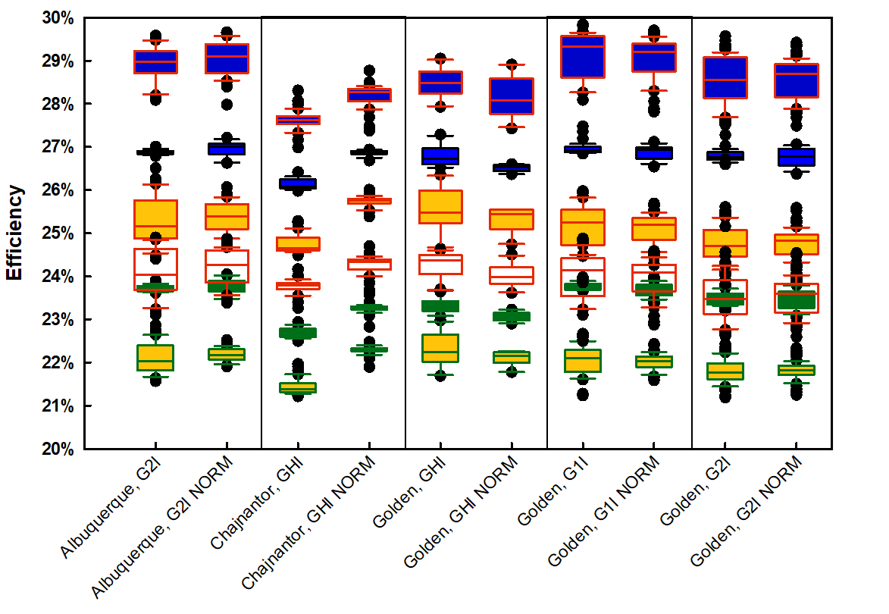
Figure 9. Sensitivity of performance variation to the normalization method. For each site, the left-hand data contains the full measurement range (Table 1); for the right-hand data (labeled “NORM”), measured values beyond 1050 nm have been substituted with AM1.5 values.

Calculation of cell efficiency from the quantum efficiency
Cell efficiencies are calculated using the open-circuit voltage (V_{OC}) and fill factor (FF) confirmed under Standard Test Conditions (25° C, 1000 W/m², AM1.5 spectrum). Variations in spectral irradiance are assumed to affect only the cell short-circuit current. Second-order effects, such as changes to voltage or fill factor with changing irradiance⁸³, or increases in fill factor in multijunctions due to current mismatch³⁴ are not considered here. The short-circuit current is derived from a cell’s spectral response and quantified using the cell quantum efficiency, which is a measure of the percentage of incoming photons at each wavelength that are absorbed and converted into current. Quantum efficiencies obtained from the Solar Cell Efficiency Tables are digitized at 5-nm wavelength intervals. Since the amplitude of the published quantum efficiencies is often normalized, the amplitudes are scaled to obtain the short-circuit current confirmed under the standard spectrum, AM1.5G (AM1.5D, for the III-V multijunctions)²⁰.
To obtain the current generated under a given spectrum, the spectral irradiance (G_{λ}) is divided by the photon energy at each wavelength (E_{λ}) to give the number of photons in that interval (5-nm intervals are used in this study). Multiplying by the quantum efficiency (QE_{λ}) gives the “spectral current density” [mA/cm²/nm] that would be converted to current at that wavelength. Multiplying by the wavelength interval (λ) yields current density [mA/ cm²] for each interval; summing over all wavelengths obtains the short-circuit current density (J_{SC}):
$$J_{SC}=\sum_{λ}{\left(\frac{G_{λ}}{E_{λ}}\right)∙{QE}_{λ}∙λ}$$
The product V_{OC}⋅FF⋅J_{SC} is then the cell power density [W/cm²]. Dividing by the broadband irradiance [W/cm²] obtains the cell efficiency.
Once the quantum efficiency of a given cell type is known, the current density (and cell efficiency) under a standard spectrum can be used to determine the current density under a second spectrum by applying a spectrum mismatch correction⁷⁵.

Efficiency for III-V multijunctions
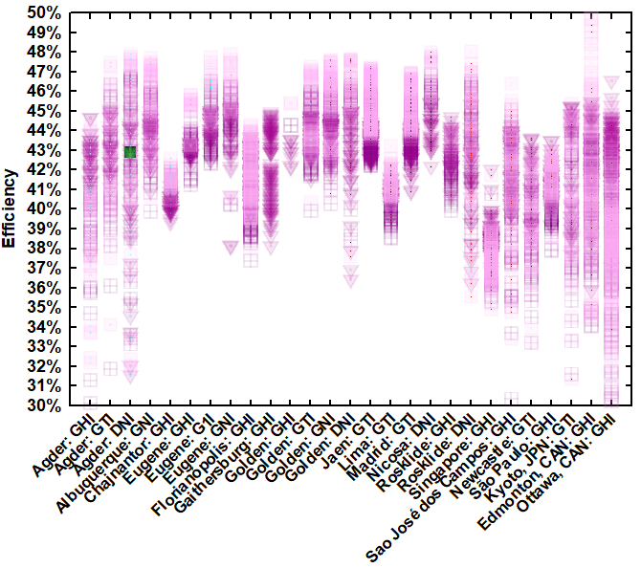 | 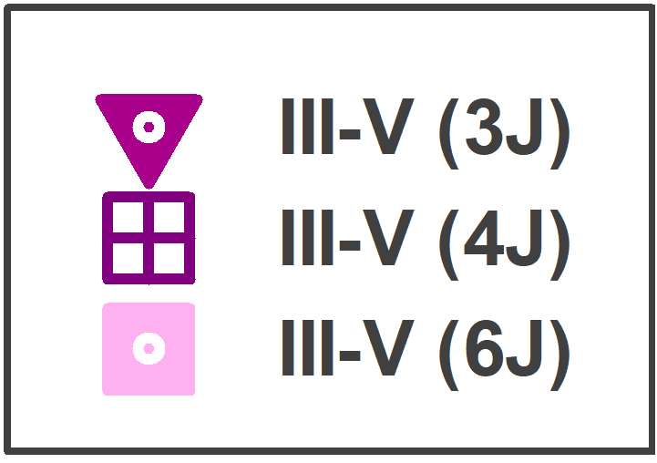

Figure 10. Efficiency as a function of location and orientation for III-V multijunction cells.

Measured vs. synthetic spectra
Models for solar spectral irradiance enable synthesis of spectral using input atmospheric conditions⁵⁶. Inputs include site pressure and aerosol, water vapor, ozone, and CO₂ levels. The outputs are corroborated with a growing body of measurements from both satellite (NOAA/NASA GOES-R) and ground-based instruments. The National Solar Radiation Database at NREL hosts Spectral On-Demand, a tool accessible online as part of the satellite-derived data in the NSRDB Data Viewer⁸⁴. Spectral On-Demand generates synthetic spectra for points within the area defined by NREL’s Physical Solar Model: longitude: -25°E to -175°W, latitude: -20°S to 60°N⁶⁴. In Figure 12, synthetic spectra and measured spectra are compared.
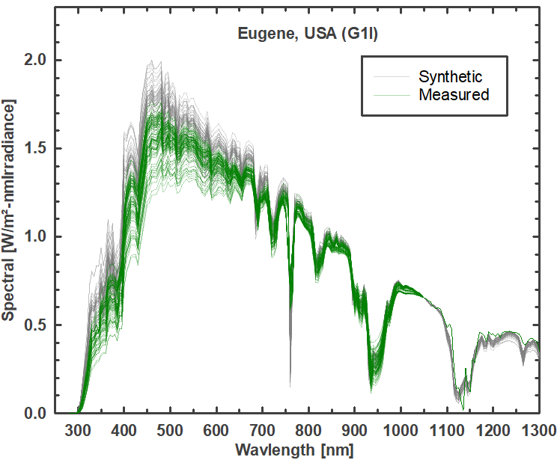 | 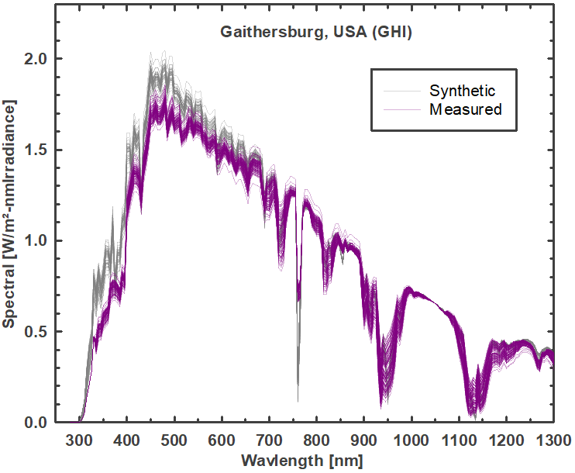 | 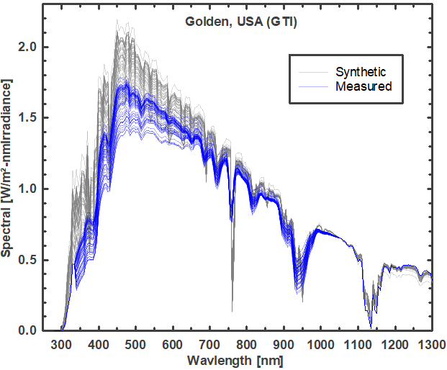
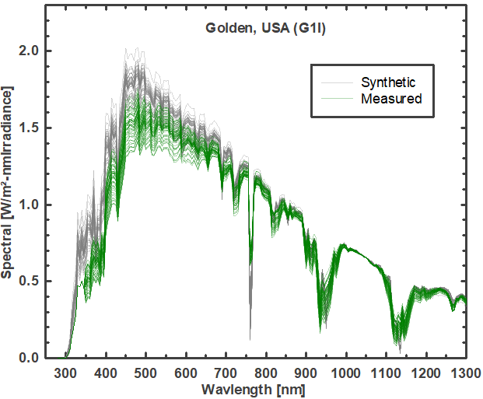 |  | 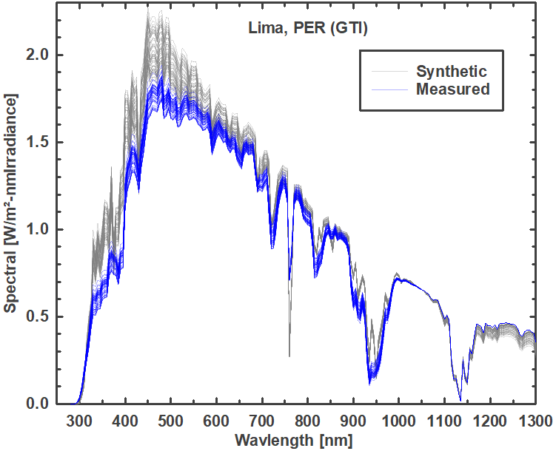
Figure 11. Measured spectra compared against synthetic spectra from NREL’s Spectral On-Demand.
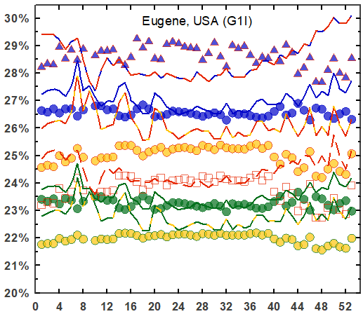 | 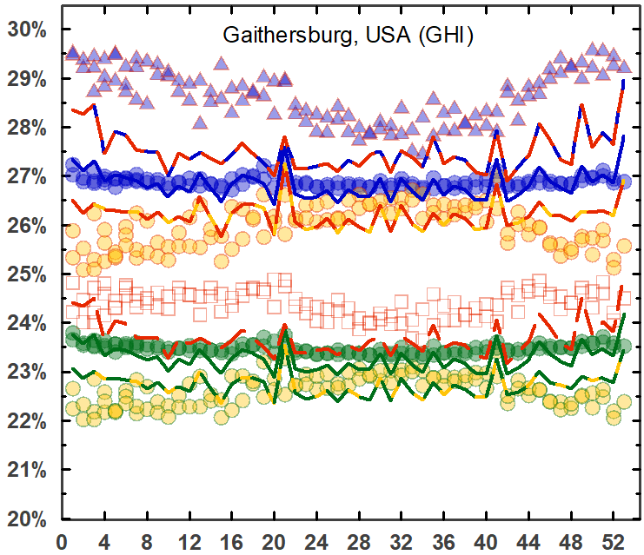 | 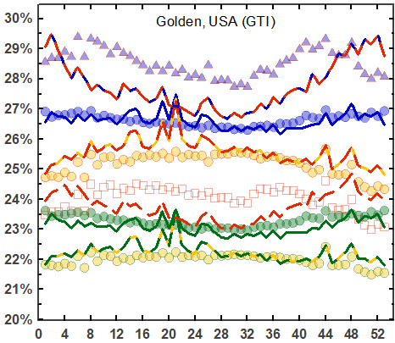
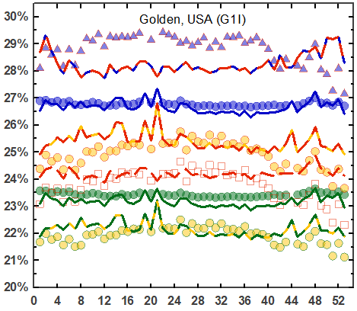 | 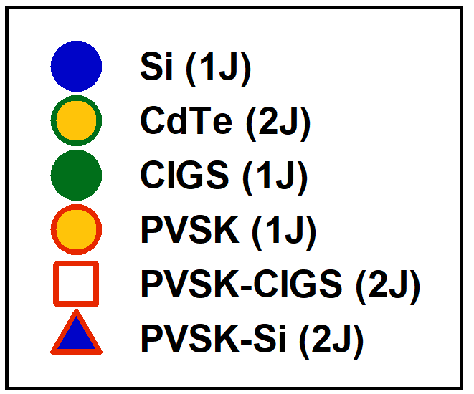 | 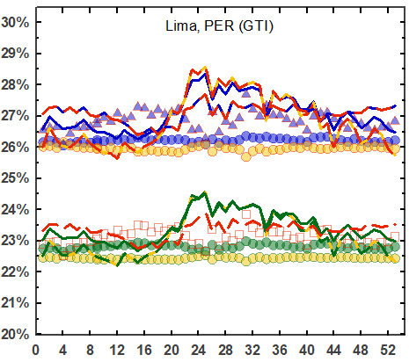
Figure 12. Measured (symbols) vs. synthetic spectra (lines) for sites available from NREL’s Physical Solar Model⁸⁴ (currently, longitude: -25°E to -175°W, latitude: -20°S to 60°N).

Diurnal and seasonal variation
Seasonal and diurnal efficiency variations for cells with one or two junctions. Seasonal changes are delineated using one month of data for March, June, September, and December from the most recent year available. Where available, data from prior years is semi-transparent in the background.
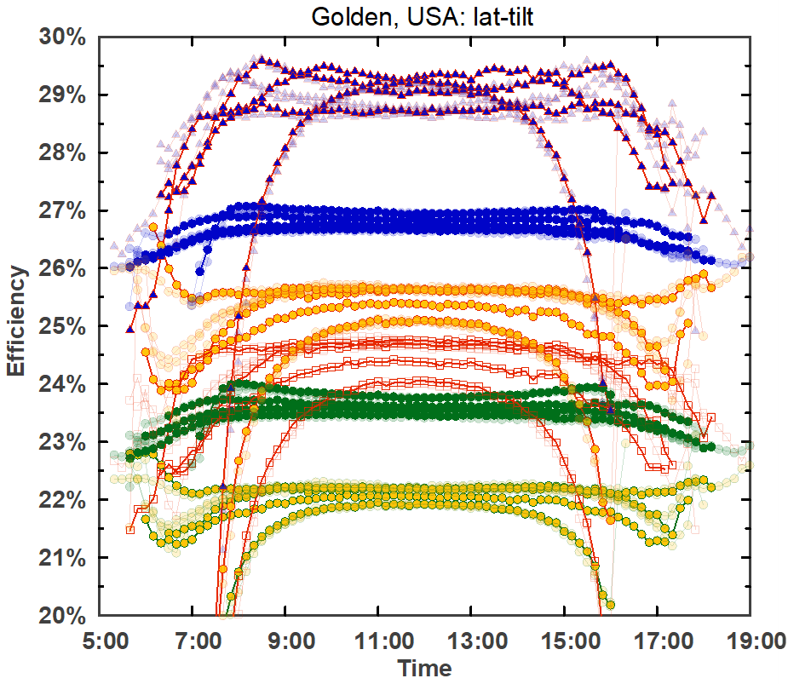 | 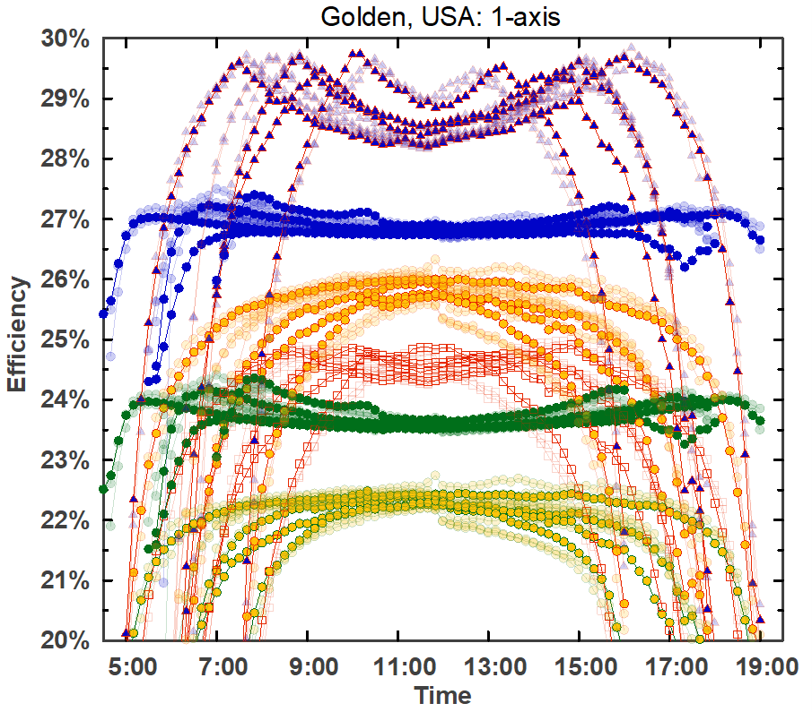 | 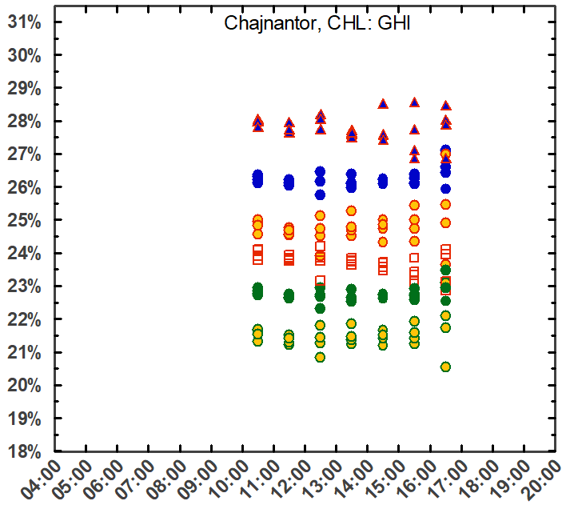
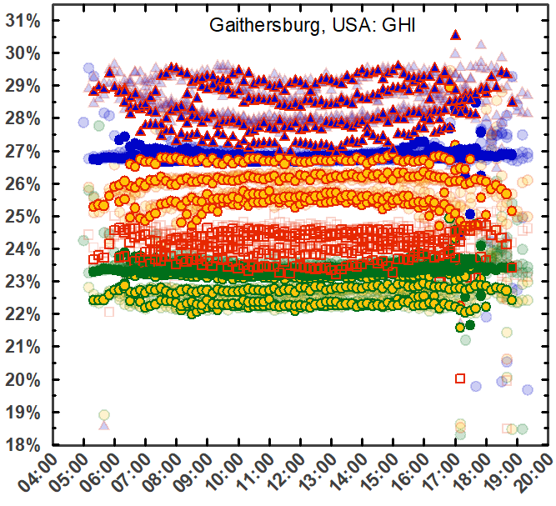 | 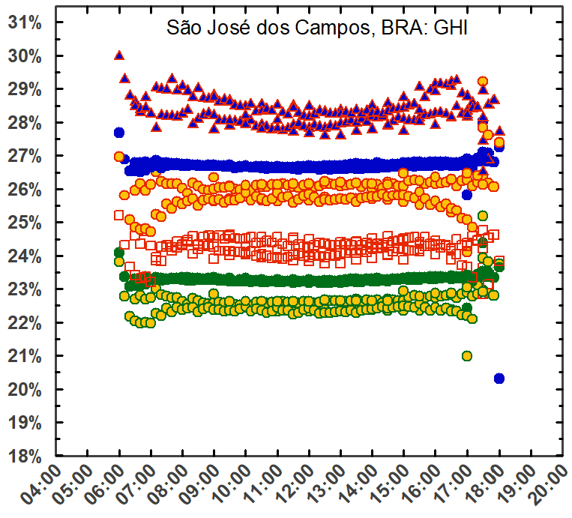 | 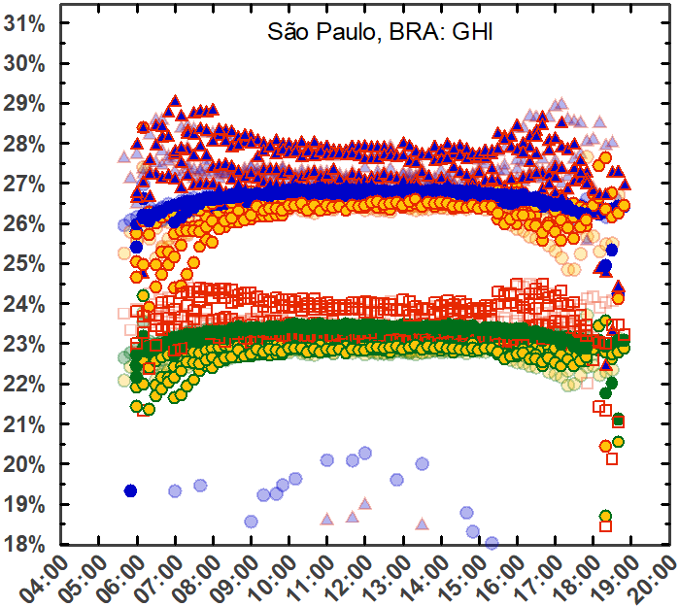
 | 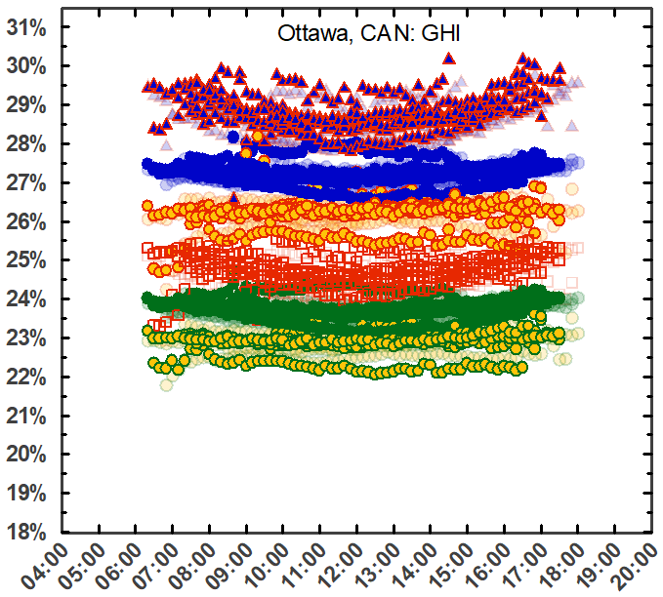

Annual efficiency variation: absolute efficiency vs. week of the year for one- and two-junction cells
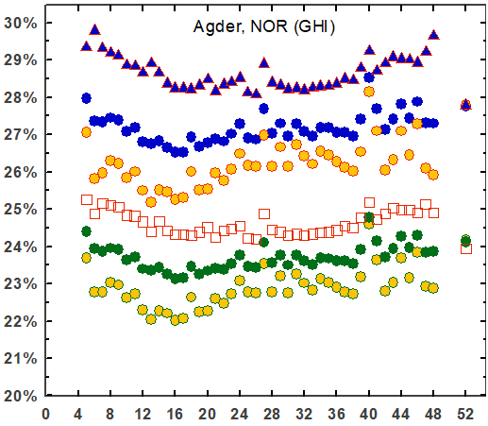 | 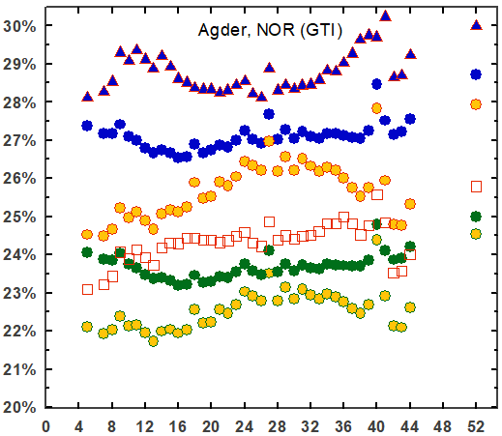 | 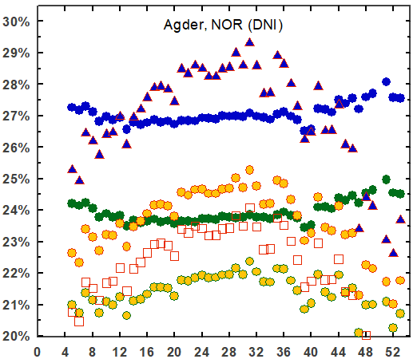
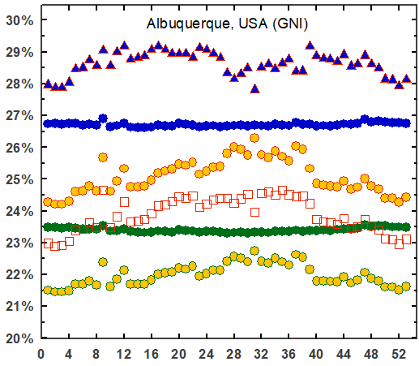 | 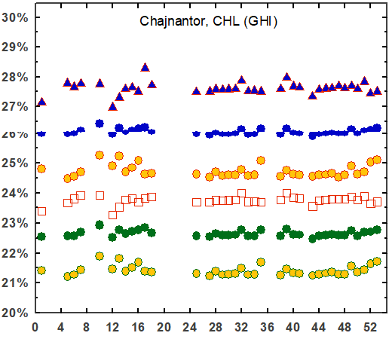 | 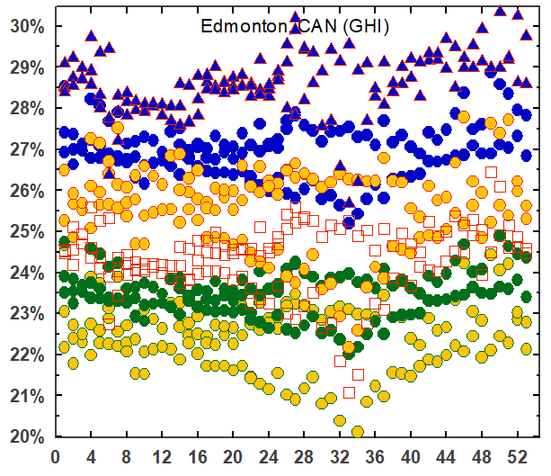
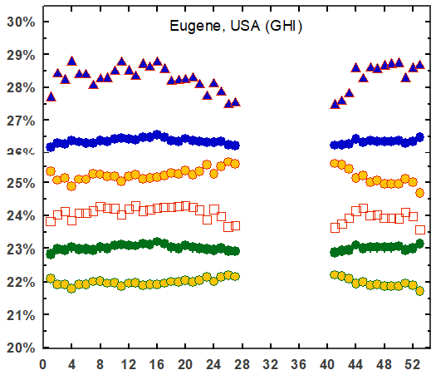 | 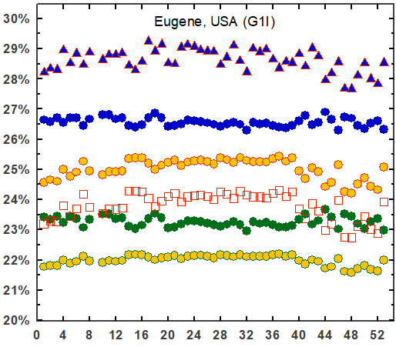 | 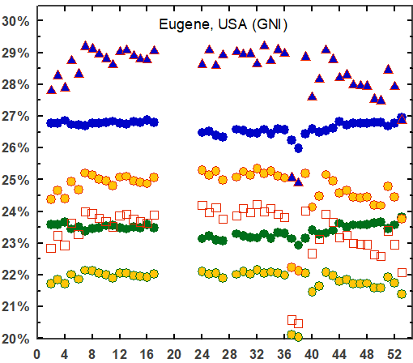
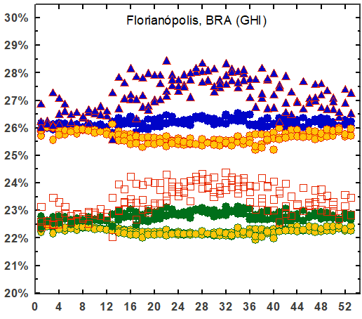 | 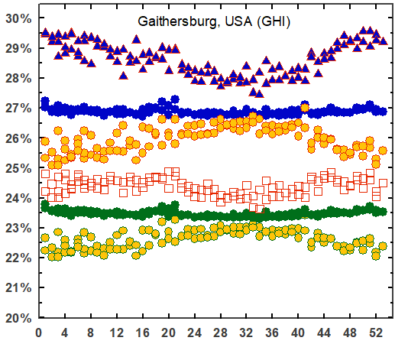 | 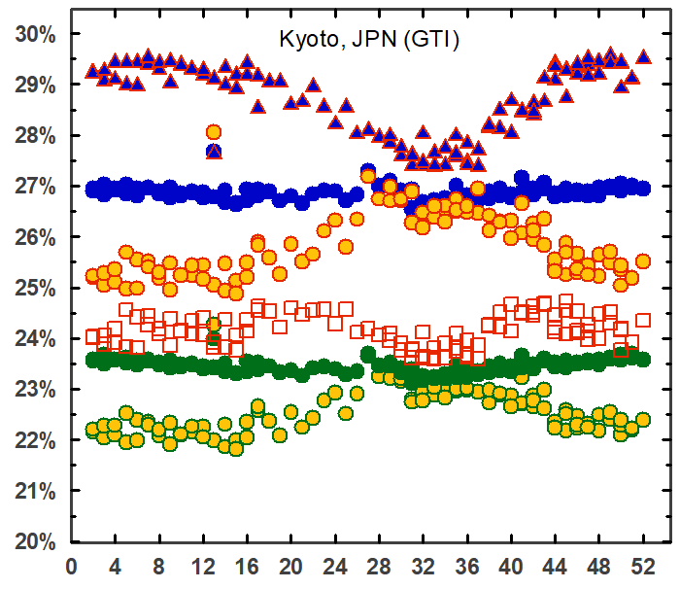

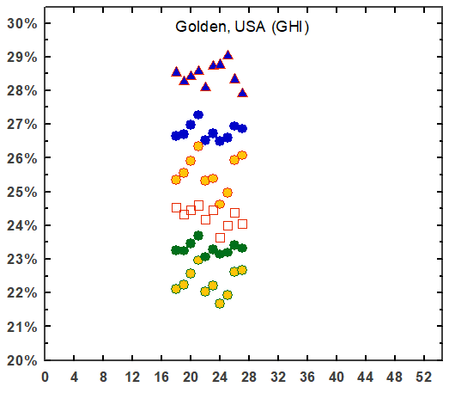 | 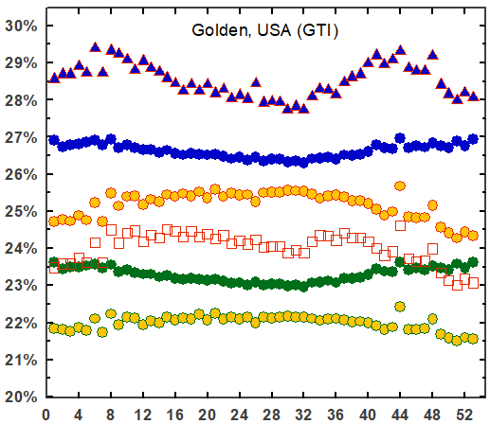 | 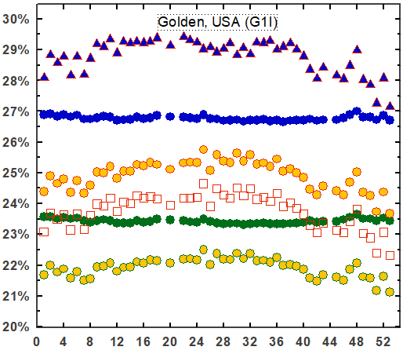
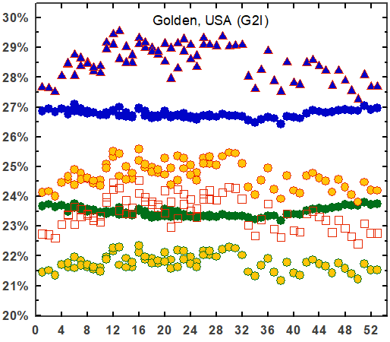 | 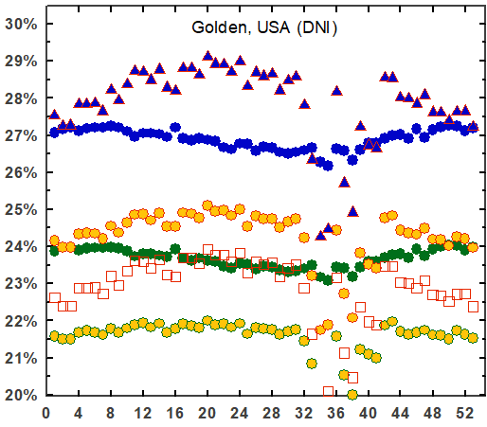 | 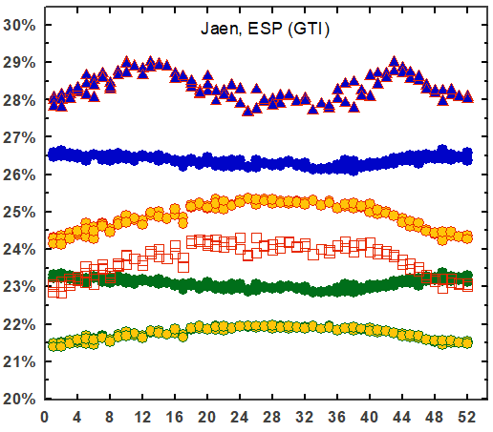
 | 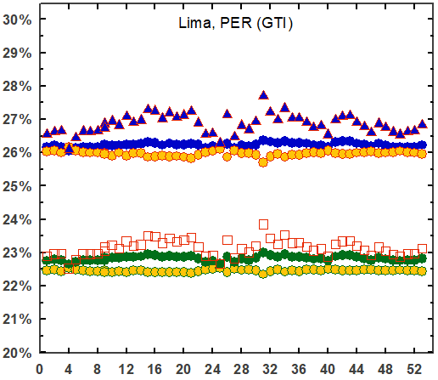 | 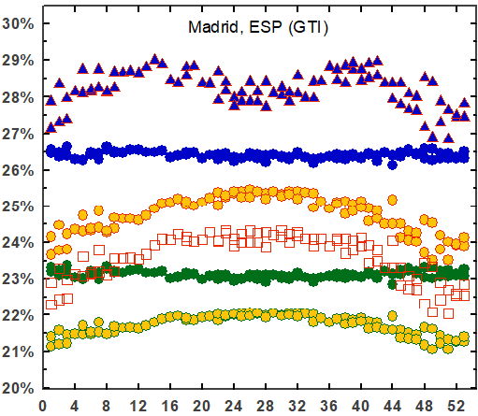
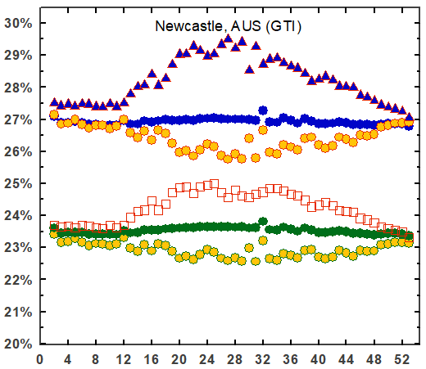 | 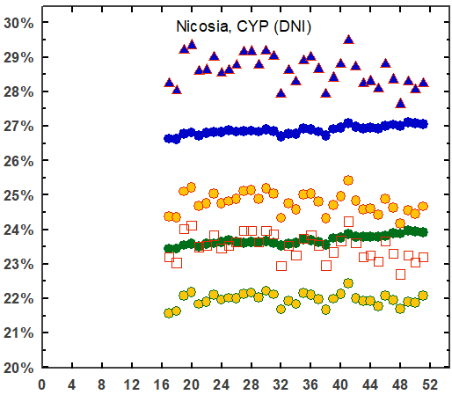 | 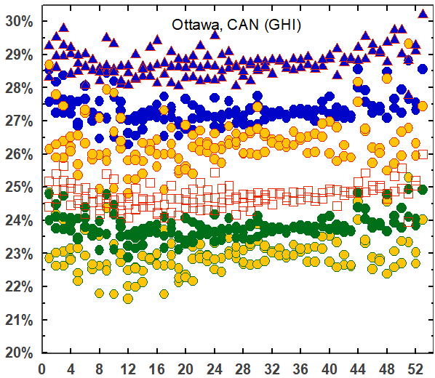

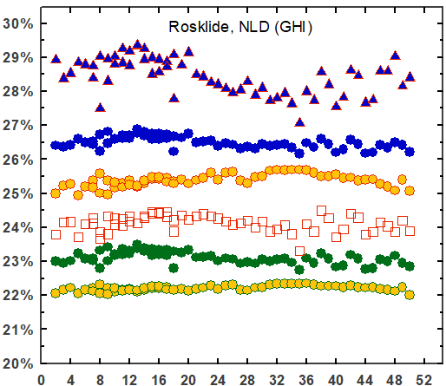 | 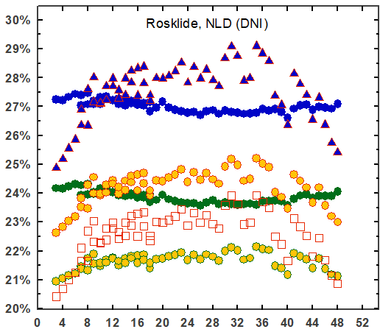 | 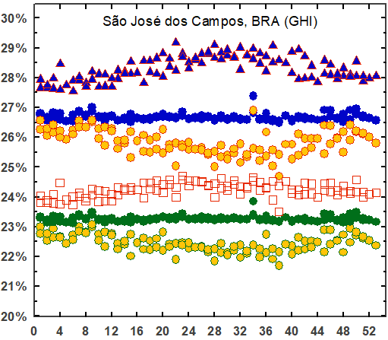
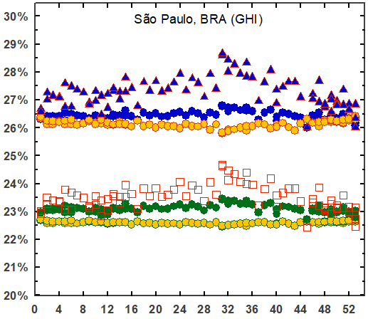 | 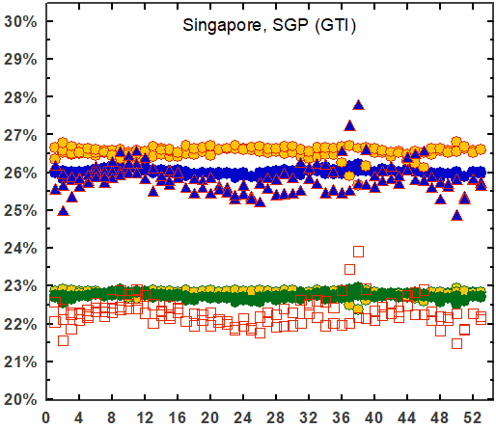

References
1. ASTM. ASTM E490-00a (2019), Solar Constant and Zero Air Mass Solar Spectral Irradiance Tables. ASTM International (2004).
2. ASTM G173-03. G173-03(2012) Standard Tables for Reference Solar Spectral Irradiances: Direct Normal and Hemispherical on 37° Tilted Surface. ASTM International (2012).
3. Faine, P., Kurtz, S. R., Riordan, C. & Olson, J. M. The influence of spectral solar irradiance variations on the performance of selected single-junction and multijunction solar cells. Solar Cells 31, 259–278 (1991).
4. Krauter, S. & Hanitsch, R. Actual optical and thermal performance of PV-modules. Solar Energy Materials and Solar Cells 41–42, 557–574 (1996).
5. Nann, S. & Emery, K. Spectral effects on PV-device rating. Solar Energy Materials and Solar Cells (1992) doi:10.1016/0927-0248(92)90083-2.
6. Schweiger, M. Impact of spectral irradiance on energy yield of PV modules measured in different climates. 4th PV Performance Modelling and Monitoring 17 Workshop (2015) doi:10.13140/RG.2.2.33591.73122.
7. Kinsey, G. S. Spectrum sensitivity, energy yield, and revenue prediction of PV modules. IEEE Journal of Photovoltaics 5, (2015).
8. Nofuentes, G., García-Domingo, B., Muñoz, J. v. & Chenlo, F. Analysis of the dependence of the spectral factor of some PV technologies on the solar spectrum distribution. Applied Energy 113, 302–309 (2014).
9. Minemoto, T., Nagae, S. & Takakura, H. Impact of spectral irradiance distribution and temperature on the outdoor performance of amorphous Si photovoltaic modules. Solar Energy Materials and Solar Cells (2007) doi:10.1016/j.solmat.2007.02.012.
10. Myers, D. R., Emery, K. & Gueymard, C. Revising and validating spectral irradiance reference standards for photovoltaic performance evaluation. in International Solar Energy Conference (2002). doi:10.1115/SED2002-1074.
11. Hirata, Y. & Tani, T. Output variation of photovoltaic modules with environmental factors—I. The effect of spectral solar radiation on photovoltaic module output. Solar Energy 55, 463–468 (1995).
12. IEC. IEC 60904-1 Ed. 2.0 b:2006 - Photovoltaic devices - Part 1: Measurement of photovoltaic current-voltage characteristics. IEC https://webstore.ansi.org/Standards/IEC/IEC60904Ed2006?gclid=Cj0KCQjw7MGJBhD-ARIsAMZ0eeuLqyJsaU8ouzY8cQhNxdJTJaTpIaxiyA_XhrmcN8dzjFlLhwwzBW0aAsRIEALw_wcB (2006).
13. NREL. Reference Air Mass 1.5 Spectra | Grid Modernization | NREL. https://www.nrel.gov/grid/solar-resource/spectra-am1.5.html.
14. IEC. IEC 60891 Ed. 2.0 b:2009 - Photovoltaic devices - Procedures for temperature and irradiance corrections to measured I-V characteristics. https://webstore.ansi.org/Standards/IEC/IEC60891Ed2009 (2009).
15. Trina Solar. Utility Scale Solar Panels - Trina Solar. https://www.trinasolar.com/us/product/utility (2021).
16. Jinko Solar. LIMITED WARRANTY. www.jinkosolar.com (2020).
17. IEC. IEC 61724 Ed. 1.0 b:1998 - Photovoltaic system performance monitoring - Guidelines for measurement, data exchange and analysis. https://webstore.ansi.org/Standards/IEC/IEC61724Ed1998?gclid=Cj0KCQjwpreJBhDvARIsAF1_BU1KSlCweyVqr2NGsnJJEWBJBzH1TJVw28jHUdoGUdo2Bgb9_RMeodQaAgkpEALw_wcB (1998).
18. IEC. IEC 61853-1 Ed. 1.0 b:2011 - Photovoltaic (PV) module performance testing and energy rating - Part 1: Irradiance and temperature performance measurements and power rating. https://webstore.ansi.org/Standards/IEC/IEC61853Ed2011?gclid=CjwKCAjwybyJBhBwEiwAvz4G7zGGe1v53mSa7VebpR9Olf3ZvBe-uj7mNzKvhAxoSPOoTrqdBclnCRoCoqIQAvD_BwE (2011).
19. Pricing Carbon. https://www.worldbank.org/en/programs/pricing-carbon.
20. Kinsey, G. S. Solar cell efficiency divergence due to operating spectrum variation. Solar Energy 217, 49–57 (2021).
21. IEA. Snapshot 2020 - IEA-PVPS. https://iea-pvps.org/snapshot-reports/snapshot-2020/ (2020).
22. NREL. Best Research-Cell Efficiency Chart | Photovoltaic Research | NREL. https://www.nrel.gov/pv/cell-efficiency.html (2020).
23. Fernandez, E. F., Cruz, F. A., Mallick, T. K. & Sundaram, S. Effect of Spectral Irradiance Variations on the Performance of Highly Efficient Environment-Friendly Solar Cells. IEEE Journal of Photovoltaics (2015) doi:10.1109/JPHOTOV.2015.2434593.
24. Alonso-Abella, M., Chenlo, F., Nofuentes, G. & Torres-Ramírez, M. Analysis of spectral effects on the energy yield of different PV (photovoltaic) technologies: The case of four specific sites. Energy (2014) doi:10.1016/j.energy.2014.01.024.
25. Huld, T. & Gracia Amillo, A. M. Estimating PV module performance over large geographical regions: The role of irradiance, air temperature, wind speed and solar spectrum. Energies (2015) doi:10.3390/en8065159.
26. Norton, M., Amillo, A. M. G. & Galleano, R. Comparison of solar spectral irradiance measurements using the average photon energy parameter. Solar Energy 120, 337–344 (2015).
27. Dirnberger, D., Blackburn, G., Müller, B. & Reise, C. On the impact of solar spectral irradiance on the yield of different PV technologies. Solar Energy Materials and Solar Cells 132, 431–442 (2015).
28. Cornaro, C. & Andreotti, A. Influence of Average Photon Energy index on solar irradiance characteristics and outdoor performance of photovoltaic modules. Progress in Photovoltaics: Research and Applications (2013) doi:10.1002/pip.2194.
29. Ishii, T., Otani, K., Takashima, T. & Xue, Y. Solar spectral influence on the performance of photovoltaic (PV) modules under fine weather and cloudy weather conditions. Progress in Photovoltaics: Research and Applications (2013) doi:10.1002/pip.1210.
30. Kinsey, G. S. Spectrum sensitivity, energy yield, and revenue prediction of PV and CPV modules. in 2015 IEEE 42nd Photovoltaic Specialist Conference, PVSC 2015 (2015). doi:10.1109/PVSC.2015.7355850.
31. Lee, M., Ngan, L., Hayes, W. & Panchula, A. F. Comparison of the effects of spectrum on cadmium telluride and monocrystalline silicon photovoltaic module performance. in 2015 IEEE 42nd Photovoltaic Specialist Conference, PVSC 2015 (2015). doi:10.1109/PVSC.2015.7356174.
32. Simon, M. & Meyer, E. L. The effects of spectral evaluation of c-Si modules. Progress in Photovoltaics: Research and Applications (2011) doi:10.1002/pip.973.
33. Philipps, S. P. et al. Energy harvesting efficiency of III-V triple-junction concentrator solar cells under realistic spectral conditions. Solar Energy Materials and Solar Cells (2010) doi:10.1016/j.solmat.2010.01.010.
34. Reynolds, S. & Smirnov, V. Modelling Performance of Two- and Four-terminal Thin-film Silicon Tandem Solar Cells under Varying Spectral Conditions. in Energy Procedia (2015). doi:10.1016/j.egypro.2015.12.321.
35. Minemoto, T., Nagae, S. & Takakura, H. Impact of spectral irradiance distribution and temperature on the outdoor performance of amorphous Si photovoltaic modules. Solar Energy Materials and Solar Cells 91, 919–923 (2007).
36. Ripalda, J. M., Chemisana, D., Llorens, J. M. & García, I. Location-Specific Spectral and Thermal Effects in Tracking and Fixed Tilt Photovoltaic Systems. iScience 23, (2020).
37. Kinsey, G. S. Preprint: Solar cell efficiency divergence due to operating spectrum variation. https://engrxiv.org/yfx9r/ (2020) doi:10.31224/osf.io/yfx9r.
38. Riedel-Lyngskar, N. et al. Spectral Albedo in Bifacial Photovoltaic Modeling: What can be learned from Onsite Measurements? 2021 IEEE 48th Photovoltaic Specialists Conference (PVSC) 0942–0949 (2021) doi:10.1109/PVSC43889.2021.9519085.
39. Neves, G., Vilela, W., Pereira, E., Yamasoe, M. & Nofuentes, G. Spectral impact on PV in low-latitude sites: The case of southeastern Brazil. Renewable Energy 164, 1306–1319 (2021).
40. Amillo, A. M. G., Huld, T., Vourlioti, P., Müller, R. & Norton, M. Application of satellite-based spectrally-resolved solar radiation data to PV performance studies. Energies (2015) doi:10.3390/en8053455.
41. Futscher, M. H. & Ehrler, B. Modeling the Performance Limitations and Prospects of Perovskite/Si Tandem Solar Cells under Realistic Operating Conditions. ACS Energy Letters (2017) doi:10.1021/acsenergylett.7b00596.
42. Louwen, A., de Waal, A. C., Schropp, R. E. I., Faaij, A. P. C. & van Sark, W. G. J. H. M. Comprehensive characterisation and analysis of PV module performance under real operating conditions. Progress in Photovoltaics: Research and Applications 25, 218–232 (2017).
43. Braga, M., Rafael Do Nascimento, L. & Rüther, R. Spectral Impacts on the Performance of mc-Si and New-Generation CdTe Photovoltaics in the Brazilian Northeast.
44. Conde, L. A. et al. Spectral effects on the energy yield of various photovoltaic technologies in Lima (Peru). Energy 223, 120034 (2021).
45. Braga, M., do Nascimento, L. R. & Rüther, R. Spectral modeling and spectral impacts on the performance of mc-Si and new generation CdTe photovoltaics in warm and sunny climates. Solar Energy 188, 976–988 (2019).
46. Sirisamphanwong, C. & Ketjoy, N. Impact of spectral irradiance distribution on the outdoor performance of photovoltaic system under Thai climatic conditions. Renewable Energy 38, 69–74 (2012).
47. Representative identification of spectra and environments (RISE) using k‐means - Looney - 2021 - Progress in Photovoltaics: Research and Applications - Wiley Online Library. https://onlinelibrary.wiley.com/doi/10.1002/pip.3358.
48. Looney, E. E. et al. Representative identification of spectra and environments (RISE) using k-means. Progress in Photovoltaics: Research and Applications 29, 200–211 (2021).
49. Braga, M., do Nascimento, L. R. & Ruther, R. Spectral Impacts on the Performance of mc-Si and New-Generation CdTe Photovoltaics in the Brazilian Northeast. Conference Record of the IEEE Photovoltaic Specialists Conference 1226–1231 (2019) doi:10.1109/PVSC40753.2019.8981152.
50. Magare, D. B. et al. Effect of seasonal spectral variations on performance of three different photovoltaic technologies in India. International Journal of Energy and Environmental Engineering 7, (2016).
51. Riedel, N. et al. Direct Beam and Diffuse Spectral Irradiance Measurements in a Nordic Country Analyzed with the Average Photon Energy Parameter. 2018 IEEE 7th World Conference on Photovoltaic Energy Conversion, WCPEC 2018 - A Joint Conference of 45th IEEE PVSC, 28th PVSEC and 34th EU PVSEC 2575–2580 (2018) doi:10.1109/PVSC.2018.8548240.
52. Peters, I. M., Liu, H., Reindl, T. & Buonassisi, T. Global Prediction of Photovoltaic Field Performance Differences Using Open-Source Satellite Data. Joule 2, 307–322 (2018).
53. Spectroradiometers | EKO Instruments. https://eko-eu.com/products/solar-energy/spectroradiometers.
54. Tatsiankou, V., Hinzer, K., Schriemer, H., Haysom, J. & Beal, R. A novel instrument for cost-effective and reliable measurement of Solar Spectral Irradiance. 2015 IEEE 42nd Photovoltaic Specialist Conference, PVSC 2015 (2015) doi:10.1109/PVSC.2015.7356407.
55. Tatsiankou, V. et al. Extensive validation of solar spectral irradiance meters at the World Radiation Center. Solar Energy 166, 80–89 (2018).
56. Gueymard, C. A. SMARTS2: a simple model of the atmospheric radiative transfer of sunshine: algorithms and performance assessment. Report No. FSEC-PF-270-95 (1995).
57. Myers, D. R. & Gueymard, C. A. Description and availability of the SMARTS spectral model for photovoltaic applications. in Organic Photovoltaics V (2004). doi:10.1117/12.555943.
58. Myers, D. R., Emery, K. & Gueymard, C. Terrestrial solar spectral modeling tools and applications for photovoltaic devices. in Conference Record of the IEEE Photovoltaic Specialists Conference (2002). doi:10.1109/pvsc.2002.1190943.
59. Xie, Y. & Sengupta, M. A Fast All-sky Radiation Model for Solar applications with Narrowband Irradiances on Tilted surfaces (FARMS-NIT): Part I. The clear-sky model. Solar Energy (2018) doi:10.1016/j.solener.2018.09.056.
60. Xie, Y., Sengupta, M. & Wang, C. A Fast All-sky Radiation Model for Solar applications with Narrowband Irradiances on Tilted surfaces (FARMS-NIT): Part II. The cloudy-sky model. Solar Energy (2019) doi:10.1016/j.solener.2019.06.058.
61. Kinsey, G. S., Stone, K., Brown, J. & Garboushian, V. Energy prediction of Amonix CPV solar power plants. Progress in Photovoltaics: Research and Applications 19, (2011).
62. Kinsey, G. S. Weighing the merits of solar power plants using concentration photovoltaics - PV Tech. PV Tech https://www.pv-tech.org/technical-papers/weighing-the-merits-of-solar-power-plants-using-concentration-photovoltaics/ (2012).
63. Kinsey, G. S. et al. Advancing efficiency and scale in CPV Arrays. IEEE Journal of Photovoltaics 3, (2013).
64. Sengupta, M. et al. The National Solar Radiation Data Base (NSRDB). Renewable and Sustainable Energy Reviews (2018) doi:10.1016/j.rser.2018.03.003.
65. Ponce, A. M. et al. Chemical composition of aerosol particles from direct emissions of vegetation fires in the Amazon Basin: water-s... Cite this paper Chemical composition of aerosol particles from direct emissions of vegetation "res in the Amazon Basin: water-soluble species and trace elements.
66. JD, H., AR, W., R, T. & JW, H. An influence of solar spectral variations on radiative forcing of climate. Nature 467, 696–699 (2010).
67. Foote, E. Circumstances Affecting the Heat of the Sun’s Rays. The American Journal of Science and Arts, Art. XXXI 382 https://books.google.co.uk/books?id=fjtSAQAAMAAJ&lpg=PA382&dq=%22Circumstances%20Affecting%20the%20Heat%20of%20the%20Sun%E2%80%99s%20Rays%22%20foote&pg=PA382#v=onepage&q&f=false (1856).
68. Green, M. A. et al. Solar cell efficiency tables (Version 53). Progress in Photovoltaics: Research and Applications (2019) doi:10.1002/pip.3102.
69. Green, M. A. et al. Solar cell efficiency tables (version 50). Progress in Photovoltaics: Research and Applications (2017) doi:10.1002/pip.2909.
70. Green, M. A., Emery, K., Hishikawa, Y., Warta, W. & Dunlop, E. D. Solar cell efficiency tables (Version 45). Progress in Photovoltaics: Research and Applications (2015) doi:10.1002/pip.2573.
71. Green, M. A. et al. Solar cell efficiency tables (Version 55). Progress in Photovoltaics: Research and Applications (2020) doi:10.1002/pip.3228.
72. Green, M. A. et al. Solar cell efficiency tables (version 56). Progress in Photovoltaics: Research and Applications (2020) doi:10.1002/pip.3303.
73. Green, M. A., Emery, K., Hishikawa, Y., Warta, W. & Dunlop, E. D. Solar cell efficiency tables (version 42). Progress in Photovoltaics: Research and Applications (2013) doi:10.1002/pip.2404.
74. Kinsey, G. S. 2021 Photovoltaic Reliability Workshop Poster Session D, “Solar cell efficiencies under operating spectra” D-2 February 25, 2021 - YouTube. https://www.youtube.com/watch?v=Uctmjh06KKQ&t=3240s (2021).
75. IEC 60904-7. IEC 60904-7 Edition 3.0 Part 7: Computation of the spectral mismatch correction for measurements of photovoltaic devices. International Electrotechnical Commission (2008).
76. Kipp & Zonen. Solar Irradiance Monitoring in Solar Energy Projects. https://www.kippzonen.com/Download/810/Brochure-Solar-Irradiance-Monitoring-in-Solar-Energy-Projects.
77. Built solar assets are ‘chronically underperforming’ and modules degrading faster than expected, research finds - PV Tech. https://www.pv-tech.org/built-solar-assets-are-chronically-underperforming-and-modules-degrading-faster-than-expected-research-finds/.
78. IRENA. Electricity storage and renewables: Costs and markets to 2030. /publications/2017/Oct/Electricity-storage-and-renewables-costs-and-markets.
79. NREL. Electrification Futures Study: A Technical Evaluation of the Impacts of an Electrified U.S. Energy System | Energy Analysis | NREL. https://www.nrel.gov/analysis/electrification-futures.html.
80. Herscher, R. Texas Electricity Bills Skyrocket Due To Winter Storm : Live Updates: Winter Storms 2021 : NPR. NPR https://www.npr.org/sections/live-updates-winter-storms-2021/2021/02/21/969912613/after-days-of-mass-outages-some-texas-residents-now-face-huge-electric-bills (2021).
81. Penney, V. How Texas’ Power Generation Failed During the Storm, in Charts - The New York Times. New York Times https://www.nytimes.com/interactive/2021/02/19/climate/texas-storm-power-generation-charts.html (2021).
82. SunPower. SunPower product performance. Products https://us.sunpower.com/products/solar-panels (2020).
83. Kinsey, G. S. et al. Concentrator multifunction solar cell characteristics under variable intensity and temperature. Progress in Photovoltaics: Research and Applications 16, (2008).
84. NREL. NSRDB Data Viewer. https://maps.nrel.gov/nsrdb-viewer/.

AUTHOR AFFILIATIONS:

Zuva Energy, New York, USA. Email: geoffreykinsey@zuvaenergy.com
IDEA Research Group, Center for Advanced Studies in Earth Science, Energy and Environment (CEACTEMA), University of Jaén, Campus de Las Lagunillas, 23071-Jaén, Spain
PV Technology Laboratory, FOSS Research Centre for Sustainable Energy, Department of Electrical and Computer Engineering, University of Cyprus, Nicosia 1678, Cyprus
Institute for Renewable Energy, Eurac Research, Viale Druso 1, Bolzano, Italy
Department of Electrical and Electronic Engineering, Ritsumeikan University, 1-1-1 Nojihigashi, Kusatsu, Shiga 525-8577, Japan
Brazilian National Institute for Space Research (Instituto Nacional de Pesquisas Espaciais - INPE)
Solar Energy Research Institute of Singapore (SERIS), National University of Singapore (NUS), Singapore 117574, Singapore
Sandia National Laboratories, Albuquerque, NM 87185, USA

