Achieving maximum flow for Inter-planetary networks
Vijay Bhaskar Chiluveruª
ª Department of Electronics and Electrical Communication Engineering,
Indian Institute of Technology, Kharagpur

Abstract
Inter-planetary network (IPN) systems on earth and spacecrafts communicate with systems on other planets. Communications and data are often relayed and delivered by the IPN systems. Delay/Disruption Tolerant Networking (DTN) have several unique characteristic features with significant challenges such as intermittent link connectivity, long and variable propagation delays, link bandwidth asymmetry, high link error rates and Power constraints. It is vital to overcome these challenges to achieve maximum flow for IPN systems. The aim of this project is to address the issue of achieving maximum flow in Inter-planetary network. To tackle these issues, a DTN model as time aggregated graph (TAG) was proposed and a bidirectional storage transfer series was used to correlate various time intervals and aid in maximizing flow. Our results suggest that the maximum flow can be achieved by seeking an augmenting path, computing its maximum flow, and getting its residual network using an iterative approach. In future, we intend to investigate the increase in difficulty of achieving maximum flow.

This thesis is submitted in June 2018 Vijay Bhaskar Chiluveru (14EC10013) to Indian institute of technology, Kharagpur in fulfillment for the award of the degree by the Department of electronics and electrical communication engineering, Indian institute of technology, Kharagpur.

- Introduction

Inter-planetary network consists of systems on earth and various spacecrafts communicating with remotely located systems on other planets. It is used for communication services and scientific data delivery among said systems. Data generated by outer space nodes are relayed through the inter-planetary network and subsequently retrieved by the ground stations on Earth. In deep space, data is transmitted via limited transmission opportunities between nodes unlike various terrestrial networks where spurious connectivity between nodes isn’t the case. Required data is sent from source to destination by using successive series of transmission opportunities among various nodes. Details of transmission windows among nodes are mostly deterministic as the duration for which the nodes will be in line-of-sight is predictable from orbital dynamics. However, there exist significant challenges that affect successful and reliable data transmission. The following are some of the challenges associated with these networks: i) Intermittent link connectivity, ii) Long and variable propagation delays, iii) Link bandwidth asymmetry, iv) High link error rates and v) Power constraints.

The nodes in interplanetary network are characterized by their orbital motion. Hence, connectivity between them is highly dependent on orbital positions as they come into range of each other only for periodic windows of time. Therefore, the link is said to become active only in such cases instead of continuous availability. The highly complex relative motion of these deep space nodes gives us significantly a smaller number of opportunities for line-of-sight contacts. Thus, data must be transmitted based on where the receiving node will be at a later stage. Deep space communication links can have extremely long propagation delays. For example, end-to-end round-trip time (RTT) for Mars-Earth communication network varies from 8.5min to 40min depending on the orbital positions of the planets. Such delays are considerably longer than those for terrestrial networks.

The asymmetry in the bandwidth capacities of the forward and reverse channels is typically of the order of 1000:1 in deep space networks. Therefore, the uplink from earth to space node offers a bit rate of the order of 10Kbit/s whereas the downlink offers in Mbit/s as it handles various images, scientific data, etc.

The raw bit error rates on interplanetary links is unusually high of the order of 10⁻¹
This is due to the issues of long propagation delay and harsh environment. The power availability in deep space nodes (say spacecrafts) is extremely limited. Therefore, effective power management becomes crucial in these deep space nodes to ensure longevity of its operation.

Inter-planetary network development is the next step in the realization of deep space networks as the Internet of planetary networks. Owing to above mentioned challenges, the existing terrestrial protocols and algorithms are not suitable for interplanetary networks. The problem of routing and scheduling from source to destination must be tackled in such a way that it ensures maximizing the probability of successful data delivery. This optimization is to be done keeping in mind the need to utilize the very limited number of transmission opportunities between the nodes. The determination of maximum amount of data that can flow through the network can be used to effectively use transmission time windows. Therefore, the objective is to implement a strategy that can achieve the maximum flow possible. In specific, the research objectives are to survey different approaches to achieving maximum flow in Inter Planetary networks, and to apply the best suited algorithmic approach to achieve maximizing flow problem.

- Methods
2.1 Literature review

We Surveyed the existing techniques of achieving maximum flow in Inter planetary networks. We have studied various techniques to model the interplanetary network and the most important approaches are given below: Snapshot approach, Time expanded graphs and Time aggregated graphs.
Time aggregated graphs approach is the best suited technique among them to achieve our objective of maximum flow problem. Time aggregated graphs allow the properties of contacts (edges) to be conveniently modeled as a time series. Since the model needn’t replicate the entire graph for each time interval, it uses less memory and the algorithms for flow-over-time problems are computationally more efficient than those of time-expanded graphs. Now that we have an approach to achieve maximum flow of DTN, all we need is the way to divide the large time ‘T’ into small intervals that form time series which can be used by time-aggregated graphs to achieve maximum flow [2]. We describe the approach to obtain these time intervals below.

Linear programming formulation of flow over-time It consists of two main parts:
1. Discrete steps in which raw data about contacts is used to obtain subdivisions of relevant time intervals and 2. Dynamic version of multi-commodity flow problem with piece-wise constant edge capacities and transit delays. We start with set of contacts as a directed graph G=(V, E). We then extract the various time intervals and their respective edge delays to form $∆ =$max (D) where ''D'' is the set of all possible delays. The next step is to approximate the numbers in set D by rational numbers to form d_{i} = n_{i}/m_{i} for appropriate n_{i} and m_{i}'s. Once we have all d_{i}'s of such rational form, we perform the following.

q = lcm{m_{i}'s} and p = gcd{(n_{i}*(q/m_{i})) | $∀$i }

we finally get the length of the individual smaller time intervals as $∈$=p/q. the interval size is given by $∈$. The above condition ensures maximum utilization of the episodic link contacts. Interplanetary network is modelled as the STAG (Storage time-aggregated graph).
STAG = {(V, E, T, C_{T}^{u,v}, N_{T}^{v})|u,v are vertices & (u,v) is an edge} wherein
V : set of nodes
E : set of edges
C_{T}^{u,v} : capacity time-series of edge (u,v) i.e., (cτ₁^{u,v},.,cτ_{q} ^{u,v},.,cτ_{h}^{u,v})
N_{T}^{v} : bidirectional storage transfer series of node ‘v’

Bidirectional storage series is defined for modelling store-carry-forward mechanism which is widely used in cases of sporadic connectivity.
It has the following two functions. Forward storage : Data transferred from τ_{q} to τ_{q+1} and Reciprocal storage: Data transferred from τ_{q+1} to τ_{q .} The proposed bidirectional storage transfer series can be leveraged to exploit the correlation between time intervals and to seek as many augmenting paths as possible. Therefore, maximum flow can be achieved by following three steps: Seeking an augmenting path, computing its maximum flow and getting its residual network; in an iterative fashion until there is no augmenting path available.

  - Time aggregated graph algorithm
The deep space network can now be modelled as a directed graph G = (V,E) within a large time period given by T = [t_{o},t_{h}). We have the set of smaller time intervals {τ₁,.,τ_{q},.,τ_{h}} obtained by the above discussed linear programming algorithm. IPN is modelled as the following STAG (Storage time-aggregated graph).

STAG = {(V, E, T, C_{T}^{u,v}, N_{T}^{v})|u,v are vertices & (u,v) is an edge} wherein
V : set of nodes
E : set of edges
C_{T}^{u,v} : capacity time-series of edge (u,v) i.e., (cτ₁^{u,v},.,cτ_{q} ^{u,v},.,cτ_{h}^{u,v})
N_{T}^{v} : bidirectional storage transfer series of node ‘v’

Bidirectional storage series is defined for modelling store-carry-forward mechanism which is widely used in cases of sporadic connectivity.
It has the following two functions. Forward storage : Data transferred from τ_{q} to τ_{q+1} and Reciprocal storage: Data transferred from τ_{q+1} to τ_{q .} We introduce an intermediary quantity named ‘bidirectional storage transfer series to each node thereby modifying it as storage time aggregated graph (STAG). This storage series is intended to describe the data storage process at every node and the correlation between time intervals of each edge. A transfer rule can be formulated to incorporate two storage functions namely ‘forward storage function’ and ‘reciprocal storage function’. The augmenting path is a simple path from source node to sink in STAG. Depth First Search (DFS) combined with bidirectional storage series can be utilized to get it. The key thing is to adjust routing start time using storage series from which the adjacent node is chosen as the next hop.
Maximum flow can be achieved by following steps in an iterative fashion until there is no augmenting path available. Our algorithm firstly checks for the possibility of path between the source and the drain in every iteration. In case that a path is possible, the nest step is using fordfulkerson approach by updating the edges of the network and calculating the maximum flow possible in the respective iteration. This procedure continues until no further paths are possible between the source and drain and the algorithm gives the final output of total possible maximum flow.
Intuitively, given a STAG and flow f_{T} , the residual network STAG (rSTAG) consists of newly added edges with capacities and nodes with storage series. Residual capacity time series is given as follows. (For u, v belongs to vertex set)
rcτ_{q}^{u,v} = cτ_{q}^{u,v} - fτ_{q}^{u,v} if (u,v) $∈$ E
Correspondingly, its reverse counterpart (v, u) can also obtain residual capacity time series given by the following.
rcτ_{q}^{v,u} = cτ_{q}^{v,u} + fτ_{q}^{v,u} if (v,u) $∈$ E
The aim of the project to obtain the maximum flow of the network by giving a feasible routing scheme is achieved using STAG approach.

3. Results and Discussion
The figure (Figure 1) below illustrates a deep space network which we've applied our algorithm to achieve the maximum flow possible.
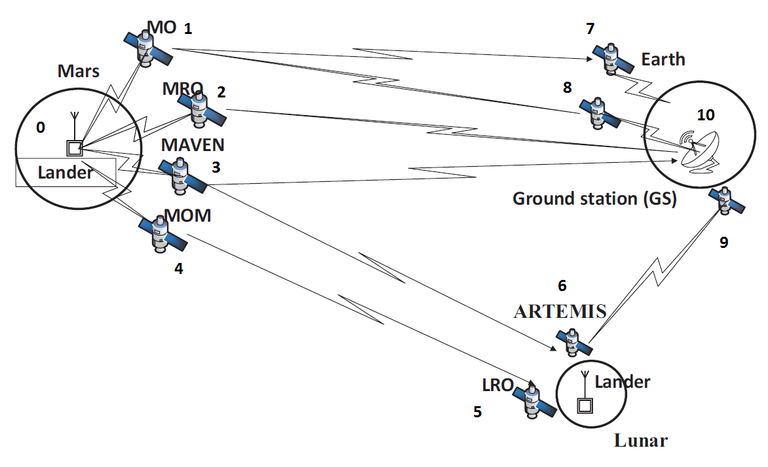
Figure 1: Deep space network for maximum flow possible
The above deep space network has the following features: Total 11 nodes in the above deep space network; Mars system – lander(0), MO(1), MRO(2), MAVEN(3), MOM(4); Lunar satellites – LRO(5) & ARTEMIS(6) and Earth Satellites(7,8 and 9) & GS(10).

We use the data obtained from the simulation of the above network and apply the above discussed algorithmic approach to finding maximum flow possible through this DTN. We have taken the case of node (0) as source whereas node(10), the ground station, as the drain. We have taken the case in which node(0) is the source and node(10), the ground station, is the drain. The above discussed algorithm was applied to the Inter planetary network to achieve the following results. Our algorithm firstly checks for the possibility of path between the source and the drain in every iteration. In case that a path is possible, the nest step is using fordfulkerson approach by updating the edges of the network and calculating the maximum flow possible in the respective iteration. This procedure continues until no further paths are possible between the source and drain and the algorithm gives the final output of total possible maximum flow. The following table (Table 1 ) is result obtained by applying our algorithm to the given network.

#Iteration | DFS path | Max flow
1 | 0-3-6-7-10 | 2688
2 | 0-4-9-10 | 3850
3 | 0-2-7-6-9-4-8-10 | 2200
4 | 0-1-10 | 1024
5 | 0-2-9-6-8-4-7-10 | 440
6 | 0-2-9-6-8-4-7-10 | 488
7 | 0-1-9-2-7-4-6-8-10 | 256
8 | 0-2-9-6-8-4-7-10 | 502
9 | 0-2-9-6-7-4-8-10 | 328
 | No paths remaining | Total flow = 11776
Table 1: Maximum flow iterations

4. Conclusion
The aim of the project is to address the issue of achieving maximum flow in Inter-planetary network. We have discussed the various characteristic features of this special kind of DTN which result in significant challenges to achieve our goal. To tackle these issues, we described the DTN model as time aggregated graph (TAG). Secondly, an innovative bidirectional storage transfer series was used to correlate various time intervals and aid in maximizing flow. The proposed STAG based max flow algorithm can be effectively used to solve the maximum flow problem. It also results in a simpler graph and less memory by aggregating the link and node attributes. We have applied our algorithm to the case where h=1000 as can be observed above. Here, h is the number of smaller intervals that is h=1/$∈$. Typical Delay tolerant networks such as the ones seen above actually have much higher values of h. Future work includes studying the increase in difficulty of achieving maximum flow as we increase h and get closer to real inter planetary networks.

Acknowledgements
This thesis is a result of project performed under the guidance of Prof. Raja Datta and Research scholar Sangita Dhara at Indian Institute of Technology, Kharagpur, India. With great pleasure I avail this unique opportunity to express my profound sense of gratitude and indebtedness to Prof. Raja Datta, Indian Institute of Technology, Kharagpur, for his efficacious advice, perpetual and prolific encouragement and constructive criticism during the work and in the preparation of this project report.

References
- I.F.Akyildiz, O.B.Akan, C.Chen, J.Fang, W.Su, “InterPlaNetary Internet: state-of-the-art and research challenges” in: Elsevier, Computer Networks 43 (2003).
- J.Alonso, K.Fall, “A linear programming formulation of flows over time with piecewise constant capacity and transit times” in: Intel Research Berkeley, 2003.
- H.Li, T.Zhang, Y.Zhang, K.Wang, J.Li, “A maximum flow algorithm based on storage time aggregated graph for delay-tolerant networks” in: Elsevier, Ad hoc Networks 59 (2017).
- E.kohler, R.Mohring, M.Skutella, “Traffic networks and flows over time” TU-Berlin technical report 752/2002 2002.
- L.R.Ford, D.R.Fulkerson, “Constructing maximal dynamic flows from static flows” Operations Research 6:419-433, 1958

