Design and Modeling of Straight-Blade Vertical Axis Wind Turbine in Pakistan

S M Nazmuz Sakib
Graduate of BSc in Business Studies
School of Business And Trade
Pilatusstrasse 6003, 6003 Luzern, Switzerland
sakibpedia@gmail.com

Student of Department of Law
Dhaka International University
House # 4, Road # 1, Block - F, Dhaka 1213
sakibpedia@students.diu.ac

Student of BEcon in Environmental and Resource Economics
Dhaka School of Economics
4/C Eskaton Garden Rd, Ramna, Dhaka 1000, Bangladesh.
sakib.bee5@dsce.edu.bd

Keywords: Wind Turbine Design, Wind Turbine Architecture, Wind Turbine, Wind Turbine Technology

ABSTRACT
Pakistan is one of those countries which has large potential of energy harvest from renewable energy sources and specially from wind. With the surge of global warming, the world is moving towards cleaner and viable sources of energy. Horizontal Axis Wind Turbines (HAWT) currently dominates the most of the wind power farm markets in the world but Vertical Axis Wind Turbines (VAWT) are also capable of harvesting large amounts of energy with benefits over the HAWTS. VAWTS do not need a control system to be pointed in the direction of wind because with its blade in radial arrangement, wind from any direction is useful. In this report, a Straight-Blade VAWT is designed for low speeds and its performance parameters are also identified for which the improvement of the VAWT will be obtained. Self-starting ability of VAWT is also analyzed and stress and vibration analysis will be investigated in ANSYS Fluent.

ABBREVIATIONS
VAWT | Vertical Axis Wind Turbine
HAWT | Horizontal Axis Wind Turbine
DMST | Double Multiple Stream Tube
COP | Coefficient of Power
CFD | Computational Fluid Dynamics

NOMENCLATURE
$$K.E$$ | Kinetic Energy of Air
$$P_{w}$$ | Power Available from Air
$$\dot{m}$$ | Double Multiple Stream Tube
$$C_{p}$$ | Coefficient of Power
$$σ$$ | Turbine Solidity
TSR | Tip-Speed Ratio
$$α$$ | Angular Acceleration/Angle of Attack
$$β$$ | Blade Pitch Angle
R | Rotor Radius
A | Turbine Swept Area
c | Chord Length
b | No of Blades
H | Blade Height

Chapter 1: INTRODUCTION
Bangladesh have been facing the energy deficit and load shedding crisis from the time of its independence. Apart from that, the concerns of increasing global warming and harmful emission gases such as CO₂, SO₂, and NO_{x}, have caused many countries of the world to switch from powerplants that use fossil fuels to renewable energy. Bangladesh has a large potential of harvesting energy and decreasing the energy deficiency in the country through wind energy. Wind energy has a number of advantages over the traditional power plants. Wind energy is clean, environmentally friendly and inexhaustible source unlike fossil fuels. Currently, most of the wind farms are dominated by HAWTS, but the importance and energy potential of VAWTS cannot be ignored. VAWTS are very small in size than HAWTS and they hardly produce any noise pollution which allow them to be placed near traffic roads and high wind velocity locations.
In the near future there is a high chance that the source of fossil fuels maybe depleted and, in that case, it is highly recommended to invest in wind energy early on in the 21st century.

Wind Power
Every object in motion must posses some kind of kinetic energy. High speed winds in motion contains large amount of kinetic energy that can be harvested for electricity generation. The kinetic energy of wind can be related as:
$$K.E=Kinetic Energy=\frac{1}{2}mv_{∞}^{2}$$
Where $m$ is the mass of air under control volume and $v_{∞}$is the free stream velocity. The rate of energy or power can be obtained by the gradient of kinetic energy.
 | $$P=\frac{dK.E }{dt}=\frac{1}{2}\dot{m}v_{∞}^{2}$$ | (1)
The mass flow rate needs to be defined as only a small portion of wind power is converted into useful electrical energy and is dependent on the size of the turbine.
 | $$\dot{m}=ρAv_{∞}$$ | (2)
Where $ρ$ is the density of air at ambient conditions, $A$ is the are of the wind swept normal to the direction of flow.
Now by combining equation (1) and (2) we get,
 | $$P_{w}=\frac{1}{2}ρAv_{∞}^{3}$$ | (3)
From the investigation of equation (3) we see that to obtain large amounts of power from the wind, we need high swept area, density and specially the wind velocity because the wind power is proportional to the wind velocity to the third power.

Power Coefficient
In order to define the effective efficiency of how much wind power is converted into electrical energy, we define a new term known as the power coefficient. The power from the wind is first used to drive the turbine blades and shaft and hence it is converted to mechanical energy. The mechanical energy is then converted to electrical energy by the use of an alternator and gearbox. The important component of the turbine here are the blades. For maximum harvest of wind energy, turbine blades are to be carefully designed.
The power coefficient, related the conversion of wind power to mechanical energy by the turbine blades and is related as
 | $$C_{P}=\frac{P_{Mechanical}}{P_{w}}$$ | (4)
Since there are energy losses in the system due to wake, aerodynamic losses, blade-tip vortices and rotation losses, the power coefficient obtained is very much less than the theoretical value and is usually in the range of 30% to 40%
Lanchester-Betz calculated the theoretical efficiency limit for a Horizontal Axis Wind Turbine which is about 59.3% and is called Betz Limit
For a VAWT however the limit is about 64% which are determined by momentum, viscid and inviscid theories.

Wind Turbines
Wind turbines convert wind power into mechanical energy and then into electrical energy. Various types and kinds of turbines have been developed throughout the history to harvest the free energy from the wind. Each turbine has its pros and cons and the final choice often ends on the most energy for the least price. Wind turbines can be classified into several types, according to their configuration of blades, turbine capacity, generator driving pattern and location of installation.

Horizontal Axis and Vertical Axis Wind Turbines:
The most commonly used and found wind turbine today is Horizontal Axis Wind Turbine. In this type of configuration, the turbine blade is mounted high in to the sky on a pedestal. There are very large in sizes and usually contains three propellers because high number of propellers causes high noise pollution. They also need a yaw control system to orient them to the wind. The power generated is restricted by the diameter of the rotor and hence a larger diameter will produce more power but since a HAWT experience large thrust forces and torque, the size is limited by blade strength and construction.
Figure 1 shows several types of Vertical Axis Wind Turbines. The turbine blades of VAWTS rotate about an axis that is normal to ground. A very important advantage of VAWTS over HAWTS is that, they can accept wind from any direction and they do not require any control system to point them in the direction of wind and thus no yaw control is needed. The turbine construction is also simplified because the main components of the turbine such as gearbox and generator can be located on the ground as compared to HAWTS and as a consequence reduces cost. One limitation of VAWTS is that it requires external energy source during initiation because it is supported on only one end at the ground and due to buckling and toppling, its practical height is limited. Due to low amounts of power coefficients of VAWT, their usage is limited and make a small percentage of the turbines.
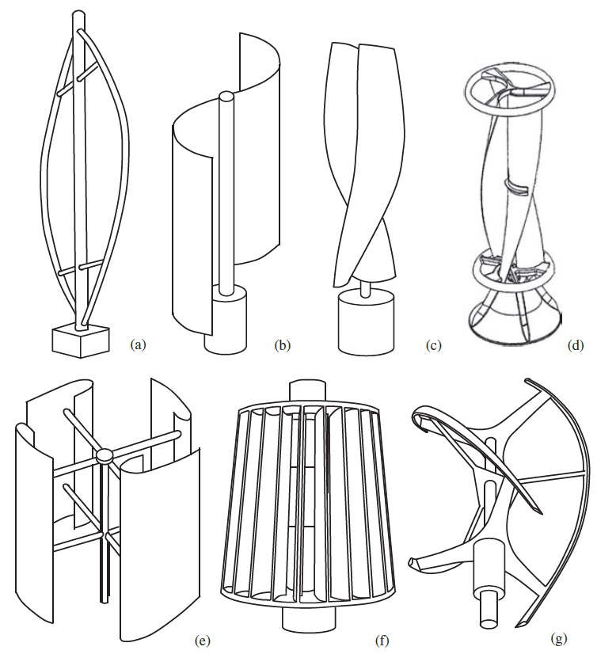
Figure 1 Several typical types of vertical-axis wind turbines: (a) Darrius, (b) Savonius, (c), Solarwind, (d), Helical, (e) Noguchi, (f) Maglev (g) Cochrane [1]
Figure 2 Horizontal Axis Wind Turbine [2]

Vertical Axis Wind Turbines
VAWTs come in good number of physical configurations, and involve some advanced aerodynamics. These turbines were the first ones to be developed and they vary in sizes according to the requirement of operation. According to literature, the maximum Coefficient of Performance of a VAWT is higher than a HAWT and this make VAWTs a potential source of energy. From the early 1970’s to 1990s there have been a lot of research on VAWTs and a great deal has been learnt from that research. Despite the advantages of VAWTs over HAWTS, they have fallen very far behind.
As the VAWTs rotate about an axis normal to ground, the velocity of the air relative to the rotor shat is changing direction constantly in magnitude and direction. In addition, each blade will interact with the wakes of other blades, and possibly its own wake, when it passes through the downstream half of its path about the turbine axis. Both these effects result in fluctuating aerodynamic forces on the blades, which in turn lead to a potentially significant fatigue issue for the design of the blades and overall turbine structure. The fluctuating blade loads also lead to a varying torque transferred to the mechanical load.
Tip speed ratio is a parameter that is very important for a VAWT because most of the designs of VAWTs produce low torques, and even negative torques sometimes at low tip speed ratios. Despite a lot of losses and drawbacks of VAWTs, they are good means of generating electrical energy. There are variety of sizes of VAWTs available and will vary according the required application.

Types of VAWTS
Over the decades, a wide variety of have VAWTs have been developed and they are to be discussed to consider the advantages and efficiency of each. Some of the major types of VAWTs are explained in the next sections.

Savonius Turbines:
The invention credit of this VAWT goes to Savonius, who patented this device in 1930’s. At that time, there was a huge requirement of pumping water in rural or remote areas and development of wind turbines were used to that purpose. This type of VAWT has been popular both for both professional and amateur types of turbines. Over the years, different variations of Savonius VAWT have been developed and are used to produce electricity. But despite this brilliant innovation, it has never been used on a large-scale electricity generation. The Savonius turbine has low tip to speed ratio has a number of advantages, such as they produce less aerodynamic noise which is a important issue today in turbines and even for a 3 bladed HAWT. Savonius VAWT provides a cost-effective solution to turbines installed on to building, but still a lot of innovations are required to build an efficient integrated wind turbine. Urban types of VAWTS are usually characterized by low wind speeds and high turbulence.
Savonius VAWT is actually a drag device, with some modifications of the rotor performance available due to air crossing in each vane mutual coupling of the other halves of the rotor. All drag devices have low operating tip-speed ratio which makes it not a good choice for electricity generation. Mostly, it is used with a gearbox to modify the speed and to minimize the step up ratio requirement. Several studies have been performed on this type of turbine and it has been determined the coefficient of performance is about 23% at a tip-speed ratio of less than 1. Currently, there have been a lot of studies using CFD analysis also. [1]
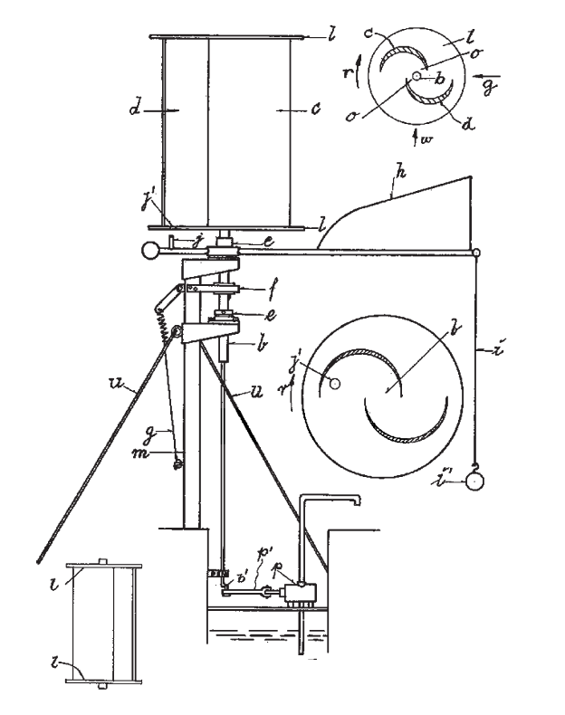
Figure 3 Principal embodiment of the Savonius VAWT Patent [1]

Darrieus Turbines:
The Darrieus VAWT was invented by Darrieus in 1931. This type of turbine had high tip-speed ratio and it opened up new possibilities of VAWTs in terms of electricity generation. The fundamental principle of this turbine was to increase the velocity of the blades several folds than the free stream velocity of the wind so that the lift forces could be used significantly to improve the coefficient of performance of the VAWTs over previous inventions. This type of VAWT include both curved blade and straight blade as shown in Error! Reference source not found.. Darrieus also proposed active type of straight blades, which could control their pitch, and optimize the angle of attack of air.
There is one drawback of Darrieus VAWT, an that is its self-starting capacity due to insufficient torque to overcome the friction during starting. This is mainly due to very small lift forces at low rotational speeds of the rotor and mostly for two bladed- machines, for each of the stationary blades, the torque generated is same irrespective of the rotor’s azimuth relative to incident wind. In a given wind velocity, the large commercial turbines need to be run at a significantly high tip-speed ratio to avoid rotors from stalling at most azimuth angles. Darrieus VAWT do have some self-starting capability but it is none the less not of commercial value.
There are also some strategies which can be used to enhance the self-starting capacity of a turbine. These include:
1. Using odd number of blades
2. Providing Blade-Pitch Mechanism
3. Using Skewed Blades
4. Increase Solidity
In terms of noise pollution, Darrieus VAWT showed great results as compared to modern HAWTS because of low tip speeds. [1]
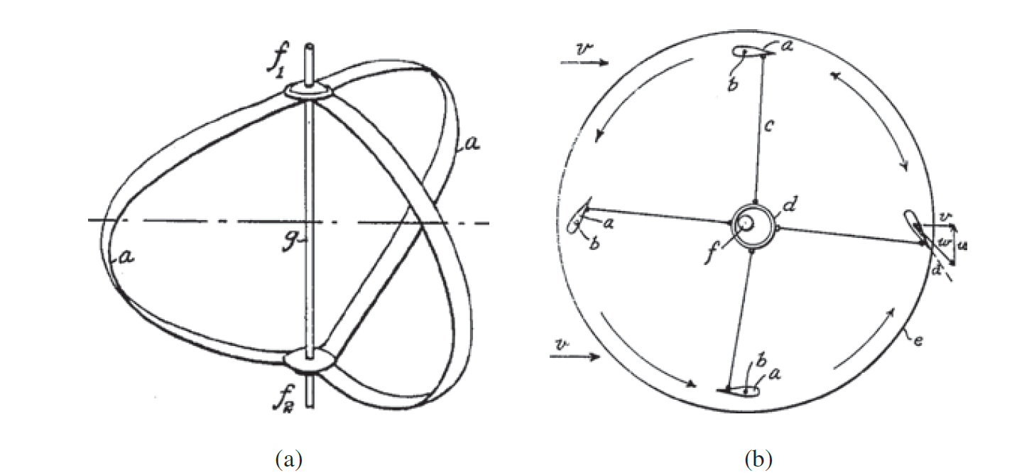
Figure 4 Images from the Darrieus VAWT patent: (a) Curved-Blade rotor embodiment(b) Plane view of Straight-Blade Rotor [1]

Straight Blade Turbines:
Two of the problems that needed to be addressed in VAWTs was to control the power of the turbine at high wind speeds and active control of the blade pitch resulted in complex mechanical system for large scale VAWTs. Musgroove, a British aeronautical engineer, research led to the development of a furling system, whereby straight blades could be hinged at their mid points so that angle of the blades relative to axis of the rotor could be adjusted by mechanical actuators. During that time, a number of geometries were created but it is imperative to mention that the furling method, generates a lot of lift and turbulence which most of the cause potential failure of supporting radial arms. A typical design of a straight-blade VAWT is shown in Figure 5.
Figure 5 A Straight-Blade VAWT

Project Aims and Objectives:
The aims of this project is to design and develop a working H-type straight blade VAWT for areas of good wind speed like Sindh or Punjab to harvest renewable energy and to complete the energy deficit from the country. A wind power density chart and map has been shown in Figure 6, which shows the potential wind energy in different areas of Bangladesh.
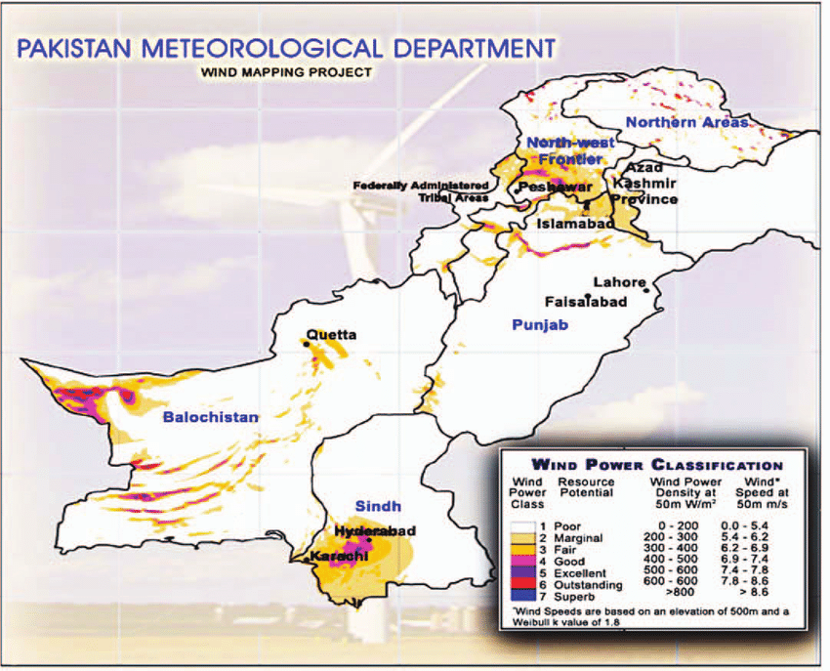
Figure 6 Wind Velocity Distribution (Pakistan Meteorological Department)

CHAPTER 2: LITERATURE REVIEW

Wind Resource and Site Assessment:
Before starting the design of a VAWT, it is imperative to have some information about the potential wind site. The wind map showing the estimate of wind resource in Pakistan is shown in Figure 6. In this section, it will be explained how the wind resource can assessed. The steps are explained in great detail starting with the identification of initial site. Later on, different instruments for measuring the wind speed are explained. Having analyzed wind data and prepared a layout, the next step is energy yield calculation.

Initial Site Identification:
The wind resource is the most critical aspect to be assessed when planning a wind turbine or a wind farm. The information on the wind climate can be obtained using different approaches and techniques. General information about the wind is mostly available in countries, where wind farms are in vast quantities. The information on wind charts is often color coded which and shows which part of the country have best wind energy density. The wind analysis is usually produced with Wind Atlas Analysis and Application (WAsP) or combined models which involve the use of both meso and micro model. The wind data statistics depends on the distance the target site and the station, the input data and complexity of the site itself. The main source of information for wind is usually performed at height of 10m. These data are based on general models and their accuracy and precision pretty much smaller for wind energy available. A very viable first estimate can be calculated through a nearby wind farm if the production data is available. The financial success of wind farm totally depends on the correct assessment of wind resource because wind power is proportional to third power of wind velocity and hence this step requires maximum possible attention from the designers. But usually, wind measurements are usually neglected and measurement height is not sufficient for the complexity of the site. It cannot be stressed enough that the most expensive part when measuring wind is the loss of data. Any wind resource assessment requires a minimum measurement period of one complete year in order to avoid seasonal biases. If instrumentation fails due to lightning strike, icing, vandalism or other reasons and the failure is not spotted rapidly, the lost data

Wind Speed Measurements:

Introduction:
The measured wind climate is the main input for the flow models, by which you extrapolate the spot measurement vertically and horizontally to evaluate the energy distribution across the site. Such a resource map is the basis for an optimized layout. The number and height of the measurement masts should be adjusted to the complexity of the terrain as with increasing complexity, the capability of flow models to correctly predict the spatial variation of the wind decreases. The more complex the site, the more and the higher masts have to be installed to ensure a
reasonable prediction of the wind resource. Unfortunately, wind measurements are frequently neglected. Very often the measurement height is insufficient for the complexity of the site, the number of masts is insufficient for the size of the site, the measurement period is too short, the instruments are not calibrated, the mounting is sub-standard or the mast is not maintained. It cannot be stressed enough that the most expensive part when measuring wind is the loss of data. Any wind resource assessment requires a minimum measurement period of one complete year in order to avoid seasonal biases. If instrumentation fails due to lightning strike, icing, vandalism or other reasons and the failure is not spotted rapidly, the lost data will falsify the results and as a consequence the measurement period has to start all over again. Otherwise, the increased uncertainty might jeopardize the feasibility of the whole project.

Instruments:

General:
Wind speed measurements put a very high demand on the instrumentation because the energy density is proportional to the cube of the mean wind speed. Furthermore, the instruments used must be robust and reliably accumulate data over extended periods of unattended operation. The power consumption should be low so that they can operate off the grid. Most on-site wind measurements are carried out using the traditional cup anemometer. The behavior of these instruments is fairly well understood and the sources of error are well known. In general, the sources of error in anemometry include the effects of the tower, boom and other mounting arrangements, the anemometer design and its response to turbulent and non-horizontal flow characteristics, and the calibration procedure. Evidently, proper maintenance of the anemometer is also important. In some cases, problems arise due to icing of the sensor, or corrosion of the anemometer at sites close to the sea. The current version of the internationally used standard for power curve measurements, the IEC standard 61400-12-1, only permits the use of cup anemometry for power curve measurements. The same requirements for accuracy are valid for wind resource measurements. Therefore, it is advisable to use also these instruments for wind resource assessment. Solid state wind sensors (e.g., sonics) have until recently not been used extensively
for wind energy purposes, mainly because of their high cost and a higher power consumption. These have a number of advantages over mechanical anemometers and can further provide measurements of turbulence, air temperature, and atmospheric stability. However, they also introduce new sources of error which are less known, and the overall accuracy of sonic anemometry is lower than for high-quality cup anemometry. Recently, remote sensing devices based either on sound (Sodar) or on laser (Lidar) have made an entry into the market. Their clear merit is that they replace a mast which can have practical advantages. However, they often require more substantial power supplies which bring other reliability and deployment issues. Also, more intensive maintenance is required since the mean time between failures does not allow unattended measurements for periods required for wind resource assessment. While the precision of a Lidar seems to be superior to the Sodar, and often comparable to cup anemometry, both instruments suffer at the moment from short-comings in complex terrain due to the fact that the wind speed sampling takes place over a volume, and not at a point. Remote sensing technologies are currently evolving very rapidly and it is expected they will have a significant role to play in the future.

Cup anemometer:
This instrument is basically a drag device which usually consists of three cups mounted on a single end of a horizontal arm 120 degree apart from each other on a vertical shaft
The construction of cup is so that the drag coefficient of the front open surface is greater than the blunt back surface of the cup. The air flow past the cups in any horizontal direction turns the cups in a manner that is proportional to the wind speed. Therefore, counting the turns of the cups over a set time period produces the average wind speed for a wide range of speeds. Despite the simple geometry of an anemometer its measurement behavior depends on a number of different factors. One of the most dominant factors is the so-called angular response, which describes what components of the wind vector are measured. A so-called vector anemometer measures all three components of the wind vector, the longitudinal, lateral and vertical component. Thus, this type of anemometer measures independently of the inflow angle and is less sensitive to mounting errors, terrain inclination and/or thermal effects. However, for power curve measurements the instrument must have a cosine response thus measuring only the horizontal component of the wind. Since for energy yield calculations the measurement behavior of the anemometer used for the power curve and used for resource assessment should be as similar as possible, it is advisable to also use an anemometer with a cosine response for resource assessment. One of the key arguments for using such an instrument for power curve measurements is that the wind turbine utilizes only the horizontal component. This is, however, a very simplified approach as, particularly for large rotors, three-dimensional effects along the blades leads to a utilization of energy from the vertical component. Care has to be taken when using a cosine response anemometer as it is sensitive to mounting errors. One of the most relevant dynamic response specifications is the so-called over-speeding. Due mainly to the aerodynamic characteristics of the cups, the anemometer tends to accelerate faster than it decelerates, leading to an over-estimate of wind speed particularly in the middle wind speed range. Another dynamic response specification is the response length or distance constant, which is related to the inertia of the cup anemometer. The dynamic response can be described as a first order equation. When a step change of wind speed from $U to U + Δ u$ hits the anemometer, it will react with some delay of exponential shape. The distance constant, i.e., the column of air corresponding to 63% recovery time for a step change in wind speed, should preferably be a few meters or less.
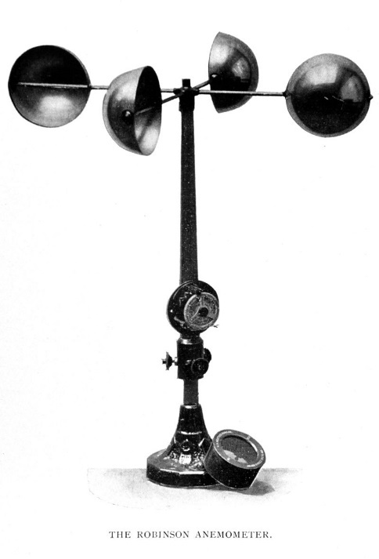
Figure 7 The Robinson Cup Anemometer (Wikipedia)

Ultrasonic anemometer
Ultrasonic or sonic anemometers use ultrasonic waves for measuring wind speed
and, depending on the geometry, the wind direction. They measure the wind speed
based on the time of flight between pairs of transducers. Depending on the number
of pairs of transducers, either one-, two- or three-dimensional flow can be
measured. The travelling time forth and back between the transducers is different
because in one direction the wind speed component along the path is added to the sound speed and subtracted from the other direction. If the distance of the transducers
is given with s and the velocity of sound with c then the travelling times can be expressed as,
$$t_{1}=\frac{s}{c+u} and t_{2}=\frac{s}{c-u}$$
These equations can be re-arranged to eliminate c and to express the wind speed
u as a function of t₁, t₂ and s. The sole dependency on the path length is advantageous, as the speed of sound depends on air density and humidity:
$$u=\frac{s}{2}(\frac{1}{t_{1}} -\frac{1}{t_{2}} )$$
It can be seen that once u is known, c can be calculated and from c the temperature can be inferred (slightly contaminated with humidity, this is known as the “sound virtual temperature”). The spatial resolution is determined by the path length between the transducers, which is typically 10–20 cm. Due to the very fine temporal resolution of 20 Hz or better the sonic anemometer is very well suited for measurements of turbulence with much better temporal and spatial resolution than cup anemometry.
The measurement of different components of the wind, the lack of moving parts, and the high temporal resolutions make the ultrasonic anemometer a very attractive wind speed measurement device. The major concern, inherent in sonic anemometry, is the fact that the probe head itself distorts the flow – the effect of which can only be evaluated in detail by a comprehensive wind tunnel investigation. The transducer shadow effect is a particularly simple case of flow distortion and a well-known source of error in sonics with horizontal sound paths. Less well known are the errors associated with inaccuracies in probe head geometry and the temperature sensitivity of the sound transducers. The measurement is very sensitive to small variations in the geometry, either due to temperature variations and/or mechanical vibrations due to wind. Finally, specific details in the design of a given probe head may give rise to wind speed-dependent errors.
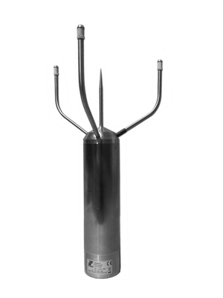
Figure 8 Ultrasonic Anemometer (Wikipedia

Analysis of VAWT Performance:
There are number of levels of complexity which one can analyze the performance of VAWTs. Basically, there are four main approaches to model the VAWTs and they are:
- Momentum Models
- Vortex Models
- Local Circulation Methods
- Viscous Models
An extremely basic method that can be used by anyone with basic knowledge of fluid mechanics is disc or blade element momentum theory.

The Disc/Momentum Theory and Betz Limit:
This theory was proposed by Betz in 1926 and It can be used to determine the power, thrust of the wind on an ideal rotor configuration.
In this simple aerodynamic model, the wind turbine is known as “Actuator Disc Model” in which the rotor is assumed as a homogenous disc that produces energy from the wind .
The following assumption are made in the Actuator Disc Theory:
- Incompressible Flow
- Steady-State Flow
- Frictional Drag is negligible
- Thrust per unit area is constant over the disk
- The tangential component of the velocity in the slipstream is zero
- Continuity of velocity through the disc
- There is infinite no of blades in the turbine
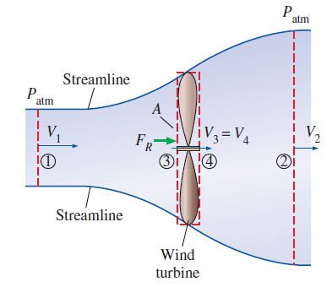
Figure 9 Air flow through a Wind Turbine [2]
We consider two control volumes surrounding the disc area, as shown in Figure 9. The axisymmetric steam tube in Figure 9 can be thought of as an imaginary duct for the air flow through the turbine. From Reynold’s Transport theorem, the control volume equations for momentum of large control volume and steady flow and is analyzed in x direction.
 | $$\frac{dp}{dt}=\frac{d}{dt}\int_{C.V}{ρvdV+\int_{C.S}{ρv.\hat{n}dA}}$$ | (5)
Since location 1 and 2 are far from the turbine, P₁ = P₂ = P_{atm} which yields zero pressure force on the control volume. The velocities at the inlet and the outlet can be approximated as uniform V₁ and V₂ and the momentum flux correction factors, are β₁ = β₂ =1. The equation no 5 reduces to,
 | $$F_{R}=\dot{m}V_{2}-\dot{m}V_{1}=\dot{m}(V_{2}-V_{1})$$ | (6)
The smaller control volume in Fig 9 encloses the turbine and the Area A₃ = A₄ = A , since the control volume is infinitesimally thin. Since the air is considered incompressible, V₃ = V₄ but since the energy is extracted from the wind from point 3 to 4 then P₃ is not equal to P₄. By applying momentum equation on the smaller control volume, we get,
 | $$F_{R}+P_{3}A-P_{4}A=0→F_{R}=(P_{4}-P_{3})A$$ | (7)
Bernoulli’s equation cannot be used in between a turbine due to irrotational flow but it is a good approximation between location 1 and 3 and between locations 4 and 2.
 | $$\frac{P_{1}}{ρg}+\frac{V_{1}^{2}}{2g}+z_{1}=\frac{P_{3}}{ρg}+\frac{V_{3}^{2}}{2g}+z_{3} and \frac{P_{4}}{ρg}+\frac{V_{4}^{2}}{2g}+z_{4}=\frac{P_{2}}{ρg}+\frac{V_{2}^{2}}{2g}+z_{2}$$ | (8)
In this ideal analysis, the pressure starts at atmospheric pressure far upstream and rises to P₃ and then drops sudden to P₄ and then again rises to P₂ ending at P₂ = P_{atm} . Now setting P₁ = P₂ = P_{atm}, V₃ = V₄, and z₁ = z₂ =z₃ = z₄ and adding equations 6 and 7 we get:
 | $$\frac{V_{1}^{2}-V_{2}^{2}}{2}=\frac{P_{3}-P_{4}}{ρ}$$ | (9)
By substituting $\dot{m}=ρV_{3}A$ into equation 6 and combining the result with equation 7 and 8
 | $$V_{3}=\frac{V_{1}+V_{2}}{2}$$ | (10)
“Then we conclude that the average velocity of the air through an idea wind turbine is the arithmetic average of the far upstream and downstream velocities. The validity of the result of limited by the Bernoulli’s Equation” [2]
We define a new variable, knows as fraction loss of velocity from far upstream to turbine disc as,
 | $$a=\frac{V_{1}-V_{3}}{V_{1}}$$ | (11)
The velocity through the turbine will become
 | $$V_{2}=V_{1}(1-2a)$$ | (12)
For an ideal turbine, without irreversible losses such as friction, the power generated by the turbine is just the difference between the incoming and the outcoming kinetic energies.
 | $${\dot{W}}_{ideal}=\dot{m}\frac{V_{1}^{2}-V_{2}^{2}}{2}=ρAV_{1}\left(1-a\right)\frac{V_{1}^{2}-V_{2}^{2}{\left(1-2a\right)}^{2}}{2}=2ρAV_{1}^{3}a{\left(1-a\right)}^{2}$$ | (13)
The power coefficient of a turbine is defined as,
 | $$C_{p}=\frac{{\dot{W}}_{rotor shat , output}}{\frac{1}{2}ρV_{1}^{3}A}=\frac{{\dot{W}}_{ideal}}{\frac{1}{2}ρV_{1}^{3}A}=\frac{2ρAV_{1}^{3}a{\left(1-a\right)}^{2}}{\frac{1}{2}ρV_{1}^{3}A}=4a{\left(1-a\right)}^{2}$$ | (14)
We can calculate the maximum possible value of C_{p} by setting the derivative of C_{p} with respect to a to zero i.e
 | $$\frac{{dC}_{p}}{da}=0$$ | (15)
The equation 15 will yield, a = 1/3. Then from equation 14 and a = 1/3
 | $$C_{p,max}=\frac{4}{3}{\left(1-\frac{1}{3}\right)}^{2}=\frac{16}{27}≈0.5926$$ | (16)
This is the maximum value of C_{p} for a HAWT and is knows as Betz limit. All real-world turbines have maximum power coefficient less than this because we have assumed an ideal scenario and due to losses, turbines never reach this efficiency.

Three effects that lead to maximum power coefficient less than the Betz limit are,
- Rotation of the wake behind the rotor
- Finite number of rotor blades
- Non-zero aerodynamic drag on the rotor blades

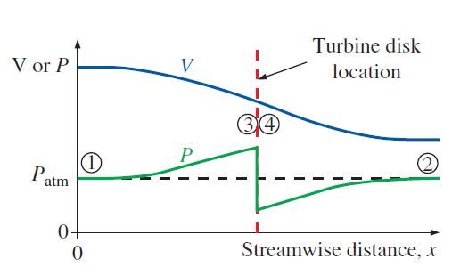
Figure 10 Velocity Profile of Wind Through Turbine

Aerodynamics of Straight-Blade H-Type Vertical Axis Wind Turbine:
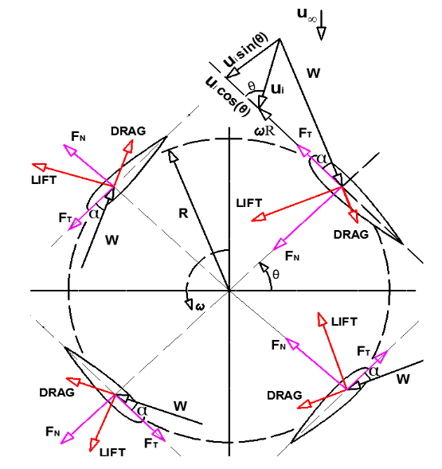
Figure 11 VAWT Flow Velocities [3]
The aerodynamics of this type of VAWT is somewhat complicated than the conventional HAWT because the VAWT have a rotational axis normal to the ground. The main drawbacks of a VAWT are its steep local angle of attacks and turbulent wake coming from the blade upwind.
This type of VAWT works typically at high tip-speed ratio which makes it a viable option for electricity generation. Unfortunately, they are not self-starting and requires some external energy in the start.
From the 2-D representation of VAWT in Figure 11. The relative velocity from the figure can be calculated as:
 | $$w=\sqrt{{\left(u_{i}sinθ\right)}^{2}+{\left(u_{i}cosθ+ωR\right)}^{2} }$$ | (17)
Where u_{i} is the induced velocity through the rotor, $ω$ is the rotational velocity, and R is the radius of turbine and $θ$ is the azimuth angle.
It can be also written in non-dimensional form, as
 | $$\frac{w}{u_{∞}}=\sqrt{{\left(\frac{u_{i}}{u_{∞}}sinθ\right)}^{2}+{\left(\frac{u_{i}}{u_{∞}}cosθ+\frac{ωR}{u_{∞}}\right)}^{2} }$$ | (18)
From equation (10) and (11) we get,
 | $$u_{i}=u_{∞}\left(1-a\right)$$ | (19)
Defining a constant $λ$ as,
 | $$λ=\frac{wR}{u_{∞}}$$ | (20)
Now the equation (18) can be written as,
 | $$\frac{w}{u_{∞}}=\sqrt{{\left(1-a)sinθ\right)}^{2}+{\left((1-a)cosθ+λ\right)}^{2} }$$ | (21)
The local angle of attack from Figure 11 can be calculated as:
 | $$tanα=\frac{u_{i}sinθ}{u_{i}cosθ+wR}$$ | (22)
As we did for relative velocity, we can modify the equation (22) in non-dimensional form and by using equation (19),
 | $$α=\tan^{-1}\left(\frac{\left(1-a\right)sinθ}{\left(1-a\right)cosθ+λ}\right)$$ | (23)
The normal and tangential force components can be expressed as:
 | $$C_{N}=C_{L}cosα+C_{D}sinα$$ | (24)
 | $$C_{T}=C_{L}sinα-C_{D}cosα$$ | (25)
Where C_{L} and C_{D} is the lift and drag coefficients respectively for any angle of attack $α$
Then for a single blade, the normal and tangential forces for single blade at single azimuth location are:
 | $$F_{N}=\frac{1}{2}ρw^{2}hcC_{N}$$ | (26)
 | $$F_{T}=\frac{1}{2}ρw^{2}hcC_{T}$$ | (27)
Where h is the blade height and c the blade chord length and the product h*c is the wing form area.
The instantaneous thrust force can also be calculated from Figure 11 which is the force of wind on the turbine experienced by one blade element in the direction of air flow is:
 | $$T_{i}=F_{T}cosθ-F_{N}sinθ$$ | (28)
Using equations (24), (25),(26),(27),(28) we get:
 | $$T_{i}=\frac{1}{2}ρw^{2}(hc)(C_{N}sinθ-C_{T}cosθ)$$ | (29)
The tangential component of force drives the rotation of the wind turbine and produces the necessary torque to generate electricity. The instantaneous torque by a single blade at a single azimuth location is:
 | $$τ_{i}=F_{T}R$$ | (30)
Substituting equation (27) into equation (30) we get:
 | $$τ_{i}=\frac{1}{2}ρw^{2}hcC_{T}R$$ | (31)
[3]

Double Actuator Disc Theory:
The main disadvantage of the previous mode is its inability to distinguish between upwind and downwind part of the turbine. Instead of one, two actuators’ disks can be placed behind each other connected at the center as shown in Figure 10. Instead of one constant, here we define two constants, a and a’. The induced velocity on the upstream will be the average of the air velocity at far upstream and the air velocity at downstream equilibrium. The air velocity at the downstream equilibrium can be expressed as:
$$v_{e}=\left(2v_{i}-v_{∞}\right)=\left(1-2a\right)v_{∞}$$
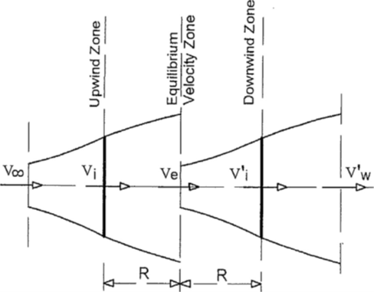
Figure 12 Double Actuator Disc Theory

Multiple Stream-tube Model:
This model was developed by Strickland and is based on momentum theory. The main improvement as compared to disc models is that more stream tubes make different induced velocities possible as shown in Figure 12. Each stream will have its own velocity allowing for change in the velocity which will depend on the direction, perpendicular to free steam velocity. The accuracy of this model depends on the number of stream-tubes used. The momentum balanced is analyzed for each stream tube separately. For each of the blade elements and steam tubes, the momentum equations have to be calculated and it will result in ‘n’ induction factors. The total span of the single-stream tube will be divided into multiple tubes by using a fixed angle $∆ϕ$
 | $$∆ϕ=\frac{2π}{N_{ϕ}}$$ | (32)
A single blade passes each stream-tube twice per revolution in the upstream and downstream.
The mean aerodynamic thrust with a turbine having “b” blades and spend $\frac{∆ϕ}{π}$ time in the stream tube, we get:
 | $$T_{mean}=2\left(\frac{v∆ϕ}{π}T_{i}\right)$$ | (33)
Or a single stream-tube, consider the swept area of the turbine to be $A=HR∆ϕ$ once can easily get the non-dimensional thrust coefficient
 | $$C_{T}=\frac{T_{mean}}{\frac{1}{2}ρv_{∞}^{2}(HR∆ϕ sinϕ)}=\left(\frac{bc}{2R}\right){\left(\frac{w}{v_{∞}}\right)}^{2}\frac{2}{π} (C_{t}\frac{cosϕ}{sinϕ}-C_{n})$$ | (34)
The average torque on rotor by “b” blades and on the complete interval and blade length H is given by:
 | $$τ_{avg}=b*\sum_{j=1}^{N_{ϕ}}{\frac{(\frac{1}{2}ρw^{2}HcC_{T}R)}{N_{ϕ} }}$$ | (35)
Then the torque coefficient can be defined as:
 | $$C_{τ }=\frac{τ_{avg}}{\frac{1}{2}ρv_{∞}^{2}HRD}=(\frac{Bc}{D})\sum_{i=1}^{N_{ϕ}}{\frac{{\left(\frac{w}{v_{infty}}\right)}^{2}C_{T}}{N_{ϕ}}}$$ | (36)
 | $$C_{P}=C_{Q}Λ$$ | (37)
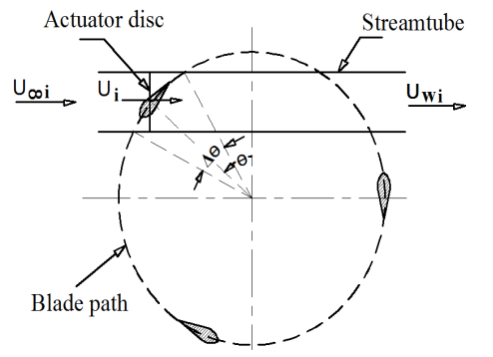
Figure 13 Steam-Tube Model

Double-Multiple-Stream-tube Analysis:
In the previous models, the performance of VAWT was estimated by using momentum analysis and the level of difficulty was fairly simple in which single or multiple stream-tubes were considered. However, for accurate analysis, it is preferable to use multiple stream tube analysis since the resultant wind velocities and wind forces are strong functions of azimuth angle.
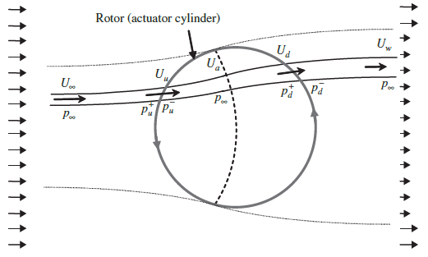
Figure 14 Plane view of a double-multiple-stream-tube analysis of the flow [1]
The Double-Multiple Stream Tube-Model was patented by Loth and McCoy in 1983. Later on, Paraschivoiu and Delclaux combined the multiple stream-tube theory with double actuator disc theory. This theory will allow us to model velocity variations in the direction normal to the free-stream velocity.
The previous models were not able to calculate the influence of upwind on the downwind part of the turbine. The blades extract energy from the wind and the wind speed at downstream is less than the wind speed at far upstream.
The interaction of turbine with air in the upstream and downstream are treated separately.
The assumption in this model is that the wake from the upstream pass is fully expanded and the maximum wake velocity has been reached before the interaction with the blades in the downstream. Then the downstream velocity will see a reduction in velocity.
The Double-Multiple-Stream tube model simultaneously solves two equations for the stream-wise force at the actuator disc, one obtained by conservation of momentum and other based on the aerodynamic coefficients of the airfoil (lift and drag) and the local wind velocity. These equations are solved twice; for the upwind and for the downwind part of the rotor.
The thrust coefficient, torque coefficient, and the power coefficient can be calculated once the relative wind velocity and angle of attack are found the new induction method.
The DMST model requires numerical methods and calculations to solve the induction factor equation.

The following procedure is followed to calculate the flow velocity in DMST.

Figure 15 Numerical Procedure for DMST
One of the popular open-source software that is used for this model is named Qblade.

Computational Fluid Mechanics (CFD) Based Models:
The importance of computer aided analysis cannot be ignored as modern softwares are capable of performing sophisticated analysis. CFD and experimental analysis can be performed to assess the accuracy of the results and whether the results complement each other or not. For example, engineers may obtain global properties, such as lift, drag, pressure drop, or power, experimentally, but use CFD to obtain details about the flow field, such as shear stresses, velocity and pressure profiles, and flow streamlines.

The procedure for CFD analysis in summarized below:

Figure 16 CFD Solution Steps

CHAPTER 3: METHODOLOGY
In this section, we will design the straight-blade H-type VAWT by first using parametric performance analysis and then comes the design analysis. Following steps will be followed for the design of VAWT:
- Performance Analysis: Study of different parameters that will affect the performance. Using this step, we will get overall dimensions of the turbine.
- Design Analysis: In this step, the material will be selected by the knowledge of forces from the previous step and stress analysis.

VAWT Performance Parameters:
The parameters that would affect the different design aspects and performance of the VAWT are:
- Mass Moment of Inertia
- Tip-Speed Ratio
- Number of Blades
- Turbine Solidity
- Pitch Angle of Blades
- Airfoil Type
- Turbine Aspect Ratio
- Turbine Swept or Disc Area
Each of the performance parameters are explained in detail in this section.

Mass Moment of Inertia:
Moment of inertia has a big effect on the performance of the VAWT due to that fact that it is proportional to torque necessary or electricity generation. Hence a VAWT with a lower value of moment of inertia will spin faster and generate greater electricity. But by reducing moment of inertia, the stability is somewhat reduced at high wind speeds.
From rotational mechanics we know that,
 | $$α=\frac{τ}{I_{m}}$$ | (38)
Where $α$ is the angular acceleration, $τ$ is the aerodynamic torque and $I_{m}$ is mass moment of inertia of turbine.

Tip-Speed Ratio:
Another important design factor in VAWT is its tip-speed ratio. It is defined A VAWT with a low moment of inertia has also a good starting performance. It is defined as the ratio of rotational or tangential speed of the turbine to free-stream velocity of the wind.
 | $$Tip-Speed Ratio=\frac{ωR}{v_{∞}}$$ | (39)
The tip-speed ratio should be optimized because if the rotational speed is too high, the it will block the incoming air and reduce any useful power extraction from the wind. Same thing occurs if the rotational speed is low and that would mean that the wind just passes the turbine without any useful power extraction.

Number of Blades:
The number of blades in a VAWT has a direct effect on the fluctuation of torque that is being generated. Good performance was shown with a VAWT had an odd number of blades as compared to even number of blades. The smooth operation is required in a VAWT design and it is economical to go with a design that was three blades.

Turbine Solidity:
A important non-dimensional parameter which determines and affects the self-starting capabilities of a VAWT and it is defined as the ratio of blade plane-form area to projected Turbine Area.
 | $$σ=\frac{bc}{R}$$ | (40)
Solidity will determine whether the assumptions in momentum models are applicable or not. A self-starting turbine is achieved only when $σ≥0.4$ [1]

Pitch Angle of Blades:
For the maximum performance, the proper selection of airfoil is necessary and it will greatly affect the aerodynamic performance. It is difficult to compromise between the turbine solidity, power coefficient when it comes to selection of airfoil.
Pitch angle has a great impact on the overall performance of VAWT. The different pitch angles can increase the coefficient of power an that is why different pitch control mechanism are used.
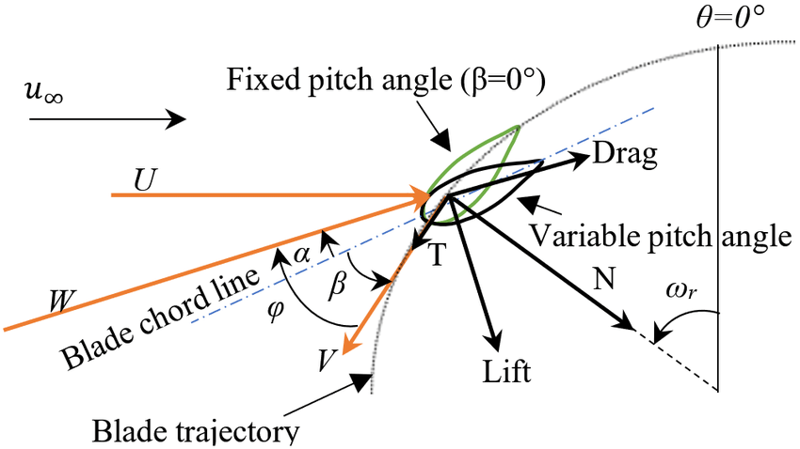
Figure 17 Pitch Angle of Airfoil

Airfoil Type:
It is really important to analyze different airfoil types and based on the best performance, the airfoil type then be selected. Following factors maybe be used to weigh different airfoils.
- Power Coefficient
- Lift/Drag Ratio
- Symmetry
- Structural Integrity

Turbine Aspect Ratio:
Turbine-Aspect ratio is defined as the ratio of turbine blade height to the turbine rotor radius. This ratio changes the Reynold’s number and Reynold’s number has a direct effect on coefficient of power. A high aspect ratio means greater rotational velocity than aerodynamic torque for the same power produced.

Turbine Swept or Disc Area:
It is the projected area normal to air flow for which the air passes through the turbine. The area will depend on the rotor configuration and some of them are shown in Figure 18. For a HAWT the swept area is circular shaped.
Swept area is related to coefficient of performance and mass flow rate and is adjusted by the dimensions of the VAWT.
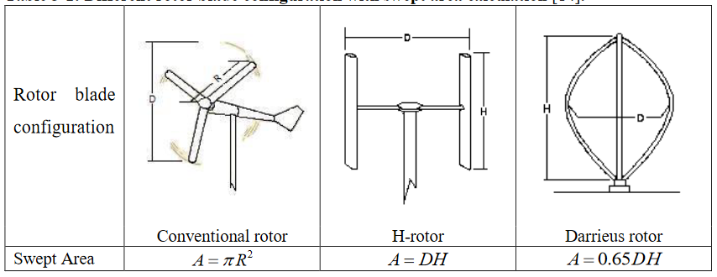
Figure 18 Swept Area for Different Turbines

Parametric Study:
Initially we will define some parameters for the turbine and analyze the results using equations and literature described in the previous sections.
From Figure 6 we can see that the average wind velocity in Punjab in about 8 m/sec and we have assumed that the air is at room temperature. From APPENDIX I: Property Tables, the density of air at 25°C is 1.184 kg/m³
 | $$P=\frac{1}{2}ρ{Av}^{3}$$ | (41)
Based on our CAD Models, Height of the blade is $H=$ 1.45 m and diameter of the rotor is 1.5 m and hence the swept area is 2.175 m².
The maximum power that can be extracted from these dimensions and wind velocity is:
 | $$P=\frac{1}{2}*1.184*2.175*8^{3}=659.25 W$$ | (42)
We also said that that maximum efficiency of a VAWT is about 64% (pg.6) then the maximum power that can be obtained is, about 421.9 W.
The power obtained will increase with wind velocity as it is proportional to its third power and during storms, very huge amount of power can be obtained.

Airfoil Selection:
Qblade software has been used to analyzed different kinds of NACA Airfoils. First the airfoils were modeled in the software and then they were analyzed at about 10⁵ Reynold’s Number. Different results were obtained for the coefficient of lift and drag.
The simulation and airfoil data has been given in APPENDIX II: Simulation data
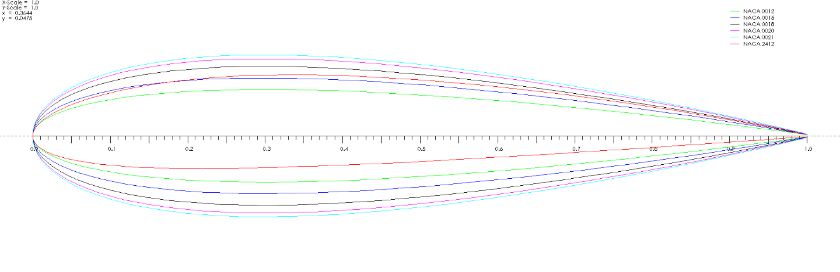
Figure 19 NACA Airfoils in Qblade

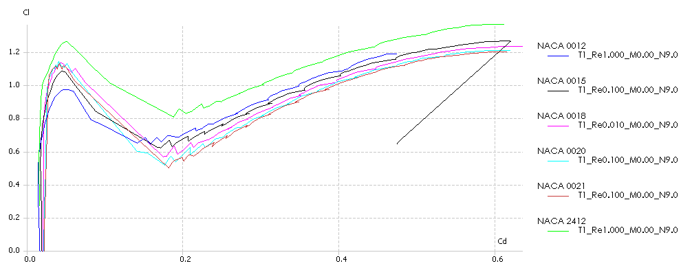
Figure 20 Coefficient of Lift Vs Coefficient of Drag in Qblade
At different angle of attacks, the Qblade software was used to compare the different airfoils, as we can see from Figure 20 , NACA 2412 has the most amount of lift and least amount of drag at all angle of attacks.
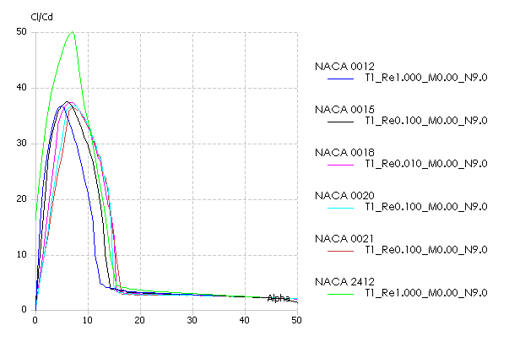
Figure 21 Cl/Cd of Air-Foils
Maximum lift to drag ratio was obtained at about 7.5° angle of attack.

Turbine Aspect Ratio:
Having selected the airfoil from the previous section, the turbine aspect ratio is to be compared next. Different aspect ratios were compared and best aspect ratio were chosen or maximum coefficient of performance.
Following parameters were used in Qblade for the comparison of different aspect ratios.

Table 1 Aspect Ratios
Turbine Height (m) | Rotor Radius (m) | Aspect Ratio (H/R) | Chord Length (m)
1.45 | 1.5 | 0.97 | 0.25
2.5 | 1.5 | 1.67 | 0.25
3.5 | 1.4 | 2.86 | 0.25
4.5 | 1.2 | 3.75 | 0.25
6 | 1 | 6 | 0.25

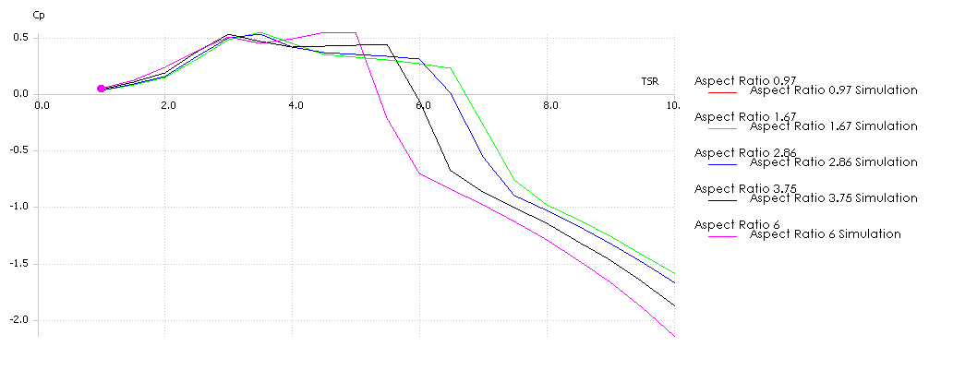
Figure 22 Turbine Aspect Ratio VS Coefficient of Performance
From Figure 22 we see that the maximum coefficient of performance is achieved for the aspect ratio of 6, but we have chosen aspect ratio of 3.75 because the bigger aspect ratio would cost more and we cannot just make our decision based on power coefficient, we also need to see the torque generated as shown in
With aspect ratio of 3.75 and NACA 2412, a power coefficient of 0.527 is achieved.
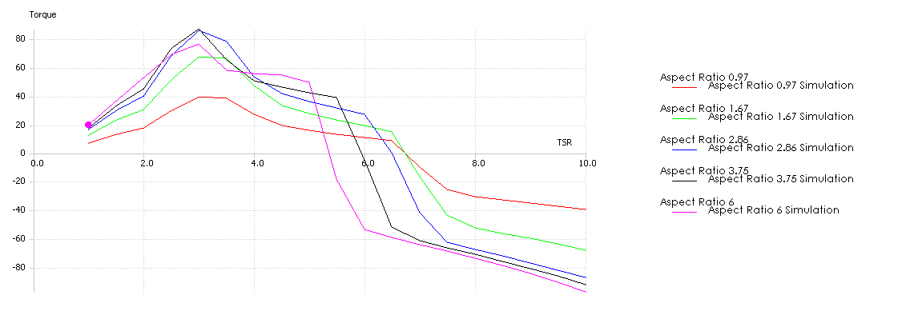
Figure 23 Torque Comparison for Different Aspect Ratios

The maximum torque is achieved for a aspect ratio of 3.75 and the power coefficient is also good. The torque achieved by the aspect ratio 3.75 is about 86 N.m at about 3 Tip-Speed Ratio.
The Qblade performs calculations based on DMST model explained in the literature.
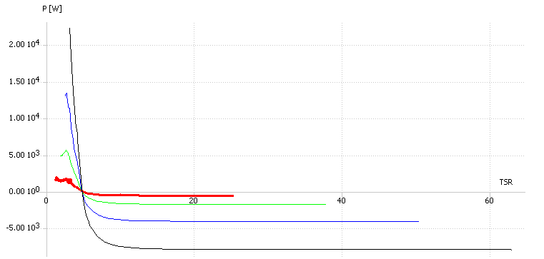
Figure 24 Power Vs TSR for Different Rotational Speeds
Figure 24 compares the power being generated at different Tip-speed ratios and at different rotational speeds. The red line shows a rpm of 200. At this point using equations(3) the maximum power than can be achieved for an aspect ratio of 3.75 is 1627 W for wind speed of 8 m/sec.

Turbine Solidity:
For an aspect ratio of 3.75, the turbine height is 4.5 meters and its rotor radius is 1.2 m and the no of blades are 3.
Then the solidity is,
 | $σ=\frac{bc}{R}=\frac{3*0.25}{1.2}=0.625$ | (43)
As discussed in the literature, for a self-starting turbine, the solidity should be greater than 0.4.

Pitch Angle:
Although the power coefficient is affected by the pitch angle but it is not as significant as the other variables and hence a 0° fixed pitch angle is used.
The overall dimensions calculated in this section that will be used in the next section are:
Table 2 Parameters Selected
Turbine Swept Area (m²) | 5.4
Turbine Diameter (m) | 1.2
Blade Length (m) | 4.5
Number of Blades | 3
Solidity (m) | 0.625
Chord Length (m) | 0.25
Tip-Speed Ratio | 3
Airfoil Type | NACA 2412
Fixed Pitch Angle (Degree) | 0

Construction of Turbine:
Having selected basic dimensions and parameters from the previous section, CAD models were made and its construction is explained here. Further dimensions can be seen from the drawing in APPENDIX III: Engineering Drawings

Blades:
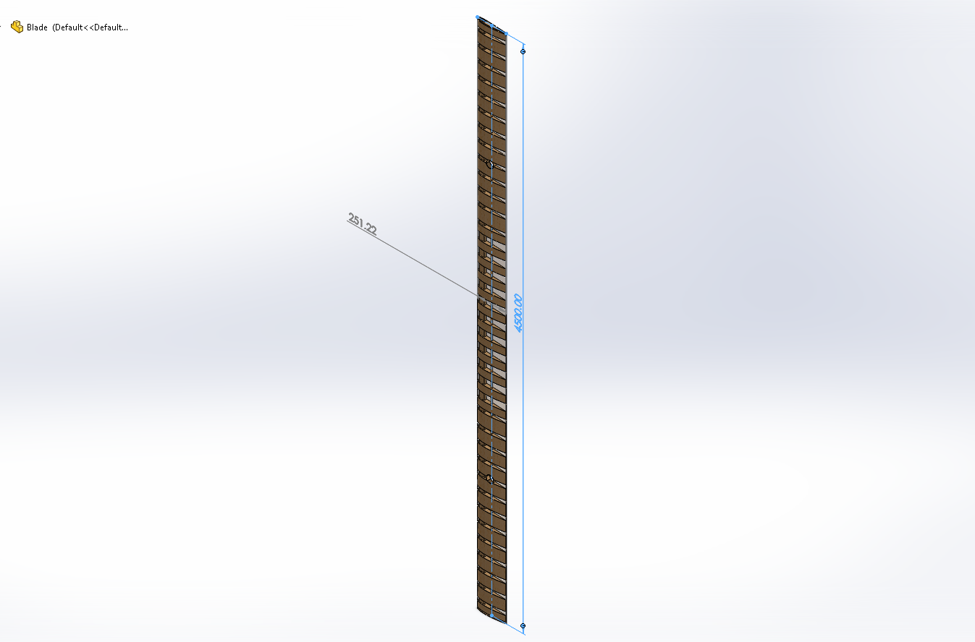
Figure 25 NACA 2412 Blade
As seen in parametric analysis, for a aspect ratio 3.75, the blade height is about 4.5 m and its cord length is 251mm. We have used NACA 2412 airfoil to construct the blade in solidworks. A transparent view of the blade is shown in Figure 25 and we have used ribs to spars to add some structural strength to the wind. The spar used is shown in Figure 26
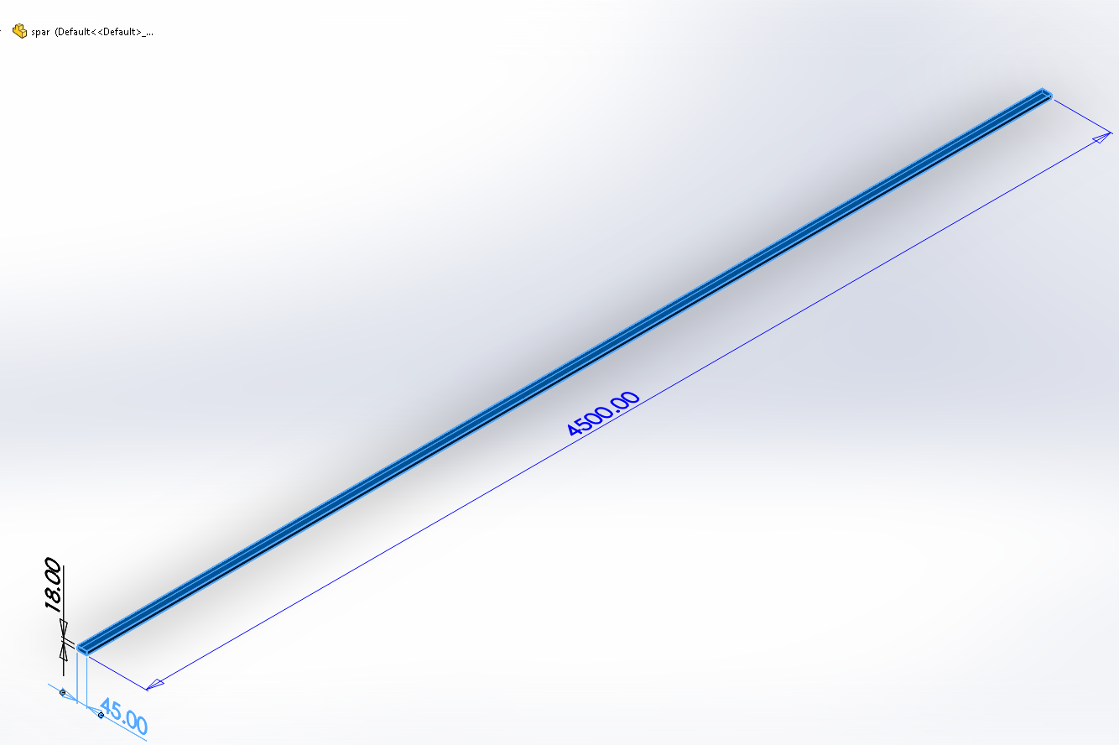
Figure 26 Spars

Arms:
The arms are used to support the blades to the tower and to rotate the shaft. Based on our parametric calculations, the rotor radius was used to be 1.2 m. The blades are attached to arms using bolts. The arms are shown in Error! Reference source not found.
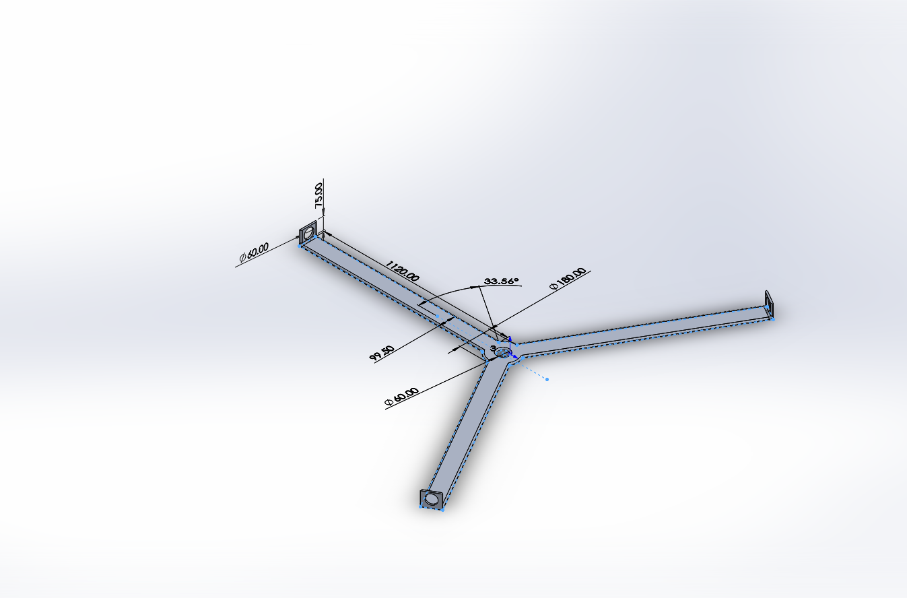
Figure 27 Arms for Blade Support

The arms are attached to bearing housing and hub on the tower end,.

Hub:
The hub supports the bearings and bearing housings and the shaft. The arms are also supported by the hub.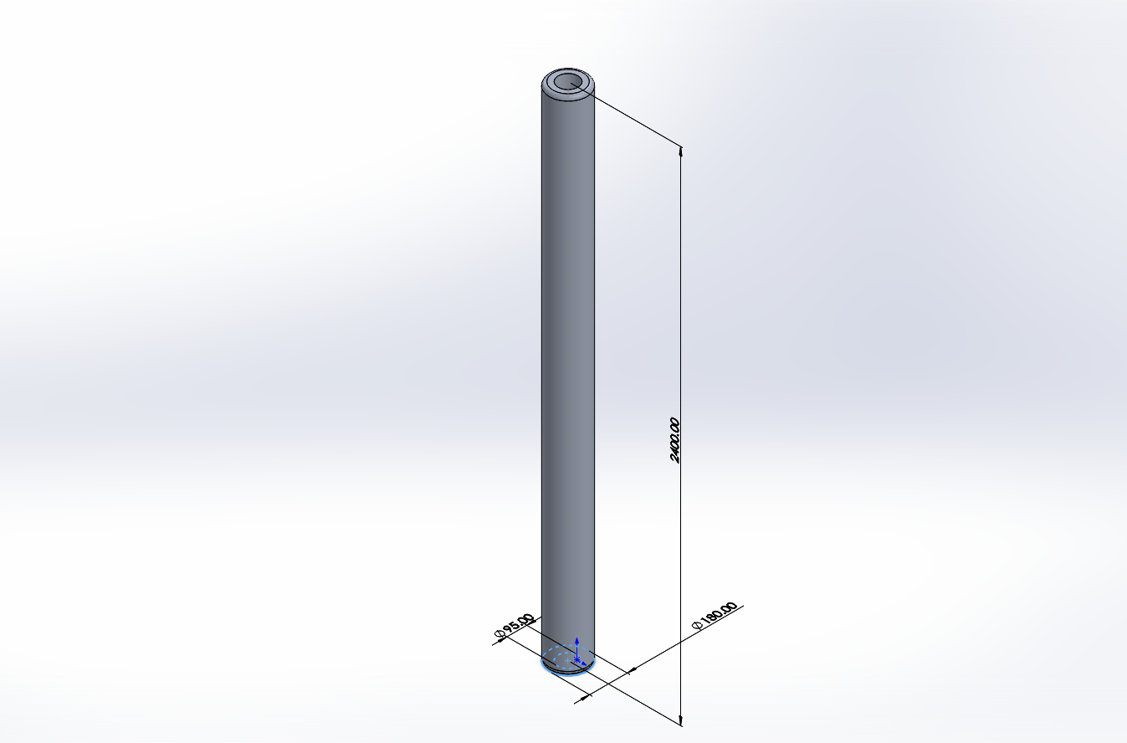
Figure 28 Hub
The hub is made out of steel and has a good height and because of that it is quite heavy.

Shaft:
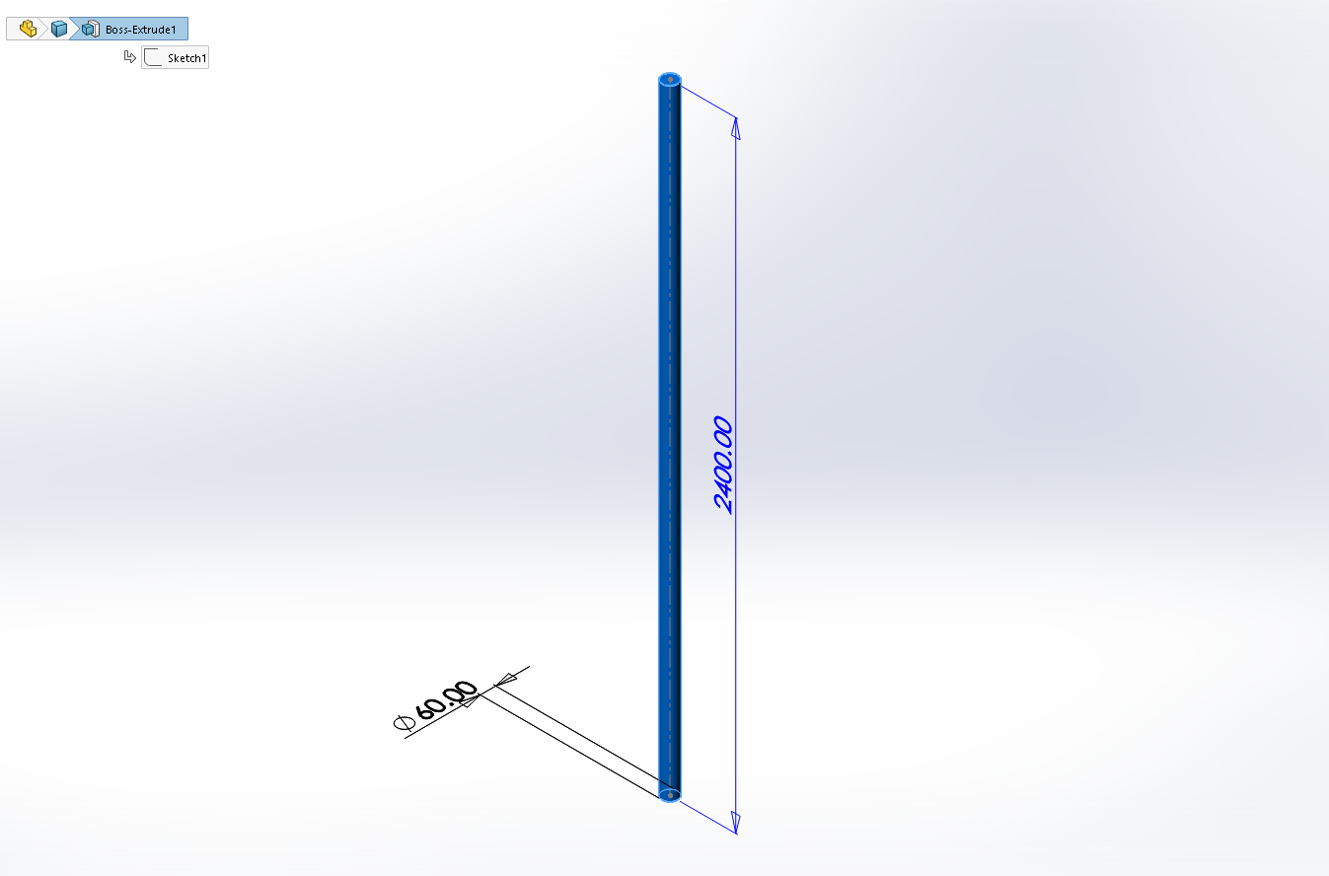
Figure 29 Mechanical Shaft
The shaft is connected to the bearing and the arms and can be attached to a gearbox and generator for electricity generation

Bearings and Bearing Housing:
The bearing housing is supported by the hub and SKF bearings are attached to the housing. The housing is bolted to the tower on the lower end. 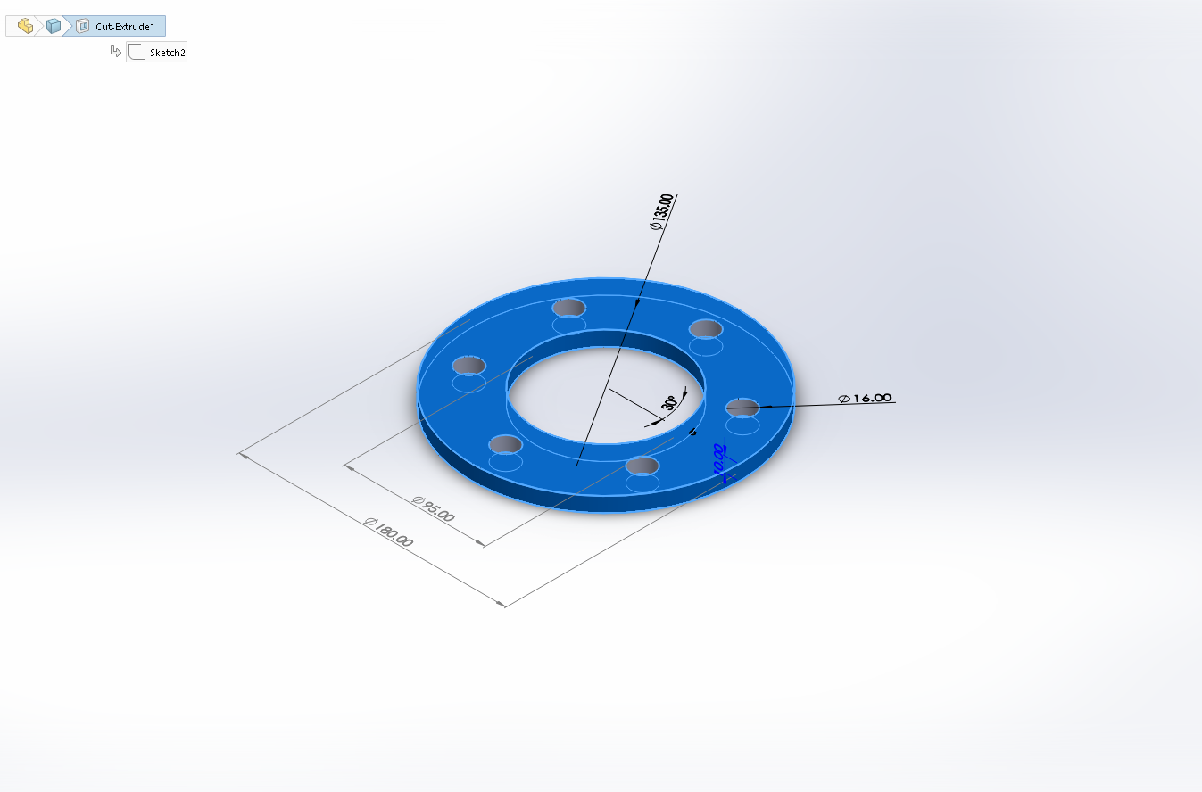
Figure 30 Bearing Housing

Tower:
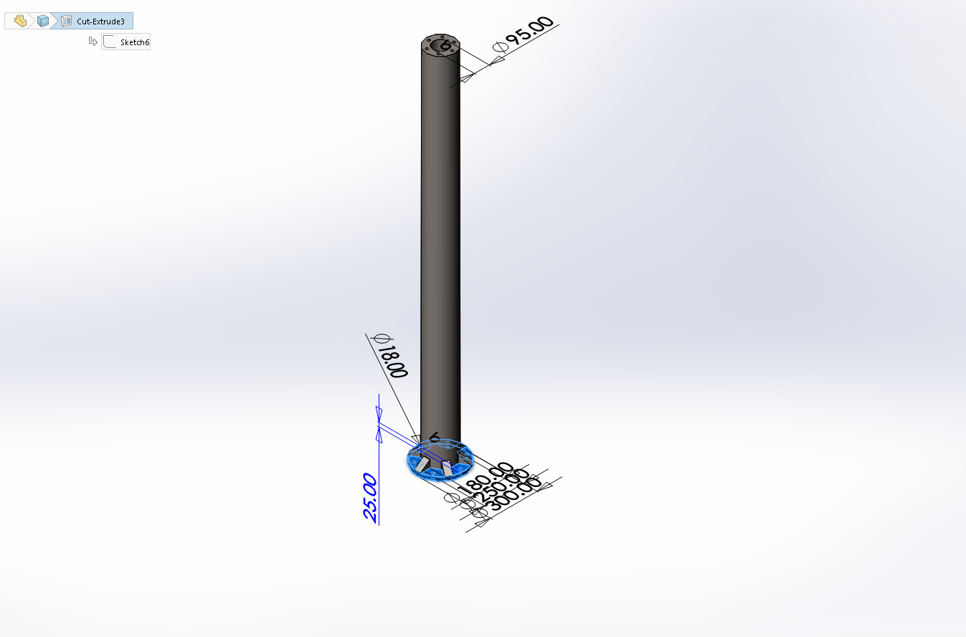
Figure 31 The Tower
The tower basically supports all the weight and is made in a flange type so that it can fastened to the concrete using bolts.

CFD Analysis:
Initial CFD analysis was performed in solidworks to investigate the flow trajectories and the coefficient of performance at 200 rpm and 8 m/sec wind velocity. From Figure 32 we see that there is small vortex inside the wind turbine which may cause slight decrease in performance due to reverse flows.
A 0.4 coefficient of power was obtained on the basis of torque calculations by solidworks and wind velocity.
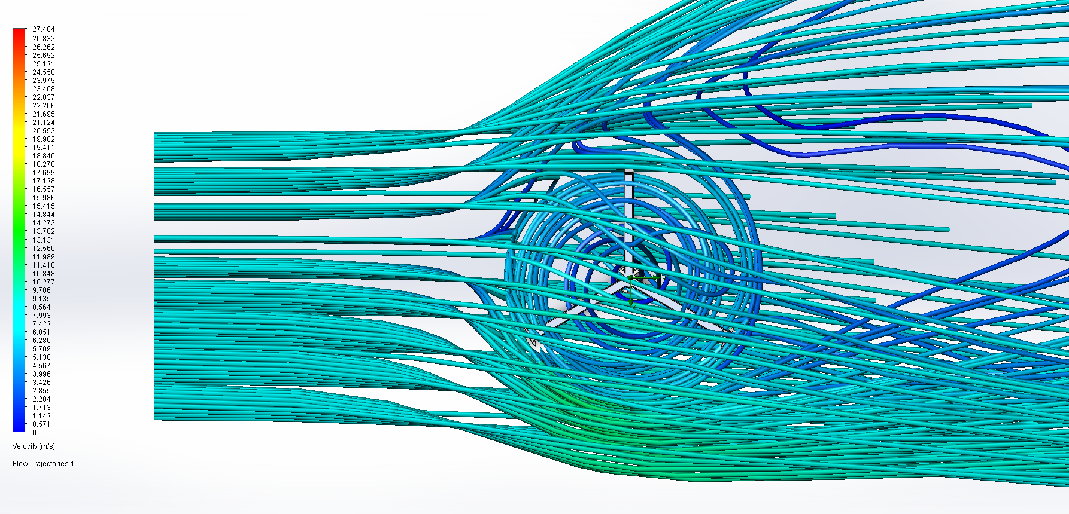
Figure 32 Flow Trajectories from Top View
The pressures from CFD analysis were imported into solid works static analysis. Based on our CFD analysis, the stress is shown in Figure 33.
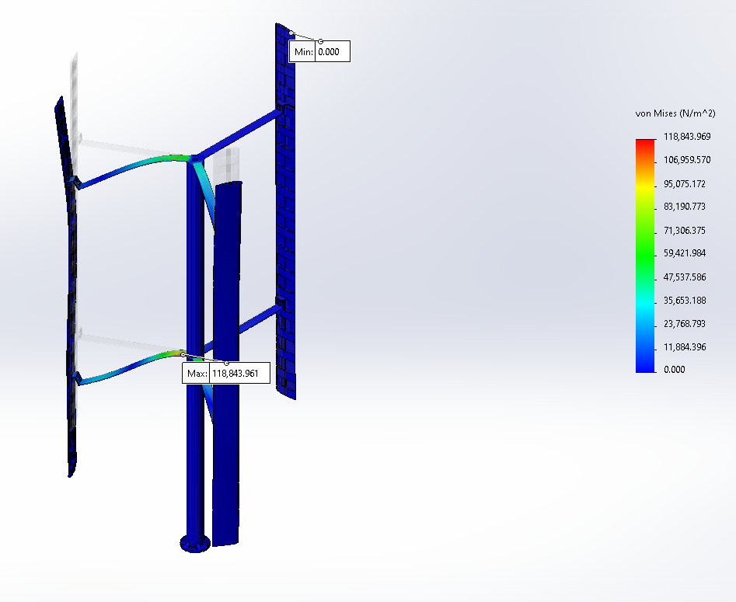
Figure 33 Static Analysis in Solidworks
The maximum von mises stress was obtained about 118 kPa and it is was below the yield point of any material.
Similar simulation was run in ANSYS but a 6 DOF 2d model was used for simplification of results.
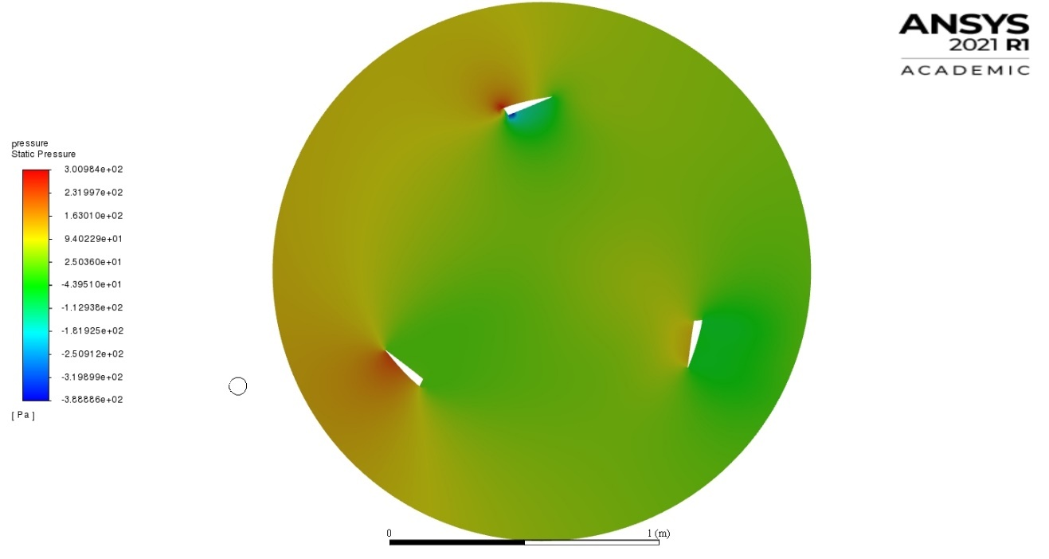
Figure 34 Stagnation Pressures on Turbine in ANSYS

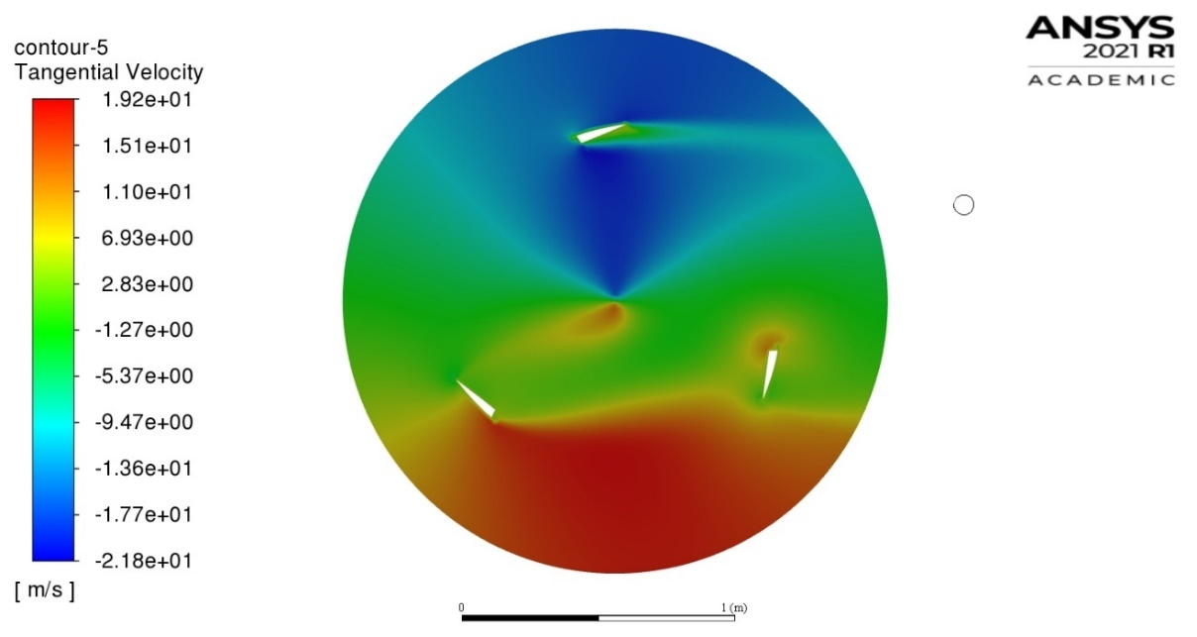
Figure 35 Tangential Velocity of Turbine
A moving mesh method was used to obtain the tangential velocity of the blade at 200 rpm.

CHAPTER 4: RESULTS and DISCUSSIONS
In the previous section, we had performed many simulations and analysis. We first defined some performance parameters and using Qblade, we selected airfoil and some of the parameters of VAWT. We then performed CFD in solidworks and ANSYS to verify our results.
Based on the pressures on the turbine, we also performed static simulations and we have sleeted the following materials for each part of the turbine based on the results.
Table 3 Materials
Part Name | Material | Selection Criteria | Elastic Modulus | Yield Strength | Weight
Blade Spar | Plywood | High Strength | 8.62 GPa | 63 Mpa | 1.8 kg
Blade Ribs | Balsa Wood | Low Weight | 3 Gpa | 20 Mpa | 45g
Blade Body | Balsa Wood | Low Weight | 3 Gpa | 20 Mpa | 3.2 kg
Arms | 6063-T6 Aluminum | Bending Strength | 69 Gpa | 215 Mpa | 9.6 kg
Hub | 2014 Alloy Aluminum | Torsional Stiffness | 73 Gpa | 96 Mpa | 122.65 kg
Shaft | AISI 1045 Steel, cold drawn | Torsional Stiffness | 205 Gpa | 530 Mpa | 53.27 kg
Towe Base | AISI 1045 Steel, cold drawn | Overall Strength and Mass Density | 205 Gpa | 530 Mpa | 412.20 kg

Based on our previous analysis, we have came to the following quantities and dimensions:

Table 4 Final Parameters
Quantity | Value
Turbine Swept Area (m²) | 5.4
Turbine Diameter (m) | 1.2
Blade Length (m) | 4.5
Number of Blades | 3
Solidity | 0.625
Chord Length (m) | 0.25
Tip-Speed Ratio | 3
Airfoil Type | NACA 2412
Fixed Pitch Angle (Degree) | 0
Maximum Coefficient of Power | 0.527

CHAPTER 5: CONCLUSION AND RECOMMENDATION
We firstly discussed the historical development of the VAWT and how VAWT has several advantages over HAWT. We also discussed the types of VAWTs and their pros and cons. The literature related to turbines and VAWT specifically was reviewed. We also derived the maximum coefficient of power for HAWT and also stated COP for VAWT. Firstly, we went over the necessity of site assessment and identification for the installment of VAWT and we also went over instruments that are used to measure average wind velocity. The wind density map of Pakistan was also reviewed to determine the average wind velocity in Pakistan. We also reviewed the aerodynamics and forces developed on the turbine blade and based on that we derived some useful equations and parameters. We defined our methodology that we will analyze firstly the performance parameters that will affect the efficiency of the turbine and coefficient of power. We performed our parametric study using DMST which was implemented in Q-Blade software. Using Q-blade, we also compared different airfoils to be in VAWT and based on the maximum torque, coefficient of lift and COP, we selected NACA 2412 airfoil. We also selected the aspect ratio for maximum COP for this airfoil. With the initial dimensions and parameters fixed, we developed CAD model of VAWT. After CAD models were made, CFD analysis were performed to investigate the flow trajectories, COP and pressure on the VAWT.
CFD study results were imported into a static study to determine the stresses generated in the VAWT. Based on the CFD and structural analysis finally, materials were selected.
In the end all the parameters and selected dimensions were summarized into the table.

Bibliography

[1] | W. Tong, Wind Power Generation and Wind Turbine Design, WIT Press, 2010.
[2] | J. M. C. Yunus A. Cengel, Fluid Mechanics, Fundamentals and Applications, MCGrawHill, 2013.
[3] | Asress Mulugeta Biadgo, Aleksandar Simonovic et al, "Numerical and Analytical Investigation of Vertical Axis Wind Turbine," FME Transactions, pp. 49-58, 2013.
[4] | Ahmed El.Attar and Ahmed Shahin, "Vertical Axis Wind Turbine," Alexandria University, 2018.
[5] | David Marten, "QBlade v0.95 Guidelines for Lifting Line Free Vortex Wake Simulations".

