A waste-derived nanocomposite sealant for repairing micro-cracks in concrete
Uthradevi Kannan, Shibil Abdul Gafoorª, Sonali Srivastava^{a,1}, M. Nithyadharan#, Soujit Sen
Gupta and Shihabudheen M. Maliyekkal*

Department of Civil and Environmental Engineering,
Indian Institute of Technology Tirupati, Tirupati – 517506, India

*Corresponding author address: Email: shihab@iittp.ac.in; sm.maliyekkal@gmail.com
Phone: +91 877 2503164; Fax: +91 800 2500370

#Corresponding author address: Email: nithyadharan@iittp.ac.in
Phone: +91 877 2503160; Fax: +91 800 2500370

ª These authors contributed equally

Abstract
The use of renewable resources has been gaining interest due to their high economic benefits. They are attractive as a sustainable alternative to conventional resources for producing useful and valuable materials. The paper focuses on using a composite of graphene-oxide and chitosan, an aquaculture waste-derived material, as a renewable feedstock for producing a sealant for healing micro-cracks in concrete. The sealant named Eco-Nanoseal is well characterised, and its interaction with concrete is studied. A possible binding mechanism of Eco-Nanoseal with concrete is also proposed. The nanofibrous film-forming composite can solidify in the concrete environment quickly without any external polymerising agent. The quick ability to form a solid plug and strong bonding with concrete surface makes Eco-Nano seal a potential candidate for healing micro-cracks in concrete. The novel application is demonstrated well in M25 grade concrete cube specimens. With low environmental factor (E-factor) and process mass intensity (PMI) values of 0.05 and nearly 1, respectively, the Eco-Nanoseal complies the critical parameters of materials’ sustainability indices. The Eco-Nanoseal is a promising and environmentally-friendly alternative to synthetic polymer-based adhesives.
Keywords: Aquatic waste material; Chitosan; Renewable resources; Graphene oxide; Micro-cracks sealant; Nanocomposites

Graphical abstract

Introduction
Periodic repair and rehabilitation of buildings are essential to preserving the performance and aesthetic appearance of a structure. Appropriate repairing agents play a significant role in the maintenance process. According to statistics, existing buildings are responsible for more than 55% of the world's total primary energy consumption and 38% of global carbon dioxide emissions (UNEP, 2020). Notably, the use and maintenance phase of the building is the major contributor to the environmental impact of the life cycle of the building (Blengini, 2009; Madureira et al., 2017). The embodied energy of the building alone contributes nearly 60% of the total energy consumption during the life cycle of the building (Shadram et al., 2016, Taffese and Abegaz, 2019). With the current trend and advancements of building towards lower operational consumption, it is logical to think that future attention will be on reducing the embodied energy of the building materials. In this context, renewable materials with low embodied energy and toxicity hold the key to minimizing the environmental footprint and addressing the ever-increasing demand for new materials, including repairing materials (Zahoor et al., 2021).
Concrete is the most extensively used building material in the world. Cracking is an inherent property of concrete and is a perpetual problem. Several human-made and automatic repair approaches including autogenous (Zhu et al., 2012), mineral admixtures-based (Wang et al., 2018), adhesive-based (Anbarlouie et al., 2018), grouting with cement (El-Reedy, 2020), and bacteria-based methods (Vijay et al., 2017) are developed to address the problem of concrete cracks. Among the available techniques, injecting structural adhesives like polyurethane, epoxy, or acrylic-based chemicals into the cracks is a matured technology and is widely practised in the field (Pan et al., 2017). However, these synthetic polymers based sealants are eco-unfriendly, toxic, non-renewable, and have high embodied energy. The product carbon footprint for the synthetic resin and polymer-based adhesives is around 1-3 and 4-10 kg of CO₂ equivalent, respectively (Klebstoffe, 2009). Moreover, the weak bonding of some of these adhesives with the concrete surface can affect their performance and service life. Therefore, new efforts are required to develop affordable and sustainable alternatives to the existing sealants and reduce the environmental impact of the use and maintenance phase of the building life cycle.
In this context, aquatic waste derived material, chitosan, based composite is investigated as an alternative to conventional synthetic polymers for healing micro-cracks in concrete. The chitosan is an exciting choice for the application due to its abundant availability, biocompatibility, superior mechanical strength, metal chelating ability, and ability to form hydraulically stable films in the concrete environment. It is also worth noting that chitosan is a derivative of chitin, a polymer mainly obtained from waste shells of crustacean species. As per Food and Agricultural Organisation (FAO) report 2020, globally, 1 to 3 million tonnes of crustacean shell wastes are generated per annum, and India is one of the largest producers of chitin in the world (FAO, 2020). Worldwide, around 2000 tonnes of chitosan are being produced every year ( Muñoz et al., 2018). Chitosan with different quality and grades are used for biomedical, food preservation, water and wastewater treatment, and agriculture applications. However, to the best of authors knowledge, its application in repairing and rehabilitating buildings is not explored. The chitosan market was 476.6 million USD in 2016, and it is expected to reach 1088 million USD by the year 2022 with 14.5% of Compound Annual Growth Rate (CAGR) (Markets and Markets, 2018). Regardless of the various applications of chitosan, the disposal problems of spent chitosan materials have not been addressed. Due to its organic nature, the American Polymer Standards Corporation (APSC) has prevented dumbing chitosan into sewers or the ground (APSC, 2019). Therefore, the newly proposed application is also interesting for the recycling and safe management of used chitosan from various sectors. We believe that chitosan-based materials as building and repairing agents can address the disposal problem sustainably.
However, in spite of various favourable properties, the chitosan needs additional modifications to enhance its chemical stability and mechanical strength for structural and non-structural building applications. Graphene oxide (GO) is an ideal chitosan modifier due to its ability to bind with the polymer and form stable homogenous dispersion (Kannan et al., 2021). This can result in uniform stress distribution and reduce stress concentration, leading to a significant increase in mechanical strength. GO can also help in lowering the segmental chain mobility of chitosan. To the best of the authors' knowledge, no study has been published reporting the use of chitosan and modified chitosan as possible feedstock to produce a sealant for sealing micro-cracks in concrete.

In the present work, the chitosan is reinforced with GO to make a nanocomposite sealant with enhanced mechanical and chemical properties (Girão et al., 2016). The sealant application in plugging micro-cracks is demonstrated, and the nanocomposite interaction mechanism with hydrated cement is proposed. The studies show that the nanocomposite sealant has qualities of a concrete micro-crack adhesive, including tunable viscosity, film-forming ability, and excellent ability to bind to the concrete surface through chemical bonding. The authors believe that such waste-derived material with less embodied energy and enhanced properties significantly reduces the building's cost and environmental impact during its life cycle. The present study will pave the pathway for developing environmentally-friendly sealants in place of conventional synthetic polymers. Also, it opens up a way for disposing of used chitosan-based materials safely.

2. Materials and Methods

2.1 Materials
Chitosan (degree of deacetylation ≥ 85%) was supplied by Pelican Biotech and Chemical Labs, Kerala, India. Graphite powder (100 microns, 12.01 g/mol) and potassium pentoxide (AR,
95%) were supplied by SD Fine Chem. Ltd., Mumbai, India. Potassium permanganate (KMnO₄, 98.5%), sulphuric acid (H₂SO₄, 95-98%), potassium persulphate (K₂S₂O₈, 98%), hydrogen peroxide (H₂O₂, 98%), phosphorus pentoxide (P₂O₅, 95%), and acetic acid (CH₃COOH, 98.5%) were procured from Sisco Research Labs Pvt. Ltd., India. Unless otherwise mentioned, all reagents were prepared in deionized water of conductivity ~0.056 µ℧/cm. Ordinary Portland Cement (OPC) 53 grade was purchased from UltraTech Cement Ltd., Tirupati, India. Fly ash was procured from Apgenco Nellore, Andhra Pradesh. Coarse aggregates (20 mm and 12 mm) and manufactured sand (M-sand) used as fine aggregates were supplied by UltraTech Cement Ltd., Tirupati, India. Physical and chemical characteristics of OPC determined as per Indian Standards IS 269:2015 (BIS 269, 2015) is given in Tables S1 and S2 of Supporting Information (SI), respectively. The physical properties of Fly ash are shown in Table S3 of SI. Capping gypsum S- 420 grade (with Compressive strength 42 N/mm²) was purchased from Chir-Ayu Controls Pvt. Ltd., Gujarat, India. The moulds adhering to IS 10086:1982 (BIS 10086, 1982) were used for casting the cubes.

2.2 Preparation of Eco-Nanoseal
Graphene oxide (GO) was synthesized by the modified Hummers method (Chen et al., 2013). Detailed information on the synthesis method is given in S1 of SI. The desired concentrations of the GO sample (0.01%) were prepared by diluting the GO stock solution using deionized water and subjected to ultrasonication for 45 s using a probe sonicator. The chitosan (2%) solution was prepared by dissolving 2 g of chitosan powder in 100 mL of deionized water containing 2% (v/v) acetic acid. The nanocomposite sealant was synthesized by adding 0.01% of GO to the filtered protonated chitosan solution at a 1:1 ratio under stirring (Sreeprasad et al., 2011). The nanocomposite solution was degassed and stored in an amber bottle at ambient conditions. The as-developed sealant is named as Eco-Nanoseal.

2.3 Preparation of cement mortar and Eco-Nanoseal mixture
Cement mortar cubes were cast as per IS 4031-6:1988 (BIS 4031-6, 1988). The cubes were kept undisturbed for 24 h, then demoulded and cured for both 7 days and 28 days separately, under ambient conditions. The hydrated cubes were crushed and ground into a fine powder using mortar and pestle. The powdered sample was mixed with Eco-Nanoseal and kept for drying in a vacuum oven at 40º C. The dried sample was crushed finely, transferred to an air-tight zip bag and stored in a desiccator until further use. The powdered sample was used for spectroscopic and microscopic analysis.

2.4 Preparation of concrete cube test specimens
The cube specimens were prepared using M25 grade concrete. The concrete mix proportioning was carried out as per IS 10262:2009 (BIS 10262, 2009), and the details are given in S2 of SI. The concrete mix was prepared following weigh batching method as per IS 516:1959 (BIS 516, 1959). The weight proportion of the constituents of M25 grade concrete is given in Table S4 of SI. The standard cube specimens of dimension (150 x150 x150 mm) were fabricated with and without artificial cracks. The cube specimens without crack and a single artificial crack in one of its loading faces were designated as Uncracked Concrete Cube (UCC) and Single-crack Concrete Cube (SCC), as shown in Figure S1 of SI. The artificial crack of thickness 0.25 mm, length 138 mm and depth 50 mm was created by inserting a galvanized iron (GI) sheet in the fresh concrete (refer to Figure S1 of SI). The fixtures holding the GI sheet and plastic mould are shown in the inset of Figure S2(A) of SI. The specimens were cast as per IS 516:1959 (BIS 516, 1959), and GI sheet was removed after 4 h. The cubes were demoulded after 24 h and kept for curing for 7 days and 28 days. The loading faces of the test specimen were levelled by a thin layer of gypsum capping as per the American Society for Testing and Materials (ASTM)-C617:2015 (ASTM C617, 2015). In SCC cubes, the crack openings were covered to avoid crack closure by gypsum paste during capping.

2.5 Simulation of artificial cracks
The compression tests on SCC and UCC specimens were carried out in a controlled manner to avoid complete damage to the test samples and simulate desired crack widths 0.3 mm. This was achieved by stopping the test at a particular post-peak decrement load of 10 kN. In the case of SCC specimens, the deeper cracks were induced by placing the cube face with the artificial opening aligned with a gap of two machined bearing plates positioned 0.3 mm apart, as shown in the inset of Figure S2(B) of SI. Under compression loading, the crack was initiated at the interior edge of the artificial opening due to stress concentration, which further propagated nearly up to 50-75% depth of the cube as shown in Figure S2(C) of SI. This crack pattern mimics the failure pattern of the concrete split-tensile strength test IS 5816:1999 (BIS 5816, 1999). The main advantage of the proposed test setup for the SCC specimen was that it simulates deeper vertical cracks and cracks' width 0.3 mm.

2.6 Compression testing and repairing of cubes
The test matrix consists of 48 specimens, including 24 UCC and 24 SCC specimens. Of these, specimens numbered 1 to 10, and 11 to 24 were considered for the 7th and 28th day compression strength tests. The compression tests were carried out with a constant loading rate of 0.229 MPa/s, as per IS 516:1959 (BIS 516, 1959). Both pristine SCC and UCC samples were subjected to compressive load to induce cracks 0.3 mm width, designated as damage induced specimens (DIS). The DIS can possess certain residual strength under compressive loading. To measure the residual strength and gain in compression strength after repair, the DIS were divided into groups: a) Residual test specimen – the DIS which was used to evaluate the residual compression strength (in the absence of the sealant), and b) Repaired test specimen - the DIS employed for measuring the gain in compressive strength after applying Eco-Nanoseal. The overall approach adopted in this study is illustrated in Figure 1. Photographs of four sides of damage-induced, residual, and repaired test specimens were taken before and after subjecting to compressive loading. The failure planes were observed, and crack widths were measured using a crack width measuring scale. The compressive strength of cubes, structural integrity, and the range of crack widths before and after the repair was evaluated. The free concrete present in the damage-induced concrete specimen after the initial compressive loading was mildly tamped with a wooden mallet. After cleaning the surface, Eco-Nanoseal was injected into the cracks using a syringe until the crack volume was filled, as shown in Figure S2(D) of SI. The repaired cubes were cured under ambient condition and tested after 24 h to evaluate the repaired strength. The test specimens were viewed through a stereo microscope to observe sealant plug formation.
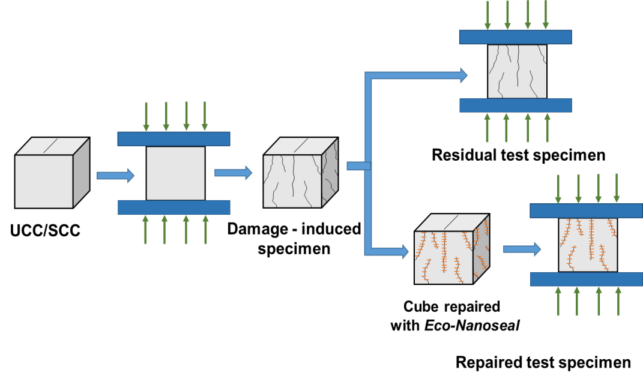
Figure 1. Illustration of the experimental scheme followed for testing the compressive strength of the test specimens. Residual test specimens are damaged cubes subjected to compressive loading to understand gain in strength without sealant.

2.7 Tensile testing on films
The Eco-Nanoseal and chitosan films were cast through evaporative drying of their respective solutions at 50 ºC for 8 h. Figure S3 of SI shows the test setup. Total 6 nos. of test specimens in each Eco-Nanoseal and chitosan films were tested under tensile loading in 2.5 kN UTM. The test specimens' dimension was 20 mm width and 175 mm length with 75 mm as gauge length. The chitosan and Eco-Nanoseal films' average thicknesses were measured to be 0.043 ± 0.001 mm and 0.040 ± 0.001 mm, respectively. Tensile tests on films were carried in displacement control mode with a 5 mm/min loading rate. The clamping pressure was pre-set to 4 bar, and a pre-loading rate of 0.1 mm/min was applied to eliminate any slack in films.

2.8 Instrumentation
PerkinElmer Lambda 365 UV/Vis spectrophotometer was used to record the UV/Vis spectra of GO, chitosan, and Eco-Nanoseal. Attenuated Total Reflectance Infra-Red (ATR-IR) spectra were measured in the range of 4000 – 400 cm⁻¹ by Spectrum Two FT-IR spectrometer, PerkinElmer Singapore. X-ray powder diffraction (XRD) technique was used to identify the crystalline phases of the materials used in the study (PanAnalytical Xpert Pro, Netherlands). Field Emission Scanning Electron Microscope (FESEM) (CARL ZEISS, SIGMA- GEMINI column, USA) equipped with Energy Dispersive X-ray Spectroscopy (EDS) (Bruker, Nano XFlash Detector, Germany) was used to analyse the surface morphology and elemental analysis. X-ray Photoelectron Spectroscopy (XPS) measurements were performed by Thermoscientific K-alpha XPS system, using monochromatic Al Kα as an X-ray source. The XPS survey spectra of samples were collected using point source gun A<W, with X-ray FG on at 400 µm and shutdown at 0 µm. The data were collected by subjecting the samples to 10 scans. A probe ultrasonicator (1200 W, MRC Lab, Israel) was used to sonicate the GO dispersion. Load control CTM (Auto-max, COMPACT-Line Super Automatic Compression Machine) was used to check the concrete specimens' compressive strength. Pan type concrete mixer (MATEST, C165, yield capacity: 165 L, Italy) was used to prepare the concrete mix. The microscopic images of the plug formation inside the cracks were captured using a Stereo Microscope (Leica S9i, Germany). Crack widths were measured using the Crack Compactor HM-639 measuring scale. The films' tensile strengths were measured using a 2.5 kN Universal Testing Machine (Zwick Roell, Germany). The composite films' thicknesses were measured using a digital micrometre having a resolution of 0.001 mm (Mitutoyo, Japan).

3. Results and Discussion

3.1 Characterization of Eco-Nanoseal

The photographic images of GO, chitosan, and Eco-Nanoseal are given in Figure 2(A). Figure 2(B) shows the comparative plots of UV-Vis absorbance spectra of GO, chitosan, and Eco-Nanoseal. The GO shows an absorption peak centred at 230 nm, represents the π-π* transition of C-C bonds, and a shoulder peak appeared at 301 nm, represents n-π* electronic transition of C=O groups in GO sheets (Lai et al., 2012). The chitosan spectral peak at 205 nm is due to Nacetyl glucosamine units in the polymeric chains. The disappearance of the peak at 205 nm in the composite sample indicates amine functional groups' involvement in its formation. Besides, the peak at 230 nm is shifted to 263 nm, supporting a partial reduction of GO to reduced graphene oxide (pRGO). Figure 2(C) shows the ATR-IR spectra of the GO, chitosan, and Eco-Nanoseal. In the GO spectra, the peaks at 3171 cm⁻¹, 2802 cm⁻¹, 1613 cm⁻¹, 1173 cm⁻¹ and 1045 cm⁻¹ corresponds to OH stretching, symmetric CH₂ stretching, C=C stretching of aromatic groups, epoxy C-O and alkoxy C-O stretching, respectively. In the chitosan spectrum, the peaks at 3336 cm⁻¹,1631 cm⁻¹, 1562 cm⁻¹, 1379 cm⁻¹ and 1021 cm⁻¹ are owing to OH stretching, CH₂ stretching, NH₂ bending, C-O-C (epoxy) stretching, and C-O stretching, respectively. In EcoNanoseal, the spectral peaks at 3336 cm⁻¹, 1544 cm⁻¹, 1412 cm^{-1,} and 1017 cm⁻¹ is due to OH stretching, NH₂ bending, and symmetric -COO stretching and a primary alcoholic group of C6OH stretching, respectively (Kannan et al., 2021). The chitosan spectral peak shift from1562 cm⁻¹ to 1544 cm⁻¹ and GO spectral peak from 1045 cm⁻¹ to 1041 cm⁻¹ in Eco-Nanoseal indicates an interaction between amine functional groups present in the chitosan and C-O functional groups present in GO.
ATR-IR spectra of blended cement (BC), blended cement hydrated for 28 days (BCH28), and a composite of blended cement hydrated and Eco-Nanoseal hydrated for 28 days (BCHE28)
are given in Figure 2(D). The spectrum of BC shows peaks centred at 1095 cm⁻¹, 877 cm⁻¹, and 513 cm⁻¹ corresponds to S-O stretching in SO₄²⁻ groups present in gypsum, C-O bending in CO₃²⁻ groups present in calcium carbonate, and Si-O bending in SiO₂ groups present in Alite (3CaO.SiO₂) and Belite (2CaO.SiO₂) compounds, respectively (Ylmén et al., 2014). In the BCH28 spectrum, the peak at 1426 cm⁻¹ is due to -OH in-plane vibration of HO-metal bonds. The peaks centred at 952 cm⁻¹ and 864 cm⁻¹ correspond to Q₂ of Si-O bridges and Si-O symmetric stretching, respectively. A broad peak observed in the region of 3400 cm⁻¹ represents the characteristic O-H stretching frequency, which is contributed mainly by the interlayer water molecules and Si-OH groups present in C-S-H gel (Ylmén et al., 2014). The peaks in the wavenumber range of 1650 cm⁻¹ to 400 cm⁻¹ in both BCH28 and BCHE28 spectra were deconvoluted using Gaussian function mode. The deconvoluted spectra of BCH28 and BCHE28 are shown in Figures 2(E and F). The corresponding R² and standard error values are 0.98 and 0.01, respectively, for both BCH28 and BCHE28 spectra. The peak at 1087 cm⁻¹ in the BCH28 spectrum is due to the Si-O network formation, and this peak disappeared in the BCHE28 spectrum. The peak corresponding to C6-OH groups is also shifted from 1017 cm⁻¹ to 1027 cm⁻¹ in the BCHE28 spectrum. The shift can be due to the reaction between silanol groups present in BCH and –OH groups present in the Eco-Nanoseal. It is to be noted that the peak at 689 cm⁻¹ in BCH28 is shifted to 641 cm⁻¹ in BCHE28. This shift is attributed to the interaction of N and O with the metal ions present in cement. The appearance of amide II band at 1567 cm⁻¹ in BCHE28 indicates the presence of -NH groups in Eco-Nanoseal and the peak at 965 cm⁻¹ corresponding to the interaction of Si-O with metals in BCH28, which is shifted to 957 cm⁻¹ indicates that there is an interaction between metals in BCH and Eco-Nanoseal. The peak at 869 cm⁻¹ and 713 cm⁻¹ in the BCHE28 spectrum correspond to (C-O) bending of CO₃²⁻ groups present in calcite.
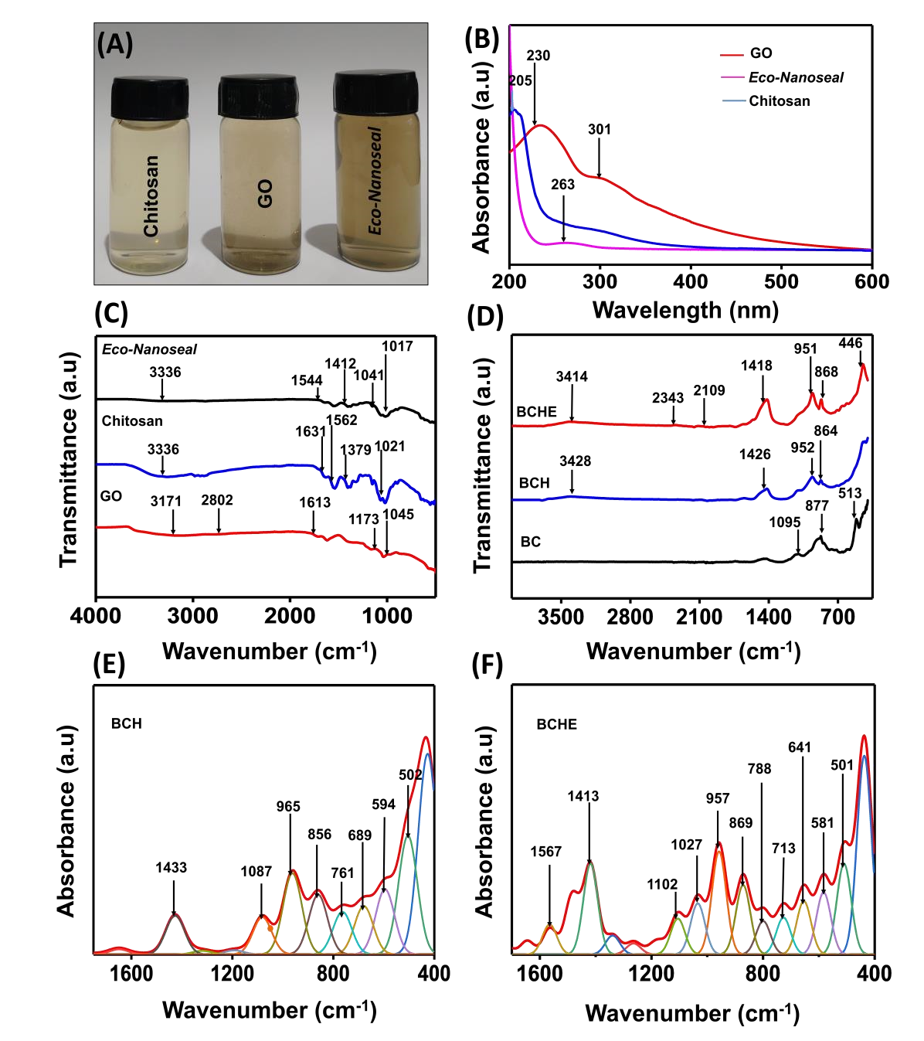
Figure 2. (A) Photographic images and (B) UV-Vis spectra of GO, chitosan, and EcoNanoseal. (C) ATR-IR spectra of chitosan, GO, and Eco-Nanoseal. (D) ATR-IR spectra of BC, BCH28 and BCHE28. (E and F) Deconvoluted ATR-IR spectral regions in the range 1650 cm⁻ to 400 cm⁻¹ of BCH28 and BCHE28. The spectra are shifted vertically for clarity.

The blended cement samples hydrated for 7 days (BCH7) and BCH28 were examined using
FESEM coupled with EDS. The FESEM images of BCH28 and BCHE28 are shown in Figure 3(A and B) and (E and F), respectively. The FESEM images of BCH7 and BCHE7 at different magnifications are shown in Figure S4 and S5 of SI, respectively. The spheres of 6-8 µm diameter shows the presence of fly ash in BCH7. After hydration of BCH for 28 days, the spherical structures are not visible in Figure 3(A and B). This can be due to the pozzolanic reaction of fly ash and Ca(OH)_{2,} produced during the hydration of dicalcium silicate and tricalcium silicates in cement. The EDS spectrum of BCH7 and BCH28 shown in the inset of Figure S4(B) of SI and Figure 3(C) confirms the presence of principal elements carbon, calcium, silica, iron, aluminium, and oxygen in the sample. The EDS colour mapping images in Figure 3(D) ((i)-(vi)) show the distribution of the oxygen, silica, aluminium, carbon, iron and calcium present in BCH. The FESEM images of BCHE28 at various magnification presented in Figure 3(E and F) reveal nanofibers' presence in the sample. The enlarged images of the nanofibers are given in the inset of Figure 3(E and F). The diameter of the nanofibers is in the range of 30 nm to 200 nm.

The presence of nanofibers is also visible in the BCHE7 sample, as shown in Figure S3(B-E) of SI. These nanofibers are due to Eco-Nanoseal in the test samples. EDS spectra of BCHE28 confirms the presence of principal elements: carbon, calcium, silica, iron, aluminium, calcium, and oxygen, similar to BCH. The presence of nitrogen peak, originating from the amine functional groups present in chitosan, in BCHE samples supports Eco-Nanoseal in the sample. There additional carbon is from chitosan and GO. The elemental compositions of BCH28 and BCHE28 are given in the inset of Figure 3(C) and 3(G), respectively. The EDS colour mapping images of BCHE28 in Figure 3(H) ((i)-(vii)) shows the distribution of oxygen, silica, aluminium, carbon, iron, nitrogen, and calcium. The colour contour in the EDS maps shows that the nitrogen is distributed in the region where the metal ions (Ca, Al and Fe) are distributed. The pattern of distribution hints that there might be an interaction between the N group in Eco340 Nanoseal and the metal ions in BCHE.

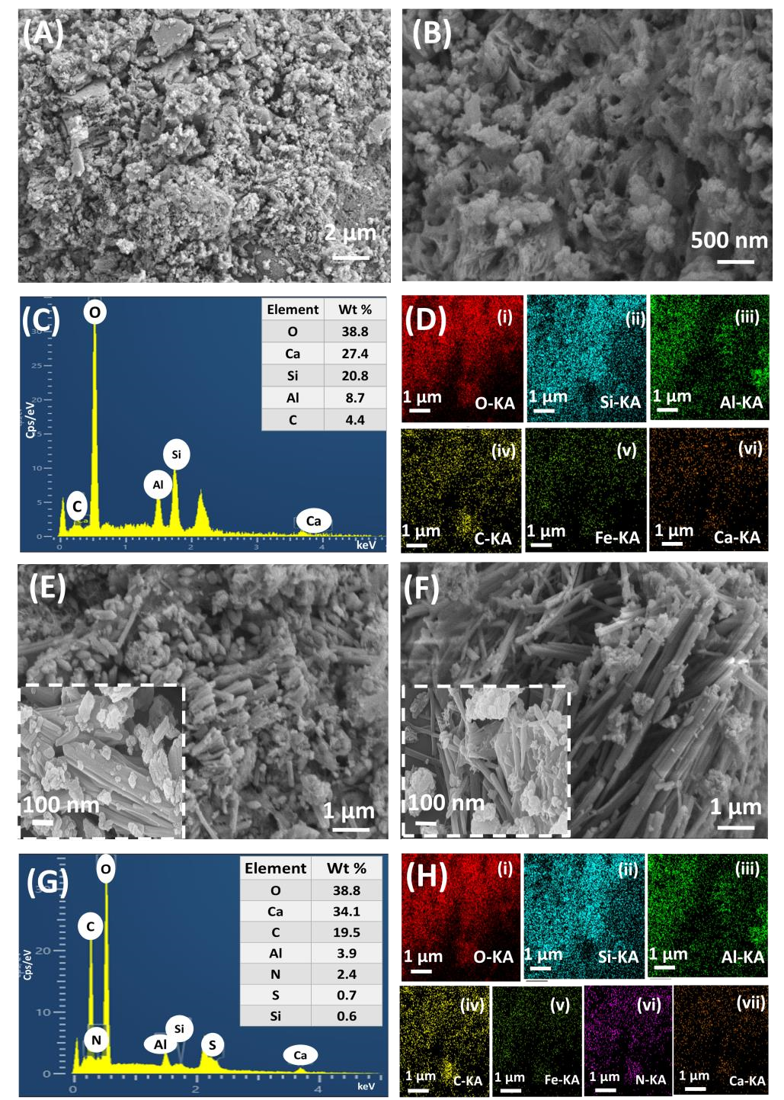
Figure 3. (A and B) FESEM images of BCH28. (C) EDS spectra of BCH28. The table in the inset shows the elemental composition present in BCH28. (D) EDS elemental mapping images showing the distribution of the elements (i) oxygen, (ii) silica, (iii) aluminium, (iv) carbon, (v) iron and (vi) calcium present in BCH28. (E and F) FESEM images of BCHE28. (G) EDS spectra of BCHE28, the table in the inset shows the elemental composition present in BCHE28. (H) EDS elemental mapping images showing the distribution of the elements (i) oxygen, (ii) silica, (iii) aluminium, (iv) carbon, (v) iron, (vi) nitrogen and (vii) calcium present in BCHE28.

The XRD patterns of chitosan, GO, and Eco-Nanoseal are given in Figure 4(A). The XRD of GO shows a sharp peak at 11.21˚, which corresponds to (001) plane with a d-spacing of 0.81 nm. The diffractogram of chitosan shows a small peak around 11.69˚, and a broad peak at 21˚ is attributed to its semi-crystalline nature as found elsewhere (Kannan et al., 2021). The loss of sharp peak at 11.21˚ and the peak shift to 13.12˚ confirms the partial reduction of GO to form pRGO in Eco-Nanoseal. The XRD data of BCH7 and BCHE7 is given in Figure S6 of SI, and the XRD data of BCH28 and BCHE28 is given in Figure 4(B). The XRD data were analysed, and the compounds present in the samples were identified by comparing the crystal structure of known phases of reference compounds in the Inorganic Crystal Structure Database (ICSD) (Grazulis et al., 2009). In the X-ray diffractogram of BCH28, the 2Ɵ peaks at 18.02º, 34.11º, 47.11º, and 64.42º correspond to portlandite. The peaks at 54.46º, 60.79º, and 64.42º correspond to quartz. The 2Ɵ peaks at 26.76º, 35.39º, 36.86º, 39.41º, and 40.98º correspond to calcite, 29.36º, 32.47º, 39.41º, and 40.98º corresponds to C-S-H gel, and 54.46º corresponds to gypsum present in the cement sample. In the X-ray diffractogram of BCHE28, the 2Ɵ peak at 9.30º is due to GO. The peaks at 18.02º, 32.33º, 43.24º, 47.64º, 48.56º and 64.81º are due to portlandite. The peaks at 53.63º and 60.67º correspond to quartz, 20.87º, 26.76º, 39.41º, 40.98 º corresponds to calcite, 23.01º, 29.53º, 39.39º, 47.50º, and 48.70º corresponds to C-S-H gel in the sample. The peak at 34.86º corresponds to ettringite, and 53.36º corresponds to gypsum in the sample specimen.
Figure 4. (A) X-Ray diffractogram of GO, Eco-Nanoseal, and chitosan, (B) XRD of BCH28 and BCHE28, (C) XPS survey spectra of Eco-Nanoseal, BCH28, and BCHE28. (D), (E) and (F) are the deconvoluted spectra of N1s, C1s, and O1s elements, respectively present in (i) BCHE28, (ii) BCH28, and (iii) Eco-Nanoseal.

The XPS survey spectra of Eco-Nanoseal, BCH28 and BCHE28 are given in Figure 4(C). The XPS data were deconvoluted using XPS Peak 4.1 software (available at https://xpspeak.software.informer.com/4.1/). Shirley background was used by default for performing background correction for all the data. Adventitious carbon correction was performed at 284.8 eV. The compounds were identified from the National Institute for Standards and Technology (NIST) database (available at https://srdata.nist.gov/xps/main_search_menu.aspx) using the respective binding energy peaks (NIST, 2012). The deconvoluted spectra of the elements nitrogen, carbon, and oxygen are given in Figure 4(D), 4(E), and 4(F), respectively. The survey spectrum of Eco-Nanoseal shows the presence of oxygen, nitrogen, and carbon, originating from chitosan and GO. The deconvoluted nitrogen spectrum in Figure 4(D) (iii) shows N-H groups' presence at 399.2 eV, confirming the interaction of C=O functional groups present in GO with NH₃⁺ groups in chitosan to form NH-CO interaction in Eco-Nanoseal. The NH₃⁺ groups at 401.4 eV in the spectrum show a few unreacted protonated amine (NH₃⁺) functional groups. The deconvoluted carbon spectrum in Figure 4(E) (iii) confirms C=O, C-O, C-C, and C-N functional groups present in the Eco-Nanoseal. The oxygen spectrum in Figure 4(F) (iii) of Eco-Nanoseal confirms O=C and O-C functional groups' presence.
The XPS survey spectrum of the BCH28 sample confirms carbon, oxygen, calcium, silica, aluminium and traces of iron. The deconvoluted nitrogen spectra do not show any peaks, and the deconvoluted carbon spectra in Figure 4(E) (ii) confirms the presence of M-(CO₃)²⁻, C-O, C-C groups present in the sample (where M corresponds to metals in the BCH28, primarily Al, Ca, and Fe). The deconvoluted oxygen spectra in Figure 4(F) (ii) shows -O-M functional groups. The XPS survey spectrum of BCHE28 samples confirms nitrogen in Eco-Nanoseal and calcium, oxygen, carbon, silica, aluminium and iron in BCH28. The deconvoluted oxygen spectra in Figure 4(F) (i) confirms the presence of M-(OH)₂, M-O, M-M(O₄)²⁻ groups present in the sample originating from C-S-H gel produced during the reaction between BCH and EcoNanoseal. In the BCHE28 sample, the nitrogen spectra show C-NH₃⁺ and C-NH₂ functional groups at 401.4 eV and 399.1 eV, respectively (Figure 4(D) (i)). The nitrogen groups present in the BCHE samples are from the Eco-Nanoseal. It is worth noting that the lone pair electrons present in the amine groups in the Eco-Nanoseal interact with calcium and the transition metal such as aluminium present in the BCHE28 sample. The presence of N-Al peaks in Figure S7(B) (i) of SI confirms this interaction.

3.2 Proposed mechanism of interaction of Eco-Nanoseal with concrete

The free -NH₃⁺ groups present in Eco-Nanoseal play a significant role in binding the sealant with concrete. The presence of unreacted –NH₃⁺ groups in Eco-Nanoseal is confirmed from the deconvoluted XPS nitrogen spectra (Figure 4(D) (iii)). The –NH₃⁺ functional groups can bind with the silica, aluminium and calcium compounds present in the concrete. The silanol groups present in the concrete can also form bond with the hydroxyl groups in Eco-Nanoseal via hydrogen bonding. The interaction of silica and –OH groups present in Eco-Nanoseal is evident from the shift in C6-OH peak from 1017 cm⁻¹ (BCH28) to 1015 cm⁻¹ in the BCHE28 spectrum. Also, the peaks at 689 cm⁻¹ and 965 cm⁻¹ in the BCH28 is shifted to 641 cm⁻¹ and 957 cm⁻¹, respectively, in the BCHE28, supporting the interaction of N and O with metals present in the concrete sample. The lone pair electrons of nitrogen in amine groups covalently binds with the aluminium and calcium in the cement sample and it is supported by the XPS spectra given in Figure S7(B) (i) and C(i) in SI, respectively. Through this interaction, the nanofibers present in the Eco-Nanoseal can bond firmly to concrete. In an alkaline concrete environment, the chitosan-based Eco-Nanoseal undergoes deprotonation and forms a solid plug inside the micro-cracks present in the concrete, and it is evident from the stereo-microscopic images given in Figure 5(A). In addition, the quick setting and strong chemical bonding of Eco-Nanoseal helps in regaining the compressive strength of the damaged cubes after repair. The schematic representation of the proposed mechanism of interaction between Eco-Nanoseal and the concrete is given in Figure 5(C).

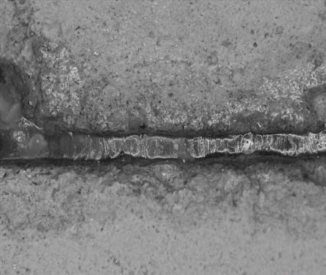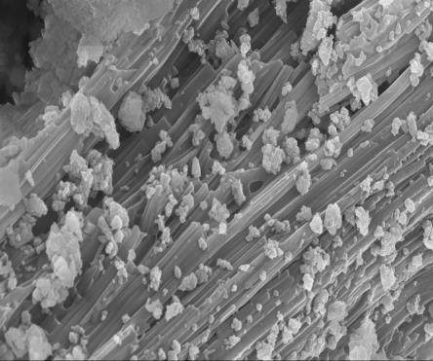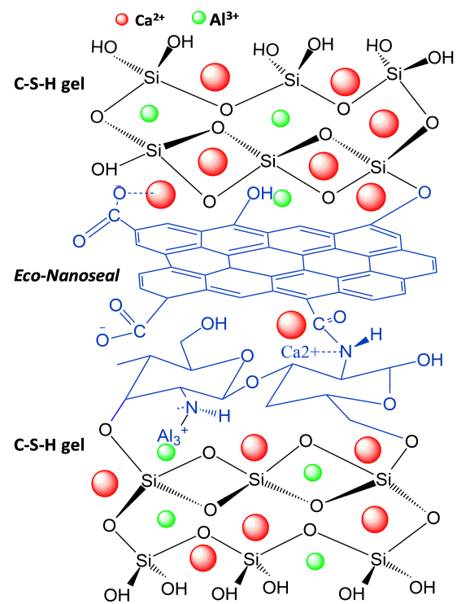

Plug formation
by
Eco
-
Nanoseal
Nano fibres
1
µm
)
(
A
)
B
(
)
C
(
Figure 5. (A) Stereo-microscopic images of the repaired SCC specimen (Top-view). (B) FESEM image showing the well-packed nanofibers in the concrete. (C) The proposed mechanism of interaction of Eco-Nanoseal and the concrete.

3.3. Mechanical characterization
3.3.1 Tensile testing on films
Figure 6. (A) and (B) Stress-strain curves of chitosan and Eco-Nanoseal films along with their average curves. (C) and (D) Average stress-strain plot of chitosan film and Eco-Nanoseal along with its elastic and strength parameters indicated. Inset of Figure C and D are the photographs of ruptured chitosan film and Eco-Nanoseal film, respectively.
The stress-strain plots of chitosan and Eco-Nanoseal films that failed at the gauge section (away from loaded ends) are presented in Figure 6. Both films' stress-strain curves exhibit linear behaviour in the initial loading stages and show significant nonlinear behaviour until ultimate stress. The Equal Arc Segment (EAS) approach proposed by Zhong and Wille (Zhong and Wille, 2016) was adopted to obtain the average stress-strain curves for identical films tested under tensile loading and shown in Figure 6. Since the film's average stress-strain curve does not show a sharp yield point, the proof stress at 0.2% plastic extension is considered as proportional limit, as shown in Figure 6. The initial elastic modulus (E_{F}), stress and strain at the proportional limit (σ_{p}, ε_{p}), and the ultimate stress and strain (σ_{u,} ε_{u}) are measured from the average experimental response, and the data are summarized in Table S4 of SI.

From Table S4 of SI, it is clear that both the test samples have sustained significant plastic deformation and exhibits ductile behaviour before failure. The Young's modulus, yield strength, and ultimate strength of Eco-Nanoseal are nearly 8.5%, 23% and 35% higher when compared to the chitosan film. Also, it is observed that the tensile strength of the EcoNanoseal is around 5 times higher than that of concrete, which is 3.5 N/mm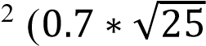) as per IS 456:2000 (BIS 456, 2000). The higher tensile strength, stiffness and ductility of the Eco-Nanoseal form a plug with good tensile strength and restrict the crack propagation in the concrete and sustain load under compression loading.

3.3.2 Compressive strength test
The 7th and 28th day compressive strengths of the cubes were evaluated for SCC and UCC specimens. The tests were performed on the pristine, residual, and repaired test specimens. The cubes' compressive strength with individual variation less than ±10% from the average compressive strength of the pristine SCC and UCC specimens is only presented in this study. Figure 7 compares 7th day and 28th day individual and the average compressive strength of the pristine specimen, residual, and repaired test specimens. The 7th day and 28th day average compressive strengths of pristine SCC specimens are 21.7 N/mm² and 34 N/mm² at 7th and 28th day. The 7th day and 28th day average residual compressive strength of SCC specimens are 24% and 33% less than that of pristine samples. However, the repaired specimens regained the compressive strength and are comparable to that of the pristine test specimens. The repaired specimens showed 25% (7th day) and 30% (28th day) enhancement in strengths than the residual strengths of the specimens.
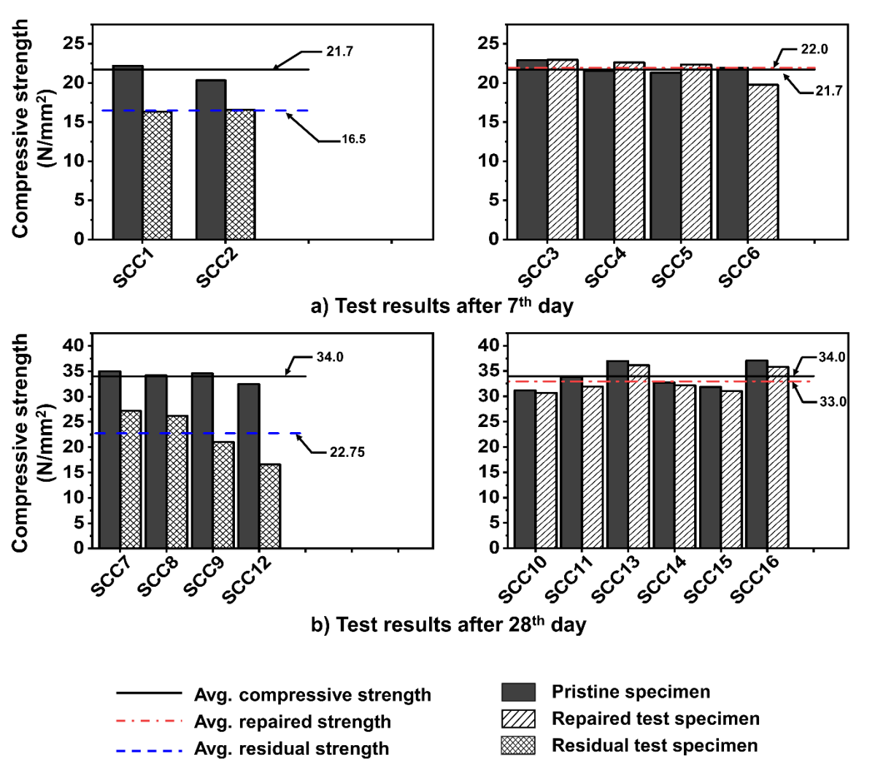
Figure 7. Comparison of individual and average compressive strength of SCC pristine, residual, and repaired test specimens at (a) 7th day and (b) 28th day.

Similarly, Figure S8 of SI compares 7th and 28th day individual and the average compressive strength of pristine, residual, and repaired UCC test specimens. The 7th and 28th day average residual compressive strengths of the UCC specimens is 0.7% and 11.2% less than the pristine specimens. The average compressive strength of repaired test specimens has attained a strength higher than the pristine specimen by 11% and 2.4% on 7th and 28th day, respectively. The difference in gain in strength could be attributed to the higher surface and deep vertical cracks in the SCC specimens compared to that of the UCC specimens.
The failure pattern and the measurement of crack widths on all the four faces of the SCC and UCC specimens were carried out to study and compare the structural integrity of the test specimens before and after application of Eco-Nanoseal. Figure 8 show the crack pattern and measured crack width of SCC specimens on all faces for a typical residual test specimen (SCC12) and the repaired test specimen (SCC10) tested on the 28th day. The measured crack widths on all faces of the DISs (SCC12 and SCC10) are in the range of 0.1 to 0.35 mm. It is evident from Figure 8A(ii) that the residual test specimen (SCC12) suffered severe damages on all faces and along the vertical edges, making it unsuitable for further repair. The crack widths measured in the repaired test specimen (SCC10) are in the range of 0.1 to 0.5 mm, which is similar to the order of crack widths and failure pattern observed in the DIS (Figure 8B((i) and (iii)). The data demonstrates that the sealant possesses significant tensile and compressive strength, restricting further crack widening and propagation in the SCC specimens. The nanofibers in Eco-Nanoseal can also penetrate the macro and mesopores in concrete and firmly bind the concrete (See Figure 3(E and F), preventing the crack propagation.

Figures S9 and S10 of SI present the crack pattern and measured crack width of UCC specimens on all four faces for a typical residual test specimen (UCC10) and repaired test specimen (UCC9) tested on the 28th day. The measured crack widths on all four faces of the DISs range from 0.1 mm to 0.4 mm. The residual test specimens (UCC10) suffered moderate edge damages in faces A, B, and D, and severe damage in one of the vertical edges in face C. The UCC residual specimen (UCC10) had suffered moderate damage (Figure S9(ii) of SI) compared to the SCC residual specimen (SCC12) at 28th day (Figure 8 A(ii)), which has deteriorated significantly. The observed crack widths for the repaired test specimen (UCC9) range from 0.25 to 0.65 mm, which is slightly higher than the order of crack widths observed in the DIS. From the figures, it is observed that all the exposed faces are equally cracked, with no damage on the loading faces that were in contact with compression platen. None of the cubes tested exhibited tensile crack or associated failure, showing that the proposed test setup and loading arrangement is valid as per European Nation Standards (EN) 12390-3:2019 (BS EN 12390-3, 2009).

(A) SCC-12
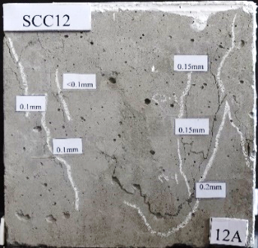  <0.1 mm – 0.2 mm  <0.1 mm – 0.2 mm  <0.1 mm – 0.15 mm  <0.1 mm – 0.3 mm |  | 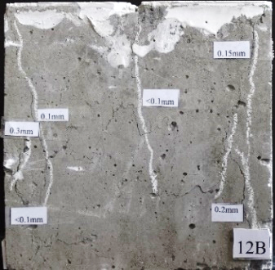 |  | 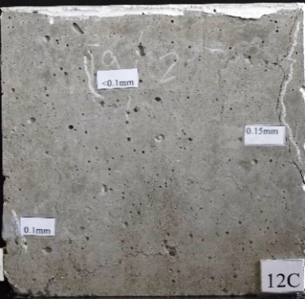 |  | 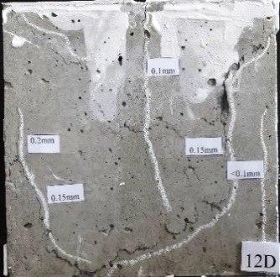
(i) Cracks observed in a damage-induced specimen
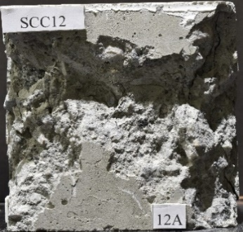 |  | 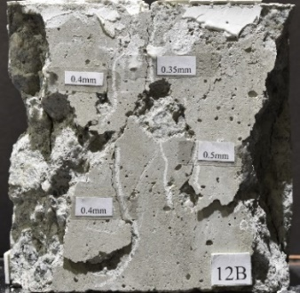 |  | 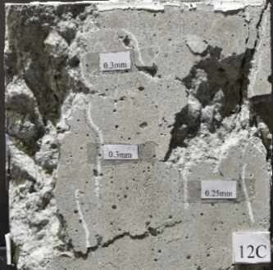  0.25 mm – 0.3 mm |  | 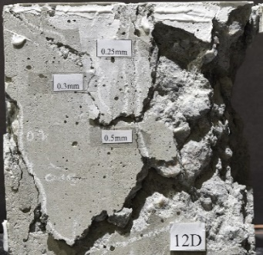
Face severely damaged |  | Edges severely damaged  -  0.25 mm – 0.5 mm  0.35mm – 0.5 mm |  | Edges severely damaged |  | Edges severely damaged
(ii) Damage observed in a residual test specimen
(B) SCC-10
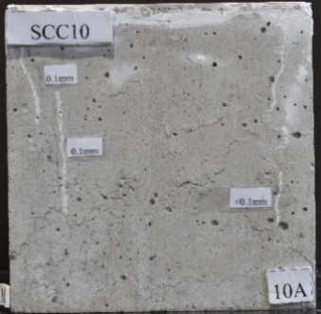  <0.1 mm – 0.1 mm | 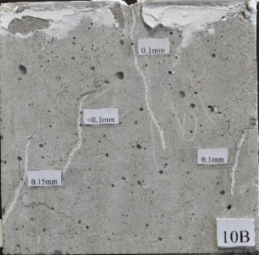  <0.1 mm – 0.15 mm |  | 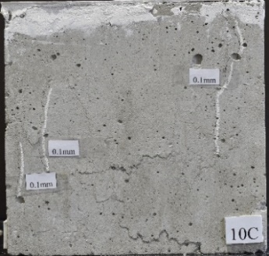  0.1 mm |  | 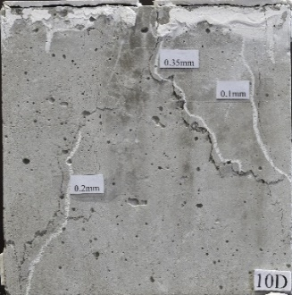  0.1 mm – 0.35 mm
(i) Cracks observed in a damage-induced specimen.
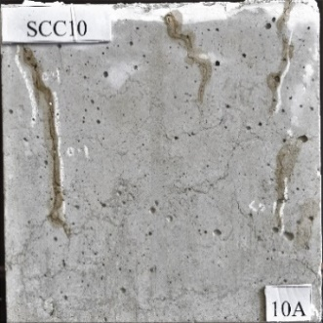 | 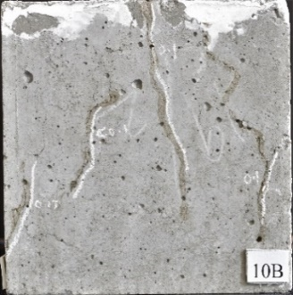 |  | 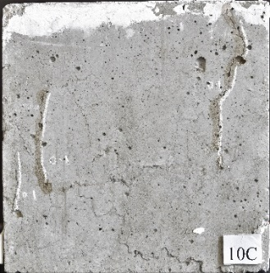 |  | 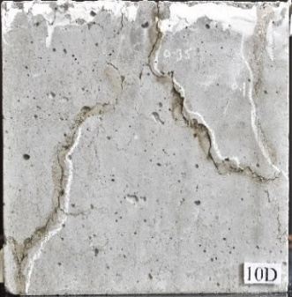
(ii) Specimen repaired with Eco-Nanoseal
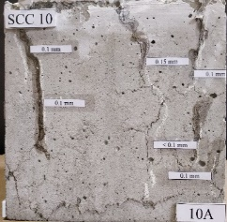  <0.1 mm – 0.15 mm | 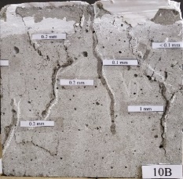  <0.1 mm – 1 mm |  | 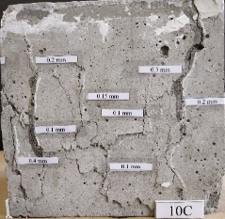  0.1 mm – 0.4 mm |  | 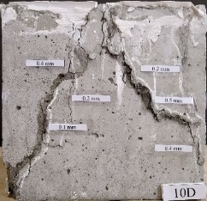  0.1 mm – 0.5 mm
(iii) Cracks observed in repaired test specimen

Figure 8. (A) Failure pattern of residual test specimen SCC-12 on all four faces. (B) Failure pattern of repaired test specimen SCC-10 on all four faces.

3.4 Product cost and sustainability indices
Selection of an eco-friendly and reliable raw materials and optimization of resources is essential to make environmentally benign products and minimize adverse environmental impact. Several indicators have been developed to assess the process and product sustainability. The Environmental Factor (E-Factor) and Process Mass Intensity (PMI) are major parameters used in chemical and connected industries to assess waste minimization and resource efficiency (Sheldon, 2017). Parameters such as Energy Intensity (EI) and Reaction Mass Efficiency (RME) are also used to measure material's sustainability. The equations to calculate these indicators are presented from Equations E1 to E4.
PMI (g/g) = $\frac{Mass of reactants excluding water}{Mass of Product }$ (E1)
EI (kWh/g ) = $\frac{Amount of power consumed}{Mass of Product }$ (E2)
E-Factor = $\frac{Mass of reactants-Mass of product }{Mass of product }$ (E3)
RME (%) =$\frac{Mass of product }{Mass of all reactants}$X100 (E4)
The calculated E-factor of Eco-Nanoseal is 0.05, indicating that the wastes produced in the preparation of Eco-Nanoseal are minimal. The material has a PMI of 1.05 and RME of 94.6%. The PMI value close to 1 indicates that a significant portion of the raw materials is converted into the desired product. The RME value of 94.6% and nearly 1 PMI value denotes that the synthesis of Eco-Nanoseal complies with the important sustainability metrics in green chemistry. Typically, the calculation of the E-factor solely depends on the solid mass and not the water used in the synthesis process. The inclusion of water intake consumed in the computation is debatable and still not yet concluded (Sheldon, 2017). The energy intensity calculation reveals that 0.044 kWh energy is needed to prepare one litre of Eco-Nanoseal, having a viscosity of 0.038 Pa.s at laboratory conditions. The estimated production cost of Eco-Nanoseal at lab-scale is approximately 0.2 USD/L. The preparation cost can be reduced further on the industrial scale. A comparison of various concrete sealants with Eco-Nanoseal is given in Table S6 of SI. On comparing with different sealants, the Eco-Nanoseal is found to be less costly and eco-friendly.

4. Conclusion

The occurrence of micro-cracks in concrete is a common phenomenon that needs serious attention. If the cracks are not sealed properly on time, they may grow wider and expose the reinforcement to the outside environment. This can accelerate the corrosion of the reinforcement and can lead to the catastrophic collapse of the structure. Though several sealants are developed to plug the cracks, most of them are synthetic-based polymers and toxic. There is a need for an environmentally benign adhesive considering the frequency and volume of its use. The chitosan-derived sealant developed in the study is hydraulically stable and has an excellent ability to plug micro-cracks in concrete. Unlike conventional acrylic-based sealants, the Eco-Nanoseal is derived from renewable materials. It is non-toxic, affordable, and can chemically bind with the concrete surface under ambient conditions. Based on the studies, we believe that the waste-derived sealant with less embodied energy and enhanced properties significantly reduces the building's cost and environmental impact during its life cycle. We also believe that the present study would open up a way to recycle and manage used chitosan-based materials effectively.

Acknowledgement
This work was financially supported by the Department of Science and Technology (DST), Science and Engineering Research Board (SERB), Government of India (SRG/2019/000283).
Author Uthradevi Kannan expresses gratitude to DST- Innovative in Science Pursuit for Inspired Research (INSPIRE), Government of India for the fellowship support (IF 160288) to pursue a Ph.D. at IIT Tirupati, India. Authors acknowledge Ultratech cement, Tirupati, India, for providing cement, aggregate, and fly ash.

CReDiT authorship contribution statement
S.M.M. conceptualised the idea and secured the funding; U.K., S.B.G., S.S, M.N, and S.M.M. designed the experiments; U.K., S.B.G., S.S, S.S.G performed the experiments. S.M.M., M.N., U.K., S.B.G., and S.S.G. wrote, reviewed, and edited the manuscript.

Declaration of competing interest
The authors declare that they have no known competing financial interests or personal relationships that could have appeared to influence the work reported in this paper.

References
American Polymer Standards Corporation, 2019. Safety data sheet: Chitosan, Ohio, USA. http://www.ampolymer.com/SDSPDF/ChitosanSDS.pdf (accessed on 10th October 2021).
American Society for Testing and Materials. ASTM C617 / C617M, 2015. Standard practice for capping cylindrical concrete specimens, ASTM International, West Conshohocken, PA, USA.
Anbarlouie, M., Mahdikhani, M., Maleki, A., 2018. The contribution of encapsulated polyurethane adhesive in improving the static torsional resistances of self-healing concrete beam comparing bonded FRP technique. Construction and Building Materials. 191, 904-911. https://doi.org/10.1016/j.conbuildmat.2018.09.188.
Blengini, G.A., 2009. Life cycle of buildings, demolition and recycling potential: A case study in Turin, Italy. Building and Environment. 44(2), 319-330. https://doi.org/10.1016/j.buildenv.2008.03.007l.
British Standard Institution, BS EN 12390-3, 2009. Testing hardened concrete–Part 3: Compressive strength of test specimens. British Standard Institution, London, UK.
Bureau of India Standard, BIS 5816, 1999. Indian standard splitting tensile strength of concrete- Method of Test, BIS, New Delhi, India.
Bureau of India Standards, BIS 10262, 2009. Concrete mix proportioning – guidelines, BIS, New Delhi, India.
Bureau of Indian Standards, BIS 456. 2000. Plain and reinforced concrete -Code of Practice, BIS, New Delhi, India.
Bureau of Indian Standards, BIS 269. 2015. Ordinary portland cement- Specification (6th Revision), BIS, New Delhi, India.
Bureau of Indian Standards, BIS 516. 1959. Code of practice for methods of tests for strength of concrete.
Bureau of Indian Standards, BIS 4031 (Part-6), 1988. Methods of physical tests for hydraulic cement, BIS, New Delhi, India.
Bureau of Indian Standards, BIS 10086, 1982. Specification for moulds for use in tests of cement and concrete, BIS, New Delhi, India.
Chen, J., Yao, B., Li, C., Shi, G., 2013. An improved Hummers method for eco-friendly synthesis of graphene oxide. Carbon. 64, 225-229. https://doi.org/10.1016/j.carbon.2013.07.055.
El-Reedy, M.A., 2012. Offshore structure loads and strength, In Offshore Structures (Second Edition). 23-91, ISBN 9780123854759, https://doi.org/10.1016/B978-0-12-385475-9.00002-X.
Food and Agricultural Organisation, 2020. The State of World Fisheries and Aquaculture 2020. Sustainability in action. Rome. http://www.fao.org/3/ca9229en/CA9229EN.pdf (accessed on 4th October 2021).
Girão, A.F., Pinto, S., Bessa, A., Gonçalves, G., Henriques, B., Pereira, E., Marques, P.A.A.P., 2016. Graphene Oxide: A Unique Nano-platform to Build Advanced Multifunctional Composites. In Advanced 2D Materials (eds A.Tiwari and M. Syväjärvi). 193-236. https://doi.org/10.1002/9781119242635.ch6.
Grazulis, S., Chateigner, D., Downs, R. T., Yokochi, A. F., Quiros, M., Lutterotti, L., Manakova, E., Butkus, J., Moeck, P., Le Bail, A., 2009. Crystallography Open Database – an open-access collection of crystal structures. Journal of Applied Crystallography. 42(4), 726-729. https://doi.org/10.1107/S0021889809016690.
Kannan, U., Sabumon, P.C., Maliyekkal. S.M., 2021. Development of an eco-friendly and reusable point-of-use disinfection system. Process Safety and Environmental Protection. 148, 104-113. https://doi.org/10.1016/j.psep.2020.09.055.
Klebstoffe, 2009. Typical "Product Carbon Footprint "(PCF)-Values for Industrial Adhesives. https://www.klebstoffe.com/wp-content/uploads/2020/04/M-RS_2014. 29_Typische_PCF_Werte_engl_v3_PDFv2__final_.pdf.(accessed 29th September 2021).
Lai, Q., Zhu, S., Luo, X., Zou, M., Huang, S., 2012. Ultraviolet-visible spectroscopy of graphene oxides. AIP Advances. 2(3), 032146. https://doi.org/10.1063/1.4747817.
Madureira, S., Flores-Colen, I., de Brito, J., Pereira, C., 2017. Maintenance planning of facades in current buildings. Construction and Building Materials. 147, 790-802. https://doi.org/10.1016/j.conbuildmat.2017.04.195.
Markets and Markets, 2018. Chitosan Market by Grade (Industrial, Food, and Pharmaceutical), Application (Water Treatment, Food & Beverages, Cosmetics, Medical & Pharmaceuticals, and Agrochemicals), and Region (Asia Pacific, North America, Europe, Row) - Global Forecast to 2022. https://www.marketsandmarkets.com/Market-Reports/chitosan-market-202177578.html (accessed on 4th October 2021).
Muñoz, I., Rodríguez, C., Gillet, D., Moerschbacher, B.M., 2018. Life cycle assessment of chitosan production in India and Europe. The International Journal of Life Cycle Assessment. 23(5), 1151-1160. https://doi.org/10.1007/s11367-017-1290-2.
National Institute of Standards and Technology, 2012. XPS Home. https://srdata.nist.gov/xps/main_search_menu.aspx.(accessed on 26th August 2020).
Pan, X., Shi, Z., Shi, C., Ling, T., Li, N., 2017. A review on concrete surface treatment Part I: Types and mechanisms. Construction and Building Materials. 132, 578-590. https://doi.org/10.1016/j.conbuildmat.2016.12.025.
Shadram, F., Johansson, T.D., Lu, W., Schade, J., Olofsson, T., 2016. An integrated BIM-based framework for minimizing embodied energy during building design. Energy and Buildings. 128, 592-604. https://doi.org/10.1016/j.enbuild.2016.07.007.
Sheldon, R.A., 2017. The E factor 25 years on: the rise of green chemistry and sustainability. Green chemistry. 19(1), 18-43. https://doi.org/10.1039/C6GC02157C.
Sreeprasad, T.S., Maliyekkal, S.M., Lisha, K.P., Pradeep, T., 2011. Reduced graphene oxide– metal/metal oxide composites: facile synthesis and application in water purification. Journal of Hazardous Materials. 186(1), 921-931. https://doi.org/10.1016/j.jhazmat.2010.11.100.
Taffese, W.Z. and Abegaz, K.A., 2019. Embodied energy and CO₂ emissions of widely used building materials: The Ethiopian context. Buildings. 9(6), 136. https://doi.org/10.3390/buildings9060136.
United Nations Environment Programme, 2020. Global Status Report for Buildings and Construction: Towards a Zero-emission, Efficient and Resilient Buildings and Construction Sector. Nairobi. https://globalabc.org/sites/default/files/inline-files/2020%20Buildings%20GSR_FULL%20REPORT.pdf (accessed 29th September 2021).
Vijay, K., Murmu, M., Deo, S.V., 2017. Bacteria based self-healing concrete–A review. Construction and Building Materials. 152, 1008-1014. https://doi.org/10.1016/j.conbuildmat.2017.07.040.
Wang, X., Fang, C., Li, D., Han, N., Xing, F., 2018. A self-healing cementitious composite with mineral admixtures and built-in carbonate. Cement and Concrete Composites. 92, 216-229. https://doi.org/10.1016/j.cemconcomp.2018.05.013.
Ylmén, R., Jäglid, U., Panas, I., 2014. Monitoring Early Hydration of Cement by Ex Situ and In Situ ATR FTIR–a Comparative Study. Journal of the American Ceramic Society. 97(11), 3669-3675. https://doi.org/10.1111/jace.13186.
Zahoor, M., Nizamuddin, S., Madapusi, S., Giustozzi, F., 2021. Recycling asphalt using waste bio-oil: a review of the production processes, properties and future perspectives. Process Safety and Environmental Protection. 151, 39-50. https://doi.org/10.1016/j.psep.2021.01.032.
Zhong, R., Wille, K., 2016. Equal arc segment method for averaging data plots exemplified for averaging stress versus strain curves of pervious concrete. Journal of Materials in Civil Engineering. 28(1), 04015071. https://doi.org/10.1061/(ASCE)MT.1943-5533.0001345.
Zhu, Y., Yang, Y., Yao, Y., 2012. Autogenous self-healing of engineered cementitious composites under freeze–thaw cycles. Construction and Building Materials. 34, 522-530. https://doi.org/10.1016/j.conbuildmat.2012.03.001.

