Investigating the Shear Strength Characteristic of Clayey Soil by Using Coir Fiber & Brick Dust

S M Nazmuz Sakib
Graduate of BSc in Business Studies
School of Business And Trade
Pilatusstrasse 6003, 6003 Luzern, Switzerland
sakibpedia@gmail.com

Student of Department of Law
Dhaka International University
House # 4, Road # 1, Block - F, Dhaka 1213
sakibpedia@students.diu.ac

ABSTRACT

Soil is main part of every building and structure, without soil no structure could stand up. Soil plays a vital role in the constructure of every structure. If soil is strong in shear strength the building above it will also safe from failure/collapse. So, strength of soil is necessary is the construction of foundation, piers, dams, roads and multistory buildings.

To increase the strength of soil we have different choices as to replace the weak soil with the strong soil, or to add other materials in soil to increase its strength like cement, lime etc. This study helps in increasing the shear strength of soil by using brick dust and coir fiber which are waste material but can provide sufficient strength.

We use the clayey soil from Nandipur, which is weak in nature. Brick dust obtain from a kiln in Faisalabad and coir fiber which are easily available and economical. Direct shear test is performed to find shear strength and its parameters, CBR is performed to find the bearing capacity of soil and Modified proctor test is used to find out the optimum moisture content and maximum dry density of soil. We perform direct shear test at different percentages of brick dust to find optimum percentage of brick dust and then at this optimum brick dust percentage we vary the percentage of coir fiber to find its optimum value and also CBR for the varying percentage of coir fiber.

Keywords: shear strength, brick dust, coir fiber, soil science, soil structure

i

List of Acronyms

NFC

IEFR

B. D

C.F

CBR

L. L

P. L

P. I

O.M.C

c

φ

ASSTHO

ASTM

USCS

M.D. D

M.P. T

w

γd

γb

National Fertilizer Corporation

Institute of Engineering and Fertilizer Research

Brick Dust

Coir Fiber

California Bearing Ratio

Liquid Limit

Plastic Limit

Plastic Index

Optimum Moisture Content

Cohesion

Internal friction Angel

American Association of State Highway and Transportation Organization

American Society for Testing and Materials

Unified Soil Classification System

Maximum Dry Density

Modified Procter Test

% Moisture content

Dry Density

Bulk Density

ii

Chapter No. 1 Introduction

Chapter No. 1

- INTRODUCTION

1.1 General

Clayey soil which is weak in nature (problematic soil) and can cause the collapse of buildings. In geotechnical engineering mitigation of the effects clayey soil on which structures are built in areas with expansive clays is a major challenge. Many areas of Pakistan like Nandipur, Narowal, Layyah and many more contain weak clayey soil. We use problematic clayey soil collected from Nandipur. Nandipur (روپ یدنن ) is an industrial town located near Gujranwala, Punjab, Pakistan. The clayey soil in Nandipur is weak in shear strength and causes the failure of building and foundations. General purpose of this project is to study the behavior of soil under loading and if the soil comes out to be unstable, we will apply soil stabilization techniques to increase soil strength. To enhance the engineering properties of soil various methods are used as “cut and replace” method and blending or mixing the soil with admixtures. Admixtures like cement, fly ash, rice husk lime etc., are widely used and grabs the attention of many researchers due to their local availability and low cost. Our project purpose is to increase the shear strength of the weak soil by using coir fiber and brick dust. Also, to find the optimum value of coir fiber and brick dust at which maximum strength is obtained. Brick dust is a local waste material easily available at brick kiln, have high strength and low in price. Coir fiber is a natural waste material of coconut husk. A low percentage of coir fiber and brick dust gives satisfactory results.

1

Chapter No. 1 Introduction

1.2 SCOPE OF PROJECT

Soil strength is necessary for foundation, road, pavement dam and bridge design. If soil fails, so structure and foundation collapse. To increase its strength of soil replacement of weak soil with strong or addition of other material (like cement, lime, brick dust, rice husk etc.) is used. Soil replacement is costly method so engineers decided to find other methods to increase the strength while keeping cost in mind. Brick dust is usually obtained from brick kiln as a wastage, is stronger in strength and increases bearing capacity of soil. Coir fiber is a waste natural material obtained from coconut increases the tensile strength of soil and also bearing capacity of soil. Different tests are performed to find shear strength of soil and effect of these materials on soil shear strength.

In transportation engineering during the construction of highway and airway if come across weak soil then compete replacement of soil will increase the cost of project so in order to complete the project while keeping the project economical, we require soil stabilization techniques. Our project covers one economical and efficient technique.

In our project we used of brick dust and coir fiber in soil will increase its shear strength and bearing capacity. Now-a-days constructure of building, roads, pavement, dams etc. is increasing, in many areas soil is weak in nature and soil replacement increases the cost of project. Use of brick dust and coir fiber in soil is economical in these areas as brick is available in all areas of our country. These materials are also easily available and their small quantity gives better results. Use of these materials in soil reduces the pavement thickness, So the materials also decrease. The life span of brick dust and coir fiber is about 15 years. This also increases the durability of soil. Coir fiber increase the tensile strength of soil, so reduction in cracking of soil due to long time load on soil at a certain time. Brick dust provide additional strength to soil and make it strong in shear strength and increases the bearing capacity. These materials reduce the cost of project by decreasing the thickness of pavement and material cost.

2

Chapter No. 1 Introduction

1.3 OBJECTIVE

The objectives of project are;

- To determine the shear strength parameters of soil on varying percentage of brick dust.

- To determine the shear strength parameters of soil on optimum percentage of brick dust and varying coir fiber.

- To determine the bearing capacity of soil on optimum percentage of brick dust and varying coir fiber.

1.4 THESIS OVERVIEW

This thesis entitled as “Investigating the Shear Strength Characteristic of Clayey Soil by Using Coir Fiber & Brick Dust” has been compiled in five chapters containing details of proceeding of this thesis.

1.4.1 Chapter 1

This chapter (introduction) is about the objectives and scopes of this project including the short introduction of clayey soil and its location.

1.4.2 Chapter 2

This chapter includes the basic concepts and terminology regarding soil, soil formation and soil classification systems are briefly described in this chapter. This chapter also includes a detailed description about the strength parameters how they are affected and the name of the experiments that are used to find the sub grade strength.

1.4.3 Chapter 3

This chapter consists of the procedures of the experiments (according to USCS and AASHTO for soil classification) according to AASHTO specifications for collection of soil

3

Chapter No. 1 Introduction

sample, for finding soil bearing capacity and these experiments are performed to find the strength of soil.

1.4.4 Chapter 4

This chapter consists of the results and the conclusion of the experiments performed to evaluate the soil shear strength using direct shear test, Optimum moisture content and California Bearing Ratio (CBR) method.

1.4.5 Chapter 5

This chapter includes the conclusions that are made on the basis of the results obtained from the experiments. This chapter also includes the recommendations which are made on the project site for the construction of the pavement.

4

Chapter No. 2

2LITERATURE REVIEW

2.1 General

S. Muthu Lakshmi, et al. (2018) conducted an experimental study to improve the strength of soil by reinforcing the soil by means of non-woven randomly distributed Coconut Coir Fiber (CCF). Laboratory tests were conducted on locally available soil to classify the soil based on its index properties and the soil was found to be SC soil (Clayey Sand). CCF was added to the soil in varying percentages of 0.3%, 0.6%, 0.9%, 1.2% and 1.5% and in varying lengths of 1cm, 2cm, 3cm, 4cm and 5cm, to determine the optimum percentage and optimum length of CCF at which maximum strength of soil was observed in Unconfined Compression test and soaked CBR test. From the experimental results, it was observed that soil with 1.2 % CCF of length varying from 2cm to 3cm showed maximum increase in UCC strength of 43.2 % and 47.4 % respectively and soaked CBR value was found to increase by approximately four times that of unreinforced soil.

- Singh et al. (2014) Use the different percentages of coir fiber to improve shear strength of soil. The percentage of coir fiber by dry weight of soil is taken as 0.25%, 0.50%, 0.75% and 1% and corresponding to each coir fiber content unsoaked and soaked CBR and UCS tests are conducted in the laboratory. Test result indicates that both unsoaked and soaked CBR value of soil increases with the increase in fiber content. Soaked CBR value increases from 4.75% to 9.22% and un-soaked CBR value increases from 8.72% to 13.55% of soil mixed with 1% coir fiber. Fiber changes the brittle behavior of the soil to ductile behavior.

Ali Al-Baidhani et al. (2019) used the brick dust to improve the shear strength of soil. Uses different percentage of brick dust from 5% to 25%. Performed CBR to check the bearing

5

Chapter No. 2 Literature

capacity of soil and found that at 25% the maximum value of strength is obtained at 25 % B.D.

Rizwan Khan et al. (2019) has stabilized the local clayey soil by using brick dust and coir fiber. Varying different percentages of brick dust from 10 to 30 %, at 30% maximum value of strength is obtained. Then by varying different percentages of coir fiber from .5 % to 1% and 0.75% gives optimum value of coir fiber.

Table 2.1.1 : Researches Summary

 |  |  |  |  |  | Soil | Ration used |  |  |  | Test
Name of |  |  |  |  |  | Soil |  |  |  |  | Test
 |  |  |  |  |  | sample |  |  |  |  | Perfor | Results
Researcher |  |  |  |  |  | sample | % Brick Dust |  | Other |  | Perfor | Results
 |  |  |  |  |  | used |  |  |  |  | med
 |  |  |  |  |  | used | (B.D) |  | Material |  | med
 |  |  |  |  |  |  | 10%,20% | and |  |  |  | CBR | value
 |  |  |  |  |  |  | 10%,20% | and | - |  |  | increases | as
 |  |  |  |  |  |  | 30% |  | - |  | OMC, | increases | as
(Rizwan |  |  |  |  |  | local | 30% |  |  |  | OMC, | BD % increases
 |  |  |  |  |  | local |  |  |  |  | MDD
Khan, |  |  |  |  |  | clayey |  |  |  |  | MDD
 |  |  |  |  |  | clayey |  |  |  |  | and
 | 2019 |  | ) |  |  | soil |  |  | Coir Fiber |  | and | CBR | value
 |  |  | ) |  |  | soil |  |  |  |  | CBR | CBR | value
 |  |  |  |  |  |  | 30% constant |  | (CF) .5%,. |  | CBR | increases | as
 |  |  |  |  |  |  |  |  | 75&1% |  |  | CF % increases
(Nikhil |  |  |  |  |  |  |  |  | Fly | ash | OMC, | Keeping | fly ash
 |  |  |  |  |  | Local | 4%,8%,12% | & | Fly | ash | MDD
 |  |  |  |  |  | Local | 4%,8%,12% | & |  |  | MDD | constant | and
Kumar, |  |  |  |  |  | Local | 4%,8%,12% | & | 4% | ,6%,8 | MDD | constant | and
 |  |  |  |  |  | soil | 16% |  | 4% | ,6%,8 | and
 |  |  |  |  |  | soil | 16% |  |  |  | and | varying BD shear
2019) |  |  |  |  |  | soil | 16% |  | %&10% |  | and
 |  |  |  |  |  |  |  |  |  |  | CBR
 |  |  |  |  |  |  |  |  |  |  | CBR | strength

6

Chapter No. 2 Literature

 |  |  |  |  |  |  |  |  |  |  | increases | up to
 |  |  |  |  |  |  |  |  |  |  | certain limit.
 |  |  |  |  |  |  | local |  | Coir Fiber |  | CBR and | UCC
(Mittal, |  |  |  |  |  |  | local |  | (CF) .25% | UCC,C | CBR and | UCC
 |  |  |  |  |  |  | clayey | - | (CF) .25% | UCC,C | value increases as
2014) |  |  |  |  |  |  | clayey | - | ,.5%,.75 | BR
 |  |  |  |  |  |  | soil |  | ,.5%,.75 | BR | CF % increases
 |  |  |  |  |  |  | soil |  | & 1%
(Al- |  |  |  |  |  |  | Expansive |  |  |  | CBR | value
 |  |  |  |  |  |  | Expansive | 5%,10%,15%,20 |  | CBR,M | increases | as
Baidhani, |  |  |  |  |  |  | Clay | 5%,10%,15%,20 | - | CBR,M | increases | as
 |  |  |  |  |  |  | Clay | % and 25% | - | DD | BD % increases
2019) |  |  |  |  |  |  | Soil
 |  |  |  |  |  |  | Soil |  |  |  | up to 20%
 |  |  |  |  |  |  |  |  | Coir Fiber
(S. Muthu |  |  |  |  |  |  |  |  | (CF)0.3%, | UCC,M | CBR and | UCC
 |  |  |  |  |  |  | Clayey |  | 0.6%, | UCC,M | value increases as
Lakshmi, |  |  |  |  |  |  | Clayey | - | 0.6%, | DD and
 |  |  |  |  |  |  | Sand | - | 0.9%, | DD and | CF % increases
2018) |  |  |  |  |  |  | Sand |  | 0.9%, | CBR
 |  |  |  |  |  |  |  |  | 1.2% and | CBR | up to 1.2%
 |  |  |  |  |  |  |  |  | 1.5%

From Various researches as mention above that increase in % B. D increases the shear strength of soil and also addition of coir fiber also increases the bearing capacity of soil and shear strength they are also economical to use. They are waste products so easily available and economical.

7

Chapter No. 2 Literature

2.2 Soil

Solid particles which are produced due to disintegration of rocks to form an unconsolidated. The void space between the particles may contains air, water or both. Organic matter may also be present in solid particles.

All human made structures rest on the soil. These structures transfer their entire load to the soil, we construct the foundations in such a way that these structures are retained by the soil. Hard soil contain sufficient strength so shallow foundations are provided on them. Strength of the soil helps us to decide which type of foundation should be used.

2.3 Origins

Soil origins form rocks due to following

- Weathering of rocks

- Transportation

- Deposition

Soils are formed as the results of geological events occurring in nature. The structure of a soil depends on the geological processes that formed the particular soil.

- Breakdown of parent rock:

Weathering, decomposition, erosion are the causes of breakdown of parent rocks.

- Transportation to site of final deposition:

The weathered particles are transferred by gravity, flowing water, ice, wind from one place to another.

- Environment of final deposition:

8

Chapter No. 2 Literature

The eroded particles are deposited in flood plain, river terrace, glacial moraine, lacustrine or marine.

Subsequent conditions of loading and drainage - little or no surcharge, heavy surcharge due to ice or overlying deposits, change from saline to freshwater, leaching, contamination.

2.3.1 Origins of soils from rocks

Solid rocks in the Earth's crust are the direct or indirect source of soil:

2.3.1.1 Igneous rocks

Crystalline bodies formed when hot magma is cooled are called igneous rocks. Examples

Granite, basalt, dolerite, gabbro, syenite, porphyry

2.3.1.2 Sedimentary rocks

Sedimentary rocks are formed from pre-existing rocks. Sedimentary rocks are layers of

consolidated and cemented sediments. Examples

Limestone, sandstones, mudstone, shale, conglomerate

2.3.1.3 Metamorphic rocks

Due to high temperature and pressure from igneous intrusions (e.g. marble, quartzite, hornfels) or pressure due to crustal movement (e.g. slate, schist, gneiss) rocks formed by the change of existing rocks are called metamorphic rocks.

9

Chapter No. 2 Literature

2.3.2 Weathering of rocks

2.3.2.1 Physical weathering

The actions of water, frost, temperature changes, wind and ice cause disintegration and wearing of rocks are various physical or mechanical processes taking place on the Earth's surface. Coarse soils (silts, sands and gravels) are the main product of physical weathering. Coarse soils and gravels consisting of broken rock particles are produced due to physical weathering.

2.3.2.2 Chemical weathering

The disintegration of rock by chemical reactions is called chemical weathering. These reactions include oxidation, hydrolysis, and carbonation. The minerals are either formed or destroyed due to chemical reaction which alter the nature of the rock's mineral composition. Chemical weathering occurs in wet and warm conditions. Fine soil with separate mineral grains, such as clays and silts are produced due to chemical weathering. Some minerals, such as quartz, are resistant to the chemical weathering and remain unchanged.

2.3.3 Transportation

Transportation of these disintegrated particles from one pace to another occurs due to gravity and various other means. Grains of soil become sub-rounded or rounded when they are transferred through water or air and grain sizes are graded which produces poorly-graded deposits. Crushing of soil particles occurs when particles are transported through ice and size distribution becomes wider and deposits are well-graded.

Basic nature of the soil which are the size, shape, composition and distribution of the solid particles are determined by weathering and transportation of soil. The environment into which deposition takes place also describe nature of soil. State of the soil, (i.e., density, moisture content) and the structure or fabric of the soil is determined by subsequent geological events taking place in the area.

10

Chapter No. 2 Literature

2.3.4 Deposition

Larger particles are deposited in flowing water as velocity drops due to their weight, e.g., gravels in river terraces, silts and clays in lakes and seas. In still water horizontal layers of successive sediments are formed, which may change with time.

- Deltaic & shelf deposits are often both horizontally and vertically.

- Arid conditions contain material which are usually poorly-graded and lies on slopes.

- Glacier deposition from well-graded material.

2.4 Types of soil

There are two types of soil according to grain size;

- Coarse Grain

- Fine Grain

2.4.1 Coarse grained soils

Soils retaining on a No. 200 (0.075 mm) sieve are called coarse grained soils. Coarse-grained soil has grain which are visible with the naked eye. Gravel and sand are example of coarse-grained soils. When coarse-grained soil is oven dried, they can easily be separated into individual grains. Moisture does not affect the separation of the grains.

11

Chapter No. 2 Literature
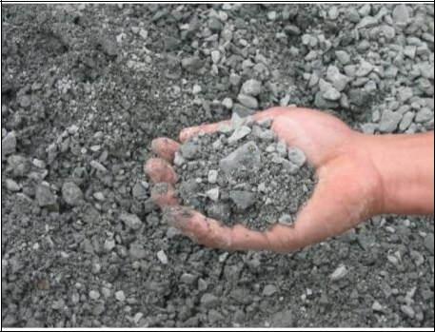

Figure 2.1 : Coarse Grains

2.4.2 Fine grained soils

Soil particles passing through No. 200 sieve are called fine grained soils. Fine grained soil particles are usually not visible through naked eye. Silt and clay are examples of fine-grained soils. Plasticity and cohesion are properties exhibited by fine grained soil.
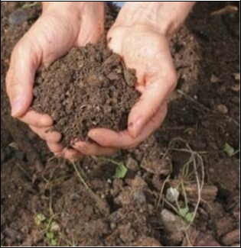

Figure 2.2 : Fine Grains

12

Chapter No. 2 Literature

2.5 Types of Soil Structure

Types of soil on the basis of soil structure are following

2.5.1 Plate-like structure

Plate structure are flat and plate like. The horizontal dimensions are much more dominant than the vertical. Soils that have been subject to leaching or compaction usually contain platy structure. These plates can be separated with a little effort. Platy structure tends to hinder the downward movement of water.
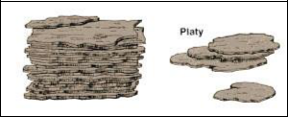

Figure 2.3 : Plate Like Structure

2.5.2 Prism-like structure

Prism like structure contain vertical dimensions much more dominant than the horizontal, giving a pillar-like shape. When the top of particle is in rounded form, the structure is known as columnar, and when the top is flat structure is called prismatic. Arid and semi-arid regions normally have prism like structure in sub soil range.

13

Chapter No. 2 Literature
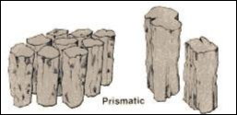

Figure 2.4 : Prism Like Structure

2.5.3 Block-like structure

Dimensions of all sides are almost same and particles are cube-like. When the faces of particles are flat and the edges are sharp angular the structure is called as angular blocky. When the faces and edges are round it is known as sub angular blocky. Block like types usually are confined to the subsoil.
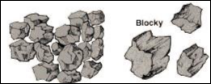

Figure 2.5 : Block Like

14

Chapter No. 2 Literature

2.5.4 Spheroid (Sphere-like structure)

Sphere like aggregates contain all round aggregates, diameter of which is not over 0.5 inches. The rounded particles usually lie loosely and separately. In sphere-like structure infiltration, penetration and aeration are not affected by wetting of soil.

2.6 Determination of soil texture

2.6.1 Feel Method

The sense of feel is used to determine the texture of soil in the field. When the soil is scrapped between thumb and fingers under wet conditions, we get following

- Sand particles can be easily seen and feels crumbly when gets wet.

- Silt is plastic when it gets wet and when dry silt feels like a flour and talcum powder.

- Clayey particles feel very plastic when wet and are hard under dry conditions.

2.6.2 Laboratory Method

A more reliable and basic method has been devised for classification of soils. In this method we perform various test to determine nature of soil and classify it accordingly. Soil I a mixture of different particle sizes.

2.7 Soil classification

Systematic categorization of soils based on distinguishing characteristics is soil classification.

Principles of Soil Classification

A good soil classification system must satisfy the following basic principles:

- Universal, brief, comprehensive and meaningful terms should be used in the system.

15

Chapter No. 2 Literature

- Simple field or laboratory identification and classification tests must be utilized.

- The groups and sub-groups must categorize soils of similar characteristics and engineering behavior.

Soil Classification is classified by different international system like ASTM, USCS and AASTHO, according to their;

- GSD

- Atterberg Limits

2.7.1 GSD

Grain Size Distribution is used to classify soil according to their grain size. The sizes of the grains vary greatly in any soil mass. In order to classify the soil properly we must know its grain size distribution.

Grain-size distribution methods

- Sieve analysis

- Hydrometer analysis

Sieve analysis determines the grain-size distribution of coarse-grained soil whereas Hydrometer analysis is used for the grain-size distribution of fine-grained soil.

Grain-size distribution curve can be used to determine the following parameters for a given soil.

D10 is the particle size at 10 percent finer on the gradation curve.

D30 is the particle size at 30 percent finer on the gradation curve.

D60 is the particle size at 60 percent finer on the gradation curve.

16

Chapter No. 2 Literature

Effective size (D10)

Effective size of sample is particle size in which 10 percent of particles is smaller while 90 percent if greater. Diameter in the particle-size distribution curve corresponding to 10% finer.

Well Graded

Soil which is mixture of particles of a wide range of sizes. Sizes from the No. 4 to No. 200 sieves are present in a well graded soil.

A well graded gravel is classified as GW while a well graded sand is classified as SW.

Poorly Graded

Soil that does not have a good representation of all sizes of particles from the No. 4 to No. 200 sieve is called poorly graded soil. A poorly graded gravel is classified as GP while a poorly graded sand is classified as SP. Soil liquefaction is more susceptible in poorly graded soil than well graded soils.

Gap-Graded

Soil that has an excess or deficiency of certain particle sizes of soil. Gap graded may also be defined as soil that has at least one particle size missing. An example of a gap-graded soil is one in which sand of the No. 20 and No. 80 sizes are missing, and all the other sizes are present.

Uniformity Coefficient (Cu)

Uniformity coefficient is estimated using the gradation curve as obtained through the sieve analysis. Uniformity coefficient is used to classify the soil as well graded or poorly graded.

Cu = D60/D10

17

Chapter No. 2 Literature

Well graded sand has Cu > 4 and well graded gravel has Cu > 6

Coefficient of Curvature (Cc)

It measures the gradation of particles.

Cc = (D30^2) / (D60 × D10)

Well graded sand and gravel Cu lies between, 1 < Cc < 3

2.7.1.1 Sieve Analysis

Measured amount of dry, well-pulverized soil is taken and is passed through a stack of progressively finer sieves with a pan at the bottom in order to conduct sieve analysis. The weight of soil retained on each sieve is measured, and the cumulative percentage of soil passing through each is determined. Sieves commonly used for the analysis of soil for classification purposes are 10,20,40,60,80,100 and 200.
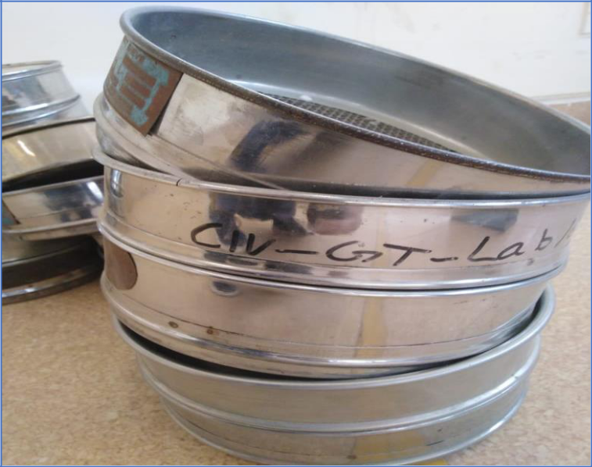

Figure 2.6 : Sieves

18

Chapter No. 2 Literature

2.7.1.2 Hydrometer

Particles passing through sieve no 200 use hydrometer analysis to find particle sizes. Hydrometer analysis is widely used method for obtaining an estimate of the distribution of soil particle sizes passing sieve # 200. Hydrometer analysis calculates the size of soil particles from the speed at which they settle in liquid.

In this method, a 1000ml suspension of soil, 5 gm NaPO3 and water is prepared. Then hydrometer is insert in the solution.

This hydrometer is calibrated to read grams of soil of a value of G=2.65 in 1000 cc of suspension as long as no more than 50 gm of soil is involved. The reading is, of course, directly related to the specific gravity of the solution. The hydrometer displays the specific gravity of the soil-water suspension at the center of the bulb.
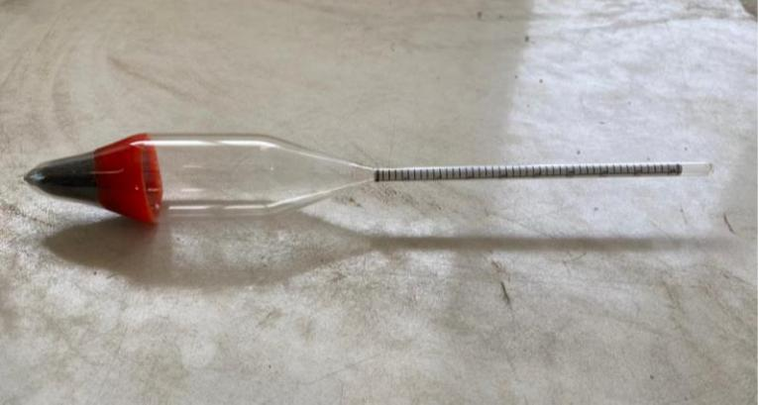

Figure 2.7 : Hydrometer

2.7.2 Atterberg Limits

Atterberg limits are the consistency limits, the term consistency is used to indicate the resistance to deformation or firmness of fine-grained soils. The consistency of cohesive

19

Chapter No. 2 Literature

soils in natural state, in general, is expressed quantitatively in terms of soft, stiff, very stiff and hard.

The moisture contents of a soil at the points where it passes from one stage to the next are called consistency limits or Atterberg limits.

Atterberg limits are;

- Liquid limit (L.L)

- Plasticity Limit (P.L)

- Plastic Index (PI)

Liquid Limit (LL)

It is the minimum moisture content at which the soil will flow under its own Weight under the influence of a small disturbing force, According to Casagrande, L.L is defined as the moisture content at which a standard groove cut in the remolded soil sample by a grooving tool will close over a distance of 13 mm (0.5") at 25 blows of the LL cup falling 10 mm on a hard rubber base .All plastic soils possesses a minimum constant value of shearing strength at LL.

Plastic Limit (PL)

The PL is defined as the minimum moisture content at which the soil can be rolled into a thread of 3 mm (1/8") in diameter without crumbling.

Plastic Index (PI)

It is the range of moisture content over which a soil remains in plastic state.

As P.I = L.L – P.L

20

Chapter No. 2 Literature

The PI is useful in engineering classification of cohesive soils and many engineering properties have been found to empirically correlate with PI.

Specific Gravity (Gs)

The specific gravity of soil is defined as the unit weight of the soil mass divided by the unit weight of distilled water at 4°C.

Gs = γsoil/γwater

2.8 Types of Classification System

2.8.1 AASHTO

The AASHTO Soil Classification System was developed by the American Association of State Highway and Transportation Officials, and is used as a guide for the classification of soils and soil-aggregate mixtures for highway construction purposes & aggregates relative to their suitability for pavement construction.

AASHTO system is useful for evaluation of soil for use in embankment, subgrades, subbases and bases of roads and airport pavements.

The system is based on the following three soil properties:

- Grain size distribution (GSD).

- Liquid limit (L.L)

- Plasticity index (P.I)

2.8.2 USCS

21

Chapter No. 2 Literature

The Unified Soil Classification System (USCS) is a soil classification system used in engineering and geology to describe the texture and grain size of a soil. The classification system can be applied to most unconsolidated materials, and is represented by a two-letter symbol. Classify soil according to their size and Atterberg Limits.

The USCS has three major classification groups:

- Coarse-grained soils (e.g. sands and gravels)

- Fine-grained soils (e.g. silts and clays)

- Highly organic soils (referred to as "peat").

22

Chapter No. 3

3 METHODOLOGY

3.1 General

Methodology is an important part is a research. In methodology we describe the methods, adopted in performance of experiments on soil for classification and to find strength of soil. All methods and procedures are according to AASTHO specification.

3.2 Soil Location

Soil sample is collected from the Nadipur area. Purpose of selection of Nadipur soil is that it is problematic (weak in nature). The structures are unstable in this area due to soil issues so deep foundation is needed. So, this soil is selected to improve its shear strength and bearing capacity.

3.3 Soil Collection

We took clayey soil by excavation of soil up to 4 feet for better results and to avoids coarse, dirt, leaves, waste materials etc., in soils sample. Soil is grey in color and hard due to dry up soil moisture in soil during summer (sun heat).

3.4 Soil Pulverization

The soil was hard due to loss of moisture in sun heat. To pulverize this soil, we use “Pebble rod mill machine” available in chemical department. The following procedure is adopted to Pulverize the soil with the help of Pebble rod mill machine:

23

Chapter No. 3 Methodology

- We took soil and fill one third of the cylinder of Pebble rod mill machine with soil.

- Fill this cylinder with 45 steel balls (with different diameters) to Pulverize soil.

- Place the cap of cylinder and fixed it with nuts.

- Now place the cylinder on Machine and run for 15 to 20 minutes.

- Then remove it from the cylinder and pass from sieve# 100. Also removed the steel balls.

List of tests

Different tests are performed for classification and strength of soil are;

Soil Classification Tests

- Moisture Content Test

- Specific Gravity

- Dry Sieve analysis

- Wet Sieve analysis

- Hydrometer

- Liquid Limit

- Plastic Limit

Soil Strength Test

- Modified Proctor Test

- Direct Shear Test

24

Chapter No. 3 Methodology

- California bearing ratio test

Soil Classification Systems

- AASHTO

- USCS

3.5 Soil Tests

3.5.1 Moisture Content Test

Introduction

The ratio of moisture content to dry soil is called moisture content. It is used in many tests like CBR, MDD etc. Water content in soil sufficiently effects the strength behavior of soil.

Standard Reference

ASTM D 2216-98

Apparatus

- Containers

- Dry Oven

- Gloves

- Balance (with accuracy to 0.01g)

Procedure

- Weight the empty clean and dry container W1.

- Select the test specimen in container carefully.

- Again, weight the container with soil sample and note down W2.

- Place the sample in over for 24 hours at 110C .

25

Chapter No. 3 Methodology

- After 24 hours weight the dry sample and note down W3.

- Calculate the weight of water present in sample by Weight of water = W2-W3.

- Now calculate the percentage moisture content by dividing the weight of water to weight of dry soil and multiplying by 100.

Formula

Moisture content = w = [(W2-W3)/ (W3-W1)] x100
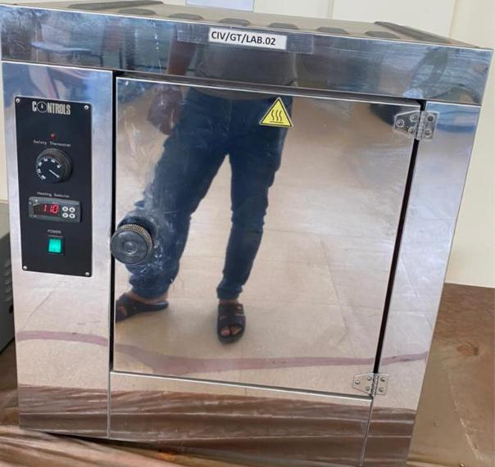

Figure 3.1 : Dry Oven

3.5.2 Specific Gravity Test

Introduction

The unit weight of the soil mass divided by the unit weight of distilled water in equal volume at 4°C called specific gravity. It is denoted by Gs.

Standard reference

ASTM D 854-0 Standard Test for Specific Gravity of Soil Solids by Water Pycnometer

26

Chapter No. 3 Methodology

Apparatus

- Volumetric Flask (250 or 500 ml)

- Thermometer

- Weighing Balance (L.C = 0.5 gm).

Procedure

- First of all, determine the weight of empty and dry volumetric flask and record the weight as W1.

- Take 100 grams of oven dried soil and put this this into the flask.

- Now weigh the flask and dry soil and record the weight as W2.

- Keep on adding water in the flask until it gets two third full. Carefully and gently mix the mixture.

- Add some more water in flask until the bottom of the meniscus is exactly at the volume mark. Weigh the flask and record it as W3.

- Empty the flask and thoroughly wash it. Then fill the flask with water up to the mark and weight as W4.

- Repeat the above all steps at least three times.

- Record the temperature of soil water mixture by the thermometer.

- Specific Gravity of Soil is then, computed by diving the weight of soil by the weight of an equal volume of water as below.

Formula

Gs = [(W2-W1) / ((W4-W1) - (W3-W2))] × α

27

Chapter No. 3 Methodology

Where, α is a temperature constant define as the ratio of density of water at room temperature to density of water at temperature, α = γt / γ(4℃).

3.5.3 Dry Sieve Analysis

Introduction

Dry soil sample of known weight is shaken mechanically through a series of woven-wire square mesh sieves with successively smaller openings is called sieve analysis. Usually we use Sieve # 4, 10,30,40,50,100 and 200 for sieve analysis.

Standard Reference

ASTM D 422 - Standard Test Method for Particle-Size Analysis of Soils.

Apparatus

- Weigh balance

- Set of sieves # 4,10,30,40,50 ,100 and 200

- Sieve shaker

- Tray

Procedure

- Take 500 gm oven dry sample of soil for sieve analysis.

- Arrange the sieves as # 4,10,30,40,50,100, 200 and pan for the sieve analysis. Such that sieve #4 is at top and other sieves are according to their order and at bottom of sieve#200 place pan.

- Place the arranged sieves on the pan so that the sieves do not move when the sieve shaker is operated.

- Shake the arranged sieve on sieve shaker foe 3 to 4 minutes.

28

Chapter No. 3 Methodology

- Stop the sieve shaker and separate the sieves one by one from the stack.

- Weight the soil retained on each sieve and pan at the end.

- Compute % retained of soil by using formula %WR= WR/Wsoil x100

- Compute % cumulative weight (%WC).

- Compute % passing as 100 - %WC

- Plot a graph on semi log table where %passing is at ordinate and grain size at abscissa.

- Compute Cc and Cu from the present data.

3.5.4 Atterberg Limits Tests

Scope

The Atterberg limits can be used to distinguish between silt and clay, and to distinguish between different types of silts and clays. The water content at which the soils change from one state to the other are known as consistency limits or Atterberg's limit. This test is performed to determine the plastic and liquid limits of a fine-grained soil.

Standard

Standard Reference (ASTM D 4318-Standard Test Method for Liquid Limit, Plastic Limit and Plasticity Index of Soils).

3.5.4.1 Liquid Limit

Apparatus

- Flat grooving tool with gage,

29

Chapter No. 3 Methodology

- Containers (for Moisture content)

- Weighing Balance (L.C = 0.5 g)

- Spatula

- Wash bottle filled with distilled water

- Drying oven (105° C)

- Porcelain (evaporating) dish

- Glass plate

Procedure

- Take the soil and place it into the porcelain dish. The soil should previously pass through a No. 40 sieve, air-dried, and then pulverized thoroughly. Thoroughly mix the soil with a small amount of distilled water until it appears as a smooth uniform paste. Cover the dish with cellophane to prevent moisture from escaping.

- Weigh of the empty moisture cans with their lids, and record the weights and can numbers on the data sheet.

- Adjust the liquid limit apparatus by checking the height of drop of the cup. The point on the cup that comes in contact with the base should rise to a height of 10 mm. The block on the end of the grooving tool is10 mm high and should be used as a gage.

- Place a portion of the previously mixed soil into the cup of the liquid limit apparatus at the point where the cup rests on the base. spread it into the cup to a depth of about 10 mm at its deepest point. The soil pat should form an approximately horizontal surface.

30

Chapter No. 3 Methodology

- Use the grooving tool carefully cut a clean straight groove down the center of the cup. The tool should remain perpendicular to the surface of the cup as groove is being made.

- Turn the crank of the apparatus at a rate of approximately two drops per second and count the number of drops, N it takes to make the two halves of the soil pat come into contact at the bottom of the groove along a distance of 13 mm (1/2 in.).

- We have taken a sample, using the spatula, from edge to edge of the soil pat. The sample should include the soil on both sides of where the groove came into contact. Place the soil into a moisture can cover it. Immediately weigh the moisture can containing the soil, record its mass, remove the lid, and place the can into the oven. Leave the moisture can in the oven for at least 16 hours.

- Remix the entire soil specimen in the porcelain dish. Add a small amount of distilled water to increase the water content so that the number of drops required closing the groove decrease.

3.5.4.2 Plastic Limit

Apparatus

- Glass plate

- 1/8” rod or scale

- Gloves

Procedure:

- Weigh the remaining empty moisture cans with their lids, and record the respective weights.

- Take soil sample and add distilled water until the soil is at a consistency where it can be rolled without sticking to the hands.

31

Chapter No. 3 Methodology

- Roll the soil mass between the fingers and the glass plate. Use sufficient pressure to roll the mass into a thread of uniform diameter. The thread shall be deformed so that its diameter reaches 3.2 mm (1/8 in.), taking no more than two minutes time.

- When the diameter of the thread reaches the correct diameter, break the thread into several pieces. Continue this alternate rolling, gathering together, kneading and re-rolling until the thread crumbles.

- Gather the portions of the crumbled thread together and place the soil into moisture container, and then cover it. If the container does not contain at least 6 grams of soil, place the container into the oven. Leave the moisture can in the oven for at least 16 hours.

- Now measure the oven dry weight and calculate % moisture content.

- Repeat steps three, four, and five at least two more times. Remember to use the same balance for all weighing.

- Take average of moisture content, this value is the plastic Limit of soil.

3.5.5 DIRECT SHEAR TEST

Purpose

- The purpose of the direct shear test of soil is to determine its ultimate shear resistance, its angle of internal friction, its cohesion between soil particles, and its shear stress deformation features.

- This information is important for substructure analyses, in determining the bearing capacity of the soil, in calculations of stability of earth slopes, in pile construction and other earthwork sites.

Standards:

AASHTO T236-90 & ASTM D3080-90 3.6.4

32

Chapter No. 3 Methodology

Apparatus

Apparatus required for conducting the direct shear test are

- Shear box

- Shear box container

- Base plate with cross groves on its top

- Porous stones (2Nos)

- Plain Grid plates (2Nos)

- Perforated grid plates (2Nos)

- Loading pad with steel ball

- Digital weighing machine

- Loading frame with loading yoke

- Proving ring

- Dial gauges (2Nos)

- Weights

- Tampering Rod

- Spatula

- Rammer

- Sampler

Sample Preparation

33

Chapter No. 3 Methodology

If an undisturbed sample is used, it should be large enough to give a minimum of three corresponding specimens. Prepare the samples so that the moisture loss is negligible. Trim oversize specimens to the inside diameter of the direct shear device and to the length of the trimmer Extreme care shall be taken in the preparation of undisturbed specimens of soft soils in order to avoid the disturbance of their natural structure. Determine the initial mass of the samples for consequent use in determining initial moisture content.

Procedure

- Prepare at least three samples with the help of sample trimmer.

- Carefully place the sample in the shear box and insert the top loading block in place as shown.

- Place the box in its appropriate position on the shearing machine.

- Mount the loading yoke on the steel ball, placed on the loading position, and add 0.5 kg normal load.

- Apply shear force so that the loading knob just touches the top portion of the shear box and a very small load is applied.

- Remove the fixing screws (pins) connecting the upper and lower part of the box together and raise the upper half box slightly larger than the largest soil particles in the sample by updating the spacing screws. Then back off the spacing screws so that they clear the bottom half of the box.

- Fix the proving (load) ring dial to read zero and apply the shear force and shear the sample slowly at a fix rate until the maximum shear force is reached at the failure of the sample.

- Repeat the test procedure on identical samples under increasing normal loads of 0.5, 1 kg, & 1.5 etc.

34

Chapter No. 3 Methodology

- Plot the failure enclosure between normal stress as abscissa & shear stress as ordinate using the same scale. Measure the slope of the line to read the angle of internal friction (φ) and the

Precautions

- If the test is performed corresponding the saturated condition, then put porous stone at the top and bottom of the shear box with grippers before starting the test.

- After placing the shear box cart in the machine, fill the cart fully with water and allow the saturation of sample.

Merits & Demerits of Direct Shear Test

Merits

- This test is simple and convenient to use.

- The preparation of soil sample for the test is easy and less time consuming.

- The test does not need skilled person and even a mature can quickly learn to conduct the test with little practice

- The equipment used for the test is simple and less costly except with the ordinate as cohesion, C.

Demerits

- The failure plane in the test is predetermined (horizontal), which may not be the weakest point. This results in over-estimation of shear strength of the soil, which is erratic.

- The stress distribution is not same over the failure plane. The stresses are higher at the edges and lesser at the center. This leads to errors in the estimation of shear parameters.

35

Chapter No. 3 Methodology

- The stress conditions are known only at the time of failure. Superior to failure, the stresses are indeterminate and Mohr’s circles cannot be drawn.

- In spite of the above serious limitations, the direct shear test is more famous than other types of shear tests and is more frequently used than the others on all types of soils. This is due to only because of the very simple test procedure and very short time needed for the test
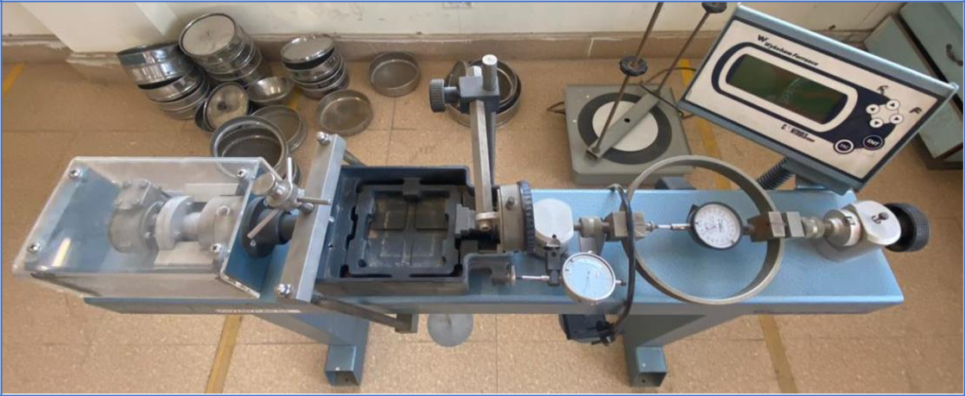

Figure 3.2 : Direct Shear Machine

3.5.6 MODIFIED PROCTOR TEST

Test is used to determine the compaction of different types of soil and the properties of soil with a change in moisture content and the relationship between Dry Density and Moisture Content.

Purpose

Compaction is the densification of unsaturated soil by the reduction in the volume of voids that are filled with air, while the volume of solids & water content remains the same.

The main purpose of compaction of soil is to increase shear strength, decrease compressibility, reduce permeability, & to control swelling & shrinkage of soil.

36

Chapter No. 3 Methodology

The degree of compaction of soil is calculated in terms of its dry density. The maximum dry density of soil occurs at optimum moisture content (OMC).

The Modified Proctor Test is of great importance and is widely used in the construction of roads, highways, earth fill dams, earth filling, Airports, etc. In modified Proctor test, the soil is compacted in the given mold in Five (05) layers with a rammer of 10 lbs (4.5 kg) with a fall of 18 inches (45 cm).

Standards

AASHTO T180-90 & ASTM D1557-91

Apparatus

Cylindrical Metal Mold, internal diameter 4″ (10.16 cm) or 6″ (15.24 cm), internal effective height of 4.6” (11.7 cm) and the mold should have detachable base plate & color 2″ (5.08 cm) Rammer;

- Weighing 10 lbs. (4.5 kg) &with a fall of 18 inches (45.7 cm)

- Sensitive Balance; (L.C 0.5g)

- Thermostatically controlled oven (105°C – 110°C)

- Steel straightedge

- Moisture containers

- Sieve No.4

- Tray & scoop

- Graduated cylinder

- Mixing Tools (spoon, trowel, Spatula)

Procedure

37

Chapter No. 3 Methodology

- Take about 4 kg of air-dried soil sample passing No. 4 sieve and mix it with an optimum quantity of water.

- Weigh the empty mold without a collar, with base plate attached.

- Place the mold with the collar attached on a solid base and compact the soil mass into the mold using standard compaction in five layers with 25 blows per layer and with a 4.5 kg rammer dropping from a height of 45 cm. Take care in distributing the blows uniformly over the surface of each layer, and to let the rammer fall freely.

- Remove the collar carefully strike off the subjected part of the compacted soil by steel straight edge.

- Remove the compacted soil specimen from the mold and split it on a large tray. Take a sample for moisture content determination.

- Break-up the specimen to No.4 sieve size, and mix it with the remainder of the original sample. Add suitable quantity of water, and mix properly for at least six trials. After that repeat it 3 to 5 steps for each trial.

- Draw compaction curve on a graph with dry density on ordinate and moisture contents on the abscissa. Maximum dry density shall be at the crown of the curve and optimum moisture content (OMC) at which maximum dry density is obtained.

Precautions

- Take the sample carefully free from any other materials.

- Mix the water thoroughly.

- Soil should be air-dried and passed through sieve No. 4

- Compaction should be done in specific layers, and each part should be compacted properly and then other layer is laid on the previous layer

38

Chapter No. 3 Methodology

- If the soil has been cured add 1% water by weight in the account for evaporation losses

3.5.7 CALIFORNIA BEARING RATIO (CBR)

California Bearing Ratio test performed to calculate the bearing capacity of sub grade for pavement design.

California Bearing Ratio can be divided in two methods that are

- One Point CBR Method

- Three Point CBR Method.

The CBR test is one of the most commonly used methods to determine the strength of a sub grade soil, sub base, and base course material for design of thickness for highways and airfield pavement.

The California bearing ratio test is penetration test which meant for the evaluation of sub grade strength of roads and pavements. The results obtained by these tests are used with the empirical curves to determine the thickness of pavement and its component layers. This is the most generally used method for the design of flexible pavement. CBR value is the most important test for road construction.

Standards

This test carried out by following the American Association of State Highway and Transportation (AASHTO T 193). To perform the CBR test first calculate the Optimum Moisture Content (OMC) by Modified Proctor test (AASHTO T180).

Apparatus

- Mould

39

Chapter No. 3 Methodology

- Steel Cutting collar

- Spacer Disc

- Surcharge weight

- Dial gauges

- Sieves

- Penetration Plunger

- Loading Machine

- Miscellaneous Apparatus

Procedure

- For three-point method 5 kg soil sample has been taken.

- Add (O.M.C) water in soil and mixed it properly.

- Set the mould and attach to base plate.

- Weight the empty mould W1. and attach collar on top.

- Apply 10, 30 and 65 blows on 5 layers for three moulds (same procedure above)

- After compaction, removed the collar and leveled the surface.

- Weighted the mould with sample W2.

- Weighted the mould + compacted specimen W3.

- Then placed the sample under the penetration piston and applied surcharge load of 10 lb.

- Applied the load and noted the penetration load values.

40

Chapter No. 3 Methodology

- Sample has been taken for calculating of moisture content.

- Drawn the graphs between the penetration (mm) and penetration load (kg/cm^2) and find the value of CBR.

- CBR (%) = (Actual load / standard load) x 100

SOAKING

- Place the swell plate with adjustable stem on the soil sample in the mould and applied sufficient annular.

- Place the tripod with dial indicator on top of the mould and noted an initial dial reading.

- Immersed the mould in water to allow free access of water to top and bottom of the specimen. Soaked the specimen for 96 hours (four days).

- Note the value of swelling after 24 hours. calculated the swell as a percentage of the initial sample length.

- Percent swell = (Change in length in mm during soaking/115) x 100

- At the end of 96 hours, noted a final dial reading on the soaked samples and calculated the swell as a percentage of the initial sample length. Percent swell = (Change in length in mm during soaking/116.43) x 100

41

Chapter No. 3 Methodology
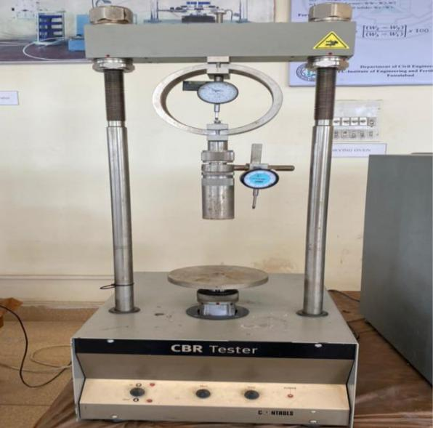

Figure 3.3 : CBR Machine

42

Chapter No. 4

4 RESULTS

4.1 General

This chapter deal with the results of test performed on soil. We took three soil sample to check which soil is problematic soil. Soil sample A from Narowal ,Soil Sample B from Nadipur near and Soil C from Nadipur near .

4.2 Classification Test

4.2.1 Moisture Content Test

% Moisture Content = 21.89 %

4.2.2 Dry Sieve Analysis

Sieve # 200 passing is 42.1%.

4.2.3 Wet Sieve Analysis

Sieve # 200 passing is 97.25%.

4.2.4 Hydrometer Test

43

Chapter 4 |  |  |  |  | Results
 | 110.00
 | 100.00
 | 90.00
 | 80.00
 | 70.00
Finer | 60.00
Finer | 50.00
% | 50.00
 | 40.00
 | 30.00
 | 20.00
 | 10.00
 | 0.00
 | 0.0010 | 0.0100 | 0.1000 | 1.0000 | 10.0000
 | D10 | D30 | Size of particles (mm)
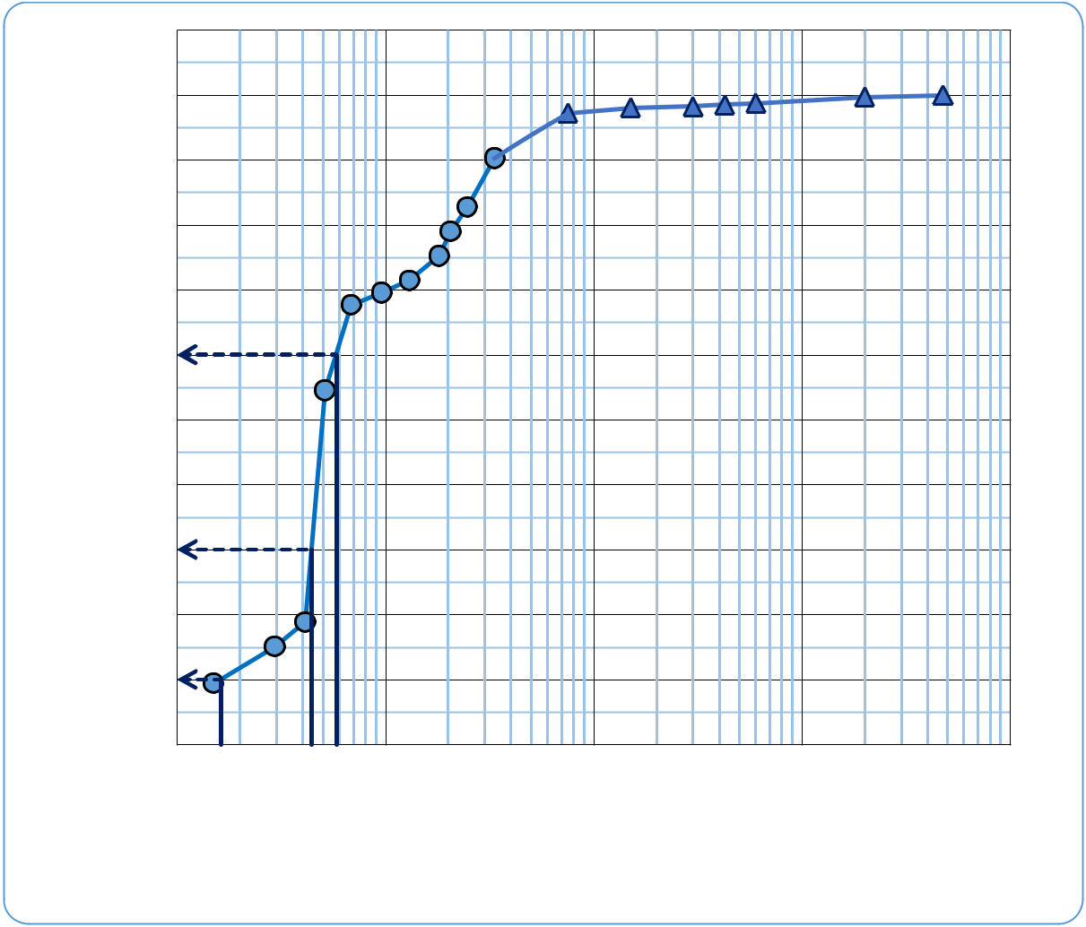

Hydrometer Analysis Sieve Analysis

Figure 4.1 : Grain Size Distribution Curve

From Figure 4.1 grain size curve we find;
Cu = ^{D60} = 3.59, as Cu < 4,

^{D}10

So, soil is not well graded sand.
Cc = | ( ₃₀)² |  | = 2.06, as 1 < Cc < 3,
Cc = |  | × | = 2.06, as 1 < Cc < 3,
 | 60 | 10

So, soil is well graded.

44

Chapter 4 Results

4.2.5 Plastic Limit Test

Plastic Limit is 25.56%.

4.2.6 Liquid Limit

Liquid Limit = 46.93%

4.2.7 Plastic Index

Plastic Index = P.I = L. L - P.L

P.I = 21.38%

4.2.8 Specific Gravity Test

Gs = 2.81

4.3 Classification of soil

The classification of soil done by two methods;

- ASSTHO Classification

- USCS Classification

4.3.1 ASSTHO classification

Group Index (G.I)

So, G.I = 14

For classification of soil through AASTHO we use the AASTHO classification system table given below;

45

Chapter 4 Results

Classification

So, soil is A-7-6 (14), Clayey Soil and Poor as subgrade.

4.3.2 USCS Classification

Soil Symbol and Name

CL and Sandy Lean Clay

Table 4.1 : Soil Properties

Specific Gravity | 2.81
Liquid Limit | 46.93 %
Plastic Index | 21.38 %
ASSTHO Classification | A-7-6 (14), Clayey Soil and
 | poor as subgrade
USCS Classification | CL and Sandy Lean Clay

4.4 Strength Tests

4.4.1 Direct Shear Test

First, we change percentages of Brick dust from 0% to 30% to find out optimum value.

46

Chapter 4 Results

4.4.1.1 For Soil
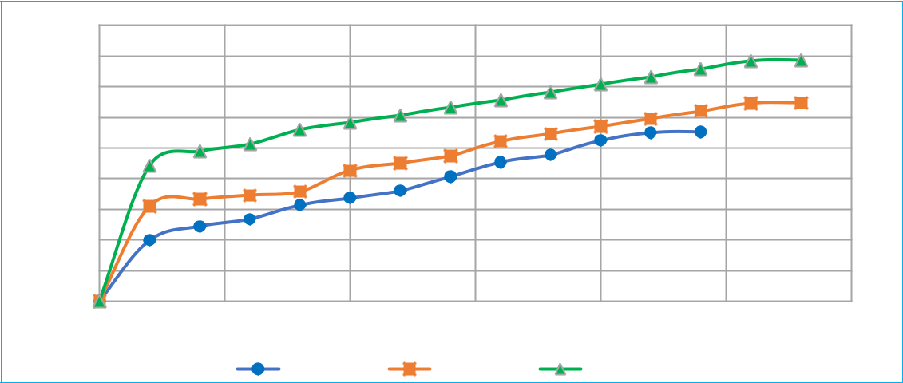

 | 45
 | 40
(KPa) | 35
(KPa) | 30
Stresses | 30
Stresses | 25
Stresses | 20
Shear | 15
Shear | 10
 | 5
 | 0
 | 0 | 0.0005 | 0.001 | 0.0015 | 0.002 | 0.0025 | 0.003
 |  |  | Horizontal Defection (m)
 |  |  | 0.5 Kg Load | 1.0 Kg Load | 1.5 Kg Load

Figure 4.2 : 0% B.D Deformation Vs Shear Stress
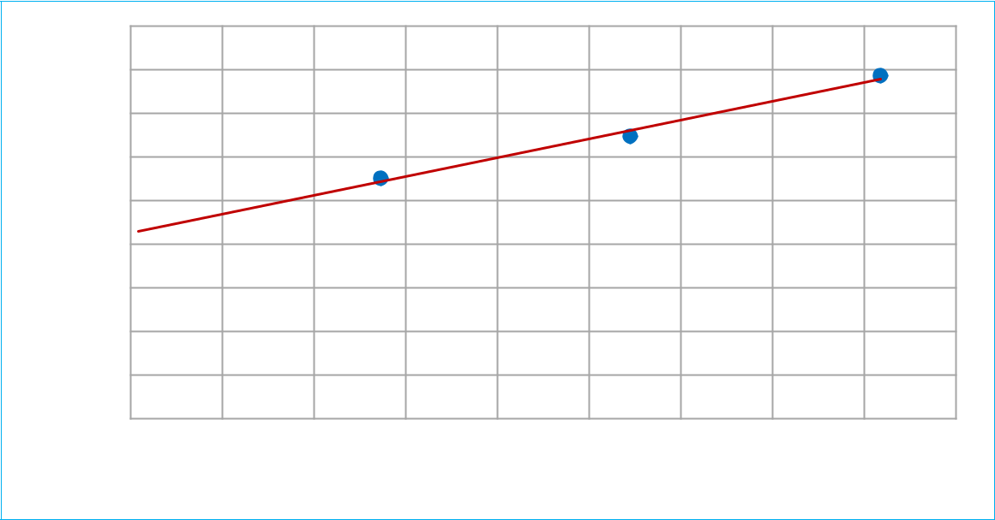

 | 45.00
 | 40.00
(KPa) | 35.00
(KPa) | 30.00
Stresses | 25.00
Stresses | 20.00
Shear | 15.00
 | 10.00
 | 5.00
 | 0.00
 | 0 | 0.5 | 1 | 1.5 | 2 | 2.5 | 3 | 3.5 | 4 | 4.5
 |  |  |  |  | Normal Stresses (KPa)

47

Chapter 4 Results

Figure 4.3 : 0% B.D Shear strength Parameters 4.4.1.2 For 10% B.D
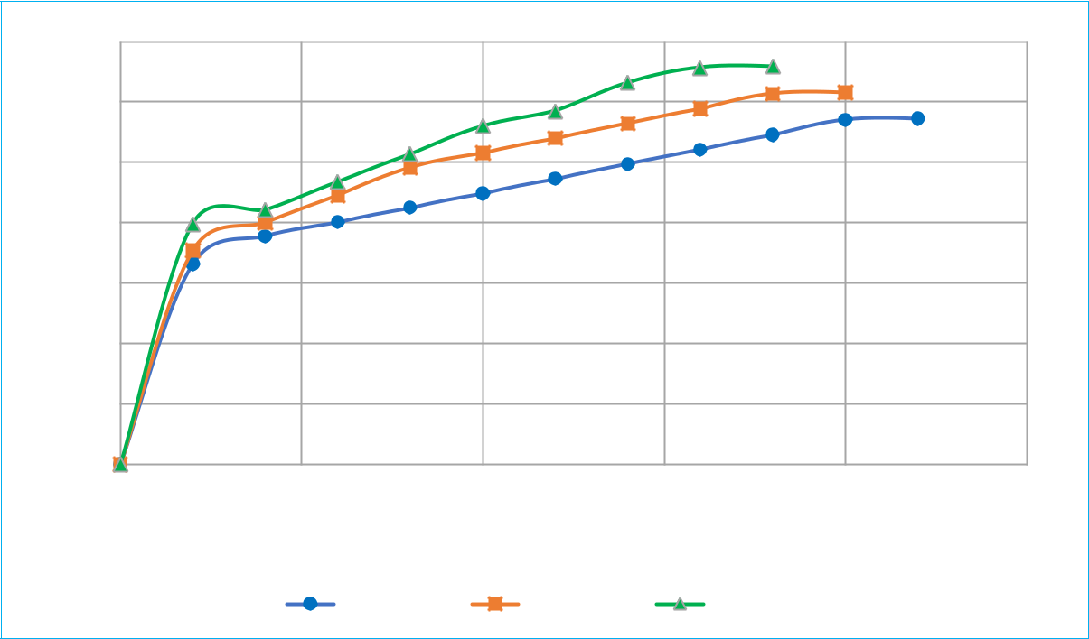

 | 35
(KPa) | 30
(KPa) | 25
Stresses | 20
Shear | 15
 | 10
 | 5
 | 0
 | 0 | 0.0005 | 0.001 | 0.0015 | 0.002 | 0.0025
 |  | Horizontal Defection (m)
 |  | 0.5 Kg Load |  | 1.0 Kg Load | 1.5 Kg Load

Figure 4.4 : 10% B.D Deformation Vs Shear Stress

 | 35.00
 | 30.00
(KPa) | 25.00
Stresses | 20.00
Stresses | 15.00
Shear | 10.00
 | 5.00
 | 0.00
 | 0 | 0.5 | 1 | 1.5 | 2 | 2.5 | 3 | 3.5 | 4 | 4.5
 |  |  |  |  | Normal Stresses (KPa)
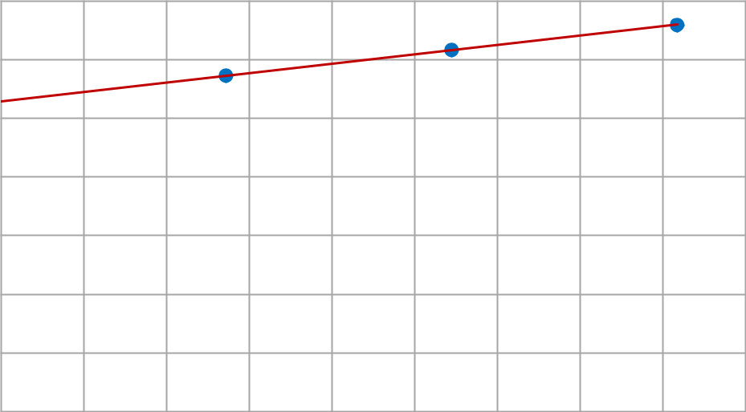

48

Chapter 4 Results

Figure 4.5 : 10% B.D Shear strength Parameters 4.4.1.3 For 20% B.D
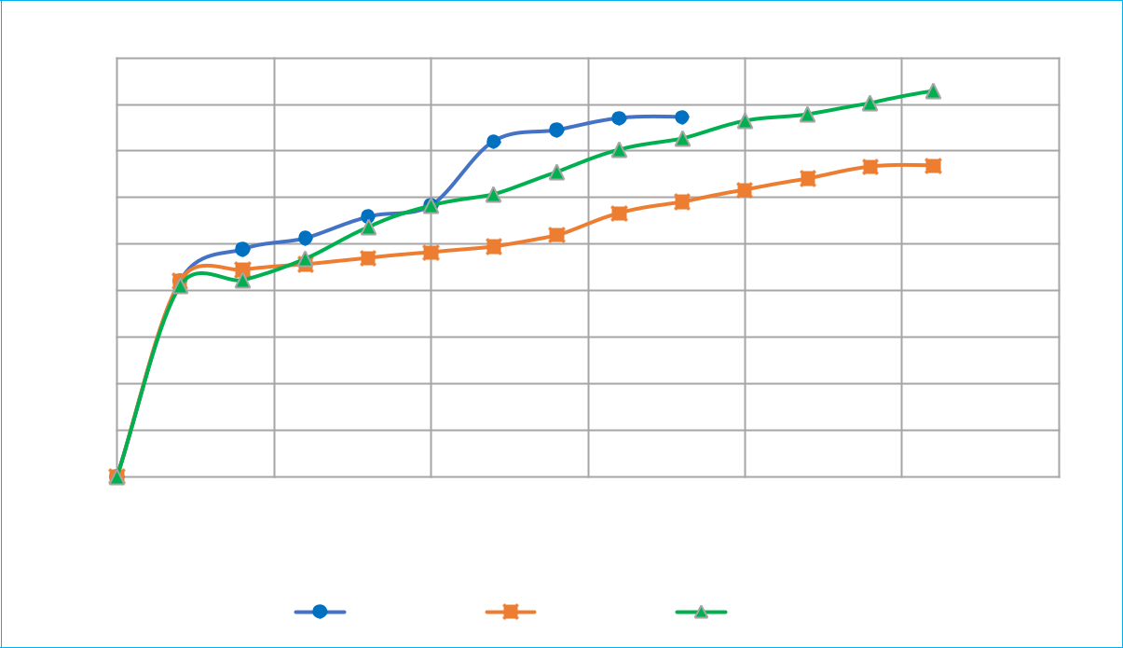

 | 45
(KPa) | 40
(KPa) | 35
Stresses | 30
Stresses | 25
Shear | 20
Shear | 15
 | 10
 | 5
 | 0
 | 0 | 0.0005 | 0.001 | 0.0015 | 0.002 | 0.0025 | 0.003
 |  |  | Horizontal Defection (m)
 |  |  | 0.5 Kg Load | 1.0 Kg Load | 1.5 Kg Load

Figure 4.6 : 20% B.D Deformation Vs Shear Stress

Shear Stresses (KPa)

45.00
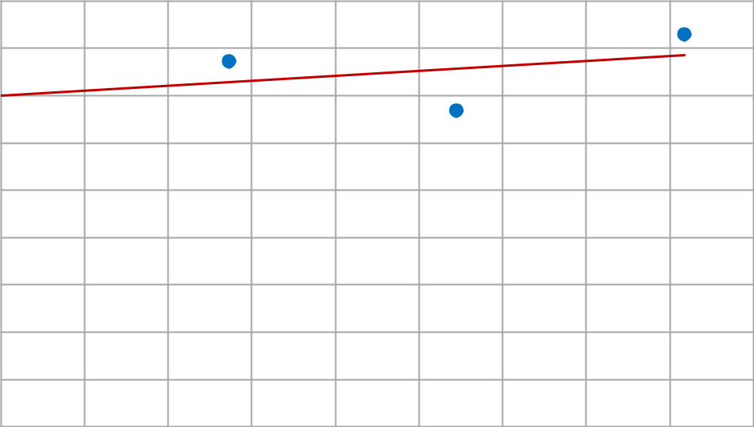

40.00

35.00

30.00

25.00

20.00

15.00

10.00

5.00

0.00

0 0.5 1 1.5 2 2.5 3 3.5 4 4.5

Normal Stresses (KPa)

49

Chapter 4 Results

Figure 4.7 : 20% B.D Shear strength Parameters 4.4.1.4 For 25% B.D
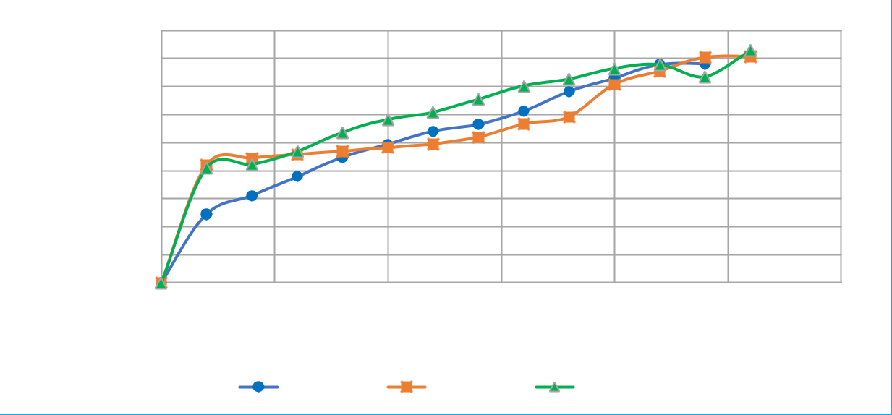

 | 45
 | 40
(KPa) | 35
(KPa) | 30
Stresses | 30
Stresses | 25
Stresses | 20
Shear | 15
Shear | 10
 | 5
 | 0
 | 0 | 0.0005 | 0.001 | 0.0015 | 0.002 | 0.0025 | 0.003
 |  |  | Horizontal Defection (m)
 |  | 0.5 Kg Load |  | 1.0 Kg Load | 1.5 Kg Load

Figure 4.8 : 25% B.D Deformation Vs Shear Stress

 | 42.00
 | 41.50
(KPa) | 41.00
(KPa) | 40.50
Stresses | 40.00
Stresses | 39.50
Shear | 39.00
Shear | 38.50
 | 38.00
 | 37.50
 | 0 | 0.5 | 1 | 1.5 | 2 | 2.5 | 3 | 3.5 | 4 | 4.5
 |  |  |  |  | Normal Stresses (KPa)
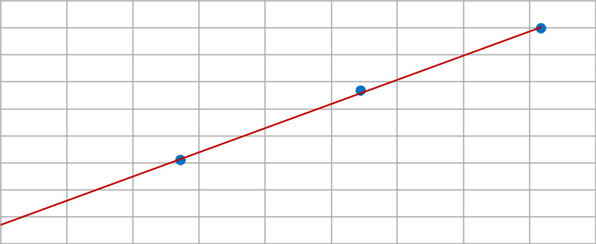

50

Chapter 4 Results

Figure 4.9 : 25% B.D Shear strength Parameters

4.4.1.5 For 30% B.D
 | 45
(KPa) | 40
(KPa) | 35
Stresses | 30
Stresses | 25
Shear | 20
 | 15
 | 10
 | 5
 | 0
 | 0 | 0.0005 | 0.001 | 0.0015 | 0.002 | 0.0025 | 0.003
 |  |  | Horizontal Defection (m)
 |  |  | 0.5 Kg Load | 1.0 Kg Load | 1.5 Kg Load
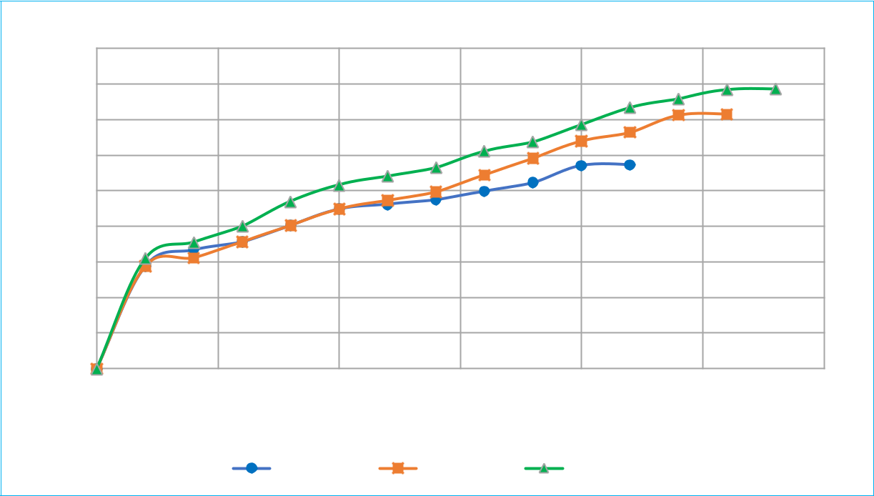

Figure 4.10 : 30 % B.D Deformation Vs Shear Stress
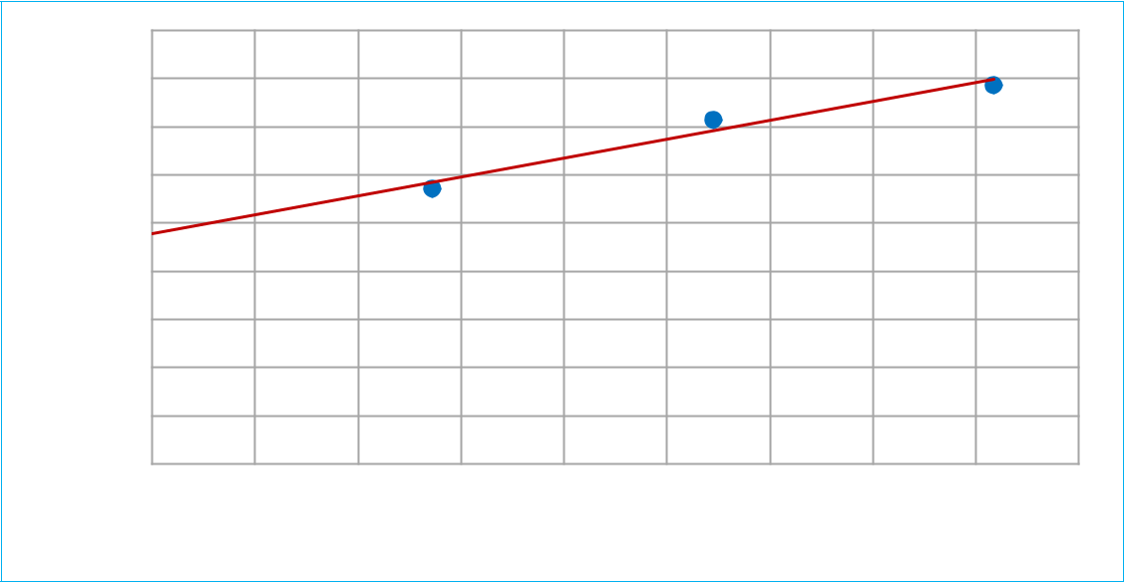

 | 45.00
 | 40.00
(KPa) | 35.00
(KPa) | 30.00
Stresses | 25.00
Stresses | 20.00
Shear | 15.00
Shear | 10.00
 | 5.00
 | 0.00
 | 0 | 0.5 | 1 | 1.5 | 2 | 2.5 | 3 | 3.5 | 4 | 4.5
 |  |  |  |  | Normal Stresses (KPa)
 |  |  |  |  |  |  |  |  |  | 51

Chapter 4 Results

Figure 4.11 : 30% B.D Shear strength Parameters

4.4.1.6 Comparison Between %B. D and Shear strength parameters Table 4.2 : Comparison between C and by φ varying % B.D
%B.D | C | Φ | Remarks
%B.D | Kpa | Degree | -
0 | 21 | 76.97 | -
10 | 26.4 | 57.94 | -
20 | 35 | 46.22 | -
25 | 37.853 | 41.85 | Optimum Value
30 | 23 | 75.72 | -

φ (degree)

90
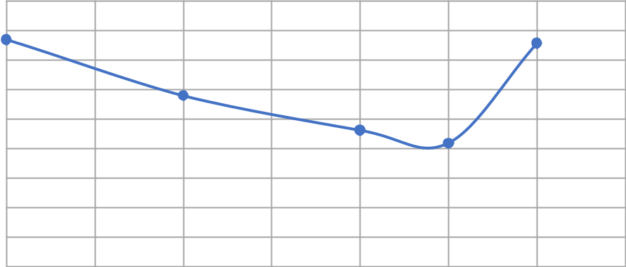

80

70

60

50

40

30

20

10

0

0 5 10 15 20 25 30 35

% B.D

52

Chapter 4 Results

Figure 4.12 : φ vs %B. D

C (KPa)

45
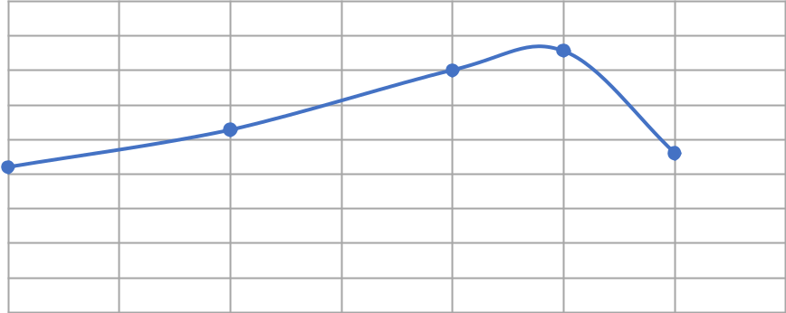

40

35

30

25

20

15

10

5

0

0 5 10 15 20 25 30 35

% B.D

Figure 4.13 : C vs %B. D

Result: Optimum Value is 25% B.D, where c = 37.85 KPa and φ = 41.85

Now we take the optimum value of B.D and vary Coir fiber from 0 to 1.2 % with 0.3 % interval.

4.4.2 Modified Proctor Test

53

Chapter 4 |  |  |  |  |  |  |  |  | Results
 | 1.900
 | 1.850
(g/cm^3) | 1.800
(g/cm^3) | 1.750
Density | 1.700
Density | 1.650
Dry | 1.600
 | 1.550
 | 1.500
 | 14.00 | 15.00 | 16.00 | 17.00 | 18.00 | 19.00 | 20.00 | 21.00 | 22.00 | 23.00
 |  |  |  |  | % Moisture Content
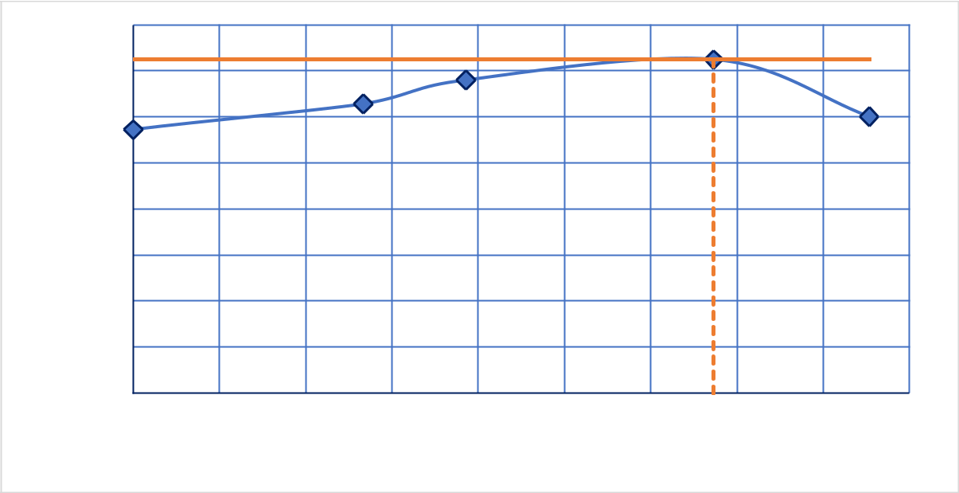

Figure 4.14 : Compaction Curve

4.4.3 CBR

4.4.3.1 For Soil

Table 4.3 : C.B.R Values

P.R.R | Standard
P.R.R | Load | % CBR (10 blow) | % CBR (30 blow) | % CBR (65 blow)
(inch)
(inch) | (kN)
0.1 | 13.44 | 40.11 | 36.70 | 29.73
0.2 | 20.06 | 41.84 | 36.77 | 31.21
Average CBR Value |  | = 35.51 %

54

Chapter 4 Results
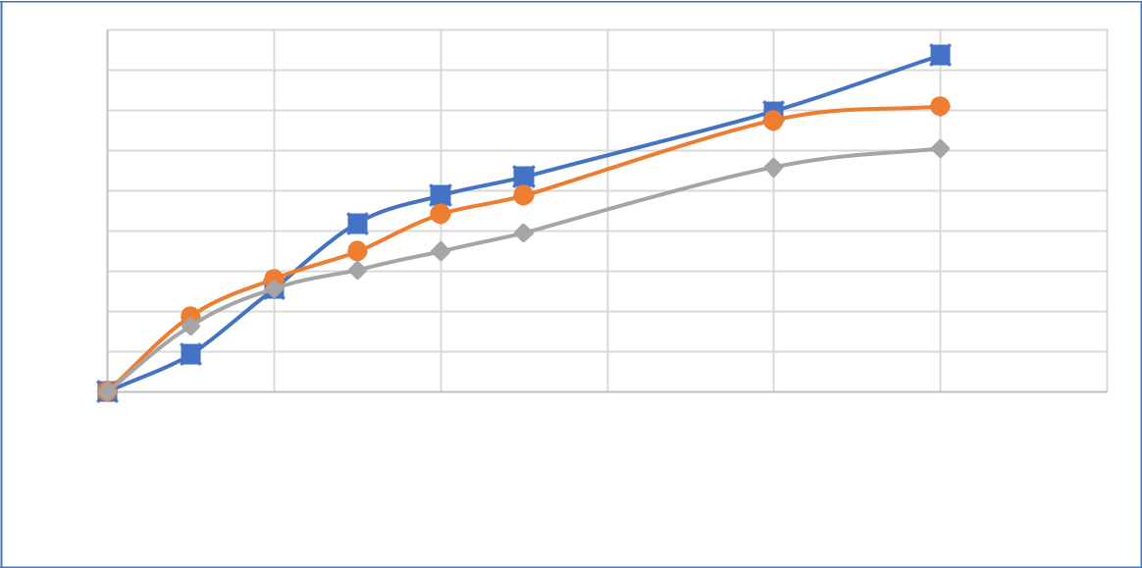

 | 9
 | 8
 | 7
(KG) | 6
(KG) | 5
Load | 4
Load | 3
 | 2
 | 1
 | 0
 | 0 | 1 | 2 | 3 | 4 | 5 | 6

Penetration (mm)

10 blows 30 blow 65 blows

Figure 4.15 : Load vs Penetration

Swelling (mm)

1.2
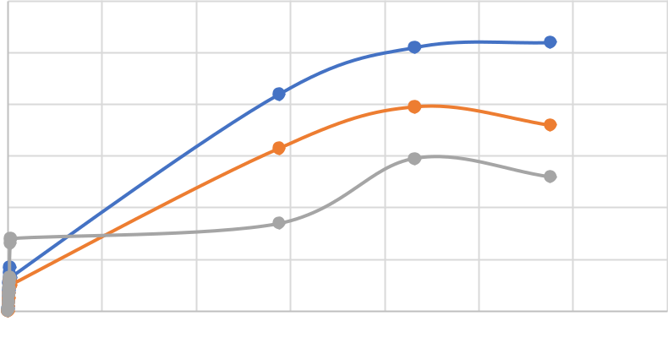

1

0.8

0.6

0.4

0.2

0
0 | 1000 | 2000 | 3000 | 4000 | 5000 | 6000 | 7000
 |  |  | Time (minutes)
 |  | 10 Blows | 30 Blows |  | 65 Blows

Figure 4.16 : Swelling Vs Time

4.4.3.2 For 25 % Brick Dust in soil

55

Chapter 4 Results

Table 4.4 : C.B.R Values (25% B.D)

P.R.R | Standard
P.R.R | Load | % CBR (10 blow) | % CBR (30 blow) | % CBR (65 blow)
(inch)
(inch) | (kN)
0.1 | 13.44 | 46.94 | 38.29 | 36.60
0.2 | 20.06 | 41.87 | 37.92 | 36.30
Average CBR Value |  | = 40.61 %
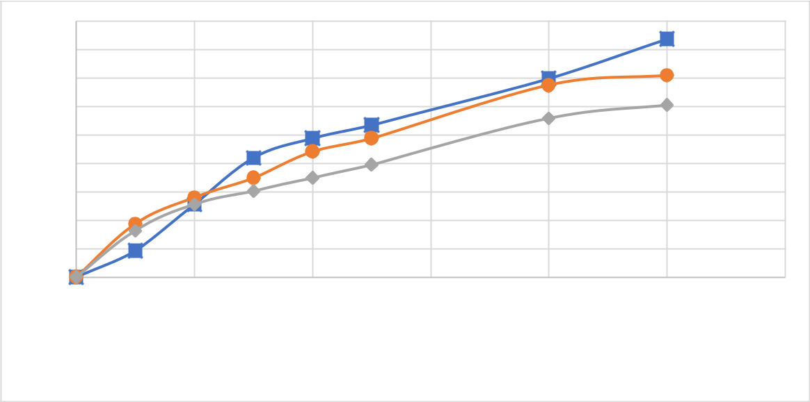

 | 9
 | 8
 | 7
(KG) | 6
(KG) | 5
Load | 4
Load | 3
 | 2
 | 1
 | 0
 | 0 | 1 | 2 | 3 | 4 | 5 | 6

Penetration (mm)

10 blows 30 blow 65 blows

Figure 4.17 : Load vs Penetration (25% B.D)

56

Chapter 4 Results
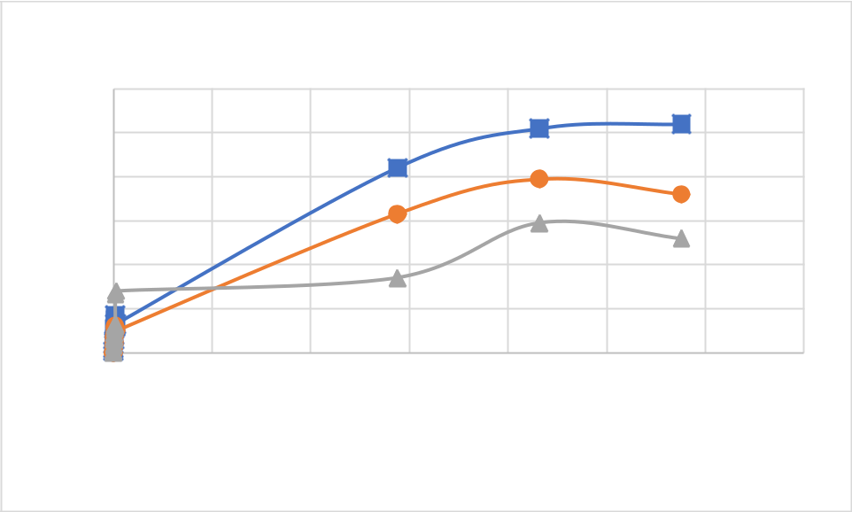

Swelling

Swelling (mm)

1.2

1

0.8

0.6

0.4

0.2

0
0 | 1000 | 2000 | 3000 | 4000 | 5000 | 6000 | 7000

Time (minutes)

10 Blows 30 Blows 65 Blows

Figure 4.18 : Swelling Vs Time (25% B.D)

57

Chapter No .5

5 CONCLUSION

Conclusion

Soil is classified as CL () according to USCS and A7(2) according to ASSTHO.

58

6

REFERENCES

[1] Al-Baidhani, A., & Al-Taie, A. (2019). Review of brick waste in expansive soil stabilization and other civil engineering applications. J. Geotech. Stud, 4(3), 14-23.

[2] Mittal, R. R. S. E. S. (2014). Improvement of local subgrade soil for road constuction by the use of coconut coir fiber. International Journal of Research in Engineering and Technology, 3(5), 707-711.

[3] Nikhil Kumar, S. K., Dr. Sanjeev Suman & Chetana. (2019). Use Of Brick Dust and Fly Ash as a Soil Stabilizer. Symposium on Recent Advances in Sustainable Geotechnics.

[4] Rizwan Khan, V. K. S. (2019). Soil Stabilization using Brick Kiln Dust and waste Coir Fibre. International Journal of Recent Technology and Engineering (IJRTE), 8(2).

[5] S. Muthu Lakshmi, S. S., V. Padmavathi, S. Priya & V. Saranya2. (2018). Utilization of Coconut Coir Fiber For Improving Subgrade Strength Characteristics Of Clayey Sand. International Research Journal of Engineering and Technology, 5(4), 2873-2878.

