Wastewater Treatment and Design by Capital Development Authority

S M Nazmuz Sakib
Graduate of BSc in Business Studies
School of Business And Trade
Pilatusstrasse 6003, 6003 Luzern, Switzerland
sakibpedia@gmail.com

Student of Department of Law
Dhaka International University
House # 4, Road # 1, Block - F, Dhaka 1213
sakibpedia@students.diu.ac

ABSTRACT
Capital Development Authority (CDA) wants to develop one of its newly planned sectors in Islamabad. The planned population of the sector is 100,000 persons. The average consumption of per capita is 135 l/c/d with 250 mg/l of Biological Oxygen Demand (BOD). You need to calculate the total wastewater generation rate and total concentration of organic load to be removed from the wastewater. Moreover, Apply/use different wastewater treatment techniques to control/ remove the contamination from wastewater to recover the environment and natural resources. Devise different comparisons among the various suitable techniques including aerobic biological treatment offering all type of treatments (4 examples 2 from each, suspended and attached growth systems).
Keywords: CDA, Water Development, Water Engineering, Water Science, Water, Water Economics

INTRODUCTION
Wastewater treatment, also called sewage treatment, the removal of impurities from wastewater, or sewage, before it reaches aquifers or natural bodies of water such as rivers, lakes, estuaries, and oceans. Since pure water is not found in nature (i.e., outside chemical laboratories), any distinction between clean water and polluted water depends on the type and concentration of impurities found in the water as well as on its intended use. In broad terms, water is said to be polluted when it contains enough impurities to make it unfit for a particular use, such as drinking, swimming, or fishing. Although water quality is affected by natural conditions, the word pollution usually implies human activity as the source of contamination.

Sources of Water Pollution
Water pollutants may originate from point sources or from dispersed sources. A point-source pollutant is one that reaches water from a single pipeline or channel, such as a sewage discharge or outfall pipe. Dispersed sources are broad, unconfined areas from which pollutants enter a body of water. Surface runoff from farms, for example, is a dispersed source of pollution, carrying animal wastes, fertilizers, pesticides, and silt into nearby streams.
General types of water pollutants include pathogenic organisms, oxygen-demanding wastes, plant nutrients, synthetic organic chemicals, inorganic chemicals, microplastics, sediments, radioactive substances, oil, and heat. Sewage is the primary source of the first three types. Farms and industrial facilities are also sources of some of them. Sediment from eroded topsoil is considered a pollutant because it can damage aquatic ecosystems, and heat (particularly from power-plant cooling water) is considered a pollutant because of the adverse effect it has on dissolved oxygen levels and aquatic life in rivers and lakes.

Sewage Characteristics

Types of Sewage
There are three types of wastewater, or sewage:
- Domestic Sewage
- Industrial Sewage, and
- Storm Sewage
Domestic sewage carries used water from houses and apartments; it is also called sanitary sewage. Industrial sewage is used water from manufacturing or chemical processes. Storm sewage, or storm water, is runoff from precipitation that is collected in a system of pipes or open channels.
Domestic sewage is slightly more than 99.9 percent water by weight. The rest, less than 0.1 percent, contains a wide variety of dissolved and suspended impurities. Although amounting to a very small fraction of the sewage by weight, the nature of these impurities and the large volumes of sewage in which they are carried make disposal of domestic wastewater a significant technical problem.

Principal pollutants
- Organic material
The amount of putrescible organic material in sewage is indicated by the biochemical oxygen demand, or BOD; the more organic material there is in the sewage, the higher the BOD, which is the amount of oxygen required by microorganisms to decompose the organic substances in sewage. It is among the most important parameters for the design and operation of sewage treatment plants. Industrial sewage may have BOD levels many times that of domestic sewage. The BOD of storm sewage is of particular concern when it is mixed with domestic sewage in combined sewerage systems.
- Suspended solids
Another important characteristic of sewage is suspended solids. The volume of sludge produced in a treatment plant is directly related to the total suspended solids present in the sewage. Industrial and storm sewage may contain higher concentrations of suspended solids than domestic sewage. The extent to which a treatment plant removes suspended solids, as well as BOD, determines the efficiency of the treatment process.
- Plant nutrients
Domestic sewage contains compounds of nitrogen and phosphorus, two elements that are basic nutrients essential for the growth of plants. In lakes, excessive amounts of nitrates and phosphates can cause the rapid growth of algae and Algal blooms, often caused by sewage discharges, accelerate the natural aging of lakes in a process called eutrophication.
- Microbes
Domestic sewage contains many millions of microorganisms per gallon. Most are coliform bacteria from the human intestinal tract, and domestic sewage is also likely to carry other microbes. Coliforms are used as indicators of sewage pollution. A high coliform count usually indicates recent sewage pollution.

Conventional Wastewater Treatment Process
Conventional wastewater treatment process consists of the following stages:
- Preliminary Treatment
- Primary Treatment
- Secondary Treatment
- Tertiary/Advanced Treatment

Preliminary Treatment
The objective of preliminary treatment is the removal of coarse solids and other large materials often found in raw wastewater. Removal of these materials is necessary to enhance the operation and maintenance of subsequent treatment units.

Primary Treatment
The objective of primary treatment is the removal of settleable organic and inorganic solids by sedimentation, and the removal of materials that will float (scum) by skimming. Approximately 25 to 50% of the incoming biochemical oxygen demand (BOD₅), 50 to 70% of the total suspended solids (SS), and 65% of the oil and grease are removed during primary treatment. Some organic nitrogen, organic phosphorus, and heavy metals associated with solids are also removed during primary sedimentation, but colloidal and dissolved constituents are not affected.

Secondary Treatment
The objective of secondary treatment is the further treatment of the effluent from primary treatment to remove the residual organics and suspended solids. In most cases, secondary treatment follows primary treatment and involves the removal of biodegradable dissolved and colloidal organic matter using aerobic biological treatment processes. Aerobic biological treatment is performed in the presence of oxygen by aerobic microorganisms (principally bacteria) that metabolize the organic matter in the wastewater, thereby producing more microorganisms and inorganic end-products (principally CO₂, NH₃, and H₂O). Several aerobic biological processes are used for secondary treatment differing primarily in the manner in which oxygen is supplied to the microorganisms and in the rate at which organisms metabolize the organic matter. Secondary treatment includes the:
- Biological Reactor / Aeration Tank for biological Treatment
- And Secondary Clarifier

Tertiary/Advanced Treatment
Tertiary and/or advanced wastewater treatment is employed when specific wastewater constituents which cannot be removed by secondary treatment must be removed. Individual treatment processes are necessary to remove nitrogen, phosphorus, additional suspended solids, refractory organics, heavy metals, and dissolved solids. Because advanced treatment usually follows high-rate secondary treatment, it is sometimes referred to as tertiary treatment.

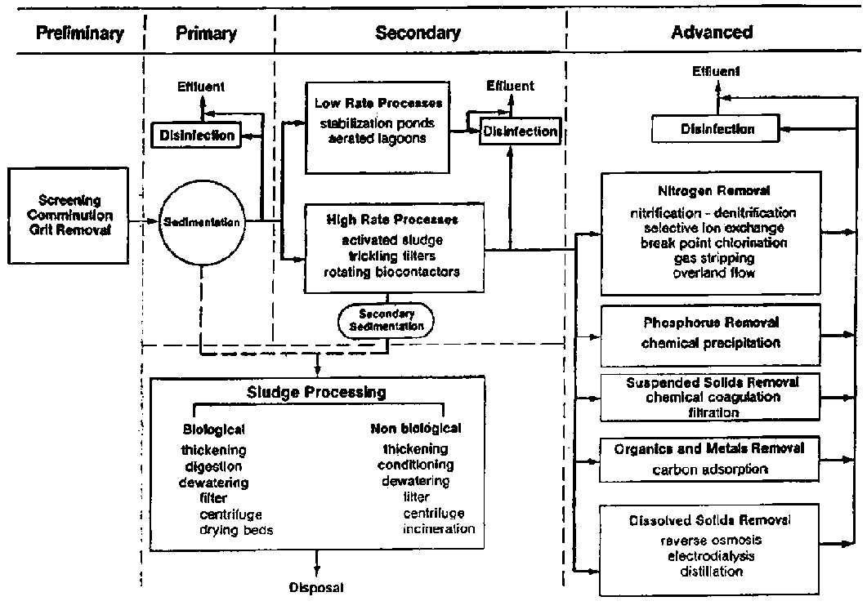
Figure 1 General Flow Chart of Wastewater Treatment Process

WASTEWATER TREATMENT OF CDA SECTOR

Wastewater Generation and Organic Loading Rate
Given Data:
Population = 100,000 persons
Per Capita Demand = 135 lpcd
BOD = 250 mg/l
Calculation:
Wastewater Generation = Q_{avg}= 0.8 * 100000* 135
Q_{avg}= 0.8 * 13,500,000
Q_{avg}= 10800 m³/day
Wastewater Generation/ Flow = Q_{Avg}= 2.85 MGD
Organic Loading Rate = BOD (mg/l) * Flow (MGD) * 8.34 (lb/gal)
= 250*2.85*8.34
Organic Loading Rate = 4942.25 lb/day
OR
Organic Loading Rate = 2241.8 kg/day

Preliminary Treatment
Preliminary treatment operations typically pumping, coarse screening, grit removal and comminution of large objects is applied.
    - Screening and Pumping
The incoming wastewater passes through screening equipment where objects such as rags, wood fragments, plastics, and grease are removed. The material removed is washed and pressed and disposed of in a landfill. The screened wastewater is then pumped to the grit chamber.
    - Grit Removal / Grit Chamber
In this step, heavy but fine material such as sand and gravel are removed from the wastewater. This material is also disposed of in a landfill. In grit chambers, the velocity of the water through the chamber is maintained sufficiently high, or air is used, so as to prevent the settling of most organic solids. Grit removal is not included as a preliminary treatment step in most small wastewater treatment plants.

Comminutors
Comminutors are adopted to supplement coarse screening and serve to reduce the size of large particles so that they will be removed in the form of a sludge in subsequent treatment processes. Flow measurement devices, often standing-wave flumes, are always included at the preliminary treatment stage.

Primary Treatment
The material, which will settle, but at a slower rate than step two, is taken out using large circular tanks called clarifiers. The settled material, called primary sludge, is pumped off the bottom and the wastewater exit the tank from the top. Floating debris such as grease is skimmed off the top and sent with the settled material to digesters. In this step, chemicals are also added to remove phosphorus.
Primary sedimentation tanks or clarifiers may be round or rectangular basins, typically 3 to 5 m deep, with hydraulic retention time between 2 and 3 hours. Settled solids (primary sludge) are normally removed from the bottom of tanks by sludge rakes that scrape the sludge to a central well from which it is pumped to sludge processing units. Scum is swept across the tank surface by water jets or mechanical means from which it is also pumped to sludge processing units. In large sewage treatment plants (> 7600 m3/d in the US), primary sludge is most commonly processed biologically by anaerobic digestion. In the digestion process, anaerobic and facultative bacteria metabolize the organic material in sludge.
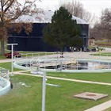
Figure 2 Primary Clarifier

Secondary Treatment
In most cases, secondary treatment follows primary treatment and involves:
- Aeration tank for the removal of biodegradable dissolved and colloidal organic matter using aerobic biological treatment processes
- a secondary clarifier.
Aerobic biological treatment is performed in the presence of oxygen by aerobic microorganisms (principally bacteria) that metabolize the organic matter in the wastewater, thereby producing more microorganisms and inorganic end-products (principally CO₂, NH₃, and H₂O). Several aerobic biological processes are used for secondary treatment differing primarily in the manner in which oxygen is supplied to the microorganisms and in the rate at which organisms metabolize the organic matter. Aerobic Biological Treatment techniques are divided into three main categories: attached growth, suspended growth and combined systems biological treatment. Majorly attached growth and suspended growth processes are used for aeration tank and following are some commonly used methods consisting of attached and suspended growth systems.

Activated Sludge Process (ASP)
In the activated sludge process, the dispersed-growth reactor is an aeration tank or basin containing a suspension of the wastewater and microorganisms, the mixed liquor. The contents of the aeration tank are mixed vigorously by aeration devices which also supply oxygen to the biological suspension. Aeration devices commonly used include submerged diffusers that release compressed air and mechanical surface aerators that introduce air by agitating the liquid surface.
Hydraulic retention time in the aeration tanks usually ranges from 3 to 8 hours but can be higher with high BOD5 wastewaters. Following the aeration step, the microorganisms are separated from the liquid by sedimentation and the clarified liquid is secondary effluent. A portion of the biological sludge is recycled to the aeration basin to maintain a high mixed liquor suspended solids (MLSS) level. The remainder is removed from the process and sent to sludge processing to maintain a relatively constant concentration of microorganisms in the system. Several variations of the basic activated sludge process, such as extended aeration and oxidation ditches, are in common use, but the principles are similar.
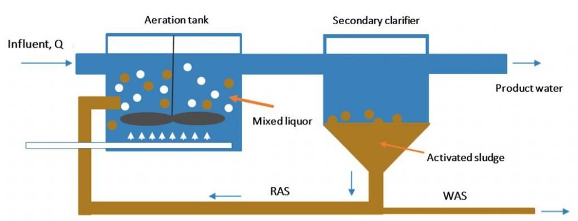
Figure 3 Activated Sludge Process (ASP)

Oxidation Ditch (OD)
An oxidation ditch is a large circular basin equipped with aerators that is used to remove organic matter and pollutants from sewage through the processes of adsorption, oxidation, and decomposition.
- Ensures stable, continuous dissolved oxygen measurements
- Reduces operating costs
- Eliminates the need for manual cleaning
It is the modification of the activated sludge process and consumes high energy but compensated by simplicity of the process. It gives the efficiency up to 97-98 % BOD removal.
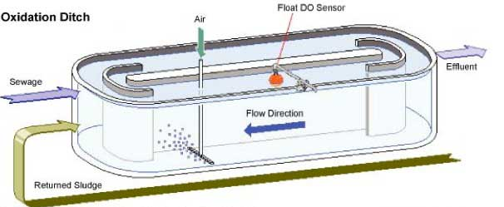
Figure 4 Oxidation Ditch

Trickling Filters (TF)
A trickling filter or biofilter consists of a basin or tower filled with support media such as stones, plastic shapes, or wooden slats. Wastewater is applied intermittently, or sometimes continuously, over the media. Microorganisms become attached to the media and form a biological layer or fixed film. Organic matter in the wastewater diffuses into the film, where it is metabolized. Oxygen is normally supplied to the film by the natural flow of air either up or down through the media, depending on the relative temperatures of the wastewater and ambient air. Forced air can also be supplied by blowers but this is rarely necessary. The thickness of the biofilm increases as new organisms grow. Periodically, portions of the film 'slough off the media. The sloughed material is separated from the liquid in a secondary clarifier and discharged to sludge processing. Clarified liquid from the secondary clarifier is the secondary effluent and a portion is often recycled to the biofilter to improve hydraulic distribution of the wastewater over the filter.
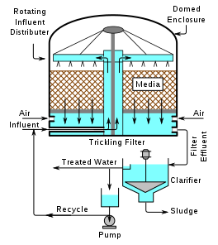
Figure 5 Trickling Filters

Rotating Biological Contactors (RBCs)
Rotating biological contactors (RBCs) are fixed-film reactors similar to biofilters in that organisms are attached to support media. In the case of the RBC, the support media are slowly rotating discs that are partially submerged in flowing wastewater in the reactor. Oxygen is supplied to the attached biofilm from the air when the film is out of the water and from the liquid when submerged, since oxygen is transferred to the wastewater by surface turbulence created by the discs' rotation. Sloughed pieces of biofilm are removed in the same manner described for biofilters.
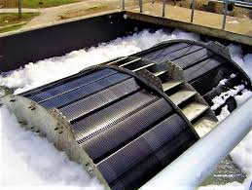
Figure 6 Rotatory Biological Contractors
Table 1 Comparison of Different Wastewater Treatment Technologies
Technology | Advantages | Disadvantages
ASP | - Low installation cost  - Good quality effluent  - Low land requirement  - Loss of head is small  - Freedom from fly and odor nuisance high degree of treatment | - Not very flexible method  - Operation cost is high  - Sludge disposal is required on large scale  - This process is sensitive to certain industrial wastes  - Skilled supervision is required to check that the returned sludge remains active
OD | - Flexible, can adapt to minor pH, organic and temperature changes  - Small Area Required  - Degree of Nitrification is Controllable  - Relatively minor Odor Problem | - High operating Cost  - Generates solid requiring sludge disposal  - Some process alternatives are sensitive to shock load and metallic  - Requires continuous Air supply
TF | - Simple and reliable process that is suitable in areas where large tracts of land are not available for a WSP treatment system  - Effective in treating high concentrations of organic material depending on the type of media used  - Very efficient in removal of ammonia from wastewater  - Appropriate for small- to medium-sized communities | - Additional treatment may be needed for the effluent to meet strict discharge standards  - generates sludge that must be treated and disposed of  - Regular operators’ attention is needed  - Relatively high incidence of clogging  - Relatively low loadings required depending on the media
RBCs | - Simple Operation  - Low Energy Requirements  - Low Head Loss  - Low Solids Generation  - Process Stability with Load Variations  - More Reliable Liquid/Solids Separation  - No Sludge Return  - High contact time and high effluent quality | - Lack of Flexibility  - Sensitivity to Industrial Wastes  - Possible Low Dissolved Oxygen  - Limited Controls  - Limited Experience and Training

Secondary Clarifier
Large circular tanks called secondary clarifiers allow the treated wastewater to separate from the biology from the aeration tanks at this step, yielding an effluent, which is now over 90% treated. The biology (activated sludge) is continuously pumped from the bottom of the clarifiers and returned to the aeration tanks in step four.

Filtration
The clarified effluent is polished in this step by filtering through 10-micron polyester media. The material captured on the surface of the disc filters is periodically backwashed and returned to the head of the plant for treatment.

Disinfection
Disinfection normally involves the injection of a chlorine solution at the head end of a chlorine contact basin. The chlorine dosage depends upon the strength of the wastewater and other actors, but dosages of 5 to 15 mg/l are common. Ozone and ultraviolet (UV) irradiation can also be used for disinfection, but these methods of disinfection are not in common use. Chlorine contact basins are usually rectangular channels, with baffles to prevent short-circuiting, designed to provide a contact time of about 30 minutes. However, to meet advanced wastewater treatment requirements, a chlorine contact time of as long as 120 minutes is sometimes required for specific irrigation uses of reclaimed wastewater. The bactericidal effects of chlorine and other disinfectants are dependent upon pH, contact time, organic content, and effluent temperature.

Effluent storage
Although not considered a step in the treatment process, a storage facility is, in most cases, a critical link between the wastewater treatment plant and the irrigation system. Storage is needed for the following reasons:
- To equalize daily variations in flow from the treatment plant and to store excess when average wastewater flow exceeds irrigation demands; includes winter storage.
- To meet peak irrigation demands in excess of the average wastewater flow.
- To minimize the effects of disruptions in the operations of the treatment plant and irrigation system. Storage is used to provide insurance against the possibility of unsuitable reclaimed wastewater entering the irrigation system and to provide additional time to resolve temporary water quality problems.
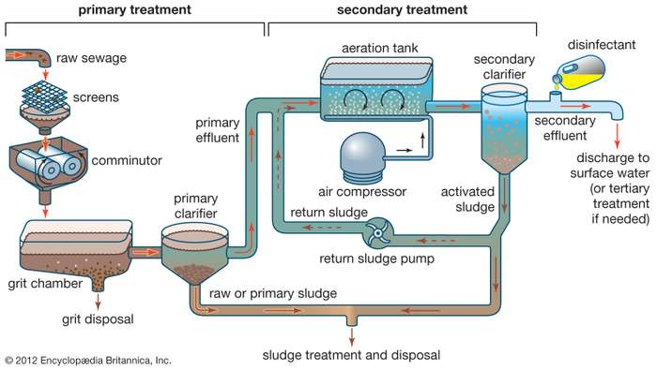
Figure 7 Selected Wastewater Treatment (ASP) for CDA Sector

Sludge Treatment and Disposal
The residue that accumulates in sewage treatment plants is called sludge (or biosolids). Sewage sludge is the solid, semisolid, or slurry residual material that is produced as a by-product of wastewater treatment processes. This residue is commonly classified as primary and secondary sludge. Primary sludge is generated from chemical precipitation, sedimentation, and other primary processes, whereas secondary sludge is the activated waste biomass resulting from biological treatments. Treatment of sewage sludge may include a combination of thickening, digestion, and dewatering processes.

Thickening
Thickening is usually the first step in sludge treatment because it is impractical to handle thin sludge, a slurry of solids suspended in water. Thickening is usually accomplished in a tank called a gravity thickener. A thickener can reduce the total volume of sludge to less than half the original volume.

Digestion
Sludge digestion is a biological process in which organic solids are decomposed into stable substances. Digestion reduces the total mass of solids, destroys pathogens, and makes it easier to dewater or dry the sludge. Digested sludge is inoffensive, having the appearance and characteristics of a rich potting soil.
Most large sewage treatment plants use a two-stage digestion system in which organics are metabolized by bacteria anaerobically (in the absence of oxygen). In the first stage, the sludge, thickened to a dry solids (DS) content of about 5 percent, is heated and mixed in a closed tank for several days. Acid-forming bacteria hydrolyze large molecules such as proteins and lipids, breaking them into smaller water-soluble molecules, and then ferment those smaller molecules into various fatty acids. The sludge then flows into a second tank, where the dissolved matter is converted by other bacteria into biogas, a mixture of carbon dioxide and methane. Methane is combustible and is used as a fuel to heat the first digestion tank as well as to generate electricity for the plant.

Dewatering
Digested sewage sludge is usually dewatered before disposal. Dewatered sludge still contains a significant amount of water often as much as 70 percent but, even with that moisture content, sludge no longer behaves as a liquid and can be handled as a solid material. Sludge-drying beds provide the simplest method of dewatering. A digested sludge slurry is spread on an open bed of sand and allowed to remain until dry. Drying takes place by a combination of evaporation and gravity drainage through the sand.

Disposal
The final destination of treated sewage sludge usually is the land. Dewatered sludge can be buried underground in a sanitary landfill. It also may be spread on agricultural land in order to make use of its value as a soil conditioner and fertilizer. Since sludge may contain toxic industrial chemicals, it is not spread on land where crops are grown for human consumption.

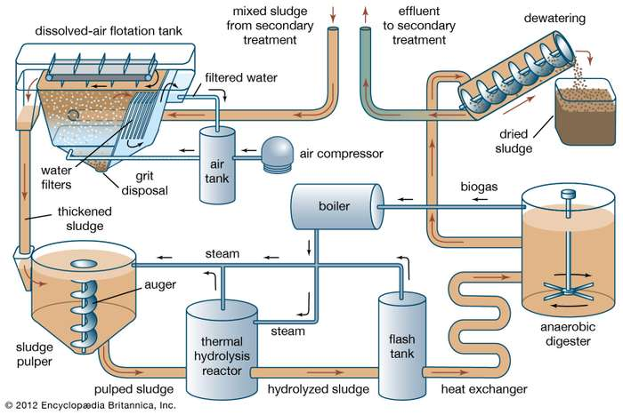
Figure 8 Sludge Treatment and Disposal

REFERENECES
- Cema, G., Żabczyński, S., &Ziembińska-Buczyńska, A. (2016). The assessment of the coke wastewater treatment efficacy in rotating biological contractor. Water Science and Technology, 73(5), 1202-1210.
- Rouse, J. D., Yazaki, D., Cheng, Y., Koyama, T., & Furukawa, K. (2004). Swim-bed technology as an innovative attached-growth process for high-rate wastewater treatment. Japanese Journal of Water Treatment Biology, 40(3), 115-124.
- Mohan, S. V., Rao, N. C., Prasad, K. K., Madhavi, B. T. V., & Sharma, P. N. (2005). Treatment of complex chemical wastewater in a sequencing batch reactor (SBR) with an aerobic suspended growth configuration. Process Biochemistry, 40(5), 1501-1508.
- Henze, M. (1992). Characterization of wastewater for modelling of activated sludge processes. Water Science and Technology, 25(6), 1-15.
- Naz, I., Saroj, D. P., Mumtaz, S., Ali, N., & Ahmed, S. (2015). Assessment of biological trickling filter systems with various packing materials for improved wastewater treatment. Environmental Technology, 36(4), 424-434.

