Structural Design & Risk Management

S M Nazmuz Sakib
Graduate of BSc in Business Studies
School of Business And Trade
Pilatusstrasse 6003, 6003 Luzern, Switzerland
sakibpedia@gmail.com

Student of Department of Law
Dhaka International University
House # 4, Road # 1, Block - F, Dhaka 1213
sakibpedia@students.diu.ac

Abstract

This article discusses the structural design of concrete, verification, load paths, calculations etc. with the risk and sustainability issues.
In the local city center, a multi-storey residential building project in the area of ​​waterfront regeneration, which is the 2020 project. In the area of ​​revitalization of the waterfront of the local city center, a scheme was developed for the "Monier Tower" for a "22-storey" residential tower. The building has two floors of retail space on the ground floor and first floor and a single-storey basement. On the side of the old docklands is a new tower situated in the area of ​​reconstruction near the waterfront.
Manageability is the ability of an association to wait for its task or program to go far into what is to come. There are different classes of specialized or design data. A specific commitment is a necessary prerequisite as a record or set of reported needs to be met by a given material, plan, item, administration. Model types of associations include partnerships, associations, exchanges, national government, expertise, association of principles based on reasons, such as ISO, or impartial vendor settings. It is public that one association mentions the gauges of another.

Keywords: sustainability, risk management, risk issues, risk, structural design, manageability research.

Section 01

Structural Design & Risk Management

1.1 Introduction:
In a local city center , a multistory residential building project in a waterfront
regeneration area which is a 2020 project. Two story of retail area with studio, two and one bedroom apartment above, with double story penthouse apartments which are four in number provided in the building. If consultant’s team need feedback from participant then participant must respond.

In the waterfront revitalization area of a local city center, there developed a scheme
for a “Monier Tower” for a “22-story” residential tower. Building has two story of retail area at ground and first floor and one story basement. The residential tower consisting of one and two bedroom apartments and a studio comes off a podium deck at level 2. The Tower’s one face is sloping up to 18th level. It is a garden level with four story block rising from the garden level, covering a penthouse apartment of two story.

Within the side of old docklands there is a new tower situated in a redevelopment
area close to waterfront. To take account of location of seaside any external concrete should must be considered to be in exposure class XS1. The car parked in the basement is accessed via ramp in north west corner of the site and needs to provide spaces for car parking of thirty and sixty in number respectively. The car parking should not be used by the users of the retail space and must be used for the residents of the tower (E. N. C. Perera, D. T. Jayawardana & P. Jayasingh, 2019).

The columns with a minimum spacing of 8m and 4m height of floor to ceiling for the merchandising space which is at Ground and Level-1. Provided access between Level 1 and the Ground should be different from the housing units above and of the car parking situated in the basement. It must be consist of two escalators , two lifts and the stair core as well and these must also be located in the best possible position within the space (Sanket Nayak & Obula Reddy, 2013).

Basement and housing levels will be through two lifts with one lift only be used for
firefighting and also an essential stair case. On top levels, the penthouse will have shared lift and staircase and with inner staircases between the floors

At Level 9, the architect has provided a typical layout for both the penthouse levels
and the apartments. North façade is sloping while the other levels will going to be similar, to suit smaller
area we should revise the layouts towards the top of the tower. On upper level, number of apartments thus will be reduced. Within the walls on the architect’s plan we will place the structure.

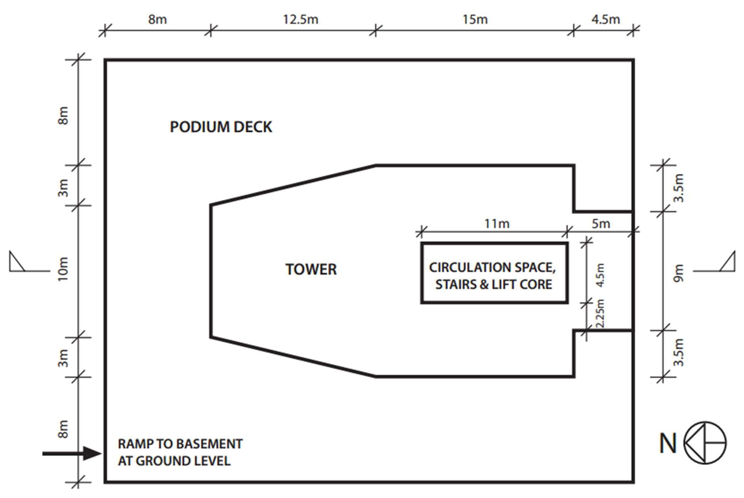
Fig. 1.1 Podium / Tower Level 2

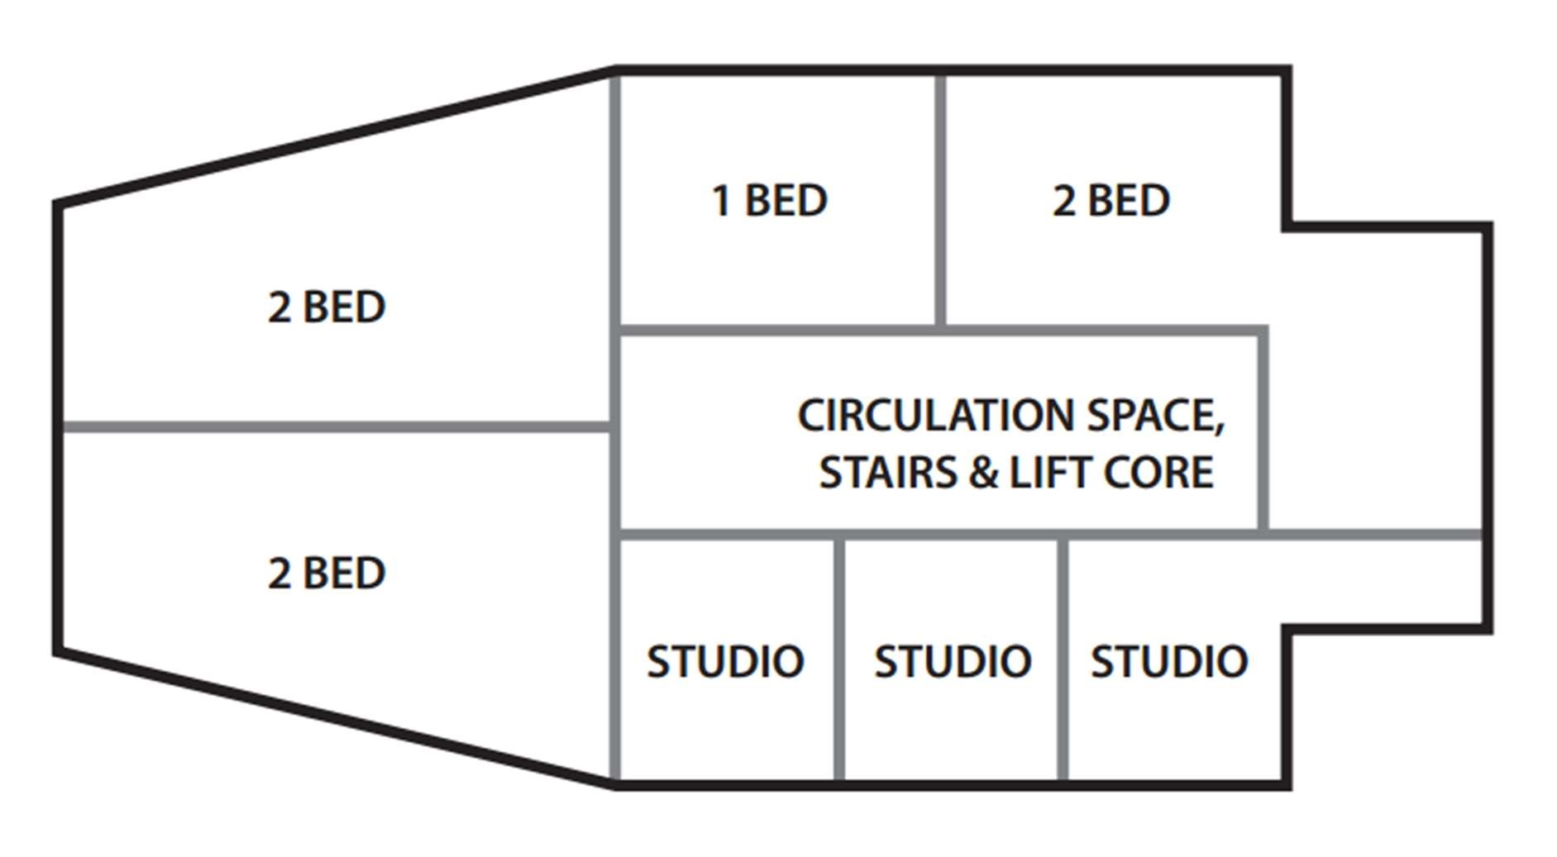
Fig. 1.2 Architect’s layout for Level 9

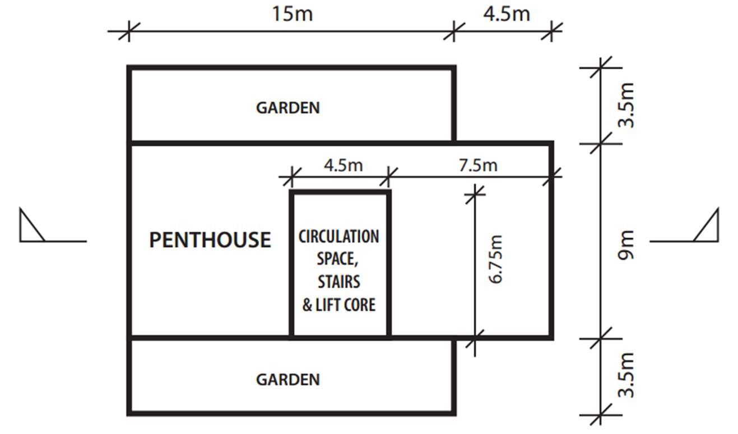
Fig. 1.3 Garden / Penthouse Level 18

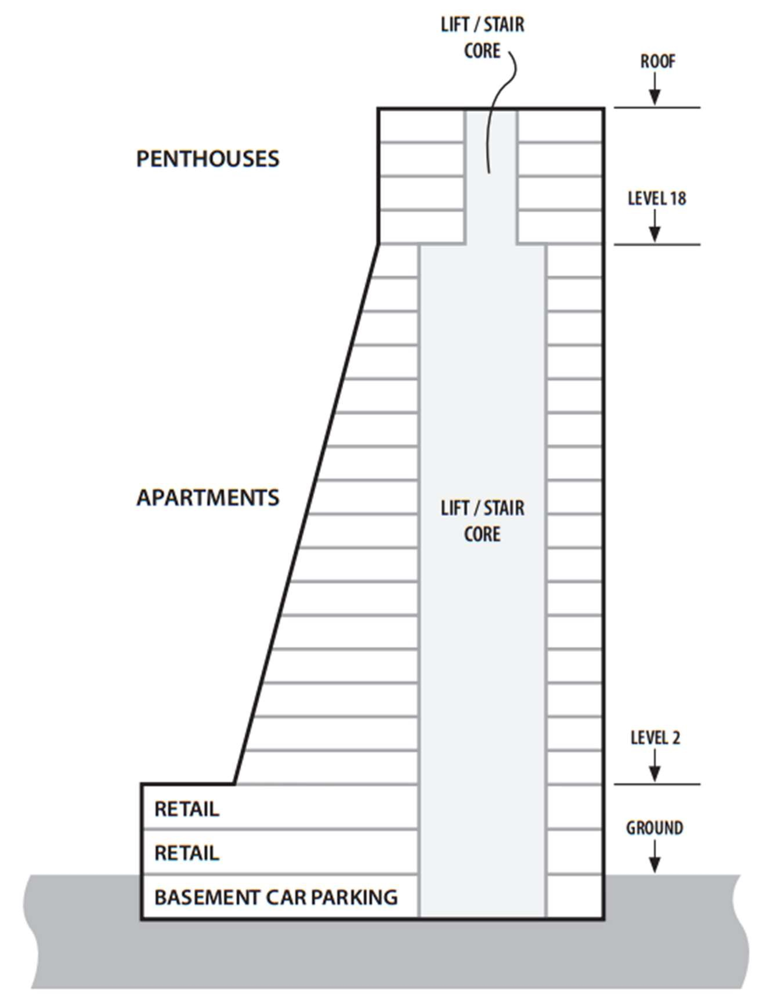
Fig. 1.4 Cross section through building
1.2 Building Features:
We designed this building for reinforcement cement concrete and it’s a frame structure
multistory building. The foundation of this building consists of raft which depends on the soil conditions and also on the piles. All the frame structure of the building will be designed as reinforcement design of building consists on the beam, slab of concrete and steel. The load of the frame structure buildings is transferred by transferring though slab to the beams and then the load of the beams is transferred to the columns. The steel structure of this building will also be designed but as for assignment we have
chosen to design as a concrete structure (Charlotte de Fraiture, 2019).

1.3 Structural Concrete:
Structural concrete for this building is considers to as exposure to the weather and
located to near the ocean so weather conditions and wind effect will be consider in the design of concrete type and properties. The new tower on a prominent site in a revitalization area which is situated near waterfront within the premises of the old docklands. And any external concrete should be considered to be in exposure class XS1 to take account of the seaside location. Different types of concrete depending on the strength tested in laborites for gain a required strength of the concrete for using Design Strength for design of structural steel required for columns, beams and slabs etc. (C.B Wilby, 1983) Usually 4000psi, 5000psi or 6000psi strength concrete is used for frame structural building or also used for the residential buildings. We will give the design strength of concrete in this report when gives calculations of design.

1.4 Building Connectivity of Structure:
Building Connectivity of Structure is defines by parts by which construction of columns, beams, and slab of building. Connectivity of building is start from the foundation of building as first of all the foundation is created which is help to stable all the structure or floors of building by connecting the column to the foundation or erection of column from foundation. These columns then connect the beams and slab which is casting monolithically on the site and column size and beam connectivity depending on the design and shape of building. To make a good connectivity of the building with each element or part of building steel reinforcement connected by overlapping or bending to the next element of building. This steel reinforcement is connected by welding of bars or binding by hooks after overlapping. When steel connections is prepared then the pouring of concrete made an strengthen joint of building parts like slab, beam and columns (Michael D. Kotsovos, 2017).

1.5 Stability of the Tower:
Building Connectivity of Structure is defines by parts by which construction of
columns, beams, and slab of building. Connectivity of building is start from the foundation of building and stability is depend on the type of foundation and load distribution of the members and floor of building. Wind load as well as the effect of earthquake is also considered in the design of building according to structural concrete design. And settlement of soil is also depend on the type of soil and test report of soil of the tower near the ocean. Stability of the tower is also depend on the type of materials used in the construction and also depends on the strength and properties of materials. In this multistory tower construction mainly two materials concrete and steel are important which will be depend on the stability of tower.

1.6 Structural Element:
Structural elements for tower frame structure which consist on foundation, columns, beams, slab and retaining wall etc. Foundation of the tower is important element which will bears the load of whole building and also transfer the load to the soil. And foundation take whole building load from the columns which takes load from beams and slabs. Column of tower may be rectangular or circular depending on the shape of building and use of space or area in the building and also decoration required for the interior of the building. We use for the tower project rectangular shape of columns and size of column will be reduce as on the moving to upper floor of building. Size of building is also depend on the load of building. Beams of tower may be different in size reliant on the load on beam and span of the beams (M.D. Kotsovos & M.N. Pavlovic, 1999). Structural Design of beams may be singly reinforcement or doubly reinforcement depending on the required depth of beam. Slab thickness of each floor is also depending on the span of each span. Retaining wall of basement on tower design as the thrust of the soil on the wall.

1.7 Construction Methodology:
Construction methodology use for tower construction is same as project management process but here we give some point about methodology (Furlong, R W, 1948). Use this process regularly as:-
- Modernize plans, genuine costs, risks and opportunities, performance metrics.
- Seek feedback from customer.
- Review these internally with the project.
- Review these with senior management.

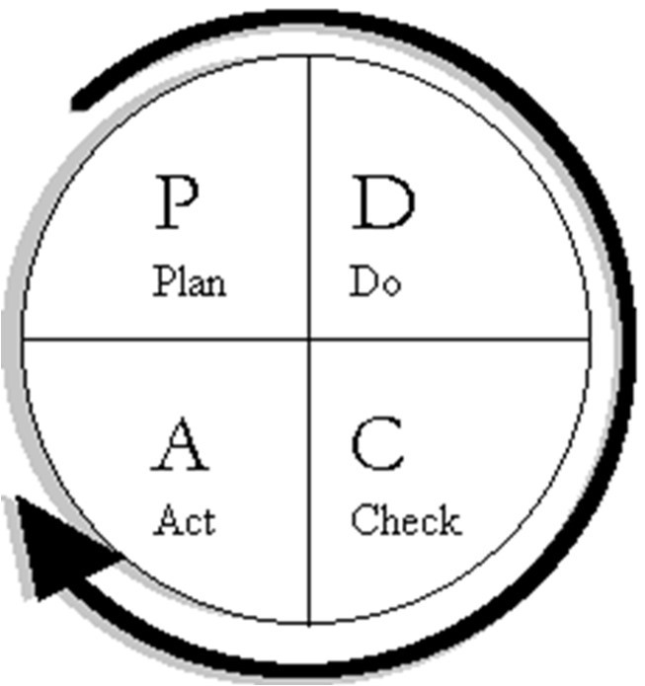
Fig. 1.5 Deming Cycle for Project
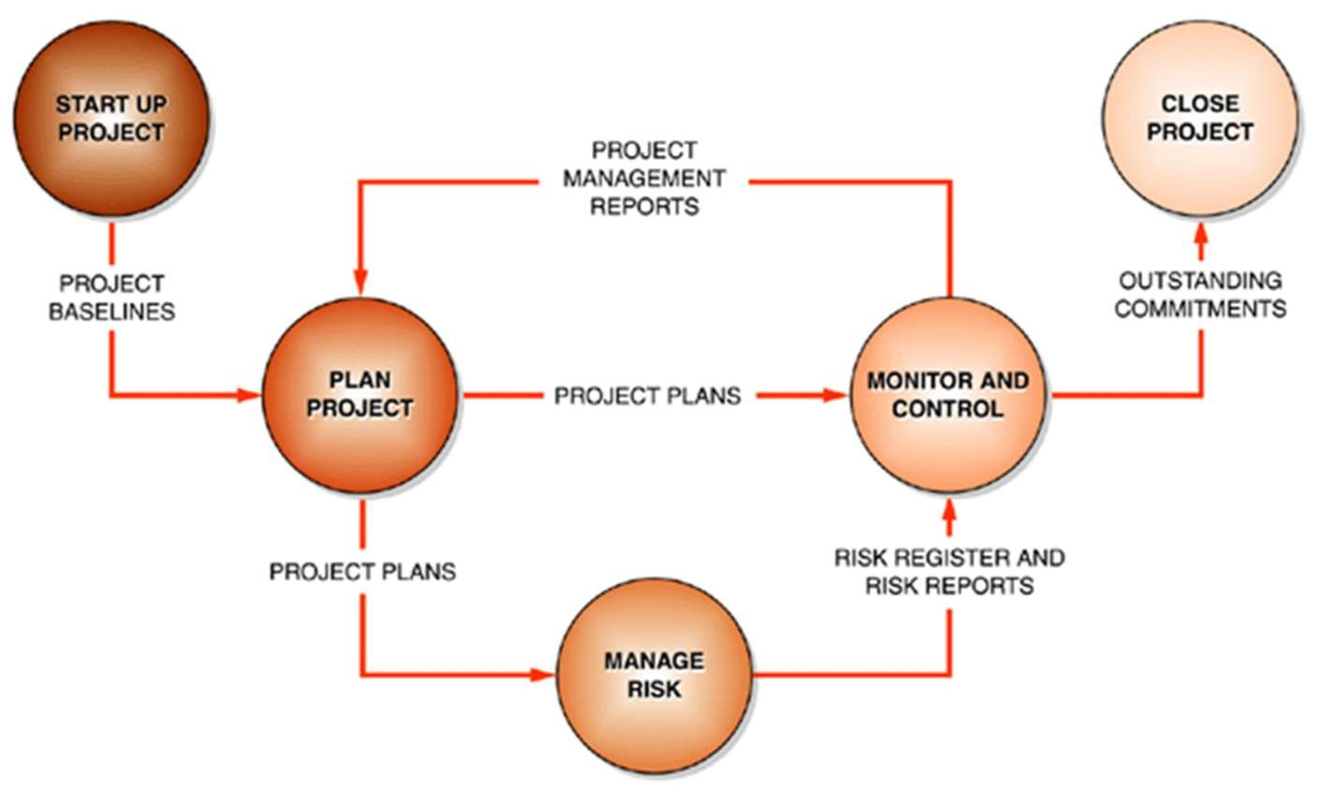
Fig. 1.6 Project Management Data Flow Diagram

These are the main points to startup Project from initial stage:-
- Review lessons learned
- Establish key success criteria
- Plan the project
- Develop the Integrated Management Plan
- Review risks and opportunities
- Assemble the project team ➢ Launch the project.
Construction methodology
- Office/Historical Data Collection
- Initial Site Visit
- Primary Field Survey
- Initial Data Analysis
- Secondary Field Survey
- Laboratory Materials Characterization
- Secondary Data Analysis
- Structural Capacity Analysis
1.8 Merits and Disadvantages:
Frame structure building have many merits and disadvantages depending on design of building but here we discuss only merits and disadvantages of the Monier Tower Design.

➢ Merits
- Monier Tower structure is design according to frame structure which each element is connected to each other to increase stability of structure.
- Each floor is constructed by separately by columns, beams and slab etc. which help to monolithic construction of building.
- Frame structure of Tower is help to transfer of load of each floor of building to foundation.
- Concrete is best choice for occur shape of building according to design or exterior view by property of concrete that it help to achieve any shape of building.
- Reinforcement (Steel) is also help to gain any shape of building by ductile property and it can also bent in any shape to made any shape of building.
- Analysis of frame structure is easy to check the stability of tower by using the mechanic
of structure theories and formulas (Kong, F & EVANS, R H, 1983). ➢ Disadvantages
- Monier Tower structure design by frame structure and it is constructed according to design by concrete structure this concrete building increase the Dead load of building so as compare with steel structure of building frame is decrease the dead load.
- Concrete structure of the tower is difficult to bear the impact load and earthquake thrust so when these loading are occurs concrete structure damage by the cracks in the concrete elements like column, beams and slab etc.
- In the construction of upper floors of building it is very difficult to reach the concrete to the upper floors.
- If the one side of building is overload according to the load on each column then the settlement of soil will be occur and differential settlement of foundation will occur and result will be fail of whole structure of building.
1.9 Significant Differences:
We design Monier Tower as frame structure multistory building and design according to the Concrete structure so significant of tower same as concrete significant for construction of the frame structure of building. And differences between the frame structure and stability of building as property of the concrete structure consider according to the steel structure of the building (C.B Wilby,
1983). Some Significant differences of tower compare with steel structure building are given below:- ➢ Concrete structures rise the dead load of the building as compared to the steel structures.
- Concrete structures buildings age is very larger as compare with the steel structures buildings.
- Construction process of concrete structure of tower is too large time is required as compare with the steel structure.
- Concrete structures help to gain shape of building easy as compare with the steel structure.

  - Recommendation:
Monier Tower is design as concrete structure so we recommended that it will required
to constructed it as steel structure. Because concrete structure is increase the load of building as compare with the steel structure. And also concrete structure building is costly as compare with the steel structure building. We recommended that Tower basement, ground floor and first floor design for concrete structure and the uppers stories design for steel structure to achieve best structure of the building
(Ahmad Shayan & Aimin Xu, 2002).

  - Foundation Scheme:
Monier Tower foundation will be consist on the pile foundation and the raft combination. The foundation which is used most of the times is raft foundation. This type of foundation is also known as Mat foundation. The brief theory, working principle, types, materials, construction steps and when to choose raft foundation are given as follows.
Introduction to Raft Foundation:
It is basically a slab of concrete laid on a good amount of soil reinforced with the help of steel. The load is transferred from the structure to soil with the help of it and can also supports walls or columns. In general, we put mat foundation on overall region of the structure.
How Raft Foundation Works?
It divides the whole load from building to the ground floor. Total weight of mat foundation and the structure is being calculated and after calculation we will divide it by overall area covered of the foundation by which soil stress is being calculated. Area of interaction is very much larger when it is compared with some other types of the foundation and thus resulting in very much lesser soil stress and failure chances are being reduced in this way.
At what time we should use Raft Foundation?
Most important thing in designing any foundation is to that if the particular selected foundation is accurate or not. The Raft foundation is the best possible foundation for the given scenario because the soil has a low bearing capacity. Structural load has to be circulated in excess of a big area.
Half of the total ground area under the structure is covered by any other utilized foundation. Footings of an individual might overlay as walls are located so close. Thus in this scenario , the raft foundation is the most effective and best suited.
Raft Foundation of different types:
- Flat plate mat
- Thickened plate under the pier/column
- Beam(2-way) and slab Raft
- Plate raft including pedestals
- Piled raft
- Raft Foundation of cellular type.

1.12 Specification for Concrete:
Many type of concrete used in building for achieve different purposes but for the Monier Tower concrete will be exposure class XS1 due to construction near the seaside. Exposure classification of concrete is given below:-
- XC: Corrosion persuaded by carbonation
- XD: Corrosion persuaded by chlorides
- XS: Corrosion persuaded by chlorides from sea
- XF: Freeze-thaw outbreak/attack
- AC: Chemical outbreak/attack

Purpose for the performance properties for concrete depends upon the identification
of following necessities:
Exposure Conditions that are applicable:
Environmental conditions must be evaluated by the designer that the concrete might face over a certain period of time and also the owner might help in the future productivity of concrete.

Requirements for the structure:
Minimum properties of the concrete are needed to be fixed by the designer to get closer to the loading requirements.

Requirements for architecture:
Designer must also take this into his consideration if the architectural finishes on concrete properties that are practically applicable.
Requirements for the minimum durability:
Designer must select/choose the best possible concrete considering the durability to its higher preference for accurate and effective results.

1.13 Specification for Reinforcing Materials:
Concrete can be strengthen by using many of the material. Deformed bars can be used for the purpose reinforcement. Theses strengthened concrete are rarely being subjected to natural disasters like earthquake during their whole life time period (M.D. Kotsovos & M.N. Pavlovic, 1999).

For this concrete to be resilience to the earthquakes it must have a great meticulousness because the critical moment of the seismic event will going to test the structure for the limits of its power and hence proving that application must be thorough for all the rules of the reinforced concrete.
The basic provisions reinforcement of anti-seismic are four and are given as follows:
- Reinforcement for the concrete cover.
- The shortest distance between reinforcement bars.
- Bending of rebars (Gradually)
- The anti-seismic stirrups.

1.14 Construction Procedure:
Construction procedure consist on different phases or stages some stages given below:-
- Formulate construction site and pour the foundation
- Construct rough framing
- Complete rough plumbing, electrical and HVAC
- Install insulation
- Complete drywall and interior textures
- Finish interior trim
- Install hard-surface flooring and countertops, and complete exterior grading
- Finish mechanical trims
- Install mirrors, shower doors and finish flooring, and finish exterior landscaping ➢ Final walkthrough with the builder

1.15 Robustness to avoid disproportionate collapse:
The ability of the structure to withstand the events just like explosives, fire and human error is known as Robustness. The structure for which is to be robust should not face any failure under the loading which is done unintended. Large panel systems and buildings for precast concrete are in more danger of being collapsing. The type of the given structure depends on what kind of robust structure should be made as if your given building is steel farmed then robustness is achieved by the help link between frame’s elements.

1.16 Letter to the client :

[DATE OF LETTER]
[CONTACT NAME]
[CLIENT NAME]
[ADDRESS]

Dear [CLIENT NAME],

We know that understanding creative projects necessitates an exceptional blend of effort, determination, ability and nominal knowledge so at the firm (Architect Firm) we may only employ the best to make it sure that we provide the most accurate and the most efficient solution.
(Architect Firm) takes pride on turning the projects in reality for the given period of time and remaining in the boundaries of the specified budget so if you would like to communicate with a big list of our satisfied customers/clients then please do let us know about it. We are confident enough to talk to you and would love to listen from your side as well. For further satisfaction, you can check our portfolio for our recent work.
In the Monier Tower we provide staircase, lifts and escalators as shown in the design of building. You are want to provide an extra staircase use in case of Fire from the Basement to Level 17 of the Tower. If we provide an Emergency staircase in the tower in the exterior ends. Then use design will be affected and Apartments floors will be affected. But if you want to provide emergency staircase then we will try to provide it in the building. But we need to revise the design and may also need to redesign of the whole Tower floors from the Basement to the level 17
The client’s satisfaction is our first priority and we take care of our all clients and work reasonably well for designing any sort of shape or structure with highly technical professionals at a very reasonable cost as well. Our designing and planning is pretty much environment friendly to make your building as beautiful as possible.
In case of any query do contact us without any hesitation and do give us your feedback we can cover up our mistakes and make things better to your satisfactory level. We are optimistic that your response will be a positive one and you might give us the chance to deliver you on time.

Yours Truly,
[ARCHITECT FIRM]

Signature

Section 02

VERIFICATION OF STRUCTURAL VIABILITY 2.1 Appendices:

2.1.1 Appendix 1
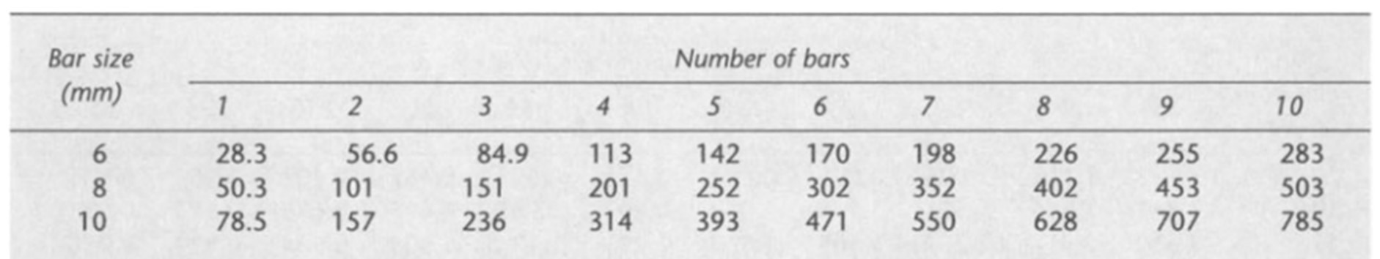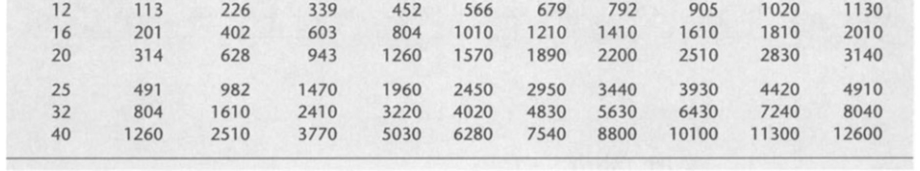
Appendix 1 Sectional areas of groups of bars (mm²) 2.1.2 Appendix 2
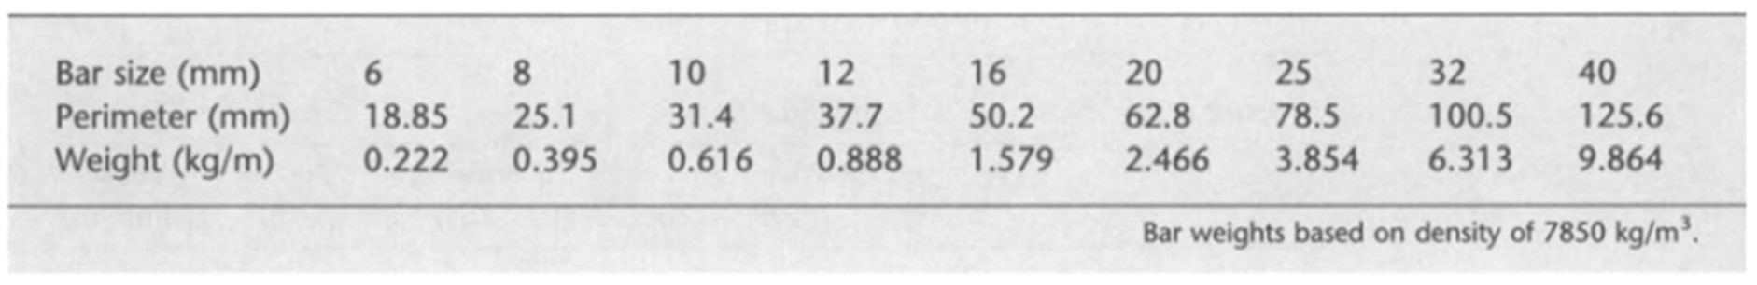
Appendix 2 Perimeters and weights of bars 2.1.3 Appendix 3
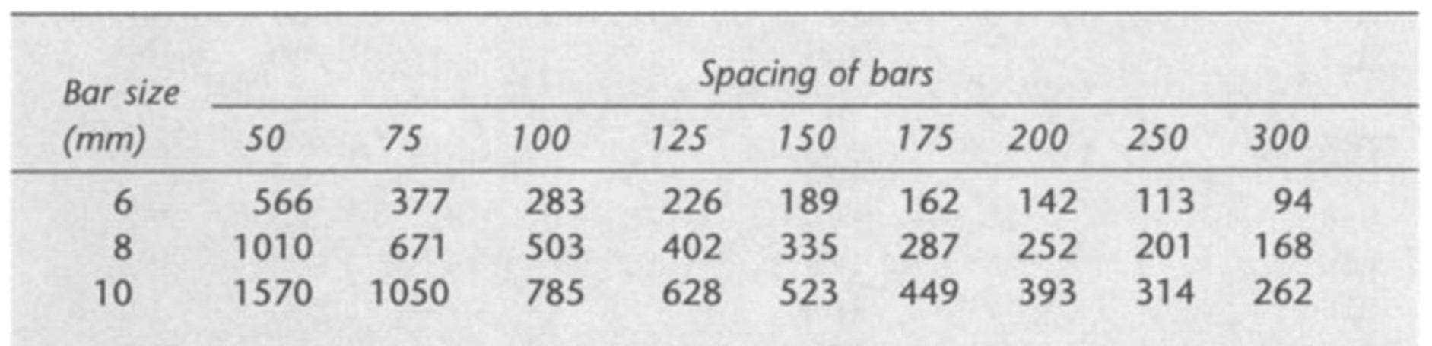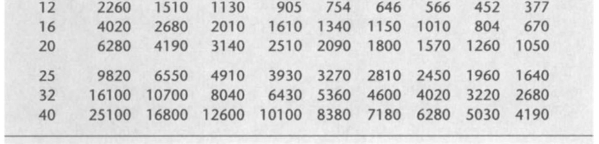
Appendix 3 Sectional areas per meter width for various bar spacings (mm²)

2.1.4 Appendix 4
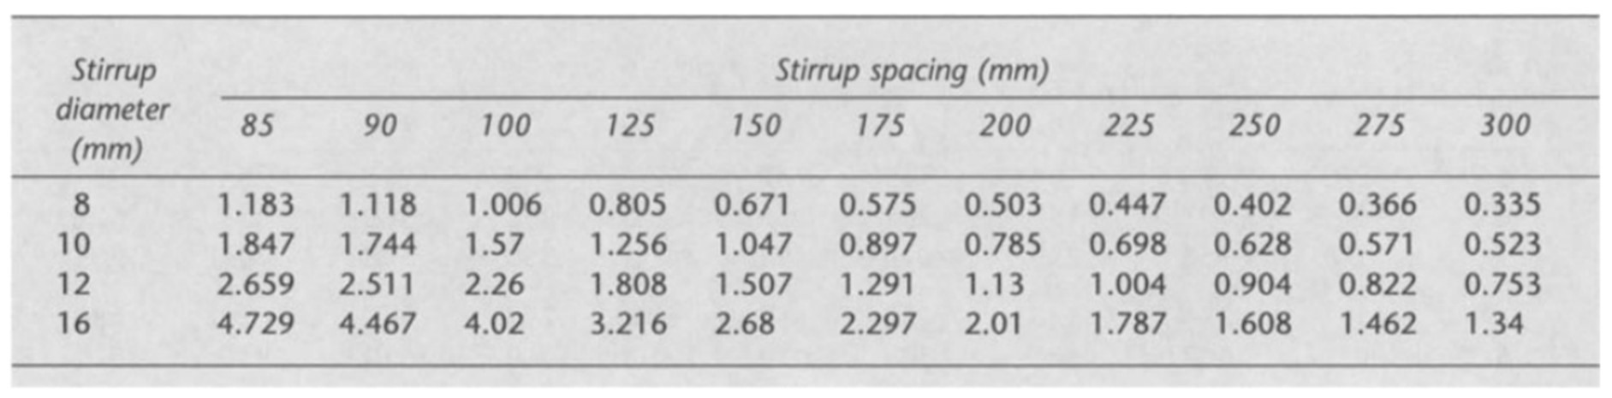
Appendix 4 Shear reinforcement A_{sv}/S_{v} for varying stirrup diameter and spacing 2.1.5 Appendix 5
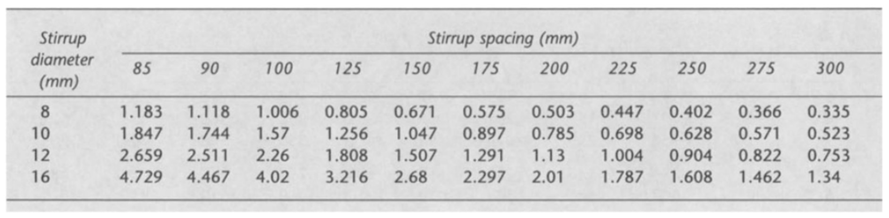
Appendix 5 Anchorage lengths (anchorage length L = K_{Ax} bar size) 2.1.6 Appendix 6
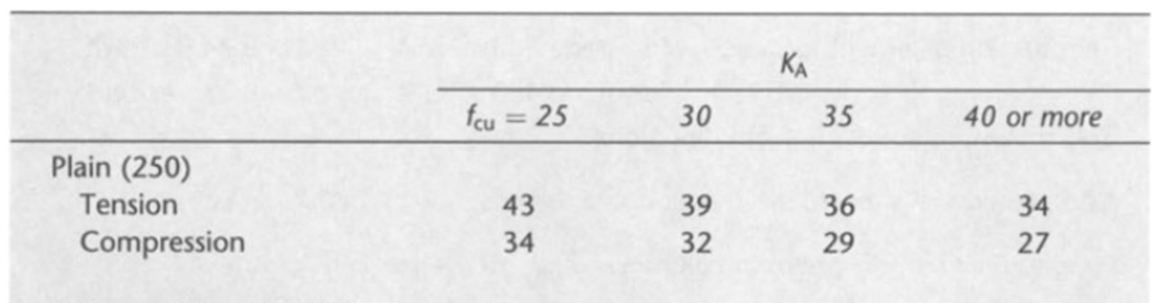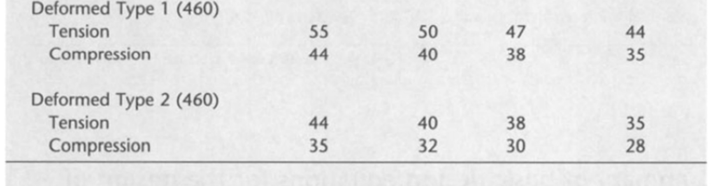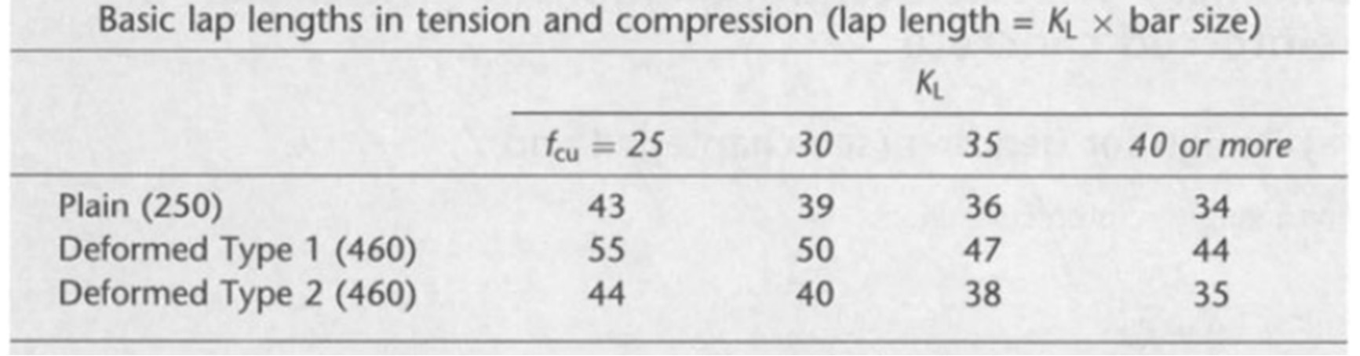
Appendix 6 Anchorage lengths (anchorage length L = K_{Ax} bar size)

2.1.7 Appendix 7
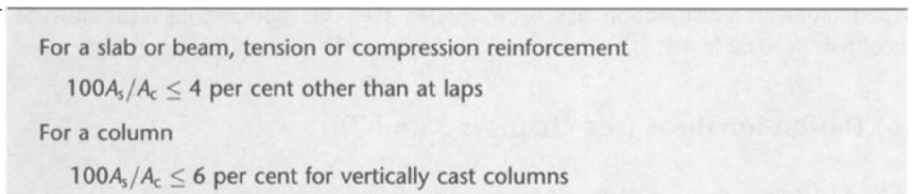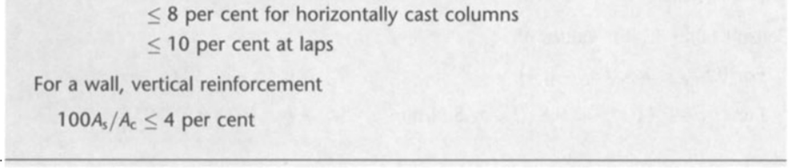
Appendix 7 Maximum areas of reinforcement 2.1.8 Appendix 8
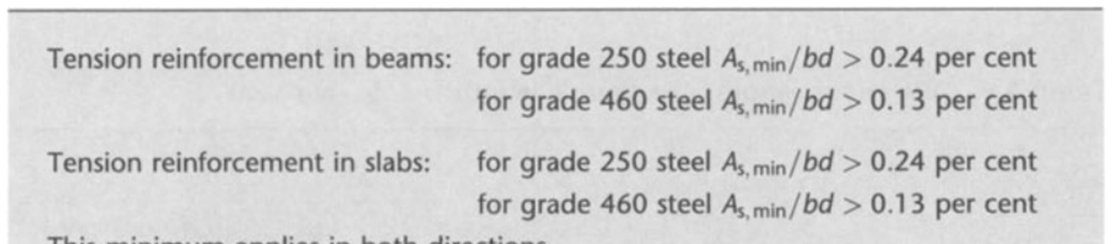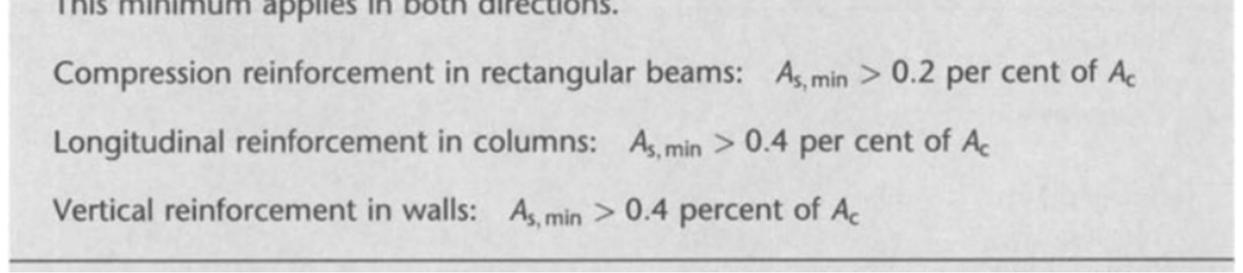
Appendix 8 Minimum areas of reinforcement

2.2 Load paths:
Load on each floor and the load path is given on the next pages.

2.3.1 Imposed Load Podium / Tower Level 2
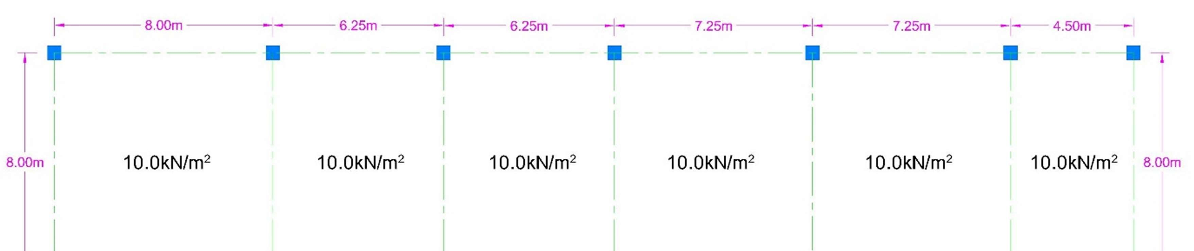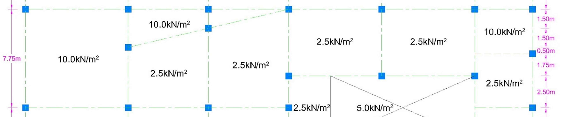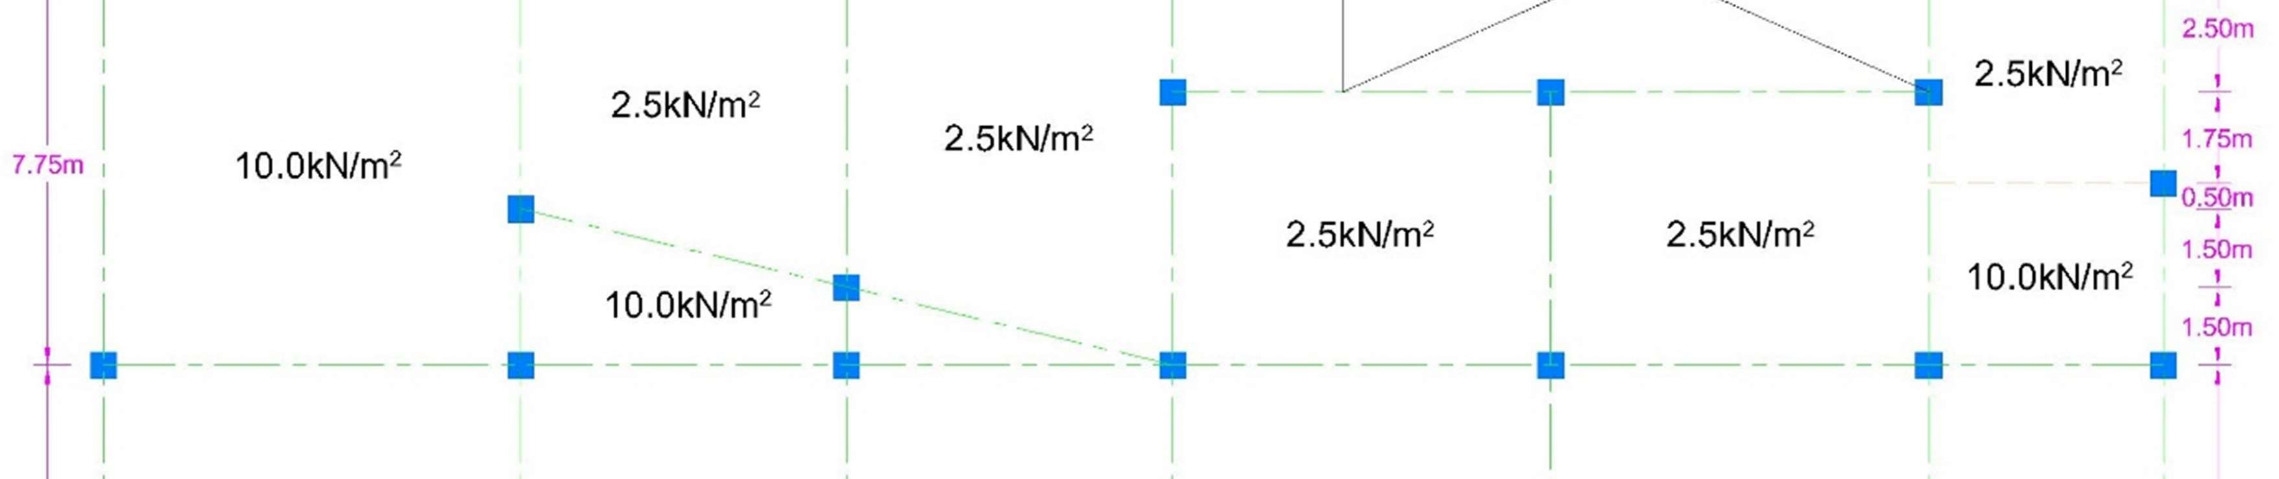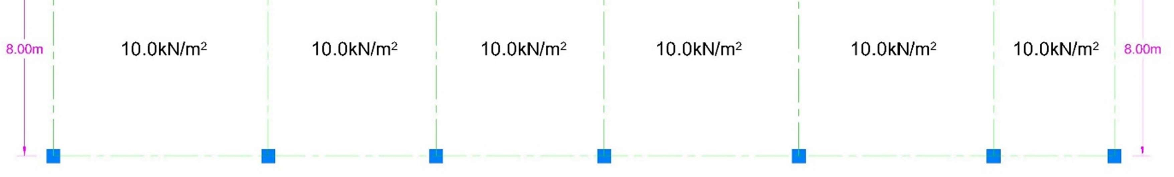
Fig. 2.1 Imposed Load Podium / Tower Level 2

2.3.2 Imposed Load Level 9
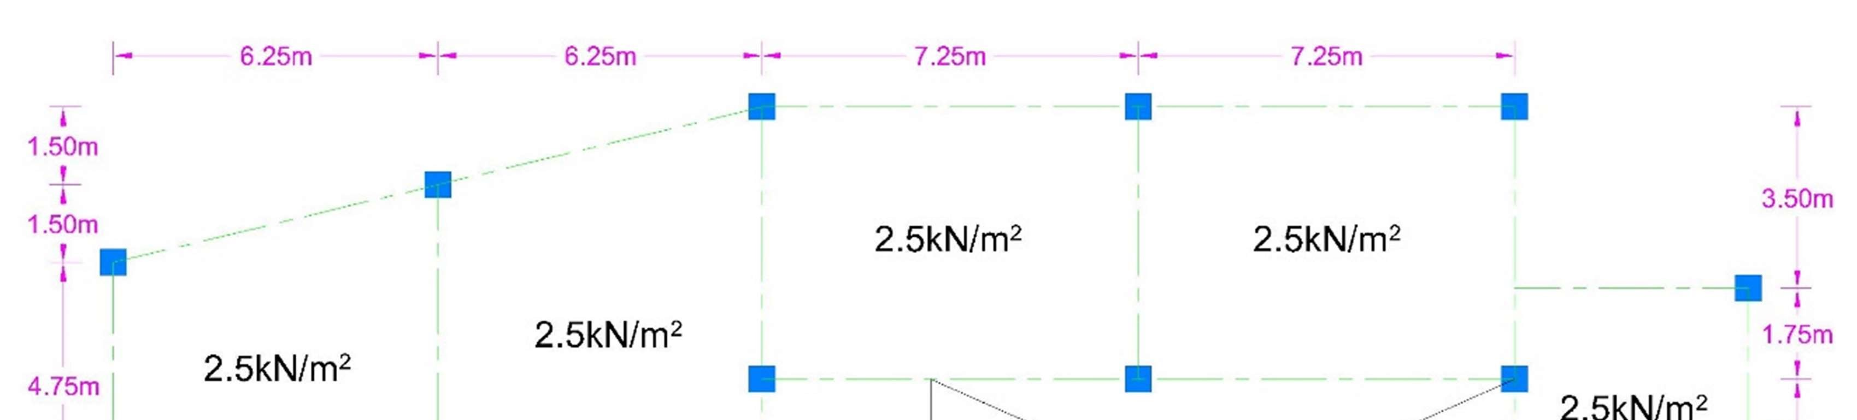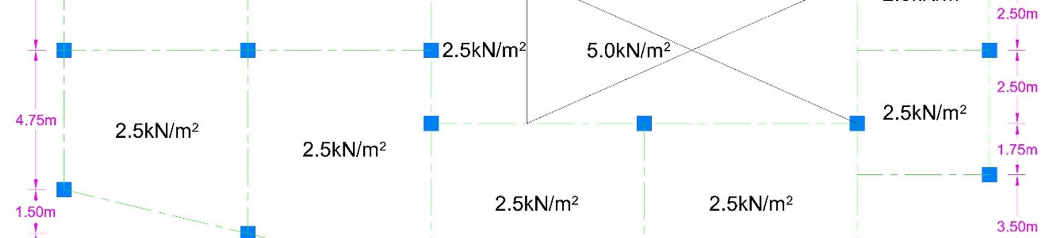
Fig. 2.2 Imposed Load Level 9

2.3.3 Imposed Load Level 18
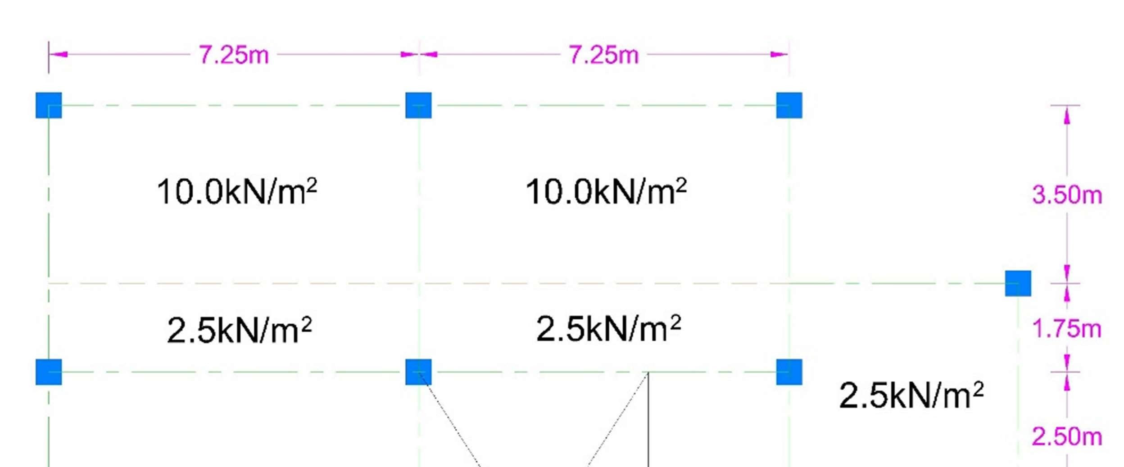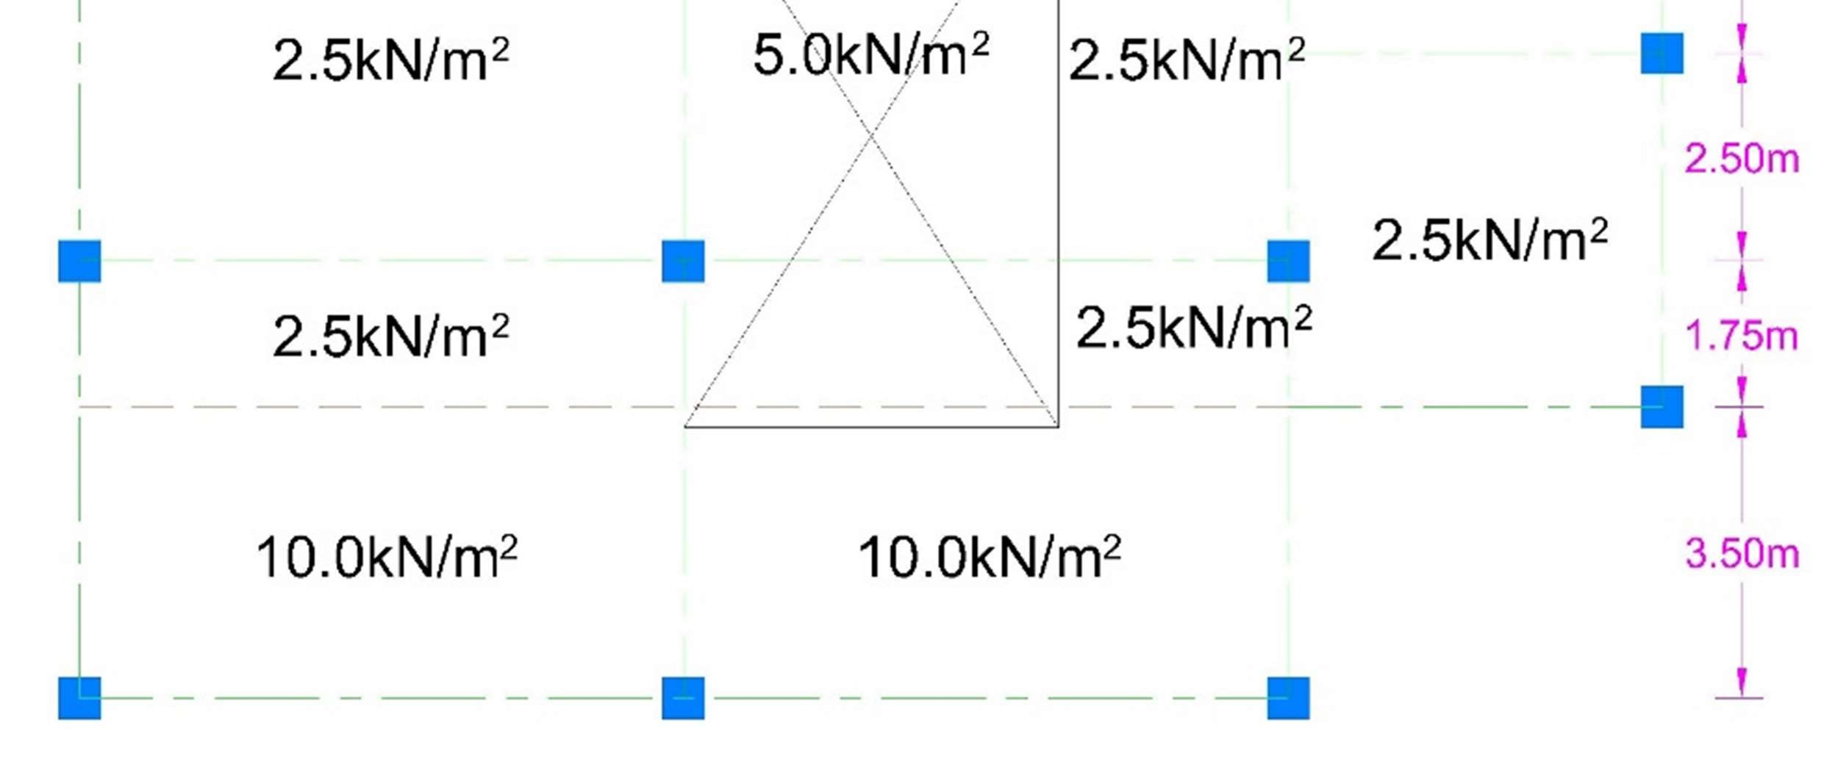
Fig. 2.3 Imposed Load Level 18

2.3.4 Vertical Load Path at Section of Building Section Line
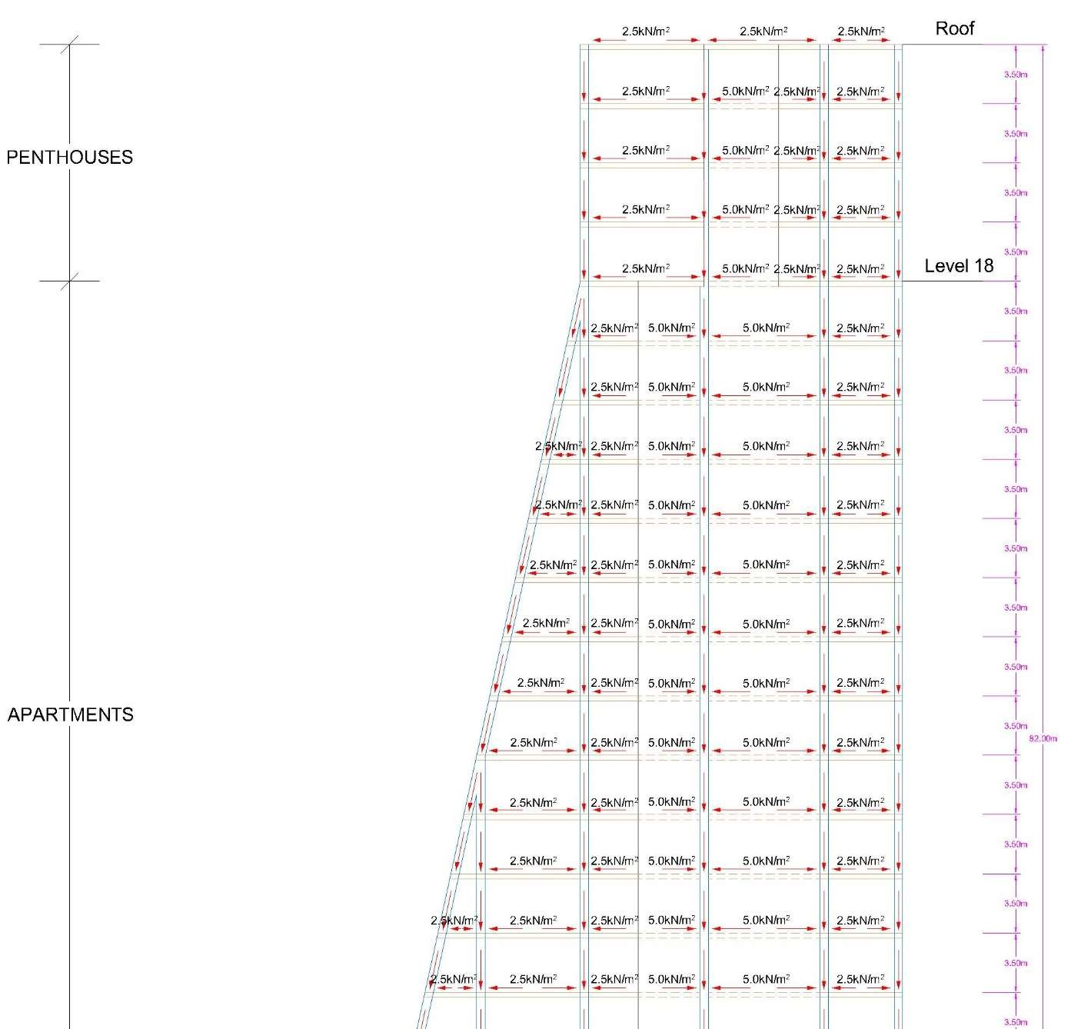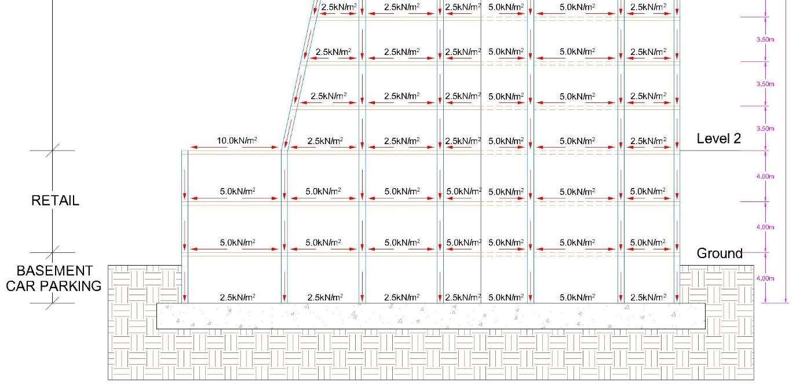
Fig. 2.4 Vertical Load Path at Section of Building Section Line

2.3 Calculations for Individual elements:
Design Calculations will be consist on the only required design elements of the
Monier Tower building. We need to design only one column at the level 2. And the reinforcement detail where one of the columns supporting the tower meets Level 2 (Mohammed, Aziz, 2004).

2.3.1 Design of Column at level 2:
Selected column for calculation is given in below figures with the imposed loads and tributary area.
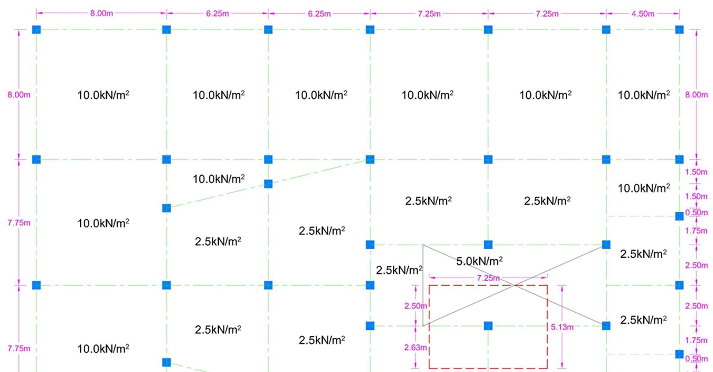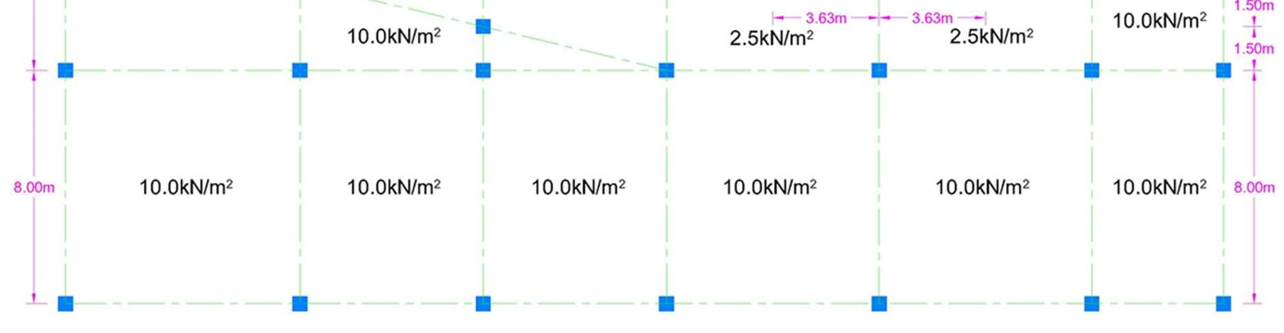
Fig. 2.5 Tributary Area of Column at Tower Level 2
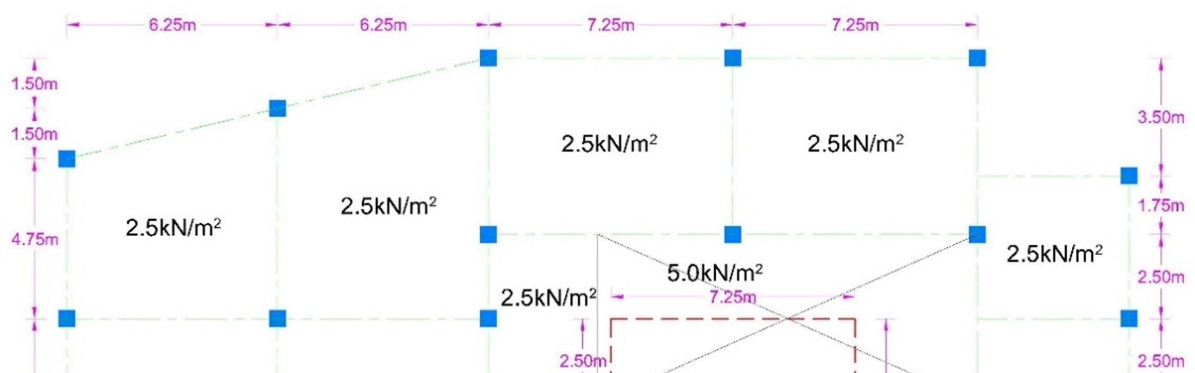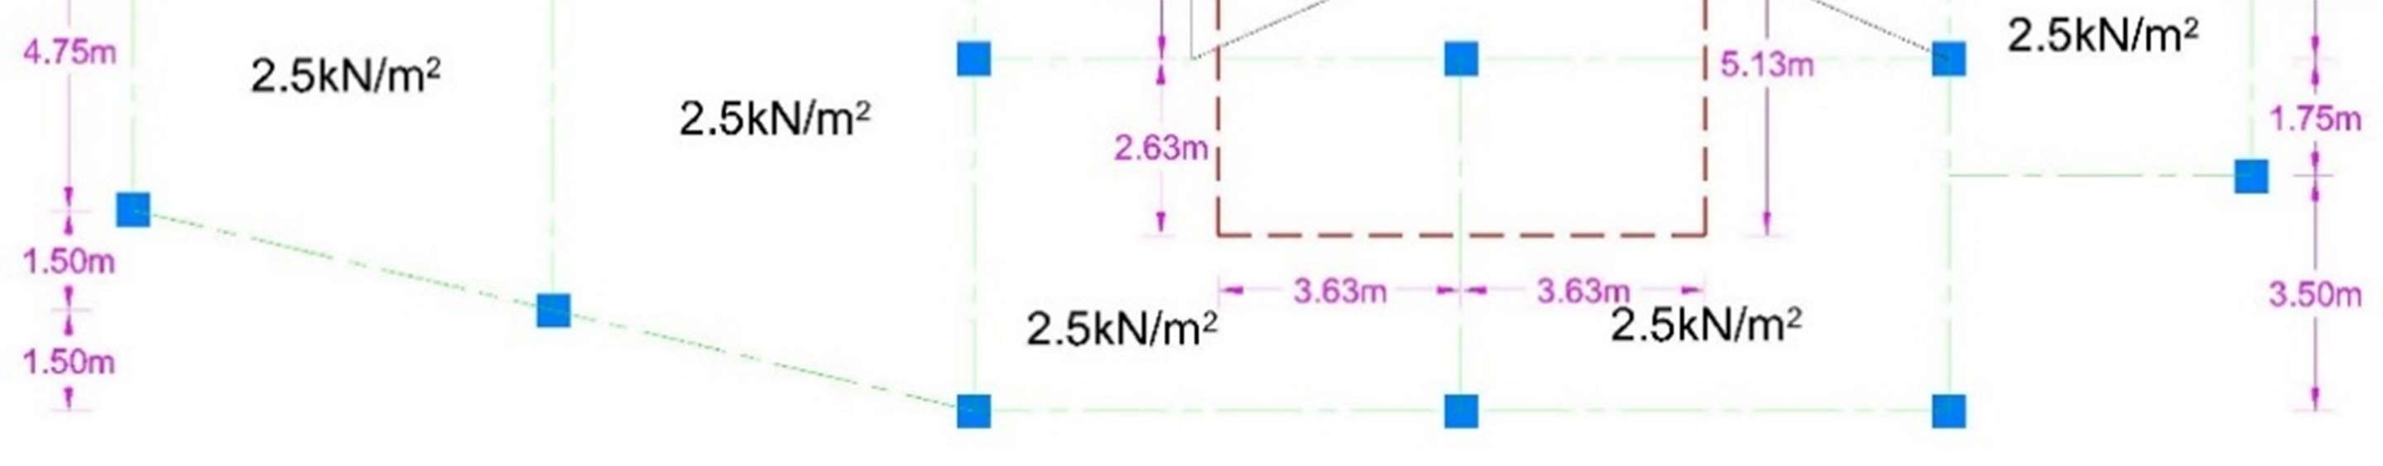
Fig. 2.6 Tributary Area of Column at Level 9

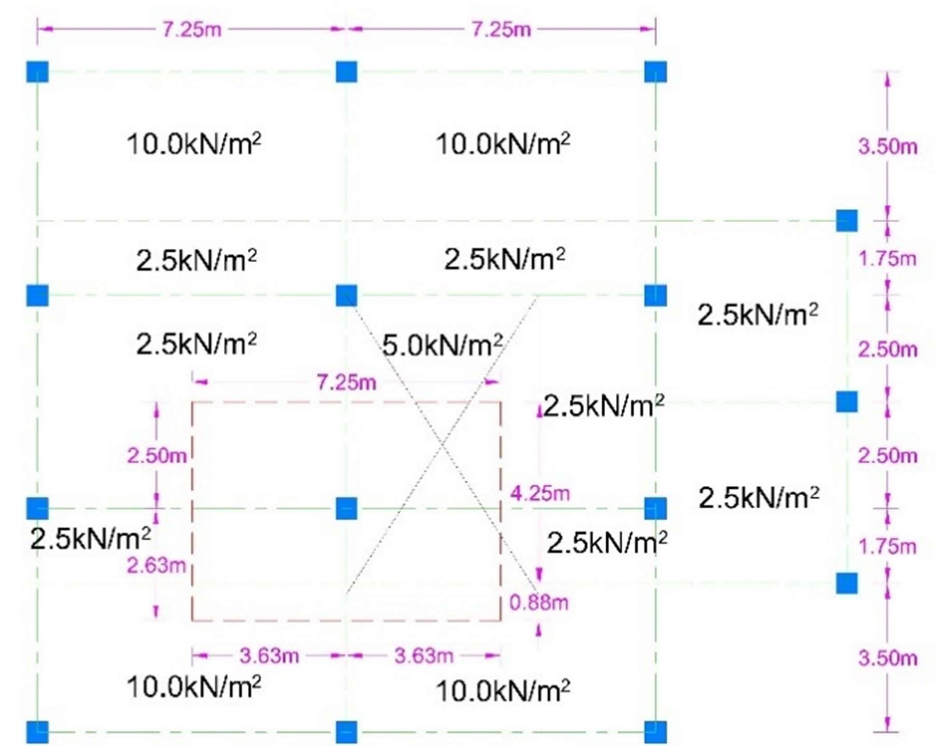
Fig. 2.7 Tributary Area of Column at Level 18

First of all we need to compute the Axial load on the column by calculating
tributary area of each column at each level and then sum these areas and also need to add the column loads on the above levels.
Load from level 18 to Roof
Self-load of Slab = Slab thickness x density of concrete
= 0.15m x 25kN/m³
= 3.75kN/m²
Axial Load (kN) = Tributary Area x [Imposed load + self-load of slab per square meter]
= ({[(4.25m x 3.63m) x (2.5kN/m² + 3.75kN/m²)] + [(4.25m x 3.63m) x (5kN/m² +
3.75kN/m²)] + [(7.25m x 0.88m) x (10.0kN/m² + 3.75kN/m²)]}x 4) + [(7.25m x
5.13m) x 2.5kN/m²]
= 1,369.53kN
Load from level 2 to level 18
Self-load of Slab = Slab thickness x density of concrete
= 0.15m x 25kN/m³
= 3.75kN/m²
Axial Load (kN) = Tributary Area x [Imposed load + self-load of slab per square meter]
= ({[(7.25m x 2.63m) x (2.5kN/m² + 3.75kN/m²)] + [(7.25m x 2.50m) x (5kN/m² +
3.75kN/m²)]}x 15) = 4,166.48kN
Total Load on column at Level 2
Total Load (kN) = [Load from level 2 to level 18] + [Load from level 18 to roof] + [load of Column above this column] + [Self load of column]
= [4,166.48kN] + [1,369.53kN] + [{(0.5m x 0.5m x 3.5m) x 25kN/m³} x 19] +
[(0.5m x 0.5m x 3.5m) x 25kN/m³]
N_{ultimate} = 5,973.51kN say 6000kN

Selected Values
Concrete f_{ck} = 25 N/mm²
Steel f_{yk} = 500 N/mm²
Column Size = 500mm x 500mm (Square Column)
Area of longitudinal Steel
Gross Area A_{g} = 500x500
= 250000mm²
Formula
N_{ud} = 0.567f_{ck}A_{c} + 0.87A_{s}f_{yk}
N_{ud} = 0.567f_{ck}(A_{g} -A_{s}) + 0.87A_{s}f_{yk}
6,000kN = 0.567 x 25N/mm² (A_{g} -A_{s}) + 0.87A_{s} x 500N/mm²
6,000,000N = 0.567 x 25N/mm² (A_{g} -A_{s}) + 0.87A_{s} x 500N/mm²
6,000,000N = 0.567 x 25N/mm² (250000 -A_{s}) + 0.87A_{s} x 500N/mm²
6,000,000 = 3,543,750 - 14.175A_{s} + 435A_{s}
6,000,000 = 3,543,750 + 420.825A_{s}
420.825A_{s} = 6,000,000 - 3,543,750
420.825A_{s} = 2,456,250
A_{s} = 2,456,250 / 420.825
A_{s} = 5,836.75mm²
Use 25mm diameter for longitudinal bars
Area of
Single Bar = 491mm²
No. of Bars = 5,836.75 / 491
= 11.887 say 12 Bars

Design of links
Minimum size = 1/4×size of the compression bar but not less than 6 mm
= ¼ x 25mm
= 6.25mm Say 6mm
Maximum spacing should not exceed the lesser of 20 × size of the smallest compression bar or the least lateral dimension of the column or 400mm.
Maximum spacing
= 20 x Diameter of smallest compression bar
= 20 x 25mm
= 500mm
Or
Least Dimension = 500mm
Or
= 400mm
Select Minimum Dimension which is 400mm
Provide 6mm diameter links at 400mm spacing center to center in column.

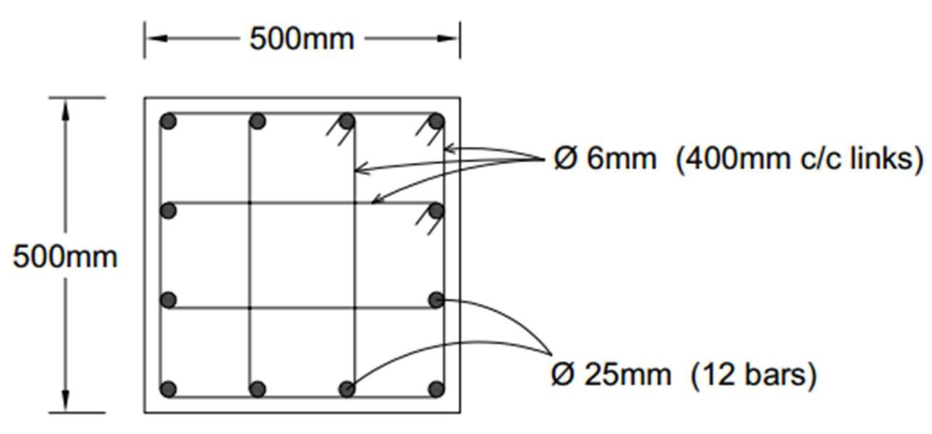
Fig. 2.8 Reinforcement of Selected Column at Level 2

2.3.2 Design of Slab in Retails:
Selected Slab Panel for calculation is given in below figures with the imposed loads and tributary area.

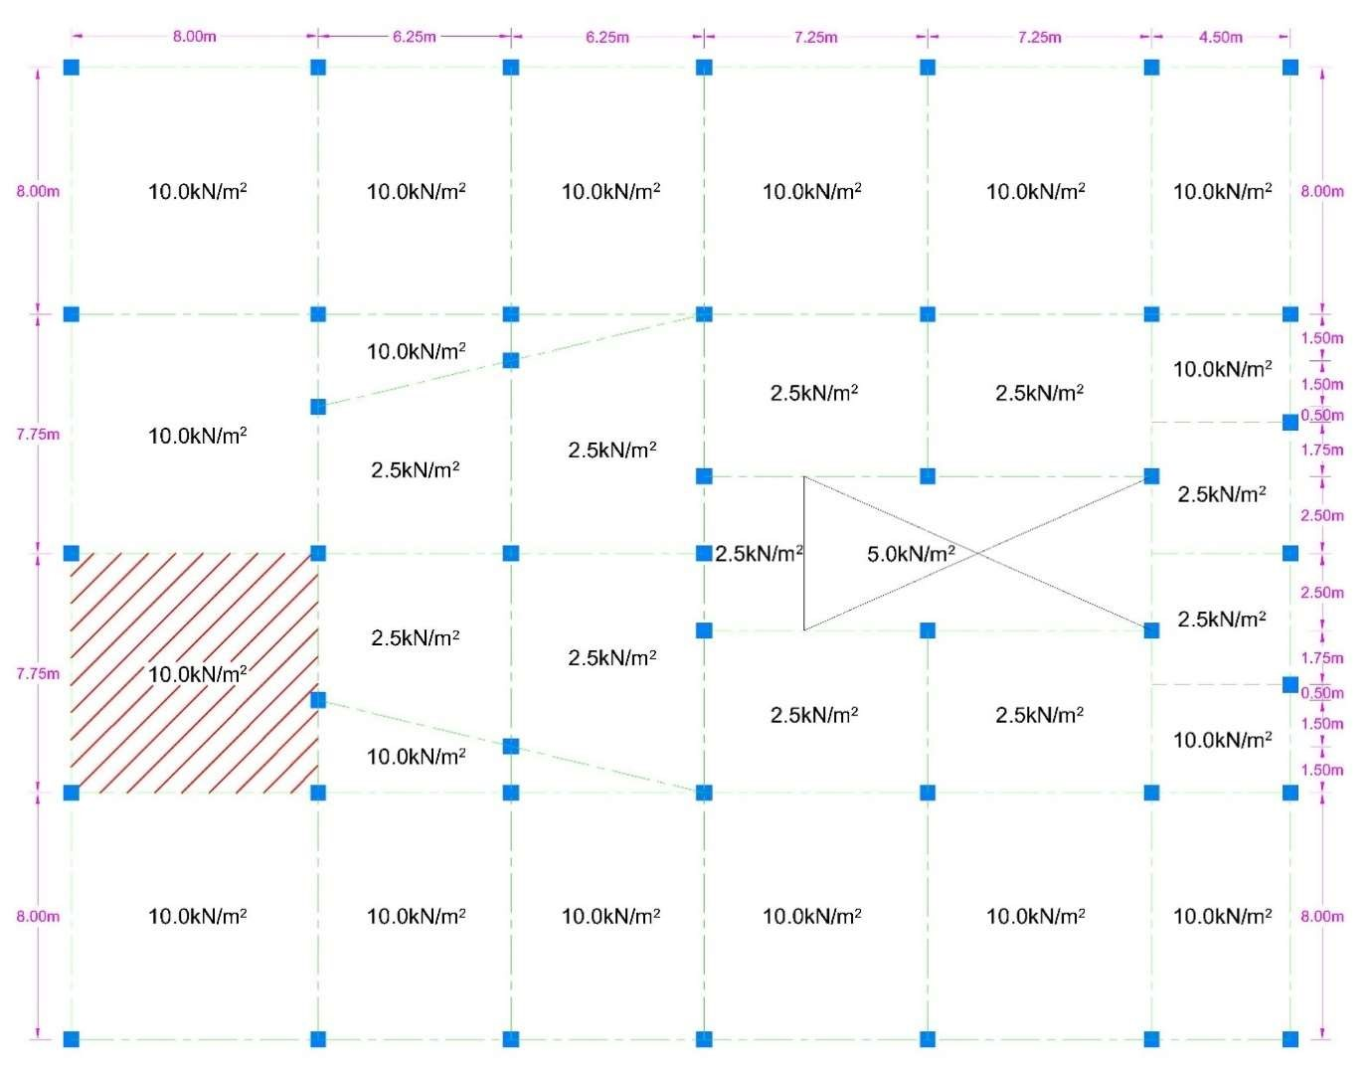
Fig. 2.9 Tributary Area of Selected Slab Panel at Retails

Step 1: Calculation of loads and coefficient
Selected Values
Concrete f_{ck} = 25 N/mm² Steel f_{yk} = 500 N/mm²
Longer Span = l_{y} = 8.00m Shorter Span = l_{x} = 7.75m
Ratio = l_{y} / l_{x}
= 8.00 / 7.75
= 1.032 say, 1.0 (shows Two way Slab)
From the table we choose values of Coefficients.
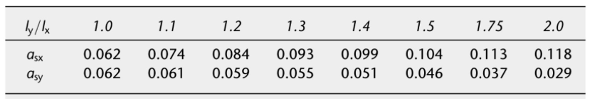
α_{sx} = 0.062
α_{sy} = 0.062
Step 2: Design for bending (for shorter and longer span due to Same Coefficients)
Imposed load = 10.0kN/m²
Estimate of Slab thickness from Empirical Chart approximately 220mm.
Thickness of Slab = 220mm
Self-weight
of Slab | = (220/1000) x 25kN/m³
 | = 5.5kN/m²
Ultimate Load | = 1.35g_{k} + 1.5q_{k}
 | = (1.35 x 5.5) + (1.5 x 10.0)
 | = 22.43 kN/m²
Effective Depth = d = thickness of slab – concrete cover
Effective Depth = d = 220 – 35
= 185mm
M_{sx} = α_{sx}nl_{x}²
= 0.062 x 22.43 x (7.75)²
= 83.53kN.m
M_{sy} = α_{sy}nl_{x}²
= 0.062 x 22.43 x (7.75)²
= 83.53kN.m
For shorter span
K = M_{sx} / bd²f_{ck}
= 83.53 x 10⁶ / (1000 x 185² x 25)
= 0.098
From the lever arm curve diagram
l_{a} = 0.92
hence z = 0.92 x effective slab depth
= 0.92 x 185
= 170mm
Area of steel = M_{sx} / 0.87f_{yk}z
= 83.53 x10⁶ / (0.87 x 500 x 170)
=1130mm²/m
Spacing of Bars
Area of H12 bar = 113mm²
Spacing | = (113 /1130) x 1000
 | = 100mm
Provide H12 bars at 100mm c/c on shorter span
For longer span
K = M_{sy} / bd²f_{ck}
= 83.53 x 10⁶ / (1000 x 185² x 25)
= 0.098
From the lever arm curve diagram
l_{a} = 0.92
hence z = 0.92 x effective slab depth
= 0.92 x 185
= 170mm
Area of steel = M_{sy} / 0.87f_{yk}z
= 83.53 x10⁶ / (0.87 x 500 x 170)
=1130mm²/m
Spacing of Bars
Area of H12 bar = 113mm²
Spacing = (113 /1130) x 1000
= 100mm
Provide H12 bars at 100mm c/c on longer span

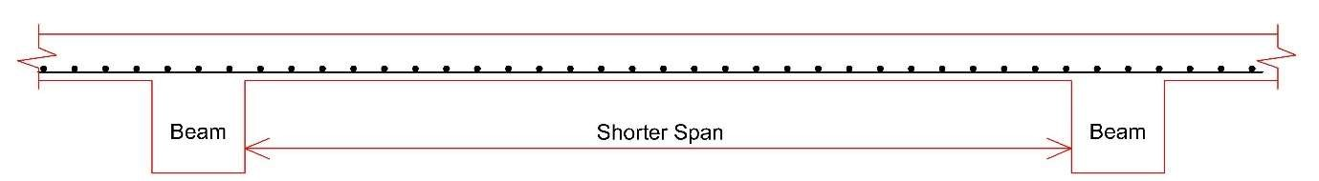

H12 @ 100mm c/c (Length = 8.0m)

H12 @ 100mm c/c (Length = 7.75m)

2.3.3 Design of Slab in Apartments:
Selected Slab Panel for calculation is given in below figures with the imposed loads and tributary area.

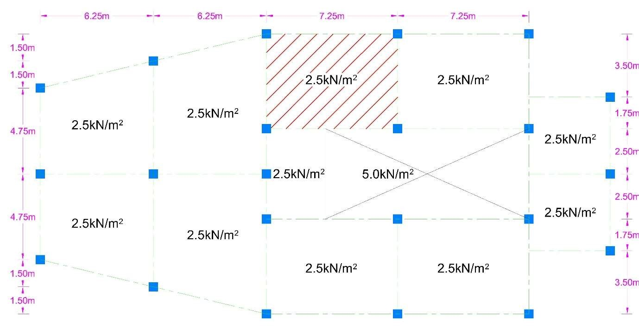
Fig. 2.10 Tributary Area of Selected Slab Panel at Apartments

Step 1: Calculation of loads and coefficient
Selected Values
Concrete f_{ck} = 25 N/mm² Steel f_{yk} = 500 N/mm² Longer Span = l_{y} = 7.25m Shorter Span = l_{x} = 5.25m
Ratio = l_{y} / l_{x}
= 7.25 / 5.25
= 1.38 say, 1.4 (shows Two way Slab)
From the table we choose values of Coefficients.
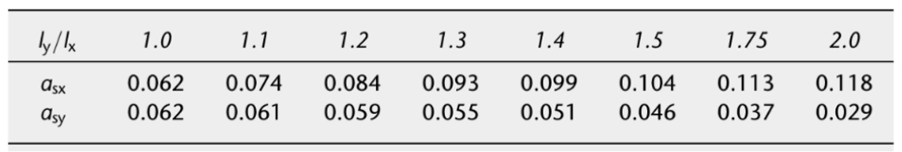
α_{sx} = 0.099 α_{sy} = 0.051
Step 2: Design for bending (for shorter and longer span due to Same Coefficients)
Imposed load = 2.5kN/m²
Estimate of Slab thickness from Empirical Chart approximately 190mm.
Thickness of Slab = 190mm
Self-weight
of Slab = (190/1000) x 25kN/m³
= 4.75kN/m²
Ultimate Load = 1.35g_{k} + 1.5q_{k}
= (1.35 x 4.75) + (1.5 x 2.5)
= 10.16kN/m²
Effective Depth = d = thickness of slab – concrete cover
Effective Depth = d = 190 – 35
= 155mm
M_{sx} = α_{sx}nl_{x}²
= 0.099 x 10.16 x (5.25)²
= 27.72kN.m
M_{sy} = α_{sy}nl_{x}²
= 0.051 x 10.16 x (5.25)²
= 14.28kN.m
For shorter span
K = M_{sx} / bd²f_{ck}
= 27.72 x 10⁶ / (1000 x 155² x 25)
= 0.046
From the lever arm curve diagram
l_{a} = 0.96
hence z = 0.96 x effective slab depth
= 0.96 x 155
= 149mm
Area of steel = M_{sx} / 0.87f_{yk}z
= 27.72 x10⁶ / (0.87 x 500 x 149)
= 428mm²/m
Spacing of Bars
Area of H12 bar = 113mm²
Spacing = (113 /428) x 1000
= 264mm
Provide H12 bars at 264mm c/c on shorter span
For longer span
K = M_{sy} / bd²f_{ck}
= 14.28 x 10⁶ / (1000 x 155² x 25)
= 0.024
From the lever arm curve diagram
l_{a} = 0.98
hence z = 0.98 x effective slab depth
= 0.98 x 155
= 152mm
Area of steel = M_{sy} / 0.87f_{yk}z
= 14.28 x10⁶ / (0.87 x 500 x 152)
=216mm²/m
Spacing of Bars
Area of H12 bar = 113mm²
Spacing = (113 /216) x 1000
= 523mm
Provide H12 bars at 523mm c/c on longer span

H12 @ 523mm c/c (Length = 7.25m)

H12 @ 264mm c/c (Length = 5.25m)

2.3.4 Design of Slab in Penthouses:
Selected Slab Panel for calculation is given in below figures with the imposed loads and tributary area.

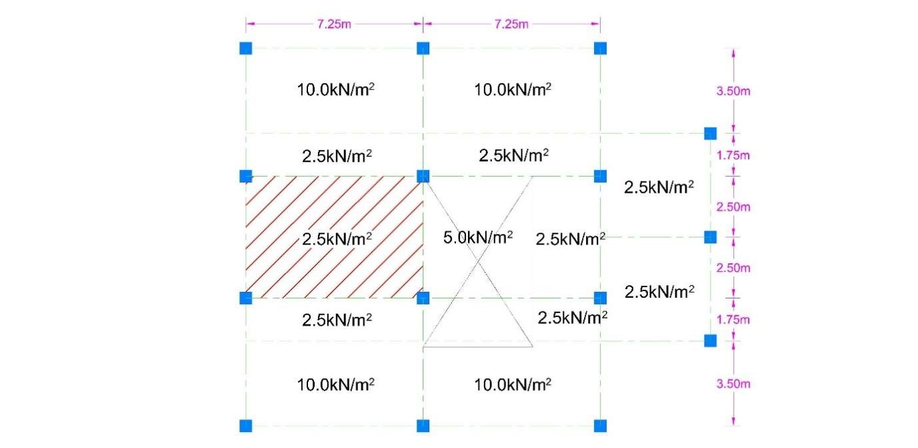
Fig. 2.11 Tributary Area of Selected Slab Panel at Penthouses
Step 1: Calculation of loads and coefficient
Selected Values
Concrete f_{ck} = 25 N/mm² Steel f_{yk} = 500 N/mm²
Longer Span = l_{y} = 7.25m Shorter Span = l_{x} = 5.0m
Ratio = l_{y} / l_{x}
= 7.25 / 5.0
= 1.45 say, 1.5 (shows Two way Slab)
From the table we choose values of Coefficients.
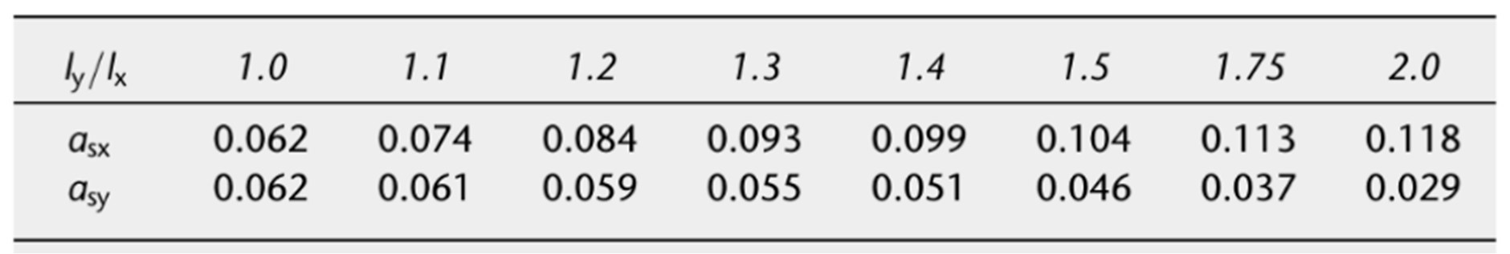
α_{sx} = 0.104 α_{sy} = 0.046
Step 2: Design for bending (for shorter and longer span due to Same Coefficients)
Imposed load = 2.5kN/m²
Estimate of Slab thickness from Empirical Chart approximately 190mm.
Thickness of Slab = 190mm
Self-weight
of Slab | = (190/1000) x 25kN/m³
 | = 4.75kN/m²
Ultimate Load | = 1.35g_{k} + 1.5q_{k}
 | = (1.35 x 4.75) + (1.5 x 2.5)
 | = 10.16kN/m²
Effective Depth = d = thickness of slab – concrete cover
Effective Depth = d = 190 – 35
= 155mm
M_{sx} = α_{sx}nl_{x}²
= 0.104 x 10.16 x (5.0)²
= 26.42kN.m
M_{sy} = α_{sy}nl_{x}²
= 0.046 x 10.16 x (5.0)²
= 11.68kN.m
For shorter span
K = M_{sx} / bd²f_{ck}
= 26.42 x 10⁶ / (1000 x 155² x 25)
= 0.044
From the lever arm curve diagram
l_{a} = 0.97
hence z = 0.97 x effective slab depth
= 0.97 x 155
= 150mm
Area of steel = M_{sx} / 0.87f_{yk}z
= 26.42 x10⁶ / (0.87 x 500 x 150)
= 405mm²/m
Spacing of Bars
Area of H10 bar = 78.5mm²
Spacing = (78.5 / 405) x 1000
= 194mm
Provide H10 bars at 194mm c/c on shorter span
For longer span
K = M_{sy} / bd²f_{ck}
= 11.68 x 10⁶ / (1000 x 155² x 25)
= 0.020
From the lever arm curve diagram
l_{a} = 0.98
hence z = 0.98 x effective slab depth
= 0.98 x 155
= 152mm
Area of steel = M_{sy} / 0.87f_{yk}z
= 11.68 x10⁶ / (0.87 x 500 x 152)
=177mm²/m
Spacing of Bars
Area of H10 bar = 78.5mm²
Spacing = (78.5 / 177) x 1000
= 444mm
Provide H10 bars at 444mm c/c on longer span

H10 @ 444mm c/c (Length = 7.25m)

H10 @ 194mm c/c (Length = 5.0m)

2.3.5 Design of Beam in Retails:
Selected Beam in Retails for calculation is given in below figures with the imposed loads and tributary area.

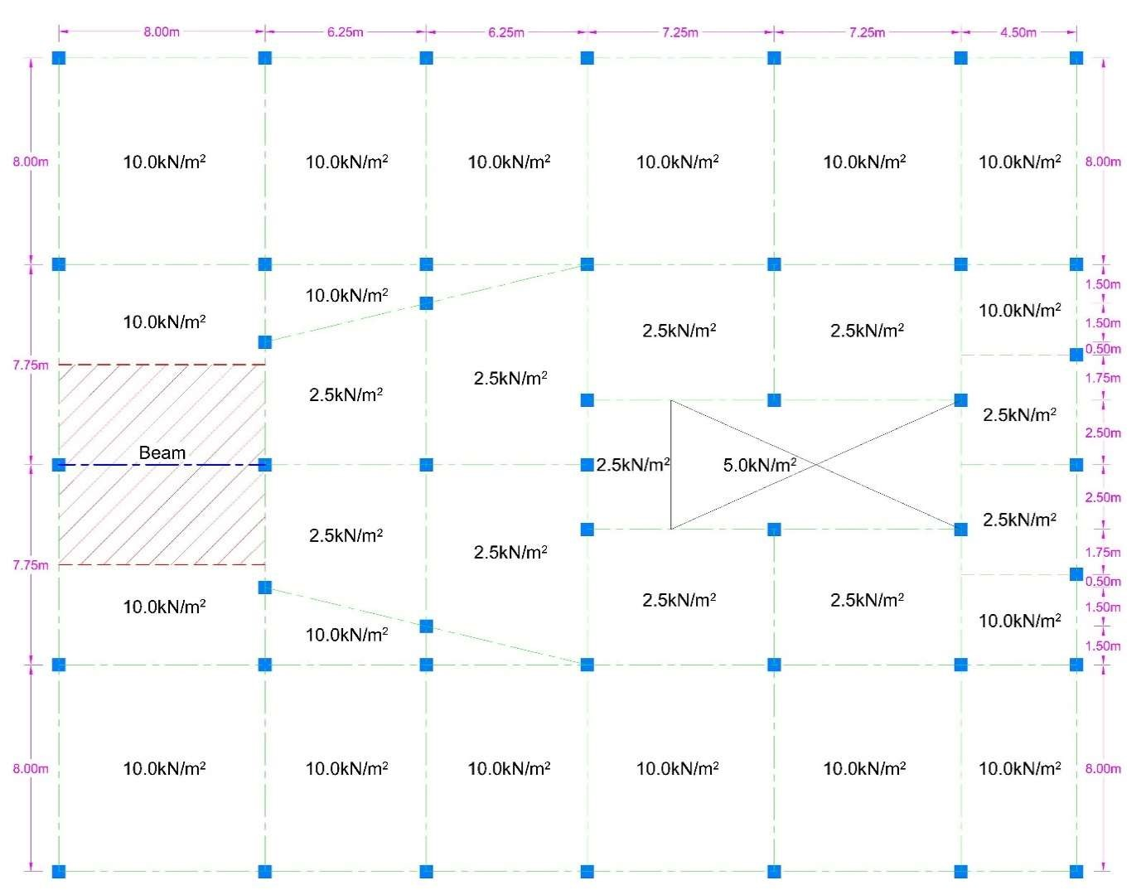
Fig. 2.12 Tributary Area of Selected Beam at Retails
Step 1: Calculation of loads and Moments on Beam
Selected Values
Breadth = b = 400mm Depth = h = 500mm
Concrete Cover = 40mm
Effective Depth = 500 – 40
= 460mm
Concrete f_{ck} = 25 N/mm² Steel f_{yk} = 500 N/mm²
Steel f_{cs} = 500 N/mm²
Beam Span = L = 8.0m
Imposed load = 10.0kN/m²
Thickness of Slab = 220mm
Self-weight
of Slab | = (220/1000) x 25kN/m³
 | = 5.5kN/m²
Ultimate Load | = 1.35g_{k} + 1.5q_{k}
 | = (1.35 x 5.5) + (1.5 x 10.0)
Effective Strip | = 22.43 kN/m²
Width | = 7.75m
U.D.L on Beam = Ultimate Load x Effective Strip Width
= 22.43 x 7.75
= 173.83 kN/m
Ultimate moment = wl²/8
= (173.83 x 8²) / 8
M = 1390.64 kN.m
Step 2: Check for Compression Reinforcement Required
K = M / bd²f_{ck}
= (1390.64 x 10⁶) / (400 x 460² x 25)
= 0.657
K_{bal} = 0.167
K > K_{bal} So, Compression Reinforcement Required and x = x_{bal} = 0.167
Step 3: Calculation of area of compression steel
A_{s}’ = (M - K_{bal} f_{ck} bd²) / (f_{sc} x (d - d’))
= ((1390.64 x 10⁶) – (0.167 x 25 x 400 x 460²)) / (500 x (460 – 40))
= 4939.37mm²
Area of H25 bar = 491mm²
No. of Bars = A_{s}’/ Area of H25 bar
= 4939.37 / 491 = 10.06 Say, 10 Bars
Step 4: Calculation of area of tension steel lever arm = z_{bal} = 0.82d
z_{bal} = 0.82 x 460 = 377.2mm
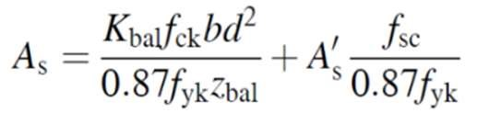
A_{s} | = [(0.167 x 25 x 400 x 460²) / (0.87 x 500 x 377.2)] + [(4939.37 x 500) / (0.87 x
 | 500)]
A_{s} | = 7831mm²
Area of H25 bar = 491mm²
No. of Bars = A_{s}’/ Area of H25 bar = 7831 / 491 = 15.9 Say, 16 Bars
Design of Shear Reinforcement:
Step 1: Calculation of ultimate design shear forces
V_{Ed} | = wl / 2
V_{Ed} | = (173.83 x 8) / 2
V_{Ed} | = 695.32 kN
Step 2: Calculation of Check the crushing strength
V_{Rd,max} | = 0.124b_{w}d(1 - f_{ck}/250)f_{ck}
V_{Rd,max} | = (0.124 x 400 x 460) x (1 - (25/250)) x 25
 | = 513360N
 | = 513.36kN
V_{Rd,max} < V_{Ed} So, Need to fine θ.
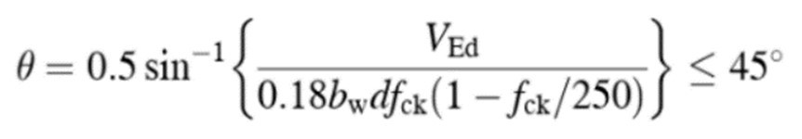
θ = 0.5sin⁻¹{(695.32 x 10³) / (0.18 x 400 x 460 x 25) x (1 - (25/250))} ≤ 45º θ = 0.5sin⁻¹{(695320) / (828000) x (0.9)} ≤ 45º θ = 0.5sin⁻¹{0.9331} ≤ 45º θ = 34.46º ≤ 45º
Step 3: Calculation of shear links
Selected link
Diameter = 10mm
Area of link = A_{sw}= 4 x 78.5mm²
= 314mm²
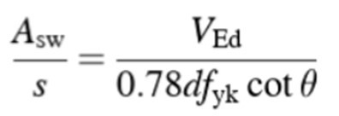
s = (0.78df_{yk}cotθ x A_{sw} ) / V_{Ed}
s = (0.78 x 460 x 500 x cot(34.46º) x 314 ) / 695320 s = 118mm c/c
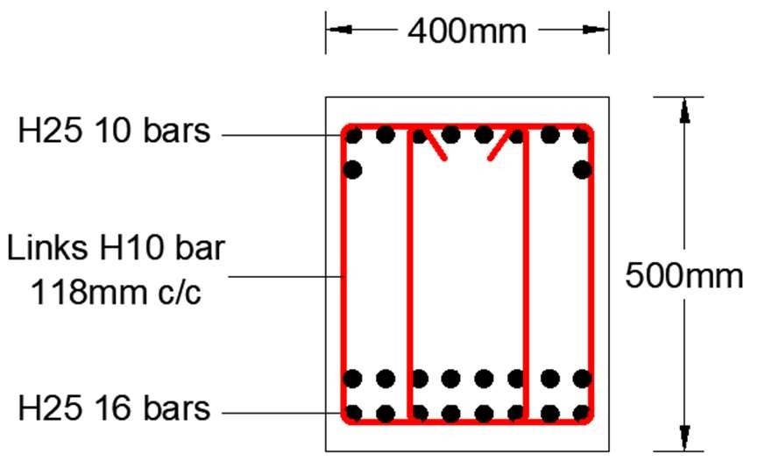
Fig. 2.13 Selected Beam Cross Section at Retails

2.3.6 Design of Beam in Apartments:
Selected Beam in Apartments for calculation is given in below figures with the imposed loads and tributary area.

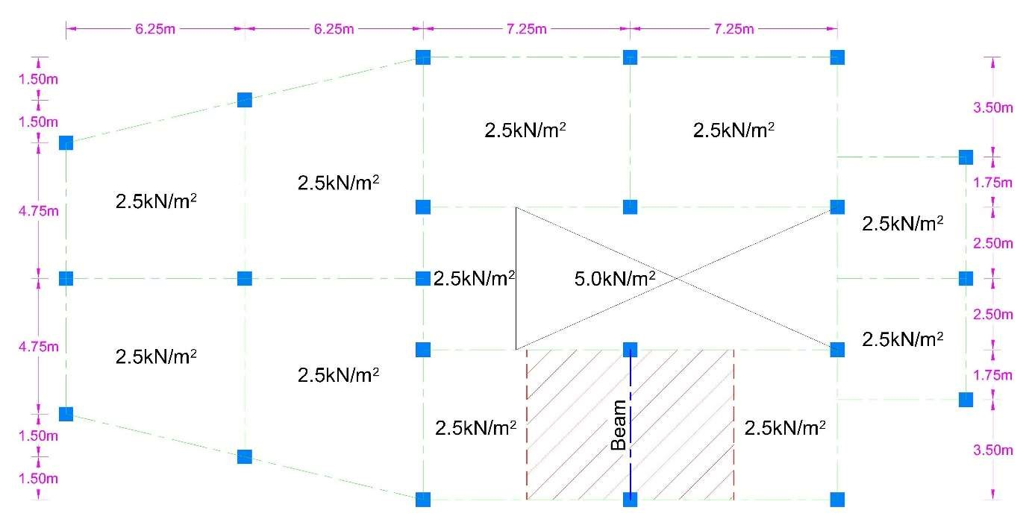
Fig. 2.14 Tributary Area of Selected Beam at Apartments
Step 1: Calculation of loads and Moments on Beam
Selected Values
Breadth = b = 300mm
Depth = h = 300mm
Concrete Cover = 40mm
Effective Depth = 300 – 40
= 260mm
Concrete f_{ck} = 25 N/mm²
Steel f_{yk} = 500 N/mm²
Steel f_{cs} = 500 N/mm²
Beam Span = L = 5.25m
Imposed load = 2.5kN/m²
Thickness of Slab = 190mm
Self-weight
of Slab | = (190/1000) x 25kN/m³
 | = 4.75kN/m²
Ultimate Load | = 1.35g_{k} + 1.5q_{k}
 | = (1.35 x 4.75) + (1.5 x 2.5)
Effective Strip | = 10.16kN/m²
Width | = 7.25m
U.D.L on Beam = Ultimate Load x Effective Strip Width
= 10.16 x 7.25
= 73.66 kN/m
Ultimate moment = wl²/8
= (73.66 x 5.25²) / 8
M = 253.78 kN.m
Step 2: Check for Compression Reinforcement Required
K = M / bd²f_{ck}
= (253.78 x 10⁶) / (300 x 260² x 25)
= 0.501
K_{bal} = 0.167
K > K_{bal} So, Compression Reinforcement Required and x = x_{bal} = 0.167
Step 3: Calculation of area of compression steel
A_{s}’ = (M - K_{bal} f_{ck} bd²) / (f_{sc} x (d - d’))
= ((253.78 x 10⁶) – (0.167 x 25 x 300 x 260²)) / (500 x (260 – 40))
= 1537.37mm²
Area of H20 bar = 314mm²
No. of Bars = A_{s}’/ Area of H20 bar
= 1537.37 / 314 = 4.90 Say, 5 Bars
Step 4: Calculation of area of tension steel lever arm = z_{bal} = 0.82d
z_{bal} = 0.82 x 260 = 213.2mm
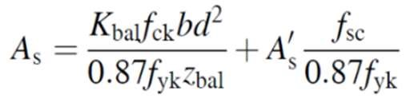
A_{s} | = [(0.167 x 25 x 300 x 260²) / (0.87 x 500 x 213.2)] + [(1537.37 x 500) / (0.87 x
 | 500)]
A_{s} | = 2680.04mm²
Area of H25 bar = 491mm²
No. of Bars = A_{s}’/ Area of H25 bar = 2680.04 / 491 = 5.46 Say, 6 Bars
Design of Shear Reinforcement:
Step 1: Calculation of ultimate design shear forces
V_{Ed} | = wl / 2
V_{Ed} | = (73.66 x 5.25) / 2
V_{Ed} | = 193.36 kN
Step 2: Calculation of Check the crushing strength
V_{Rd,max} | = 0.124b_{w}d(1 - f_{ck}/250)f_{ck}
V_{Rd,max} | = (0.124 x 300 x 260) x (1 - (25/250)) x 25
 | = 217620N
 | = 217.62kN
V_{Rd,max} > V_{Ed} So, θ = 22º.
Step 3: Calculation of shear links
Selected link
Diameter = 10mm
Area of link = A_{sw}= 2 x 78.5mm²
= 157mm²
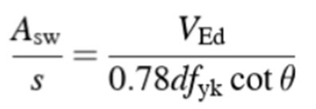
s = (0.78df_{yk}cotθ x A_{sw} ) / V_{Ed}
s = (0.78 x 260 x 500 x cot(22º) x 157 ) / 193360 s = 204mm c/c
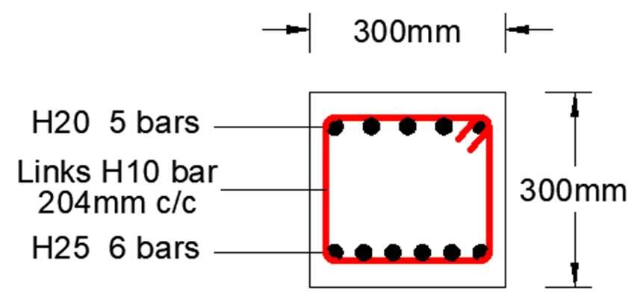
Fig. 2.15 Selected Beam Cross Section at Apartments

2.3.7 Design of Beam in Penthouses:
Selected Beam in Penthouses for calculation is given in below figures with the imposed loads and tributary area.

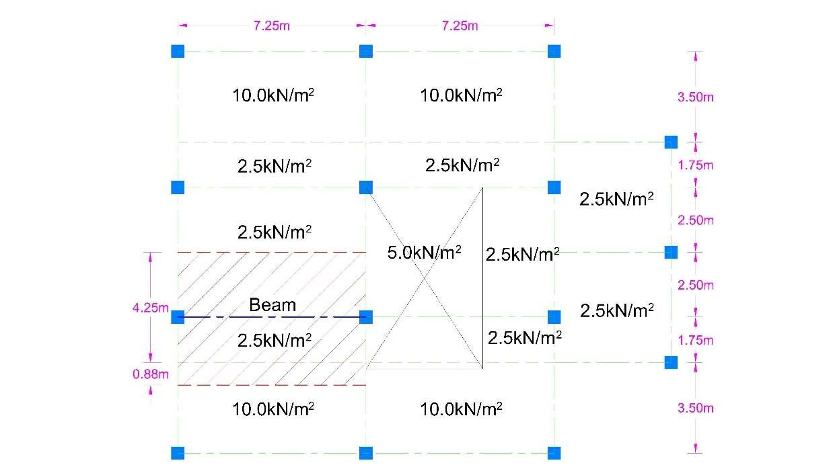
Fig. 2.16 Tributary Area of Selected Beam at Penthouses
Step 1: Calculation of loads and Moments on Beam
Selected Values
Breadth = b = 300mm Depth = h = 400mm
Concrete Cover = 40mm
Effective Depth = 400 – 40
= 360mm
Concrete f_{ck} = 25 N/mm² Steel f_{yk} = 500 N/mm²
Steel f_{cs} = 500 N/mm²
Beam Span = L = 7.25m
Imposed load = 10.0kN/m²
Imposed load = 2.5kN/m²
Thickness of Slab = 190mm Self-weight
of Slab = (190/1000) x 25kN/m³
= 4.75kN/m²
Ultimate Load = 1.35g_{k} + 1.5q_{k}
 | = (1.35 x 4.75) + (1.5 x 10.0) for 10kN/m² Tributary Area
 | = 21.41 kN/m²
Ultimate Load | = 1.35g_{k} + 1.5q_{k}
 | = (1.35 x 4.75) + (1.5 x 2.5) for 2.5kN/m² Tributary Area
Effective Strip | = 10.16 kN/m²
Width | = 4.25m + 0.88m
 | = 5.13m
U.D.L on Beam = Ultimate Load x Effective Strip Width
= (10.16 x 4.25) + (21.41 x 0.88)
= 62.02 kN/m
Ultimate moment = wl²/8
= (62.02 x 7.25²) / 8
M = 407.49 kN.m
Step 2: Check for Compression Reinforcement Required
K = M / bd²f_{ck}
= (407.49 x 10⁶) / (300 x 360² x 25)
= 0.419
K_{bal} = 0.167
K > K_{bal} So, Compression Reinforcement Required and x = x_{bal} = 0.167
Step 3: Calculation of area of compression steel
A_{s}’ = (M - K_{bal} f_{ck} bd²) / (f_{sc} x (d - d’))
= ((407.49 x 10⁶) – (0.167 x 25 x 300 x 360²)) / (500 x (360 – 40))
= 1532.29mm²
Area of H20 bar = 314mm²
No. of Bars = A_{s}’/ Area of H20 bar
= 1532.29 / 314 = 4.88 Say, 5 Bars
Step 4: Calculation of area of tension steel lever arm = z_{bal} = 0.82d
z_{bal} = 0.82 x 360 = 295.2mm
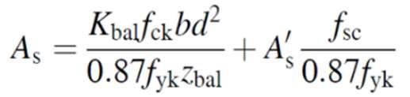
A_{s} | = [(0.167 x 25 x 300 x 360²) / (0.87 x 500 x 295.2)] + [(1532.29 x 500) / (0.87 x
 | 500)]
A_{s} | = 3025.34mm²
Area of H25 bar = 491mm²
No. of Bars = A_{s}’/ Area of H25 bar = 3025.34 / 491 = 6.16 Say, 6 Bars
Design of Shear Reinforcement:
Step 1: Calculation of ultimate design shear forces
V_{Ed} | = wl / 2
V_{Ed} | = (62.02 x 7.25) / 2
V_{Ed} | = 224.82 kN
Step 2: Calculation of Check the crushing strength
V_{Rd,max} | = 0.124b_{w}d(1 - f_{ck}/250)f_{ck}
V_{Rd,max} | = (0.124 x 300 x 360) x (1 - (25/250)) x 25
 | = 301320N
 | = 301.32kN
V_{Rd,max} > V_{Ed} So, θ = 22º.
Step 3: Calculation of shear links
Selected link
Diameter = 10mm
Area of link = A_{sw}= 2 x 78.5mm²
= 157mm²
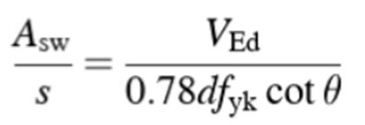
s = (0.78df_{yk}cotθ x A_{sw} ) / V_{Ed}
s = (0.78 x 360 x 500 x cot(22º) x 157 ) / 224820 s = 242mm c/c
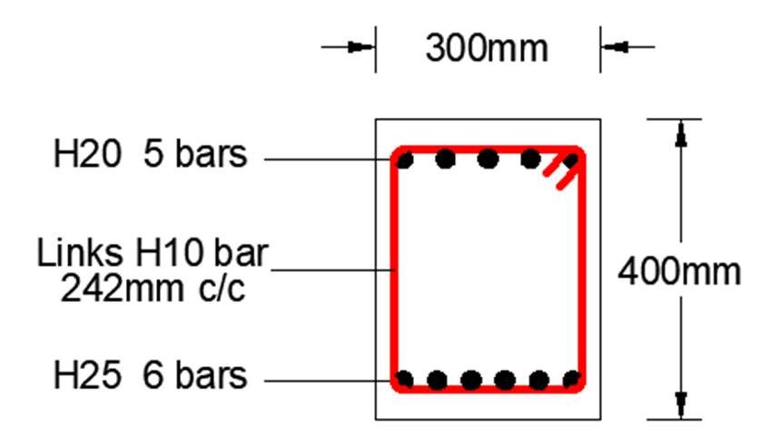
Fig. 2.17 Selected Beam Cross Section at Penthouses

2.4 Serviceability and Ultimate Limit States:
The structural elements which cannot be achieved with the specific period of time
must resembles with the serviceability limit state. When there is no need of cost for labor and the whole structure is totally secured and user friendly then it is known as serviceability. The structure’s type is selected by considering the factor of serviceability needs.

During the that stage of the structure when it is being planned then to avoid any amendments or changings for designing stage, we must take serviceability into our higher consideration to effective and best possible design and also for gaining the satisfaction of our client. Required serviceability can be achieved by designing exactly according to its necessary requirements for the performance and in the end the verification of serviceability. For example, road bridge made up of steel, correct and effective performance objects are taken into consideration to the highest preference.
For the structural stage of the planning, it is also very important to take account of the questions that are linked directly to the dimension of our given structure. There are many other different ways to define serviceability for the rest of the remaining structures (Michael D. Kotsovos, 2017).

The computational check which must be done is known as Service Limit State (SLS).
Our goal is to verify the application of characteristic design loads and also taking into consideration of the some specific magnitudes of forced distortions. The SLS design must not be exceeded through structural behavior. The standard involve different limits for the stress, deformation, flexibility. For gratifying the limit state of serviceability, the structure must remain functional for its use subject for loading in routine.
On the lower half of elastic zone, there must be a calculation check performed.

Section 03

VERIFICATION OF STRUCTURAL VIABILITY

3.1 Architectural Detail Drawing:
Architectural Detail Drawing is given in A3 sheet with the name of “ARCHITECTURAL DETAIL SHEET 01” and “ARCHITECTURAL DETAIL SHEET 02”.

3.2 Reinforcement Detail Drawing:
Reinforcement Detail Drawing is given in A3 sheet with the name of “REINFORCEMENT DETAIL SHEET 01”.

Section 04

SUSTAINABILITY REPORT 4.1 Sustainability aspects of the project:
A few highlights of undertaking maintainability, for example, financial, monetary,
social, social, political, legitimate, ecological, and instructive are sightseen for a wide-extending way to deal with venture execution. Manageability is the ability of an association to wait on its assignment or program far into what's to come. At last every undertakings must be finished; however the impact of the task should proceed.
A project or organization can be sustainable in three main categories:
- Organizational
- Financial
- community sustainability
The four key factors are
- Sustainable Innovation Business Model
- Stakeholders Management
- Economic and Competitive Advantage
- Environmental Policies and Resources Saving

When the team supervising a project in an environment takes the element of
environmental pollution into consideration. In other words, the project team will not only prioritize project achievement but also make sure that they achieve the project function devoid of pollution.
However, where the project team makes safety a part of their priority.
For instance, building structures that are put in place should satisfy the safety
rules. In other words, the structural engineers must have constructed it keeping in mind that the lives of the inhabitants will be at stake if safety is not considered. Sustainability is a renovated kind of management system where the value derived from the consequence remains unaffected.

4.2 Specification of the Structure:
Determination of any structure relies on the sort of structure and material utilized in execution of the structure. There are differing classes of specialized or designing particulars. A commitment particular is a prerequisite as records, or set of reported necessities, to be fulfilled by a given material, plan, item, administration.
A down to earth determination is a sort of necessity detail which may show viable charts. A structure or item detail characterizes the highlights of the answers for the Requirement Specification, alluding to either a planned arrangement or last created arrangement. It is as often as possible used to control manufacture/creation. An information sheet characterizes the specialized attributes of a thing or item, as often as possible distributed by a maker to assist individuals with picking or utilize the items. An information sheet is anything but a specialized detail in the feeling of advising how to deliver.
Determinations are a sort of specialized standard that might be set up by any of a few sorts of associations, both open and private. Model association types involve a partnership, an affiliation, an exchange, a national government, an expert affiliation, a reason made principles association, for example, ISO, or seller unbiassed set up general necessities. It is public for one association to allude to the gauges of another. Unpaid norms may get required whenever actualized by a legislature.

References
- Sanket Nayak & Obula Reddy. (2013). structures designed for seismic loading, India: cross mark .
- Charlotte de Fraiture. (2019). Development of an integrated food hazard assessment model, Switzerland: Springer nature.
- M.D. Kotsovos & M.N. Pavlovic (1999).Ultimate limit-state design of concrete structures, Australia: Thomas Telford.
- C.B Wilby. (1983). Structural steel, Unite Kingdom: Butter worth.
- Michael D. Kotsovos. (2017). Toward a Consistent Design of Structural Concrete, United States:
PCI journal.
- Furlong, R W.(1948). Concrete encased steel columns design, United States, Media info
- Kong, F & EVANS, R H. (1983). Handbook of structural concrete, United States: Media info.
- Thomas T.C. Hsu. (1968). Torsion of Structural Concrete-Behavior of Reinforced Concrete
Rectangular Members, America, Special Publication
- Ahmad Shayan & Aimin Xu. (2002). Performance and Properties of Structural Concrete, America, Material Journal.
- Mohammed, Aziz. (2004). Design of Structural Concrete Using Strut-Andtie Model, Ethiopia, addis ababa.
- E. N. C. Perera, D. T. Jayawardana & P. Jayasingh. (2019). Landslide vulnerability assessment based on entropy. Sri Lanka, Springer link.

