Thermal comfort and energy performance of personal comfort systems (PCS): a systematic review and meta-analysis
Wenfang Songª, Ziran Zhangª, Tingyi Liª, Zihao Chenª, Faming Wang^{b,*} , Bin Yang^{c}
ªSchool of Art and Design, Guangdong University of Technology, Guangzhou 510000, China
^{b}School of Energy and Environment, Southeast University, Nanjing, 211189, China
^{c}School of Energy and Safety Engineering, Tianjin Chengjian University, Tianjin, 300384, China

*Corresponding author, Prof. Faming Wang, E-mail: dr.famingwang@gmail.com

Word count: ~8818 words (title, abstract, keywords, acknowledgements & references excluded)

Running title: Thermal comfort & energy performance of PCS

Postal address: School of Energy and Environment, Southeast University, Jiulong Lake Campus, Nanjing, 211189, China

Abstract
Personal comfort systems (PCSs) that are energy efficient have been widely used indoors to improve occupant thermal comfort and acceptability under a variety of indoor temperatures. Although numerous studies have shown that the use of PCSs has beneficial effects, definitive conclusions on the effectiveness of PCSs on thermal comfort enhancement have yet to be drawn. Furthermore, detailed analyses of specific indoor conditions that may be the most promising are lacking. As a result, a comprehensive meta-analysis review was conducted to summarize, analyze, and compare findings from eligible documented studies on the effects of various PCSs on occupants’ perceptual responses. Besides, the energy performance of various PCSs was examined. The effects of total cooling or heating area as well as types of PCSs, on occupants’ perceptual responses were specifically addressed. This meta-analysis and systematic review serve as a foundational reference source for the selection of highly energy-efficient and effective personal comfort systems to improve thermal comfort of indoor occupants.

Keywords: Personal comfort system; Personal cooling devices; Personal heating devices; Thermal comfort; Energy performance

List of abbreviations
ABL | Natural or cool air blowers utilizing convective thermal transfer mechanism
AI | artificial intelligence
ASHRAE | American Society of Heating, Refrigerating and Air-Conditioning Engineers
CCP | Cooling chairs/pads utilizing conductive thermal transfer mechanism
CEP | Corrective efficiency power
CI | Confidence interval
CRT | Cooling radiators using radiative thermal transfer mechanism
EFS | Effect size
HAB | Hot-air blowers based on both radiative & convective thermal transfer mechanisms
HCP | Heated chairs/pads that utilize conductive thermal transfer mechanism
HRT | Heating radiators utilize radiative thermal transfer mechanism
HVAC | Heating, ventilation, and air conditioning
ISO | International Organization for Standardization
MCD | Multiple cooling devices that utilize more than two heat transfer mechanisms
MHD | Multiple heating devices that adopt more than two thermal transfer mechanisms and combine two or more of the above devices
PCD | Personal cooling device
PCS | Personal cooling system
PHD | Personal heating device
PRISMA | Preferred Reporting Items for Systematic Reviews and Meta-Analyses

- Introduction
People in urban areas spend the majority of their time indoors, and the quality of indoor environment has a significant impact on human health and work efficiency [1]. The indoor environmental quality is mainly affected by its thermal, acoustic, and visual conditions as well as indoor air quality, etc. [2]. Recent research has consistently found that thermal comfort contributes most to people’s overall satisfaction with the environmental quality indoors [3,4]. In order to achieve better indoor thermal comfort, utilizing the heating, ventilation, and air conditioning (HVAC) system is the primary method of controlling thermal environment indoors. HVAC, on the other hand, has been criticized for the drawbacks associated with high energy consumption, air pollution and the greenhouse effect [5]. Furthermore, due to individual differences such as gender, age, fitness, and personal preference, indoor uniform temperature and humidity created by an HVAC system has been found to be difficult to satisfy individual thermal comfort needs [6,7]. To address issues of the HVAC system, personal comfort systems (PCSs) that provide direct cooling or heating at an appropriate intensity to an occupied space have been extensively researched for their effectiveness in improving thermal comfort and lowering energy expenditure indoors [8,9]. It has been reported that using HVAC alone could only satisfy about 80% of occupants, whereas utilizing PCSs in conjunction with HVAC could satisfy a higher percentage of occupants. More important, proper use of PCSs could save a significant amount of energy consumption [10-12]. It is estimated that the use of appropriate PCSs could result in an energy savings ranging from 4% to 60% [13-15].
Currently, various types of PCSs for cooling and heating have been investigated in extensive literature studies, including chairs and desks that incorporated cooling or heating elements [16,17], thermal radiators that were located near the human body [18,19], air nozzles that provide various airflow rates and directions [20,21], personalized ventilation systems that provide improved quality of inhaled air and elevate air movement around occupants [22,23], wearable clothing/pads incorporating cooling or heating units [24,25], and multiple comfort systems that combine two or more of the aforementioned technologies [26,27]. To date, several systematic literature reviews have described various PCSs in detail, including their types, effects, energy consumption and economics, etc. [8,11,12,28-33]. However, definitive conclusions about the effectiveness of PCSs in terms of human thermal comfort and energy saving efficiency have yet to be drawn. The reason for this is that the data from PCS interventions cannot be directly compared or integrated because they are based on different PCS types, protocols (e.g., activity intensity) and body regions targeted by PCSs (e.g., head, torso). Moreover, detailed analyses of the specific conditions in which PCSs may be most promising are currently lacking. Therefore, it is critical to classify and evaluate existing studies in order to analyze the effects of the multiple types of PCSs in various scenarios.
To assess the effectiveness of using PCSs in improving thermal comfort, the main parameters, i.e., whole-body and local thermal sensation, thermal comfort and thermal acceptability, were often separately or concurrently utilized by researchers [33,34]. Thermal sensation refers to the magnitude and sign (warm versus cool) of the experience, whereas thermal comfort is defined in the ASHRAE 55 standard as the state of mind that expresses satisfaction with the thermal environment. Thermal acceptability provides an estimate of the subjects’ acceptance level towards to the ambient thermal environments [33,34]. These parameters, however, could not be used to compare the effectiveness of different PCSs under various environmental conditions. Corrective power (CP) proposed by Zhang [28] provides a means of comparing the performance of various PCSs, which could quantify the degree to which a warm or cool ambient temperature (expressed in temperature, thermal sensation, or thermal comfort) can be compensated by a PCS. Corrective power, for example, can be calculated as the difference in average thermal sensation or thermal comfort at steady-state between the reference case and a case with PCS [28]. A review study published in the year of 2015 calculated the corrective power values of published papers on PCSs, but it failed to provide specific guidance on which types of PCSs performed best because existing studies were conducted under different testing scenarios [28].
To evaluate the energy performance of PCSs, various parameters such as energy saving percentage and energy consumption were used, which are obtained through either model simulations or rough estimations [34]. However, the energy performance of various PCSs cannot be compared directly using these parameters because they are assessed under different environmental and building conditions [8]. In light of this, corrective power efficiency (CEP) was introduced, which was used to compare the energy performance of various PCSs [28], CEP relates to the energy consumption for correcting the ambient temperature to neutral one and corrective power. This parameter has been used in several studies to compare the energy efficiency of personal heaters [17]. Nevertheless, no review of the literature summarized, analyzed, or compared the CEP values of the existing PCSs.
Therefore, a meta-analytical and systematic study was carried out to review and synthesize current literatures on the effectiveness of PCSs in improving thermal comfort and their energy performance indoors. Meta-analysis is a statistical technique used to extract and synthesize statistic data from independent individual studies gathered through a systematic literature review aimed at deriving the collective intelligence (i.e., the summary effect) [35]. The method provides a precise overall effect of an intervention weighted by the sample size of the included studies, and it addresses uncertainty when outcomes differ across individual studies [35]. The meta-analysis adopted here was to identify the optimum PCSs for improving occupant thermal comfort. In addition, a systematic review was conducted to compare the energy performance of the various PCSs by expanding temperature setpoint of building air conditioning. Integrating, categorizing, and analyzing various studies is critical for gaining a clear understanding of the “best practice” and guiding future research and applications.

2. Methods
We conducted this review in accordance with the Preferred Reporting Items for Systematic Reviews and Meta-Analyses (PRISMA) statement [36], which aims to assist reviewers in improving the quality of systematic reviews and meta-analysis reporting. The statement includes a checklist and a flow chart that outline a standardized four-stage process (Identification, Screening, Eligibility and Inclusion) for identifying and evaluating sources for inclusion in the review. It can be used to assess interventions [36], and in this study, personal comfort systems are the interventions introduced to improve thermal comfort of human body.

2.1. Literature research
Extensive literature research was conducted using Google Scholar (1920-2021), Web of Science (1949-2021), Science Direct (1949-2021), Scopus (1949-2021), Wiley Online Library (1949-2021) and Taylor and Francis Online (1892-2021) and the following keywords: “personal comfort system/device”, personalized cooling/heating”, “personalized ventilation”, ‘“heating/cooling clothing”, “task ambient conditioning” and “wearable thermal equipment”. Searches were systematically conducted by combining the keywords and using Boolean operators “AND” and “OR” to produce the most relevant studies. In addition, additional publications including review articles were tracked by examining the references listed in the searched results.

2.2. Selection criteria
The extensive literature search yielded a great number of potential publications. The publication selection process is shown in Fig. 1. First, studies in non-English expression or with only the abstract and unpublished theses were excluded. Then, publications were included according to the following criteria based on the objectives of this study:
1) Personal comfort systems (PCSs) were adopted to indoor conditions where participants are sitting, standing or performing low intensity activities (i.e., metabolic rate<2.1 mets) [37];
2) PCSs were employed in high (>26 ºC) or low air temperature environments (<20 ºC), which were studied for primarily achieving thermal comfort;
3) Participants were defined as “healthy” or “able-bodied”, and without disability or diseases that affects thermoregulation and perceptual responses;
4) Studies were randomized controlled trials with participants either being administered with cooling/heating trials or control trials;
5) Human trials conducted in laboratories with steady-state thermal environments;
6) Studies assessed occupant thermal sensation, thermal comfort, and/or thermal acceptability of PCSs as an outcome with sufficient quantitative information (e.g., means, standard deviations, the number of participants) to determine the effect size of PCSs.
Thereafter, a quality assessment process was performed to eliminate low-quality studies. It is based on the Physiotherapy Evidence Database (PEDro) scales, which were widely utilized to assess the methodological quality of clinical trials [38]. Except for item 1, each of the eleven items in PEDro (i.e., eligibility criteria and source of subjects specified) contributes one point and the eleven items could produce a total score of 10. In fact, the three items including blinding the cooling/heating modalities used on subjects, administrators or assessors are often impossible, and thus the attainable maximum score of the PEDro is 7. In view of this, publications with scores greater than 6 were considered to be of high quality [39]. Three reviewers were asked to score the publications chosen based on the above criteria, and if there was any disagreement, a group meeting was held.

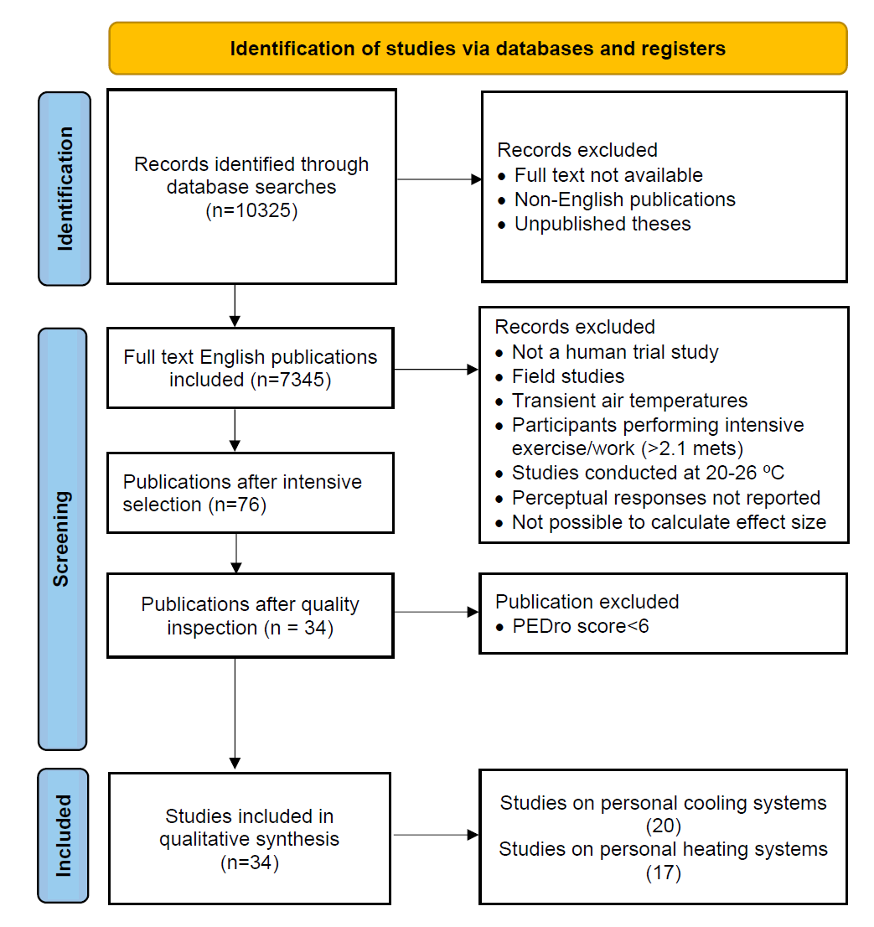
Fig. 1. Flow chart showing the searching and selection process of literature publications.

2.3. Study classification
PCSs discussed in included studies include personal cooling devices (PCDs) and personal heating devices (PHDs). They were further classified based on these two types of devices.

2.3.1. PCD classification
Currently, PCSs can be classified in a variety of ways, including heat transfer modes, subject response, etc. [12]. In this study, PCDs were classified into five subgroups based on heat transfer modes, i.e., cooling chairs/pads close to the human body that use conductive thermal transfer mechanism (CCPs), cooling radiators that use radiative heat transfer mechanism (CRTs), natural or cool air blowers that use convective heat transfer mechanism (NCABs) and multiple cooling devices that utilize more than two heat transfer mechanisms (MCDs). It is worth noting that CCPs were constructed by incorporating thermoelectric-cooling pads into chairs [40,41], covering cooling pads on the head [42] or overlaying the pads on clothing [43]. CRTs were either radiant panels filled with circulating chilling water that were placed around the human body [44] or clothing made of infrared-transparent textiles [45]. NCABs include table air fans [46-49], air cooling chairs [50,51], personal ventilation providing cool and clean air [52,53], air nozzles [54,55], ceiling jets [56]. The multiple cooling device consists of two or more of the above-mentioned device types and employs combined heat transfer mechanisms [48, 57-59].

2.3.2. PHD classification
Similarly, PHDs were divided into five subgroups, i.e., heating chairs/ pads that based on the conductive heat transfer mechanism (HCPs), heating radiators based on the radiative heat transfer mechanism (HRTs), hot-air blowers that employ both radiative & convective thermal transfer mechanisms (HABs), and multiple heating devices that adopt more than two heat transfer mechanisms and combining two or more of the above devices (MHDs). HCPs were constructed by embedding electric heating pads into chairs [60-63], placing heating pads under feet [64] or incorporating the pads into clothing [65]. Heating radiators include footwarmers [60,66], retrofitted Huotong (i.e., a warm barrel with halogen heating tubes inside) [67], and heated floor panels under feet [68]. Hot-air blowers include local heating devices that supply hot air to feet and calves [69,70] as well as thermoelectric air conditioning system that supply hot air to the chest region [71]. Multiple heating devices comprise of two or more of aforementioned devices, and use multiple heat transfer mechanisms [72,73].

2.4. Effect size assessments and statistical analyses
The standardized mean difference effect size and 95% confidence intervals (95% CI) were calculated to evaluate effects of the use of PCSs on improving thermal comfort. Here, the bias-corrected hedge’s effect size (EFS) was adopted to overcome drawbacks associated with the small sample size using Review Manager software (RevMan version 5.4.0, Cochrane, London, UK) [74]. Mean and standard deviation values of perceptual responses (i.e., thermal sensation, thermal comfort and thermal acceptability) and the sample size of each study were required for calculating EFSs. When relevant data was only presented in figures, one of the authors extracted it using GetData Digital Digitizer software, and had it validated by another author. When only the standard error was given, the standard deviation can be calculated by multiplying the standard error by the square root of sample size. Authors of the specific studies were contacted if important data were missing from published studies.
The assessment of the publication bias was performed using Egger’s funnel plot, which describes the relationship between effect size and standard deviation of effect size. The Egger’s funnel plot has been widely used to evaluate study differences [75]. Statistical heterogeneity (using I² statistic) was used to determine the percentage of the variability in effect estimates. When moderate (I² ranging from 50% to 75%) or high heterogeneity (I² > 75%) was detected, a random-effects regression model was chosen to calculate the pooled intervention effect; otherwise, a fixed-effect inverse variance approach was used to calculate the intervention effect [76]. The weighted-mean effect size was calculated based on the weighting of each study. EFSs in the range of 0-0.19, 0.2-0.49, 0.5-0.79 and higher than 0.8 represent negligible effect, small effect, moderate effect, and large effect, respectively [77]. In addition, subgroup-differences were presented as p values, with statistically significant differences set as p<0.05 [78].

3. Results
3.1. Included studies
Table S1 lists high-quality publications with PEDro scores greater than 6. Based on the selection process, a total of 34 articles (including 33 journal articles and 1 conference paper) were identified as meeting all inclusion criteria. The number of papers focusing on PCDs and PHDs is 20 and 17, respectively, with 3 papers examining both heating and cooling devices [40, 54, 58]. Several papers compared multiple PCSs in a single or multiple environments or examined a single PCS in multiple environments. The total number of studies on PCDs and PHDs is 65 and 67, respectively. Tables S2 and S3 provide an overview of those articles, including the authors and year of publication, sample size, genders, occupant demographic characteristics, testing protocols, environmental conditions, types of PCDs and PHDs, effect sizes of perceptual responses as and power consumption of those PCS devices.
As for the perceptual response outcomes, thermal sensation was assessed using either the ASHRAE 7-point [37] or 9-point scale method [79], thermal comfort was assessed using the ASHRAE 7-point scale [37], ISO 4-point scale [79] or accommodated 5-point [48], 9-point [40] or 11-point scale [53], and thermal acceptability was evaluated using a 2-point scale [72], the ASHRAE 3-point scale [45] or the adjusted 6-point scale [63].

3.2. Publication bias
The publication bias of 65 PCD studies and 67 PHD studies was assessed using funnel plots (the EFS versus the standard error of the EFS) (Fig. 2). It should be noted that thermal comfort, rather than thermal sensation, was used for the assessment because it serves as a comprehensive index for evaluating the effectiveness of PCSs [33]. Besides, thermal comfort is associated with more research studies than thermal acceptability. The plot of PCD studies demonstrates that there is no publication bias (Fig. 2a), which is supported by insignificant Egger’s (p>0.05) and Begg’s tests (p>0.05). In contrast, publication bias was found in PHD studies (see Fig. 2b), as evidenced by statistically significant Egger's (p<0.01) and Begg's tests (p<0.01). Cooling studies had low heterogeneity, as evidenced by I² of 38%, whereas heating studies has moderate heterogeneity, as evidenced by I² of 64%. As a result, the fix-effects model and the random-effects model were used to calculate thermal comfort EFSs for PCDs and PHDs, respectively.
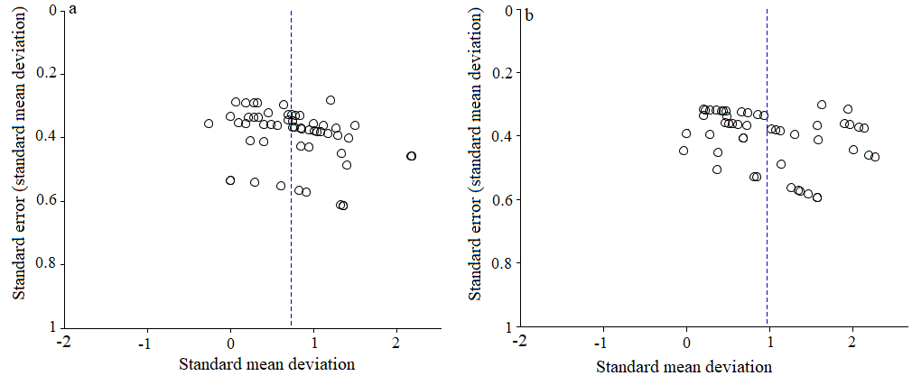
Fig. 2. Funnel plots for analysis publication bias: (a) personal cooling systems, (b) personal heating systems (standard error vs. standard mean deviation).

3.3. Effects of PCDs on perceptual responses and power consumption
The I² statistic values for thermal sensation, thermal comfort and thermal acceptability are 45%, 38% and 0%, respectively. PCDs showed large effect in reducing thermal sensation [EFS=1.23, 95% Confidence Intervals (CI): 1.13 to 1.32; n=65 studies] and moderate effects on thermal comfort (EFS=0.73, 95% CI: 0.63 to 0.83; n=55) and thermal acceptability (EFS=0.68, 95% CI: 0.52 to 0.84; n=19).

3.3.1. Effect of PCDs on perceptual responses targeting different body regions
Fig. 3 shows the effects of PCDs on thermal sensation, thermal comfort and thermal acceptability targeting at different body regions. Cooling the head/face demonstrated a large effect on improving thermal sensation (EFS=1.07, 95% CI: 0.9 to 1.23, n=20), and moderate effects in improving thermal comfort (EFS=0.55, 95% CI: 0.36 to 0.74, n=16) and thermal acceptability (EFS=0.77, 95% CI: 0.35 to 1.18, n=2).
Cooling the torso had a large effect on thermal sensation improvement (EFS=1.33, 95% CI: 1.06 to 1.59, n=29), a moderate effect on thermal comfort (EFS=0.71, 95% CI: 0.58 to 0.85, n=29) and a small benefit on thermal acceptability (EFS=0.47, 95% CI: 0.19 to 0.75, n=9). One study found that cooling the extremities had a negligible effect on both thermal sensation (EFS=0.20, 95% CI: -0.5 to 0.89, n=1) and thermal acceptability (EFS=0.19, 95% CI: -0.51 to 0.88, n=1).
Cooling more than two body regions manifested large effects in improving thermal sensation (EFS=1.30, 95% CI: 1.11 to 1.49, n=15), thermal comfort (EFS=0.96, 95% CI: 0.6 to 0.8, n=9) and thermal acceptability (EFS=0.8, 95% CI: 0.57 to 1.02, n=8).

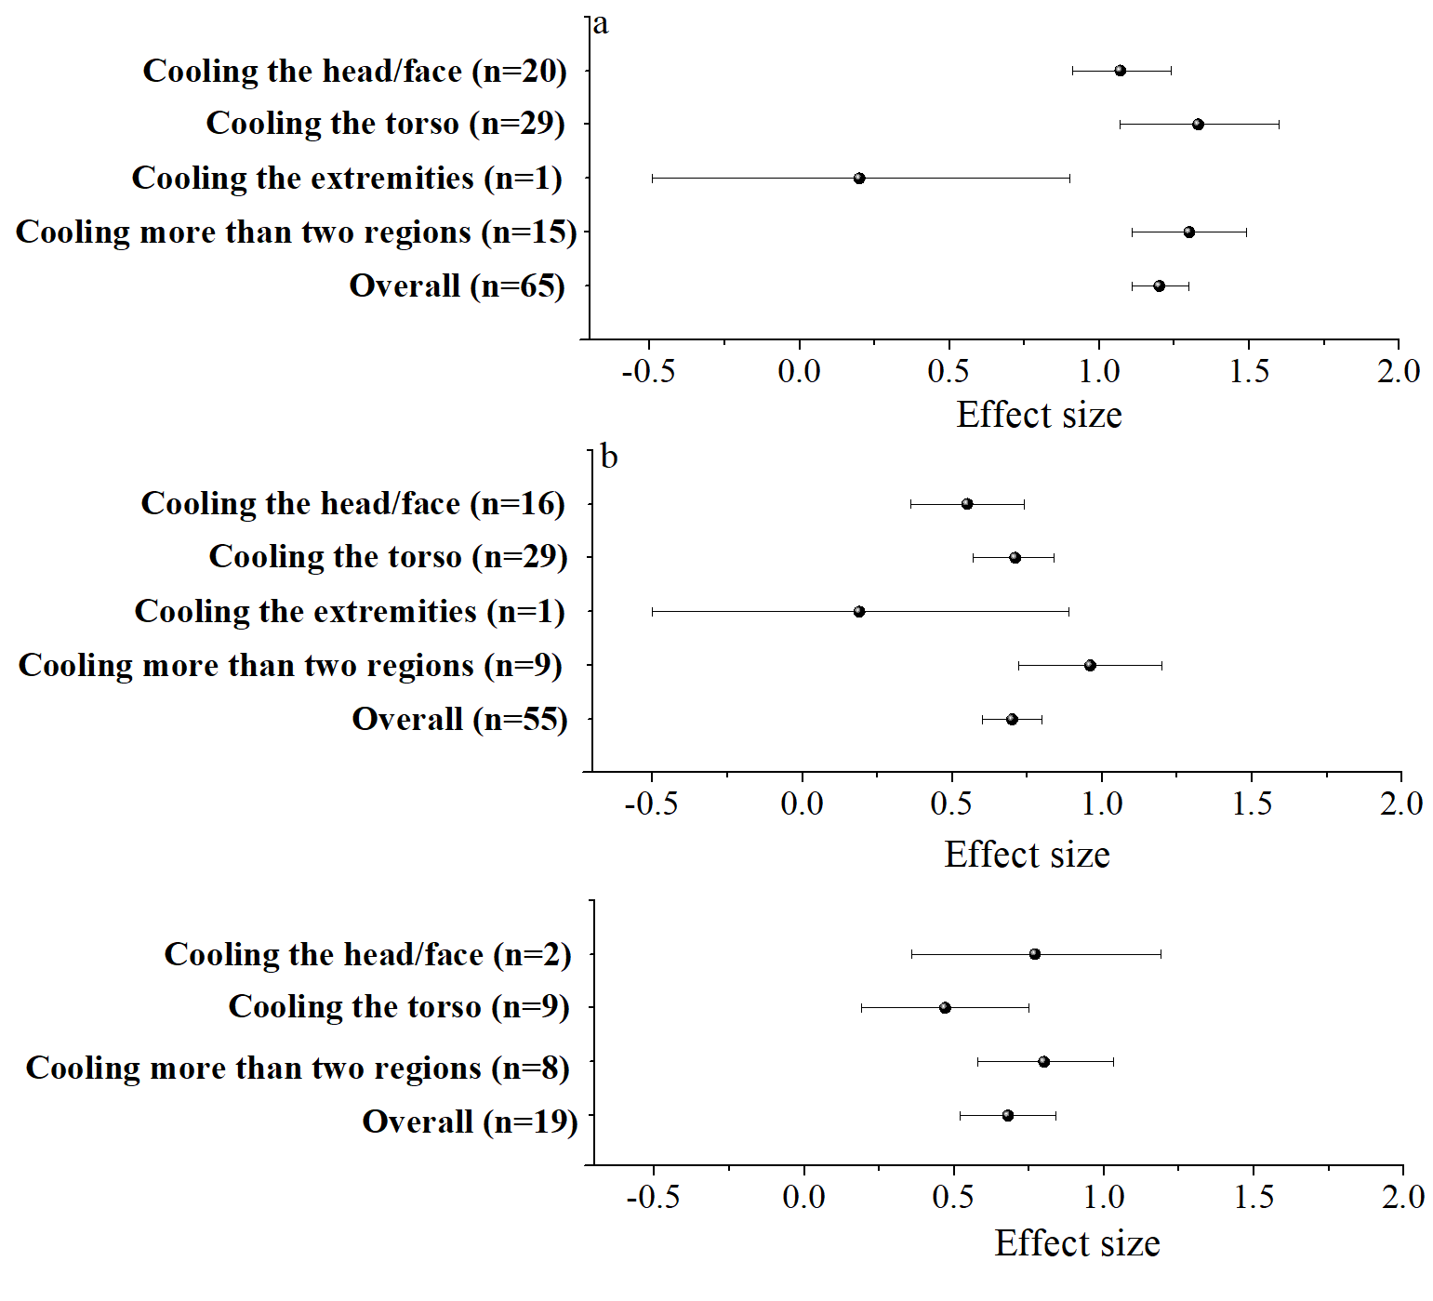
Fig. 3. The hedge’s effect sizes of personal cooling devices on thermal sensation (a), thermal comfort (b) and thermal acceptability (c) in high temperature environments related to subgroups based on cooled body regions.

3.3.2. Effect of different types of PCDs on perceptual responses
Fig. 4 displays the forest plot of the hedge’s effect sizes for the effect of different types of PCDs on thermal sensation, thermal comfort and thermal acceptability. CCPs showed a large effect on thermal sensation (EFS=1.55, 95% CI: 1.19 to 1.91, n=18) and thermal comfort (EFS=0.95, 95% CI: 0.78 to 1.13, n=18), but a small effect on thermal acceptability (EFS=0.42, 95% CI: 0.06 to 0.79, n=3). For the two types of CCPs, cooling chairs had a large effect on thermal sensation (EFS=1.88) and thermal comfort (EFS=1.17), while cooling pads had a large effect on thermal sensation (EFS=1.13), and a moderate effect on thermal comfort (EFS=0.66).
The NCABs had large effects on thermal sensation (EFS=1.14, 95% CI: 1.02 to 1.26, n=37), and moderate effects on thermal comfort (EFS=0.66, 95% CI: 0.45 to 0.87, n=31) and thermal acceptability (EFS=0.65, 95% CI: 0.37 to 0.92, n=9). For the various NCABs, desk fans, personalized ventilations, air nozzles and desk fans & air-cooling chairs demonstrated large effects in thermal sensation improvements (EFSs>0.99), while air-cooling chair demonstrated a moderate effect (EFS=0.71). Only desk fans & air-cooling chairs had a large effect on thermal comfort improvement (EFS=1.34), while the other types of NCABs showed moderate effects on thermal comfort (EFSs: from 0.5 to 0.59). The NCABs reported a moderate effect on thermal acceptability improvements (EFSs: from 0.54 to 0.79).
CRTs had a large effect on thermal sensation improvement (EFS=0.86, 95% CI: 0.14 to 1.31, n=2), but a small benefit on improving thermal comfort (EFS=0.34, 95% CI: 1.11 to 1.62, n=1) and thermal acceptability (EFS=0.42, 95% CI: 0.02 to 1.18, n=1).
MCDs exhibited large effects on improving thermal sensation (EFS=1.36, 95% CI: 1.11 to 1.62), thermal comfort (EFS=0.91, 95% CI: 0.59 to 1.22) and thermal acceptability improvements (EFS=0.87, 95% CI: 0.61 to 1.14). This type of device had a greater impact on improving the perceptual sensations than other types of PCDs (p<0.05).

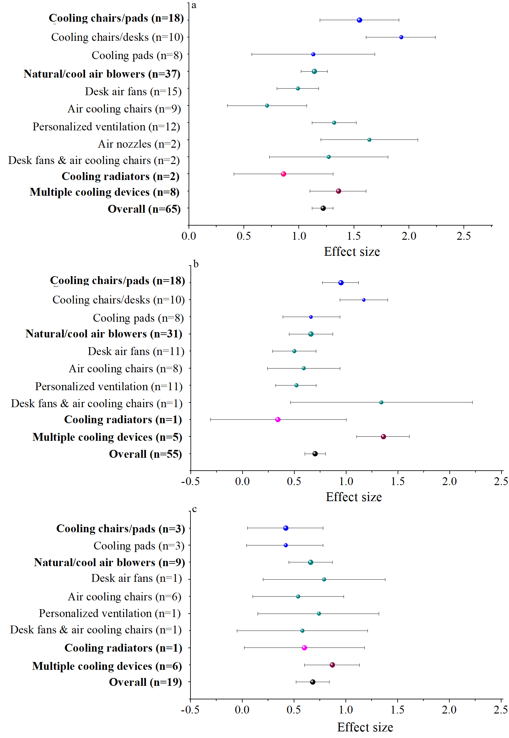
Fig. 4. The hedge’s effect sizes of personal cooling devices on thermal sensation (a), thermal comfort (b) and thermal acceptability (c) in high temperature environments related to subgroups based on the type of PCDs.

3.3.3. Energy performance of PCDs
Thirty-one studies from eight publications reported on the power consumption and energy performance of PCDs (Table S4). The various PCDs were discussed with air temperatures and relative humidity levels ranging from 28 to 32 ºC and 40% to 60%, respectively. It should be noted that corrective power (CP) and corrective power efficiency (CEP) were included in the table, as well as the relationship between CEP. It should also be noted the maximum input power values were presented in some papers, and thus were listed as ranges. Corrective power values were calculated based on the thermal sensation values. The relationship between CEPs and air temperatures are depicted in Fig. 5.
CEP values of CCPs are clearly seen to range from 11.4 to 47.6 W/K. It is also discovered that NCABs that use wind generated by mechanical fans produce much lower CEPs (i.e., <3.5 W/K) in the various air temperatures examined. A study that investigated air nozzles and hand devices with cooled supply air from the chamber’s HVAC system found CEPs of less than 13.6 W/K, which was lower than those of CCPs under the same temperatures. At 32 ºC, an MCD consisting of a cooling desk and a radiator cooled with chilled water from cooling-water machine has a CPE of 32.7 W/K. In contrast, one study found that an MCD with a desk fan, an air-cooling chair and a thermoelectric-cooling wristband has lower CPE (i.e., 1.9 W/K) at 29 ºC. Interestingly, the energy consumption and CEP values of a long-sleeved shirt made of an infrared transparent visible opaque fabric are both zero at 27 ºC.

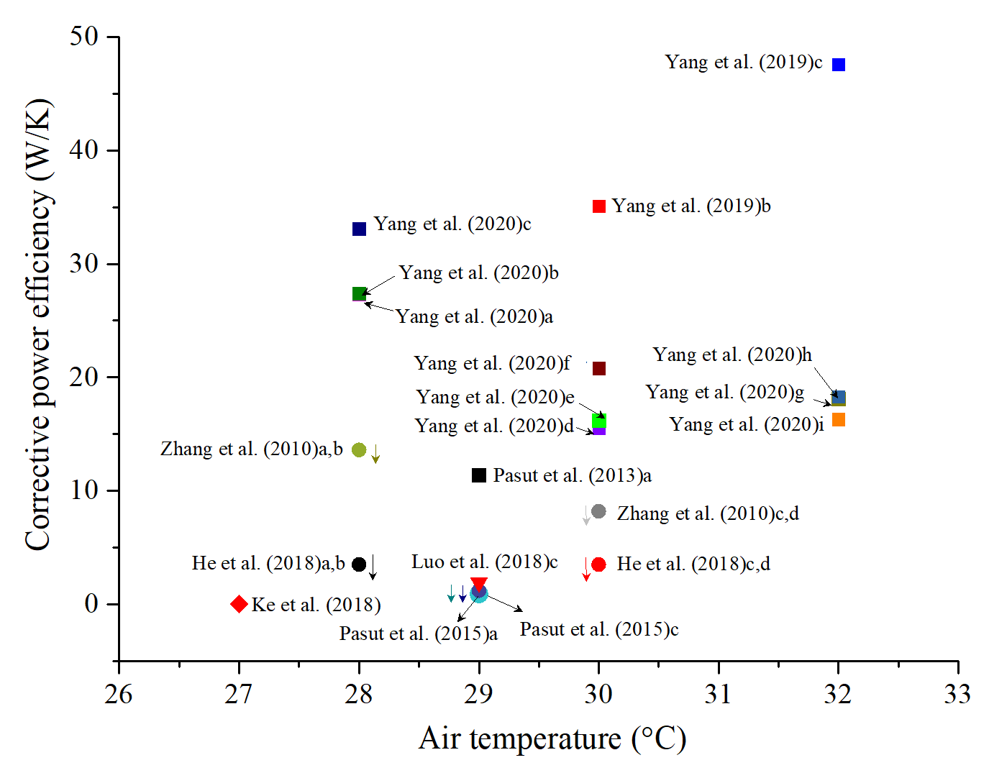
Fig. 5. Relationship between corrective power values of personal cooling devices and air temperatures.

3.4. Effects of PHDs on perceptual responses and energy consumption
The I² statistic values for thermal sensation, thermal comfort and thermal acceptability are 62%, 64% and 66%, respectively. PHDs displayed a large effect on thermal sensation (EFS=1.05, 95% CI: 0.91 to 1.21; n=72), thermal comfort (EFS=0.99, 95% CI: 0.81 to 1.71; n=59) as well as thermal acceptability (EFS=1.02, 95% CI: 0.71 to 1.32; n=15).

3.4.1. Effects of PHDs on perceptual responses targeting different body regions
Fig. 6 displays the effects of PHDs on thermal sensation and thermal comfort when directed at various body regions. Heating the torso displayed a large effect on thermal sensation (EFS=1.05, 95% CI: 0.78 to 1.33; n=19) and thermal comfort (EFS=1.22, 95% CI: 0.86 to 1.57; n=16) but had a negligible effect on thermal acceptability improvement (EFS=0.23, 95% CI: -0.21 to 0.68; n=4).
Heating extremities showed large effects on improving thermal sensation (EFS=0.95, 95% CI: 0.76 to 1.15; n=38) and thermal acceptability (EFS=1.0, 95% CI: 0.55 to 1.44, n=7), but had a moderate effect on thermal comfort improvement (EFS=0.73, 95% CI: 0.53 to 0.93; n=26).
Heating both the torso and the extremities exhibited large effects on improving thermal sensation (EFS=1.4, 95% CI: 1.05 to 1.76; n=11), thermal comfort (EFS=1.39, 95% CI: 1.04 to 1.73; n=10) and thermal acceptability (EFS=1.39, 95% CI: 1.16 to 1.49; n=5).

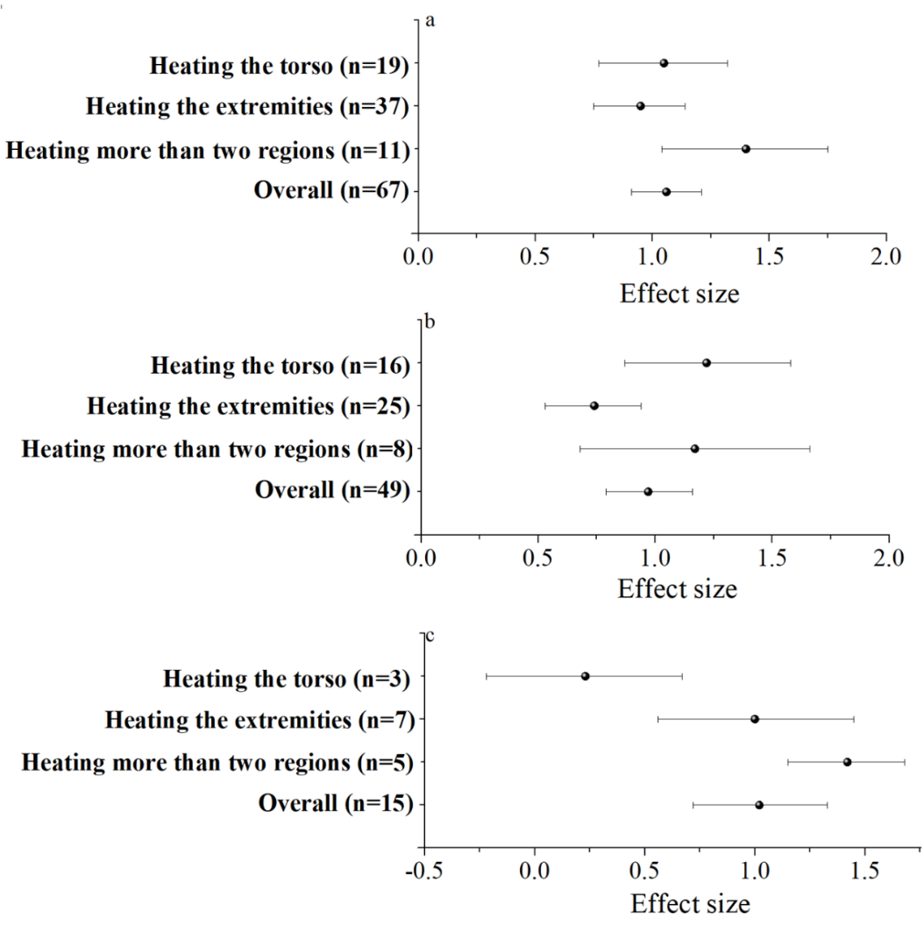
Fig. 6. The hedge’s effect sizes of personal cooling devices on thermal sensation (a), thermal comfort (b) and thermal acceptability (c) in high temperature environments related to subgroups based on heated body regions.

3.4.2. Effects of different PHD types on perceptual responses
Fig. 7 depicts the effects of various types of PHDs on thermal sensation, thermal comfort and thermal acceptability. HCPs showed large effects on thermal sensation (EFS=0.85, 95% CI: 0.86 to 1.57; n=42) and thermal comfort (EFS=1.03, 95% CI: 0.81 to 1.25; n=36), while displayed moderate effects on thermal acceptability (EFS=0.78, 95% CI: 0.4 to 1.15; n=9). For the various types of HCPs, heating chairs had large effects on thermal sensation (EFS=0.89) and thermal comfort improvements (EFS=1.23) while having a negligible effect on thermal acceptability improvements (EFS=0.23); heating pads showed large effects on thermal sensation improvement (EFS=0.83), and moderate effects on thermal comfort (EFS=0.5) and thermal acceptability improvements (EFS=0.58); Heating chairs & pads demonstrated large effects on improving perceptual responses.
HABs showed large effects on improving thermal sensation (EFS=1.33, 95% CI: 1.04 to 1.68; n=10) and thermal comfort (EFS=0.82, 95% CI: 0.14 to 1.51; n=3). HRTs demonstrated moderate effects on improving thermal sensation (EFS=0.45, 95% CI: 0.12 to 0.78; n=6) and thermal comfort (EFS=0.50, 95% CI: 0.17 to 0.84; n=6). There was no research reported the effects of HRTs and HABs on thermal acceptability.
MHDs displayed large effects on improving thermal sensation (EFS=1.56, 95% CI: 1.01 to 2.1; n=9), thermal comfort (EFS=1.31, 95% CI: 0.75 to 1.86; n=7) and thermal acceptability (EFS=1.37, 95% CI: 0.97 to 1.77; n=6). In addition, MHDs showed the greatest effects benefits in terms of improving perceptual responses.
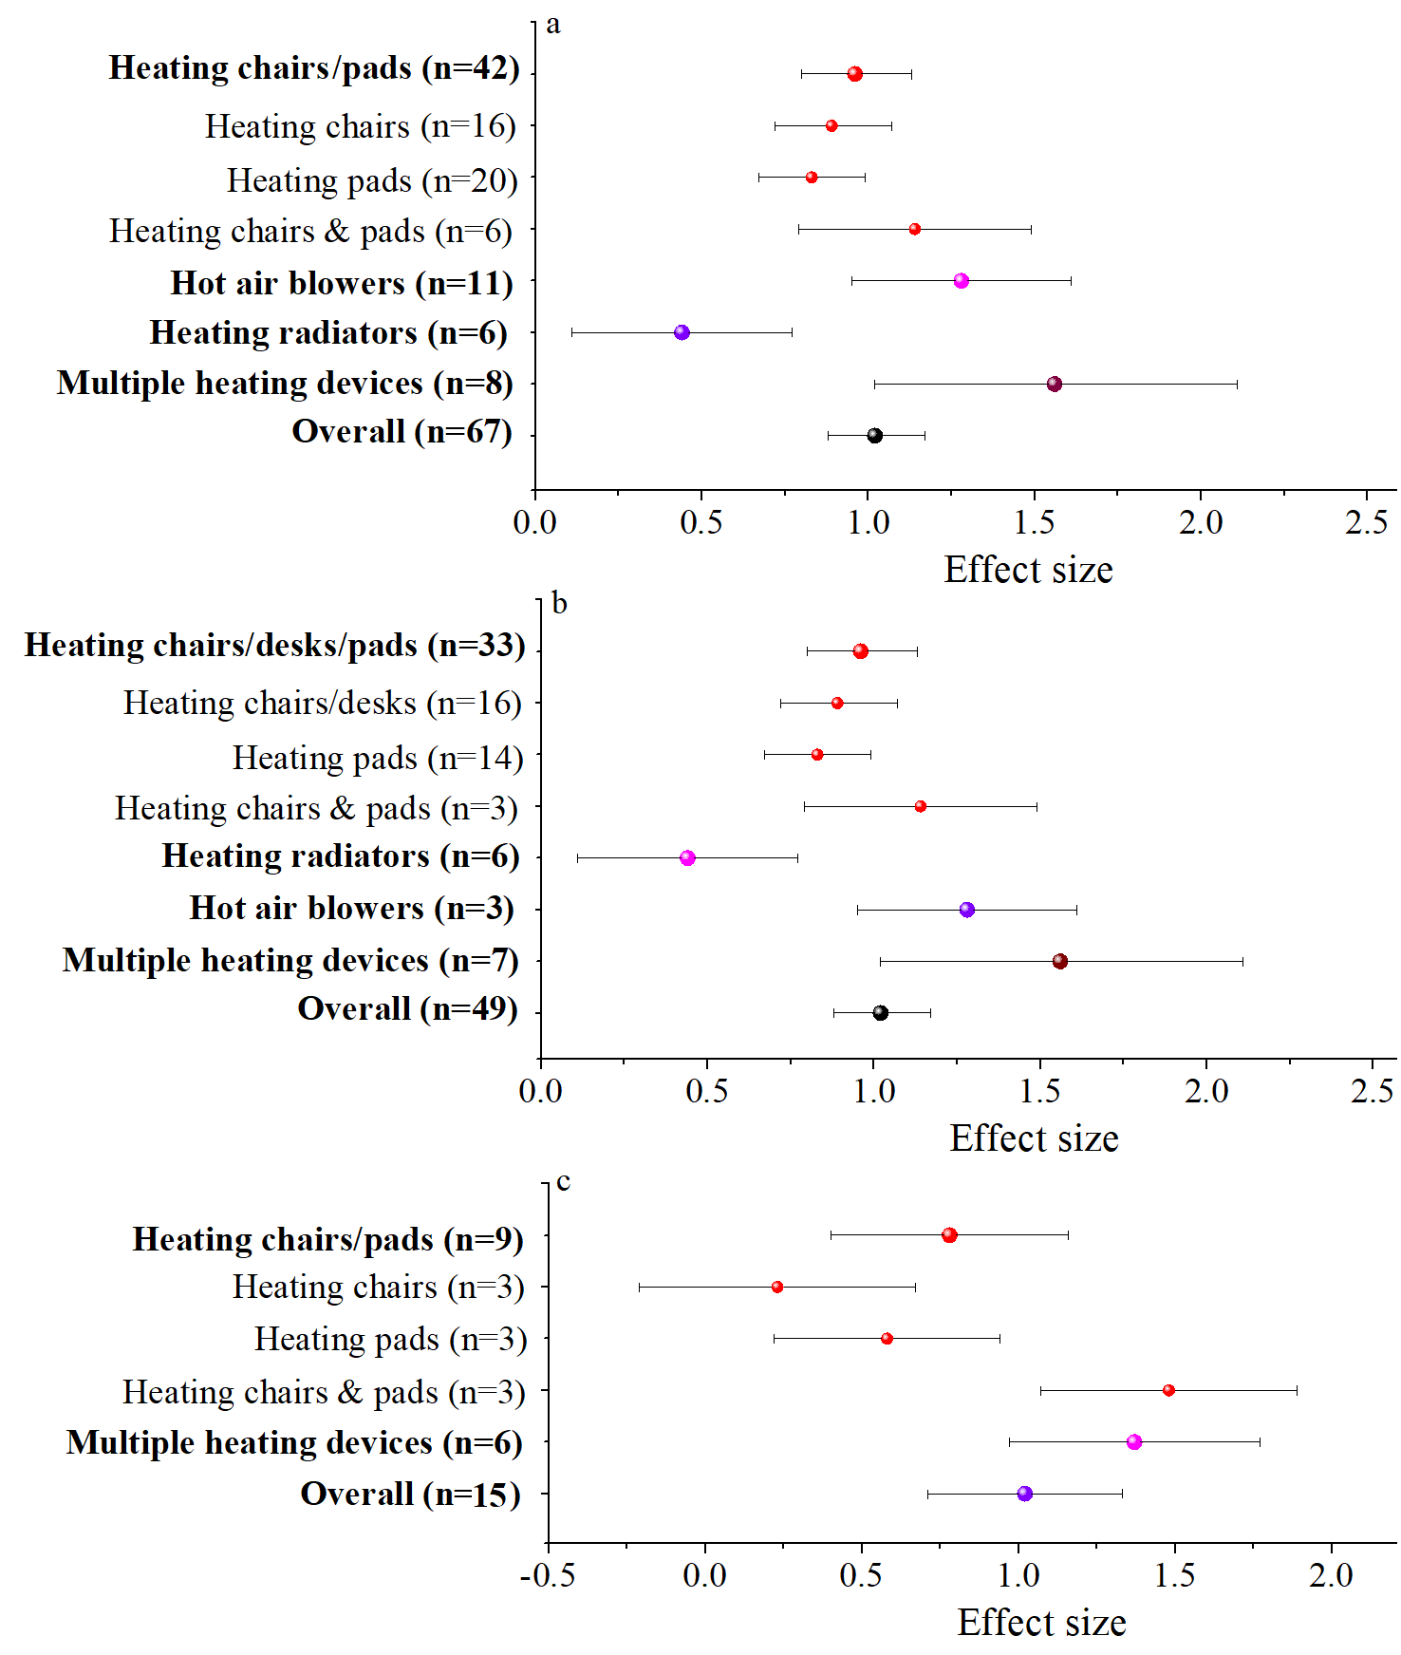
Fig. 7. The hedge’s effect sizes of personal cooling devices on thermal sensation (a), thermal comfort (b) and thermal acceptability (c) in high temperature environments related to subgroups based on types of personal heating devices.

3.4.3. Energy performance of using PHDs
A total of fifty-five studies from thirteen publications provided power consumption or energy performance analysis of PHDs (Table S5). Fig. 8 depicts the relationship between CEP values and air temperatures of the PHDs. The various PHDs were examined at air temperatures and relative humidity levels ranging from 8 to 18 ºC, and 40% to 50%, respectively. CEP values of CCPDs appear to range widely (from 0 to 57.9 W/K). Using an electrically heated pad under the feet produced much higher CEP values than incorporating one or two pads directly under the surface chairs (<22.5 W/K). Using heated chairs, researchers obtained a CEP value of 3.3 W/K at 10 ºC, and a value less than 3.1 W/K at 16 ºC. It is also worth noting that heated chairs with electric resistance elements have lower CEP values than those with thermoelectric-heating pads. In addition, HRTs displayed higher CPE values than HCPs at the discussed air temperatures of 10 ºC and 18 ºC. For MHDs, a warm-barrel has CEP values ranging from 12.6 to 14.9 W/K in air temperatures ranging from 9 to 18 ºC, and a combination of a heated insole, thermoelectric-heating wristband and heated chair has a lower CPE of <8.8 W/K.

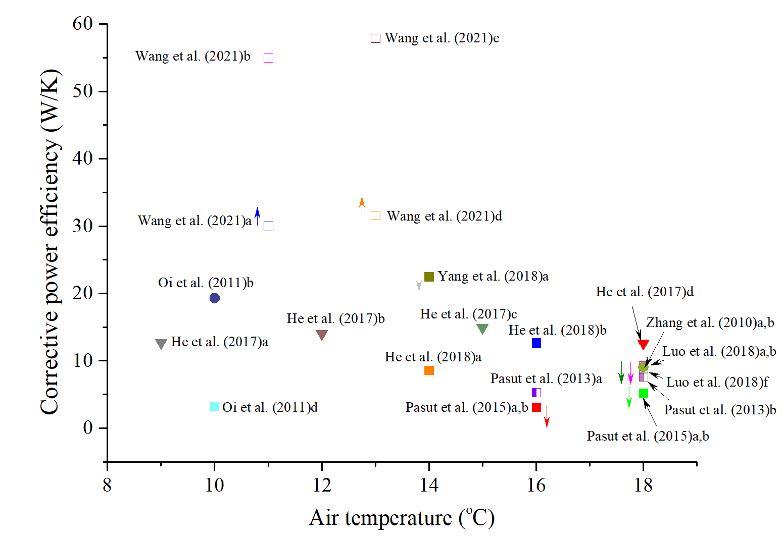
Fig. 8. Relationship between the corrective power values of personal heating devices and air temperatures.

- Discussion
  - Effects of personal cooling devices
Personal cooling devices (PCDs) were found to have a large effect on reducing thermal sensation, a moderate effect on improving thermal comfort and thermal acceptability in high temperature environments. Cooling more than two body regions exerts a large effect on improving thermal comfort and thermal acceptability. Furthermore, cooling chairs/pads that use the conductive thermal transfer mechanism (CCPs) or multiple cooling devices employing the combined thermal transfer mechanisms (MCDs) exhibit a large effect on improving thermal comfort. Natural/cooled air blowers (NCABs) showed a moderate effect on improving thermal comfort but may be more energy efficient than CCPs. MCDs with limited coverage that combine natural air-cooling units and thermoelectric cooling units could achieve a large effect on thermal comfort and thermal acceptability improvements, as well as better energy performance.

4.1.1. Effects of cooling regions
Cooling the head/face, torso and more than two body regions showed large effects on improving occupants’ thermal sensation. Previous research [42,80] pinpointed that there is a lack of vasoconstrictive innervation in the head region, but abundant blood supply is noted in this region, resulting in a great amount of heat loss when head cooling is used. Furthermore, high sudomotor thermosensitivity to face cooling greatly suppresses sweating at the facial area [42,81]. As a result, cooling the head/face is more efficient than cooling other body parts per unit surface area [82, 83]. It has also been reported that cooling local regions with appropriate cooling stimulus density could produce more notable effects on local thermal comfort improvement. Improved local thermal comfort of specific body parts can attenuate the discomfort of other body parts, resulting in an increase in overall thermal comfort [84]. Cooling the head/face had a moderate effect on improving thermal comfort.
Cooling the torso and more than two regions demonstrated a larger effect on improving body thermal sensation and thermal comfort than cooling the head/face. Cooling more than two body regions demonstrated the largest effects on thermal sensation and thermal comfort. Researchers found that the torso region is the “most influential group” of local body parts influencing thermal comfort, owning larger cooling area, greater vascularization, and greater number of cold receptors at the torso [85]. This could explain why cooling the torso or cooling more than two regions has a large effect on improving body thermal sensation. Regarding thermal comfort improvements, predication models were proposed for improving thermal comfort in non-uniform environments created by the use of PCDs. Zhang et al [86,87] discovered that the overall thermal comfort is determined by the average of the body points with the greatest comfort and the two with greatest discomfort. Zhang et al. [88] found that thermal comfort is linearly related to the maximum thermal sensation difference across the entire body. He et al. [59] proposed a more accurate model in which thermal comfort is determined by the overall thermal sensation as well as the local discomfort caused by cooling. Cooling a larger body region with a lower cooling density could result in a greater reduction in thermal sensation, less local discomfort in the cooled regions, and a narrowing of the maximum thermal sensation difference across the entire body [59]. This could explain why there is a greater improvement in body thermal comfort when cooling the torso or more than two regions, particularly the latter. One study also found [44] that cooling extremities has a negligible effect on thermal sensation improvement, which is consistent with the fact that extremities are the least thermosensitive body parts [88]. It is thus not surprising that cooling extremities exerts a negligible effect on thermal comfort due to its limited effect on thermal sensation enhancement.
Only cooling more than two body regions displayed a large effect on improving thermal acceptability, and the eight studies involved produced moderate to large results. Thermal acceptability was found to be linearly related to thermal comfort in both uniform and non-uniform environments [87]. Other factors that influence thermal acceptability include indoor air quality, air movement and stuffy air [82, 89]. This was most likely because PCDs with no function for fresh air exchanges could not alleviate the poor perceived air quality and stuffy air. Indeed, good air movement preference was perceived when air blowers were used, which positively influenced occupants’ thermal acceptability [82, 90]. Cooling radiators that create a cooling environment around the face also improved air quality [59]. Among the eight studies, five involved table air fans directed at the human face, and three involved cooling radiators positioned in the front of human face, which accelerated air movement or improved air quality around the face area [44,54]. Apart from having a large effect on thermal comfort, cooling more than two body regions with preferred air movement or air quality has the potential to significantly improve air quality and thus have a large effect on thermal acceptability.
Cooling the head/face with air fans or personalized ventilations was discovered to exert a near large effect on thermal acceptability, possibly due to the improved air quality [44]. However, it is difficult to draw any firm conclusions on head/face cooling in terms of thermal acceptability enhancement because only two studies from a publication are documented. Cooling the torso only exhibits a moderate effect on thermal acceptability. This could be because studies on cooling the torso had no or little effects on air quality improvement in occupied areas.

4.1.2. Effects of various types of cooling devices
CCPs showed a large effect on improving thermal sensation and thermal comfort, which may be attributed to the effective and efficient conductive heat loss of such types of PCDs [41]. For the two types of CCPs, cooling chairs/desks had greater effects than cooling pads, and the possible reason is that the former was mostly targeted at a greater body surface area (both buttocks & back) than cooling pads (smaller cooling area in most cases). Cooling pads had only a moderate effect on improving thermal comfort. Aside from minor thermal sensation improvements, there are also other possible explanations, such as the local discomfort caused by ‘overcooling’ in the cooled regions which is frequently reported in documented studies [41,43,44]. MCDs displayed large effects on improving thermal sensation and thermal comfort, with the most remarkable effect on improving thermal comfort. This is understandable given that they have a larger cooling body surface area than other types of PCDs.
NCABs and CRTs demonstrated large effects on thermal sensation but only moderate effects on thermal comfort. For various NCABs, personalized ventilation proving cooling air at the breathing area, air nozzles providing cooling air at the head region and a combination (i.e., desk fan & air-cooling chair) with larger cooling body surface area displayed larger effect on improving thermal sensation than the other two types of PCDs (i.e., desk fan, air-cooling chair). Only the combination demonstrated a large effect on thermal comfort improvement. This could be due to the larger cooling body surface area which results in greater thermal sensation improvement and possibly greater thermal inhomogeneity caused by these cooling devices [86]. The effect of air nozzles on thermal comfort improvement was not reported. Cooling radiators (reported in one study only) showed less benefits than other four types of cooling devices. This is evidenced from the study of Melikov et al. [44] who found placing radiant panels around the occupants was less effective in reducing thermal sensation than CCPs and NCABs. It is very likely that the radiated cooling was absorbed by the ambient environments, weakening their effects on the human body [44].
Only MCDs demonstrated a large effect on improving thermal acceptability, while the other three types of PCDs displayed moderate effects on thermal acceptability. The more remarkable benefit of MCDs is due to the more significantly enhanced thermal comfort [86] and improved air quality achieved through the use of air fans [58] or cooling radiators in front of the face [44]. CCPs displayed a moderate effect on thermal acceptability, which is because that the three studies involved are cooling pads that produced moderate effects in thermal comfort improvements [43].

4.1.3. Energy performance of PCDs
The energy performance of reported PCSs is heavily dependent on the cooling mechanisms adopted, the adjustability of the devices, cooling area and ambient air temperatures, etc. [31, 91]. Corrective power efficiency (CEP) refers to the amount of energy required to compensate of one unit of thermal sensation using a PCS [27]. PCSs with lower CEP values mean that they require the least amount of power per mitigated thermal comfort [27].
At the same air temperatures, CCPs using only the thermoelectric-cooling method showed higher CEP values (11.4 to 47.6 W/K) than those using other cooling mechanisms [40,41,43]. A thermoelectric pad made of two different semiconductor materials connected in series is based on the Peltier-Setback effect, which creates cooling and heating at both ends of the device when direct current is passed through it. This method is criticized for its inefficient cooling and high energy consumption [91]. Though existing thermoelectric cooling devices use small-sized semiconductor chilling pads to provide local cooling at one or two body regions, they may still consume more energy than other cooling mechanisms.
NCABs using wind generated by mechanical fans produce much lower CEPs (i.e., <3.5 W/K) in the various air temperatures examined [49,51,58]. A study discussing air nozzles that utilized cooling air from the chamber’s HVAC system presented CEPs less than 13.6 W/K [54]. Though CEP values were presented in ranges, it is expected that a higher power value was needed to cool the air for the NCABs using cooling air. Though being aimed at a large body surface area, an MCD consisting of an air fan, air-cooling chair & a wristband has much lower CPE (i.e., 1.9 W/K) at 29 ºC, owning to the low energy consumption natural air-cooling devices and tiny thermoelectric device used (i.e., cooling wrist). It is worth noting that a garment that uses the passive cooling method consumes 0 W, while still producing a large cooling effect in terms of thermal sensation reduction [58]. The garment in this case is made of infrared transparent visible opaque textiles, which are transparent to the near infrared radiation, allowing for excessive passive radiative body cooling in moderate indoor conditions [45]. The cooling benefit provided by the passive cooling clothing, on the other hand, was insufficient to have a significant impact on thermal comfort enhancement.
Furthermore, it is critical to analyze a PCS in conjunction with the building, because shifting a heating set point will result in different energy savings potential [12], which may not correspond to the energy performance differences between the various PCSs.

  - Effects of personal heating devices
Personal heating devices (PHDs) were found to have a large impact on thermal sensation, thermal comfort and thermal acceptability in low temperature environments. Heating a larger body surface area, i.e., both torso & extremities, demonstrated more remarkable effects on improving thermal comfort and thermal acceptability than heating only the torso or extremities. Large effects on improving thermal comfort were found on heating chairs/pads utilizing conductive thermal transfer mechanism (HCPs), hot air blowers (HABs) and multiple heating devices employing the combined thermal transfer mechanisms (MHDs). MHDs demonstrated the most impressive effects in improving thermal comfort and thermal acceptability. Heated chairs with electric resistance elements may have better energy performance than other types of heating systems.

4.2.1. Effects of heated body regions
Heating the torso exerted a large effect on improving thermal sensation, which was highly related to the large, heated body area as well as the high thermal sensitivity at the torso [93]. Though the targeted heating area is small, heating the extremities also exerted a large effect on improving thermal sensation. It is widely acknowledged that extremities are the coldest parts of the human body and heating the extremities could significantly raise the skin temperature and thus promote blood flow. As a result, both local thermal sensation and overall body thermal sensation could be greatly improved [94,95]. It is also not surprising to learn that heating both the torso and the extremities could result in a large effect on thermal sensation.
Given the preceding analysis, it is not surprising that heating the torso, as well as heating both the torso and extremities could induce a large effect on improving thermal comfort. In particular, heating both body regions exerted a more prominent effect on thermal comfort. Previous studies have demonstrated that thermal acceptability is linearly related to thermal comfort [87]. This could explain why thermal acceptability was more significantly improved while PHDs heated both regions rather than just the torso or extremities. Notably, thermal acceptability reported in the two studies was rated as “totally acceptable” when PHDs were used to heat both the torso and extremities at 16 ºC and 18 ºC [62,73]. Heating extremities could also greatly improve thermal acceptability but results were inconsistent. He et al. [67] found that a retrofitted warm barrel targeting the legs and feet generated a large effect on thermal acceptability. In contrast, several studies using small-sized heating devices covering hands or feet reported small to moderate effects on thermal acceptability [58,62]. When PHDs were used to heat the torso, only a minor benefit was discovered, which could be attributed to the small to moderate effects (i.e., ranging from 0 to 0.68) on thermal comfort observed in the three studies from a publication [58]. This should not be used to dismiss the effectiveness of torso heating due to the small number of documented studies.

4.2.2. Effects of types of heated devices
Heated chairs/pads (HCPs) have a large impact on thermal sensation and thermal comfort. The large effect could be attributed to the instantaneous and efficient conductive thermal transfer mechanism, large body region and high sensitivity of warm pots involved in heated region (mostly the torso region) [95]. For the three types of HCPs, heating pads produced a moderate effect on improving thermal comfort, whereas heated chairs and heated chairs & pads generated a large effect on thermal comfort. The twelve studies that used heated pads under feet may have reduced their benefit, possibly due to the small heating area and the thermal insulation of shoes [64]. In contrast, heated clothing that used heated pads with a large covering area (both torso & legs) produced a large effect on improving thermal comfort. Based on the results of the preceding analysis, utilizing both heated chair & pad produced a greater effect on thermal comfort than using only chairs or pads.
Heating radiators (HRTs) produced moderate effects in improving thermal sensation and thermal comfort, with the 6 studies involved reporting small to large effects on thermal sensation and thermal comfort. That is, heating radiators aimed at the feet or hands produced only small to moderate effects, whereas heating both feet & legs produced large effects. This contradicts studies found that in cold environments, overall thermal sensation was dominated by the local thermal sensation of hands and feet [87,94]. According to Wang et al. [94], the legs and thighs are more influential body parts in receiving local cold stimuli. The large effects observed on heating radiators aimed at feet and calves could be attributed to the large heated area and the calves’ high thermal sensitivity. Given the preceding analysis, it understandable to find that the studies involving hot-air blowers (HABs) with feet and calf heating reported large effects on occupants’ thermal sensation and thermal comfort. Notably, a garment using hot air targeting at the chest region had a much larger effect on increasing thermal sensation than other HABs, but its other benefits, such as thermal comfort improvements were not reported [70].
Multiple heating devices (MHDs) demonstrated more significant impacts on thermal sensation and thermal comfort improvements than other types of devices. The reason for this is that using MHDs that target a larger body surface area with a lower heating intensity may result in a more significant benefit [66]. Given this, a greater benefit was revealed in MHDs in terms of improving thermal acceptability.
HCPs demonstrated a moderate effect on improving thermal acceptability. For the three types of HCPs, only using heating chairs & pads had a large effect on improving thermal acceptability, possibly due to the larger heating area. Using heating pads or heating chairs produced only small and moderate effects on thermal acceptability.

4.2.3. Energy performance of PHDs
HCPs’ energy performance varied greatly. Heating pads placed under the feet had higher CEPs (i.e., > 30 W/K) [64], indicating that it was an energy-intensive method, whereas the pads placed in other body regions had lower CEPs (i.e., < 9.3 W/K) [58]. Heated chairs produced much lower CEPs (i.e., <12.7 W/K) [40,51,60,62,63], which could be attributed to the instantaneous and efficient thermal conductive transfer mechanism. Under the same ambient temperatures, heated chairs using electric resistance wires had lower CEPs than those heated with thermoelectric heating modules, confirming the higher energy consumption of the thermoelectric heating method [40]. The low energy consumption was also observed in heating clothing with electric resistance wires (input power of 16 W) [64]. A study concerning a combination (heating chair & pad) using electric heating wires also revealed a lower CEP (<8.8 W/K) [58].
Larger CEPs were discovered in HRTs (>9.1 W/K) than HCPs (<9.3 W/K) under the same air temperatures [54]. The poor energy performance of the HRTs may be because the radiant heat of the device is partly absorbed by the ambient environment [54]. It is understandable that MHDs with a greater heating area that used radiant and conductive thermal transfer produced larger CEPs (12.6 W/K) than HCPs and HRTs with a smaller heating area [66].

  - Practical implications
In practical applications, in addition to thermal comfort and energy performance, other factors such as convenience of use, space occupation, adjustability, adjustment response time, cost and user willingness to use or purchase the system should be considered for PCS selection [11,12].
PCSs using conductive thermal transfer mechanism were built by incorporating into the cooling/heating elements into the chairs, allowing for instantaneous and efficient cooling/heating power [40,41,50,51]. This type of device is simple to operate, and the users can fully control the system via a knob or key on the interface. Besides, its control is fast due to the conductive thermal transfer mechanism. CCPs, on the other hand, necessitate a heat dissipation system to dissipate the heat generated on the hot surface of the semiconductor chip such as heat exchangers, water tank and water pump, all of which have the disadvantages of extra occupied area requirement and an unappealing appearance. The rigid and heavy weight of the cooling pad (1.3 kg reported in a paper) that overlay on a body part, in particular, may make people unwilling to use the device [43]. The advantage is that there is less protrusion in HCPs that do not require extra space, particularly in heated chairs that are similar to regular chairs.
The control of PCSs via convective thermal transfer mechanism is also simple and quick, the airflow rates, airflow directions or the air temperatures can all be freely adjusted. For the various NCABs, desk fans and air-cooling chairs occupy less space, particularly air-cooling chairs that could integrate the air-cooling system as an integral. A test performed by Knecht et al [95] indicated that a desk fan is perceived as more convenient for workspace use than cooling pads because it allows for greater adjustability of position and cooling affect. However, using high-velocity desk air fans may cause vibration and noise, as well as other discomforts such as eye-dryness and draft [44]. Using both air fans & air-cooling chairs may address this issue by choosing moderate air velocity and providing a large cooling effect. However, these devices provide an isothermal airflow, which becomes ineffective at high air temperatures for dissipating human heat loss [50]. Personalized ventilation and air nozzles could provide clean and cool air to the human breathing area or chest region, with adjustable airflow temperatures and direction controlled by manual manipulation. However, connecting the devices to the HVAC system or outdoors necessitates complex and costly wiring, which may limit their application. For HABs, local heaters were placed near human feet, requiring extra occupation space, and more importantly, inducing draft sensations, dry eye symptoms and an uncomfortable feeling in the users [68,69].
CRTs or HRTs using radiant thermal transfer mechanism are inefficient and not energy efficient. Most of PCSs using combined thermal transfer mechanisms are made up of more than two types of devices, making them more complex and inconvenient. Among various systems, an MCD using desk fan & thermoelectric wristband is a relatively simpler system, and the wristband is small enough to produce an instantaneous cooling effect with input power close to 1 W [58]. This type of device may be very useful because if its ease of use and very low power consumption. An MHD using a warm barrel with halogen heating tubes inside has fewer ergonomic issues, which could be regarded as a special type of heated chair [66].
It should be noted that portable PCSs such as a cooling garment incorporated with air fans and PCM packs and heated clothing embedded with electric resistance wires, have been reported [57,64]. Previous studies showed that users prefer solutions that require little interaction to run [95]. However, users have to recharge the batteries after several hours of use and also need to load and unload the PCMs, making them impractical [95]. Furthermore, the discomfort caused by the direct contact batteries, circuits, and PCMs, as well as the lack of aesthetic appearance and bulkiness make users unwilling to use it [96]. Future studies should focus on designing heating clothing with micro-electronic components and flexible circuits to alleviate existing ergonomic issues. A nanoPE shirt, like regular clothing, does not require power supply. Nevertheless, it only has a minor effect on improving thermal comfort at an air temperature of 27 ºC [45]. This represents a type of passive cooling material (such as 3D printing and graphene coated fabric) [97], and it is also the only one that has been examined using human physiology experiments. Other issues addressed in this study, that may limit its application include transparency, sweat porosity, mechanical resistance and foldability, as well as the safety associated with the use of nanotechnology [98]. That demonstrates the need for additional research or other textile solutions.
The economic issue is another important factor affecting the application of the PCSs. For the PCSs that are fixed to the building (such as personalized ventilation and air nozzles) or some PCSs that are the partly fixed to the ambient environment (such as cooling chairs), payment should be the offered by the landlord while the profit is the tenant. For the portable PCSs such as cooling wearables, the cost should be borne by the users, and accordingly, the price of the PCSs should be a determining factor. Wearables are typically an individual’s free choice for office workers, and the issues addressed above cause the users to refuse to use the items. Using desk fans, in particular, is a practical strategy with low cost and the benefits discussed above.
Future research should consider the ergonomic and economic issues associated with PCSs, as well as thermal comfort and energy performance. Besides, novel technologies such as wireless charging, microelectronics, and artificial intelligence (AI) offer great opportunities to save energy, improve thermal comfort, while reduce ergonomic issues. For instance, AI technology could non-invasively capture the real-time personal data and automatically adjust the personal comfort system to meet personal thermal comfort requirements [8,31].

- Limitations and future perspectives
This comprehensive meta-analysis review aims to investigate the effects of personal comfort systems on thermal comfort and energy consumption as well as to identify the appropriate personal comfort strategies for indoors. This study’s strengths lie in the selection criteria, the quality of the studies, and the extent to which the information from those studies can be integrated. Several limitations, however, must be acknowledged. Only studies written in the English language were included, which may result in study omissions, resulting in publication bias. Indeed, publication bias was detected in this study because a few negative results were reported. This could be due to a lack of publications and the preference for positive outcomes [66]. It is impossible to blind the participants, investigators and outcome assessors from cooling or heating, and hence, the “placebo effect” of PCSs cannot be eliminated. All of these factors may amplify the effects of PCSs.
Furthermore, research discussing other types of PCSs, such as floor fans, the ceiling fans and radiant heaters that target the majority of body parts, may be missing after the publication selection. Apart from that, differences in methodologies (e.g., testing duration), subject characteristics (e.g., gender and age), environmental conditions (e.g., air temperature and relative humidity), clothing (e.g., insulation and moisture permeability) and chairs (e.g., insulation) could be the barriers to the overall assessment and comparison of those studies. Apart from that, different visual analogue scales were used to assess occupant’s perceptual responses when using PCSs, which may have influenced the results. In future studies, all of the aforementioned factors should be standardized based on the actual-use scenario of the PCSs. Their effects on thermal comfort and energy consumption should be investigated and compared in uniform experimental settings.
Finally, the effectiveness of PCSs was primarily assessed in laboratory settings. The reported effectiveness on the use of various types of PCSs obtained in laboratory setting may differ significantly from actual performance in the field. There are numerous issues in actual working environments that could impair the effectiveness of the devices. For example, instead of sitting still, occupants may have the compound moving forms of the body. More field studies should be carried out to assess the benefits of various PCSs in terms of thermal comfort enhancement and energy consumption. In addition, as computer vision technology advances, PCSs should be operated more intelligently in order to improve occupant thermal comfort [99].

- Conclusions
This meta-analysis review indicates that the use of PCSs can improve thermal comfort indoors at air temperatures that deviate from thermoneutral temperatures. Cooling or heating a larger body surface area has more noticeable effects on improving thermal comfort and thermal acceptability than cooling or heating a specific small region.
In terms of cooling devices, using cooling chairs/pads (CCPs) has a significant impact on thermal comfort improvement. The multiple cooling devices (MCDs) demonstrated a large impact on thermal comfort and thermal acceptability improvements. Natural/cool air blowers (NCABs) or multiple cooling devices utilizing air-cooling units and a thermoelectric cooling unit with limited coverage are more energy efficient than other PCDs. With regard to HCPs, heating chairs/pads utilizing conductive thermal transfer mechanism (HCPs), hot air blowers (HABs) and multiple heating devices employing the combined thermal transfer mechanisms (MHDs) produced large effects in improving thermal comfort, and MHDs manifested the most remarkable effect on improving thermal comfort and thermal acceptability. Heated chairs with embedded heating elements, particularly those that use electric heating wires, may have better energy performance.
Considering practical implications, using desk fan & air-cooling chair has a large impact on improving occupants’ thermal comfort and thermal acceptability while exhibiting fewer ergonomic issues and good energy performance. Furthermore, MCDs based on air cooling units or air cooling and tiny-sized thermoelectric cooling units could achieve significant improvements in both thermal comfort and thermal acceptability, as well as less ergonomic issues and good energy performance. Regarding the various PHDs, heating chairs demonstrated large improvements in thermal comfort while exhibiting fewer ergonomic issues and good energy performance.

Acknowledgements
This work was jointly funded by grants from the Natural Science Foundation of China (Project no. 51606131) and the Innovation and Entrepreneurship Project of Guangdong University of Technology (Project no. 212210280).

Author Contributions
Conceptualization, FW & WS; Data curation, WS, ZZ, TL, & ZC; Formal analysis, WS, ZZ, TL, & ZC; Funding acquisition, WS; Methodology, WS & FW; Resources, WS; Software, WS; Supervision, WS, FW & BY; Validation, FW, WS & BY; Roles/Writing - original draft, WS; Writing - review & editing, FW & BY.

References
- Tham S, Thompson R, Landeg O, Murray KA, Waite T. Indoor temperature and health: a global systematic review. Public Health 2020;179:9-17.
- Yang D, Mak CM. Relationships between indoor environmental quality and environmental factors in university classrooms. Build Environ 2020;186:107331.
- Tang H, Ding Y, Singer B. Interactions and comprehensive effect of indoor environmental quality factors on occupant satisfaction. Build Environ 2020;167:106462.
- Zalejska-Jonsson A, Wilhelmsson M. Impact of perceived indoor environment quality on overall satisfaction in Swedish dwellings. Build Environ 2013;63:134-44.
- Tong Z, Chen Y, Malkawi A, Liu Z, Freenman RB. Energy saving potential of natural ventilation in China: The impact of ambient air pollution. Appl Energy 2016;179:660-8.
- Indraganti M, Rao KD. Effect of age, gender, economic group and tenure on thermal comfort: A field study in residential buildings in hot and dry climate with seasonal variations. Energ Build 2010;42:273-81.
- Karjalainen S. Thermal comfort and gender: a literature review. Indoor Air 2012;22:96-109.
- André M, Vecchi RD, Lamberts R. User-centered environmental control: a review of current findings on personal conditioning systems and personal comfort models. Energ Build 2020;222:1-27.
- Seem JE, Braun JE. The impact of personal environmental control on building energy use. ASHRAE Trans 1992;98:903-909.
- Heinemeier KE. Task conditioning for the workplace: issues and challenges. ASHRAE Trans 1990;106:678-689.
- Vesely M, Zeiler W. Personalized conditioning and its impact on thermal comfort and energy performance–A review. Renew Sust Energ Rev 2014;34:401-8.
- Rawal R, Schweiker M, Kazanci OB, Vardhan V, Jin Q, Duanmu L. Personal comfort systems: A review on comfort, energy, and economics. Energ Build 2020;214:109858.
- Yang B, Sekhar C, Melikov AK. Ceiling mounted personalized ventilation system in hot and humid climate - an energy analysis. Energ Build 2010;42:2304-8.
- Pan CS, Chiang HC, Yen MC, Wang CC. Thermal comfort and energy saving
of a personalized PFCU air-conditioning system. Energ Build 2005;37:443-9.
- Schiavon S, Melikov AK. Energy-saving strategies with personalized ventilation
in cold climates. Energ Build 2009;41:543-50.
- Zhang TF, Li PH, Wang SG. A personal air distribution system with air terminals embedded in chair armrests on commercial airplanes. Build Environ 2012;47:89-99.
- Vesely M, Molenaar P, Vos M, Li R, Zeiler W. Personalized heating–comparison of heaters and control modes. Build Environ 2017;112:223-32.
- Tian Z, Love JA. field study of occupant thermal comfort and thermal environments with radiant slab cooling. Build Environ 2008;43:1658-70.
- Yang B, Li Z, Zhou B, Olofsson T, Li A. Enhanced effects of footwarmer by wearing sandals in winter office: A Swedish case study. Indoor Built Environ 2020;30:875-85.
- Makhoul A, Ghali K, Ghaddar N. Thermal comfort and energy performance of a low-mixing ceiling-mounted personalized ventilator system. Build Environ 2013;60:126-36.
- Fang ZS, Liu H, Li BZ, Du XY, Baldwin A. Investigation of the effects of temperature for supplied air from a personal nozzle system on thermal comfort of air travelers. Build Environ 2017;126:82-97.
- Schiavon S, Melikov AK, Sekhar C. Energy analysis of the personalized ventilation system in hot and humid climates. Energ Build 2010;42:699-707.
- Verhaart J, Li R, Zeiler W. User interaction patterns of a personal cooling system: A measurement study. Sci Technol Built Environ 2018;24:57-72.
- Newsham GR. Clothing as a thermal comfort moderator and the effect on energy consumption. Energ Build 1997;26:283-91.
- Udayraj, Li Z, Ke Y, Wang F, Yang B. Personal cooling strategies to improve thermal comfort in warm indoor environments: Comparison of a conventional desk fan and air ventilation clothing. Energ Build 2018;174:439-51.
- Tham KW, Pantelic J. Performance evaluation of the coupling of a desktop personalized ventilation air terminal device and desk mounted fans. Build Environ 2010;45:1941-50.
- Habchi C, Chakroun W, Alotaibi S, Ghali K, Ghaddar N. Effect of shifts from occupant design position on performance of ceiling personalized ventilation assisted with desk fan or chair fans. Energ Build 2016;117:20-32.
- Zhang H, Arens E, Zhai Y. A review of the corrective power of personal comfort systems in non-neutral ambient environments. Build Environ 2015;91:15-41.
- Melikov AK, Skwarczynski MA, Kaczmarczyk J, Zabecku J. Use of personalized ventilation for improving health, comfort, and performance at high room temperature and humidity. Indoor Air 2013;23:250-63.
- Shahzad S, Calautit JK, Calautit K, Hughes B, Aquino AI. Advanced personal comfort system (APCS) for the workplace: a review and case study. Energ Build 2018;173:689-709.
- Godithl SB, Sachdeva E, Garg V, Browns R, Kohler C, Rawal R. A review of advances for thermal and visual comfort controls in personal environmental control (PEC) systems. Intelligent Build Int 2019;11:75-104.
- Yang B, Ding X, Wang F, Li A. A review of intensified conditioning of personal micro-environments: moving closer to the human body. Energ Built Environ 2021;2:260-70.
- Enescu D. A review of thermal comfort models and indicators for indoor environments. Renew Sust Energ Rev 2017;79:1353-79.
- Saad SM, Shakaff AYM, Saad ARM, Yusof AM, Andrew AM, Zakaria A, et al. Development of indoor environmental index: Air quality index and thermal comfort index. AIP Conference Proceedings 2017;1808:020043.
- Akhter S, Pauyo T, Khan M. What is the difference between a systematic review and a meta-analysis?. In: Basic Methods Handbook for Clinical Orthopaedic Research, Springer; 2019.
- Liberati A, Altman DG, Tetzlaff J, Mulrow C, Gotzsche PC, Ioannidis JPA, et al. The PRISMA statement for reporting systematic reviews and meta-analyses of studies that evaluate healthcare interventions explanation and elaboration. BMJ 2009;339:b2700.
- ASHRAE 55: Thermal environmental conditions for human occupancy. 2020.
- Moseley AM, Elkins MR, van der Wees PJ, Pinheiro MB. Using research to guide practice: The physiotherapy evidence database (PEDro). Braz J Phys Ther 2020;24:384-91.
- Albanese E, Butikofer L, Armijo-Olivo S, Ha C, Egger M. Construct validity of the Physiotherapy Evidence Database (PEDro) quality scale for randomized trials: Item response theory and factor analyses. Res Synth Method 2019;11:227-36.
- Pasut W, Zhang H, Arens E, Kaam S, Zhai Y. Effect of a heated and cooled office chair on thermal comfort. HVAC&R Res 2013;19:574-83.
- Yang H, Deng Y, Cao B, Zhu Y. Study on the local and overall thermal perceptions under nonuniform thermal exposure using a cooling chair. Build Environ 2020;176:106864.
- Katsuura T, Tomioka K, Harada H, Iwanaga K, Kikuchi Y. Effects of cooling portions of the head on human thermoregulatory response. Appl Hum Sci 1996;15:67-74.
- Yang H, Cao B, Ju Y, Zhu Y. The effects of local cooling at different torso parts in improving body thermal comfort in hot indoor environments. Energ Build 2019;198:528-41.
- Melikov AK, Krejcirikova B, Kaczmarczyk J, Duszyk M, Sakoi T. Human response to local convective and radiant cooling in a warm environment. HVAC&R Res 2013;19:1023-32.
- Ke Y, Wang F, Xu P, Yang B. On the use of a novel nanoporous polyethylene (nanoPE) passive cooling material for personal thermal comfort management under uniform indoor environments. Build Environ 2018;145:85-95.
- Atthajariyakul S, Lertsatitthanakorn C. Small fan assisted air conditioner for thermal comfort and energy saving in Thailand. Energy Conv Manag 2008;49:2499-504.
- Cui W, Cao G, Ouyang Q, Zhu Y. Influence of dynamic environment with different airflows on human performance. Build Environ 2013;62:124-32.
- Pallubinsky H, Schellen L, Rieswijk TA, Breukel CMGAM, Kingma BRM, van Marken Lichtenbelt WD. Local cooling in a warm environment. Energ Build 2016;113:15-22.
- He Y, Li N, Li N, Li J, Yan J, Tan C. Control behaviors and thermal comfort in a shared room with desk fans and adjustable thermostat. Build Environ 2018;136:213-26.
- Watanabe S, Shimomura T, Miyazaki H. Thermal evaluation of a chair with fans as an individually controlled system. Build Environ 2009;44:1392-8.
- Pasut P, Zhang H, Arens E, Zhai Y. Energy-efficient comfort with a heated/cooled chair: Results from human subject tests. Build Environ 2015;84:10-21.
- Wang Y, Hwang RL, Lian Z. A study on the parameter ranges of the locally supplied air in a task ambient conditioning system with chest exposure. Sci Technol Built Environ 2018;24:238-47.
- Verhaart J, Quaas L, Li R, Zeiler W. Comfort of cooling by personal air movement. Indoor Air 2016;1-8.
- Zhang H, Arens E, Kim DE, Buchberger E, Bauman F, Huizenga C. Comfort, perceived air quality, and work performance in a low-power task–ambient conditioning system. Build Environ 2010;45:29-39.
- Du X, Li B, Liu H, Wu Y, Cheng T. The appropriate airflow rate for a nozzle in commercial aircraft cabins based on thermal comfort experiments. Build Environ 2017;112:132-43.
- Maula H, Hongisto V, Koskela H, Haapakangas A. The effect of cooling jet on work performance and comfort in warm office environment. Build Environ 2016;104:13-20.
- Song W, Wang F, Wei F. Hybrid cooling clothing to improve thermal comfort of office workers in a hot indoor environment. Build Environ 2016;100:92-101.
- Luo M, Zhang H, Arens E, Ghahramani A, Wang Z, Jin L, et al. Heating and cooling the human body with energy-efficient personal comfort systems (PCS). The 15th Conference of International Society Indoor Air Quality & Climate (ISUAQ), 2018;1-9.
- He Y, Li N, He M, He D. Using radiant cooling desk for maintaining comfort in hot environment. Energ Build 2017;145:144-54.
- Oi H, Yanagi K, Tabata K, Tochihara Y. Effects of heated seat and foot heater on thermal comfort and heater energy consumption in vehicle. Ergonomics 2011;54:690-9.
- Brooks JE, Parsons KC. An ergonomics investigation into human thermal comfort using an automobile seat heated with encapsulated carbonized fabric (ECF). Ergonomics 1999;42:661-73.
- Yang H, Cao B, Zhu Y. Study on the effects of chair heating in cold indoor environments from the perspective of local thermal sensation. Energ Build 2018;180:16-28.
- He Y, Wang X, Li N, He M, He D. Heating chair assisted by leg-warmer: A potential way to achieve better thermal comfort and greater energy conservation in winter. Energ Build 2018;158:1106-16.
- Wang H, Li W, Wang J, Xu M, Ge B. Experimental study on local floor heating mats to improve thermal comfort of workers in cold environments. Build Environ 2021;205:108227.
- Song W, Wang F, Zhang C, Lai D. On the improvement of thermal comfort of university students by using electrically and chemically heated clothing in a cold classroom environment. Build Environ 2015;94:704-13.
- Zhang H, Arens E, Taub M, Dickerhoff D, Bauman F, Fountain M, et al. Using footwarmers in offices for thermal comfort and energy savings. Energ Build 2015;104:233-43.
- He Y, Li N, Zhou L, Wang K, Zhang W. Thermal comfort and energy consumption in cold environment with retrofitted Huotong (warm-barrel). Build Environ 2017;11:285-95.
- Yu G, Gu Z, Yan Z, Chen H. Investigation and comparison on thermal comfort and energy consumption of four personalized seat heating systems based on heated floor panels. Indoor Built Environ 2020;30:1252-67.
- Yamashita K, Matsuo J, Tochihara Y, Kondo Y, Takayama S, Nagayama H. Thermal sensation and comfort during exposure to local airflow to face or legs. J Physiol Anthropol 2005;24:61-6.
- Du C, Liu H, Li C, Xiong J, Li B, Li G, et al. Demand and efficiency evaluations of local convective heating to human feet and low body parts in cold environments. Build Environ 2020;171:106662.
- Lou L, Shou D, Park H, Zhao D, Wu YS, Hui X, et al. Thermoelectric air conditioning undergarment for personal thermal management and HVAC energy saving. Energ Build 2020;226:110374.
- Deng Y, Cao B, Liu B, Zhu Y. Effects of local heating on thermal comfort of standing people in extremely cold environments. Build Environ 2020;185:107256.
- Kaczmarczyk J, Ferdyn-Grygierek J. Thermal comfort and energy use with local heaters. Energies 2020;13:2912.
- Garamszegi LZ. Comparing effect sizes across variables: generalization without the need for Bonferroni correction. Behav Ecol 2006;17:682-7.
- Simmonds M. Quantifying the risk of error when interpreting funnel plots. Syst Rev 2015;4:24.
- Melsen WG, Bootsma MCJ, Rovers MM, Bonten MJM. The effects of clinical and statistical heterogeneity on the predictive values of results from meta-analyses. Clin Microbiol Infect 2014;20:123-9.
- Hedges LV, Olkin I. Statistical methods for meta-analysis. 1985.
- Sdgwick P. Meta-analyses: heterogeneity and subgroup analysis. BMJ 2013;346:f4040.
- ISO 7730: Ergonomics of the thermal environment — Analytical determination and interpretation of thermal comfort using calculation of the PMV and PPD indices and local thermal comfort criteria. 2004.
- Pereira LD, Raimondo D, Corgnati SP, da Silva MG. Assessment of indoor air quality and thermal comfort in Portuguese secondary classrooms: methodology and results. Build Environ 2014;81:69-80.
- Sheng Y, Zhu Y. The crosstalk between autonomic nervous system and blood vessels. Int J Physiol Pathophysiol Pharmacol 2018;10:17-28.
- Cotter JD, Taylor NAS. The distribution of cutaneous sudomotor and alliesthesial thermosensitivity in mildly heat-stressed humans: an open-loop approach. J Physiol 2005;565:335-45.
- Candido CM. Indoor air movement acceptability and thermal comfort in hot-humid climates. PhD Thesis, Macquarie University, 2010.
- Fang Z, Liu H, Li B, Tan M, Olaide OM. Experimental investigation on thermal comfort model between local thermal sensation and overall thermal sensation. Energ Build 2018;158:1286-95.
- Arens E, Zhang H. The skin's role in human thermoregulation and comfort. In: Pan N, Gibson P (eds) Thermal and Moisture Transport in Fibrous Materials, Woodhead Publishing; 2006.
- Zhang Y, Zhao R. Overall thermal sensation, acceptability and comfort. Build Environ 2008;43:44-50.
- Zhang Y, Zhao R. Relationship between thermal sensation and comfort in non-uniform and dynamic environments. Build Environ 2009;44:1386-91.
- Zhang H, Arens E, Huizenga C, Han T. Thermal sensation and comfort models for non-uniform and transient environments, part III: Whole-body sensation and comfort. Build Environ 2010;45:399-410.
- Kume M, Yoshida T, Tsuneoka H, Kimura N, Ito T. Relationship between body surface cooling area, cooling capacity, and thermoregulatory responses wearing water perfused suits during exercise in humans. Jpn J Phys Fitness Sports Med 2009;58:109-22.
- Rupp RF, Vasquez NG, Lamberts R. A review of human thermal comfort in the built environment. Energ Build 2015;105:178-205.
- Adeli MM, Farahat S, Sarhaddi F. Optimization of energy consumption in net-zero energy buildings with increasing thermal comfort of occupants. Int J Photoenergy 2020;9682428.
- Ebale LO, Gomat LJP, Nzonzolo, Mavoungon MR, Kibongani F. Optimization of a thermoelectric cooling system with Peltier effect. Am J Energy Eng 2019;7:55-63.
- Luo M, Wang Z, Zhang H, Arens E, Filingeri D, Jin L, et al. High-density thermal sensitivity maps of the human body. Build Environ 2020;167:106435.
- Zhang H. Human thermal sensation and comfort in transient and non-uniform thermal environments. PhD Dissertation, University of California Berkeley, 2003.
- Wang L, Tian Y, Kim J, Yin H. The key local segments of human body for personalized heating and cooling. J Therm Biol 2019;81:118-27.
- Knecht K, Bryan-Kinns N, Shoop K. Usability and design of personal wearable and portable devices for thermal comfort in shared work environments. The 30th International BCS Human Computer Interaction Conference 2016:1-12.
- Pakdel E, Naebe M, Sun L, Wang X. Advanced functional fibrous materials for enhanced thermoregulating performance. ACS Appl Mater Interfaces 2019;11:13039-57.
- Peng Y, Cui Y. Advanced textiles for personal thermal management and energy. Joule 2020;4:724-42.
- Yang B, Li X, Hou Y, Meier A, Cheng X, Choi JH, Wang F, Wang H, Wagner A, Yan D, Li A, Olofsson T, Li H. Non-invasive (non-contact) measurements of human thermal physiology signals and thermal comfort/discomfort poses-a review. Energ Build 2020;224:110261.

