Comprehensive Examination of Novel Altmetrics Data in Relation to Citation Based Impact: A Case Study in the Field of Information Sciences
¹S M Nazmuz Sakib (Orchid- https://orcid.org/0000-0001-9310-3014) (sakibpedia@gmail.com)

¹ Graduate of BSc in Business Studies
School of Business And Trade
Pilatusstrasse 6003, 6003 Luzern, Switzerland

¹ Student of LLB(Hon’s)
Department of Law
Dhaka International University
House # 4, Road # 1, Block - F, Dhaka 1213

Abstract
For a long time, the scholarly impact of a researcher has been evaluated by its citation and publication count. As social media becomes a vital part of our lives, scholars use “Altmetrics” platforms to promote their publications through the use of different social networking sites like Twitter, Facebook, CUL (Cite You Like), Mendeley, etc. Twitter is one of the popular and rapidly growing microblogging platforms that is also used in the context of “Altmetrics” as a strong alternative scale to identify quality research work. This research test whether Twitter indicators are helpful to identify quality research work. Our research is based upon a small dataset of 6613 tweets in the field of natural sciences. We compared Twitter indicators (“favorite count and retweet count”) vs. traditional indicator (“citation count”). We also analyzed Twitter text (comments) based on sentiment analysis by using different algorithms. Our research came up with the outcome that neither the favorite count, retweet count, nor the comments were the strong indicators to identify quality research work. These results would help the researchers to understand the role of Twitter indicators to capture quality research work online. Keywords: Altmetrics, Twitter Indicators, Sentiment Analysis, Microblogging
38

Chapter 1
Introduction
The concept of citation is to measure the quality of research work. Earlier it was only the scholarly citation later this concept is extended to the altmetric citation. In the following section, first I will discuss the brief history of scholarly citation and then the altmetric citation.

1.1 Background
According to the Rjwilmsi (2017), the traditional citation is used for a long time to keep track of the research information. But the development of Web 2.0 has changed this scenario totally. Many journals start collecting article-level metrics systemically. So, in 2010, a non-traditional citation system is proposed named as altmetrics. It calculates the scholarly impact from social media, blogs, online news, etc. As claimed by Lawsonstu (2015) and Altmetric (2014), for collecting altmetrics data, almetric.com was founded in 2011. The company keeps track of like, share, mention and many others activities. It also provides tools and services to monitor this activity.

1.2 Problem Statement
Even though the concept of altmetrics is new, but it’s getting popular by leaps and bounds. The published paper takes time to recognized by the researchers. That’s why scholars share and discuss their articles on social media to promote their research within no time. Due to excessive use of altmetrics, there is a need to identify the indicators that are useful for other scholars to access the quality stuff on social media platforms. Some of these indicators are defined by Saeed-Ul-Hassan and Gillani (2016):
- Like, share, mention count for Twitter & Facebook
- One-plus for google+
- Mention count on blog, wiki

1.3 Objectives
The focus of this research is to identify either Twitter indicators are helpful to identify good research or they can be used as an alternative to the traditional citation. To get the desired objective from this research, we use three types of social indicators:
- Retweet count
- Favorite count
- Comments

1.4 Assumptions and Limitations
- Text/comments data is not easily available.
- The machine learning algorithm cannot apply for sentiment analysis.
- User comments contain minimal contextual information.

1.5 Research Study Outline
Chapter 2 is divided into two parts: the first part covers the brief history of altmetrics, while the second part reviews literature related to sentiment analysis, co-citation analysis, bibliometric analysis, keyword network, and altmetrics measuring related topics. Chapter 3 briefly explained the methodology I used for my research, including data collection, and an implementation part. Chapter 4 explain the experiments and results of my methodology part. Chapter 5 concludes the research, summarizes the contribution, and outlines future work.
Chapter 2
Literature Review

2.1 Background
This chapter is divided into two parts. In the first part, there is a brief historical discussion about citation index and altmetrics while in the second part we review some important literature review relevant to altmetrics.

2.2 Citation History
The word citation count is used to check the quality of research papers, whereas altmetrics is relatively a new metric that is similar to the citation count. This new type of citation is computed from social media where researchers like and share research work. In this section, I will discuss a brief history of both scholarly citation and altmetrics citation.

2.2.1 Scholarly Citation
In the opinion of Fgnievinski (2013), probably in the 12th century, biblical citations were the earliest known citation index in rabbinic literature, these citations arranged alphabetically, used for both general and legal studies. Later in 1714, The Talmudic citation index included a symbol to indicate bibliographic citation. The most important and best-known citation was Shepard’s citation introduced in 1873. In 1950, the citation indexing was based upon three factors:
- Need of cost effective managing information system.
- Find an effective retrieval system to solve the problem of lack of indexing subject that meet the needs of active researchers.
- Development of citation index
As the computer started developing in this era, there was tremendous project start by U.S government to investigate the possibilities of these types of projects. Eugene Garfield and his fellows in early’s 1960, started two projects:
- Creation of database that index the citation of 5,000 chemical patents. The analysis report of the project was the subject-oriented indexing was not possible using arbitrary classification.
- In the second project, an index for complete literature on genetics was built. To cover a full literature three databases were built. The analysis report of the project was if the source publication database was a broad set then the formed publications would provide a very useful guide in the field of genetics.
At the completion of the project, government sponsors encouraged Eugene for private publication of its first edition of the Science Citation Index. Available for purchase since 1963, the web-based version of that index is also available today an indexing 5,600
journals.
According to Thomas (2018), the objective of Garfield’s work was to establish a citation index to find and pulled out a related paper from published literature. Today it is the most reliable source and the part of every scientific work.

2.2.2 Almetric Citation
According to Rjwilmsi (2017), traditional scholarly citations are used to keep track of the information about the research. But the development of Web 2.0 has changed this scenario totally. Many journals start collecting it’s altmetrics data between 2008 and
2009. Some institute started experimenting with altmetrics including the University of Pittsburgh. So, in 2010 an alternative, non-traditional citation system is proposed and named as altmetrics. With the help of open script and algorithms, altmetrics collect the data across different platforms. It calculates the scholarly impact using online platforms like social media, blogs, online news and so on.
As claimed by Lawsonstu (2015) and Altmetric (2014) website, for collecting altmetrics data a data science company named almetrics or almetric.com was founded in 2011. The company keeps track of published online activity like, share, mention, and many other metrics. It also provides tools and services to monitor this activity.
According to the website Altmetrics (2014), for online activity and research some popular altmetrics sources are given in the TABLE 2.1 represents a list of data sources and their
indicators:
Table 2.1: Indicators for altmetrics. Reprinted from Saeed-Ul-Hassan and Gillani (2016).
Data Source | Indicators(s)
Twitter | Mention Count, Favorites, Retweets
Facebook | Mention Count, Likes, Shares
Google Plus | One-plus
Mendeley | Reader
CiteULike | Bookmarks
Blogs | Mentions Count
Wiki | Mentions Count
2.2.2.1 Twitter Microblogging
According to Thompson (2017), twitter founded in 2006, with more than 200 million active users. Every social platform has some indicator that helps to find the answer to our research question. Saeed-Ul-Hassan and Gillani (2016) claimed that the indicator for Twitter includes re-tweet, favorite and mention count. Eysenbach (2011) found a correlation between future citation count and articles of the Journal of Medical Internet research. This finding show that Twitter can predict the highly cited paper within 3 days of its publications and character allow limit is 140.
2.2.2.2 Facebook
Saeed-Ul-Hassan and Gillani (2016) found that Facebook is the most frequently used platform with 1.5 billion users. The indicator for Facebook includes like, share and mention (comment) count. According to Sugimoto, Work, Larivière, and Haustein (2017), there is a low coverage of research paper on Facebook(less than 1% to 10%),. Also, the correlation between Facebook and scholarly citation is low (0.10), while with other altmetrics. For researches facebook refereed as “zero credibility".
2.2.2.3 Google Plus
Altmetrics start collecting the altmetrics data from google in Oct 2011. The indicator for google+ is one-plus and mention. According to Saeed-Ul-Hassan and Gillani (2016), google+ is the fourth most effective channel for using social impact follow by Mendeley, Twitter and Facebook.
2.2.2.4 Mendeley
On the report of Saeed-Ul-Hassan and Gillani (2016), Sugimoto et al. (2017), the indicator for Mendeley is the reader and it’s the most effective channel for altmetrics data. It also provides an opportunity for interdisciplinary research. The correlation of Mendeley readers and citation range from 0.2 to 0.7, the analysis report showed this range from 0.5 to 0.6. Despite retrieved data from Twitter is more than 500 million per day still
Mendeley is claimed to the most effective and reliable source for altmetrics.
Altmetrics started to take attention in 2011 and until now many research has been already done in this field to keep track which social media source is better for future citation. Stefanie Ringelhan (2015) found that Facebook likes can predict psychological business citation.

2.3 Literature Review on Altmetrics
From the last decade the use of social media become the most important part of our lives, we share our ideas, opinions, and research over there. A researcher can extract data from there to examine the desire research question and make an important future finding on the bases of output. As the availability of this kind of documents is increasing rapidly. There is a need for a mechanism to extract the desired messages from these documents. There are many different operations that we can perform on this data like:
- Sentiment Analysis
- Co-citation Analysis
- Bibliometric Analysis
- Keywords Network
- Measuring Altmetrics
Now, I will discuss the literature relevant to the above methods in this chapter.

2.3.1 Sentiment Analysis
Wang, Can, Kazemzadeh, Bar, and Narayanan (2012), started collecting the tweet data relevant to sentiment analysis since October 2012. They collected over 36 million data about USA presidential elections. Analysis of such data gathered from heterogeneous people, help the political members and state administration to take a timely decision.
They faced two main challenges to model such huge data:
- tweets written in local languages, to address this issue they designed the model based on people’s behavior.
- analyzed tweets in harsh language.
They used expert rules based on qualitative and quantitative metrics in order to get an accurate vision of political activities. Their result showed that the designed system gave accurate score and insight into the evaluation of public sentiment towards the election campaign. All the proposed methods and architecture used for sentiment analysis was generic and can be used for any other sentiment analysis (e.g. Oscar nominations, etc.).
Aamera Khan and Thakare (2015) used a different approach for sentiment analysis about the company, product or services, etc. Their solution was based on supervised learning. They adopted a lexicon analysis approach; the method first performs entity-level sentiment analysis through chi-square test. This method gave a low recall but high precision score. Additionally, in order to make the recall score better, tweets identified automatically with the help of lexicon analysis. Then a classifier gives polarities to these newly identified tweets. Like Aamera Khan and Thakare (2015), Mehta, Mehta, Chheda, Shah, and Chawan (2012) also analysis the people opinion/review about the product, services, and quality that later can be used for marketing purposes. For this purpose, they built a sentiment classifier. Data was collected from twitter. Twitter has its own custom language with a fixed length of 140 characters such as:
- “RT" is an abbreviation for re-tweet.
- “#" represent reshape of a tweet.
- “@abc" represents a response to a person whose name is abc.
- Website links and emotion expression were also used in the tweets.
They performed 3 steps for preprocessing of the data:
- Tokenization: identification of acronyms and emotion is the task of this part.
- Normalization: acronyms and emotion are substitutes with original meaning.
- Part of speech tagging.
Their method helped to improve product and services with positive reviews. It also helped to plan a new business where followers act as stakeholders.
Sentiment analysis was not only used for the product, services review, but It can also be used to categorize the twitter messages. For this purpose Kouloumpis, Wilson, and Moore (2011), identify the sentiment of Twitter messages using language characteristics. In the experiment, they used three types of data set:
- Hash-Tag data set: This data set contained 97 million data generated over a period of 2 months. They cleaned the hash-tag data set by removing duplicate, non-English and without tag tweets from data. After cleaning the remaining data set reduced to 4 million. For the final selection, they selected those tags that appeared at least 1000 times and they only selected top hash-tags.
- Emotion data set: This data set contained 2308011 positive and 150570 negative tweets. Most of the tweets don’t have any hash-tags at all.
- ISieve data set: This data set contained approximately 4000 tweets. The selected data was on a certain topic and label of each reflect its sentiments.
They performed three steps for preprocessing:
- Tokenization
- Normalization
- Parts of Speech (POS) tagging: Number of the count of verbs, adverb, adjective or any other part of speech.
From experiment result, they concluded that POS is not a good characteristic for analysis of sentiments in microblogging domain, using hash-tagging and emotion approach may be useful but including microblogging features make it’s less beneficial. Unlike Kouloumpis et al. (2011), Pak and Paroubek (2010) built a sentiment classifier, that classifies data into three sentiment categories. In the first step, classifier checked the distribution of word frequencies and also identified the word characteristics using Zipf’s law. Later used TreeTagger to tag all the posts and performed a pairwise comparison. Multinomial
Naive Bayes classifier is used N-gram and POS-tags are used as features. Their result Table 2.2: Classifier Accuracy. Reprinted from Go et al. (2009).
Features | Keyword | Naive Bayes | MaxEnt | SVM
Unigram | 65.2 | 81.3 | 80.5 | 82.2
Bigram | N/A | 81.6 | 79.1 | 78.8
Unigram + Bigram | N/A | 82.7 | 83.0 | 81.6
Unigram + POS | N/A | 79.9 | 79.9 | 81.9
showed a very high-level accuracy was achieved with a low decision value. While Go, Bhayani, and Huang (2009) proposed a totally different idea for sentiment analysis. Their idea was based on automatically categorize the Tweeter messages. There was no previous research available on this topic. They used Naive Bayes and SVM based machine learning algorithms for categorization of the sentiments. Training data may contain noisy labels, e.g. “message have smileys" in it. Their research result showed that their classifier had high performance with 83% accuracy. These result can be used for many purposes e.g., customers used them before purchasing any product or services. It can also be used by companies or organizations to get review and satisfaction towards their product and services. The accuracy of different classifiers using different features is given in Table 2.2, where POS represents parts of speech, biagram to the negative phrase, the unigram to both positive, and negative phrases.
Llewellyn, Cram, and Favero (2016), spent eight months to collect the data from Twitter.
They used three ways to collect data from Twitter:
- Hash-tag using skillful opinion
- Random data-set
- Data from people’ discussion
Hash-tag approach had the largest data set of ten million tweets. After applying different approaches for finding relevance, the result showed that data collected from different techniques seemed unfair towards pro-leave opinion and the term Brexit is not purely neutral. Naveed et al. (2011) worked on the characteristics of Twitter message content. They identified that there were two types of characteristics level high and low. The low level contains URL, emotions, hash-tag, etc. On the other end, high level usually consists of sentiments. Based on the logistic regression method, they defined the following equation:
(2.1)
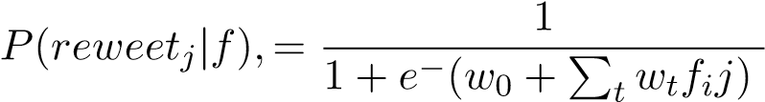
,
This equation helped to determine the possibility of sharing the new message. They concluded a general rule as high chances of sharing if the tweet was about public affairs. Twitter sentiment analysis not only used for product reviews or service quality analysis but it can also be used to check the quality of research articles. For this purpose Mike Thelwall and Haustein (2013), performed a pilot study using 270 data collected from nine different resources. After analysis, their results showed that tweet content provides very little information about the quality of the research.

2.3.2 Co-citation Analysis
A co-citation is a new tool to observe the development in the scientific field and to determine the degree of interconnection between them. There are many proposed solutions to recognize similar documents that help scientists in their research work for example:
- Bibliographic coupling: if two documents cite one or more than one document in common.
- Co-citation analysis: recurrence with which two documents are cited together by other documents.
- Text mining approach: use when references are not available.
Sometime satisfactory results are not achieved from the above-mentioned methods. That’s why the CPA (Co-citation Proximity measure) approach was proposed by Gipp and Beel (2009), that can be used to get better results, their solution consists of three steps:
- In the first step parsed the document and number of analysis were performed on
it.
- Citations were allocated to their similar item in the bibliography.
- Proximity between each citation pair was measured. There was more probability of association with each other if the citations were closer. CPI (Co-citation Proximity Index) was calculated. If the documents were closer then CPI value was approximately 1 and if only some paragraphs were similar than CPI value was approximately 1/2.
To get the best results weighted average was calculated. To improve the result they used the CPA approach with the combination of text mining. the CPA gave the best result as compare to the other old methods. The result of this research can be seen using FIGURE 2.1 for the CPA but according to the author of this paper, this cannot completely replace the co-citation analysis method.
Undecided
17
%
28
%
55
%
Co-Citation Analysis
Co-Citation Proximity Analysis
Figure 2.1: Comparison of CPA and Co-citation analysis. Reprinted from Gipp and Beel (2009).
While Small (1973) used Science Citation Index (SCI) to calculate the occurrence of two scientific paper that calculate their similar entries.
Haddawy, Saeed-Ul Hassan, and Amin (2016), examined the citation-based metrics and metrics of peer review and determine the quality of the Journal compared to ERA (Excellence in Research for Australia). These citation metrics was the bases of the normalized factor, the raw impact per paper (RIP), and journal impact factor (JIF). ERA is a national committee that evaluates the quality of the publication, universities, and journal rating. It also informs the government about to take the necessary future decision. Over 10,000 journals grouped into 27 subjects. After performing correlation and ROC curve analysis their results showed that SNIP (Source Normalized impact per paper) had a strong correlation followed by RIP and JIF. JIF score did not increase in any case from the other two metrics. It can be concluded that SNIP was the better choice in order to determine the journal quality as compared to RIP and JIF. Pável Calado and Gonçalves (2003), proposed an idea to enhance the result of web documents collection for information retrieval purpose. There were two types of classifiers:
- Link-based classifier
- Content-based classifier
In the link-based classifiers for similarity measure Bibliographic coupling, Co-citation,
Amsler, and Companion were used. These methods merged with SVM, KNN, and Navie Bayes content-based classifiers. The experiment showed that if they link document from an external source, best results can be achieved. If only out-link details were used then bibliographic coupling showed the best result and if the external link were considered as a measure then all classifier show better result except bibliographic coupling. If only link-based classifier was used it classify the documents correctly but noise also existed. Content-based classifier removed some noise but also removed related content from classification. In the combination model, weight was assigned to the documents if they were related. The model can be altered according to the user-defined weights. In general, the scholarly impact of any paper is measured by calculating it’s citation and publications. But nowadays authors also use social media to promote their publications. For research on this topic Bar-Ilan et al. (2012), collected the data of 57 participants from STI (Science & technology Indicators) conference held in Leiden 2010. Data of these participants was collected from social media like Linked-In, Twitter, Google+, and from the Scopus. The focus of the research was to check if authors actively participated in social media and they have their own home pages. Comparison of altmetrics data with traditional metrics (current study only focus on Mendeley and CUL (Cite you Like) databases), and what additional information we can get from this study like tags/keyword information. From 57 participants, 10 were excluded as their information was not found in Scopus and WOS database. For data collection purpose, Mendeley API was used to extract papers from Mendeley platform while DOI approach was used to extract the paper from CUL. Table 2.3: Correlations between citations and bookmarks for 1,136 documents reprinted from Bar-Ilan et al. (2012).
Spearman’s ρ | citations  (Scopus) | bookmarks  (Mendeley) | bookmarks  (CiteULike)
citations (Scopus) |  | .448** | .232**
bookmarks (Mendeley) | .448** |  | .441**
bookmarks (CiteULike) | .232** | .441**
** Correlation is significant at the 0.01 level (2-tailed).
Their result showed that about 84% of authors had their own homepages, 70% on LinkedIn, and 16% were on Twitter. Social Media manager like CUL and Mendeley were compared with Scopus and WOS. The authors claimed that Mendeley covered about 80% of sampled articles and was correlated based on Spearman correlation with Scopus. Table 2.3 represents the Spearman correlations between different mediums. The highest correlation value was between Scopus and Mendeley and the lowest was between CUL and Scopus.

2.3.3 Bibliometric Analysis
Jia Zhu and Xie (2014), measured the academic research performance of the Chinese universities in seven subjects as compared to top universities of Europe and USA. The data for this purpose was retrieved from Scopus, from the period of 2007 to 2010. Quality, quantity, and internationalization were the three factors used to measure the performance.
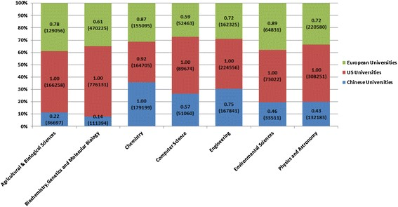
Figure 2.2: Normalized number of publications by US, European, and Chinese universities. Reprinted from Jia Zhu and Xie (2014).
After measuring quality and quantity, internationalization was measured using international collaboration, citation, and impact. Using all these metrics a research performance score was measured to check the research strength of the universities in each subject. The results showed that Chinese universities publications were high as compare to the US and European universities but received less citation that was because of their papers were usually published in less prestigious venues. According to FIGURE 2.2, Chinese universities concentrate on the discipline of engineering and theoretical areas such as Chemistry. Like Jia Zhu and Xie (2014), Andrea Bonaccorsi and Hassan (2017), addressed the excellence of research between the US and European universities. The current research covered 251 subjects from 2007 to 2010 duration. The result of the research showed that European universities exhibit excellence only in a few disciplines while the US universities show excellence in all the disciplines. It was because they enroll, teach, and retain high quality researchers to publish high-quality research to receive the maximum citations. A similar research study in sustainable development using scientific literature was done by Saeed-Ul Hassan and Zhu (2014). They retrieved the data over the time period of 2000-2010 from the Scopus database. The scope of the study was both at an institutional and a country level. In the first step, the keywords list of sustainable development and its sub-areas declared by domain experts. All of these keywords were independent of publication venue. In the next step using the given keywords, a new keyword list was generated by extracting the new keywords from title, abstract, and author-defined keywords. Later this list was presented to the domain experts to eliminate the irrelevant keywords. This process was repeating until no new keywords were added to the list.
From the defined keyword list, citation per paper was calculated. Their research result indicated that if the institute in sustainable development was strong then its sub-areas may not be strong. Similarly, if the institute was strong in sub-areas then it maybe not strong in sustainable development. China seemed strong in term of publication, but not in the citation. This type of research study helped the higher administration to take necessary actions to combine the multiple niches in the country. FIGURE 2.3 showed the top ten countries in the Sustainable Development in term of publication during the 2000-2010 time period. The United States at the top and China at the 2nd rank in term of publication. According to the FIGURE 2.3, there was a space between the US and China and the rest of the countries. Further, in recent years, in the field of sustainable development, China increased its publications.
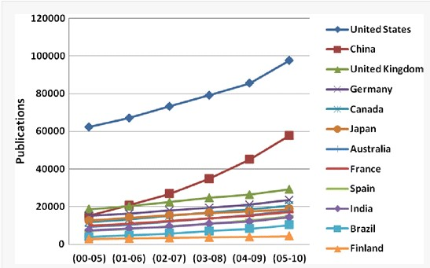
Figure 2.3: Publication research strengths in Sustainable Development during 2000–2010. Reprinted from Saeed-Ul Hassan and Zhu (2014).

2.3.4 Keyword Network
Danhao Zhu and Haddawy (2013), extract 111,444 keywords collection from the Scopus to determine either keyword reveal the behavior of small-world phenomenon. Using average distance proprieties and clustering coefficients small-world phenomenon could be revealed. Further, this research can be used to detect the research hot-spot of the discipline. The accuracy of this system was also compared with word frequency.

2.3.5 Measuring altmetrics
The term altmetrics become popular these days but the question is either what type of people are aware of it or its usage. For this purpose, Aung and Theng (2017) collected data using a survey. Their survey result showed that non-faculty members were more aware of this term than the faculty members. The most used altmetrics were shares and mention. There was a strong correlation between social media and altmetrics. While Imran, Said, Safder, Hassan, and Aljohani (2018) checked what type of disciplines people are most interested in social media. They collected 6 million data from Twitter to analyze different type of social media activities across 17 disciplines. Their research results showed that Engineering, Environmental Science and Medicine communities were highly connected and interact with each other while Art, Business and Humanities communities were less interact with each other on social media. Zahedi, Costas, and Wouters (2014), study the existence and impact of altmetrics across the field, discipline and measure how much it correlates with citation indicators. For this purpose, DOI was used to extract over 20000 random publications from all disciplines between 2005 and 2011 covered by Web of Science. To extract altmetrics data a web-based tool “ Impact Story (IS)" was used. Later this data was transformed into CSV format and matched with the Web of Science DOI data. Out of 20000, 19772 publications were in the final list. Table 2.4 showed the number and percentage of papers in the IS database with or without metrics. According to the table, Mendley was the main source for altmetrics with 62.6% with metrics while for the other resources (Twitter, Wikipedia, and Delicious) the percentage was very low 98% for without metrics. Table 2.4: % of altmetrics from different data sources in the IS database.
Reprinted from Zahedi et al. (2014).
Sources | Papers with metrics | Percentage | Papers without metrics | Percentage
Mendeley | 12,380 | 62.6 | 7,392 | 37.3
Twitter | 324 | 1.6 | 19,448 | 98.3
Wikipedia | 289 | 1.4 | 19,483 | 98.6
Delicious | 72 | 0.3 | 19,700 | 99.7
The result from this study showed that major output was from Mendeley 62.6% of the papers with metrics while other sources only gave minor information. While Mendeley readership and citation spearman correlation were 0.49. That showed that reading and citation were related activities. But researchers were still unable to conclude the quality of altmetrics data.
Saeed-Ul-Hassan and Gillani (2016), proposed the idea of new altmetrics indicator, using the data from different social media (Facebook, blogs, Google+, Twitter, and Mendeley, etc.). Similar to h-index the idea of alt-index was proposed, with the Pearson’s correlation (0.247) between scholarly and social citation.
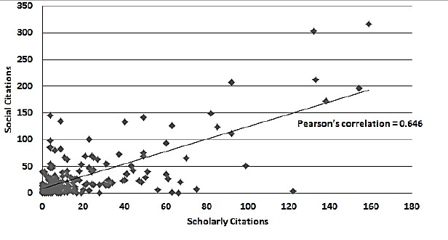
Figure 2.4: Social citations vs. scholar citations of selected researchers.
Reprinted from Saeed-Ul-Hassan and Gillani (2016)).
To measure the alt-index, all the data from google scholar was extracted using keyword “altmetrics". FIGURE 2.4 showed the correlation between social and scholarly citation values. Among the selected 77, scholars 47 were active on social media. Social and scholarly citation of these 47 scholars were extracted during 2010-2014. For each social media, there were some indicators for Facebook such as like, share and mention. Each paper was linked with multiple indicators. A score was assigned to each indicator if a publication was cited directly then score was 1, for liking the score was 0.5. The final data-set contains 47 researchers, 214 publications, 5238 scholarly citations, and 7452 social citations. After calculating alt-index, results showed that there was 42.2% more social citation as compared to the traditional one. Mendeley and Twitter appeared the more effective channel of social impact. FIGURE 2.5 showed the percentage of contribution of social media and the highest contribution was from Mendley followed by Twitter and Facebook.
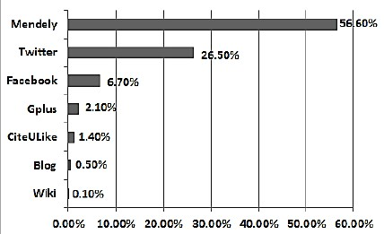
Figure 2.5: Social indicators drill down for all social citations. Reprinted from Saeed-Ul-Hassan and Gillani (2016).
A similar study is done by Alhoori and Furuta (2014), they introduced the new metrics JSI (journal impact factor), based on eleven different sources including Facebook, Mendeley, CUL, etc. For this purpose, they collected the data of 820 science journals and compared it with JSI.
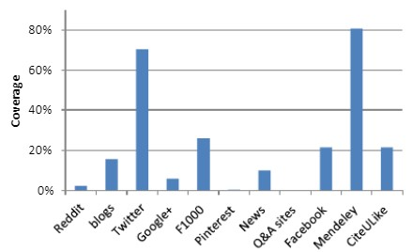
Figure 2.6: Coverage of research articles in different platforms. Reprinted from Alhoori and Furuta (2014).
Their research result showed that JSI was significantly correlated with traditional journal level metrics and Twitter and Mendeley were the most used altmetrics sources. FIGURE 2.6 represented the two highest coverage on the online platform was from Mendeley and Twitter. Holmberg and Vainio (2018), investigated why researchers got more attention on Twitter and Mendeley as compared to the other social media. For this purpose, they designed a questionnaire in English and Finnish. Questionnaire was conducted through an email. It was filled by the people from different disciplines including Natural Science, Engineering, Medical, etc.
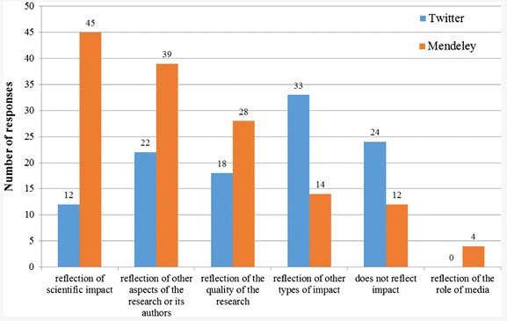
Figure 2.7: Twitter and Mendeley respondents’ opinions about online attention. Reprinted from Holmberg and Vainio (2018).
Their research results showed that online attention was the combination of many factors and these factors vary for each platform. On Mendeley, the reason for the attention was the academic audience while on Twitter it was a larger number of audience. FIGURE
2.7, showed scientific article online attention in many cases, especially on Twitter and Mendeley. According to the author’s opinion that received attention on Twitter online attention was considered as some type of impact but many respondents (24) didn’t agree with this statement. Thus, Twitter had not to get significant attention. In case of Mendeley, according to the 45 replies, online attention and the scientific impact was similar, 14 replies claiming it was the same as the societal impact. According to 12 replies, online attention did not reflect any impact. Authors that received more attention on Mendeley concluded that there was a correlation between online attention and number of citation.
Didegah, Bowman, and Holmberg (2018), investigated the factors for scientific research that receive more online attention. For this purpose, they extracted 46,730 documents from Web of Science by selecting a country like Finland. Out of selected papers, 37,183 had DOI, using the DOI 13,623 papers extracted that had altmetrics data. There were two types of variables involved in this study, dependent and independent. Dependent variables were citation count, Twitter posts, blogs posts, etc. Independent variable included individual collaboration, international collaboration, journal impact factor, etc.
As the dependent variables were the count variable Negative Binomial model was used. Results showed that out of all independent and dependent variables journal impact factor was the most important one for receiving more citation and altmetrics count. As the high impact factor journal contain high-quality content, thus cited more and also read, post, share and mention more on social media. For increased citation count and Twitter count eight factors were important, seven for Mendeley readers, three for Facebook, six for blogs and five for news posts. Shema, Bar-Ilan, and Thelwall (2014), took all research article related blog posts to test their hypothesises. According to their hypothesis result the article received more blog citation near to their publication date also receive the more scholarly citation. For this purpose, they took all the blog posts that were posted at ResearchBlogging.org. This site had all the article with bibliometric reference including blog citation details. For research purpose, all the data was downloaded from the website using the Firefox plugin between 2009-2011. The software was developed to extract the required information from the downloaded data such as date of publication of the post, title, URL of the post and the name of the blog, etc. Details of all articles extracted from the software were retrieved from Web of Science using their actual publication date. Apply the one-sample binomial test to find the aggregated citation was higher or lower than journal median values. Their experiment results showed that blog article value was higher than the journal’s population median. And the article published in 2009 and 2010 support the above hypothesis with 58% and 68%. According to the results, blog citation can be used as an alternative source. Stefanie Ringelhan (2015), took 300 papers from the Harvard University website to research about whether
Facebook likes can be used as a replacement for the prediction of citation in the future. All the papers were in a psychological and non-psychological category. And the result showed that if the number of facebook likes increased, the more citation a paper received. For the further strengthening of the first result, 600 papers were retrieved from the bioRxiv website. The overall result altmetrics citation in the psychological area was predicted by Facebook likes. Meschede and Siebenlist (2018) investigated the metric compatibility within altmetrics with the help of PlumX and altmetrics.com aggregator. They collected 5000 journal articles from six different disciplines. Both intra-correlation and inter-correlation calculated across one aggregator. For both aggregators, a diversity of metrics had observed from low to medium. For inter-correlation, both aggregators were highly consistent with the highest values was for Mendeley r = 0.97 and lowest for News r = 0.11. Haustein (2016), discussed the challenges for altmetrics including heterogeneity the diversity of events occur on social media, lack of accuracy, consistency, dependency on DOI, and API and many more.
Chapter 3
Methodology
This chapter divided into different subsections to briefly explain different modules. The primary goal of the research is to analyze either Twitter indicators are helpful to identify quality research papers.

3.1 Data & Methodology

3.1.1 Data Collection
On June 14, 2016, altmetrics shared their data with the authors. The whole dataset contains information on different platforms activities that can uniquely identify using altmetric id. According to Adie (2011), Elsevier (2004), this dataset consists of 4.5 million JSON files with each representing a unique publication. Using this data, 1.7 million unique and common publications selected from both altmetrics and publication data between July 2011 and December 2015. For this research we used the published dataset (2016) from Scopus Database, journals indexed the sub-discipline of Library and Information Sciences. For collecting the data Scopus API used. Note that Scopus use of ASJC (All Science Journal Classification) for indexing journals. ASJC classification covers journal and conferences over 27 broader subjects, such as chemistry, computer science and social sciences together with more than 300 sub-disciplines containing safety Research, and library and information sciences. From the 820 total journals and conference publications (at least one tweet activity), indexed under library and information science, were extracted from Scopus database from July 2011 to December 2015. The data is extracted using DOI and if DOI is not available then publication title used to extract the publication information from Scopus database using Scopus API. In addition, all the tweets activity associated with these publications were obtained. A combination of tweet ids (from Altmetric.com) and the Twitter API was used to collect tweet text, resulting in the dataset of 10,345 tweets made by 5,490 unique users. These tweets contained 8,373 mentions and 4,061 retweets. All tweet information was then stored in a relational database.
We have 8816 publication data available against 103,46 tweet_ids. Our final dataset consists of 8816 values without removing any duplicate values.

3.1.2 Indicators
We used three type of Twitter indicators:
- Count of favorite - numeric data type
- Count of retweet - numeric data type
- Tweet comments - textual data type
After data cleaning, we performed different types of analysis techniques on both type of datasets. Pearson correlation applied to numeric dataset and textblob library used for textual data analysis.
3.1.2.1 Data Overview
For numerical datatype, by removing null and duplicate values, the final dataset consists of 8662 rows. After data cleaning, we performed Pearson correlation between altmetric citation count, favorite, and retweet count. We performed two types of analysis on this data, with outlier and without outlier values.
Table 3.1 consists of 5 columns.
Table 3.1: Twitter dataset used in our experiments.
alt_id | retweet_count | favorite_count | cita-  tion_count | comments
1301774 | 3 | 0 | 7 | RT @infoism: The role of public libraries in c ...
1302862 | 0 | 0 | 6 | Online access to higher education on YouTubeED...
2572404 | 0 | 1 | 5 | The future of open access and library publishi...
2664241 | 4 | 0 | 11 | RT @johnpoverington: Two ...
2664242 | 4 | 0 | 1 | Two #ChEMBL papers just out in J Cheminf http:...
- alt_id: unique altmetrics id.
- retweet_count: number of times a tweet share without alteration.
- favorite_count: numbers of likes a tweet received.
- citation_count: it’s a weighted count of all the attention received by a research paper on social media.
- the text parameter represents the comments of the user on a tweet.
Similar for textual data, after data cleaning and removing null and duplicate values, the final dataset consists of 6133 rows. For this part, we perform a Sentiment Analysis technique using python ’textblob’ library. A textblob library built on the top of nltk library.
It’s a text processing library for tokenization, tagging, stemming and classification etc. We also performed manual sentiment labeling and compare the result with ’textblob’ library in order to determine the accuracy. In the next chapter I will briefly explain the techniques and discuss results.
Chapter 4
Experiments & Results

4.1 Overview
In this chapter we will briefly explain the integral and textual data results. Below is the proposed research hypotheses that we address in this section:
- Is favorite/retweet count is a helpful way to predict highly cited papers/research?
- Is the tweet comments are useful to distinguish a quality research work?
- Is sentiment exists in Twitter data?

4.2 Numeric Data Analysis
In this part, we will concisely explain the result of first research question with or without removing outliers from the data. For this section, FIGURE 4.1 model used, where we first evaluate the value of r, p-value using linregress function of python. If it’s less than α, we will reject the hypotheses and predicted values using regression equation. Else if the value of p-value is greater than α, we will accept the hypotheses and given any value of one variable, the sample mean is the best. for another variable.
Start
Evaluate r and test
the hypothesis
ρ<α
reject hypothesis
(
absence of a
linear relationship)
accept hypothesis
(
existence of a
linear relationship)
predict values using
regression equation
predicted value is sample mean
Yes
No
Figure 4.1: Procedure for Predicting Relationship in Data. Reprinted from
F.Triola (2006)

4.2.1 Calculation with Outlier
To perform the experiment we will take our Twitter. FIGURE 4.2 represents a plot, where the x-axis represents a favorite count and most of the tweets favorite count is less than 10 while the y-axis represents citation count.
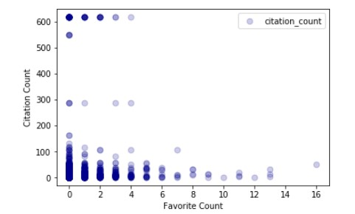
Figure 4.2: Favorite count & Citation count Scatter plot.
The value of the Pearson correlation between favorite and citation count is 0.166 represents a weak positive relationship between both altmetrics citation count and twitter favorite count. The value of low correlation indicates the lower association between the two selected attributes. In order to check, if there is any linear relationship between favorite count and citation count, we will calculate p-value using linregress() function of python.
H₀ : ρ = 0 (absence of linear relationship) H₁ : ρ 6= 0 (existence of linear relationship) α = 0.05 (level of significance)
The p-value is 3.04E-21 that is less than level of significance, we claim that there is a linear relationship between them by rejecting the null hypothesis.
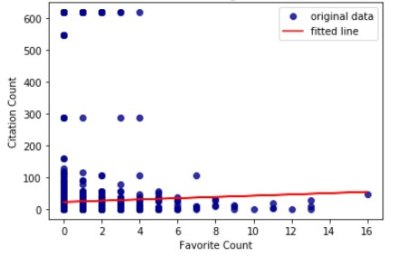
Figure 4.3: Regression line between Favorite Count & Citation Count.
FIGURE 4.3, represent the number of favorite count on the x-axis and the number of citation count on the y-axis. In the figure, most of the values are clustered lower part of the graph closer to the fitted line. As the correlation is positive regression line is also in the positive direction we can also use this regression line to predict the value of y using the value of x.
For the retweet count data, we will use exactly the same approach as described above for favorite count data result. FIGURE 4.4 represents a plot, where the x-axis represents retweet count and all the values are between 0 to 20 except the one act as an outlier while the y-axis represents citation count. The value of the Pearson correlation is 0.180 represents a weak positive relationship between citation and twitter retweet count. The value of low correlation indicates the low association between them.
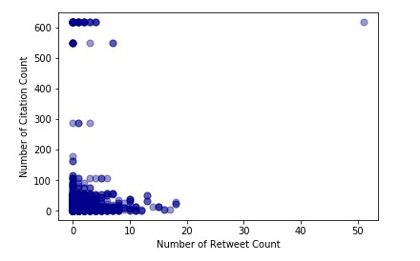
Figure 4.4: Retweet count & Citation Count Scatter plot.
The p-value for the retweet count is 1.11E-24 that is less than significance level, we claim that there is a linear relationship between them. The existence of a linear relationship represents the change in the independent variable (retweet count) will produce a corresponding change in dependent (citation count) variable.
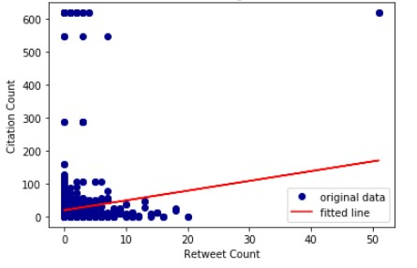
Figure 4.5: Regression line between Retweet Count & Citation Count.
FIGURE 4.5 represent the number of retweet count on the x-axis and the number of citation count on the y-axis. In the figure, most of the values are clustered lower part of the graph closer to the fitted line. As the correlation is positive regression line is also in the positive direction we can also use this regression line to predict the values.
In case of retweet and favorite count, the lower values of correlation show that we can’t use both of these indicators to get quality research work but there is a linear relationship between citation and retweet count and citation and favorite count. This means citation count is dependent to retweet count and favorite count up to some extent.

4.2.2 Calculation without Outlier
After data cleaning, we will remove the outliers using Algorithm 1. In the algorithm, take all the data frame columns in the loop and calculate for each column first and third quartile and interquartile range using Q₁ and Q₃. Later calculate low and higher values to identify outlier values. Convert the data frame into a numpy array and start comparing the value with both outlier values and append in the empty list. The output is the data frame without an outlier.
Algorithm 1 Outlier Detection Algorithm

Result: Return a dataframe without any outlier
initialization
while i in data-frame columns do instructions
calculate Q₁ (first quartile) & Q₃ (third quartile)
calculate IQR (inter quartile range) . IQR = Q₃ - Q₁ calculate lower outlier value (LTV) . Q1 - 1.5 * IQR calculate upper outlier value (UTV) . Q3 + 1.5 * IQR x = np.array(df [i] ) . convert dataframe to numpy array
create an empty list p
for j in x do
If j < LTV or j > UTV
p.append( df[i].median() ) else p.append(j);
df[i] = p return df
end.

FIGURE 4.6 represents a scatter plot, where the x-axis represents a favorite count and the favorite count range is between 0 to 2 while the y-axis represents citation count. The value of the Pearson correlation between favorite and citation count is −0.023 represents a weak negative relationship between citation count and favorite count. The value of low negative correlation indicates the lower association between them.
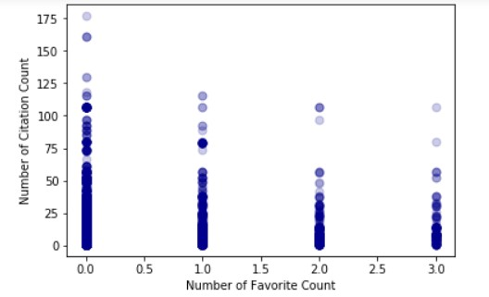
Figure 4.6: Scatter plot of Favorite Count & Citation Count.
And to check linear relationship between favorite count and citation count we will calculate p-value using linregress() function of python. The p-value is 0.080 that is greater than 0.05, we claim that there is a no linear relationship between them by accepting the null hypothesis and the sample mean value for favorite count is 0.258.
FIGURE 4.7 represents a scatter plot, where the x-axis represents retweet count and all the values are between 0 to 5 while the y-axis represents citation count. The value of the Pearson correlation is −0.008 represents a weak negative relationship between citation and retweet count. The value of low negative correlation indicates the low association between them.
And to check if there is any linear relationship between we will calculate p-value using linregress() function of python. The p-value for the retweet count is 0.54 that is greater than 0.05, so we claim that there is no linear relationship between them and the sample mean value for retweet count is 0.889.
In both retweet and favorite count, if we ignore outlier values we can’t use both of these indicators to get quality research work as the correlation values are lower. And citation count is independent of favorite and retweet count.
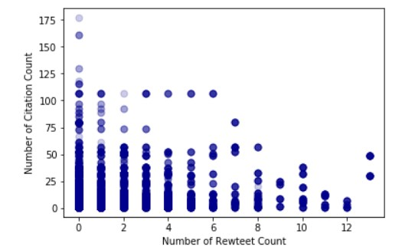
Figure 4.7: Scatter plot of Retweet Count & Citation count.

4.3 Textual Data Analysis
To give the answer to our last two research questions we divide this discussion into two sections. In the first section, our Algorithm 2 takes text column as an argument and go through row by row to remove all the links and special characters using the regular
expression.

Algorithm 2 Data Cleaning Function

Result: Clean the text in a tweet by removing links and special characters def (clean_tweet(tweet)) instructions
’ ’.join(re.sub ("(@[A − Za − z0 − 9]+)|([⁰−9A − Za − z¨])|(+ : §+)”, " ",
tweet).split())
. Utility function to clean the text in a tweet by removing links and special characters using regex.

Later the our Algorithm 3 takes the clean data column as an argument and go through row by row to assign a polarity to the tweets using textblob library. The polarity is either 1 for positive, 0 for neutral, −1 for a negative sentiment. For the second section, we take text data CSV file and assigned polarities manually.

Algorithm 3 Assign Polarities Function

Result: Assign polarity of a tweet using textblob
instructions analysis = TextBlob(clean_{t}weet(tweet)) ifanalysis.sentiment.polarity > 0 : return1 elifanalysis.sentiment.polarity == 0 :
return0 else :
return − 1
. Utility function to classify the polarity of a tweet using textblob..

According to our observation the contents from a tweet text are:
- The sentiment is positive if someone praises it using interesting, wow, thoughtful type words.
- But if someone passes negative judgments using dull, poor or bad type words then it’s sentiment is negative.
- The sentiment is neutral if there is no sentiment.
- Author self-cite its article using words my article or our latest article.
- User comment contains just an article link or article name.
We label 3408 data manually. The data tag using textblob is label as predicted data and the manual tag data is label as actual data. Now a function checks each row if the predicted and actual data tags are the same or different and assigned an appropriate label. Using the assigned label from 1 to 4 we divide the data into 4 part true positive, true negative, false positive and false negative. All these 4 values (true positive, true negative, false positive and false negative) are used to predict the either our classification is being correct or incorrect.
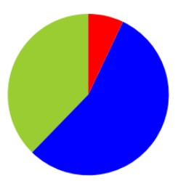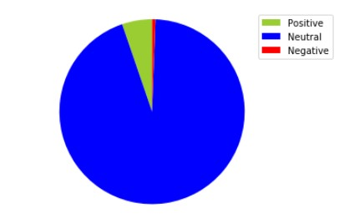
Figure 4.8: Sentiment ratio using Figure 4.9: Sentiment ratio La-
TextBlob belled Manually
FIGURE 4.8 represents the ratio of positive, neutral and negative sentiment we get using textblob sentiment analyzer. According to the pie chart, we have 37.72% positive, 55.19% neutral and 7.08% negative tweets in our data.
Using true positive, true negative, false positive and false negative values, we calculate confusion matrix. Confusion matrix is used to describe the performance of the classifier and the calculated accuracy for our classifier is 58.23%.
If we observe the FIGURE 4.9, most of the values reside in the neutral category which shows that the content of the tweet is less likely to provide significant information about quality research paper except in special cases. We cannot use tweeter text as a strong indicator to identify a good research work.
Chapter 5

Conclusion and Recommendations
In our research, we study the impact of research papers via social media like “Twitter” across the field of natural sciences that are indicated in the Scopus Database and also recorded by Altmetrics. The comparison between Twitter indicators (“favorite count, retweet count”) and traditional indicator (“citation count”) used by most of the researchers. Our result showed that both of the Twitter indicators are not very useful to identify a quality research work either with the outliers value or upon removal of outliers. A linear relationships between favorite count and citation count and retweet count and citation count are found without outliers removal.
In the second phase of the research, user comments on tweets are analyzed based on sentiment analysis and the results exhibited that most of the comments are neutral because of insignificant discussion about articles. Twitter comments appear as a strong indicator to identify quality research paper except in special cases.
In our future work, models will be developed for the numeric and textual type of data using relatively larger dataset. We intend to extend the scope of the research for other social networks and media e.g. Mendeley, Facebook, blogs and news, etc.

References
Aamera Khan, M. A., & Thakare. (2015). Combining lexicon-based and learningbased methods for twitter sentiment analysis. Special Issue of International Journal of Electronics, Communication Soft Computing Science and Engineering, 89.
Adie, E. (2011). Who’s talking about your research? "https://www.altmetric
.com/.
Alhoori, H., & Furuta, R. (2014). Do altmetrics follow the crowd or does the crowd follow altmetrics? Proceedings of the 14th ACM/IEEE-CS Joint Conference on Digital Libraries, 375–378.
Altmetric. (2014). https://www.altmetric.com/about-us/.
Altmetrics. (2014). "https://www.altmetric.com/about-our-data/our
-sources/.
Andrea Bonaccorsi, T. C., Peter Haddawy, & Hassan, S.-U. (2017). The solitude of stars. an analysis of the distributed excellence model of european universities. Journal of Informetrics, 11(2), 435–454.
Aung, M. E., & Theng, Y. (2017). Awareness and usage of altmetrics: A user survey. Proceedings of the Association for Information Science and Technology, 54(1), 18–26.
Bar-Ilan, J., Haustein, S., Peters, I., Priem, J., Shema, H., & Terliesner, J. (2012). Beyond citations: Scholars’ visibility on the social web. arXiv preprint arXiv:1205.5611, abs/1205.5611. http://arxiv.org/abs/1205.5611.
Danhao Zhu, S. H., Dongbo Wang, & Haddawy, P. (2013). Small-world phenomenon of keywords network based on complex network. Scientometrics, 97(2), 435–442. 10.1007/s11192-013-1019-3. doi: https://doi.org/
10.1007/s11192-013-1019-3 dataset. (2016). https://github.com/slabitu/influential_twitter_users/.

Didegah, F., Bowman, T. D., & Holmberg, K. (2018). On the differences between citations and altmetrics: An investigation of factors driving altmetrics vs. citations for finnish articles. arXiv preprint arXiv:1710.08594, abs/1710.08594. http://arxiv.org/abs/1710.08594.
Elsevier. (2004). Search for an author profile. "https://www.scopus.com/ freelookup/form/author.uri.
Eysenbach, G. (2011). Can tweets predict citations? metrics of social impact based on twitter and correlation with traditional metrics of scientific impact. Journal of medical Internet research, 13(4).
Fgnievinski. (2013). Citation index. https://en.wikipedia.org/wiki/Citation
_index.
F.Triola, M. (2006). Elementary statistics. Pearson/Addison-Wesley Reading,
MA.
Gipp, B., & Beel, J. (2009). Citation proximity analysis (cpa): A new approach for identifying related work based on co-citation analysis. ISSI’09 : 12th
International Conference on Scientometrics and Informetrics, 2, page 571 -
575. http://gipp.com/wp-content/papercite-data/pdf/gipp09a.pdf.
Go, A., Bhayani, R., & Huang, L. (2009). Twitter sentiment
classification using distant supervision. CS224N Project Report, Stanford, 1(12), 1-6. http://www.stanford.edu/~alecmgo/papers/
TwitterDistantSupervision09.pdf.
Haddawy, P., Saeed-Ul Hassan, A. A., & Amin, S. (2016). A comprehensive examination of the relation of three citation-based journal metrics to expert judgment of journal quality. Journal of Informetrics, 10(1), 162–173. https:// doi.org/10.1016/j.joi.2015.12.005. doi: 10.1016/j.joi.2015.12.005
Haustein, S. (2016). Grand challenges in altmetrics: heterogeneity, data quality and dependencies. Scientometrics, 108(1), 413–423.
Holmberg, K., & Vainio, J. (2018). Why do some research articles receive more online attention and higher altmetrics? reasons for online success according to the authors. Scientometrics, 1–13. doi: https://doi.org/10.1007/s1119
Imran, M., Said, A. A. A., Safder, I., Hassan, S.-U., & Aljohani, N. R. (2018). Exploiting social networks of twitter in altmetrics big data. STI 2018 Conference Proceedings, 1339–1344.
Jia Zhu, H. T. M., Saeed-Ul Hassan, & Xie, Q. (2014). Measuring recent research performance for chinese universities using bibliometric methods. Scientometrics, 101(1), 429–443. https://doi.org/10.1007/s11192-014-1389-1. doi: 10.1007/s11192-014-1389-1
Kouloumpis, E., Wilson, T., & Moore, J. (2011). Twitter sentiment analysis: The good the bad and the omg! In Icwsm (Vol. 11, p. 164).
Lawsonstu. (2015). Altmetric. https://en.wikipedia.org/wiki/Altmetric.
Llewellyn, C., Cram, L., & Favero, A. (2016). Avoiding the drunkard’s search: Investigating collection strategies for building a twitter dataset. In Proceedings of the 16th ACM/IEEE-CS on joint conference on digital libraries, JCDL 2016, newark, nj, usa, june 19 - 23, 2016 (pp. 205–206). http:// doi.acm.org/10.1145/2910896.2925433. doi: 10.1145/2910896.2925433
Mehta, R., Mehta, D., Chheda, D., Shah, C., & Chawan, P. M. (2012, April). Sentiment analysis and influence tracking using twitter. International Journal of Advanced Research in Computer Science and Electronics Engineering. ijarcsee.org/index.php/ijarcsee/article/download/32/29.
Meschede, C., & Siebenlist, T. (2018). Cross-metric compatability and inconsistencies of altmetrics. Scientometrics, 115(1), 283–297.
Mike Thelwall, S. W. K. H., Andrew Tsou, & Haustein, S. (2013). Tweeting links to academic articles. Cybermetrics: International Journal of Scientometrics, Informetrics and Bibliometrics, 1–8.
Naveed, Nasir, Gottron, Thomas, Kunegis, J., & Alhadi, A. C. (2011). Bad news travel fast: A content-based analysis of interestingness on twitter. Proceedings of the 3rd International Web Science Conference, 8:1–8:7. http:// doi.acm.org/10.1145/2527031.2527052. doi: 10.1145/2527031.2527052
Pak, A., & Paroubek, P. (2010). Twitter as a corpus for sentiment analysis and opinion mining. In Lrec (Vol. 10, p. 1320-1326).
Pável Calado, E. M. N. Z. B. R.-N., Marco Cristo, & Gonçalves, M. A. (2003). Combining link-based and content-based methods for web document classification. In Cikm ’03 proceedings of the twelfth international conference on information and knowledge management (p. 394-401). http://doi.acm.org/
10.1145/956863.956938.
Rjwilmsi. (2017). Altmetrics. https://en.wikipedia.org/wiki/Altmetrics.
Saeed-Ul-Hassan, & Gillani, U. A. (2016). Altmetrics of" altmetrics" using google scholar, twitter, mendeley, facebook, google-plus, citeulike, blogs and wiki. arXiv preprint arXiv:1603.07992.
Saeed-Ul Hassan, P. H., & Zhu, J. (2014). A bibliometric study of the world’s research activity in sustainable development and its sub-areas using scientific literature. Scientometrics, 99(2), 549–579.
Shema, H., Bar-Ilan, J., & Thelwall, M. (2014). Do blog citations correlate with a higher number of future citations? research blogs as a potential source for alternative metrics. JASIST, 65(5), 1018–1027. https://doi.org/ 10.1002/asi.23037. doi: 10.1002/asi.23037
Small, H. (1973). Co-citation in the scientific literature: A new measure of the relationship between two documents. Journal of the American Society for Information Science, 24, 265-269. http://dx.doi.org/10.1002/asi
.4630240406.
Stefanie Ringelhan, I. M. W., Jutta Wollersheim. (2015). I like, i cite? do facebook likes predict the impact of scientific work? PLoS One, 10(5), e0134389.
Sugimoto, C. R., Work, S., Larivière, V., & Haustein, S. (2017). Scholarly use of social media and altmetrics: A review of the literature. Journal of the Association for Information Science and Technology, 68(9), 2037–2062.
Thomas, A. (2018). History of citation indexing. https://clarivate.com/ essays/history-citation-indexing/.
Thompson, E. (2017). What is twitter? use the microblogging platform.
"http://twitterboost.co/what-is-twitter-use-the-microblogging -platform/.
Wang, H., Can, D., Kazemzadeh, A., Bar, F., & Narayanan, S. (2012, july). A system for real-time twitter sentiment analysis 0f 2012 u.s. presidential election cycle. Proceedings of ACL, 115-120.
Zahedi, Z., Costas, R., & Wouters, P. (2014). How well developed are altmetrics? A cross-disciplinary analysis of the presence of ’alternative metrics’ in scientific publications. Scientometrics, 101(2), 1491–1513. https://doi.org/
10.1007/s11192-014-1264-0. doi: 10.1007/s11192-014-1264-0

