INTRODUCTION OF FATTY ALCOHOL SULFATES: A SHORT REVIEW

Tubagus Rayyan Fitra Sinuhaji¹, Renita Manurung²
Chemical Engineering Department, Faculty of Engineering, Universitas Sumatera Utara^{1,2}
Jl. Almamater Kampus USU Medan 20155, Indonesia
eaglefansrayyan@gmail.com¹, renitachem@yahoo.com²

Abstract - Fatty Alcohol Sulfate (FAS) which has sodium salt is an active ingredient that is generally used to make detergent products, because of its good ability to be wetted and produce froth. In addition, this type of FAS is a biodegradable surfactant. Surfactant is the basic ingredient of some cleaning products such as bath soap, facial wash soap, and liquid soap. There are two methods commonly used to produce higher alcohol than commercial ones: high-pressure hydrogenation and reduction with sodium metal.
Keywords: FAS, Hydrogenation, Sodium Metal Reduction, Surfactants.

Introduction
Fatty Alcohol Sulfate (FAS) which has sodium as its salt is an active ingredient that is generally used to make detergent products, because of its good ability to be wetted and produce foam. In addition, this type of FAS is also a biodegradable surfactant. Surfactants are the basic ingredients of some cleaning products such as bath soap, face wash, and liquid soap.
FAS is usually produced by reacting fatty alcohol with sulfur trioxide (SO₃), then neutralized with sodium hydroxide (NaOH), with the following reaction equation [1]:

$\begin{matrix}RCH_{2}OH \\ Fatty alcohol\end{matrix}+\begin{matrix}SO_{3} \\ Sulfur trioxide\end{matrix}→ \begin{matrix}RCH_{2}OSO_{3}H \\ Fatty alcohol sulfuric acid\end{matrix}$ (1)

$\begin{matrix}RCH_{2}OSO_{3}H \\ Fatty alcohol sulfuric acid\end{matrix}+\begin{matrix}NaOH \\ Natrium hydroxide\end{matrix}→\begin{matrix}RCH_{2}OSO_{3}Na \\ Sodium Fatty alcohol sulfate\end{matrix}+\begin{matrix}H_{2}O \\ water\end{matrix}$ (2)

The intermediate product of this reaction is usually a mixture of esters and sulfuric acid. These intermediates are unstable enough that they must be neutralized immediately. The final product contains 1.5% sodium sulfate, 1-1.5% unreacted alcohol, and less than 0.5% free alkali. In the sulfation process, other SO₃ sources can be used such as oleum or chlorosulfonic acid [1].
Based on the raw material of manufacture, surfactants can be divided into two, namely petrochemical surfactants derived from petroleum and oleochemical surfactants that are not derived from petroleum. In the manufacture of petrochemical surfactants, alcohol is obtained by converting branched-chain hydrogen into straight chains. In 1938, Otto Roelen developed an oxo reaction (hydroformylation) to produce aldehydes from olefins, CO, and H₂ so that they could be processed into oxo-alcohols. After that, the manufacture of linear primary alcohol was developed by oxidizing trialkyl aluminum to aluminum alcoholate followed by a hydrolysis process in a closed system. This process was developed in 1954 by Karl Ziegler. The results of these two processes are then made into anionic surfactants in the form of LAS [1].
In the manufacture of oleochemical surfactants, one of which was initiated by Fremy in 1831. Fremy made the first surfactant by reacting olive oil with sulfuric acid. Then began to develop in 1930, where fatty alcohol began to be developed as a basic ingredient for making surfactants by carrying out catalytic hydrogenation of coconut oil and palm seed oil derivatives in parallel by Deutsche Hydrierwerke in Germany, and E. I DuPont in the United States. Fatty alcohol is obtained in two stages, first, by carrying out a transesterification reaction in oil, then the results from the transesterification reaction in oil, then the results from this transesterification reaction are hydrogenated using a copper chrome catalyst at a pressure above 3000 psi and a temperature of 200˚C [1].
Brian D. Condo in 1993 compared surfactants produced by the Ziegler process to oleochemical surfactants from coconut oil and palm seed oil. From his research, the comparison results show that oleochemical surfactants have a washing ability that is not much different from petrochemical surfactants. The same research was also carried out by Karlheinz Hill in 2000. The results of his research show that oleochemical surfactants allow the development of competitive, consumer-friendly, and environmentally friendly surfactants [1].
In 1997, Rieke et al carried out a hydrogenation reaction of methyl laurate using a copper-chromium oxide catalyst at a temperature of 280˚C with a hydrogen gas pressure of 13.8 Mpa to see the side reactions that occur during the hydrogenation process in the manufacture of fatty alcohols. Furthermore, in 2006, Virginie Zuzaniuk conducted research to replace chromium catalyst because of its toxic nature with various catalysts CuZn-Pt, CuZn-Ni, CuZn-Rh and CuZn-Pd with a reaction temperature of 250˚C and a pressure of 50 bar [1].
In addition to fatty alcohol made using coconut oil, the manufacture of surfactants is also carried out by synthesizing 1-O-aminoacyl-3-O-alkyl acyl glycerol using lipase enzymes as has been done by Chen et al in 1999. Meanwhile, Hedman et al. epoxidation of pine oil fatty acids [1].
In 2006, Astri conducted research on the transesterification process of coconut oil in the manufacture of SLS (Sodium Lauryl Sulfate) surfactant. Furthermore, in 2007 Desti and Wiwik compared the activities of Ni and Cu catalysts in the hydrogenation reaction of methyl esters for the manufacture of SLS surfactants. The results of this study indicate that the more reactive catalyst in catalyzing methyl laurate to produce lauryl alcohol in the hydrogenation reaction is Ni catalyst. In the same year, a study was conducted on the effect of the operating conditions of the hydrogenation reaction of methyl laurate with a nickel catalyst for the manufacture of SLS surfactant by Desti Andani. From this research, it is known that there is no laurel alcohol content from the hydrogenation reaction but the surfactant ability is obtained with optimum hydrogenation conditions at a temperature of 270˚C with a catalyst of 30% by weight of reactants and a hydrogen flow rate of 1 mL/s [1].

Table 1. Table of manufacture of anionic surfactants based on fatty alcohol raw materials used [1].
No | Name | Year | Raw Material | Catalyst | Operating Conditions
1 | Fremy | 1831 | Olive oil | - | Low pressure  (open system)
2 | Deutsche Hydrierwerke | 1930 | Coconut oil | Cu-Cr | High pressure  (closed system)
3 | E.I DuPont | 1930 | Palm seed oil | Cu-Cr | High pressure  (closed system)
4 | Otto Roelen | 1938 | Petroleum | - | Low pressure  (closed system)
5 | Karl Ziegler | 1954 | Petroleum | - | Low pressure  (closed system)
6 | Rieke | 1997 | Coconut oil | Cu-Cr | High pressure  (closed system)
7 | Virginie Zuzaniuk | 2006 | Coconut oil | Catalyst Variation | High pressure  (closed system)
8 | Wiwik | 2007 | Coconut oil | Cu | Low pressure  (open system)
9 | Desti | 2007 | Coconut oil | Ni | Low pressure  (open system)
10 | Sutariyono | 2008 | Coconut oil | Ni | Low pressure  (closed system)
The difference between oleochemical surfactants compared to petrochemical surfactants can be seen in table 2.

Table 2. Differences between oleochemical surfactants and petrochemical surfactants [1].
 | Oleochemical Surfactants | Petrochemical Surfactants
Effect on environment | More environmentally friendly | Not environmentally friendly (difficult to decompose)
Effectiveness | Its performance is not very effective in cleaning solutions with high metal content. | Effective in various water conditions, both water with high metal content (hardness) and low.
Energy requirements | Low | High
Biaya produksi | Low | High
Examples of surfactants | SLS (Sodium Lauryl Sulfate) | LAS (Linear Alkylbenzene Sulfonate)
In this short review, further research will be described (some will be discussed which mentions the introduction) regarding alcohol sulfate regarding the raw material (oil or fat), the process used and the results provided.

Method
The method used in writing this paper is in the form of a literature review from various sources, especially from journals that examine alcohol sulfate. Primary data sources use search engines/online search engines. Data and literature are separated and traced based on the year of publication and their quality both internationally and nationally. So that obtained several studies of alcohol sulfate derived from oleochemical derivative products.

Results and Discussion
According to Kertess, 1936 [2]. (Six years after the Deutsche Hydrierwerke research) Commercial “Sulfonated” Fatty Alcohols are derived from saturated and partially unsaturated high molecular alcohols ranging from C12 to C18. The resistance to lime soap decreases as the number of carbon atoms decreases from 18 to 12 but C12 based products are readily soluble and exhibit excellent wetting and dispersing effects, which decrease slightly in intensity as the carbon content increases. Saturated alcohols are produced by catalytic hydrogenation of suitable oils such as coconut oil, followed by fractional distillation. Unsaturated alcohols such as Oleyl alcohol, obtained from spermaceti or by high hydrogenation. Sulfonation is affected by a special process and the product is converted to sodium salt. The first patent for the catalytic hydrogenation of fatty acids was taken by Deutsche Hydrierwerke A.–G., a company of Boeme-Fett-Chemie, Chemnitz was the first to discover the most suitable method for sulfonating. The interesting fact that the presence of the –COOH group in many oils used in the textile industry is the cause of poor grinding efficiency and poor resistance to water and strong acids, was discovered by Bertsch.
Dreger, et al (1944) [3] mentioned surface activity involving the alcohol sulfate property of the fatty alcohol component. For example, the secondary alcohol component of a ketone. The fatty acids or methyl esters used in the synthesis of ketones are obtained mainly from natural sources. To remove the unsaturated fatty acids present as impurities, the methyl esters of the fatty acids are treated with excess potassium permanganate in boiling acetone solution, filtered, washed with alkaline solution and with water, dried and crystallized from acetone solution. These esters are then fractionally distilled. Ketones are prepared by passing steam above pure acid or its methyl ester, at a temperature of 375-400˚C, over thorium oxide which functions as a catalyst (Ref. Organic Syntheses, Vol. 16, P.47, 1936). Symmetrical ketones are obtained by passing a single fatty acid or ester over a catalyst, asymmetric ketones are prepared by passing an appropriate mixture of two pure fatty acids or esters over a catalyst. In the Dreger process [3] the yield is 80-95% of the theoretical amount.
Hatcher's (1957) review [4] Alcohol sulfate was the earliest detergent discovered and introduced. Sulfuric alcohol was first prepared by Dumas in 1836; nearly 100 years later, in 1932, alcohol sulfate was included in the first successful retail detergent in the United States. As far as detergents are concerned, the four sources of alcohol are: coconut oil, palm kernel oil, tallow and sperm oil. There are two methods commonly used to produce higher fatty alcohols commercially: high pressure hydrogenation and reduction with metallic sodium.
In brief the hydrogenation process involves a large and limited capital investment to produce saturated fatty alcohols because under most of the hydrogenation conditions the double bonds are saturated. For some applications, unsaturated alcohols, such as oleyl alcohol, are more desirable than saturated alcohols, and sodium reduction should be used. Hydrogenation is also versatile but in that fatty acids, in addition to various fatty acid esters, can be used as starting materials. Glyceryl esters are not normally used in this operation because the glycerin is further hydrogenated to propylene glycol and in some cases to isopropyl alcohol. It is a more common practice to recover glycerin from glycerides first by means of fat separation or ester exchange. A hydrogenation operation is then performed, using fatty acids or methyl esters. Due to the drastic conditions used (3,000 to 5,000 psi and 200˚C to 400˚C in hydrogenation, there can also be substantial amounts of hydrocarbons formed, which is a product loss and can change the properties of the fatty alcohol derivatives.
The sodium reduction process usually does not represent an investment as large as the hydrogenation method. It is more flexible because both saturated and unsaturated alcohols can be produced. However, in producing saturated fatty alcohols, for example, fats must be hydrogenated before being reduced by sodium. The starting material must be an ester because the fatty acids react directly with sodium to form soap, making further processing steps difficult. When using glyceride esters as raw materials, glycerin is recovered from the process in the form of a caustic solution and glycerin. The usual impurities present in crude alcohol are soap and unreacted esters, which are then removed by fractional distillation. These processes are represented in Figures 1 and 2.

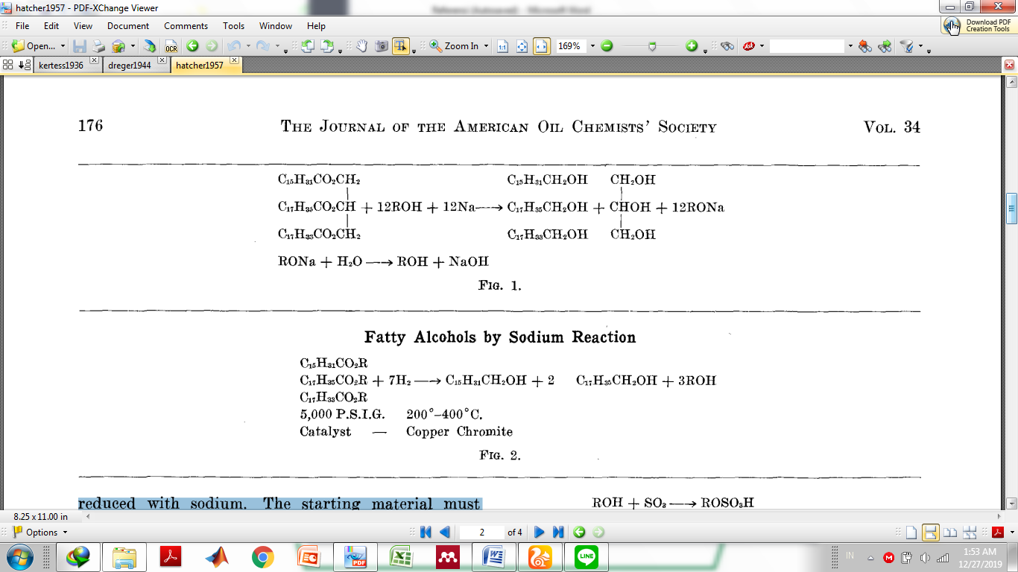
Figure 1. Hydrogenation [4].
Figure 2. Reaction of sodium [4].

An Italian study by Bifulco, et al (1995) [5] Finding bioactive Prenyl Hydroquinone and Novel C₃₁ Furano Terpene Alcohol Sulfate from Marine Sponge, Ircinia Sp. Furanoterpene alcohol sulfate is named after ircinol sulfate. The method used is extraction and isolation with petroleum ether, CH₂Cl₂, CH₂Cl₂-MeOH and MeOH. Another study related to alcohol sulfate from animals in the study of Li, et al (2013) [9] from the Department of Fisheries, University of Michigan, US. Sulfate conjugate from bile, 3,12-diketone-4,6-petromyzonene-24-sulfate (DKPES) from Male Sexual Lamprey Fish (Petromyzon marinus) and 3-keto petromyzonol sulfate (3 KPZ) which are sexual pheromones of lamprey fish. It was previously known that bile can produce sulfated alcohol from small skates (King erinacea) in 1989 [10].
FAS which is a biodegradable material as medium chain alcohol sulphate Decyl sulfate (DS) was chosen as the model component in the study conducted by Huber, 1999. and showed biodegradation under anaerobic conditions. Degradation begins with enzymatic cleavage by ester bonds, resulting in alcohol and sulfate. The alcohol molecule is then transformed into carboxylic acid and channeled to the anaerobic beta-oxidation pathway and further degraded [6]. Two studies from Malaysia in 2013 [7,8] discussed the phase and rheological behavior of alcohol sulfate from palm oil. The rheology of the manufactured alcohol sulfate is great for households as a detergent. Degradable well.
The flow chart for the manufacture of detergents in general [11].

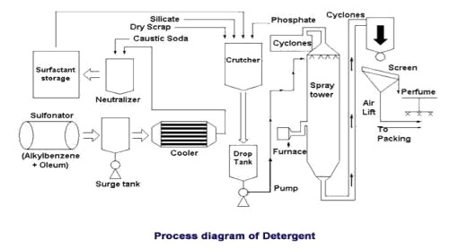
Figure 3. Flowchart of producing detergent [11].

Conclusion
Based on the raw material of manufacture, surfactants can be divided into two, namely petrochemical surfactants derived from petroleum and oleochemical surfactants which are not derived from petroleum. In the manufacture of petrochemical surfactants, alcohol is obtained by converting branched-chain hydrogen into straight chains. In 1938, Otto Roelen developed an oxo reaction (hydroformylation) to produce aldehydes from olefins, CO and H₂ so that they could be processed into oxo-alcohols. After that, the manufacture of linear primary alcohol was developed by oxidizing trialkyl aluminum to aluminum alcoholate followed by a hydrolysis process in a closed system. This process was developed in 1954 by Karl Ziegler. The results of these two processes are then made into anionic surfactants in the form of LAS. Alcohol sulfate is the earliest detergent discovered and introduced. Sulfuric alcohol was first prepared by Dumas in 1836; nearly 100 years later, in 1932, alcohol sulfate was included in the first successful retail detergent in the United States. As far as detergents are concerned, the four sources of alcohol are: coconut oil, palm kernel oil, tallow and sperm oil. There are two methods commonly used to produce higher fatty alcohols commercially: high pressure hydrogenation and reduction with metallic sodium.

Reference
[1] Sutariyono. 2009. Studi Pembuatan Surfaktan Fatty Alcohol Sulphate (FAS) Dengan Reaksi Hidrogenasi Virgin Coconut Oil (VCO) Pada Tekanan Atmosferik Menggunakan Katalis Nikel. Undergraduate Theses. Depok: Universitas Indonesia.
[2] Kertess, A. F. 1936. Sulphated Fatty Alcohols. The Journal of The Society of Dyers & Colourist. 2(LII): 42-45.
[3] Dreger, E. E.; G. I. Keim; G. D. Miles; Leo Shedlovsky and John Ross. 1944. Sodium Alcohol Sulfates. Industrial and Engineering Chemistry. P: 610-617.
[4] Hatcher, David B. 1957. Fatty Alcohol Sulfates. The Journal of The American Oil Chemists’ Society. P: 175-178
[5] Bifulco, Dipartimento, Ines Bruno, Luigi Minale dan Raffaele Riccio. 1995. Bioactive Prenyl Hydroquinone Sulfates and a Novel C₃₁ Furanoterpene Alcohol Sulfate From The Marine Sponge, Ircina Sp. Journal of Natural Product. 58(9): 1444-1449.
[6] Feitkenhauer H., dan U. Meyer. 2002. Anaerobic Digestion of Alcohol Sulfate (Anionic Surfactant) Rich Wastewater – Batch Experiment: Part I: Influence of The Surfactant Concentration. Bioresource Technology. 82: 115-121.
[7] Hong, Liew Kin, Nur Syazani Harun, Mohd Suzeren Md Jamil dan Rahimi M. Yusop. 2013. Phase Behaviour and Rheology of Fatty Alcohol Sulphate, Fatty Alcohol Ether Sulphate From Palm Based and Mixture with Other Surfactant. The Malaysian Journal of Analytical Science. 17(1): 101-108.
[8] Harun, Nur Syazani, Norhana Mohamed Talip, Liew Kin Hong, Mohd Suzeren Md Jamil dan Rahimi M. Yusop. 2013. Phase Behaviour of Fatty Alcohol Sulphate and Fatty Alcohol Ether Sulphate from Palm Based. The Malaysian Journal of Analytical Science. 17(1): 139-145
[9] Li, Ke, Cory O. Brant, Michael J. Siefkes, Hanna G. Kruckman dan Weiming Li. 2013. Characterization of a Novel Bile Alcohol Sulfate Released by Sexually Mature Male Sea Lamprey (Petromyzon marinus). Plos One. 8(7): 1-8.
[10] Karlagani, G., S.E Bradley, J. L. Boyer, A. K. Batta, G. Salen, B. Egestad dan J. Sjovall. 1989. Journal of Lipid Research. Volume 30. Hal: 317-322.
[11] Nurani, Arsyi. 2011. Makalah Deterjen. [online] : https://www.slideshare. net/acikacikajja/makalah-7932299 access 26/Des/19

