A Novel Method That Utilizes Light to Test Aerodynamics

Dhyey Patel

Abstract
Aerodynamics is a very important topic which has uses in a wide array of fields and is involved in things that range from bridges to spacecrafts. Despite this, most aerodynamic tests are performed only one of two ways, using extremely expensive wind tunnels or by using CFD (computational fluid dynamics) simulation. Both of these preexisting methods have flaws however, with wind tunnels costing gargantuan amounts of money and CFD methods consuming large amounts of energy. These flaws have prompted scientist and engineers to actively seek new solutions and methods that will help to address the cost and energy issues associated with the other two methods. This search has been to no avail so far as new novel methods have not been found until now. I have found a new method that concerns the use of light in order to test the aerodynamics of objects. To prove the feasibility, I have experimented using this method and have found it to accurately simulate aerodynamics behavior in all cases tested by me. This discovery is rather significant as it would lead to a substantial shift in the field of testing aerodynamics.

Introduction
As discussed earlier, the subject that is of concern in this paper is a novel method to test aerodynamics fueled primarily by the use of light. First let us examine current methods of testing aerodynamic. Currently, there is no standardized aerodynamics testing method in the industry despite all research institutions and companies using one of two methods. One of these methods is the use of wind tunnels while the other is the use of computational fluid dynamics. This has happened because of the high costs associated with each of these methods thus, a novel method that minimizes the costs would help create a standard and make aerodynamics testing more accessible to all. As discussed earlier, current approaches to testing aerodynamics include wind tunnel testing and testing via CFD simulations. Wind tunnel testing while effective in testing aerodynamics, has a very significant economic and environmental cost. The economic costs are more often than not tens of millions of dollars while the environmental costs include large amounts of energy from fossil fuels being required to operate the structures. Computational fluid dynamics on the other hand, is relatively much cheaper economically however, there are functional limitations of this method and also environmental concerns associated with it. The functional limitations arise because of the theoretical nature of the method and due to the inability to reach specific conclusions in many complex cases. The environmental concerns of using CFD stem from the power requirements of the complex, time consuming process that is carried out on very powerful computers. Due to these reasons, a novel method would be of great importance to the industry. Thus, as discussed here-to-fore, the novel method that I have devised, addresses these problems and is as affective as the traditional methods according to my early experiments. This method makes use of the phenomenon, light radiation pressure. This phenomena states that light exerts a small but quantifiable force on any object. Further, the basic setup of this method would have a subject object in front of light sources with varying properties to create shadows that would simulate airflow. Additionally, this method decreases its environmental footprint because it does not include very energy consuming processes but rather the use of very energy efficient and rather small sources of light. Likewise, the method does not need large infrastructure and expensive equipment thus, addressing economic concerns related with the method. Lastly, since this process is not theoretical, this process would be able to minimize approximations and arrive at specific conclusions unlike CFD simulations.

Results
In this section, I will discuss the results I attained by using this method. I tested various shapes from simple shapes such as boxes to complex figures such as airfoils. According to my experiments, all the results I attained by using this could be also achieved using CFD and I also found that all results that I can attain by using CFD simulation could be duplicated using this novel method. This suggests that this novel method is indeed genuine and could be used widely without exceptions. Additionally, I was able to devise some correlations with factors associated with the light source and the properties of fluid flow. Particularly, I found that by increasing the angle of the light source, the shadow became more “streamlined.” Lastly, I found that no effects to the shadow were seen by initial experiments when intensity of the light and/or the wavelength of the light were varied. Pictures on the next page show the effect of varying the angle of the light source.
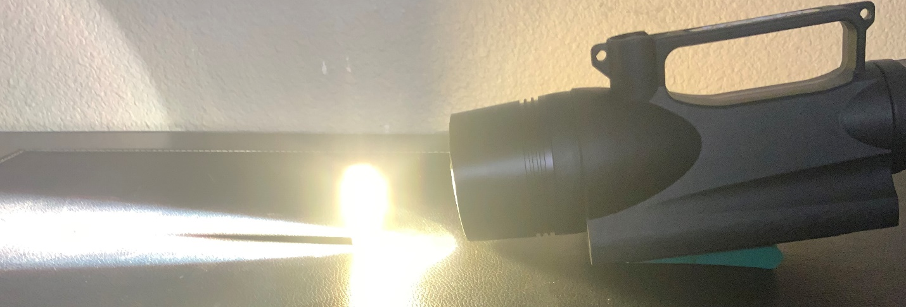
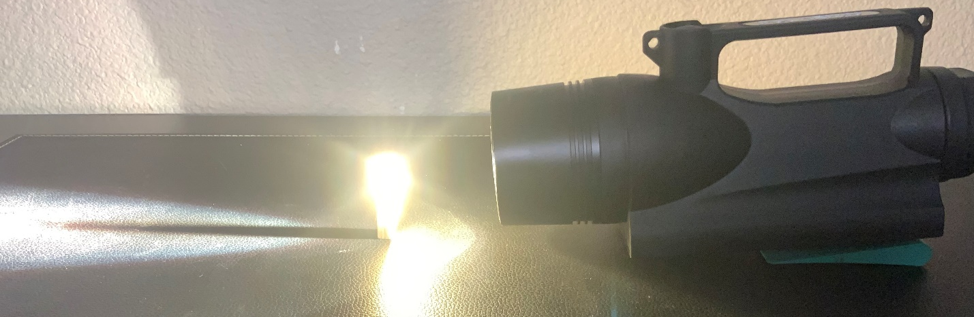
Picture on top shows the light source elevated at a smaller angle from the horizontal while the bottom picture shows a greater angle between the horizontal and the light source.

Discussion
As discussed earlier, the method that is the subject of this project proposal, stems from the principle of “light radiation pressure.” Since we have established the definition and that light exerts a force on all objects, we can also conclude that there would be a way to decrease this force just like there is a way to decrease aerodynamic drag. Now we examine the basic equation for aerodynamic drag on any object. This equation is: drag = (Cd*p*A*v^2)/2. In this equation, Cd is the drag coefficient of the object being examined, p is the density of the fluid, A is the surface area of object and v is the difference between the velocity of the object and the wind. It is clearly evident that decreasing the surface area and the drag coefficient would decrease both drag caused by aerodynamic force and the force by “radiation pressure.” We also see that the density of the fluid as well as the difference in velocity cannot be used in calculating force caused by “radiation pressure.” We now examine the factors that could be changed using light. These factors include, intensity of light, wavelength of the light, distance between light source and object being tested, angle between horizontal and light source and finally the size of the light source itself. Thus, we see that by finding a clear correlation between the factors associated with light and the properties of airflow, we can conclude that light could be used to simulate aerodynamics of various objects.

Methods
We discussed the basic principle and the line of reasoning that guides this novel method. I shall now discuss the methods used by me to reach to the conclusion that light can indeed be used to test aerodynamics. The setup used by me was very basic however, the results attained by these experiments were enough to conclude that this method is genuine and that it would be able to successfully able to simulate aerodynamic behavior in all cases. A simplified diagram that shows the top view of the setup used by me is shown below.
Top view of Object being Tested

Basic shadow that depicts aerodynamic behavior

Top view of Light Source (Torch, Lamp, etc.)

The setup shown above, can be used to test the basic aerodynamic. Further, it is also to be noted that I used light sources of different wavelengths and intensities while also varying the angle of the light source as well as the distance between the light source and the object being tested. Additionally, I also varied the object being tested and the size of the light source. Lastly, I confirmed the various results I attained using this novel method by comparing them to simulations from computational fluid dynamics software.

