Protecting Public Health and Preserving the Financial Viability of North Carolina’s Critical Health Care Facilities during Infectious Disease Outbreaks

Harrison B. Zeff, PhD*, Nicholas DeFelice, PhD, Yufei Su, PhD¹², Bethany Percha, PhD³, Stephen Teitelbaum, MD, Laura McGuinn³, and Gregory W. Characklis, PhD¹²
*Corresponding Author: Harrison B. Zeff, 135 Dauer Dr, Chapel Hill, NC 27599, ORCID: https://orcid.org/0000-0003-0006-789X, Email: zeff@live.unc.edu, Phone (01-717-856-2464)

Abstract
While hospitals’ primary emphasis during the COVID-19 pandemic has been on ensuring sufficient health-related resource capacity (e.g., ICU beds, ventilators) to serve admitted patients, the impacts of the pandemic on the financial viability of hospitals has also become a critical concern. Data from the period March 2020-Janaury 2021 suggest that the halt to elective and non-emergency inpatient procedures, combined with a reduction in emergency room procedures, led to losses equal to 6.5% of revenue from inpatient procedures, or about $825 million. This study finds that societal measures to reduce the community transmission rates have a larger impact on available healthcare capacity and hospital financial losses than hospital-level decisions. This study illustrates the tradeoffs between hospital capacity, quality of care, and financial risk faced by health care facilities throughout the U.S. as a result of COVID-19, providing potential insights for many hospitals seeking to navigate these uncertain scenarios through adaptive decision-making.

Introduction
Hospitals represent a critical line of defense for reducing the impacts of COVID-19, which has killed more than 900,000 Americans as of October 2nd, 2021 (CDC, 2021). While the primary emphasis has been on ensuring sufficient health-related resource capacity (e.g., ICU beds, ventilators) to manage new cases, the impacts of the pandemic on the financial viability of hospitals and other primary care facilities present significant challenges that have received less attention.
As the number of COVID-19 cases surged in the spring of 2020, hospitals made operational decisions with the intent of ensuring enough available capacity to accommodate a potentially rapid influx of COVID-19 patients. One common approach to doing this was reducing or eliminating elective and/or non-essential procedures, including many orthopedic procedures, all plastic surgeries, some vascular surgeries, and others (American College of Surgeons, 2020). The North Carolina Department of Health and Human Services (NCDHHS), for example, decided to cancel or postpone all such procedures in North Carolina hospitals from March 20th – May 1st, 2020 (Cohen, 2020).
In many parts of the U.S., including North Carolina, however, mask mandates, stay-at-home orders, and other social distancing measures enacted in spring 2020 reduced COVID-19 hospitalizations below worst-case projections. As a result, the surge of COVID patients was less than expected and this, combined with the postponement of elective procedures, led to large quantities of unused hospital capacity which in turn created substantial financial shortfalls. By April 2020, the North Carolina Hospital Association estimated that the state’s hospitals were losing over $1 billion per month (NCHA, 2020) due to reduced revenues, largely attributed to the elimination of elective surgeries. Although North Carolina hospitals and hospital systems later received $720 million in one-time payments through the CARES Act (CDC, 2020) many systems struggled to recover financially, causing staff layoffs (Hardin and Basden, 2020) and credit rating downgrades (Moody’s, 2020) for health care providers across both North Carolina and the nation (BLS, 2020). The American Hospital Association estimates the aggregate pandemic-related financial losses for hospitals and health systems was $320 billion in 2020, with two thirds of those losses coming in the four-month period from March to June 2020 when concerns over the availability of hospital resources to meet the needs of COVID-19 patients were most acute (AHA, 2020). This research is intended to assist hospitals to better understand the tradeoffs associated with the decisions they made in the spring of 2020, as well as the potential advantages of formulating more carefully calibrated health care capacity management policies that protect public health in a manner that is also financially sustainable.
Hospitals have a number of options available to help them manage critical care resources. Many ICU admissions are variable and largely beyond the control of the hospital (e.g., trauma, myocardial infarction, sepsis, etc.), but elective and non-emergency surgeries that require post-op admission to the ICU can be cancelled or rescheduled to exercise some level of control over ICU patient inflow (Kolker, 2008). Any decision related to managing and/or reducing patient flows gives rise to concerns over potential negative health impacts, including reduced quality of care (Asplin et al., 2006), but there are often financial tradeoffs as well (AHA, 2020). In this investigation, we use a patient-level dataset from the University of North Carolina hospital system to quantify how variations in the overall rate and composition of inpatient admissions impact hospital revenues and available ICU capacity. The size of the revenue shortfall experienced by a hospital depends on the types of patients affected and how their procedures are billed. Although the billing process for individual hospitals can be complex and opaque (Reinhardt, 2006), the Medicare Severity Diagnosis Related Group (MS-DRG) system, introduced in 1983 (Iglehart, 1983), provides patient-specific weights that can be used as a proxy for the revenue generated from each individual admission. Weighted-average MS-DRG metrics are used to determine a hospital’s case mix index (CMI), designed as a basis for calculating hospital payments. Here, we compare the sum of all patient MS-DRG weights admitted from March 2020 – February 2021 to a baseline from 2018-2019 to estimate hospital revenue reductions attributable to the COVID-19 pandemic. Inpatient admissions also have a variable impact on hospital resource utilization, particularly with respect to ICU capacity.
After an analysis of the observed trends in hospital admissions from March 2020 – February 2021, this investigation extends the results with a scenario-based simulation of COVID-19 community transmission and hospital resource utilization, covering the period February - June 2021. In this stage, resource utilization by admitted patients (including ICU capacity) is simulated with a probabilistic model based on patient flow data for hospitalized COVID-19 patients. While most COVID-19 admissions never require hospital ICU capacity, the most severe cases are admitted to the ICU for significant periods of time. Properly accounting for this small, but resource-intensive, group is necessary for hospitals to accurately assess how their available ICU capacity can best be managed over the course of a large-scale infectious disease outbreak. As growing COVID-19 admissions reduce the available ICU capacity within a hospital system, decisions by administrators to cancel non-essential procedures are simulated in terms of their ability to make available additional ICU capacity, while also tracking the impacts of these decisions on hospital revenues. Conditions and decisions are simulated under two community transmission scenarios, distinguished by changes in the effective reproductive rate (R_{e}) of COVID-19. While results are generated using data from a particular hospital system, the insights developed here should be useful to many hospitals throughout the U.S. seeking to navigate the tradeoffs between hospital capacity, quality of care, and financial risk.
Methods
This study uses data from nine hospitals in the Research Triangle region of North Carolina (the ‘Triangle’) (Table 1) to evaluate changes in hospital resource utilization and revenue during the COVID-19 pandemic. Daily data detailing individual admissions (both from scheduled procedures and emergency department admissions), patient MS-DRG classifications, and resource utilization/duration is available from a subset of these hospitals, all of which are part of the University of North Carolina (‘UNC’) system. Following the logic developed in Wang et al. (2020), we classify COVID-19 patient oxygen usage into five categories of devices – room air, low-flow O₂, high-flow O₂, CPAP/BiPAP machines, and mechanical ventilation, and track any changes over each day of their hospital stay. The probability of a patient utilizing a particular resource, conditional on time elapsed since the patient was admitted, can be calculated by grouping COVID-19 patients into chronological, 200-person cohorts, (Figure 1). From Figure 1, it is apparent that most COVID-19 admissions are short-term (<14 days) with minimal resource requirements (room air and/or low-flow O₂), but a significant portion of patients who require ICU care (CPAP/BiPAP or mechanical ventilation) are hospitalized for much longer periods (>21 days).
To estimate changes in hospital revenue during the pandemic, we compare admission rates during the period March 2020 – February 2021 with a baseline from 2018-19, adjusted using patient MS-DRG classifications from a comprehensive dataset of inpatients in the UNC hospital system. The patient’s MS-DRG code is used to weight each inpatient admission with a score designed for Medicare reimbursement, based on procedure complexity and the patient’s medical history. Although many other factors impact hospital billing (Gottlober et al., 2001), inpatient MS-DRG weights serve as a simple proxy for hospital gross revenues (Mendez et al., 2014).
Using the patient flow and revenue data observed in UNC hospitals during the period March 2020 – February 2021 as a baseline, this study then extends the analysis through June 2021 via simulation to explore the impacts of two different potential scenarios of COVID-19 community transmission. The simulation model consists of three parts, (i) a mathematical epidemiological model used to simulate infection spread of new COVID-19 cases in the community and how these relate to admissions in nine hospitals in the Research Triangle region of North Carolina, (ii) a probabilistic patient-flow model that dynamically links COVID-19 admissions with utilization of scarce hospital resources, including supplemental oxygen and ICU beds, and (iii) a statistical model that estimates hospital revenues based on changes to the MS-DRG-weighted composition (Gottlober et al., 2001) of hospital inpatient admissions. The coupled model components address tradeoffs between capacity utilization and revenue losses faced by hospitals during a pandemic. Simulations build on previous efforts to track hospital ICU capacity over time through process simulation (Alban et al., 2020) by accounting for the impact of changing admissions patterns observed during the COVID-19 pandemic period (March 2020 – February 2021).
Community Transmission Model
Changes to the effective reproductive rate (R_{e}) of COVID-19 in the Triangle represent changes in community transmission and are estimated using a compartmental model to describe the epidemiological transmission dynamics within the study region. The model has four (4) compartments, (i) the susceptible population, those who remain vulnerable to infection, (ii) the exposed population, those who have been exposed to the infection but are not yet infectious, (iii) the infectious population, those who are transmitting the virus, and (iv) the hospitalized population, those who are infected and have been admitted to the hospital (Figure 2). In this work we use a data assimilation method to calibrate our model to the local outbreak dynamics of the Triangle hospital system using observed data on total system hospitalizations from June 2020 – February 2021. The calibrated model is capable of making estimations of daily COVID-19 hospital admissions in the region based on simulated changes to R_{e}. For further details on the community spread model-inference hospital projection systems, see the Supplemental Appendix A.
Probabilistic COVID-19 Patient Flow
Patient flow data from the UNC hospital systems from March 2020 – February 2021 can be used to develop resource utilization probabilities as a function of time since admission. As the number of days since a patient was admitted grows, the resource utilization probabilities approach zero as patients are either discharged from the hospital or pass away. Any patients requiring CPAP/BiPAP or a ventilator are classified as utilizing an ICU bed (Figure 1). For further details on patient flow probabilities, see Supplemental Appendix B. The expected population of COVID-19 patients in the ICU at any particular time can be estimated from previous COVID-19 inpatient admissions such that:
${ICUCOV}_{t} =\sum_{d=0}^{t}{H_{d}*{picu}_{t-d}}$ (1)
where ICUCOV = population of COVID-19 patients in the ICU on day t; H = COVID-19 inpatient admissions on day d; and picu = probability that an individual COVID-19 patient is utilizing CPAP/BiPAP, or ventilator resources t-d days after they are admitted to the hospital.
Non-COVID-19 Patient Response to COVID-19 admissions
During the COVID-19 pandemic, hospital ICU resources are utilized by both COVID-19 and non-COVID-19 patients, either for scheduled procedures or via patients admitted by the emergency department (Figure 3). Figure 4 shows observations of non-COVID-19 inpatient admissions in panel 1, COVID-19 ICU patients (estimated and observed) and available ICU beds in panel 2, and estimated hospital revenue losses in panel 3 across all nine Research Triangle hospitals. Detailed inpatient admission data is only available for the three Research Triangle hospitals that are a part of the UNC hospital system, and we assume that the same patterns were observed in all nine Research Triangle hospitals. Reductions in the ICU capacity used by non-COVID-19 patients can be observed after the suspension of elective and non-emergency procedures from March 20th – May 1st 2020 (shaded area in Figure 4), and again starting in October 2020 as non-COVID-19 admissions decline in response to rising regional COVID-19 case rates and hospitalizations. Non-COVID-19 ICU utilization is linked to non-COVID-19 hospital admissions by grouping admissions into 26 major diagnostic categories (MDC), the parent groups for MS-DRG codes. The impact of changes to non-COVID-19 hospital admissions on hospital ICU populations (excluding COVID-19 patients) is estimated using a linear regression, such that:
${ICU}_{t} =\sum_{mdc}{{k_{mdc}*ADMIT}_{mdc,t}}+C$ (2)
where ADMIT = total daily admissions of patient MDC group (admissions/day); ICU = total ICU population at timestep t (patients); mdc = MDC group (1-26); and C = regression constant
Values for k_{a,m} and C are estimated using daily non-COVID-19 admissions to the UNC hospital system (subset of the 9-hospital Research Triangle hospital system) and ICU population data from those hospitals, obtained from the NC DHHS, during the period March 1st, 2020 – February 1st, 2021.
To simulate the impact of hospital decisions on admission rates, we calibrate a series of logistic functions to observed admission rates. Changes to daily admission rates can be observed (Figure 4) in response to (a) the cancellation of elective and non-essential procedures on March 16th, 2020, (b) restarting elective and non-essential procedures on May 1st, 2020, and (c) increases in COVID-19 hospitalizations from a regional low point on October 1st, 2020. These changes are gradual and reflect the fact that demand for hospital services takes time to decline from, and return to, normal levels. For each period (March 16th – May 1st, May 1st – October 1st, and October 1st – February 1st), a logistic function is fitted for admissions in each MDC group, such that:
${ADMIT}_{mdc, t,p} ={ADMIT}_{mdc,p}^{o}-\frac{{ADMIT}_{mdc, p}^{o}-{ADMIT}_{mdc,p}^{**}}{1+e^{-k_{mdc,p}(t-z_{mdc,p})}}$ (3)
where ADMIT = total daily admissions of patient group mdc on day t of period p (admissions/day); p = period number (1, 2, 3); ADMITº = daily admissions at the beginning of period p; ADMIT** = daily admissions at the end of period p; k = logistic parameter to determine how quickly patient admissions decline from ADMITº to ADMIT** (-); and z = logistic parameter to determine the number of days after the start of period p until half the reduction in patient admissions have occurred.
These statistical relationships allow the coupled model to simulate inpatient responses to direct hospital decisions (e.g., cancelling procedures) and may also reflect individuals’ general concerns over seeking medical care in a hospital with increasing numbers of COVID-19 patients. These combined factors lead to lower admissions which are then linked to financial (inpatient MS-DRG composition) and physical (ICU population) hospital metrics to allow the coupled model to evaluate tradeoffs between hospital capacity and financial risks, tradeoffs then examined under two different community transmission scenarios.
Results
The cancellation of elective and non-emergency procedures reduced hospital gross inpatient revenues by an estimated 25% during the roughly six-week period from March 20th – May 1st, 2020. Total revenue shortfalls during the entire pandemic period (March 2020 – February 2021) were equal to 5.2% of 2018-2019 inpatient revenues (Figure 4), caused by reduced inpatient admissions from both scheduled procedures and emergency department admissions. In 2019 (pre-pandemic), the nine Raleigh-Durham hospitals (Table 1) generated $25 billion in gross revenues (AHD, 2020), with $12.75 billion (51%) of that total coming from inpatient procedures (AHA, 2019). We estimate that pandemic-related disruptions to inpatient services cost Triangle hospitals over $660 million (5.2% of $12.75 billion in gross inpatient revenues) in gross revenues shortfalls from March 1st, 2020 through February 1st, 2021.
During January 2021, the Triangle region observed a decline in the effective reproduction rate (R_{e}) from approximately 1.5 (increasing infected population) to below 1.0 (decreasing infected population), such that the new COVID-19 admissions rate declined before regional ICU capacity was overwhelmed. If measures to reduce R_{e} within the community (e.g. mask mandates, social distancing) had not been successful, hospitals may have been forced to once again cancel elective and non-essential procedures to ensure ICU capacity for COVID-19 patients. Here, we develop two alternative transmission scenarios that measure the potential impact on hospital revenues of forestalling the implementation of more restrictive social measures for one month. The first scenario is a low transmission scenario, where R_{e} falls below 1.0 in January. The second, high transmission scenario, simulates conditions in which measures (e.g., mask mandates, social distancing) taken within the community to reduce R_{e} in January were delayed by one month until February, leading to a R_{e} that remained at 1.5 through the month of January, and then fell below 1.0 during the month of February. After February, the R_{e} in both scenarios has a mean of 0.9 through May 2021 (Figure 2).
In the low transmission scenario, declining COVID-19 admissions allow regional ICU populations to decline before ICU capacity is overwhelmed, thereby avoiding the need for the Triangle hospital system to cancel elective procedures over the simulated period (February – June 2021). In the high transmission scenario, this decline is delayed by the failure to institute tighter social measures, and, in the absence of any action by the hospital (i.e. cancellation of elective and non-emergency procedures), the ICU populations end up exceeding ICU capacity in early February (Figure 5). The exceedance of ICU capacity can be avoided by cancelling elective and non-emergency procedures once available system ICU capacity falls below 5% of capacity (30 beds) in early February. And, while the cancellation of these procedures avoids overloading ICU capacity, it has a significant financial impact, reducing revenues during the simulated period (February 1 2021 – May 31st 2021) by nearly 15% ($390 million). The additional losses estimated during the simulated period are lower than those estimated from the observed data (March 16th 2020 – February 1st, 2021) because higher levels of COVID-19 admissions were able to mitigate some of the revenue losses inflicted by canceled elective and non-essential procedures. The $390 million in revenue losses represents a tradeoff between generating revenue from elective procedures and maintaining adequate ICU capacity that would have been faced by hospital administrators if social measures had failed to slow COVID-19 transmission in the Research Triangle community during January 2021.
Discussion
Inpatient admissions data shows that the cancellation of elective and non-essential procedures during the period March 16th – May 1st also resulted in reduced admissions from the emergency department, a group of patients not directly impacted by the policy. In addition, lower demand for scheduled procedures and emergency department admissions continued after restrictions were lifted, resulting in revenue losses that continued through July 2020. The $660 million in estimated lost revenues represents a financial risk for hospital administrators if social measures cannot control community transmission during future infectious disease outbreaks. The difference between the simulated low- and high- transmission scenarios illustrates the potential impact of social measures to control community transmission (e.g., mask wearing, social distancing, business closures) in both financial and health related terms. In the low transmission scenario, the spread of new infections within the community is effectively controlled before regional ICU capacity is overwhelmed. In the high transmission scenario infections are allowed to spread for an additional month, and the hospitals are forced to cancel elective procedures or exceed their ability to provide quality care to patients requiring ICU services, with the decision to cancel procedures resulting in lost revenue of $390 million. The impact of reduced community transmission over this short, one-month period suggests that identifying thresholds to implement social measures to reduce transmission could significantly reduce revenue losses for hospitals while avoiding an exceedance of ICU capacity. While this general result is not surprising, the magnitude of the potential losses is significant and has not been previously estimated. It should be noted, however, that this analysis did not estimate the broader societal losses stemming from the reduced economic activity associated with many societal measures to reduce disease transmission, nor did it evaluate the long-term impact to patient health associated with cancelled or postponed elective and non-emergency procedures. In terms of future advances, simulations of this type could involve using COVID-19 testing results data to provide an earlier indicator of changes to the COVID-19 effective reproductive rate relative to changes in hospital admissions (which are used in these simulations), as individuals typically test positive for COVID-19 before they are admitted. For example, official guidelines in California called for using ICU capacity thresholds (i.e., 85% of beds occupied) as a trigger for implementing measures intended to reduce community transmission (Shewry and Pan, 2020), but this does not provide enough time for lower community transmission to reduce stress on hospital capacity. Individual-level testing may be suitable for this purpose, but monitoring community wastewater for SARS-CoV-2 could also provide valuable information (Hart and Halden, 2020) without requiring individuals to seek out testing facilities, and can provide advanced warning of a surge in COVID-related hospital admissions (Daughton, 2020). Wastewater samples may also be more representative and consistent in sampling a community through time compared to individual-level testing, which may be biased by certain subgroups (e.g., healthcare workers) being tested more frequently or by variability in the availability of testing for different subgroups over time.
Conclusions
During an infectious disease outbreak such as COVID-19, hospital resources can be managed through hospital-level decisions such as cancelling elective and non-essential procedures, or via community-level decisions to take social measures that limit transmission. Hospital decisions can be administered quickly in response to acute stresses on critical capacity such as ICU beds, but entail potentially large financial risks to hospitals in terms of lost revenue. Social measures to reduce infections within the community reduce or eliminate the need to cancel procedures, but they need to be implemented early because there is a lag between changes to human behavior and a reduction in ICU patients within the hospital system.
Data collected over the period March 2020 – January 2021 suggests that cancelled elective and non-emergency procedures and reduced emergency department visits cost hospitals in the Triangle region an estimated 5.2% of their annual revenue from inpatient procedures, or $660 million. Simulations show that by delaying the implementation of social measures to control community transmission in January 2021, Research Triangle hospitals could have faced an additional $390 million in revenue losses if the cancellation of elective and non-emergency procedures were needed to avoid overloading the system’s ICU. Although these results focus on a particular hospital system, the tradeoffs between hospital capacity, quality of care, and financial risk faced by health care facilities throughout the U.S. as a result of COVID-19 are common across hospitals and thus these results may provide insights for those seeking to navigate these uncertain scenarios in the future.

Figures and Tables

Table 1: Triangle Hospital System

Hospital Name | Bed Capacity | ICU Capacity | Ventilator Capacity | 2019 Total Revenue ($MM)
UNC Rex Hospital | 491 | 181 | 134 | 3,096
UNC Medical Center | 818 | 135 | 295 | 5,359
UNC Chatham Hospital | 25 | 4 | 6 | N/A
Duke Raleigh Hospital | 182 | 15 | 25 | 1,947
Duke Regional Hospital | 256 | 22 | 36 | 1,310
Duke University Hospital | 850 | 109 | 130 | 8,245
Wake Medical Center | 588 | 76 | 123 | 3,836
Wake Medical Center - Cary | 178 | 12 | 17 | 1,119
Central Carolina Hospital | 53 | 8 | 6 | 443

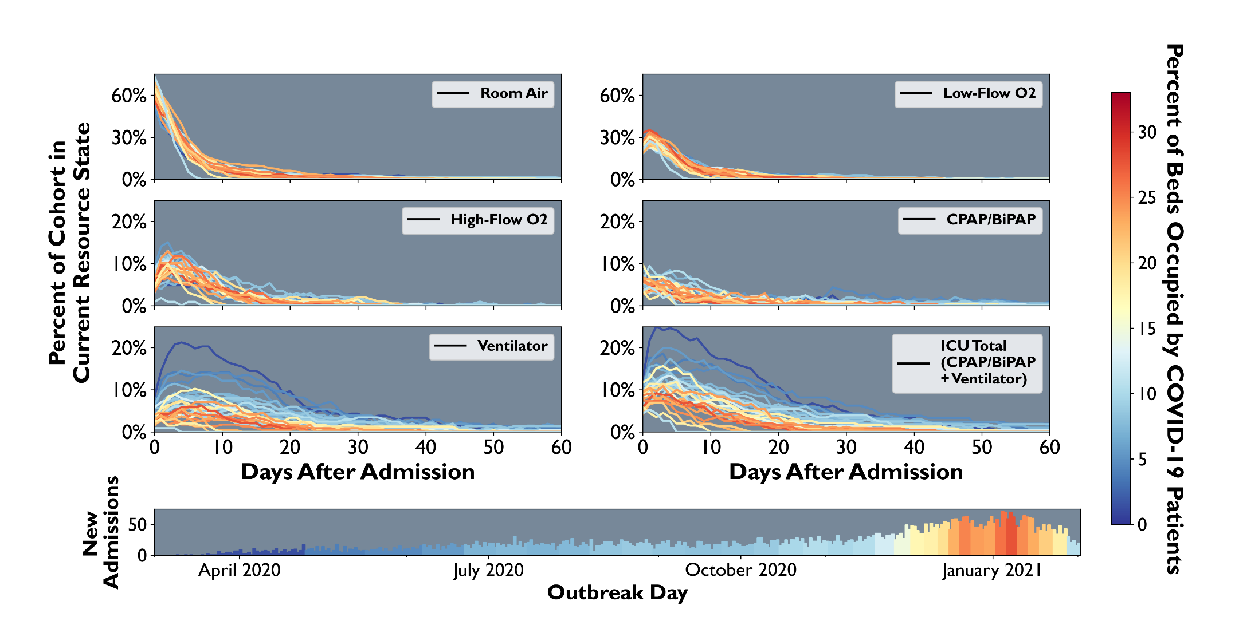
Figure 1: Cohort level probability distributions for resource use through time, University of North Carolina hospital system. Line color shows the percentage of all regional hospital beds occupied by COVID-19 patients at the time of cohort admission.
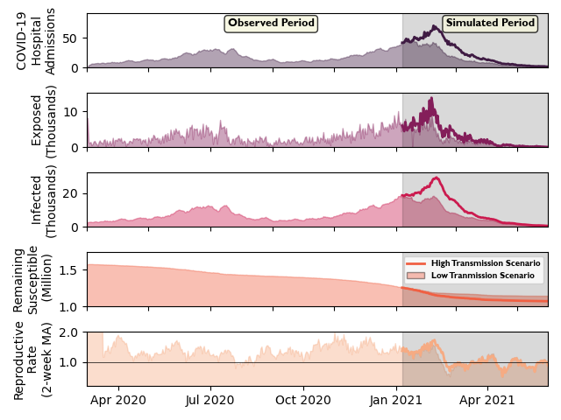
Figure 2: Daily hospitalization for all Triangle hospitals is used to model susceptible, exposed, and infected populations calculated within the SEIRH model, as well as the reproductive rate for COVID-19 transmission in the Triangle. Note: daily hospitalizations from March-May 2020 are estimated from DHHS data from June 2020 – February 2021
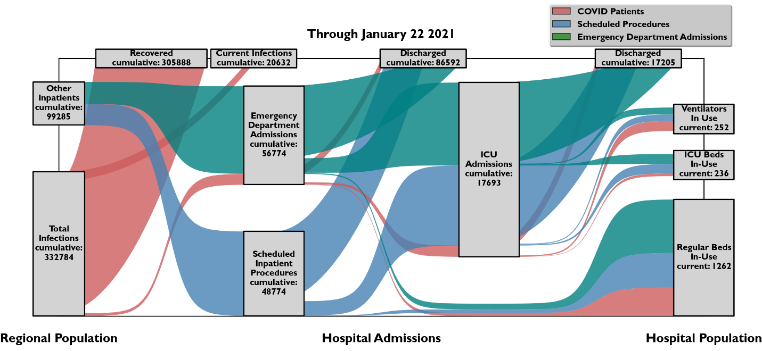
Figure 3: Patient flows between the community and the Triangle hospital system, including ICU and ventilator resources.
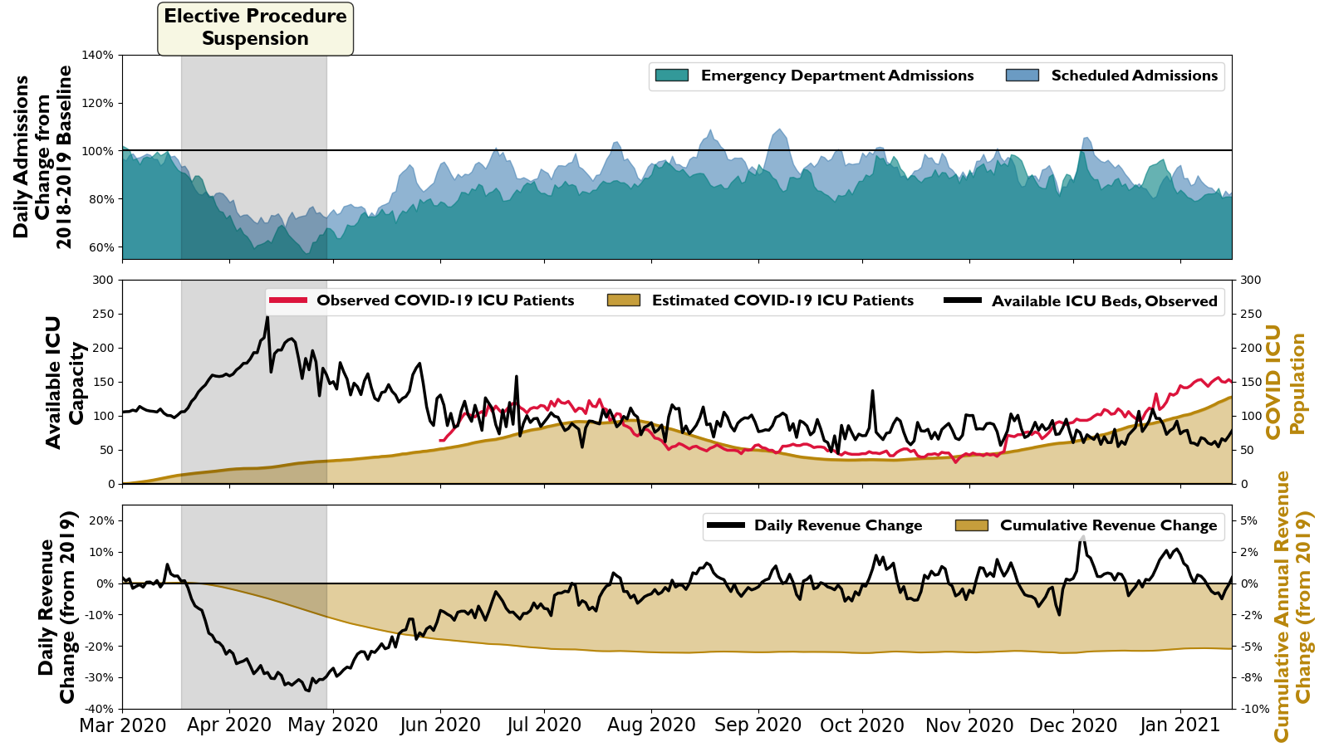Figure 4: Observed data including new hospital admissions, ICU capacity and COVID-19 population, and lost revenues for nine hospitals in the Research Triangle during the period March 2020 – February 2021.

\
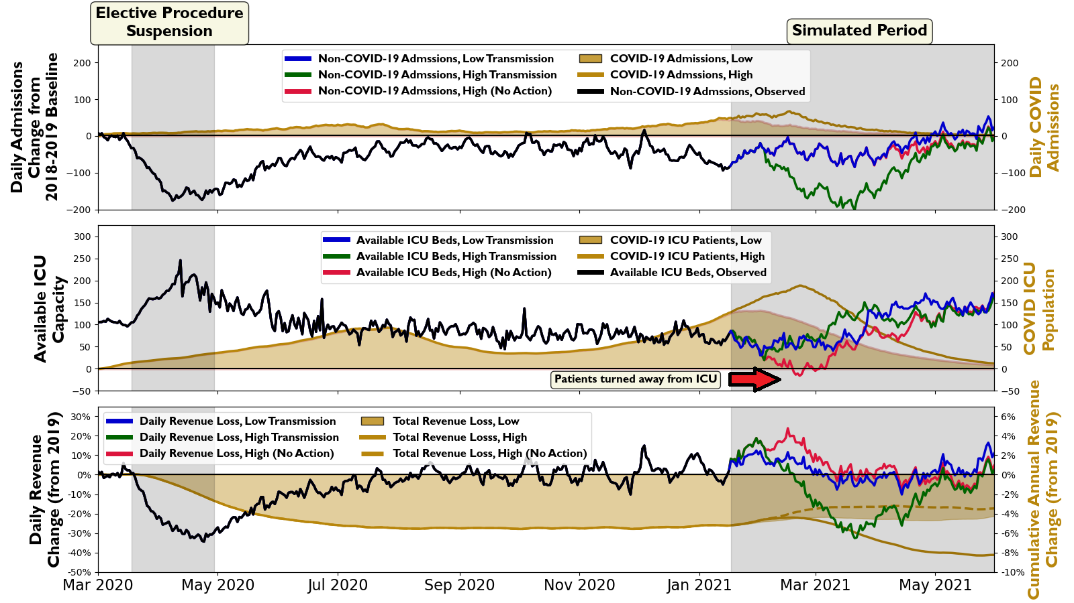Figure 5: Simulated admissions, ICU capacity, and revenue losses for the Research Triangle hospital system in response to different COVID-19 community transmission scenarios. Results assuming hospital action to cancel elective and non-emergency procedures in early February is compared to a scenario of no action.

References
Allen, C.R., Fontaine, J.J., Pope, K.L., and A.S. Garmestani (2010). Adaptive management for a turbulent future. Journal of Environmental Management 92, 1339-1345.
American College of Surgeons (2020). COVID-19: Elective Case Triage Guidelines for Surgical Care. Available online: https://www.facs.org/covid-19/clinical-guidance/elective-case, Accessed February 10, 2021.
The American Hospital Association (2019). The American Hospital Association Hospital Statistics. Chicago, IL
The American Hospital Association (2020). Hospitals and Health Systems Face Unprecedented Financial Pressures Due to COVID-19. Available at: https://www.aha.org/system/files/media/file/2020/05/aha-covid19-financial-impact-0520-FINAL.pdf
American Hospital Directory. The American Hospital Directory, Inc. 19 May, 2020. https://www.ahd.com/ Accessed 12 January, 2021.
Angulo, F., Finelli, L., and D.L. Swerdlow (2021). Estimation of US SARS-CoV-2 Infections, Symptomatic Infections, Hospitalizations, and Deaths Using Seroprevalence Surveys. JAMA Network Open, 4(1), doi:10.1001/jamanetworkopen.2020.33706.
Armony, M., Israelit, S., Mandelbaum, A., Marmor, Y.N., Tseytlin, Y., and G.B. Yom-Tov (2015). On patient flow in hospitals: a data-based queueing-science perspective. Stochastic Systems 5(1): 146-194.
Arroyo-Marioli, F., Bullano, F., Kucinskas, S., and C. Rondon-Moreno (2021). Tracking R of COVID-19: A new real-time estimation using the Kalman filter. PLoS ONE 16(1), https://doi.org/10.1371/journal.pone.0244474
Asplin, B.R., Flottemesch, T.J., and B.D. Gordon (2006). Developing Models for Patient Flow and Daily Surge Capacity Research. Academic Emergency Medicine, 13, 1109-1113.
Badr, H.S., Du, H., Marshall, M., Dong, E., Squire, M.M., and L.M. Gardner. (2020). Association between mobility patterns and COVID-19 transmission in the USA: a mathematical modelling study. The Lancet Infectious Diseases.
Balasubramanian, S., and E. Jones (2016). Hospital closures and the current healthcare climate: the future of rural hospitals in the USA. Rural and Remote Health, 16(3).
Bureau of Labor Statistics (2020). Employment Situation Summary. 8 May 2020. Available at: https://www.bls.gov/news.release/empsit.nr0.htm
Byrne, A.W., McEvoy, D., Collins, A.B., Hunt, K., Casey, M., Barber, A., Butler, F., Griffin, J., Lane E., McAloon, C., O’Brien, K. ,Wall, P., Walsh, K.A., and S.J. More (2020). Inferred duration of infectious period of SARS-CoV-2: rapid scoping review and anslysis of available evidence for asymptomatic and symptomatic COVID-19 cases. BMJ Open 10(8) http://dx.doi.org/10.1136/bmjopen-2020-039856.
The Center for Disease Control (2020). HHS Provider Relief Fund Dataset. Available online at: https://data.cdc.gov/Administrative/HHS-Provider-Relief-Fund/kh8y-3es6

The Center for Disease Control (2021). Estimated COVID-19 Burden. Available online at: https://www.cdc.gov/coronavirus/2019-ncov/cases-updates/burden.html#est-infections

The Centers for Medicare and Medicaid Services (2020). CMS Releases Recommendations on Adult Elective Surgeries, Non-Essential Procedures During COVID-19 Response. Available at: https://www.cms.gov/newsroom/press-releases/cms-releases-recommendations-adult-elective-surgeries-non-essential-medical-surgical-and-dental

Cohen, M. North Carolina’s Responsible Return to Elective Surgeries and Procedures. Hospital and Ambulatory Surgery Center Leaders, May 1, 2020. Available at: https://files.nc.gov/covid/documents/guidance/healthcare/COVID-19-Elective-Surgeries-Final.pdf

Daughton, C., (2020). Wastewater surveillance for population-wide COVID-19: the present and future. Science of the Total Environment. 736, 139631.

DeFelice, N.B., Little, E., Campbell, S.R., and J. Shaman (2017). Ensemble forecast of human West Nile virus cases and mosquito infection rates. Nature Communications, 8, 14592.

Dong, E., Du, H., and L. Gardner (2020). An interactive web-based dashboard to track COVID-19 in real time. Lancet Infect Dis, published online Feb 19, 2020. https://doi.org/10.1016/S1473-3099(20)30120-1.

Einav, S., Hick, J.L., Hanfling, D., Erstad, B.L., Toner, E.S., Branson, R.D., Kanter, R.K., Kissoon, N., Dichter, J.R., Devereaux, A.V., and M.D. Christian. (2013). Surge Capacity Logisitics: Care of the Critically Ill and Injured During Pandemics and Disasters: CHEST Consensus Statement. CHEST Journal, 146(4) E17S-E43S.

Fauci, A., Lane, C., and R.R. Redfield (2020). Covid-19 – Navigating the Uncharted. New England Journal of Medicine 382, 1268-1269.

Gottlober, P., Brady, T., Robinson, B., and T. Davis (2001). Medicare Hospital Prospective Payment System: How DRG Rates are Calculated and Updated. Office of the Inspector General, Region IX Available online: https://oig.hhs.gov/oei/reports/oei-09-00-00200.pdf

Hardin, T., and S. Basden. ‘Vidant Health losing millions each week amid coronavirus’. WCTI News (Greenville, NC). 29 April, 2020, available online: https://wcti12.com/news/local/vidant-health-losing-millions-each-week-amid-coronavirus

Hart, O. and R. Halden (2020). Computational analysis of SARS-CoV-2/COVID-19 surveillance by wastewater-based epidemiology locally and globally: Feasibility, economy, opportunities, and challenges. Science of the Total Environment, 730(15), https://doi.org/10.1016/j.scitotenv.2020.138875.

Hauser, N. ‘As Vidant Health system capacity hovers around 92%, concern is high for employee well being’. WITN News (Greenville, NC). 22 December, 2020, available online: https://www.witn.com/2020/12/22/as-vidant-health-system-capacity-hovers-around-92-concern-is-high-for-employees-well-being/

He, X., Lau, E.H.Y, Wu, P., Deng, X., Wang, J., Hao, X Lau, Y.C., Wong, J.Y., Guan, Y., Tan, X., Mo, X., Chen, Y., Liao, B., Chen, W. Hu, G., Zhang, Q., Zhong, M., Wu, Y., Zhao, L. ,Zhang, F., Cowling, B.J., Li, F., and G.M. Leung (2020). Temporal dynamics in viral shedding and transmissibility of COVID-19. Nature Medicine 26, 672-675.

Iglehart, J.K. (1983). Medicare begins prosective payment of hospitals. New England Journal of Medicine. 308, 1428-1432.

Jeffery, M.M., D’Onofrio, G., and H. Paek (2020). Trends in Emergency Department Visits and Hospital Admissions in Health Care Systems in 5 States in the First Months of the COVID-19 Pandemic in the US. JAMA Internal Medicine 180(10), 1328-1333.

Kolker, A. (2008). Process Modelling of ICU Patient Flow: Effect of Daily Load Leveling of Elective Surgeries on ICU Diverson. Journal of Medical Systems 33, 27-40.

Li, R., Pei, S., Chen, B., Song, Y., Zhang, T., Yang, W., and J. Shaman (2020). Substantial undocumented infection facilitates the rapid dissemination of novel coronavirus (SARS-CoV-2). Science, 386(6490), 489-493.

Maves, R.C., Downar, J., Dichter, J.R., Hick, J.L., Devereaux, A., Geiling, J.A., Kissoon, N., Hupert, N., Niven, A.S., King, M.A., Rubinson, L.L, Hanfling, D., Hodge, J.G., Marshall, M.F., Fischkoff, K., Evans, L.E., Tonelli, M.R., Wax, R.S., Seda, G., Parrish, J.S., Truog, R.D., Sprung, C.L., and M.D. Christian. (2020). Triage of Scarce Critical Care Resources in COVID-19: An Implementation Guide for Regional Allocation. CHEST Journal 158(1), 212-225.

Mendez, C.M., Harrington, D.W., Christenson, P., and B. Spellberg (2014). Impaxt of Hospital Variables on Case Mix Index as a Marker of Disease Severity. Population Health Management, 17(1), 28-34.

Moghadas, S.M., Shoukat, A., Fitzpatrick, M.C., Wells, C.R., Sah, P., Pandey, A., Sachs, J.D., Wang, Z., Meyers, L.A., Singer, B.H., and A.P. Galvani. (2020). Projecting hospital utilization during the COVID-19 outbreaks in the United States. Proceedings of the National Academies of Sciences 117(16), 9122-9126.

Moody’s Investors Service, 2020. Rating Action: Moody’s downgrades Vidant Health (NC) to A2; outlook stable. Available online: https://www.moodys.com/research/Moodys-downgrades-Vidant-Health-NC-to-A2-outlook-stable--PR_906468695

Opgenorth, D., Stelfox, H.T., Gilfoyle, E., Gibney, R.T.N., Meier, M., Boucher, P., Job McIntosh, C.N., Wang, X., Zygun, D.A., and S.M. Bagshaw (2018). Perspectives on strained intensive care unit capacity: A survey of critical care professionals. PLoS ONE 13(8). https://doi.org/10.1371/journal.pone.0201524

Park, M., Pawliuk, C., Nguyen, T., Griffitt, A., Dix-Cooper, L., Fourik, N., Dawes, M (2020). Determining the period of communicability of SARS-CoV-2: A rapid review of the literature. MedRXiv.

Shaman, J. and A. Karspeck (2012). Forecasting seasonal outbreaks of influenza. Proceedings of the National Academies of Sciences USA, 109, 20425-20430.

Shaman, J., Yang, W., and S. Kandula (2014). Inference and forecast of the current West African Ebola outbreak in Guinea, Sierra Leone and Liberia. PLoS Currents Outbreaks doi: 10.1371/currents.outbreaks.3408774290b1a0f2dd7cae877c8bff6.

Shewry, S. and E.S. Pan. (2020). Regional Stay At Home Order. California Department of Public Health. Available online: https://www.gov.ca.gov/wp-content/uploads/2020/12/12.3.20-Stay-at-Home-Order-ICU-Scenario.pdf

Steinmann, P., Wang, J.R., van Voorn, G.A.K., and J.H. Kwakkel (2020). Don’t try to predict COVID-19. If you must, use deep uncertainty methods. Review of Artificial Societies and Social Simulation 17.

Topchik, M., Gross, K., Pinette, M., Brown, T., Balfour, B., and H. Kein (2020). The Rural Health Safety Net Under Pressure: Rural Hospital Vulnerability. The Chartis Center for Rural Health, Februrary 2020. Available at: https://www.chartis.com/forum/insight/the-rural-health-safety-net-under-pressure-rural-hospital-vulnerability/
Villa, S., Prenestini, A., and I Giusepi (2014). A framework to analyze hospital-wide patient flow logistics: evidence from an Italian comparative study. Health Policy 115, 196-205.
Wang, J.G., Liu, B., Percha, B., Pan, S., Goel, N., Kusum, M., Gao, C., Tandon, P., Tomlinson, M., Yoo, E., Howell, D., Eisenberg, E., Naymagon, L., Tremblay, D., Chokshi, K., Dua, S., Dunn, A., Powell, C., and S. Bose (2020). Cardiovascular disease and severe hypoxemia associated with higher rates of non-invasive respiratory support failure in COVID-19. MedRXiv. https://doi.org/10.1101/2020.09.27.20202747
Watson S.K., Rudge, J.W., and R. Coker (2013). Health Systems’ ‘Surge Capacity’: State of the Art and Priorities for Future Research. The Milbank Quarterly 91(1), 78-122.
Weissman, G.E., Crane-Droesch, A., Chivers, C., Luong, T., Hanish, A., Levy, M.Z., Lubken, J., Becker, M., Draugelis, M.E., Anesi, G.L., and P.J. Brennan (2020). Locally informed simulation to predict hospital capacity needs during the COVID-19 pandemic. Annals of internal medicine. https://doi.org/10.7326/M20-1260.
Yang, W., Cowling, B.J., Lau, E.H., and J. Shaman. Forecastig influenza epidemics in Hong Kong. PLoS Computational Biology, 11, e1004383.

Department of Environmental Sciences and Engineering, University of North Carolina at Chapel Hill
Center on Financial Risk in Environmental Systems, University of North Carolina at Chapel Hill
Department of Environmental Medicine and Public Health, Icahn School of Medicine at Mount Sinai
Mount Sinai Institute for Exposomic Research, Icahn School of Medicine at Mount Sinai
Mount Sinai Health System

