Time series modelling to predict the anaerobic digestion process

Dynamic simulation and optimization of anaerobic digestion processes using MATLAB
Prabakaran Ganeshan ¹, Karthik Rajendran ^{1, *}
¹Department of Environmental Science, School of Engineering and Sciences, SRM University-AP, Amaravati, Andhra Pradesh 522240, India.
*Corresponding author Email: rajendran.k@srmap.edu.in
Email: prabakaran_g@srmap.edu.in
Highlights:
- Modified Hill’s model was used to develop time-series prediction of AD processes.
- Model could successfully predict both batch and continuous processes.
- Difference between simulation and literature varied between ±7.6%.
- No significant difference was found between experimental and simulations (P>0.05).
- Effect of varying loading rates was investigated to optimize CH₄ yield.

Abstract:
Time series-based modeling provides a fundamental understanding of process fluctuations in an anaerobic digestion process. However, such models are scarce in literature. In this work, a dynamic model was developed based on modified Hill’s model using MATLAB, which can predict the biomethane production with time series. This model can predict the biomethane production for both batch and continuous process, across substrates and at diverse conditions such as total solids, loading rate, and days of operation. The deviation between literature and the developed model was less than ±7.6%, which shows the accuracy and robustness of this model. Moreover, statistical analysis showed there was no significant difference between literature and simulation, verifying the null hypothesis. Finding a steady and optimized loading rate was necessary to an industrial perspective, which usually requires an extensive experimental data. With the developed model, a stable and optimal methane yield generating loading rate could be identified at minimal input.
Keywords: Anaerobic digestion, dynamic modeling, MATLAB Simulation, Sensitivity analysis, time series modeling,

Graphical abstract:
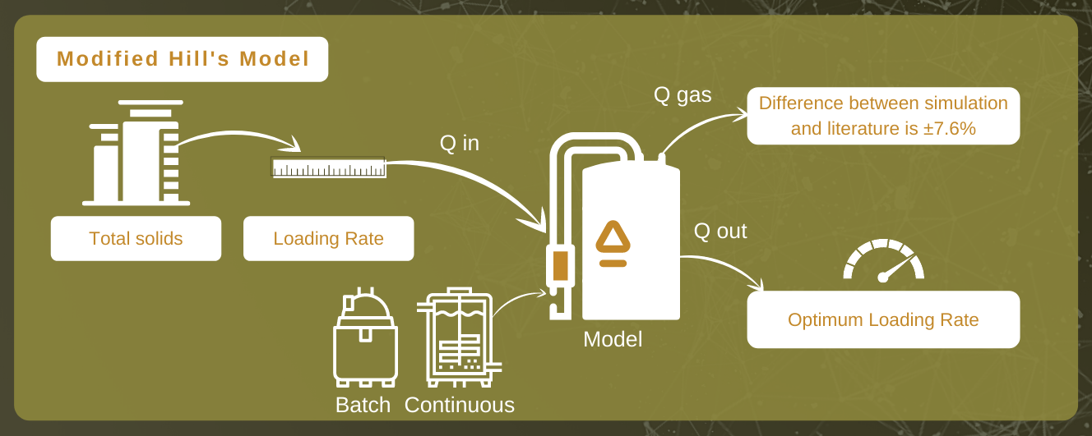

Introduction
Anaerobic Digestion (AD) is an established technology which converts organics to energy (CH₄) and biofertilizer. However, there are several consortia of microbes and process parameters involved in this conversion, which makes it difficult to achieve an optimum yield. Process stability and optimization could be achieved through process control strategies such as models, and simulations. Such strategies play a pivotal role in understanding the dynamic behavior of AD and process optimization. Current mathematical models describe the AD process in a steady-state condition, where time-series prediction is scarce in literature. Moreover, such models have a deficiency in describing the process parameters under transient state or start-up operations resulting from changes in input. Therefore, there is a need for a dynamic model, which can predict an optimum methane yield involving process parameters yet matches with the reality. Dynamic models provide a reliable and efficient operation of future plants with a combination of available sensor data and laboratory analyses (Weinrich and Nelles, 2021).
Andrews et.al., (1971) developed the first dynamic model for AD processes, which uses unionized acid as a rate-limiting substrate. After then, Hill and Barth, (1977) developed a model taking into account the inhibition of fatty acids for manure and animal wastes. Later, IWA (International Water Association) developed the ADM1 model, that became popular and widely accepted (Batstone et al., 2006). ADM1 include 12 algebraic and 19 differential equations with 24 dynamic variables. ADM1 describes the degradation of biochemical pathways, enzymatic hydrolysis to methanogenesis (Weinrich and Nelles, 2021). However, some processes are not included such as sulfate reduction, sulfide inhibition, and acetate oxidation reactions. Apart from ADM1, there are other models developed to predict AD processes including modified Gompertz model, simple kinetic model, empirical model (Abunde Neba et al., 2020; Weinrich and Nelles, 2021).
Anaerobic digestion is affected by several process driven factors such as loading rate (OLR), retention time (HRT), pH, temperature, and mixing. These factors strongly affect the methane yield. According to the authors knowledge, time-series, or the dynamic nature of the process over an operating period with the inclusion of above-mentioned process parameters is never reported in the literature. Predicting the dynamic behavior helps the industry to implement a real-time solution.
In this work, we had developed a model based on the modified Hill’s equation using MATLAB V2020b. No earlier models had reported the effect of varying OLR to optimize the methane yield and over days of operation. This is the first simulation study to report the effect of varying loading rate with time series which works for both batch and continuous processes. The goal of this work include: (1) develop and validate the model against literature to verify if there are any difference between them. (2) Analyze the dynamic behavior of the AD process over days of operation. (3) Study the effect of varying loading rates to find optimum methane yield over time.

Methods

Model description
In this work, modified Hill’s model was used to (Hill and Barth, 1977) forecast the dynamic behavior of the AD processes. This model used a set of differential equations characterizing the various stages of AD (hydrolysis, acidogenesis, acetogenesis, and methanogenesis). The microbial communities of various stages were divided as acid formers and methane formers. The growth rate of the microbes was modelled using Monod kinetics (Hill, 1983). The key input to the model includes organic loading rate (OLR), reactor volume, and operating temperature, while monitoring parameters included death rate and rate kinetics (Figure 1). The model was simulated by using the MATLAB (V2020b), and the required input data such as, Monod half velocity constant, yield factors and death rate of microbes were taken from the literature (Haugen et al., 2013; Pathmasiri et al., 2013; Saeed et al., 2019).

Model development
The modified Hill’s model was used in this study were described in Equations (1) to (6). Eqn. (1) & (2) was used to model the hydrolysis and acidogenesis stages of AD process. Eqn. (1) stands for the rate of change of VS breakdown in the reactor during AD processes. The change in VS concentration was found by the reactor loading rate with its kinetics. The rate of change in total VFA was obtained by adding total VFA produced with the difference between the growth rate of acid formers and methanogens (Eqn. 2).
The next stage in an AD process was acetogenesis, which figures out the rate of change in acetic acid concentration Eqn. (3). This was obtained by multiplying the total acid concentration with the difference between growth and death rate of acetogens, and retention time. Like Eqn. (3), Eqn. (4) stands for the rate of change of methane formation, which was obtained by multiplying the methanogens concentration with the difference between the growth and death of methanogens, and retention time.
Methane volume produced from the reactor was calculated by multiplying reactor volume with the growth kinetics and concentration of methanogens (Eqn. 5). The maximum growth rates of acidogens and methanogens were expressed in Eqn. (6), which depends on temperature.
${\dot{s}}_{b}={(s}_{b_{in}}-s_{b})(\frac{F_{feed}}{V})-\left[\left(\frac{μ_{m}}{\frac{K_{s}}{s_{b}}+1}\right).K_{1}∙X_{acid}\right]$ (1)
${\dot{s}}_{v}={(s}_{v_{in}}-s_{v})(\frac{F_{feed}}{V})+\left[\left(\frac{μ_{m}}{\frac{K_{s}}{s_{b}}+1}\right).K_{2}∙X_{acid}\right]-\left[\left(\frac{μ_{mc}}{\frac{K_{sc}}{s_{v}}+1}\right).K_{3}∙X_{meth}\right]$ (2)
${\dot{X}}_{acid}=\left[\frac{μ_{m}}{\frac{K_{s}}{s_{b}}+1}-K_{d-} \left(\frac{{F_{feed}}/b}{V}\right)\right]∙ X_{acid}$ (3)
${\dot{X}}_{meth}=\left[\frac{μ_{mc}}{\frac{K_{sc}}{s_{v}}+1}-K_{dc-} \left(\frac{{F_{feed}}/b}{V}\right)\right]∙ X_{meth}$ (4)
$F_{meth}=\left[V∙ \frac{μ_{mc}}{\frac{K_{sc}}{s_{v}}+1}{∙ K}_{4 } ∙{\dot{X}}_{meth}\right]$ (5)
$μ_{m}(T_{react)}=μ_{mc}(T_{react)}=0.013∙T_{react}-0.129$ (6)
The key assumptions of this model include constant reactor stirring, reactor volume, and temperature being constant. The kinetic coefficients were obtained from (Haugen et al., 2013), while the death rates of acetogens and methanogens taken from the literature (Fedailaine et al., 2015; Haugen et al., 2013; Pathmasiri et al., 2013).
About twenty parameters were added to perform the simulations using MATLAB. These parameters include VS concentration, acid concentration, growth rates, volume, and retention time. The equations were placed in MATLAB (version R2020b) as main and function scripts (Anaya Menacho et al., 2022; Carlini et al., 2020). All the parameters were defined in main script, while function scripts hold the differential equations mentioned above (Eqn. (1-6)). The main script acts as an input-output model, while the function scripts perform the calculations. The output was returned to the main scripts, from which the methane production was obtained (Weinrich and Nelles, 2021).

Model Validation
The robustness of the model was verified and validated using various literature. The variation included scale, substrate, operating parameters, and volume. Table 1 shows the operating conditions used in each scenario and the respective experimental yield obtained.
Case (1): Cow manure was used as a feedstock, which was (Kaparaju et al., 2009) operated in a batch mode. The OLR was 0.328 kgVS /L/d with a 5-L reactor volume and the reported methane yield was 353.5 L/kgVS/d at a 15-day HRT.
Case (2): This scenario used swine manure in a 30L reactor at a OLR of 7.68 gVS/m³. The biogas obtained was 0.269 m³/kgVS at 8 days retention time (Fujita et al., 1980).
Case (3): Most earlier scenarios used a mono-digestion, while in this validation a co-digestion concept was assessed. The substrate composition used was 70% MSW and 30% citrus waste (Forgács et al., 2012) in a 5L reactor. The methane yield reported was 0.55 m³CH4/kgVS/d at 21 days HRT by using a loading rate of 3-gVS/L/d.
Case (4): Food waste was used as a substrate in a continuous mode with 340 m³ reactor volume. The methane yield reported was 0.59 m³CH₄/kgVS at 48 days HRT with a OLR was 6.4 kgVS/m³/d. (Liu et al., 2020).
Case (5): MSW was used as a substrate in a continuous mode (Eliyan et al., 2007). This was a pilot reactor with a volume of 600L operating at a OLR of 3 gVS/L/d with 19 days HRT. The reported biogas production was 401 L/kgVS.
Case (6): This scenario used an industrial data using MSW, with a volume of 3000-m^{3,} running at a OLR of 3.5 kgVS/m³/d. The biogas production from that plant was 9600 m³ /d at 21 days HRT (Rajendran et al., 2014).

Statistical analysis
The scenarios that were confirmed against the model was evaluated for its significance through statistical analysis. A probability plot was drawn for the difference between the experimental resulted reported and simulated results obtained. Key statistical indicators such as p-value, mean, and standard deviations were looked out for. This probability plot used a 95% confidence interval. Minitab V19 was used to plot the probability plot.

Sensitivity analysis
The key inputs to the model were the loading rate and solids concentration. The sensitivity of the model to the solid’s concentration was evaluated by varying it in a range of ±5%, ±10%, ±20%. A trend line was plotted across these variations and the resulting R² value was reported, and it was checked for correlation.

Loading Rate Optimization
The modified Hill’s model predicts the biomethane production, however the loading rate at which maximum yield obtained was not embedded. The OLR was optimized in MATLAB using the interior-point algorithm and minimum constraint solver (fmincon) (Khan et al., 2016)(Donoso-Bravo et al., 2011). The solver works based on lower- and upper- bound limits in an iterative process. The iteration was repeated until maximum methane yield and the respective loading rate was reported as output.

Results and Discussion
The Modified Hill’s model was applied in this study, while examining diverse operating conditions of AD. The simulations could predict the methane yield across substrates, loading rates, and temperature in a dynamic timeframe with an accuracy of 92±7.6%. The simulation was confirmed with literature ranging from laboratory to industrial data, and the differences were calculated. Besides, statistical analyses and sensitivity of the model was assessed to prove its robustness.

Model validation
The operating conditions, experimental yield, simulation yield and the difference between the two for various case studies were summarized in Table 1. The difference between simulation and experimental methane yield varied between +7.5 to -7.6%. For instance, scenario-3 used a swine manure which was run in a batch mode had reported an experimental biogas yield of 0.266 m³/kgVS, while the dynamic model developed in this study reported the biogas yield of 0.269 m³/kgVS. The error difference between the simulation and experimental yield was -1.1%. This error difference could be due to lack of ammonia inhibition (Lee et al., 2018).
Figure 2 shows the dynamic response from the model alongside experimental and simulated values. The batch process had a fixed amount of VS available and hence over the higher days of operation, the substrate gets degraded which was reflected as the decrease in the biomethane/biogas yield Fig 2(a-c). In addition, In Fig 2(c) the experimental yield reported was 0.555 m³ CH₄/kgVS, while the simulation reported a yield of 0.621 m³ CH₄/kgVS at 21 days HRT. However, the dynamic response from the simulation shows that at 10 days HRT, 0.692 m³ CH₄/kgVS could be achieved. This shows that the reactor was not operated at maximum biomethane yield.
As the VS decreases, the biomethane / biogas yield decreases over time in a batch process (Fig 2 a-c). Contrastingly, in continuous processes (Fig 2 d-f), the biogas/methane yield did not decrease, instead a steady state condition was achieved. This was due to the continuous supply of VS in these processes (Fig 2d-f). Fig 2(d) shows that the difference between experimental and simulated result was 0.3% at 48 days retention time. Nonetheless, running the reactor at 30 days retention time did not decrease the methane yield by greater than 5%. Such a trade-off could be predicted from the simulation which can help the industry or research community for a better decision making and operation of the digester. This trade-off offers a 37% reduction in reactor volume, without compromising on the methane yield significantly.

Statistical analysis
Evaluating the simulation statistically shows the accuracy of its robustness. A statistical analysis was conducted to check the significance of difference between random scenarios mentioned earlier and their error difference between experimental and simulated results. The probability plot was drawn to check the P-value and the significance of differences with a 95% confidence interval (CI) for various scenarios (Figure 3). The P-value obtained was 0.377 (>0.05), shows that across random scenarios the difference between experimental and simulated results were insignificant, which verifies the null hypothesis (Silva and De Bortoli, 2020) (Hamawand and Baillie, 2015; Rajendran et al., 2014).

Sensitivity analysis
Sensitivity analysis shows the effect of critical parameters on the model output and its efficacy. The critical input to the model is TS concentration (Calise et al., 2020), which was altered by ±5%, ±10%, and ±20% for both batch and continuous processes to study its sensitivity. Figure 4 shows the effect of sensitivity analysis for batch (a) and continuous processes (b). Both batch and continuous processes showed a linear correlation with varying solids concentration. All the correlation had a R² value greater than 0.97. The average R² value was 0.98, and 0.986 for batch and continuous processes, respectively. This strong correlation shows the higher degree of robustness and accuracy of the model. A study by Mukumba et al., (2018), showed a similar correlation against the experimental data and the R² value was 0.9712.

Effect of methane production on various loading rates
Optimizing the OLR for a given substrate improves the productivity and methane yield. An attempt was made to optimize OLR by simulating the experimental data against certain standard conditions including 500-m³ reactor volume and 37°C as operating temperature. Under these conditions, the optimal loading rate at which maximum methane yield obtained was identified. Optimizing the OLR against standard conditions reduces any errors within the operating parameters. Different OLRs was simulated for optimization including 2,3,5,7,9, and 12 kgVS/m³/day.
The type of feedstock, composition, and its operating conditions have a varying optimal point on OLR. For example, food waste (Fig 5d) had an optimal OLR of 5 kgVS/m³/day, while MSW (Fig 5f) had an optimal OLR of 3 kgVS/m³/day. This could be explained by the fact that food waste has easily degradable organics, while MSW was a complex substrate and hence higher loading could not be achieved. Until 20 days of operation (Fig 5f), OLR of 2 kgVS/m³/day received a maximum methane yield, while after that 3 kgVS/m³/day had a higher methane yield. This shows that longer days of operation could optimize better loading rates, or which helps in reaching a steady-state conditions. In Fig 4(e), OLR of 3 kgVS/m³/day could not support its stability, while 2 kgVS/m³/day could maintain steady state at a longer operating period. Such time-dependent predictive analytics were not reported in literature elsewhere, shows the importance, innovation, application, and usability of such simulation in industries.
Eliyan et.al (2007) reported that increasing the OLR from 2 to 2.5 kgVS/m³/d using MSW as a substrate saw a decline in methane yield from 140 to 62.5 m³CH₄/kgVS/d (55.3%). The same study when simulated with the current model by increasing the OLR from 2 to 2.5 kgVS/m³/d revealed a methane yield decline from 108 to 66.62 m³CH₄/kgVS/d (38.2%) depicting the reality shows the reproducibility of the model and its validation against experimental data (Fig 5e).

Optimization studies
Optimizing the loading rate through experiment was not easy, as multiple trials were necessary. However, with a standard input given and by using the optimization algorithm in MATLAB, the maximum methane of an AD process could be predicted. Lower loading rates yield low methane, while higher loading creates imbalance and decreases the stability (Khan et al., 2016). Hence, running at the optimum point is essential for maximum profitability.
As different studies reported distinct inputs and combinations, a standard condition was assumed to evaluate the maximum loading rate prediction. This includes a reactor size of 3000-m³ running at mesophilic temperature (37°C). Experimental data of case-6 reported operating at 3.5 kgVS/m³/d, and the methane yield was 9600 m³/d. Increasing the loading rate to 5.0 kgVS/m³/d in simulations showed a decline in methane yield to 8600 m³/d (Note: The errors between simulation and experiments are not considered here) (Figure 6). A lower and upper bound limit was given to the optimization algorithm in MATLAB based on the flow rate, which in term governs the loading rate, solid concentration. The lower bound flow rate was kept at 1 m³/d, while the upper bound value was kept at 500-m³/d.
The output from MATLAB yielded an optimum OLR of 4.1 kgVS/m³/d against the experimental data of 3.5 kgVS/m³/d. Adding the error difference from base case (-5.5%) scenario; the simulation resulted in a methane yield of 9875 m³/d (OLR- 4.1 kgVS/m³/d) against 9600 m³/d from experiments (OLR- 3.5 kgVS/m³/d). Similarly, each base case was optimized to find its maximum loading rate and methane yield, that was reported in Table 2. The optimum conditions obtained for food waste (case (4), according to simulations reached an OLR of 4.6 kgVS/m³/d with a methane yield of 521 m³/kgVS/d. Similarly, case (3) using MSW with citrus waste reported a maximum loading of 3 kgVS/m³/d, while simulation optimized the loading rate to 3.4 kgVS/m³/d.

Discussion
The current model we had developed could maximize the loading rate and methane yield. However, there are certain shortcomings that need to be addressed. This includes the effect of mixing such as agitation speed, and duration that might affect the methane yield in industrial applications. Besides, this model considered only volatile fatty acids inhibition, while other inhibitions such as ammonia, metal ions, and foaming were not included. Including them in further versions of the model will enhance the robustness and accuracy in implications of it. Furthermore, we considered the solids loading, C/N ratio, while adding the composition of substrate as carbohydrates, proteins and fats will help in having a deeper understanding in model prediction.
Various models have been developed in the past that has predicted the AD processes for batch, and continuous operations. ADM1 was widely accepted by academia and industry as it was a comprehensive model accounting most of the factors that affect the biomethane production (Donoso-Bravo et al., 2011). Most models work either for a batch or continuous process
Those models were used to study the transient behaviour of batch and continuous processes of AD and its estimate the gas yield from a particular substrate. In this work, studied the dynamic behaviour of AD and the simulated results confirmed with literature studies, and the difference was ±7.6 %. The simulation model was suitable for any substrates and both batch and continuous operations.
One of the important operational parameters of AD is OLR, it increases the biogas yield also increased up to certain load then decreased. In this paper, studied the volumetric methane yield for various OLR, it varies from 2 kgVS/m³/d to 12 kgVS/m³/d at 500 m³ and mesophilic temperature conditions. The simulation results revealed that, biomethane production was increased certain days then its stable or decreased due to overloading. In fig 5 (d) the gas yield was increased gradually up to 30 / 40 days of operation then its stable at OLR range from 2 to 5 kgVS/m³/d. Further increased OLR 7 kgVS/m³/d, the methane production was unstable and decreased due to overloading. In methane yield was nearly zero at 80days of operation at OLR 12 kgVS/m³/d. Temperature is another critical parameter that affects the reaction rate and methane production. An increase in temperature leads to an increase in gas production with shorter retention time. The optimal operation conditions are required for stable and efficient operation of anaerobic digesters.
An optimal OLR was beneficial in improving methane production and ensure the operation stability of AD with efficient and economic operation of the plants. The optimal OLR was varied with different temperatures. From that simulation results, the methane production was 107.1, 521, and 970 m³/kgVS/d, and the optimal OLR was 1.2, 4.6, and 8.2 kgVS/m³/d at temperatures 20°C, 37°C, and 55°C, respectively. The results indicated the methane production increased with the increases in temperature and the appropriate range of OLRs.
Common operating temperature of an AD process lies in three ranges: (1) psychrophilic, (2) mesophilic and (3) thermophilic. In tropical countries, ambient temperatures are preferred, as when compared with industrialized countries which operated AD digester at mesophilic and predominantly thermophilic range. Using optimization algorithm, the temperature at which maximum biomethane could be yielded was identified for the base case scenarios reported earlier. Figure 1(s) (Supplementary file) shows the effect of various temperature
The growth rate and activities of microorganisms will change with respect to temperature. The simulation was studied three operating temperatures such as, 20°C, 37°C, and 55°C and found the optimum OLR. From results, the best loading rate on food waste was 1.2, 4.6, and 8.2 kgVS/m³/d, and methane yield was 107.1, 521, and 970.5 m³/kgVS/d at reactor temperatures 20°C, 37°C, and 55°C respectively at reactor volume 500 m³.
The result shows that the reactor ran at 20°C, the OLR and methane yield was less, then step up the temperature 37°C, and 55°C it increases the OLR and methane production at constant reactor volume. Temperatures which were leads to an increase in OLR and methane production rate.

Conclusion
Using MATLAB and with modified Hill’s equations, the dynamic behaviour of AD processes was predicted. This simulation could be applied for both batch and continuous process, which had a deviation of ±7.6% from experiments. The statistical validation showed that there was no significant difference between experiments and simulation across literature ranging from laboratory to industry, and batch to continuous processes. The effect of varying loading rates against the time showed the region of process stability yet achieving a maximum methane yield. The implications of this work include to use it real-time operations of an AD plant and laboratories to estimate the best region of operation in terms of loading rate and yield.
CRediT author statement
Prabakaran Ganeshan: Conceptualization, Methodology, Formal Analysis, Visualization, Writing- Original draft preparation, Software, Validation; Karthik Rajendran: Conceptualization, Methodology, Investigation, Supervision, Writing- Reviewing and Editing, Project Administration
Declaration of competing interest
The authors declare no competing interests.
Acknowledgements
Prabakaran Ganeshan acknowledges the University Research Fellowship (URF) received from SRM University-AP to conduct this work.

Nomenclature
$$s_{b}$$ | Biodegradable volatile solid concentrations in reactor (kg / m³)
$$s_{b_{in}}$$ | Biodegradable volatile solid concentrations in feed (kg / m³)
$$F_{feed}$$ | Feed flow rate (constant volume) (m³ / d)
$$V$$ | Volume of the reactor (m³)
$$μ_{m}$$ | Maximum growth rate for acidogens (d⁻¹)
$$K_{1}$$ | Yield constant
$$K_{s}$$ | Monod half-velocity constant for acidogens (kg / m³)
$$X_{acid}$$ | Concentration of acidogens (kg / m³)
$$T_{react}$$ | Reactor temperature (°C)
$$s_{v}$$ | Total volatile fatty acid concentration in reactor (kg / m³)
$$s_{v_{in}}$$ | Total volatile fatty acid concentration in feed (kg / m³)
$$K_{2}$$ | Yield constant
$$μ_{mc}$$ | Maximum growth rate for methanogens (d⁻¹)
$$K_{3}$$ | Yield constant
$$K_{sc}$$ | Monod half-velocity constant for methanogens (kg / m³)
$$X_{meth}$$ | Concentration of methanogens (kg / m³)
$$K_{d}$$ | Specific death rate for acidogens (d⁻¹)
$$b$$ | Retention time factor
$$K_{dc}$$ | Specific death rate for methanogens (d⁻¹)
$$F_{meth}$$ | Methane gas flow (m³ /kg_{VS}. d)
$$K_{4 }$$ | Yield constant

References
Abunde Neba, F., Asiedu, N.Y., Morken, J., Addo, A., Seidu, R., 2020. A novel simulation model, BK_BiogaSim for design of onsite anaerobic digesters using two-stage biochemical kinetics: Codigestion of blackwater and organic waste. Sci. African 7, e00233. https://doi.org/10.1016/j.sciaf.2019.e00233
Anaya Menacho, W., Mazid, A.M., Das, N., 2022. Modelling and analysis for biogas production process simulation of food waste using Aspen Plus. Fuel 309, 122058. https://doi.org/10.1016/j.fuel.2021.122058
Bakraoui, M., Karouach, F., Belhadj, S., Joute, Y., Ouhammou, B., Aggour, M., Essamri, A., El Bari, H., 2018. Modified gompertz kinetic study of methane production from anaerobic digestion of recycled paper mill sludge. Eur. Biomass Conf. Exhib. Proc. 2018, 849–854.
Batstone, D.J., Keller, J., Steyer, J.P., 2006. A review of ADM1 extensions, applications, and analysis: 2002-2005. Water Sci. Technol. 54, 1–10. https://doi.org/10.2166/wst.2006.520
Calise, F., Cappiello, F.L., D’Accadia, M.D., Infante, A., Vicidomini, M., 2020. Modeling of the anaerobic digestion of organic wastes: Integration of heat transfer and biochemical aspects. Energies 13. https://doi.org/10.3390/en13112702
Carlini, M., Castellucci, S., Mennuni, A., Selli, S., 2020. Simulation of anaerobic digestion processes: Validation of a novel software tool ADM1-based with AQUASIM. Energy Reports 6, 102–115. https://doi.org/10.1016/j.egyr.2020.08.030
Donoso-Bravo, A., Mailier, J., Martin, C., Rodríguez, J., Aceves-Lara, C.A., Wouwer, A. Vande, 2011. Model selection, identification and validation in anaerobic digestion: A review. Water Res. 45, 5347–5364. https://doi.org/10.1016/j.watres.2011.08.059
Eliyan, C., Adhikari, R., Juanga, J.P., Visvanathan, C., 2007. Anaerobic Digestion of Municipal Solid Waste in Thermophillic Continuous Operation. Int. Conf. Sustain. Solid Waste Manag. Asian Inst. Technol. Thail. https://doi.org/10.1.1.539.3346
Fedailaine, M., Moussi, K., Khitous, M., Abada, S., Saber, M., Tirichine, N., 2015. Modeling of the anaerobic digestion of organic waste for biogas production. Procedia Comput. Sci. 52, 730–737. https://doi.org/10.1016/j.procs.2015.05.086
Forgács, G., Pourbafrani, M., Niklasson, C., Taherzadeh, M.J., Hováth, I.S., 2012. Methane production from citrus wastes: Process development and cost estimation. J. Chem. Technol. Biotechnol. 87, 250–255. https://doi.org/10.1002/jctb.2707
Fujita, M., Scharer, J.M., Moo-Young, M., 1980. Effect of corn stover addition on the anaerobic digestion of swine manure. Agric. Wastes 2, 177–184. https://doi.org/10.1016/0141-4607(80)90014-1
Hamawand, I., Baillie, C., 2015. Anaerobic digestion and biogas potential: Simulation of lab and industrial-scale processes. Energies 8, 454–474. https://doi.org/10.3390/en8010454
Haugen, F., Bakke, R., Lie, B., 2013. Adapting dynamic mathematical models to a pilot anaerobic digestion reactor. Model. Identif. Control 34, 35–54. https://doi.org/10.4173/mic.2013.2.1
Hill, D.T., 1983. Simplified monod kinetics of methane fermentation of animal wastes. Agric. Wastes 5, 1–16. https://doi.org/10.1016/0141-4607(83)90009-4
Hill, D.T., Barth, C.L., 1977. A Dynamic Model for Simulation of Animal Waste Digestion All use subject to JSTOR Terms and Conditions A dynamic of animal model waste for simulation digestion. Water Pollut. Control Fed. 49, 2129–2143.
Kaparaju, P., Ellegaard, L., Angelidaki, I., 2009. Optimisation of biogas production from manure through serial digestion: Lab-scale and pilot-scale studies. Bioresour. Technol. 100, 701–709. https://doi.org/10.1016/j.biortech.2008.07.023
Khan, M.A., Ngo, H.H., Guo, W., Liu, Y., Nghiem, L.D., Hai, F.I., Deng, L.J., Wang, J., Wu, Y., 2016. Optimization of process parameters for production of volatile fatty acid , biohydrogen and methane from anaerobic digestion. https://doi.org/10.1016/j.biortech.2016.08.073
Lee, D.J., Bae, J.S., Seo, D.C., 2018. Potential of biogas production from swine manure in South Korea. Appl. Biol. Chem. https://doi.org/10.1007/s13765-018-0390-4
Li, D., Lee, I., Kim, H., 2021. Application of the linearized ADM1 (LADM) to lab-scale anaerobic digestion system. J. Environ. Chem. Eng. 9. https://doi.org/10.1016/j.jece.2021.105193
Liu, Y., Huang, T., Li, X., Huang, J., Peng, D., Maurer, C., Kranert, M., 2020. Experiments and modeling for flexible biogas production by co-digestion of food waste and sewage sludge. Energies 13. https://doi.org/10.3390/en13040818
Mukumba, P., Makaka, G., Mamphweli, S., 2018. Mathematical modelling of the performance of a biogas digester fed with substrates at different mixing ratios. Asian J. Sci. Res. 11, 256–266. https://doi.org/10.3923/ajsr.2018.256.266
Pathmasiri, T.K.K.S., Haugen, F., Gunawardena, S.H.P., 2013. Simulation of a Biogas Reactor for Dairy Manure Simulation of a Biogas Reactor for Dairy Manure 394–398.
Rajendran, K., Kankanala, H.R., Lundin, M., Taherzadeh, M.J., 2014. A novel process simulation model (PSM) for anaerobic digestion using Aspen Plus. Bioresour. Technol. 168, 7–13. https://doi.org/10.1016/j.biortech.2014.01.051
Saeed, M., Fawzy, S., El-Saadawi, M., 2019. Modeling and simulation of biogas-fueled power system. Int. J. Green Energy 16, 125–151. https://doi.org/10.1080/15435075.2018.1549997
Silva, M.I., De Bortoli, A.L., 2020. Sensitivity Analysis for Verification of an Anaerobic Digestion Model. Int. J. Appl. Comput. Math. 6, 1–12. https://doi.org/10.1007/s40819-020-0791-z
Weinrich, S., Mauky, E., Schmidt, T., Krebs, C., Liebetrau, J., Nelles, M., 2021. Systematic simplification of the Anaerobic Digestion Model No. 1 (ADM1) – Laboratory experiments and model application. Bioresour. Technol. 333. https://doi.org/10.1016/j.biortech.2021.125104
Weinrich, S., Nelles, M., 2021. Systematic simplification of the Anaerobic Digestion Model No. 1 (ADM1) – Model development and stoichiometric analysis. Bioresour. Technol. 333, 125124. https://doi.org/10.1016/j.biortech.2021.125124
Westerholm, M., Liu, T., Schnürer, A., 2020. Comparative study of industrial-scale high-solid biogas production from food waste: Process operation and microbiology. Bioresour. Technol. 304, 122981. https://doi.org/10.1016/j.biortech.2020.122981

List of Tables and Figures
Figure 1: Block flow diagram of the proposed model showing the inputs, and parameters that affect the methane yield.
Figure 2: Dynamic response of the model against experimental results. (a) Cow manure (TS 6%), (b) Swine manure (TS 6.4%), (c)MSW+CW (TS 13%), (d) Food waste (TS 32%), € MSW (TS 10%), (f) MSW (TS 15%).
Figure 3: Probability plot of the different cases validated against the simulated result.
Figure 4: Sensitivity analysis of simulation based on the change in total solid concentration as ± 5%, ± 10%, and ± 20% (a) Batch mode (b) continuous mode.
Figure 5: Effect of various OLR (kgVS/m³/d) on methane production (m³/kgVS/d) (a) Cow manure (TS 6%), (b) Swine manure (TS 6.4%), (c) MSW+CW (TS 13%), (d) Food waste (TS 32%), € MSW (TS 10%), (f) MSW (TS 15%).
Figure 6: Effect of optimizing loading rate against the real-time experimental data.

Table 1: Overall summary of experimental data used and the simulated results.
Table 2: Effect of optimizing loading rate and methane yield against standard conditions.
Table 3: Comparison of various literature reported models for AD prediction and their accuracies.

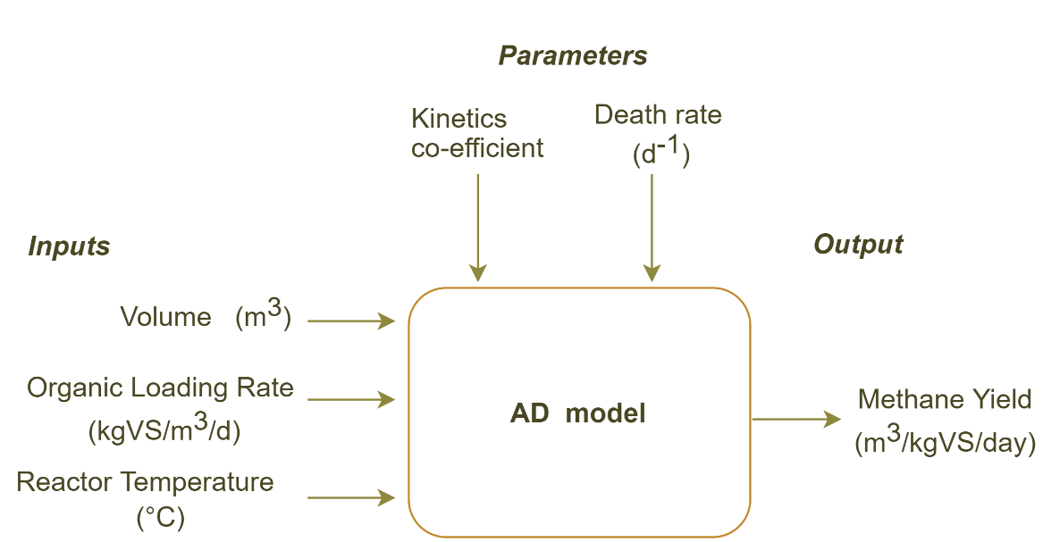
Figure 1

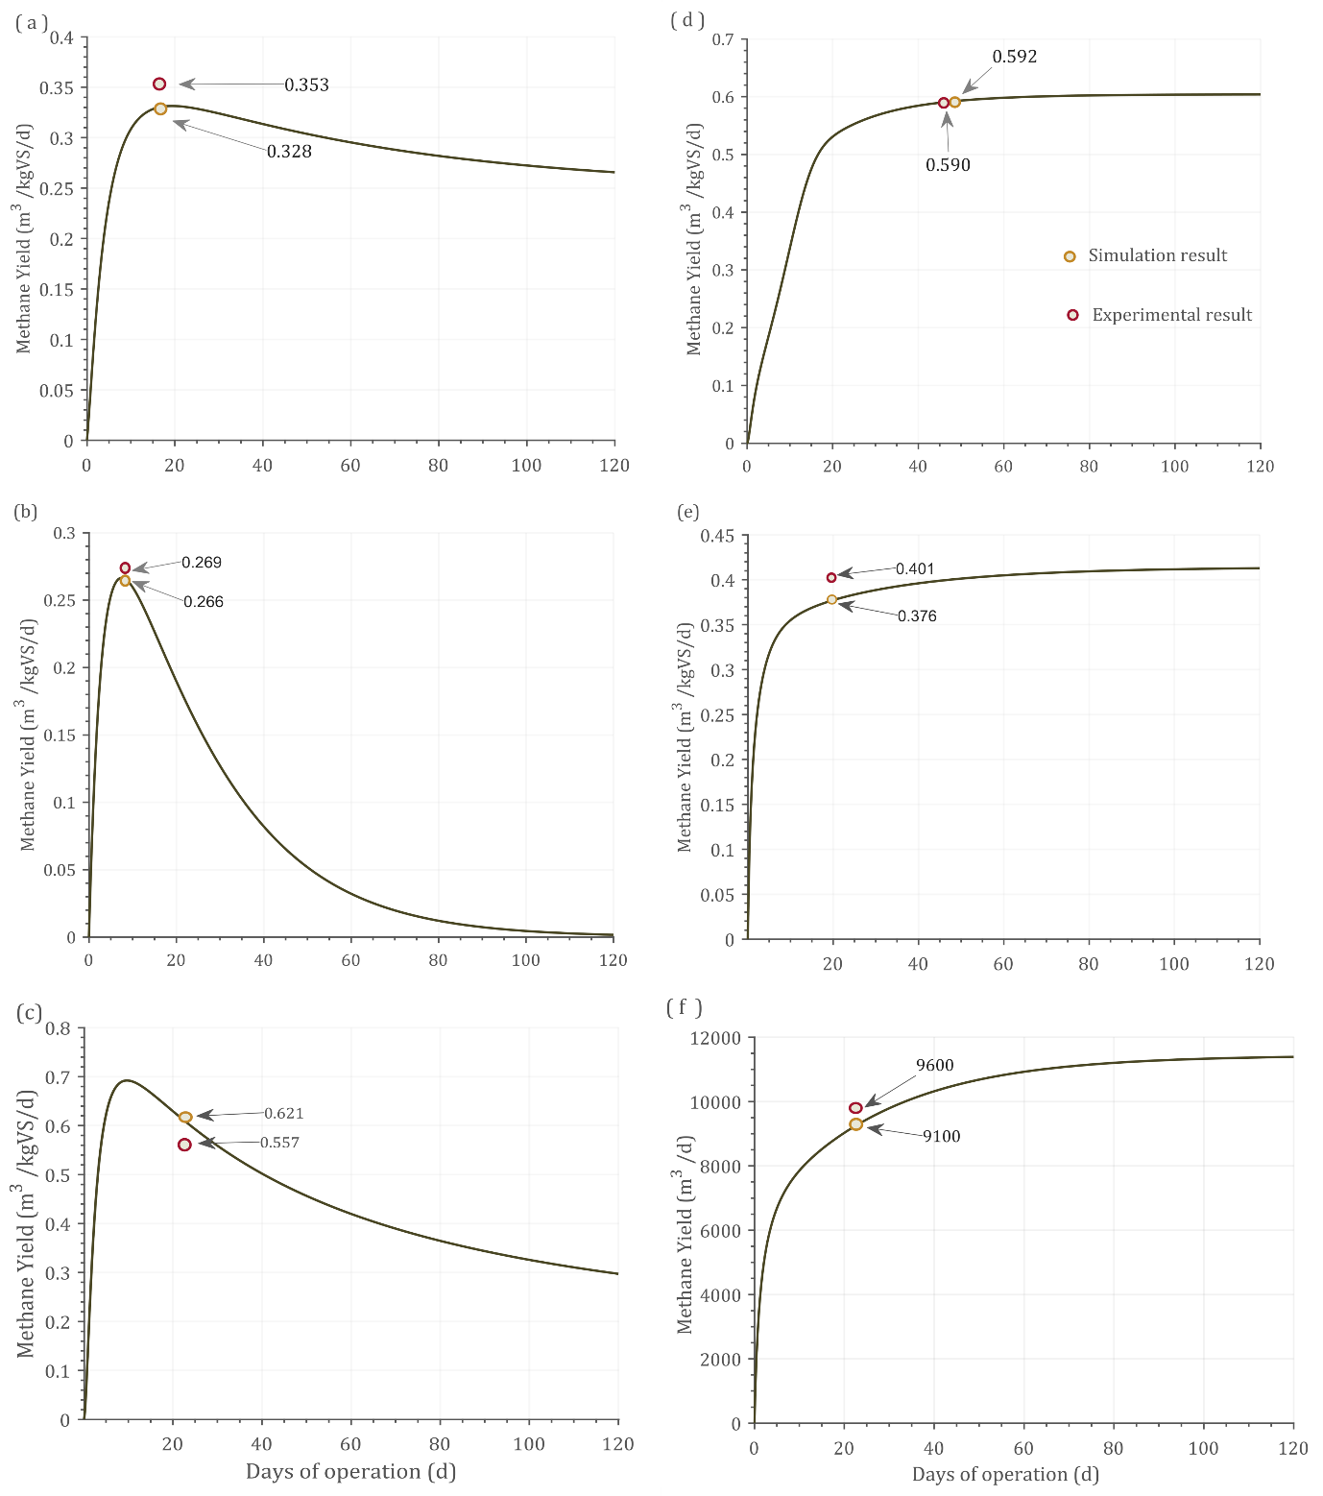
Figure 2

Figure 3

Figure 4

Figure 5

Figure 6

Table 1
Case | Substrate | Feeding mode | TS (%) | VS (%) | Reactor volume | HRT (days) | Temperature  (°C) | Loading rate | Experimental results | Simulation results | Difference (%) | Reference
1 | Cow manure | Batch | 6 | 80 | 5 L | 15 | 54 | 0.328 kgVS /L | 353.5 L /kgVS | 328.5 L /kgVS/d | -7.6 | (Kaparaju et al., 2009)
2 | Swine manure | Batch | 6.4 | 72 | 30 L | 8 | 55 | 7.68 gVS/m³ | 0.269 m³/kgVS | 0.266 m³ /kgVS | -1.1 | (Fujita et al., 1980)
3 | MSW+CW | Batch | 13 | 87 | 2 L | 21 | 55 | 3 gVS/L | 0.555 m³CH₄/kgVS | 0.621 m³CH₄ /kgVS | 7.5 | (Forgács et al., 2012)
4 | Food Waste | Continuous | 32 | 89 | 340 m³ | 48 | 35 | 6.4 kgVS/m³/d | 0.590 m³CH₄/kgVS/d | 0.592 m³CH₄ /kgVS/d | 0.3 | (Liu et al., 2020)
5 | MSW | Continuous | 10 | 90 | 600 L | 19 | 55 | 3 gVS/L/d | 401 L/kgVS removed | 376 L /kgVS removed | -6.6 | (Eliyan et al., 2007)
6 | MSW | Continuous | 15 | 85 | 3000 m³ | 21 | 52 | 3.5 kgVS/m³/d | 9600 m³/d | 9100 m³/d | -5.5 | (Rajendran et al., 2014)

Table 2
Case | Feed Type | Q (m³/d) |  | Optimum Results
Case | Feed Type | Lower limit | Upper limit | Q (m³/d) | OLR (kgVS/m³/d) | Methane Yield (m³/kgVS/d)
1 | Cow Manure | 1 | 500 | 216.9 | 2.1 | 162.3
2 | Swine Manure | 1 | 500 | 217.0 | 2.0 | 162.3
3 | MSW+CW | 1 | 500 | 151.0 | 3.4 | 393.6
4 | Food Waste | 1 | 500 | 169.1 | 4.6 | 521.0
5 | MSW (TS 10%) | 1 | 500 | 155.6 | 3.7 | 429.5
6 | MSW (TS 15%) | 1 | 500 | 162.4 | 4.1 | 471.0

Table 3
Model | Simulation tool | Sample size | Model accuracy | Operating mode | Time  series | Optimization | Parameter effect | Statistical validation | Significance | Shortcomings | Reference
Stoichiometry based simulation model | Aspen plus /FORTRAN program | 7 | 80% | Continuous | No | No | No | Yes | Stoichiometry based hydrolysis reactions were included | More inputs needed | (Rajendran et al., 2014)
Biokinetic model | MATLAB | 1 | 82% | Batch | yes | No | Initial biomass concentration | No | substrate degradation, and microbial activity | No inhibitors | (Fedailaine et al., 2015)
Modified Hill’s model | MATLAB/ Simulink | NA* | NA* | Batch | Yes | No | Flow rate | No | MATLAB uses less time thank Simulink | No experimental validation | (Pathmasiri et al., 2013)
Linearized ADM1 (LADM) | MATLAB | 1 | 93% | Continuous | Yes | No | No | No | Linearized ADM1 was compared laboratory data | Complex parameter required | (Li et al., 2021)
Simplified ADM1 | MATLAB/ Simulink | NA* | 93% | Semi-continuous | Yes | No | No | No | Original ADM1 was simplified | Complex model | (Weinrich et al., 2021)
Simplified ADM1 – thermal | MATLAB | NA* | NA | Continuous | No | No | Operating temperature | No | 1°C variance in atm. Temp. it changes 0.3°C in digester | No experimental validation | (Calise et al., 2020)
ADM1 | Aspen plus | 3 | 97% | Continuous | No | No | Fat concentration | No | Simulated the two stage AD | No dynamic range of studies in OLR and HRT | (Anaya Menacho et al., 2022)
Modified Gompertz model | NA | 1 | 87% | Batch | No | No | Loading rate | No | Two kinetics model compared with experimental data | No inhibitors | (Bakraoui et al., 2018)
1First order kinetic model | NA | 1 | 73.6% | Batch | Yes | No | No | No | Experimental data was adopted with mathematical model | Less sample size | (Bakraoui et al., 2018)
Modified Hill’s model | MATLAB | 6 | 92% | Both | Yes | Yes (OLR) | OLR & Temperature | Yes | OLR and its optimization | Inhibitions except VFA | This model
NA - Not applicable; * - No experimental comparison

