A Research on Performance of Filter Bank Multi-Carrier (FBMC) Systems

¹S M Nazmuz Sakib (Orchid- https://orcid.org/0000-0001-9310-3014) (sakibpedia@gmail.com)

¹ Graduate of BSc in Business Studies
School of Business And Trade
Pilatusstrasse 6003, 6003 Luzern, Switzerland

¹ Student of BSc in Civil Engineering
Department of Civil Engineering
Sonargaon University
147/I, Green Road, Panthapath, Dhaka

¹ Student of LLB(Hon’s)
Department of Law
Dhaka International University
House # 4, Road # 1, Block - F, Dhaka 1213

¹ Student of BSc in Physiotherapy
Faculty of Medicine
University of Dhaka
Nilkhet Rd, Dhaka 1000



¹Author Biography

S M Nazmuz Sakib is an eLearning expert and done more than 500 MOOCs or Massive Open Online Courses and experienced as an instructor in sites like Udemy. He has completed his BSc in Business Studies from School of Business And Trade, Switzerland with CGPA 4 in the scale of 4 and 97.06% grade marks on an average. He is also a certified Google IT Support Professional, Google Data Analytics Professional and IBM Customer Engagement Specialist Professional.

ABSTRACT

Need for multicarrier modulation has got great attention from the researchers and engineers across the past few years due to growth in wireless internet devices as they offer higher data rates. Furthermore, they also provide high spectral efficiency and resistance to fading in wireless communication. OFDM has been the most dominant technology in broadband multicarrier communication [1], [2]. OFDM has many advantages but it also has certain drawbacks like high amplitude fluctuations and use of rectangular window which causes OOB [1], [3]. Due to use of CP in OFDM system the spectral efficiency decreases thus OQAM/FBMC can be used as an alternative to achieve spectral efficiency by providing well-organized waveforms both in frequency and time domain [3]. Despite the fact, OQAM/FBMC offers the same PAPR as OFDM but it can be fairly reduced by using reduction techniques or modifying the prototype filters used, therefore OQAM/FBMC is a potential technique to overcome the problem of PAPR [4].
This research focuses on finding a possible pathway to reduce PAPR in the OQAM/FBMC system via implementing D-CSLM. This research also aims to experiment with different prototype filters length to reach the expected outcome.

Chapter 1

Introduction

In wireless communication, multicarrier systems have high importance due to their ability to cope up with frequency selective channels and resistance towards fading [2]. Another reason for the popularity of Multicarrier modulation (MCM) techniques is that they offer to send off a huge quantity of data over a transmission medium thus improving the robustness of the communication channel [2]. Orthogonal frequency division multiplexing (OFDM) is widely used MCM technique as it provides higher data rate but does not offer the flexibility of waveforms in time and frequency domain due to which OFDM is not a strong candidate to be used in situations like frequency division multiple access due to which an alternative need is required to be explored [3]. Due to limitations of OFDM, off-set quadrature amplitude modulation filter bank multicarrier (OQAM/FBMC) modulation is one of the most recommended research analysis and have been widely used due to its improved spectral efficiency than OFDM as it does not require any cyclic prefix or guard interval. Furthermore, it offers better waveform localization in both time and frequency domain [5], [6]. Moreover, OQAM/FBMC offers suppression of out of band (OOB) emission, more data rate and bandwidth efficiency, thus making it a strong applicant for future wireless communication [7], [3].
Unfortunately, like other multi-carrier systems, OQAM/FBMC also suffers from Peak-to-average ratio (PAPR) [8], [7]. Due to unique overlapping structure of OQAM/FBMC, techniques which are used to reduce PAPR in OFDM cannot be directly employed in OQAM/FBMC system and thus a modification is required to deliver a better and an efficient system. There are several suppression techniques used in literature for OQAM/FBMC that can be used to reduce PAPR such as partial transmit sequence (PTS), tone reservation (TR), selective mapping (SLM), non-linear companding transform, and clipping and filtering (CF), however, these techniques used to reduce PAPR have high complexity.
The main area of research of this thesis is to minimize the PAPR in OQAM/FBMC by proposing an improved version of SLM which is conversion vector-based low complexity SLM (C-DSLM). Moreover, this research also covers how modification of prototype filters which are used to design polyphase filters in OQAM/FBMC system affects the PAPR [7], [4].

Background
The upcoming 5G Wireless communication demands higher data rate due to the increase in wireless internet applications. In wireless communication, data is modulated using a carrier wave to be transferred over the transmission medium. Currently, wireless communication can be divided into single-carrier and multicarrier modulation depending on how frequency available is utilized. In single carrier, modulation data is sent over the channel by exploiting single frequency whereas in multicarrier modulation data is send over the channel by dividing the entire frequency into subcarriers and the high rate data stream is divided into low data rate stream to transfer them parallelly. When comparing single carrier with multicarrier modulation, it has lower PAPR and offers good synchronization in time and frequency domain due to less sensitivity to frequency shift and phase noise. Thus, to meet the high data rate requirement by the current wireless communication system the single carrier modulation is not suitable therefore multi-carrier modulation is used. However multicarrier modulation provides higher spectral efficiency as compared to single carrier modulation because it deals effectively and efficiently with multipath fading channels [9].
Orthogonal frequency division modulation is a rising technology in wireless communication because subcarriers can be demodulated without inter-carrier-interference (ICI) since it uses CP. On the other hand, the rising technology 5G requires maximum connectivity, less OOB, and high spectral efficiency [10].
Although it overcomes ICI it uses CP and rectangular pulses on an individual subcarrier which reduces spectral efficiency and generates OOB emissions respectively, therefore OQAM/FBMC is a strong candidate [1], [2]. Fig.1 shows the simple architecture for the OQAM/FBMC system, which consists of N subcarriers and four major process blocks at the transmitter and receiver side [2]. OQAM/FBMC contains a bank of filters, the individual filter is designed for each subcarrier based on prototype filers by frequency shifting and bandpass filers. Filters used at the receiver and the transmitter are synthesis and analysis filter banks, respectively [10].
As discussed above although single carrier modulation offers lower PAPR increases in wireless internet devices requires a higher data rate therefore multicarrier modulation can be used to offer higher data rate. MCM can be used to meet the demand for higher data rate they offer higher PAPR. In contrast to OFDM, OQAM/FBMC offers the same PAPR and data rate but it is spectral efficient and suffers from fewer OOB emissions. The difference between the two is how pulse shaping is performed at each receiver. Moreover, in OFDM only one rectangular filter is used for all subcarriers whereas in OQAM/FBMC separate filter is used for each subcarrier. Due to designing and using of separate filter for each subcarrier, the computational complexity is very high as compared to OFDM [10].
The major problem and concern in multicarrier modulation system is a large PAPR of the transmitted signal, due to which it suffers from power inefficiency. PAPR of a signal can be defined as the ratio of its peak power divided by its average power. For the OQAM/FBMC system to determine the effectiveness of applied PAPR reduction technique, Complementary Commutative Density Function (CCDF) is used. CCDF is used to completely describes the stats of signal power and performance assessment of the signal. CCDF will give the probability that the value of PAPR will be above a certain threshold [5], [2].
The conventional methods used to reduce problem PAPR in OFDM systems cannot be used directly in OQAM/FBMC systems. There are several methods to reduce PAPR such as tone reservation (TR), selected mapping (SLM), iterative clipping and filtering (ICF), and partially transmit sequences (PTS). [2], [8]. SLM is a probabilistic approach for reducing PAPR without any signal distortion, data loss incurrence and increase in required power.

Problem Statement
High PAPR can result in clipping of signal or some other nonlinearities resulting in high battery power consumption and degrading the efficiency and performance of the power amplifier, therefore a solution should be explored to reduce PAPR by implementing appropriate reduction technique and using suitable characteristics of filters used. Slight nonlinearity in the system would result in OOB spectrum [11].

Research questions
Research is done in determining the main differences between the structure of OFDM and OQAM/FBMC system, due to the reason the techniques used to reduce PAPR in OFDM have a similar structure with some modifications. The main issue encountered by both OFDM and OQAM/FBMC technique is PAPR therefore studying PAPR vital. As OQAM/FBMC uses prototype filters and their characteristics have an impact on PAPR. Thus, research in PAPR is essential. To reduce PAPR C-DSLM is utilized which is a modified version of conventional SLM, Dispersive SLM (DSLM) and conversion vector-based SLM (CSLM). Further research is done by comparing the results for different prototype filter lengths and D-CSLM to finding the optimum solution.

Aim and Research Objectives

The basic aim of the thesis is to reduce PAPR in the OQAM/FBMC system using C-DSLM reduction technique and modifying the prototype filters used in the OQAM/FBMC system. The core objectives of the thesis are as follows:

- Understanding and analyzing the key differences between OFDM and OQAM/FBMC system.
- Understanding the impact of D-CSLM technique on PAPR.
- Understanding the effect of the prototype filter on PAPR.
- Evaluating techniques and finding an optimum solution to reduce PAPR.

Chapter 2

Literature review

The world has seen many changes in mobile communication technology. With every passing decade, mobile communication field brings high data rates, improved quality of service, resistance towards faded signals, immune to interference and advancement in digital signal processing. The evolution of mobile generation from 1G to 5G has increased the data rates from 2kbps to 100Mbps. Among all, 4G LTE and 5G are the future of the digital world. WiMAX (Worldwide Interoperability for Microwave Access), MIMO (Multiple Input Multiple Output), OFDM, MBWA (Mobile Broadband Wireless Access) and smart antenna technologies are all used by 4G LTE. Nevertheless, some of these technologies cannot fulfil the user requirements of smartphones, laptops, and evolving computing gadgets. 5G solves this problem; it delivers enhanced coverage, speed, and low latency rates, which are essential to fulfil the gaming and streaming requirements, including high-quality voice and audio for the digital world.
5G follows the packet-switched system with an enlarged area coverage and exceptionally high throughput. 5G also offers high resolution, finest QoS, large bandwidth in both directions to connect a minimum 100 billion devices with low latency rate and 10Gbps throughput capacity. One of the utmost modulation techniques used by 5G is FBMC. FBMC depends on the multicarrier techniques that provide immune to fading and inter-symbol interference. But before discussing the FBMC modulation technique in detail, we discuss OFDM and explain how the performance of FBMC is better than the OFDM.

2.1 Orthogonal Frequency Division Multiplexing (OFDM)

Existing telecommunication systems and wireless communication channels are working on OFDM. OFDM-based systems enable users to encode digital data on multiple carrier frequencies. This function of OFDM makes it a successful technique for wideband digital communication. Wi-Fi standards (802.11a, 802.11ac and others) have been deploying OFDM modulation format to attain large data rates. This modulation technique also offers high data rates and permits the wireless channels to resolve challenges of multipath fading. Data-intensive applications deploy OFDM technique to get useful data rates from it. Similarly, 4G LTE, wireless networks, audio broadcasting are also implementing OFDM technique. The ability of OFDM to cope with frequency selective channels allow the users to use this MCM technique in physical layer transmission [9].
OFDM modulates all the data streams on the subcarriers and divides the data streams exhibiting high-bit-rate into data streams exhibiting low-bit-rate. OFDM handles the challenges of multipath reception by sending narrow-band digital signals, which overlap each other side by side in one wideband. This property of OFDM makes it valuable for those communication channels that demand frequency selective fading.
But the main issue is present at the receiving side as it has a complex infrastructure. As a result, it becomes difficult to handle selective fading at the receiving terminal. However, it is easy to address flat fading in contrast to frequency selective fading through error correction and equalization methods [2].
Since OFDM exploits CP (Cyclic Prefix) and rectangular pulses on each subcarrier, it limits the spectral efficiency and creates unwanted spacing for spectrum slots in the CR (Cognitive Radio). Reduction of spectral efficiency is a major drawback of the OFDM multicarrier modulation technique, especially for 5G and the evolving mobile generations. Besides this, 5G also demands 100% connectivity, availability, carrier aggregation usage and limited out of band radiation. All these essential requirements cannot be provided by OFDM networks effectively [4].

2.2 Orthogonal Quadrature Amplitude Modulation Filter Bank Multicarrier (OQAM/FBMC)
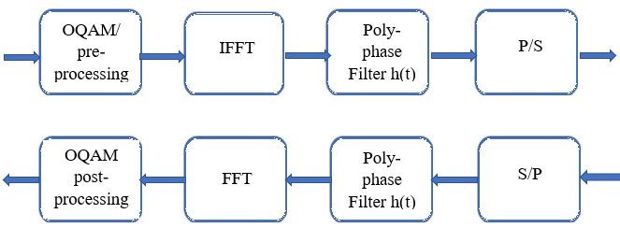
Figure 1 OQAM/FBMC transmitter and receiver block diagram
Filter bank multicarrier combines both modulation and multiplexing technique with a function. This combination takes place by dividing the wideband channel into a narrowband channel known as subchannels. The OQAM/FBMC systems generate complicated modulation values and spread over different carriers and then use a prototype filter to filter them. The fig.1 shows a simple architecture for the OQAM/FBMC system for transmitter and receiver having four major processing blocks at each side. For OQAM/FBMC at the transmitter side, the data to be transmitted goes through four processing units: OQAM/ pre-processing, inverse fast Fourier transform (IFFT), poly-phase filter having filter response h(t), and parallel to the serial converter. Whereas on the OQAM/FBMC system receiver side the received data is passed through four processing blocks: serial to parallel convertor, poly-phase filter, fast Fourier transform (FFT), and OQAM post-processing.
The simple and yet effective system of OQAM/FBMC offers sturdiness to frequency offset as compared to OFDM. Since it does not use any CP, it will not limit the spectral efficiency. Like FBMC, UFMC (Universal Filtered Multi-Carrier), GFDM (Generalized Frequency Division Multiplexing) and f-OFDM (filtered OFDM) are also gaining the attention of researchers as all of them have more potential than OFDM, and they’ll bring profound advantages for future mobile generations. Nevertheless, the purpose of this research work is to compare the performance of OFDM and OQAM/FDMC only. All the other modulation schemes are beyond the scope of this research work.
The systems of OQAM/FBMC act as a subclass of the systems of MC or multicarrier. In the modulation process of OQAM/FBMC, different synthesis sets, and analysis filters are implemented at the transmitting and receiving sides respectively wherein bandpass filters are used as an analysis filter in OQAM/FBMC multicarrier. In the bandpass filter, frequency shifted, or different versions of modulation are used as a prototype lowpass frequency filter.
OQAM/FBMC delivers both high spectral containment and bandwidth efficiency than the OFDM. The reason is, it does not use a CP-like OFDM, and it uses selectivity as a parameter that can be varied while designing lowpass prototype structure for improvised spectral efficiency containment. The absence of CP enables the OQAM/FBMC systems to attenuate the interferences that lie close or within the bands in an effective manner. Another valuable advantage of OQAM/FBMC systems is that it offers high resistance to overcome the interference created by narrowband noise [11].
Consider the graphical representation of the OQAM/FBMC transmitter and receiver from figure 2 and 3. In figure 2, the input signal represented by x(n) is first demultiplexed by adaptive bit demultiplexer to generate N branches. The second step is to perform modulation through either the same or different signal cancellation depending on the demand. The corresponding modulated branches are then unsampled to generate N number of clones. Set of synthesis filters are used to send unsampled data such as gk (n), where the value of k ranges from 0 to N-1. Lastly, the results from all the filters are compiled to generate a transmitted signal s(n).
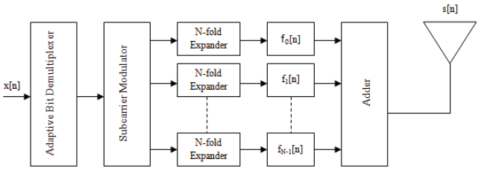
Figure 2 FBMC Transmitter [11]

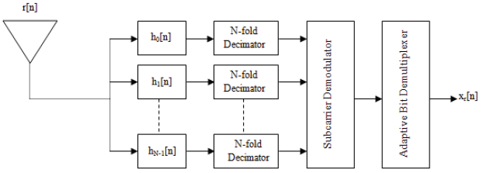
Figure 3 FBMC Receiver [11]
The received signal represented by r(n) is then processed through the series of bank filters such as fk (n) where the value of k ranges from 0 to N-1. After this, the signal in every branch will be first down-sampled through N. Similarly, demodulation and multiplexing are applied to determine the value of the original signal represented by Xr(n) [11].

2.3 Offset Quadrature Amplitude Modulation (OQAM)

Since now we have discussed the valuable alternative of OFDM, we will discuss different variants of FBMC system in this section. The purpose of our research work is to limit the bandwidth efficiency caused by OFDM through FBMC and OQAM is the ideal case in this scenario as it provides extremely high spectral efficiency than other variants of FBMC. Authors also used staggered multitone and cosine-modulated multitone names for OQAM in their research work. All the subcarriers of the FBMC are modulated with OQAM where both real and conjugate samples of the signals are transferred by shifting half of a sample period between them [8].
In [11], the author has explained the evolving history of OQAM/FBMC. In the 1960s, Chang presented settings that were essential for signalling a parallel set of PAM (Pulse Amplitude Modulated) symbol classifications. The author used an array of vestigial side bank (VSB) modulated filters to achieve the signalling of PAM symbols. The proposed method was further extended and modified by Saltzberg by using the transmission of QAM symbols instead of PAM. Lastly, Hiroshaki worked on FBMC and described an efficient polyphase execution for the prior one.
Due to significant advancements on the DSL (Digital subcarrier line) field, two different classes of FBMC were proposed in the 1990s: filtered multitone (FMT) and discrete wavelet multitone (DWMT). Since DWMT has been using filter bank based on the cosine modulation, it is commonly known as cosine modulated multitone (CMT) [1]. In contrast to FMBC-OQAM, CMT uses only half of the bandwidth, and thus providing only partial data rate while assuming an equal number of symbol duration and subcarrier numbers.

2.4 Prototype filers

In contrast to the OFDM, filtration of subcarriers is completed in the baseband of the digital domain in OQAM/FBMC systems. This filtering of subcarriers is performed after the IFFT process. For every subcarrier, a single filter is employed, and all the deployed filters are allied into a filter bank. The purpose of this filter bank is to describe the waveform nomenclature. The advantage of using this prototype filter is that they help in achieving certain goals such as reducing the stopband energy, inter-carrier interference (ICI), and inter symbol interference (ISI). OQAM/FBMC contains two prototype filter bank one at the transmitter and on at receiver.
In this filter bank, the filter that is connected or aligned with a subcarrier having a zero-frequency is referred to as the prototype filter [10]. By using the duplicate of this prototype filter, filters for remaining subcarriers are created along with the shift of their respective frequencies. Subsequently, a polyphase filter bank is generated, containing filters arranged in parallel orientation. As in OQAM/FBMC, each subcarrier is assigned an individual prototype filter therefore the number of filters in the filter bank is equal to the number of subcarriers used in the system.
All the prototype filters present in this filter bank are categorized by K-fold factor K. The factor K is an overlapping factor and calculated by the ratio of the filter’s impulse response duration to the symbol period of multi-carrier, meaning that it defines the total number of multi-carrier symbols that intersect with each other in the time domain. Generally, root-raised cosine prototype filters are used with the OQAM/FMBC system as explained by [10].

2.5 Selective mapping technique
In this research reducing PAPR is the main aim. As discussed earlier the suppression techniques used in OFDM must be modified therefore they are categorized into three main categories as shown in the table. 1: signal distortion, probabilistic, and hybrid category.
Table 1 PAPR Reduction Categories
Category | PAPR Reduction Scheme | Advantages | Disadvantages
Signal Distortion | - Non-linear compounding technique  - Clipping and Iterative compensation technique | Reduces PAPR | Causes out-of-band distortion
Probabilistic | - Modified PTS-based scheme  - Modified SLM-based scheme | - Better PAPR suppression  - Does not reduce the time-frequency focusing performance (out-of-band radiations) | Computationally complex
Hybrid | Combination of any above two schemes | Better PAPR suppression | - Very computationally complex  - Easily cause out-of-band distortion

In signal distortion, category signal is clipped and to compensate for the clipped signal and iterative noise cancellation is implemented this scheme is known as clipping and iterative suppression technique. Another scheme that comes under this category is non-linear compounding technique, in which the original signal is transformed into a new signal by using trapezoidal power distribution and then an adaptable factor is used thus reducing PAPR. Hybrid category is obtained by combining any two different signal distortion and probabilistic approaches. Signal distortion approaches however reduces PAPR, but they can also cause out-of-band distortion resulting in a greater degree of interference with neighbouring frequency bands and the future of wireless communication involves communication using the closely packed spectrum. Talking about the hybrid techniques they also easily encounter out-of-band emissions thus when comparing the three categories probabilistic approach is best suited to meet the requirement of the future world of wireless communication and this research. The probabilistic approach includes modified PTS-based and SLM-based techniques. In this research basic structure of SLM is studied to get the idea of dispersive SLM (DSLM) and then a C-DSLM is proposed. Although to implement C-DSLM it involves few additional steps for generating a few alternative signals, but it reduces the complexity when compared to DSLM technique [4]
To accomplish the implementation of the C-DSLM on OQAM/FBMC system, the structure of conventional SLM, DSLM and CSLM technique is studied and table.2 gives brief features of these three.
Table 2 Types of SLM Techniques [4]
SLM type | Features
Conventional selective mapping (SLM) | - Requires Side information (SI)  - Decreases data throughput  - High computational complexity
Conversion vector-based selective mapping (CSLM) | - Complexity lower than conventional SLM but higher than DSLM
Dispersive Selective Mapping (DSLM) | - Same PAPR reduction compared to C-DSLM but more computational complexity
Conversion Vector-based low-complexity dispersive selection mapping (C-DSLM) | - 10 % complexity that of DSLM  - Same PAPR reduction as in DSLM but the less computational complexity

2.4 FBMC PAPR Challenge

Although FBMC is highly reliable in providing robustness to frequency and synchronization incorrect position, extreme data rates, large bandwidth efficiency along with the active suppression in OOB emissions, it also offers high PAPR. High PAPR creates signal clipping at the receiver edge because of the nonlinearity section of a high-power amplifier (HPA). Henceforth, reliable suppression in OOB emanation is still a strong challenge to overcome. In [7], the author proposed a sliding window tone reservation (TR), partial transmit sequence (PTS), clipping and filtering, and selected mapping (SLM) techniques to address the FBMC PAPR challenge.

Chapter 3

Methodology

3.1 Introduction

This chapter discusses the research objectives as discussed in chapter 1 and the data researched in the literature as per explained in the literature review chapter 2. The main aim of this chapter is to construct a process to analyze the outcomes of the research. The whole research methodology is based on the research of onion ideology by saunders [12].
This chapter gives a detailed overview of how data is collected, processed, and then comparing the results to get the optimum solution by modifying prototype filters and C-DSLM technique for reducing PAPR.
The main aim of the research is to find an optimum method to reduce PAPR in FBMC. This can be achieved by studying the structure of OFDM as it is also a multicarrier modulation system and techniques used to overcome PAPR is similar, but they cannot be applied directly. The research philosophy is based on positivism approach.
As stated by [12], positivism philosophy is to be taken when the research objectives are observable and measurable. Hence this philosophy is taken into consideration as it correlates with the research aims and objectives. Furthermore, the research onion states that the research philosophy suits the best using the deductive research approach. According to the research published by [13] states that this approach is used with the theory-driven hypothesis which enables easy data collection and more observable points for analysis. One of the main advantages of using a deductive approach is that it provides a greater opportunity for data collection. This thesis focuses on reducing PAPR by modifying various filters depending on C-DSLM technique used which will be applied on the randomly generated input signal. The main consideration in OQAM/FBMC will be given on the prototype filter. One of the most implemented strategy in a deductive approach for mathematical research is an experimental strategy. As this strategy provides greater opportunity to examine and compare the result generated. Since the input signal generated is taken as random to understand the impact of the implanted technique on the prototype filter selection thus providing much effective platform to see the changes in PAPR using C-DSLM techniques.

3.2 Theory

Understanding the structure of OQAM/FBMC, PAPR, prototype filters, and SLM techniques are of the primary elements of this research. As developing the relation between each structure will help during the research in reaching the expected outcome. Performance of OQAM/FBMC is evaluated by plotting CCDF for PAPR. This research will aim to reduce PAPR by using a reduction technique C-DSLM. As OQAM/FBMC uses prototype filters thus the length of prototype filters used is changed to see its effect on the PAPR reduced by the C-DSLM.

3.2.1 Structure of OQAM/FBMC
As discussed above FBMC is a kind of multicarrier modulation and there are different variants of FBMC, and this thesis focus is on OQAM/FBMC. Fig. 4 below shows the generalized model for OQAM/FBMC. The input at the transmitter is the complex input OQAM symbols as shown in:
$x_{k}(m)= a_{k}(m)+ b_{k }(m)$ (1)

where for the m^{th} symbol with subcarrier k for $x_{k}(m)$ the real and imaginary part are a_{k}(m) and b_{k}(m) respectively.
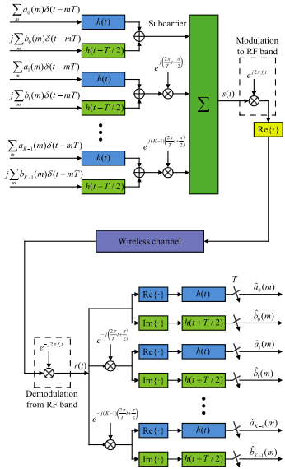
Figure 4 OQAM/FBMC Communication System Model [14]
The real and imaginary parts of the input signal are then shifted by T/2, where T denotes the symbol period of the signal and then these parts are passed through filters. The impulse response is represented by h(t) for prototype filters. Using K subcarriers as shown in fig.4 modulation is performed in which the carrier frequencies of the subcarriers are separated by 1/T. The equation below shows the final representation of the OQAM/FBMC system.

$s \left(t\right)= \sum_{k=0}^{K-1}{}\sum_{m= -∞}^{∞}{}[a_{k }\left(m\right)h\left(t-mT\right)+jb_{k} \left(m\right)h(t-mT-T/2)]e^{jkφ_{t}}$ (2)

Regarding this research, the aim of reducing PAPR, ideal conditions are considered which enables the input signal to be equivalent to the output signal. Any losses and impairments which can affect the input signal are considered as barriers to this research.
Due to its high complexity and relatively more time-consuming nature, the conventional OQAM/FBMC can be easily implemented with the help of Inverse Fast Fourier transform (IFFT) and Fast Fourier transform (FFT) at transmitter and receiver, respectively.
The figs.5 and 6 shows the OQAM/FBMC system using K x K matrix and performing IFFT at transmitter and FFT at receiver for modulation and demodulation, respectively.
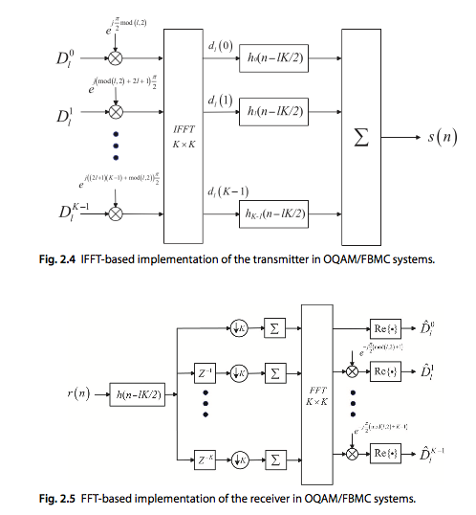
Figure 5 IFFT- Based Implementation Of OQAM/FBMC System Transmitter [14]
Figure 6 FFT Based Implementation of OQAM/FBMC System Receiver [14]

D_{l} represents complex input symbols matrix at the transmitter side having real and imaginary component a_{k}(m) and b_{k}(m) respectively, which can be written as:

$D_{l}=[D_{l}^{0} , D_{l}^{1},……, D_{l}^{K-1}]$, where l = 0, 1, ……., 2L – 1 (3)

Complex OQAM symbols matrix is reconstructed using the conditions:
$D_{2l}^{k}= a_{k}\left(l\right) and D_{2l+1}^{k}= b_{k}\left(l\right)$ (4)
According to the above condition the size of the matrix $D_{l}$ should be as twice as that of matrix $a_{k}\left(l\right)$.
To get $d_{l}\left(i\right)$, inverse fast Fourier transform function is performed using K x K matrix. The steps are broken down into two steps by first calculating $E_{l}^{k}$ using $D_{l}^{k}$ by the equation below in which modules operation is represented by mod(l, 2).

$E_{l}^{k}=KD_{l}^{k}e^{j\frac{π}{2}(k\left(2l+1\right)+mod (l, 2))}$ (5)

To get the output at the Inverse Fast Fourier Transform function block, $E_{l}^{k}$ is calculated using the below:
$d_{l}\left(i\right)= \frac{1}{K} \sum_{k=0}^{K-1}{}E_{l}^{k} e^{j\frac{2πki}{K}}$ (6)
After the implementation of IFFT the signal is passed through prototype filters. OQAM/FBMC uses prototype filters having filter response $h_{i} (n- \frac{lK}{2})$, where n = mK + I, m = 0, 1, …., $α$ + 1, I = 0,1, …, K-1.
$s_{l }\left(nK+i+ \frac{lK}{2}\right)= d_{l}\left(i\right)h(nK+i)$ (7)

The length of the prototype filter is taken $L_{p}$ which is:

$L_{p }= αK+1$, where $α$ is a positive integer (8)

The transmitted signals at the output of the transmitter are the summation of all the outputs of the prototype filters and can be calculated which is represented as s(n).

$s\left(n\right)= \sum_{l=0}^{2L-1}{}s_{l}(n), n=0, 1, . . . ,\left(α +L -\frac{1}{2}\right)K$ (9)
The length of the signal $s_{l }\left(n\right)$and $s\left(n\right)$ is $αK+1$ and $\left(α+L-\frac{1}{2}\right)K+1$ respectively as shown fig.8 [14].
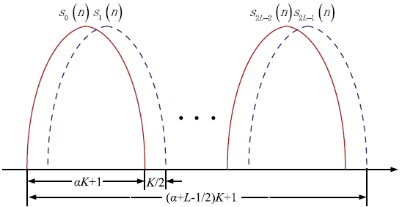
Figure 7 Signal Length of OQAM/FBMC Systems [14]

3.2.2 Prototype filters

Prototype filters are an essential component in OQAM/FBMC to determine the performance of system OQAM/FBMC such as inter-carrier interference (ICI), inter-symbol interference (ISI) and stopband attenuation. OAM/FBMC makes use of multiplexers which are filter-bank-based. To derive these filter banks comprising of synthesis filter at the transmitter and analysis at the receiver filter, prototype filters are used [3]. The prototype filters can either fulfil perfect reconstruction (PR) or nearly perfect reconstruction (NPR). This thesis considers the ideal wireless channel thus PR condition is considered during the research. Therefore, complex input OQAM symbols $x_{k}\left(m\right)$equal complex output OQAM symbols ${\hat{x}}_{k}\left(m\right)$as below: [9].

$x_{k}\left(m\right)= {\hat{x}}_{k}(m)$ (10)

Moreover, the length of the prototype filter $L_{p}$ is a dominating factor in determining PAPR reduction performed by implemented technique [5]. While designing the prototype filter the main aim is to reduce the side lobes to achieve suppressed PAPR. Two possible prototypes that can be used are PHYDAS and Hermite, but PHYDAS filter gives better frequency-localization and better results as suggested in [15]. The PHYDAS filter can be constructed using the below:
$p\left(t\right)=\{\frac{1+2 \sum_{i=1}^{O-1}{}b_{i }coscos \left(\frac{2πt}{OT_{o}}\right) }{O\sqrt{T_{o}} } if-\frac{OT_{o}}{2} <t ≤ \frac{OT_{o}}{2}$ otherwise 0 (11)
Where O determines the overlapping factor, hence the number of values of $b_{i }$depends on overlapping factor [15].

3.2.3 Peak to Average Power Ratio (PAPR)

PAPR of a given signal is the ratio of peak power of the signal to its average power of the given signal. PAPR is a parameter that is used to measure sensitivity present in the nonlinear devices of transmission. The PAPR of a continuous-time signal can be calculated by the general formula:
$PAPR= \frac{Peak Power }{Average Power}$ (12)

For discrete-time signal s(n), PAPR in linear scale can be calculated as:

$PAPR\left(s\left(n\right)\right)= \frac{\max_{0≤n<N} {|s[n]|}^{2}}{E[|{s\left[n\right]|}^{2}]}$ (13)
Where E [.] denotes the expected value of the signal.

To convert the linear scaled value of in dB log of linear scaled value is taken using the formula:

$PAPR \left(dB\right)=10\log_{10}(PAPR)$ (14)
Once signals are generated using the OQAM/FBMC system their PAPR is calculated. In the OQAM/FBMC system, the signals are modulated using K sub-carriers generating a discrete-time signal, therefore the PAPR is calculated using the formula below:

${PAPR}_{p}=10\frac{\max_{p T≤t≤\left(p+1\right)T}{|s(t)|}^{2} }{P_{ave}}$ , p = 0,1, …., M + $α$ – 1 (15)

For OQAM/FBMC signals, the commutative distribution function (CDF) is used which gives the probability of PAPR being below certain threshold value z:

$CDF\left(z\right)=prob \left(PAPR\left(s[n]\right) ≤z \right)=$, where z = threshold (16)

To determine and analyse the effectiveness and efficiency of the techniques used to reduce PAPR, probability of PAPR above a certain threshold is measured by constructing CCDF:

$CCDF=Prob (PAPR>z)$ (17)

The CCDF curve contains threshold for PAPR on the horizontal axis and probability of PAPR being greater than threshold z on the vertical axis. Moreover, PAPR is better reduced if the CCDF curve is closer to the vertical axis [16], [2], [17].

3.2.3 Selective Mapping (SLM)
Selective mapping technique is considered as a promising solution to condense the PAPR value. It works like a distortion less technique to decrease PAPR effectively without enhancing the power specifications and experiencing data loss. In the SLM technique, an identical data source is used to generate U substitute transmit sequences. After producing alternative sequences, select only those sequences that contain the lowest PAPR. The basic reason behind this is that array of the transmit data vectors is required to determine PAPR values. After IFFT, and by multiplying these data vectors with some random phase, the characteristics of PAPR will be transformed. Statistically, an array of U labelled differently, and fixed pseudo-random vectors are produced [18], [6].
For instance, consider we’ve data from input source X [X1, X2 X3…… XN-1]. Now take independent phase sequences P = [ X1(U), X2(U), X3(U)……., XN-1(U)] in which U shows the phase sequence numbers (u = 0, 1, …., U-1). Multiply phase sequence numbers with the data from the source. However, before multiplying original data source and phase sequence numbers, the length of both variables should be kept equal i.e., N (u = 0, 1, …., U-1).
To convert the frequency domain signal into the time domain, apply IFFT on each of the sequences. The outcome from the product of these values will generate an OFDM system data block, comprising of different time-domain signals along with length U and distinct PAPR values which are X(u) = [ X1(U), X2(U), X3(U)……., XN-1(U)]. In the last step, PAPR values are compared from the independent data blocks, and the value that contains the least PAPR value will be selected for further transmission. The basic principle of the SLM technique is shown in the figure below:

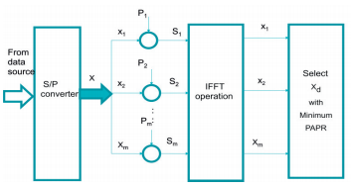
Figure 8: SLM Technique Basic Principle [18]
The equation below represents the optimal candidate having the lowest PAPR that will be acquired for transmission.
$P \left(PAPR>z\right)={F(z)}^{N}={(1-{(1-e^{-z})}^{N})}^{N}$ (18)
In the above equation, Z represents threshold and z displays the real number. Due to the over-sampling and band-limiting process, the above equation will be approximated as follows wherein the value of α is taken as 2.8 to achieve a better PAPR value [18]:

$P \left(PAPR>z\right)={F(z)}^{N}={(1-{(1-e^{-z})}^{αN})}^{N}$ (19)

To limit the value of PAPR in the FBMC signal, a dispersive selected mapping (DSLM) was proposed in the paper [4]. The procedure to generate rotated candidate signals in FBMC system containing intrinsic overlapping structure is almost equal to the conventional SLM scheme which means that it needs U IFFTs, making it more complex and complicated. Conventional SLM technique developed for OFDM signal requires only current symbol while choosing the optimal rotation sequence due to which it has limited computational complexity than the original SLM technique. However, DSLM technique considers the current symbol along with the effect of prior symbols on the current symbol. But one of the important challenges comes during DSLM technique is the selection of ‘‘T_{o}’’. Poor selection of T_{o} won’t consider the overlapping structure of the FBMC signal and thus, the original purpose to reduce PAPR won’t be accomplished.
To address the issue of high computational complexity, the paper [4] extends the concept of DSLM technique by proposing conversion vector-based low-complexity DSLM technique (C-DSLM) to suppress the PAPR of an FMBC/OQAM signal. The implementation of C-DSLM technique consists of five steps: initialization phase, conversion vector-based modulation, PAPR calculation, selection and updating [4], [6] The author used different value of phase rotation vectors U = 4, 6, or 8 to compare the computational complexity between DSLM and C-DSLM schemes. The computational complexity reduction ratio (CCRR) decreased to 75% for U = 4, 87.5% for U = 6, and 93.8% for U = 16 with C-DSLM technique as compared to conventional DSLM technique. The reason is, C-DSLM follows two conditions.
- The quantity of nonzero elements in the conversion vector must not longer than 4.
- The real and complex parts of the nonzero elements in the conversion vector must be from the range of set {1, -1, 0} while ignoring the value of constant factor 1/2.

3.3 Implementation

As this thesis considers the OQAM/FBMC system and according to fig, 1 the input data is OQAM symbols. To generate OQAM symbols random function is used in MATLAB generating random binary data. Once random binary data is generated that binary data is used to generate OQAM symbols having modulation order M and send over K subcarriers each subcarrier containing L number of OQAM symbols.
The number of subcarriers and symbols each subcarrier ranges from 0 – K and 0 – L, respectively. A transmission matrix D_{l} is created using OQAM symbols in which each element is OQAM symbol having $\log_{2}(M)$ bits/symbol. D_{l} matrix contains real and imaginary part $a_{k}\left(m\right) and b_{k }\left(m\right) respectively.$ OQAM/FBMC is implemented using FFT, therefore, the OQAM symbols transmission matrix is passed through IFFT matrix block having size K x K using eq.3 - eq.6. to get $d_{l}\left(i\right)$. Till now the OQAM/FBMC system is implemented till IFFT block of the transmitter. The MATLAB code used for the above process is given in appendix A.

To evaluate the PAPR of a signal two cos signals are taken x1 and x2 having carrier frequency 60 and 100, respectively as below:

$x1=$cos (2π×60×t) (20)

$x2=cos⁡(2π×100×t)$ (21)
Signal y is generated by adding x1 and x2.

$y\left(t\right)= x1+x2$ (22)

To calculate signal y PAPR peak and average power are calculated and their ratio is calculated by using the eq. 10. Appendix B shows MATLAB code generating the sum of two cosine functions and their PAPR.

3.4 Results

The simulation results generation of $D_{l}$, $E_{l}^{k}$, and $d_{l}\left(i\right)$ matrixes in which row represents subcarrier and column represents the number of symbols transferred on one subcarrier.
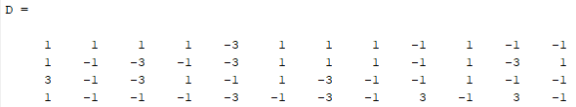

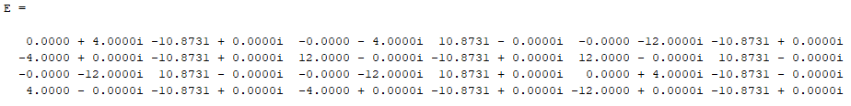

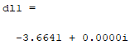

Furthermore, the simulation results show PAPR (dB) value 20.7944dB of the sum of cos signals generated using eq. 18 – eq.20.

3.5 Future Work

So far OQAM signals are generated and passed through IFFT matrix. This thesis will aim to apply prototype filters on the signals generated to construct an OQAM/FBMC system. Furthermore, C-DSLM technique will be applied to the OQAM/FBMC system generated. The analysis is done by calculating PAPR and constructing CCDF for comparing the effect of C-DSLM and prototype filter used. The fig.9 shows the expected program of work to be done in next semester for completion of thesis B.

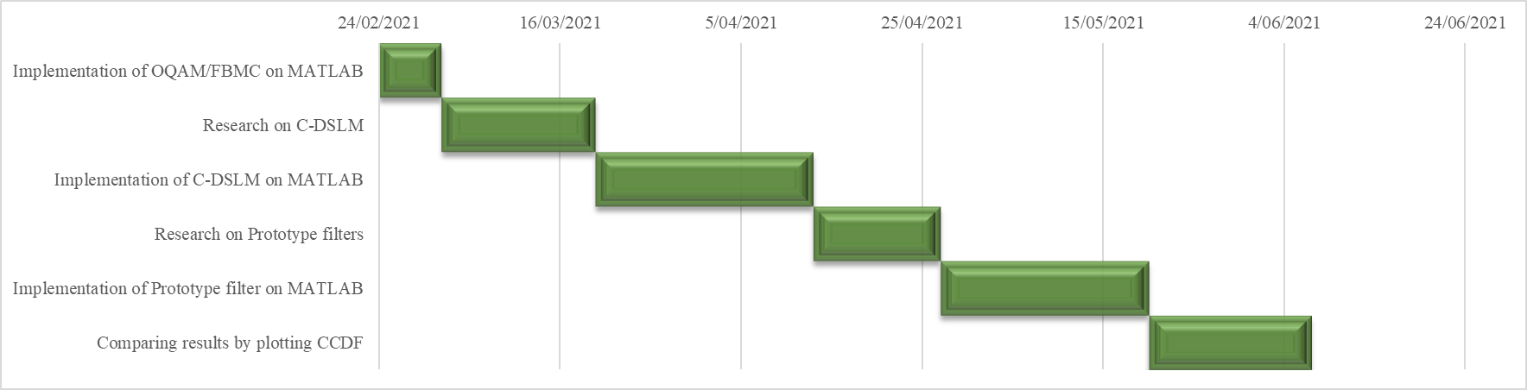
Figure 9 Program of Work

Chapter 4

Conclusions

In conclusion, we noticed that multicarrier modulation is a promising scheme to provide higher data rate as required by the increasing number of wireless internet devices. OFDM has been popular multicarrier modulation technique offering higher data rate but suffers from lower spectral efficiency due to the use of CF and guard interval. Moreover, it uses rectangular window resulting in OOB. Like other modulation techniques, OQAM/FBMC suffers also suffers from high PAPR ratio resulting in degradation of the signal but it offers better spectral efficiency than OFDM as it does not use CP or guard interval. Due to uniqueness of the overlapping structure of both OFDM and OQAM/FBMC the suppressing PAPR techniques used in OFDM differ from that used in OQAM/FBMC. Techniques used in OFDM need to be modified to be used on OQAM/FBMC. The PAPR suppressing techniques are divided into three main categories: signal distortion, probabilistic and hybrid categories, according to the problem to be catered in the OQAM/FBMC system.
According to the main aim of the thesis which is reducing PAPR in the OQAM/FBMC system, SLM is best suited which reduces PAPR without increasing power specifications and loss of data. As this approach encounters higher complexity therefore C-DSLM is used although it involves extra steps but reduces the complexity and low equipment cost comparatively.
This thesis also researches to find an optimum solution for reducing the PAPR in OQAM/FBMC by implementing C-DSLM and determining the influence of prototype filter by using different filter lengths on the PAPR reduction technique studied. In future, the results are compared by varying the number of subcarriers K, and the size of U by plotting CCDF.

Appendix A
clc
close all
M = 8; % modulation order
bits = log2(M); % bits/symbol
Maxm = 6; % last symbol
K = 4; % number of sub-channels
n = bits * Maxm * K; % number of processed binary bits
dataIn = randi([0 1],n,1); % row vector for binary data
dataInMatrix = reshape(dataIn, length(dataIn)/bits,bits);% creating input bits data matrix
dataSymbolsIn = bi2de(dataInMatrix) % converting bits into numbers
dataMod = qammod(dataSymbolsIn,M,'bin');
[c1 c2] = size(dataMod); % matrix size in which c1 = rows & c2 = column
L = c1/K; % dividing rows by subchannels to determine no of columns for transmission matrix (a)
a = zeros (K , L); % transmission matrix initialize with zeros
b = zeros (K , L);
D = zeros (K, 2*L);
x = 1; % integer defined to use dstsSymbolsIn matrix position in for loop
for k = 0 : K-1 % for no of rows of transmission matrix (a)
for l = 0 : L-1 % for no of columns of transmission matrix (a)
a(k+1,l+1) = real(dataMod(x)); % real part of transmission matrix
b(k+1,l+1) = imag(dataMod(x)); % imaginary part of transmission matrix
%D(k+1,l+1)=a(k+1,l+1)+(i*b(k+1,l+1)); % transmission matrix from ak & bk
D(k+1,(2*(l+1)-1))=a(k+1,l+1);
D(k+1,(2*(l)+ 2)) = b(k+1,l+1);
x = x + 1; % incrementing integer to derive position of transmission matrix (a)
end
end
a
b
D
E = zeros (K , L);
for k = 0 : K-1 % for no of rows of transmission matrix (a)
for l = 0 : L-1 % for no of columns of transmission matrix (a)
E(k+1,l+1) = K*D(k+1,l+1)*exp((1+l)*j*(pi/2)*(k+1)*((2*l)+1)+mod(l,2));
end
end
E;
dl1= 0;
for h=1:K
for k = 1 : K % for no of rows of transmission matrix (a)
for l = 1 : L % for no of columns of transmission matrix (a)
dl1= (1/K)*(dl1+((E(k,l))*exp(1j*((2*pi*k*h)/K))));
end
end
end
dl1

Appendix B
%%Time specifications for x1:
fs = 7000; % no of samples per second
dt = 1/fs; % seconds per sample
ST= 0.25; % stop time in seconds
t = (0:dt:ST-dt)'; % seconds
%%Sine wave (x1):
fc1 = 60; % frequency in hertz
x1 = cos(2*pi*fc1*t);
% Plot signal versus time:
figure;
plot(t,x1);
xlabel('time (in sec)');
title('Signal versus Time');
zoom xon;

%%Sine wave (x2):
fc2 = 100; % hertz
x2 = cos(2*pi*fc2*t);
% Plot signal versus time:
figure;
plot(t,x2);
xlabel('time (in sec)');
title('Signal versus Time');
zoom xon;

%%adding signals:
y = x1+ x2;
figure;
plot (t , y);

%%calculating PAPR
% calculating peak
peak = max(abs(y))
% calculating average power
signals = [x1; x2];
avgsignals = mean(signals.^2)
PAPR = peak.^2/avgsignals
PAPR_dB = 10*log (PAPR)

Appendix C

Abbreviation

MCM: Multi-Carrier Modulation
OFDM: Frequency Division Multiplexing
OQAMFBMC: Offset Quadrature Amplitude Modulation/Filter Bank Multicarrier
OOB: Out of Band
PAPR: Peak-to-Average Power Ratio
PTS: Partial Transmit Sequence
TR: Tone Reservation
SLM: Selection Mapping
CF: Clipping and Filtering
ICI: Inter-Carrier Interference
IFFT: Inverse Fast Fourier Transform
FFT: Fast Fourier Transform
DSLM: Dispersive SLM
C-DSLM: conversion vector-based low-complexity DSLM
CR: Cognitive Radio

Bibliography

[1] | B. D. Tensubam and S. Singh, "A Review on FBMC: An Efficient Multicarrier Modulation System," International Journal of Computer Applications (0975 – 8887), vol. 98, no. 17, pp. 6-9, 2014.
[2] | A. Agarwal and R. Sharma, "Review of Different PAPR Reduction Techniques in FBMC-OQAM System," in Internet of Things and Big Data Applications, Ghaziabad, India, Springer Nature Switzerland AG 2020, 2020, pp. 183-191.
[3] | S. K. Shaikhah and S. Mustafa, "A robust filter bank multicarrier system as a candidate for 5G," Physical Communication, vol. 43, pp. 1-13, 2020.
[4] | X. Cheng, D. Liu, W. Shi, Y. Zhao, Y. Li and D. Kong, "A Novel Conversion Vector-Based Low-Complexity SLM Scheme for PAPR Reduction in FBMC/OQAM Systems," IEEE Transactions on Broadcasting, vol. 66, no. 3, pp. 656-666, 16 march 2020.
[5] | B. Elmaroud, A. Faqihi, M. Abbad and D. Aboutajdine, "On the Impact of Prototype Filter Length on the PAPR Reduction of FBMC Signals," International Journal of Engineering and Technology (IJET), vol. 6, no. 4, pp. 1951-1960, 2014.
[6] | P. Jirajaracheep, S. Sanpan, P. Boonsrimuang and P. Boonsrimuang, "PAPR Reduction in FBMC-OQAM Signals with Half Complexity of Trellis-based SLM," International Conference on Advanced Communications Technology(ICACT), pp. 1-5, 2018.
[7] | M. A. ABOUL-DAHAB1, M. M. FOUAD and R. A. ROSHDY, "Generalized Discrete Fourier Transform for FBMC Peak to Average Power Ratio Reduction," IEEE Access, vol. 7, pp. 81730-81740, 2019.
[8] | C. Jose and S. M. Deepa, "Peak to Average Power Ratio Reduction and Inter Symbol Interference Cancellation of FBMC-OQAM Signals," INTERNATIONAL JOURNAL OF ENGINEERING RESEARCH & TECHNOLOGY (IJERT), vol. 3, no. 3, pp. 1890-1894, 2014.
[9] | T. Jiang, D. Chen, C. Ni and D. Qu, "CHAPTER 1," in OQAM/FBMC for Future Wireless Communications, Principles, Technologies and Applications, 2018, pp. 01-24.
[10] | A. Ibrahim and M. Abdullah, "The potential of FBMC over OFDM for the future 5G mobile communication technology," in AIP Conference Proceedings 1883, 2017.
[11] | D. N. a. K. Choi, "Low PAPR FBMC," IEEE Transactions on Wireless Communications, vol. 17, pp. 182-193, 2018.
[12] | M. N. K. Saunders, P. Lewis and A. Thornhill, Research Mehtids for Business Students, 8th ed., Harlow, UK: Pearson Education Limited, 2019.
[13] | R. W. Gregory and J. . Muntermann, "Theorizing in Design Science Research: Inductive versus Deductive Approaches,", 2011. [Online]. Available: https://aisel.aisnet.org/icis2011/proceedings/engagedscholarship/2. [Accessed 4 11 2020].
[14] | T. Jiang, D. Chen, C. Ni and D. Qu, "CHAPTER 2 Fundamentals of OQAM/FBMC," in OQAM/FBMC for Future Wireless Communications, Principles, Technologies and Applications, 2017.
[15] | R. Nissel, S. Schwarz and M. Rupp, "Filter Bank Multicarrier Modulation Schemes for Future Mobile Communications," IEEE Journal on Selected Areas in Communications, vol. 35, pp. 1768-1782, 2017.
[16] | S. H. HAN and J. H. LEE, "An overview of peak-to-average power ratio reduction techniques for multicarrier transmission," IEEE Wireless Communications, vol. 12, no. 2, pp. 56-65, 2005.
[17] | T. Jiang, D. Chen, C. Ni and D. Qu, "CHAPTER 5 Peak-to-Average Power Ratio," in OQAM/FBMC for Future Wireless Communications, Principles, Technologies and Applications, 2017.
[18] | K. Mhatre and U. P. Khot, "Efficient Selective Mapping PAPR Reduction Technique," Procedia Computer Science, vol. 45, no. 1, pp. 620-627, 2015.
[19] | A. J. Onwuegbuzie and K. M. T. Collins, "A Typology of Mixed Methods Sampling Designs in Social Science Research," The Qualitative Report, vol. 12, no. 2, pp. 281-316, 2007.

