Preparation and characterization of magnesium oxalate cement
S.T. Erdoğan^{a,*}, B.A. Bilginerª, O. Canbek^{a,1}.
ªDepartment of Civil Engineering, Middle East Technical University, Ankara, Turkey.
*Corresponding author. Email: sinante@metu.edu.tr
¹Present address: Department of Civil and Environmental Engineering, Georgia Institute of Technology, Atlanta, USA

Abstract
The production of portland cement causes CO₂ emissions. Alternative binders proposed in recent years often rely on scarce materials or use environment-threatening chemicals. Industrial waste CO₂ can be bound into carbonate-based construction materials but the process is slow, and the final product is often a precast block, making concrete lose its advantage of being cast on site. This paper introduces magnesium oxalate cement, a novel acid-base binder made at room temperature from oxalic acid salts and magnesium oxide. The oxalate ion (C₂O₄²⁻) has twice the equivalent carbon content of the carbonate ion and oxalic acid (H₂C₂O₄) is one of the simplest multi-carbon chemicals to produce with captured CO₂ using electrochemistry. The direct use of oxalic acid and two different oxalate salts are compared. The strength development and water stability of different magnesium oxalate cements are discussed based on their mineralogies and microstructures. Glushinskite (MgC₂O₄.2H₂O) is the main reaction product in magnesium oxalate mortars, which are shown to reach 28-d compressive strengths up to 45 MPa.

Keywords: cement; alternative binders; carbon dioxide; oxalate; magnesium.

- Introduction
The everlasting preference for portland cement (PC) concrete is not simply due to its low cost, but also its ability to be cast into any shape on-site, its high compressive strength, and durability to natural events. The decomposition of calcium carbonate in limestone and the fuel burned to heat the kiln to ~1450 ºC lead to carbon dioxide (CO₂) emissions of 0.5-1.0 t per ton of PC produced. With a global production of > 4*10⁹ t/yr, the PC industry is responsible for 8-9 % of anthropogenic CO₂ emissions [1,2,3]. The global move to reduce CO₂ emissions has sparked an interest to seek replacements for PC.
Despite the myriad alternatives proposed, it has proven difficult to find materials with significantly lower carbon footprints but with similar mechanical properties and versatility. Some special cements (e.g. calcium sulfoaluminate cement) can be made with lower calcium contents than PC, or high volumes of industrial by-products like coal ash or natural materials like clay can be used to partly replace PC in concrete mixtures [4,5]. However, the reduction in calcium content becomes detrimental to mechanical properties beyond a lower limit. Alkali-activated materials which rely on partly dissolving natural or waste aluminosilicates in an alkaline solution of a hydroxide, silicate, carbonate, etc. [6,7] can, in some instances, greatly reduce the carbon footprint. However, production of the alkaline chemicals needed to dissolve the aluminosilicates not only increases cost but also leads to various other types of environmental impact [8]. More importantly, many alkali-activated binders described in the literature require curing at higher-than-ambient temperatures [7], which limits their field use. Efforts to sequester CO₂ by carbonating calcium and magnesium minerals in a chamber have also been reported [9,10] however, less expensive and easier-to-carbonate minerals like CaO and Ca(OH)₂ are themselves obtained through carbon-emitting reactions and the amount of CO₂ that can be fixed into the mineral is often less than the original amount emitted [11]. Carbonation of industrial byproducts with no initial associated carbon emissions, such as blast furnace slag, is also possible but the amount of available slag is quite low compared with the global demand for PC [12,13]. Also, because the product of carbonation is a solid, the concrete specimen in a carbonation chamber needs to be precast into its ultimate shape (e.g. a block). The ability to cast on-site is an important feature of concrete, hence carbonation in a chamber greatly limits versatility. CO₂ can be injected directly into fresh PC concrete, allowing it to still be cast-in-place [14]. CO₂ forms nano calcium carbonate in the hydrating mixture, however the amount of CO₂ that can be sequestered this way is a small fraction of the mass of the cement. Hence, the search for a carbon-neutral yet practical concrete is ongoing. Such a binder ideally requires the use of an inexpensive and low-carbon-footprint powder, the ability to sequester large amounts of CO₂ in it, a reaction product with adequate mechanical and physical properties, durability, and the ability to be cast on-site.
One method to increase the amount of carbon sequestered in concrete may be to form minerals with a number of carbon atoms. CO₂ captured at point sources or directly from air can be processed to manufacture multi-carbon chemicals [15, 16, 17]. It is important for the viability of any such approach not only that the capture and conversion processes be as fast and inexpensive as possible but also that there exists great demand for the end product. Synthetic fuels are end products difficult to make but in great demand [18] while simple carboxylic acids are easier to make but in low demand [19]. A tremendous quantity, more than 1 m³ per person per year, of concrete is used worldwide [20]. If the multi-carbon chemical produced can be effectively used to make concrete, it could be a highly-demanded end product for captured CO₂. Schuler et al. [21] compared, using green chemistry principles, many pathways to produce oxalate (C₂O₄²⁻) or oxalic acid (H₂C₂O₄), over ten of which start with CO₂. They concluded that these are among the most sustainable routes to oxalic acid (particularly the electrocatalytic reduction of CO₂ to formate, followed by formate coupling and paired electrodialysis). Oxalic acid is used for various industrial purposes like leaching rare earth elements from ore [22]. Nevertheless, total demand for oxalic acid is quite limited, ~350*10³ t/yr [21]. Production of concrete with oxalic acid would provide an additional outlet for captured CO₂. Not only are oxalates rather easy to produce through electrochemistry [21,23], but also their Ca and Mg salts have low solubility in water [24] with K_{sp} similar to their carbonates. In fact, ~80 % of kidney stones are composed of calcium oxalate crystals [25]. Trapping of atmospheric CO₂ as calcium or magnesium oxalates exists in plants, fungi, and lichens [26,27]. The “CO₂ equivalent”/cation molar ratio in Ca- and Mg-oxalates is 2:1, higher than the 1:1 ratio in their carbonates. This can allow for a greater amount of CO₂ to be trapped, and a carbon neutral system to be achieved, even when the source of the powder is an inexpensive carbonate (e.g. MgCO₃ MgO). This additional negative CO₂ can then also account for some or all of the fuel-related emissions in the process such as those from calcination or grinding. Recent studies have shown that magnesium oxide will react with oxalic acid to give a strong binder but that the reaction needs to be controlled [28,29]. Ferrous oxalate pastes have also been reported [30]. This study investigates the development of magnesium oxalate cements (MgOx), a novel acid-base cement that, in theory, can be made using captured CO₂.

- Experimental

  - Materials

As oxalate cements are acid-base cements, magnesium phosphate cement, widely researched as a construction binder [31,32,33], was identified as the most obvious analog to oxalate cements. Hence Mg²⁺ was preferred over other cations that can form oxalates (e.g. Ca²⁺, Fe³⁺ or Al³⁺) for technical and economic reasons and MgO was used as the basic powder component in the mixtures. A low-cost MgO powder with an unknown calcination history was purchased. The oxide compositions of this MgO and other starting powders, shown in Table 1, were determined using semi-quantitative x-ray fluorescence spectroscopy (Rigaku ZSX Primus). Fig. 1a shows the x-ray powder diffractogram (XRD) of the as-received MgO.

Table 1. Oxide analysis of the as-received MgO, dead-burned MgO, and fly ash used.
Oxide | Mass (%)
 | As-received MgO | Dead-burned MgO | Fly Ash
MgO | 81.30 | 82.80 | 2.26
SiO₂ | 9.35 | 10.60 | 40.09
Al₂O₃ | 0.06 | 0.08 | 16.24
Fe₂O₃ | 0.60 | 0.72 | 7.21
CaO | 1.74 | 1.85 | 21.24
CO₂ | 6.89 | 3.82 | -
NiO | 0.12 | 0.13 | -
K₂O | - | - | 1.33
TiO₂ | - | - | 0.77
P₂O₅ | - | - | 0.40
SO₃ | - | - | 6.71

The reactivity of the MgO was assessed using an acetic acid neutralization test. 30 g of powder MgO was added to 300 ml of a 1 M acetic acid solution (initial pH ~2.4) and the time to achieve neutral pH was recorded. The rapid and highly exothermic reaction of the MgO with acetic acid suggests that it had been light-burned. Changes in reactivity were assessed for MgO calcined at several temperatures from 600 °C to 1500 °C. Loosely compacted powder was heated in an alumina crucible in air at a rate of ~10 °C/min, retained at the chosen max. temperature for 1 h and then allowed to cool slowly inside the oven. The time required for acetic acid neutralization increased as the calcination temperature increased (Table 2) indicating a reduction in reactivity. A sharp decrease in reactivity was observed at > 1300 °C.

Table 2. Effect of calcination on the reactivity of magnesia powder.
Calcination Temperature (°C) | Acetic Acid Neutralization Time (s)
N/A (as received) | 8
600 | 8
1000 | 9
1200 | 22
1300 | 502
1500 | 1267

As such, calcination of MgO was deemed necessary to obtain a controlled reaction. Calcination at 1500 °C solidified the powder hence it was ground briefly to ~3000 cm²/g Blaine. Fig. 1b shows the particle size distribution of this calcined, ground powder (MgO1500) measured using low-angle light scattering (Malvern Mastersizer 2000).

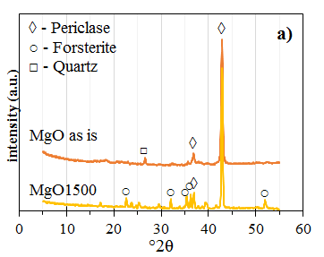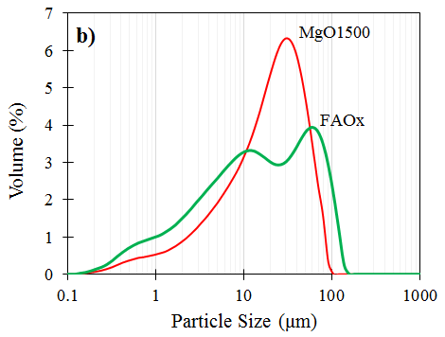
Fig. 1. a) X-ray diffractograms of as-received and dead-burned MgO; b) Particle size distributions of the powders used to prepare MgFAOx.

Calcination at 1500 °C does not greatly change the chemical composition of the MgO powder (Table 1) but it alters the surfaces of individual grains and causes the formation of forsterite (Mg₂SiO₄), which decrease its acid solubility [34]. Forsterite forms due to the reaction of MgO with the impurity SiO₂. The pH of a MgO:water = 1:1 (by mass) solution decreases slightly, from 10.6 to 10.2, after calcination. Calcination also increases the density of the particles from 3.10 g/cm³ for MgO to 3.45 g/cm³ for MgO1500.
Technical grade oxalic acid dihydrate (C₂H₂O₄.2H₂O, OxAc) obtained as sub-mm particles, was used. After preliminary experiments showed that pastes made with OxAc self-heated excessively and cracked shortly after setting due to vapor pressure, two different acid salts of OxAc were prepared by partially neutralizing it. The first, “NaOx”, was prepared by mixing NaOH (Merck, 99 %) with OxAc at a 1:1 molar ratio (~40:126 by mass). Water, equal to ~5 % by mass of the powder was enough to start the reaction since the neutralization water quickly gave a wet paste, which heated up rapidly, giving off fumes, before setting into a solid. The mixture was cured in a dry oven at 105 °C. After 24 h, the paste had set into a hard solid which was cooled and ground to a fineness of ~3000 cm²/g Blaine. The other acid salt “FAOx” was prepared by mixing 1:1.5:0.5 (by mass) of fly ash:OxAc:water to obtain a paste which was subsequently cured and ground similar to NaOx. The fly ash (FA) used was obtained from Afşin Elbistan coal burning thermal power plant in Turkey. The oxide composition and mineralogy of this ash are given in Table 1 and Fig. 2. The fly ash is of the high-calcium type according to ASTM C 618 [35], containing > 20 % CaO, as well as ~40 % SiO₂ and ~16 % Al₂O₃. The main minerals making up the ash are quartz, and anhydrite remaining from the desulfurization process at the plant. Despite > 3*10⁶ t/yr of this ash being produced, it is unsuitable for use as a pozzolan in portland cement concrete due to its high sulfate content. The specific gravities of NaOx and FAOx were measured as 1.87 and 1.96, respectively. Fig. 2 compares the XRD patterns of NaOx and FaOx with FA and OxAc.

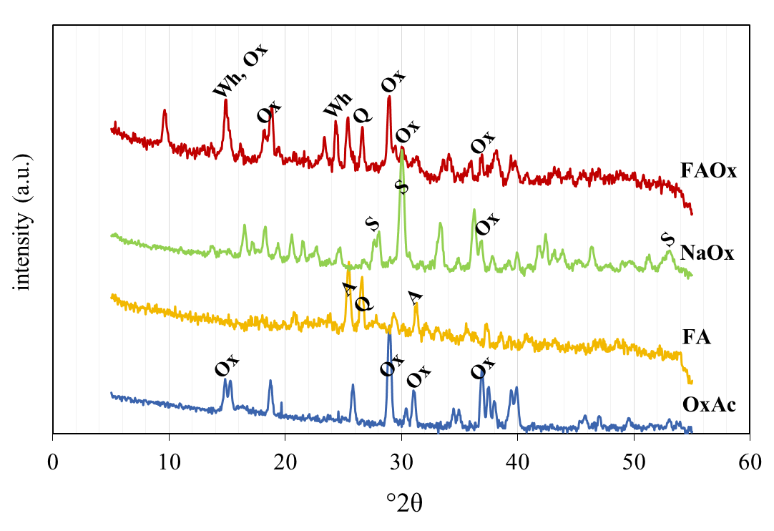
Fig. 2. X-ray diffractograms of the oxalic acid salts used, NAOx and FAOx (Q: Quartz; A: Anhydrite; Wh: Whewellite; S: Sodium hydrogen oxalate monohydrate; Ox: Oxalic acid).

Sodium hydrogen oxalate monohydrate (NaHC₂O₄.H₂O) is the main mineral in NaOx and a hydrated calcium oxalate, Whewellite (CaC₂O₄.H₂O) is predominant in FAOx, due to the high calcium content of the ash. Pastes made by mixing ground NaOx or FAOx with water set into strong, uniform solids in tens of minutes but are not water resistant.

  - Methods

Mixtures with four different compositions were used (Table 3). Pastes were initially made using equal parts of OxAc and as received MgO or MgO1500. Water-to-powder (W/P) was chosen as 0.5. After initial experiments with OxAc, pastes and mortars were prepared using MgO1500 and either NaOx or FAOx. The chosen acid salt was mixed with water and allowed to partially dissolve for two or three minutes. In the case of mortars, 0-2 mm silica sand conforming to EN 196-1 [36] was then mixed in. Finally, MgO1500 was added and the resulting paste or mortar was mixed until uniform. MgOx pastes and mortars are pseudoplastic in nature like many other acid-base cements and require higher shearing rates than PC for effective mixing [34]. As such, it is difficult to compare the flow of a MgOx paste with that of a PC paste. The mixtures in this study were prepared in small batches (~300 cm³ for mortars), mixed manually and vigorously.

Table 3. MgOx mixtures prepared in the study.
Mixture ID | MgO (as received) | MgO1500 | OxAc | NaOx | FAOx | Sand | Water
MgO_OxAc | 0.5 | - | 0.5 | - | - | - | 0.5
MgO1500_OxAc | - | 0.5 | 0.5 | - | - | - | 0.5
MgNaOx | - | 0.5 | - | 0.5 | - | 2 | 0.35
MgFAOx | - | 0.33 | - | - | 0.67 | 2 | 0.3

Table 3 shows that mixtures made with the two acid salts had different acid salt-to-MgO1500 ratios. The 1:1 mass ratio used for MgO:NaOx in MgNaOx gives a C₂O₄²⁻:Mg²⁺ ~0.3 (molar). This ratio was deemed suitable considering similar PO₄²⁻:Mg²⁺ in magnesium phosphate cements give satisfactory results. The oxalate content of NaOx is greater than that of FAOx, hence a smaller MgO:FAOx was chosen for MgFAOx to supply a sufficient amount of oxalates to the reaction. W/P also differed between the mixtures. NaOx reacts more violently with water than FAOx and requires more water to achieve sufficient flow to be cast and compacted adequately. Sand/powder = 2 (by mass) was used for the mortars to highlight the contribution of the paste phase to mechanical properties.
The final setting times of MgOx pastes were determined using the Vicat needle penetration test. The heat evolution of fresh MgOx pastes was assessed by measuring temperature changes over time using a semi-adiabatic set up. 10 g of powder (MgO1500+acid salt) and 4.5 g water were used in the pastes. First, the acid salt was placed in an insulated container through an opening in the lid. Water was added, recording of temperature was started and the mixture was stirred for 60 s. Then, MgO1500 was added and the mixture was stirred for another 60 s. The opening in the lid was closed and temperature was measured every second using a T-type thermocouple wire.
Several characterization tests were also performed on hardened samples. The compressive strengths of MgOx samples were determined using 4 cm x 4 cm x 6 cm mortar prisms, over a 16 cm² compression area on the larger faces. The prism molds were filled in two layers, with gentle compaction after each layer was poured. The samples were demolded after 1 h, kept at ambient laboratory conditions (~21 °C, ~50 % RH) until the testing day, and tested similar to ASTM C109 [37]. Load was applied, using a Universal Testing Machine with 250 kN capacity, at a rate of 1.5 kN/s. Two samples per mixture were tested for each age and the average was reported. The pore size distribution of hardened MgOx pastes was assessed using mercury intrusion porosimetry (Quantachrome Poremaster 60). A maximum pressure of 375 MPa was applied. The Washburn equation was used to relate applied pressure to pore size, with an assumed contact angle of 140 ° and using 480 mN/m as the mercury surface tension. X-ray powder diffraction (Olympus BTX-II) was used to study the mineralogies of starting powders and hardened paste samples. Intensity was measured between 5° and 55° 2θ, with a resolution of 0.05°. Cu Kα radiation was used at a voltage of 30 kV and a current of 330 µA. The analysis of hydrated pastes was performed on ground powder samples, at age 7 d. The nature of the reaction products was also investigated using thermogravimetric analysis (TGA) (TA Instruments Discovery SDT 650) on hydrated pastes cured for 7 d. Samples were heated in an N₂ environment to 900 °C, at a rate of 20 °C/min and mass loss was recorded. The microstructures of hardened paste samples were studied using scanning electron microscopy (SEM, FEI Quanta 400 F).
Changes in the pH of paste samples were also measured, using a digital pH meter (Oakton 300). Initial pH measured was that of the fresh paste. Subsequent measurements used mixtures made by pulverizing 10 g of the hardened sample and combining it with 10 g of water. The resistance of MgOx mortars to water was also tested. Mortar samples cured in air for 28 d were placed in water at 21 °C for 28 d. Upon removal from water, the surfaces of the samples were quickly dried using a cloth and they were immediately loaded in compression until breaking.

- Results and Discussion

  - Mixtures made with oxalic acid

Regardless of the mixing order (adding water to a mixture of the powders or adding OxAc to an MgO slurry), MgO_OxAc pastes started boiling immediately after all three ingredients made contact and partially solidified within seconds. As such, no sand could be added and these pastes could not be mixed into a coherent mass. MgO1500_OxAc pastes did not react as quickly and could be mixed and shaped as desired, in the small volumes used. However, after setting (a few minutes), these mixtures heated excessively, expanding and cracking due to a buildup of vapor pressure. A yellow acidic solution oozed out through the cracks. Hence, the direct use of oxalic acid is unsuitable for preparing useful MgOx cements. Efforts to delay the reaction (e.g. using chilled water) simply delay the cracking. The rapid reaction of MgO is related with its high solubility in the acidic mixing environment (Table 2). Although MgO1500 is considerably less reactive, the initial pH of MgO1500_OxAc is quite low, ~1, caused by the direct use of OxAc. pH increases in the first 24 h due to ongoing reactions (Fig. 3), but only to ~4, indicating incomplete neutralization of the components.

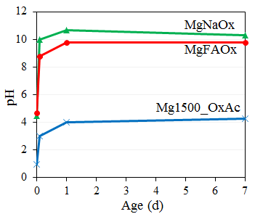
Fig. 3. pH development of MgOx pastes.
  - Mixtures made with oxalic acid salts

The reactions and setting of mixtures made with either acid salt were slower than mixtures made directly with OxAc. It was possible to prepare useful samples with MgNaOx and MgFAOx, which set in five and four minutes, respectively. This is related with their higher initial (fresh paste) pH. The solubilities of the acid salts, hence the effect of the acid salt on the initial pH of MgOx pastes, depend on the powder reacted with the acid. NaOx, containing sodium salts of oxalic acid, has higher solubility than FAOx, which contains calcium salts, among others (Fig. 2). Various soluble salts of oxalic acid can be used to supply C₂O₄²⁻ to the system, e.g. Na₂C₂O₄. However, pH of the salt and the specific cation influence the reaction rates, strength, and water-stability of the final MgOx product, as well as its cost. Na₂C₂O₄ has too high a pH (~7) preventing an acid-base reaction from taking place. NaOx is costly and can form soluble Na compounds in the final product. An acidic intermediary able to release oxalate ions in a controlled manner but which does not produce soluble compounds in the final product, is preferable. FA contains significant quantities of Ca, Al, Fe, as well as Si, which can influence the rate of release of oxalate ions. The pH development of MgNaOx and MgFAOx are shown in Fig. 3. The initial pH of pastes prepared with the acid salts is ~4-5. A controlled reaction is possible under these less acidic conditions. pH increases in the first few hours after start of reaction, explaining the rapid setting and increase in strength observed, and stabilizes at ~10 after 24 h. The slightly basic final product is due to unreacted MgO remaining in the system. Fig. 4 compares the x-ray diffractograms of MgNaOx and MgFAOx pastes.

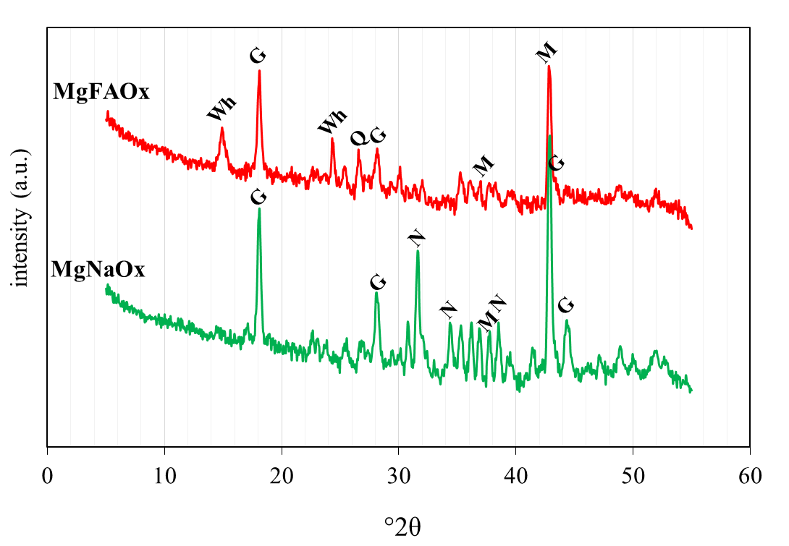
Fig. 4. XRD patterns of MgOx pastes made with NaOx and FAOx (G: Glushinskite; M: Periclase; Wh: Whewellite; N: Disodium oxalate; Q: Quartz)

The reactions of MgOx proceed in two steps. First, FAOx dissolves in water contributing H+ and oxalate ion species making the solution acidic. Oxalic acid is a diprotic acid with pKa₁ = 1.27 and pKa₂ = 4.27. So, at the initial measured pH of 4-4.5 (Fig. 3) approximately 50 % each of HC₂O₄⁻ and C₂O₄²⁻ are present in the solution [30]. The acidic solution facilitates the dissolution of periclase and forsterite in MgO1500, releasing Mg²⁺ and amorphous silica into solution, which causes a rapid rise in pH (the first hour in Fig. 3). Mg²⁺ ions formed in the first stage react with HC₂O₄⁻ and C₂O₄²⁻ to form Glushinskite (MgC₂O₄.2H₂O) via the following reactions:

${Mg}^{2+}+{{C_{2}O}_{4}}^{2-}+2H_{2}O → Mg{C_{2}O}_{4}.2H_{2}O$ (Eqn. 1)
${Mg}^{2+}+{{{HC}_{2}O}_{4}}^{-}+2H_{2}O→ Mg{C_{2}O}_{4}.2H_{2}O+H^{+}$ (Eqn. 2)

The contribution of Eqn. 1 and Eqn. 2 to the formation of Glushinskite depends on pH. With increasing pH, Eqn. 1 quickly predominates. The precipitation of Glushinskite continues at a slowing pace as pH rises. Unreacted periclase (MgO) and, when NaOx is used, some natroxalite (Na₂C₂O₄) are also found in the final solid. Whewellite (CaC₂O₄.H₂O) and quartz are present in pastes made with FAOx. Scanning electron micrographs (Figs. 5b and 5d) show crystals of Glushinskite growing on the surfaces of MgO1500 grains.

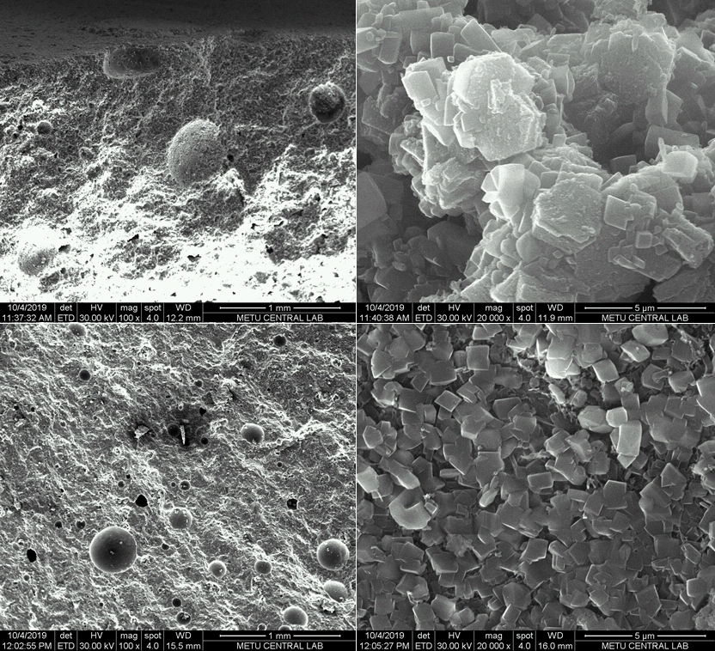
d)
c)
b)
a)
Fig. 5. Microstructures of MgOx pastes at different magnifications: a,b) MgNaOx; c,d) MgFAOx.

Large pores (up to ~100s of µm) remaining in the MgOx pastes are due to excess water from mixing or water formed by the neutralization reaction (Figs. 5a and 5c). MgFAOx paste has finer pores than MgNaOx and more uniform crystal distribution. Fig. 6 compares the compressive strength development of MgNaOx and MgFAOx mortars.

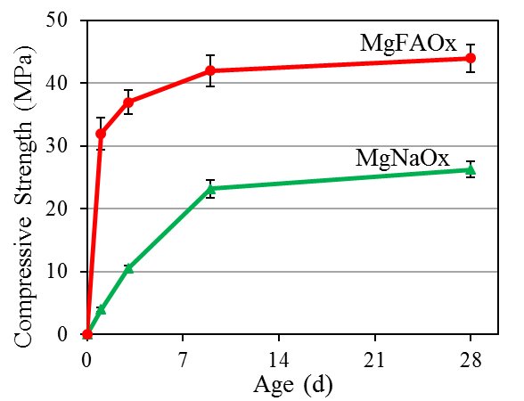
Fig. 6. Strength development of MgOx mortars.

The strength of MgFAOx is > 30 MPa at 24 h. Rapid early strength gain is due to the crystalline microstructure (Fig. 5). Ultimate strength is ~45 MPa, significant considering the unit weight of MgFAOx mortars is ~2100 kg/m³, owing to the low density of the acid salts. Of course, strength is dependent on W/P as in many other cementitious systems including PC [38]. Some water is needed for the dissolution of reactants and to form products. However, since neutralization reactions produce some more water, the effective W/P is slightly higher than initially chosen, and the flow of mortars improves after a brief period of mixing. Lowering W/P increases strength but compromises fluidity. MgNaOx mortars reach ~25 MPa strength. The more uniform crystal distribution of MgFAOx (Fig. 5d) could explain its greater ultimate strength. Another factor may be the C₂O₄²⁻:Mg²⁺ in the system. The molar ratio of C₂O₄²⁻:Mg²⁺ is 1:1 in Glushinskite. Assuming an anhydrous acid salt powder after oven curing, the amount of C₂O₄²⁻ in FAOx made by combining OxAc:FA =1.5 can be estimated as ~51 % by mass. So, 1 g MgO1500 needs ~4.3 g FAOx to form Glushinskite. Experiments not shown here however indicate that FAOx:MgO1500 = 2 (by mass), as in Table 3, gives a better product in terms of strength and water stability. This could be due to several factors. The purity of low-cost MgO suitable for construction materials is not very high, ~81 % in this study. Additionally, the dissolution of MgO1500 is only partial. Similarly, some of the C₂O₄²⁻ in FAOx may never become available when mixed with water. The Ca-oxalate in FAOx is insoluble in water but partly soluble in acidic media. The pH of the system increases rapidly with time due to neutralization and the solubilities of these phases likely change. Slightly different FAOx:MgO1500 (e.g. 1:3 to 3:1) also give strong, solid products, with the ratio influencing setting time, ultimate strength, and water resistance. Very low FAOx:MgO1500 results in an oxalate deficiency which leads to low strength. A very high ratio results in a system similar to FAOx hydrated in the absence of Mg²⁺ ions, strong but with water stability. The water resistance of MgFAOx cements is significantly higher than MgNaOx, as shown in Fig. 7.

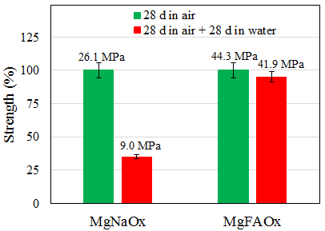
Fig. 7. Strength retention of MgOx mortars after water submersion for 28 d.

The improved water resistance is not only due to the absence of much Na in the system but is also likely related with the contribution of the many ions contributed by FA. This is a point in need of further investigation. 28-d-old MgFAOx mortars kept submerged in water for 28 d retain ~95 % of their strengths when tested immediately after removal from water. In comparison MgNaOx mortar samples only retain ~35 % of their strengths. Part of this measured loss may be due to hydraulic pressure on pore walls caused by absorbed water. Both samples demonstrate greater strength retention if allowed to dry after removal from water. Analysis of a 28-d-old MgFAOx paste sample (Fig. 8a), shows many pores smaller than 100 nm, similar to a typical PC-only paste. The higher-strength MgFAOx sample has a smaller average pore size and total porosity than MgNaOx. Water can penetrate a portion of these larger pores. Total (interparticle and intraparticle) intruded volume is measured as 14 %.

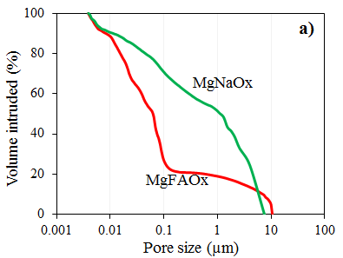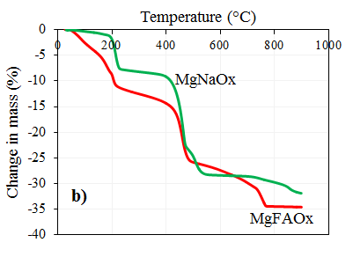
Fig. 8. a) Pore size distributions; b) Thermogravimetry, of MgOx pastes.

The thermal decomposition of MgOx is also affected by its composition. Theoretically, mass loss of magnesium oxalate dihydrate is 24.3 % at ~160-240 °C, and 48.5 %, at 400-500 °C. Calcium oxalate monohydrate decomposes in three steps, losing 12.3 % at 150-200 °C (dehydration), 19.2 % at 450-500 °C (loss of CO), and 30.1 % at 650-850 °C (loss of CO₂). Fig. 8b shows that MgNaOx decomposes at two distinct temperature ranges, consistent with its main reaction product Glushinskite (Fig. 4). The first step yields anhydrous magnesium oxalate and the second magnesium oxide. The decomposition of anhydrous magnesium oxalate and the magnesium carbonate formed overlap in the second step. MgFAOx decomposes in three steps, because of Whewellite coming from FAOx. Thermogravimetry suggests that oxalate concretes would not be expected to maintain their integrity beyond 400-500 ºC. Although not very high, such an upper limit is similar to that of a PC paste without pozzolans. MgFAOx has other differences with PC systems, some advantageous and some not. Rate of heat evolution in MgOx cements is greater than in hydrating PC (Fig. 9).

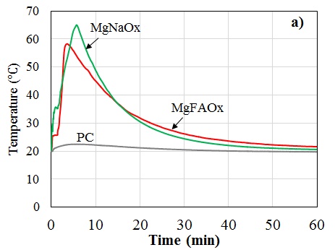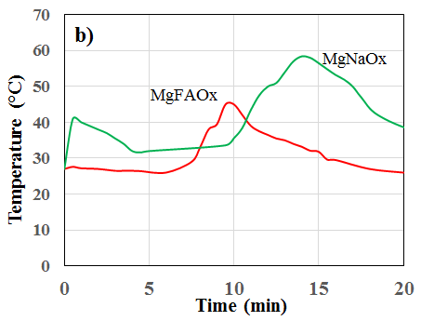
Fig. 9. Temperature evolution of MgOx pastes: a) one-step mixing; b) two-step mixing.

The temperature of MgOx paste rises sharply once all ingredients have made contact. In Fig. 9a, drawn from the semi-adiabatic test results, this corresponds to ~1 min. The temperature of both MgFAOx and MgNaOx pastes peak within 10 minutes. The maximum temperature reached is significantly greater than for a typical PC paste (drawn for comparison, using ordinary portland cement and identical W/P). Employing a two-step mixing procedure to first react the acid salts with water, wait for 5 min, and then adding MgO1500 reveals differences between MgNaOx and MgFAOx. The heat evolved due to the wetting and dissolution of NaOx is significant, causing a noticeable increase in the temperature of even the small paste sample used. No free mixing water remains in this paste after a few seconds. The dissolution of FAOx does not cause a significant temperature increase (in the small volume used) and the mixing water remains visible as a solution. Upon addition of MgO1500 and remixing, temperatures of both pastes remain unchanged for a few minutes, after which temperature rises significantly. A later but greater peak is observed for MgNaOx, Another difference is that the final setting (assessed by scratching the surfaces of the pastes) of MgFAOx takes place at ~20 min, after the main temperature peak whereas for MgNaOx, final set takes place at ~11 min, on the ascending branch of the temperature peak. In mixtures in which the acid salt dissolution causes a temperature rise, the delay before adding MgO1500 could slightly reduce the maximum temperature recorded. Nevertheless, being an acid-base cement, MgOx samples have much greater heats of reaction than comparable PC samples. A suitable retarder, like borax used in phosphate cements, could possibly lower the maximum temperature of the paste by widening the MgOx peaks in Fig. 9.

  - Carbon footprint and feasibility of MgOx cements

Simple calculations can give an idea about the carbon footprint of MgOx cements: The production of 1 g MgO from pure MgCO₃ emits ~1.09 g CO₂ chemically. Additional CO₂ is emitted to calcine MgO at 1500 °C. This emission depends on the type of fuel and the burning technology. Since the maximum temperature is similar to PC production, it can be assumed that ~0.4 g fuel-related CO₂ is emitted per 1 g MgO1500 produced [39]. CO₂ emission related with electricity usage for grinding the raw materials can be assumed similar to that due to the grinding of cement clinker: 0.1 g per 1g MgO1500 (or FAOx) [40]. The total CO₂ emitted becomes ~1.6 g per 1 g MgO1500 obtained. If, as in this study, FAOx is made using OxAc:FA = 1.5 and FAOx:MgO1500 = 2 is used to prepare MgFAOx, C₂O₄²⁻:MgO1500 is ~1.02. Considering C₂O₄²⁻ made from captured CO₂ to be equivalent to emitted CO_{2,} a concrete made with these proportions would be low carbon but not carbon neutral. FAOx:MgO1500 $≥$ 3.1 is needed to make the system carbon neutral. Some studies [41,42] report slightly higher CO₂ footprints for dead-burned MgO than that assumed here, which would increase the needed FAOx:MgO1500 further. Similarly, this ratio would increase slightly if CO₂ emissions related with preparation of FAOx (mainly heating at 105 °C) or related with the electricity used for the production of OxAc are also considered. Conversely, the use of renewable sources for this electricity demand and the use of a low-carbon-footprint MgO (e.g. derived from saline lakes or seawater [43]), could significantly lower emissions and make the present system carbon negative. The identification of a lower-carbon-footprint base (e.g. a magnesium silicate) to react with the oxalates could also render the system carbon negative. In addition, the acid salt used can be prepared with a greater oxalate content than in this study. If OxAc:FA~3 is used to prepare FAOx, FAOx:MgO1500 required for neutrality decreases to ~2.3. However, using a high OxAc:FA resembles directly using OxAc and the rate and heat of reaction increase rapidly. The optimum OxAc:FA hence depends on the FA selected. The main role of FAOx is to control the participation of oxalates in the reactions. Since coal fly ashes from different power plants differ in composition, their effectiveness in preparing an acid salt will differ. With a different fly ash, suitable values for OxAc:FA to prepare FAOx, for FAOx:MgO1500 to prepare the final binder, and for W/P may vary from the values in this study. It was initially predicted that high-lime ashes could work better than low-lime ashes to neutralize OxAc (due to their ability to form calcium oxalates) and allow acid salts with higher OxAc:FA to be prepared. However, it is possible that low-lime fly ashes or other materials can be used to prepare the acid salts. Finding other suitable, abundant wastes or natural materials for this task requires more research.
Related with the cost of MgOx cements, the goal of this study is not to perform a detailed feasibility analysis but rather to arrive at a ballpark figure to compare with the price of PC concrete. The reader is encouraged to rerun the analysis with different numbers. The greatest uncertainty is related with the production of oxalic acid from CO₂ as this is not currently done at a large scale. Nonetheless, a simplified cost analysis of MgOx concrete can be presented by making assumptions about the unit costs of various materials or operations: Choosing MgFAOx as the binder and assuming 300 kg/m³ of powder (MgO1500 + FAOx) per 1 m³ of concrete, ~146 kg OxAc (dihydrate) would be required (two thirds of the powder is FAOx and ~0.73 g OxAc is required to make 1 g of FAOx). A European research project focused on producing oxalic acid from CO₂ [21], estimated the current cost (including the cost of CO₂) as > 1100 $/t but projected < 450 $/t beyond 2030, with lower or negative CO₂ cost, a reduced electricity price, a reduction in cell cost, and improved current densities. Fischer et al. [44], making various assumptions, estimated the cost of electrochemically producing OxAc from CO₂ as being equal to the market price of oxalic acid made from other sources, which could be assumed to be > 600 $/t, not including the cost of capturing CO₂. The cost of captured CO₂ needed to produce OxAc is also difficult to estimate. Keith et al. [15] calculate > 94 $/t for direct air capture. Then, the cost of CO₂ to make 1 m³ MgFAOx concrete becomes ~9.6 $ (for 146 kg OxAc/m³, since 70 % by mass of OxAc is equivalent CO₂). Based on these studies and using 450 $/t, 750 $/t, and 1100 $/t as low, intermediate and high estimates for the unit price of OxAc made from captured CO₂, the cost of OxAc in MgFAOx becomes 66-161 $/m³ (Table 4).

Table 4. Simple cost analysis for 1m³ MgFAOx.
Material or process | kg/m³ concrete | Unit price ($/t) |  |  | Estimated cost ($/m³)
 |  | Low | Intermediate | High | Low | Intermediate | High
OxAc (including CO₂ capture) | 102  (from 146 kg H₂C₂O₄.2H₂O) | 450 | 750 | 1100 | 65.7 | 109.5 | 160.6
MgO1500 | 100 | 150 |  |  | 15.0
FA | 98 | 20 |  |  | 2.0
FAOx production  (heating 200 kg/m³) | - | 15 |  |  | 3.0
Aggregates | 1900 | 10 |  |  | 19.0
Water | 120 | 5 |  |  | 0.6
Total | 2320 | - |  |  | 105.3 | 149.1 | 200.2

If MgO1500 from a low-purity MgO like the one in this study is assumed to cost 150 $/t, then it adds another 15 $/m³ (a third of the powder binder is MgO1500). To this must be added the cost of ~98 kg/m³ FA (49 % of FAOx). The FA in this study is not suitable for PC concrete and is a waste but still assuming a price of 20 $/t, this adds ~2 $/m³. The cost of producing FAOx is assumed as 15 $/t by comparison with similar low-temperature processes like gypsum production. This adds another 3 $/m³ (for 200 kg/m³ FAOx). Adding 19 $/m³ for aggregates (~1900 kg/m³ in the concrete, and 10 $/t), and 0.6 $/m³ for 120 kg/m³ water, the total cost of MgFAOx concrete ranges between 105 and 200 $/m³. Of course, this total does not involve mixing, delivery etc. which would have to differ from PC systems because of differences in properties like setting time. In comparison, the price of ordinary ready-mixed concrete in many developed countries can be 100 $ or higher. This simplified analysis hence suggests that the cost of MgFAOx may be higher than that of PC concrete but not as much as one might initially think. Two-thirds or more of the cost is linked to the capture of CO₂ and production of OxAc. Partial or complete replacement of MgO1500 with a lower-carbon base powder could also lower cost due to a reduced need for oxalates in the mixture (hence oxalic acid). Advances in these fields and tax incentives for carbon capture and reuse are needed.

- Conclusions

The development of magnesium oxalate cement (MgOx), a novel acid-base binder, was presented. The following conclusions were reached:
- Dead-burned MgO and an oxalic acid salt are needed to obtain a controlled reaction between magnesium and oxalate ions. The use of light-burned MgO gives an incoherent reaction product and the use of oxalic acid gives a highly exothermic reaction that cracks the paste shortly after setting.
- The acid salt can be made by partially neutralizing oxalic acid with a commodity chemical like NaOH or, more economically, with a suitable fly ash.
- Fresh MgOx pastes are pseudoplastic, and high-shear mixing is beneficial. Setting time is on the order of minutes for unretarded mixtures.
- The main reaction product is identified as Glushinskite, MgC₂O_{4.}2H₂O. Microscopy reveals ~1 µm imperfect crystals. Smaller amounts of other minerals, such as Whewellite, also exist when a calcium-containing acid salt is used as the source of oxalates. Some MgO always remains unreacted.
- The use of a fly ash acid salt and a Mg²⁺/C₂O₄²⁻ molar ratio of ~2.2 gives strong and water resistant mortars. The strength gain of magnesium fly ash oxalate mortars is rapid, reaching > 30 MPa after 24 h and ~45 MPa ultimately. The practical water-to-binder ratio for MgOx mortars is ≥ 0.30.
- The final pH of MgOx pastes is slightly basic, ~10.
- Although dependent on mixture composition, the heat of reaction of a MgOx paste is significantly higher than that of a PC paste.
- < 100 nm intercrystalline porosity is predominant in well-developed pastes. Some sub-millimeter spherical pores left over from mixing and neutralization water also exist.
- Oxalates dehydrate at ~200 °C and start to decompose at 400-500 ºC, which may be the practical upper operating temperature for MgOx.

References
[dataset] [1] T.A. Boden, R.J. Andres, G. Marland, Global, Regional, and National Fossil-Fuel CO₂ Emissions. Carbon Dioxide Information Analysis Center, Oak Ridge National Laboratory, U.S. Department of Energy, Oak Ridge, Tenn., U.S.A, 2017, https://data.ess-dive.lbl.gov/view/doi:10.3334/CDIAC/00001_V2017 (accessed 4 February 2022).
[2] USGS-Cement, Mineral Commodity Summaries: Cement. https://pubs.usgs.gov/periodicals/mcs2020/mcs2020-cement.pdf, 2020 (accessed 4 February 2022).
[3] L. Barcelo, J. Kline, G. Walenta, E. Gartner, Cement and carbon emissions, Mater. Struct. 47 (2014) 1055-1065. https://doi.org/10.1617/s11527-013-0114-5.
[4] V. Afroughsabet, L. Biolzi, P.J.M. Monteiro M.M. Gastaldi, Investigation of the mechanical and durability properties of sustainable high performance concrete based on calcium sulfoaluminate cement, J. Build. Eng. 43 (2021). 102656. https://doi.org/10.1016/j.jobe.2021.102656
[5] K. Scrivener, F. Martirena, S. Bishnoi, S. Maity, Calcined clay limestone cements (LC³), Cem. Concr. Res. 114 (2018) 49-56. https://doi.org/10.1016/j.cemconres.2017.08.017.
[6] J. Davidovits, Geopolymer chemistry and applications, third Ed., Institut Géopolymère, St. Quentin, 2008.
[7] J.L. Provis, J.S.J. van Deventer, Geopolymers: structures, processing, properties and industrial applications, first ed., Woodhead Publishing, Cambridge, 2009.
[8] G. Habert, J.B. d’Espinose de Lacaillerie, N. Roussel, An environmental evaluation of geopolymer based concrete production: reviewing current research trends, J. Clean. Prod. 19 (2011) 1229-1238. https://doi.org/10.1016/j.jclepro.2011.03.012.
[9] V. Meyer, N. de Cristofaro, J. Bryant, S. Sahu, Solidia cement an example of carbon capture and utilization, Key Eng. Mater. 761 (2018) 197-203. https://doi.org/10.4028/www.scientific.net/kem.761.197.
[10] K.S. Lackner, D.P. Butt, C.H. Wendt, Progress on binding CO2 in mineral substrates, Energy Convers. Manag. 38 (1997), S259-S264. https://doi.org/10.1016/S0196-8904(96)00279-8
[11] Y.A. Criado, B. Arias, J.C. Abanades, Effect of the carbonation temperature on the CO₂ carrying capacity of CaO. Ind. Eng. Chem. Res. 57 (2018) 12595-12599. https://doi.org/10.1021/acs.iecr.8b02111.
[12] Y. Shao, M. Mahoutian, Z. Ghouleh, 2018. US Patent 10,112,871 B2. Carbonate-bonded construction products from steel-making residues and method for making the same. https://patents.google.com/patent/EP3119730A4/en
[13] USGS-Slag, Mineral Commodity Summaries: Iron and Steel Slag. https://pubs.usgs.gov/periodicals/mcs2020/mcs2020-iron-steel-slag.pdf, 2020 (accessed 4 February 2022).
[14] R. Niven, G.S. Monkman, D. Forgeron, 2012. US Patent 8,845,940 B2. Carbon dioxide treatment of concrete upstream from product mold. https://patents.google.com/patent/US8845940B2/en
[15] D.W. Keith, G. Holmes, D. St. Angelo, K. Heidel, A process for capturing CO₂ from the atmosphere. Joule 2 (2018) 1573-1594. https://doi.org/10.1016/j.joule.2018.05.00
[16] R. Socolow, M.J. Desmond, R. Aines, J.J. Blackstock, O. Bolland, T. Kaarsberg, N. Lewis, M. Mazzotti, A. Pfeffer, J.J. Siirola, K. Sawyer, B. Smit, J. Wilcox, Direct air capture of CO₂ with chemicals: A Technology Assessment for the APS Panel on Public Affairs American Physical Society, 2011. https://www.aps.org/policy/reports/assessments/upload/dac2011.pdf
[17] Y. Zheng, A. Vasileff, X. Zhou, Y. Jiao, M. Jaroniec, S. Qiao, Understanding the roadmap for electrochemical reduction of CO₂ to multi-carbon oxygenates and hydrocarbons on copper-based catalysts, J. Am. Chem. Soc. 141 (2019) 7646-7659. https://doi.org/10.1021/jacs.9b02124.
[18] O.S. Bushuyev, P. De Luna, C.T. Dinh, L. Tao, G. Saur, J. van de Lagemaat, S.O. Kelley, E.H. Sargent, What should we make with CO₂ and how can we make it?, Joule 2 (2018) 825-832. https://doi.org/10.1016/j.joule.2017.09.003.
[19] A. Chen, B-L. Lin, A simple framework for quantifying electrochemical CO₂ fixation, Joule 2 (2018) 594-606. https://doi.org/10.1016/j.joule.2018.02.003.
[20] K.L. Scrivener, R.J. Kirkpatrick, Innovation in use and research on cementitious material, Cem. Concr. Res. 38 (2008) 128-136. https://doi.org/10.1016/j.cemconres.2007.09.025.
[21] E. Schuler, M. Demetriou, N. R. Shiju, G.J.M. Gruter, Towards Sustainable Oxalic Acid from CO2 and Biomass, ChemSusChem 14 (2021) 3636-3664. https://doi.org/10.1002/cssc.202101272.
[22] R.D. Abreu, C.A. Morais, Purification of rare earth elements from monazite sulphuric acid leach liquor and the production of high-purity ceric oxide, Miner. Eng. 23 (2010) 536-540. https://doi.org/10.1016/j.mineng.2010.03.010.
[23] S. Subramanian, K.R. Athira, M.A. Kulandainathan, New insights into the electrochemical conversion of CO₂ to oxalate at stainless steel 304 L cathode, J. CO2 Util. 36 (2020) 105-115. https://doi.org/10.1016/j.jcou.2019.10.011
[24] D.R. Lide, CRC Handbook of Chemistry and Physics, 88th ed., CRC Press, Florida, 2007.
[25] J. Lemann Jr, Composition of the diet and calcium kidney stones, N. Engl. J. Med. 328 (1993) 880-882. https://www.nejm.org/doi/full/10.1056/NEJM199303253281212.
[26] L. A. J. Garvie, Decay of cacti and carbon cycling, Naturwissenschaften 93 (2006) 114-118. https://doi.org/10.1007/s00114-005-0069-7.
[27] M.J. Wilson, D. Jones, J.D. Russell, Glushinskite, a naturally occurring magnesium oxalate, Mineral. Mag. 43 (1980) 837-840. https://doi.org/10.1180/minmag.1980.043.331.02
[28] S.T. Erdoğan, Oxalate acid-base cements as a means of carbon storage, American Geophysical Union Fall Meeting 2017, New Orleans, 11-15 December 2017.
[29] S.T. Erdoğan, Magnesium oxalate cements for carbon reuse, American Geophysical Union Fall Meeting 2019, San Francisco, 9-13 December 2019.
[30] Z. Luo, Y. Ma, H. He, W. Mu, X. Zhou, W. Liao, H. Ma, Preparation and characterization of ferrous oxalate cement - A novel acid-base cement, J. Am. Ceram. Soc. 104 (2) (2021) 1120-1131. https://doi.org/10.1111/jace.17511.
[31] I.K. Jeon, A. Qudoos, H.G. Kim, Influence of carbonation curing on hydration and microstructure of magnesium potassium phosphate cement concrete, J. Build. Eng. 38 (2021). 102203. https://doi.org/10.1016/j.jobe.2021.102203
[32] A.S. Wagh, Chemically Bonded Phosphate Ceramics, first ed., Elsevier Science, Oxford, 2004.
[33] B. Xu, B. Lothenbach, A. Leemann, F. Winnefeld, Reaction mechanism of magnesium potassium phosphate cement with high magnesium-to-phosphate ratio. Cem. Concr. Res. 108 (2018) 140-151. https://doi.org/10.1016/j.cemconres.2018.03.013
[34] B.A. Bilginer, Development of magnesium potassium phosphate cement pastes and mortars incorporating fly ash, M.S. Thesis, Middle East Technical University, Ankara, Turkey, (2018). http://etd.lib.metu.edu.tr/upload/12622593/index.pdf (accessed 4 February 2022).
[35] ASTM C618, Standard Specification for Coal Fly Ash and Raw or Calcined Natural Pozzolan for Use in Concrete, ASTM International, West Conshohocken, PA, 2019. https://doi.org/10.1520/C0618-19.
[36] TS EN 196-1, Methods of testing cement - Part 1: Determination of strength, Turkish Standards Organization, Ankara, 2016.
[37] ASTM C109, Standard Test Method for Compressive Strength of Hydraulic Cement Mortars (Using 2-in. or [50 mm] Cube Specimens), ASTM International, West Conshohocken, PA, 2020.
[38] D. Roy, New strong cement materials: Chemically bonded ceramics, Science 235 (1987) 651-658. https://doi.org/10.1126/science.235.4789.651.
[39] E. Gartner, Industrially interesting approaches to “low-CO₂” cements, Cem. Concr. Res. 34 (2004) 1489-1498. https://doi.org/10.1016/j.cemconres.2004.01.021
[40] G. Habert, C. Billard, P. Rossi, C. Chen, N. Roussel, Cement production technology improvement compared to factor 4 objectives, Cem. Concr. Res. 40 (2010) 820-826. https://doi.org/10.1016/j.cemconres.2009.09.031
[41] P. Badjatya, A.H. Akca, D.V.F. Alvarez, B. Chang, S. Ma, X. Pang, E. Wang, Q.V. Hinsberg, D.V. Esposito, S. Kawashima, Carbon-negative cement manufacturing from seawater-derived feedstocks, ChemRxiv (2021), 10.26434/chemrxiv-2021-5dznt-v2
[42] V.-T. Luong, R. Amal, J.A. Scott, S. Ehrenberger, T. Tran, A comparison of carbon footprints of magnesium oxide and magnesium hydroxide produced from conventional processes, J. Clean. Prod. 202 (2018) 1035-104. https://doi.org/10.1016/j.jclepro.2018.08.225
[43] M. Turek, W. Gnot, Precipitation of magnesium hydroxide from brine, Ind. Eng. Chem. Res. 34 (1995) 244-250. https://doi.org/10.1021/ie00040a025.
[44] J. Fischer, T. Lehmann, E. Heitz, The production of oxalic-acid from CO₂ and H₂O, J. Appl. Electrochem. 11 (1981) 743-750. https://doi.org/10.1007/BF00615179.

