Impact of RPA in the Banking Sector: A case study of KSA
¹S M Nazmuz Sakib* (Orchid- https://orcid.org/0000-0001-9310-3014) (sakibpedia@gmail.com)

¹

¹Author Biography

S M Nazmuz Sakib is an eLearning expert and done more than 500 MOOCs or Massive Open Online Courses and experienced as an instructor in sites like Udemy. He has completed his BSc in Business Studies from School of Business And Trade, Switzerland with CGPA 4 in the scale of 4 and 97.06% grade marks on an average. He is also a certified Google IT Support Professional, Google Data Analytics Professional and IBM Customer Engagement Specialist Professional.

Abstract:
The advancement of technology gives rise to a new phenomenon called automation. The banking system of the Saudi kingdom is under the control of the government and is based on Islamic laws. Automation activities in the banking system ensure productivity growth at the individual level and as a whole. Robotic process automation is one of the emerging technology for the current business world, which is developed for replacing the low productivity efforts of humans with technology-supported high productivity. This research aims to investigate the impacts of Robotic process automation in the banking sector of the Saudi kingdom. RPA is a systematic software robot that works to perform high-level tasks and rule-based performance to support the banking system of Saudi Arabia. RPA is a digital transformation of the banking sector to ensure customer satisfaction and ensure the efficiency of the banking sector. Customer satisfaction is achieved by improving work quality, bringing stability in the performance of employees, fast processing, reducing chances of error, and improving productivity and staff efficiency. This research aims to develop a perspective on customer satisfaction improvement due to the emergence of Robotic Process Automation. Thus, customer satisfaction is the dependent variable, and it depends upon employees' efficiency, chances of performance error, quality of working in the banking sector, and staff efficiency.
Keywords: Robotic Process Automation, Islamic Rules of Banking, Dependent and Independent Variables

Table of Contents
The Impact of Robotic Process Automation on the Banking Sector in the Kingdom of Saudi Arabia 2
Abstract: 2
Introduction: 4
Background of Study: 5
Problem Statement: 6
Research Questions: 8
Research Objectives: 8
Definitions of Key Terms: 10
Robotic Process Automation: 10
Islamic Banking Rules: 11
Dependent and Independent Variables of Research: 11
Justification of the Study: 12
Scope of the Study: 13
References 15

Introduction:
IT innovation in the banking sector started a new era of development. The working efficiency of the banking sector is highly improved due to the development of innovative and creative technologies. Robotic process automation replaces the banking sector's traditional working methodologies and performs many innovative tasks based on customer satisfaction. Saudi Arabia is the Islamic Kingdom in which the banking system is based on Shariah laws. According to Shariah law banking system is operated as non-interest banking. The Saudi banking system did not take interest on loans or money deposits in the bank. But banking system always seeks to make a profit for investors. There are 12 local banks and 12 foreign bank branches are working in Saudi Arabia. Banking control regulation is responsible for the Saudi banking system and issues licenses for carrying entities on banking activities. The dominant bankers working in Saudi Arabia are Al-Ahli Bank, Riyad Bank, Al Rajhi Bank, and Samba Financial Groups to hold the market share of Saudi Arabia (Aguirre & Rodriguez, 2017).
Traditional working in the banking sector is based on human efforts and development. According to global estimation, human error in the banking and finance sector costs $ 878,000 and 25000 hours of rework per year. The Saudi government also upgraded the banking sector to robotic process automation to avoid human error and ensure the low-cost working of the sector. Globally, different business sector upgrades their functioning towards robotic process automation and reduce avoidable rework hours. Robotic process automation consists of a robotic application that supports the finance sector and avoids human errors. Adjustment in the human error cost is high in the banking sector and requires a repetitive process for efficient working. Robotic applications to the banking sector avoid repetitive human error working and enable the employees to focus on critical tasks. It helped a lot in bringing competitive advantages to the market. Robotic automation is based on pre-programmed instructions to tackle the situation. It is a rule-driven process that works without variation and brings accuracy to work. It is considered a major drawback of robotic process automation, but the Saudi government invests in uplifting the economic standards of the banking sector.
The Saudi banking sector implements machine learning, artificial intelligence technologies, and natural language processing capabilities to handle the business sector's complex working processes. Customer satisfaction is improved due to the introduction of the RPA system in the banking sector. This research explains the impacts of robotic process automation on customer satisfaction and views the employees' performance improvement due to the advancement of technology. RPA systems have positive and negative impacts on the Saudi banking sector.

Background of Study:
The country's finance department is considered the backbone of the country's economy. Human error in the finance and banking sector disrupts the economic standards of the Saudi kingdom. Traditional banking sector working costs high value to reduce human error and is destructive in terms of money and time. The primary goal of the Saudi kingdom is to control tedious and repetitive tasks with limited resources. The introduction of Robotic process automation reduces human error and limits the processing time, increasing working accuracy and reliability. Robotic process automation, along with artificial intelligence, plays a significant role in developing the banking sector. RPA process has vast application in human life. Its implication in the banking sector is the initial stage of evolution. It assists humans while conducting their jobs accurately and effectively. If the countries control the finance sector of their development, it should be the first step towards advancement and development. Expert's views about the robotic automation process explain its importance for the current banking sector. It is a streamlined critical process that heralded the banking sector easily and extended the legacy system's life. The banking sector of the Saudi kingdom focuses on long-term advantages of technology transformation and eliminating costly disruption of business and tactical band-aids (IBS intelligence, 2019).
Robotic process automation is widely used globally in the manufacturing, healthcare, and insurance sectors. It is designed to assist the finance sector in bringing accuracy in functioning and avoiding repetitive tasks. In 2020, RPA implication increased productivity up to $ 1.57 billion. It is expected that in the coming years, the RPA system will have a stronghold in the finance sector of the business world. The implication of the RPA system in the banking system is the source of building customer interest towards the functionality and improving the country's economy. The reason behind the implication of RPA technology in the banking sector is its interesting features. Robotic process automation allows the banking sector to scale operations. RPA process reduces the required time to perform tasks effectively. It can work without a break for hours and cut employees' expenses. In the traditional working of the banking sector, the IT department interferes by disrupting the functioning. Development of the RPA system minimizes the IT department interference and develops robotic assistance. It does not require significant infrastructure to improve functionality, and it sits on top of existing banking applications. The Saudi government also revolutionized its banking sector by introducing Robotic process automation and ensuring a high productivity ratio. RPA assists the Saudi banking sector in mortgage processing, investment management, accounts payables, knowing customer values, and report generation.

Problem Statement:
The factors that affect the banking performance of the Saudi Kingdom are management efficiency, liquidity, asset quality, earning ability, and capital adequacy. With the advancement of technology and daily emerging new ideas, the Saudi banking system is also upgraded during the last decade across the world. The banking industry and finance have immensely upgraded their policies. Banks play an important role in foreign investment and spreading country business worldwide. Saudi Arabia is the wealthiest nation globally and has world oil resources as its economic power. According to the Sariah laws, the government allowed foreign banking to expand their business and manage the country's economy. The banking system provides a competitive environment for foreign investors. Although the Saudi kingdom's banking system is based on technology, mortgage processing, investment management, accounts payables, knowing customer values, and report generation are major issues that the banking sector faces. RPA system assists the banking sector in these sectors to ensure customer satisfaction.
A performance report document comprises detailed information and is considered an error-prone task for the employees. Manual handing of payable accounts is time-consuming. To validate all the fields of the banking sector, Saudi banks require digitizing vendors. Traditional mortgage processing in the Saudi banking sector requires two months to publish the closing report. Laon officers conduct different types of inspections while proceeding with mortgage processing. Human error chances exist, and small error slow-downs the processing process. The banking sector has to be aware of customer values. It is another time-consuming process for efficient working in the Saudi banking sector. Knowing customers eat up $ 388 million and 1000 full-time equivalent hours to perform the task in compliance.
The banking sector requires professional analysts to review customer values. It has a bad impact on loyal customer values and disrupts the proficient functioning of the banking sector. A major problem in the banking sector is anti-money laundering compliances. Data collection about money laundering consume 75% time of skilled analyst and affect their functioning. Anti-fraud practices of customers and employees increased disrupt the banking reputation badly. So, there must be a digital system to control the mess and ensure the accuracy of services. Robotic process automation generates daily, monthly, and yearly financial reports of the banking sector. It enables the banking sector to tackle challenges and generate accurate performance reports. RPA system has optical character recognition ability to handle the payable accounts. It is necessary to develop robotic process automation to accurately evaluate the banking sector's performance and control payable accounts (IRPAAI, 2018).

Research Questions:
Following are the questions that are investigated in this research.
- What are the consequences of robotic process automation in customer satisfaction in the banking sector?
- Does adaptation of RPA in the Saudi banking sector improve staff efficiency and productivity?
- How is the performance stability of employees affected by the implication of the RPA system?
- What is the role of RPA in fast processing and reducing chances of error in the banking sector?
- What is the role of robotic process automation in improving the work quality of the banking sector?

Research Objectives:
The main objective of the research is to investigate the impacts of robotic process automation in the banking sector of Saudi Arabia. The development of the banking sector is based on customer satisfaction and the accuracy of working employees. The manual process of the banking sector costs highly for employees development and ensuring customer satisfaction. There are always chances of human error that disrupt accurate working and make the process time-consuming. Robotic process automation is the digital transformation of the banking sector with limited sources. Customer satisfaction is increased by bringing technology innovation into the business sector. It is necessary to measure the effectiveness of the RPA system in preventing serious losses in the banking sector. RPA is a tool that allows quick automation processes and requires a centralized IT department. Capturing customer interest and initiating the development process requires digital advance support. For developing customer satisfaction, the banking sector requires to focus on independent variables of customer satisfaction. This research work develops a tentative framework to investigate the independent variables of customer satisfaction. It is a way of developing a relationship between customer satisfaction and a robotic process automation system. Although the actual effects of the RPA system are not investigated yet, it has become a valuable tool in the banking sector of Saudi Arabia (Asatiani & Penttinen, 2016).
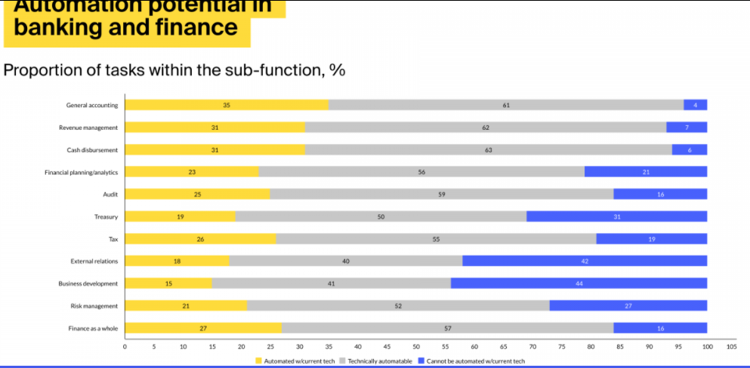
This research aims to develop a theoretical and tentative framework based on the technology used and the technology acceptance model in response to research questions. Independent variables of the research are investigated by viewing the employee's reaction toward robotic process automation. Internal analysis of the banking sector is conducted to evaluate the impacts of robotic process automation. Management reviews explain robotic system automation's role in improving staff efficiency and productivity. RPA system fasts the process of automation and improves the work quality of the banking sector. It is also to understand the impacts of RPA on customer satisfaction from the management point of view. The dependent variable of the research is investigated by conducting customer reviews about the services of the banking sector. The Saudi Banking system is based on the Islamic System but has not fully implemented Islamic rules to run a successful banking system. The current framework of the banking system of Saudi Arabia does not permit Islamic Banking. Most banks use only selective activities of the Islamic rule of banking. Many amendments are required to turn the Saudi Banking system fully towards the Islamic system (Lacity & Willcocks, 2018).

Definitions of Key Terms:

Robotic Process Automation:
Digital transformation of technology that automates the execution of the business sector's manual and repetitive intensive activities is known as robotic process automation. It can communicate with other software, process transactions, and manipulate the data to advance the business sector. It interrupts the existing software of the banking sector and develops ways for assisting the system in ensuring an accurate working and reducing human error. It is supported by machine learning and artificial intelligence and replaces humans to handle high-volume tasks. Finance maintenance in the banking sector requires repetitive tasks to ensure accuracy in the work. The automation process of these tasks reduces the labor cost, eliminates human error, increases accuracy and productivity, and manages the process's execution time. Like other economic supportive industries of the Saudi kingdom, the banking sector is also looking to increase profitability and stay competitive. Robotic process automation is an effective solution for the banking sector to focus on employees efficiency, working accuracy, and customer satisfaction (Institute for Robotic Process Automation & Artificial Intelligence: Definition and Benefits. , 2019).

Islamic Banking Rules:
The Islamic banking system is based on the Islamic faith and its relation to commercial transactions. The principles of Islamic banking are derived from the Holy Quran and the teachings of the Holy Prophet PBUH. The legal code of Islam is Sariah. All the dealing, either banking or business, occurs according to this. Rules of Sariah related to the banking system are known as Fiqh al-muamalat. People working in Islamic banks are entrusted and do not deviate from the principle of the Holy Quran and Sariah while conducting business dealings. In case of query, bankers are recommended by Islamic scholars for the guideline of banking rules from the Quran or allowed to use independent reasoning based on customary practices. Thus, innovative practices of the Saudi banking system require focusing on its custom values set by Allah Almighty.

Dependent and Independent Variables of Research:
Customer satisfaction is a dependent variable of the research, which depends on the banking sector's ease of facilities. The independent variables of research work are improved work quality, fast process, performance stability, improved staff efficiency and productivity, and less error. These variables collectively play a role in investigating the answer to research questions. The manual transaction model and customer policies affect customer values in the banking sector. Application procession, data preparation, transferring data, knowledge management, and saving data are a few processes that affect the accurate working of employees and cause hindrance in achieving customer satisfaction.

Justification of the Study:
Robotic process automation contains structured data that prevents bank employees from redundant and repetitive tasks. There are three development stages of the RPA system. It includes automation, enhanced process automation, and cognitive automation. The banking sector develops basic automation processes through rule-based programming and ensures that repetitive tasks and transactions are automated. The banking sector recognizes unstructured data patterns during the second stage and utilizes machine learning techniques for limited decision-making automation. The second stage of the RPA process is also known as decision-making-based tasks. The banking sector develops a cognitive automation level after developing basic automation practices in the business model and limiting the decision-making process. During this level banking sector evolves as machine learning, artificial intelligence, and natural language processing to ensure accuracy in the functioning of the banking sector.
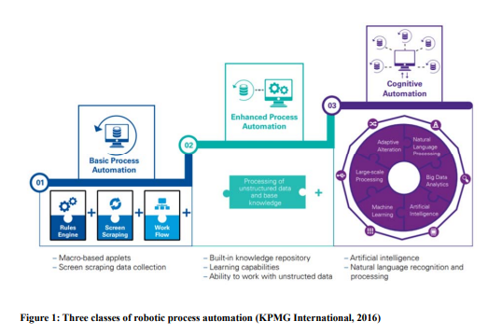
Most of the business sector relies on basic automation processes to uplift the economic standards of their organization. An organization like Arago and Ipsoft develop themselves as intelligent automation stage to ensure innovative and digital transformation practices in the business model. Cognitive automation practices of Google Deep mind, Alpha, IBM Watson, and Wolfram ensure the success of the business sector. These organizations communicate with the employees and enable understanding of the RPA process. Artificial intelligence in the business approach enables the banking sector to develop a strong communication channel with the employees and fulfill customer requirements. RPA system is significantly important for the banking sector. The implication of advanced and cognitive automation systems is dependent on the nature of the industry. It performs different functions according to the working nature of the industry. Legal services, HR, Finance, IT, Accounting, and many other fields where RPA serves the business sector. The banking sector provides ease of human error and increases profitability. The major functionality of the banking sector comprises credit card issuance, loan information system, financial industry, and fraudulent claim detection. RPA system controls the general business affairs of the banking sector. Anti-money laundering practices of the banking sector are also controlled through the implication of the Robotic Process Automation system. Insurance payment claims also utilize the RPA system to ensure customer satisfaction (Romão, Costa, & Costa, 2019).

Scope of the Study:
Robotic process automation software is an easy approach to reducing the time cycle of customer performance. It performs rule-based performance more effectively than other finance controlling software. Automation in the banking sector saves $ 2 trillion yearly. It is estimated that 455 industries implement automation practices in the business model on the global network. Advantages of the RPA system to the business sector are not limited to efficiency ensuring and cost-saving. It is also a=beneficial for agility, case of deployment, and speed. Ancient business sectors adopt business process management schemes to control efficiencies of the business sector and cost-saving. The extra features of the RPA system rapids deliver the value of the banking sector, digitize the process, and give sustainable values by reducing overall risks of policy failure. RPA system enhances cost optimization and efficiency of the banking sector in limited time availability. It allows to save considerable human resources cost and reduce full-time employees. Human resources of the banking sector cost 1/3rd of total labor cost. Controlling human resources through the RPA system ensures the effective development of the Saudi banking sector. Robots offer non-stop work to the sector and enhance productivity significantly. The robotic system can improve the performance of the banking sector and continuously improve the learning process (KUMAR & BALARAMACHANDRAN, 2020).
Robotic process automation improves data analytics in the banking sector. It can process the transaction in real-time and centrally manage the data flow. Another benefit of the robotic system is defining structures and rules to retrain itself to ensure functioning accuracy. It can process immediately against newly updated data and increased outcomes. It increased the operating speed of the organization, improved quality and quantity, and ensured the definite success of proposed business values. A newly developed concept about the emergence of technology merges artificial intelligence with the robotic automation process. Working dynamics of the banking sector are improved and ensure customer satisfaction towards the services. Hence, it has shown that the banking sector improves wealth advisory, fraud mitigation, loan processing, right from customer experience, and digital transformation initiatives with Robotic process automation.

References
Aguirre, S., & Rodriguez, A. (2017). Automation of a business process using robotic process automation (RPA): A case study. Workshop On Engineering Applications. 65-71.
Asatiani, A., & Penttinen, E. (2016). Turning robotic process automation into commercial success – Case OpusCapita. Journal Of Information Technology Teaching Cases, 67-75.
IBS intelligence. (2019, April 20). Cognitive Automation - Convergence of AI and RPA in Banks. Retrieved from https://ibsintelligence.com/wp-content/uploads/2019/10/Cognitive-Automation-Covergence-of-AI-RPA-in-Banks.pdf
Institute for Robotic Process Automation & Artificial Intelligence: Definition and Benefits. . (2019, April 14). Retrieved from https://irpaai.com/definition-and-benefits/
IRAQI. (2018, February 25). Robotic Process Automation in the Real World: How 3 Companies are innovative with RPA. Retrieved from https://irpaai.com/robotic-process-automation-real-world-3-companies-innovating-rpa/
KUMAR, K., & BALARAMACHANDRAN, P. (2020, April 12). ROBOTIC PROCESS AUTOMATION - A STUDY OF THE IMPACT ON CUSTOMER EXPERIENCE I. Retrieved from RETAIL BANKING INDUSTRY: https://www.icommercecentral.com/open-access/robotic-process-automation-a-study-of-the-impact-on-customer-experience-in-retail-banking-industry.php?aid=87176
Lacity, M., & Willcocks, L. P. (2018). Innovating in Service: The role and management f automation, in L. Willcocks, I. Oshri & J. Kotlarsky (eds) Dynamic Innovation in Outsourcing. Technology. Work and Globalization, Palgrave Macmillan, Cham, 269-325.
Romão, M., Costa, J., & Costa, C. (2019). Robotic Process Automation: A case study in the Banking Industry. Iberian Conference On Information Systems And Technologies. CITI.

