Automatic Bottle Filling and Capping using PLC
¹S M Nazmuz Sakib (Orchid- https://orcid.org/0000-0001-9310-3014) (sakibpedia@gmail.com)

¹ Graduate of BSc in Business Studies

School of Business And Trade
Pilatusstrasse 6003, 6003 Luzern, Switzerland

¹ Student of BSc in Civil Engineering
Faculty of Science and Engineering
Sonargaon University
147/I, Green Road, Panthapath, Dhaka

¹ Student of LLB(Hon’s)
Faculty of Law
Dhaka International University
House # 4, Road # 1, Block - F, Dhaka 1213

¹ Student of BSc in Physiotherapy
Faculty of Medicine
University of Dhaka
Nilkhet Rd, Dhaka 1000

¹

¹Author Biography

S M Nazmuz Sakib is an eLearning expert and done more than 500 MOOCs or Massive Open Online Courses and experienced as an instructor in sites like Udemy. He has completed his BSc in Business Studies from School of Business And Trade, Switzerland with CGPA 4 in the scale of 4 and 97.06% grade marks on an average. He is also a certified Google IT Support Professional, Google Data Analytics Professional and IBM Customer Engagement Specialist Professional.

Abstract:

PLC plays a vital role in the world of automation. It is the key part which makes system and whole process simpler, flexible and accurate. PLC provides low power consumption, reduces operational cost, increases production rate and Time saving. This project is designed to overcome the issues faced in the conventional industries process problems and also for small-scale industries issues where there is huge number of labors, accuracy issue, production rate, factory shut down issues due to human errors which results in to loss. These problems can be solved by converting the old style manual operated machine into automated, highly (Programmable Logic Controller).This project involves the Ladders Language used in PLC to automate the bottle filling and capping plant. In first cycle, the bottle is passed through the conveyer belt, stopped at the filling point. The Bottle then filled to the desired level at very high accuracy, using DC pump and solenoid valve. At second cycle, bottle gets into second phase where capping process is done. The bottle is moved to accurate position where the cap is placed on the bottle during movement. Then the cap is tightened using DC motor and actuated piston. All the process from the bottle placement to capping and then to final product is done automatically according to user requirement. Motor over load, over current protection can also be done with the help of PLC. There will be push buttons for the start, stop, emergency stop, fault error indicator LED, also there is a counter for counting of bottles filled. Do counters can also be used at start and end for the detection whether a bottle during the process is dropped or not. Production rate due to this automation is greater than that conventional way of filling. This project also helps us in gaining knowledge about PLC, its coding, connections and uses in different ways.

CHAPTER 1 INTRODUCTION

Introduction

Our project is basically based upon Programmable Logic Controller (PLC). It is used to control automated industries. A programmable logic controller (PLC) or the programmable controller is indeed an industrial computer control system which has been ruggedized and supports the implementation of manufacturing including the assembly lines, robotic devices, or even any activity that necessitates high reliability, simplicity of programming, as well as process defect detection. Automation, also known as automatic control, is use of numerous control systems to operate equipment like machinery, factory processes, boilers as well as heat-treating ovens, phone network switching, ship steering as well as normalization, and some other applications & vehicles with negligible or low from time to time.[1] Control system uses PLC. Filling and Capping is done on conveyer via IR sensors, water pump and solenoidvalve.Theconveyersareusedinindustriesforthemovementofobjectsfromone placetoanother.Thebottleismovedtowardscappingprocesswhenfillingprocessisdone. ThisprojectinvolvestheLaddersLanguageusedinPLCtoautomatethebottlefillingand capping plant. In first cycle, the bottle is passed through the conveyer belt, stopped at the filling point. The Bottle then filled to the desired level at very high accuracy, using DC pump and solenoid valve. At second cycle, bottle gets into second phase where capping process is done. The bottle is moved to accurate position where the cap is placed on the bottle during movement. Then the cap is tightened using DC motor and actuated piston. All the process from the bottle placement to capping and then to final product is done automatically according to user requirement. Motor over load, over current protection can alsobedonewiththehelpofPLC.Therewillbepushbuttonsforthestart,stop,emergency stop, fault error indicator LED, also there is a counter for counting of bottles filled. Counters can also be used at start and end for the detection whether a bottle during the process is dropped or not.

Problem Statement

In the conventional industries process problems and also for small-scale industries issues where there is huge number of labors, accuracy issue, production rate, factory shutdown issuesduetohumanerrorswhichresultsintoloss.Manualmachinesrequirelaborforevery task, due to this time taken for production increases and thus decreases overall efficiency. Theseallresultsintodecreasedproductionrateandincreasedproductcost.Theseproblems canbesolvedbyconvertingtheoldstylemanualoperatedmachineintoautomated,highly accurate machine by use of PLC (Programmable Logic Controller).

Aims and objectives

Aims

Inthisproject,itisaimedtodesigntheprototypefortheAutomaticwaterbottlefillingand capping using PLC with high accuracy.

Objectives

The Objectives are described below
- Maximum Integration
- Formulate the Design and Implementation
- Testing of Formulated design

CHAPTER 2 LITERATURE REVIEW

Programmable Logic Controller

A programmable logic controller or PLC is an industrialized digital computer which is used for controlling of manufacturing processes, like long conveyer lines and assembly point ,automatic robotic devices, or any action that involves high dependability, ease of programming as well as process error analysis. Programmable logic controllers were first made in the vehicle engineering industry to provide elasticity and user friendly programmable controllers to substitute tough-wired relay logic schemes. From then, these controllers have been broadly taken as high-dependability computerization controllers appropriate for rough environments.[3]

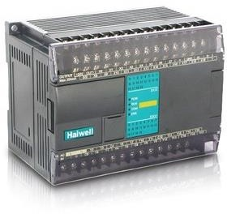

Figure 2.1: PLC

The research has built and implemented logic for the Industrial Crane Automation and Monitoring with aid of PLC. The benefit of programmable controllers in terms of flexible wiring is enormous. It is, in reality, among the most essential characteristics of PLCs. Modifications to the control system are simple and inexpensive because too soft wiring. Simply modify a control Program to make a device in PLC system act differently as well as control a variant processing element. Implementing this sort of adjustment in a typical system would need physically replacing the wiring between devices, which would be an expensive & time-consuming process. All the other controlling mechanisms will undoubtedly be controlled by PLC throughout the future.

Architecture of PLC

A PLC consists of:
      - A central processing unit CPU which reads inputs, implements the governing program stored in memory and directs output indicators.
      - A power supply unit which changes Alternating Current voltage to Direct Current voltage.
      - A memory unit that stores data from inputs and programmes that will be executed by the processor.
      - An input/output interface via which the controller receives and sends data to and from external devices.
      - A communications interface that collects and delivers data from or to remote PLCs through a communication network.

Mechanical Design of PLC

There are two types of automated designs for PLC systems.
      - Oneboxisasmalladjustablecontrollerthatconvertstheentireunitandismounted to another rigid compressed cover, while, for instance, the input and output expansion modules are available.
      - The second kind of standard PLC design comprises a framework (also known as a rack) that provides room for modules with various functions, such as power supply, processor, I/O module selection, and connectors – all of which may be modified for a given application. A single CPU may move many racks with thousands of inputs and outputs. Racks are spread distant from the processor via either a dedicated high-speed I/O connection or a similar communication method, lowering the cost of the bigger plant thread. I/O points can be installed directly on machine and used to easily connect sensors & valves, saving time on wiring and allowing them to be replaced.

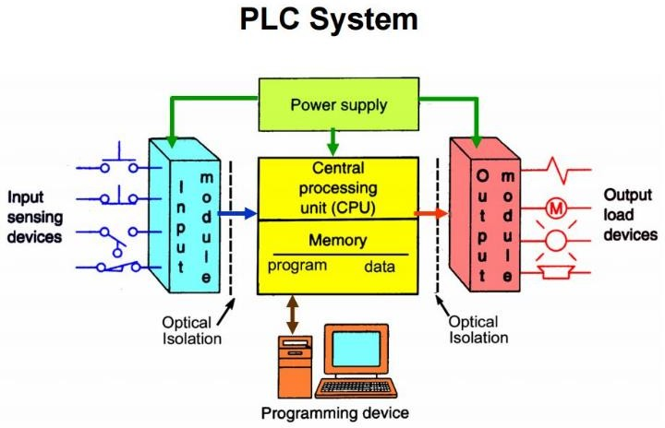
Figure 2.1: Block Diagram of PLC

Technical Specification

The CPU is a powerful controller that integrates a microprocessor, integrated power transmission, input & output circuits, built-in PROFINET, high-speed I/O control, and analogue board input in to integrated chassis. The CPU contains the required functionality for monitoring as well as controlling devices in application after downloading the software. The CPU keeps track of the output and adjusts it based on the user's programming logic.
For connectivity with the PROFINET network, the CPU has a PROFINET port.

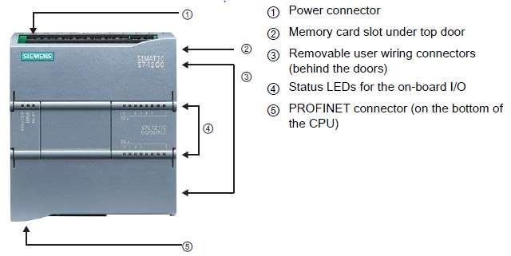

Figure2.2: PLC Parts

Programming Language

- LAD (ladder logic) graphic programming language. Presentation is based on circuit diagrams.
- FBD (Function Block Diagram) is a programming language centered on Boolean algebra's graphical symbols.
- SCL (Structural Control Language) is a high-level language based on text.

Ladders Language

Circuit diagrams, such as normally closed and regular open contacts, and coils are connected to form networks. To create a concept of complex operations, you can branch out to create logic for linear cycles. The corresponding branches are opened upside down or directly connected to the power train. You cut the branches up. LAD provides "box" commandsforvariousfunctions,suchasmath,timecalculator,calculator,andnavigation.
Figure 2.3: Ladders Language

PLC Compare with the other control system

PLCs can handle a wide range of the automation tasks. These are generally industrial processes in production where cost of establishing and implementing the automated system is considerable in comparison to the total expense of automation, and when modifications to system are anticipated during system's operating life. PLCs have input as well as output devices that are compatible to industrial pilot devices; minimal electrical infrastructure is proposed, as well as the design challenge is describing the desired operating sequence. Because PLC applications are frequently highly specialized, the cost of a packaged PLC is inexpensive when comparing the cost of the custom-built controller design. Customized control mechanisms, on the other hand, are cost-effective in the case of mass-produced items because of lower cost of components, which may be ideally chosen rather than a "generic" solution, and when non-recurring engineering costs are distributed over thousands or even millions of units. Different approaches are utilised for big volume or extremely basic fixed automation operations. An electromechanical camera timer, for example, might be used to regulate a household dishwasher and would cost merely a few $ in manufacturing numbers. Where hundreds and thousands of components will be generated, a microcontroller-based structure will be suitable, because as development cost (layout of power cables, input or the output hardware, as well as necessary conformity assessment) can be expanded over many purchases as well as the end-user do not need to change the control. For instance, as in automotive industry, millions more units are produced each year, yet only a small percentage of end-users modify the programming of such controllers. Nevertheless, because the quantities are limited and the development cost is prohibitive, certain specialist vehicles, like transit buses, employ PLCs rather than custom-designed controllers. Complex control system, such as that employed in the chemical sector, may necessitate algorithms or performances that are beyond the reach even for the most powerful computers PLCs.[2] Customized solutions may be required for the very high-speed or precise controls, such as aircraft control surfaces. Motion control, position control, as well as torque control are all common applications for programmable controllers.

Automation

There are three different forms of production automation:
- Fixed Automation,
- Programmable Automation,
- Flexible Automation

Fixed Automation

Fixedautomationisotherwisecalled"automation,"alludestoamechanizedcreationoffice whereinthearrangementofpreparingactivitiesisfixedbythegeardesign.As a consequence, bespoke orders are stored throughout the machines as cam, masts, wiring, and many other devices that cannot be easily switched from one product style to next. This type of computerization is portrayed by high beginning speculation and high creation rates. It is thusly reasonable for items that are made in enormous volumes. Instancesoffixedautomationincorporatemachiningmovelinesfoundinthecarbusiness, programmed get together machines, and certain substance forms.[4]
It's a process wherein the equipment design dictates the order of processing (or assembly) activities. In most cases, the procedures in the series are straightforward. The system's complexity stems from the integration & coordination of several similar processes into a single device. The following are some of the characteristics of fixed automation:

a. Custom–engineered equipment requires a large initial expenditure;
b. Significantly higher rates of production; &
c. Inflexible when it comes to adapting product modifications.

Fixed automation has an economic rationale in items with large demand rates & quantities. The equipment's initial high cost may be distributed across a wide range of scales, rendering the unit price reasonable when compared with alternative manufacturing techniques. Mechanized assembly & machining transfer lines are instances of fixed automation.

Programmable Automation

It is a type of automation for delivering items in clumps. The items are made in cluster amountsrunningfromafewdozentoafewthousandunitsoneafteranother.Foreachnew bunch, the creation hardware must be reconstructed and changed over to oblige the new itemstyle.Thisreinventingandchangeoversetasidesomeefforttoachieve,andthereisa time of useless time followed by a creation run for each new group. Creation rates in programmableautomationarebyandlargelowerthaninfixedautomation,onthegrounds that the hardware is intended to encourage item changeover as opposed to for item specialization. A numerical-control machine apparatus is a genuine case of programmable automation. The program is coded in PC memory for each unique item style, and the machine device is constrained by the PC program. Modern robots are another model.
The manufacturing equipment is built in this way so that the sequence of activities may be changed to fit various product combinations. A programme, which is a set of instructions written such that the system may read and comprehend them, controls the underlying operating system. To generate new items, new programmes can be created and placed into equipment. The following are among the characteristics of programmable automation:

a. Significant investment in the general-purpose machinery;
b. In compared to fixed automation, low output rates;
c. Adaptability to changes in product configuration; &
d. It's best for the batch manufacturing.

In medium and low volume manufacturing, programmable automated manufacturing systems are employed. Batches of parts or goods are routinely produced. To create each new batch of the different product, system should be reprogrammed with new product's series of machine code. The machine's physical configuration must be switched over as well: tools should be loaded, fixtures must be mounted to machine table,& machine specifications must be inputted. This method for switching over takes some time. As a result, the usual cycle for a particular product involves a period of setup & reprogramming, following a period in which all the batch is manufactured. 'Numerically controlled' machine tools as well as industrial robots are instances of programmed automation.

Flexible Automation

It's a type of programmable automation that's been enhanced. The disadvantage of programmable computerization seems to be the time it takes to rebuild and switch over the production hardware for every new cluster of objects. This is money spent on missed creation time. The variety of things in adaptable automation is sufficiently limited, so gear replacement should be feasible quickly and efficiently. In adaptive automation, the hardware reconstruction is done remotely; that is, the development of computer programmes is done at a workstation instead of using the creation equipment itself. There is no apparent need to bundle indistinguishable goods together; instead, a mix of diverse products can be supplied one after another.

It's a step forward in the evolution of programmable automation. The flexible automated system is the one that can produce a wide range of goods (or parts) with little or no downtime between them. While reprogramming a system and changing the physical configuration, no production time is wasted (tooling, fixtures, & the machine setting). As a result, rather than requiring that goods be manufactured in separate batches, the system may produce a variety of combinations as well as schedules. The following are some of the characteristics of flexible automation:

1. The cost of a custom-engineered system is high.
2. Constant manufacturing of varied product mixes.
3. Production rates that are moderate.
4. The ability to adapt to changes in product design.

The following are the key characteristics that separate flexible automation from programmable automation:

1. the ability to switch component programmes without sacrificing production time; and
2. the ability to switch over physical configuration without losing any production time.

These features enable the automated production system to continue operating without downtime which programmable automation is known for. Part programmes are often changed by preparing them off-line on a computer system and then electronically transferring them to automated manufacturing system. As a result, the time spent programming for the future task does not interfere with the present job's output. This programming capacity in flexible automation is primarily due to advancements in computer systems technology. Performing the changeover off-line & then putting it into place when the following component comes into position for processing is how the physical arrangement between parts is changed. One method to apply this strategy is to utilize pallet fixtures that hold the pieces and move them into place at the workplace. The diversity of parts that may be manufactured on the flexible automated production system is typically more confined than that on a system controlled by the programmable automation for such techniques to be effective.

The following diagram depicts the relative locations of the three forms of automation for various production quantities and product variations.

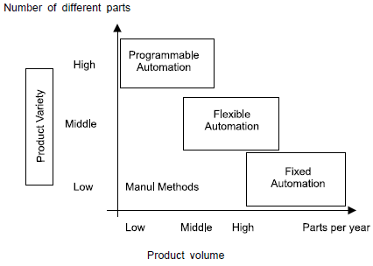

Conveyer System

History

Conveyor belts have been in use since the nineteenth century. Thomas Robins initiated a series of the inventions in 1892 that culminated in the creation of a conveyor belt for transporting coal, ores, as well as other materials. Sandvik developed and began producing steel conveyor belts in 1901. Richard Sutcliffe changed the mining business by inventing the first conveyor belts to be used in the coal mines in 1905.
At Ford Motor Company's Highland Park, Michigan facility, Henry Ford implemented conveyor-belt assembly lines in 1913. The French organization REI built the world's longest straight-belt conveyor, measuring 13.8 kilometers, in the New Caledonia in 1972. The idea designer was Hyacynthe Marcel Bocchetti. The B. F. Goodrich Company invented a conveyor belt in 1957, and the Turnover Conveyor Belt System was born. Because it featured a half-twist, it had a longer life than traditional belts because it might expose all its surface area for wear and strain. Untwisted contemporary belts may be made more robust by building them from many layers of various materials, therefore mobius strip belts will be no longer manufactured.
Conveyors are critical in quarrying, mining, as well as mineral processing activities, yet we often overlook them. We're taking a look back at the history of conveyors, from their beginnings in the late 1700s through decades of development and invention that have changed them into dependable machines we rely on today.

      - The Earliest Conveyors

If there was a single inventor or original installation location for conveyors, such knowledge has unfortunately been lost to time. While Henry Ford made conveyors renowned with his automotive assembly lines throughout the early twentieth century, he did not create them (as often people mistakenly believe) — he simply improved on previous technology.

Conveyors were originally introduced around 1795, according to several accounts. These early conveyors were small, hand-operated, and made of leather belts & wooden beds. They were mostly employed at ports to transport agricultural produce from the land to the ship.

      - Revolutionary Improvements

Manual work in several industrial contexts began to be taken out in favor of steam-powered equipment when the Industrial Revolution gained root in Great Britain during 18th century, and just a little later in America. Somewhere at time, steam power was indeed the new technology!
Machine-driven conveyors soon gained popularity and began to emerge in a variety of sectors, though it'd be almost a century before they were used in mining operations. For most of the 1800s, railcars were primary means of transporting gravel and coal from mines to surface activities. However, when new belt materials such as rubber and steel were available, this began to alter.

      - New Belt Materials

Vulcanized rubber was invented in 1844 by inventor Charles Goodyear. Rubber became a lot more stable material that didn't respond badly to temperature fluctuations as a result of this breakthrough. Rubber was employed as conveyor belt component in the past, according to some accounts, although it was far from perfect. When exposed to low temperatures, it became stiff and inflexible, but when warmed, it melted after becoming sticky.
It's true because steel conveyors were among the first to be used in the transfer of mined gravel and coal. Starting in 1902, Sandvik was the very first company to create these belts.
The first subterranean conveyor belt, composed of layered cotton and rubber, was introduced a few years later, in 1905, by mining engineer and inventor Richard Sutcliffe. Steel belts were more frequently used in the food processing sector at the time, whereas rubber-covered belts become industry standard in mining & mineral processing due to its greater durability as well as flexibility.

      - “Rails are out, Conveyors are in”

Mining & quarrying were transformed during the next several decades because to Sutcliffe's subterranean conveyor belt, which allowed huge quantities of material to be transported from extraction site with far less effort. It was no longer necessary to construct and maintain costly train lines.
Conveyors did, however, require some positive PR to gain popularity, as technological advances did not spread as fast as they do now. In addition, purchasing and installing conveyors wasn't quite as simple in the beginning.
After inventor Hymle Goddard invented the first roller conveyor in 1908, things began to move quickly. Around 1913, Henry Ford famously began using conveyors across his assembly lines at his automotive factories, and shortly after, problem-solvers in a wide range of industries started refining & inventing different forms of conveyors. Conveyors swiftly replaced locomotives and rail lines as in quarrying, mining, & mineral processing sectors from the 1920s until the onset of war in 1940s.

      - Conveyors Keep Getting Better

Several conveyor advancements from the twentieth century have led us to where we are now. For a while, America's intervention in World War II hindered mining sector at home, however wartime was wonderful for conveyors, since a scarcity of rubber created the very first synthetic belt materials.
In 1950s, the tremendous development of the postwar American economy prompted even more conveyor advancements. The turnover conveyor, for instance, was developed in 1957 and decreased the cost of running conveyors constantly due to increased belt longevity. Thor invented the telescopic conveyor in 1992, which was another important conveyor breakthrough.

      - Computerization and customization in the present and future

Conveyors have become even more dependable and simpler to deal with in recent years as a result of computerization. Conveyors now are "smart," alerting operators to the need for repair. They can also respond to programmed orders by running, stopping, and changing pace. Conveyor systems have become more customizable as a result of computerization, allowing mine and quarry operators to get the exact results they want.
Indeed, choosing the proper conveyor for your needs these days frequently entails designing a system which can carry material effectively and inexpensively from extracting point to stockpile and even beyond, regardless of mine / quarry site's constraints.
Better machine learning & artificial intelligence (AI) are expected to enhance conveyors also in future, reducing maintenance as well as breakdowns even more and removing more direct human control while work is being done. As a result, both the safety & efficiency of our mining sites will improve.

Conveyer Belt

A conveyor belt (also known as a belt conveyor) is made up of two or more pulleys that are connected by a continuous loop of the material called a conveyor belt that revolves around them. The belt as well as the material on belt are moved forward by one / both pulleys being driven. The drive pulley is indeed the powered pulley, whereas the idler is the unpowered pulley. Belt conveyors are divided into two categories: general material handling, like the one used those used to move boxes around a factory, as well as bulk material handling, which includes those used to transport agricultural and industrial materials including grain, ores, coal, and other bulk materials in the outdoor areas. Generally, firms that provide belt conveyors for ordinary material handling do not sell bulk material handling conveyors. Belt conveyors are also used in a variety of commercial applications, like grocery shops. One or even more layers of the material make up the belt. Rubber may be used to make them. In general material handling, numerous belts feature two layers. A carcass is an underlayer of the material that provides linear stiffness and form, and a cover is an overlayer. A cotton / plastic web / mesh is frequently used as the carcass. The cover is frequently made of a variety of rubber or plastic compounds that are determined by the belt's function. For unique purposes, such as heat or traction, covers could be manufactured from the more exotic materials including silicone or gum rubber.[8]

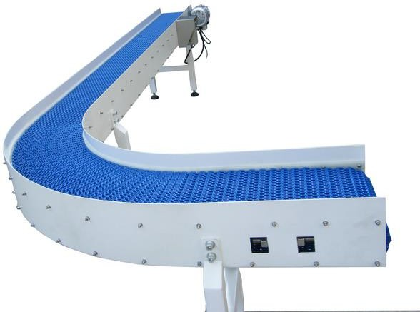
Figure 2.4: Conveyer Belt

Filling Methods

Conventional Filling

The first way to fill the bottle is conventional process. In, conventional process, you need a labor because you don’t have machines. Every task is performed by men instead of machines. You have to pay the labor which in turn a costly method. Man, himself places the bottle for filling and then for capping and then do packing.

Automated Filling

The empty bottle is weighed by the filling mechanism. The load cell monitors change in total weight because the machine fills bottle. The filling process automatically ends when the predetermined overall weight is attained, as well as the bottle is delivered to capping station.[6]

Purpose of Automation

Automation helps businesses to expand while maintaining consistency in customer experience, allowing them to optimize internal resource allocation, capitalize on opportunity costs, and optimize internal resource allocation. Businesses may either save or make money with the automation.[7] In industrial automation, PLCs are used to enhance system dependability, stability, & performance while reducing need for the human operators as well as the risk of human mistake.

Why Automation is Preferred

Following are the 6 reasons to use automation in bottle Filling

Consistent Filling

It doesn't make a difference what sort of automated water bottle filling machine you pick, it will guarantee steady and solid filling. This machine expels the vulnerability into the

filling strategy with the goal that the restrains fill easily. The individuals who need to top off various fluids into the containers simultaneously then they can depend on this gear. It can play out the filling on a specific model. The gear finishes each cycle in an effective and comparable way. For packagers that need to meet specified production objectives, the absence of ambiguity and unpredictability is obviously a big plus.

Speed

The speed of the automated bottle filling machine is customizable. Regardless of whether your creation request is low or on the ascent, this filling machine will work for you. There is no compelling reason to enlist works to help up your creation level when you have this hardware.Itcanfilleachcontainereffectivelyandquicklywithoutdroppingthefluid.You canincrementorabatementthespeedatwhateverpointyouneed.Theforcetransportswill change as indicated by the settings. This element is ideal for the organizations that need to meet the high creation level. It is the most evident advantage of equipment, and also the most frequently mentioned reason for introducing automatic gear.

Versatility

A few organizations require multi-reason machines to do the filling procedure. On the off chancethatyouarelookingforsuchamachine,atthatpointthisprogrammedfillingbottle hardwareisperfectforyou.Itisadaptablewhichimpliesthatitcandealwithvariousthings. You don't need to buy diverse filling machines for various things. For example, the water bottle filling machine will work for the filling of various beverages. Automatic liquid fillers' flexibility allows a packager set up a single machine to run a variety of the product & the container combinations.

Ease of Use

On the off chance that you need filling hardware that is anything but difficult to utilize, at that point the programmed bottle filling machine is ideal for you. It has a PLC program thatempowersyoutoworkthemachinewithouttrouble.Thereisatouchscreenpresenton the hardware through which you can deal with the activities of this gear.[5]

Price

The last motivation to make a buy is the bottle filling machine cost. The cost of this hardware is reasonable. All little and enormous container drink organizations can buy it with no issue. The cost as well as the support cost of this filling apparatus is additionally sensible.Itinfersthatyoudon'tneedtospendatonofmoneyonitsupkeep.Also,itdoesn't require visit upkeep.

    - Ability to upgrade

Automatic filling machinery has the advantage of being able to expand with the firm if it is constructed appropriately. In most situations, just planning for the addition of extra heads in future may enable a liquid filler to expand with the firm as product demand increases or new liquids are introduced to line. Components like various nozzles, the neck guides, & more could be added or adjusted to meet changing product lines in other cases.
While this is by no means a complete list of the advantages that a packager may get by automating the filling process, these are advantages that nearly always present when such a decision is taken. Contact the LPS headquarters to talk with a Packaging Specialist about automatic bottle fillers, alternative filling concepts, or any other of the equipment produced by Liquid Packaging Solutions.

CHAPTER 3 HARDWARE MODULES

Programmable Logic Controller

Allen Bradley MicroLogix1500

In an alternating growth Odo Josef Struger is occasionally known as the "ancestor of the PLCs". During the years 1958 to 1960, he was engaged in the development of the Allen Bradley programmable logic controller, and that he is credited with coining the term PLC.Allen- Bradley now a brand retained by Rockwell Automation converted a main PLC manufacturer in US during his tenure. Struger performed a headship role in rising IEC 61131-3 PLC programming language principles. We are using Allen Bradley MicroLogix 1500 in our project and its specifications are below.
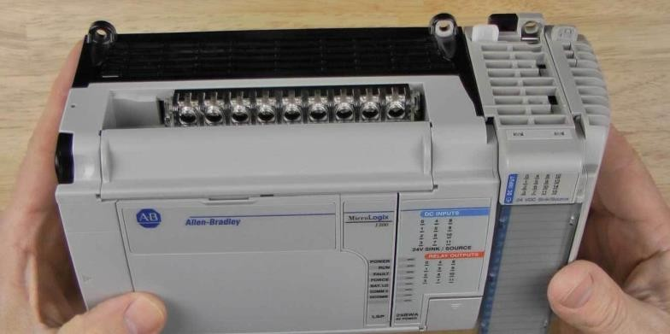

Figure 3.1: Allen Bradley MicroLogix 1500

Special Features

Table3.1: Specifications of Allen Bradley MicroLogix1500

Attributes | Values
Manufacturer Series | MicroLogix 1500
For use with | MicroLogix 1500 Series
Line Voltage | 19.2 → 32 V dc
Use Power output voltage | 24V dc
Output Current | 4 A
Length | 118mm
Width | 70mm
Depth | 87mm
Minimum Operating Temperature | 0°C

IR Sensors

An infrared (IR) sensor is an electrical device that detects & measures infrared radiation in its immediate environment. In the year 1800, astronomer William Herschel made an unintentional discovery of infrared light. He noticed that the temperature just above red light was quite high when measuring the temperature of each light hue (separated by a prism).IR is invisible to human eye, as its energy is much higher than that of visible light (although it is still in the electromagnetic mirror). Anything that emits heat (all with temperatures above five degrees Kelvin) emits infrared radiation.
Infrared sensors are divided into two categories: active and suitable. Infrared radiation is emitted and detected by active infrared sensors. A light emitting diode (LED) and a receiver make up active infrared sensors. When an object approaches a sensor, the LED emits infrared light, which the receiver detects as the item's output. Functional infrared sensors are frequently utilised in obstacle detection systems because they operate as nearby sensors (such as robots).

Working Principle

The basic concept of infrared Sensor which is used as an Obstacle detector to transmit infrared signal, this image signal shows it from the surface of the object and the signal is received from the infrared receiver. There are five basic elements used in the standard infrared detection system: infrared source, transmission point, light element, infrared or receiverandsignalfunction.InfraredlaserandinfraredLED'sspecificwavelengthscanbe used as infrared sources. The three main types of media used for infrared transmission are vacuum, atmosphere and bone fibers. Optical elements are used to focus on infrared radiation or to limit the viewing response. Optical lenses made of Quartz, Germanium and Silicon are used to focus on infrared radiation. Infrared receivers can be photographers, phototransistors etc. Specific details for infrared receivers are image sensing, acquisition and equal sound power. Signal operation is performed by amplifiers as the output of the infrared detector is very small.[9]

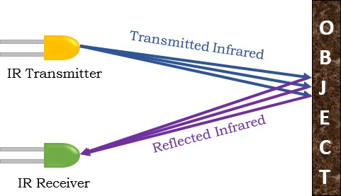

Figure 3.1: IR Sensor Functioning

Relay

Relays are switches aimed at the closing & opening circuits electronically as well as mechanically. It controls the opening and closing of electrical circuit contacts. When the relaycontacthaspassedopen(NO),thetransmissionisnotenabledbytheopenconnection. However, when closed (NC), the relay does not enable the closed contact. However, when power is installed (electricity or tariffs), the states are tended to change. Relays are often usedincontrolpanels,indesignandautomationtocontrolthepoweraccompaniedby

changingthesmallamountsavailableinthecontrolcircuit.However,theamplificationcan help control large amperes and voltages because when low voltage is applied to relay coil, the maximum voltage can be adjusted by contact. When preventive relays are used, they can detect excess current, overload, small current, and reverse current to ensure the protection of electrical equipment.
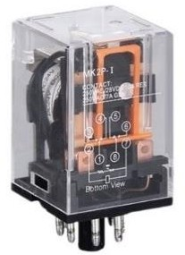

Figure 3.3: Relay

Types of Relays

      - Electrothermal Relays: Two different materials are inContact to form a bimetallic strip and when it heats it is used for connections. Thermal relays are commonly used to safeguard electric motors.
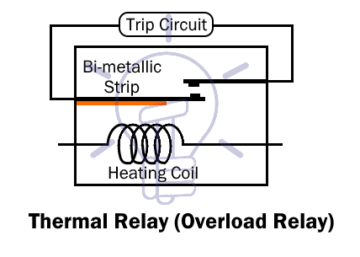

      - ElectromechanicalRelays:Whenmechanicalpartsareinboundandelectromagnet is placed in it, connections will be done through this arrangement. Mechanical relays can take a lot of current, but they aren't as quick as other forms of relays at switching. Based on the purpose and design, they can indeed be employed with Ac or Dc currents.
      - Solid State Relays: These relays use semiconductors to establish connections. When compared to electromechanical relays, solid state relays offer quicker switching rates. Its life expectancy is further increased due to the lack of moving components, and they tend to generate very little noise.
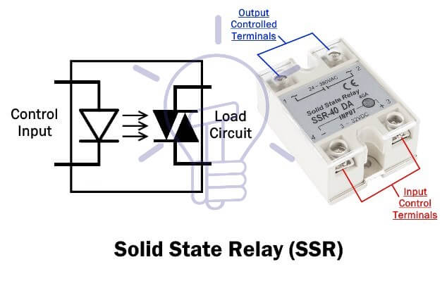
      - Hybrid Relay: This is the mixture of solid state and electromechanically relays. Electrical relays & electronic components make up these relays. The electrical circuitry that performs rectification as well as other control tasks is generally found in input component, whereas the electromagnetic relay is found in the output component.
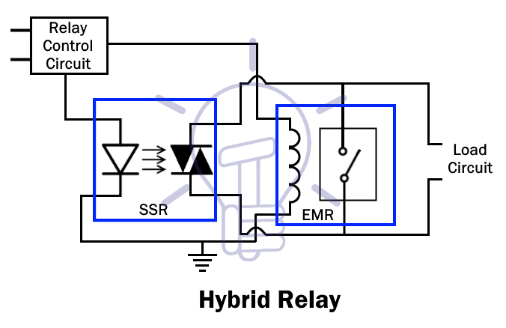

Solenoid Valve

A solenoid valve is an electrically controlled valve. The valve inserts the solenoid, that is an electric coil with ferromagnetic core (plunger) in the center. And, the plunger seals the tiny hole while it is at rest. A magnetic field is created by the electric current passing through the coil. The plunger that opens the aperture is subjected to an increasing magnetic force. The basic concept for opening & closing solenoid valves is given.

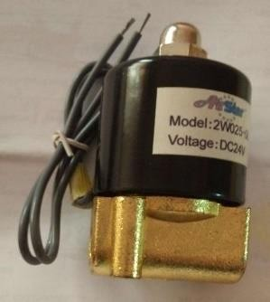

Figure 3.4: Solenoid Valve

Working Principle

The solenoid valve is made up of two major parts: the solenoid as well as the valve body (G). The components are shown in Figure 9. The plunger is an electromagnetically induction coil (A) that is wrapped around the metal base in the middle of the solenoid (E). It is generally open normally (NO) or closed normally (NO) at rest (NC).An open valve is open as well as a closed valve is sealed in a de-energized state. The coil is turned on and creates a magnetic field when electricity passes through solenoid. This produces a magnetic attraction that moves the plunger and overcomes the spring's force (D).The plunger is lifted if the valve is typically closed, allowing the seal (F) to open the orifice and enable media to flow through valve. When the valve is open, the plunger moves downward, blocking the aperture and stopping the passage of media via the valve. The shade ring (C) keeps the AC coils from vibrating and becoming soft.

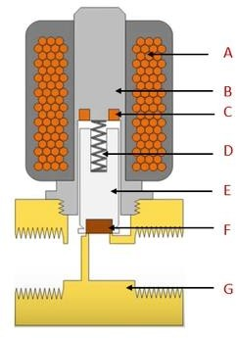
Figure 3.5: Solenoid Valve Parts

Conveyer Belt

On a belt conveyor system, a conveyor belt is a means of moving items (usually shortened to a conveyor belt). Conveyor systems come in a variety of shapes and sizes, and the belt conveyor system is one of them. The belt conveyor system is composed of two or even more pulleys (also known as drums) with a rotating conveyor belt as a permanent indicator of intermediate bearing. The belt as well as the material in front strap are moved by either or both of the pulleys, which are strong. The drive pulley is indeed the powered pulley, whereas the idler pulley is just the powerless pulley. Belt conveyors are classified into two major industrial categories: those used to transport large volumes of raw materials and agricultural products, such as grain, ore, coal, salt, sand, and a variety of other items, and those used to transport large volumes of raw materials and agricultural products, such as grain, ore, coal, salt, sand, and a variety of other items’ was utilised as a material. This belt was chosen because of its minimal friction and ability to be oil-free.

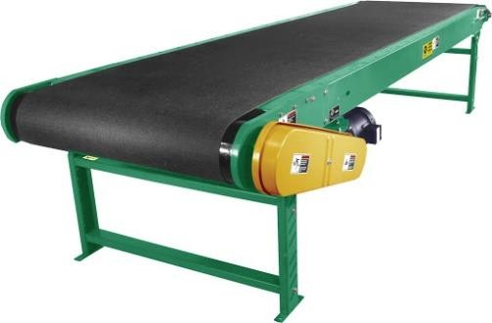
Figure 3.6: Conveyer Belt

DC Geared Motor

DC motors converts electrical power into mechanical power, and motor speed can be changed with variable voltage. DC-powered motors are DC-type motors with gear assembly. This increases torque & reduces speed of applying it to electrical devices that require different speeds. The DC motor utilised is a DC geared type motor with a shaft that is linked to the roller shaft. This motor offers a 12v input voltage and a 600mA to 14A input current. It spins at 50 RPM with no load. This motor was chosen because it produces great torque at a steady speed. It has a torque of 70kgcm, which is more than enough torque for our load. A metal gearbox and a centered shaft are included with the motor. For wear resistance, the shaft is loaded with bearings. The hefty rollers along either side of hardware, which is attached with a conveyor belt, are the reason for adopting such a high torque.

Figure 3.7: DC Geared Motor

DC Water Pump

The pump weight is 150 gm. The input and output dimensions are 15 mm and 5 mm. The power output is 12 V DC and the current is 0.1 - 0.5 A. It can lift 130 cm at 12 V DC and the flow rate is 300L / H.

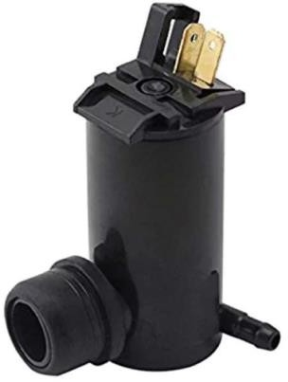
Figure 3.8: DC Water Pump

CHAPTER 4 IMPLEMENTATION AND CONTROL

PLC Programming with Instructions

Ladder drawing is another easy way to use PLC. The language of the coding system from electronic relay circuits. Each program statement is represented by a line, called rung, whichhasalltheleftinputandoutputright.Theoutputdeviceofrungispoweredwhenan electric current flow directly from the left side of the rung to the right side. Input devices are considered to prevent power flow when not in triggered. While making the ladder drawing,thePLCreadsthereportsofalltheinput,thendeterminesthestatesforalloutput from the top connection, down to the end, and finally updates the state of the device being used.
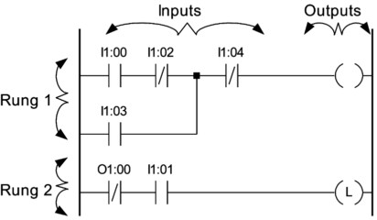

Figure 4.1: Ladders Language Parts

Instructions

During the construction of a PLC program, we must use certain words to identify inputs, outputs, memory flags, countdown times and counters. PLC makers use a variety of methods to compute input, output and other resources. The normal naming convention is

to put the input "I" and the output with the letter "O", followed by a 1-digit number that identifies the input number and a two-digit number that identifies the input or output point of the slot.
For example:
I1:00 means the 1st slot input 1.
O2: 00 means the first output of slot 2.
Some make numbers input or output from 00, while others use number 01 to identify the first input or output. Output condition can also be used as input to drawing of ladder. In suchacasethePLCusesthestatusofaparticularoutputdevicestoredintheoutputimage memory[10]

Table4.1 Ladders Language Instructions

Symbol | Title | Description
-[]- | Examine If Closed Normally Open | Closed, whenever the input is energized
-[/]- | Examine If Opened Normally Closed | Opened, whenever the input is energized
-()- | Output Coil  Normally inactive coil | Energized / Closed, whenever the rung is closed
-(/)- | Normally active coil | Energized / Opened, whenever the rung is closed

Filling Process

In this part, the bottle enters in the phase of filling, where it goes through filling process. The bottle is placed on the conveyer and then it moves towards the fix position where the solenoid valve is placed. The bottle gets aligned automatically. The PLC detects the bottle through the sensor and then starts filling the bottle. The time taken to fill the bottle is 3 secondswhichiscalculatedbelowwiththehelpofflowrateofdcpumpandrequiredwater level.

Calculation:
FlowRate: 300L/Hr.
Means; 300L water fills in 1 Hour Time Taken for500mLWater: 6 sec.

Conveyer

Conveyer is used for the movement of bottle, controlled by PLC, The Conveyer dimensions are given below in table. We have used nylon belt in the conveyer. The DC geared motor is attached to the Pulley on which the belt is moved. Other mechanism such as relay modules, solenoid valve etc. are placed along with the conveyer body.

Table4.2 Conveyer Belt measurements

Length | 4 ft.
Width | 8 inches
Pulley Diameter | 3 inches
Motor Speed | 50 RPM

Bottle straight Process

Whenthebottleisplacedmanuallyontheconveyer,itisnotalignedtobeatsameposition under the nozzle for filling. There is a chance of wastage of water. We have designed a mechanism which align the bottle in exact direction. We have used to curved aluminum platesplacedaboveatbothsideofconveyer.Whenthebottlepassesthroughit,getsaligned at the center of the conveyer. The mechanism is shown below:
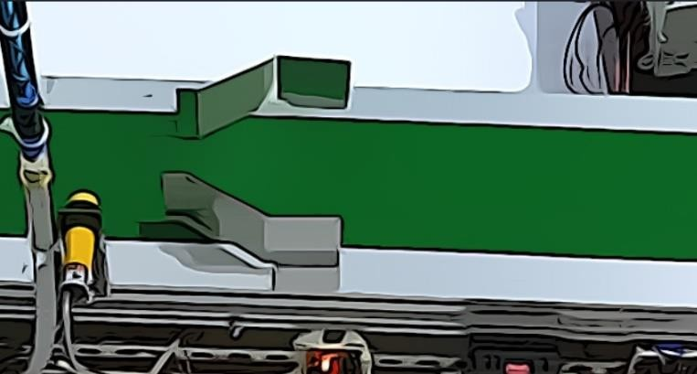
Figure 4.2: Bottle Straightening Process

Bottle Position detection

Thebottleneedstobestopexactunderthenozzlesothatwaterdoesnotspreadoutsidethe bottle or on the conveyer. For this problem, we have used IR Sensor for the detection of bottle. The IR Sensor is fixed exact under the nozzle. When the Bottle comes across it the IR sensor gives signal to PLC, which stops the conveyer and execute further instructions.
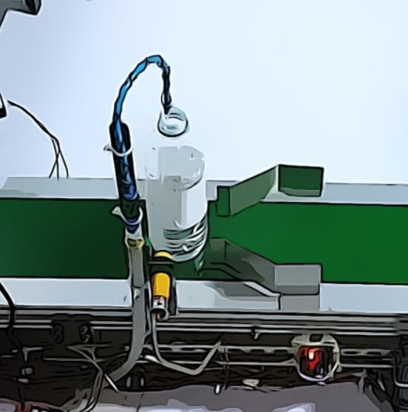
Figure 4.3: bottle position detection

Filling Method

The Filling is done with the help of DC Pump and DC water solenoid valve. When the bottle stops under the nozzle, PLC energizes the respective relay which further turns on the Pump and Solenoid valve. This remains energized for 3 seconds in which the 500mL bottle gets filled. Then PLC turns off both and conveyer starts taking bottle towards the capping process.

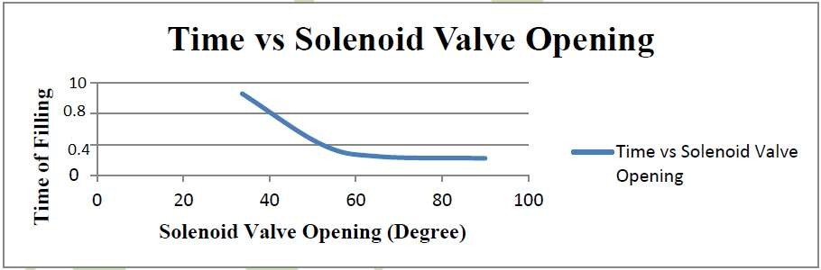

Capping Process

The Capping procedure is little bit complex; it comprises of rotating disc with cuts on it to fit the bottle in it. This rotating part is moved with the help of DC Motor. The Bottle moves to a specific point on that disc, where DC motor is placed for the tightening of cap. This motor moves upwards and downwards with the help of actuated piston. During the movement of bottle, the cap is placed automatically.

Rotary System

TheRotarypartconsistsoftwocirculardisc.Oneissolidandtheotheriscutinsuchaway thatbottlegetsfitintoit.ThismechanismismovedwiththehelpofDCmotorplacedunder it. There is an angled plated placed, where the bottle enters that part. This plate plays an important role in shifting the bottle form conveyer to rotary part. Same mechanism is used at the second end.

Mechanism of cap hopper

Wehaveusedaverysimplemechanismforcapplacement.TheAluminumbasealongwith boundary at two side of it. At the end, there is a moveable piece fitted through a rod. The small portion of cap is hung at same side of it, when the bottle passes through it that small portion of cap stuck on the top of the bottle during this, the cap is placed on the bottle.

Cap tightening

When the cap is placed on the bottle then bottle stops at the place where the dc motor in whichcaphopperisfittedcomesdownwardwiththehelpofactuatedpiston.Thedcmotor tightens the cap and then then comes upward instantly.

Table4.3: Cap Process Measurements

Variable | Size
Rotary Outer Diameter | 200mm
Rotary Small circle Diameter | 75mm
Cap Hopper Length | 120mm
Cap Hopper Width | 28mm

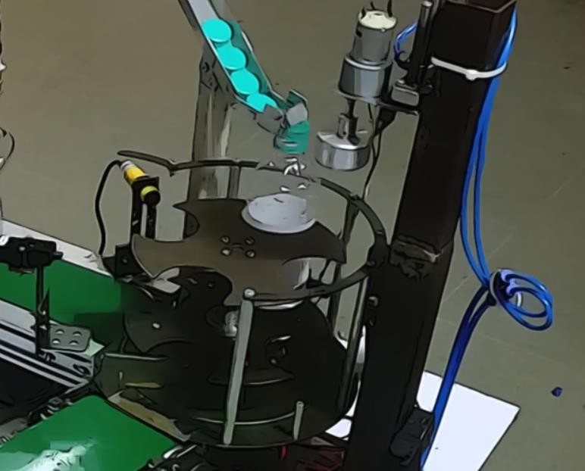
Figure 4.4: Capping Mechanism

Overall Structure and Functioning

The main task is synchronizing the bottle filling and capping process in such a way that whenonebottleisinfillingstagethenextbottlemustbeincappingstagesothatthewhole processgoessmoothlywithoutanyotherdelay.Andwehaveachievedthissynchronization in our code. Our hardware comprises of 3 main stations named as Filling station, Capping station and Packaging station. Filling station is first conveyor belt on which bottle filling is done. Capping Station is basically a rotary disc mechanism on which bottle capping is done. Packaging station is second conveyor belts which carries the bottle from capping disc towards the packing carton.

Step 1:
Instep1pushbuttonispressedwhichturnsONtheMotor1andthefirstconveyor(filling station) belt starts moving. The moving conveyor belt carries the empty bottles towards solenoid valve formfilling.

Step 2:
Whenbottlereachesrightbelowthevalve,thesensorsensesitspositionandturnsOFFthe Motor 1, after a delay of 0.5 seconds it turns ON the solenoid valve which start filling the

bottle. When valve turns ON the PLC ON-Delay timer remains active until the bottle becomes filled according to the present value of timer depending upon the capacity of bottle and cross-sectional area of the nozzle of valve.

Step 3:
When bottle is filled, the PLC ON-Delay timer becomes OFF, which turns OFF the solenoidvalveandtheMotor1becomesONandconveyorbeltstartsmoving,carryingthe bottle towards capping station. PLC UP-Counter is used to count the number of bottles filled, every time the solenoid valve closes, the counter will add 1 to the previous value of count.

Step 4:
Afterthebottleisfilleditmovestowardsthenextphasewhichiscapping,thesensorsenses the upcoming bottle and gives signal to the stepper motor installed under the disc and rotates the disc 90 degrees clockwise. When coming bottle falls on disc, another sensor senses its position and the disc is again rotated 90 degrees clockwise. At that point an actuated piston is installed on the top side which moves the cap hopper vertically downward which rotates to install the cap of the bottle. Finally, when the cap is installed properly, actuated piston moves the cap hopper vertically upward and the disc moves 180 degreesclockwiseandcarriesthebottletowardsthesecondconveyorbelt(packagingbelt) which drops the bottle in the packaging carton.

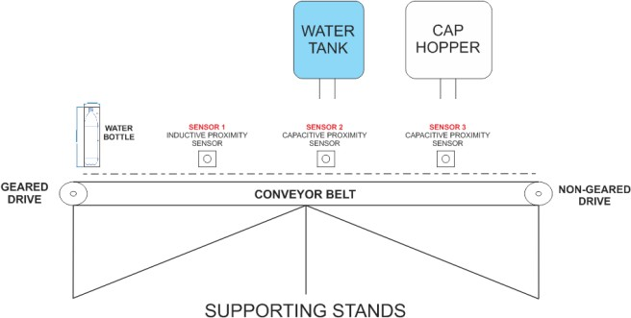
Figure 4.5: Overall structure

Block Diagram

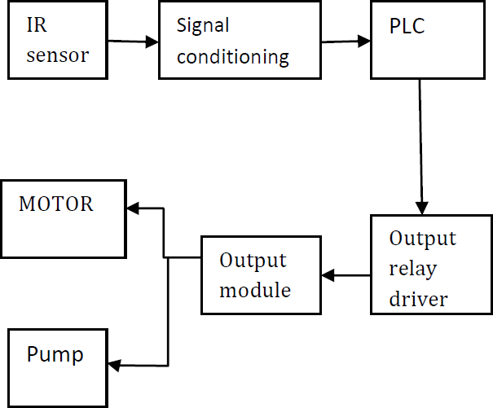
Figure 4.6: Block Diagram

Flowchart

No
Start
Start push button?
Conveyer motor ON
Is there bottle under?
Conveyer motor OFF and Solenoid valve ON
Start Bottle Filling
Is bottle full?
Solenoid valve OFF and conveyer motor ON
Start push button?
END

No

No

No

Figure 4.7: Flow Chart

Circuit Diagram

Photoelectric
Sensor-1
Photoelectric Sensor-2
Photoelectric
Sensor-3
INPUTS

Allen Bradley MicroLogix 1500
24VDC
Power Supply
12VDC Power Supply
OUTPUTS
+ Common
+ Common
+ Common
+ Common
+ Common
+ Common
Relay
Relay
Relay
Relay
Relay
Relay
NC
NO
NC
NO
NC
NO
NC
NO
NC
NO
NC
NO
Water Pump
Solenoid Valve
Conveyer Motor-1
Rotary Motor
Actuated Piston & DC Motor
Conveyer Motor-2

Figure 4.8: Circuit Diagram

Chapter 5TEST ANDRESULTS
As we are using PLC as a controller so there is limited simulation to verify all the tests. Allen Bradley has a software named RS Logix 500 which is used for the communication ofPCwithPLC-AllenBradleyMicroLogix1500Series.Ithasitsownsimulationsoftware named RS Logix 500 Emulator which can be linked to the main software through a communication software named RS Linx Classic. In the simulation, we verified that the code is working properly. Each bit, output, timer and other relevant instructions are working properly.

As due to COVID Pandemic, we are only restricted to software based or simulation-based work or tests. We tested our code there, by switching on the start button, the respective bit turns 1and so the other code. All the simulation results are according to other calculations.

Figure 6.1 Shows the Software named RSLinx Classic which is used to link the emulator or PLC to the RS Logix 500 software. Here, we have created an emulator link can be seen on the left side named EMU500-1, DH-485. After the selecting the file in emulator, we selected the workstation and emulated MicroLogix 1500 is created.
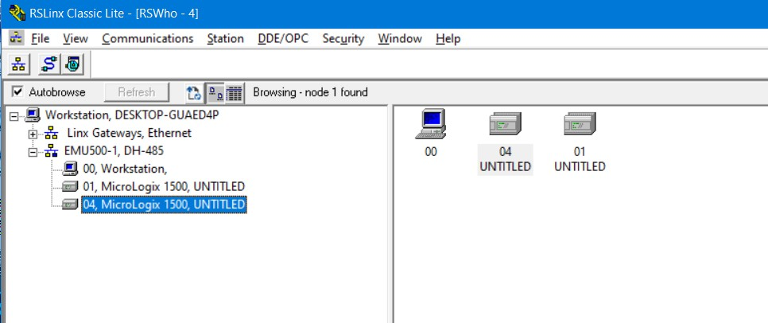
Figure 6.1: RSLinx Classic Lite

Figure 6.2 shows the RS Logix 500 Software, here the closed / activated bit and inputs are highlightedbyGreenColor.Byswitchingontherespectiveinputandobservingtheoutputs, the code is verified.

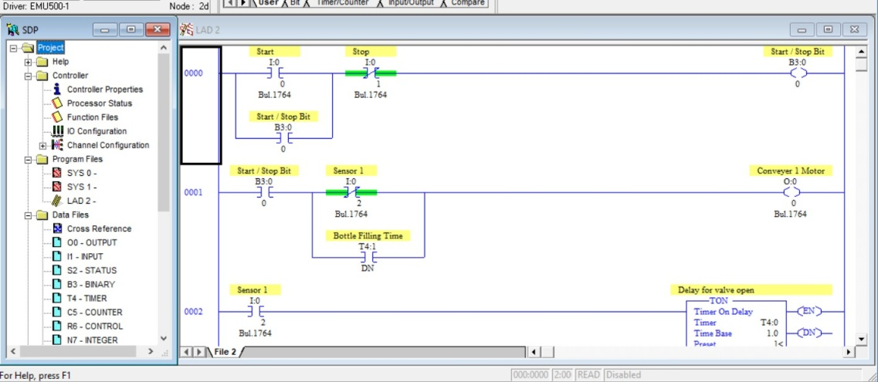
Figure 6.2: RS Logix 500

CHAPTER 6 CONCLUSION

Conclusion

Automatic bottle filling system using PLC is designed and observed thoroughly. All the work is concluded in following key points.
    - This method reduces the number of workers required in manual bottle filling methodhenceitisveryhelpfulinreducingthelaborcostandalsoreducesthetime required. Also, the maintenance cost of this system is minimal.
    - Infirststage,wedidbottlefillingwhichwasdonebysolenoidvalve.Wedidcoding insuchawaythatitturnedONthevalveforfewsecondstofillthebottleaccording to its capacity and our desired value.
    - In second stage we did bottle capping which was done by Dc motor. Dc motor moved the cap hopper up and down to perform bottle capping. In third stage conveyor belt carried the capped bottle right into the packaging carton.

Future Work

This process can be made more advance by doing following modifications.
    - Robots can be used to make it fully automatic in which there is no need of labor. Robots will place the bottles on the conveyor belt, after filling and capping of bottles robots will pick the bottles from conveyor belt to the packaging carton.
    - Multi-Nozzle system can be used to increase the productivity. In this system number of bottles can be filled simultaneously and for capping these bottles at a time multi-cap hopper can be used. This method can be used to save a lot of time.
    - Image processing can be used to perform the sorting of the bottles on the basis of their sizes and colors.

ABBREVIATIONS

PLC | Programmable Logic Controller
DC | Direct Current
LED | Light Emitting Diode
IR | Infrared
I/O | Input / Output
CPU | Central Processing Unit
PC | Personal Computer
LAD | Ladders Language
FBD | Functional Block Language
SCL | Structural Control Language
NC | Normally Closed
NO | Normally Open
AC | Alternating Current
PVC | Poly-Vinyl Chloride
RPM | Revolutions Per Minute

REFERENCE

- Galloway, B., & Hancke, G. P. (2012). Introduction to industrial controlnetworks. IEEE Communications surveys & tutorials, 15(2),860-880.

- Abinandhan, P., Nayan Prakash, R., & Samad, R. K. (2008). Study and implementation of programmable logic controller (Doctoraldissertation).

- Martins, J., Lima, C., Martínez, H., & Grau, A. (2010). A Matlab/Simulink framework for PLC controlled processes. Matlab-Modelling, Programming and Simulations,211.

- Ohab, A., Abid, M., & Rahman, M. (2019). Study on Comparative Security Analysis of IOT Framework (Doctoral dissertation, Daffodil International University).

- Ross, A. (2004). No-collar: The humane workplace and its hidden costs. Temple UniversityPress.

- Mosher, O. A. (1998). U.S. Patent No. 5,767,455. Washington, DC: U.S. Patent and TrademarkOffice.

- Quinn, J. B., & Paquette, P. C. (1990). Technology in services: creating organizational revolutions. MIT Sloan Management Review, 31(2),67.

- Algitta, A. A., Mustafa, S., Ibrahim, F., Abdalruof, N., & Yousef, M. (2015). Automated packaging machine using PLC. International Journal of Innovative Science, Engineering & Technology, 2(5),282-288.

- Sharma, K., & Kamboj, S. Software Implementation of Automatic bottle filling using PLC forIndustries.

- Industrial Application of PLCs In Bangaladesh” 1 Ahmed Ullah AbuSaeed,2 Md.Al- Mamun,3 A.H.M.ZadidulKarim, Department of EEE, University of Pacific, Dhanmondi, Dhaka. International Journal of Scientific & Engineering Research (ISSN2229-5518)2012

