Robots in Healthcare
¹S M Nazmuz Sakib (Orchid- https://orcid.org/0000-0001-9310-3014) (sakibpedia@gmail.com)

¹ Graduate of BSc in Business Studies
School of Business And Trade
Pilatusstrasse 6003, 6003 Luzern, Switzerland

¹ Student of BSc in Civil Engineering
Faculty of Science and Engineering
Sonargaon University
147/I, Green Road, Panthapath, Dhaka

¹ Student of LLB(Hon’s)
Faculty of Law
Dhaka International University
House # 4, Road # 1, Block - F, Dhaka 1213

¹ Student of BSc in Physiotherapy
Faculty of Medicine
University of Dhaka
Nilkhet Rd, Dhaka 1000

¹

¹Author Biography
S M Nazmuz Sakib is an eLearning expert and done more than 500 MOOCs or Massive Open Online Courses and experienced as an instructor in sites like Udemy. He has completed his BSc in Business Studies from School of Business And Trade, Switzerland with CGPA 4 in the scale of 4 and 97.06% grade marks on an average. He is also a certified Google IT Support Professional, Google Data Analytics Professional and IBM Customer Engagement Specialist Professional.

Abstract: The robotic system has been used in a variety of fields, most notably robotics use in areas that require a high degree of accuracy. The robotic system is developing and changing markets worldwide. This system is rapidly emerging, particularly when it combines with other capabilities including artificial intelligence (AI) in order to learn from the surroundings as well as humans. AI technology is capable of transforming the position of the doctor substantially and transforming the medical practice framework. This research study analyses some recent health studies in applications based on robotic systems or AI in various medical fields and examines both the existing benefits and problems associated with this new technology. Doctors, particularly those who have some top position in the healthcare sector, have to be mindful of the speed at which AI systems developing in the healthcare sector so they are prepared to adjust the transition needed for its implementation by the health system. Even though many practices have been made simpler by robotics, the use of such technologies has a range of implications that have had an effect on ethical policies as well as pharmacist recruitment policies. Substituting workers with robotics for organizations in the service sector is an inevitable option, not least in the healthcare sector, given the difficult and often unsanitary working climate. However, it is also being proposed by studies that it should be carried out in a way that contributes to improved jobs and motivation for staff members in the healthcare sector.
Keywords: artificial intelligence (AI); robotic system; healthcare sector; employment

Background and Introduction
Robotics research has advanced dramatically in the last two decades. In this age of knowledge explosion, human capital has been one of the key driving factors behind service sector organizations’ economic growth. It is also essential for all physicians, particularly those in leading roles in the healthcare sector, to foresee future developments and to predict their consequences so that they can make strategies and policies to deal with them (Garcia et al., 2007). For the reason that AI or robotic technology has the potential to turn the role of the doctor dramatically and to revolutionize the profession. For a short span of time, the workers from the manufacturing sector have suffered the effects of robotic technology and cybernetics. Over the last fifty years, robots become integrated into everyday life, which used to be sci-fi is now a reality (Wolton, 2020). Nowadays, innovations in robotics help everybody in the developing world in their daily lives (Wolton, 2020). A similar change in the healthcare sector is becoming more and more a political interest; this is driven by efforts to increase the quality and protection of treatment while at the same time reducing costs (Bates and Gawande, 2003). The new development has started to substitute various facets of human performance with computational capacities (robotic system), such as accuracy (clinical robots), logistically or mechanically (service robots), as well as complex reasoning activities.
The healthcare sector has been relatively reluctant to implement electronic schemes, such as electronic health records system (EHRs), in comparison with other sectors such as hospitality or airlines and EHR system has recently become common (Palabindala et al., 2016). Likewise, while AI is now integrated with several technologies including smartphones and software, its use in clinical practice is still limited. However, research exploration in this field is expanding at a rapid pace. This research study mainly covers the framework of the robotic system implementation in the healthcare sector along with its positive perspectives of usage in this sector as well as the challenges it brings with its implementation in the healthcare sector.

Literature Review

Positive Perspective of Robotic System in Healthcare Sector
The healthcare sector deals with infection diagnosis as well as with their treatment and prevention. The sector also deals with some other physical and psychological injuries in people. The health care sector may possibly a major contributor to the economy of any country. Pharmaceutical management can take advantage of the framework of robotic predictability. The employees in the healthcare services sector have had to expand their hours of service in the hospital and ambulatory care at the turn of the new century. During the time period of 2007, a service robot was used for prescription-filling in over a number of hospitals due to the expanded hours as well as prescriptions (Lin et al., 2007). In addition to screening and barcode checking for the drug, the robotic device shall reach the suitable flask, collect the medicine and mark each flask, and packaging, storing and distributing filled medicines to patients (Butter et al., 2008). Nowadays, robotic system is in high demand in the healthcare sector because this technology can perform tasks in a way that humans can’t, or they don’t want to do those tasks, or can’t have the ability to do proficiently as the robots can do. As demonstrated by overworked hospital staffs and a lack of home nurses, proficiency is considered as an important factor in both the hospital as well as home-based healthcare environments. This market is naturally enhanced by an aging population. People all over the world generally live a longer life (Chen et al., 2019; Robinson et al., 2014).
Similarly, this robotic system may possibly be able to help in meeting the demand of services that has increased due to the inclusive upsurge in healthcare costs, especially labor costs. While the long-term cost efficiency of robotics is under discussion, the capacity of robots to extend facilities beyond the conventional health care environment could alleviate existing hospital resources stress (Van Der Loos et al., 2016). Moreover, the market movement towards customized healthcare will boost the demand of robotic system. The robotic system can be particularly useful to rehabilitated patients as well as for those who need some special care or treatment (Simshaw et al., 2015).
Global Trends in the Robotics market, 2020
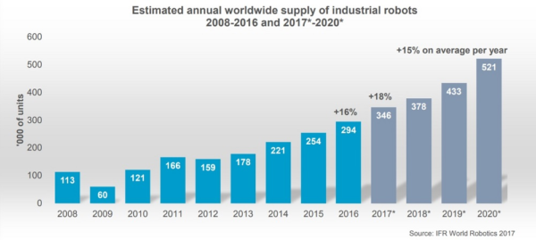
Figure: 1
It can be observed that the expected global sales to industrialized robots will grow by 18 percent to around 346,800 units during the year of 2017. The above trends showed that worldwide industrial robotics sales rise by at least 15 percent annually in average during the time period of 2018 to 2020. Whereas, it can be observed by the trends above showing that during the year of 2017 to 2020 that more than 1.7 million innovative industrialized robotics will be introduced in processing plants all throughout the globe. Despite the fact that the automobile sector continues to be the largest user of industrialized robotics and the electronic market is on the rise.

The Challenging Factor of Robotic System in Healthcare Sector
Given its possible advantages, the difficulty of the processing and application of robotic system data raises the possible safety and privacy challenges of the healthcare sector (Batth et al., 2019; Simshaw et al., 2015). Their implementation must be a key element and provide awareness of possible protection and privacy problems that if unnoticed could damage patients and customers, weaken the interest of strategic investors of robotics system regarding the healthcare sector, and hold back long-run revolution. Comprising these risks includes an assessment of how robotic systems in the healthcare sector and the controlling environment under which robotics operate are used or can be used (Batth et al., 2019; Simshaw et al., 2015). On the other hand, automation-repository robots have led to overloading, when medication functions have replaced some tasks for the operator and potentially the running, storage, and diagnostic processes for robotics delivery (Lin et al., 2007). Such drawbacks include the cost of supplies, restoration of provision, and robotic failure to stock vaccinate, wholesale materials, and chilled goods in its courier method (Summerfield et al., 2011).
Current tendency/unwillingness to implement robotic system in the healthcare sector
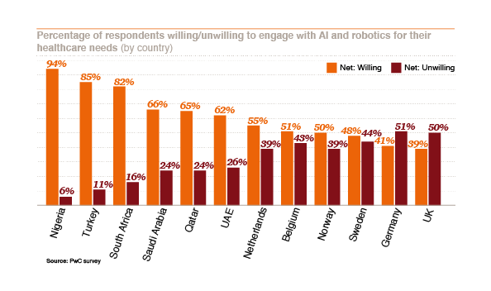
Figure: 2
It is clear that improved access to and precision in medical care was a major motivator for the contributors’ readiness to use an AI based robotic system, whereas the lack of confidence and the human aspect being their main cause of reluctance.
The research study on robotic representations was suggested that robotic system may also lead to misinterpretations of the word and miscommunication between people when seen from a wide spectrum of experience. While not quite recent, over the years, ordinary citizens and experts used the word robots or robotics in certain parts of their work, highlighting that the skills of this technology can be used and that will modify the understanding and perception of the term among the multitudes (Kar, 2019; Craig, 2004). If careful care is not taken at any point of designing, implementation, and usage, the rates at which the robotic system is being built and taken could marginalize those protection and confidentiality concerns. With the advancement of implementation of robotic system in the healthcare sector, it is critical that current and new data practices are continually revised, that data are assessed and analyzed in order to capture, preserve, and use data, and that robots and manufacturers be mindful of the regulatory challenges they pose (Simshaw et al., 2015).
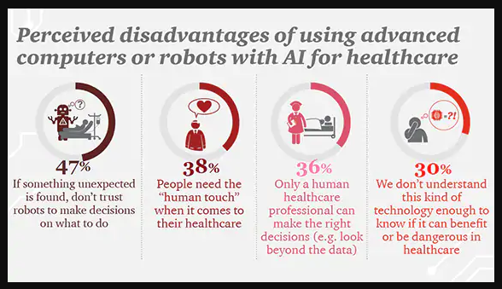
Figure: 3
Patients are becoming more likely to interact with AI and robotics if it means improved access to healthcare. The pace and precision at which diagnoses and treatments are made is a vital factor in this willingness. Trust in technology is essential for broader use and adoption; the “human touch” is also an important part of the healthcare experience. But the case of UK is different as compared to other countries.

Limitations and Further Research
The range of robotic applications in the healthcare industry extends from the operations room to the dining room. Robots have been used in a variety of applications to assist humans with activities that can be tedious, include considerable risk, require precise accuracy, or require some kind of refined multifaceted skill. As by discussing the limitation of this research, this research has the main focus on the health sector only and it has considered the benefits as well as challenges of robotic system in the healthcare sector. Moreover, this research has only focused on secondary data gathered, and there is space for primary data analysis. More can be done by concentrating on various sectors of the robotic environment that have more benefits than their drawbacks of robotic applications. Where the essential need to perform effectively lies in this robotic device, it may be manufacturing, retail sectors etc.

Conclusion
Robots also aided patients and health professions in a variety of areas in the medical sector. Moral concerns are related to technical cost-efficiency, the need to maintain the security of patients and to ensure that health workers tolerate fewer clinical touches, but the health benefits both for the patients and employees seem to dominate the traditional disadvantages of robotic system. The study (Butter et al., 2008) proposed that it will take another 25 years to join the healthcare sector with some emerging technologies, by considering prospective robotics procedures in Europe can be further studied with robotics supervised operations, patient observing, and behavioral, mental, and social therapy (Butter et al., 2008).
Sociotechnical issues related to the introduction of robotic systems are important in healthcare environments, but they are likely to vary with various robotic implementations and cultures. These problems must be possibly expected and proactively dealt with. As healthcare environments are distinguished by their care activities, this is provoked in an increasingly digital and technical world to maintain or escalate. This can only be achieved if we foresee and actively solve problems of emerging developments by integrating them into current social guidelines. The robots have some kind of functions through which they are able to respond or to deal with the instructed situation. In that case, they would not be able to respond in any sudden situation appeared as that they did not have any functionality framework. As a result, their replacement with robotics is therefore an unavoidable option for organizations in services, especially in the area of healthcare. Similarly, researchers recommend that it be carried out in a way that helps improve the jobs and motivation of workers in that field.
The research has found the effects of robotic system on the quality of work and employee morale, positively as well as negatively and it is worth noticing. In addition, the research work is valuable for the healthcare sector in order to map the main fields of interest about the effect of robotic system implementation on jobs and morale of health workers. The emphasis will then be on developing the sector's reliable, safe and job-friendly robots or robotic system.

References
Bates, D. W., and Gawande, A. A. (2003). Improving Safety with Information Technology. New England Journal of Medicine, 348(25), 2526–2534. https://doi.org/10.1056/nejmsa020847
Batth, R. S., Nayyar, A., and Nagpal, A. (2019). Internet of Robotic Things: Driving Intelligent Robotics of Future - Concept, Architecture, Applications and Technologies. Proceedings - 4th International Conference on Computing Sciences, ICCS 2018. https://doi.org/10.1109/ICCS.2018.00033
Butter, M., Rensma, A., van Boxsel, J., Kalisingh, S., Schoone, M., Leis, M., Gelderblom, G. J., Cremers, G., de Wilt, M., Kortekaas, W., Thielmann, A., Cuhls, K., Sachinopoulou, A., and Korhonen, I. (2008). Robotics in Helthcare, Final Report. Robotics in Helthcare, 179.
Chen, Y., Abel, K. T., Janecek, J. T., Chen, Y., Zheng, K., and Cramer, S. C. (2019). Home-based technologies for stroke rehabilitation: A systematic review. In International Journal of Medical Informatics (Vol. 123). https://doi.org/10.1016/j.ijmedinf.2018.12.001
Craig, J. J. (2004). (book)Introduction to Robotics: Mechanics and Control 3rd. Prentice Hall, 1(3).
Garcia, E., Jimenez, M. A., De Santos, P. G., and Armada, M. (2007). The evolution of robotics research. IEEE Robotics and Automation Magazine, 14(1). https://doi.org/10.1109/MRA.2007.339608
Kar, S. (2019). Robotics in HealthCare. 2019 2nd International Conference on Power Energy Environment and Intelligent Control, PEEIC 2019. https://doi.org/10.1109/PEEIC47157.2019.8976668
Lin, A. C., Huang, Y. C., Punches, G., and Chen, Y. (2007). Effect of a robotic prescription-filling system on pharmacy staff activities and prescription-filling time. American Journal of Health-System Pharmacy, 64(17). https://doi.org/10.2146/ajhp060561
Palabindala, V., Pamarthy, A., and Jonnalagadda, N. R. (2016). Adoption of electronic health records and barriers. Journal of Community Hospital Internal Medicine Perspectives, 6(5). https://doi.org/10.3402/jchimp.v6.32643
Robinson, H., MacDonald, B., and Broadbent, E. (2014). The Role of Healthcare Robots for Older People at Home: A Review. International Journal of Social Robotics, 6(4). https://doi.org/10.1007/s12369-014-0242-2
Simshaw, D., Terry, N., Hauser, K. and Cummings, M.L. (2015). Regulating healthcare robots: Maximizing opportunities while minimizing risks. Rich. JL & Tech., 22, p.1.
Summerfield, M. R., Seagull, F. J., Vaidya, N., and Xiao, Y. (2011). Use of pharmacy delivery robots in intensive care units. In American Journal of Health-System Pharmacy (Vol. 68, Issue 1). https://doi.org/10.2146/ajhp100012
Van Der Loos, H. F. M., Reinkensmeyer, D. J., and Guglielmelli, E. (2016). Rehabilitation and health care robotics. In Springer Handbook of Robotics. https://doi.org/10.1007/978-3-319-32552-1_64
Wolton, D. (2020). The robots are coming. Cleanroom Technology, 28(2). https://doi.org/10.1145/1060189.1060233

