Low-velocity impact and compression-after-impact performance of non-conventional automated fibre placement composites
* Xie Li ª, Sonya A Brown ^{b}, Garth M Pearce ^{c}
^{a,c} ARC Training Centre for Automated Manufacture of Advanced Composites, School of Mechanical and Manufacturing Engineering, UNSW Sydney, NSW 2052, Australia
^{b} School of Mechanical and Manufacturing Engineering, UNSW Sydney, NSW 2052, Australia

ª xie.li@student.unsw.edu.au
^{b} sonya.brown@unsw.edu.au
^{c} g.pearce@unsw.edu.au
*Corresponding author, xie.li@student.unsw.edu.au, UNSW Sydney, NSW 2052

Abstract
Advanced Placed Ply (AP-Ply) laminates are novel semi-woven, non-conventional architectures which combine the benefits of Automated Fibre Placement (AFP) and textile composite technologies. They are fabricated using AFP by rearranging the tow placement sequence. The AP-Ply concept provides a huge design space for AFP and offers more opportunities to obtain lightweight composite structures while retaining damage tolerance and other desirable properties. This paper aims to experimentally investigate the benefits and limitations of AP-Ply with emphasis placed on the low-velocity impact and compression-after-impact performance. The internal impact damage is quantitatively assessed with X-ray computed tomography scans. The results indicate the damage within the AP-Ply is more concentrated while traditional AFP laminates tend to have fewer, but larger cracks and delaminations. A significant improvement is noted for AP-Ply relative to traditional AFP benchmarks in terms of the damage resistance and tolerance.
Keywords: Automated Fibre Placement, Damage tolerance, Impact behaviour, Composite laminates, Computed tomography.

Introduction
One of the major drawbacks of composite laminates is the low through-thickness strength, which makes layered composite parts extremely sensitive to out-of-plane damage, such as that induced by impact. Low-velocity impact (LVI) attracts more attention as the resulting damage can be embedded in the laminate in the form of matrix cracking, fibre breakage and delamination while potentially only leaving a trivial indent on the outer surface, which can easily escape routine inspections. Those internal damages, especially delamination, can reduce the residual compressive strength of the composite structure by more than 50% [1, 2]. Hence, improving the through-thickness performance and understanding the associated failure mechanisms of composite laminates are of critical importance.
The literature reports several factors that affect the through-thickness performance of composite laminates, such as fabric architecture, resin toughness, stacking sequence, fabric hybridization, etc. Those factors have been thoroughly reviewed by Shah et al. [3]. In their study, the fabric architecture and resin toughness were identified as the primary elements that affect the damage resistance and tolerance. Tailoring the fabric architecture such as stitching, z-pinning, weaving, braiding etc, was proven to be effective in many studies [4-8]. However, the drawbacks of these techniques such as stress concentration arising from yarn crimping [9], resin-rich pockets due to the fish-eye generation [3] during the stitching process and microstructural damage resulting from z-pins insert [10], also compromise the laminate in-plane properties substantially. The resin toughness is another critical factor that directly affects the interlaminar properties. Using a toughed resin material such as thermoplastic or by adding extra toughening particles to a thermoset resin have been shown to significantly improve the damage resistance and tolerance [11, 12].
Along with the efforts to research the key factors in improving the through-thickness performance of composite laminates, for the aerospace industry, emphasis is also placed on manufacturing efficiency and cost effectiveness [13]. A new laminate concept named advanced placed ply (AP-Ply), which was proposed by Nagelsmit et al. [14] has been demonstrated to improve the impact resistance and damage tolerance by tailoring the fabric architecture without sacrificing in-plane properties. This advanced laminate concept integrates the textile technology into the automated additive manufacturing method, Automated Fibre Placement (AFP), which has great tailoring flexibility for both fibre positions and orientations. Traditional AFP manufacturing is achieved via placing multiple parallel tows on the mould surface to construct a ply, which maintains a nearly identical fibre architecture with unidirectional (UD) tape laminates. To further utilise the advantages afforded by AFP, the tow placement sequence is customised in AP-Ply, resulting in a semi-woven fibre architecture, as illustrated in Fig. 1. The difference between fully woven textile fabrics and semi-woven AP-Ply is depicted in Fig. 2. Due to the additive composites manufacturing characteristic, the tow cannot be placed underneath preceding tows, which hence can only generate a semi-woven structure. The major benefit of the AP-Ply concept over textile composites is it offers a much higher degree of freedom for fibre path customization by using AFP. Each tow of AP-Ply can be tailored directionally which substantially extends the design space and offers opportunities to achieve more lightweight composite structures with automation.
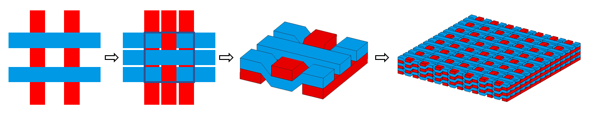
Figure 1. The formation process of AP-Ply laminate [15]
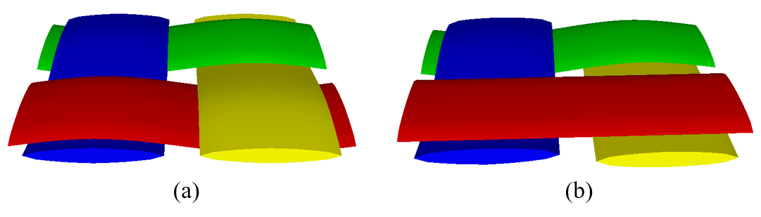
Figure 2. Schematic illustration of (a) fully woven and (b) semi-woven structures

As the AP-Ply concept was only proposed during the last decade, the experimental studies are limited in the literature. Nagelsmit et al. [14] have investigated the LVI and compression-after-impact (CAI) performance of AP-Ply structure in terms of numbers of design parameters including tow width, weaving pattern, fibre angle, number of layers to interweave, etc. The results indicated that a slight improvement in the residual compressive strength of 5-10% is achievable with an optimised design. More importantly, from the cross-sectional images of the impacted samples, the AP-Ply indicated more concentrated damage in the form of multiple small delaminations, matrix cracks and fibre failures while the UD exhibited few major but much wider delaminations. Rad et al. [16] studied the high-velocity impact performance of AP-Ply with a hybrid laminate structure, which combines both UD and AP-Ply layers. They found the hybrid laminate can significantly reduce the back surface damage by 45% and deflections by 19.5%. Li et al. [15] recently have demonstrated that the AP-Ply can achieve comparable short beam strength with UD when the degree of inter-ply tow weaving is small. The potential benefits of AP-Ply structure were also investigated analytically and numerically by Zheng et al. [17, 18].
The design space of AP-Ply is huge. Although the potential of this advanced laminate concept has been demonstrated with several specific configurations, the defects including tow crimping, resin pockets, thickness variations, voids, etc., can substantially compromise the structural performance. To obtain an optimum AP-Ply design, a thorough understanding of the effect of these defects, as well as how they interact with the material failures is critical. This, however, requires extensive material testing and numerical investigations to facilitate the understanding. This paper does not attempt to address these significant challenges. Instead, the primary aim is to both quantitatively and qualitatively evaluate the damage resistance and tolerance of AP-Ply with different weaving morphologies to further facilitate the understanding of associated reinforcing and damage mechanisms of the semi-woven structure. The impact resistance is defined as the impact energy per unit damaged area [19]. The quantitative assessment of the damaged area is achieved via X-ray computed tomography (CT) scanning. The damage tolerance is defined as the retention capability of pristine strength. The residual strength is measured via a CAI test and the pristine strength is evaluated using a combined loading compression (CLC) test.
The laminate design and specimen preparation are provided in detail in Section 2. In Section 3, the LVI, CAI and CLC experimental setup and procedures are introduced. The test results for different laminate configurations are presented in Section 4, and the benefits and limitations of the AP-Ply structure are discussed by comparing against the UD laminate. In Section 5, the key findings and the corresponding conclusions are highlighted.

Manufacturing and specimen preparation
As shown in Fig. 3, each traditional ply can be subdivided into sets, each representing a collection of tows. The maximum number of sets is equivalent to the number of tows in the ply, but the number of combinations of set composition is extremely large, even for lab-scale panels. By manipulating the ply divisions and customizing the deposit sequence, substantial structural variants can be achieved with AP-Ply. To efficiently distinguish these variants and convey the geometric information, the AP-Ply notation from [15] was used in the present study. Different to the conventional laminate notation, where each ply is simply defined as θ (ply angle), the notation in AP-Ply is defined as $θ_{\frac{m}{n}}$. These two extra indices indicate the total number of ply divisions (n) and the specific division number (m). A simple example consisting of two conventional layers [0/90] is used in Fig. 3 to further illustrate the AP-Ply notation.
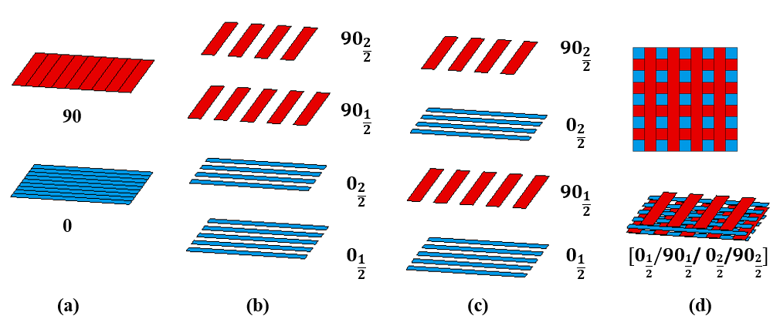
Figure 3. The illustration of AP-Ply notation: (a) conventional two-ply laminate example consists of 0º (blue) and 90º (red), (b) each conventional ply is divided into 2 divisions and each division is labelled in order, (c) the tow placement sequence is rearranged, (d) the formation of AP-Ply and the complete AP-ply notation [15].

In this study, two typical fibre architectures of AP-Ply laminates were manufactured and tested including 2D weaving and 3D weaving, which are analogous to the concept of plain-woven and 3D angle-interlock woven in textile composites. These two different AP-Ply architectures were labelled as AP2D and AP3D for simplification throughout the present study. A traditional AFP laminate was also used as a baseline for comparison (analogous to a UD tape laminate). Fig. 4 depicts the difference in fibre architectures between these laminates. It should be noted that the visualization is only used here to illustrate the weaving morphology and does not correlate with any physical specimen dimensions.
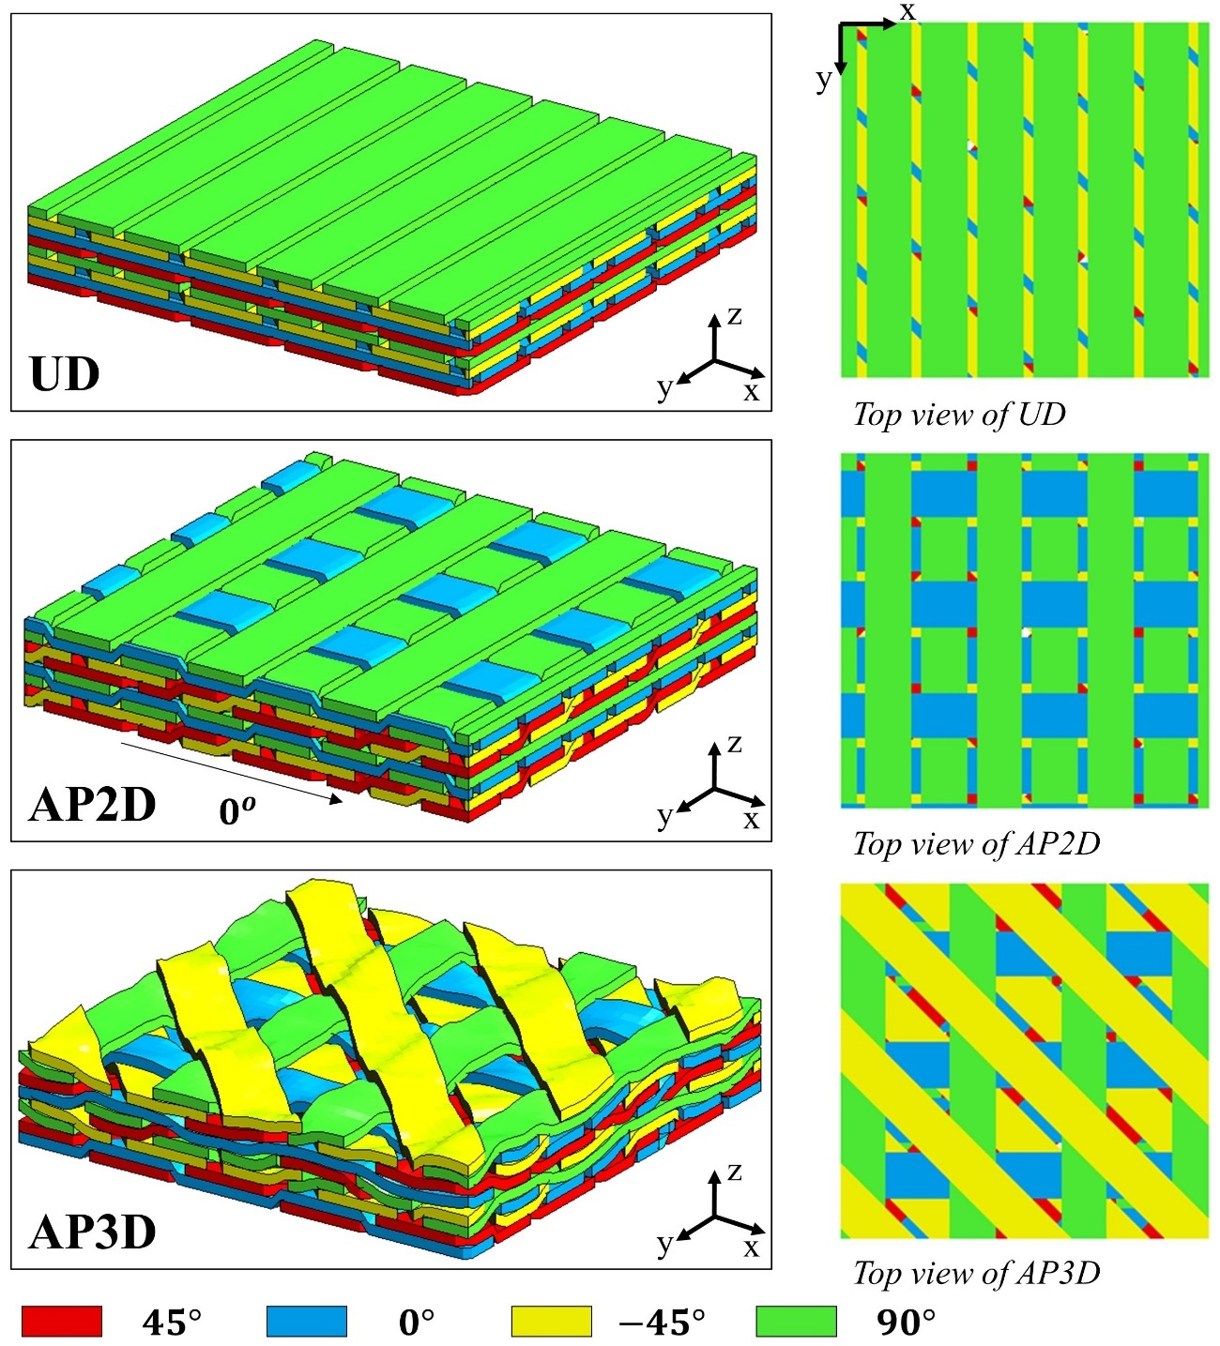
Figure 4. 3D visualization of fibre architectures between different laminate configurations

Every two orthogonal layers were designed to be semi-woven for AP2D. While for AP3D, an interlocked structure in the through-thickness direction was achieved with a special tow placement sequence, as presented in Fig. 5. This technique is called fully interwoven, which was proposed by Nagelsmit et al. [14]. Using this approach, each layer can be designed to be interlocked with adjacent touching layers, resulting in an integrated woven structure.
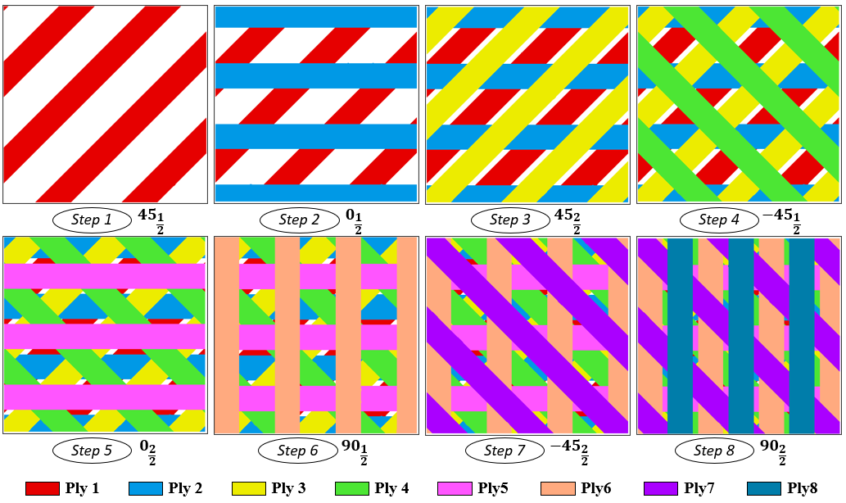
Figure 5. The tow placement order to achieve a fully interlocked laminate structure.

The specimen dimensions of this test were designed following the ASTM D7136 [20], which requires an in-plane specimen size of 150 x 100mm and a thickness of 4 to 6mm. A recommended layup [(45/0/-45/90)]_{4s} from the standard was used for the UD configuration. The AP-Ply laminate layups were designed based on the same stack sequence with a goal of achieving comparable layups with the UD. This is to mitigate the effect brought by the differences induced by the stack sequence. A total layer number of 32 was designed for each configuration to achieve an approximately 4mm thick laminate. To illustrate the tow placement sequence, the notation for each configuration is presented below:
- UD: [(45/0/-45/90)]_{4s}
- AP2D: [${45}_{\frac{1}{2}}$/${-45}_{\frac{1}{2}}$/${45}_{\frac{2}{2}}$/${-45}_{\frac{2}{2}}$/$0_{\frac{1}{2}}$/${90}_{\frac{1}{2}}$/$0_{\frac{2}{2}}$/${90}_{\frac{2}{2}}$)]_{4s}
- AP3D: [${45}_{\frac{1}{2}}$/($0_{\frac{1}{2}}$/${45}_{\frac{2}{2}}$/${-45}_{\frac{1}{2}}$/$0_{\frac{2}{2}}$/${90}_{\frac{1}{2}}$/${-45}_{\frac{2}{2}}$/${45}_{\frac{1}{2}}$/${90}_{\frac{2}{2}}$)₇/$0_{\frac{1}{2}}$/${45}_{\frac{2}{2}}$/${-45}_{\frac{1}{2}}$/$0_{\frac{2}{2}}$/${90}_{\frac{1}{2}}$/${-45}_{\frac{2}{2}}$/${90}_{\frac{2}{2}}$]
All the laminates were manufactured in the Automated Dynamics AFP machine at the University of New South Wales with the HST45E23/E-752-LT prepreg (145gsm and resin content of 35%). The materials were cured with a pressure of 6.2 bar at 177ºC for 2.5 hrs. Caul plates were placed on top of each panel to achieve a uniform thickness and consistent surface finish. The specimen cutting was accomplished with a Multicam Computer Numerical Control (CNC) Routing system.
To mitigate the thickness undulations near the tow overlap areas, an artificial tow-to-tow gap size of 1.3mm was intentionally added to all plies (see UD in Fig. 4). This does not lead to large resin-rich regions in most laminates as the tows easily spread under consolidation pressure. Fig. 6 presents the cross-sectional tow distributions and resin pockets of the cured laminate configurations. It can be observed that the tow-to-tow gaps have nearly disappeared in UD, while for AP-Ply laminates the resin pockets were concentrated on the weaving corner, which might be because the weaving structure constrained the flows of fibre with different orientations. The resin gaps observed in the semi-woven configurations are comparable or smaller than those found in fully-woven textile composites.

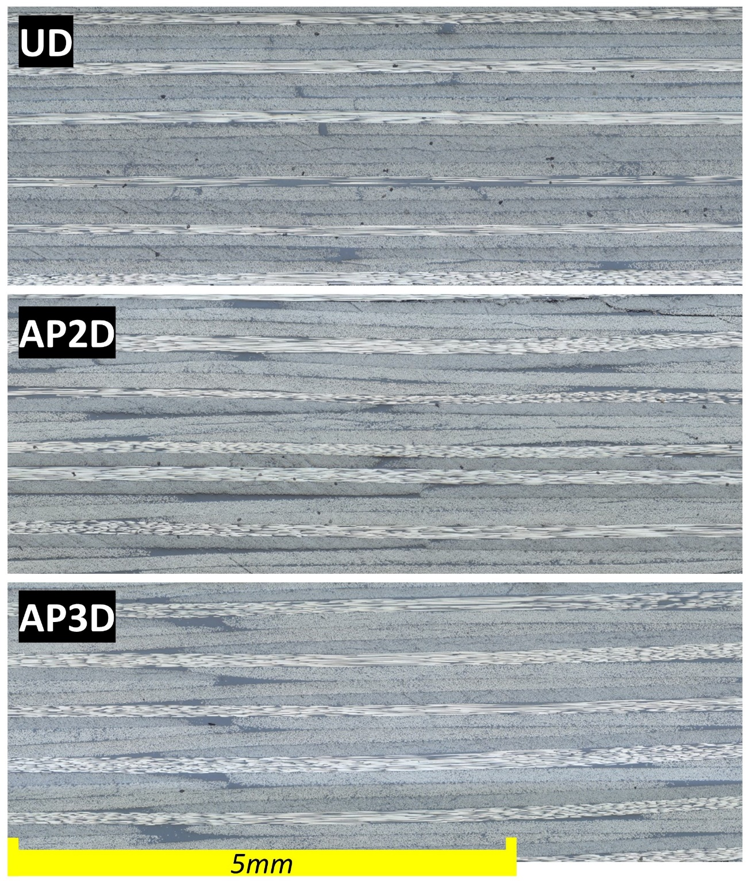
Figure 6. The detailed cross-sectional view of different laminates

Experiment description

LVI experimental setup
The LVI experiment was carried out with an Instron CEAST 9350 Drop Tower system, as per the ASTM D7136 [20]. A schematic diagram of the LVI experimental setup is presented in Fig. 7. A hemispheric indenter with a diameter of 16mm and a mass of 4.392kg was used as the drop weight impactor. The specimens were placed in the centre of the impact support fixture base including a 125 x 75mm cut-out and secured with four clamps with rubber tips. Guiding pins were used to ensure the specimen can be centrally aligned with the cut-out. An anti-rebound system was activated after impact to prevent secondary damage to the samples. The force-time response during the LVI event was captured by the data acquisition system. All the laminate configurations were tested with two different impact energies, 25J and 40J, which were controlled by adjusting the drop height of the impactor. Three samples were tested for each laminate configuration and energy level.
To quantify and understand the damage mechanisms occurring between different laminate structures, a Non-Destructive Inspection (NDI) method, X-ray CT scanning, was carried out on the impacted specimens.
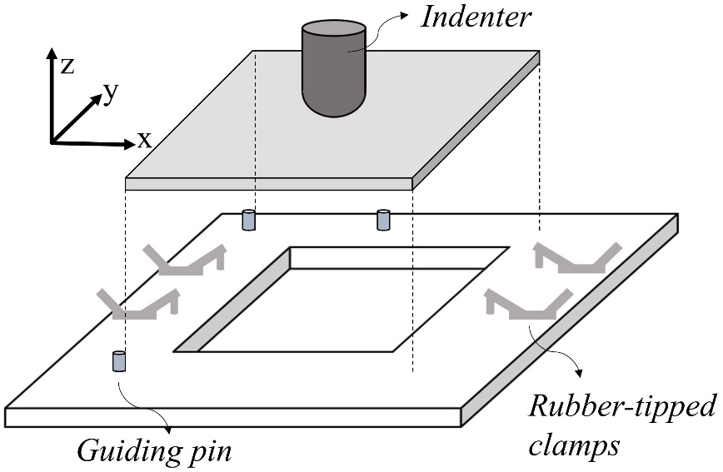
Figure 7. The schematic setup of low-velocity impact test

The displacement ($δ\left(t\right)$) and absorbed damage ($E\left(a\right)$) can be computed based on the force-time response following the formulations provided by ASTM D7136 [20], as expressed by
$δ\left(t\right)= δ_{i}+v_{i}t+ \frac{gt^{2}}{2}-\int_{0}^{t}{(\int_{0}^{t}{\frac{F(t)}{m}dt)dt}}$ (1)
$E\left(a\right)= \frac{m\left(v_{i}^{2}-v{\left(t\right)}^{2}\right)}{2}+mgδ\left(t\right)$ (2)
Where $δ_{i}$ refers to the initial impactor displacement from the reference point, $v_{i}$ denotes the initial impact velocity, $g$ represents the gravity acceleration, and $m$ refers to the impactor mass. The indenter velocity ($v(t)$) during the impact can be computed by
$v\left(t\right)= v_{i}+gt- \int_{0}^{t}{\frac{F(t)}{m}dt}$ (3)

CAI and CLC experimental setup
The CAI and CLC (baseline) tests were both conducted with a servo-hydraulic testing machine, Instron 8804 with a load cell of 500kN. The schematic setup of CAI test is displayed in Fig. 8. For the CAI test, the impacted samples were placed in a multi-piece support fixture to prevent buckling during the compression loading. Instead of being fully clamped at all the specimen edges, the side supports are four steel plates with knife edges which do not provide constraints against local rotations. The compression was applied via two flat platens with a displacement rate of 1.25mm/min in accordance with the ASTM D7137 [21]. All the impacted samples for each laminate configuration were tested.
For the CLC test, the in-plane dimensions of the specimen were designed as 140 x 30mm with a gauge length of 13mm, as per the ASTM D6641 [22]. The maximum suggested specimen width was used in this test to incorporate a representative weaving material volume. Similar to the CAI test, the compression was applied via two flat platens but with a displacement rate of 1.3mm/min. Five samples for each laminate configuration were tested. The pristine and residual strength can be computed by $σ=F/A$, where F and A refer to the maximum force prior to failure and the cross-sectional area, respectively.
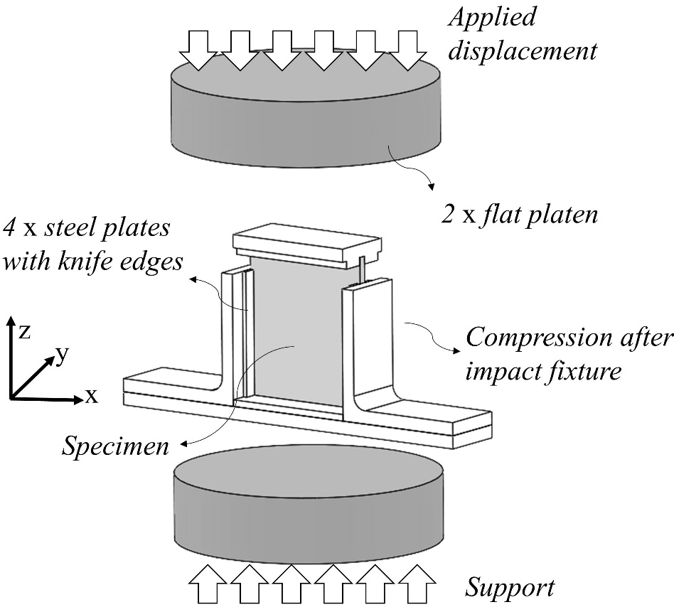
Figure 8. The schematic setup of compression-after-impact

Results and Discussion

Global response of LVI
The global responses of different laminate configurations subject to various impact energy levels are presented in Fig. 9. The representative force-time, force-displacement, and energy-time responses were compared between different laminates. The global trend of the LVI response in this work shows a similar pattern with previous studies [23, 24], in which 3-phases damage mechanisms were identified including: (i) in phase-1, an approximate linear elastic behaviour was observed, matrix failure can occur in this stage; (ii) in phase-2, a clear load drop and structural stiffness variation occurred when the load reached the delamination threshold, multiple interfaces failure and matrix cracking initiated and propagate; (iii) in phase-3, fibres started to break and eventually, catastrophic failure occurred due to multi-layer fibre failures, which was accompanied by a significant load drop.
The delamination threshold ($F_{dt}$), peak load ($F_{p}$) and absorbed energy ($E_{absorb}$) were used as the primary metrics of comparison. Specifically in this study, these parameters for UD at an impact energy of 25J are highlighted with dashed lines in Fig. 9 and they refer to the load before the first major drop, the maximum load before catastrophic failure, and the kinetic energy of the impactor after impact, respectively. The results for each laminate configuration at the tested impact energies are recorded in Table 1.
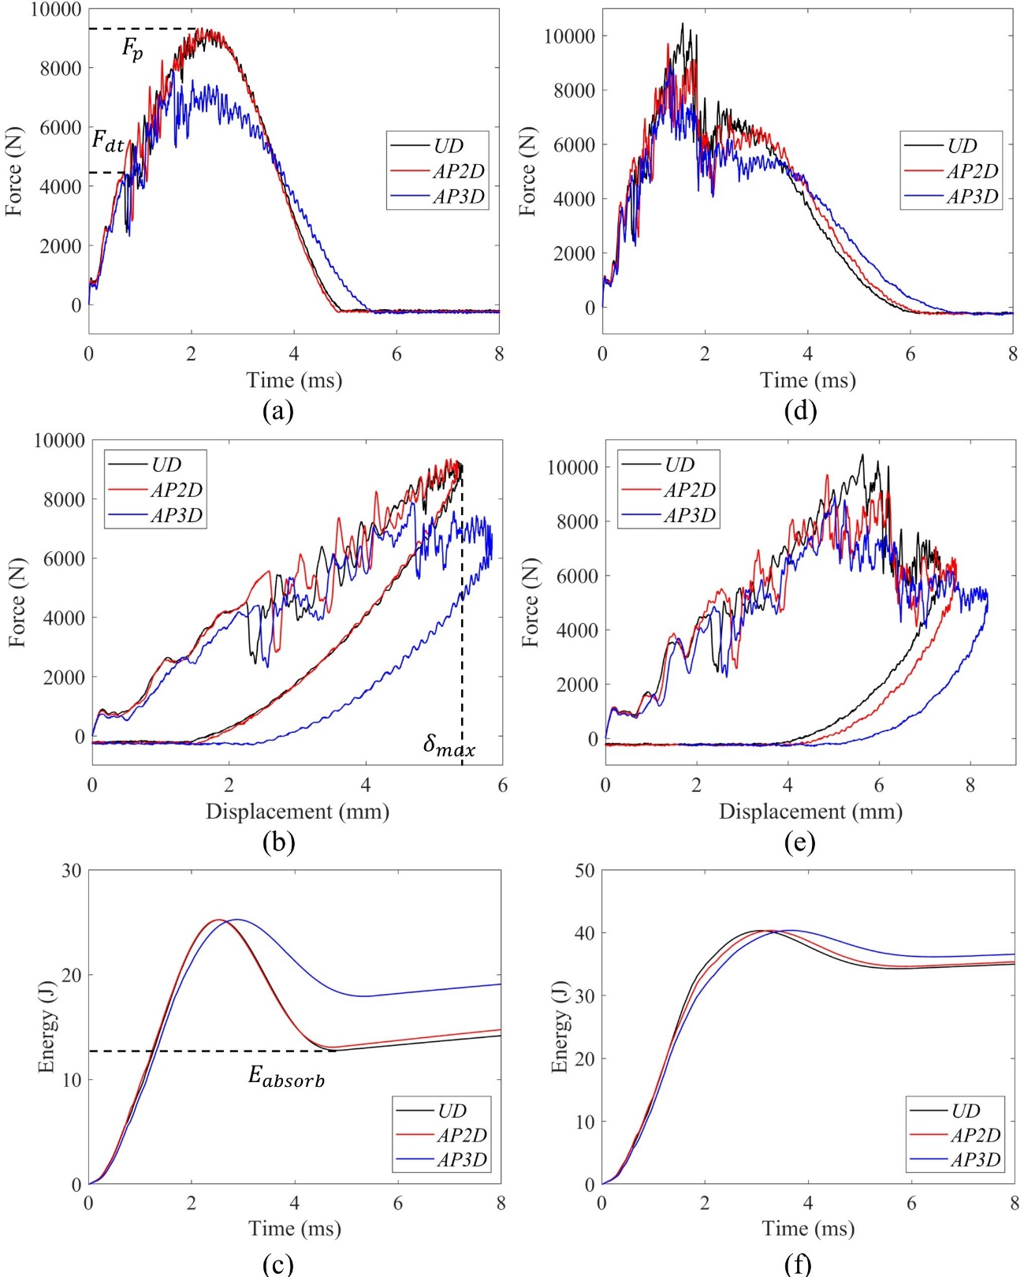
Figure 9. Representative global responses of LVI tests for different laminate configurations, where (a-c) refer to the impact energy of 25 J, and (d-f) refer to the impact energy of 40 J.
Table 1. The results comparison between different laminate configurations in terms of delamination threshold ($F_{dt}$), peak load ($F_{p}$) and absorbed energy ($E_{absorb}$). For each configuration, the mean value is used, and the bracketed value refers to the coefficient of variation.
 | Impact energy: 25J |  |  | Impact energy: 40J
 | UD | AP2D | AP3D | UD | AP2D | AP3D
$F_{dt}$ (N) | 4.88 (5.17) | 5.52 (2.10) | 4.89 (7.06) | 4.53 (0.93) | 5.50 (2.69) | 4.98 (2.21)
$F_{p}$ (N) | 9.32 (0.12) | 9.25 (1.84) | 8.4 (6.96) | 10.15 (2.32) | 10.04 (4.77) | 8.35 (6.83)
$E_{absorb}$ (J) | 12.64 (1.44) | 13.17 (3.27) | 16.3 (12.32) | 34.05 (3.39) | 33.93 (2.00) | 36.16 (0.00)

When the impact energy was 25J, the phase-3 damage mechanism was not observed, and nearly identical loading and unloading global responses were obtained in both UD and AP2D configurations. Small indentations and limited splitting were observed on the impacted and back surfaces of the laminate, as shown in Fig. 10. While for AP3D, a substantial difference regarding the global response can be observed and notably more back face damage was observed. This means that for AP3D, the impact energy of 25J reached the load level where the phase-3 damage mechanism started to occur. This can also be confirmed with the absorbed energy, which showed that AP-3D absorbed 15% more impact energy than the other two configurations. However, it should be noted that this trend occurred in two of the three AP3D samples while the other one showed similar behaviour to the UD and AP2D samples. The AP-Ply laminates have spatial variation in their properties due to the weave pattern, so the impact event may have been affected by impact location to some extent.
All the laminates indicated a substantial failure in the form of a greater indentation size and increased back face damage at an impact energy of 40J, as shown in Fig. 11. The global responses also experienced a sharp load drop for every configuration. Instead of an instant significant load drop, both AP2D and AP3D exhibited a degree of plasticity, as illustrated in the force-displacement plot shown in Fig. 9e. In exchange for that, the catastrophic failure initiated slightly earlier, which can be noted from both the force-time and force-displacement plots (Fig. 9d-e). A comparable amount of impact energy was absorbed by UD and AP2D whereas AP3D recorded a slight increase of 5%. Moreover, Fig. 11 depicts similar size of indent at the front face but a completely different back face damage pattern, where UD showed an elongated hump, while AP2D presented very concentrated but relatively smaller damage and AP3D exhibited twisted and concentrated damage with extensive fibre failures. To understand the differences of damage mechanisms between these laminates, a non-destructive internal damage evaluation needs to be performed and the results are presented in Section 4.2.
It can be found from Table 1 that for each laminate configuration, the delamination threshold showed a consistent result between impact energy 25J and 40J. AP2D exhibited an approximate 10-20% higher delamination threshold than UD and AP3D. The high delamination strength of AP2D can be induced by the difference in fibre architecture. A lower peak load was noticed at an impact energy of 25J than 40J for both UD and AP2D, whereas the difference was trivial for AP3D. AP3D recorded up to 17.7% lower peak load than the other two configurations for both impact energies. However, AP3D exhibited a higher energy absorption for both impact energies by 5-10%. As a result, this suggested that the AP-3D had the highest degree of plasticity among these configurations.
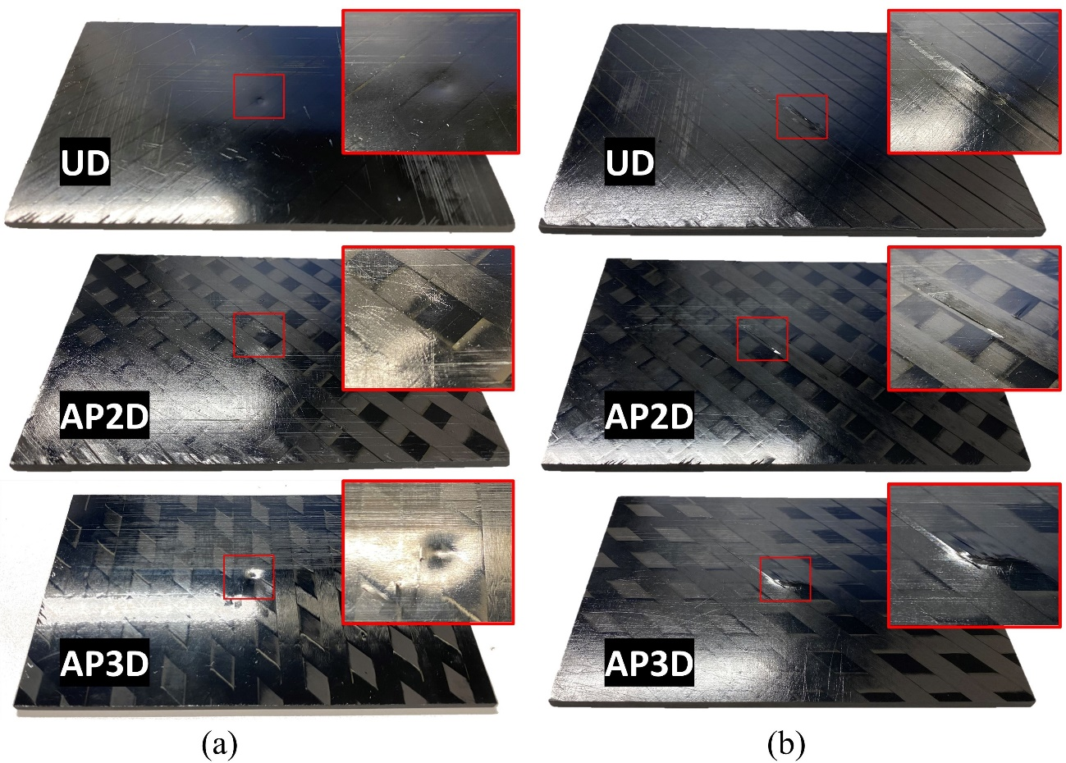

Figure 10. The visualization of impact damage (a) front and (b) back surface for UD, AP2D and AP3D at the impact energy of 25J.

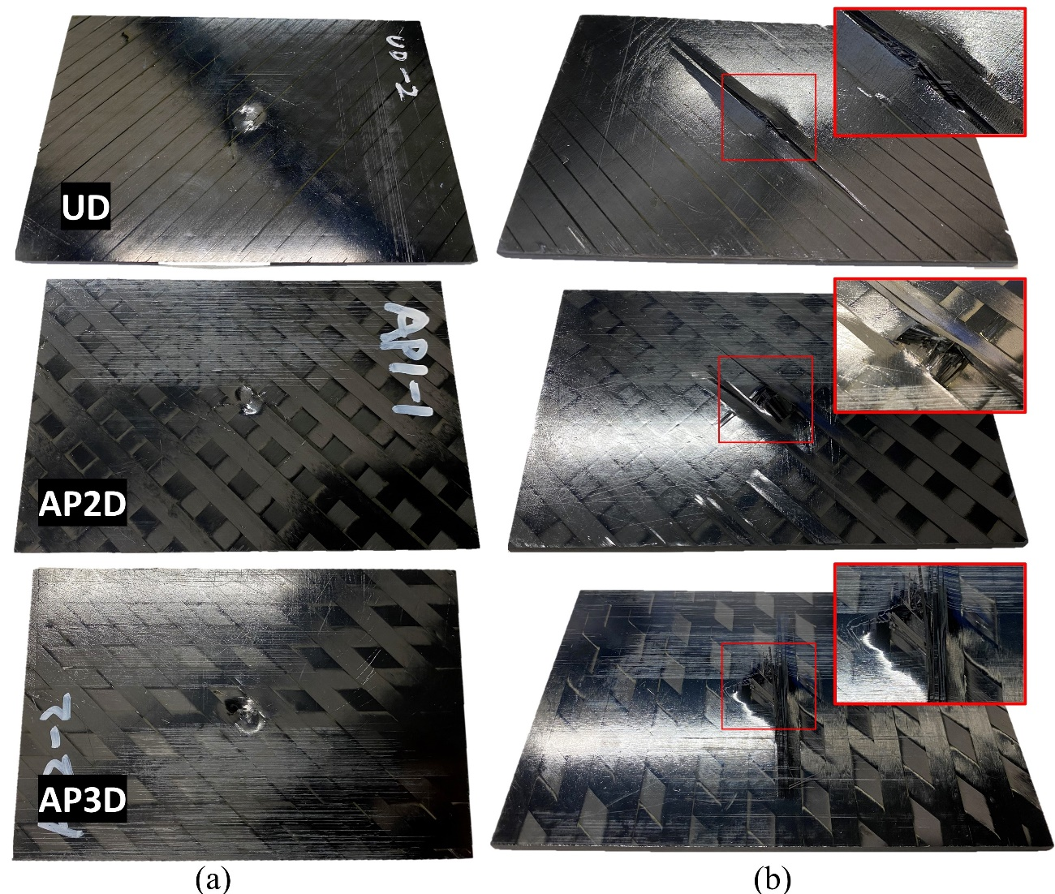
Figure 11. The visualization of impact damage, (a) front and (b) back surface for UD, AP2D and AP3D at the impact energy of 40J.

Damage area (Impact resistance)
The majority of the damage is in the form of matrix cracking, delamination and fibre fracture that occurs inside the laminate, hence a non-destructive inspection technique, µCT scanning, was carried out to assess the failure mechanisms and damage size. Specimens tested at both impact energies of 25J and 40J were scanned, the 25J specimens indicated trivial failure damage which was localised near the impact area. The group with 40J included more significant damage and hence are presented and compared across different laminate configurations in this section.
Considering the size of the panel (150 x 100mm) and image resolution, only the region of interest near the impact location was scanned as shown in Fig. 12a. The crack morphology in the through-thickness direction near the impact centre (section A-A), in which the maximum deflection and damage occurred, was visualised in Fig. 12b. The black areas attached to the specimen surface both above and below refer to air. In addition to this, several differences can be observed in the impacted regions (i) the after-impact indentation depth: AP3D > AP2D > UD; (ii) UD exhibited many wide through-thickness delaminations, while AP-Ply indicated a more concentrated fracture mode with smaller delaminations but extensive matrix and fibre failures, particularly for AP3D.
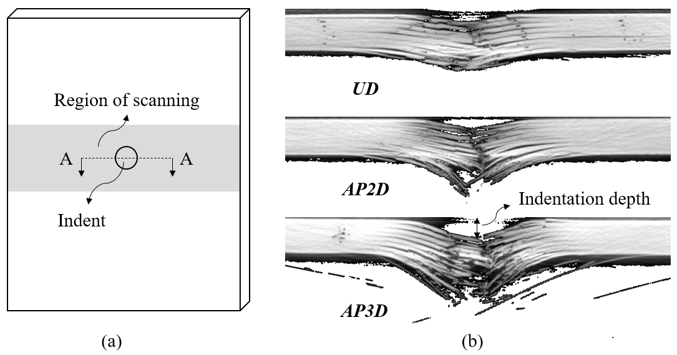
Figure 12. (a) The schematic representation of the CT scanning sample. (b) The cross-sectional views (A-A) of different laminate configurations at the impact region.

To further analyse the damage, a 3D damage visualisation of the impacted specimen was obtained via Avizo 2020. The segmentation technique can be used to partition the cracks based on different material grayscale. Fig. 13 depicts the approximate size of the in-plane damage of different laminate configurations. As the voxel size is around the same magnitude as the ply thickness, identifying the specific interface damage is challenging. Hence, the damage is not separated by interface angle in this visualisation. An isometric view and a front view are provided for the visualisation of the 3D damage morphology. To quantitatively assess the impact resistance, the damaged area was computed based on the maximum in-plane dimensions. Two of the three samples were scanned and computed to ensure the results were representative. The results are presented in Table 2. It can be concluded that the impact resistance of both AP2D and AP3D were much greater than UD.
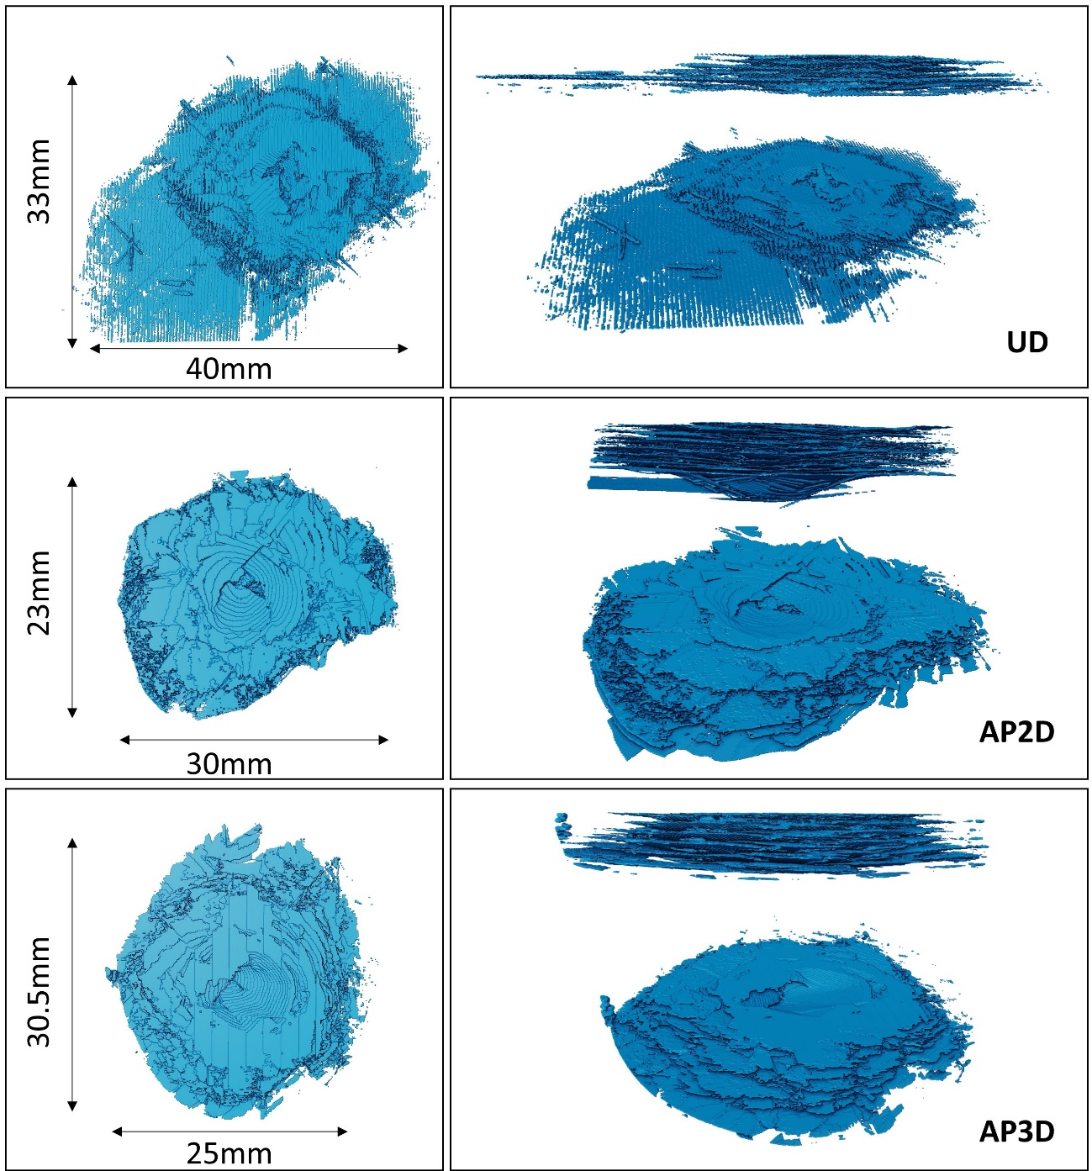
Figure 13. The results of CT-Scan with different laminate configurations, including a top view, a front view and an isometric view.

Table 2. Damage resistance of different laminate configurations at an impact energy of 40J. Note: the measurements refer to mean values.
 | Max length (mm) | Max width (mm) | Impact resistance (J/mm²)
$$UD$$ | 42.3 | 33.38 | 0.028
AP2D | 25.6 | 22.87 | 0.068
AP3D | 28.8 | 29.5 | 0.047

Damage tolerance
Fig. 14 depicts two different fracture modes that were observed in the CLC test. Fig. 14a shows an acceptable fracture mode per ASTM D6641, where the failure occurred in the gauge section. Instead, an unacceptable fracture mode refers to failure that appeared elsewhere within the gripped area, such as end-crushing. In this study, the unacceptable fracture was more commonly observed in AP-Ply laminates rather than UD. This suggests that the spatial variation of the semi-woven structure had a significant impact on the load introduction at the specimen boundaries. The global load-displacement responses of all the specimens excluding the samples with unacceptable failures are plotted in Fig 15. A comparable ultimate fracture load was observed between the different laminate configurations while AP3D indicated a slight stiffness drop, which was induced by the larger fibre crimping. The pristine compressive strength, as recorded in Table 2, can be computed based on the ultimate fracture load and specimen dimensions.
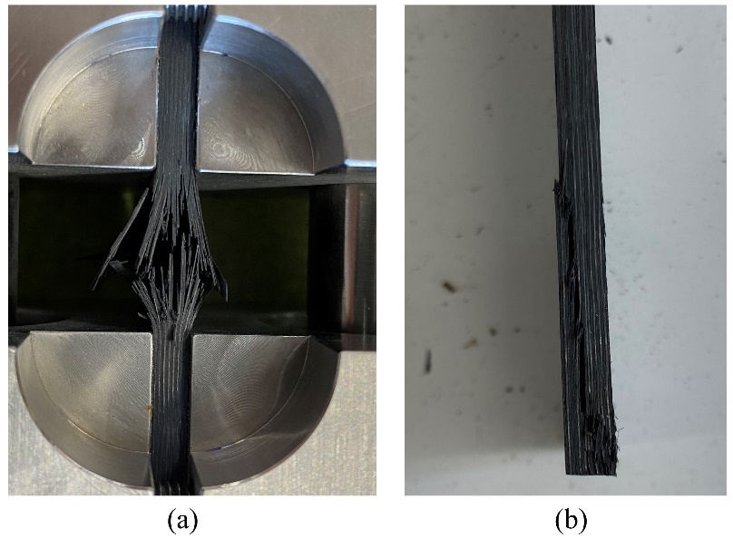
Figure 14. The CLC test with (a) acceptable fracture mode; (b) unacceptable fracture mode with end-crushing

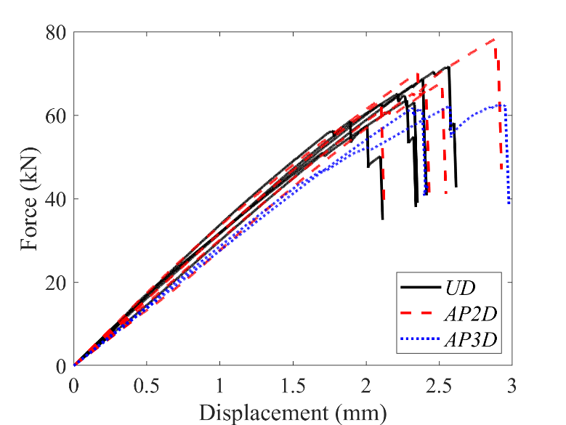
Figure 15. The global responses of CLC tests

The typical global responses of UD, AP2D and AP3D at both impact energies are shown in Fig. 16. A similar trend was observed with the ultimate fracture load at both impact energies: AP2D > AP3D > UD. It should be noted that the difference of fracture load between AP-Ply and UD was amplified substantially at the impact energy of 40J. The residual strengths of different laminate configurations were determined based on the fracture load and respective specimen dimensions. The results are recorded in Table 3. At impact energy of 25J, AP2D and AP3D indicated 17% and 12% higher residual strength, respectively over UD. The improvement of the residual strength at an impact energy of 40J is further increased by 29% for both AP-Ply configurations. This indicates that AP-Ply is more advantageous than UD with larger impact energies. This is potentially induced by the different failure mechanisms between UD and AP-Ply, where UD tends to have a few wider and dominant cracks in the form of delaminations while AP-Ply is inclined to have a more concentrated but extensive matrix and fibre failures.
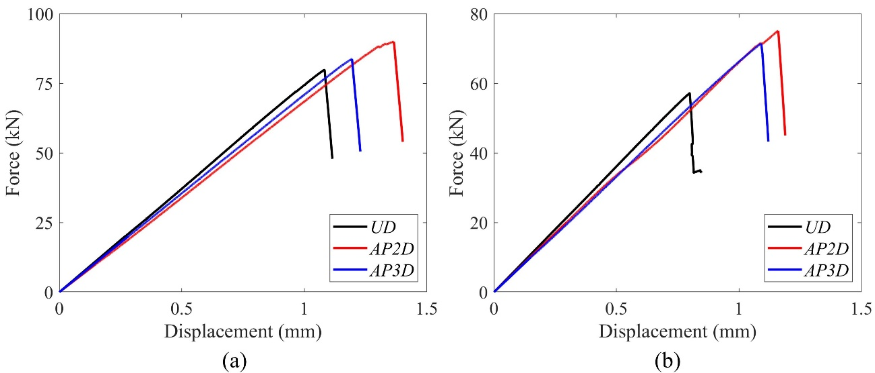
Figure 16. The global responses of CAI tests, (a) at an impact energy of 25J, and (b) at an impact energy of 40J

Table 3. The comparison of pristine and residual strength between UD, AP2D and AP3D.
Configuration | Pristine (MPa) | Impact energy: 25J (MPa) | Impact energy: 40J (MPa)
UD | 551.24 | 192.84 | 140.32
AP2D | 581.52 | 225.56 | 181.31
AP3D | 524.92 | 215.98 | 180.96

Conclusion
The weave structure of textile composites has been shown to have great potential in improving damage resistance and tolerance [4-8]. This study has examined the LVI and CAI performance of semi-woven AFP manufactured laminates called AP-Ply. The AP-Ply concept has introduced extra design parameters which substantially extend the design space of AFP laminates and create possibilities of obtaining more lightweight composite structures. Based on the current study, the key findings include:
- The 3-phase damage mechanisms under LVI were similar between UD and AP-Ply. However instead of an instant load drop in phase 3, both AP2D and AP3D exhibited a degree of plasticity. The semi-woven structure has also been shown to have a great impact on the delamination threshold, peak load and energy absorption.
- The failure mechanisms between UD and AP-Ply are different, in which UD tends to have a few major delaminations while AP-Ply tends to have many more concentrated matrix cracks, delaminations and fibre failures. By definition, the impact resistance of both AP-Ply configurations was higher than the UD laminate.
- A comparable pristine compressive strength was observed between AP-Ply and UD. This means that a small degree of inter-ply tow weaving can substantially increase the damage resistance and damage tolerance without affecting the laminate in-plane compressive strength.
- AP2D and AP3D have improved the CAI residual strength by 12% and 17%, respectively at an impact energy of 25J. The improvement is more advantageous with 29% for both AP-Ply configurations at a larger impact energy of 40J.

Acknowledgements
This project was supported by UNSW with UIPA stipend (RSRE7063) and conducted within the ARC Training Centre for Automated Manufacture of Advanced Composites (IC160100040), supported by the Commonwealth of Australia under the Australian Research Council’s Industrial Transformation Research Program.
The data that support the findings of this study are available from the corresponding author, Xie Li, upon reasonable request.

References
[1] Prichard JC, Hogg P. The role of impact damage in post-impact compression testing. Composites. 1990;21(6):503-11.
[2] Richardson M, Wisheart M. Review of low-velocity impact properties of composite materials. Composites Part A: Applied Science and Manufacturing. 1996;27(12):1123-31.
[3] Shah S, Karuppanan S, Megat-Yusoff P, Sajid Z. Impact resistance and damage tolerance of fiber reinforced composites: A review. Composite Structures. 2019;217:100-21.
[4] Ko FK. Three-dimensional fabrics for composites. Elsevier Science Publishers, Textile Structural Composites. 1989:129-71.
[5] Mouritz AP, Bannister MK, Falzon P, Leong K. Review of applications for advanced three-dimensional fibre textile composites. Composites Part A: applied science and manufacturing. 1999;30(12):1445-61.
[6] Tong L, Mouritz AP, Bannister M. 3D fibre reinforced polymer composites: Elsevier; 2002.
[7] Dransfield K, Baillie C, Mai Y-W. Improving the delamination resistance of CFRP by stitching—a review. Composites Science and Technology. 1994;50(3):305-17.
[8] Chiu C, Lai M, Wu C. Compression failure mechanisms of 3-D angle interlock woven composites subjected to low-energy impact. Polymers and Polymer Composites. 2004;12(4):309-20.
[9] Baker AA. Composite materials for aircraft structures: AIAA; 2004.
[10] Mouritz A. Review of z-pinned composite laminates. Composites Part A: applied science and manufacturing. 2007;38(12):2383-97.
[11] Bull D, Scott A, Spearing S, Sinclair I. The influence of toughening-particles in CFRPs on low velocity impact damage resistance performance. Composites Part A: Applied Science and Manufacturing. 2014;58:47-55.
[12] Beland S. High performance thermoplastic resins and their composites: William Andrew; 1990.
[13] Bibo GA, Hogg P, Backhouse R, Mills A. Carbon-fibre non-crimp fabric laminates for cost-effective damage-tolerant structures. Composites Science and Technology. 1998;58(1):129-43.
[14] Nagelsmit MH. Fibre Placement Architectures for Improved Damage Tolerance. [PhD]: Delft University; 2013.
[15] Li X, Brown SA, Joosten M, Pearce GM. Tow Wise Modelling of Non-conventional Automated Fibre Placement Composites: Short Beam Shear Study. Composites Part A: Applied Science and Manufacturing. 2021:106767.
[16] Rad CV, Kodagali K, Roark J, Revilock D, Ruggeri C, Harik R, et al. High velocity impact response of hybridized pseudo-woven carbon fiber composite architectures. Composites Part B: Engineering. 2020;203:108478.
[17] Zheng W, Kassapoglou C. Prediction of delamination onset and growth for AP-PLY composite laminates using the finite element method. Composites Part A: Applied Science and Manufacturing. 2017;101:381-93.
[18] Zheng W, Kassapoglou C, Zheng L. Tailoring of AP-PLY composite laminates for improved performance in the presence of delaminations. Composite Structures. 2019;211:89-99.
[19] Potluri P, Hogg P, Arshad M, Jetavat D, Jamshidi P. Influence of fibre architecture on impact damage tolerance in 3D woven composites. Applied Composite Materials. 2012;19(5):799-812.
[20] ASTM D7136/D7136M-15 standard test method for measuring the damage resistance of a fiber-reinforced polymer matrix composite to a drop-weight impact event.
[21] ASTM D7137/D7137M-17 standard test method for compressive residual strength properties of damaged polymer matrix composite.
[22] ASTM D6641. Standard test method for compressive properties of polymer matrix composite materials using a combined loading compression (CLC) test fixture. West Conshohocken, PA: American Society for the Testing of Materials, 2016.
[23] Abisset E, Daghia F, Sun X, Wisnom MR, Hallett SR. Interaction of inter-and intralaminar damage in scaled quasi-static indentation tests: Part 1–Experiments. Composite Structures. 2016;136:712-26.
[24] Lopes C, Sádaba S, González C, Llorca J, Camanho P. Physically-sound simulation of low-velocity impact on fiber reinforced laminates. International Journal of Impact Engineering. 2016;92:3-17.

