Different Aspects of Smoke Impact in case of Big Fires

M.L. Ivanov
Academy of the Ministry of Interior, Sofia, Bulgaria

C.H. Cheng and C.L. Chow
Department of Architecture and Civil Engineering
City University of Hong Kong, Hong Kong, China

W.K. Chow*
Department of Building Environment and Energy Engineering
The Hong Kong Polytechnic University, Hong Kong, China
*Email: wan-ki.chow@polyu.edu.hk

Abstract

Current research shows the importance of applying fire science to explore how urban and forest big fires can be controlled as well as the reduction of the environmental impact due to smoke. This includes a better understanding of the fire phenomena and development of firefighting methods. Although there are great differences in the firefighting tactics for extinguishing different types of large fires, these big fires are usually similar in their large impact on the surrounding environment and the people due to the emitted smoke. It is possible that the pollutant in a fire might contain carcinogenic dioxins. In the present study, several case studies of big fires are examined with the conclusion that the scientific aspects of fire safety management and firefighting operation have to be further explored. This includes innovative and extraordinary firefighting tactics of forest firefighting using counter-fire as well as understanding the smoke hazards in closed-space fire. Exploring new relevant upstream fire scientific phenomena is important. Fire safety management is highlighted.

- Introduction

It is always a difficult task for the firefighters and management staff to deal with big fires of any kind. There are great differences in the firefighting tactics for extinguishing different types of large fires, for example in big forest fires [1-3], ship firefighting [4], warehouse fires, or big fires in urban environments with flashover [5, 6] or backdraft [7] risks. However, all of these fires are usually similar in their large impact on the surrounding environment and the population of the emitted smoke.
The term “smoke” is defined in ISO 13943 [8] as a visible suspension of solid and/or liquid particles in gases resulting from incomplete combustion. It is one of the first response characteristics to be manifested and should almost always be taken into account in any assessment of fire hazard as it represents one of the greatest threats to occupants of a building or other enclosure, such as a ship or train, on fire.

It is important to apply fire science to explore how such big fires can be controlled [9-12]. This includes not just a better understanding of fire phenomena and prediction of fire occurrence, but scientific aspects of fire safety management and firefighting operations have to be explored.

The pollutant in a fire might contain carcinogenic dioxins [13, 14]. There are updated reports on dioxins and particulate matters [15-17]. Children and the elderly have a higher risk of breathing difficulty when exposed to dioxins. People with asthma may feel irritating and asthma might be triggered. Dioxins would be formed during combustion as long as the material has a small amount of chlorides such as Polyvinyl Chloride (PVC) or salt. Since Hong Kong is an offshore city, sea salt can be found extensively in the local environment.

Burning waste in the open air can indeed produce a small amount of dioxins, but this is within acceptable limits, which will not do harm to humans. As an example, the statistics about dioxins in the air reported by Tsuen Wan monitoring stations in Hong Kong from 2016 to 2021 show that in the first five months of 2021 it decreases from about 0.9 ppm to 0.08 ppm [18], which is below the standard norms in Canada (0.1 ppm) or Japan (0.6 ppm), for example. However, the data for the concentration of dioxins during the incident are unavailable.

Particles with diameters less than 10 μm are known as respirable suspended particulates or PM₁₀. PM₁₀ can get deep into the lungs and have impacts on health, in particular, including irritation of the airways, coughing, or difficulty in breathing, decreasing lung function, worsening asthma, chronic bronchitis, and adverse effects on the cardiovascular system.

It has also been shown that the health risks would be higher for those particles with particle sizes of 2.5 microns or less, which are commonly referred to as fine suspended particles or PM_{2.5} [19].

Burning plastics could release dangerous chemicals such as hydrochloric acid, sulphur dioxide, dioxins, and heavy metals, as well as particulates into the atmosphere. Worst still, burning PVC could liberate hazardous halogens and cause air pollution. One of the impacts is climate change. Alabi et al. [20] stated that PVC could cause chronic bronchitis, birth defects, genetic changes, cancer, skin diseases, deafness, vision failure, ulcers, liver dysfunction, and indigestion. Polystyrene (PS) could do harm to the central nervous system. The hazardous brominated compounds would act as carcinogens and mutagens. Dioxins settled on the crops and in our waterways where they eventually entered the food chain through crops and livestock. These dioxins are the lethal persistent organic pollutants (POPs), which have high toxicity. These could induce cancer and neurological damage, and cause disruption to the reproductive thyroid and respiratory systems. In summary, burning plastic wastes would increase the risk of heart disease, aggravate respiratory ailments such as asthma and emphysema and caused rashes, nausea or headaches, and damages to the nervous system as reported by Verma et al. [21].

- Big Fires in Urban Environment

The dangerous factors for human health in case of big fires in an urban environment can be divided into three categories. The first one contains flames, sparks, and radiant heat, and direct contact with them inevitably results in burns. The human body can get burns even away from the flames themselves, due to the radiant heat. The second one is the high air temperature, which causes damage to both unprotected human skin and the inner surface of the respiratory organs. The third one as a key topic of the current research is the smoke and its toxic ingredients. Smoke is the main and most considerable danger to human health and life in case of fire. In addition to soot, smoke also contains a variety of chemicals, most of which are toxic and cause severe damage or death to organisms. The most common gases emitted during combustion are carbon monoxide (CO) and carbon dioxide (CO₂). While carbon monoxide is a toxic gas that binds to hemoglobin in the blood 200-300 times faster than oxygen and causes oxygen starvation in the body, carbon dioxide is not toxic, but it is a suffocating gas that causes respiration to accelerate, so larger amounts of other toxic gases are inhaled. The smoke emitted also has an elevated temperature and can cause burns. It reduces visibility and can easily lead to disorientation and difficult evacuation of people in case of fire. Smoke zone is that part of the space that belongs to the combustion zone and is filled with flue gases, where the concentration of these gases endangers human health and complicates the firefighting operations. The smoke impact in urban environment can be clearly seen in Figure 1.

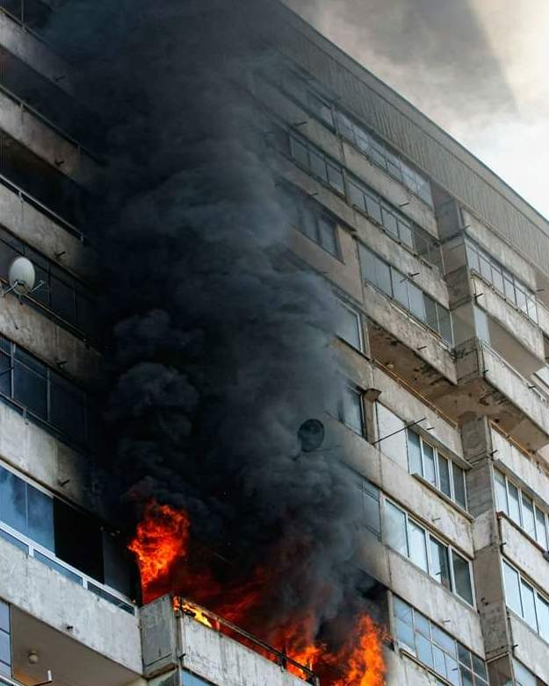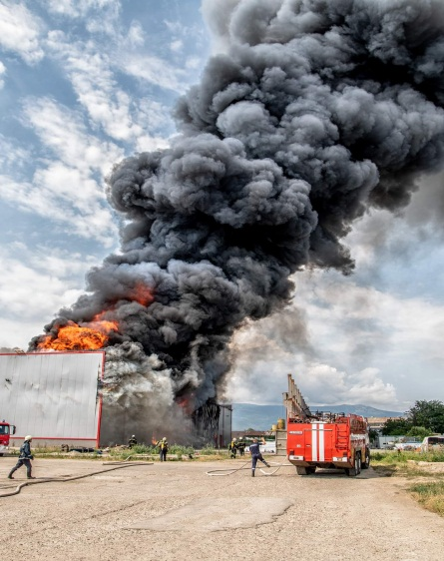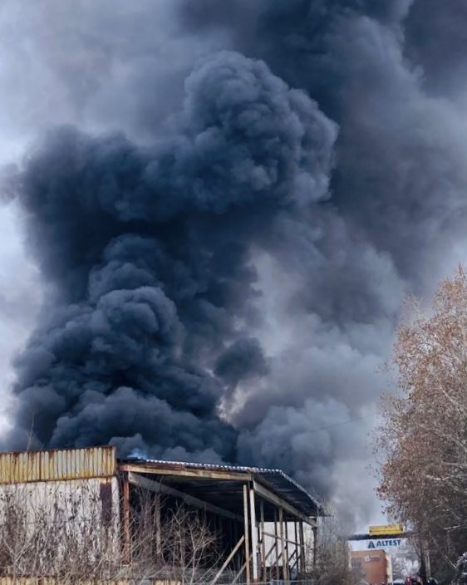
Figure 1: Smoke impact in big fires in urban environment
a) Residential flat fire; b) Clothes warehouse fire; c) Paper warehouse fire
(Origin of images: ©Martin Ivanov)
A big challenge is the smoke in closed spaces fire. It is so dangerous and explosions can occur in the presence of critical backdraft conditions. It is necessary to know and understand the backdraft signs. They are the smoke colour (dark black or greenish), smoke coming out through tiny gaps and under the doors and windows, the high temperature on the outside of windows, no visible flames, and soot-blackened windows. These signs clearly show that all the elements necessary for combustion are present except for the oxidizer, the air. A single airflow is sufficient for the combustible mixture to enter its ignition zone. This flow of air may be induced by window breakage due to the high temperature, or wrong firefighter’s action on breaking a window or opening a door. In case of opening the room, a quantity of air is sucked in and the mixture might falls within the limits of ignition and an explosion would occur.

- Big Forest Fires

The main characteristic of forest fires is that the burning process is not limited by constructions. Heat exchange takes place directly with the environment. The temperature of open-space fires is higher than that of internal fires as the gas exchange is more intense. This is determined by gas flows, wind speed, and direction. The nature of the smoke zone changes. The fire propagation direction and speed mainly depend on wind speed and direction, and may develop over large areas, depending on the type of forest, season, and tree moisture. The smoke impact in case of forest fires can be clearly seen in Figure 2.

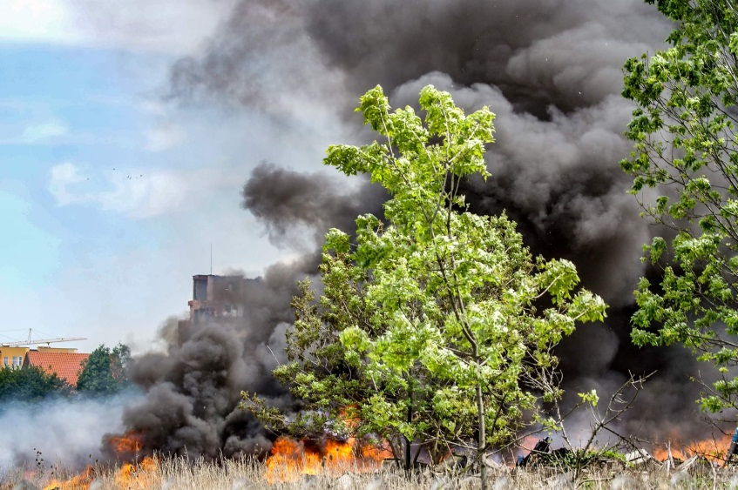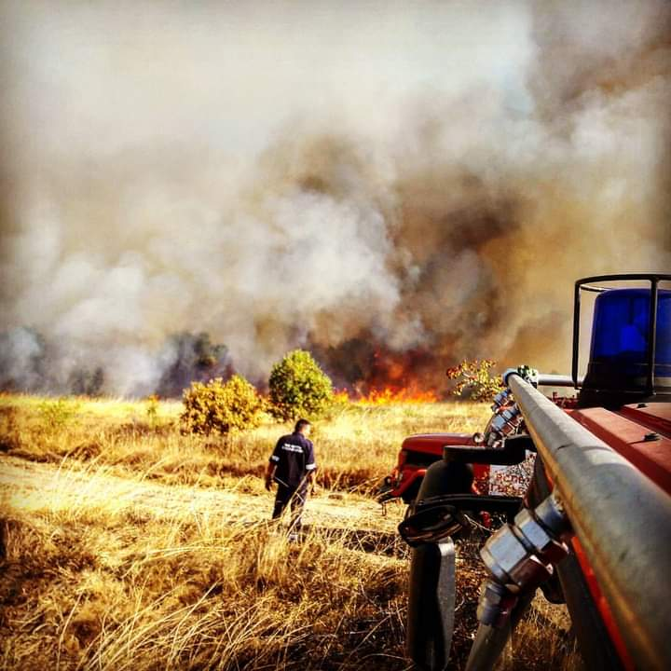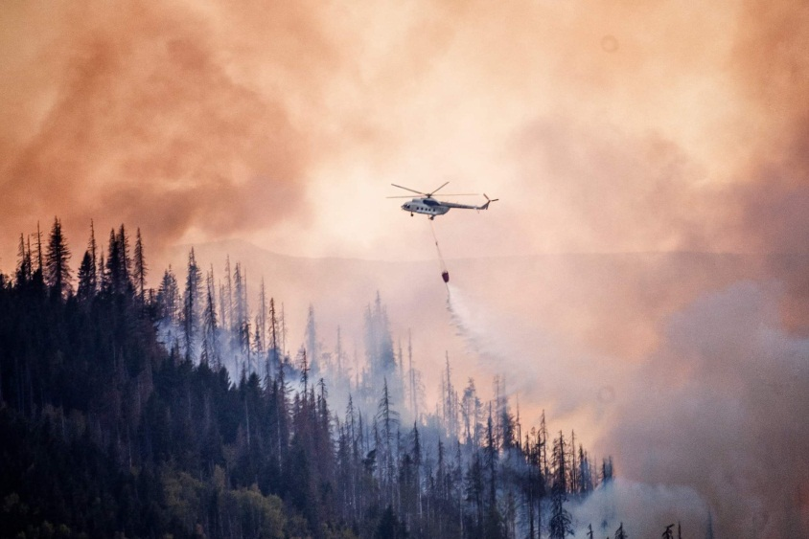
Figure 2: Smoke impact in big forest fires
(Origin of images: ©Martin Ivanov)
Forest fires are very hazardous for the people and the environment [22-26]. As reported by Ceccherini et al. [22] using fine-scale satellite data, the average patch size of the harvested area increased rapidly across Europe due to expansion of wood markets. EU vision of forest-based climate mitigation may be hampered. Carbon losses from forests would require extra emission reductions in other sectors in order to reach climate neutrality by 2050. This argument was not agreed [23] and criticized. There is an urgent need [24] to re-examine available forest information that can accurately and reliably inform the policy discussions in the framework of the European Green Deal, particularly the EU forest strategy for 2030.

The spatiotemporal predictability of overwintering fires could be used by fire authorities to facilitate early detection as raised by Scholten et al. [26]. This might reduce carbon emissions and firefighting costs.

The emission of carbon dioxide into the atmosphere was estimated by van der Velde et al. [27] using satellite observations of carbon monoxide, an analytical Bayesian inversion, and observed ratios between emitted carbon dioxide and carbon monoxide. Forest fires release substantial amounts of carbon dioxide into the atmosphere [28]. Emission estimates based on fire inventories are uncertain [29] and vary by up to a factor of four for this event as reported by van der Velde et al. [27].

Innovative and extraordinary firefighting tactics in case of big forest fires can be used, showing the management staff skills and experience in reducing the negative impact on the people and the environment. For example, one of the most effective ways to fight small to medium forest fires is to use counter-fire, which means artificially induced controlled fire aimed at the main fire. The purpose of the counter-fire is to remove the combustible load in front of the main direction of the main fire. When choosing the right place for counter-fire ignition, it is necessary to consider at what distance from the main fire have to be created. Natural (rivers, lakes, etc.) or artificial (roads, clearings, mineralized strips, etc.) barriers can be used for the counter-fire restrictions. It is advised that for small forest fires, the counter-fire shall pass a distance of at least 20 meters from the support strip in front of the fire front, and to locate medium or high crown forest fires at least 100-200 meters. Also, it is advisable to ignite the counter-fire either late in the evening or early in the morning to use the calm of the wind.

- Case Studies

Even with adequate resources for big fires in urban areas of developed cities or big forest fires, there are too many unexpected challenges. It might take a long time to suppress the fire with high environmental impact on citizens due to smoke [30]. Three big fires occurred in Hong Kong in two weeks in 2021 [31], the one at London Underground [32], and the big forest fire in Sichuan, China in 2019 [33] clearly demonstrates that smoke is a big problem. Viable fire safety management schemes and firefighting are needed.

The first big fire F1 in Hong Kong was that a 100 m long vessel in the harbour was burning in the evening on 2 June 2021, and was extinguished the next morning. Two barges of 45 m length were found on each side of the vessel handling metal scrap. The vast amount of smoke was emitted from the burning vessel when the ship kept on burning. The environment was polluted for such a long time of 15 hours, affecting citizens around the harbour area [34,35]. The fire incident was suspected to be caused by an explosion of the computer’s lithium-ion batteries. Strong wind from southwest drove the thick smoke emitted towards half of the districts in Hong Kong. Residents in these areas felt panic and inhaled toxic smoke for a few hours. Air quality monitoring stations of the Hong Kong government recorded poor air quality, 10 times above acceptable levels on suspended PM₁₀ and PM_{2.5} for several hours. Four fireboats arrived on the scene quickly to apply water cannons on the ship’s fire. As there were winds and strong sea waves at the burning site, firemen were difficult to board the cargo ship to take appropriate action. In addition, the ship piled up 3000 tonnes of metal scrap blocking water and bubble fluid ejected to reach the fire source. The ship became tilted to give a more violent fire. It took over 15 hours to control, even when using 32 fire trucks and ambulances, 9 firefighting vessels, 183 firemen and ambulance staff, four fire extinguishing water cannons, two bubble guns, and a smoker [31].

The second fire F2 was in a typhoon shelter. The fire incident happened at 2:34 a.m. on 27 June 2021 [36]. Two yachts at a typhoon shelter caught fire initially and affected the yachts and boats nearby. The narrow water channel, strong wind, and the burnt rope after the yachts caught fire, made the yacht drift away by the action of water. These accelerated the spread of blazes and increased difficulty in firefighting. Again, thick smoke spread to different parts of the city by the wind. Residents in these areas were advised by the fire authorities to shut the windows if affected by the smoke or peculiar smell. Firemen used water cannons for firefighting operations. The fire was extremely violent and the flame billowed skyward, upgraded to a level-3 fire alarm two hours later. Fuel tanks exploded. The blaze was under control after 6 hours. The fire services deployed 7 fire boats, 43 fire and ambulances and, 215 firemen and ambulance staff in this fire.

The third fire F3 was in a waste management area. A waste collection station caught fire [37] at 5:38 a.m. on 29 June 2021. Smoke originated from burning plastics spread to residential districts by the action of wind, affecting many residents. As the fire source was located inside the “iron scrap mountain”, it took 5 hours to extinguish. In the blaze, no injuries were recorded. However, smoke spread to many areas around. Residents complained that the smell spread to the building even though the windows were closed [37].

A severe blaze F4 broke out at an underground railway station in London on 28 June 2021 at 13:43. About 100 firefighters battled the blaze at some railway arches near the Elephant and Castle station. The cause of the blaze was not expected to be a terrorist attack [32]. The fire then spread to the adjoining arches and there was acrid smoke going up. Fifteen fire engines were called to the fire scene, with the fire thought to have started in garages close to the underground station, where five people had escaped before the firefighters arrived. The blaze was under control two hours later with firefighters at the scene for a few hours to dampen down the scene.

The big forest fire F5 occurred at Liangshan Yi, Sichuan, China on 30 March 2019 with a high number of casualties [33]. The cause of the disaster remains unclear, likely to have eruption [38]. As explosion noise was heard [33], burning combustible from wood chips, dry leaves, and others available in the forest might become deflagration, on top of tree exploded. Scientific investigation to explore possible scenarios [39] is required at least by a physical scale model. However, it takes years to work out effective firefighting systems and equipment from new fire science. More importantly, water is not available for suppressing such big forest fires.

- Fire Safety Management

Different fire safety management codes and guidelines are available worldwide [40-45] following the local challenges in the different countries.

Concerning the smoke management issues in case of building fires in urban environment implementation and controlling the requirements for HVAC control systems is a priority of the whole fire protection process [46]. However there are different hazards in case of a building fire, the smoke and hot gases in the escape routes are considered as the main risks to life safety from inhalation of toxic gases and burning as reported by Kodur et al. [47]. In this respect, portable anonymous fans for firefighting in front of the main entrance of the buildings are so useful for increasing the overpressure in the escape routes for better evacuation. New technologies in fire safety and artificial intelligence in fire safety are being increasingly used [48].

Concerning the smoke management in forest fires, a good example is ASHRAE Guideline 44P, Protecting Building Occupants from Smoke During Wildfire and Prescribed Burn Events [49], which provides adequate proposals for heating, ventilation, and air conditioning (HVAC) and building measures to minimize occupant exposures and health impacts from smoke during forest fires and prescribed burn smoke events. Here the process for making a building smoke ready is divided into two main phases: before the forest fire season and during the forest fire season. Before the forest fire season it is recommended to develop a Smoke Readiness Plan, including: performing maintenance on HVAC, upgrading system filters and testing HVAC, optimizing system airflows, adding supplemental filtration, checking filter conditions, limiting smoke intrusion, enhancing capabilities to monitor indoor PM_{2.5}, etc. Just before the forest fire season it, is so essential to test the HVAC system in the smoke-ready mode. Finally when a big forest fire occurs, implement the Smoke Readiness Plan, monitor the effectiveness of the plan, and adjust the operate intensity in the smoke-ready mode until the smoke subsides.

Another example is California as a place with severe forest fires damages on an annual basis. California Air Resources Board has its own “Smoke Ready California” initiative including six activities to protect the people from smoke in case of forest fires: 1. Check air quality; 2. Close windows and doors; 3. Run air-conditioner on recirculating mode with a new filter; 4. Use a CARB-certified air cleaner; 5. Avoid vacuuming, frying food or using gas-powered appliances; 6. Wear an N95 mask [50]. This scheme can be successfully followed not only in forest fires but also in case of big fires with lots of smoke in urban environments.

- Conclusion

Exploring relevant upstream fire scientific phenomena is important. However, it must be noted that time is required to accept the science, taking a long time to implement the concept, and to transfer to downstream applications. Even with adequate resources and training, there are still unknown challenges in firefighting as in the above fire examples. This would lead to a longer fire duration and severer environmental impact.

Fire safety management is essential. Urgent action is to identify the possible water sources available in those forest areas, and the distribution water circuit to build or be allocated temporarily or for firefighting. Even with a nearby river, water distribution should be worked out to pump water available for fighting against forest fires.

It must be pointed out that big fires can happen very near urban areas. Good fire safety management must be implemented to avoid having a long-duration fire. The environmental impact of such big fires can bring disaster as raised before.

References

1. Yuan, C., Zhang, Y. and Liu, Z., 2015. A survey on technologies for automatic forest fire monitoring, detection, and fighting using unmanned aerial vehicles and remote sensing techniques. Canadian Journal of Forest Research, 45(7), pp. 783-792. https://doi.org/10.1139/cjfr-2014-0347.
2. de la Asunción, M., Castillo, L., Fdez-Olivares, J., García-Pérez, Ó., González, A. and Palao, F., 2005. SIADEX: An interactive knowledge-based planner for decision support in forest fire fighting. Ai Communications, 18(4), pp. 257-268.
3. North, M.P., Stephens, S.L., Collins, B.M., Agee, J.K., Aplet, G., Franklin, J.F. and Fulé, P.Z., 2015. Reform forest fire management. Science, 349(6254), pp. 1280-1281. https://doi.org/10.1126/science.aab2356.
4. Sumic D, Males L, Rosic M. 2021. An agent-based ship firefighting model. Journal of Marine Science and Engineering, 9(8):902. https://doi.org/10.3390/jmse9080902.
5. Peacock, R.D., Reneke, P.A., Bukowski, R.W. and Babrauskas, V., 1999. Defining flashover for fire hazard calculations. Fire Safety Journal, 32(4), pp. 331-345. https://doi.org/10.1016/S0379-7112(98)00048-4.
6. Chow, W.K., 1997. Study on the flashover criteria for compartmental fires. Journal of Fire Sciences, 15(2), pp. 95-107.
https://journals.sagepub.com/doi/10.1177/073490419701500202
7. Weng, W.G. and Fan, W.C., 2003. Critical condition of backdraft in compartment fires: a reduced-scale experimental study. Journal of Loss Prevention in the Process Industries, 16(1), pp.19-26. https://doi.org/10.1016/S0950-4230(02)00088-8.
8. ISO 13943:2017 Fire Safety - Vocabulary. International Organization for Standardization.
9. Scholten, R.C., Jandt, R., Miller, E.A. et al. 2021. Overwintering fires in boreal forests. Nature 593, pp. 399-404. https://doi.org/10.1038/s41586-021-03437-y.
10. Parisien, MA. 2016. Science can map a solution to a fast-burning problem. Nature 534, 297. https://doi.org/10.1038/534297a.
11. Bowman, D., Williamson, G., Yebra, M., Lizundia-Loiola, J., Pettinari, M.L., Shah, S., Bradstock, R., Chuvieco, E., 2020. Wildfires: Australia needs national monitoring agency. Nature 584, pp. 188-191. https://doi.org/10.1038/d41586-020-02306-4.
12. Editorial - Take action to stop the Amazon burning. Nature 573, 163 (2019). https://doi.org/10.1038/d41586-019-02615-3.
13. Brazier, Y. What to know about dioxins. https://www.medicalnewstoday.com/articles/17685. Updated on July 26, 2021.
14. World health Organization. Dioxins and their effects on human health. https://www.who.int/news-room/fact-sheets/detail/dioxins-and-their-effects-on-human-health, retrieved 27 June 2021.
15. Kashiwagi, K., Iizuka, Y. 2020. Effect and underlying mechanisms of airborne particulate matter 2.5 (PM2.5) on cultured human corneal epithelial cells. Scientific Reports 10, 19516. https://doi.org/10.1038/s41598-020-76651-9.
16. Daellenbach, K.R., Uzu, G., Jiang, J., Cassagnes, L.E., Leni, Z., Vlachou, A., Stefenelli, G., Canonaco, F., Weber, S., Segers, A. and Kuenen, J.J., 2020. Sources of particulate-matter air pollution and its oxidative potential in Europe. Nature 587, pp. 414-419. https://doi.org/10.1038/s41586-020-2902-8.
17. Dedoussi, I.C., Eastham, S.D., Monier, E. and Barrett, S.R., 2020. Premature mortality related to United States cross-state air pollution. Nature 578, pp. 261–265. https://doi.org/10.1038/s41586-020-1983-8.
18. Environmental Protection Department. The level of dioxins in air in Hong Kong. https://www.aqhi.gov.hk/en/sub-download/sub-air-quality-reports/dioxinshk.html, retrieved 6 July 2021.
19. Environmental Protection Department. Health Effects of Air Pollutants - Respirable and Fine Suspended Particles (PM10 and PM2.5). https://www.aqhi.gov.hk/en/health-advice/health-effects-of-air-pollutants9b5f.html?start=5, retrieved 6 July 2021.
20. Alabi, O.A., Ologbonjaye, K.I., Awosolu, O., Alalade, O.E., 2019. Public and Environmental Health Effects of Plastic Wastes Disposal: A Review. Journal of Toxicology and Risk Assessment 5:021. https://doi.org/10.23937/2572-4061.1510021.
21. Verma, R. K. S. Vinoda, K.S., Papireddy, M., A.N.S Gowda, A.N.S., 2016. Toxic Pollutants from Plastic Waste- A Review Procedia Environmental Sciences, 35, pp. 701-708. https://doi.org/10.1016/j.proenv.2016.07.069.
22. Ceccherini, G., Duveiller, G., Grassi, G., Lemoine, G., Avitabile, V., Pilli, R. and Cescatti, A., 2020. Abrupt increase in harvested forest area over Europe after 2015. Nature 583, pp. 72–77. https://doi.org/10.1038/s41586-020-2438-y.
23. Wernick, I.K., Ciais, P., Fridman, J., Högberg, P., Korhonen, K.T., Nordin, A. and Kauppi, P.E., 2021. Quantifying forest change in the European Union. Nature 592, E13–E14. https://doi.org/10.1038/s41586-021-03293-w.
24. Palahí, M., Valbuena, R., Senf, C., Acil, N., Pugh, T.A., Sadler, J., Seidl, R., Potapov, P., Gardiner, B., Hetemäki, L. and Chirici, G., 2021. Concerns about reported harvests in European forests. Nature 592, E15–E17. https://doi.org/10.1038/s41586-021-03292-x.
25. Ceccherini, G., Duveiller, G., Grassi, G. et al., 2021. Reply to Wernick, I. K. et al.; Palahí, M. et al. Nature 592, E18-E23. https://doi.org/10.1038/s41586-021-03294-9.
26. Scholten, R.C., Jandt, R., Miller, E.A., Rogers, B.M. and Veraverbeke, S., 2021. Overwintering fires in boreal forests. Nature 593, pp. 399-404. https://doi.org/10.1038/s41586-021-03437-y.
27. van der Velde, I.R., van der Werf, G.R., Houweling, S., et al. 2021. Vast CO₂ release from Australian fires in 2019–2020 constrained by satellite. Nature 597, pp. 366-369. https://doi.org/10.1038/s41586-021-03712-y.
28. Australian Government Technical Update 2020. Estimating greenhouse gas emissions from bushfires in Australia’s temperate forests: focus on 2019–20. https://www.industry.gov.au/sites/default/files/2020-04/estimating-greenhouse-gas-emissions-from-bushfires-in-australias-temperate-forests-focus-on-2019-20.pdf, last accessed 23 July 2021.
29. Pan, X., Ichoku, C., Chin, M., Bian, H., Darmenov, A., Colarco, P., Ellison, L., Kucsera, T., da Silva, A., Wang, J., Oda, T., and Cui, G., 2020. Six global biomass burning emission datasets: intercomparison and application in one global aerosol model, Atmospheric Chemistry and Physics, 20, pp. 969-994. https://doi.org/10.5194/acp-20-969-2020.
30. United States Environmental Protection Agency. How Smoke from Fires Can Affect Your Health. https://www.epa.gov/pm-pollution/how-smoke-fires-can-affect-your-health, retrieved 27 June 2021.
31. The Standard, 4 June 2021, Stench from burning metal-waste ship blows across HK. https://www.thestandard.com.hk/section-news/section/11/230923/.
32. BBC News, 28 June 2021. Elephant and Castle fire: Six hurt in huge blaze at railway arches. https://www.bbc.com/news/uk-england-london-57642027.
33. Global Times, 30 firefighters killed battling Sichuan Province forest fire, 1 April 2019. https://www.globaltimes.cn/page/201904/1144263.shtml.
37. The Standard, 3 June 2021, Only metal scrap found on burning vessel at Stonecutters Island: firemen. https://www.thestandard.com.hk/breaking-news/section/4/173729/.
38. rthk.hk, 'Mountains' of scrap metal hindered operation: FSD, 3 June 2021. https://news.rthk.hk/rthk/en/component/k2/1594115-20210603.htm.
36. Reuters, 27 June 2021, Ten cabin cruisers sink in Hong Kong marina fire, no serious casualties. https://www.reuters.com/world/asia-pacific/ten-cabin-cruisers-sink-hong-kong-marina-fire-no-serious-casualties-2021-06-27/
37. The Limited Times, 30 June 2021. Tsing Yi scrap metal recycling yard catches fire. https://newsrnd.com/news/2021-06-30-tsing-yi-scrap-metal-recycling-yard-catches-fire.rkl8ZJntnO.html
38. Viegas, D.X., Simeoni, A., Xanthopoulos, G., Rossa, C., Ribeiro, L.M., Pita, L.P., Stipanicev, D., Zinoviev, A., Weber, R., Dold, J. and Caballero, D., 2009. Recent forest fire related accidents in Europe. JRC Scientific and Technical Reports. European Commission. http://effis-gwis-cms.s3.amazonaws.com/effis/reports-and-publications/effis-related-publications/recent-forest-fire-related-accidents-in-europe_ec3ybmu.pdf.
39. Chow, W.K. Possible deflagration in an erupted forest fire blowup. Academia. Posted on 26 February 2022. https://www.academia.edu/72481735
40. Chow, W.K., 2000. Fire safety management using modeling technique. Journal of System Safety, 36(3), pp. 17-24.
41. Lui, G.C.H. and Chow, W.K., 2001. Fire safety management for karaoke establishments in Hong Kong. Journal of System Safety, 37(4), pp. 10-15.
42. Chow, W.K., 2001. General aspects of fire safety management for tunnels in Hong Kong. Journal of Applied Fire Science, 10(2), pp. 179-190.
43. Chow, W.K., 2003. Fire safety management: Replacement procedure of fire doors for an existing building. Architectural Science Review, 46(1), pp. 13-17.
44. S.C. Tsui and W.K. Chow, 2004. Legislation aspects of fire safety management in Hong Kong. Facilities, 22(5/6), pp. 149-16.
45. Chow W.K., 2001. Review on fire safety management and application to Hong Kong. International Journal on Engineering Performance-Based Fire Codes, 3(1), pp. 52-58 (2001). Also available at https://www.academia.edu/71836841
46. Ivanov, M.L., Chow, W.K., Yue, T.K, Tsang, H.L., Peng, W. 2022. Upgrading of fire safety requirement for tall buildings in Bulgaria and proposal of implementing fire safety management under facility management. Facilities 40(5/6), pp. 380-393. https://doi.org/10.1108/F-10-2021-0107.
47. Kodur, V., Kumar, P. and Rafi, M.M., 2020. Fire hazard in buildings: review, assessment and strategies for improving fire safety. PSU Research Review, 4(1), pp. 1-23. https://doi.org/10.1108/PRR-12-2018-0033.
48. Ivanov, M.L., Chow, W.K., Yue, T.K, Tsang, H.L., Peng, W. Fire Safety Requirements and Innovative Technologies for Tall Buildings in Rapidly Developing Areas (in preparation).
49. Javins, T., Robarge, G., Snyder, E.G., Nilsson, G. and Emmerich, S.J. 2021. Protecting Building Occupants From Smoke During Wildfire and Prescribed Burn Events. ASHRAE Journal, 63(3). https://www.epa.gov/sites/default/files/2021-05/documents/ashrae_journal_article_march_2021-tagged.pdf.
50. California Air Resources Board, Protecting Yourself from Wildfire Smoke. https://ww2.arb.ca.gov/protecting-yourself-wildfire-smoke.

engrxiv_EIFF21-2r

