Introduction
Autonomous vehicles have a potentially tremendous impact to society. They can deliver better safety with fewer traffic collisions, increased roadway capacity and reduced traffic congestion by decreasing intervehicle space, occupants are freed from the burden of driving and can be more productive, and with improved safety, a reduction in the need for traffic police and vehicle insurance. In addition, vehicle autonomy can provide mobility to those who otherwise wouldn’t have it such as the blind, handicapped, or elderly.
According to research by the National Highway Traffic Safety Administration (NHTSA), 93% of accidents are caused by human error and 3,328 deaths and 421,000 injuries in 2012 were the result of driver distraction. Without the need of a driver, there are no risks of human decisions or distraction. And, with less traffic accidents, we can make a significant decrease to the estimated $300 billion annual [American Automobile Association] damage from automobile accidents, when looking at this from a cost perspective.
The elderly is living an average of 7 to 10 years beyond the point they’re physically able to drive. [AAA]. The Bureau of Transportation Statistics reports that 12% of people with disabilities find it difficult to get the transportation they need with most cited reasons being no or limited public transportation (33%), don’t own a car (26%), difficulty using transportation (17%), or they simply don’t have anyone to rely on (12%). What this means in sheer numbers is 1.9 million people with disabilities who never leave their home.
Autonomous vehicles have the ability to drive closer together, which increases roadway capacity without impacting safety since a computer has a much quicker reaction time as compared to a human. Connected autonomous vehicles can use a Cooperative Adaptive Cruise Control (CACC) system which transmit and receive acceleration, velocity, and position states of other vehicles on the road. Time gaps are reduced to between 0.6 s and 1.1 s, compared to the normal Adaptive Cruise Control range of 1.1 s to 2.2 s [Nowakowski]. This means increased traffic flow density and efficiency without compromising safety or expanding roadway infrastructure. Furthermore, this can mean a reduction in roadway infrastructure and more pedestrian space such as parks and businesses.
However, there is still much to be done before fully autonomous vehicles on our roadways become a reality. There’s still a great need for better sensor integration, roadway mapping techniques, and object recognition. To aid in the progress, several companies and institutions have developed autonomous robots and small-scale vehicle kits. Combined with open-source software environment, which provides a collaborative framework, researchers in separate fields can apply their knowledge more easily with one another.
In this paper, we discuss several of major robot/vehicle platforms available and demonstrate the implementation of autonomous techniques on one such platform, the F1/10. Robot Operating System was chosen for its existing collection of software tools, libraries, and simulation environment. We build on the available information for the F1/10 vehicle and illustrate key tools that will help achieve properly functioning hardware. We provide methods to building algorithms and give examples of deploying these algorithms to complete autonomous driving tasks and build 2D maps using SLAM. Finally, we discuss the results of our findings and how they can be improved.
Nowakowski, Christopher, et al. Cooperative adaptive cruise control: Testing drivers' choices of following distances. California PATH Program, Institute of Transportation Studies, University of California at Berkeley, 2010

Background
Autonomy means being capable of sensing the environment and navigating it without human input. Vehicle autonomy has been studied for decades, however, it is only until recently has the advancement of sensors and computational technology made it both easier and more affordable to implement, propelling progress forward at an exponential rate. Many newcomers are advancing the research and doors have been opened to non-automakers such as Apple, Google, Uber, and Mobileye.

Google-Waymo Self-Driving Vehicle
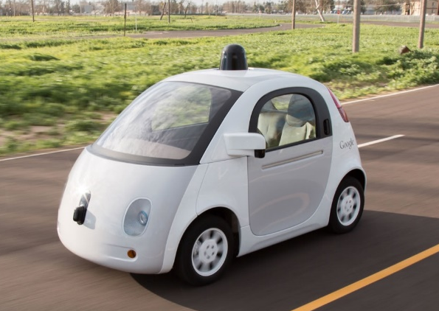
For a vehicle to achieve autonomy, it requires situational awareness (knowing and interpreting one’s surroundings). This means autonomy has the requirement of having surroundings mapped out for the vehicle to know how to navigate. This difficult problem is overcome with simultaneous localization and mapping (SLAM). SLAM is a solution to knowing where one is by constructing and updating a map of an unknown environment while simultaneously tracking the location. The two most popular methods are both statistical techniques and include extend Kalman filter (EKF) and particle filter, with both having their respective benefits.
With knowing where it is and its current state, the controller give signals to the actuators which in turn control the vehicle. Motion planning for the controller can include simple obstacle-avoidance, waypoint navigation or a merging of the two. The computational complexity and real-time challenges must be accounted for to ensure predictable behavior. Many current vehicles have features of semi-autonomy such as adaptive cruise control, lane keeping assist, and automated parking.
The study of autonomy is furthered by advanced and flexible software tools. Several platforms are available to aid in the research development of robotic algorithms for autonomous navigation. Examples of these platforms include University of Pennsylvania’s F1/10, MIT’s RACECAR, Georgia Tech’s Autorally, and Willow Garage’s Turtlebot and, not so attainable, the Roborace Robocar. The availability of these robot vehicles has increased significantly alongside the growth of the Robot Operating System (ROS) which has lessens the learning curve for researchers and hobbyists.

ROBORACE
Roborace will be the first autonomous vehicle racing championship. The Robocars top out at a speed of 186 mph (299 kph) and will compete on the same tracks as the FIA Formula E Championship. The primary purpose of the new motorsport is to discover and evaluate the limitations of algorithms. Just as major sports car brands use the knowledge gained from Formula 1, so will the sponsors of Roborace gain value insight into reliability and safety of their components and software. The championship obviously represents the peak of autonomous vehicle capabilities and requires competing with many other hopeful participants to earn the opportunity to be a part of the chosen teams.
The development car for the Robocar car is called the DevBot. The DevBot includes a cockpit for a human rider/driver to gain better understanding of how the software is performing and experience the hardware. In turn, the qualitative and quantitative data that is collected will be used to develop the software used on the Robocar.
The vehicles are reported to utilize NVIDIA Drive PX2 which uses dual Tegra CPUs and dual Pascal GPUs. The AI computing platform is designed to be air and water-cooled and can be integrated into the hybrid’s battery cooling system. NVIDIA, which is a huge proponent of deep learning, has enabled the Drive PX2 to use its 12 CPU cores and deep neural networks to process data from multiple sensors and cameras at 24 trillion operations per second. Software development takes place through the NVIDIA DriveWorks SDK which contains application, tools, and module libraries.
In addition to the Drive PX2, the Robocar will have a wide variety of sensors including cameras on the front and top, ultrasonic sensors on the front, lidar in the front, side and rear, and radar on the front and rear. The vehicle will also be equipped with V2X communication to transmit and receive data from team officials, other vehicles, and the track itself. A diagram of the hardware is shown in the figure below.
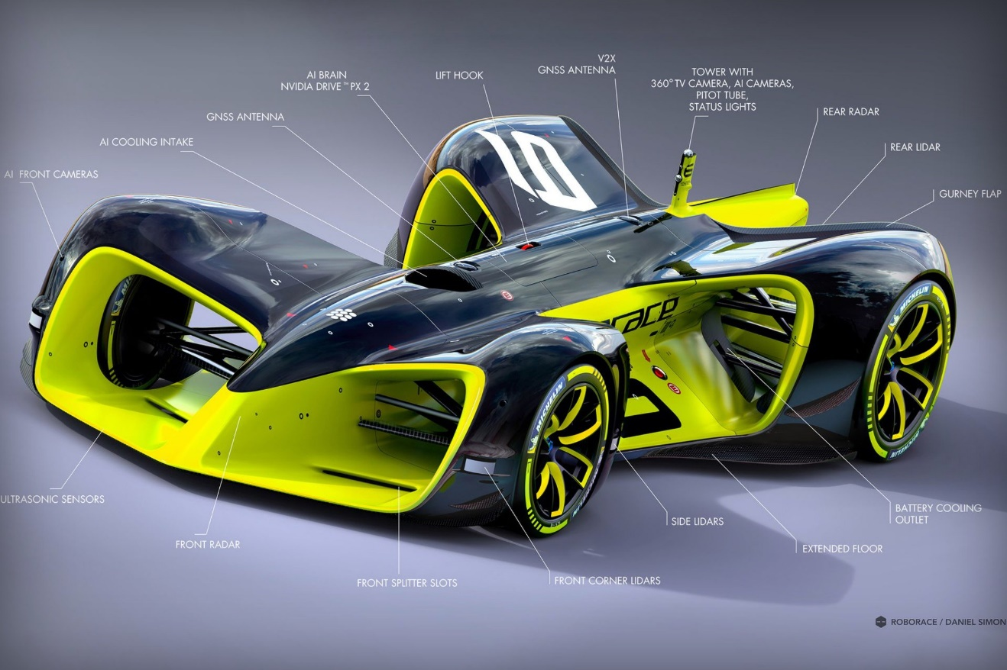

F1TENTH
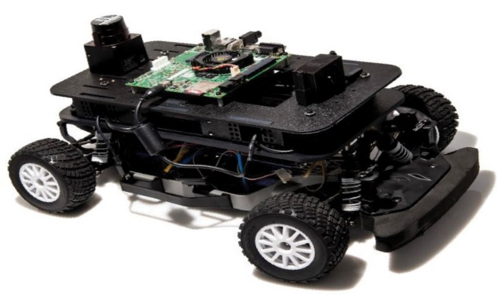
On a much smaller scale to that of the Robocar, is the F1/10 autonomous racing competition. In this competition, an RC roughly one tenth the size of a Formula 1 car is modified and equipped with a variety of sensors that enable it to navigate a closed course without human interaction. The project was started by University of Pennsylvania with the goal of providing a hands-on introduction to autonomous robots.
Figure 1 F1/10
In this competition, teams made up of university students are given a list of components and basic instructions on how to get the hardware functioning. However, the focus is not necessarily on the hardware itself rather the development of algorithms that make practical use of them. This involves building a deeper understanding of perception and control for autonomous navigation.
The major hardware includes a commercially available Traxxis Rally Racer, an inertial measurement unit (IMU), to approximate acceleration and velocity, Lidar, to assist in estimating position, building maps, and localizing, a structure sensor, which can be fused with Lidar readings to give a better estimate of position, and a NVIDIA Jetson TK1 for computation. The Jetson is a developer board that allows for software development in a Linux environment.
The F1/10 platform uses a flexible software tool called Robot Operating System (ROS). First conceived by Stanford, “[ROS] is a collection of tools, libraries, and conventions that aim to simplify the task of creating complex and robust robot behavior across a wide variety of robotic platforms.” [http://www.ros.org/about-ros/]. This software allows for collaborative software development so multiple developers can more easily implement their contributions and reach a single goal. For instance, an expert in control can develop a controller that takes input published from LIDAR software developed by a sensing expert. With a single platform, or framework, these two pieces of software can communicate effortlessly with one another. ROS has steadily become the most popular robotics software tool in the industry. For this reason, F1/10 has also become more popular to help prepare students for careers in the field of robotics and autonomous vehicles.
More information is available on F1tenth can be found at http://f1tenth.org/

MIT TUNNEL RACE (RACECAR)
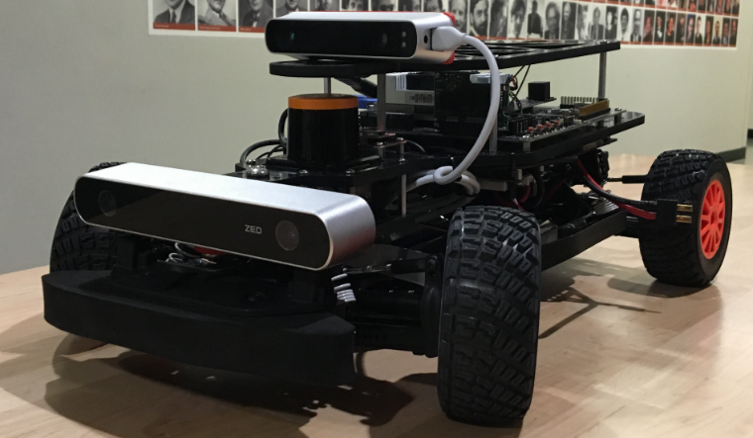
MIT has created a similar platform to the F1/10, called the Rapid Autonomous Complex-Environment Competing Ackermann-steering Robot (RACECAR). Since its debut in January of 2015, MIT has used this platform in three course offerings and another for high school students. RACECAR is based on the same Traxxis Rally Car as F1/10 but instead uses a NVIDIA Jetson TX1, which is both smaller and more powerful. Comparably, the RACECAR platform has improved velocity approximation by means of an Electronic Speed Control (ESC) unit which is used as a visual wheel odometer.
Figure 2 RACECAR [http://fast.scripts.mit.edu/racecar/]
Software is open-source and is available at https://github.com/mit-racecar. A simulator for the ROS Gazebo environment is also available through the link provided.
AUTORALLY
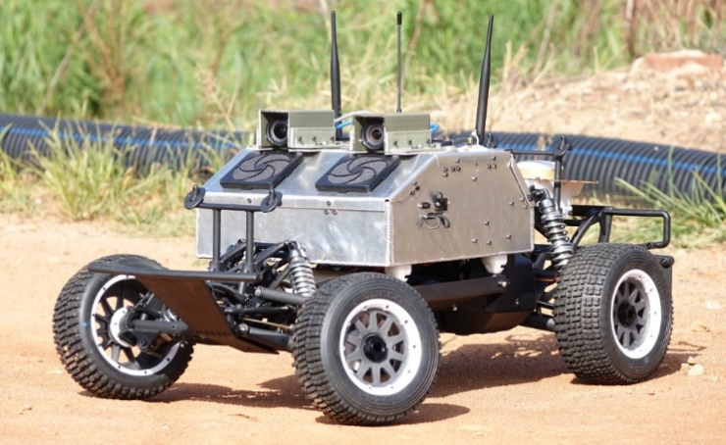
AutoRally is a 1:5 scale rally car platform developed by Georgia Institute of Technology. It differs from F1/10 and RACECAR in that it is intended to by operated off-road. Also, the hardware is much more advanced with a Mini-ITX compute box which uses an Intel Quad-core i7, 32 GB of RAM, and NVIDIA GTX 750ti GPU, just to name a few. The robot is stated to be cost-effective, but at nearly $19,000, it is much more expensive than similar platforms.
Figure 3 AutoRally
Georgia Tech has developed this platform to serve as a “high-performance testbed for advanced perception and control research.” Like F1/10 and RACECAR, the Autorally robot software is built through ROS. The purpose of the project is to speed up the algorithm development process rather than to focus on hardware matching. Furthermore, the core software and ROS Gazebo simulation are made publicly available to allow for quick startup.
More information is available at https://github.com/AutoRally

TURTLEBOT
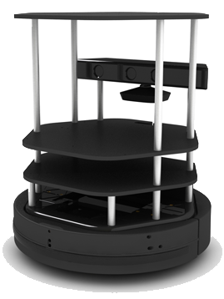
Willow Garage, a robotics research lab, has developed a plug and play personal robot with open source software called the TurtleBot. The robot is intended to reduce the expense and complexity of the software and hardware normally incurred when studying robotics. The main components of the hardware consist of a Kobuki mobile base, Microsoft’s Kinect depth sensor, and a laptop with the minimum computing power that can handle the robot’s capabilities. Using these consumer electronics is the primary reason for the lost cost ($500-1500) of the system. Additionally, the platform is officially supported by ROS and includes a full ROS package which includes Gazebo and Rviz simulation.
Figure 4 TurtleBot
The Kobuki base is supplied with a gyro, calibrated at factory, and wheel encoders to provide odometry. The data from these two sensors are fused using an extended Kalman filter algorithm, available open-source. Since the primary purpose of this platform is creating navigation algorithms, knowing the positon of the robot is necessary. Much of the open-source documentation for this robot is easily adaptable to other ROS based platforms, which extends the impact of this project to entire field of robotics.
More information can be found at :http://www.turtlebot.com

BARC
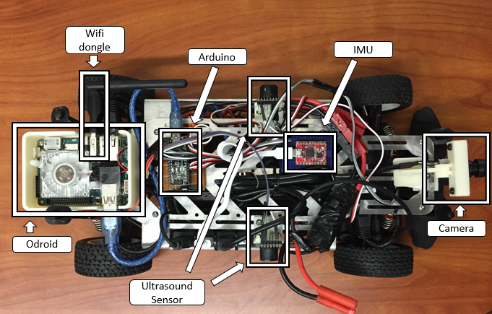
The Berkeley Autonomous Race Car (barc) is another 1/10 scale autonomous vehicle platform developed by University of California, Berkeley. Its purpose is to aid in the advance complex vehicle control algorithms for maneuvers such as lane change and obstacle avoidance, even drifting as is explicitly mentioned in the documentation. It uses ROS at the core of its framework just as it appears the overwhelming majority of the available platforms utilize.
Figure 5 BARC
One major advantage over the F1/10, and is the case for RACECAR, the barc uses Electronic Speed Control (ESC) to estimate and set the target speed of the vehicle. Unlike the other platforms, barc uses a much more compact, and less capable, Odroid single board computer. Other hardware includes Arduino, IMU, camera, ultrasonic sensor, and hall effect sensors.
More information can be found at http://www.barc-project.com/

. Methods

Robot Operating System (ROS)
The Robot Operating System (ROS) is an open-source operating system for robotics. First conceived by Standford, “[ROS] is a collection of tools, libraries, and conventions that aim to simplify the task of creating complex and robust robot behavior across a wide variety of robotic platforms.” [http://www.ros.org/about-ros/]. For instance, an expert in control can develop a controller that takes input published from LIDAR software developed by a sensing expert. With a single platform, or framework, these two pieces of software can communicate effortlessly with one another.
Here we utilize ROS to give the F1/10 vehicle the ability to perform all its necessary functions, sensing, planning, and acting. ROS is vital to the implementation of map building algorithms, sensor interpretation and visualization, and control. We found this system to work very well in splitting coding tasks between group members.
ROS nodes are stand-alone software algorithms that can communicate with one another using topics. For example, one node can gather LIDAR data while another node uses the data to provide PID control for forward and lateral movement. Another key benefit is added fault tolerance because a node that crashes doesn’t crash all the other nodes. Code can be split to individual tasks, alleviating the need for huge all-inclusive pieces of code.

MATLAB Robotic Systems Toolbox (RST)
The MATLAB Robotics System Toolbox allows for interfacing between MATLAB and Simulink and ROS. The toolbox also supports C++ code ROS node generation from a Simulink model.

Turtlebot
Turtlebot is a low-cost robot-kit with open-source software. To the following link it is possible to find all the resources and the information a person needs to start using such a device: http://www.turtlebot.com/about/.
This platform was useful at the beginning of the course to get use of the general architecture of a robot equipped with ROS. This platform is also well known and used for educational purpose; in fact, several tools are available to simulate this robot in Gazebo and learn how to use the principles of mobile robotics and ROS programming. In this course for example we used the simulation tools of Turtlebot since the first assignment. It was a good way to install the PC environment and start using ROS because we have the particular goal to move a robot.
The first experience we did was teleoping the robot first in the simulator, then teleoping the actual robot. We appreciate that even if the real and the simulated worlds were pretty close to each other, actually some difference specially in the odometry came out: for example, a turn of 360 degrees in Gazebo hardly corresponded to a full turn of the robot in the real world.
The Turtlebot was also used to learn about the Kinect and the Mapping algorithm. By teleoping the robot, we experienced how to create a map; searching how different ways of navigation impact on the final map was interesting. The natural next step was crating algorithm for autonomous navigation and obstacle avoidance.

Implementation

System Overview
To understand how this vehicle operates, we must first understand the basic structure of the vehicle. The vehicle is a typical RC car with input from the autonomous vehicle system added as an alternative to the radio input to the vehicle.
Figure 6 System structure of F1/10 Vehicle
From the hardware perspective: The blocks listed in the right column are the normally original parts you can get when you purchase a RC vehicle. The blocks list in the left column are the mobile computer (Jetson), micro-controller (Teensy), and sensors (LIDAR, IMU, structure sensor) that custom integrated to make the RC vehicle to be an autonomous RC vehicle (F1/10 platform).
- Traxxas RC Truck
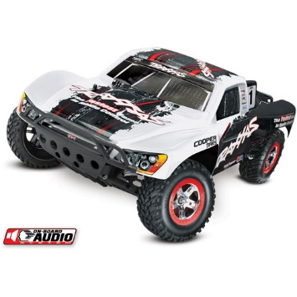
The Traxxas RC Truck is in 1/10 scale as the real vehicle in our daily life of which the highest is up to 60 miles per hour. Therefore, it’s a good research platform to integrate multiple sensors and software environment, which can be used to demonstrate the new algorithms in control, decision making, task planning before implementing them on a real vehicle. The platform can significantly accelerate the research while reduce the cost and potential risks. More information about the Trassas RC truck can be found at: http://www.jegs.com/i/Traxxas/430/58034-2-WHTE/10002/-1
Figure 7 RC Truck
- NVIDIA Jetson TK1
The Jetson TK1 is the main computing unit on the F1/10 platform. Jetson Tk1 is a mobile computing unit developed by NVIDIA which has a decently powerful mobile CPU and GPU for the TDP of 7.5W. The Jetson TK1 comes pre-installed with Linux4Tegra OS (basically Ubuntu 14.04 with pre-configurated drivers) and support for ROS.
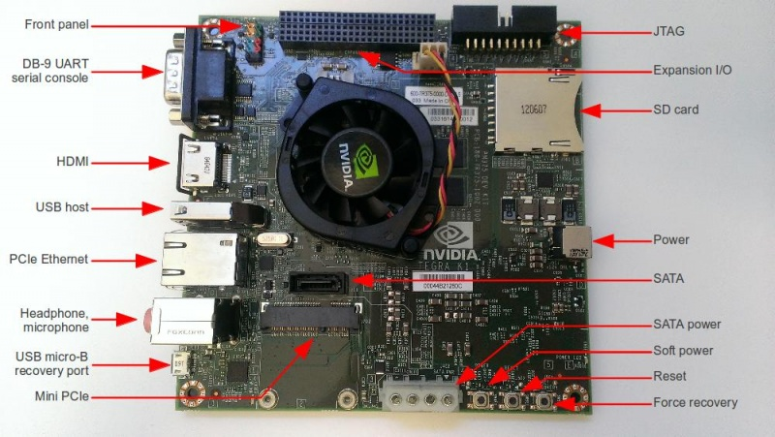
The USB 3.0 interface is integrated on the Jetson TK1 which can be used to handle the communication with the sensors such as LIDAR, IMU, Structure sensor and the micro-controller such as Teensy. The Ethernet interfaced on Jetson TK1 can be used for WIFI communication with the server laptop. The NIVIDA Kepler GK20a GPU and the corresponding CUDA cores has nice performance on GPU-accelerated image processing which provide the potential applications such as autofocus driving based on Deep Learning. More information about the Jetson TK1 can be found at: http://elinux.org/Jetson_TK1
Figure 8 NVIDIA Jetson TK1
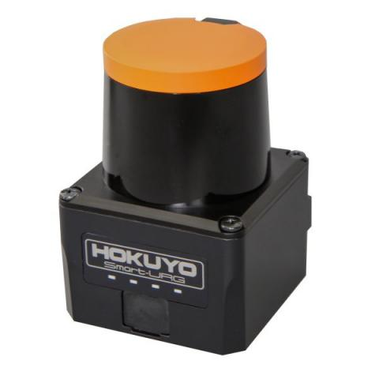
- HOKUYO UST-10LX LIDIA
Figure 9 Hokuyo UST-10LX Lidar
The HOKUYO UST-10LX Lidar is integrated to the F1/10 platform as one of the most expensive and import sensor. This LIDAR is only 130g, which is the smallest and the lightest in its product serial, with 10 meters of mid-detection range, 270 degrees of detection angle, 0.25 degrees of angular resolution. More information about the specifics and the applications about the HOKUYO Lidar can be found at: https://www.hokuyo-aut.jp/search/single.php?serial=167
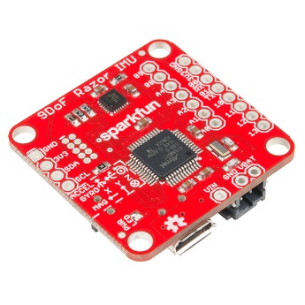
- Inertial Measurement Unit (IMU)
Figure 10 SparkFun IMU
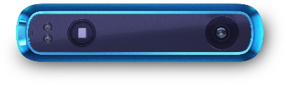
A SparkFun 9 DOF Razor IMU is integrated to the F1/10 platform. This re-programmable multi-purpose tiny-dimension IMU consist of a SAMD21 micro-processor and a MPU-9250 sensor which features three 3-axis sensors (accelerometer, gyroscope and magnetometer). The IMU can sense linear acceleration, angular rotation velocity and magnetic field vectors. The onboard microprocessor, Atmel’s SAMD21, is an Arduino-compatible, 32-bit ARM Cortex-M0+ microcontroller that can be programed with Arduino IDE. The serial communication and the power supply for the board can be handled with a unique micro-USB port. More information about this SparkFun IMU can be found at: https://www.sparkfun.com/products/14001
Figure 11 Structure Sensor (depth camera)
- Structure Sensor
A STRUCTURE depth camera is integrated onto the F1/10 platform. The Structure sensor is a cross-platform (capable for Windows, Linux, Android and Mac) easy-to-use depth camera. The depth information in the information in front of the vehicle can be achieved when it is setup as a looking-forward camera on the F1/10 platform. The opensource OpenNI2 is used as the driver and the software develop kit (SDK) which is integrated in the ROS. More information about the structure sensor can be found at: https://structure.io/
- Pico Station
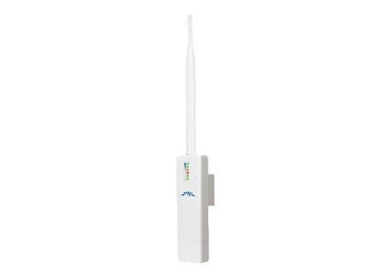
A Pico Station is a small size, medium-range wireless access point that delivers up to 100Mbs through TCP/IP communication. The Pico-station is connected to the NVIDIA Jetson TK1 though its Ethernet port, which makes the Jetson TK1 is accessible by a laptop. Therefore, the F1/10 platform can be remote accessed, monitored and controlled through a laptop or a desktop when the vehicle is running in a significant wide workspace.
Figure 12 Pico Station
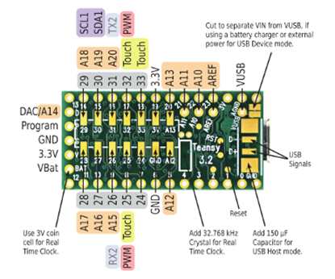
- Micro-Controller (Tennsy)
Figure 13 Tennsy 3.2
A Tennsy board is used as the micro-controller of the F1/10 platform. It can be programed by Arduino IDE and control the Electronic Speed Controller (ESC) and the steering servo with two PWM ports.
- USB Hub
A 7 Port USB 3.0 Hub with power adapter is used for the communication between Jetson TK1, Teensy and other sensors.
- Battery Pack
An Energizer XP18000AB Universal Power Adapter is use as a power supply for the NVIDIA Jetson TK1, the Pico Station, the USB hub and all the sensors.
From the software perspective: The operation system on the NVIDIA Jetson TK1 is the Ubuntu 14.04 for ARM. The ROS indigo is used to for the sensor integration and vehicle control. All the program is built by Python 2.7 or C++.

Hardware Assembly
Written by Yi
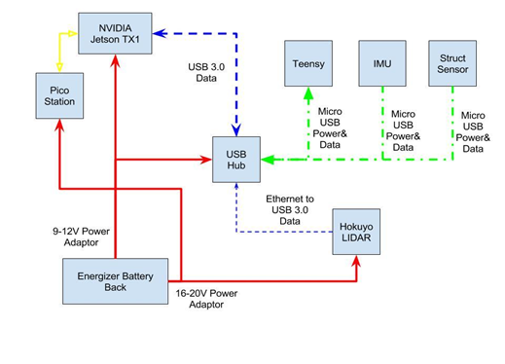
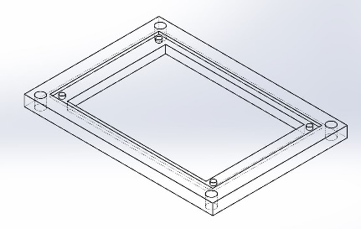
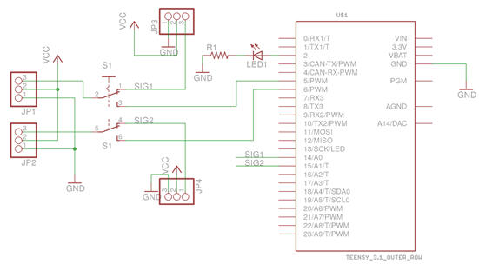
The hardware connection diagram of the F1/10 platform is shown in (Figure 14). Everything of F1/10 platform is powered by the Energizer power adapter except for the servo and the motor of the RC truck. The red solid lines in the figure illustrates that there are two different level of output voltages on the Energizer power adaptor: one is 9 to 12 Volt DC output which is used to power the Jetson TK1 and the USB hub, the other is 16 to 20 Volt DC output which is used to power the Hokuyo Lidar and Pico Station. Two custom wired connections with property adapter need to be made for the power supply. The yellow solid line illustrates the connection between the Ethernet port on TK1 and the Pico Station, which make the TK1 as a WIFI access port. The 3px blue dash line illustrates the connection between the USB hub output and the USB 3.0 port of TK1. The green dot dash line illustrates the connection between the USB hub and Teensy, IMU and Structure sensor. These three sensors are directly powered by the USB hub (which is powered by the Energizer power adaptor). The Teensy and IMU communicate with the TK1 through serial communication with USB interface.
Figure 14 Hardware Connection
Figure 15 Mount of Teensy
Figure 16 Peripheral Circuit for Teensy
The lacer-cut chassis and the custom designed mountings are necessary to make sure all the parts set stable and reliable on the RC truck. The mount of the Teensy with breakout board and the IMU, which produced by 3D printing, are designed as Figure and Figure. The material and the drawing of the lacer-cut chassis can be found at: http://f1tenth.org/car-assembly
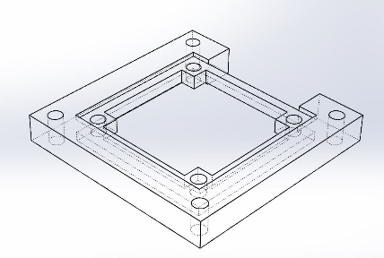
Welding job is needed to build a breakout board for the Teensy (micro-controller) so that we can control the drive motor and the steering servo of the RC track by the Teensy but keep the original remote control function offered by the RC truck manufacture and be able to switch between the two modes. The peripheral circuit of the Teensy breakout board is given in Figure17, the mode of the RC vehicle can be changed by the switch S1 in the diagram.
Figure 17 Mount of IMU
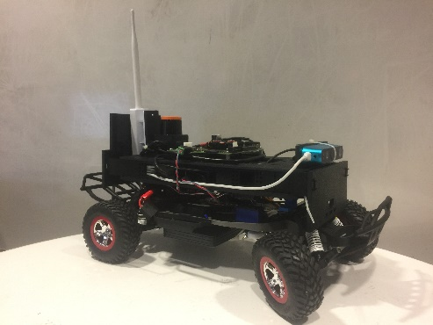
The fully assembled F1/10 platform is shown in Figure 18. More introduction and the video tutorial for the assembly can be found at: http://f1tenth.org/car-assembly
Figure 18 Assembly of F1/10 Platform

Software Environment Setup
- ROS Installation
Install ROS indigo on TK1 by following the tutorial “Ubuntu ARM install of ROS Indigo” on the ROS Wiki: http://wiki.ros.org/indigo/Installation/UbuntuARM
- Rules of Networks
Before the sensors setup, the rules of the networks and IP address is defined.
- The Jetson TX1:
  - IP: 192.168.1.150
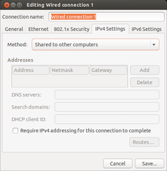
  - Subnet Mask: 255.255.255.0
Figure 19 Share WIFI of the Laptop to TK1
  - Gateway: 192.168.1.1
- Hokuyo Lidar:
  - IP: 192.168.1.151
  - Port: 10940 (Default)
- Pico Station
  - 192.168.1.152
  - Subnet Mask: 255.255.255.0
  - Gateway: 192.168.1.1
- Laptops of our team member
  - IP: 192.168.1.155 ~160
  - Subnet Mask: 255.255.255.0
  - Gateway: 192.168.1.1
Everyone in the team need to obey the rules to setup their own device when trying to test the F1/10 platform through remote control. A separated link is built on TK1 so that the TK1 can get access to the Eduroam when it is directly connected to the laptop through its Ethernet port. In the TK1, create a new Ethernet connection called “eduroam_laptop” and keep all the configuration as default. In the laptop, create a new Ethernet connection called “share_eduroam”, then change the “Method” list in the “IPv4 Settings” tab to “Shared to other computers”. More details of sharing the WIFI can be found at: https://askubuntu.com/questions/359856/share-wireless-internet-connection-through-ethernet
- Wireless Network Setup
The wireless network should be set up based on the rules in the previous section by following the “Tutorial 4 – Wireless Network Setup” on F1/10 website: http://f1tenth.org/session1t#tut5a
On TK1 side, make sure that the option “Connect automatically ” is checked for the Ethernet connection to Pico Station, and all the other connection should not be connected automatically.
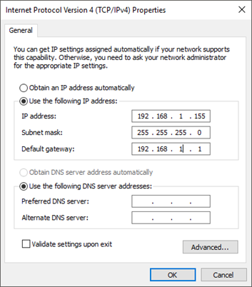
- Lidar Setup
Figure 20 Internet Setting of Windows PC
After the assembly, all the sensors and the Pico Station need to be configurated one by one before the F1/10 platform can test on the trail. Here are the steps to setup the Hokuyo Lidar.
Step 1: Download the “URG Data Viewing Tool” on a Windows PC, manually set the network of the Windows PC as
- IP Address 192.168.0.155
- Subnet Mask 255.255.255.0
- Default Gateway 192.168.1.1
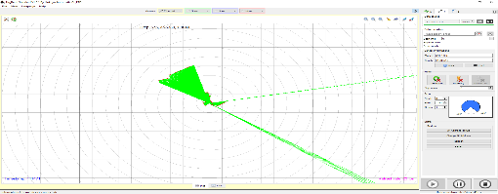
Step 2: Power the lidar by 16-20V output of the Energizer power adaptor, make sure the lidar is working (the blue led on the lidar is on), connect the lidar to the windows pc with Ethernet cable. Open the URG Data Viewing Tool, the lidar should be detected and you should see the results like Figure 21.
Figure 21 URG Data Viewing Tool
Step 3: Download the “URG IP Changing Tool”, change the IP to the address of lidar list in previous section. Then open the URG Data Viewing Tool and manually update the IP address to the new one, you should see the similar result like the Step 2.
Step 4: The connection of the lidar and the Pico station need to be bridged before we can get data from the lidar on TK1. Firstly, the bridge-utils need to be installed on TK1.
Secondly, A script called “setup.sh” is developed to make sure that the bridge of the lidar and the Pico Station can be bridged through remote control (SSH). The setup.sh can be built by copy the following commands into the file.
Step 5: Install the urg node as the driver of the lidar on Tk1
Step 6. Test the data streaming of lidar
More information about the lidar setup can be found in the extra tutorial on the F1/10 website.
- IMU Setup
The SparkFun 9DoF Razor IMU M0 (SEN-14001) IMU has three, three-axis sensors which include an accelerometer, gyroscope, and magnetometer. This makes it possible to sense linear acceleration, angular rotation velocity (roll, pitch, yaw), and magnetic field (can be used like a compass). The processor is a 32-bit ARM Cortex microcontroller that is programmable through Arduino IDE. The physical layout of the IMU is shown below:
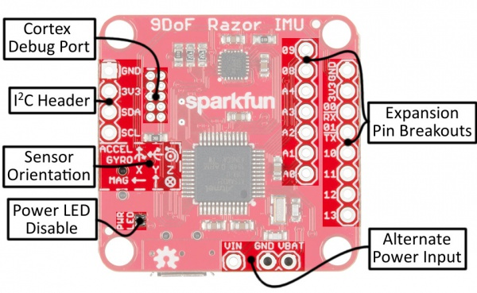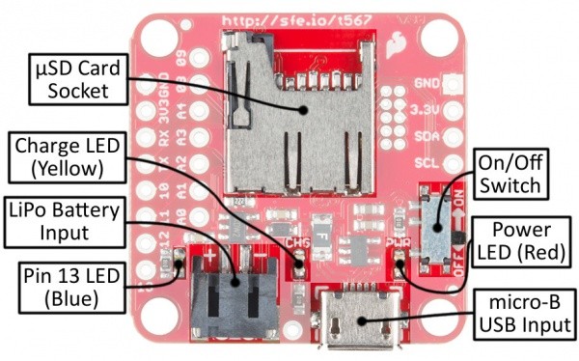
The IMU requires configuring through Arduino IDE. Support for SAMD Boards needs to be installed to be able to communicate with the SparkFun 9DoF Razor IMU M0 (SEN-14001) board.
https://raw.githubusercontent.com/sparkfun/Arduino_Boards/master/IDE_Board_Manager/package_sparkfun_index.json
Additionally, the 9DoF Razor IMU M0’s firmware requires the SparkFun MPU-9250 Digital Motion Processing (DMP) library.
https://github.com/sparkfun/SparkFun_MPU-9250-DMP_Arduino_Library
As the F1/10 supplied code for the IMU was intended for older version of the IMU, a new node had to be created for ROS to communicate with it. The preloaded firmware on the IMU gives many options for output. All available outputs were selected to give maximum flexibility for software development. The firmware must be reflashed on the IMU for the changes to occur.
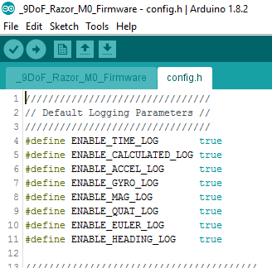
One can confirm serial output through the serial logger in Arduino IDE.
Quaternion orientation data is then used to find the direction and magnitude of gravity and the gravity is moved into the IMU coordinate frame and subtracted out. This makes the IMU only output motion acceleration without gravity included. The threshold for IMU readings acts a filter, limiting the minimum acceleration reading. If the reading is above the threshold, the threshold value is subtracted from the reading and the reading is assumed to be reliable. The pseudocode for the IMU node is seen below:
- Reorient gravity into IMU frame (X,Y,Z) and remove contribution
- Average first 100 readings when vehicle is stationary
- Average set as minimum threshold for readings
- IF measurement > threshold: Treat threshold as offset and remove from reading
- ELSE: Set value to 0
The image below shows the raw acceleration (top terminal) and the calibrated data (bottom terminal).
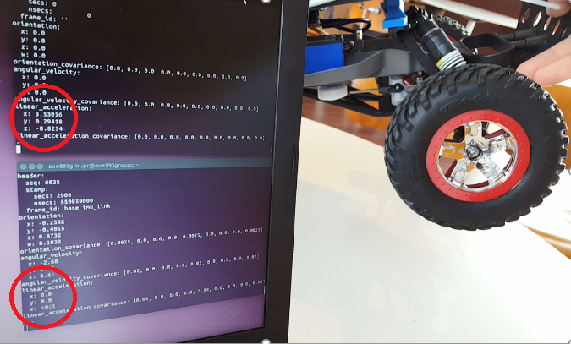
As can be seen in the above figure, the acceleration noise is not completely removed. Better filtering techniques are recommended, such as Kalman filtering.
A second node is currently under development to publish a few raw data topics for the hector_pose_estimation node (https://github.com/tu-darmstadt-ros-pkg/hector_localization/tree/catkin/hector_pose_estimation).
This node takes raw IMU data and magnetometer readings among other sensor data, and provides sensor fusion and filtering (EKF) to estimate the robot pose in 6 DOF. This can be in turn used with LIDAR in SLAM algorithms. However, it appears either raw IMU data or magnetometer readings are too noisy or other sensor data is needed for the node to work properly. Currently, raw acceleration and magnetometer data gave a decent estimate of IMU orientation. More sensor data and better preprocessing are still needed for movement position approximation.
- Structure Sensor Setup

- Teensy Setup
The Teensy is programed with Arduino IDE to make it as a subscriber in ROS, so that the Teensy can subscribe the velocity command from the TK1 through serial communication, the Servo library are used in Teensy to transfer the velocity command the PWM wave outputs on the corresponding pins that control the steering servo and the driver motor through the ESC.
Firstly, the rosserial package should be installed.
Secondly, the latest version of Arduino IDE for Linux should be installed. You can download the latest version of Arduino IDE at: https://www.arduino.cc/en/Main/Software
Thirdly, install the ros_lib to the Arduino IDE. Run roscore, then open a new terminal and do following command
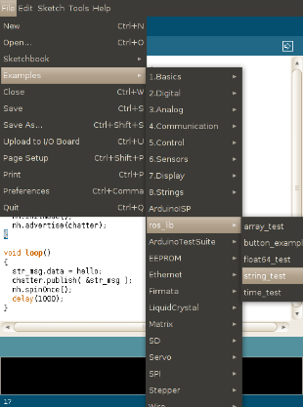
Now you can open open Arduino IDE and check is there a new list called ros_lib in File>Example>ros_lib. If there is, your installation is completed!
Figure 22 Setup of ROS support in Arduino IDE
The tutorial of setup the add-on of Teensy on Arduino IDE can be found at https://www.pjrc.com/teensy/teensyduino.html
For the Teensy to work like Turtlebot, we selected the topic /cmd_vel with messages of type twist. For the reasons of safely, we do the following things:
- Set neutral point at defaults or 0
- Set maximum speed to be a third of maximum possible speed
- Set maximum turning angle to be 30 degrees in any direction
Next, to enable rosserial, we include the library of ros.h and initialize the ros node. We will also use the twist.h library to define the twist message type for the /cmd_vel topic. The twist message has 2 vector3 numbers, each consisting of 3 float64 variables. The Teensy microcontroller supports up to float32, so there is data loss in the conversion. The loss here has minimal impact to us, so we’ll just continue using this method. Once we have the ros node, we subscribe to the /cmd_vel and read the values. Our next task is to convert these values to PWM, so we’ll use a famous library from Arduino, servo.h. While this library is designed for servos, it generates PWM values that can also be used to control the ESC of the vehicle. For this library, 10% duty cycle is equivalent to 0, 15% duty cycle is equivalent to 90 and 20% duty cycle is equivalent to 180.
For the twist command, we use linear.x to drive the vehicle’s ESC and angular.z to set the steering servo angle
- Joystick Setup
A wireless Xbox360 Joystick is connected to the USB hub, the joy package for ROS is installed by following the tutorial on ROS at: http://wiki.ros.org/joy/Tutorials/ConfiguringALinuxJoystick
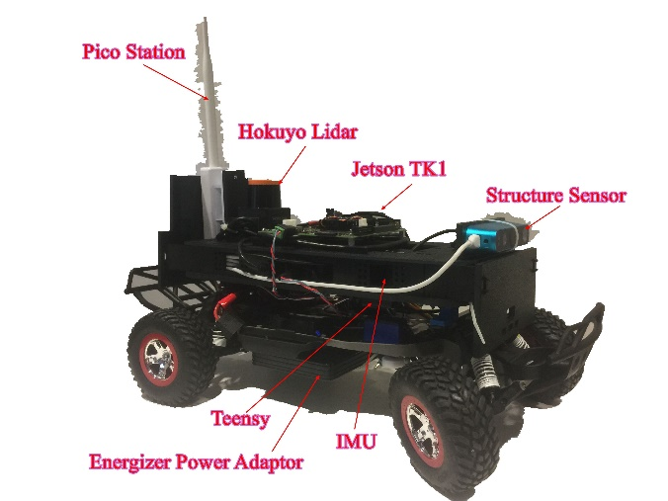
So far, the basic setup of the F1/10 platform is completed (Figure).
Figure 23 Assembled F1/10 Platform

Joystick Control
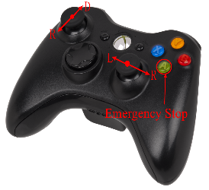
The velocity command to drive the vehicle is a Twist message. A ROS node called “telop_joy” is developed where the /joy topic is subscribed, and the input of joystick on axis 1 is map the linear x of the twist message, the input of joystick on axis 2 is matched to the angular z of the twist, other members in Twist message is equal to zero. The Twist message is published as a topic called “/cmd_vel”. Therefore, the velocity command to drive the vehicle is generated by the joystick by the joystick.
Figure 24 joystick Control

Control Simulation
All the simulator is available at the URL https://github.com/mit-racecar, The simulation is done in a laptop to evaluate the algorithm of the Lidar based steering control and Lidar based speed control.
Step 1: Create the Catkin workspace called “racecar_ws”
Step 2: Go to https://github.com/mit-racecar clone: racecar, racecar_simulator, TA_example_labs, Vsec.
Step 3: git clone https://github.com/wjwwood/serial
Setup 4: git clone https://github.com/ros-drivers/ackermann_msgs
Step 5: Run “catkin_make”
Step 6: To run the Gazebo model some more Ubuntu packages are also necessary. Install the following packages using the commands:

Lidar based Steering Control
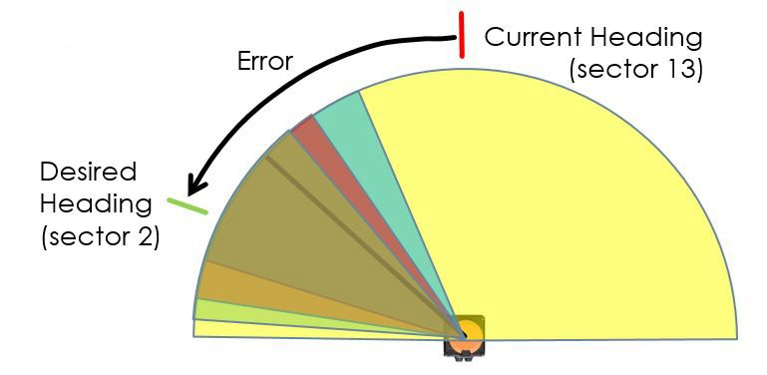
As a first stage of setup the test platform, we are trying to implement some simple and efficient logic to make the vehicle can determine its heading solid and fast in a racing scenario instead of use some fancy logic.
Figure 25 Overlapped Section
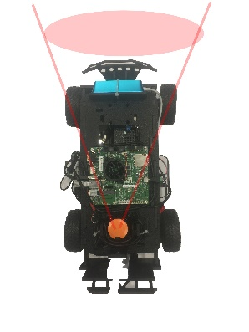
There are typically two objectives of our steering control: Firstly, the vehicle should be able to turn to the best direction where there is a space to let it pass through. Secondly, the vehicle should follow an out-in-out curve at the corner to take advantage of the width of the road and make its trajectory as straight as possible.
Figure 26 Section of Lidar
Based on the objectives above, the designed heading is chosen as the centerline of the section where the lidar data has the largest value. The error used to implement a proportional–derivative (PD) controller is defined as the error between the current heading section and the desired heading section.
To handle the width of the vehicle, the size of the section is set as 45 degrees. As the angular resolution of the lidar is 2.5 degrees, the step size of scan is defined as 5 degrees. Therefore, the overlapped size of two adjacent section is 40 degrees. The weight of each section is defined as the sum all the feedback values of lidar beams. The section who has maximum weight is chosen as the desired heading section, and the angle of the its center line is the desired heading angle.
This algorithm is firstly tested in the trail when the linear speed of the vehicle is controlled by the joystick. The linear speed is increased gradually when the parameters is tuned at this moment to make the vehicle can turning smoothly, cut the angle through a out-in-out line without hit the corner.

Lidar based speed control
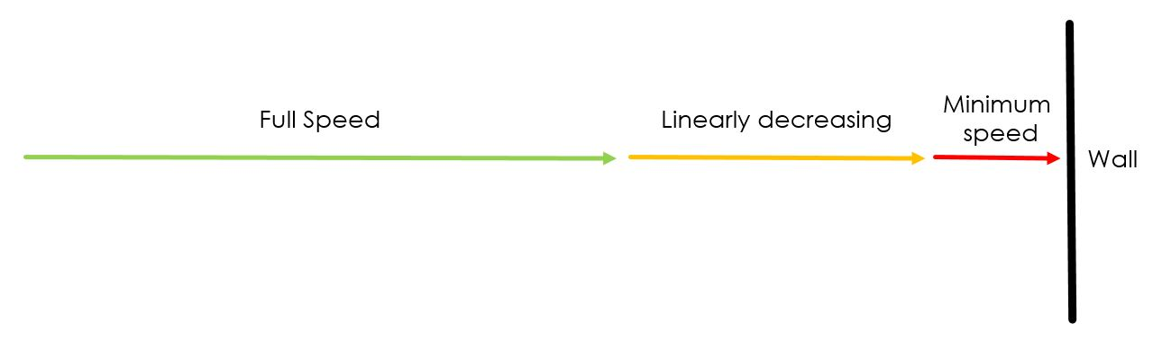
Figure 27 Speed Control

The Lidar based speed is also designed for reach the highest speed in turning. Since the previous steering controller, it tested and proved that the vehicle will obey an out-in-out line at the corner (when the speed in controlled by the joystick), the vehicle need to decelerate when approaching the corner, and reach a smaller speed. Moreover, the speed at the corner should be determined by the shape or the corner. The vehicle should be accelerated as soon as possible when it departures the corner. A proportional controller is used to achieve this goal. The input of this controller is the same error that used for steering control. The vehicle always runs in maximum speed in straight line and no obstacle in the front (error = 0), keep decelerating when it approaches the corner until it near to the center of the corner. After passing the center of the corner, it will accelerate if the Lidar see a free space in the front.

SLAM
Since we do not have odometry information, we use scan-matching based Hector SLAM to generate a map of the environment. To make this work, we used Howard Brand’s instructions to set up the tutorial launch file for Hector SLAM. We then sync the time between the 2 systems by connecting both systems to internet and retrieving the time.
By running the vehicle at speeds between 15 and 25, we can make a map of the environment.

Results
In our work, we exploited only the LIDAR out of all the set of available sensors. The main starting point for the future work will be to integrate all the remaining sensors in the control laws and in the slam algorithm. The structure sensor for example can be integrated to detect obstacles which are out of the beam of the LIDAR such as short objects. Generally, a sensor fusion can be developed to have a better estimation of the surrounding environment. In this way, a better obstacle avoidance as well as a better mapping could be done.
The introduction of odometry could also help for localization and to improve the map and the navigation. The navigation itself could be developed based on the real-time map. In the case of racing, the track is going to be repeated several times and the real-time map can be used to calculate an optimal path to achieve a better performance. Since no sensor is available for odometry, exploiting the esc and the characteristic of the dc motor could be a way to create the odometry for this vehicle.
A sensitive feature missing to this vehicle is an effective breaking system.
The results of the Lidar based steering and speed control is shown as below:
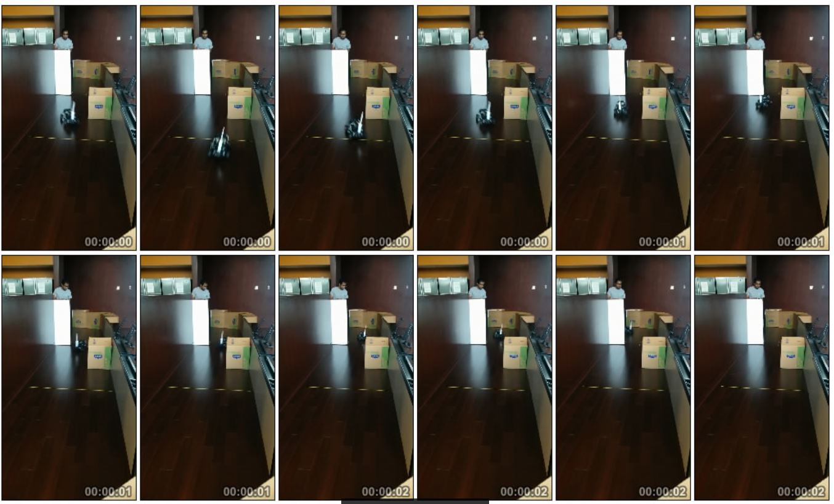
Figure 28 Lidar Based Speed and Steering Control
The vehicle speed can reach up to about 2 m/s, the solid steering is achieved to avoid the obstacles in the trail by implementing a S curve.
The result of SLAM is shown below:
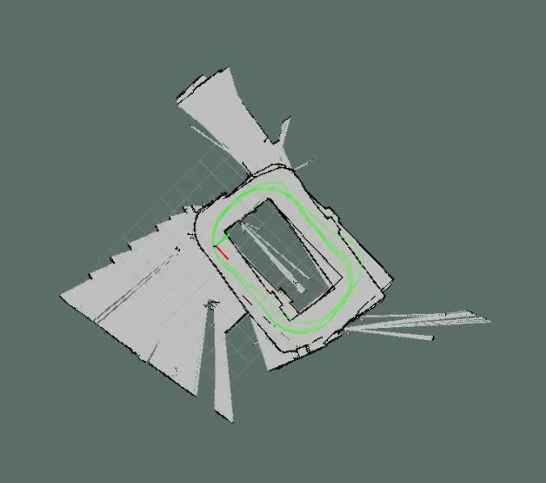
Figure 29 SLAM
All the walls around the trails are detected, and the map can be built within a single lamp when the car is running in high speed. A good accuracy is achieved.

Conclusions and Discussion

In the previous chapters, we explained step by step our experience in making an autonomous racing car. We went thought the assembly of all its parts, the integration of all the sensors, and explained our complex control logic.
Even though for most of us this was the first experience of system integration, we have been able to achieve very satisfactory results. All the team worked on different tasks always keeping in touch to each other’s work to create a link between each module. In such a way, the final integration as well as the debug phase have been easier and allow us to have final superior performance.
A LIDAR PD based controller was implemented to keep the center of the lane of the track as well as an efficient obstacle avoidance. Both the features have been achieved by using a single controller structure which only requires different parameters’ values at different speeds of the vehicle.
A LIDAR based forward speed controller as well as a LIDAR based slam has been developed and tested at different speeds.
As result of our work, our vehicle can run the defined track at less than 8.5 seconds while performing obstacle avoidance.

