Abstract
Most of the world's wind turbines operate under various turbulent wind conditions. Turbulent wind is a big source of uncertainty, and could cause, if unaddressed, significant variation from a turbine's calculated efficiency and even its destruction.
Turbulent flow in wind turbines has a profound effect on various aspects including structural load[1], estimation of a site's energy potential[2], calculated efficiency[3], and many more. However, even though significant advances have been made in the field of anemometry the subjects of estimating a wind turbine's site energy potential and analyzing a turbine's efficiency has not been updated.
In this work high frequency wind measurements that included wind speed using two different anemometers, wind direction and others were gathered and analyzed. The energy potential and efficiency of the turbine was calculated using this data and compared to the figures that would have been received by using the methods described in the IEC 61400-12-2 Standard.
Results show that by using a higher frequency measuring system both a site's energy potential and turbine's efficiency can vary substantially in comparison with the methods described in the International Standard.
This research can affect the way a future wind turbine's site energy potential is measured, it can cause existing wind turbine to reevaluate their productivity performance, and on top of all it can cause the examination of the validity of the International Standards regarding wind turbine performance: IEC 61400-12-1 and IEC 61400-12-2.

Introduction:
Despite the fact that wind energy has very long history of around 1000 years the physical characteristics of the wind itself still remain at large a mystery.
As a result of this of these uncertainty estimations for productivity, structural loads and power output are greatly miscalculated.
First and foremost is the research of wind flow vector stability, one reason for this anomaly (that explains why this research has never been conducted) is the fact that anemometry was unable until recently to provide accurate high frequency three dimensional measurements and data acquisition systems.
Since wind is (as of today) is a very hard to predict resource so is its impact, wind turbine included. Currently, the method of measurement according to the international standards is relied upon averaging past wind over a 10 minute time span. This method is not ideal since the wind's characteristic time scale is unknown, the averaging information could lead to the loss of information[4]. This loss of information can lead to the false assessment of turbine performance, a site's energy potential and loads operating on the turbine.
A literary search was conducted using the following key words: AEP calculations, wind averaging, wind turbulence flow, wind turbine efficiency with the following results:
Many articles [5][6] try to evaluate the power density or energy potential of a specific site by statistic means, others have researched the influence or turbulent flow on those predictions [3], [7], [8], [9] . It is also reflected in the international standard IEC 61400-12-1[10] and IEC 61400-12-2[11]. However, whether addressing the turbulent issue or not, all of these articles calculate the energy potential according to the method of measuring and averaging data over a 10 minute period.
Other works[12],[1] have studied the connection between turbulent flow and the load acting upon the turbine body; however either a high frequency method was not adopted or pure numerical methods was used without actual field data.
The study was conducted under the guidance and with the support of Winflex Co.
the company built a measuring platform for their wind turbine but the data was processed and evaluated according to the norms in the wind industry and according to the International and Israeli standards i.e. averaging long periods of time into one data points, some attempts were made in high frequency measurements but no real work was done.
The purpose of this study is to determine the effects of turbulent flow, by using high frequency measurement, on wind turbines efficiency, energy potential and control system.
Using low frequency measurements to determine the efficiency, energy potential and control might prove unreliable on account of information lost between measurement points.
The study was conducted by using high frequency data gathered by the Winflex Co. sensors [13], these results were analyzed and compared results that would have been received if the system was using a low frequency method. By doing so it might be possible to quantify and evaluate the difference in the parameters mentioned before in different measuring frequency. If significant differences will be found it might be necessary to re-evaluate the methods being used today to calculate those parameters. In addition, high speed measurement can advance our understanding of the true profile of turbulent wind flow.
The results of this study were presented in the 14th World Wind Energy Conference in Jerusalem[2].

Methods

Sum of sin functions:
Taken into account that turbulence is totally chaotic and no assumptions that are made are valid it is always possible to describe it as a sum of sin functions [14][15].
Assuming it is possible to describe the wind as a sum of sin functions raises the question of how many sin functions are required?
The obvious answer will be an infinite number; however a fair approximation of the real wind behavior is obtainable with a small amount as seen in the following example:
While attempting to "predict" wind speed behavior a number of sin functions were pieced together quite arbitrarily using "Matlab" as each step another one was added, in the following figures it is possible to see the process "creating" the wind prediction example:
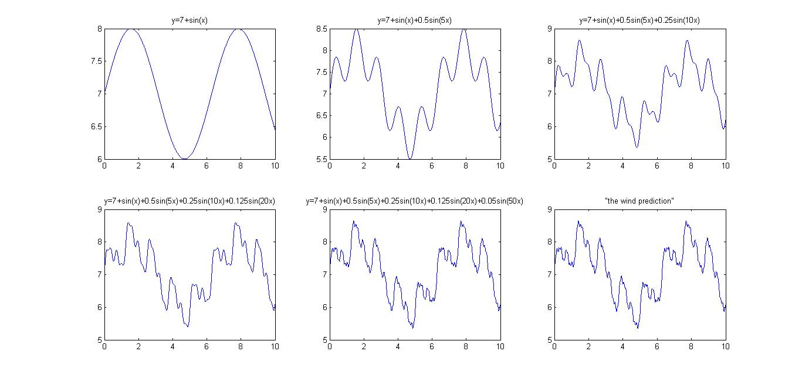
Figure 1 - Effect of sin functions on the "Wind Prediction"
A more convenient display of the final result
Figure 2 - The "Wind Prediction"
A real 15 second wind measurement segment can be seen below:
Figure 3 - 15 seconds Wind Measurement
These are 300 points taken at a 20 Hz frequency, there is a small amount of similarity between the two graphs but nothing more than that; this result is quite understandable since actual wind prediction is not possible, definitely not with a couple of sin functions added together randomly in "Matlab", more so because the characteristic length and time of the wind is not yet fully understood although some work was done in that area by A. Kolmogorov and G.I. Taylor.
If the turbine is constructed to accommodate the maximum gust speed it should be bigger, more robust but also heavier. However, a heavy turbine will need stronger winds in order to operate and may not work at all at lower winds due to its weight. A robust design affects the economic outcome greatly: a big turbine is more expansive to build and because it is designed for higher winds it wouldn't work with lower winds that could take up a considerable portion of the time. However designing turbine to in accordance with the average site wind speed has its own disadvantages, first and foremost the face that the turbine might break comes a strong wind gust. As a result of this fact turbine designers always walk this thin line between financial feasibility and structural security.

Meteorological Data gathering system:
For several months various meteorological data was gathered and stored on a computer in order to analyze and review them.
A wind data gathering system was installed on top of the turbine's tower, the system is located slightly above the level of the nacelle in a way that the wind that is measured is really the wind that runs through the sails and drives the turbine as described in the IEC 64100-12-2. This ensures the best and closest measurement to the actual wind that can be utilized by the system.

Meteorological data measurement system
Figure 4 - Meteorological data gathering system
The data gathered from the meteorological sensors could be stored on a computer and analyzed together with other data; the data is gathered at a high rate and is equivalent to 0.6-0.7 Meg-bytes of information for 1 minute of data of 20 Hz measurements.

The difference between cubic and arithmetic mean

Arithmetic Mean:
Arithmetic mean is defined as the sum of the group divided by the number of its members and is calculated by:
Equation 1 - Arithmetic mean

Cubic Mean:
Cubic mean is defined as the cubic root of the sum of each of the valued in the power of 3 divided by the number of members in the group:
Equation 2 - Cubic mean
Since using different means amounts to different results the conclusions derived will also differ, I.E. the cubic mean will always be bigger than the arithmetic mean.
These different methods will become the major difference between mean measurements and differential measurements.
While in the IEC standard[11] the wind speed in averaged using arithmetic mean and then the efficiency and power are calculated according to this value it actually means that power is in direct proportion to the wind speed (), while in essence wind power equals , meaning ().
Using cubic mean instead of arithmetic mean should solve this problem and provide more accurate results for wind power measurements.

The measurement method in use today is as described in the standard[11] uses an arithmetic mean of data gathered in the period of 10 minutes, the use of this mean method in the standard is justified by the attempt to conform it with [10] Standard that uses a measuring station located 4-6 times the rotor diameter upwind. The 12.2 standard addresses the problematic nature of this method but no change has been made to this day. The Standard is aware of it's inherent problem and even addresses it but still continues to use the same 10 minute average method.
This method could of course have effects in many areas, some notable examples are:

Annual Energy Production – AEP
When measuring a site's energy potential a parameter called Annual Energy Production – AEP is used. This is calculated by applying the power curve to a 2nd order weibull distribution called Rayleigh distribution.
The concept of wind potential and AEP (Annual Energy Production) became clearer with more accurate measurements and a method of averaging the wind speed across the span of several minutes was chosen. This method became the standard for assessing a site's and is defined in the international standards [10] and [11]:
The Wind measurements are averaged out across a 10 minute time span and then divided into bins of 1 m/s ranging from 4 to 11 and the AEP is calculated using Equation 3:
Equation 3 - AEP calculated according to IEC 61400-12-2
The AEP is then separated into measured production and approximated production.
The measured AEP is deduced from the turbine's power curve assuming zero power production above and below the measuring range.
The approximated AEP is deduced from the turbine's power curve assuming zero power below the measuring range and power equal to that received at the maximum of the range for any speed above it.
It is evident that using the method described above will lead to a rough averaged estimation of the AEP of a site. This method is understandable when using cup anemometers because the inherent inertia and low measurement frequency doesn’t allow the accurate tracking of wind gusts and changes that can occur at frequencies of 20 Hz and higher.

A comparison of wind measured using a cup anemometer sampling at 1 Hz and an Ultra-Sonic anemometer sampling at 20 Hz for the duration of 10 minutes is shown below Figure 5:

Figure 5 -Cup anemometer and US anemometer Vs. Time - 10 minute scope

Figure 6 - Cup Anemometer and US anemometer Vs. Time - 1 Minute interval
While the overall average speed is very similar using the two methods it is evident that the Ultra-Sonic anemometer tracks the wind with higher accuracy, even though if calculated using the AEP standard method the result will be identical.
Figure 6 is small a fragment of Figure 5 over a 1 minute time, the "constant" measurement of the cup anemometer and the fluctuating Ultra-Sonic measurements is visibly clear in that figure.

Coefficient of Productivity
Another parameter often examined is the Coefficient of Productivity (), which is measured in the following form according to the International Standard [11]:
Equation 4 - Coefficient of productivity according to IEC 61400-12-2
It is evident that in this case as well using momentary wind speed vs. average wind speed will yield a significantly different result.

The advantage of using momentary wind speed in a constant TSR control system:
Tip Speed Ratio (TSR) is a very important parameter in wind turbine operation [16]; every turbine design has its own optimal TSR work regime in order to reach maximum efficiency, a characteristic efficiency Vs. TSR Graph looks along the following lines:
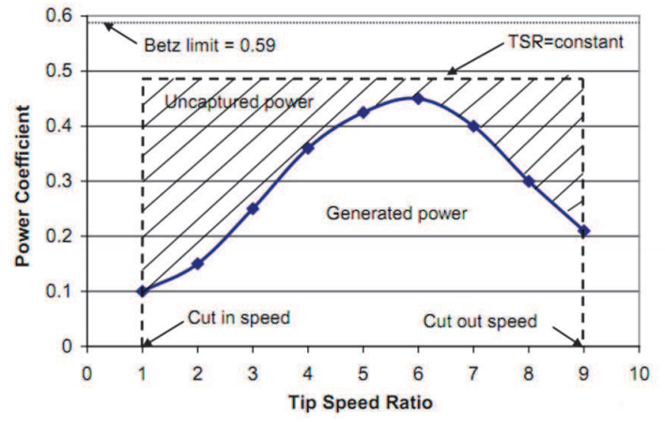
Figure 7 -Typical Power coefficient Vs. TSR Graph
In Figure 7 we can see a power coefficient Vs. TSR graph. The rotor clearly has an optimal TSR operation point (pointed out by the arrow), and any deviation from this optimal TSR, either a higher or lower value will dramatically decrease the efficiency.
In the following Figure 8 we can see various rotor types and its efficiency vs. TSR:
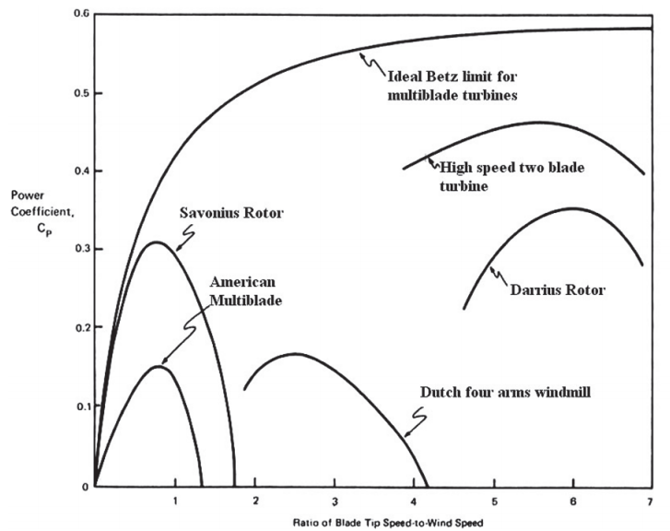
Figure 8 - various rotor types and its efficiency vs. TSR
As was mentioned before different rotors have various TSR operation ranges, we can see that all rotor types have a very narrow TSR range of operation that outside of it the rotor's efficiency falls dramatically.
Since the importance of maintaining a constant TSR has been established the benefits of high speed wind tracking are more than evident: The wind changes its speed constantly, so does the rotor has to change its speed in order to maintain optimal TSR.
If the rate of the measurement is not high enough then efficiency will most likely be compromised.
If, in extreme cases, the wind is only measured by the demands of the standard; I.E. averaged across a ten minute time span and the TSR is determined according to the previous ten minute time span a turbine could and most probably would never work in its designated TSR and thus never achieve its optimum efficiency.
A turbine operating in this form would work inefficiently and would lose efficiency in comparison to its designated potential.

Experimental results

Energy considerations
The databases for both the cup and the ultrasonic anemometers was comprised of roughly 1.6 data samples with a similar 4.5 [m/s] average wind speed and a 0.4 [m/s] standard deviation.
The data acquired from the sensors was analyzed in several different methods:
- According to the method described in the standard, the data was divided into bins and averaged over each of them.
The binned data was summed and multiplied by 8760 hours a year.
- Cup Anemometer data was gathered, wind speed below 4 m/s was discarded; the rest was summed, divided by the number of measurements, normalized to fit 1 hour time, and multiplied by 8760 hours a year.
- Ultra-Sonic anemometer data was gathered, wind speed below 4 m/s was discarded; and the rest was summed, divided by the number of measurements, normalized to fit 1 hour time, and multiplied by 8760 hours a year.
The data was analyzed as mentioned beforehand and the results are shown below:
Figure 9 - AEP Calculated in different methods
In Figure 9 we could see the Annual Energy Production calculated in the different methods described above, it is evident that using a 20 Hz measurement system varies as much as 150% than the AEP derived from the IEC standard.

Importance of measurement frequency
Another aspect that is worth reviewing is the importance of measurement frequency to the overall system efficiency.
As seen before a turbine's efficiency is very much dependent on its Tip Speed Ratio, it is highly visible in Figure 8.
Since it is very important to track the wind speed in the highest accuracy and frequency; if the frequency isn't high enough, the turbine will fail to follow its optimal TSR and efficiency will drop.
To test these theorems a wind speed section of 10 minutes was taken along with a characteristic TSR Vs. efficiency line. The turbine's optimal TSR was taken according to the 20 Hz measured wind speed and then a simulation was made to check what would happen if the measuring frequency was lower, i.e. the TSR, and thus the efficiency, would fluctuate from its optimal point. The data was then compared to a "0 Hz" measurement that uses the standard method of using a 10 minute wind speed average.
In Figure 10 we could see a graph of turbine efficiency vs. measurement frequency:

Figure 10 - Turbine efficiency Vs. Measurement frequency
It is evident that higher frequency equals a more close to optimal TSR equals higher efficiency, while using the frequency described in the standard i.e. 0.0016667 [Hz] leads to inferior results.
In Figure 11 we could see projected energy produced using different frequencies:
Figure 11 – Percent of Standard energy using different measurement frequency.
Like the former figure there is a sizeable difference between the standard method and a higher frequency method, this difference can reach up to 15%.

Wind direction and intensity:
Examining Wind speed measurement raises an important question, since both the US anemometer and the Cup anemometer measures the wind in it's own plane, how is the wind distributed inside the plane? This is very important because wind turbine in general can only harvest wind in the direction they are facing, so if the wind constantly changes not only its amplitude but also its direction it would be impossible for wind turbines to take advantage of these changes (i.e. "follow the wind") on account of structural aspects that would prevent the turbine to change its direction as rapidly as the wind does.
Figure 12 - Wind Speed distribution in separate planer direction vs. overall wind speed
It is visible in Figure 12 that even as the wind speed increases the X axis wind speed keeps on taking the greatest part of the wind speed and that the ratio between the X wind speed direction and the Y wind speed direction remains approximately constant, meaning that the wind speed changes are in fact intensity changes and not wild direction changes.
However, even if the relative distribution of wind speed doesn’t change inside the plane, the wind can divert some of its speed from the turbine plane to the vertical plane and thus effectively change the measured wind speed.
This effect was investigated in the following by measuring the percent of change in wind speed () vs. the percent of change in wind direction (), the results are shown below:
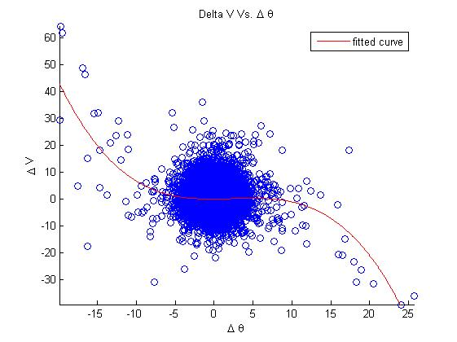
Figure 13 - Change of wind speed Vs. the Change of wind direction
In Figure 13 it can be seen that the wind can change its speed in up to 60% with intense changes of angle. These changes are probably attributed to eddies and turbulences that redistribute energy and momentum spatially. However, the majority of the results show that there is no real evidence that suggest the correlation between the change in the angle of the wind and the change in the intensity of the wind. The middle section is shown in a larger scale at the rectangle above.
An attempt to fit a 3rd degree polynomial equation was also made.

Conclusions
1. Investigating turbulent wind displays the need to re-evaluate the energy stored there; this energy can differ up to 60% from conventional estimations in weak and medium winds (4-7 m/s).
2. Investigation of wind speed changes and better wind turbulence tracking could lead to the creation of a better control system that could prevent damage to the turbine without adding safety factors and decrease the overall uncertainty of the system.
3. The study of turbulent flow leads to questioning the validity of International Standards: American, European and every other country that uses these standards, including Israel.
4. The difference in energy assessment between using arithmetic mean as in the standard and using a cubic mean can differ up to 20%.
5. Energy extraction using adaptive control that follow the wind can improve performance up to 60% from using control according to standard.
6. The "extra" energy identified in the wind is not necessarily extractable or useable for wind turbines using aerodynamic improvement, but its identification represents an improvement for the measuring technique used in International Standards.
7. The additional energy found in turbulent wind may be utilized using a high speed adaptive control system that could track the wind speed changes.
8. The interaction between the vertical wind speed and the turbine are negligible since it has been shown that the wind operates according to the Blasius solution;
meaning the vertical wind becomes negligible as it progresses along the X axis.
9. The theoretic efficiency obtainable from a wind turbine can rise strongly up-to 90% (from the theoretic maximal Betz value) in increasing the control frequency from 1 [Hz] to 5 [Hz] and will grow steadily up to 95% rising to 20 [Hz] frequency. This improvement can reach up to 60% from conventional methods.
10. Turbulence frequency investigation showed that the most significant sinus frequency in the wind is between 0.5-2 [Hz] while the method of 10 minute averaging "assumes" a 0.0016667 [Hz] frequency. In the period of 10 minutes between 300-1200 sinus cycles could fit, each with an approximate change of 10% from the value evaluated by the standard.
11. The method proposed above could help build a turbine's power curve and accelerate the documentation and creation of new turbines, a process that today can take years and cost millions of dollars.
12. The increase in productivity, especially in weak winds (averaging at 4-6 m/s), may double the economic feasibility of using wind energy.
13. A vast improvement to the AEP could be made without any modifications to existing data and data acquisition system simply by eliminating the 10 minute averaging method.

Acknowledgments:
This work is executed with the help and on the basis of "Winflex Co" wind power site along with its measurement equipment. The author would like to take this opportunity to thank Winflex Co. and especially Dr. Vladimir Kliatzkin and Mr. Eliezer Kliatzkin that made the combination between this paper and the company's research process possible, and using all the required equipment and knowledge needed for this purpose.
The Author would also like to thank Prof. Aviv Rosen, Dr. Uriel Fisher, and Professor Michael Shapiro from the Technion - Israel's Institute of Technology for their contribution and support in the creation of this work.

References

[1] | T. Mücke, D. Kleinhans and J. Peinke, "Atmospheric turbulence and its influence on the alternating loads on wind turbines," Wind Energy, pp. 301-316, 2011.
[2] | E. Shalem, "Proposed Modification to Wind Turbines Performance Tests," in Wolrd Wind Energy Conference, Jerusalem, 2015.
[3] | A. Rosen and Y. Sheinman, "The average output power of a wind turbine in a turbulent wind," Journal of Wind Engineering and Industrial Aerodynamics, vol. 51, no. 3, 1994.
[4] | E. Shalem, "Energy output and structure aspects of wind turbine in turbulent flow," Winflex co., Haifa, 2015.
[5] | I. Fyrippis, P. J. Axaopoulos and G. Panayiotou, "Wind energy potential assessment in Naxos Island, Greece.," Applied Energy, no. 87, pp. 577-586, 2010.
[6] | A. A. Shata and R. Hanitsch, "The potential of electricity generation on the east coast of the Red Sea in Egypt," Renewable Energy, no. 31, pp. 1597-1615, 2006.
[7] | S. Wußow, L. Sitzki and T. Hahm, "Simulation of the turbulent wake behind a wind turbine," Journal of Physics, 2007.
[8] | R. J. Barthelmie, S. T. Frandesen, M. N. Nielsen, S. C. Pryor, P. E. Rethore and H. E. Jorgensen, "Modelling and Measurments of Power Losses and Turbulence Intensity in Wind Turbine Wakes at Middelgrunden Offshore Wind Farm," Wind Energy, pp. 517-528, 2007.
[9] | Y. Hristov, G. Oxley and M. Žagar, "Improvement of AEP Predictions Using Diurnal CFD Modelling with Site-Specific Stability Weightings Provided from Mesoscale Simulation," Journal of Physic, 2014.
[10] | I.-6.-1.-1. International Standard, Wind turbines - Part 12-1: Power performance measurments of electricity producing wind turbines, 2005.
[11] | I.-6.-1.-2. International Standard, Wind turbines – Part 12-2: Power performance of electricity-producing wind turbines based on nacelle anemometry, 2013.
[12] | P. H. Madsen, K. Pierce and M. Buhl, "Predicting ultimate loads for wind turbine design," American Institute of Aeronautics & Astronautics, pp. 355-364, 1999.
[13] | W. Co., Winflex Data-Base, Kibbutz Moran: Winflex Co., 2013-2015.
[14] | E. Persoon and K.-S. Fu, "Shape Discrimination Using Fourier Descriptors," IEEE TRANSACTIONS ON SYSTEMS, MAN, AND CYBERNETICS, pp. 170-179, 1977.
[15] | U. Yoshinori, "A New Fourier Descriptor Applicable to Open Curves," Electronics and Communications in Japan, Vols. 67-A, no. 8, 1984.
[16] | A. M. Ragheb, Wind Turbines Theory - The Betz Equation and Optimal Rotor Tip Speed Ratio, INTECH Open Access Publisher, 2011.
[17] | :. ,. ,. P. W. E. Knowles Middleton, Invention of the Meteorological Instruments, The Johns Hopkins University Press, 1969.
[18] | K. H. Bergey, "The Lanchester-Betz limit," Journal of Energy, vol. 3, 1979.
[19] | J. S. Jean Mathieu, An Introduction to Turbulent Flow, Cambridge University Press, 2000.
[20] | D. Chiras, Wind Power Basics: A Green Energy Guide, New Society Publishers, 2010.
[21] | W. Tong, Wind Power Generation and Wind Turbine Design, WIT Press, 2010.
[22] | V. Lyatkher, Wind Power: Turbine Design, Selection, and Optimization, Wiley, 2013.
[23] | C. M. Institute, "Millennium Problems," [Online]. Available: http://www.claymath.org/millennium-problems. [Accessed 10 June 2015].
[24] | H. Schlichting, Boundary-layer Theory, McGraw-Hill, 1979.
[25] | F. P. Incropera, D. P. DeWitt, T. L. Bergman and A. S. Lavine, Fundamentals of Heat and Mass Transfer, Wiley, 2011.
[26] | T. Mücke, D. Kleinhans and J. Peinke, "Atmospheric turbulence and its influence on the alternating loads on wind turbines," Wind Energy, no. 14, pp. 301-316, 2011.

