Supply Chain of Renewable Energies: Evaluation and Analysis of 20 Years of Scholarly Literature
Iman Rahimi, Javad Nematian*

Abstract- This study is the first analysis of 20 years of scholarly literature in supply chain of renewable energies and provides an evaluation and analysis for the most relevant journals and keywords. All related the papers including research articles, reviews, book/book chapters, conference papers, etc., between 2000 and 2020 have been extracted and have been analyzed using Excel and RStudio. Scopus and Web of Science as two well-known databases are used to extract data. The analysis shows that "wind energy" has been attracted by many researchers as a source of renewable energy and "optimization", specifically metaheurics, as an approach are used as a methodology. The last sections discuss future trends and conclusion.
Keywords- supply chain, renewable energy, review, analysis, literature.

- Introduction

Suppliers, manufacturers, warehouses, distributors, and vendors are important factors of the supply chain that aim to develop the product, procurement of material, shipment of products, manufacturing products, and then distribute finished goods between plants (CHRISTOPHER, 2017; Mentzer et al., 2001). The global economy is developing rapidly and consequently, energy requirements have been focused, particularly in developing countries. Due to climate change and environmental protection, fossil fuel resources are replacing by renewable energies (Vine, 2007).
Solar energy generation could be used to generate hot water by the means of solar thermal systems or electricity via solar photovoltaic (PV) and concentrating solar power (CSP) systems (Nematian & Rahimi, 2022) (I. Rahimi & Nematian, 2022). Wind also is known as the second source of renewable energies in Iran and wind speeds are generally above average in many areas of the country, therefore, it is reliable making wind farm projects for its power generation application (Fazelpour et al., 2014)(Nematian & Rahimi, 2022).
In general, the renewable energy concept has been applied to several sectors. Renewable energy is an energy , which is provided from renewable resources namely, sun, wind, marine, tides, waves, and geothermal energy (Ellabban et al., 2014). Nowadays, many countries across the world already have renewable energy contributing to the energy supply and national renewable energy markets are predicted to continue to develop powerfully (Teske et al., 2017).
In this study, the authors have extracted data from Scopus as a well-known databases (Supplementary A) and used keywords namely, “supply chain” and “renewable energy” or"logistic" and "renewable energy" to find the related articles published between 2000 and 2020. Microsoft Excel 2013, RStudio 3.5.2 and VOSviewer (van Eck & Waltman, 2011) were used to analyze the mentioned data and conducted scientometric analysis (I. Rahimi et al., 2019) (I. Rahimi et al., 2018). It is noteworthy to mention that there were some missing values in our data, however, the authors have tried to provide precise results as much as possible. In Figure 1, number of published documents based on types have been presented. As it is clear from the Figure 1, there is a significant difference in publishing article type between 2010-2015 and 2015-2020.

Figure 1 Documents type

This paper is the first study of 20 years of scholarly literature in supply chain of renewable energies between 2000 and 2020. The other sections of the paper have been organized as follows: Section 2 presents publication statistics. The last sections discusses the summary, future studies, and conclusion.
- Publication statistics

Based on Scopus, there are 2545 publications in the field (Supplementary file). The mentioned publications include all types of documents such as research articles, reviews, conference papers, editorial materials, book/book chapters.
  - Publication statistics by year
Figure 2 presents the distribution of publications by year. In the first 6 years of evolution of research articles in the field, the trend is slow, from 3 papers in 2001 to 28 articles in 2006, but trends show a rapid growth from 47 papers in 2007 to 309 articles in 2020.

Figure 2 Distribution of publications by year
  - Publication statistics by journal
In Table 1 the top 20 journals with the greatest number of supply chain of renewable energy papers have been shown. Sources such as Journal of Cleaner Production, Applied Energy, Renewable and Sustainable Energy Reviews, and Renewable Energy are the most utilized. The reason is clear so that the mentioned journals are in the field of renewable energy.
Table 1 The top 20 sources that have published the greatest number of the papers (WOS)
# | Journal | Record count | % of total
1 | Journal Of Cleaner Production | 101 | 3.968
2 | Applied Energy | 75 | 2.94
3 | Renewable And Sustainable Energy Reviews | 74 | 2.90
4 | Renewable Energy | 54 | 2.12
5 | Energy Policy | 53 | 2.08
6 | Energy | 48 | 1.88
7 | Biomass And Bioenergy | 45 | 1.76
8 | Sustainability Switzerland | 41 | 1.61
9 | Energies | 38 | 1.49
10 | International Journal Of Hydrogen Energy | 30 | 1.17
11 | Energy Procedia | 27 | 1.060
12 | Computer Aided Chemical Engineering | 25 | 0.98
13 | Biofuels Bioproducts And Biorefining | 17 | 0.66
14 | Energy Conversion And Management | 16 | 0.62
15 | International Journal Of Life Cycle Assessment | 16 | 0.62
16 | Iop Conference Series Earth And Environmental Science | 15 | 0.58
17 | Applied Mechanics And Materials | 13 | 0.51
18 | Chemical Engineering Transactions | 12 | 0.47
19 | Iop Conference Series Materials Science And Engineering | 12 | 0.47
20 | Bioresource Technology | 11 | 0.43

  - Publication statistics by author

In total, 5,720 authors have worked in this field (Web of Science (WOS)). Figure 3 shows the top 10 active authors. Lam HL from Malaysia, Klemes JJ from Czech Republic, and Khan SAR from Peoples R China , with 23 (1.252 % of total), 13 (0.708% of total), and 12 (0.653% of total) publications (respectively) are top 3 authors in the field (there are 1873 documents in total and WOS indexed). To have a better analysis, the authors have divided the time horizon into 4 periods (2000-2005, 2005-2010, 2010-2015, 2015-2020). Table 2 shows the top 10 most frequent authors in each period.

In total, 0.104 % of authors owns more than 10 documents, 0.856% possess between 5 and 10 documents, 4.038% have between 2 and 5 papers, 8.758% owns 2 and 86.244% have 1 document (Figure 4). Also, figure 5 depicts the collaboration network that recent activities have been highlighted with different colors.
Table 2 Five most frequent authors in each period from 2000 to 2020
# | 2000-2005 | 2005-2010 | 2010-2015 | 2015-2020
1 | Kaltschmitt, M. | Lam, H.L. | Kravanja, Z. | Junginger, M.
2 | Wihersaari, M. | Klemeš, J.J. | Klemeš, J.J. | Ponce-Ortega, J.M.
3 | Abdul Aziz, A.N.A. | Varbanov, P. | Lam, H.L. | Stolten, D.
4 | Abdul Wahid, R. | Grob, G.R. | Sowlati, T. | Grube, T.
5 | Abrahamson, L.P. | Cundiff, J.S. | Lam, H.L. | Khan, S.A.R.
6 | Altgeld, H. | Faaij, A.P.C. | Leduc, S. | Pari, L.
7 | Arena, U. | Klemeš, J. | Bertok, B. | Santibañez-Aguilar, J.E.
8 | Arkesteijn, K. | Minciardi, R. | Cabezas, H. | Acuna, M.
9 | Bai, L. | Narodoslawsky, M. | Cucchiella, F. | Castillo-Villar, K.K.
10 | Bauen, A. | Robba, M. | Dotzauer, E. | Jin, T.

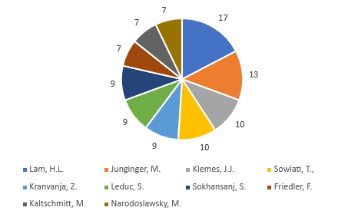
Figure 3 the top 10 authors with most publications

Figure 4 Contribution of authors according to the number of documents

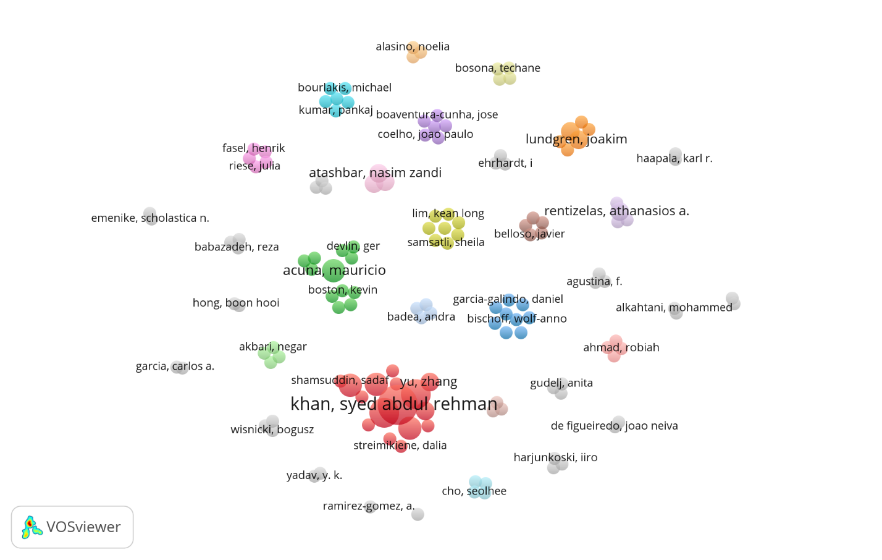
Figure 5 Network of co-authorship
  - Publication statistics by number of pages (pages count)

Between 2000 and 2020, approximately 21963 pages of the related papers were published, with an average of 8.62 pages per paper. About 19.85 % of the articles possess between 10 and 15 pages, 9.03% of the manuscripts are between 15 and 20 pages, 32.06 % of the papers are between 5 and 10 pages, and 75.14% of the manuscripts are between 5 and 25 pages. In Figure 6 the distribution of the papers according to the page count have been presented. As it can be seen from Figure 6, the most distribution and the least belong to the papers with 7 and 2 pages, respectively.

Figure 6 Distribution of documents based on pages count

  - Publication statistics by the number of authors
There are 5716 authors and 2545 documents, in total by Scopus indexed, with average 2.2459 authors per publication. Nearly 2.92% of the papers are single author, while 17.62% of the manuscripts were published by two authors. 65.46% of the articles have less than or equals 4 authors, 38.03% of the papers possess less than 7 and greater than 4 authors, and 0.09% of the manuscripts have 10 or greater than 10 authors. Figure 7 presents the distribution of the related papers based on the number of authors.

Figure 7 Distribution of theI related papers based on the number of authors

  - Publication statistics by countries

Figure 8 illustrates the top 10 active countries hav ebben shown. In the first period, United States, Netherland, and Germany are top three countries that own most documents in the field while in the last period, United States, China, and Germany are top three active countries, respectively. Figures 9 and present the growth rate and coolaboration network among the countries. From Figure 9, the most significant differences belong to the second and third period (2005-2010, 2010-2015). In Figure 10, size of the circles shows the activities of the countries.

Figure 8 Documents by country

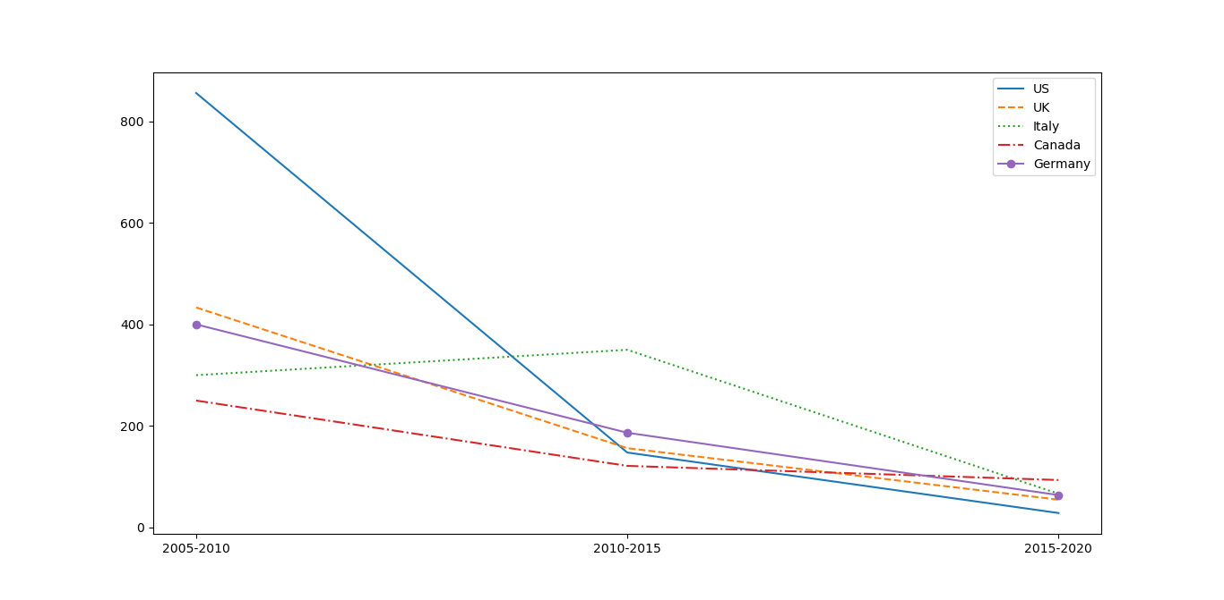
Figure 9 Growth rate of published papers for top 5 countries
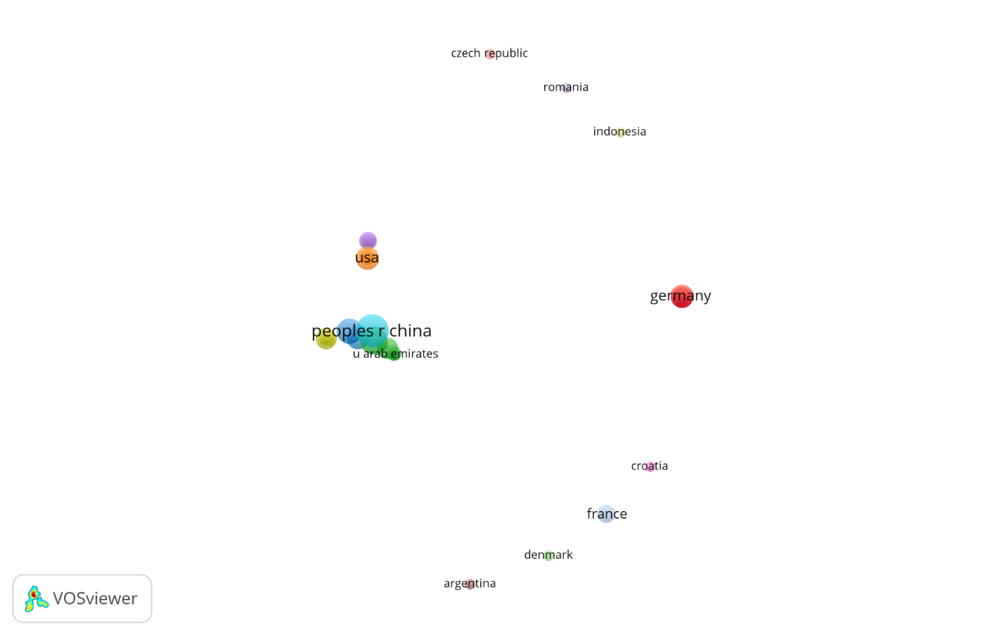
Figure 10 Collaboration among countries
  - Publication statistics by affiliation

Figure 11 shows the collaboration between organizations that have published articles in the area. Size of the circles presents the activity of the organization in which the yellow color the recent activity and blue and dark colors depict the contributions prior to 2014. From figure 12, Imperial College London (UK) and Utrecht University (Ntherland) are the top two affiliations, which first authors of the published documents belong to.
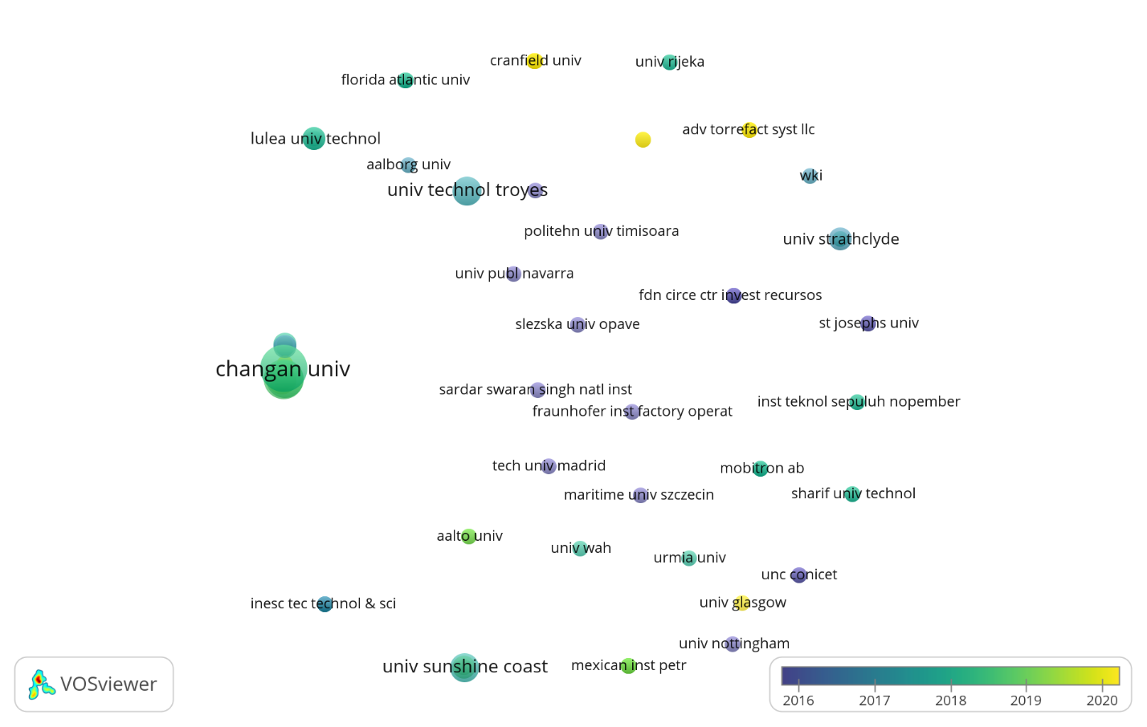
Figure 11 Overlay visualization of different affiliations

Figure 12 Top 10 affiliations in the field

  - Statistics on citations

In this section, an analysis over citations of the top articles in the field has been presented. The analysis has been conducted based on WOS, however, there may exist some differences over the results. However, to conclude consistent results, the authors used WOS a confident database for their results in this section. In total, more than 40,000 citations have been received by the related papers, on average 2,120.32 citations per year, and with average citations per item 21.93. 38,330 out of 40,000 are without self-citations and H-index is 86. Figure 13 presents total citations vs. number of documents per year. Energy storage technologies and real life applications - A state of the art review by (Aneke & Wang, 2016), Structural health monitoring for a wind turbine system: a review of damage detection methods by (Ciang et al., 2008), and Formic-acid-induced depolymerization of oxidized lignin to aromatics by (A. Rahimi et al., 2014) are top three cited articles based on WOS.

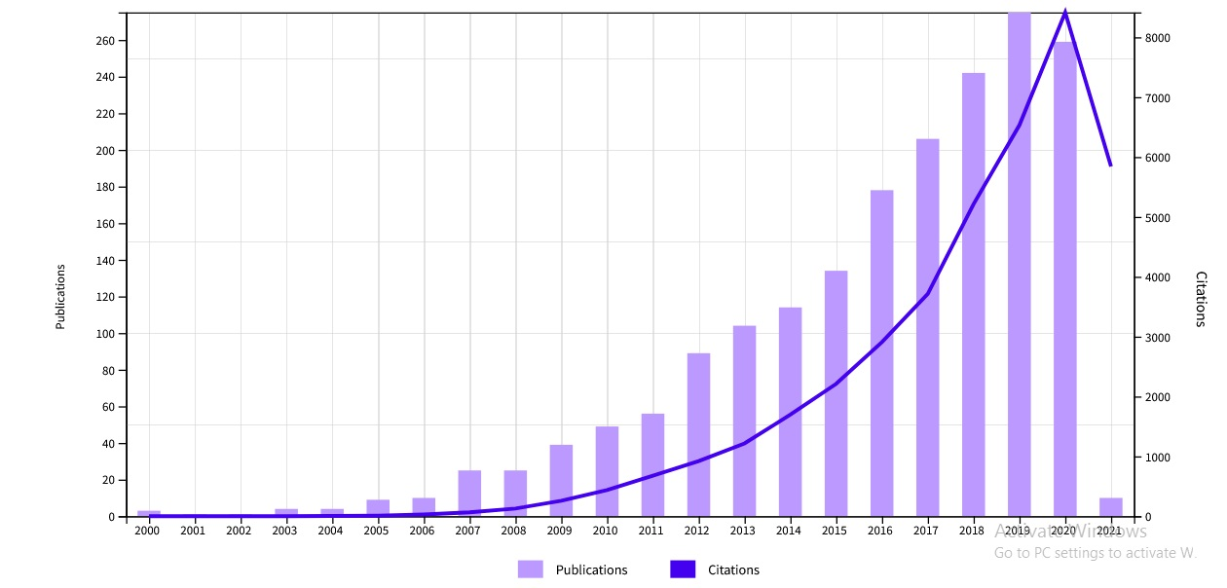

Figure 13 Total citations vs number of documents per year

  - Publication statistics by keywords
It is clear that “renewable energy” and “supply chain” are among the keywords with the most frequency in our data. "renewable energy investment", "wind turbine blade", "blade", "government subsidy", "particle" are also the most famous keywords in the related papers. Table 3 presents the top 20 keywords in the articles.

Table 3 Top 20 keywords with the most frequency in the articles
Keyword | Occurrences
Renewable energy investment | 14
Wind turbine blade | 11
blade | 30
Government subsidy | 13
Particle | 13
Iron ore | 11
Gas turbine | 21
Fault | 19
Copper | 20
Aluminum | 19
Blockchain technology | 12
Blockchain | 15
Biogas technology | 15
Lead | 22
Logistics industry | 16
House hold | 66
Iron | 18
Cold chain logistic | 17
Negative impact | 14
Offshore wind farm | 14

- Summary and future trends
The statistics showed rapid growth in the field specifically since 2010 up to 2020. Also, Journal of Cleaner Production, Applied Energy, Renewable and Sustainable Energy Reviews, and Renewable Energy are the most utilized sources.Since 2000, more than 5,000 authors have worked in the field of supply chain of renewable energy. Lam HL from Malaysia, Klemes JJ from Czech Republic, and Khan SAR from Peoples R China , with 23 (1.252 % of total), 13 (0.708% of total), and 12 (0.653% of total) publications (respectively) are top 3 authors in the field, respectively.
In total, 0.104 % of authors owns more than 10 documents, 0.856% have between 5 and 10 papers, 4.038% have between 2 and 5 papers, 8.758% owns 2 and 86.244% have 1 paper.
Nearly 2.92% of the papers are single author, while 17.62% of the manuscripts were published by two authors. 65.46% of the articles have less than or equals 4 authors, 38.03% of the papers possess less than 7 and greater than 4 authors, and 0.09% of the manuscripts have 10 or greater than 10 authors.
Moreover, About 19.85 %, 9.03%, 32.06%, and 75.14% of the articles have between 10 & 15; 15 & 20; 5 & 10; and 5 & 25 pages, respectively. To have a better analysis, the authors have divided the time horizon into 4 periods (2000-2005, 2005-2010, 2010-2015, 2015-2020). In the first period, United States, Netherland, and Germany are top three countries that own most documents in the field while in the last period, United States, China, and Germany are top three active countries, respectively.
Furthermore, Imperial College London (UK) and Utrecht University (Ntherland) are the top two affiliations, which first authors of the published documents belong to.

Besides, statistics on citations presented that more than 40,000 citations have been received by the related papers, on average 2,120.32 citations per year, and with average citations per item 21.93. 38,330 out of 40,000 are without self-citations and H-index is 86.
Likewise, keywords analysis depicted that "renewable energy investment", "wind turbine blade", "blade", "government subsidy", "particle" are also the most famous keywords in the related papers.
As a future research, the authors have discovered the top 5 most keywords and research fields in between 2019 and 2020. Tables 4 and 5 show the mentioned keywords and research fields in 2019 and 2020. It is noteworthy to mention that the authors have ignored some popular keywords namely, renewable energy and supply chain.

Table 4 Top 5 keywords in 2019 and 2020
No. | Keywords
1 | Energy
2 | Model
3 | Biomass
4 | Cost
5 | Production

Table 5 Top 5 research fields in 2019 and 2020
No. | Research fields
1 | Energy (24.6%)
2 | Engineering (19.2%)
3 | Environmental Science (16.5%)
4 | Business, Management, Accounting (5.2%)
5 | Agricultural and Biological Science (4.7%)

- Conclusion
This study is the first analysis of 20 years of scholarly literature in supply chain of renewable energies and provides an evaluation and analysis for the most relevant journals, keywords, authors, and articles. It was found that more than 5,000 authors have worked in the field of supply chain of renewable energy. Lam HL from Malaysia, Klemes JJ from Czech Republic, and Khan SAR from Peoples R China , with 23 (1.252 % of total), 13 (0.708% of total), and 12 (0.653% of total) publications (respectively) are top 3 authors in the field, respectively.
In total, 0.104 % of authors owns more than 10 documents, 0.856% possess between 5 and 10 documents, 4.038% have between 2 and 5 papers, 8.758% owns 2 and 86.244% have 1 document. Furthermore, Imperial College London (UK) and Utrecht University (Ntherland) are the top two affiliations, which first authors of the published documents belong to. Moreover, keywords analysis depicted that "renewable energy investment", "wind turbine blade", "blade", "government subsidy", "particle" are also the most famous keywords in the related papers. As a future study, it is recommended to to focus on specific renewable energy and conduct a deep review in the field. Moeover, it is interesting to review application of machine learning in renewable energy (Perera et al., 2014) (Gu et al., 2019) (I. Rahimi et al., 2013) (Behmanesh & Rahimi, 2012).
Conflict of Interest and Funding: None.
Human Participants and/or Animals: None.

References
Aneke, M., & Wang, M. (2016). Energy storage technologies and real life applications--A state of the art review. Applied Energy, 179, 350–377.
Behmanesh, R., & Rahimi, I. (2012). Using combination of optimized recurrent neural network with design of experiments and regression for control chart forecasting. Business Engineering and Industrial Applications Colloquium, 1(1), 435–439.
CHRISTOPHER, M. I. N. (2017). Logistics & supply chain management.
Ciang, C. C., Lee, J.-R., & Bang, H.-J. (2008). Structural health monitoring for a wind turbine system: a review of damage detection methods. Measurement Science and Technology, 19(12), 122001.
Ellabban, O., Abu-Rub, H., & Blaabjerg, F. (2014). Renewable energy resources: Current status, future prospects and their enabling technology. Renewable and Sustainable Energy Reviews, 39, 748–764.
Fazelpour, F., Soltani, N., & Rosen, M. A. (2014). Feasibility of satisfying electrical energy needs with hybrid systems for a medium-size hotel on Kish Island, Iran. Energy, 73, 856–865. https://doi.org/10.1016/j.energy.2014.06.097
Gu, G. H., Noh, J., Kim, I., & Jung, Y. (2019). Machine learning for renewable energy materials. Journal of Materials Chemistry A, 7(29), 17096–17117.
Mentzer, J. T., DeWitt, W., Keebler, J. S., Min, S., Nix, N. W., Smith, C. D., & Zacharia, Z. G. (2001). Defining supply chain management. Journal of Business Logistics, 22(2), 1–25.
Nematian, J., & Rahimi, I. (2022). Feasibility study of using renewable energies in Iranian Seas: A comparative study. Renewable Energy.
Perera, K. S., Aung, Z., & Woon, W. L. (2014). Machine learning techniques for supporting renewable energy generation and integration: a survey. International Workshop on Data Analytics for Renewable Energy Integration, 81–96.
Rahimi, A., Ulbrich, A., Coon, J. J., & Stahl, S. S. (2014). Formic-acid-induced depolymerization of oxidized lignin to aromatics. Nature, 515(7526), 249–252.
Rahimi, I., Ahmadi, A., Zobaa, A. F., Emrouznejad, A., & Aleem, S. H. E. A. (2018). Big data optimization in electric power systems: A review. Big Data Analytics in Future Power Systems, 55–84.
Rahimi, I., Behmanesh, R., & Ahmadi, A. (2019). Scientometric analysis of scheduling in renewable energy: a keyword and citation analysis. Journal of Energy and Power Technology, 1(4), 1.
Rahimi, I., Behmanesh, R., & Yusuff, R. M. (2013). A hybrid method for prediction and assessment efficiency of decision making units: Real case study: Iranian poultry farms. International Journal of Decision Support System Technology (IJDSST), 5(1), 66–83.
Rahimi, I., & Nematian, J. (2022). A Bibliometric Analysis on Optimization Solution Methods Applied to Supply Chain of Solar Energy. Archives of Computational Methods in Engineering, 1–19.
Teske, S., Fattal, A., Lins, C., Hullin, M., & Williamson, L. E. (2017). Renewables global futures report: Great debates towards 100% renewable energy.
van Eck, N. J., & Waltman, L. (2011). Text mining and visualization using VOSviewer. ArXiv Preprint ArXiv:1109.2058.
Vine, E. (2007). The Integration of Energy Efficiency, Renewable Energy, DemandResponse and Climate Change: Challenges and Opportunities for Evaluatorsand Planners.

Data Science Institute, Faculty of Engineering & Information Technology, University of Technology Sydney, Sydney, Australia (iman83@gmail.com ).
2 Department of Industrial Engineering, Faculty of Mechanical Engineering, University of Tabriz, Iran (corresponding author:jnematian@tabrizu.ac.ir).

