Digital Video Integrated System as a Virtual Learning Tool for Surgery at the University College Hospital (UCH) Ibadan
Afieharo I., Anyaeche O., Olubode G., Oguntade M.
Background
Learning has become a key issue across different disciplines. The school is no longer seen as the only significant site of learning, and learning is no longer seen as a matter of the ‘mind’ alone (Säljö, 2009; Lave and Wenger, 1991. The operating theatre provides a unique environment for teaching and learning the art of surgery to medical students, student nurses, surgical trainees, anesthesia trainees etc. It is however also a place where safety and maintenance of
Ideally only personnel involved in the surgery should be in the operating room. The design of our operating room experience for students necessitates their being present within the operating room. This invariably leads to overcrowding. Additionally to these from the survey we conducted 57.9% observing students or trainees are not able to directly observe the operation when it is taking place. To illustrate any aspect of the operation to the students the surgeon may have to pause the operation briefly or step aside for one or two students to come closer to identify an important structure. This is because a sterile field would have been created and the operating field is small.
Hence, the development of Digital Video Integrated System (DVIS) a multi-component digital device which would help to combat the problems of overcrowding, deprivation of other students from having a first-hand view of the surgical process and inability of the surgeons to recast the surgical process after the surgery.
The Objectives of the Digital Video Integrated System
The Digital Video Integrated System aims at decongesting the traffic of medical students and perioperative nurses in the operating theatre of the University College Hospital (UCH), Ibadan during operative sessions by helping eliminating the problem of theatre overcrowding which is a common sight at the UCH, Ibadan. 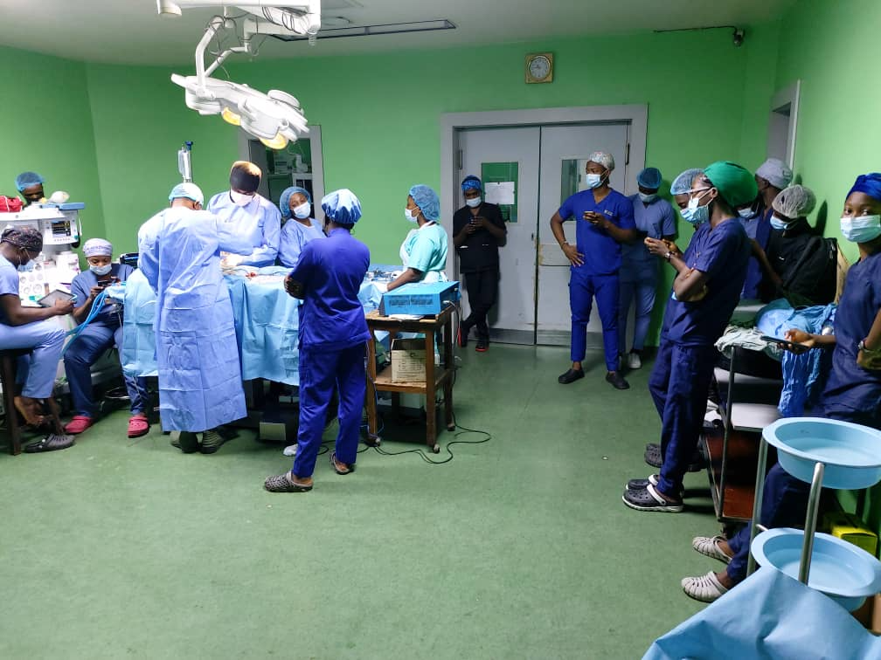
Figure 1: University College Hospital, Ibadan Theatre Suite
Also, the design is also aimed at providing audio-visual representation of the surgical procedures for the medical students and perioperative nurses which have hitherto been a challenge due to the fact that the population of the medical students and perioperative nurses exceeds the carrying capacity of the theatre suites at the UCH, Ibadan.
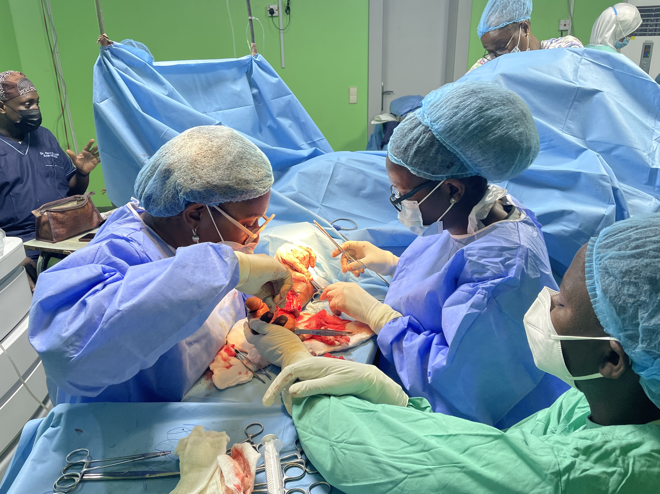
Figure 2: Surgical procedure in progress at the University College Hospital, Ibadan
Also, the inclusion of a feedback system into the design would allow for a feedback and smooth interaction between the students and the surgeon.
Also, the system is designed in such a way that the surgeon would have access to the saved and archived document for recast after the surgery.
Current Practice at the University College Hospital, (UCH), Ibadan
The current model for teaching and learning at the University College Hospital (UCH), Ibadan is as follows as observed by the team:
- The surgeon would have a 5-10 minutes discussion with the students on the nature of the case, the cause, and the steps he would take while performing the surgery, this usually takes place at the induction room
- During the surgery, the surgeon would sometimes step back; invite one or two students to have a view of the layer or the diseased parts he/she (the surgeon) is working on.
- The students are placed in groups of 10 students each just to accommodate for the large population and also prevent the incidence of overcrowding the operating theatre.
Existing Digital Technology incorporated in Surgery
An example of the incorporation of digital technology as a virtual tool for teaching and learning in the operating theatre is the use of recording devices such as camera and phones which were used to record the proceedings of the surgery and which are then hereafter relayed to the students for them to view (Adeodatus Yuda Handaya et al., 2021). Also, other existing digital technology involves the installation of camera system (which costs millions of naira) in hospital facilities with video output where patients’ relatives and other acquaintance of the patient can view the proceedings of the surgery.
Design Need
The design requirement for the device is outlined below.
Range of coverage: the transmission of the audio-visual signal from the camera head on the surgeon to the output monitor for the receiving students should be able to travel over a wider range of coverage.
Durability: the camera head and the Digital video Integrated System should be very durable and can be easily transported from one point to another and can be easily set up and installed by the end user
Weight: the camera head should be very light and not cause discomfort to the surgeon during a long or short surgical procedure.
Ease of Use: the use of the device should not be complex. A lay man should be able to use the device without requiring a certification in any technologically based course
Safety and privacy: the device should be safe for use by the surgeon and there should be no incidence of electric shock
Affordability: as opposed to the currently existing systems which requires millions of naira to purchase, the DVIS should be readily affordable for purchase and subsequent maintenance
Effectiveness: the device must be very effective in transmitting, capturing and saving data sinal from the point of surgery to the output monitor where the students would be viewing the surgical proceedings.
Clarity: the device camera should be clear enough to display the surgical proceedings and clearly depict the body parts and organs been worked on by the surgeon.

Design Concept and Prototyping
The component parts of the prototype digital video integrated system (DVIS) involve the aggregation of different components which culminates as the DVIS.
The component parts which comprises an Ordro EP8 camera device, a central processing unit, a monitor output, and a feedback system (comprising a microphone and a speaker). The other component parts were purchased in Nigeria except the Ordro camera which was ordered on Amazon.
The design concept comprises four phases in transmission of audio-visual signal to and from the surgeon:
- The Signal capture phase
- The Processor and intermediary phase
- The output phase
- The feedback system

The signal capture phase: the Ordro EP8 FPV camera will pick all visual images of the procedures; the images will then be transmitted remotely over a Wi-Fi wireless network.
The camera also has an in-built microphone which would create room for communication to the students during the surgery procedures.
The camera also has a memory card adapter, which will accommodate Micro SD card for direct data storage
Table 1: The specifications of the Audio-Visual Signal Capturing Device Ordro EP8 FPV Camera
Specification | Value
View Angle | 90º - 120°,
Focus Range | 10cm~infinity
Product Dimension | 3.7 x 1 x 1 inches (9.4 x 2.5 x 2.5 cm)
Item Weight: | 80- 85grams
Specific feature | 4K (3840x2160 pixels video image resolution)
Image capture speed | 60 fps (frame per seconds)
Video Capture Format | Mp4
Maximum Focal Length | 4.88 Millimeters
Mode of mounting | Detachable
Sensor: | 1/2.8 inch CMOS sensor
Photo format | JPEG.
Video resolution | - 4K:3840*2160 (60fps)/3840*2160 (30fps) 2K:2704*1524(30fps) FHD:1920*1080(60fps)/1920*1080 (30fps) HD:1280*720(60fps)
Stabilization | Two Axis Gimbal

The Processor and intermediary phase: the processor phase is where the preview of the audio-visuals from the camera is viewed, processed, saved before transmitting to the student’s output monitor. The desktop computer interface with the Ordro EP8 FPV eyewear camera through the WiFi network of the Ordro EP8 FPV camera as seen displayed on the desktop computer’s network. The desktop computer will have pre-installed a third party software (Many Cam / OBS/ Adobe Premiere Pro Software), which would be used for interfacing between the camera and the Desktop computer

The desktop computer will also serve has the storage center for the data files (Visual and Audio files) generated.
Also, an HDMI cable can be connected directly to the Ordro EP7 FPV camera and then to the input port of the CPU of the desktop computer for interlacing

Table 2: The specifications of the Desktop Computer
Specification | Value
Operating system | Windows 10
CPU processor | core i5, 64-bit, x64-based processor, CPU @ 1.90GHz 2.40 GHz system
RAM size | Minimum of 4Gigabyte
System hard drive | 250Gigabyte

The Output Phase: the output phase shall contain the audio-visual signal relayed from the camera through the processing unit to a monitor at a specified location where the medical students and pre-operative nurses and any other personnel would be congregating. The main component of the output phase is the TV screen.
The Feedback System: the feedback system will comprise a microphone which would be used to send audio signal from the medical students, preoperative nurses and surgeon-in-training at the induction room or at any other specified location to the speakers in the operating theatre for the surgeon to hear and give response.
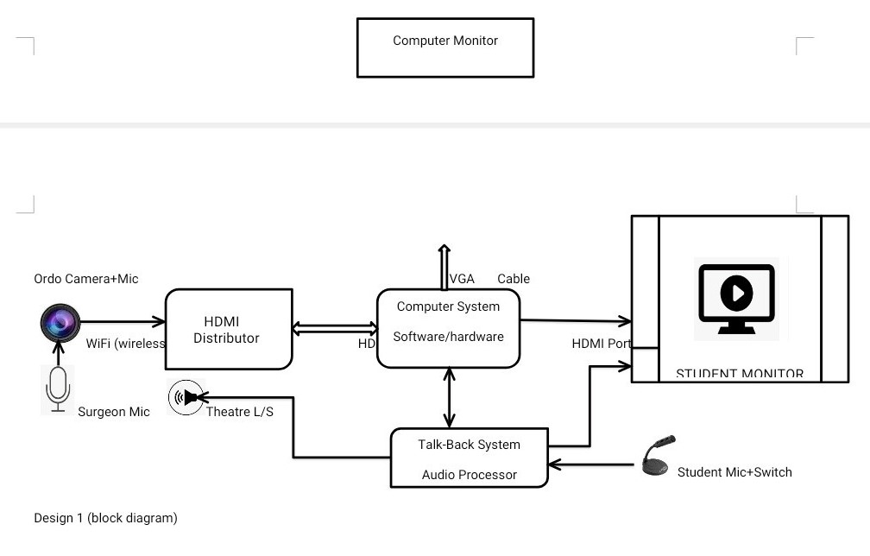
Design Schematics for the Digital Video Integrated System (DVIS).

Future considerations

The Digital Video Integrated System’ features would be upgraded thus as future considerations:
- Development of a customized software that would be specifically for the running of the system
- Incorporation of IP address that would enable a wider range of coverage and participation by individuals (Chief Medical Directors, Chief Matrons and other Head of departments) who may be in their respective offices but would love to participate in the surgery.
Conclusion
We have presented our design concept and even prototyped the Digital Video Integrated System (DVIS). Our largest user would be primarily the teaching hospitals as this would help to bridge the communication gap between the surgeon and the medical students, preoperative nurses and surgeons-in-training.
Acknowledgement
The research reported in his publication was supported by the Rice University and North- Western University Biomedical Innovation Program at the Faculty of Technology, University of Ibadan/ University College, Hospital.
References
- Fry A.M., Orr R.L., Doyle P.T., “Use of eyewear for high definition video recording in surgical training”, Br. J. Oral Maxillofac. Surg. 52 (2014) 983–984.
- Nair A.G., Kamal S., Dave T.V., Mishra K., Reddy H.S., Della Rocca D., Della Rocca R.C., Andron A., Jain V., “Surgeon point-of-view recording: using a high-definition head-mounted video camera in the operating room”, Indian J Ophtamol 63 (2015) 771.
- Henken K.R., Jansen F.W., Klein J., Stassen L.P., Dankelman J., van den Dobbelsteen J.J., “Implications of the law on video recording in clinical practice”, Surg. Endosc. 26 (2012) 2909–2916.
- Lee S., Lee J.M., Suh K.S., Hong S.K., Cho J.H., Yi N.J., Lee K.W., “Wearable recording video technology for surgical training in living donor liver transplantation”, Annals of Hepato Biliary Pancreatic Surg. 24 (2020) 38–43.
- Goh P.S., Sandars J., “A vision of the use of technology in medical education after the COVID-19 pandemic”, MedEdPublish 9 (2020) 1–8, https://doi.org/10.15694/ mep.2020.000049.1.
- Papadopoulos N., Polyzos D., Gambadauro P., Papalampros P., Chapman L., Magos A., “Do patients want to see recordings of their surgery?” Eur. J. Obstet. Gynecol. Reprod. Biol. 138 (2008) 89–92.
- Magos A., Kosmas I., Sharma M., Buck L., Chapman L., Taylor A., “Digital recording of surgical procedures using a personal computer”, Eur. J. Obstet. Gynecol. Reprod. Biol. 120 (2005) 206–209.
- Ordro EP5 headset action camera full HD touch control - black. https://www. gearbest.com/camcorders/pp_1308792.html.
- Ganry L., Sigaux N., Ettinger K.S., Salman S.O., Fernandes R.P., “Modified GoPro Hero 6 and 7 for intraoperative surgical recording—transformation into a surgeon” Annals of Medicine and Surgery 62 (2021) 347–352 352
- Yuda Handaya et al. “Perspective professional quality recording system”, J. Oral Maxillofac. Surg. 77 (2019), 1703-e1.
- Ortensi A., Panunzi A., Trombetta S., Cattaneo A., Sorrenti S., D’Orazi V., “Advancement of thyroid surgery video recording: a comparison between two full HD head mounted video cameras”, Int. J. Surg. 41 (2017) S65–S69.
- Rahman R., Wood M.E., Qian L., Price C.L., Johnson A.A., Osgood G.M., “Head mounted display use in surgery: a systematic review”, Surg. Innovat. 27 (2020) 88–100.
- Lyon P.M. “Making the most of learning in the operating theatre: student strategies and curricular initiatives”. Med Educ. 2003;37(8):680-8.
- Jensen R.D., Seyer-Hansen M., Cristancho S.M., Christensen M.K. “Being a surgeon or doing surgery? A qualitative study of learning in the operating room” . Med Educ. 2018;52(8):861-76.
- Chapman S.J., Hakeem A.R., Marangoni G., Raj Prasad K. “How can we enhance undergraduate medical training in the operating room? A survey of student attitudes and opinions”. J Surg. Educ. 2013;70(3):326-33.
- Lyon P. “A model of teaching and learning in the operating theatre”. Med Educ. 2004;38(12):1278-87.
- Ravindra P., Fitzgerald E., Bhangu A., Maxwell-Armstrong C. “Quantifying factors influencing operating theater teaching, participation, and learning opportunities for medical students in surgery”. J Surg. Educ. 2013;70(4):495-501.
- Hong D., Regehr G., Reznick R.K. “The efficacy of a computer-assisted pre-operative tutorial for clinical clerks”. Can. J Surg. 1996;39(3):221-4.
- Broderick T.J., Russell K.M., Doarn C.R., Merrell R.C. “A novel telemedicine method for viewing the open surgical field”. J Laparo-endosc. Adv. Surg. Tech. A. 2002;12(4):293-8.
- Lewis L., Jones J., Haynes E. “Low-cost video-films in the teaching of undergraduate and postgraduate medical students. J Telemed Telecare”. 2000;6 Suppl 2:S45-7. Int J Med Educ. 2019;10:75-87 87
- McIntyre T.P., Monahan T.S., Villegas L., Doyle J., Jones D.B. “Teleconferencing surgery enhances effective communication and enriches medical education”. Surg. Laparoscope Endoscope Percutan Tech. 2008;18(1):45-8.

