Characterization of Nanofluids in Evaporating Droplets by Dynamic Light Scattering

Wenchang Wu,¹ David H. Panduro Vela,² Andreas Bück,² and Andreas P. Fröba^{1,}*
¹Institute of Advanced Optical Technologies – Thermophysical Properties (AOT-TP), Department of Chemical and Biological Engineering (CBI) and Erlangen Graduate School in Advanced Optical Technologies (SAOT), Friedrich-Alexander-Universität Erlangen-Nürnberg (FAU), Paul-Gordan-Straße 8, 91052 Erlangen, Germany
²Institute of Particle Technology, Department of Chemical and Biological Engineering, Friedrich-Alexander Universität Erlangen-Nürnberg, Cauerstraße 4, 91058 Erlangen, Germany

*Author to whom correspondence should be addressed.
Tel.: +49-9131-85-29789, email: andreas.p.froeba@fau.de

ABSTRACT
The diffusion of nanoparticles in nanofluids in form of pendant drops and levitated droplets is characterized by dynamic light scattering. In combination with a heterodyne detection scheme, particle diffusivity in pendant drops can be determined by this method. The diffusivities therein correspond well to the values measured inside a cuvette. During evaporation, crust formation in the drop can also be identified by the method. Dynamic light scattering experiments for levitated droplets are performed with an ultrasonic acoustic levitator. Again, the dynamics of the particle number density fluctuations inside the droplet can be characterized, but the derivation of particle diffusivities is not yet possible. In both cases, the evolution of the characteristic time reflecting the diffusive process of nanoparticles can be determined until the point of crust formation. In summary, the applicability and limitation of dynamic light scattering for the characterization of diffusion of particles in evaporating drops are identified.

Keywords: Diffusion, Drying, Dynamic Light Scattering, Levitation, Nanofluid, Pendant Drop

- Introduction
Generation of functional solid structures by drying of nanofluids which represent a colloidal suspension of nanoparticles (NPs) is a key aim in a variety of applications and industries, for example in the production of conductive solid films [1]. Spray drying is a major process to transform solid containing liquids into free-flowing powders. It is widely used in the foods and agrochemical industry [2]. The formulation of porous coating layers on carrier particles is another major process to design specific release rates. For instance, in the works of Rieck et al. [3] and Schmidt et al. [4] on spray fluidized bed layering, it was shown (for solutions and suspensions) that different thermal conditions yield different layer properties. Control over structure formation is required to guarantee tight bounds on product quality, e.g., the conductance of solid thin films, as used for instance in solar cells or OLEDs, depends on the spatial structure generated by the deposited solids after drying [1, 5, 6], as does antimicrobial action of solid films [7]. Control over layer porosity in spray coating is required to design, e.g., the specific release rate of an active pharmaceutical ingredient from a coated tablet into the human body with therapeutic effect and avoiding overdosing.
Taking spray drying of nanofluids as a specific example in the following, the particle structure is generated from sprayed droplets by the complex interplay of gas-liquid heat and mass transfer with the particulate phase: Heat is provided to the nanofluid by convection, conduction or radiation or a combination thereof, as a result the liquid evaporates. The kinetics of heat and mass transfer influence the transport of the dispersed particulate phase within the remaining liquid. Depending on the speed of drying, different structures are obtained. Fig.1, after Walzel and Furuta [8], shows the different possible outcomes, ranging from small and compact to large and hollow particles.
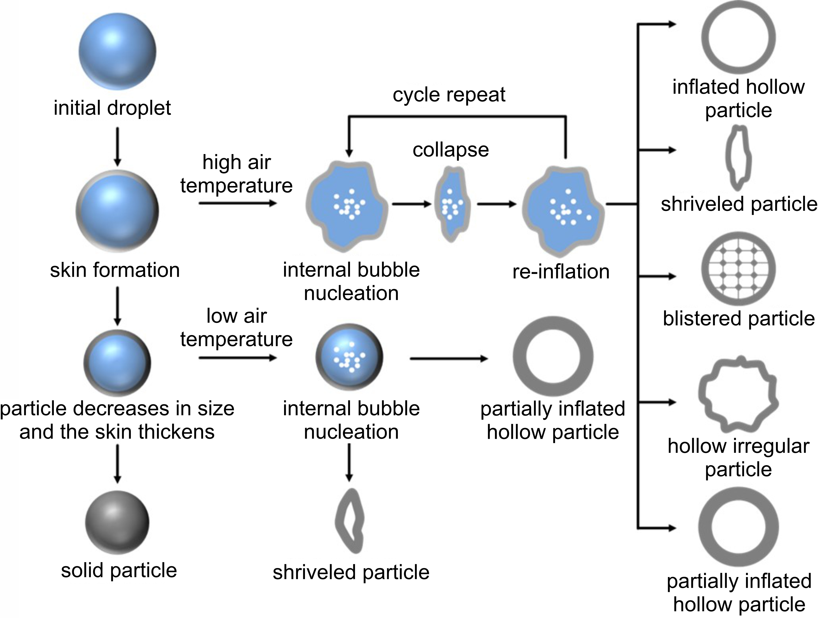
Figure 1. Schematic representation of possible particle morphologies starting from a single spherical droplet (after Walzel and Furuta [8]).

The movement of the NPs within the droplet is influenced by different transport phenomena and particle-particle interactions. Convection due to droplet-internal flow fields, diffusion, aggregation of NPs into larger structures, or breakage into smaller aggregates of NPs can take place. The magnitudes of diffusion, aggregation and breakage are linked to the local concentration field $c$ of the dispersed solid. Whereas diffusion is proportional to the local gradient in concentration, agglomeration and breakage are proportional to the square of the local value of the concentration field where different proportionality factors apply. With increasing solids concentration, simultaneous occurrence of particle transport and interaction is observed. At very low solids concentration, diffusion dominates. Here, the diffusivity of nanoparticles is typically described by the Stokes-Einstein law and aggregation and breakage are unlikely. With shrinking liquid volume, e.g., by evaporation, the solids concentration increases. This induces changes in the viscosity of the nanofluid, changes the diffusivity of NPs and also increases the likelihood of successful aggregation of NPs into aggregates.
Technical nanofluids are typically polydisperse, e.g., NPs and their aggregates possess a size distribution. This in turn yields a distribution in the properties of the dispersion which culminates in effective properties, e.g., effective diffusivities. Due to the changing liquid volume as a result of evaporation, its value is transient. Elucidation of the dependency of the effective diffusivity on evaporation rate of the liquid depending on gas temperature, polydispersity of the initial nanofluid and solids concentration is a key requirement for particle structure, process, and product design. Moreover, the final structure of the particle product is influenced by the ability of the NPs to diffuse to the center of the droplet. Hence, the formation of dense particles is associated with the domination of diffusion of the NPs over the drying process, whereas hollow particle formation is expected when the evaporation process dominates over the particle diffusion.
In order to effectively investigate evaporating droplets, contactless and non-invasive characterization methods are necessary. Until now, only a few methods are reported that can be applied for the characterization of the internal or the surface structure of a droplet. For instance, the group of Basu [9-12] intensively investigated the morphological transition in an acoustically levitated nanofluid droplet by droplet imaging. Yarin et al. [13] applied a similar method in measurements on the drying behavior of droplets of aqueous suspensions of glass beads. A static light scattering-based method by Mitic et al. [14], rainbow refractometry by Saengkaew et al. [15] and Li et al. [16] as well as digital in-line holography by Coëtmellec et al. [17] were also presented. The application of the dynamic light scattering (DLS) method for the characterization of levitated droplets of nanofluids was pioneered by Bronk et al. [18]. They demonstrated that the obtained characteristic decay times from the analysis of the intensity correlation function correspond well to the size of the scatterers inside the levitated droplet. In recent studies, both Krieger and Zardini [19] as well as Derkachov et al. [20] applied the DLS method for studying single microdroplets of dispersions of NPs. However, they delivered rather diverse conclusions. In detail, Krieger et al. [19] used DLS to characterize non-spherical micrometer-sized single aerosol particles levitated in a quasi-electrostatic balance. They could show that the recorded correlation functions were influenced by the rotational motion of the droplet and even a qualitative analysis was prohibited. Derkachov et al. [20] concluded in their study that it is possible to find the characteristic times corresponding to the Brownian motion of the dispersed NPs at the initial stage of the evaporation. Later, the drying microdroplet transforms into a non-rigid rotating microaggregate, which masks the Brownian motion of the dispersed NPs. Based on the previous studies, it seems that the DLS method can be applied for the characterization of the diffusive processes of NPs inside a droplet. However, further attention including a deeper exploration of the limits of DLS for this purpose is needed.
For the bulk of a nanofluid, DLS method has been widely applied to determine particle diffusivities as well as particle size and size distribution over a wide concentration range [21-23]. Recently, several studies make use of DLS to characterize particle diffusion under the confinement of porous media [24-29]. The investigations with porous materials reported in Ref. [28] resemble to a certain extent to those with a droplet of nanofluid. In both cases, the diffusive process of NPs is much more complex compared to that in the bulk of a nanofluid. Furthermore, the diffusion process is difficult to be accessed by DLS or any other scattering-based techniques due to the weak signals from the particles masked by a strong background originating from the scattering at the matrix of the porous material or from the surface of the droplet.
In this contribution, we applied the DLS method to study the diffusive process in a single pendant drop or a levitated droplet of nanofluids containing spherical silica (SiO₂) NPs. In a first step, the particle diffusivity in nanofluids filled in a cuvette was determined. In a second step, to reduce the complexity of the investigations, nanofluids in form of a pendant drop was studied by DLS. The advantage of the pendant drop is given by its larger size and stability compared to a levitated droplet. Different experimental temperatures were investigated to vary the speed of the evaporation process of the pendant drop. In a final step, DLS investigations were extended to levitated droplets with help an ultrasonic acoustic levitator and an optimized experimental setup. The results are discussed in connection with the applicability and limitation of the DLS method for the characterization of diffusive processes of NPs inside an evaporating drop.

- Experimental Section
  - Ultrasonic acoustic levitator
Due to the fast drying kinetics of droplets consisting of (primary) NPs in spray dryers, the recording of the changes of interested properties in the droplets during the drying process becomes complicated [30]. This limitation can be overcome by studying the evaporation phenomena of a single droplet in a controlled environment. Investigations on a single droplet by suitable techniques also provide access to information about the evolution of e.g., the mass, diameter, and rheology of the drop, the temperature as well as the diffusion coefficients of the NPs [31, 32]. Moreover, the change in the structure of the drop, e.g., curst formation, can be reflected by the physical deformation of the drop during the drying. Single droplet levitated via acoustic levitation offers the possibility to simulate the drying of droplets close to the operation conditions in spray dryers, thus, enabling a better understanding on drying kinetics and particle formation of colloidal droplets. First investigation on a single droplet of a colloidal suspension containing γ-Al₂O₃ particles using acoustic levitation was presented by Groenewold et al. [33]. Later, Schiffter et al. reported more in-depth studies on drying kinetics and particle formation in connection with dependence of the final morphology of the particle on the gas-side drying conditions [34, 35].
The working principle of acoustic levitation, depicted in Fig.2, is based on the generation of a standing ultrasound field as a result of multiple reflections of a sound wave between a solid reflector (flat or concave) and the ultrasonic radiator. Levitation of liquids or solid samples is only possible if their equivalent diameter is less than half a wavelength λ of the standing wave. In this work, an ultrasonic levitator (11-0130911, Tec5 GmbH) operated at a frequency f = 100 kHz was used. The theoretical λ is around 3.4 mm in the case of present study, i.e., at temperature T ≈ 293 K. Based on our experiments, the levitator allows a stable positioning of a nanofluid droplet with an equivalent diameter of up to 1.43 mm. The stability of the positioned levitated droplet can be optimized by adjusting the distance between the reflector and the radiator with help of a micrometer screw. In addition to the light scattering experiments, the projection or the image of the levitated droplet can also be obtained with a camera to track the evolution of the droplet diameter.
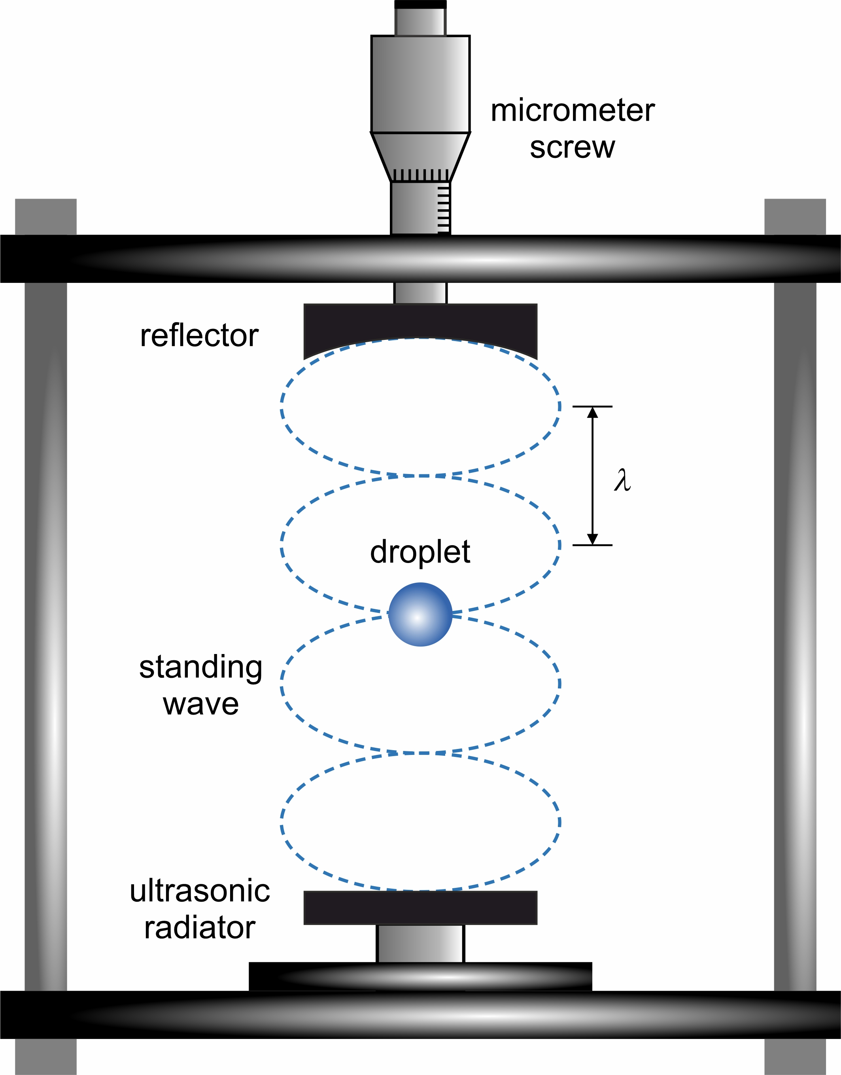
Figure 2. Schematic of the working principle of the acoustic levitation

  - Materials and their characterization
A technical grade silica (SiO₂) nanofluid (Köstrosol 9550, Chemiewerk Bad Köstritz GmbH) was used in this work. Particle morphology was obtained by scanning electron microscopy (SEM) (GEMINI 500, Zeiss GmbH). The nanofluid contains at least three different sizes of particles. The number-weighted diameters d_{P} of the particles being (25.4 ± 7.8, 45.8 ± 13.4 and 97.7 ± 10.5) nm were derived from the analysis of at least three corresponding SEM images containing at least 36 particles in the view using ImageJ software [36]. Here, d_{P} is considered to be the hydrodynamic diameter d_{H} of the particle by neglecting any additional contribution from, e.g., the surfactant, to the layer thickness around the particles. The uncertainty of d_{P} or d_{H} was estimated with help of the double standard deviation (k = 2) of the corresponding individual values.

  - Sample preparation and handling
All nanofluids were prepared gravimetrically with a balance (ENTRIS224I-1S, Sartorius) with a precision of 0.1 mg. The nanofluids with lower weight fraction w were diluted from the stock nanofluids by the addition of de-ionized water. The latter was filtered one time with help of a polyvinylidene fluoride (PVDF) syringe filter (Millex-VV, Merck KGaA) with pore size of 100 nm to reduce possible impurities in the de-ionized water. Considering an relative expanded uncertainty (k = 2) of 4 % for the weight fraction of the stock nanofluids, an absolute expanded uncertainty (k = 2) of 1 mg in the weighted mass of the balance, the relative expanded uncertainty in w is between (4 and 20) % and 11 % on average for all prepared nanofluids. The diluted nanofluids did not exhibit any visually observable sedimentation over at least 24 hours. To ensure minimum sedimentation and aggregation in the samples, prior to the DLS measurements, each nanofluid was sonicated for at least 10 mins.
In this work, the prepared nanofluids in different forms were investigated. For simplicity reasons, we denote NF_{cuvette}, NF_{pendant} and NF_{levitated} to be the nanofluid filled in the cuvette, suspended as a pendant drop and suspended as a levitated droplet, respectively. After sonication, the prepared nanofluid was either filled into a quartz cuvette (111-10-40, Hellma GmbH & Co. KG) using glass pipette, or taken into a plastic syringe. The NF_{pendant} was created with help of a syringe cannula with a blunt tip. For placing the NF_{levitated} in the ultrasonic acoustic levitator, a cannula with a sharp tip was used as the resulting droplet was much easier to be captured by the nodes of the standing sound wave. For each experiment, the equivalent droplet diameter for NF_{pendant} and NF_{levitated} was set to (1.9 ± 0.2) mm and (1.4 ± 0.3) mm. For the investigations of NF_{pendant} and NF_{levitated}, the cuvette was placed in the temperature-controlled cuvette holder as described in Section 2.4. The investigations of NF_{levitated} were performed at room temperature which was measured to be around 294 K.

  - Method – dynamic light scattering
DLS from the bulk of fluids analyzes the dynamics of statistical fluctuations in temperature or entropy, pressure, and concentration or particle number density in macroscopic thermodynamic equilibrium [37, 38]. The method allows the absolute determination of diffusivities from the analysis of the scattered light caused by these fluctuations by calculating the time-dependent correlation function (CF), also called the second-order correlation function. Taking an ideal bimodal nanofluid and neglecting fluctuations on a molecular level, a general CF takes the form
(1)
Here, I_{LO} stands for the time-averaged intensity of a reference light that is coherently superimposed to the scattered light. The reference light can be generated in a defined way or be present from further scattering processes [29, 39, 40]. I_{i} describes the time-averaged intensity of scattered light related to fluctuations in the particle number density of particle species i. The correlation time τ_{C,i} which is equivalent to the mean lifetime of fluctuations in the particle number density of species i is related to the diffusivity D_{i} by
. (2)
In eq. (2), q is the modulus of the scattering vector
, (3)
where Θ_{S} is the scattering angle and n_{nanofluid} is the refractive index of the nanofluid at the laser wavelength in vacuum λ₀. Depending on the probing wavelength Λ = 2π/q and the interparticle distance d, either the self-diffusivity of the particle species i (when Λ < d) or the eigenvalues of the collective diffusion matrix (when Λ > d) is probed by DLS. For nanofluids with small w, where the interparticle interactions can be neglected, the self-, collective, and the tracer diffusivity D∞ are equal [41-47]. For nanofluids with large w, the abovementioned diffusivities deviate, and their corresponding concentration dependences were reported by Beenakker et al. [48] and Kops-Werkhoven et al. [49].
As it is very difficult to extract reliable information from a sum of multiple exponentials, cf. eq. (1), with decay times on the same order of magnitude, the aim of the experimenter is to realize a situation where one or some of the exponentials clearly dominate. Therefore, one has to design the experiment so that either only scattered light from the sample itself is detected by the detector (I_{LO} ≪ I_{i}, i.e. I_{LO} → 0) to realize a homodyne case, or to design the experiment so that the scattered light from the sample with a much stronger coherently superimposed reference light is detected (I_{LO} >>I_{i}) to achieve heterodyne case. The latter case is very beneficial and should be pursued if the scattered light intensities are comparatively weak, or the homodyne case relates to larger complexity in its experimental realization or data evaluation. For example, often it is very difficult to ensure a pure homodyne detection scheme, since I_{LO} generated from dust, windows of the sample cell, and even the solvent of the nanofluid cannot be neglected compared to I_{i}. Assuming that the signals are free of disturbances, a practical heterodyne CF for a bimodal nanofluid takes the form
, (4)
which is derived from eq. (1) by its normalization with (I_{LO})². Here, a is an adjustable parameter which should be close to the ideal value of 1. b₁ and b₂ are associated with the ratios of the amplitudes of the individual heterodyne contributions of eq. (1) to (I_{LO})². τ_{C,1} and τ_{C,2} are the mean lifetimes of fluctuations in particle number densities of two particle species and are linked to the particle diffusion coefficients D by eq. (2). A simplification is given for bimodal nanofluids in the case that the signal amplitude associated with one particle species is much larger than the other one. Then, the normalized intensity CF can be represented by a single exponential and only one single τ_{C} can be determined.

  - Experimental Setup
A detailed description of the DLS method related to its experimental realization can be found in our previous work [29, 50]. In the following, only information relevant for the present study will be given. Fig.3 (A) shows the top view of the optical and electronic arrangement of the experimental setup used for the present study. Here, for sample inside a cuvette, e.g., NF_{cuvette} and NF_{pendant}, two different configurations indicated by the dashed boxes are used to optionally analyze the scattered light at a scattering angle Θ_{S} close to 90° (A-1) or in the back-scattering direction close to 180° (A-2). For NF_{levitated} inside an ultrasonic acoustic levitator, the scattered light is analyzed at a Θ_{S} = 90° (A-3). The pendant drop inside a cuvette, the used ultrasonic acoustic levitator and a levitated droplet are shown in Fig. 3 (B-D). The output laser light from a fiber laser is directed and focused via a set of mirrors (M) and a lens (L) into the sample cell represented by a temperature-controlled holder for a cuvette or onto the levitated drop. The incident laser beam is split by a beam splitter (BS) into a main beam and a reference beam represented by the solid and dashed line. The reference beam with intensity I_{LO} is coherently superimposed to the scattered light with intensity I_{P}, where I_{LO} is much larger than I_{P}. The intensity and polarization of both the main and the reference beam are controlled using combinations of a half-wave plate (λ/2) and a polarization beam splitter (PBS). For each beam path, the PBS is aligned so that only vertically polarized is transmitted. For the reference light, a neutral density filter (NDF) was also inserted into the beam path to further reduce its intensity. The direction for the detection of the scattered light is defined by two apertures (A) and is indicated by the dotted line in Fig.3 (A-1) and (A-2). For the DLS experiments on NF_{cuvette} or NF_{pendant} inside a cuvette, the alignment of the reference direction and the adjustment of the incident are described in Refs. [29, 50]. For the DLS experiments on NF_{levitated}, a 2f optical system was constructed for the collection of the scattered light inside the droplet with help of a bi-convex lens (L2) with a focal length f of 62.9 mm. Here, the PBS, the lens L2, the aperture and the fiber coupler are mounted on a XYZ linear stage indicated by the green dashed box in (A-3). This is especially useful to adjust the distance in x-axis between L2 and the levitated droplet to be close to 2f as well as the relative position with respect to the center of the levitated droplet in y- and z-axis without moving the acoustic levitator which destabilizes the droplet. Therefore, for a more precise alignment, only the 90° (A-3) configuration was used. Since a precise superposition of the scattered light and the reference light with a fixed direction is no longer possible, in DLS experiments applied to a levitated droplet, the reference beam was not used in the configuration shown in (A-3). The detection of the scattered light, used correlators and their correlation scheme, as well as the regulation of the temperature of the cuvette holder are detailed in Refs. [29, 50]. For the DLS experiments on NF_{cuvette}, the average temperature of the sample and its stability being (1, 6, and 36) mK are quantified by the mean value and the double standard deviation of the temperature data recorded by the temperature probe inside the cuvette within one measurement series typically lasing 2 h. For the DLS experiments on NF_{pendant} inside the cuvette, the latter value is calculated to be (1, 8 and 10) mK based on data recorded by the same temperature probe which was placed inside an empty cuvette close to the position where the pendant drop would have been placed. The reported T in the figures and Table 1 represent the mean values of the data recorded during one complete measurement series.
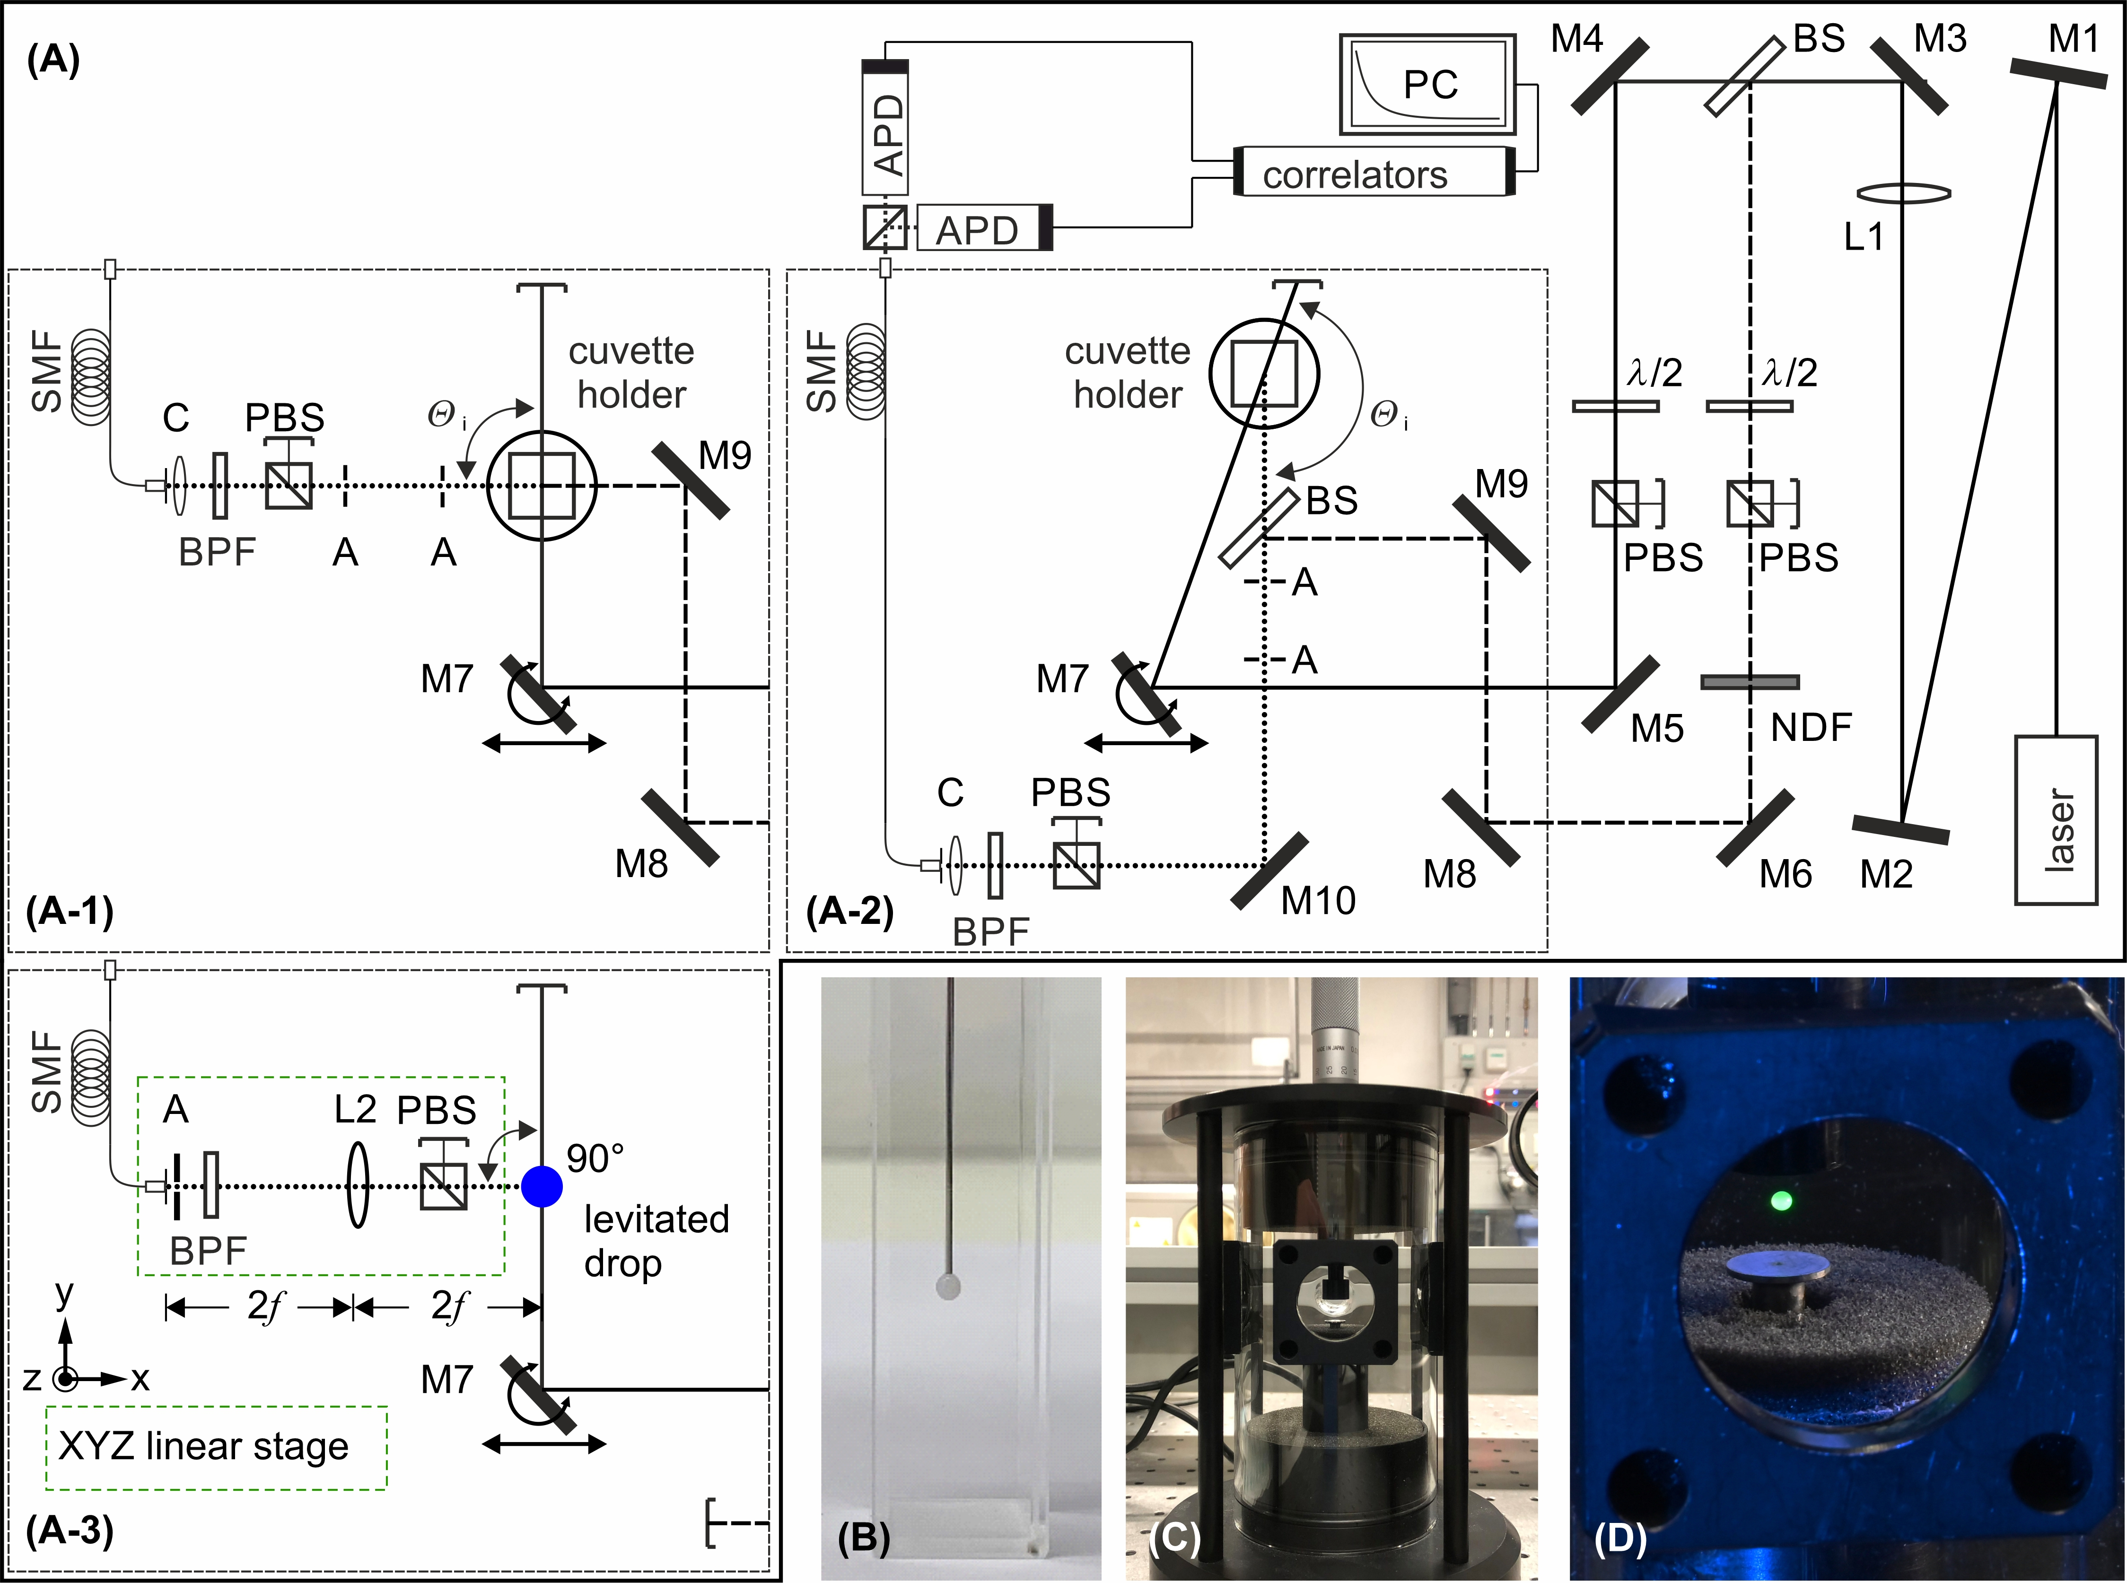
Figure 3. (A) Setup with optical and electronic arrangement for the detection of the scattered light close to a scattering angle of 90° (A-1) or close to 180° (A-2) from sample inside a cuvette or at 90° (A-3) from a levitated droplet inside an ultrasonic acoustic levitator. The green dashed box in (A-3) represents a XYZ linear stage. The solid and dashed lines correspond to the incident laser beam and a reference beam which is coherently superimposed to the scattered light for a heterodyne detection scheme. The direction for the detection of the scattered light is represented by the dotted line. The abbreviations used in the figure are defined in the main text. The pendant drop placed inside a cuvette (B), the used ultrasonic acoustic levitator (C) and a levitated drop (D) are also shown.

  - Experimental Procedure and Data Evaluation
For NF_{cuvette}, DLS measurements were performed with different Θ_{i} between (70 and 160)° using two types of correlators to record a total of at least 6 CFs with a run time of at least 10 mins for each CF. For nanofluids with higher concentration w, DLS measurements were performed only at Θ_{i} = (160 and 170)° due to the sample non-transparency. For the NF_{pendant} in a cuvette, DLS measurements were performed at Θ_{i} = 160° since only high concentrated nanofluids were investigated due to their relevance in real applications. Here, multiple CFs with a run time of at least 60 s were recorded with both correlators until the pendant drop was fully evaporated. For the DLS measurements at lower temperature, e.g., at T = 298 K, the run time for each CF was increased to 200 s as the evaporation of the drop was much slower. For the NF_{levitated}, DLS measurements were performed at Θ_{i} = 90° using both correlators to record multiple CFs, each with a run time of 20 s, until the drop was evaporated. For the acquisition of CFs, a custom-made software for the correlators was used which allows saving multiple individual CFs with desired short integration times automatically [29]. Here, for an individual investigation of a specific NF_{cuvette} with a defined detection scheme, a typical number of CFs is 600 with integration time of 1 s. Thus, the total integration time or total experimental run time is always 10 min. For investigations of a NF_{pendant} or NF_{levitated}, while the integration time of individual CFs was fixed to be 10 s, the number of CFs varied from 2 to 20 depending on the experimental temperature, thus, the speed of the evaporation.
From the individual CFs obtained with the same correlator, detection scheme, and thermodynamic state, one average CF with desired run time is calculated using a post-processing algorithm. The average experimental CFs are fitted with an appropriate theoretical model, which is given by either a single exponential or multiple exponentials, using the Levenberg-Marquardt algorithm to find the experimental constants and the dynamics of the fluctuations of interest, i.e., their characteristic lifetimes τ_{C}. Two typical average CFs obtained using a heterodyne detection scheme for NF_{cuvette} and for NF_{pendant}, both with w = 0.3 are shown in Fig.4.
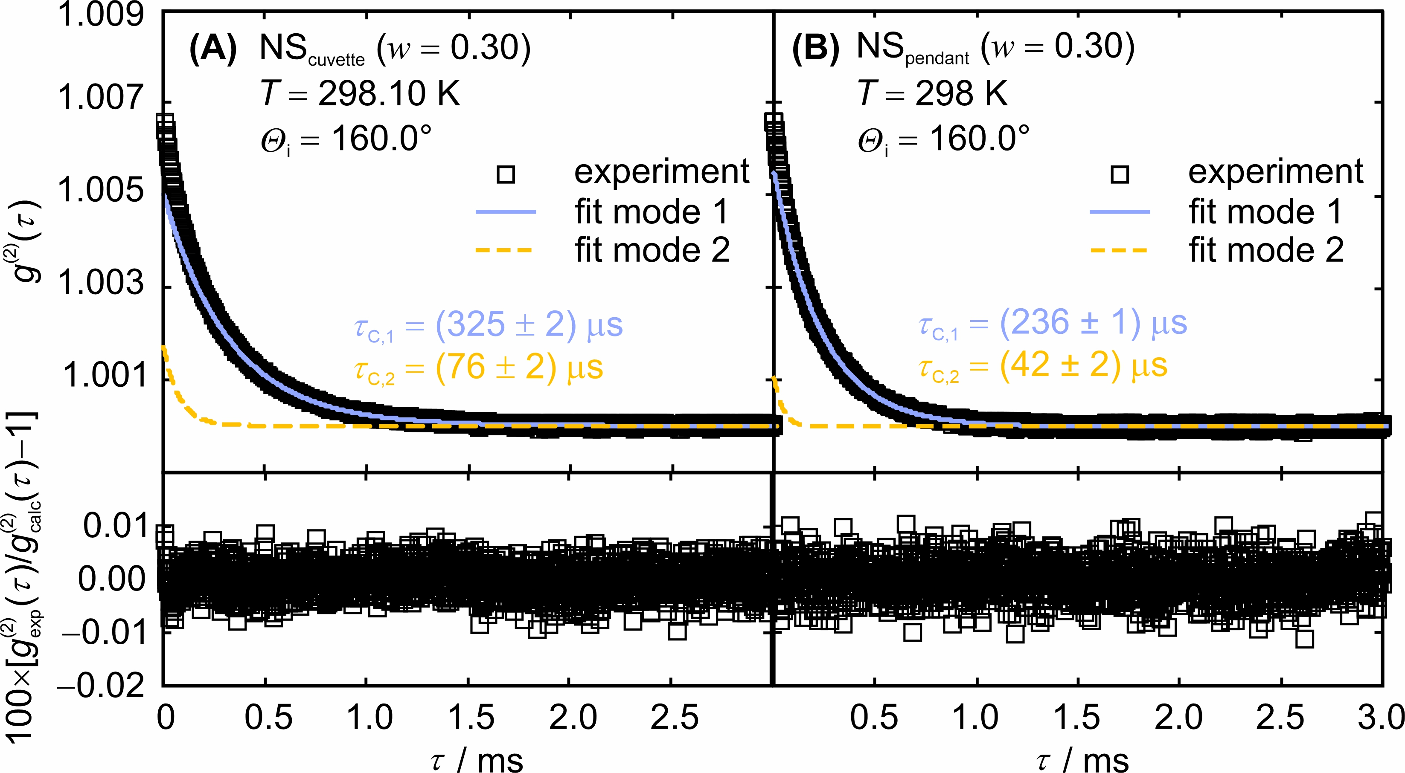
Figure 4. Averaged experimental CFs (square symbols) obtained for the analysis of (A) NF_{cuvette} or (B) NF_{pendant} with w = 0.30 at T = 298 K. The solid and dashed lines indicate the corresponding modes resulting from the fitting procedure of the CFs. Residuals of the measured CFs from their fits show no systematics.

As shown in Fig.4 (A), for the DLS measurements in NF_{cuvette}, the obtained average CF can be described by two exponentials and an additional term in form of a linear term or a second order polynomial. The additional linear term or second order polynomial counts for disturbances normally observable at large delay times and was added to model the complete CF for an accurate determination of τ_{C} [29]. For clarity, Fig.4 shows the averaged CFs after subtracting the additional linear term or second order polynomial from the original measured CF. The slow mode having a larger amplitude with a decay time of τ_{C,1} should be associated with the NPs with larger diameters, i.e., the 97.7 nm ones. The fast mode with a smaller amplitude and a decay time τ_{C,2} should be associated with the other NPs having diameters of around (25 and 46) nm. Due to the small diameter ratio of the latter two particle fractions and the fact that the scattered light intensity of these two particle fractions is much weaker than that of the larger particles, it is not possible to reliably resolve their individual contributions within the fast mode τ_{C,2}. The interpretation of the fast mode can be confirmed by the observation of a third mode τ_{C,3} in the experimental CFs for nanofluids with higher w, e.g. w >0.30. However, the third mode or the resulting diffusivity will not be discussed and displayed in this study as it always associates with large experimental uncertainty. For the DLS measurements in NF_{pendant}, the obtained average CF as shown in Fig.4 (B) can also be described by two exponentials with an additional term as it was the case for that from the NF_{cuvette}. The shown CF was obtained with a run time of 200 s at an evaporation time t, i.e., time since the drop was created, of 400 s.
According to eqs. (2) and (3), diffusivities D are obtained from the fitted decay time τ_{C}, scattering angle Θ_{S}, the wavelength in vacuo λ₀, and the refractive index of the nanofluid n_{nanofluid}. Since the n_{nanofluid} could not be determined with our available Abbe refractometer for nanofluids with high w which are non-transparent, in this work, the n_{nanofluid} values of the investigated nanofluids were interpolated with a linear mixing rule considering the volume fraction of the nanofluid as well as the refractive indices of pure water and pure silica at a given T and λ₀. The temperature dependence and the wavelength dependence of the refractive index of pure water and pure silica were taken from Refs. [51, 52].
For NF_{cuvette}, the reported diffusivities for a given sample and thermodynamic state were determined by averaging the individual results for the diffusivities from all averaged CFs obtained with both correlators in one measurement series, where a weighting scheme based on the inverse relative uncertainties of the individual diffusivity data was applied [53]. For NF_{pendant}, the reported diffusivities and their uncertainties for a given sample, thermodynamic state, and a given evaporation time t were determined by averaging the individual results for the diffusivities from all averaged CFs obtained with both correlators in one measurement series. For both cases, the uncertainty of each individual diffusivity value was given on a 95% confidence level (k = 2) and was determined by error propagation calculations accounting for the statistical uncertainty in the fitting of the CF as well as for the experimental uncertainties in n_{nanofluid} and Θ_{i}.
- Results and discussion
In this manuscript, only the diffusivity values obtained in the NF_{cuvette} will be listed in the table. The diffusivity results obtained from the DLS measurements in the NF_{pendant} will only be displayed in figures.
  - Particle diffusivity obtained in the nanofluid filled in the cuvette
The experimental diffusion coefficients of SiO₂ NPs in NF_{cuvette} with different particle weight fractions w and their corresponding expanded relative uncertainties U_{r} (k = 2) are summarized in Table 1. Here, the diffusion coefficients are denoted by D_{1,cuvette} and D_{2,cuvette}. Considering all investigated temperatures, U_{r}(D_{1,cuvette}) ranges from (1.4 to 7.8)% and is 3.8% on average. These values for U_{r}(D_{2,cuvette}) are (14, 181 and 54)%, respectively. Due to the large uncertainty for D_{2,cuvette}, only D_{1,cuvette} values are plotted in Fig. 5 as a function of w.
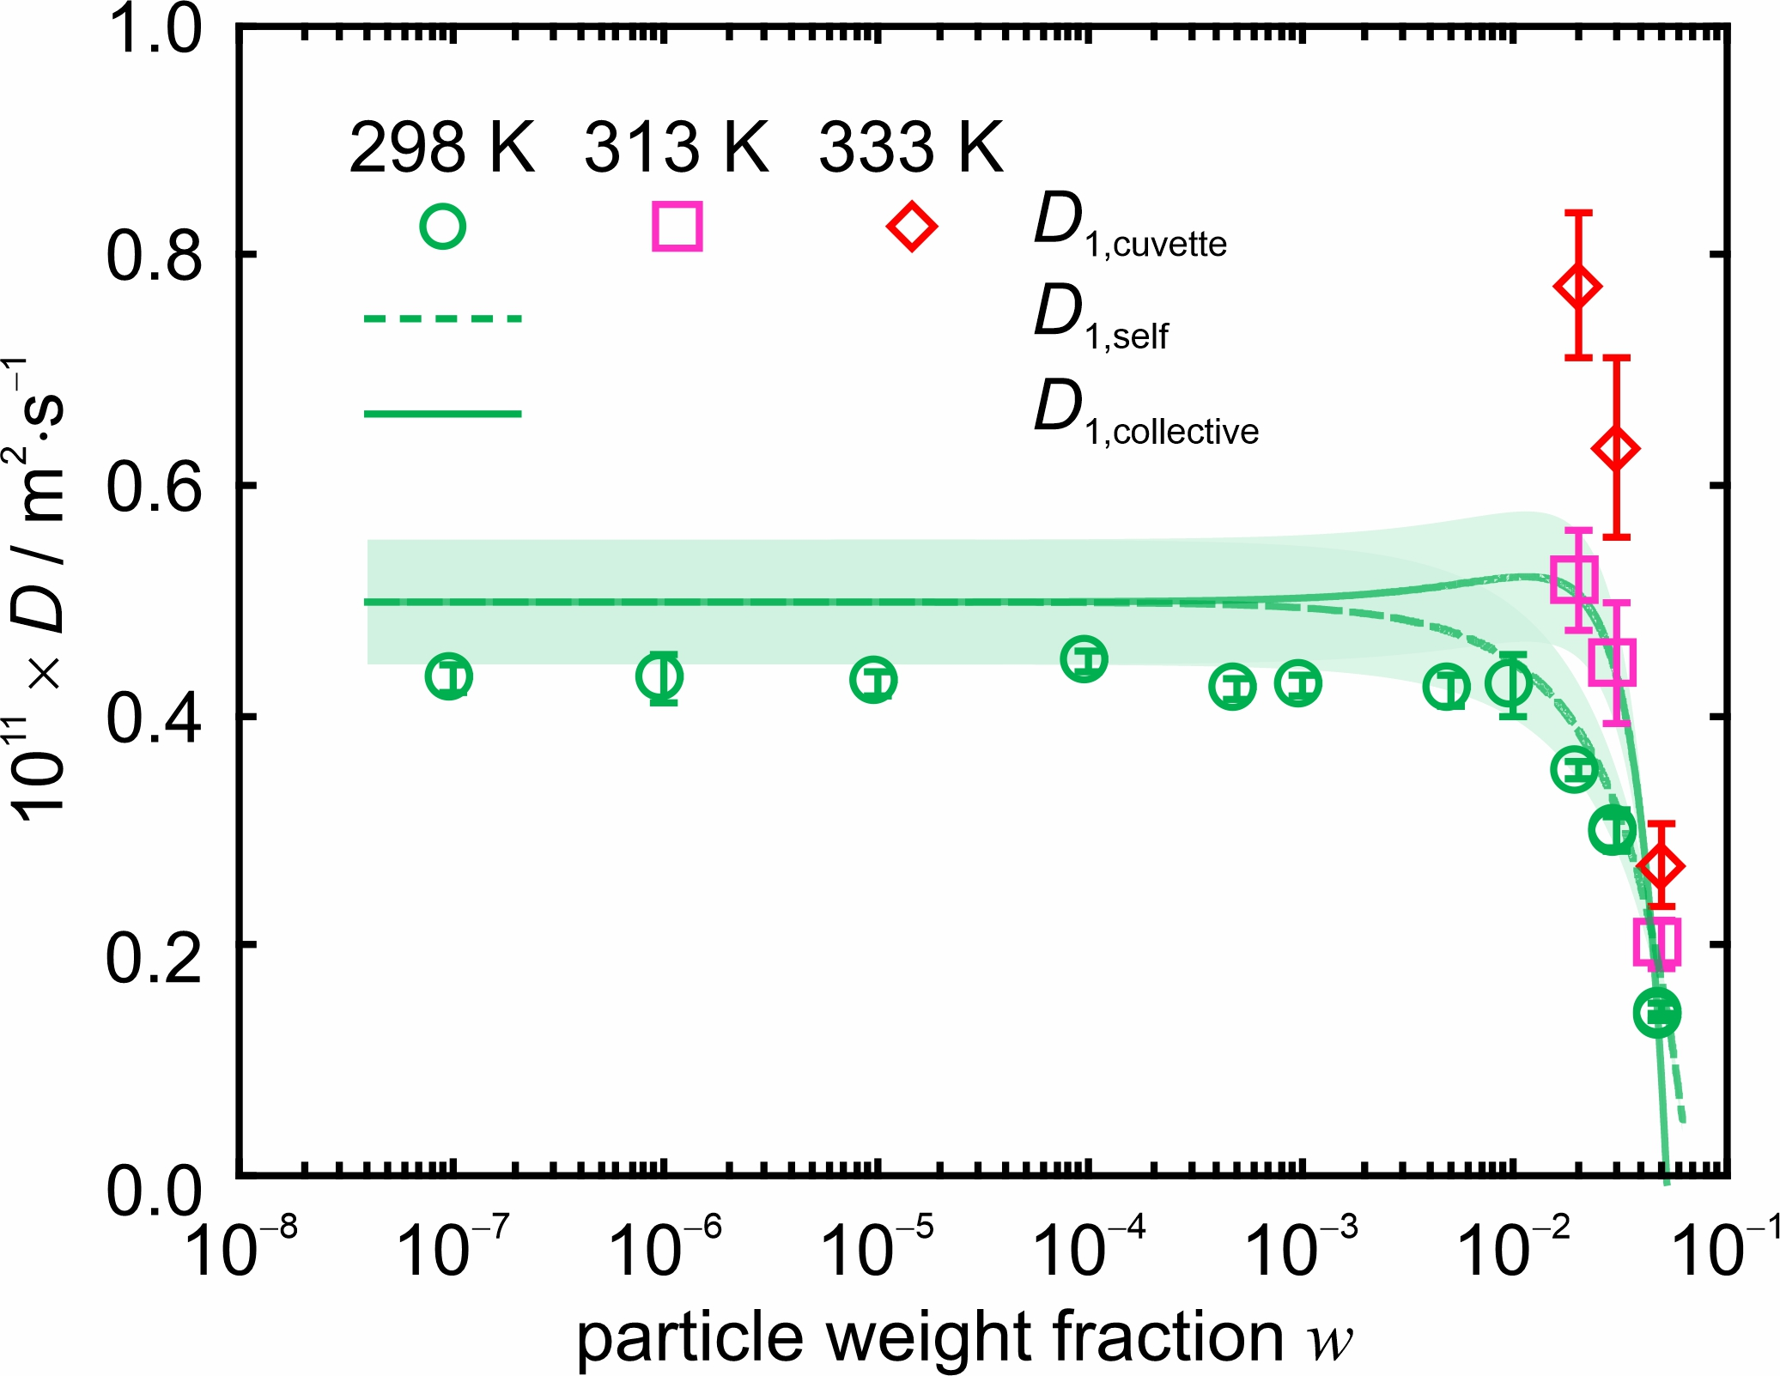
Figure 5. Diffusion coefficient D_{1,cuvette} of SiO₂ NPs in the bulk of a nanofluid as a function of w determined by DLS under heterodyne conditions at different T. The error bars of the D_{1,cuvette} values indicate the measurement uncertainties on a confidence level of 95%.

For all NF_{cuvette} with the exception of the one with w = 0.001, two distinct diffusivities can be found. As mentioned in Section 2.6, the smaller diffusivity D_{1,cuvette} is assigned to the larger particles having a diameter of around 97 nm. The larger diffusivity D_{2,cuvette} is an effective diffusivity related to the particle fractions having diameters of around (25 and 46) nm.
At T = 298 K, the determined D_{1.cuvette} value remains constant from w = 10⁻⁷ to w = 0.101, and then decreases rapidly approaching the stock weight fraction w = 0.497. Here, the measured value is 70% lower than that measured at w = 10⁻⁷, which is close to infinite dilution. Considering the applied experimental conditions, the probing wavelength Λ is around 270 nm. This means for nanofluids with w > 0.05, the diffusivity determined by DLS should resemble the collective diffusivity as the interparticle distance is smaller than the probing wavelength. The concentration dependences of the self-diffusivity D_{1,self} and the collective diffusivity D_{1,collective} are calculated based on the correlations proposed by Beenakker et al. [48] and Kops-Werkhoven et al. [49] and are indicated by the dashed and solid lines in Fig.5. The values of D_{1,self} and D_{1,collective} were calculated using the d_{H} value of 97.7 nm and the dynamic viscosity of water η = 0.89 mPa⋅s at T = 298 K [54]. The conversion between the volume fraction as used in Ref. [48] and the weight fraction was performed using the densities of SiO₂ and water (2 and 0.997) g⋅cm⁻³ [55, 56]. The shaded area around the dashed line represents the uncertainties of D_{1,self} and D_{1,collective} considering the standard deviation of d_{H} described in Section 2.1. The generally larger value of D_{1,self} or D_{1,collective} compared that of D_{1,cuvette} might be related to a systematic underestimation of the solvent viscosity or the hydrodynamic diameter of the NPs. The differences in D_{1,self}, D_{1,collective}, and D_{1,cuvette} values will not hinder a qualitative comparison of their concentration dependence. As can be seen, the determined D_{1,cuvette} value generally better follows the concentration dependence of the self-diffusivity D_{1,self} rather than that of the collective diffusivity D_{1,collective}. This might be related to more complex interactions present in the nanofluid, which could be caused by polydispersity of the nanofluid or possible surfactants, or this is simply related to particle aggregation at higher particle weight fractions. As it is not the focus of this work to identify the reasons for the observed discrepancy, this issue will not be further discussed.
Table 1. Experimental particle diffusivities D₁ and D₂ as well as their relative uncertainties U_{r}(D₁) and U_{r}(D₂) (k = 2) of SiO₂ NPs in nanofluid filled in the cuvette
T/ K | w | 10¹²×D₁ / (m²∙s⁻¹) | 100×U_{r}(D₁) | 10¹²×D₂ / (m²∙s⁻¹) | 100×U_{r}(D₂)
298 | 10⁻⁶ | 4.3ª | 3 | 20 | 104
298 | 10⁻⁵ | 4.3ª | 4 | 14 | 181
298 | 10⁻⁴ | 4.3ª | 3 | 14 | 180
298 | 0.001 | 4.5ª | 2 | -
298 | 0.005 | 4.2ª | 2 | 16 | 32
298 | 0.010 | 4.3 | 2 | 13 | 33
298 | 0.050 | 4.2ª | 3 | 17 | 24
298 | 0.101 | 4.3ª | 7 | 21 | 35
298 | 0.201 | 3.5 | 2 | 11 | 19
298 | 0.300 | 3.0 | 5 | 10 | 25
298 | 0.302 | 3.0 | 5 | 15 | 28
298 | 0.497 | 1.4 | 5 | 5.9 | 27
298 | 0.497 | 1.4 | 2 | 5.4 | 14
313 | 0.201 | 5.2 | 8 | 16 | 39
313 | 0.300 | 4.4ª | 12 | 16 | 56
313 | 0.497 | 2.0 | 10 | 8.6 | 70
333 | 0.201 | 7.8 | 8 | 24 | 41
333 | 0.300 | 6.3 | 12 | 19 | 51
333 | 0.497 | 2.7 | 13 | 9.5 | 54
ªDLS experiments were performed with a laser operated at λ₀ = 488 nm
  - Particle diffusivity obtained in a pendant drop
The diffusion coefficients of SiO₂ NPs in NF_{pendant} with w = 0.300 as a function of the evaporation time t determined from three exemplary DLS experiments at T = (298, 313, 333) K as well as their corresponding expanded relative uncertainties U_{r} (k = 2) are shown in Fig. 6. Evaporation time refers to the time span since the formation of the pendant drop. Due to the large amount of data, the diffusivity values will not be shown in a table. Here, the diffusion coefficients are denoted by D_{1,pendant} and D_{2,pendant}.
For all measurements, two diffusivities D_{1,pendant} and D_{2,pendant} can be simultaneously determined, as was the case for the investigations in NF_{cuvette}. D_{1,pendant} and D_{2,pendant} should correspond to D_{1,cuvette} and D_{2,cuvette}. This means that the diffusive processes of NPs inside a nanofluid suspended as a pendant drop can be characterized by the DLS method applying a heterodyne detection scheme. At smaller t, while the diffusivity D_{1,pendant} agrees with that determined in NF_{cuvette}, larger values of D_{2,pendant} compared to those in NF_{cuvette} were determined. Taking the measurements at T = 298 K for example, at the initial stage of evaporation, i.e., t = 400 s, the relative increase in D_{2,pendant} compared to that obtained in NF_{cuvette} is around 60%. This implies that there are further influencing factors on the dynamics of NPs. A sound conclusion cannot be given in this work. However, such behavior on the particle diffusivities might be related to, e.g., the presence of advection either inside [57] or on the surface of the drop [58, 59]. The additional advective flow superimposes with the diffusive process of the NPs, thus, affecting the determined particle diffusivity.
At T = 298 K, stable signals could still be detected even at t = 7500 s due to the extremely slow evaporation process of the NF_{pendant} inside the cuvette, as confirmed by several DLS experiments repeated for the same NF_{pendant} at this T. The slow evaporation was achieved by bringing the air in the cuvette close to saturation with a thin liquid film at the bottom of the cuvette. Almost saturated conditions were initially generated to determine the effect of droplet morphology on DLS results as compared to measurements in the liquid-filled cuvette. The deviation from saturation conditions is a measure for the driving force of evaporation. This driving force depends on the saturation temperature, that is linked to the saturation vapor pressure of water in air at a given temperature. With increasing gas temperature, the driving force increases. Therefore, to speed up the evaporation of the NF_{pendant}, DLS experiments at higher T were also performed. At higher temperatures, the evaporation of the NF_{pendant} was significantly faster and the time span t in which reliable DLS experiments could be performed is reduced. As shown in Fig.6 (B) for T = 313 K and Fig.6 (C) for T = 333 K, D_{1,pendant} and D_{2,pendant} decrease rapidly with t. Taking the results obtained at T = 313 K as an example, while the D_{1,pendant} always decreases approaching the maximum t of around 3000 s, D_{2,pendant}, however, decreases first then increases. In addition, the associated experimental uncertainty of D_{2,pendant} indicated by the error bars increases dramatically at the final stage of evaporation. Similar observations could also be found for the DLS experiments at T = 333 K. This can be related to the appearance of oscillations in the recorded CFs after t of around 2000 s which is defined here as locking point t_{lock}. It determines the moment when the drying droplet transforms into a wet particle. Whereas drying of the droplet is determined by gas-side conditions alone, drying of the wet particle is also influenced by particle-side heat and mass transfer processes, e.g., heat conduction through the formed, porous crust and vapor diffusion from the interior of the particle towards the solid-gas-interface. Oscillation in the CFs is a clear indication of the formation of particle crust around the NF_{pendant}, indicating the wet particle stage. As a proper fitting of the CFs was not possible in the presence of oscillations, the CFs obtained after t_{lock} were neither analyzed nor discussed in this study.
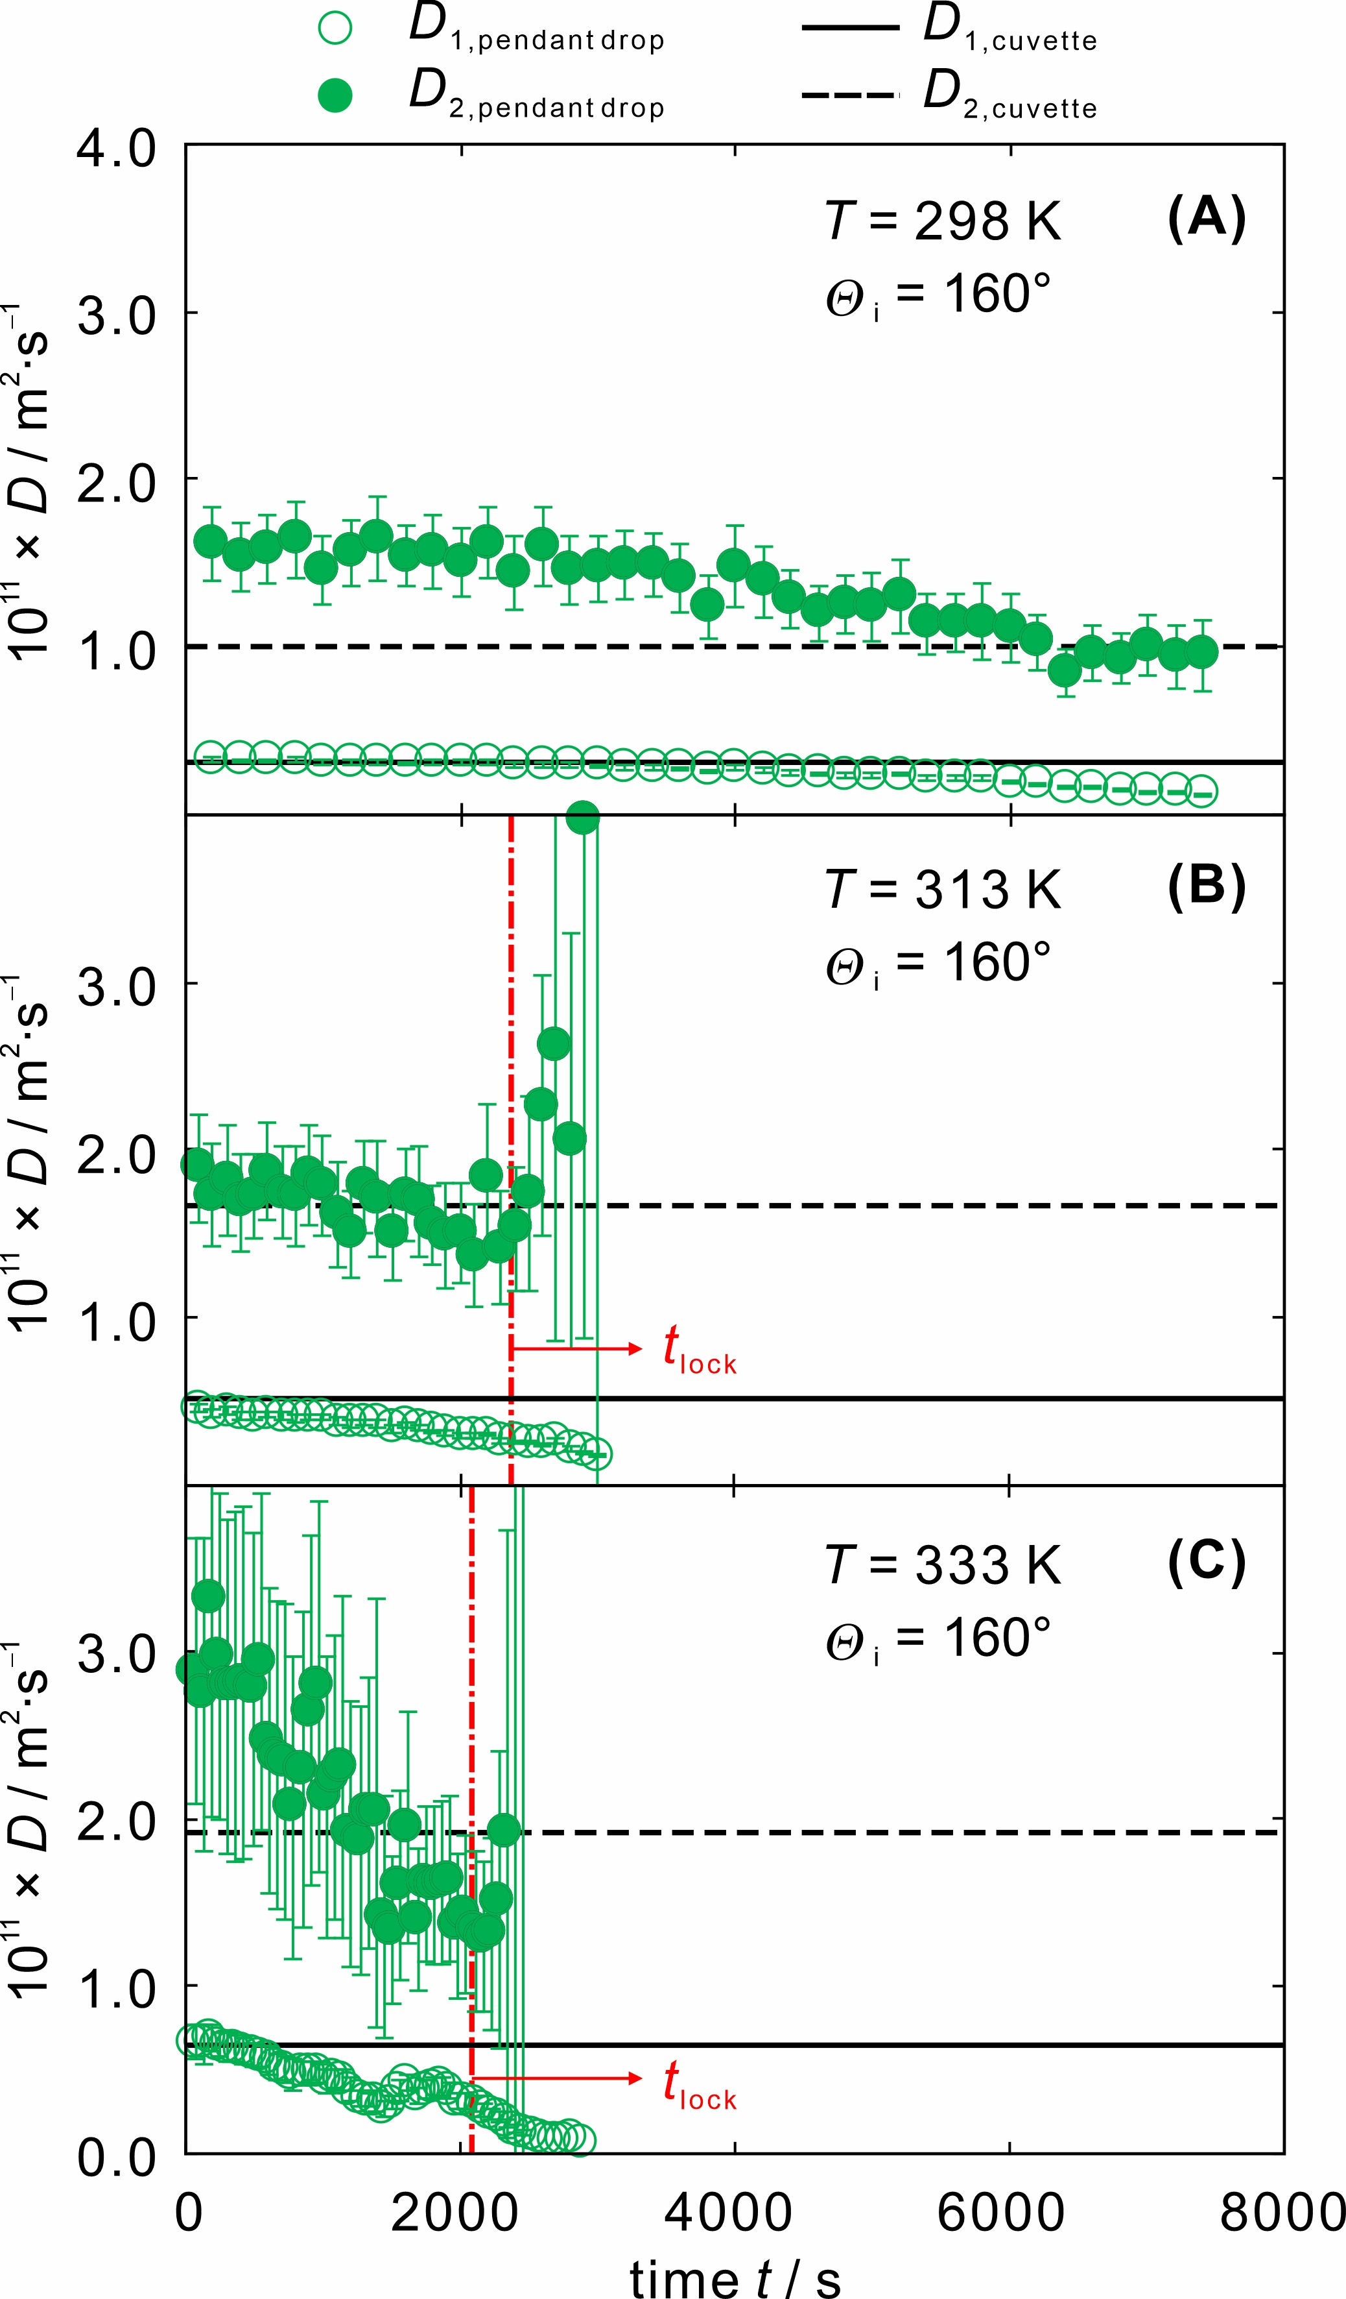
Figure 6. Particle diffusivities D_{1,pendant} and D_{2,pendant} of SiO₂ NPs in NF_{pendant} with w = 0.300 as a function of the evaporation time t at T = 298 K (A), 313 K (B), and 333 K (C). The error bars of the D_{1,pendant} values represent the measurement uncertainties on a confidence level of 95%. The large error bars of the D_{2,pendant} values are not displayed in the figure for clarity purposes. The dashed-dotted lines indicate a critical value of t at where oscillations appear in the recorded CFs.

For all the investigated temperatures, D_{1,pendant} and D_{2,pendant} both decrease with the evaporation time t. The reasons for this may be twofold. Firstly, the decrease in D_{1,pendant} and D_{2,pendant} during the evaporation of the NF_{pendant} can be partially related to the concentration dependence of the diffusivities for nanofluids with w approaching the stock value. For example, as can be seen in Fig.5, the relative decreases in the values of D_{1,cuvette} and D_{2,cuvette} from w = 0.300 to those at w = 0.495 are around 55% and 45% at T = 298 K, which corresponds well with the observation in the case of NF_{pendant}, cf. Fig.6 (A). Secondly, it is highly unrealistic to assume that the individual NPs do not aggregate during the evaporation of the pendant drop. Therefore, the determined diffusivities naturally decrease as the diameter of the scatterers, i.e. particle aggregates, inside the NF_{pendant} increases.
To further identify whether the decrease in the diffusivities during the drying of the drop is purely caused by their concentration dependence or is combined with the influence from particle aggregation or agglomeration, the determined experimental diffusivity D_{1,pendant} values in NF_{pendant} are plotted in Fig.7 as a function of calculated w until the locking point. Here, the calculation of w considers only the evaporation of water and assumes particles do not aggregate.
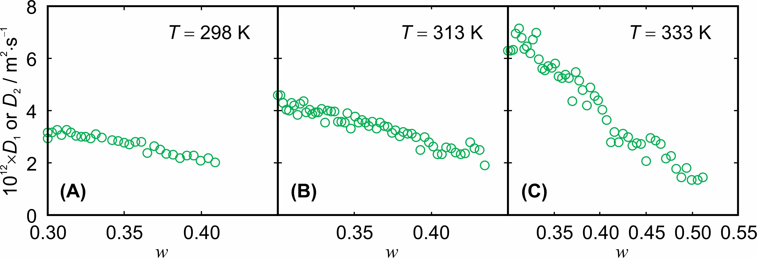
Figure 7. Experimental particle diffusivity D_{1,pendant} of SiO₂ NPs in NF_{pendant} as a function of the calculated particle weight fraction w until the locking point at T = 298 K (A), 313 K (B), and 333 K (C). Here, the calculation of the particle weight fraction w is described in the main text.

The calculation of the particle weight fraction w during evaporation is described in the following. At first, the theoretical change of the drop diameter d during evaporation is calculated using a correlation between d and the evaporation time t proposed by Yarin et al. [13]. Here, the initial d is determined to be (1.9 ± 0.2) mm for a NF_{pendant} with w = 0.300. Afterwards, the theoretical change in the volume of the drop as a function of t can be retrieved based on the d. As the mass of the particles inside the drop remain the same during evaporation, therefore, the increase in the particle weight fraction w is solely linked to the decrease in the mass of the water. The latter is converted from the decrease in the volume of the drop using the density of water at corresponding temperatures.
For the measurements at T = (298, 313, and 333) K, the relative decrease in D_{1,pendant} from the initial w = 0.300 to the highest w is around (34, 52, and 78) %. For the same concentration range, in comparison, the relative decrease in D_{1,cuvette} is around (27, 34, and 62) %. The D_{1,cuvette} value at the corresponding T and the highest w is interpolated by a second polynomial function based on the concentration dependence of D_{1,cuvette}. The larger decrease in the diffusivity in the case of NF_{pendant} compared to the case of NF_{cuvette} clearly indicates that the decrease in D_{1,pendant} and D_{2,pendant} during the drying of the pendant drop can be attributed to the combined influences of the concentration dependence of diffusivity and particle aggregation or agglomeration.
  - Particle diffusivity obtained in a levitated droplet
To explore the applicability of the DLS method for the characterization of diffusive process of NPs in a real free droplet, DLS experiments were performed for the same nanofluids suspended as a levitated droplet with the help of an ultrasonic acoustic levitator using the modified DLS setup as shown in Fig.3 (A-3).
Three example CFs obtained for the analysis of the NF_{levitated} with w = 0.01 at different t are shown in Fig.8 (A). Similar to other CFs obtained in NF_{levitated}, only one exponential related to the 97 nm NPs could be found compared to those obtained in NF_{cuvette} and NF_{pendant}. This is because of the low signal-to-noise (SNR) ratio of the recorded CFs in NF_{levitated}. The contrast of the CFs decreases with increasing t. Here, the contrast is the intensity ratio between the free NPs or aggregated NPs and other scattering processes, e.g., at the surface of the droplet. This might be related to the increasing scattering intensity of the rather rigid NPs which were enriched at the surface of the droplet prior to the formation of the crust and/or the reducing scattering volume when the droplet evaporates.
The decay time τ_{C} determined from the fitting of the CFs, shown in Fig.8 (B), increases with increasing the evaporation time t. The error bars represent the fitting uncertainties (k = 1) of the τ_{C} value. From t = 20 s to the end of the evaporation stage, i.e., t = 400 s, the relative increase in τ_{C} is around 350%. This can again be explained by the combined influences of an increasing diameter of the scatterers as the droplet evaporates and the concentration dependence of the diffusivity at high w.
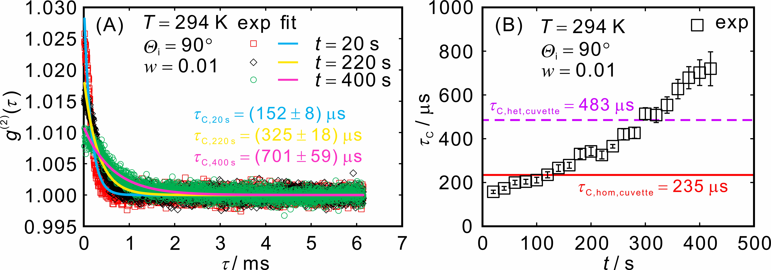
Figure 8. (A) Averaged experimental CFs (empty symbols) obtained for the analysis of a nanofluid with w = 0.01 suspended as a levitated droplet at room temperature. For the averaged CF, 2 individual CFs with single integration time of 10 s are taken into consideration. The solid lines indicate one exponential resulting from the fitting procedure of the experimental CF. (B) Experimental decay times τ_{C} (empty squares) determined from the fitting of the experimental CFs as a function of the evaporation time t. The error bars represent the fitting uncertainties (k = 1). The solid and dashed lines indicate the decay times obtained from the analysis of a NF_{cuvette} with w = 0.01 at room temperature applying a homodyne and heterodyne detection scheme.

As described in Section 2.5, additional defined reference light was not used for the DLS experiments on NF_{levitated}. However, the resulting detection scheme for those DLS experiments is unclear in the presence of light scattered from the surface of the levitated droplet. Therefore, the decay times τ_{C,hom,cuvette} and τ_{C,het,cuvette} obtained from the analysis of a NF_{cuvette} with w = 0.01 at room temperature applying a homodyne and heterodyne detection scheme are also plotted in Fig.7 (B), indicated by the solid and dashed lines. As can be seen, τ_{C,het,cuvette} is two times larger than τ_{C,hom,cuvette}, which agrees very well with the theory [60]. In NF_{levitated}, the decay times τ_{C,levitated} do not agree with τ_{C,het,cuvette} and τ_{C,hom,cuvette}, neither at small nor large t. This suggests that either the resulting detection scheme of the DLS experiments on NF_{levitated} is neither homodyne nor heterodyne, or the diffusive process of NPs inside NF_{levitated} is very different than that in NF_{cuvette} if a defined detection scheme could be assumed. Because of the former reason, a reliable determination of the diffusivities was not possible. Therefore, for the DLS investigation on NF_{levitated}, diffusivities will not be calculated or discussed. Based on the contrast value of the experimental CFs which is proportional to I_{i}/(I_{i}+I_{LO}) being smaller than 0.03, the resulting detection scheme should be closer to a heterodyne detection scheme. In this case, it can be concluded that the dynamics of the NPs inside NF_{levitated} is much faster than that inside NF_{cuvette} at the initial stage of the evaporation. This is most likely caused by strong advection of the NPs and by the increase in the internal temperature as a result of the imposed ultrasonic sound energy. At t around 400 s close to the end stage of the evaporation, τ_{C,levitated} values are much larger than τ_{C,het,cuvette}, indicating a much slower dynamics of the scatterers in NF_{levitated}. Here, the scatterers can be the individual NPs which are densely packed and aggregated NPs.
After t_{lock} which is typically around 400 s, oscillations will again appear in the obtained experimental CFs and their magnitude increases with further increasing time t. The difference in value of t_{lock} compared with the values obtained in NF_{pendant} at similar temperatures is explained by the change of experimental conditions: I) The surrounding gas volume is much larger than in the cuvette, i.e., gas-side conditions do not significantly change during evaporation and the driving force remains almost constant. II) The gas is not partially saturated, i.e., driving force for evaporation is much larger. III) A certain portion of the energy of the standing pressure wave is dissipated in the droplet, leading to slightly higher droplet temperature than in the pendant drop case. IV) The standing wave induces a small convective flow around the levitating droplet. Convection enhances the kinetics of evaporation, thereby contributing to a faster transition from drying droplet to drying of a wet particle. The appearance of the oscillation in the CFs is again a clear indication of the formation of crust around the droplet. Shortly after reaching t_{lock}, the levitated droplet will dry out completely.
- Conclusion
The present work demonstrates the characterization of diffusion of nanoparticles in nanofluids suspended as a pendant drop and as a levitated droplet using dynamic light scattering. Corresponding experiments on a nanofluid suspended as a pendant drop were performed at temperatures of 298, 313 and 333 K applying a heterodyne detection scheme. In comparison to investigations of a nanofluid filled in a cuvette, similar diffusivity values can be simultaneously determined during the evaporation process of the pendant drop. Larger values of the diffusivity associated with the smaller nanoparticles in the pendant drop suggest that there are further influencing factors, e.g., advection either inside or on the surface of the drop. During the evaporation of the pendant drop, crust formation and its time of appearance can also be identified by the appearance of oscillations in the recorded correlation functions. Before the crust is formed, the decrease in the determined particle diffusivities during the drying of the drop can be attributed to a combined influence of the concentration dependence of particle diffusivity and particle aggregation or agglomeration. For levitated droplets, it was also demonstrated that the dynamics of the particle number density fluctuations can be characterized. Here, the diffusive process of nanoparticles can be characterized until the crust formation. In summary, the applicability and limitation of dynamic light scattering for the characterization of diffusive processes of nanoparticles inside an evaporating droplet were identified, also reflecting a proof-of-concept for its application under process-relevant condition. In future work, we intend to study the aggregation rate of nanoparticles in addition to the characterization of their diffusion.

Conflicts of interest
There are no conflicts to declare.

Acknowledgements
This research was funded by the Deutsche Forschungsgemeinschaft (DFG, German Research Foundation) – Project-ID 416229255 – SFB 1411. The authors gratefully acknowledge funding of the Erlangen Graduate School in Advanced Optical Technologies (SAOT) by the Bavarian State Ministry for Science and Art.

Author contributions
Wenchang Wu: Investigation, Validation, Writing – Original Draft David H. Panduro Vela: Investigation, Validation, Writing – Original Draft Andreas Bück, Andreas Paul Fröba: Conceptualization, Writing – Review & Editing, Supervision

References
[1] M. Layani, M. Gruchko, O. Milo, I. Balberg, D. Azulay, S. Magdassi, Transparent Conductive Coatings by Printing Coffee Ring Arrays Obtained at Room Temperature, ACS Nano, 3 (2009) 3537-3542.
[2] N.M. Eijkelboom, A.P. van Boven, I. Siemons, P.F.C. Wilms, R.M. Boom, R. Kohlus, M.A.I. Schutyser, Particle structure development during spray drying from a single droplet to pilot-scale perspective, Journal of Food Engineering, 337 (2023) 111222.
[3] C. Rieck, T. Hoffmann, A. Bück, M. Peglow, E. Tsotsas, Influence of drying conditions on layer porosity in fluidized bed spray granulation, Powder Technology, 272 (2015) 120-131.
[4] M. Schmidt, A. Bück, E. Tsotsas, Shell porosity in spray fluidized bed coating with suspensions, Advanced Powder Technology, 28 (2017) 2921-2928.
[5] Z. Wu, Z. Chen, X. Du, J.M. Logan, J. Sippel, M. Nikolou, K. Kamaras, J.R. Reynolds, D.B. Tanner, A.F. Hebard, A.G. Rinzler, Transparent, Conductive Carbon Nanotube Films, Science, 305 (2004) 1273-1276.
[6] X. Wang, L. Zhi, K. Müllen, Transparent, Conductive Graphene Electrodes for Dye-Sensitized Solar Cells, Nano Letters, 8 (2008) 323-327.
[7] Y. Fu, E.G. Dudley, Antimicrobial-coated films as food packaging: A review, Comprehensive Reviews in Food Science and Food Safety, 20 (2021) 3404-3437.
[8] P. Walzel, T. Furuta, Morphology and Properties of Spray-Dried Particles, Modern Drying Technology, 2011, pp. 231-294.
[9] K. Pandey, D. Prabhakaran, S. Basu, Review of transport processes and particle self-assembly in acoustically levitated nanofluid droplets, Physics of Fluids, 31 (2019) 112102.
[10] A. Miglani, S. Basu, Sphere to ring morphological transformation in drying nanofluid droplets in a contact-free environment, Soft Matter, 11 (2015) 2268-2278.
[11] A. Saha, S. Basu, R. Kumar, Effects of acoustic-streaming-induced flow in evaporating nanofluid droplets, Journal of Fluid Mechanics, 692 (2012) 207-219.
[12] E. Tijerino, S. Basu, R. Kumar, Nanoparticle agglomeration in an evaporating levitated droplet for different acoustic amplitudes, Journal of Applied Physics, 113 (2013) 034307.
[13] A.L. Yarin, G. Brenn, O. Kastner, C. Tropea, Drying of acoustically levitated droplets of liquid–solid suspensions: Evaporation and crust formation, Physics of Fluids, 14 (2002) 2289-2298.
[14] S. Mitic, M.Y. Pustylnik, G.E. Morfill, E. Kovačević, In situ characterization of nanoparticles during growth by means of white light scattering, Opt. Lett., 36 (2011) 3699-3701.
[15] P. Massoli, Rainbow refractometry applied to radially inhomogeneous spheres: the critical case of evaporating droplets, Appl. Opt., 37 (1998) 3227-3235.
[16] C. Li, X.-c. Wu, J.-z. Cao, L.-h. Chen, G. Gréhan, K.-f. Cen, Application of rainbow refractometry for measurement of droplets with solid inclusions, Optics & Laser Technology, 98 (2018) 354-362.
[17] S. Coetmellec, W. Wichitwong, G. Gréhan, D. Lebrun, M. Brunel, A.J.E.M. Janssen, Digital in-line holography assessment for general phase and opaque particle, 2014.
[18] B.V. Bronk, M.J. Smith, S. Arnold, Photon-correlation spectroscopy for small spherical inclusions in a micrometer-sized electrodynamically levitated droplet, Opt. Lett., 18 (1993) 93-95.
[19] U.K. Krieger, A.A. Zardini, Using dynamic light scattering to characterize mixed phase single particles levitated in a quasi-electrostatic balance, Faraday Discussions, 137 (2008) 377-388.
[20] G. Derkachov, D. Jakubczyk, K. Kolwas, K. Piekarski, Y. Shopa, M. Woźniak, Dynamic light scattering investigation of single levitated micrometre-sized droplets containing spherical nanoparticles, Measurement, 158 (2020).
[21] D. Feller, M. Otten, M. Hildebrandt, M. Krüsmann, G. Bryant, M. Karg, Translational and rotational diffusion coefficients of gold nanorods functionalized with a high molecular weight, thermoresponsive ligand: a depolarized dynamic light scattering study, Soft Matter, 17 (2021) 4019-4026.
[22] A.R. Karow, J. Götzl, P. Garidel, Resolving power of dynamic light scattering for protein and polystyrene nanoparticles, Pharmaceutical Development and Technology, 20 (2015) 84-89.
[23] J. Lim, S.P. Yeap, H.X. Che, S.C. Low, Characterization of magnetic nanoparticle by dynamic light scattering, Nanoscale Research Letters, 8 (2013) 381.
[24] V. Beschieru, B. Rathke, S. Will, Particle diffusion in porous media investigated by dynamic light scattering, Microporous and Mesoporous Materials, 125 (2009) 63-69.
[25] C. Giraudet, M.S.G. Knoll, Y. Galvan, S. Süß, D. Segets, N. Vogel, M.H. Rausch, A.P. Fröba, Diffusion of Gold Nanoparticles in Inverse Opals Probed by Heterodyne Dynamic Light Scattering, Transport in Porous Media, 131 (2020) 723-737.
[26] B. Over, B. Rathke, S. Will, Investigations on particle diffusion in porous glass by angle-dependent dynamic light scattering, Journal of Molecular Liquids, 222 (2016) 972-980.
[27] J.G.H. Joosten, E.T.F. Geladé, P.N. Pusey, Dynamic light scattering by nonergodic media: Brownian particles trapped in polyacrylamide gels, Physical Review A, 42 (1990) 2161-2175.
[28] L. Lobry, N. Ostrowsky, Diffusion of Brownian particles trapped between two walls: Theory and dynamic-light-scattering measurements, Physical Review B, 53 (1996) 12050-12056.
[29] W. Wu, J. Cui, U. Sultan, L. Gromotka, P. Malgaretti, C. Damm, J. Harting, N. Vogel, W. Peukert, A. Inayat, A.P. Fröba, Diffusion of gold nanoparticles in porous silica monoliths determined by dynamic light scattering, Journal of Colloid and Interface Science, 641 (2023) 251-264.
[30] N. Fu, M.W. Woo, X.D. Chen, Single Droplet Drying Technique to Study Drying Kinetics Measurement and Particle Functionality: A Review, Drying Technology, 30 (2012) 1771-1785.
[31] R. Hülsmann, M. Mast, C. Schnorr, G.J. Esper, R. Kohlus, Implementation of an acoustic levitator experimental setup for the investigation into drying kinetics of single droplets, Drying Technology, 40 (2022) 1436-1450.
[32] M. Griesing, H. Grosshans, T. Hellwig, R. Sedelmayer, S.R. Gopireddy, W. Pauer, E. Gutheil, H.-U. Moritz, Influence of Air Humidity on the Particle Formation of Single Mannitol-Water Droplets during Drying, Chemie Ingenieur Technik, 88 (2016) 929-936.
[33] C. Groenewold, C. Möser, H. Groenewold, E. Tsotsas, Determination of single-particle drying kinetics in an acoustic levitator, Chemical Engineering Journal, 86 (2002) 217-222.
[34] H. Schiffter, G. Lee, Single-Droplet Evaporation Kinetics and Particle Formation in an Acoustic Levitator. Part 1: Evaporation of Water Microdroplets Assessed Using Boundary-Layer and Acoustic Levitation Theories, Journal of Pharmaceutical Sciences, 96 (2007) 2274-2283.
[35] H. Schiffter, G. Lee, Single-Droplet Evaporation Kinetics and Particle Formation in an Acoustic Levitator. Part 2: Drying Kinetics and Particle Formation From Microdroplets of Aqueous Mannitol, Trehalose, or Catalase, Journal of Pharmaceutical Sciences, 96 (2007) 2284-2295.
[36] C.A. Schneider, W.S. Rasband, K.W. Eliceiri, NIH Image to ImageJ: 25 years of image analysis, Nat Methods, 9 (2012) 671-675.
[37] A.P. Fröba, Dynamic Light Scattering (DLS) for the Characterization of Working Fluids in Chemical and Energy Engineering, Friedrich-Alexander-Universität, 2009.
[38] A. Leipertz, A.P. Fröba, Diffusion Measurements in Fluids by Dynamic Light Scattering, Springer-Verlag, pp. 579-618.
[39] G.A. Schumacher, T.G.M. Van De Ven, Photon correlation spectroscopic studies of bimodal colloidal dispersions, Langmuir, 7 (1991) 2060-2065.
[40] L. Benzhuo, Particle Sizing with PCS Mixed of Self-beating Mode and Heterodyne Mode, Particle & Particle Systems Characterization, 25 (2008) 414-419.
[41] C.W.J. Beenakker, P. Mazur, Diffusion of spheres in a concentrated suspension: Resummation of many-body hydrodynamic interactions, Physics Letters A, 98 (1983) 22-24.
[42] G.K. Batchelor, Brownian diffusion of particles with hydrodynamic interaction, Journal of Fluid Mechanics, 74 (1976) 1-29.
[43] G.K. Batchelor, An Introduction to Fluid Dynamics, Cambridge University Press, 2000.
[44] C.W.J. Beenakker, P. Mazur, Diffusion of spheres in a concentrated suspension II, Physica A: Statistical Mechanics and its Applications, 126 (1984) 349-370.
[45] G. Nägele, On the dynamics and structure of charge-stabilized suspensions, Physics Reports, 272 (1996) 215-372.
[46] M.C. Marchetti, J.F. Joanny, S. Ramaswamy, T.B. Liverpool, J. Prost, M. Rao, R.A. Simha, Hydrodynamics of soft active matter, Reviews of Modern Physics, 85 (2013) 1143-1189.
[47] Y. Goto, H. Tanaka, Purely hydrodynamic ordering of rotating disks at a finite Reynolds number, Nature Communications, 6 (2015) 5994.
[48] C.W.J. Beenakker, P. Mazur, Self-diffusion of spheres in a concentrated suspension, Physica A: Statistical Mechanics and its Applications, 120 (1983) 388-410.
[49] M.M. Kops‐Werkhoven, H.M. Fijnaut, Dynamic light scattering and sedimentation experiments on silica dispersions at finite concentrations, The Journal of Chemical Physics, 74 (1981) 1618-1625.
[50] W. Wu, M. Supper, M.H. Rausch, M. Kaspereit, A.P. Fröba, Mutual Diffusivities of Binary Mixtures of Water and Poly(ethylene) Glycol from Heterodyne Dynamic Light Scattering, International Journal of Thermophysics, 43 (2022) 177.
[51] C.Z. Tan, J. Arndt, Chapter 2 - The refractive index of silica glass and its dependence on pressure, temperature, and the wavelength of the incident light, in: H.S. Nalwa (Ed.) Silicon-Based Material and Devices, Academic Press, Burlington, 2001, pp. 51-91.
[52] I. Thormählen, J. Straub, U. Grigull, Refractive Index of Water and Its Dependence on Wavelength, Temperature, and Density, Journal of Physical and Chemical Reference Data, 14 (1985) 933-945.
[53] C. Giraudet, T. Klein, G. Zhao, M.H. Rausch, T.M. Koller, A.P. Froba, Thermal, Mutual, and Self-Diffusivities of Binary Liquid Mixtures Consisting of Gases Dissolved in n-Alkanes at Infinite Dilution, J Phys Chem B, 122 (2018) 3163-3175.
[54] M.L. Huber, R.A. Perkins, A. Laesecke, D.G. Friend, J.V. Sengers, M.J. Assael, I.N. Metaxa, E. Vogel, R. Mareš, K. Miyagawa, New International Formulation for the Viscosity of H2O, Journal of Physical and Chemical Reference Data, 38 (2009) 101-125.
[55] M. Tanaka, G. Girard, R. Davis, A. Peuto, N. Bignell, Recommended table for the density of water between 0 °C and 40 °C based on recent experimental reports, Metrologia, 38 (2001) 301.
[56] D. Li, X. Sheng, B. Zhao, Environmentally Responsive “Hairy” Nanoparticles: Mixed Homopolymer Brushes on Silica Nanoparticles Synthesized by Living Radical Polymerization Techniques, Journal of the American Chemical Society, 127 (2005) 6248-6256.
[57] B.J. Fischer, Particle Convection in an Evaporating Colloidal Droplet, Langmuir, 18 (2002) 60-67.
[58] D. Tam, V. von Arnim, G.H. McKinley, A.E. Hosoi, Marangoni convection in droplets on superhydrophobic surfaces, Journal of Fluid Mechanics, 624 (2009) 101-123.
[59] S.Y. Misyura, A.V. Bilsky, O.A. Gobyzov, M.N. Ryabov, V.S. Morozov, Convection in an evaporating drop of aqueous solution at a high concentration of microscopic particles, Journal of Physics: Conference Series, 2057 (2021) 012100.
[60] R. Pecora, Dynamic Light Scattering: Applications of Photon Correlation Spectroscopy, Springer US, 1985.

