Validation of drinking water distribution monitoring schemes including water demand variability and minimum detectable concentrations

Supplementary materials
Number of pages: 6; number of tables: 2; number of figures: 3

Marco Gabrielli¹, Alessandro Leoni¹, Laura Di Domenico¹, Manuela Antonelli¹

¹ Dipartimento di Ingegneria Civile e Ambientale – Sezione Ambientale, Politecnico di Milano, Milan, Italy

S1 Graph-based monitoring layout selection strategies details
Several monitoring layouts were generated following several graph-based methodologies varying edges weighting, graph clustering and centrality measure. Similarly to Giudicianni et al. (2020) and Di Nardo et al. (2017), first, the DWDS structure was considered as a graph composed of nodes (i.e., pipes interconnections) and edges (i.e., pipes), which were either unweighted (uW) or weighted depending on pipes diameter (D), length (L) or the ratio between the two (D/L). Secondly, the DWDS graph, weighted in all different methods, was divided in different clusters using the algorithms presented in Table S1, ensuring manually the interconnection between the nodes within each sub-graph. Finally, within each sub-graph, the most central node was identified using the centrality measures illustrated in Table S2.

Table S1. Clustering algorithms used for graph-based monitoring location identification.
Algorithm | Theoretic Principle | Principle
K-means | $$d_{j}=\sqrt{{\left(x_{j}-x_{C.}\right)}^{2}+{\left(y_{j}-y_{C.}\right)}^{2}}$$ | Vertices clustering into a fixed number k of communities is performed by:  - Selecting k random vertices, named centroids, one for each community;  - Assigning each of the remaining vertices to the community with the nearest centroid, namely that with the shortest Euclidean distance, computed from the nodes plane coordinates;  - Calculating new centroid for each community.  Second and third steps are repeated until convergence (Hastie et al., 2009).
Edge Betweenness | $$EB\left(e_{j}\right)=\sum_{\left(v_{j},v_{k}\right)∈G}{\frac{σ_{v_{j}v_{k}}\left(e_{j}\right)}{σ_{v_{j}v_{k}}}}$$ | Vertices clustering into a fixed number of communities is performed by:  - Calculating the edge betweenness of all the edges of the original graph;  - Removing one or more edges having the highest value of betweenness;  - Calculating of betweenness of all the remaining edges in the updated graph structure;  Second and third steps are iteratively repeated until the desired number of cluster is obtained (Newman and Girvan, 2004).
Spectral | $$L=D-A$$ | Vertices clustering into a fixed number k of communities is performed by Di Nardo et al. (2017):  - Computing the first k eigenvectors u₁,…,u_{k} of the Laplacian matrix L, i.e. the eigenvectors corresponding to the smallest k eigenvalues;  - Storing these eigenvectors as columns of the n x k matrix U;  - Performing same search loop of  K-means algorithm as previously discussed, over the rows of matrix U.
Spectral Random Walk | $$L_{rw}=D^{-1}∙L$$ | Spectral alg. performed upon the normalized random walk Laplacian matrix, L_{rw} (Di Nardo et al., 2017).
Spectral Symmetric | $$L_{sym}=D^{{-1}/2}∙L∙D^{{-1}/2}$$ | Modified Spectral Alg., performed upon normalized symmetric Laplacian matrix, L_{sym} (Di Nardo et al., 2017).

Table S2. Centrality measures used for graph-based monitoring location identification.
Measure | Formula | Theoretic Principle
Closeness Centrality | $$C_{C}\left(v_{i}\right)=\frac{1}{\sum_{v_{j}∊G}^{n-1}{d\left(v_{i},v_{j}\right)}}$$ | Reciprocal of the sum of shortest paths lengths connecting the vertex v_{i} to all others (Freeman, 1978).
Harmonic Centrality | $$C_{H}\left(v_{i}\right)=\sum_{v_{j}∈G}^{n-1}{\left(\frac{1}{d\left(v_{i},v_{j}\right)}\right)}$$ | Sum of the reciprocal of shortest paths lengths connecting the vertex v_{i} to all others (Marchiori and Latora, 2000).
Betweenness Centrality | $$C_{B}\left(v_{i}\right)=\sum_{\left(v_{j},v_{k}\right)∈G}{\frac{σ_{v_{j}v_{k}}\left(v_{i}\right)}{σ_{v_{j}v_{k}}}}$$ | Number of shortest paths passing through vertex v_{i}, divided by total number of shortest paths (Freeman, 1977).
Degree Centrality | $$C_{D}\left(v_{i}\right)=\sum_{j=1}^{n-1}{w_{ij}}$$ | Sum of the weights of the edges incident to vertex v_{i} (Freeman, 1978).
Eigenvector Centrality | $$C_{E}\left(v_{i}\right)=\frac{1}{λ}∙\sum_{j=1}^{n-1}{A_{ij}∙C_{E}\left(v_{j}\right)}$$ | The eigenvector corresponding to the dominant eigenvalue of the adjacency matrix (Bonacich, 1972).
Katz Centrality | $$C_{K}\left(v_{i}\right)=α∙\sum_{j=1}^{n-1}{A_{ij}∙C_{K}\left(v_{j}\right)+β}$$ | Generalization of Eigenvector Centrality by means of a damping factor α and an exogenous factor β (Katz, 1953).
Current-Flow Betweenness C. | $$C_{C-F.B.}\left(v_{i}\right)=\frac{\sum_{\left(s,t\right)}{{F_{i}}^{\left(s,t\right)}}}{{\left[n∙\left(n-1\right)\right]}/2}$$ | Simulation of and electrical current-flow spreading mechanism (Brandes and Fleischer, 2005).
Jordan Centrality | $$\left\{\begin{aligned}ϵ\left(v_{i}\right)=\max_{v_{j}∈V}{d(v_{i},v_{j})} \\ r\left(G\right)=\min_{v_{i}∈V}{ϵ(v_{i})}\end{aligned} \right.$$ | Vertex having eccentricity equal to the radius r of the graph (Wasserman and Faust, 2009).

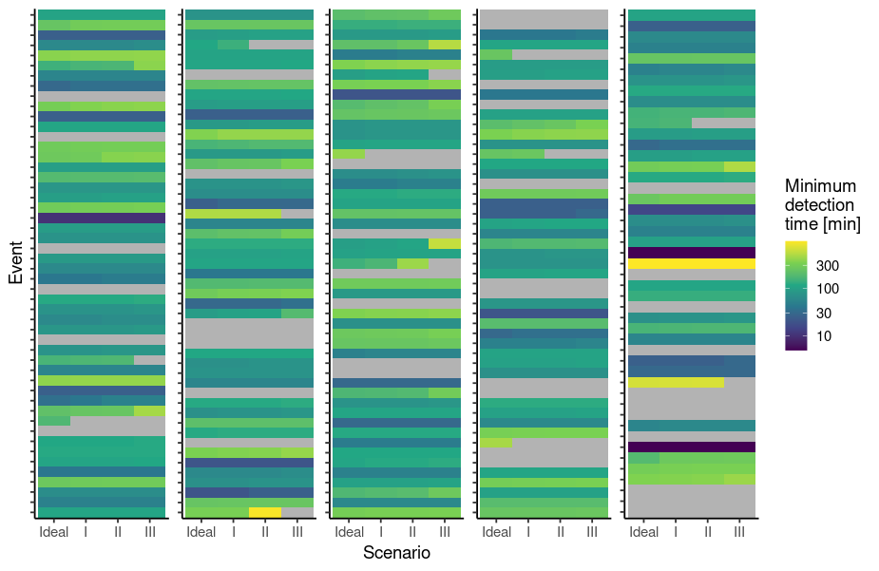
Figure S1. Minimum detection time (detTime) in the different scenarios for each simulated event in case-study C.

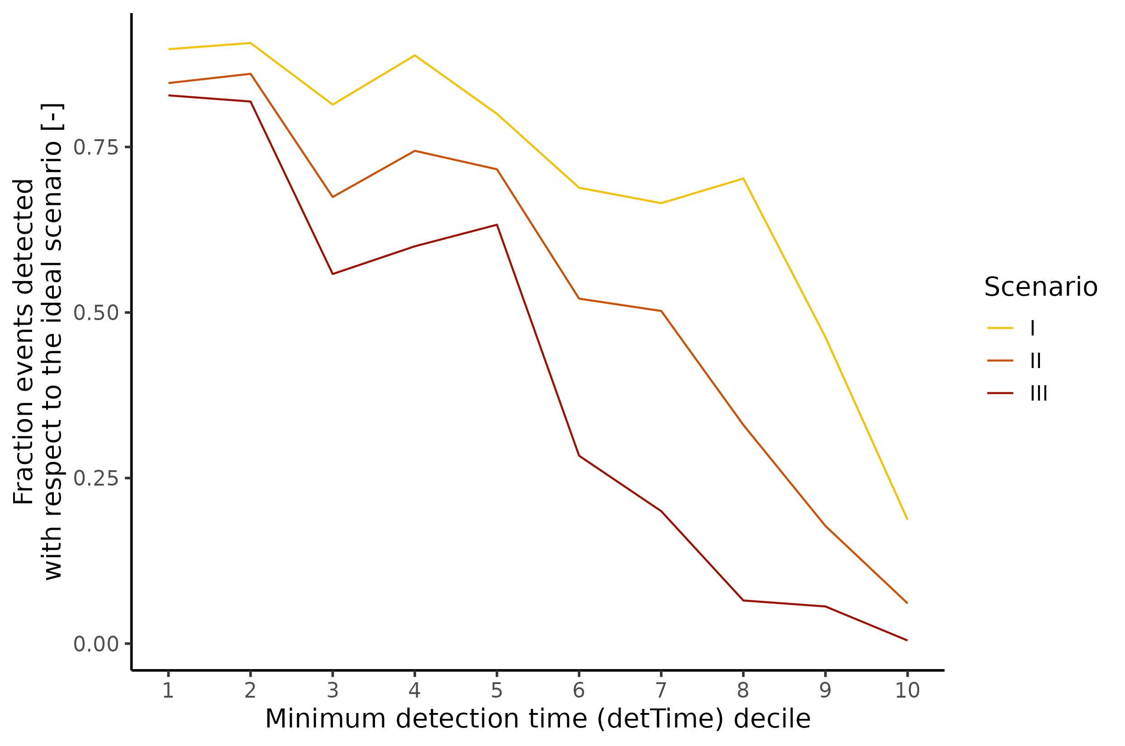
Figure S2. Fraction of events, detected in the ideal scenario, detected also in the alternative scenarios tested as a function of the minimum detection time deciles achieved in the ideal scenario for case-study R.

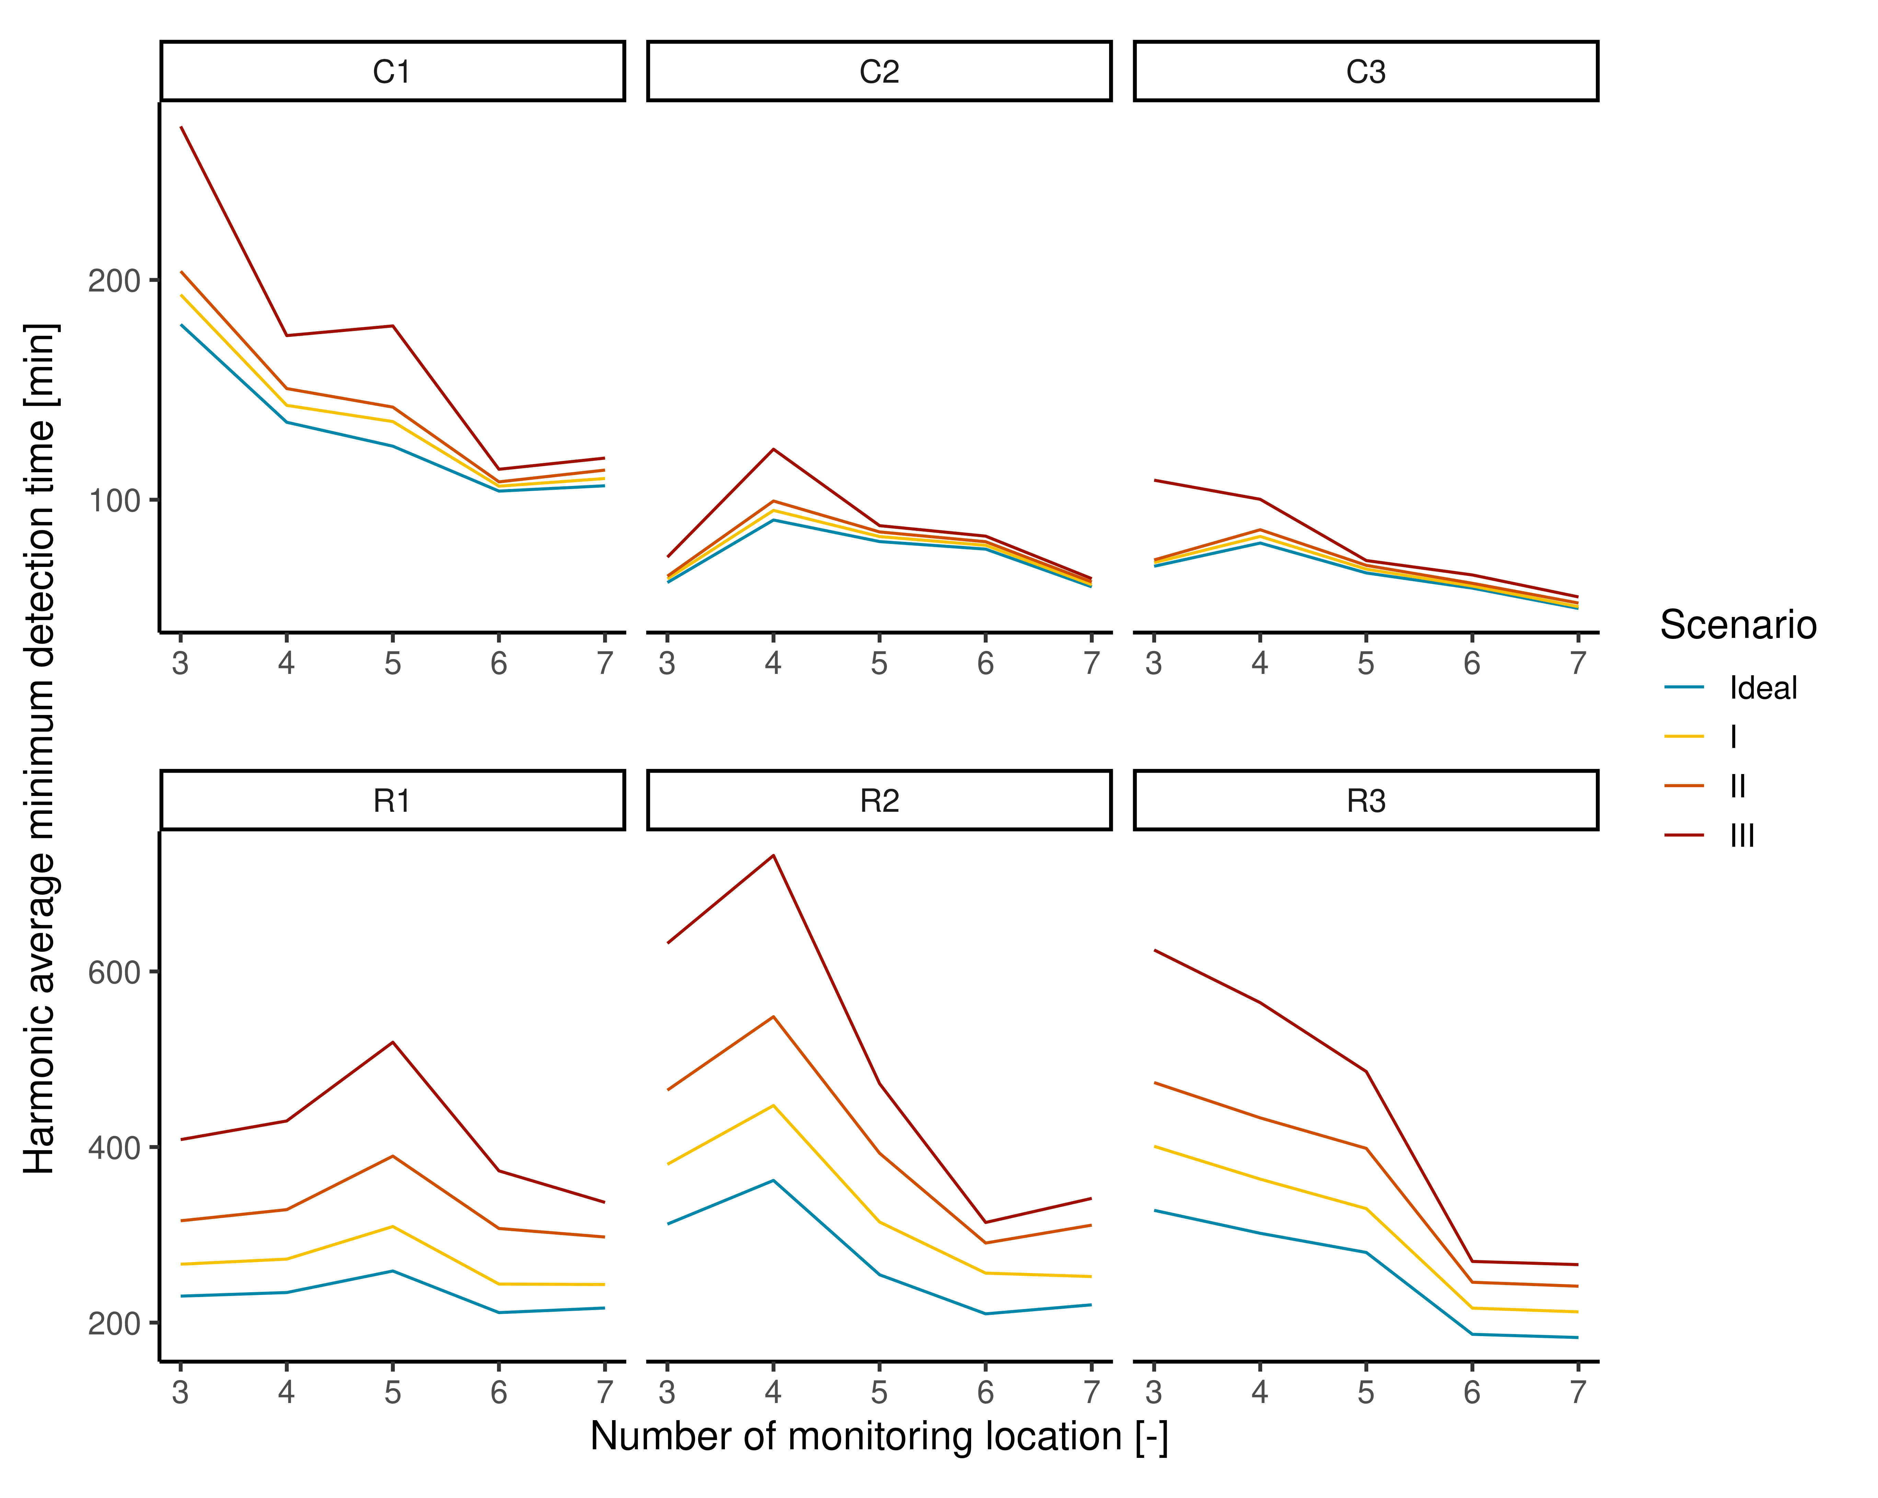
Figure S3. Harmonic average of the minimum detection times for the different water quality alteration scenarios tested. In the case of non-detected events, an infinite detection time was assumed in the estimation of the harmonic mean.

References
Bonacich, P., 1972. Technique for Analyzing Overlapping Memberships. Sociological Methodology 4, 176. https://doi.org/10.2307/270732
Brandes, U., Fleischer, D., 2005. Centrality Measures Based on Current Flow, in: Diekert, V., Durand, B. (Eds.), STACS 2005, Lecture Notes in Computer Science. Springer Berlin Heidelberg, Berlin, Heidelberg, pp. 533–544. https://doi.org/10.1007/978-3-540-31856-9_44
Csardi, G., Nepusz, T., 2006. The igraph software package for complex network research. InterJournal, complex systems 1695, 1–9.
Di Nardo, A., Di Natale, M., Giudicianni, C., Greco, R., Santonastaso, G.F., 2017. Weighted spectral clustering for water distribution network partitioning. Appl Netw Sci 2, 19. https://doi.org/10.1007/s41109-017-0033-4
Freeman, L.C., 1978. Centrality in social networks conceptual clarification. Social Networks 1, 215–239. https://doi.org/10.1016/0378-8733(78)90021-7
Freeman, L.C., 1977. A Set of Measures of Centrality Based on Betweenness. Sociometry 40, 35. https://doi.org/10.2307/3033543
Giudicianni, C., Herrera, M., Di Nardo, A., Greco, R., Creaco, E., Scala, A., 2020. Topological Placement of Quality Sensors in Water-Distribution Networks without the Recourse to Hydraulic Modeling. J. Water Resour. Plann. Manage. 146, 04020030. https://doi.org/10.1061/(ASCE)WR.1943-5452.0001210
Hagberg, A.A., Schult, D.A., Swart, P.J., 2008. Exploring Network Structure, Dynamics, and Function using NetworkX, in: Varoquaux, G., Vaught, T., Millman, J. (Eds.), Proceedings of the 7th Python in Science Conference. Pasadena, CA USA, pp. 11–15.
Hastie, T.J., Tibshirani, R., Friedman, J.H., 2009. The elements of statistical learning: data mining, inference, and prediction, 2nd ed. ed, Springer series in statistics. Springer, New York.
Katz, L., 1953. A new status index derived from sociometric analysis. Psychometrika 18, 39–43. https://doi.org/10.1007/BF02289026
Marchiori, M., Latora, V., 2000. Harmony in the small-world. Physica A: Statistical Mechanics and its Applications 285, 539–546. https://doi.org/10.1016/S0378-4371(00)00311-3
Newman, M.E.J., Girvan, M., 2004. Finding and evaluating community structure in networks. Phys. Rev. E 69, 026113. https://doi.org/10.1103/PhysRevE.69.026113
Wasserman, S., Faust, K., 2009. Social network analysis: methods and applications, 18. print. ed, Structural analysis in the social sciences. Cambridge Univ. Press, Cambridge.

