Techno-economic analysis of a combined power plant CO₂ capture and direct air capture concept for flexible power plant operation
Moataz Sheha¹, Edward J. Graham¹, Emre Gençer¹, Dharik Mallapragada^{1*}, Howard Herzog¹, Phillip Cross², James Custer², Adam Goff², Ian Cormier²
¹ MIT Energy Initiative, Massachusetts Institute of Technology, Cambridge, MA, USA
² 8 Rivers Capital, Durham, USA
*Corresponding author, E-mail: dharik@mit.edu
Abstract
The electric power sector must be deeply decarbonized at a reasonable cost to achieve sustainability through electrification of other sectors. While variable renewable energy generation is expected to dominate grid decarbonization efforts, variability creates the need for supply- and demand-side technologies that can operate flexibly to balance the system. This paper proposes a new concept for power plant flue gas capture integrated with a novel lime-based direct air capture technology to enable flexible operation of the power plant and achieve negative emissions under all operating scenarios. Steady-state models are developed, and sensitivity analyses are conducted on key process variables to investigate system performance. The results, presented at three different power plant loading levels (100%, 40%, and 0%), demonstrate negative emissions of -0.188 tCO2/MWh at 100% loading and -2.087 tCO2/MWh at 40% loading. Economic modeling suggests the need for carbon credits exceeding $170/tCO2 to achieve positive net present values.

- Introduction
Carbon dioxide capture and storage (CCS) technologies are broadly recognized as having the potential to play a key role in meeting climate change targets, through adoption in a range of sectors, including the electricity system (Bui et al., 2018). The US Department of Energy has produced baseline studies for the cost and performance of CCS on both natural gas and coal-fired power plants (James Robert E. et al., 2019). However, these and many other literature studies on CCS technology economics assume that these plants run most of the time, i.e., they have high capacity factors (e.g. 85%). However, with the growing share of variable renewable energy (VRE) generation in the electricity sector, capacity factors for fossil fuel-fired power plants have decreased and are forecast to decrease more in the future as more VREs come on-line. This is because VREs have near-zero marginal operating costs, resulting in them being dispatched ahead of fossil-fired power plants as part of economic dispatch principles driving operation of power systems across many regions. The result is that fossil-fired power plants need to operate flexibly, which means increased ramping, resulting in increased operating costs, reduced power generator efficiency, and reduced capacity factors (Kasseris et al., 2020). Deployment of CCS with fossil-fuel power generation generally leads to the following operational impacts: a) reduced plant energy efficiency due to energy consumption for CO₂ capture, and b) limited ability of plant to adjust its power output to electricity market signals, owing to limited operational flexibility of CO₂ capture systems and their tight coupling with power generation equipment. Importantly, since CCS is a capital intensive technology, reduced capacity factors mean that there are less kilowatt hours to amortize the capital investment over, resulting in increased costs. Also, one needs to assure that the CCS system can ramp up and down along with the power plant (“FLECCS | arpa-e.energy.gov,” n.d.).
The design of better flexible CCS-equipped fossil fuel power plants is therefore an important area of current research. A variety of methods have been proposed to enable flexible operation of such systems, including load following, solvent/sorbent storage, exhaust gas venting and time-varying solvent regeneration (Arias et al., 2020; Dowell and Shah, 2017; MacDowell and Shah, 2014; Mechleri et al., 2017; Oates et al., 2014; Zantye et al., 2021, 2019). All of these methods have the effect of reducing net energy consumption during periods of high electricity prices and increasing net energy consumption during periods of low electricity prices. In general, the cost advantage of flexible systems compared to the static/ base load operation increases as electricity prices become more volatile (Mechleri et al., 2017). Disadvantages of flexible operation include a) additional cost of large, on-site solvent/sorbent inventory(MacDowell and Shah, 2014) b) increased CO₂ emissions from flue gas venting (MacDowell and Shah, 2014) and c) deterioration in system performance over periods of dynamic operation (Dowell and Shah, 2017).
In the current work, calcium looping is chosen for capturing flue gas CO₂. A flexible calcium looping CO₂ capture process (FlexiCal) has been considered previously (Arias et al., 2020; Criado et al., 2017), whereby two large piles of CaO and CaCO₃ are stored at moderate temperatures (150-200 C) and calcined solids react with flue gas CO₂ from a coal power plant only while it is operational, and an oxy-calciner operates continuously at steady-state. Via sorbent storage and thermal integration of the CCS system with the powerplant, the FlexiCal system indicates a CO₂ avoidance cost of 80-120 $ per tCO₂, representing a 44% reduction in capture cost compared to the equivalent standard calcium looping system operating in base load model (Criado et al., 2017). A number of studies have also considered integration of the calcium looping process for CO₂ capture with cement production, whereby a portion of CaO exiting the calciner is used as input to the cement manufacturing process (De Lena et al., 2019; Dean et al., 2011; Rodríguez et al., 2012). The CaO sorption capacity is known to decrease rapidly with repeated cycles of calcination and carbonation (Fennell et al., 2007), and such an approach offers economic advantages by utilization of the spent sorbent.
Here we propose a new concept for low-carbon power generation that synergistically integrates power plant flue gas carbon capture via calcium looping with a novel lime-based direct air capture (DAC) technology in a way that allows for flexible operation of the power plant. Similar to the integration of calcium looping with cement production described above, in the proposed process, the spent CaO sorbent is utilized within the DAC system. This allows for the potential for net-negative emissions for the overall process and potential economic benefits via tax credits for CO₂ capture from air and/ or CO₂ sequestration. Note that CO₂ is not only generated by the power plant but also by the calcium looping system when CaCO₃ is converted to CaO sorbent for the DAC system, and by the combustion of natural gas in the calciner, which produces additional CO₂. This allows for continuous operation of the CCS system, even with the power plant shut down.
To our knowledge, no studies thus far have considered the integration of DAC and power plant CO₂ capture under dynamic power plant operation in response to VRE dominant grids. The key contributions of this work include a detailed description of the novel low-carbon power generation system with potential for net-negative emissions, and a detailed description of the steady-state simulation model of the process over a variety of operating modes, reflecting possible plant operation at different electricity prices. Results indicate that under all power plant loading levels considered (0%, 40% and 100%), it is possible to run the calciner at full capacity (constant molar solids input) and therefore high-capacity utilization of the downstream CO₂ separation and DAC units is achievable regardless of power plant operation. The system can adapt to time-varying electricity prices by maximizing power exports during times of high prices and importing power during periods of low electricity prices. Under all operational scenarios the system achieves negative emissions, specifically, -0.188 metric ton of CO₂ (tCO₂)/MWh at full loading and -2.087 tCO₂/MWh at 40% loading. Economic analysis suggests that carbon credits of $170/tonne and above are required to achieve positive net present values, however, this value will likely decrease upon further optimization of the process decision variables.
This paper is organized as follows. Section 2 describes the entire system, including the power plant, CCS process, and the DAC process. The process simulation model is then described in detail in Section 3, detailing the main equipment and operating conditions of each subsystem. Section 4 presents the different possible operating modes for the system along with the key design variables for the process. The results and discussion of the simulation runs are illustrated in Section 5. The economic model is presented in Section 6 and then followed by the conclusions in Section 7.
- System Description
Figure 1 presents a simplified schematic of the proposed calcium-based carbon capture system. The system is composed of a) a natural gas combined cycle (NGCC) power plant, b) a calcium looping system, c) a heat recovery system, d) a membrane package, e) a cryogenic purification unit (CPU), and f) a direct air capture system. The flue gas from the NGCC power plant is fed to the calcium looping system, which is composed mainly of two reactors: a calciner and a carbonator. Fresh CaCO₃ (limestone) is fed to the calciner where it breaks down into CaO (lime) and CO₂ at high temperature. The CO₂-rich gas from the calciner goes to a heat recovery stream generator (HRSG) system. The gas is then compressed and sent to a dryer where 99% of the water content is removed. The dried gas is then supplied to a membrane separator, where the CO₂ concentration increases in the permeate and decreases in the retentate. The permeate is sent to a cryogenic purification unit (CPU), where it gets compressed to 65 bars. The compressed gas is then cooled down to -50ºC, where the whole stream liquifies. The liquid stream is fed to a distillation column from the top. The distillation column has a reboiler at the bottom that controls the purity of the product liquid CO₂. The gases from the top of the distillation column are used for pre-cooling the feed to the distillation. Then these gases along with the membrane retentate are both recycled to the carbonator to increase the recovery of CO₂ and to minimize the emissions. The solid CaO from the calciner goes into two directions, a fraction goes to the direct air capture system and the rest goes to the carbonator to capture CO₂ from the power plant flue gas and the recycled streams from the membrane and the distillation column.
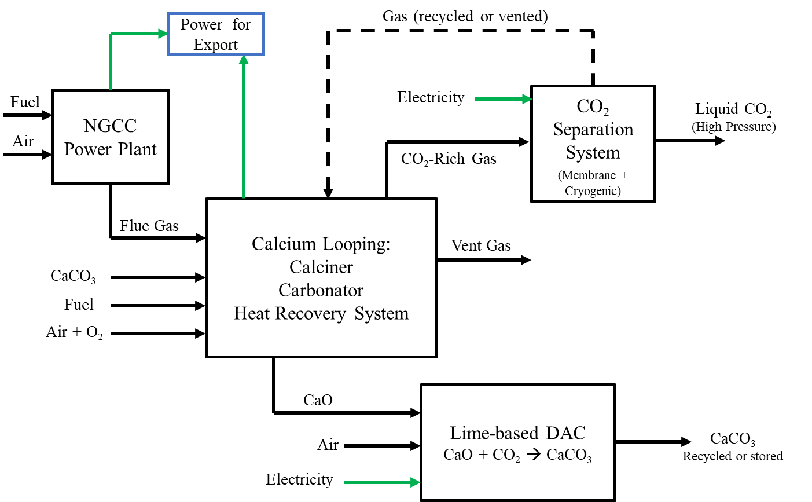
Figure 1: Proposed concept for power plant CO₂ capture integrated with lime-based DAC
Critical challenges for the steady state model development in Aspen Plus addressed in this study include:
- Modeling the part loading operation of the NGCC power plant.
- Determining the split fractions of the flue gas going to the calcium looping system and the CaO coming out of the calciner.
- Modeling the conversion of CaO in the carbonator which goes through the calcium recycle loop in the calciner/carbonator system.
- Developing a membrane model to be used in Aspen Plus
- Identifying the CPU refrigerant that cools down the CO₂ rich gas before going to the distillation column.
Section 3 illustrates the detailed process modeling of the proposed system in Aspen Plus along with the resolution implemented to overcome the above challenges.
- Detailed Process Model Description
The system is modeled in Aspen Plus V11. The SRK thermodynamic property package is used for the whole system, except the CPU where the PRMHV2 package is used. The PRMHV2 package was found to have better representation of the phase equilibria than SRK for the low temperature operation of the CPU. Each component of the process simulation model is described in detail in the following subsections.
  - Natural Gas Combined Cycle (NGCC) Power Plant
The NGCC power plant description follows the diagram shown in Figure 2. Ambient air is compressed and sent to a natural gas combustor that produces flue gas at 1423ºC. The flue gas is then fed into a gas turbine for power generation. The gas leaves the turbine at 624ºC and 1.1 bar and goes to heat recovery steam generator (HRSG) system modeled as multi-stream heat exchanger. The HRSG operates with a steam cycle of three steam turbines at three pressure levels: high pressure (175 bar), intermediate pressure (37.4 bar), and low pressure (5.2 bar). The flue gas then leaves the power plant at 83ºC and atmospheric pressure. The full loading operation of the NGCC power plant is adapted from the National Energy Technology Laboratory (NETL) cost and performance baseline study for fossil energy plants (Case B31A) (James Robert E. et al., 2019). The total gross power of the plant at full loading is 740 MW and the net power is 727 MW.
The efficiency values used for the pressure changers are listed in Table 1. These values were obtained by trial and error to match the conditions of the NETL power plant model. The flue gas exit temperature is controlled using a design specification that adjusts the steam flow rate in the steam cycle, while maintaining a 40ºC temperature approach in the HRSG. The combustor is modeled as a Gibbs reactor where the following combustion reactions take place with complete conversion:
$${CH}_{4}+2O_{2}→{CO}_{2}+2H_{2}O$$
$$2{C_{2}H}_{6}+7O_{2}→4{CO}_{2}+6H_{2}O$$
$${C_{3}H}_{8}+5O_{2}→3{CO}_{2}+4H_{2}O$$
$${2C_{4}H}_{10}+13O_{2}→8{CO}_{2}+10H_{2}O$$

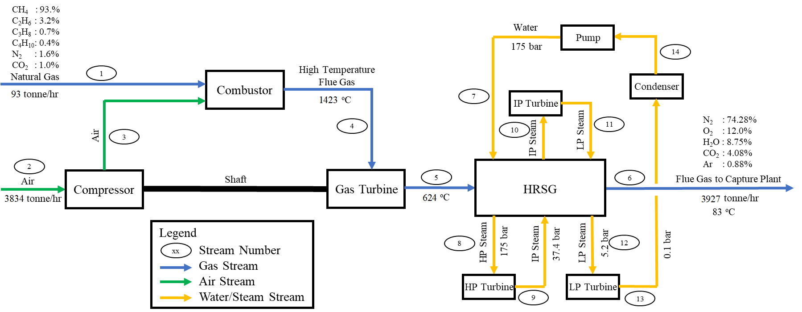
Figure 2: NGCC power plant schematic at full loading operation
Table 1
Efficiency values for the pressure changers used in the NGCC power plant model
Equipment | Isentropic Efficiency (%)
Steam turbines | 92.00
Air compressor | 80.50
Gas turbine | 87.74
Water pump | 80.00

Modeling the Power Plant Part Loading Operation
To maximize the efficiency of an NGCC power plant at any loading below 100% loading, the operation of the plant needs to be modified to reflect the real operation. In this study, the part loading operation of the power plant is adapted from (Alcaráz-Calderon et al., 2019) and adjusted to match the full loading conditions of the NETL baseline study. The minimum part loading operation of the plant is assumed to be 40% of the full plant capacity. Three inputs change from full loading (100%) to part loading (40%): 1) the flow rates of air and fuel decreases, 2) the air to fuel ratio increases, and 3) the air compressor discharge pressure decreases. The performance of the developed NGCC power plant model in this study is illustrated in Table 2. The efficiency curve of this study and that of (Alcaráz-Calderon et al., 2019) are illustrated in Figure 3. It is observed that the two efficiency curves have a similar trend but with around 1.5-2% difference in efficiency. This is because the starting point for each plant is different, where the NGCC power plant model developed in this study follows the 100% loading scenario of NETL baseline study (James Robert E. et al., 2019).
Table 2
Performance of the developed NGCC power plant model*
Power plant load | % | 100 | 90 | 80 | 70 | 60 | 50 | 40
Net power output | MW | 727 | 654 | 582 | 509 | 437 | 364 | 291
Gas turbine power | MW | 1,102 | 931 | 746 | 577 | 423 | 282 | 151
Steam cycle power | MW | 263 | 248 | 239 | 230 | 223 | 218 | 213
Air compressor power | MW | -625 | -512 | -392 | -289 | -202 | -129 | -68
Auxiliary loads | MW | 14 | 12.6 | 11.2 | 9.8 | 8.4 | 7.0 | 5.6
Air mass flow rate | kg/s | 1,065 | 978 | 897 | 822 | 754 | 692 | 637
Natural gas mass flow rate | kg/s | 25.9 | 23.7 | 21.5 | 19.5 | 17.4 | 15.4 | 13.5
Flue gas composition
Mole percent of N₂ |  | 74.28 | 74.30 | 74.32 | 74.37 | 74.43 | 74.53 | 74.67
Mole percent of O₂ |  | 12.00 | 12.04 | 12.10 | 12.22 | 12.42 | 12.70 | 13.09
Mole percent of CO₂ |  | 4.08 | 4.06 | 4.03 | 3.98 | 3.89 | 3.75 | 3.57
Mole percent of H₂O |  | 8.75 | 8.71 | 8.66 | 8.55 | 8.38 | 8.12 | 7.77
Mole percent of Ar |  | 0.88 | 0.88 | 0.88 | 0.88 | 0.88 | 0.88 | 0.89
*Results are for two trains combined as per NETL baseline study
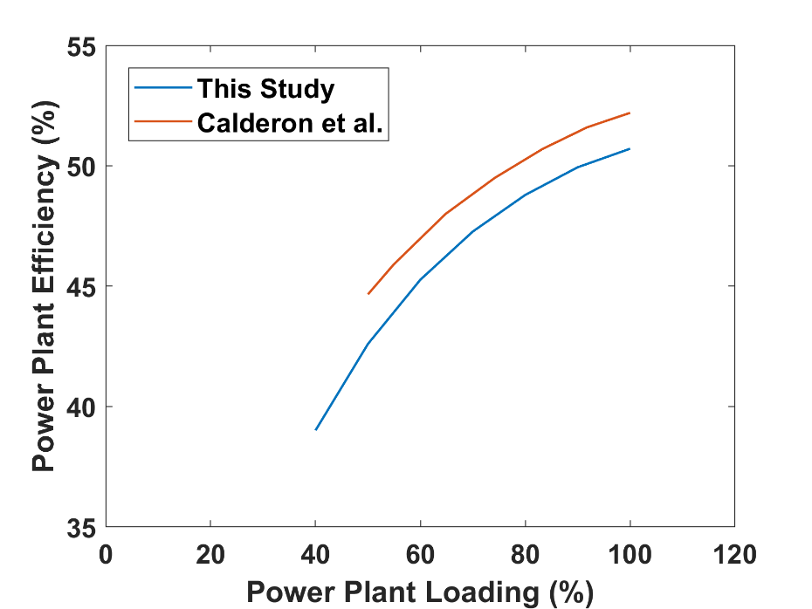
Figure 3: NGCC Power Plant Efficiency curves for this study vs. (Alcaráz-Calderon et al., 2019)
  - Calcium Looping System
The flue gas from the NGCC power plant is directed to a calcium looping system composed of a calciner and a carbonator. The calcium looping system description follows Figure 4. A fraction of the flue gas is sent to the calciner ($α$) (stream 15 in Figure 4) and the rest to the carbonator ($1-α$) (stream 16). Fresh limestone (stream 25) is fed to the calciner along with recycled solids (CaCO₃ + CaO) from the carbonator (stream 30). The calciner operates at 960ºC on one side (the solid exit/gas entrance side) and 700ºC on the other side (the gas exit/solid entrance side), where the heat is provided by natural gas combustion. To establish the different temperatures at each side of the calciner in Aspen Plus, two separate reactors were used in the simulation; a Gibbs reactor was used for the combustion reactions and a stoichiometric reactor was used for the calcination reaction. High purity oxygen (95% mole basis) (stream 21) from a vacuum pressure swing adsorption system is used in the calciner to provide 3% excess oxygen for the combustion reactions. Air (stream 22) is used as a secondary source of oxygen to keep the oxygen content $≤30\%$ by volume in the calciner feed as required by the vendor. The gas exiting the calciner (stream 24) is rich in CO₂ (around 20% on mole basis). Stream 24 then goes to a heat recovery system before going to the separation system. The same combustion reactions mentioned in section 3.1 take place in the calciner with 3% excess oxygen provided by the oxidant stream (stream 21). A reverse carbonation reaction (calcination) takes place in the calciner as well with 99% CaCO₃ conversion as follows:
$${CaCO}_{3}→CaO+{CO}_{2}$$
A fraction of the lime (CaO) out of the calciner goes to the carbonator ($β$) (stream 29) and the rest goes to the DAC system ($1-β$) (stream 28). The flue gas going to the carbonator (stream 16) is preheated in an economizer using the vent gas out of the carbonator (stream 18). The carbonation reaction itself takes place in the carbonator (modeled as a stoichiometric reactor in Aspen Plus) as follows:
$$CaO+{CO}_{2}→{CaCO}_{3}$$
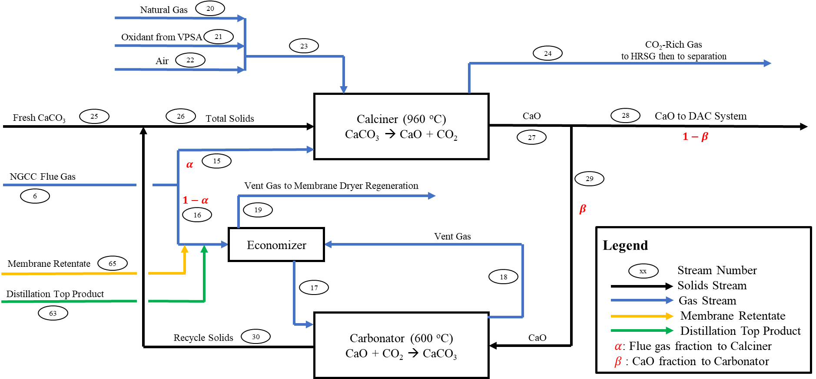
Figure 4: Simplified schematic of the calcium looping system
Flue Gas and CaO Split Fractions
A sensitivity analysis is performed in this study to explore the effect of $α$ and $β$ on the overall performance of the system. The results of the performed sensitivity analysis on the values of $α$ and $β$ is presented and discussed in Section 4 (Operating Modes and Key Design Variables).
Modeling the Conversion of CaO in the Carbonator
The CaO conversion in the carbonator is dependent on the CaO recycle fraction ($β$). This is due to the CaO sorbent capacity, which decreases the more calcination + carbonation cycles the CaO has been through. The maximum conversion of CaO for the $n$^{th} calcination + carbonation cycle is given by equation (1) as follows (Fennell et al., 2007):
$X_{n}=f_{m}^{n}\left(1-f_{w}\right)+f_{w}$ (1)
where, $X_{n}$ is the maximum conversion of CaO in the carbonator at the $n$^{th} cycle, the deactivation constant $f_{m}$ characterizes the decrease in reaction surface every cycle. The residual conversion, $f_{w}$, is the limiting conversion after many cycles.
The average CaO conversion as a function of the split fraction ($β$) is calculated by equation (2) as follows:
$\overline{X}\left(β\right)=\lim_{N→∞}{\sum_{n=1}^{N}{X_{n}z(n,β})}=\lim_{N→∞}\frac{1-β}{1-β^{N}}\sum_{n=1}^{N}{\left(f_{m}^{n}\left(1-f_{w}\right)+f_{w}\right)β^{n-1}}= \frac{\left(1-β\right)f_{m}(1-f_{w})}{1-f_{m}β}+f_{w}$ (2)
Where $z(n,β)$ is the mole fraction of particles undergoing cycle $n$. The parameters are chosen to match an operating point given by the carbonator vendor, taking values of $f_{m}=0.7$ and $f_{w}=0.25$, corresponding to Purbeck limestone with diameter 850-1000 micrometers, calcined at a temperature of 1023 K. (Fennell et al., 2007)
Figure 5 shows the conversion per pass $X_{n}$ and the mole fraction of particles entering each cycle ($z_{n}$). The conversion decreases rapidly at first with increasing cycle number and reaches the residual conversion $f_{w}$asymptotically. The smaller the split fraction, the more the particle distribution is shifted to lower cycle numbers. The mole fraction decreases more rapidly with $n$ at lower values of $β$.
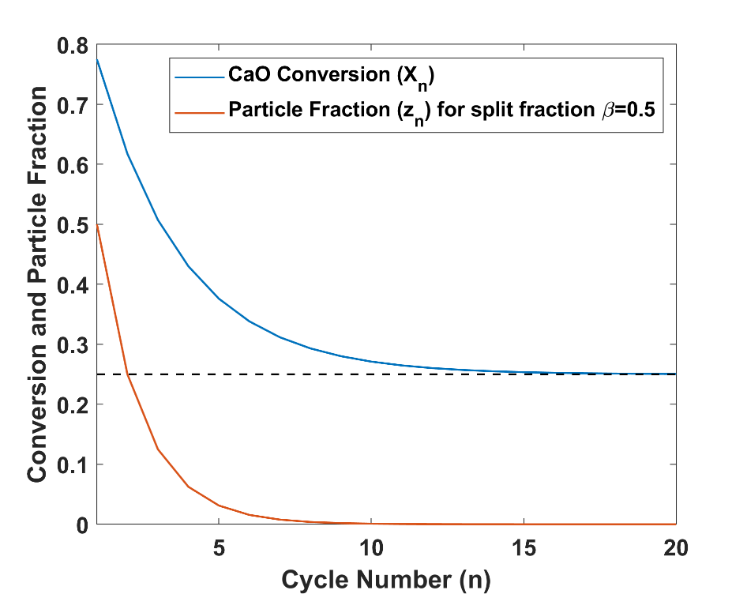
$$Residual Conversion=0.25$$
Figure 5: Effect of the number of cycles on the particle conversion in the carbonator
Figure 6 presents the average conversion for various values of the split fraction. As the split fraction approaches to 1, the average conversion approaches $f_{w}$ since particles recycle in an infinite loop; it may be possible to operate without any fresh feed at the expense of lower conversion per cycle (Grasa and Abanades, 2006). A split fraction of 0.5, or a recycle ratio of 1:1, gives a conversion of 0.65 on average.
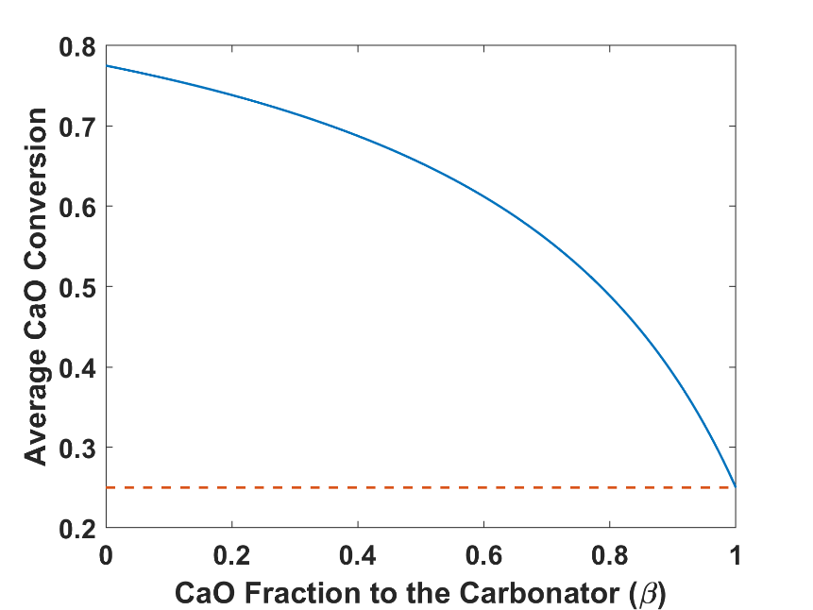
$$Residual Conversion=0.25$$
Figure 6: CaO average conversion in the carbonator vs. the CaO split fraction
The flow rate of the fresh limestone is analytically determined using equation (3) as follows:
${FF}_{{CaCO}_{3}}=\left(1-β\right)ε_{1}\left(\frac{1-c_{1}}{c_{1}}\right)+\frac{ε_{2}}{c_{2}}(\frac{1-β}{β})$ (3)
Where ${FF}_{{CaCO}_{3}}$ is the fresh feed limestone flowrate in kmol/hr, $β$ is the fraction of solids going to the carbonator, $ε_{1}$ is the extent of the reverse carbonation reaction in the calciner, $c_{1}$ is the limestone conversion in the calciner, $ε_{2}$ is the extent of the carbonation reaction in the carbonator, and $c_{2}$ is the CaO conversion in the carbonator.
  - Heat Recovery System
The heat recovery system description follows the diagram shown in Figure 7. The CO₂-rich gas from the calciner (stream 24 in Figure 7) is quenched down to 620 ºC using water (stream 31) as advised by the vendor for material limitation. The flow rate of water (stream 31) is controlled in Aspen Plus using a design specification that specifies the temperature of stream 32 by manipulating the flow rate of stream 31. The gas then goes to a HRSG system that operates with a steam cycle that has three steam turbines at three pressure levels as shown in Figure 6. The HRSG is modeled in Aspen Plus as a multi-stream heat exchanger. The vent gas that originally came out of the carbonator and used for the membrane dryer regeneration (stream 52) is also used in the HRSG to recover as much heat as possible before being vented to the atmosphere (stream 53). The CO₂-rich gas and the vent gas leave the HRSG at 180 ºC and 260 ºC, respectively. Those temperatures could not be lower because of potential temperature crossovers in the HRSG system at lower exit temperatures. The flow rate of steam used in the steam cycle is determined in Aspen Plus using a design specification by fixing the temperature of stream 33 and manipulating the flow rate of stream 34, while maintaining around 30 ºC temperature approach in the HRSG system.
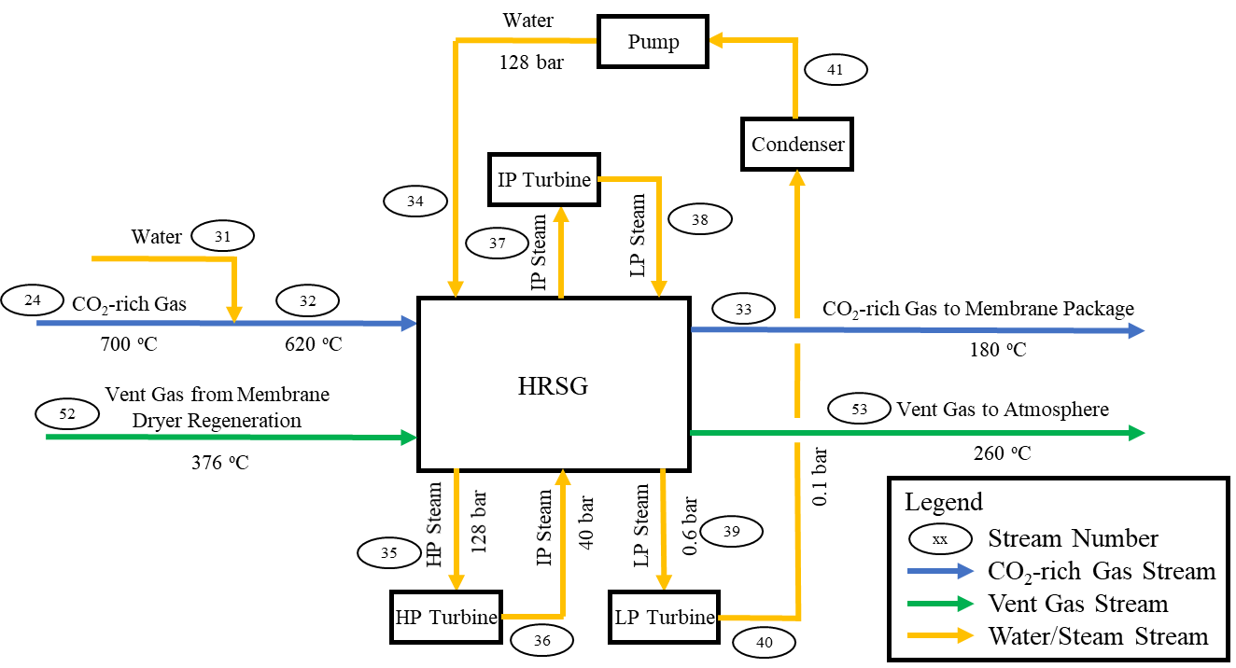
Figure 7: Heat recovery system schematic
  - Membrane Package
The membrane package description follows the diagram presented in Figure 8. The CO₂-rich gas from the HRSG goes to a flash drum where some condensates are separated from the gas at 25ºC. The gas then goes to a blower to account for the pressure drop happening in the upstream system. The gas leaves the blower at 1.1 bar and is then compressed to 7 bars in an 8-stage compressor with inter-stage cooling. The compressed gas at 25ºC then goes to a dryer where 99% of the water is removed before going to the membrane. The heat needed for the dryer regeneration is provided by the hot vent gas coming out of the carbonator economizer. The vent gas then goes to the HRSG in the capture plant for further heat recovery. The permeate out of the membrane goes to the CPU for further purification and liquefaction. The retentate from the membrane also goes to the CPU for heat integration.
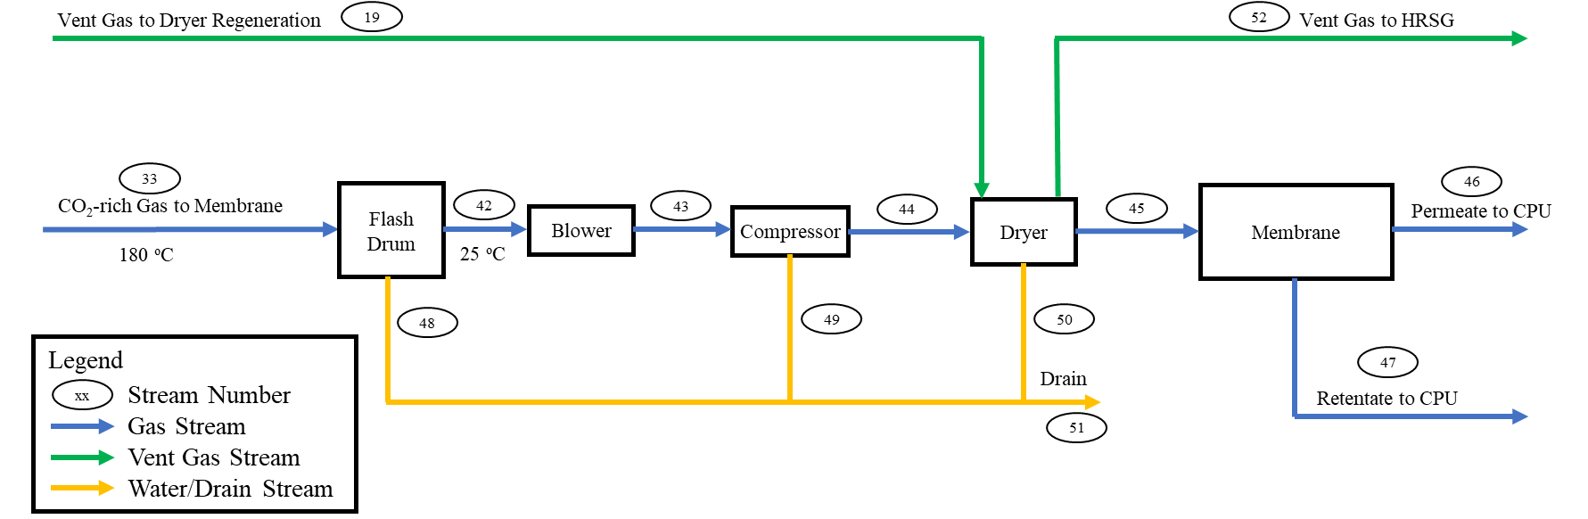
Figure 8: Membrane package schematic
Membrane Model
There are no built-in models for membrane in Aspen Plus. A custom membrane model is developed in this study using Aspen Custom modeler. The model employs the cross-plug flow assumption and may be used for any number of components. It is developed using Aspen Custom Modeler and exported for use within Aspen Plus. A schematic of the model is illustrated in Figure 9. The model equations are documented in Appendix 1. The following main assumptions are made:
- The process is isothermal.
- There is no pressure drop (feed pressure = retentate pressure).
- The permeance of each component is constant, i.e., they do not vary with temperature, pressure, and composition.
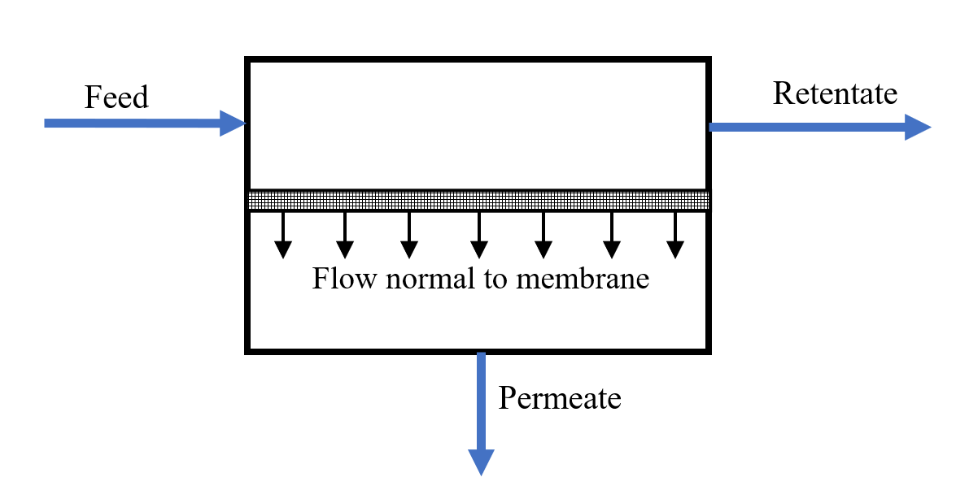
Figure 9: Cross-plug flow membrane schematic
Table 3 presents the degrees of freedom for the membrane model. There are only three independent variables since CO₂ purity, CO₂ recovery, and stage cut are all dependent. The model outputs two streams labeled retentate and permeate with their flow rates and thermodynamic state.
Table 3
Membrane model variables
Variable | Description | Units
$$A$$ | Membrane area | m$​^{2}$
Permeate Pressure | Pressure of the particles that make it through the membrane | bar
CO₂ Purity | CO₂ concentration in permeate | %mol
CO₂ Recovery | $$\frac{{CO}_{2}\text{ flow in permeate}}{{CO}_{2}\text{ flow in feed}}$$ | mol/mol
Stage Cut | $$\frac{\text{Total flow in permeate}}{\text{Total flow in feed}}$$ | mol/mol

  - Cryogenic Purification Unit (CPU)
The CPU description follows Figure 10. The permeate gas from the membrane is fed to a 5-stage compressor and leaves the compressor at 65 bar and 25ºC. The gas then enters a cold box where the temperature drops down to -50ºC. The cold box is modeled in Aspen Plus as a multi-stream heat exchanger. The gas then enters a 4-stage distillation column from the top where high purity liquid CO₂ (95%) is extracted from the bottom of the column at 13ºC and 63.5 bar. The distillation column is modeled in Aspen Plus as a RadFrac column with a reboiler only (no condenser) since it was found that a rectifying section is not needed to enhance the CO₂ recovery in the distillation column. The liquid CO₂ is then pumped and exported at 30ºC and 152.6 bar (stream 71). The gas product from the top of the distillation (stream 56) is sent back to the cold box and used for pre-cooling the feed to the distillation where the temperature of the gas goes from -47ºC in stream 56 to 12 ºC in stream 63. Stream 63 then goes back to the calcium looping system to capture the CO₂ content in this stream. Also, the membrane retentate is expanded and used for cooling the permeate in the cold box. The retentate in stream 65 then goes back to the calcium looping system to capture additional CO₂ content from this stream.
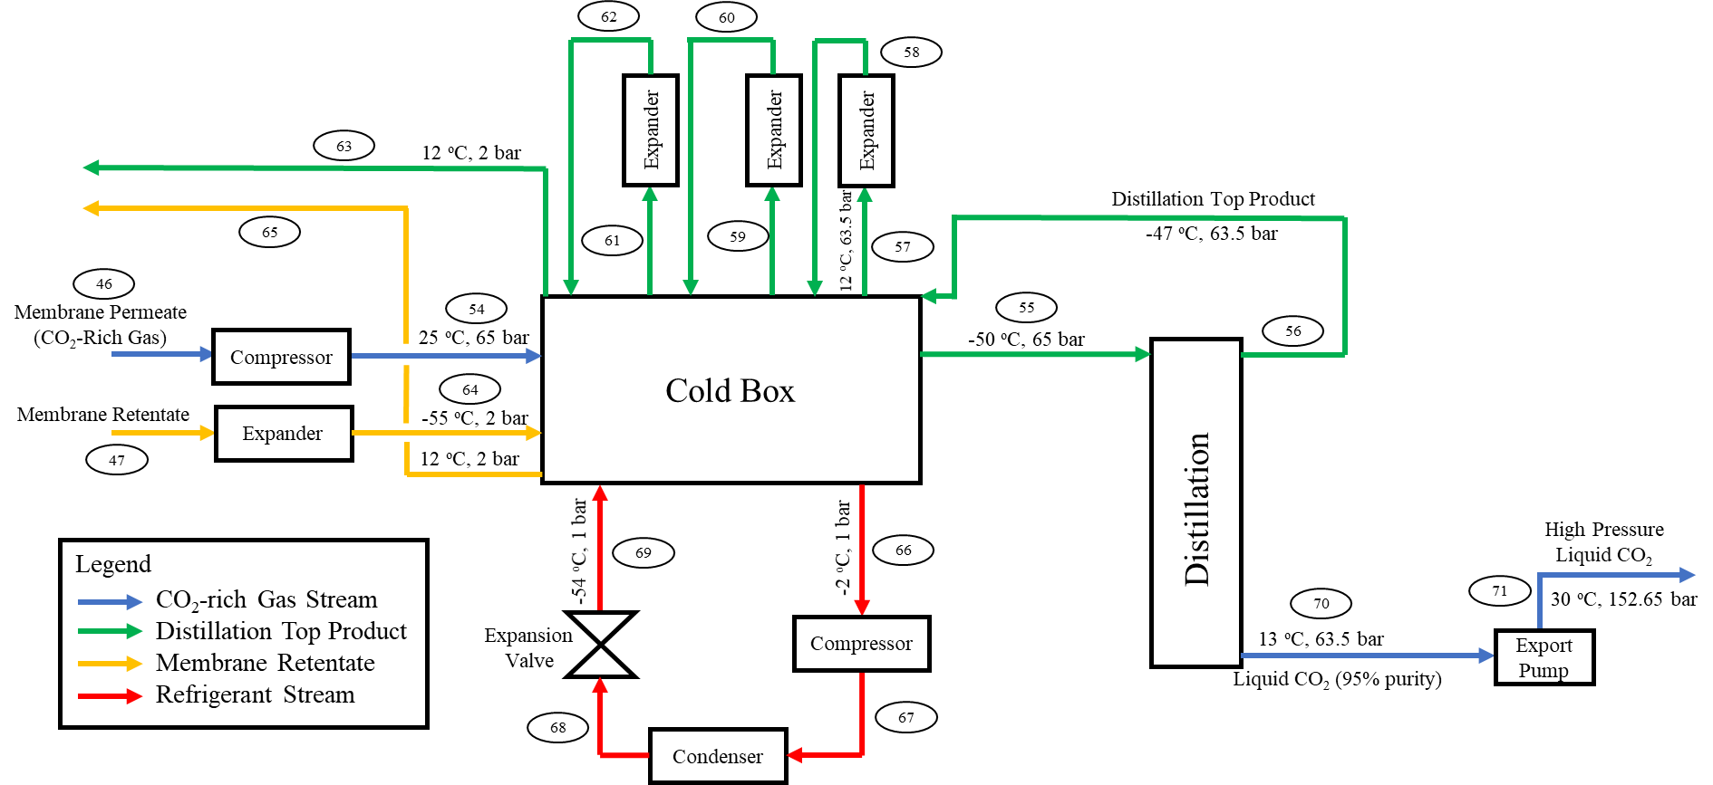
Figure 10: Cryogenic purification unit (CPU) schematic
CPU Refrigerant
The refrigerant loop (streams 66-69 in Figure 10) is needed to provide cooling to the CO₂ rich gas in stream 54 while ensuring that no freezing takes place in this loop at any time. This type of application has multiple industry standard refrigerants (McLinden and Huber, 2020). A refrigerant consisting of ethane, propane, and butane with mole fractions 0.33, 0.61, and 0.06, respectively was found to provide the lowest cost of the refrigeration loop after performing a brute-force search on various hydrocarbon mixtures.
  - Direct Air Capture
Lime from stream 28 in Figure 4 goes to a novel DAC process developed by 8 Rivers. The DAC process generates solid CaCO₃ that can be sequestered or re-used as a feed to the calciner. The lime conversion in the DAC process is modeled to be 90%. DAC was not explicitly modeled in Aspen Plus, rather the captured CO₂ from DAC is estimated using equation (4) as follows:
$F_{{CO}_{2} DAC}=F_{CaO DAC}*\frac{M_{{CO}_{2}}}{M_{CaO}}*c_{DAC}$ (4)
where, $F_{{CO}_{2} DAC}$ is the molar flow rate of captured CO₂ from DAC in kmol/hr, $F_{CaO DAC}$ is the molar flow rate of CaO feed to DAC in kmol/hr, $M_{{CO}_{2}}$ is the molecular weight of CO₂ (44.01 g/mol), $M_{CaO}$ is the molecular weight of CaO (56.08 g/mol), and $c_{DAC}$ is the conversion of the batch DAC process (90%).
The DAC operations requires space for storage of solids to expose Ca(OH)₂ to air for carbonator to CaCO₃. 8 Rivers developed a proprietary lime-based DAC system.
- Operating Modes and Key Design Variables
The optimal operation of the developed integrated CO₂ capture plant model is contingent to multiple variables. The fresh CaCO₃ flow rate, the flue gas fraction to the calciner ($α$ from Figure 4), the CaO fraction to the carbonator ($β$ from Figure 4), and the gas recycle to the carbonator from the distillation top product (stream 63 in Figure 4) and the membrane retentate (stream 65 in Figure 4) are believed to be some of the most important design variables for the system. Table 4 presents the design variables, their potential operating ranges, and their significance on the system.

Table 4
Key design variables for the proposed CO₂ capture system
Design variable | Potential operating range | Significance/Main effects on the process
Fresh CaCO₃ flow rate (stream 25 in Figure 4) | $$[0,∞]$$  Calculated using eq. (1) | - Directly proportional to the CO₂ capture from DAC.  - Affects the size of the calciner and the carbonator.  - Affects the purity of CO₂-rich gas before the membrane (stream 45 in Figure 7).  - Affects the total power consumption of the system.
Flue gas fraction to the calciner ($α$ in Figure 4) | $$[0,1]$$  Fixed at 0.2 in section 5 | - Affects the oxidant and air requirements in the calciner (streams 21 and 22 in Figure 4, respectively).  - Affects the energy requirements for the separation system
CaO fraction to the carbonator ($β$ in Figure 4) | $$[0,1]$$  Fixed at 0.8 for the 100% power plant loading case and adjusted as the loading decreases | - Affects the size of the DAC system.  - Affects the CaO conversion in the carbonator.  - Affects the size of the calciner and the carbonator.
Retentate and distillation gas recycle fraction | $$[0,1]$$  Fixed at 1 (full recycle) | - Significantly reduces CO₂ emissions.  - Increases the size of the whole system.

While the flow rate of the flue gas is controlled by the loading of the power plant (which is affected by the electricity price signals), the fresh CaCO₃ flow rate is a key parameter that does not depend on the power plant loading and can either have a fixed value or a changing value. To maximize the functionality of the calcium looping system, it is assumed that the calciner operates at full loading under all operational scenarios (i.e., the same total solids mole flow rate should be entering the calciner all the time). To achieve this, the flow rate of fresh CaCO₃ is evaluated using equation (1) and the solids split fraction ($β$ from Figure 4) is adjusted to maintain the same total solids flow rate to the calciner (stream 26 in Figure 4).
The retentate and the distillation gas recycles are illustrated by streams 65 and 63 in Figure 10, respectively. As mentioned in Table 4, the recycled gas reduces the CO₂ emissions because these gases have a significant amount of CO₂ that would contribute to the CO₂ emissions if the gases were not recycled to the carbonator. At the same time, recycling these gases means that the fresh CaCO₃ flow rate will increase to accommodate the increased CO₂ going to the carbonator and the size of the whole system will increase accordingly.
Figure 11 presents a sensitivity over the values of $α$ and $β$ vs. the mole flow of the total solids going to the calciner (stream 26 in Figure 4). As the value of $β$ increases, the solids flow rate to the calciner first starts to decrease because the fresh limestone flow rate decreases. The solids flow rate is minimized in all curves at a value of $β$ around 78-80%, except at $α=$10%, where the curve is minimized at a value of $β$ around 82-84%. Then the solids flow rate starts to increase again because at this point the lime conversion in the carbonator starts to significantly decrease, so the particle fraction of lime increases in the recycle loop and thus increases the total solids mole flow rate to the calciner. The different behavior of the $α=$10% curve is because the design specification that keeps the O₂ content at the inlet of the calciner less than 30% gets triggered when the amount of flue gas going to calciner is minimized. This is because flue gas is a source of O₂ by itself, so when the flue gas flow rate to the calciner decreases, this reduction in O₂ will be substituted by the high purity oxidant, which increases the concentration of O₂ in the total gases going to the calciner. Accordingly, the system will automatically start adding air to the calciner to maintain the 30% O₂ content design specification at the calciner inlet.
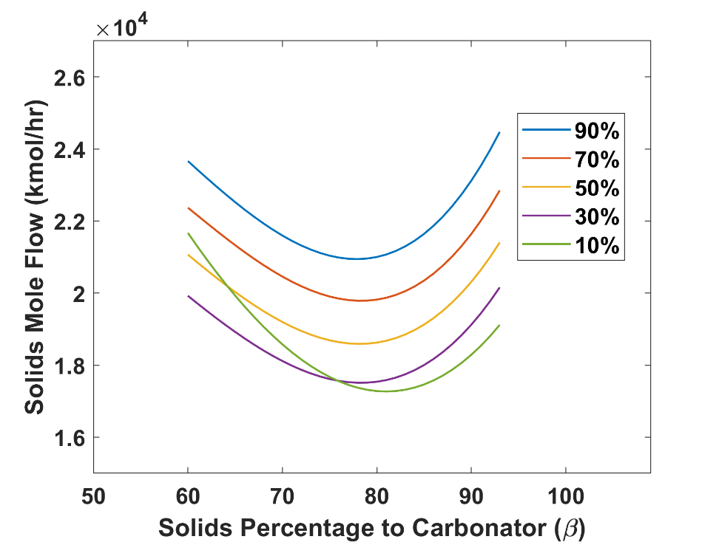
Flue Gas Fraction to Calciner ($α$)
Figure 11: Sensitivity analysis for $α$ and $β$ vs. the total solids feed to the calciner
Figure 12 presents a sensitivity analysis over the values of $α$ and $β$ vs. the CO₂ mole fraction upstream the membrane. The CO₂ mole fraction upstream the membrane is an important parameter as it determines whether the membrane will be needed at certain conditions or not. According to the technology vendor, at least 30% CO₂ concentration is needed upstream the membrane for the membrane to be effective. On the other hand, if the concentration of CO₂ is high enough (> 90%), then the membrane might need to be bypassed as it will not contribute much to increasing the concentration of CO₂ in the gas going to the CPU. From Figure 12, it is observed that the CO₂ mole fraction upstream the membrane is maximized at low values of $α$ and $β$. This is because sending most of the flue gas to the carbonator ($1-α$) maximizes the CO₂ concentration in the calciner effluent and sending most of the CaO to DAC ($1-β$) maximizes the fresh CaCO₃ flow rate, which is one of the main sources of CO₂ in the system. The opposite effect happens when most of the flue gas goes to the calciner and most of the CaO is recycled to the carbonator. In this case, the gas effluent from the calciner will have lower CO₂ concentration because of the excessive amount of flue gas and the low fresh CaCO₃ flow rate and thus the CO₂ concentration upstream the membrane will be low. There is an inflection point in all curves around 0.5 CO₂ mole fraction. This happens because the 30% O₂ specification at the calciner inlet gets activated when $α$ is small, which means less flue gas is going to the calciner and more natural gas and high purity oxidant are being fed to the calciner. Figure 12 concludes that it is preferred to have a low value of $α$ to keep the CO₂ concentration upstream the membrane above 30%. Given a low value of $α$, a low value of $β$ would increase the natural gas supply to the calciner and triggers the 30% O₂ specification, which is not favored. Also, a high value of $β$ could take the CO₂ concentration upstream the membrane below the needed 30% threshold. Therefore, an intermediate value of $β$ would be preferred based on a given small value of $α$. In section 5, a value of 0.2 for $α$ is used for all the studied cases, while the value of $β$ varies depending on the case.
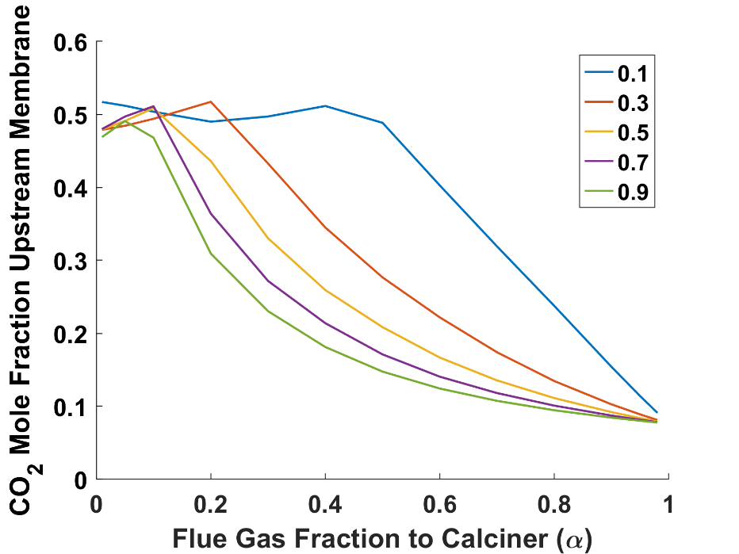
CaO Fraction to Carbonator ($β$)
Figure 12: Effect of flue gas and CaO split fractions on the CO₂ mole fraction before the membrane
Figure 13 presents the effect of the power plant loading and the fresh limestone feed flow rate on the power requirements for the capture system. $α$ and $β$ are kept constants at 0.2 and 0.8, respectively, to generate this figure. It is observed that as the fresh limestone feed flow rate increases, the power requirements for the capture system increases. This is because of the calcination reaction that takes place in the calciner and produces CO₂ gas that goes to the capture system and thus increases the power needed for compression, separation, etc. as the fresh limestone that is used in the calcination reaction increases. Similarly, as the power plant loading increases, the energy requirement for the capture system increases. This is because more flue gas is being fed to the system in this case, which introduces more CO₂ that must be separated.
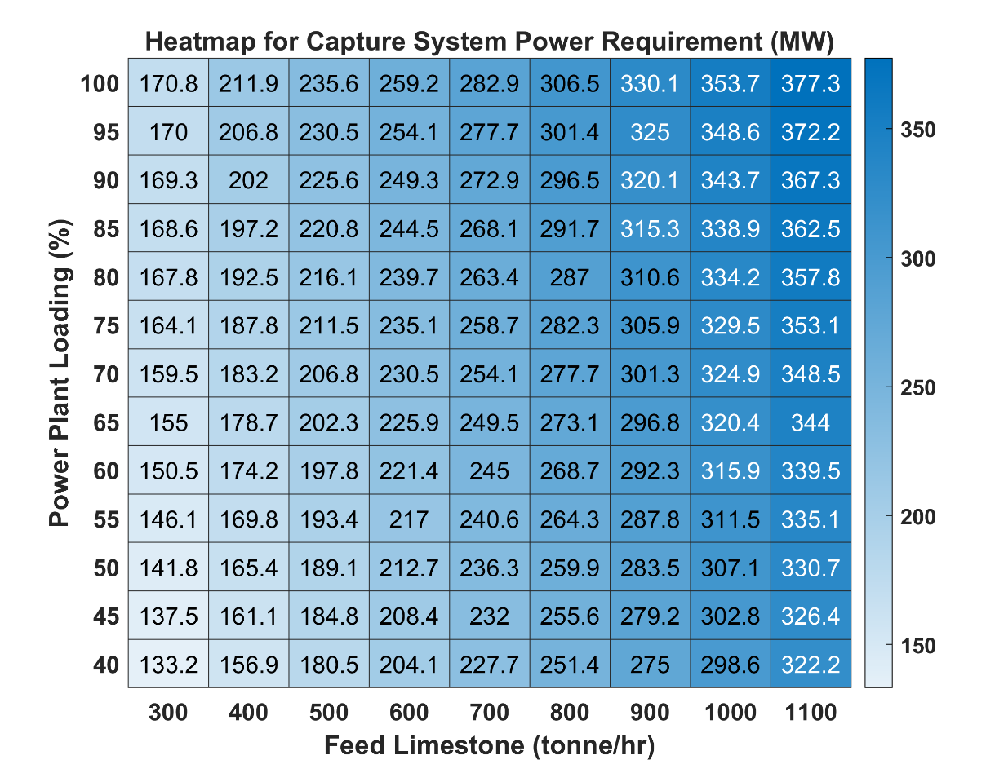
Figure 13: Effect of power plant loading and limestone feed flow on the capture system power requirement
The optimal operation of the proposed system is dependent on multiple variables that can affect the power requirements, the economics, and the net emissions. It is possible to predict a range of operation for each variable that would maximize the benefits of this system (i.e., minimizes the cost and achieve negative emissions) using sensitivity analysis on various parameters. In future work, an optimization framework will be developed to determine the optimal process decision variables and system sizing under dynamic electricity price, fuel price and carbon tax/credit scenarios.
- Simulation Results at 100%, 40%, and 0% Power Plant Loading Levels
The developed simulation model has been carried out at three power plant loading levels: 100% (full loading), 40% (part loading), and 0% (shutdown). Figures 14, 15, and 16 illustrate the block flow diagram (BFD) of the process for the 100%, 40%, and 0% power plant loading scenarios, respectively. Figures 14-16 contain results for the key streams of the process highlighting the mass flow rate, temperature, pressure, and CO₂ mole fraction along with tables for heat balance results and CO₂ capture results. Figure 17 presents the breakdown of the power generation/consumption for each unit operation under the three power plant loading levels. Note that the power plant and the HRSG are always generating power (positive MW), while the VPSA, the membrane package, and the CPU are always consuming power (negative MW). Table 5 presents the results for some of the key metrics for the process at the three illustrated power plant loading scenarios. The main observation from Figures 14-17 and Table 5 is the increase in the captured CO₂ flow rate from DAC (which corresponds to 90% of the mass flow rate of stream 28) as the power plant loading goes down. At the same time, the system goes from net power exporting at the 100% power plant loading (660 MW) to net power importing at 0% power plant loading (-86 MW). These results imply that the variation in electricity price and the carbon credit will be the main determining factors for the implementation of the presented process concept. For example, a low carbon credit that does not compensate for the power import when the power plant is shut down might not justify the investment in this system. The DAC conversion (assumed 90% in this study) is another determining factor for the economic viability of this system for the same reason. A higher DAC conversion will significantly increase the carbon credit and vice versa.
In addition, the results from the three studied power plant loading scenarios show that the system can achieve negative emissions in all cases. This is driven by having more CO₂ captured from DAC than the emitted CO₂ from the system under all operational scenarios. Note that the flow rate of the gas going through the membrane and CPU separation systems (stream 24) increases as the power plant loading level decreases. This is driven by the calciner operation where $≤30\%$ O₂ by volume is needed at the inlet of the calciner. To achieve this, as the power plant loading level decreases, the air flow rate going into the calciner (stream 22) increases, going from zero at 100% power plant loading to 865 tonne/hr at 0% power plant loading.
In addition, from Table 5, it is observed that the fresh CaCO₃ flow rate (stream 25) increases as the power plant loading decreases. This happens because the model automatically maintains the same total solids flow rate to the calciner (stream 26) at all power plant loading levels. So, when the power plant loading decreases, the fresh CaCO₃ increases by 285% going from 100% to 0% power plant loading and the CaO split fraction ($β$ in Figure 4) decreases from 80% to 27%, respectively, as shown in Figures 14-16.
It is worth mentioning that that recycled streams from the distillation and the membrane retentate to the carbonator (streams 63 and 65) significantly increase the size of the system while minimizing the CO₂ emissions at the same time. For instance, the CO₂ rich gas flow rate to the membrane (stream 45) goes from 1067 tonne/hr at 100% power plant loading without the gas recycles to 1280 tonne/hr at 100% power plant loading with gas recycles, which is the case illustrated in Figure 14. The CO₂ mole fraction in stream 45 also changes significantly just by connecting the recycled gas stream (streams 63 + 65), where it goes from 0.3352 without recycled gas to 0.4190 with recycles. This happens because of the increased CO₂ recovery when the gases are recycled to the carbonator. This means that there is a tradeoff between the cost of the system and the CO₂ recovery based on the flow rate of the gases recycled. There might be a certain gas recycle fraction that could justify the investment, while achieving the desired CO₂ recovery at the same time. An optimization framework shall be developed and solved to determine the optimal recycled gas that would maximize the profit while minimizing the emissions/maximizing negative emissions.
An interesting result from Figures 14-16 is that the flow rate of the CO₂ rich gas going through the separation system (stream 24) increases as the power plant loading decreases. This is because of the need for air in the calciner as the amount of flue gas going to the calciner decreases. This is the same issue highlighted by the $α$=10% curve in Figure 11, where the $≤$30% O₂ content constraint in the calciner feed plays the main role for this behavior. This means that some of the equipment of the system shall be sized based on the 0% power plant loading case instead of the 100% loading case. The sizing case for each equipment is discussed in Section 6.
Note that the results presented in Figures 14-17 can all be changed by changing the value of any variable in Table 4. This means that it is tedious to manually predict the optimal value for each key design variable. Therefore, a detailed optimization problem needs to be developed to identify the optimal values for the key design variables that would minimize the cost of the system, while achieving the desired CO₂ recovery and negative emissions under different electricity price profile scenarios. Developing such an optimization model requires the development of surrogate models for each unit operation of the proposed system. As a part of the awarded project by ARPA-E, surrogate models are developed along with the economic optimization of the system, details of which will be published separately.
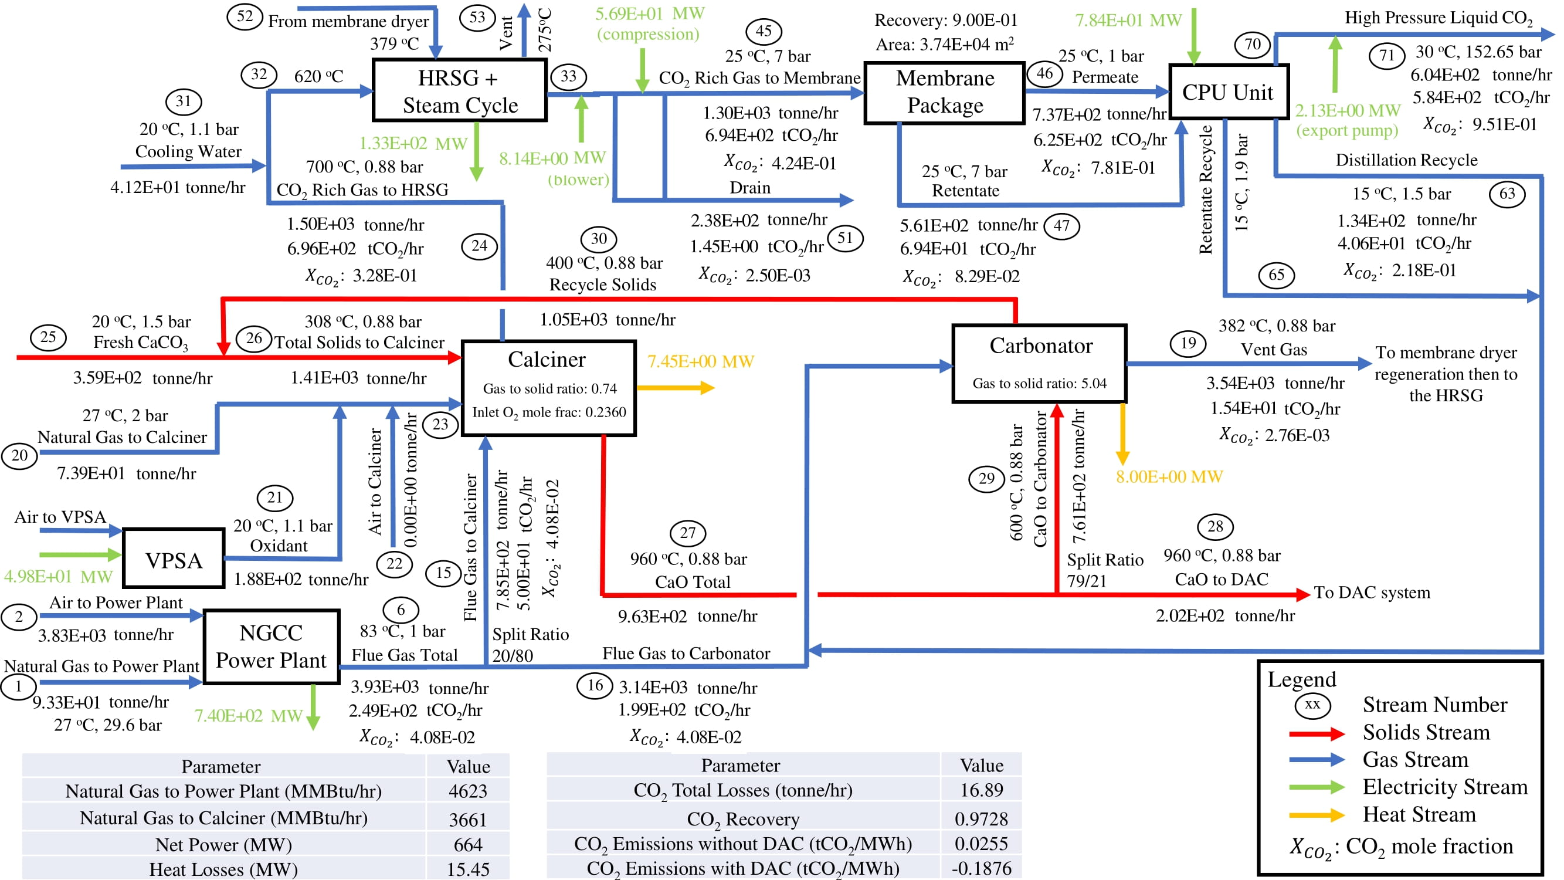
Figure 14: Detailed block from diagram with results for the 100% power plant loading scenario
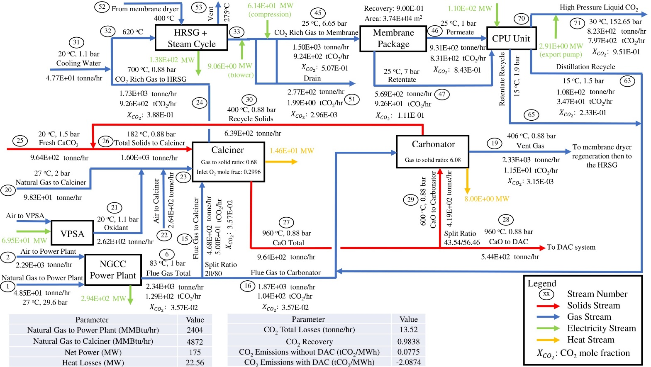
Figure 15: Detailed block from diagram with results for the 40% power plant loading scenario
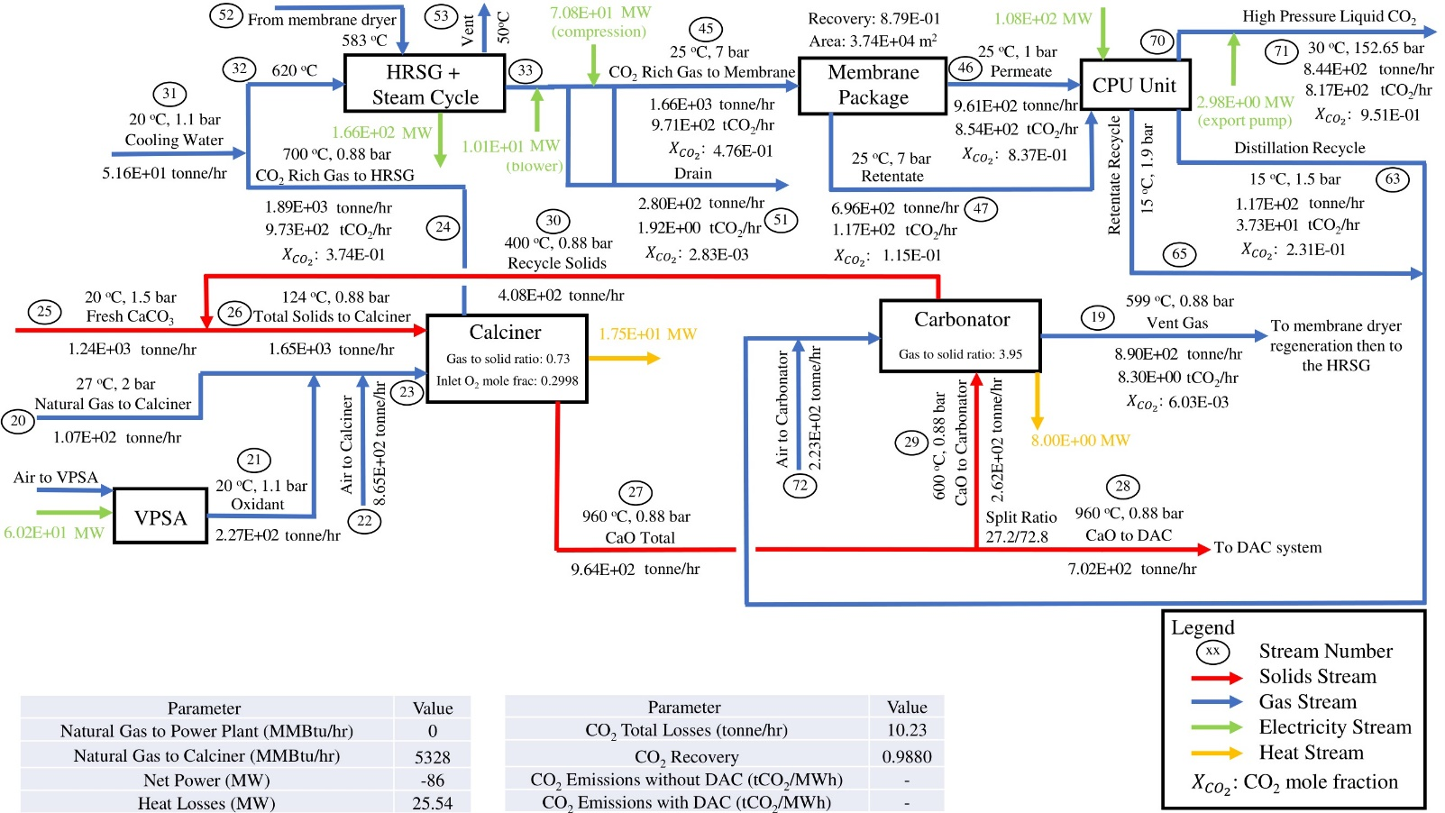
Figure 16: Detailed block from diagram with results for the 0% power plant loading scenario
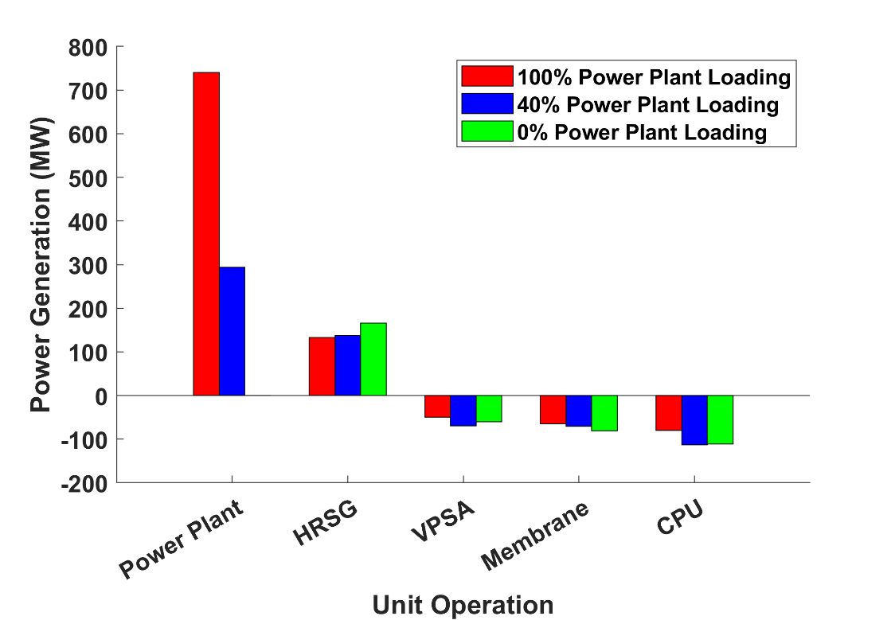
Figure 17: Power generation/consumption breakdown per each unit operation for each power plant loading scenario

Table 5
Key results for the 100%, 40%, and 0% power plant loading scenarios
Case | Fresh CaCO₃  (tonne/hr) | CO₂ mole fraction  before the membrane | CO₂ Losses  (tonne/hr) | CO₂ to storage  (tonne/hr) | CO₂ from DAC  (tonne/hr) | CO₂ emissions without DAC  (tonne/MWh) | CO₂ emissions with DAC  (tonne/MWh) | CO₂ Recovery | Net Power  (MW)
Full Loading | 340 | 0.419 | 16.68 | 592 | 134 | 0.026 | -0.188 | 0.9726 | 660
40% Loading | 958 | 0.505 | 13.47 | 819 | 376 | 0.078 | -2.087 | 0.9838 | 163
0% Loading | 1240 | 0.476 | 10.23 | 853 | 513 | - | - | 0.9880 | -86

- Economic Model
The economic viability of the proposed system is as important as the technical viability. In this study, the economic metric used to determine the economic viability of the proposed system is the net present value (NPV). The goal is to compare the needed electricity selling prices that would result in a zero NPV under different operational scenarios. Table 6 summarizes the different economic parameters used to evaluate the NPV for the developed capture system. The parameters listed in Table 6 are based on best engineering practices for relevant techno-economic studies.
Table 6
Economic parameters for the proposed CO₂ capture plant
Parameter | Unit | Value
Lifetime | years | 30
Discount rate | % | 7.25
Equipment scaling exponent |  | 0.5-1.0
Engineering, construction, management, home office, and fees | % | 15
Project contingency | % | 15-20
Capacity factor |  | 0.2-1
CO₂ tax | $/tonne | 10-150
Limestone cost | $/tonne | 5
Natural gas cost | $/MMBtu | 4.42
Process water cost | $/1000gal | 1.9
CO₂ disposal cost | $/tonne | 10

Net Present Value (NPV) Calculation for the Base Case
The calculation of the NPV depends on four components: i) the initial costs, ii) the size and timing of future net benefits, iii) the discount rate, and iv) the length of the period(Sheha et al., 2021). The NPV can be calculated using Eq. (5) as follows:
$NPV=-Plant TCC+\sum_{j=1}^{n}{\frac{{CF}_{n}}{{\left(1+i\right)}^{n}}}$ (5)
where, $Plant TCC$ is the total capital cost of the plant, $CF$ is the cash flow, $i$ is the discount rate, and $n$ is the plant lifetime. TCC is also known as the capital expenditure (CAPEX) for the plant and is evaluated to be $2.48B for the proposed system. The CAPEX is evaluated considering the cost of all equipment in the system. The equipment cost is evaluated/obtained from various sources including Aspen Capital Cost Estimator (ACCE) and vendor quotes.
CF is the annual net income/expense for the proposed system. The system CF can be calculated using Eq. (6) as follows:
$CF=Fixed OPEX+{Fuel}_{OPEX}+{Electricity}_{OPEX}+{{CaCO}_{3}}_{OPEX}+{Water}_{OPEX}+{NGCC}_{OPEX}+{Sequestered {CO}_{2}}_{OPEX}+{{CO}_{2} Emissions}_{Tax Penalty}+{{CO}_{2} Captured}_{Tax Credit}$ (6)
The first seven terms in Eq. (6) represent the operating expenditure (OPEX) of the relevant components of the system. The last two terms in Eq. (6) represent the tax penalty and tax credit for the CO₂ emissions and the captured CO₂, respectively. All units in the Eq. (6) are in $/yr.
${Fuel}_{OPEX}$ is the yearly cost for the natural gas used in the NGCC and the calciner. ${Fuel}_{OPEX}$ can be calculated using Eq. (7) as follows:
${Fuel}_{OPEX}=-{Fuel}_{Unit cost}*\left[{\left({Fuel Flow}_{NGCC}+{Fuel Flow}_{Calciner}\right)}_{100\% loading}*R+{\left({Fuel Flow}_{NGCC}+{Fuel Flow}_{Calciner}\right)}_{0\% loading}*\left(1-R\right)\right]*8760$ (7)
where, R is the capacity factor and 8760 is the number of hours per year. A sensitivity analysis is performed on the capacity factor in the interval [0.2 1] with increments of 0.1. The capacity factor below 0.2 makes the plant net importing of power annually, which does not justify the investment. Therefore, capacity factors below 0.2 were neglected from the sensitivity analysis. The capacity factor “R” assumes that the plant is operating with 100% loading at a capacity factor “R” and 0% loading at a capacity factor “1–R” (i.e., on/off operation).
The ${Fuel}_{Unit cost}$ is $4.42/MMBtu based on NETL baseline study. The $Fuel Flow$ has units of MMBtu/hr.
${Electricity}_{OPEX}$ is the yearly cost of electricity sold from the plant. Note that, for all the considered values of R, the ${Electricity}_{OPEX}$ is always positive when the system is making revenue from selling the net electricity generated from the NGCC power plant the HRSG. ${Electricity}_{OPEX}$ will be negative only if the electricity price becomes negative. ${Electricity}_{OPEX}$ can be calculated from Eq. (8) as follows:
${Electricity}_{OPEX}=X*\left[{NP}_{100\% loading}*R+{NP}_{0\% loading}*\left(1-R\right)\right]*8760$ (8)
where, X is the electricity price in $/MWh and NP is the Net Power in MW.
${{CaCO}_{3}}_{OPEX}$ is the yearly cost of fresh limestone fed to the calciner. ${{CaCO}_{3}}_{OPEX}$ can be calculated using Eq. (9) as follows:
${{CaCO}_{3}}_{OPEX}=-{{CaCO}_{3}}_{Unit cost}*\left[{{CaCO}_{3} Flow}_{100\% loading}*R+{{CaCO}_{3} Flow}_{0\% loading}*\left(1-R\right)\right]*8760$ (9)
where, ${{CaCO}_{3}}_{Unit cost}$ is the unit cost of the fresh limestone in $/tonne and ${CaCO}_{3} Flow$ is the fresh limestone flow rate in tonne/hr. The ${{CaCO}_{3}}_{Unit cost}$ used in this study is $5/tonne (Valverde et al., 2014).
${Water}_{OPEX}$ is the total cost of the water consumed at various locations in the plant. The used water unit cost is $1.9/1000gal. ${Water}_{OPEX}$ can be calculated from Eq. (10) as follows:
${Water}_{OPEX}={{Water}_{OPEX}}_{100\% loading}*R+{{Water}_{OPEX}}_{0\% loading}*(1-R)$ (10)
${NGCC}_{OPEX}$ is the operating cost of the NGCC power plant and is calculated using Eq. (11) as follows:
${NGCC}_{OPEX}={{NGCC}_{OPEX}}_{100\% loading}*R$ (11)
where ${{NGCC}_{OPEX}}_{100\% loading}$ is the NGCC power plant operating cost at full loading and has a value of $9.22 M/year, which is obtained from NETL baseline study (James Robert E. et al., 2019).
${Sequestered {CO}_{2}}_{OPEX}$ is the yearly disposal cost of the sequestered CO₂ from the plant. ${Sequestered {CO}_{2}}_{OPEX}$ can be calculated from Eq. (12) as follows:
${Sequestered {CO}_{2}}_{OPEX}=-{{CO}_{2}}_{Disposal unit cost}*\left[{{Liquid CO}_{2} Flow}_{100\% loading}*R+{{Liquid CO}_{2} Flow}_{0\% loading}*\left(1-R\right)\right]*8760$ (12)
where ${{CO}_{2}}_{Disposal unit cost}$ is the unit cost used for CO₂ disposal. The value used for ${{CO}_{2}}_{Disposal unit cost}$ in this study is $10/tonne. ${Liquid CO}_{2} Flow$ is the flow rate of CO₂ leaving the export pump after the CPU unit.
${{CO}_{2} Emissions}_{Tax Penalty}$ is the yearly tax penalty for the carbon emissions from the plant. ${{CO}_{2} Emissions}_{Tax Penalty}$ can be calculated from Eq. (13) as follows:
${{CO}_{2} Emissions}_{Tax Penalty}=-{{CO}_{2}}_{Tax}*\left({{CO}_{2} Emissions}_{100\% loading}*R+{{CO}_{2} Emissions}_{0\% loading}*\left(1-R\right)\right)*8760$ (13)
where ${{CO}_{2}}_{Tax}$ is the carbon dioxide tax in $/tonne. A sensitivity analysis is performed on ${{CO}_{2}}_{Tax}$ in the interval [10 200] with increments of $10/tonne. ${CO}_{2} Emissions$ are the emitted CO₂ with the gases out of the carbonator in tonne/hr.
${{CO}_{2} Captured}_{Tax Credit}$ is the yearly tax credit for the CO₂ captured from the plant. ${{CO}_{2} Captured}_{Tax Credit}$ can be calculated using Eq. (14) as follows:
${{CO}_{2} Captured}_{Tax Credit}={{CO}_{2}}_{Tax}*\left({{CO}_{2} Captured}_{100\% loading}*R+{{CO}_{2} Captured}_{0\% loading}*\left(1-R\right)\right)*8760$ (14)
where ${CO}_{2} Captured$ is the amount of captured CO₂ from DAC in tonne/hr. Notice that ${{CO}_{2}}_{Tax}$ is the same term used in equations (13) and (14) but with different signs.
This system of equations (5-14) was solved in Matlab using “fsolve” function to obtain the values of the electricity prices which gives NPV = 0.
Figure 18 shows a heatmap of the electricity prices that gives a zero NPV within the specified intervals of carbon credit and capacity factor “R”. The carbon credit varies from $10 to $200/tonne, while R varies from 0.2 to 1. The electricity prices at zero NPV means the system will be profitable (positive NPV) at electricity prices higher than the ones obtained in the table for each pair of R and carbon credit. It is observed that the electricity price decreases as the capacity factor increases at carbon credits lower than $170/tonne. This means the plant is more profitable at higher capacity factors when the carbon credit is lower than $170/tonne. Also, notice that the electricity price decreases as the carbon credit/tax increases. This means that the plant is more profitable at higher carbon credit/tax. It is observed that the rate of change of the electricity price with respect to R ($dX/dR$) is decreasing as the carbon credit increases up to a value of $170/tonne ($dX/dR$ is negative in up to carbon credits below $170/tonne). At carbon credits $170/tonne and higher, the electricity price increases as R increases (i.e., the value of $dX/dR$ becomes positive). This is because the carbon credits at $170/tonne and above are high to the point that the ${{CO}_{2} Emissions}_{Tax Penalty}$ (from equation 13) becomes significant as R increases. Also, the ${Sequestered {CO}_{2}}_{OPEX}$ (from equation 12) becomes more significant as R increases. Thus, the electricity price must increase to compensate for the tax penalty and the sequestration expense. There are some occurrences where the electricity price becomes negative at high carbon credits ($180, $190, and $200/tonne). This implies that the profitability of the system under these conditions would be guaranteed at any positive electricity price and even at some negative electricity prices (i.e., when the plant is paying for the exported electricity). Negative electricity prices are forecasted in futuristic scenarios at high renewable energy penetration levels and in the presence of distributed energy storage as studied by (Sheha et al., 2020)

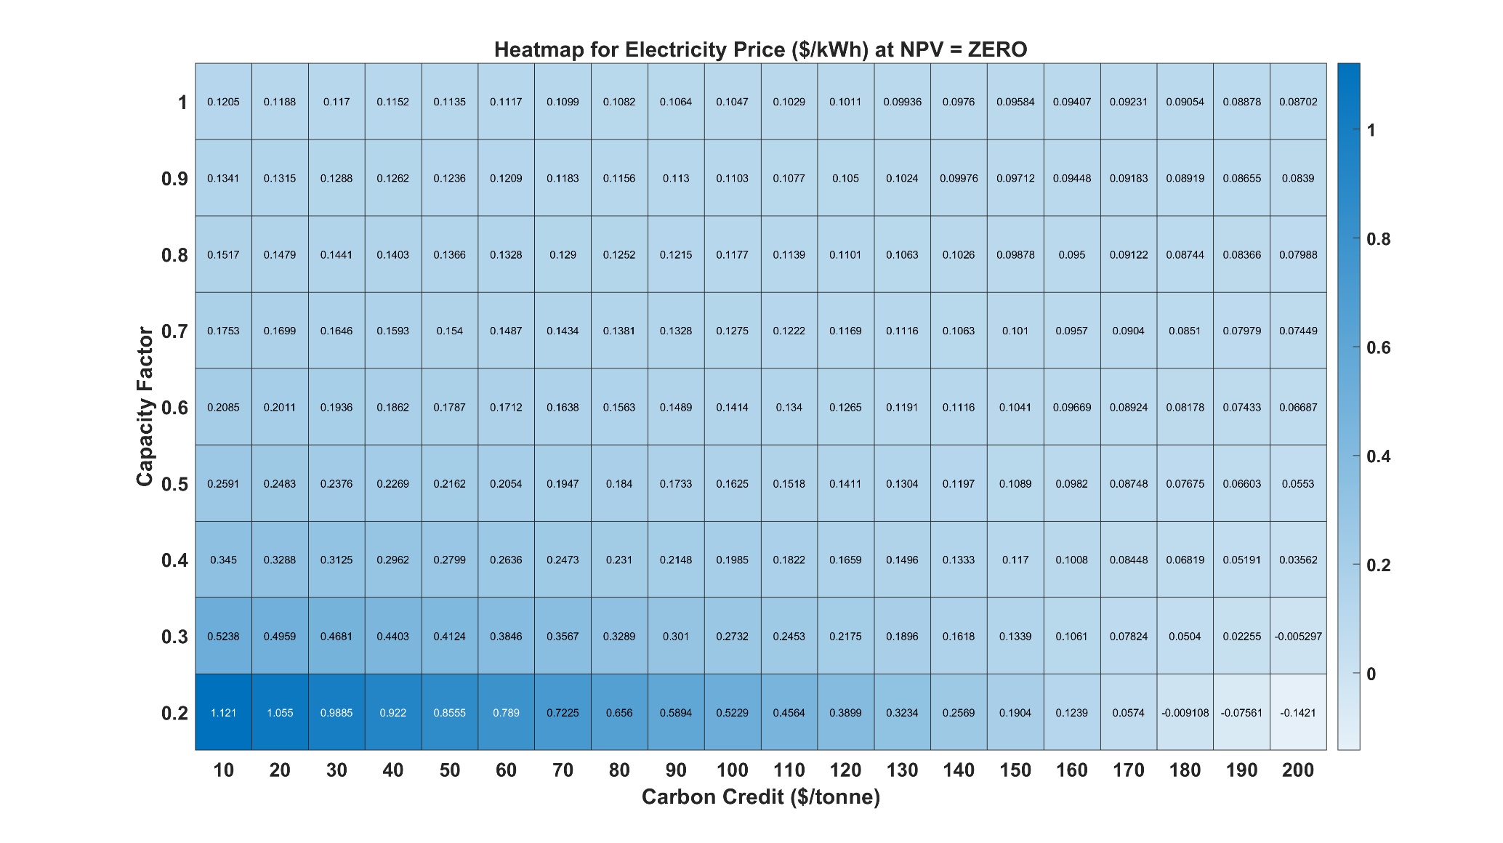

Figure 18: Electricity prices corresponding to Zero NPV condition at various Capacity Factors and Carbon Credits
Figure 19 shows a breakdown of the cash flow at R values of 1 and 0.2. The used electricity prices are the ones that give zero NPV at R = 1 and R = 0.2, which are $0.08702/kWh and $-0.1421/kWh, respectively, as per Figure 18. The main observation from Figure 19 is the increase in the income from the captured CO₂ as R decreases. This is because the flow rate of fresh limestone increases at lower capacity factors to keep the calciner fully loaded. Notice that the fresh limestone expenses increase as the capacity factor decreases as well. The plant is generating income from the exported electricity at R = 1, but it is paying expenses on electricity at R = 0.2. This is because of the negative electricity price used at R = 0.2 ($-0.1421/kWh), which gives zero NPV. Notice that the natural gas expenses are higher at R = 1 because the system uses more natural gas when it is working at its full capacity.
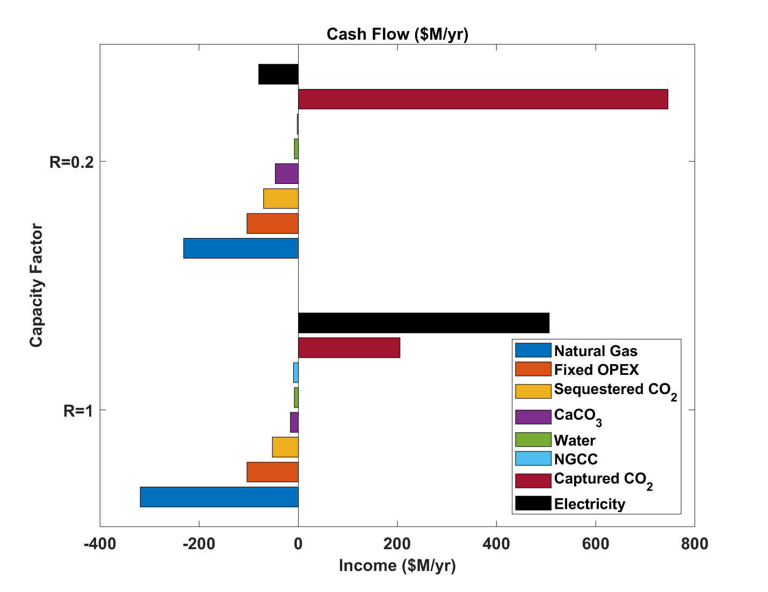
Figure 19: Cash flow at capacity factors (R label in y-axis) of 20% and 100%. The electricity prices considered for each case correspond to those that result in zero NPV for the entire prices. They are 142 and 87 $/MWh respectively.
Overall, Figures 18 and 19 illustrate that the investment can be justified only when the electricity price is higher than the value obtained at zero NPV. According to the US Energy Information Administration (EIA)(“Electric Power Monthly - U.S. Energy Information Administration (EIA),” n.d.), the average electricity price for industrial use each year from 2013 till 2022 falls between $0.067-0.0845/kWh, with the average price in 2022 being the highest ($0.0845/kWh). From Figure 18, the only cases that sit below the lowest average electricity price are the cases with a carbon credit $170/tonne or higher and low R values. To maximize R, the optimal case would be at $200/tonne carbon credit and R = 0.5, where the electricity price at zero NPV is $0.0553/kWh. If we consider the average electricity price in the most recent year (2022), more cases from Figure 18 would be profitable, with the best one being at $200/tonne carbon credit and R = 0.9 as it maximizes the capacity factor and keeps the electricity price at $0.0839/kWh, which is lower than the 2022 average ($0.0845/kWh). It is worth mentioning again that these results are highly influenced by the parameter values mentioned in Table 4 which are used as best guesses. Design and operations optimization under time-varying electricity price scenarios will be considered in future work.
Conclusion
Flexible carbon capture and storage has potential for reducing carbon emissions and potentially achieving negative emissions while improving the economics of the system at the same time. The flexibility of the proposed system stems from the coupled dependency on both the power plant flue gas and the fresh limestone. The system can operate both with and without the power plant flue gas (i.e., the system will still run when the power plant is shut down) if limestone is being continuously fed to the system, which keeps both the separation system and the DAC system in operation all the time. This allows the system to potentially complement VRE generation sources that are likely to dominate future power grids.
We find that the system is a net electricity exporter at 40% power plant loading and above and net electricity importer at 0% power plant loading (i.e., when the power plant is shutdown). However, the system can achieve negative carbon emissions at all power plant loading levels, if limestone is being continuously fed to the calciner to keep it fully loaded. Estimated captured CO₂ flow rates range from 134 to 513 tonne/hr at 100% to 0% power plant loadings, respectively. On the other hand, the estimated CO₂ emissions ranges from 16.89 to 10.23 tonne/hr at 100% and 0% power plant loadings, respectively.
Furthermore, the economic viability of the system is studied in terms of the needed electricity price to achieve zero net present value for capacity factors ranging from 20% to 100% and carbon credits ranging from 10 to 200 $/tonne of CO₂ captured. This analysis reveals that the process may be economically viable at carbon credits higher than $170/tonne. However, optimizing the key operating variables might improve the techno-economic analysis results for the proposed system, resulting lower threshold carbon credit values.
The fresh CaCO₃ flow rate, the flue gas fraction to the calciner, the CaO fraction to the carbonator, and the gas recycle to the carbonator from the distillation top product and the membrane retentate have been identified as the key operating variables for the proposed system. In future work, an integrated design and operations optimization model will be developed to understand the cost-optimal trajectories of these process variables under time-varying electricity price scenarios, in addition to determining the optimal size of different subsections of the process.

Appendix A. Cross-plug Flow Membrane Model
The symbols used in this section are defined in Table A1.
Table A1
List of symbols used in the custom membrane model
Variable | Description | Units
$$A$$ | Membrane area | m$​^{2}$
$$L$$ | Flow rate | kmol hr$​^{-1}$
$$p$$ | pressure | bar
$$Q_{i}$$ | Permeance of component $i$ | kmol / (m$​^{2}$ hr bar)
$$x_{i}$$ | mole fraction of $i$th component on retentate side | -
$$y_{i}$$ | mole fraction of $i$th component on permeate side | -
$$ϕ$$ | stage cut | -
Subscripts
$$f$$ | feed
$$p$$ | permeate side
$$r$$ | retentate side
Superscripts
’ | local values

The following equations represent a system of ODEs for a system of $n$ components(Li et al., 1990). These equations are integrated with respect to a differential area element $dA'$.
$$\frac{dx'_{i}}{dA'}=-\frac{1}{L'_{u}}\left[x_{i}'\frac{dL'_{u}}{dA'}+Q_{i}\left(p_{u}x_{i}'-p_{p}y_{i}'\right)\right], i∈\{1...n\}$$
$$\frac{dL'_{u}}{dA'}=-\sum_{i=1}^{n}{Q_{i}}\left(p_{u}x_{i}'-p_{p}y_{i}'\right)$$
$$\frac{y'_{i}}{y'_{i+1}}=\frac{Q_{i}}{Q_{i+1}}\frac{p_{u}x'_{i}-p_{p}y_{i}'}{p_{u}x'_{i+1}-p_{p}y'_{i+1}}, i∈\{1...\left(n-1\right)\}$$
$$\sum_{i=1}^{n}{y_{i}}=1$$
The initial conditions are given by:
$$x'_{i}\left(A'=0\right)=x_{f,i}$$
$$L_{u}'\left(A'=0\right)=L_{f}$$
The system of differential equations is solved up to total area $A_{t}$. The mole fraction in the permeate is given by:
$$y_{i}=\frac{x_{f,i}-\left(1-ϕ\right)x_{i}\left(z=A_{t}\right)}{ϕ}.$$
In this work we assume that only CO₂ and N₂ pass through the membrane and the permeance values are taken as $Q_{CO_{2}}$=0.000484 MMol/hr/m²/bar and $Q_{N_{2}}$=0.00002 MMol/hr/m²/bar.
Conflicts of interest
8 Rivers is the inventor and developer of Carbon8 and Calcite Direct Air Capture Technologies.
Funding
This research was funded by Advanced Research Projects Agency–Energy (ARPA-E). Grant Number DE-AR0001311.
References
Alcaráz-Calderon, A.M., González-Díaz, M.O., Mendez, Á., González-Santaló, J.M., González-Díaz, A., 2019. Natural gas combined cycle with exhaust gas recirculation and CO2 capture at part-load operation. Journal of the Energy Institute 92, 370–381. https://doi.org/https://doi.org/10.1016/j.joei.2017.12.007
Arias, B., Criado, Y.A., Abanades, J.C., 2020. Thermal Integration of a Flexible Calcium Looping CO2 Capture System in an Existing Back-Up Coal Power Plant. ACS Omega 5. https://doi.org/10.1021/acsomega.9b03552
Bui, M., Adjiman, C.S., Bardow, A., Anthony, E.J., Boston, A., Brown, S., Fennell, P.S., Fuss, S., Galindo, A., Hackett, L.A., Hallett, J.P., Herzog, H.J., Jackson, G., Kemper, J., Krevor, S., Maitland, G.C., Matuszewski, M., Metcalfe, I.S., Petit, C., Puxty, G., Reimer, J., Reiner, D.M., Rubin, E.S., Scott, S.A., Shah, N., Smit, B., Trusler, J.P.M., Webley, P., Wilcox, J., Mac Dowell, N., 2018. Carbon capture and storage (CCS): The way forward. Energy Environ Sci. https://doi.org/10.1039/c7ee02342a
Criado, Y.A., Arias, B., Abanades, J.C., 2017. Calcium looping CO2 capture system for back-up power plants. Energy Environ Sci 10. https://doi.org/10.1039/c7ee01505d
De Lena, E., Spinelli, M., Gatti, M., Scaccabarozzi, R., Campanari, S., Consonni, S., Cinti, G., Romano, M.C., 2019. Techno-economic analysis of calcium looping processes for low CO2 emission cement plants. International Journal of Greenhouse Gas Control 82, 244–260. https://doi.org/10.1016/J.IJGGC.2019.01.005
Dean, C.C., Blamey, J., Florin, N.H., Al-Jeboori, M.J., Fennell, P.S., 2011. The calcium looping cycle for CO2 capture from power generation, cement manufacture and hydrogen production. Chemical Engineering Research and Design 89, 836–855. https://doi.org/10.1016/J.CHERD.2010.10.013
Dowell, N. Mac, Shah, N., 2017. Multi-period Design of Carbon Capture Systems for Flexible Operation, in: Process Systems and Materials for CO 2 Capture . https://doi.org/10.1002/9781119106418.ch17
Electric Power Monthly - U.S. Energy Information Administration (EIA) [WWW Document], n.d. URL https://www.eia.gov/electricity/monthly/epm_table_grapher.php?t=epmt_5_03 (accessed 5.9.23).
Fennell, P.S., Pacciani, R., Dennis, J.S., Davidson, J.F., Hayhurst, A.N., 2007. The Effects of Repeated Cycles of Calcination and Carbonation on a Variety of Different Limestones, as Measured in a Hot Fluidized Bed of Sand. Energy & Fuels 21, 2072–2081. https://doi.org/10.1021/ef060506o
FLECCS | arpa-e.energy.gov [WWW Document], n.d. URL https://arpa-e.energy.gov/technologies/programs/fleccs (accessed 5.9.23).
Grasa, G.S., Abanades, J.C., 2006. CO2 Capture Capacity of CaO in Long Series of Carbonation/Calcination Cycles. Ind Eng Chem Res 45, 8846–8851. https://doi.org/10.1021/ie0606946
James Robert E., I.I.I., Keairns, D., Turner, M., Woods, M., Kuehn, N., Zoelle, A., 2019. Cost and Performance Baseline for Fossil Energy Plants Volume 1: Bituminous Coal and Natural Gas to Electricity. United States. https://doi.org/10.2172/1569246
Kasseris, E., Goteti, N.S., Kumari, S., Clinton, B., Engelkemier, S., Torkamani, S., Akau, T., Gençer, E., 2020. Highlighting and overcoming data barriers: Creating open data for retrospective analysis of us electric power systems by consolidating publicly available sources. Environ Res Commun 2. https://doi.org/10.1088/2515-7620/abc86d
Li, K., Acharya, D.R., Hughes, R., 1990. Mathematical modelling of multicomponent membrane permeators. J Memb Sci 52, 205–219. https://doi.org/10.1016/S0376-7388(00)80486-X
MacDowell, N., Shah, N., 2014. Optimisation of Post-combustion CO2 Capture for Flexible Operation. Energy Procedia 63, 1525–1535. https://doi.org/10.1016/J.EGYPRO.2014.11.162
McLinden, M.O., Huber, M.L., 2020. (R)Evolution of Refrigerants. J Chem Eng Data 65, 4176–4193. https://doi.org/10.1021/acs.jced.0c00338
Mechleri, E., Fennell, P.S., Dowell, N. Mac, 2017. Flexible Operation Strategies for Coal- and gas-CCS Power Stations under the UK and USA Markets. Energy Procedia 114, 6543–6551. https://doi.org/10.1016/J.EGYPRO.2017.03.1790
Oates, D.L., Versteeg, P., Hittinger, E., Jaramillo, P., 2014. Profitability of CCS with flue gas bypass and solvent storage. International Journal of Greenhouse Gas Control 27, 279–288. https://doi.org/10.1016/J.IJGGC.2014.06.003
Rodríguez, N., Murillo, R., Abanades, J.C., 2012. CO2 Capture from Cement Plants Using Oxyfired Precalcination and/or Calcium Looping. Environ Sci Technol 46, 2460–2466. https://doi.org/10.1021/es2030593
Sheha, M., Mohammadi, K., Powell, K., 2021. Techno-economic analysis of the impact of dynamic electricity prices on solar penetration in a smart grid environment with distributed energy storage. Appl Energy 282, 116168. https://doi.org/10.1016/J.APENERGY.2020.116168
Sheha, M., Mohammadi, K., Powell, K., 2020. Solving the duck curve in a smart grid environment using a non-cooperative game theory and dynamic pricing profiles. Energy Convers Manag 220. https://doi.org/10.1016/j.enconman.2020.113102
Valverde, J.M., Sanchez-Jimenez, P.E., Perez-Maqueda, L.A., 2014. High and stable CO2 capture capacity of natural limestone at Ca-looping conditions by heat pretreatment and recarbonation synergy. Fuel 123, 79–85. https://doi.org/10.1016/J.FUEL.2014.01.045
Zantye, M.S., Arora, A., Faruque Hasan, M.M., 2019. Operational power plant scheduling with flexible carbon capture: A multistage stochastic optimization approach. Comput Chem Eng 130, 106544. https://doi.org/10.1016/J.COMPCHEMENG.2019.106544
Zantye, M.S., Arora, A., Hasan, M.M.F., 2021. Renewable-integrated flexible carbon capture: A synergistic path forward to clean energy future. Energy Environ Sci 14. https://doi.org/10.1039/d0ee03946b

